MINUTES OF THE 37TH CEOS PLENARY
15 – 16 November 2023
Hosted by GISTDA
V1.0 FINAL

Executive Summary
- The Geo-Informatics and Space Technology Development Agency (GISTDA) of Thailand hosted a special workshop on ‘Satellite Earth Observation and Carbon Accounting’. Contributions from CEOS and other presenters effectively showcased the power of Earth observation for the local Thai carbon accounting community and invited guests from Thailand and other countries.
- CEOS Plenary endorsed the CEOS AFOLU Roadmap and its recommendations. An Action Supplement will be presented at the SIT-39 meeting to be held on April 9-11, 2024, in Tokyo. The Action Supplement will track implementation of the AFOLU Roadmap, which will continue to be stewarded by the Forests & Biomass Subgroup of the CEOS Land Surface Imaging Virtual Constellation (LSI-VC).
- WMO and partners are developing a Global Greenhouse Gas Watch (GGGW) to provide near real-time exchange of observations, 24/7 GHG modelling, and data assimilation to provide top-down flux estimates. WMO is seeking engagement by CEOS to help draft a chapter for the GGGW Implementation Plan on observations. Yasjka Meijer, lead of the CEOS Greenhouse Gas Task Team, has been invited to participate. Access to space-based GHG data will be critical to the success of GGGW, and there is a clear and important role for CEOS in the coordination of the space-based observations component.
- The 2023 CEOS Plenary highlighted the need to reinvigorate the interface between CEOS and the UNFCCC Secretariat, in particular, the Research and Systematic Observation (RSO) interface. Closer collaboration and consistent messaging among key observation bodies including CEOS, WMO, GEO, GCOS, and IOC/GOOS would be beneficial. Regular meetings with the UNFCCC Secretariat and an annual touch-base involving CEOS Chair/SIT Chair and UNFCCC Secretariat senior management and/or SBSTA Chair would be ideal. Encouraged the exploration of new ideas and paradigms. The incoming JAXA SIT Chair will follow up during its term, starting with a review of outcomes from UNFCCC COP28 and the first Global Stocktake.
- The 2023 EO Handbook “Space Data for the Global Stocktake” is available at eohandbook.com/gst.
- In 2023, the CEOS Greenhouse Gas Roadmap was updated through an update of Annex C (list of actions). Additional milestones and actions have been added, including around the sustainability of critical GHG Cal/Val networks. The CEOS GHG Satellite Mission Portal was also developed with the support of the ESA SIT Chair and JAXA SIT Vice Chair teams.
- CEOS Plenary agreed to proceed with the development of a CEOS Aquatic Carbon Roadmap as proposed by the CEOS Ocean Colour Radiometry Virtual Constellation (OCR-VC). The effort will be co-led by Hiroshi Murakami (JAXA), Laura Lorenzoni (NASA) and Marie-Helene Rio (ESA). It will complement the existing GHG and AFOLU Roadmaps and serve as a guiding vision for long term (15+ years) coordination of CEOS agency observing programmes in support of the science and policy needs for Aquatic carbon related information.
- CEOS Plenary endorsed and welcomed Environment and Climate Change Canada (ECCC) as CEOS Associate. ECCC is a key driver for Canadian EO missions. Together with CSA and the Canada Centre for Mapping and Earth Observation (CCMEO, already a CEOS member) they form the key partnership for Earth observation in Canada. ECCC is a key department and source of EO expertise.
- The WGCV Terrain Mapping Subgroup (TMSG) is seeking agencies’ support for the new initiative attempting intercomparison of Ground Control Points (GCP) for global harmonisation of orthorectification.
- The WGCV Atmospheric Composition Subgroup (ACSG) is seeking agencies’ support for the sustainability of critical Greenhouse Gas cal/val networks, particularly NDACC, TCCON and the COllaborative Carbon Column Observing Network (COCCON).
- The CEOS Interoperability Framework and Roadmap were endorsed. The CEOS Working Group on Information Systems and Services (WGISS) will develop a second version of the CEOS Interoperability Handbook in 2024.
- CEOS Plenary endorsed Dr. Nitant Dube of ISRO as WGISS Vice Chair for two years (2024-2025), followed by WGISS Chair for two years (2026-2027).
- CEOS Plenary endorsed the establishment of the Pre-operational Recovery Observatory to be led by the CEOS Working Group on Disasters (WGDisasters). This will establish capacity to provide two to four Recovery Observatories for the next three years beginning in 2024.
- CEOS Plenary endorsed the establishment of the G-VEWERS (Global Volcano Early Warning and Eruption Response from Space) initiative to be led by the CEOS Working Group on Disasters (WGDisasters). G-VEWERS is a permanent virtual facility for remote volcano monitoring. It will function on biennial renewable quotas like Supersites made possible by best-effort contributions from academic institutions, volcano observatories, and space agencies. The aim is to provide a timely response to hazardous volcanic eruptions, tracking of restless volcanoes and background monitoring of quiescent volcanoes. Operational support will be provided by USGS.
- CEOS Plenary endorsed Mr. Lôrânt Czârân of UNOOSA as WGDisasters Vice Chair for two years (2024-2025), followed by WGDisasters Chair for two years (2026-2027).
- CEOS Plenary endorsed Mr. Julio César Castillo Urdapilleta of AEM as Vice Chair of the Working Group on Capacity Building and Data Democracy (WGCapD) for two years (2024-2025), followed by WGCapD Chair for two years (2026-2027).
- CEOS Plenary endorsed the “Joint CEOS-CGMS Space Agency Statement to the UNFCCC Subsidiary Body for Scientific and Technological Advice (SBSTA)” for COP28, occurring on 30 Nov. to 12 Dec. 2023 in Dubai, United Arab Emirates. It provides a vehicle to update SBSTA on Earth observation developments, gaps, and needs. The Canadian delegation will submit and read the statement at SBSTA-59.
- CEOS Plenary endorsed the Ecosystem Extent Task Team white paper and recommendations. The white paper provides an integrated international perspective on how space-based Earth observations can be used to support ecosystem mapping and monitoring with a focus on ecosystem extent. Combining data for different sensor types presents both opportunities and challenges, as does time series analysis. Other opportunities identified include the use of hyperspectral data, integration of artificial intelligence and machine learning techniques, and application of Data Cube platforms. Challenges identified include the limited availability of value-added products, EO data usability and the technical capacity of users, and assessing ecosystem condition. In future, coordination with the GEO Ecosystem Atlas should be prioritised and expansion of this work to oceans and coasts would be a useful development direction.
- Demonstrators will be the Ecosystem Extent Task Team’s focus for 2024, with the goal being to deliver the outcomes at CEOS Plenary 2024. All three demonstrators are designed around the application of Data Cubes, which will be used to combine data from different sensors. CEOS Agencies interested in contributing a Demonstrator for the Ecosystem Extent activity are asked to coordinate with the Ecosystem Extent Task Team Leads.
- CEOS Plenary agreed to disband the CEOS Ocean Coordination Group after accepting the Group’s list of recommended deliverables for CEOS to better coordinate its ocean activities with its existing entities. Two documents were delivered: 1) Needs Assessment for Ocean Coordination Activities for Upcoming Satellite Missions; 2) List of IOC and Ocean Decade Planned Deliverables from CEOS VCs/WGs/Ad Hoc Teams.
- CEOS Plenary accepted the CEOS Coastal Observations Applications Services and Tools (COAST) Ad Hoc Team’s Initial Proposal to transition to a COAST Virtual Constellation and agreed to extend the Ad Hoc Team through to SIT-39 to prepare the necessary documentation to support a SIT-39 decision regarding the proposed transition. The COAST-AHT is proposing a transition of their activities to a Virtual Constellation (COAST-VC) due to the broad support for continuation of COAST activities beyond the procedural end of the AHT term. The Full Proposal for a new COAST Virtual Constellation, will include Terms of Reference and an Implementation Plan. Due to the nature of the coastal zone, it is recognised that a COAST-VC would need to be complementary with existing activities in other Virtual Constellations and Working Groups, and this will be addressed in the Terms of Reference.
- CEOS Plenary endorsed the 2023 CEOS Communications Strategy. The strategy outlines three campaigns to be conducted over 2024-25: 40th Anniversary of CEOS, EO for Biodiversity (supporting CSA’s CEOS Chair priority), and Greenhouse Gas Observations from Space (supporting the JAXA SIT Chair priority). It was requested that the Strategy be shared with communications staff at CEOS Agencies for their review and action. Collaboration with agencies’ communications departments is important, as it allows CEOS to greatly amplify its messages. Dedicated points of contact should be provided to the SEO.
- CEOS Plenary endorsed the New Space Task Team white paper and recommendations. It also gave its approval to disband the CEOS New Space Task Team, which was established as a temporary team two years ago. It was agreed that the document will remain internal to CEOS. Working with the relevant CEOS entities, the CEOS Executive Officer and the ESA 2022-2023 SIT Chair team will consider the CEOS New Space Task Team’s recommendations and suggested deliverables (and the related discussion from the 2023 CEOS Plenary) in the development of the CEOS 2024-2026 Work Plan. Dataset complementarity, supporting cal/val and quality assurance, and Analysis Ready Data were key themes of the recommendations.
- CEOS Plenary endorsed the nomination of United Kingdom Space Agency (UKSA) as 2025 CEOS Chair in representation of the Europe/Africa region.
- CEOS Plenary endorsed the nomination of the National Aeronautics and Space Administration (NASA) as SIT Vice Chair for 2024-2025 and SIT Chair for 2026-2027.
- CEOS Plenary welcomed the Japan Aerospace Exploration Agency (JAXA) as SIT Chair for the two-year term of 2024-2025. JAXA’s SIT Chair headline priorities are climate policy impact (addressing obstacles and opportunities for CEOS Agency data, particularly AFOLU/Biomass datasets, to ensure maximum impact in the key climate policy processes such as the Global Stocktake of the Paris Agreement) and Greenhouse Gas observations from space (addressing coordination for data continuity challenges ahead and developing good practices so that operators of all kinds may contribute to societal needs).
- CEOS Plenary welcomed the Canadian Space Agency (CSA) as 2024 CEOS Chair. CSA will prioritise one headline theme of biodiversity during their Chair term. CSA will consider both internal CEOS organisational matters as well as connect with external stakeholders to establish, by the end of 2024, a proposal regarding the future of CEOS and the biodiversity topic. CSA will also seek to raise the profile of EO amongst the biodiversity community.

Day 1: Wednesday, November 15

Session 1: Welcome and Core Business

1.1: Welcome, Opening Remarks, Agency Introductions and Summary of Objectives [slides]
Presenter: Pakorn Apaphant (GISTDA, 2023 CEOS Chair)
Main points:
- Welcomed participants to Chiang Rai, Thailand, for the 37th CEOS Plenary and acknowledged the virtual presence of many others.
- GISTDA hosted a workshop on November 15 titled ‘Satellite Earth Observation & Carbon Accounting’, which was well attended by both the local community and CEOS Agencies. Special thanks to Lawrence Friedl (NASA), Osamu Ochiai (JAXA), Frank Martin Seifert (ESA), Antony Delavois (ESA), Jeff Privette (NOAA), and Pakorn Petchprayoon (GISTDA) for their presentations and participation in the panel session. The contributions from CEOS were a very valuable showcase of the power of Earth observation for the local Thai carbon accounting community.
- Invited the head of each agency to provide a summary of their CEOS Plenary delegations. The complete list of participants can be found in Appendix A.
- Matt Steventon (CEOS Chair Team) reviewed the objectives for this Plenary, which are detailed in the agenda and in the slides linked above.

1.2: CEOS Executive Officer (CEO) Report [slides]
Presenter: Marie-Claire Greening (CEOS Executive Officer)
Main points:
- CEOS will have its 40th Anniversary in 2024. Over the last 40 years, CEOS has achieved a great deal, and this should be celebrated.
- The three primary objectives of CEOS are:
  - To optimise the benefits of space-based Earth observation;
  - To serve as the focal point for international coordination of space-based Earth observation activities;
  - To encourage complementarity and compatibility of satellite EO missions.
- The four long-term priorities of CEOS are:
  - Ensure that climate observation requirements identified by the Global Climate Observing System (GCOS) – and implications of the Paris Climate Agreement – are addressed.
  - Ensure, in the context of the Sendai Framework for Disaster Risk Reduction 2015-2030, that CEOS Agency data are made available in support of disaster risk reduction and that CEOS continues engagement with UN agencies and authorities.
  - Ensure that space-based Earth observations support the success of the next decade of the Group on Earth Observations (GEO), and that CEOS engagement in GEO governance and leadership is enhanced.
  - Proactively engage in global discussions on the critical challenges that face society, in support of the UN 2030 Agenda for Sustainable Development.
- The CEOS Executive Officer serves the entire CEOS organisation and acts with neutrality. The CEOS Executive Officer is the custodian of CEOS Governing Documents, including the CEOS Work Plan, and ensures information flow across all CEOS entities. They also handle all matters relating to membership of CEOS, as well as working with the Systems Engineering Office on communications and outreach.
- The CEOS Executive Officer is also the point of contact for all external stakeholders, both existing and new and, together with the SIT Chair, is the CEOS interface to the Group on Earth Observations (GEO).
- Four key governing documents primarily guide the work of CEOS. They are: the CEOS Terms of Reference, CEOS Strategic Guidance document, CEOS Governance and Processes document and the CEOS Work Plan.
- The 2023-2025 CEOS Work Plan identified 132 deliverables, of which 16 have been closed, 25 are overdue, 46 are due by the end of 2023, and 45 are due in 2024 and beyond.
- Marie-Claire concludes her term as CEOS Executive Officer at the end of 2023. NASA supported her as a contractor in the role from 2021-2022, with joint funding from NASA and NOAA continuing this support at the beginning of 2023. From June to December 2023, ESA took over full support as Marie-Claire joined ESA in June as a member of staff and was immediately seconded to the CEO role to complete her three-year term.
Discussion
- Pakorn Apaphant (GISTDA, 2023 CEOS Chair) thanked Marie-Claire for her three years of dedicated service as CEOS Executive Officer, and he acknowledged the critical support of NASA, NOAA, and ESA.

1.3: Update on the Next CEOS Executive Officer (CEO)
Presenter: Paul Counet (EUMETSAT)
Main points:
- Throughout 2022, there were many discussions around finding a solution to ensure continuity of the CEO role. At the 2022 CEOS Plenary, it was agreed that EUMETSAT would support the role for 2024-2025, with ESA supporting the role for 2026-2027. The other permanent CEOS Secretariat members (JAXA, NASA and NOAA) will take subsequent turns to support the role.
- EUMETSAT worked with ESA to propose a solution to staffing the CEO role for four years from 2024-2027. A consortium of nine CEOS agencies from across Europe were gathered and they have committed their support to the CEO position. EUMETSAT, in consultation with ESA, ran a hiring process to select a CEO. The initial contract covers two years, with an option for two more. The new CEO will start from 1 January 2024 and will be a 1.2 full-time equivalent position.
- A contract has been signed with Réseau Consulting, based in Geneva, and Evenflow based in Brussels. The primary contact for CEO will be Steven Ramage (Réseau Consulting), with additional support provided by Lefteris Mamais (Evenflow).
- EUMETSAT have begun discussions with CSA and JAXA regarding the CEO’s statement of work for 2024.
- Since the role of the CEO is intended to be neutral in manner, the funding agencies will defer the main line of reporting for the CEO to the CEOS Chair. They will provide the funding only.
- ESA has kindly agreed to support a period of handover with Maire-Claire Greening (current CEO) to ensure a smooth transition.
Discussion
- Selma Cherchali (CNES) thanked EUMETSAT for their coordination and establishment of a framework to ensure continuity of the CEO position. CNES is pleased to see this progress after their 2022 CEOS Chair term, during which this CEO continuity topic was a priority. CNES is happy to be part of the consortium providing funding.

Session 2: Special Topics

2.1: 2023 CEOS Chair Priorities – Report on Outcomes [slides]
Presenter: Pakorn Apaphant (GISTDA, 2023 CEOS Chair)
Main points:
- The main themes for GISTDA during their Chair term included supporting CEOS preparations and inputs to the Global Stocktake of the UNFCCC Paris Agreement, as well as supporting the exploration of new geometries for space agencies and CEOS with New Space.
- GISTDA hosted a SilvaCarbon mangrove-focused workshop in Thailand from 22 February to 2 March 2023. GISTDA also held a special side event alongside the CEOS Plenary, titled ‘Satellite Earth Observation & Carbon Accounting’.
- GISTDA has been actively involved in the New Space dialogue, hosting and attending several related events in Thailand and South-East Asia and participating in the CEOS New Space Task Team (NSTT). The information gathered at such events provided key inputs to the NSTT White Paper.
- GISTDA will continue to support CEOS activities, including the 2024 CEOS Chair priority on Biodiversity.

2.2: THEOS-2 and GISTDA SPHERE Platform [slides]
Presenter: Tanita Suepa (GISTDA, 2023 CEOS Chair Team)
Main points:
- THEOS-2 was successfully launched on 9 October 2023 with the aim of improving the Earth observation imaging capabilities of Thailand.
- The satellite has a high resolution of 50 cm, which allows for various applications, including natural resources and environmental monitoring, agriculture, water management, disasters, and urban mapping.
- SPHERE is GISTDA’s open geospatial platform, a cloud-based data processing and analysis platform. The platform provides datasets, tools, and the ability to develop applications alongside data.
- ‘Carbon Tracking’ is a new initiative from GISTDA to assist carbon accounting. It includes a website and mobile application available to the public.
- GISTDA will aim to ensure continuity of its support for CEOS.

Session 3: CEOS Agency Reports

3.1: CEOS Agency Reports

European Commission [slides]
Presenter: Mauro Facchini (European Commission)
Main points:
- There are now almost one million Copernicus users, with 7882 TB of Sentinel data and 581 products in the service portfolio as of November 2023.
- Over the past 11 years, the Copernicus Emergency Management Service Rapid Mapping has had 880 activations in response to disasters. There have been more than 8000 products released with more than 10,000 images analysed in more than 130 different countries.
- Copernicus expansion missions will begin launching from around 2026, and include CO2M, CRISTAL, LSTM, CIMR, CHIME, and ROSE-L.
- Sentinel-1C is planned to launch in 2024 to replace Sentinel-1B following the failure in late 2021.
- The Copernicus Data Space Ecosystem (CDSE) provides immediate access to Copernicus data for downloading, streaming and on-demand processing with a wide range of cloud options. The service is now operational.
Republic of Korea National Institute of Environmental Research (NIER) [slides]
Presenter: Goo Kim (NIER)
Main points:
- The Geostationary Environment Monitoring Spectrometer (GEMS) is an instrument onboard KARI’s GEO-KOMPSAT-2B, which launched in February 2020 to geostationary orbit. GEMS measures ozone, sulphur dioxide, nitrous oxide, formaldehyde (HCHO), and other aerosols in the atmosphere. The planned mission duration is ten years. GEMS covers twenty countries in East Asia.
- GEMS data can be downloaded from the Environmental Satellite Centre (ESC), which can be found at nesc.nier.go.kr. For larger volumes of data, users can apply for access through NIER.
- The GEMS Application Tool (GEMSAT) was launched in June 2023 and is an intuitive software that provides specialised and dedicated functionality for plotting, visualising, and analysing space-based air quality data so that users can easily leverage satellite measurements to meet their specific needs.
Canadian Space Agency (CSA) [slides]
Presenter: Éric Laliberté (CSA)
Main points:
- On March 30, 2023, the RADARSAT Constellation Mission (RCM) captured its one-millionth image of Earth, a little more than three years after the start of operations.
- RADARSAT+ was recently announced as the follow-on programme that will ensure continuity of the RADARSAT series’ measurements. This includes a fourth satellite to replenish RCM, as well as a next generation satellite.
- CSA’s vision for 2040 includes a next-generation Canadian satellite system, enhanced international collaborations, and free and open data as a central theme.
- SCISAT-1 has now been operational for twenty years and has users from 448 institutions across 40 countries.
- smartWhales is the first smartEarth Integrator initiative, a partnership between the Canadian Space Agency (CSA), the Department of Fisheries and Oceans (DFO) and Transport Canada (TC). The program aims to explore how data from space could help protect the endangered North Atlantic right whale and develop space-based solutions for the detection, monitoring, prediction, and modelling streams.
United States Geological Survey (USGS) [slides]
Presenter: Steve Labahn (USGS)
Main points:
- USGS is involved in many initiatives across CEOS. USGS is currently a Co-lead of the LSI-VC, Vice Chair of WGCV (Cody Anderson), and Vice Chair of WGISS (Tom Sohre) highlighting the importance of CEOS engagement to USGS.
- The fundamental goal for USGS is to ensure public availability of a primary data record about the historical condition and current state of the Earth’s land surface and to aid prediction of its future condition.
- Landsat is the flagship programme of USGS, and includes Landsat 8 and 9, as well as Landsat7 which is in a storage orbit, awaiting a ground-breaking NASA refuelling mission.
- More than 11 million unique Landsat scenes are available over the programme’s 50-year archive.
- Landsat Next is planned for launch readiness review in 2030. The mission will provide more than twice as many spectral bands as its immediate predecessor.
National Oceanic and Atmospheric Administration (NOAA) [slides]
Presenter: Stephen Volz (NOAA)
Main points:
- NOAA’s 2030 vision statement is: “A thriving Nation whose prosperity, health, security, and continued growth benefit from and depend upon a shared understanding of, and collective action to reduce, the impacts of climate change”.
- The JPSS program follow-on is the Near-Earth Orbit Network (NEON) program, which is intended to offer substantial improvement in weather forecasting and prediction of high impact weather events as it replaces previous monitoring and observation capabilities.
- The NOAA Next Generation LEO Mission will aim to accelerate development, and will include a disaggregated constellation of satellites, increasing risk tolerance in individual mission elements, and leveraging elements of commercial space hardware.
- The NESDIS Common Cloud Framework (NCCF) is a flexible enterprise framework of services that has the potential to support multiple and new missions, science needs, and new products. NCCF is a secure, scalable, resilient, fault tolerant, data and applications agnostic solution that is capable of processing and disseminating all types of data flows.
United Kingdom Space Agency (UKSA) [slides]
Presenter: Beth Greenaway (UKSA)
Main points:
- UKSA helps the UK harness the power of space to benefit people, the planet, and a shared prosperity, by catalysing investment, delivering space capabilities and missions, and acting as a champion for space.
- The UK will re-join the Copernicus component of the EU Space programme from 1 January 2024.
- Centre for Earth Observation Instrumentation (CEOI) is the UK national Earth observation technology programme. UKSA is looking for collaborations and welcomes suggestions from CEOS. The programme covers all instrument types and domains and aims to raise technology readiness levels.
- TRUTHS is a UKSA-ESA partnership mission, led by the UK. TRUTHS is set to provide SI-traceable measurements of incoming solar radiation and of radiation reflected from Earth back out into space. These measurements will allow changes in Earth’s climate to be detected more accurately and will be used to calibrate data from other satellites. In effect, TRUTHS will be a ‘standards laboratory in space’, setting the ‘gold standard’ for climate measurements. It is estimated to launch in 2031.
- MANTIS was launched on 11 November 2023, and is the first satellite to be launched from ESA’s InCubed programme. It is a multispectral high resolution optical payload for Earth observation.
- MicroCarb passed its thermal vacuum tests at the start of November 2023. It is ready for launch as soon as the launcher is available.
- The Space4Climate network includes government, industry, and academia to provide, use or develop space data into trusted climate services.
- Supporting the UK’s commitment to reach net zero emissions by 2050, UKSA has procured methane data from Canadian company GHGSat to enable accurate monitoring and reporting on methane emissions. The data acquired will be contributed to the UN Environment Programme’s (UNEP) International Methane Emissions Observatory (IMEO). There is also provision for IMEO to task GHGSat for a certain number of scenes.
- The UK is pursuing the development and adoption of internationally agreed standards for satellite-derived methane data.

Session 4: Carbon, Climate, Greenhouse Gas (GHG)

4.1: CEOS Agriculture, Forestry and Other Land Use (AFOLU) Roadmap Update [slides]
Presenter: Osamu Ochiai (JAXA, on behalf of Ben Poulter (NASA) and the AFOLU Roadmap Team)
Main points:
- The CEOS AFOLU Roadmap is a deliverable that was identified in the CEOS Global Stocktake strategy. The main objective of the Roadmap is to ensure that every country has the land satellite data required to report on AFOLU to UNFCCC using IPCC guidance.
- The recommendations of the AFOLU Roadmap cover seven areas:
  - Ensure long-term continuity and backward compatibility for missions providing activity data and emission factors;
  - Improve use of Earth observation data in UNFCCC reporting and IPCC Guidelines;
  - Recognising that different countries have various requirements to support their system for reporting, enable dialogue between inventory practitioners and CEOS community;
  - Support efforts to reconcile bottom-up, top-down, and inventory estimates of GHG emissions and removals;
  - Integration of New Space and commercial partnerships in supporting national GHG inventories;
  - Ensure consistency of CEOS AFOLU and GHG Roadmaps to support an integrated national GHG inventory system;
  - Development of actions to support the CEOS AFOLU recommendations.
- The CEOS AFOLU Roadmap is submitted for endorsement at the 2023 CEOS Plenary.
- The AFOLU Roadmap team proposes to create an ‘Actions Supplement’ to track the implementation of the Roadmap, which will continue to be stewarded by the Forests & Biomass Subgroup under the Land Surface Imaging Virtual Constellation (LSI-VC).
Discussion
- Karen St. Germain (NASA) strongly endorsed the CEOS AFOLU Roadmap and thanked the team for the multi-year effort.
- Stephen Volz (NOAA) endorsed the roadmap and appreciated the huge effort required to get to this point. He noted the well-written recommendations and suggested that the implementation actions reflect the cross-cutting nature of the work.
- Takeshi Hirabayashi (JAXA) endorsed the roadmap and thanked ESA and NASA for their leadership and cooperation in completing the roadmap. JAXA will support the implementation as the incoming SIT Chair for 2024-2025.
- Beth Greenaway (UKSA) strongly endorsed the roadmap and anticipates that the UK will be able to support several of the recommendations. She suggested a subtitle for the document that better explains the relevance to carbon accounting.
- Simonetta Cheli (ESA) also endorsed the roadmap and recognised the tremendous progress made by the team.
- Selma Cherchali (CNES) supported the endorsement and noted the importance of Cal/Val in the process. She noted the link with the GEO-TREES programme, of which CNES hosts the international office in Toulouse.
Decision 37-01 | CEOS Plenary endorsed the CEOS AFOLU Roadmap and its recommendations. An Action Supplement will be presented at SIT-39.

CEOS-37-01 | The CEOS AFOLU Roadmap Team within LSI-VC was tasked with creating an action supplement to track implementation of the CEOS AFOLU Roadmap endorsed by the 2023 CEOS Plenary. | SIT-39

4.2: WMO Global Greenhouse Gas Watch [slides]
Presenter: Natalia Donoho (WMO)
Main points:
- WMO and partners are developing a Global Greenhouse Gas Watch (GGGW), building on their experience with the World Weather Watch (WWW) and Global Atmosphere Watch (GAW). This will be an integrated system for surface and space-based Greenhouse Gas (GHG) observations. Key elements include near real time exchange of observations, 24/7 GHG modelling, and data assimilation to provide top-down flux estimates.
- Satellite agencies can help in addressing spatial and temporal gaps, ensuring sustainability of the satellite observations, assisting with the training of personnel, and communication regarding use of integrated observing systems in support of the decision-making products generation. This follows from recommendations arising from a workshop hosted by WMO on the topic.
- GGGW is a critical tool for the implementation of the Paris Agreement. It will be presented at COP 28 following the request of the Subsidiary Body for Scientific and Technological Advice (SBSTA).
- The GGGW Implementation Plan is currently being drafted. The focus is on securing funding for the upcoming four-year WMO financial period of 2024-2027.
- After much discussion, the workshops hosted by WMO independently converged on a latency requirement of 72 hours.
- WMO is seeking engagement from CEOS in helping to draft a chapter on observations. Yasjka Meijer, lead of the CEOS GHG Task Team, has been invited to participate.
- Access to space-based GHG data will be critical to the success of GGGW. This could be discussed in the context of WMO Resolution 1, either at the Workshop on Core Satellite Data (December 2023) or at CM-15 (February 2024).
- Lars Peter Riishojgaard will retire at the end of 2023. There will be a new director of the GHG programme at WMO in 2024.
Discussion
- Mauro Facchini (European Commission) noted that a lot of attention has been received by the GGGW activity. He noted the GHG observation and constellation of CO₂ observations that will be available under Copernicus. He added that there is a clear and important role for CEOS in the coordination of the space-based observations component.
- Takeshi Hirabayashi (JAXA) noted that general requirements for satellite data contributions to the GGGW have been presented. A concrete implementation plan is now being developed. He emphasised the need to continuously discuss and clarify user requirements to guide action. As the incoming SIT Chair, JAXA would like to engage with WMO directly, in addition to the connection via the GHG Task Team.
- Stephen Volz (NOAA) commended the activity of WMO and expressed appreciation for collaboration with CEOS and CGMS. He seconded Mauro’s point about the coordination of space-based observations being the role of CEOS and CGMS. He encouraged continued engagement with WMO to ensure coordinated input to the GGGW requirements and processes.
- Pakorn Apaphant (GISTDA, CEOS Chair) noted the criticality of international engagement on this topic, citing CEOS as a key body. He encouraged all agencies to provide resources to support this work.
- Natalia Donoho (WMO) noted that she has participated at the 2023 SIT Technical Workshop and this CEOS Plenary to ensure strong ties between CEOS and WMO. WMO will be pleased to work with the SIT Chair on the GHG topics during their term.

4.3: CEOS-UNFCCC Interface [slides]
Presenter: Jeff Privette (NOAA, WGClimate Chair) and Stephen Ward (SIT Chair Team)
Main points:
- Highlighted the need for a refresh and upgrade of the interface between CEOS and the UNFCCC Secretariat, particularly the Research and Systematic Observation (RSO) interface. Closer collaboration and consistent messaging among key observation bodies including CEOS, WMO, GEO, GCOS, and IOC/GOOS would be beneficial. Regular meetings with the UNFCCC Secretariat and an annual touch-base involving CEOS Chair/SIT Chair and UNFCCC Secretariat senior management and/or SBSTA Chair would be ideal.
- Encouraged the exploration of new ideas and paradigms, such as:
  - Concepts for more coordinated observations – to deliver operational services.
  - IPCC TFI GPG update to include a 5-year EO optimisation campaign.
  - New groupings – e.g., via the Covenant of City Mayors (reporting, data needs, establishment of more direct relationships?)
  - Cross-convention discussions (CBD, UNFCCC, etc.) with GEO, IOC/GOOS, etc.
  - A more coordinated UNFCCC COP presence, including Earth Observation Pavilion.
- Suggested reviewing outcomes from COP28 and the first Global Stocktake, with an emphasis on making the best use of the Earth Information Day as a mandated event.
Discussion
- Simonetta Cheli (ESA, SIT Chair) noted the occasion of the first Global Stocktake in 2023 is a good time to review. CEOS collaboration with UNFCCC and the climate community more broadly. Simonetta expressed her support for the need for increased coordination between CEOS and UNFCCC, particularly in preparation for COP meetings. JAXA has this topic as one of their SIT Chair headlines and is well versed and experienced in UNFCCC and COP processes. Simonetta is grateful for and confident in JAXA’s addressing of this issue.
- Natalia Donoho (WMO) noted that WMO, GEO and GCOS offices are in the same building. The former director of GOOS works at WMO and WMO has good communication with GEO, GCOS and GOOS. Natalia is willing to help coordination with these agencies.
- Stephen Volz (NOAA) supported JAXA’s initiative as SIT Chair to improve CEOS-UNFCCC coordination and engagement. He appreciated the point put forward by Natalia about coordinating and finding a collective approach between CEOS, GEO, CGMS, etc. to present a coordinated message to the climate conferences. The focus of COP is on countries and not on space agencies and other organisations. A strong collective approach is therefore necessary.
- Beth Greenaway (UKSA) agreed that UNFCCC COPs are focused at the national level. Input from space agencies and others will always be difficult as a result. However, despite this, the space topic has risen up the agenda quite successfully. This year, the United Arab Emirates Space Agency (UAESA) has pushed for a ‘Space Pledge’, inviting the heads of space agencies to contribute. There will be around 70,000 people at COP 28 and Earth observation is just one small community. Beth agreed that a collective voice will be much more effective in getting our messages across.
- Éric Laliberté (CSA) supports the push for improved coordination through the JAXA SIT Chair priority. He suggested that CEOS start by articulating the desired result and agreed that it is better to have a collective approach.
- Mauro Facchini (European Commission) supported the JAXA SIT Chair’s approach, noting that it is nice to see this as a headline priority for the term.
- Pakorn Apaphant (GISTDA, CEOS Chair) suggested a dedicated CEOS meeting in 2024 to prepare for UNFCCC COP 29. Takeshi Hirabayashi (JAXA) noted that a more in-depth discussion is planned for SIT-39 in Tokyo.
- Wenying Su (NASA) agreed that CEOS space agencies need to have a collective position and consistent messaging on space agency contributions to climate matters. Effective focal points via WGClimate also need to be maintained, noting the joint nature between CEOS and CGMS.
- Lôrânt Czârân (UNOOSA) added that UNOOSA can also help facilitate discussions with UNFCCC.

4.4: GHG Satellite Mission Portal [slides]
Presenter: Stephen Ward (SIT Chair Team)
Main points:
- The CEOS GHG Satellite Mission Portal was developed to try and keep track of a very busy sector and to ensure that the public space contribution is understood amongst big claims from the New Space sector. The GHG Task Team was instrumental in getting the content correct.
- Activity supported by the ESA SIT Chair and JAXA SIT Vice Chair teams.
- The portal categorises all known missions, from both public and private organisations, into Global GHG Mappers, Facility Scale Plume Mappers, or Operational Sounders. Links to mission profiles in the CEOS Missions, Instruments and Measurements (MIM) Database are provided for each mission.
- The portal is already being used – featuring in the IMEO Roadmap document and ready to be demonstrated at COP 28.
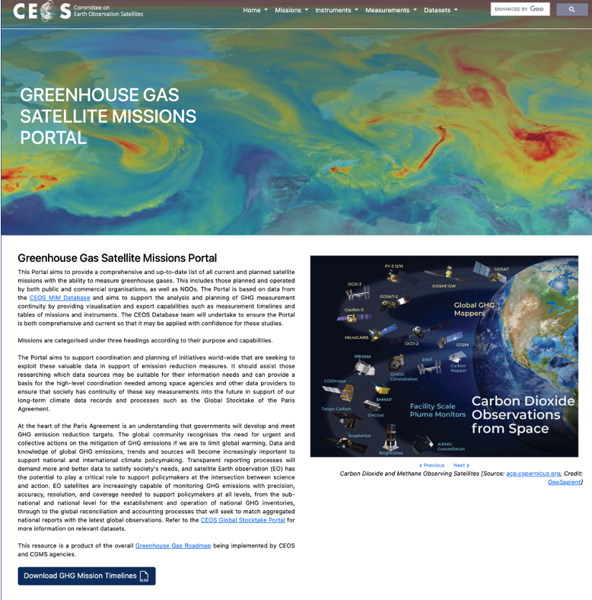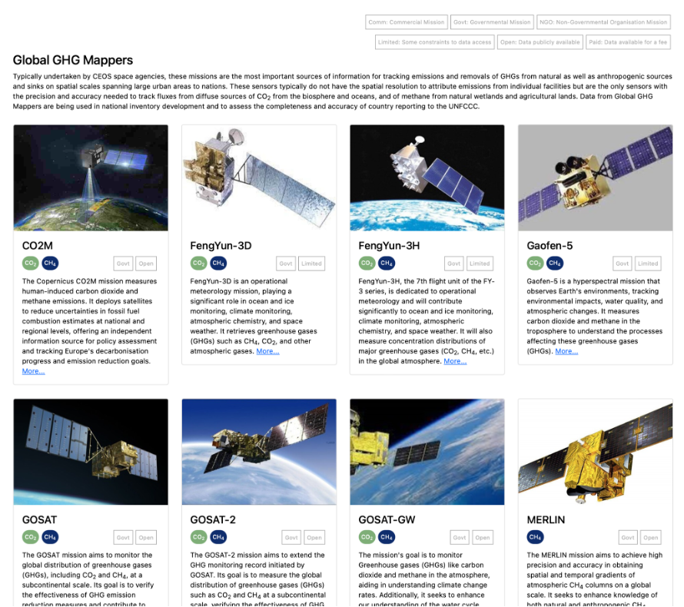

4.5: CEOS Greenhouse Gas (GHG) Roadmap [slides]
Presenter: Wenying Su (NASA, WGClimate Vice Chair)
Main points:
- The Greenhouse Gas Task Team (GHG TT) is responsible for maintaining and implementing the CEOS GHG Roadmap. The Task Team interfaces with, stimulates, and monitors GHG related activities across various teams within both CEOS and CGMS, including WGClimate, WGCV, AC-VC and WGCapD.
- The GHG Task Team webpage is now available on the CEOS website: https://ceos.org/ourwork/workinggroups/climate/ghg-tt/
- Yasjka Meijer (ESA) leads the GHG TT and is assisted by Area Leads for each of the thematic areas identified in the Roadmap.
- In 2023, the GHG Roadmap was updated through an update of Annex C (list of actions). The actions have been thoroughly reviewed by the Area Leads, and more milestones and specific actions have been added.
- There has been strong engagement with WGCV and its Atmospheric Composition Subgroup (ACSG) on the sustainability of critical GHG Cal/Val networks. Additional actions have been added to Annex C as a result.
- The GHG TT has contributed to the Space Agency Response to the GCOS Implementation Plan, as well as engaged with the International Methane Emissions Observatory (IMEO).
- There has been a rapid increase in New Space contributions to facility-scale GHG measurements, and Agencies need to understand how these can and cannot relate to climate policy.
- Challenges identified by the GHG TT include stakeholder and user engagement, mission delays or a lack of follow-on missions for key variables and communicating the fundamental differences between the capabilities of major public missions and those of the New Space sector.
- Next steps for the GHG Task Team include:
  - Coordination of activities with the AFOLU Roadmap, and evaluation of ways to contribute to the definition of an Aquatic Carbon Roadmap, should its development be endorsed by CEOS Principals.
  - Following up relevant recommendations from the New Space Task Team’s white paper.
  - Ensuring CEOS expertise is utilised in WMO’s Global Greenhouse Gas Watch (GGGW) and UNEP’s IMEO.
  - Updating and improving CO₂/CH₄ flux products and user engagement based on lessons-learned from the first Global Stocktake.
Discussion
- Stephen Volz (NOAA) noted that there are challenges to be addressed regarding commercial GHG data management and rights, particularly when seeking to integrate commercial data into federal systems. This might be a consideration for the GHG TT going forward.
- Beth Greenaway (UKSA) noted that 10 out of 15 New Space GHG missions are targeted towards measuring methane. It highlights the need for a standards framework that will confirm whether the data can be trusted and how it interoperates. There is a market and potential users, and companies will be looking to buy data, including from New Space. There is a natural role for CEOS and space agencies to ensure that all EO data is sound.
- Simonetta Cheli (ESA) noted that as Europe prepares for the CO2M mission, the approach is to promote institutional missions as well as the private sector, highlighting complementarities. She added that ESA and European agencies are working on monitoring the ‘European Green Deal’ legislation in the coming years. ESA has prepared concrete demonstrations of applications and is willing to share these with interested CEOS agencies.
- Vincent-Henri Peuch (ECMWF) added that this is a complex landscape and there are two types of information that are needed. The first is point source characterisation, where the private sector is most interested, and the second is global mapping to support top-down budgeting, etc.

4.6: Proposal to Develop a CEOS Aquatic Carbon Roadmap [slides]
Presenter: Marie-Helene Rio (ESA, OCR-VC Co-lead)
Main points:
- Actions are needed to improve ocean carbon budget estimates to improve global carbon assessments. A CEOS Aquatic Carbon Roadmap is proposed to complement the existing GHG and AFOLU Roadmaps to:
  - Provide a framework and serve as a guiding vision for long term (15+ years) coordination of CEOS agency observing programmes in support of the science and policy needs for Aquatic carbon related information in the context of the CEOS Carbon Strategy.
  - Contribute to support the needs and ambition cycle of the Global Stocktake of the Paris Climate Agreement.
  - Characterise the needs, gaps and challenges regarding the required data and products to support science, services and applications and the observing systems that can support their developments, including the needs to plan for ground and space segments. This includes addressing basic observation continuity and the necessary agency coordination to achieve it.
  - Clarify the importance and elevate the profile and complexity of remote sensing and satellite Earth observation that are already routinely used within carbon assessments, highlighting how Earth observation has much more to offer beyond its current use and serves as an effective means for communicating our intentions to society, the UNFCCC, and the national inventory community.
- The development of an Aquatic Carbon roadmap is an important but ambitious commitment. The contribution and coordination from IOCCG/CEOS OCR-VC Agencies will be essential to completing and executing the roadmap.
- Significant contribution to the Aquatic Carbon Roadmap is expected from the scientific community through the different activities being supported by CEOS member agencies.
- Relevant activities are also ongoing within the International Ocean Colour Coordination Group: an IOCCG Aquatic Carbon from Space Task Force is being initiated (led by Jamie Shutler, University of Exeter, UK and Cecile Rousseaux, NASA GSFC, US) and a Working Group on Primary Production (chaired by Robert Brewin, University of Exeter, UK).
- The Aquatic Carbon Roadmap will likely require a degree of coordination and collaboration with the AFOLU Roadmap and the GHG Roadmap, for what regards Blue Carbon ecosystems (e.g., wetlands/mangroves are part of the CEOS AFOLU Roadmap).
- Other contributions may come from other OCR-VC agencies (e.g., NOAA) and other CEOS VCs and WGs (e.g., SST-VC, OST-VC, OSVW-VC, COAST (AHT), and WGClimate).
- Principals are asked to decide whether they are willing to provide representation and resources going forward to support the development of a full CEOS Aquatic Carbon Roadmap.
- Laura Lorenzoni (NASA), Marie-Helene Rio (ESA) and Hiroshi Murakami (JAXA) are proposed to lead the activity.
Discussion
- Karen St. Germain (NASA) noted that NASA has confirmed with the ESA SIT Chair Team that Laura Lorenzoni from NASA is available to co-lead this activity.
- Simonetta Cheli (ESA) fully endorses this initiative. ESA will support Marie-Helene Rio in continuing the work.
- Éric Laliberté (CSA) endorsed the development of the Aquatic Carbon Roadmap. CSA is interested in contributing and will follow up.
- Takeshi Hirabayashi confirmed JAXA’s support for the Roadmap and for Hiroshi Murakami to co-lead the activity.
- Alex Held (CSIRO) confirmed CSIRO support. CSIRO is looking internally and with the Australian Government to provide expertise for this activity. There are many ongoing Blue Carbon applications related to the oceans surrounding Australia.
Decision 37-02 | CEOS Plenary agreed to proceed with the development of a CEOS Aquatic Carbon Roadmap as proposed by the CEOS Ocean Colour Radiometry Virtual Constellation (OCR-VC). The effort will be co-led by Hiroshi Murakami (JAXA), Laura Lorenzoni (NASA) and Marie-Helene Rio (ESA).

4.7: Session Wrap up, Summary of Actions and Decisions
- Wenying Su (NASA, WGClimate Vice Chair) congratulated the CEOS AFOLU Roadmap and Aquatic Carbon Roadmap teams for the endorsements.
- The GHG Task Team looks forward to working with both teams to ensure complementarity with the CEOS GHG Roadmap.

Session 3: CEOS Agency Reports (continued)

3.2: CEOS Agency Reports

National Aeronautics & Space Administration (NASA) [slides]
Presenter: Karen St. Germain (NASA)
Main points:
- NASA will design a new set of Earth-focused missions to provide key information to guide efforts related to climate change, natural hazard mitigation, fighting forest fires, and improving real-time agricultural processes. Each uniquely designed satellite in the Earth System Observatory will complement the others, working in tandem to create a 3D, holistic view of Earth, from bedrock to atmosphere.
- NASA's Transform to Open Science (TOPS) is a 5-year mission to accelerate the adoption of open science.
- Following the successful launch of SWOT last year, data on global sea surface height was collected during SWOT’s first full 21-day science orbit, from 26 July to 16 August 2023.
- The Plankton, Aerosol, Cloud, ocean Ecosystem (PACE) mission will extend and improve NASA’s twenty-plus years of observations of living oceans, atmospheric aerosols, and clouds, initiating a new advanced set of climate-relevant data records.
- NISAR is the NASA-ISRO SAR mission, scheduled for launch in early 2024. NISAR data will be free and open, hosted at the Alaska Satellite Facility Distributed Active Archive Center (DAAC). Observations from NISAR will inform science and applications in solid earth, ecosystems, and cryosphere, including volcanoes, soil moisture, ice sheets, glaciers, coastal processes, subsidence, and more.
European Space Agency (ESA) [slides]
Presenter: Simonetta Cheli (ESA)
Main points:
- Aeolus re-entered Earth’s atmosphere as planned on 28 July 2023.
- Harmony was selected as the 10th Earth Explorer mission. It will study small-scale motion and deformation fields in the oceans, solid Earth, and cryosphere for a better understanding of ocean sub-mesoscale circulation patterns, ice dynamics and mass balance, 3D deformation fields in land topography and the ocean-atmosphere boundary layer.
- There are two candidates for Earth Explorer 11 (EE11) – Cairt and Wivern. Cairt – short for changing-atmosphere infrared tomography – would provide the measurements needed to make a necessary step change in understanding the links between climate change, atmospheric chemistry, and dynamics in the altitude range of about 5 to 115 km. Wivern – short for wind velocity radar nephoscope – would provide the first measurements of wind within clouds and precipitation. There is a notable gap in global observations of wind in cloudy regions. The mission would also deliver profiles of rain, snow, and ice water. EE12 candidates will be sought beginning in 2024.
- The Next Generation Gravity Mission (NGGM/MAGIC) is a collaboration with NASA. Phase A and pre-development are on track.
- Sentinel-1B is manoeuvring to an orbit for disposal, while Sentinel-1C is ready for launch in Q1 2024.
- All Sentinel expansion missions are progressing:
  - Sentinel-1 NG ITT (Phase B2/C/D/E1) will be issued in early January 2024 after the procurement proposal is presented and approved at the IPC on 29 November 2023.
  - Sentinel-2 NG Phase A/B1 kick-off is expected in December 2023.
  - Sentinel-3 NG Optical Phase A/B1 TEB will take place on 13 December 2023 and the kick-off meetings of two parallel study contracts are planned in January 2024.
  - Sentinel-3 NG Topo Phase A/B1 activities are proceeding with Intermediate System Requirements Review Board meetings (OHB and ADS) planned for 15 February 2024 and with a Mission Gate Review planned on 27 March 2024.
- Successful ESA Ministerial took place at the end of 2022. 2.7 Billion Euro was allocated for Earth observation programs through 2025, which is now being implemented through the missions noted above.
World Meteorological Organization (WMO) [slides]
Presenter: Natalia Donoho (WMO)
Main points:
- The Nineteenth World Meteorological Congress approved the Global Greenhouse Gas Watch (GGGW) and the Early Warning for All (EW4All) programmes.
- WMO is looking for recommendations for additional products and applications for EW4All.
- The 15th session of the WMO Consultative Meeting on High-level Policy on Satellite Matters will be held on 6-7 February 2024. WMO wants to reinvigorate the dialogue with space agencies at the strategic level, starting with an update of WIGOS 2040.
- WMO will have entirely new management in 2024 and wants to highlight the importance of space-based observations.
- WMO will attend the World Radio Conference in the week of 20 November 2023. WMO will lobby for the preservation of the X-band radio spectrum for space-based SAR.
CEOS-37-02 | The SIT Chair team will confer with WMO on the matter of representation at the WMO Consultative Meeting on High-Level Policy on Satellite Matters (6-7 February 2024). | COMPLETE  The JAXA SIT Chair will attend the meeting and represent CEOS.
European Organisation for the Exploitation of Meteorological Satellites (EUMETSAT) [slides]
Presenter: Phil Evans (EUMETSAT)
Main points:
- Meteosat Third Generation (MTG) Imager 1 (MTG-I1) was launched in December 2022 and the commissioning phase is running smoothly.
- MTG Sounder 1 (MTG-S1) is integrated and ready for launch.
- EUMETSAT is working on proposals for EPS-Aeolus (wind lidar) and EPS-Sterna (constellation of six sounders for temperature and humidity).
- A strong socioeconomic case was needed to justify EPS-Aeolus and EPS-Sterna. The report is set to be released shortly.
- EUMETSAT has joined the Space for Climate Observatory (SCO).
- European Weather Cloud, a distributed cloud computing infrastructure of ECMWF and EUMETSAT providing access to data and other services from the two organisations, became operational on 26 September 2023.
- Delivered DestinE ‘data lake’ on 3 November 2023. Development of a coordinated Artificial Intelligence / Machine Learning roadmap is underway.
- Proposal has been submitted to extend commercial radio occultation meteorological data service.
- Preparing for future Copernicus missions, including CO2M. Sentinel-4 and Sentinel-5 will be launched as instruments onboard MTG-S1 and Metop-SGA respectively.
Roscosmos State Corporation for Space Activities (Roscosmos) [slides]
Presenter: Tamara Ganina (Roscosmos)
Main points:
- All Roscosmos activities are carried out in accordance with the Russian Federal Space Program for 2016-2025. The new program from 2026-2036 is under development.
- Currently, there are 12 satellites operating as part of the Russian remote sensing constellation which includes Kanopus-V 3-5 and Kanopus-V-IK, Meteor-M 2-2 and 2-3, Electro-L 2-4, Arctica-M1 and Kondor-FKA 1.
- Roscosmos’ geoinformation resources are being actively developed as well, providing consumers with access to remote sensing data and derived products, through the Roscosmos Geoportal, the Federal Remote Sensing Data Foundation, the Basic Products Bank and Thematic Services ‘Digital Earth’.
- Roscosmos is actively participating in CEOS WGCV, WGISS and WGDisasters.
- Roscosmos actively provides updates for the annual CEOS MIM Database update.
Centre National d'Etudes Spatiales (CNES) [slides]
Presenter: Selma Cherchali (CNES)
Main points:
- Agency focus is on research missions and collaboration with the scientific community. CNES also works closely with ESA and the European Commission on the Copernicus Programme.
- The Microcarb mission will observe atmospheric CO₂ with a total column precision of 1 ppm (>0.2%). There has been close collaboration with CEOS agencies in the development of the mission.
- MERLIN is a ‘rapid response’ mission to aid in the mitigation of CH₄. It is the first active lidar dedicated to methane measurements. The MERLIN mission aims to achieve high precision and accuracy in obtaining spatial and temporal gradients of atmospheric CH₄ columns on a global scale. It seeks to enhance knowledge of both natural and anthropogenic CH₄ emissions, contributing to better understanding and monitoring of greenhouse gas dynamics and their impact on the environment.
- CNES is collaborating with ISRO on the TRISHNA mission, which will provide ground surface temperature and daily evapotranspiration data.
- SWOT is a CNES and NASA joint mission, successfully launched on 16 December 2022. After a 6-month cal/val campaign on a dedicated 1-day revisit orbit, the SWOT satellite is now providing measurements from its ‘science orbit’ with a 21-day revisit. The one-day repeat phase for initial cal/val provided a unique scientific opportunity.
- Other missions in development include AOS (atmospheric observatory), C3IEL (clouds and precipitation), SMASH (land water level with high revisit), and ODYSEA (measuring oceanic currents and winds).
Japan Aerospace Exploration Agency (JAXA) [slides]
Presenter: Takeshi Hirabayashi (JAXA)
Main points:
- ALOS-3 was lost due to the launch failure of the H-3 launch vehicle in March 2023. Japan’s next optical satellite system is being studied together with the private sector and the Japanese government.
- ALOS-4 is expected to launch early in 2024. It will be the next in Japan’s series of L-band SAR missions, for disaster early warning detection, forest management, and monitoring infrastructure displacement.
- The Precipitation Measurement Mission (PMM) is in development, currently in Phase B.
- EarthCARE is a joint European and Japanese mission, expected to launch in 2024, to measure the cloud and aerosol radiation budget.
- GOSAT-GW (carrying AMSR-3 and TANSO-3 instruments) is a follow-on mission from GOSAT-1 and -2, for monitoring the water cycle and measuring greenhouse gas concentrations. It is expected to launch in the 2024 Japanese financial year (1 April 2024 to 31 March 2025).
- To support JAXA’s SIT Chair initiatives, JAXA is planning a series of biomass mapping activities in cooperation with several South-East Asian countries. JAXA will also support the CH4Rice project, led by VNSC, and implemented through the Asia-Pacific Regional Space Agency Forum (APRSAF) Space Applications for Environment (SAFE).

Session 5: Applications for CEOS Membership

5.1: Environment and Climate Change Canada (ECCC) Nomination to Become a CEOS Associate Member [slides]
Presenter: David Harper (ECCC)
Main points:
- ECCC participates in GEO as the Canadian Principal, is an observer in CGMS, participates at all levels in WMO groups, and works closely with EUMETSAT and the European Commission through Copernicus.
- ECCC is the largest civilian government user of satellite Earth observation data in Canada.
- Typically, ECCC data needs are for real-time data provision for operational applications, large volume, time series for change detection, high latitude coverage over Canada’s vast landmass. Free and open data access is crucial.
- Several satellite ground stations for NOAA’s GOES and POES satellites are hosted across Canada and maintained by ECCC:
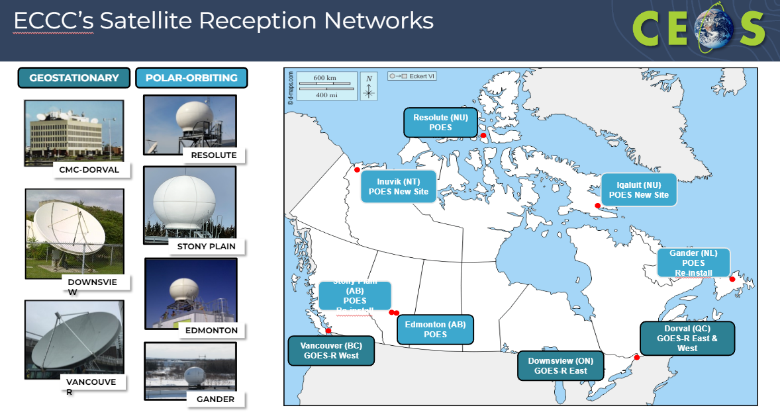
- ECCC is active across the four pillars of Canada’s Strategy for Satellite Earth Observation:
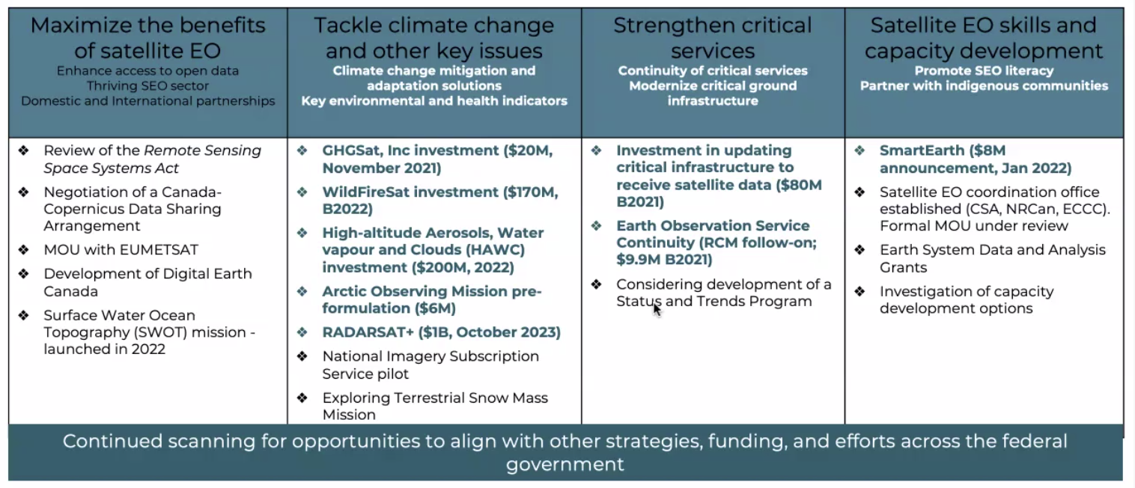
- The Terrestrial Snow Mass Mission (TSMM) is a proposed Ku-band radar mission to inform climate services and improve environmental prediction for snow covered regions. It will address a fundamental observational gap and enhance snow mass information required to safeguard water and food, support economic activities, ensure ecosystem sustainability, and protect Canadians from flood and drought risks. ECCC is the mission lead in partnership with CSA, with strong international collaborations with NASA, EUMETSAT and the Finnish Meteorological Institute. The mission is seeking inclusion in Budget 2024-25.
- Digital Earth Canada (DEC) is a cloud-based analytic environment to federate, process and analyse satellite Earth observation data to support decision-making and spur science, innovation, industry, and academia. DEC is led by CSA, with ECCC as a key collaborator working towards a DEC prototype.
- The Arctic Observing Mission (AOM) is a proposed mission of two satellites in a highly elliptical orbit, delivering new observational capacity on weather, greenhouse gases, air quality and space weather over the North with unprecedented frequency.
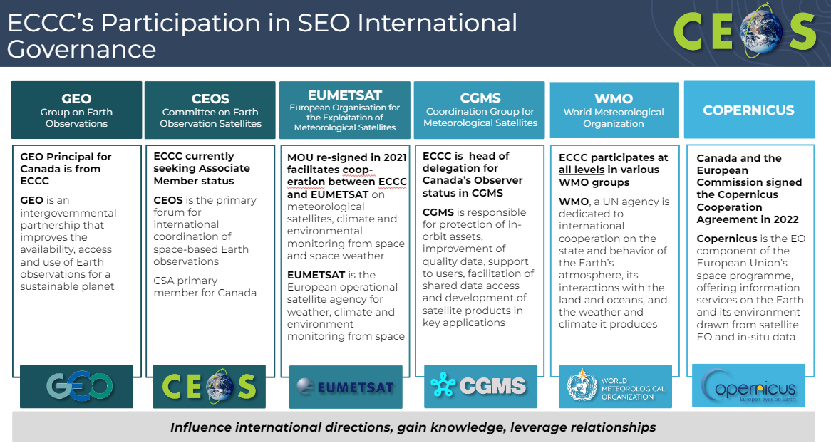
- ECCC is sponsoring one of the Ecosystem Extent Task Team Demonstrators, the results of which will be delivered at the 2024 CEOS Plenary.
- ECCC recognises the value of CEOS membership to:
  - Exchange scientific knowledge between international leaders and share ECCC expertise on environmental monitoring practices using Earth observation with the CEOS community;
  - Complement current Canadian participation in CEOS Working Groups and expert teams;
  - Ensure synergies between ECCC’s role on GEO, CGMS, CEOS and the WMO;
  - Support CSA’s CEOS chairmanship role and the priorities of exploring a post-2024 strategy for CEOS on biodiversity and increasing policy linkages with the biodiversity community;
  - Welcome further collaborations with foreign national space agencies and organisations as Canada’s planned satellite Earth observation missions advance.
David left the meeting while the CEOS Plenary debated the application and discussed the supporting information received.
Discussion
- Éric Laliberté (CSA) noted ECCC is a key driver for Canadian EO missions. Together with CSA and the Canada Centre for Mapping and Earth Observation (CCMEO, already a CEOS member) they form the key partnership for Earth observation in Canada. ECCC is a key department and source of expertise which could be a great contribution to CEOS. He supports their nomination.
- Eric added that while Canadian missions are launched and operated as CSA missions, ECCC works closely at the other end of the chain with the users and scientists.
- NASA, ESA and JAXA also supported ECCC’s nomination to become a CEOS Associate member.
- Pakorn Apaphant (GISTDA, CEOS Chair) added that the CEOS Secretariat reviewed the requirements for CEOS Associate membership and found no issues. He added his view that ECCC will be a great partner for CEOS.
Decision 37-03 | CEOS Plenary endorsed and welcomed Environment and Climate Change Canada (ECCC) as CEOS Associate.

Session 6: CEOS Working Group Reports

6.1: Working Group on Calibration & Validation (WGCV) [slides]
Presenter: Philippe Goryl (ESA, WGCV Chair)
Main points:
- The Terrain Mapping Subgroup (TMSG) is seeking agencies’ support for the new initiative attempting intercomparison of Ground Control Points (GCP) for global harmonisation of orthorectification.
- The Synthetic Aperture Radar (SAR) Subgroup has announced Dirk Geudtner from ESA as its new Chair and Stephane Cote from CSA as Vice Chair.
- The Land Product Validation (LPV) Subgroup is preparing good practices protocols for the following topics: Burned Area, Phenology, Vegetation Index, Land Cover, and Global Downward Radiation Product. Soil moisture has been promoted to Validation Stage 4.
- The Atmospheric Composition Subgroup (ACSG) is seeking agencies’ support for the sustainability of critical Greenhouse Gas cal/val networks, particularly NDACC, TCCON and the COllaborative Carbon Column Observing Network (COCCON).
- Terms of Reference for the new WGCV SITSat (SI-Traceable Satellite) Task Team were endorsed at WGCV-52, with consensus for the group to be a joint initiative with WMO’s Global Space-based Inter-Calibration System (GSICS).
- Ongoing monthly meetings to progress the organisation of the Pre-Flight Calibration workshop, which will be held November 19-21, 2024.
- A Fiducial Reference Measurement Assessment Framework has been published on the CEOS Cal/Val Portal. WGCV members and affiliates will conduct pilot assessments to understand both the suitability of the framework and the status of their sites. Potential assessments include RadCalNet, ICOS, Baqunin, FRM4DOAS, Hypernets, Gobabeb, etc. Results are expected to be presented at the WGCV-53 meeting in March 2024. Additional pilots are welcomed.
- Hyperspectral Cal/Val resources reference is now available on the CEOS Cal/Val Portal.
- In 2022, following results of new satellite missions, particularly the NASA TSIS-1 mission, which provided significantly reduced uncertainty, it was decided to revise the CEOS reference solar irradiance spectrum to that of Coddington et al (2021) https://doi.org/10.1029/2020GL091709 and later to a version 2 which extends the spectral range to thermal infrared in Coddington et al (2023) https://doi.org/10.1029/2022EA002637. This is now the WGCV-endorsed CEOS reference solar irradiance spectrum.
- WGCV contributed to the New Space Task Team’s white paper by providing sections related to calibration, validation, and data quality. Specifically, WGCV identified that CEOS contributions to ‘New Space’ could involve providing methods and protocols for cal/val, access to tools and expertise, and the development of a ‘match-up database’ – comprising coincident satellite data together with Fiducial Reference Measurements (FRM) for radiometry – typically over RadCalNet sites.
- The WGCV-53 meeting will be hosted by CONAE in Córdoba, Argentina from 5-8 March 2024. The WGCV-54 meeting will be hosted by USGS in Sioux Falls, South Dakota, U.S.A., during the Fall of 2024.

6.2: Working Group on Information Systems & Services (WGISS) [slides]
Presenter: Makoto Natsuisaka (JAXA, WGISS Chair) and Tom Sohre (USGS, WGISS Vice Chair)
Main points:
- The CEOS Interoperability Framework Roadmap has been developed following the 2022 CEOS Plenary’s delegation of this activity to WGISS. The Framework components, termed ‘Factors’ have been identified as follows:
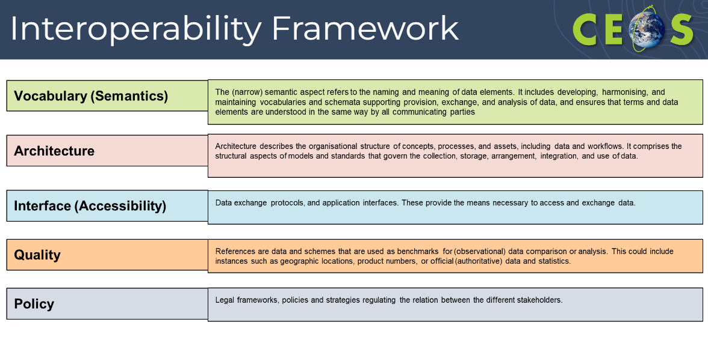
- These Factors have been mapped to existing CEOS Work Plan activities. The purpose is to identify all the activities that are taking place across CEOS which are working towards improved interoperability of Earth observation datasets. Additionally, this is intended to highlight gaps where more work is required to increase interoperability.
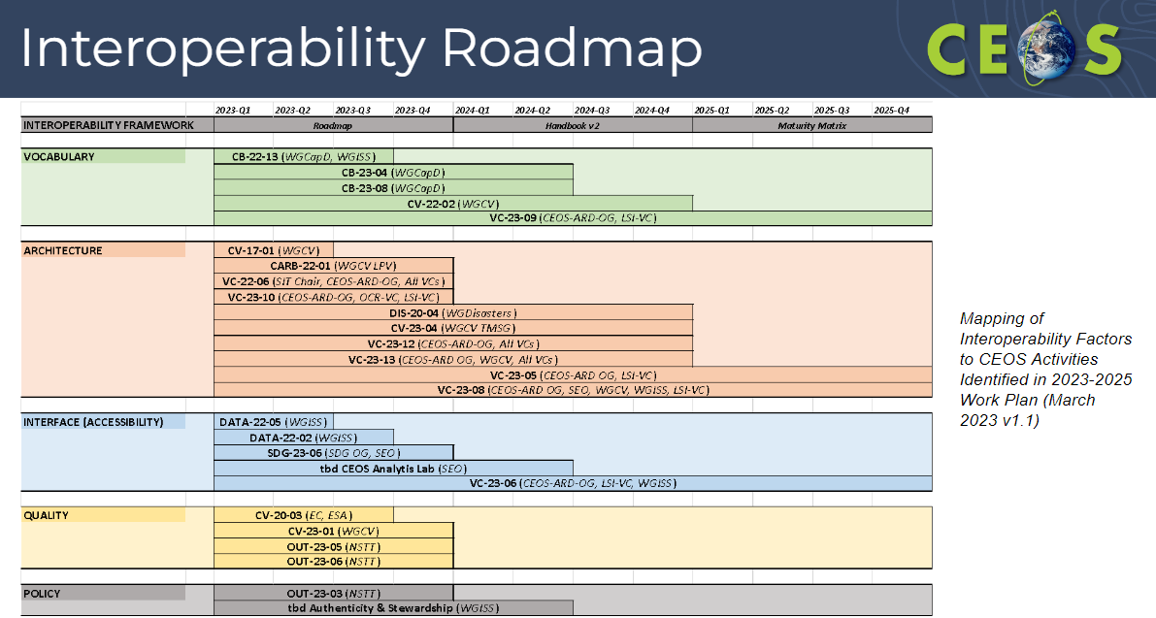
- The next steps for the Interoperability Roadmap include:
  - Appointing Factor champions to guide implementation and creation of a CEOS Interoperability Handbook version 2.0;
  - Developing a matrix that comprehensively relates CEOS activities to each of the Factors;
  - Identifying use cases (Demonstrators) for the Framework and developing a Maturity Matrix to measure improvement and communicate ongoing maturity;
  - Identify gaps and propose new supporting efforts.
- WGISS requested endorsement of the proposed CEOS Interoperability Framework and initial Roadmap.
- The Technology Exploration Interest Group is developing an Artificial Intelligence / Machine Learning white paper scheduled for delivery by Q4 2024. It will focus on practical AI/ML use cases in Earth observations, catering to application developers new to AI/ML for Earth observations. The document will avoid detailed theories or algorithms, considering the abundance of existing resources. The white paper will evolve over time to reflect advancements in AI/ML technologies and services, with potential format changes to Wiki or Git style for easier updates. The initiative will include capacity building aspects with and/or through EOTEC DevNet and others.
- ISRO has nominated Dr. Nitant Dube to serve as WGISS Vice Chair for 2024-25, followed by WGISS Chair in 2026-27. Dr. Dube has participated in WGISS since 2012.
Discussion
- Pakorn Apaphant (GISTDA, CEOS Chair) congratulated and thanked Makoto Natsuisaka (JAXA) for his four years’ service to WGISS as Chair and Vice Chair.
- Steve Labahn (USGS) endorsed the Interoperability Framework and Roadmap. He noted the complexity and challenge the Framework has presented for WGISS and he commended their handling of the task delegated at CEOS Plenary just one year ago.
- Karen St. Germain (NASA) echoed the comments from USGS and endorsed the Interoperability Framework and Roadmap.
- Takeshi Hirabayashi (JAXA) extended his thanks to WGISS for their effort on the Interoperability Framework, highlighting the effective distribution of responsibilities among Working Groups and Virtual Constellations. JAXA will continue to support the Interoperability Framework and assist in the development of the AI/ML white paper. He thanked Makoto Natsuisaka (JAXA) for his hard work and dedication as WGISS Chair and acknowledged the valuable support provided to him by CEOS colleagues. He also welcomed Dr. Nitant Dube (ISRO) as the next WGISS Vice Chair.
Decision 37-04 | The CEOS Interoperability Framework and Roadmap were endorsed. The CEOS Working Group on Information Systems and Services (WGISS) will develop a second version of the CEOS Interoperability Handbook in 2024.
Decision 37-05 | CEOS Plenary endorsed Dr. Nitant Dube of ISRO as WGISS Vice Chair for two years (2024-2025), followed by WGISS Chair for two years (2026-2027).

6.4: Working Group on Disasters (WGDisasters) [slides]
Presenter: Helene De Boissezon (CNES)
Main points:
- Two new activities were put forward for approval:
  - Global Volcano Early Warning and Eruption Response System (G-VEWERS): The CEOS Volcano Pilot (2014–17) and Demonstrator (2019–23) are a blueprint for global volcano monitoring and early warning. WGDisasters proposes the creation of the Global Volcano Early Warning and Eruption Response System (G-VEWERS), a permanent virtual facility for remote volcano monitoring. It will function on biennial renewable quotas like Supersites made possible by best-effort contributions from academic institutions, volcano observatories, and space agencies. The aim is to provide a timely response to hazardous volcanic eruptions, tracking of restless volcanoes and background monitoring of quiescent volcanoes. Operational support will be provided by USGS.
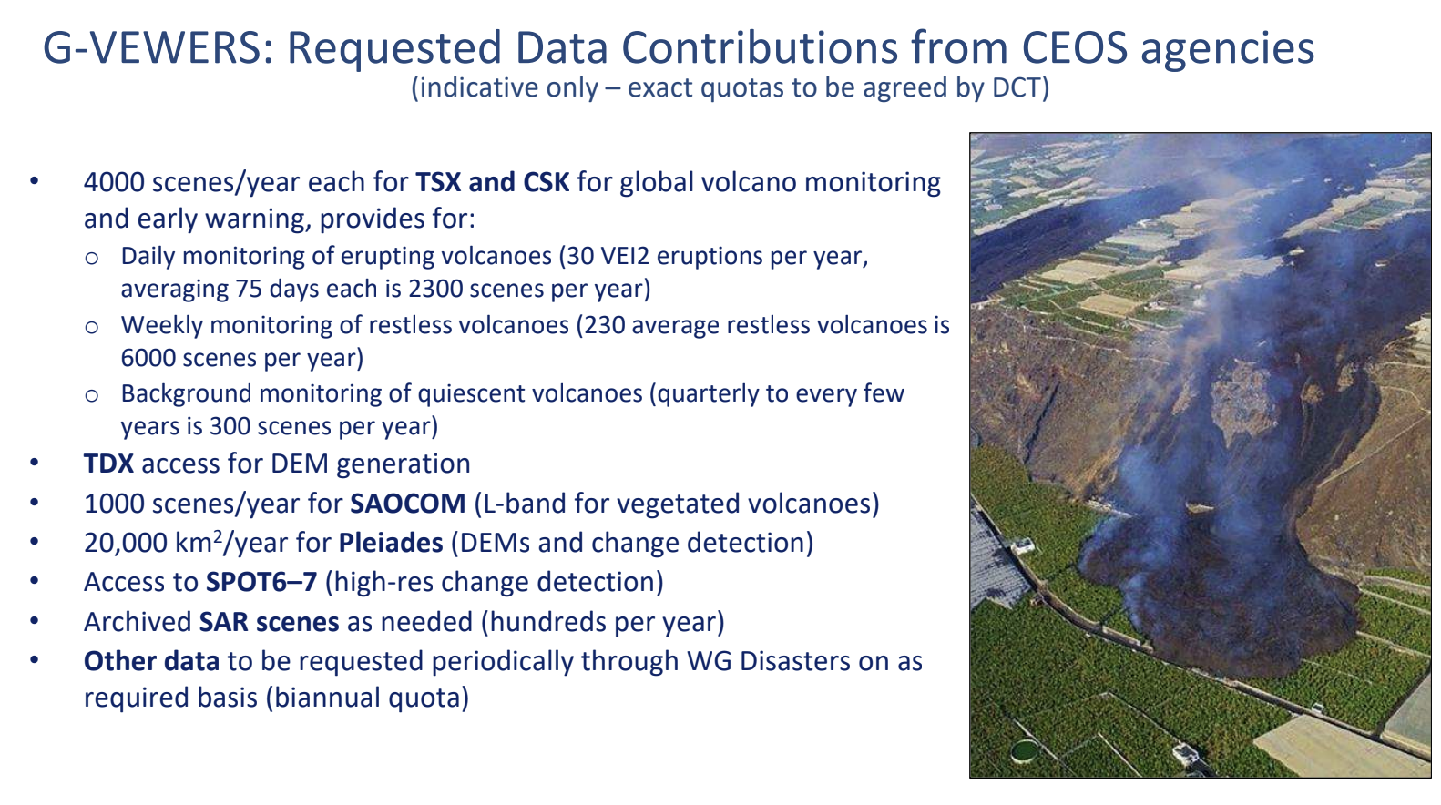
  - Pre-operational Recovery Observatory 2024-2026: Success will depend on strong RO Secretariat and RO Liaison functions (transition by 2025/2026 to recovery stakeholders) and capacity building activities. Propose to establish capacity to provide two to four Recovery Observatories for the next three years beginning in 2024.
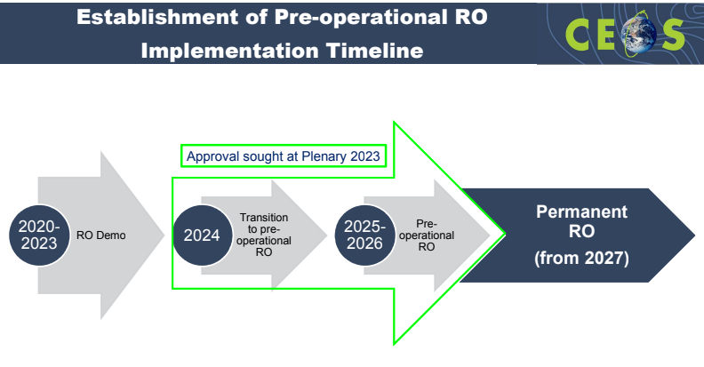
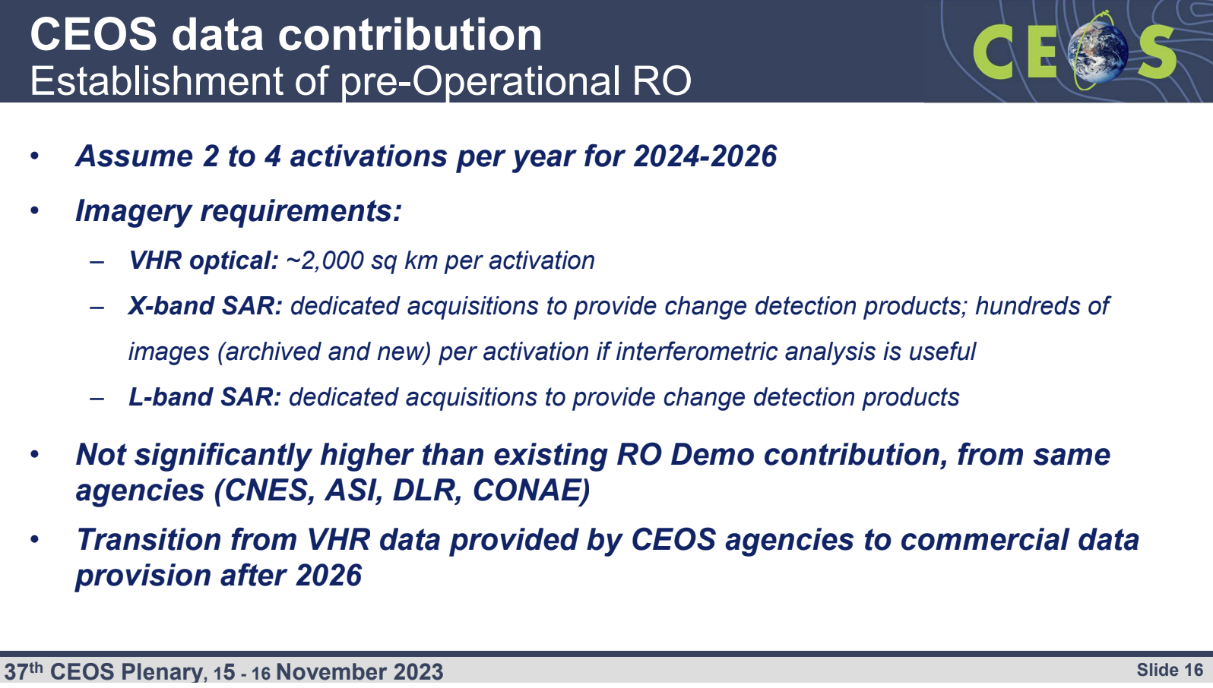
- Use cases for operationalisation of Earth observation at local level for disaster information will be available in December 2023.
- Laura Frulla from CONAE is the incoming WGDisasters Chair. Lôrânt Czârân from UNOOSA is nominated to become WGDisasters Vice Chair for 2024-25, followed by the 2026-27 term as Chair.
Discussion
- Selma Cherchali (CNES) thanked Helene De Boissezon (CNES, WGDisasters Chair) for her efforts and contribution to the disasters community and wished her well for her nearing retirement. CNES supports G-VEWERS and thanks USGS for developing the concept. The Recovery Observatory (RO) is entering a critical phase and CNES will continue to support the implementation of this activity in 2024.
- Ivan Petiteville (ESA) added that Helene has been a great Working Group Chair, providing instrumental support for the RO in particular. He highlighted her dedication to pushing this initiative for many years and emphasised the tangible benefits demonstrated to the end user community, citing a key example for Haiti. Ivan congratulated Helene for her outstanding contributions.
- Ivan recalled that G-VEWERS was initiated by Mike Poland from USGS in 2011/2012, focusing on a subgroup on volcanoes. Ivan commended Mike for his fantastic work on G-VEWERS since that time. Ivan suggested caution regarding use of the word ‘operational’ as it might give the wrong impression. Careful consideration should be made in how G-VEWERS is presented. Ivan confirmed ESA’s support to G-VEWERS.
- Helene noted that G-VEWERS is not an operational service like the International Charter: Space and Major Disasters or the Copernicus Emergency Management Service (CEMS). It provides science products around catastrophic events on a best-efforts basis. Helene added this will be clarified in the documentation, if necessary.
- Laura Candela (ASI) added that ASI will continue to support and participate in both initiatives.
Decision 37-06 | CEOS Plenary endorsed the establishment of the Pre-operational Recovery Observatory to be led by the CEOS Working Group on Disasters (WGDisasters).
Decision 37-07 | CEOS Plenary endorsed the establishment of the G-VEWERS (Global Volcano Early Warning and Eruption Response from Space) initiative to be led by the CEOS Working Group on Disasters (WGDisasters).
Decision 37-08 | CEOS Plenary endorsed Mr. Lôrânt Czârân of UNOOSA as WGDisasters Vice Chair for two years (2024-2025), followed by WGDisasters Chair for two years (2026-2027).
6.3: Working Group on Capacity Building and Data Democracy (WGCapD) [slides]
Presenter: Jorge Del Rio Vera (UNOOSA)
Main points:
- Capacity building and data democracy are important to ensure user uptake, development of Earth observation applications and services, insight-driven decision making, and return on investment.
- Four regional virtual workshops were recently held to identify user needs in different global regions. There is a lack of participation from Asian agencies within WGCapD, and hence struggle to capture user needs for that region.
- Various UN entities shared their needs at the WGCapD-12 meeting, which has been compiled into the document “UN Entities Need Analysis and Tracker“.
- The Earth Observation Training, Education and Capacity Development Network (EOTEC DevNet) is a network of networks, aiming to improve collaboration among Earth observation capacity building providers, foster the exchange of capacity building resources, and to reduce duplication of efforts. More information is available at eotecdev.net.
- The update of the EOTEC DevNet 2023-2025 Strategic Work Plan indicates that 11 tasks have been completed, 8 are currently in progress and 4 tasks have not yet started.
- The sustainability status of EOTEC DevNet is as follows:
  - NASA and Earth observation College (University of Jena) are supporting the Secretariat;
  - A new grant has been secured from Germany for support through 2026;
  - There are plans to seek further funding and collaborations to facilitate further growth;
  - WGCapD is targeting SIT-39 for overall endorsement of the approach by CEOS Principals;
  - The CEOS SEO will support the integration of trackers and calendars into the EOTEC DevNet website.
- Introduced nomination of Julio César Castillo Urdapilleta of Agencia Espacial Mexicana (AEM) as WGCapD Vice Chair for 2024-2025 and WGCapD Chair for 2026-2027.
Discussion
- Pakorn Apaphant (GISTDA, CEOS Chair) welcomed Dan Matsapola from SANSA as the incoming WGCapD Chair.
- Éric Laliberté (CSA) appreciated Jorge’s leadership, acknowledging that WGCapD is gaining visibility beyond CEOS. Eric added that the CSA-NASA joint initiative on indigenous capacity development goes well beyond satellite Earth observation.
- Pakorn Apaphant (GISTDA, CEOS Chair) reported that GISTDA will seek to nominate a representative to WGCapD.
Decision 37-09 | CEOS Plenary endorsed Mr. Julio César Castillo Urdapilleta of AEM as Vice Chair of the Working Group on Capacity Building and Data Democracy (WGCapD) for two years (2024-2025), followed by WGCapD Chair for two years (2026-2027).

Session 7: Group on Earth Observations (GEO) Topics

7.1: Group on Earth Observations (GEO) Secretariat Report
Presenter: Yana Gevorgyan (GEO Secretariat Director)
Main points:
- The GEO Post-2025 strategy was endorsed at GEO Week 2023 in the week of 6 November 2023.
- The GEO Post-2025 strategy aims to capitalise on the collaborative environment built over the past two decades, leveraging all investments to date.
- Recognising the disparity of technical institutions worldwide, the Post-2025 strategy extends beyond just data. It seeks to more closely integrate Earth observation data with socio-economic data.
- The strategy aims to deliver services to user communities, curating fit for purpose data services, and creating new partnerships within GEO.
- Reimagining GEO as a global partnership involves committing to work more closely and systematically by generating participatory action.
- GEO Principals have been asked to provide extra resources to ensure the impact of activities.
- The GEO Secretariat will start working on a community-driven implementation plan, although the specific form is yet to be determined. The timeline accounts for this development and GEO anticipates CEOS agencies will be involved in this process.
- Yana looks forward to working with CSA and JAXA as the incoming CEOS Chair and SIT Chair.

7.2: CEOS Support to GEO Governance and the GEO Work Programme [slides]
Presenter: Marie-Claire Greening (CEOS Executive Officer)
Main points:
- CEOS is a Participating Organisation (PO) to GEO. CEOS and its members provide significant support to GEO at all levels across the GEO Work Programme, including to Flagships, engagement priorities, regional GEOs, GEOSS, etc.
- CEOS has Observer status on the 2023 GEO Executive Committee. CEOS is an elected member of the GEO Programme Board for 2023-2025.
- Strategic aspects for CEOS to consider in 2024 include:
  - General engagement with GEO post-2025:
    - What CEOS expects from GEO.
    - What GEO expects from CEOS.
  - Implications for CEOS from the post-2025 GEO strategic visioning.
  - CEOS engagement in GEO’s post-2025 implementation planning.
Discussion
- Yana Gevorgyan (GEO Secretariat Director) noted that, at present, there is only a very high-level timeline for the development of the GEO Post-2025 Strategy implementation plan. The overall deadline for establishing the implementation plan is April 2025. A detailed timeline will be determined by the GEO Executive Committee (ExCom) in April 2024. A dedicated coordinator will be recruited to develop a detailed timeline.
- Stephen Volz (NOAA) encouraged CEOS to read the Ministerial statement from GEO Week 2023. The statement covers many activities to which CEOS contributes. Given the refocus on actionable information to improve outcomes, Steve highlighted Marie-Claire Greening’s presentation slide on contributions to the GEO Work Programme. CEOS agencies collectively make a significant impact and are an essential element in many of GEO’s activities.
- Simonetta Cheli (ESA, SIT Chair) highlighted the mutually beneficial nature of the GEO-CEOS relationship over the past decades. GEO provides a critical link to user communities outside of those that space agencies typically deal with directly. Simonetta hopes for a continuation of this very useful relationship.
- SANSA noted that the GEO Ministerial Declaration and Post-2025 Strategy have introduced some bold moves and step changes, including the focus on ‘Earth Intelligence’. There is an ongoing dedication to promoting equality. Acknowledging the limited presence of African agencies in CEOS, SANSA expressed the hope to bring more African countries on board to enhance the utilisation of Earth observation.
- Yana emphasised that focus should be on the GEO Work Programme activities and services that generate impact. The Global Ecosystem Atlas and Heat Service are the two newest incubators. Yana acknowledged and recognised the contributions from CEOS agencies to various Work Programme activities.
- Stephen Volz (NOAA) noted the importance of the GEO Week 2023 Youth Summit, which highlighted the need for GEO members to engage the youth in their communities.

Day 2: Thursday, November 16

Session 6: CEOS Working Group Reports (continued)

6.5: CEOS/CGMS Working Group on Climate (WGClimate) [slides]
Presenter: Jeff Privette (NOAA, WGClimate Chair)
Main points:
- The main priorities for WGClimate in 2023 were to: develop Space Agency Response to the GCOS Implementation Plan (SARGIP) (i.e., a stratified delivery plan, with dates of completion varying by Action); develop the Joint CEOS-CGMS Space Agency Statement to the UNFCCC Subsidiary Body for Scientific and Technological Advice (SBSTA) at COP 28; update and restructure the ECV Inventory, and complete the Gap Analysis Report (v3/4.1); and, to complete the climate records definitions taxonomy.
- A new approach to the GCOS IP response was co-developed with the GCOS Secretariat, with a new template for responses, stratified work and delivery schedule based on priorities, launches, etc. There were 21 activities addressed in 2023 with a draft response completed in October 2023. It is currently under review by GCOS Panels and will be submitted to CEOS and CGMS for review in February 2024. The remaining activities will also be addressed in 2024.
- The Joint CEOS-CGMS Space Agency Statement to the UNFCCC Subsidiary Body for Scientific and Technological Advice (SBSTA) at COP28 provides a vehicle to update SBSTA on Earth observation developments, gaps, and needs. The review of the statement was completed in October 2023. The Canadian delegation will submit and read the statement at SBSTA-59 at COP28 and the WGClimate Chair will provide support throughout COP28.
- WGClimate requests CEOS Plenary endorsement of the Joint CEOS-CGMS Space Agency Statement to the UNFCCC Subsidiary Body for Scientific and Technological Advice (SBSTA) at COP28.
- The Merged Gap Analysis Report report is progressing. It covers the 2021 and 2022 analyses of existing and planned Climate Data Records (CDRs), as well as planned space architecture compared against select Essential Climate Variables (ECVs).
Discussion
- Karen St. Germain (NASA) recalled that CGMS was planning to endorse the statement to SBSTA electronically. She asked whether this has already been completed. Jeff confirmed that no comments were received from CGMS Agencies, and hence, the CGMS Secretariat confirmed to WGClimate that the statement was endorsed.
- Karen noted that WGClimate has been investigating the Climate Data Records (CDRs) for a long time. As the list of CDRs grows, and the definitions remain unclear, she asked about the plan to deal with the growing list of variables.
- Jeff responded that WGClimate is not advocating to sustain all the CDRs. The goal is to be able to trace from the observable back to the instrument, and understand what agencies are producing, what they depend on, and being able to show where future gaps exist in mission planning, based on guidance from GCOS. The aim is to make sure that the required space-based observations exist such that CDRs can be produced. WGClimate is working to bring in experts from the CEOS Virtual Constellations to be able to do that thematic analysis. This has already begun with P-VC.
- Éric Laliberté (CSA) asked about the logistics of CSA reading the statement to SBSTA, as the allocated time is only two minutes. Jeff confirmed that this is standard practice, and WGClimate will work with CSA to develop a shorter statement for the verbal presentation. The full statement will be made available online.
- Stephen Volz (NOAA) asked about the use of the terms ‘observation’ and ‘climate variable’ regarding the inventory, noting that continuity of observations does not necessarily imply continuity of the climate variable. How should this be discussed with respect to resource allocation, and criteria for prioritisation? Is this prioritisation work something that WGClimate could undertake?
- Jeff suggested WGClimate work closely with GCOS on this topic. By the nature of ECVs, all are considered essential. However, different variables are more important for different sectors, for example research and academics compared to operational modelling.
- Beth Greenaway (UKSA) asked whether CEOS has considered the ‘elevator pitch’ from CEOS to the SBSTA community. It would be nice to have one sentence that CEOS can deliver to COP28. UKSA will use the topics addressed within the CEOS statement throughout COP28 to strengthen the message.
- Stephen Ward (SIT Chair Team) confirmed that 38 of the 55 ECVs are largely or exclusively measured from space, citing the new edition of the EO Handbook.
Decision 37-10 | CEOS Plenary endorsed the “Joint CEOS-CGMS Space Agency Statement to the UNFCCC Subsidiary Body for Scientific and Technological Advice (SBSTA)” for COP28, occurring on 30 Nov. to 12 Dec. 2023 in Dubai, United Arab Emirates.

CEOS-37-03 | The 2024 CEOS Chair will confer with the WGClimate on the abbreviated version of the Joint CEOS-CGMS Space Agency Statement to the UNFCCC Subsidiary Body for Scientific and Technological Advice (SBSTA) that will be read aloud at COP 28. | COMPLETE

Session 8: CEOS Virtual Constellation Updates

8.1: Virtual Constellation Synthesis Report [slides]
Presenter: Ivan Petiteville (ESA SIT Chair Team)
Main points:
Atmospheric Composition (AC-VC)
- The AC-VC-19 meeting was held 24-27 October 2023 in Brussels. It was a joint meeting with the WGCV Atmospheric Composition Sub-Group (ACSG). The discussions covered GHGs, trace gases and aerosols, air quality, and cal/val.
- The PM2.5 White Paper was endorsed at the 2022 CEOS Plenary. The follow-on roadmap is in preparation to address the recommendations made in the white paper. The final version of the roadmap is expected by mid-2024.
- AC-VC is contributing to the GHG Roadmap by leading the ‘sensor development’ actions.
Land Surface Imaging (LSI-VC)
- The CEOS-ARD for SAR combined Product Family Specification (PFS) was endorsed at LSI-VC-14 in October 2023. It includes new specifications for Geocoded Single Look Complex (GSLC) products and incorporates all previously endorsed SAR specifications.
- LSI-VC has maintained strong engagement with the Open Geospatial Consortium ARD Standards Working Group.
- LSI-VC is working with OCR-VC to expand the Aquatic Reflectance PFS beyond inland waters and coastal regions to cover the ocean domain.
- Four new CEOS-ARD land products were successfully assessed as compliant over the last year. Several others are in development and WGCV peer review. The latest table of CEOS-ARD datasets can be found here.
- LSI-VC has continued their industry engagement on the topic of CEOS-ARD through VH-RODA, JACIE, the ARD23 Workshop, IGARSS and BiDS.
- LSI-VC has been heavily involved in WGISS CEOS Interoperability Framework and Roadmap and STAC efforts and the New Space Task Team (NSTT).
- The LSI-VC Forests and Biomass Subgroup leads the CEOS AFOLU Roadmap, which was presented and endorsed by CEOS Plenary on November 15, 2023.
- A new Surface Reflectance Quality, Equivalency and Consistency project, led by Geoscience Australia is being explored in LSI-VC.
- At the request of WGClimate, LSI-VC is working to understand the state of Land Surface Temperature datasets for Climate Data Records.
- The ESA PolInSAR workshop produced several recommendations, a few of which were brought to the attention of the LSI-VC and discussed at LSI-VC-14.
- LSI-VC is working with its GEOGLAM subgroup to respond to the Essential Agriculture Variables (EAVs).
Ocean Colour Radiometry (OCR-VC)
- OCR-VC is preparing to develop an Aquatic Carbon Roadmap, which was presented and endorsed by CEOS Plenary on November 15, 2023.
- LSI-VC and OCR-VC are working together to extend the Aquatic Reflectance PFS to oceans by creating one harmonised specification for inland, coastal, and open waters.
Ocean Surface Topography (OST-VC)
- SWOT successfully launched last November. The mission is going well, with the data validation phase to end by spring 2024. Public pre-validated data will be released by the end of 2023.
- OST-VC is working on their white paper ‘A Coordinated International Satellite Altimetry Virtual Constellation: Toward 2050’. A dedicated side meeting will be held during the OSTST meeting in November 2023 to consolidate the current version. A final version is targeted for completion in Q2 2024.
Ocean Surface Vector Winds (OSVW-VC)
- Oceansat-3 launched on 26 November 2022. ISRO is working on the integration of data into the constellation. A data release for cal/val purposes will commence soon. The data is matching well with that from Scatsat-1 and ASCAT. Data will soon be released to the public, with Level 1 data planned for release to others in the Virtual Constellation soon.
Precipitation (P-VC)
- P-VC’s Terms of Reference will be updated. The VC is targeting endorsement of an updated Terms of Reference at SIT-39 in April 2024.
- A Product Family Specification (PFS) for a CEOS-ARD precipitation product is under preparation.
- GPM Core’s orbit was raised on 8 November 2023, which should keep the satellite in orbit to allow a service overlap with the JAXA Precipitation Measuring Mission (PMM), launching no earlier than 2029.
- NASA, JAXA, NOAA and EUMETSAT have produced new or updated global precipitation products (see slides).
Sea Surface Temperature (SST-VC)
- A Group for High Resolution Sea Surface Temperature (GHRSST) Science Team meeting was held at IGARSS 2023.
- SANSA and ESA are working together to determine how coastal SST data supports carbon flux measurements.
- Ed Armstrong (NASA/JPL) will be replaced as co-lead by Masako Kachi (JAXA) in December.
CEOS Thematic Observation Coordination
- Ivan recalled the page ceos.org/observations which highlights thematic strategy documents produced by various CEOS entities, including the Virtual Constellations. CEOS entities were asked to provide the SIT Chair with any updates.
Discussion
- Tanita Suepa (GISTDA, CEOS Chair Team) thanked Ivan for his valuable contributions to CEOS over many years.
CEOS-37-04 | The Precipitation Virtual Constellation (P-VC) Leads were tasked with developing and presenting updated P-VC Terms of Reference for review and potential endorsement at SIT-39. | SIT-39
CEOS-37-05 | All CEOS Working Group Chairs and Virtual Constellation Co-leads were asked to review their key documents featured on ceos.org/observations and provide updates to the SIT Chair Team. | SIT-39

Session 9: Biodiversity

9.1: Ecosystem Extent Task Team [slides]
Presenter: Gary Geller (NASA/JPL)
Main points:
- Ecosystem Extent is identified as an Essential Biodiversity Variable (EBV) and as a headline indicator in the Convention on Biological Diversity’s Kunming-Montreal Global Biodiversity Framework (GBF); CBD Parties must report on headline indicators.
- The main purpose of the Ecosystem Extent Task Team (EETT) was to assess and report on the utility for mapping Ecosystem Extent using current and forthcoming space-based observations.
- The team has two key objectives: the development of a white paper that will provide an integrated international perspective on how space-based Earth observations can be used to support ecosystem mapping and monitoring with a focus on ecosystem extent; and to explore and propose an initiative to demonstrate the use of EO for ecosystem extent mapping and monitoring.
- To develop the white paper, the co-leads had to look beyond CEOS Agency staff to gather the necessary expertise, as most agencies do not have dedicated biodiversity experts on staff.
- The paper explains the value of EO for ecosystem extent, targeted at CEOS Principals and members of the biodiversity community (such as CBD and its Parties) and the United Nations System of Environmental-Economic Accounting (UNSEEA)).
- A more scientific focused journal paper is planned to follow on from the white paper.
- Combining data for different sensor types presents both opportunities and challenges, as does time series analysis.
- Other opportunities identified include the use of hyperspectral data, integration of artificial intelligence and machine learning techniques, and application of Data Cube platforms.
- Challenges identified include the limited availability of value-added products, EO data usability and the technical capacity of users, and assessing ecosystem condition.
- The full recommendations presented in the white paper are as follows:
User Engagement | 1a. Identify specific user requirements to guide EO and identify products needed for ecosystem extent.  1b. Establish a sustainable communication channel between CEOS and user communities for continued interaction.  1c. Improve CEOS understanding of technological, socio-political, and cultural constraints for the biodiversity community to use EO data.
Technical Advances | 2a. For each ecosystem, identify the key EO datasets and processing methods needed for its delineation.  2b. Facilitate combining data from different types of sensors to take advantage of their complementarity.  2c. Facilitate time series analysis and its application to ecosystem extent mapping.  2d. Explore ways to utilise EO to characterise ecosystem condition and its relationship to ecosystem extent.
Capacity | 3. Identify opportunities for capacity development resources, e.g., a training or a Massive Open Online Course (MOOC) focused on the use of EO for ecosystem mapping and monitoring.
- Principals were asked to endorse the EETT White Paper.
Discussion
- Alex Held (CSIRO) supported and endorsed the white paper. CSIRO supports Shaun Levick’s contribution to the team as a co-lead and hopes to support this activity as it continues over the next stages. CSIRO is also keen to support the multi-sensor aspects of this work.
- Selma Cherchali (CNES) thanked the task team for their achievements in such a short time. CNES is dedicated to support the biodiversity activity at a CEOS level, as well as on a national level. Selma thanked Sandra Luque for her efforts in co-leading the team, and the EETT for their efforts.
- Beth Greenaway (UKSA) endorsed the white paper. This topic is very important to the UK. The UK Department of Environment signalled support for the GEO Ecosystem Atlas at GEO Week 2023. Beth hopes the activities in CEOS and GEO can be complementary.
- Simonetta Cheli (ESA, SIT Chair) thanked the team and endorsed the white paper. Biodiversity is increasingly discussed at a political level in Europe, following the adoption of the Kunming-Montreal Global Biodiversity Framework in 2022.
- Stephen Volz (NOAA) endorsed the white paper. He reinforced the comment from UKSA regarding coordination with the GEO Ecosystem Atlas. It is also important to expand this work to oceans and coasts, which would be a useful development direction and provide more scope for NOAA contributions.
- Takeshi Hirabayashi (JAXA, SIT Vice Chair) endorsed the white paper. Biodiversity encompasses several challenges and opportunities, and this white paper is an important guide.
- Steve Labahn (USGS) endorsed the white paper and thanked the team for their efforts. Roger Sayre is supported by USGS to continue co-leading this work and engaging with CEOS on the broader biodiversity topic.
- Eric Laliberté (CSA) noted that CSA hosted a CEOS Plenary side meeting on November 14 to discuss how the broader topic of CEOS and biodiversity moves forward. Many of the recommendations in the white paper are already being considered for CSA’s priorities as CEOS Chair in 2024. CSA endorsed the white paper and recommendations and looks forward to taking the topic forward. Eric thanked the Task Team for their work, noting the strong engagement of the four co-leads. This is clearly a priority topic for CEOS Agencies.
Decision 37-11 | CEOS Plenary endorsed the Ecosystem Extent Task Team white paper and recommendations.

9.2: Overview of the Ecosystem Extent Task Team Demonstrator Effort [slides]
Presenter: Gary Geller (NASA/JPL)
Main points:
- The objective is to demonstrate use of EO for ecosystem extent mapping and monitoring. The goal is to deliver the outcomes at CEOS Plenary 2024.
- The three identified demonstrator opportunities include: Hudson’s Bay Lowlands, coordinated by Jason Duffe (Environment and Climate Change Canada, ECCC); Costa Rica, coordinated by Sandra Luque (CNES/INRAE); and the Australian Great Western Woodlands, coordinated by Shaun Levick and a newly hired postdoc to lead this project (CSIRO).
- All three demonstrators are designed around the application of Data Cubes, which will be used to combine data from different sensors. The demonstrators will continue beyond the planned lifetime of the EETT and will provide a ‘running start’ for any future biodiversity activities within CEOS.
Discussion
- Pakorn Apaphant (GISTDA, CEOS Chair) noted that GISTDA is interested in providing a demonstrator in Thailand as well and would like to connect with the EETT Co-leads to explore possibilities.
- Ivan Petiteville (ESA, SIT Chair Team) recognised that various activities developed across CEOS are likely to come together in support of these applications, including CEOS-ARD, Open Data Cube, and the CEOS Interoperability Framework. These demonstrations will also support further development of these initiatives.
- Sandra Luque (CNES/INRAE) noted that UN CBD targets protection of 30 percent of all coastal and inland waters, and CEOS has a unique role to play in achieving this goal. Any additional demonstrators will help show what other sensors can do for different ecosystem types. The Task Team would like to work together with other CEOS groups, including COAST, to help determine ecosystem function.
- Éric Laliberté (CSA) noted there is a clear need for CEOS in this domain.
CEOS-37-06 | CEOS Agencies that are interested in contributing a Demonstrator for the Ecosystem Extent mapping activity were asked to coordinate with the CEOS Ecosystem Extent Task Team Leads. | SIT-39

Session 10: Oceans and Coasts
Charles Wooldridge (NOAA) introduced the session. At the 2022 SIT Technical Workshop, the Ocean Coordination Group (OCG) was tasked with preparing a series of recommendations on coordination of ocean-related activities in CEOS, to support the United Nations Decade of Ocean Science for Sustainable Development (2021-2030) and the first UNFCCC Global Stocktake. This required considering links to existing CEOS entities as well as considering sustainability. The OCG mandate was extended by a year to complete its work. The team was originally led by the SIT Chair Team (Ivan Petiteville), until the 2022 CEOS Plenary, at which time the SIT chair delegated its leadership to NOAA (Paul DiGiacomo).

10.1: CEOS Ocean Coordination Group (OCG) [slides]
Presenter: Katy Matthews (NOAA)
Main points:
- Katy presented on behalf of Paul DiGiacomo and Merrie Beth Neely, who led the work over the last year.
- The OCG was established with the goal to support the United Nations Decade of Ocean Science for Sustainable Development 2021-2030.
- New missions including CIMR (Copernicus Imaging Microwave Radiometer), PACE (Plankton, Aerosol, Cloud, ocean Ecosystem), GLIMR (Geosynchronous Littoral Imaging & Monitoring Radiometer) and SWOT (Surface Water and Ocean Topography) are relevant. One of the two deliverables is a spreadsheet that compiles details of all these upcoming new missions and provides details of necessary coordination (Needs Assessment for Ocean Coordination Activities for Upcoming Satellite Missions).
- The second deliverable is a spreadsheet of CEOS activities that support the UN Decade and the Global Stocktake (List of IOC and Ocean Decade planned deliverables from CEOS VCs/WGs/Ad-Hoc Teams)
- Based on discussions this past year, the group recommends to CEOS Plenary that the work of the OCG is complete with the delivery of these two outputs and the group should now be dissolved.
- The team did look at the viability of a new dedicated CEOS ocean coordination entity but concluded that this role should be covered by existing CEOS constructs, e.g., the ocean VCs. The exception was in coasts, which will be covered in the next agenda item, with a proposal for a COAST Virtual Constellation.
Discussion
- Karen St. Germain (NASA) recognised the deliverables are excellent and concurred with the recommendation to conclude the group’s activities.
- Simonetta Cheli (ESA, SIT Chair) thanked NOAA and all who contributed to the work. The deliverables are a great summary of CEOS work in the ocean domain, and ESA agrees the group should now be closed.
- Pakorn Apaphant (GISTDA, CEOS Chair) thanked NOAA and the OCG for their great work.
Decision 37-12 | Following delivery of the two documents:  - Needs Assessment for Ocean Coordination Activities for Upcoming Satellite Missions;  - List of IOC and Ocean Decade Planned Deliverables from CEOS VCs/WGs/Ad Hoc Teams.  CEOS Plenary agreed to disband the CEOS Ocean Coordination Group after accepting the Group’s list of recommended deliverables for CEOS to better coordinate its ocean activities with its existing entities.

Session moderator, Charles Wooldridge (NOAA), provided some context for the following item. The COAST Ad Hoc Team (COAST-AHT) was extended for another year at the 2022 CEOS Plenary. Based on the work that has taken place over the last year with the Ocean Coordination Group, and the continuing work of the COAST AHT, CEOS Plenary is asked to consider the initial proposal for transition of COAST to a Virtual Constellation, with a full proposal, including Terms of Reference and an Implementation Plan to follow at SIT-39 in April 2024.

10.2: Coastal Observations Applications Services and Tools (COAST) Ad Hoc Team [slides]
Presenter: Stephen Volz (NOAA)
Main points:
- The term of the COAST-AHT ends at the 2023 CEOS Plenary. The major outcomes to date include:
  - Release of an application knowledge hub and COAST developed or enhanced products, including:
    - Geoscience Australia shoreline mapping/NOAA Coastline Evolution.
    - ESA physical oceanography products for coastal regions.
    - NOAA & ISRO flooding products.
  - Other products in development include the habitat suitability index, shallow water bathymetry, hypoxia, coastal eutrophication and suspended particulate matter.
  - Stakeholder Engagement Events and Co-Design.
  - Successful use of the CEOS Analytics Lab (previously EAIL) for the Chesapeake Bay Pilot.
- The COAST-AHT is proposing a transition of their activities to a Virtual Constellation (COAST-VC) due to the broad support for continuation of COAST activities beyond the procedural end of the AHT term. Briefings to the CEOS Secretariat and SIT Technical Workshop have shown support for this plan.
- Since the coastal zone is the boundary region between land and ocean activities, it does not neatly fit within a single existing entity. It is recognised that a COAST-VC would need to be complementary with existing activities in other Virtual Constellations and Working Groups, recognising this boundary area nature.
- The COAST-AHT have consulted with all coastal-related Virtual Constellations and Working Groups, who noted the need to avoid overlaps and duplication of effort. The incoming SIT Chair was also briefed following these consultations. It is expected this can be addressed in the development of the Terms of Reference for the full proposal that will be presented at the SIT-39 meeting.
- The future potential activities could include:
  - Finish products in development and advance new ones, including coastal blue carbon/habitat mapping, shoreline (with UKSA, VNSC) and new polar pilot region.
  - Stakeholder engagement events and co-design in new pilot regions.
  - Further utilise the CEOS Analytics Lab to the extent enabled by the CEOS Systems Engineering Office (SEO).
- Both NOAA and ISRO have indicated interest in continuing to lead the VC through the transition and first round of leadership. The group is hoping to find a third co-lead. No commitments have been made, but there have been expressions of interest from several CEOS Agencies.
- The COAST-AHT requested approval for the submitted White Paper and Draft Terms of Reference documents for the COAST-VC. Input and feedback from the CEOS Principals are sought on this proposal at a high level.
- Consistent with guidance in the CEOS Virtual Constellation Process Paper, COAST will draft and submit a final Terms of Reference and Implementation Plan in time for decision at the SIT-39 meeting in April 2024.
Discussion
- Charles Wooldridge (NOAA) thanked ISRO for their support in this work. The proposed decision will require that the COAST-AHT be extended for around six more months (until SIT-39) to develop the required documentation.
- Éric Laliberté (CSA) strongly supports the proposal and the use of the VC structure. CSA would like to identify participants for the proposed Virtual Constellation and will aim to provide names to the COAST-AHT co-leads shortly.
- Mauro Facchini (European Commission) noted this is an interesting evolution, to address the cross-roads between oceans and land. EU member states have recently undertaken a similar activity to bridge the gap. Mauro offered to connect the relevant CEOS and European Commission colleagues on this topic.
- Selma Cherchali (CNES) supports the initiative, however noted concern regarding the use of the Virtual Constellation construct for this activity. It will be very important to clarify the complementarity between other Virtual Constellations, particularly on product affiliation. For example, SWOT is in the core of the OST-VC, including coastal sea surface topography. There is a specific need to address which products will belong to each constellation. Within WGClimate, there are also some projects dedicated to coastal regions.
- Stephen Volz (NOAA) thanked the European Commission for the offer to connect the CEOS COAST team with the Copernicus coastal initiative. Regarding the comment by CNES, he noted that many observations can map across different areas of responsibility, for example lake area as mapped by SWOT could be defined as under the responsibility of LSI-VC. Rather than defining responsibilities, NOAA would like to focus on awareness and integration across regimes. The objective of the COAST-VC is to apply products to a particular domain, not take full responsibility for the products. NOAA will ensure the COAST-AHT addresses the issues highlighted by CNES in the documents for SIT-39.
- Karen St. Germain (NASA) noted that NASA is in favour of COAST transitioning to a Virtual Constellation, subject to the path laid out. Karen thanked NOAA and ISRO for leading the effort.
- Takeshi Hirabayashi (JAXA, SIT Vice Chair) supported the proposal. As incoming SIT Chair, JAXA will continue to discuss with the COAST-AHT co-leads to prepare the discussion at SIT-39.
- Alex Held (CSIRO) noted that he supports this work. Australian agencies have long prioritised coastline studies and activities. The topic also aligns well with the AquaWatch Australia program, which has a strong coastal component, including for ecosystem monitoring. CSIRO is also looking to support the Pacific region as well and is open to discussing future collaborations in the region to support this work.
- Simonetta Cheli (ESA, SIT Chair) recognised the good progress made on this topic, however noted there are still some decisions to be made as to what work will be undertaken by a new COAST-VC. ESA is not entirely convinced that another Virtual Constellation is necessary, noting the need to not complicate the organisational structure. It will be good to take another six months to carefully prepare the proposal.
- Phil Evans (EUMETSAT) supported the proposal, noting the work is interesting and potentially very valuable. Clarity and ownership must be the focus of the proposal that will be developed over the next six months.
CEOS-37-07 | Consistent with the CEOS Virtual Constellations Process Paper (Section 5), the CEOS COAST Ad Hoc Team Co-leads were tasked to develop a Full Proposal for a new COAST Virtual Constellation, including Terms of Reference and an Implementation Plan, in time for consideration and decision at the April 2024 SIT-39 meeting. | SIT-39

Decision 37-13 | CEOS Plenary accepted the CEOS Coastal Observations Applications Services and Tools (COAST) Ad Hoc Team’s Initial Proposal to transition to a COAST Virtual Constellation and agreed to extend the Ad Hoc Team through to SIT-39 to prepare the necessary documentation to support a SIT-39 decision regarding the proposed transition.

Session 11: Other Business

11.1: CEOS Systems Engineering Office (SEO) Annual Report [slides]
Presenter: David Borges (SEO, NASA)
Main points:
CEOS Communications Strategy
- The new CEOS Communications Strategy, if endorsed, should be shared with communications staff at CEOS Agencies for their review and action. Collaboration with agencies’ communications departments is important, as it allows CEOS to greatly amplify its messages.
- The CEOS Communications Strategy document outlines the various stakeholders in CEOS communications – i.e., groups that communication materials should be targeted towards. The stakeholders are broken into internal and external stakeholders, recognising the methods to target each group can vary significantly.
- The strategy outlines three campaigns to be conducted over 2024-25, in line with CEOS Chair and SIT Chair priorities. The idea is to create a series of materials covering these topics. The proposed themes are the 40th Anniversary of CEOS, EO for Biodiversity (supporting CSA’s CEOS Chair priority), and Greenhouse Gas Observations from Space (supporting the JAXA SIT Chair priority).
- The SEO is responsible for publishing all CEOS communications content. The SEO will rely on CEOS community liaisons, who are volunteers from across the CEOS community to provide light support where possible. The current volunteers are Katy Matthews (NOAA), Chris Barnes (USGS), Flora Kerblat (CSIRO), Lucie Viciano (CSA) and Marie-Claire Greening (ESA, CEO). More nominations are welcome.
- CEOS Agency communications staff play a role in cross-promoting relevant content, and dedicated points of contact should be provided to the SEO if possible.
- CEOS entities, such as Working Groups and Virtual Constellations, are expected to contribute at least one communication piece each year, to help promote their work and CEOS.
- A summary of outcomes from GLOC2023 was presented at GEO Week 2023, where one of the key recommendations was improved communications.
Discussion
- Karen St. Germain (NASA) endorsed the strategy, recognising that it is an effective strategy that can be connected to all the resources available within CEOS Agencies.
- Éric Laliberté (CSA) endorsed the strategy. It is very important that CEOS have a collective view as well as common messaging. Joëlle Meyers, CSA communications expert, will be able to support the CEOS communications efforts.
- Stephen Volz (NOAA) agreed that better and more integration is needed. Another observation from GLOC2023 was that the community doesn’t need more scientists to explain the science, but rather needs more effective communications. CEOS is an essential partner that Agencies should be coordinating with.
- Selma Cherchali (CNES) endorsed the strategy and agreed with the comments from NOAA.
- Beth Greenaway (UKSA) endorsed the strategy and asked CEOS to focus on the ‘people’ aspect of CEOS. CEOS has been collaborating for 40 years and should showcase the effective collaboration for the greater good.
- Simonetta Cheli (ESA, SIT Chair) endorsed the strategy and will support promotion of the 40th anniversary of CEOS. Internally, ESA is learning about how to increase collaboration in communications to strengthen the narrative to explain the benefits of EO.
- Pakorn Apaphant (GISTDA, CEOS Chair) endorsed the Strategy and encouraged all members to support the SEO with CEOS communications efforts.
Decision 37-14 | CEOS Plenary endorsed the 2023 CEOS Communications Strategy.
Sustainable Development Goals (SDG) Coordination Group
- CEOS, through its SDG Coordination Group received one of the 2023 GEO SDG Awards (‘GEO Participating Organization’ category) at GEO Week 2023, recognizing its significant achievement over the last five years (e.g. promotion of the value of satellite data, useful materials, and technical user guides to increase data access and uptake).
- There has been good progress on all SDG Deliverables in the CEOS Work Plan, with the SDG support sheets undergoing a revision in 2023 (3 complete, and the 15.3.1 sheet is postponed to align with the current UNCCD/GEO LDN methods review).
- The SEO has created an Open Data Cube examples notebook for SDG applications, which can be found here.
- For 2024, the team is considering further work on the following topics:
  - Annual review of the four EO SDG Indicator Support Sheets.
  - UNCCD Land Degradation Neutrality (LDN) Good Practice Guidance (GPG).
  - SDG capacity building support with WGCapD.
  - Additional communications material / outreach.
  - Biodiversity activity, possibly with the Ecosystem Extent Task Team.
  - Further engagement with UN-GGIM IAEG-SDGs WG Geospatial Information (WGGI), including on the proposed “Rescuing the SDGs” paper.
  - Joint deliverables with ongoing WG/VC activities.
  - Identification of additional SDG Targets and/or Indicators for CEOS to support.
GEO Pacific Islands Advisory Group / Digital Earth Pacific Updates
- The GEO Pacific Islands Advisory Group (PIAG) is an advisory body to the GEO Secretariat on Pacific activities, created in 2020 following the Canberra GEO Ministerial Summit in 2019.
- The PIAG is co-led by Australia (CSIRO/GA), France (New Caledonia), China and SPC (Pacific Community), who co-organised the Oceania Geospatial Symposium (OGS) in New Caledonia in late 2022. A joint session of OGS and CEOS Plenary 2022 was held to connect CEOS Agencies to end-users in the Pacific region. Work is ongoing (PIAG supported SPC and SPREP to design and distribute a satellite data needs survey in 2023) through the CEOS Executive Officer and SEO to collate a formal request from PIAG to CEOS Agencies.
- Digital Earth Pacific (DE Pacific) is led by SPC (Pacific Community), with the official launch planned for November 2023. The CEOS SEO is serving on their new Advisory Committee.
Other SEO Activities
- The SEO has built upon the CEOS Earth Analytics Interoperability Lab (EAIL) to develop the CEOS Analytics Lab (CAL). The platform is open for all CEOS entities to use for collaborative working at the technical level, responding to a multi-year need for this type of resource. The platform is available at ceos.org/cal.
- The SEO will represent CEOS on the GEO Infrastructure Development Task Team (GIDTT).
- The SEO continues to engage with the Open Data Cube (ODC) community, including initiatives like Digital Earth Africa and Digital Earth Pacific.
- Recently, some new commercial missions and access to STAC data have been included in COVE (the CEOS Visualisation Environment).
- The SEO is engaged in CEOS-ARD and working to ensure broad community engagement in the Open Geospatial Consortium’s Analysis Ready Data Standards Working Group.
- The SEO is undertaking studies related to night-time lights occlusion, which will provide input for the refinement of the related CEOS-ARD Product Family Specification (PFS) and potentially other PFS.
- A query capability like ChatGPT for CEOS materials is under consideration by the SEO, to better locate content within the many CEOS documents and online resources.
- The SEO hosts exhibition booths at important international events, with the most recent one being at GEO Week 2023.
Discussion
- Jonathon Ross (GA) thanked the SEO for their ongoing support to all these areas. The Pacific is a key priority area for Australia, as Australia is part of that community. There is a significant risk in the Pacific related to climate change. The region appreciates the CEOS support and ongoing work. Clarity around user needs will help CEOS understand what is needed to make satellite EO work better for island nations as they seek to mitigate and adapt to a variety of challenges.
- Pakorn Apaphant (GISTDA, CEOS Chair) recognised that the SEO plays a key integrating and connecting role across CEOS, and congratulated David for his first year as lead of the SEO.

11.2: CEOS Missions, Instruments and Measurements (MIM) Database Report [slides]
Presenter: Ivan Petiteville (ESA)
Main points:
- The CEOS MIM Database serves as a cornerstone of all CEOS coordination and planning, with its origins dating back to the first CEOS EO Handbook in 1992 and the WMO database in the mid-90s, initiated by Don Hinsman.
- ESA plays a significant role by providing the database and the Handbook as an ongoing key contribution to CEOS. An annual survey process is in place to keep the information up to date.
- Out of the 41 agencies surveyed, there were 32 responses, accounting for a 78% response rate, with 26 of those agencies providing updates. However, there are still nine agencies who did not respond.
- Since 2021, the quarterly update reports have been published. An archive can be found here.
- Coordination is ongoing with WMO’s OSCAR/Space database to enhance compatibility and complementarity of interfaces. This has extended to linkages with ESA’s EO Portal, as well as NORAD IDs and UCS database integration.
- Some non-CEOS missions have been included in the database for certain applications such as the CEOS Greenhouse Gas Portal, although the missions are not visible on the public-facing main database website. There is scope to accommodate commercial missions for other specific applications as required.
- User growth has increased over 100% year-on-year.
- The team is planning to refresh the visual interface during 2024.
- The possibility of creating CEOS team pages, like the GHG Portal, is under consideration.
- A consultation process is planned for 2024, but feedback is always welcome at any time here.
Discussion
- Simonetta Cheli (ESA) thanked CEOS Agencies for their contributions to the MIM Database and recognised the effort required. Adding complementary commercial missions will further enhance the power of the MIM Database.
- Stephen Volz (NOAA) thanked ESA for this valuable contribution to CEOS, and suggested the team consider adding space weather capabilities to the MIM Database.
- Pakorn Apaphant (GISTDA, CEOS Chair) thanked ESA for supporting this valuable resource, which provides an important overview capability.

11.3: 2023 CEOS Earth Observation Handbook: Space Data for the Global Stocktake [slides]
Presenter: Simonetta Cheli (ESA, SIT Chair) and Stephen Ward (SIT Chair Team)
Main points:
- The CEOS EO Handbook and the underlying database were first produced in 1992 for the Rio Summit. The Handbook is used to promote CEOS work and the benefits of satellite Earth observations in support of major policy-related events.
- Recognising the opportunity of the first UNFCCC Global Stocktake (GST), ESA agreed to develop a new edition to coincide with COP28 in late 2023.
- The 2023 edition is titled “Space Data for the Global Stocktake”, and features a foreword by Simonetta Cheli (ESA, SIT Chair) and Simon Stiell (Executive Secretary of UNFCCC).
- The goal of the Handbook is to develop a broader understanding of the fundamental importance of satellite EO to the information needed to inform all aspects of the Paris Agreement and demonstrate the potential of EO to contribute to country reporting on Nationally Determined Contributions (NDCs) for the second Global Stocktake in 2028, including key user stories as inspiration and encouragement. Suggestions for Parties on where to get help on using EO data are also included.
- Part 1 addresses the importance and impact of space data for the GST, while Part 2 provides user stories and inspiration for different stakeholders.
- The 2023 EO Handbook is available in two formats: a high-end ‘scrollytelling’ website (hosted on eohandbook.com/gst) which is now live, as well as a more expansive and detailed PDF version that can be downloaded from the website.
- ESA thanked the many contributors from across the CEOS community.
- The team is looking for opportunities around COP28 and beyond to promote this resource. CEOS Agencies are asked to contact the ESA team with any suggestions for promotion. Agency booths or events would be ideal targets.
- At GEO Week 2023, a short promotional video was shown at the CEOS Booth, alongside small flyers which were handed out. Both the video and flyers can be shared for use at events.
- The GST Portal at ceos.org/gst is also being maintained and updated. There were numerous updates to articles over the past year, including one new page on the Sentinel-3 World Fire Atlas.
Discussion
- Pakorn Apaphant (GISTDA, CEOS Chair) thanked all contributors to the EO Handbook, and especially to ESA for supporting this valuable resource. The Handbook will be a great CEOS output in support of the first Global Stocktake, an important milestone of the Paris Climate Agreement.

11.4: CEOS Analysis-Ready Data (CEOS-ARD) Update [slides]
Presenter: Steve Labahn (USGS, LSI-VC Co-lead), on behalf of Ferran Gascon (ESA, CEOS-ARD Oversight Group Lead)
Main points:
- The combined CEOS-ARD for Synthetic Aperture Radar (SAR) Product Family Specification (PFS) was endorsed at LSI-VC-14 in October 2023. This includes the new specifications for Geocoded SLC (GSLC) products. The next SAR PFS under development is the interferometric radar (INSAR), which will also be integrated into the combined CEOS-ARD for SAR document. The four current SAR CEOS-ARD products (normalised radar backscatter, polarimetric radar, ocean radar backscatter and GSLC) have many cross-links and dependencies across them. Hence, by combining them all into one document, a data provider can more rapidly assess and bundle these products as desired.
- The existing Aquatic Reflectance (AR) PFS applies to data collected by multispectral and hyperspectral sensors operating in the VIS/NIR/SWIR wavelengths over coastal and inland water bodies. It was developed in collaboration with GEO-Aquawatch and Water-ForCE, alongside subject matter experts from around the world.
- In November 2022, the CEOS-ARD Oversight Group, including others from the ocean observing community, reaffirmed that a single consolidated AR PFS covering inland, coastal, and oceanic waters is the preferred approach and should be developed in collaboration between the OCR-VC, GEO-Aquawatch, and the International Ocean Colour Coordinating Group (IOCCG). Presentation of recommendations to the CEOS-ARD Oversight Group is expected in early 2024.
- The table of current CEOS-ARD products can be found at ceos.org/ard. Four new products have been assessed as CEOS-ARD compliant since CEOS Plenary 2022.
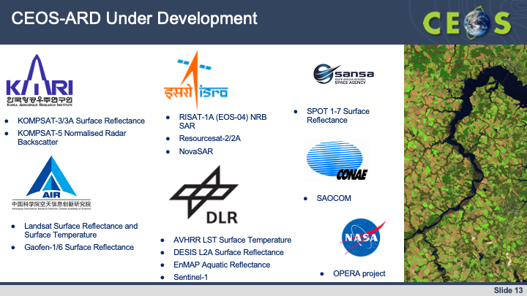
- CEOS-ARD is the first step on the ‘interoperability spectrum’, and several additional interoperability factors also need to be addressed. The team is considering factors such as data formats, discoverability and accessibility standards, consistent terminology, references and DEMs, data discovery and APIs, consistent metadata, and data versioning and collections. This will be done in coordination with WGISS and the CEOS Interoperability Framework.
- The CEOS-ARD Oversight Group is the forum for all matters related to CEOS-ARD. It includes representatives from CEOS Virtual Constellations and Working Groups having technical expertise to recommend, develop and maintain Product Family Specifications (PFS) for all domains.
- The CEOS-ARD Oversight Group, LSI-VC and CEOS SEO are actively engaging with the OGC/ISO Analysis Ready Data Standards Working Group (ARD SWG) to ensure consistency with CEOS-ARD.
- More information is available at ceos.org/ard.
Discussion
- Stephen Volz (NOAA) noted the ARD Standards Working Group engagement is a useful seed activity for the New Space theme currently under discussion within CEOS. He asked if contractual rules are covered by this activity, or is it more focused on the scientific data aspects. Steve Labahn (USGS, LSI-VC Co-lead) confirmed that contractual rules are under consideration in the frame of this activity.
- Phil Evans (EUMETSAT) asked about the impact the increasing use of AI/ML could have on CEOS-ARD. Steve Labahn (USGS, LSI-VC Co-lead) noted CEOS-ARD is intended to be an enabler for AI/ML and automated approaches, including by improving understandability, predictability, and quality assurance.
- David Borges (NASA, SEO) noted the parallel OGC Working Group that is currently working on AI/ML topics. The CEOS-ARD Oversight Group is aware of this work and is tracking it through the SEO. This may be a topic to revisit at a future meeting, to better understand the overlaps with CEOS-ARD and AI/ML.
- Pakorn Apaphant (GISTDA, CEOS Chair) recognised that ARD is an important topic within CEOS, including in the context of New Space. The New Space Task Team white paper includes several actions regarding CEOS-ARD.

Session 12: New Space

12.1: New Space Task Team [slides]
Presenter: Ivan Petiteville (SIT Chair Team)
Main points:
- Duality and complementarity between CEOS and New Space was one of the strategic priorities introduced by ESA as 2022-2023 CEOS SIT Chair. In response, the CEOS New Space Task Team (NSTT) was established to explore opportunities that bring mutual benefit to all parties, including the identification of concrete initiatives that will drive the agenda forward.
- The objectives and deliverables of the NSTT were:
  - Sharing experience between CEOS Agencies, through dedicated sessions at each CEOS meeting attended by CEOS Principals (SIT, SIT Technical Workshop, and CEOS Plenary).
  - Recommend actions within the CEOS framework that aim to enhance the outcomes of CEOS entities working with New Space companies.
  - Assess areas and issues that are common among CEOS Agencies and that may impact public EO programmes in future.
  - Issue a White Paper summarising findings and recommendations, based on both the information collected during the experience sharing sessions and reporting of specific relevant activities undertaken by CEOS entities.
- The main findings of the activity were:
  - Sharing of experience in engaging with New Space actors is beneficial to the CEOS community. New Space actors’ data is generally seen as augmenting, rather than replacing, long-term institutional programmes, albeit with potentially reduced quality.
  - New Space actors’ data aimed at an increasing number of priority applications that have historically been the domain of publicly funded missions.
  - Data from institutional missions are used by New Space actors as a reference to improve the accuracy of their own data products, and to fuse multiple data sets to generate higher level information products.
  - Data quality is an essential factor for scientific and operational endeavours.
- The NSTT White Paper and recommendations have been submitted for endorsement by the Principals at the CEOS Plenary.
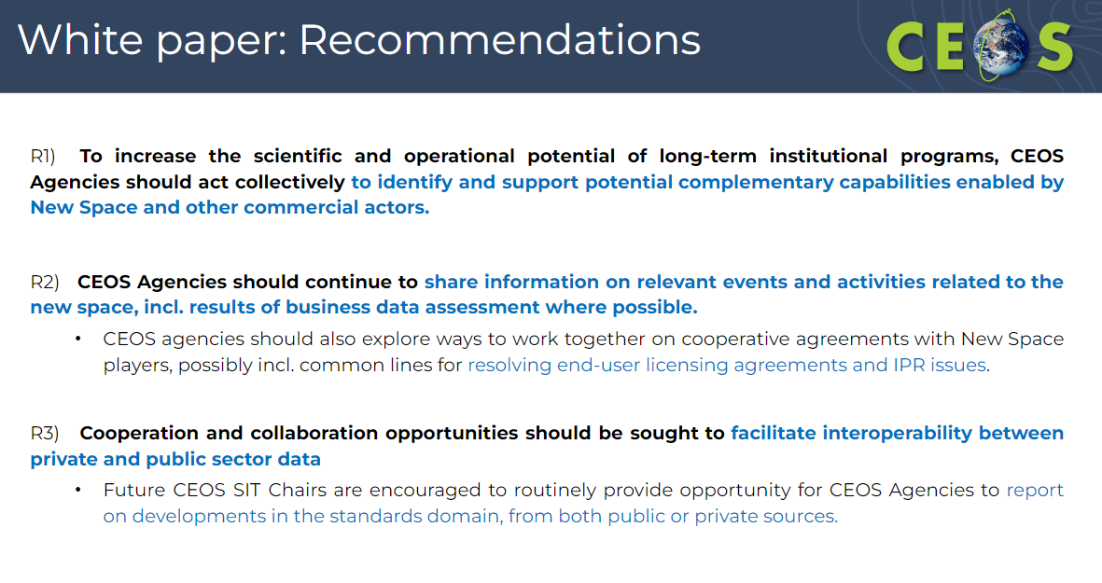
- Five deliverables are outlined in the paper, for inclusion in the next version of the CEOS Work Plan:
    - To ensure users can benefit from increased complementarity and interoperability of CEOS Agency and New Space datasets, the CEOS-ARD initiative should identify and implement mechanisms to deepen engagement with the New Space sector, consistent with CEOS Governing Documents.
    - CEOS Members and Associates should continue unified engagement with New Space actors on key topics such as ARD, cal/val, and data quality, via CEOS representation at key meetings including VH-RODA, JACIE, IGARSS, Living Planet Symposium, and ARD2x.
    - A revision of the CEOS-ARD Industry Engagement Strategy should include consideration of aspects of specific relevance to the New Space sector, and the CEOS-ARD Oversight Group should consider the merits of organising a dedicated New Space workshop.
    - The CEOS Interoperability Roadmap will ensure that legacy and new public and commercial datasets can be used more interoperably to generate advanced decision-support products and new research applications. As such, adequate resources should be made available to complete its development and maturation.
    - The CEOS Systems Engineering Office should demonstrate the integration of New Space data into the CEOS Analytics Lab and evaluate its interoperability with common CEOS datasets.
- In line with its objectives, CEOS should seek to play a supporting role within the emerging industrial community. Non-exhaustive examples include:
  - Developing common methodologies and practices for data harmonisation, cal/val and expert advisory role for matters relevant to the development of systems and services that supply Earth observation data.
  - Addressing methods to assess the data quality of constellations.
  - Providing intercomparison opportunities for current CEOS and New Space datasets.
- The NSTT does not recommend extending the term of the team.
Discussion
- Beth Greenaway (UKSA) recognised there have been lots of good discussions on this topic over the last year, on both the technical and strategic side, which have landed in a good place. CEOS should recognise that the landscape in the EO domain has changed and should embrace the new opportunities. UKSA endorses the recommendations but is aware of the need to keep this exploration going within CEOS.
- Mauro Facchini (European Commission) agreed that this topic is important in the frame of the changing environment. The public and private sector must work together. Within the paper and presentation, the terms ‘private’, ‘commercial’ and ‘New Space’ are seemingly used interchangeably. Mauro asked for clarification on what is meant by each term.
- Ivan Petiteville (ESA, SIT Chair Team) noted that, in his view, New Space is a subset of the commercial world, defined by smaller companies, with activities that are quickly developed and at relatively low cost. Their activities are flexible and iterated over time. New Space is defined by their way of working.
- Éric Laliberté (CSA) recognised that the discussions have not been easy. The space landscape has changed, and CEOS should recognise the opportunities brought by the commercial sector. A lot of the discussion and recommendations were focused on data quality aspects, however engagement with the sector was highlighted as one of the most important steps to take. At the 2023 SIT Technical Workshop, it was mentioned that all Working Groups and Virtual Constellations can invite New Space actors to participate, however there is no strategic guidance on the topics to engage on, apart from data quality to support interoperability. For example, discussions on data policies and sustainability are also key topics CEOS should discuss in the context of New Space.
- Ivan Petiteville (ESA, SIT Chair Team) agreed the importance of these topics. The policy discussions within the NSTT were mainly focused on sharing data evaluation reports, however it is also important to consider other policy issues. Additionally, the strength of public agencies is sustainability, and it is difficult to expect this of the private sector unless there is a long-term commercial incentive. These topics are worth discussing in future within CEOS.
- Stephen Volz (NOAA) noted that one action was closed, but more actions were open. The report is good and comprehensive, but it is passive and internally focused. It may be useful to have a 1–2-page synopsis that summarises the thinking in the white paper, and which could be shared with the broader community. He also asked whether there are engagement policies CEOS should recommend and suggested perhaps a workshop at the CEOS level to engage in a collective way. He added that GEO is organised such that commercial entities can sit at the table but have no voting rights.
- Ivan Petiteville (ESA, SIT Chair Team) cautioned against distributing the document openly or to the private sector, as it was written for an internal audience.
- Karen St. Germain (NASA) noted there are also fundamental challenges surrounding the compatibility of commercial datasets for scientific and operational use. It is expensive for operational organisations to adapt to even small changes in data pipelines.
- Takeshi Hirabayashi (JAXA, SIT Vice Chair) proposed that each Working Group and Virtual Constellation engage with New Space individually. As incoming SIT Chair, JAXA will provide an opportunity for groups to report at SIT Technical Workshops.
- Simonetta Cheli (ESA, SIT Chair) recognised that from the ESA side, this very valuable piece of work was made possible by strategic guidance of the SIT. ESA considers that the Task Team has completed its work with the delivery of the white paper, with clear recommendations and suggested deliverables. It will be interesting to see how the Working Groups and Virtual Constellations can act on the recommendations. CEOS should consider the core role of the public agencies and consider complementarities that can be provided by the private sector. ESA does not recommend changing the nature of how the CEOS collective works.
- Pakorn Apaphant (GISTDA, CEOS Chair) acknowledged the importance of this topic and the value of continuing these discussions. GISTDA agrees to close the Task Team, however CEOS should continue discussing in fora such as the SIT Technical Workshop. Pakorn proposed the SIT Chair follow up on the recommendations at future SIT meetings / Technical Workshops.
- The CEOS New Space Task Team Leads were asked to consider the production of a 1–2-page synopsis of the New Space Task Team white paper for external communications of the current state of CEOS thinking around space agency engagement and opportunities with the commercial sector, including ‘New Space’ companies.
- It was suggested that the CEOS Secretariat consider proposing development of a commercial (including New Space) engagement guidance and a set of principles to be collectively used across CEOS and tailored to the appropriate CEOS organisational level, including consideration of a workshop on the margins of CEOS Plenary or other key CEOS meeting. The purpose is to clarify how CEOS engages collectively.
Decision 37-15 | CEOS Plenary endorsed the New Space Task Team white paper and recommendations. It also agreed that the white paper should remain internal to CEOS and not be published on the CEOS website. CEOS Plenary gave its approval to disband the CEOS New Space Task Team, which was established as a temporary team one year ago.

CEOS-37-08 | Working with the relevant CEOS entities, the CEOS Executive Officer and the ESA 2022-2023 SIT Chair team will consider the CEOS New Space Task Team’s recommendations and suggested deliverables (and the related discussion from the 2023 CEOS Plenary) in the development of the CEOS 2024-2026 Work Plan. | SIT-39

Session 13: CEOS Agency Reports (continued)

13.1: CEOS Agency Reports

United Nations Office for Outer Space Affairs (UNOOSA) [slides]
Presenter: Jorge Rio Del Vera (UNOOSA)
Main points:
- CEOS is a Permanent Observer of the COmmittee on the Peaceful Uses of Outer Space (COPUOS), which has 102 Member States and over 40 Permanent Observers.
- COPUOS will include an item on its future agendas for each session allowing for an exchange among States members of the Committee and its permanent observers on their experiences in implementing the “Space2030” Agenda. In 2025, there will be a mid-term review of the progress made in implementing the Agenda.
- UN-Space is the new UN Interagency Coordination Mechanism on Space. WGCapD has been coordinating with UN-Space, including through the joint meeting with WGCapD-11 earlier in 2023. UNOOSA is heavily engaged with capacity building.
- UNOOSA asked that CEOS continue supporting the UN, including UN-Space, UN-SPIDER, Capacity-Building and Awareness Raising Efforts, as well as through secondments.
South African National Space Agency (SANSA) [slides]
Presenter: Asanda Sangoni (SANSA)
Main points:
- Mr Humbulani Mudau is the new CEO of SANSA. He has an Earth observation background and is also a member of the GEO Ministerial Working Group.
- SANSA’s priorities include providing access to a variety of sensors through free and commercial arrangements, climate change adaptation, disaster risk reduction and sustainable natural resources.
- SANSA plans to nominate individuals into more CEOS entities over the coming year.
- Current investments in EO include advanced predictive and forecasting tools, upskilling their EO capability, and developing the South African EO Mission to ensure government support.
- SANSA offered to serve as CEOS Chair in the coming years. They are respectful of the regional rotation and would like CEOS to keep the offer in mind.
Discussion
- Pakorn Apaphant (GISTDA, CEOS Chair) thanked SANSA for the offer to serve in future as CEOS Chair.
CEOS-37-09 | The CEOS Chair will confer with the Secretariat on the CEOS Chair geographic rotation in the context of self-nominations for the CEOS Chair role. | COMPLETE

Agenzia Spaziale Italiana (ASI) [slides]
Presenter: Laura Candela (ASI)
Main points:
- ASI has eight major objectives regarding Earth observation: Sustain and develop new instruments; Achieve autonomy in high resolution systems; Secure leadership in hyperspectral payloads; Sustain the future of SAR; Consolidate lidar capabilities; Strengthen developments in thermal infrared; Attract users towards EO applications and services.
- The COSMO-SkyMed mission continues well, with CSK-1, 2, and 4, in operation as well as CSG-1 and -2 (second generation) operational.
- MapItaly aims to provide a single access point to SAR observations over Italy for institutional users and will be operational by the end of 2023. The platform will include COSMO-SkyMed, SAOCOM and Sentinel 1 data, with an API for searching and downloading data.

Portuguese Space Agency (Portugal Space) [slides]
Presenter: Hugo Costa (Portugal Space)
Main points:
- The Portuguese Space Agency (Portugal Space) joined CEOS as an Associate Member in 2021.
- One of their main activities is capacity development – aiming to demonstrate the benefits of EO to non-traditional users. Portugal Space has hosted thematic training sessions for the energy sector, and on smart cities and disasters.
- GEOSAT-1 and -2 are Portuguese commercial satellites, supported by Portugal Space.
- Portugal Space’s GEOHub hosts data for distribution and storage.
China Academy of Space Technology (CAST) [slides]
Presenter: Jun Dai (CAST)
Main points:
- The High-Resolution Multi-mode Imaging Satellite (HRMIS) developed by CAST was launched in July 2020 with the objective to meet the growing demand for high-resolution satellite imagery. HRMIS has been in stable operation for 3 years. It has been used in applications for natural resources, emergency management, agriculture and rural affairs，ecology and environment, housing and urban-rural development, forestry, and grassland, etc. It accelerates the quantitative application of remote sensing and demonstrates tremendous potential.
United Nations Economic and Social Commission for Asia and the Pacific (ESCAP) [slides]
Presenter: Hamid Mehmood (ESCAP)
Main points:
- ESCAP is leading the UN Asia-Pacific Plan of action on Space Applications for Sustainable Development.
- The Geospatial Good Practices Database and Dashboard is an online regional knowledge-sharing platform that highlights how various space applications, geospatial information, and digital innovations are used across the Asia-Pacific to advance the 2030 Agenda for Sustainable Development.
- The dashboard is supplemented by a compendium series sharing knowledge and experience.
- ESCAP is organising timely provision of satellite imagery for disaster management, with over 150 GB of satellite imagery and products delivered to member states.
- The Virtual Satellite Constellation for Disaster Risk management (VSC) has been developed as a mechanism for sharing imagery within Asia and the Pacific to build resilience in disaster risk hot spots.
- Several Massive Open Online Courses (MOOCs) were hosted to support capacity development.

Indian Space Research Organisation (ISRO) [slides]
Presenter: Rajeev Jaiswal (ISRO)
Main points:
- There has been a change of approach within ISRO from a supply-based model to demand-based. Justification for satellites, associated ground segment, applications and their utilisation need to be driven and ensured by end-users.
- Recent demand-driven missions are EOS-6 (Oceansat-3) launched in November 2022 and EOS-4, launched in February 2022.
- IRS data, at a resolution of up to 5 metres, is now available freely and openly to all through the Bhoonidhi data portal. Government agencies can access data at all available resolutions free of charge. Furthermore, all archived IRS satellite data and satellite derived thematic data will also be made available on a free-and-open basis.
- For commercial EO data dissemination, IN-SPACe will act as a single window for all space-based applications to non-governmental Indian entities and government institutions. It will provide authorisation to Indian entities for remote sensing data dissemination.
- Bhoonidhi is a visualisation tool that enables access to an extensive archive of remote sensing data from EO satellites, including Indian and foreign sensors acquired since 1988.
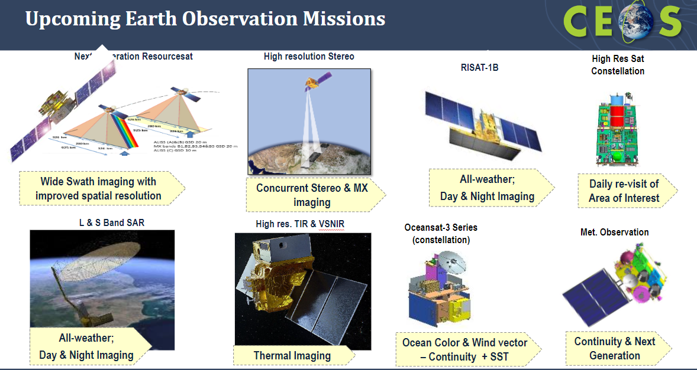

Deutsches Zentrum für Luft-und Raumfahrt (DLR) [slides]
Presenter: Klaus Schmidt (DLR)
Main points:
- The new German Federal Government’s space strategy focuses on: European and international cooperation; Space industry as a growing market (high-tech and new space); Climate change, resources, and environmental protection; Digitalisation, data and downstream; Security, strategic ability to act, and global stability; Sustainable use of space; Space research; International space exploration; Space in dialogue and talent recruitment.
- EnMAP launched on 1 April 2022 and is currently in Phase E routine operations. The data is free and open and can be accessed through https://planning.enmap.org.
- US-German missions GRACE and GRACE-FO are a success story in providing gravity data of unprecedented quality (2002-2017, 2018-present). Germany is committed, as an international partner to the U.S., to implement the GRACE-C mission to guarantee continuity of observations beyond GRACE-FO, with launch targeted for 2028.

Session 14: CEOS Leadership Transitions and Closing Business

14.1: Nomination for 2025 CEOS Chair [document]
Presenter: Beth Greenaway (UKSA)
Main points:
- UKSA sent a letter to CEOS self-nominating UKSA for the role of CEOS Chair in 2025.
- CEOS Plenary is asked to consider endorsing the nomination.
Discussion
- Pakorn Apaphant (GISTDA, CEOS Chair) thanked UKSA for nominating for the crucial role of CEOS Chair.
- Simonetta Cheli (ESA, SIT Chair) supported UKSA’s nomination for the role, and thanked them for their support and commitment to CEOS.
- Selma Cherchali (CNES) strongly supports the nomination.
- Takeshi Hirabayashi (JAXA) welcomed the nomination from UKSA.
- Éric Laliberté noted CSA is looking forward to working together with UKSA, and fully supports the nomination.
Decision 37-16 | CEOS Plenary endorsed the nomination of United Kingdom Space Agency (UKSA) as 2025 CEOS Chair in representation of the Europe/Africa region.
Paul Bate (UKSA) addressed CEOS Plenary:
- Thanks to GISTDA for hosting this year.
- UKSA is looking forward to taking on the CEOS Chair role at the end of 2024.
- The UK last hosted CEOS Plenary almost two decades ago, the same Plenary where GISTDA was accepted as a member of CEOS.
- UKSA recognises the important work of CEOS in supporting COP28.
- Earth observation is one of the key priorities of UKSA.
- UKSA would like to add an element of inspiration for the next generation to its CEOS Chair year, to help ensure the future of CEOS.
- Beth Greenaway and Niall Bradshaw will work as UKSA’s EO collaboration leads, and they are looking forward to working with CSA as CEOS Chair, JAXA as SIT Chair, and all CEOS Agencies to advance CEOS priorities.

14.2: Nomination for CEOS SIT Chair 2026-2027 [document]
Presenter: Karen St. German (NASA)
Main points:
- NASA is pleased to self-nominate for SIT Chair in 2026-2027. NASA will support JAXA as SIT Vice Chair for 2024-2025.
- NASA will also support CSA, UKSA and other future CEOS Chairs over their terms as SIT Vice Chair and SIT Chair.
Discussion
- Selma Cherchali (CNES) thanked NASA for nominating, recognising the role of SIT Chair is a large commitment. CNES supports the nomination.
- Stephen Volz (NOAA) supported the nomination from NASA.
- Takeshi Hirabayashi (JAXA) supported the nomination from NASA and stated that he looks forward to working with NASA over the next two years.
- Beth Greenaway (UKSA) supported the nomination.
- Simonetta Cheli (ESA, SIT Chair) also fully supported the nomination.
Decision 37-17 | CEOS Plenary endorsed the nomination of the National Aeronautics and Space Administration (NASA) as SIT Vice Chair for 2024-2025 and SIT Chair for 2026-2027.

14.3: ESA SIT Chair Term Report [slides]
Presenter: Simonetta Cheli (ESA, SIT Chair)
Main points:
- During their SIT Chair term, ESA chose to focus on global challenges with strong UN mandates, GEO support, and high relevance for satellite EO – through exploration of how CEOS could employ new geometries with industry, new missions, and new data and analysis techniques for maximum impact and continued relevance in a changing sector.
- SIT and SIT Technical Workshop agendas were designed to support the two-year targets. ESA has been successful in supporting thematic priorities aimed to translate into opportunities for engaging new users not familiar with EO from space.
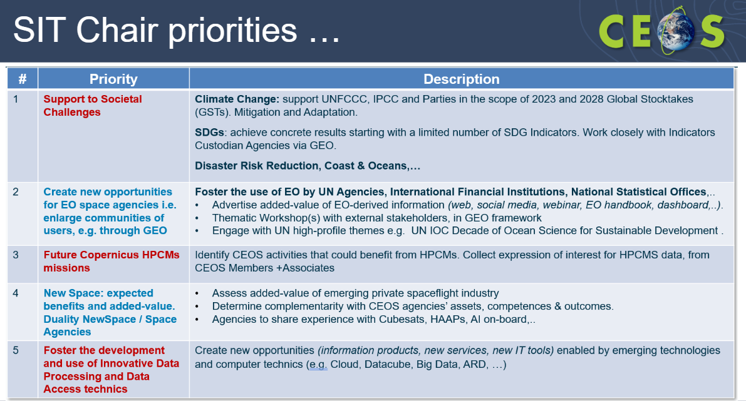
- The SIT-37 meeting was held virtually in March 2022. The 2022 SIT Technical Workshop was held at ESA/ESRIN in September 2022, which was the first face-to-face meeting since CEOS Plenary 2019, following the COVID-19 pandemic. SIT-38 was held in March 2023 at ESA/ESRIN and the 2023 SIT Technical Workshop was held in October 2023 at ESA/ESRIN.
- For the Climate and Carbon priority, significant activities and progress included:
  - Support for the JAXA, ESA and NASA leads within LSI-VC on the CEOS AFOLU Roadmap. The AFOLU Roadmap, after 2-3 years of effort, was successfully endorsed at CEOS Plenary 2023.
  - Promoted closer integration of in-country work (SilvaCarbon) with SIT Chair Team work plan items like AFOLU.
  - Ensured exposure for the important research work (e.g., Melo et. al, 2023) on changes needed to improve uptake of EO datasets.
  - Updated the CEOS Global Stocktake Portal in 2023 with new and updated datasets.
  - Developed the 2023 CEOS EO Handbook: Space Data for the Global Stocktake.
- On Greenhouse Gases, the significant activities and progress include:
  - To progress the GHG Roadmap, ESA volunteered Yasjka Meijer to take over from Mark Dowell as lead of the GHG Task Team.
  - GHG Task Team is supporting WMO in developing the Implementation Plan for its intended Global Greenhouse Gas Watch (GGGW).
  - The ESA SIT Chair Team coordinated CEOS participation and engagement in the CEOS-IMEO workshop at Harvard in June 2023.
  - ESA and JAXA jointly supported the development of the new GHG Satellite Mission Portal powered by the CEOS MIM database.
- The SDG Coordination Group was established at the 2021 CEOS Plenary, with strategic guidance led by the SIT Chair. The SIT Chair has continued to support this group throughout 2022 and 2023.
- CEOS is represented by the SIT Chair and CEO at the GEO Programme Board and at GEO Executive Committee meetings. The SIT Chair Team attended both the 2022 and 2023 GEO Week meetings.
- The SIT Chair gathered 21 CEOS Agencies to form the New Space Task Team, who met regularly over 2023. A white paper was presented and endorsed by CEOS Plenary 2023.
- The SIT Chair supported the CEOS-ARD initiative through the designation of Ferran Gascon (ESA) as the lead of the CEOS-ARD Oversight Group. Ferran will continue to lead the group during the JAXA term.
- The SIT Chair team led the CEOS Ocean Coordination Group during 2022. At the 2022 CEOS Plenary, the group was extended by one year, and Paul DiGiacomo from NOAA kindly took over leadership of the group.
- The SIT Chair team expressed gratitude toward the colleagues from ESA and CEOS who contributed to the success and outputs of the team.
- ESA wishes JAXA all the best for their SIT Chair term, and thanks them for their intensive consultation process to ensure continuity and purpose.
Discussion
- Pakorn Apaphant (GISTDA, CEOS Chair) thanked ESA for their investment in the SIT Chair role. The SIT Chair is a vital role in CEOS, and as shown by Simonetta’s presentation, can achieve a great deal.
- Simonetta Cheli (ESA, SIT Chair) thanked the whole ESA team that has supported her over the last two years.
- Takeshi Hirabayashi (JAXA, SIT Vice Chair) appreciated the great work done by ESA over their SIT Chair term.

14.4: JAXA SIT Chair Term Prospectus 2024-2025 [slides]
Presenter: Takeshi Hirabayashi (JAXA)
Main points:
- JAXA will serve as Chair of the CEOS Strategic Implementation Team (SIT) for a two-year term, 2024-2025. NASA will serve as SIT Vice Chair and will then become SIT Chair at the 2025 CEOS Plenary.
- The incoming JAXA SIT Chair Team has been consulting broadly across the organisation to set outcomes and milestones that are significant and reflect societal needs as well as CEOS Agency priorities.
- The 2024-2025 SIT Chair Team will focus on a few priorities reflecting major developments across civil EO programmes and priority needs, consistent with past CEOS outcomes. JAXA will ensure continuity for existing SIT priorities and CEOS Work Plan activities, reflecting resource availability and stressing CEOS Agency participation.
- The approach will be consistent with the original vision for SIT, in that CEOS Principals in SIT meetings will address significant challenges via coordination and observing system harmonisation across space agencies. The SIT Chair Team will aim to effectively use the different meetings throughout its SIT Chair term for greatest impact.
- JAXA’s SIT Chair headline priorities are:
  - Climate Policy Impact: Addressing obstacles and opportunities for CEOS Agency data, particularly AFOLU/Biomass datasets, to ensure maximum impact in the key climate policy processes such as the Global Stocktake of the Paris Agreement.
  - Greenhouse Gas Observations from Space: Addressing coordination for data continuity challenges ahead and developing good practices so that operators of all kinds may contribute to societal needs.
  - Supporting Existing and Emerging CEOS Business: Escalating, elevating, and expediting the CEOS Work Plan activities underway and planned in which CEOS Agencies are investing.
- The SIT-39 meeting will be held in Kudan-Kaikan Terrace Conference and Banquet, Chiyoda-ku, Tokyo from 10-11 April 2024 with 9 April as the day for side meetings.
- SIT Technical Workshop 2024 will be held during the week of 16 September 2024 in Sydney, Australia.
Decision 37-18 | CEOS Plenary welcomed the Japan Aerospace Exploration Agency (JAXA) as SIT Chair for the two-year term of 2024-2025.

14.5: CSA 2024 CEOS Chair Presentation [slides]
Presenter: Éric Laliberté (CSA, 2024 CEOS Chair)
Main points:
- CSA will prioritise one headline theme of biodiversity during their Chair term. Biodiversity is a national priority for Canada, noting the Kunming-Montreal Global Biodiversity Framework (GBF) was adopted in 2022. As seen through the EETT’s work, there is clearly a lot of interest in the CEOS community for this topic.
- The CSA team hopes to establish, by the end of 2024, a proposal regarding the future of CEOS and the biodiversity topic.
- The CSA team has held several consultation calls with agencies (primarily those active in the Ecosystem Extent Task Team) over the past month to understand agencies' involvement in biodiversity activities and to explore opportunities to foster connections and collaborations.
- CSA will undertake an exploration of whether and how CEOS should pursue a broader strategy for biodiversity. The goal is to build on the task team’s work to arrive at CEOS Plenary 2024 for a well-informed discussion on potential CEOS commitment to a broader biodiversity strategy. This work started on Tuesday, November 14, with a side meeting to commence discussions.
- The second set of tasks will have an external stakeholder focus, aiming to increase CEOS' understanding of and linkage to the biodiversity policy world, as well as strengthen awareness of the policy community of the potential benefit of EO to biodiversity, which is reportedly not well understood by policymakers and end users.
- CEOS Plenary 2024 will be held at the Canadian Space Agency’s headquarters (south of Montreal) on 22-24 October 2024.

14.6: CEOS Chair Transition and Photo
The CEOS Chair role officially transitioned to CSA.
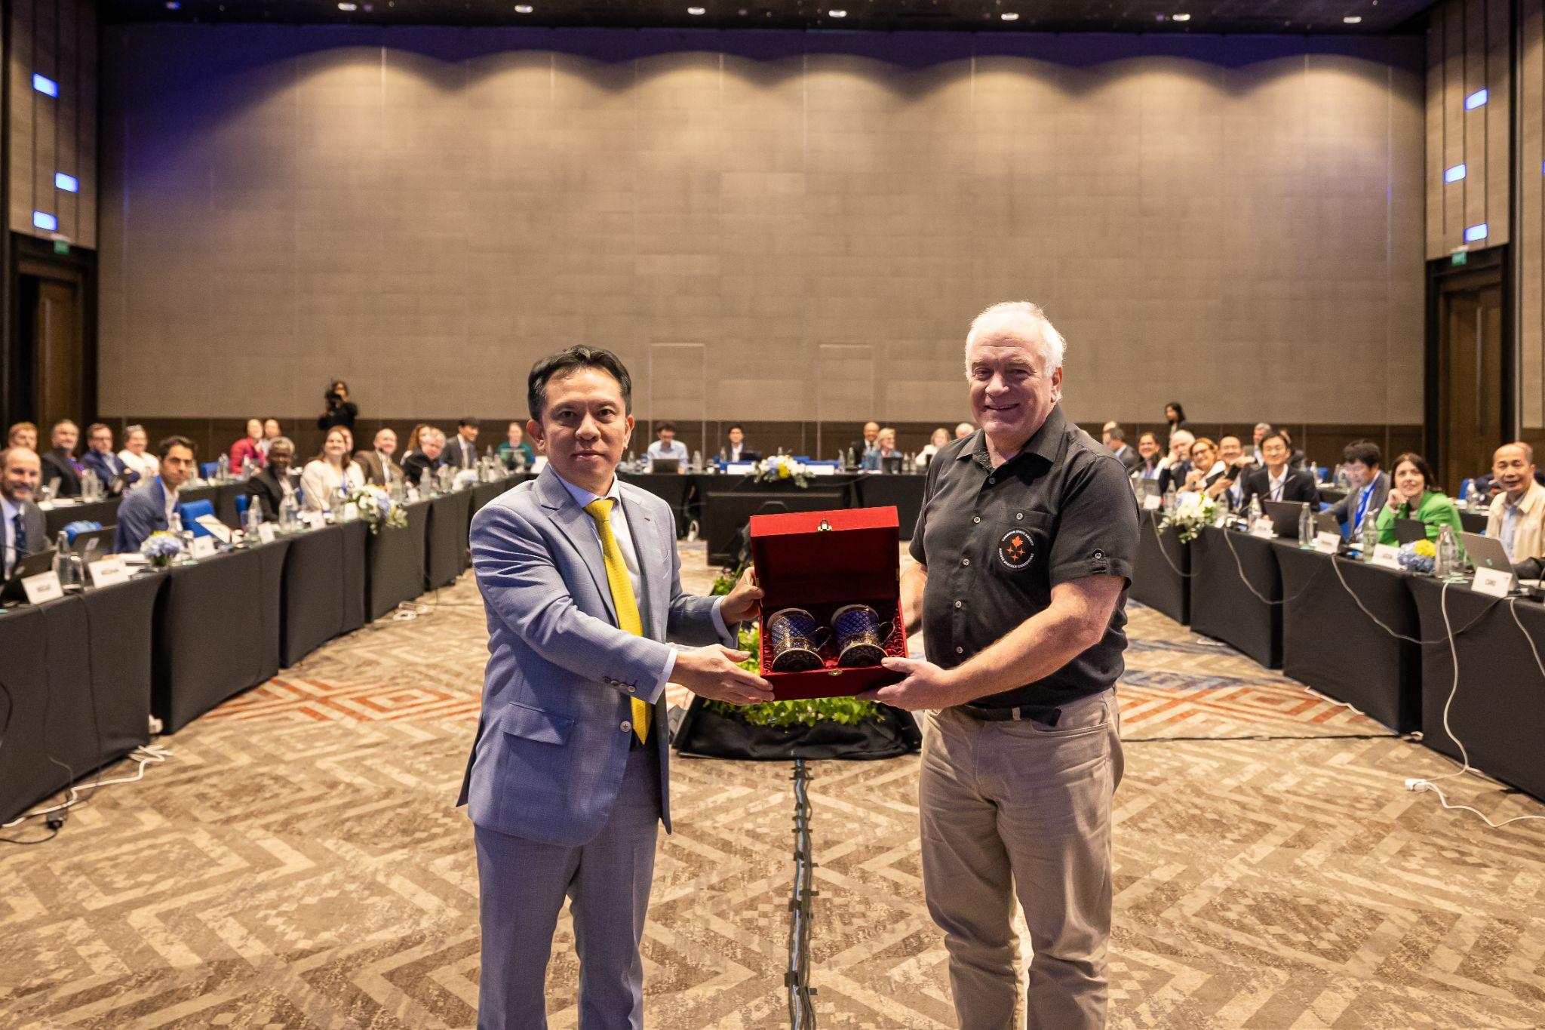
Decision 37-19 | CEOS Plenary welcomed the Canadian Space Agency (CSA) as 2024 CEOS Chair.

14.7: Review of Preliminary Action and Decision Record
Presenter: Matt Steventon (CEOS Chair Team)
Main points:
- The preliminary actions and decisions were reviewed.
- There was feedback from Stephen Volz (NOAA) suggesting the preparation of a short synopsis of the New Space Task Team white paper for communication with those external to CEOS. CEOS Plenary also agreed that the white paper should remain internal to CEOS and not be published on the CEOS website. These points have been reflected in section 12.1 above, for clarity.
- The preliminary action and decision record will be circulated by email to all participants for further review and feedback.

14.8: Closing Remarks
Karen St. Germain (NASA) expressed her appreciation for Marie-Claire Greening for serving as CEOS Executive Officer for three years. CEOS Plenary joined NASA in thanking Marie-Claire.
Pakorn Apaphant (GISTDA, 2023 CEOS Chair) made some closing remarks:
- Pakorn considers CEOS as one of his families and looks forward to continuing to work together over the coming years.
- Pakorn might leave his current role in 2024, however GISTDA intends to remain a strong member of CEOS.
- CEOS is the most important forum for EO activities to be coordinated on an international level. Pakorn compelled CEOS to continue their work.
Éric Laliberté (CSA, 2024 CEOS Chair) thanked GISTDA for being wonderful hosts, in such a beautiful location.

APPENDIX A: Attendees
In-person
Organisation | Name | Organisation | Name
ASI | Laura Candela | JAXA | Takeshi Hirabayashi
CAST | Jun Dai | JAXA | Yuko Nakamura
CAST | Lijia Fan | JAXA / RESTEC | Satoshi Uenuma
CEO | Marie-Claire Greening | NASA | Barry Lefer
CNES | Sandra Luque | NASA | Christine Bognar
CNES | Selma Cherchali | NASA | David Borges
CSA | Eric Laliberté | NASA | Gary Geller
CSA | Frederic Fournier | NASA | Karen St. Germain
CSIRO | Alex Held | NASA | Lawrence Friedl
CSIRO | Flora Kerblat | NASA | Sid Boukabara
CSIRO | Shaun Levick | NASA | Wenying Su
ECMWF | Vincent-Henri Peuch | NASA / UMD | Chris Kidd
ESA | Ivan Petiteville | NASA | Youshay Rizvi
ESA | Philippe Goryl | NIER | Dongwon Lee
ESA | Simonetta Cheli | NIER | Goo Kim
EUMETSAT | Paul Counet | NIER | Sihyun Nam
EUMETSAT | Phil Evans | NOAA | Charles Wooldridge
European Commission | Mauro Facchini | NOAA | Stephen M. Volz
European Commission | Peter Strobl | NOAA | Jeff Privette
Geoscience Australia | Jonathon Ross | NOAA | Katy Matthews
GGOS | Richard Gross | NOAA/NESDIS | Kelly Turner
GISTDA | Atipat Wattanuntachai | NSMC-CMA | An Dawei
GISTDA | Chompunut Chayawat | Portugal Space | Hugo André Costa
GISTDA | Libby Rose | ROSCOSMOS | Tamara
GISTDA | Pakorn Apaphant | SANSA | Asanda Sangoni
GISTDA | Pakorn Petchprayoon | SANSA | Humbulani Mudau
GISTDA | Poramet Thuwakham | UKSA | Beth Greenaway
GISTDA | Prayot Puangjaktha | UKSA | Niall Bradshaw
GISTDA | Raksina Lekthanoo | UNOOSA | Jorge Del Rio Vera
GISTDA | Raweewan Nutpramoon | UNOOSA | Lorant Czaran
GISTDA | Sirikul Hutasavi | US Department of State | Fernando R. Echavarria
GISTDA | Sutinee Sihirunwong | USGS | Steve Labahn
GISTDA | Tanita Suepa | USGS | Tom Sohre
GISTDA | Stephen Ward | USGS/Aerospace | Steven Covington
JAXA | Makoto Natsuisaka | VNSC | Lam Dao Nguyen
JAXA | Osamu Ochiai | WMO | Natalia Donoho

Online

Organisation | Name
AEM | Julio Castillo
CNES | Aurelien Sacotte
CONAE | Laura Frulla
CSA | Lucie Viciano
DLR | Klaus Schmidt
ECCC | David Harper
ESA | Marie-Helene Rio
ESA | Stephen Briggs
EUMETSAT | Robert Husband
EUMETSAT | Steven Ramage
European Commission | Astrid Christina Koch
GEO Secretariat | Yana Gevorgyan
ISRO | Nitant Dube
ISRO | Rajeev Jaiswal
JAXA/RESTEC | Yukio Haruyama
NOAA | Shobha Kondragunta
UNESCAP | Hamid Mehmood
UNESCAP | Keran Wang

