G-VEWERS: Global Volcano Early Warning and Eruption Response from Space
A proposal to the CEOS Working Group on Disasters

September 2023

EXECUTIVE SUMMARY

A Global Volcano Early Warning and Eruption Response from Space (G-VEWERS) initiative is needed to facilitate satellite observations of volcanoes on Earth, aiding with forecasting of volcanic activity and early warning for people at risk from hazardous impacts. G-VEWERS is a permanent partnership between international space agencies, academic institutions, and volcano observatories, with the goal of coordinating the acquisition, access, and utilization of satellite data to support volcano monitoring and early warning at volcano observatories worldwide. Data quotas from space agencies for specific satellite datasets will be renewed on a biennial basis following the submission of a status report describing results and activities from each of the four G-VEWERS regions (North Pacific and East Asia; Southeast Asia and South Pacific; Africa, Europe, and the Middle East; and Latin America and Antarctica). G-VEWERS will ultimately lead to a global society that is more informed of, and prepared for, the impacts of volcanic hazards.

BACKGROUND

In 2012, the International Forum on Satellite Earth Observation and Geohazards, chaired by the European Space Agency, brought together Earth observation and geologic hazards specialists from around the world to the island of Santorini, Greece. The goal of the conference was to define the satellite data needed by the geohazards community to aid with risk assessment. The resulting “Santorini Report” (Bally, 2012) discussed a number of hazards. Recommendations specific to volcanoes included (1) daily satellite monitoring of erupting volcanoes, (2) weekly monitoring of restless volcanoes, and (3) quarterly to every-few-years monitoring of quiescent volcanoes. Unlike many other hazards, like earthquakes and wildfires, volcanic eruptions are often preceded by measurable unrest in the form of seismicity, ground deformation, gas and thermal emissions, hydrological changes, and other indicators. Detecting and tracking these different forms of unrest can provide a basis for accurate forecasts of eruptions and their hazards and constitutes an early warning system for volcanic activity (e.g., Poland and Anderson, 2020). Volcanic hazards are also distinctively dynamic, and satellite monitoring during an eruption can be crucial for forecasting their development and duration.

While satellite monitoring can never replace data collected by in-situ sensors, only about 35% of volcanoes that have erupted in the past ~500 years have continuous ground-based monitoring (Loughlin et al., 2015). Satellite data can help to bridge this gap, with capabilities in detecting surface change, ground deformation, and thermal, gas, and ash emissions (Figure 1); thus, remote sensing offers critical data where ground-based monitoring is absent, while still providing valuable supporting information in places where ground-based sensors are present. Space-based imagery has already proven critical in eruption forecasts and supporting volcano observatory responses and early warning. For example, satellite radar data provided information upon which evacuations were recommended at Merapi volcano, Indonesia, prior to an eruption in 2010—critical early warning that led to action credited with saving thousands of lives (Pallister et al., 2013). Insights from satellite radar of Chiles-Cerro Negro volcano, on the Colombia-Ecuador border (Ebmeier et al., 2016), helped the Instituto Geofisico of Ecuador to interpret the mechanisms of nearby seismicity and set the volcano’s alert level in 2014.

Figure 1. Plot of transmission of electromagnetic radiation through the atmosphere as a function of wavelength, with the various wavelength regions and bands labeled along with volcanological applications. There is a break in scale between the infrared and microwave regions and different wavelength scales in each region. The microwave region is subdivided into radar bands, corresponding to defined frequencies and wavelengths. Modified from NASA (https://earthobservatory.nasa.gov/features/RemoteSensing/ remote_04.php). UV, ultraviolet; NIR, near infrared; SWIR, shortwave infrared; MIR, mid infrared; TIR, thermal infrared; InSAR, interferometric synthetic aperture radar; μm, micrometer; cm, centimeter.

Motivated by the Santorini Report, the Committee on Earth Observing Satellites (CEOS) Working Group on Disasters developed the “Volcano Pilot,” which operated during 2014–2017 (Pritchard et al., 2018). The project focused on satellite monitoring of volcanoes in Latin America, from Mexico in the north to Chile in the south and including islands in the Caribbean and Galápagos. The goals of the Volcano Pilot were to (1) identify volcanoes in a state of unrest; (2) comprehensively track unrest and eruptive activity using satellite data to support hazards mitigation; (3) evaluate the monitoring aims of the Santorini Report and determine the best way to identify and track different forms of volcanic activity via an international, coordinated, multi-satellite strategy; (4) improve satellite monitoring of volcanoes in developing countries, where ground-based monitoring resources may be scarce; and (5) develop capacity in countries that do not have the resources or expertise to process and interpret satellite data for volcano monitoring. The project achieved these goals, leading to a subsequent expansion of the efforts: the “Volcano Demonstrator” (2019–2023), which broadened the reach of the Pilot project beyond Latin America to also include Southeast Asia and Africa.

The CEOS Volcano Pilot and Volcano Demonstrator projects emphasized the role that satellite data can play in forecasting, detecting, and tracking volcanic activity around the world (Poland et al., 2020). Thanks to the growing number and capabilities of Earth-observing satellites, several the goals of the Santorini Report have been met. For instance, daily monitoring of gas and thermal emissions from space is a reality (at least with coarse spatial resolution; Pritchard et al., 2022). Lagging behind, however, are Synthetic Aperture Radar (SAR) and high-resolution optical datasets that are capable of detecting surface deformation and morphological changes. There is also a disparity in the geographical distribution of the application of SAR and optical data, with some important regions for volcanic hazards remaining under-served (Pritchard et al., 2022). As an example, the vast majority of volcanoes in the Demonstrator regions lack the high-resolution SAR acquisitions that are critical for identifying localized surface changes and ground deformation (Figure 2). Although these data can be collected at time scales that would meet the goals of the Santorini Report, they are not frequently collected and not widely available to volcanologists at the low latencies needed for volcano monitoring.

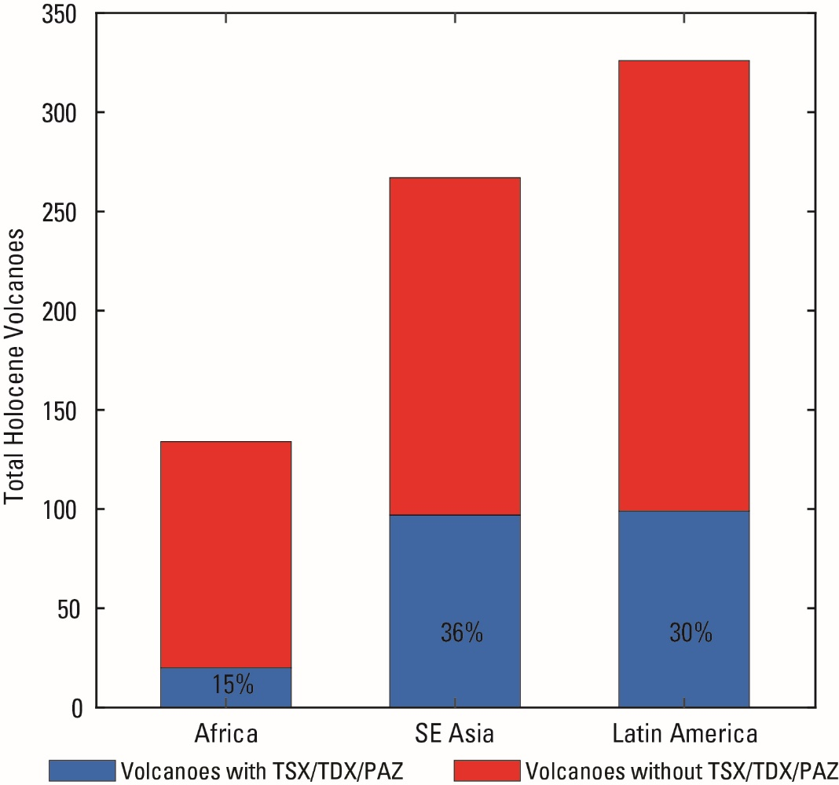
Figure 2. Number of potentially active volcanoes in the CEOS Volcano Demonstrator regions (red) compared with the fraction (shown in black text) with some high spatial resolution TSX/TDX imagery (blue) in each region.

To address this gap in volcano monitoring, a Global Volcano Early Warning and Eruption Response from Space (G-VEWERS) initiative is needed.

WHAT IS G-VEWERS?

G-VEWERS is a permanent and sustainable effort targeting global remote volcano monitoring that will ensure low-latency access to a variety of satellite datasets that are critical for forecasting, detecting, and tracking volcanic activity, and for mitigating associated hazards around the world by providing early warning of potential eruption impacts. This initiative will focus only on satellite observations, provided via biennial renewable satellite data quotas from international space agencies, and will complement the work of the more than 100 volcano observatories around the world. While in-situ data are also critical to volcano monitoring, eruption forecasting, and early warning, volcano observatories have differing policies regarding ground-based datasets, ranging from completely open to completely restricted. G-VEWERS will not be involved with any ground-based monitoring data, but rather will provide volcano observatories with satellite data that can complement terrestrial data, if any exist, and be integrated into the analysis and early warning systems of individual volcano observatories.

The world will be divided into four regions, based on existing volcanological relationships and monitoring infrastructure, to facilitate operations: (1) North Pacific and East Asia; (2) Latin America and Antarctica; (3) Africa, Europe, and the Middle East; and (4) Southeast Asia and South Pacific (Figure 3). Work in each area will be coordinated by regional contacts, following the Volcano Demonstrator model. G-VEWERS will take advantage of best-effort contributions from academic institutions, volcano monitoring agencies, and space agencies, and will leverage local capacity for monitoring and support local needs at volcano observatories worldwide.

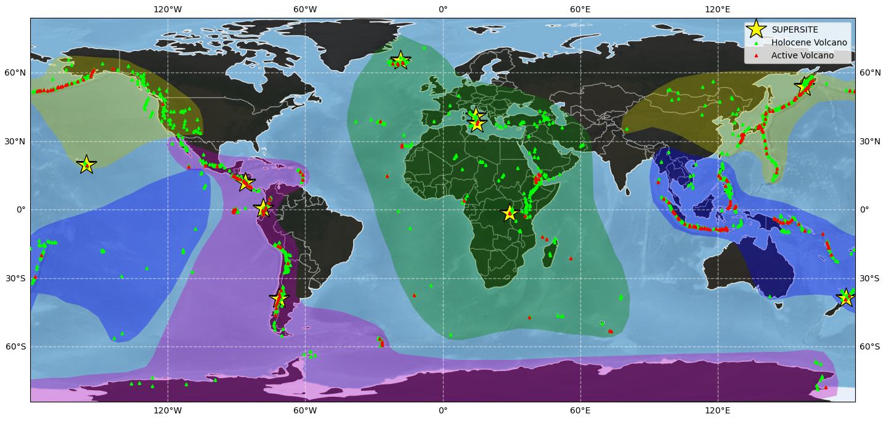
Figure 3. Global map showing distribution of volcanoes that are a priority for monitoring (categories A1 and A2) according to Pritchard et al. (2022) in red, Holocene-age volcanoes in green, and proposed G-VEWERS regions shaded in pink (Latin America and Antarctica), blue (Southeast Asia and South Pacific) green (Europe, Africa, and the Middle East), and yellow (North Pacific and East Asia).

OBJECTIVES

The primary objective of G-VEWERS is global volcano observation via synthetic aperture radar and high-resolution optical and multispectral satellite data to provide eruption response and early warning capabilities. The initiative will strive to meet the goals of the Santorini Report during the most critical phases of eruption, with daily monitoring of erupting volcanoes, of which there are on average a few dozen per year; weekly monitoring of restless volcanoes which includes about 200 volcanoes per year; and quarterly to every-few-years monitoring of quiescent volcanoes, of which there are about 1400 in the world (observation frequency for quiescent volcanoes will be based on the hazards posed and eruptive history). The classification scheme developed by the U.S. Geological Survey’s Powell Center for Volcano Remote Sensing (Pritchard et al., 2022) will be used to guide the acquisition strategy (the COMET group in the UK is already using this scheme to set processing priorities for data collected over volcanoes by the Sentinel-1a satellite).

We consider the work of G-VEWERS to be especially important in settings where (1) local capacity for satellite imagery tasking and analysis is limited, and (2) new unrest or eruptive activity occurs in places where there are no or limited ground-based networks. We therefore have two secondary objectives for the initiative. The first is to bring the latest methods and understanding from satellite radar research to bear on volcano monitoring and early warning of eruptions around the world, especially at volcanoes that have not historically been the subject of intensive study. G-VEWERS will therefore take advantage of the vast existing archives of data to better understand the behavior of restless and erupting volcanoes over time. The second is to train scientists at volcano observatories in developing countries in the utilization and interpretation of remote sensing data, especially from SAR and high-resolution optical/multispectral sensors. This capacity building will enhance the use and utility of such data for volcanic eruption early warning and response—a critical capability for populations and infrastructure that are at risk from volcanic hazards.

DATA QUOTAS

Near-weekly monitoring of most volcanoes on Earth by SAR is already made possible by ESA’s Sentinel-1 mission. While Sentinel-1 SAR will form the backbone of G-VEWERS monitoring, those data are not suitable in all situations—the sensor lacks high-spatial-resolution capabilities, and the C-band wavelength is unable to penetrate thick vegetation. Additional data are therefore needed, especially from high-resolution SAR, optical, and hyperspectral sensors (Table 1).

X-band SAR data are especially important for monitoring volcanic activity not only because of short repeats that improve temporal resolution of surface change, but also because radar intensity images can be used to track variations related to new and ongoing eruptions. To meet the goals of the Santorini Report, 4000 scenes/year each from TerraSAR-X/TanDEM-X/PAZ and COSMO-SkyMed are needed, to be distributed among the four G-VEWERS regions following a well-coordinated interagency data acquisition plan. By leveraging the complementary capabilities of the different satellite systems, this quota, combined with freely available Sentinel-1a data, will provide: (1) near-daily monitoring of ~30 hazardous eruptions each year (assuming an average eruption length of 75 days, as determined from global averages) (Figure 4), (2) weekly monitoring of 230 restless volcanoes each year, and (3) quarterly to every-few-years monitoring of quiescent volcanoes. In addition, access to TanDEM-X CoSSC data is needed to develop digital elevation models that can be used to quantify topographic change, to correct interferograms for topographic phase, and to aid other monitoring (like infrasound) and hazards modeling (including lava flow, lahar, and pyroclastic density current inundation zones). Further, access to archive data will contribute to focused studies of specific volcanic systems and events, helping to develop a better understanding of ground deformation and surface change over space and time at selected volcanoes worldwide.

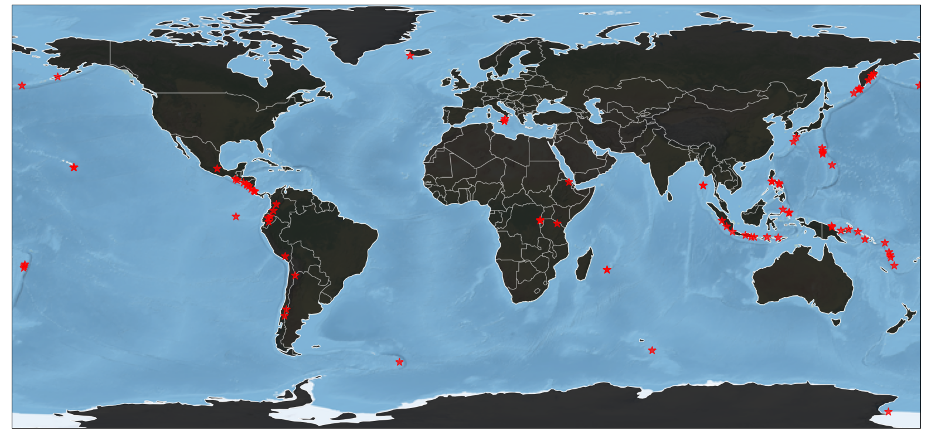
Figure 4. Map of volcanoes that experienced active eruptions in 2022. There were 85 eruptions from 80 different volcanoes. 33 were new eruptions that started during the year. About half of the eruptions included activity that was hazardous to surrounding populations and infrastructure. Data from Smithsonian Institution Global Volcanism Program.

Table 1. Data quotas requested for various missions operated by CEOS member agencies for the purpose of monitoring new/ongoing eruptions and volcanic unrest through G-VEWERS. This request does not include freely available data, like Sentinel-1, nor requests for archive data to study past eruptions/unrest. The quota requests are proposed and subject to negotiation with space agencies.
Satellite System | Agency | Request
TerraSAR-X/TanDEM-X | DLR | 4000 scenes/year
PAZ | INTA | as needed (complement TSX/TDX)
COSMO-SkyMed | ASI | 4000 scenes/year
RADARSAT-2 / RADARSAT Constellation Mission | CSA | 1000 scenes/year
SAOCOM | CONAE | 1000 scenes/year
TanDEM-X CoSSC | DLR | as needed (for DEM generation)
Pléiades | CNES | 20,000 km²/year
Spot-6/7 | CNES | as needed

L-band SAR data from SAOCOM and C-band SAR data from RADARSAT-2 and the RADARSAT Constellation Mission will supplement the X-band datasets. The RADARSAT missions have flexibility in acquisitions—for instance, differing polarizations and resolutions—that can be tailored to specific needs at volcanoes of interest, and the longer wavelength of SAOCOM will provide the ability to detect deformation at heavily vegetated volcanoes that might otherwise escape notice. A quota of 1000 scenes per year for each dataset, evenly distributed among the G-VEWERS regions, will meet the needs laid out in the Santorini Report.

Finally, high-resolution optical and multispectral data from Pléiades and SPOT-6 and 7, respectively, are needed to supplement SAR imagery for some eruptions. The Demonstrator quota of 20,000 km²/year for Pléiades will be sufficient for G-VEWERS, and access to SPOT-6 and 7 acquisitions is requested.

The proposed quotas will be subject to negotiation with individual space agencies. Additional satellite datasets will be added as they become available. The L-band NISAR mission (expected launch in 2024) will complement other sensors described above. We will also seek to add commercial and non-commercial datasets.

The initial targets for observation will be based on the Powell Center classification scheme (Pritchard et al., 2022), coupled with current lists of volcanic activity that are compiled by the Smithsonian Institution’s Global Volcanism Project (https://volcano.si.edu/). Targets will be updated on a constant basis depending on eruptions and unrest that start and end.

DELIVERABLES

Deliverables for G-VEWERS will follow the highly successful GSNL model. A biennial report will discuss work in each G-VEWERS region, showcasing responses to eruptions, explaining how satellite data have aided with volcano monitoring, hazards mitigation, and early warning during the reporting period, and detailing scientific results. In addition, presentations at international scientific conferences and space agency meetings will highlight G-VEWERS progress and successes, and manuscripts describing results will be submitted to academic journals.

G-VEWERS will also continue the tradition of capacity building that was established by the Volcano Pilot and Volcano Demonstrator projects—efforts that have contributed to the operational use of SAR data by volcano observatory scientists in Colombia, Ecuador, and Peru. Capacity-building activities will include workshops and short courses that are offered during international meetings, like the Cities on Volcanoes series (held every 2 years) and International Association of Volcanology and Chemistry of the Earth’s Interior Scientific Assembly (held every 4 years). By request, visits of satellite data experts to volcano observatories for on-site training will also be conducted. This can be done in coordination with agencies that specialize in international volcanology training. For example, the USGS Volcano Disaster Assistance Program led an InSAR training course in Arequipa, Peru, in 2019 and a remote sensing workshop in Indonesia in 2023. Similarly, the University of Hawaiʻi at Hilo Center for the Study of Active Volcanoes sponsors an annual 6-week volcanology training course for volcano observatory scientists from developing countries that includes instruction on volcano deformation and remote sensing techniques. If funding can be secured (for example, from the World Bank or UN agencies), G-VEWERS will also promote the advanced education of students from developing countries, for instance, sponsoring graduate (M.S. and Ph.D.) educations—a model that has proved successful in transferring knowledge to developing countries. This overall approach to capacity building will meet both short-term needs through workshops and site visits, as well as long-term development through investments in education. It may be possible to collaborate with the CEOS Working Group on Capacity Building and Data Democracy in these efforts.

OUTCOMES

The ultimate outcome of G-VEWERS will be a safer global society due to a better forecasting, detection, and tracking of volcanic activity, early warning of hazardous impacts, and a better scientific understanding of volcanic processes. Along the path to this overarching outcome, G-VEWERS will:
- showcase how CEOS data can be used to enhance public safety around the world through early warning efforts,
- empower local volcano observatories and academic institutions to develop new skills,
- create a new and coordinated community of satellite data users, and
- serve as a model for the assessment and mitigation through early warning of natural hazards, and as an example for other potential permanent projects of the CEOS Working Group on Disasters.

CONTRIBUTORS AND ROLES

G-VEWERS is a partnership between data providers, volcano observatories, and academic institutions.

Data providers, including international space agencies, will provide timely access to the datasets that are needed for identifying volcanic unrest, monitoring volcanic activity, and mitigating the hazards from volcanic eruptions.

Volcano observatories will process satellite data (if they are capable), interpret results, and utilize interpretations to guide hazard responses and provide early warning of volcanic impacts. Observatories will also provide feedback on data and capacity-building needs.

Academic institutions will provide volcanological and remote sensing expertise, student support, and scientific research efforts, and they will support capacity-building activities. These contributions will be made on a best-effort basis and may include soliciting financial support from funding agencies for research and development.

The U.S. Geological Survey (USGS), which is categorized as both a volcano observatory and an academic institution, will provide coordination for G-VEWERS. USGS scientists will work to ensure satellite acquisitions are tasked, conflicts are avoided, and data are made available as needed.

PROJECT MANAGEMENT

The overall G-VEWERS initiative will be overseen by an advisory panel of scientists who have expertise with SAR and high-resolution optical/multispectral data applied to volcano monitoring and research, and who have experience in global initiatives and capacity building. The panel of about 10 experts, which will be led by 2 chairs, will be drawn from the volcano observatories, data providers, and academic institutions that are supporting the project, and will represent a diversity of nationalities to ensure worldwide participation. This group will be responsible for representing G-VEWERS to the global volcanology community (including volcano observatories around the world), oversee regional activities, and coordinate satellite observation strategies to minimize conflicts and ensure complementary utilization of satellite resources (for example, that the capabilities of different X-band satellite systems are most efficiently employed and not duplicative of one another). Membership in the group (Table 2) will rotate to ensure diverse perspectives are represented and global participation is possible.

Table 2. Tentative list of G-VEWERS advisory panel (more members can be added as needed/warranted).
Name | Institution | Nationality
Michael Poland* | USGS | USA
Susanna Ebmeier* | University of Leeds | UK
Marco Bagnardi | USGS | USA
Matt Pritchard | Cornell University | USA
Juliet Biggs | University of Bristol | UK
Ian Hamling | GNS Science | New Zealand
Yosuke Aoki | Earthquake Research Institute | Japan
Virginie Pinel | Université Savoie Mont Blanc | France
Simona Zoffoli | ASI | Italy
Kathy Vargas | IGP | Peru
Stefano Salvi** | INGV | Italy
* co-chair
** GSNL representative

The project managers will meet virtually twice a year or as needed. At the initiation of the project, the panel will hold multiple “kick-off” virtual meetings to inform the global volcanological community about G-VEWERS and how academic scientists and volcano observatories can participate in the effort. The much larger group of scientists from the volcanological community will support the panel by suggesting volcanoes in need of satellite tasking, by ensuring “local” use of the data at relevant volcano observatories, and by supporting all aspects of capacity-building efforts. At least one virtual meeting of the G-VEWERS community will be held annually (with two individual meeting times to ensure global participation), and regular in-person information sessions will be held in conjunction with major international scientific meetings, including the European Geosciences Union annual meeting, American Geophysical Union fall meeting, and International Association of Volcanology and Chemistry of the Earth’s Interior meetings (General Assembly and Cities on Volcanoes conferences), as well as smaller regional meetings (for example, the Volcano Observatory Best Practices meeting) as opportunities allow.

The project will be managed via the USGS Volcano Science Center, which will have the operational responsibility for coordinating satellite tasking (based on community input that is endorsed by the management panel), ensuring data archiving and availability, coordinating license agreements with data providers, managing data quotas, and compiling biennial reports.

REFERENCES

Bally, Ph., ed., 2012, Scientific and technical memorandum of the International Forum on Satellite Earth Observation and Geohazards—The Santorini Conference: Santorini, Greece, 21–23 May 2012, European Space Agency (ESA) Publication STM-282, https://doi.org/10.5270/esa-geo-hzrd-2012.

Ebmeier, S.K., Elliott, J.R., Nocquet, J.-M., Biggs, J., Mothes, P., Jarrín, P., Yépez, M., Aguaiza, S., Lundgren, P., and Samsonov, S.V., 2016, Shallow earthquake inhibits unrest near Chiles–Cerro Negro volcanoes, Ecuador–Colombian border: Earth and Planetary Science Letters, v. 450, p. 283–291, https://doi.org/10.1016/j.epsl.2016.06.046.

Loughlin, S.C., Vye-Brown, C., Sparks, R.S.J., Brown, S.K., Barclay, J., Calder, E., Cottrell, E., Jolly, G., Komorowski, J.-C., Mandeville, C., Newhall, C.G., Palma, J.L., Potter, S., and Valentine, G., 2015, An introduction to global volcanic hazard and risk, in Loughlin, S.C., Sparks, R.S.J., Brown, S.K., Jenkins, S.F., and Vye-Brown, C., eds., Global Volcanic Hazards and Risk: Cambridge, U.K., Cambridge University Press, p. 1–80, https://doi.org/10.1017/CBO9781316276273.003.

Pallister, J., Wessels, R., Griswold, J., McCausland, W., Kartadinata, N., Gunawan, H., Budianto, A., and Primulyana, S., 2019, Monitoring, forecasting collapse events, and mapping pyroclastic deposits at Sinabung volcano with satellite imagery: Journal of Volcanology and Geothermal Research, v. 382, p. 149–163, https://doi.org/10.1016/j.jvolgeores.2018.05.012.

Poland, M.P., and Anderson, K.R., 2020, Partly cloudy with a chance of lava flows—Forecasting volcanic eruptions in the twenty-first century: Journal of Geophysical Research—Solid Earth, v. 125, no. 1, 32 p., https://doi.org/10.1029/2018JB016974.

Poland, M.P., Lopez, T., Wright, R., and Pavolonis, M.J., 2020, Forecasting, detecting, and tracking volcanic eruptions from space: Remote Sensing in Earth Systems Sciences, v. 3, no. 1, p. 55–94, https://10.1007/s41976-020-00034-x.

Pritchard, M.E., Biggs, J., Wauthier, C., Sansosti, E., Arnold, D.W.D., Delgado, F., Ebmeier, S.K., Henderson, S.T., Stephens, K., Cooper, C., Wnuk, K., Amelung, F., Aguilar, V., Mothes, P., Macedo, O., Lara, L.E., Poland, M.P., and Zoffoli, S., 2018, Towards coordinated regional multi-satellite InSAR volcano observations—Results from the Latin America pilot project: Journal of Applied Volcanology, v. 7, article 5, 28 p., https://doi.org/10.1186/s13617-018-0074-0.

Pritchard, M.E., Poland, M., Reath, K., Andrews, B., Bagnardi, M., Biggs, J., Carn, S., Coppola, D., Ebmeier, S.K., Furtney, M.A., Girona, T., Griswold, J., Lopez, T., Lundgren, P., Ogburn, S., Pavolonis, M., Rumpf, E., Vaughan, G., Wauthier, C., Wessels, R., Wright, R., Anderson, K.R., Bato, M.G., and Roman, A., 2022, Optimizing satellite resources for the global assessment and mitigation of volcanic hazards—Suggestions from the USGS Powell Center Volcano Remote Sensing Working Group: U.S. Geological Survey Scientific Investigations Report 2022–5116, 69 p., https://doi.org/10.3133/sir20225116.

