Report:
GEOGLAM Essential Agriculture Variables: Phase 1 and Future Directions
Presented to CEOS Plenary-39, UKSA, 4-6 November 2025

Background 1
Rationale for Post-2023 Efforts on GEOGLAM EAVs 2
Updates Since Plenary-38 2
Progress Toward EAV & EAV Workshop Objectives 3
Objective 1: Update the EAV Framework, Its Scope, and Its Activities [COMPLETE] 3
Objective 2: Reach Consensus on the EAV List and Affirm EAV Stewards [IN PROGRESS] 5
Summary of Phase 1 EAVs 6
Example: Crop Type 6
Example: Seasonal Cover Crop 7
See Table for Further Variables 9
EAV List & Stewards 9
Objective 3: Identify Synergies with and Opportunities for Engagement with CEOS and Adjacent Communities and their Essential Variables [PROGRESS + ACTION REQUEST] 9
Next Steps 10
Objective 4: Set Milestones and Timelines [COMPLETE / UPDATEABLE] 10
Report Versioning History 11

Background
The GEOGLAM (Group on Earth Observations Global Agriculture Monitoring) Initiative, was established in 2011 by the G20 Agriculture Ministers as a part of their action plan on food price volatility, with the mandate to use satellite data to provide timely, accurate, and actionable information on production as it impacts agricultural markets, food security, and agricultural sustainability. This mandate is implemented by the bottom-up GEOGLAM “Community of Practice,” comprising individuals active in aligned roles and fields who come from space agencies, ministries of agriculture, research centers, universities, and other organizations. Community of Practice members contribute to one or more of eight working groups, a cornerstone of which is Earth Observation Data Coordination (Liaison with CEOS) and its primary effort, the Essential Agriculture Variables (EAVs).
EAVs are satellite-based building blocks that in combination with one another and/or other non-EO information support GEOGLAM’s mandate to provide actionable, policy relevant information on state, change, and forecast of agricultural land use and productivity. A first effort was conducted in 2019-2022, wherein 30+ GEOGLAM EAV stewards collaboratively defined 40 EAVs comprising Climate and Weather Variables and Agricultural Domain Variables.

Rationale for Post-2023 Efforts on GEOGLAM EAVs
Since the inception of the EAV effort, there has been an expansion in national and international policy drivers directly related to agriculture and the EAVs, an increase in satellite measurements applicable to agriculture, an advancement of EAVs models and methods, growth of the agriculture monitoring community, and an increase in applicability of satellite data for agriculture decisions down to the sub-farm scale.
Simply put, there are proliferating uses for satellite EO, and the lack of synthesis and coordination creates inefficiency, inconsistency (in definition, product specifications), and quality issues. There is a very clear need for guidance that transcends application, scale, and political boundaries on definitions and typologies for improved agriculture monitoring and assessment. GEOGLAM, as the only international organization convened around the use of satellite data for agriculture and given the political mandate (G20) related to agriculture monitoring is best placed to coordinate this effort. Such consensus-based efforts will support multiple audiences (including space agencies) that aim to support food security, agricultural sustainability, and progress toward achieving ambitious goals set by the United Nations and others.

Updates Since Plenary-38
At Plenary-38, CEOS adopted an action (Plenary-38-08) to contribute to a stocktake or inventory of the EAVs. In May 2025, the European Commission Joint Research Centre hosted a 2.5 day long workshop with the following Objectives:
- Update the EAV framework and its scope, including prioritisation of activities and variables;
- Reach consensus on the EAV list and affirm stewards for the different EAVs;
- Identify synergies with and opportunities for engagement with CEOS activities, agency activities, and adjacent communities and their Essential Variables (e.g. Climate, Water, Biodiversity);
- Set milestones and timelines for accomplishing the increments of the EAV effort as laid out and agreed upon during the meeting.
The workshop was attended in person by 34 individuals in-person (including UKSA, ESA, NASA, and the European Commission), and virtually by another 17 (including JAXA, SANSA, Geoscience Australia, and ISRO). All of the above objectives were met, at least partially.
The immediate action that resulted from the workshop was to “pressure test” the EAV framework for 5 initial EAVs, with the plan to take lessons learned and begin expanding to other EAVs beginning in Fall 2025:
- Crop Type
- Crop Yield
- Field Boundaries
- Cover Crop
- Actual Evapotranspiration

Progress Toward EAV & EAV Workshop Objectives

Objective 1: Update the EAV Framework, Its Scope, and Its Activities [COMPLETE]
- Agreement: Objectives of the EAV Consensus Framework
  - Present a unified and authoritative approach to defining and implementing systematic agricultural assessments.
  - Provide consensus, use-agnostic definitions for measurements and quality assessments of agriculture state, change, and forecast.
  - Provide a communication tool for bridging gaps with non-satellite communities
  - Create a path to concretely embed satellite observations within agriculture decisions.
  - Set requirements tightly linked to use for delivery of data and data systems from existing satellites and for future mission planning, to assist space agencies (and CEOS) in their decision making around those topics.
  - Maintain (and grow) GEOGLAM as the international EO-for-ag authority.
- Agreement: Framework for thinking about and documenting EAVs (Figure 1):
  - Single set of scale and use-independent List and Definitions for all EAVs
    - And, supporting information such as suggested typologies, hierarchies, measurement specifications (e.g. depth, height), and good-practices for accuracy assessment of those EAVs;
  - Dual or multiple sets of requirements, inventory (result of the stocktake), gap analysis, and prioritisation for:
    - scale- and “broad-use” dependent input EAVs (input EAVs describe weather, environmental, hydrological, biophysical, geophysical, etc. variables that are generally not sufficient on their own for decision support, but which are the invaluable inputs into the decision-relevant “agriculture information EAVs”);
    - highly user-specific agriculture information EAVs.
- Agreement: The sequence of effort in the EAV activity (Figure 1):
  - Agree upon a list and single set of definitions & descriptions
    - Consistent regardless of scale, including guidelines for typologies, hierarchies, good practices for validation etc.; cross-cut with ECVs/EWVs/EBVs
  - Articulate EAV product requirements for different uses (Temporal, spatial, latency, accuracy)
  - Corresponding with each use, take stock of past, current, and planned:
    - Methods, projects, systems, and satellite instruments satellite instruments
    - State of use/uptake where relevant
  - Corresponding with each use, analyse gaps in EAV products and their sources (e.g. observation characteristics, method maturity and quality, etc.)
  - Distillation and prioritisation of gaps to resolve, with targeted requests to “EAV Audiences”
- Agreement: The list of specific users and types of uses of satellite-based EAVs that will be considered in GEOGLAM’s characterisation, stocktake, and gap analysis of the EAVs:
  - AMIS
  - Early warning
  - Quantitative production forecasting
  - SDGs / UNFCCC (AFOLU) / UNCCD (LDN) etc.
  - National statistics
  - Compliance / regulatory applications
  - Disaster response
  - Water district management and conservation planning
  - Insurance
  - Voluntary markets (GHG)
  - Supply chain traceability
  - Risk mitigation
  - Precision management
  - Land management
- Agreement: Audiences
    - CEOS / agencies
    - Agriculture decision makers
    - Agriculture information product generators
    - Input variable product generators
    - Funders/donors

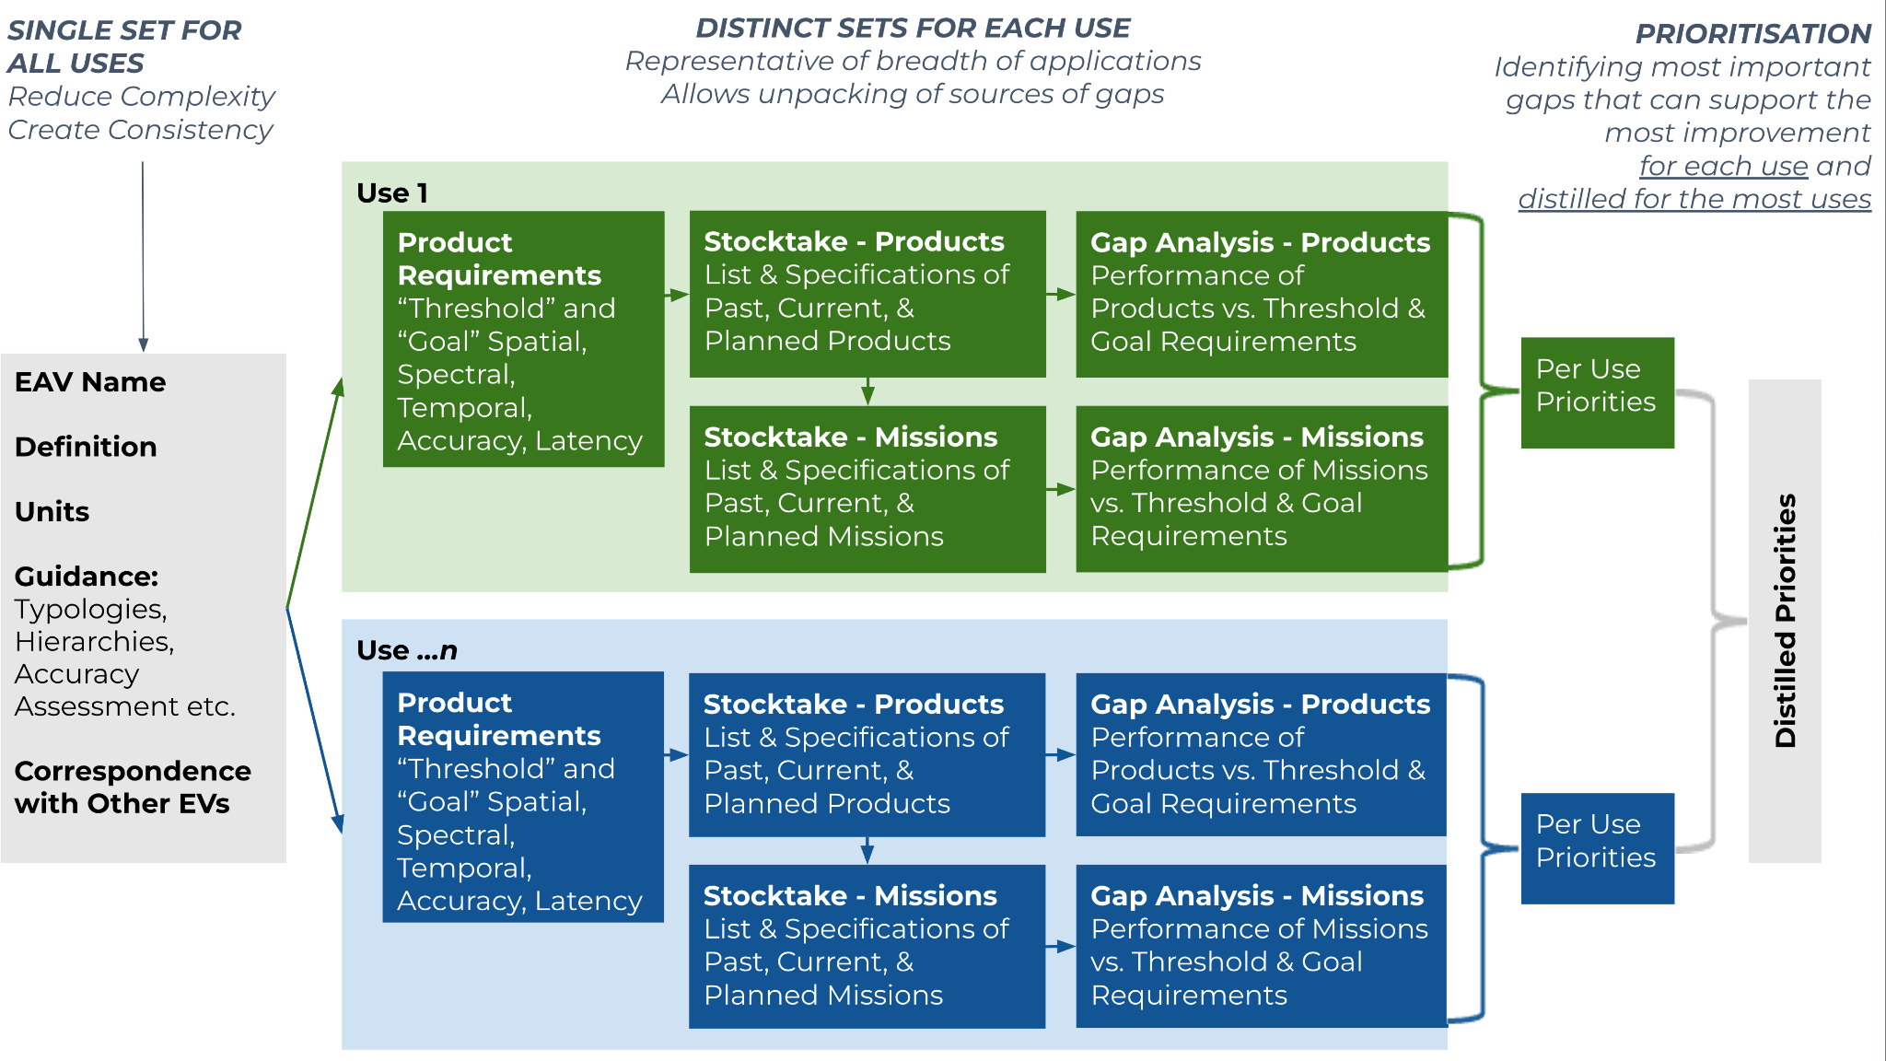
Figure 1: The Framework and Sequence of Effort in the GEOGLAM EAV Work.

Objective 2: Reach Consensus on the EAV List and Affirm EAV Stewards [IN PROGRESS]
- Agreement: An Initial “Suite” of agriculture information EAVs - to test the new EAV framework, as well as Lead Stewards (responsible parties) and Participants (contributors):

Variable | Lead Steward(s) | Participants
Crop Type | Mariana Belgiu (U of Twente)  Livia Peiser (UN FAO) | Herve Kerdiles (EC), Miao Zhang (Chinese Academy of Sciences, CAS), Felix Rembold (EC), Michel Massart (EC), Shinichi Sobue (JAXA), Zoltan Szantoi (ESA), Pierre Defourny (UC Louvain), Jinlong Fan (Beijing Normal), Shunlin Liang (Hong Kong U), Laurent Tits (VITO), Arun Pratihast (Wageningen), Lorenzo De Simone (UN FAO), Lijun Zuo (CAS), Gilberto Camara (INPE), Rakhesh Devadas (Agriculture Australia)
Crop Yield | Belen Franch (U of Valencia) | Bettina Baruth (EC), Christina Justice (U of Maryland), Michele Meroni (EC), Hongwei Zeng (CAS), Hendrik Boogaard (Wageningen), Herve Kerdilles (EC), Feng Yin (NCEO & University College London), Sophie Bontemps (UC Louvain), Livia Peiser (UN FAO), Lorenzo De Simone (UN FAO), Inbal Becker-Reshef (UMD), Maria Piles (U of Valencia), Ioannis Athanasiadis (Wageningen), Jonathan Pound (UN FAO)
Actual Evapo- transpiration | Jippe Hoogeveen (UN FAO) | Michelle Massart (EC), Michael Marshall (U of Twente), Rado Guzinski (DHI), Hongwei Zeng (CAS), Fuyou Tian (CAS), Forrest Melton (NASA), Agnieszka Soszynska (NCEO & U of Leicester), Steven Wonink (eLeaf), Greg Husak (UC Santa Barbara), Livia Peiser (UN FAO)
Field Boundaries | Catherine Champagne (Agriculture Agrifood Canada) | Lin Yan (Michigan State), Lorenzo De Simone (UN FAO), Mykola Lavreniuk, Yuval Sadeh (Monash University), Bahram Daneshfar (AAFC)
Cover Crop | Dean Hively (USGS), Alison Thieme (UMD), Alyssa Whitcraft (UMD) | Catherine Champagne (AAFC), Laurent Tits (VITO), Mike Humber (UMD), Heather McNairn (AAFC), Felid Rembold (EC)

Summary of Phase 1 EAVs
The objectives of the Phase 1 EAV articulation were two-fold:
- Characterise the first set of EAVs.
  - Each group did this a little differently. At the end, an attempt was initiated to “harmonize” the inputs, but is still in progress as of the submission of this report. The link to this dynamic table can be found here: https://docs.google.com/spreadsheets/d/1IwQbvS30-upT2N8qklVoQPxUmkOjHsmqsd1fK4WfBn8/edit?usp=sharing
- Through the exercise of characterising the first set of EAVs, “pressure test” the Framework and identify lessons learned to inform the characterisations of the subsequent EAVs.
  - Consensus:
    - Revisions within the June-September timeline allowed for improvements that clarified substantially the framework.
    - The framework is solid, logical, and valuable. Still, improvements can be made as well as clarifications about circumstances where variables appear as “non
  - Challenges:
    - Ensuring active contribution by multiple GEOGLAM community-members, particularly as we move to variables with which our most active community members are relatively less experienced
    - A greater level of effort to support the coordination of this activity is needed than is at present available.
Below, two examples are illustrated with select information shown.

Example: Crop Type
- This is a single variable:
  - Crop Type → spatially-explicit, temporally-explicit determination of identified types of non-perennial crops, types of perennial crops, managed grasslands, and/or of mixed-crop mosaics, as identified within the Cropland Mask.
  - Categories or Hierarchies → Types can be grouped into categories and/or hierarchies following globally recognized nomenclature (for example, FAO or JECAM).
    - Where categorical or hierarchical classification systems are in use, products should include documentation and definitions.
  - Coverage → Cropland Extent
- Four applications were identified and characterised separately; lesson: subsequent efforts should harmonise across applications as much as possible.
- Application described in this report:
  - National monitoring for food security, water security, and early warning systems
    - Attributes →
      - Crops making up 90% of crop production in low-income countries
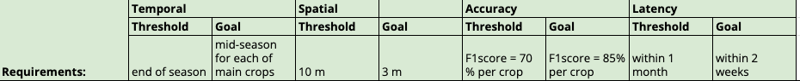
- After undertaking the Stocktake and Gap Analysis, the summary revealed that despite very high importance to GEOGLAM, its mandate, and food security in general, critical barriers existed specifically related to instrument suitability and the existence of products that were readily available for use.
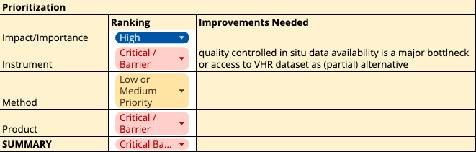
- Methods are of reasonable quality, although improvement could be made toward reaching “Need Met” Ranking.
- From this, emphasis should be placed on product generation, which itself is reliant upon quality-controlled in situ data and/or well-calibrated very high resolution satellite datasets.

Example: Seasonal Cover Crop
- Two applications were identified supported by the same set of variables with the same characterisations:
  - Monitoring, Reporting, and Verification (MRV) of Conservation Management Adoption
  - Measure WCC performance (biomass, N content, fractional cover, carbon traits) to support adaptive management of environmental benefits, inform farmer decision making, and provide input to process based environmental models
- This is a set of 4 “Ag Information EAVs” with 6 “Input EAVs” which support them:
  - Ag Information EAVs
- Seasonable Cover Crop Presence/Abscense, nested thusly:
Seasonal Green Cover
Environmental Cover (weeds, “volunteers”)
Agricultural Cover (intentionally sown)
Seasonal Cover Crop (incentive-based, non-harvested)
Harvestable Crop
Crop Type
- Seasonal Cover Crop Performance
- Seasonal Cover Crop Functional Type
- Dynamic Cropland Management Calendar
  - Input EAVs:
    - Fractional Ground Cover → Supports Ag Info EAVs #1, 2
    - Aboveground Biomass → Supports Ag Info EAVs #1, 2
    - Foliar Nitrogen Content → Supports Ag Info EAVs #2, 3
    - Forage Quality Carbon Traits → Supports Ag Info EAVs #2, 3
    - Dynamic Crop Calendar; Attributes:
      - Emergence Date → Supports Ag Info EAVs #1, 3, 4
      - Termination Date → Supports Ag Info EAVs #1, 3, 4
    - Leaf Area Index → Supports Ag Info EAVs #1, 2
- Summary: After going through the requirements setting, stocktake, and gap analysis, the limitations were summarized this way →
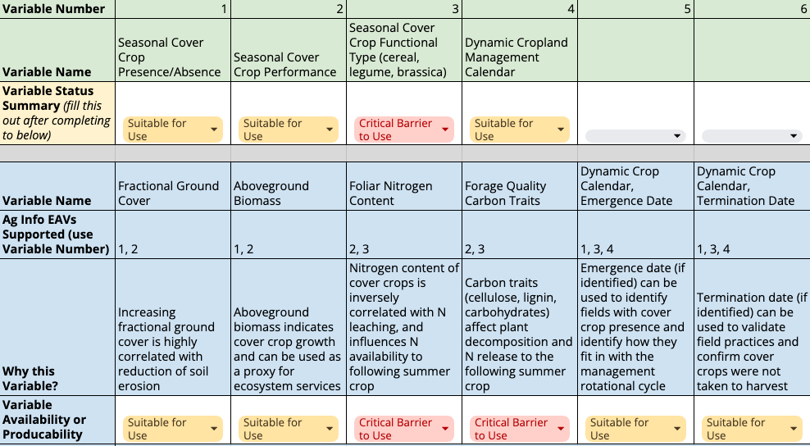
- Example Take-away Lessons:
  - Hierarchies are helpful and should be extended across variables and attributes.
  - Certain “Input EAVs” (e.g. Foliar N Content, Forage Quality Carbon Traits) could actually be attributes of a single variable (e.g. Foliar Traits)
  - Should “Dynamic Crop Calendar” be considered an “Ag Info EAV”? In other uses, it would be.

See Table for Further Variables
Link to Table: https://docs.google.com/spreadsheets/d/1IwQbvS30-upT2N8qklVoQPxUmkOjHsmqsd1fK4WfBn8/edit?usp=sharing

EAV List & Stewards
- Progress: Complete List of EAVs and Associated Stewards - work is still needed
  - We are working to ensure that the EAVs are complete but not duplicative, and that variables that can be collated are (e.g. Evapotranspiration can include aET, rET, and pET), and that variables that can be simply derived from another variable or two are not independently listed, even if the derived products are of high value to have readily available.
    - The link to this dynamic table can be found here: https://docs.google.com/spreadsheets/d/1IwQbvS30-upT2N8qklVoQPxUmkOjHsmqsd1fK4WfBn8/edit?usp=sharing
  - We also need to identify stewards for the next Phase of EAVs.

Objective 3: Identify Synergies with and Opportunities for Engagement with CEOS and Adjacent Communities and their Essential Variables [PROGRESS + ACTION REQUEST]
- Progress: Thanks to the participation of several agencies in the workshop, we have “opened the door” to cross-community collaboration.
  - Still, participation in the 5 initial EAVs as well as in future EAVs.
- Action Request: CEOS agency support, as well as coordination across land areas within CEOS LSI-VC (land Essential Climate Variables, Essential Biodiversity Variables, Essential Water Variables) and with CEOS WG Climate (atmospheric ECVs), is necessary and highly valuable to this activity.
  - Rationale for Agency Support: We know we are not fully accounting for efforts already undertaken by the agencies related to observations and EAV development. This
  - Rationale for CEOS Coordination: Identifying common variables across the different communities and reconciling (where possible) minor differences in variable specifications/requirements will maximize the efficiency of agency contributions and create clearer requests for high-priority observations, data services, and Essential Variable production.

Next Steps with CEOS

Objective 4: Set Milestones and Timelines [COMPLETE / UPDATEABLE]
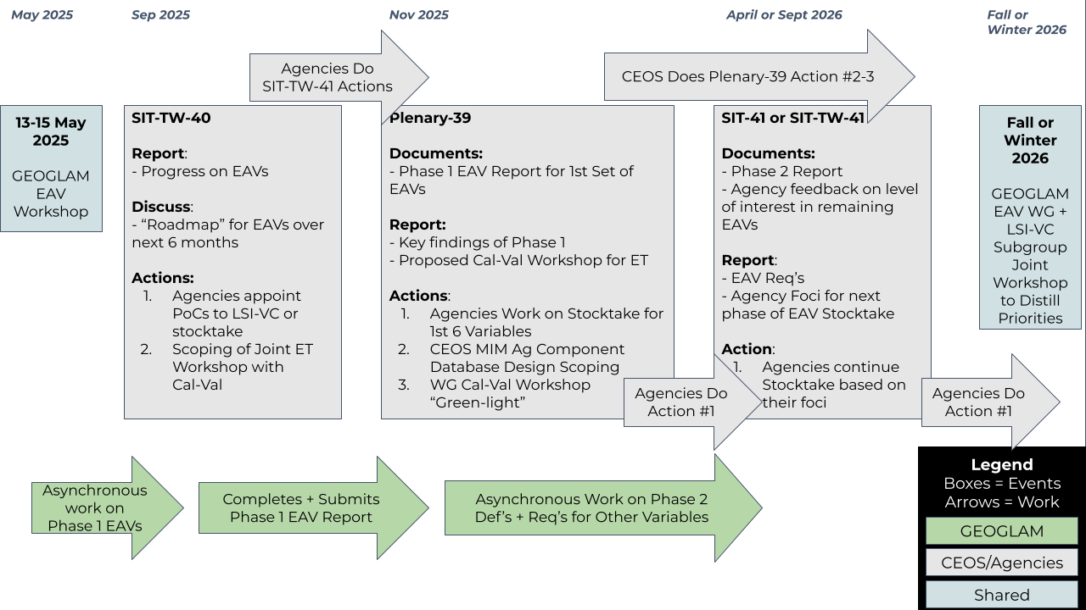
The above diagram was presented at SIT-TW-40 in September 2025. Focusing only the GEOGLAM Stocktake & Gap Analysis-related actions, at Plenary-39, it is hoped that:
- Agencies who have not yet done so will appoint PoCs to the LSI-VC GEOGLAM Subgroup and/or the stocktake + gap analysis work
- Agencies will take the action to support the stocktake + gap analysis work for the first 6 variables
  - While much of this is done, improvements can be made including adapting/enacting the lessons learned from Phase 1, and ensuring that agency contributions are accounted for in the stocktake + gap analysis.

This will be followed in the next 6-10 months by an expansion of the above, more “refined” effort toward completing the GEOGLAM EAV characterisation, stocktake, and gap analysis, including the cross-community linkages (“Objective 3”). This would then be followed by a workshop in late 2025 or early 2026 to distill the priorities into targeted requests for CEOS and the agencies.

Report Versioning History

Activity | Date | Person
Draft 1.0 Finalized and Circulated to Symbios | 10/24/2025 | Alyssa Whitcraft (akwhitcraft@GEOGLAM.org)
Feedback | 10/21/2025 | Sven Gilliams (sgilliams@geosec.org)
Draft Updated | 10/20/2025 | Alyssa Whitcraft
Contributions from EAV Lead Stewards | 10/17/2025 | See within document
Feedback | 10/1/2025 | Felix Rembold, Michele Meroni
Draft Initiated | 6/12/2025 | Alyssa Whitcraft

