Minutes V1.0

228th CEOS SECRETARIAT MEETING

Thursday 5th October 2017

7AM US East, 1PM Europe, 8PM Tokyo, 10PM Sydney

Chaired by USGS

Participants

CEO: Jonathon Ross
Incoming CEO: Steven Hosford
COM: Mauro Facchini, Michael Berger, Mark Dowell
ESA/SIT Chair Team: Stephen Briggs, Ivan Petiteville
EUMETSAT: Robert Husband
GEO Secretariat: Barbara Ryan, Akiko Noda
JAXA: Osamu Ochiai, Yukio Haruyama, Koji Akiyama
NASA: Mike Freilich, Christine Bognar
NOAA/SIT Vice-Chair Team: Steve Volz, Kerry Sawyer
SEO: Brian Killough
USGS: Frank Kelly, Steve Labahn, Jenn Lacey, Eric Wood, Matthew Steventon, Stephen Ward
WGCapD: Senthil Kumar
WGClimate: Pascal Lecomte
WGCV: Kurt Thome
WGDisasters: Stéphane Chalifoux
WGISS: Andrew Mitchell, Mirko Albani
- Welcome and Introductions
Frank Kelly (USGS, CEOS Chair) welcomed everyone to CEOS SEC-228.
- Review of Agenda
Frank Kelly (USGS, CEOS Chair) asked for feedback on the agenda/additional agenda items. Barbara Ryan (GEO SEC) requested an item on an upcoming UNFCCC Climate Show that will be held in Geneva next April.
- Action Status
Frank Kelly (USGS, CEOS Chair) noted that the updated SEC action record was included with the meeting agenda. No SEC actions were reviewed.
30th CEOS Plenary Actions
Jonathon Ross (GA, CEO) reviewed the 30th CEOS Plenary actions that are still open (included with the agenda for this teleconference). Jonathon highlighted 30-2 in particular (related to the GEOGLAM Secretariat paper on commercial engagement), noting that it is not clear what CEOS should do about this action, as we are still awaiting the paper. Barbara Ryan (GEO SEC) noted that the paper has not been completed. She also noted the recent GEOGLAM leadership change from Michel Deshayes to Ian Jarvis, and reported that she would expect the paper to be progressed following the upcoming GEOGLAM Advisory Committee meeting. We will revisit this action at CEOS Plenary and make a decision on whether to keep it open (wait and see) or close it pending further progress on the GEOGLAM side.
Jono reported that all other actions are on-track to be closed at Plenary.
- SIT Technical Workshop Action Recap
Stephen Briggs (ESA, SIT Chair) reviewed the actions from SIT Technical Workshop with due dates before or at CEOS Plenary. The status reported for each are listed below (please cross-reference with the SIT Technical Workshop action record):
- SITTWS-2017-01: No progress to date. An update will be reported at CEOS Plenary.
- SITTWS-2017-03: Press releases have been sent by CEOS, GEO, and others.
- SITTWS-2017-04: Christine Bognar (NASA) reported that David Crisp will not be attending CEOS Plenary in person, but he has offered to join remotely if needed. Mark Dowell (COM) will follow up with David regarding AC-VC presence at Plenary and potential 2018 CEOS Chair follow-on activities.
- SITTWS-2017-09: In progress. JAXA continuing to follow up with NIES.
- SITTWS-2017-10: Pascal Lecomte (WGClimate Chair) reported that the first version of the Space Agency Response to the GCOS IP was recently circulated (with one missing chapter). It is hoped that the missing chapter will be sent later today. Comments from CEOS SEC will be due by the end of next week (October 13). There is no need for a broader review. The final CEOS SEC-approved version will be sent to CEOS Principals as the recommended submission.
- SITTWS-2017-12: Speaking points are not required for COP23, however Mark Dowell (COM) will work with Pascal to extract some key ‘common messages’ from the CEOS Statement.
- SITTWS-2017-13: This action is ongoing. The final draft of the 1-pager has been sent.
- SITTWS-2017-14: Adam Lewis (GA, LSI-VC Co-Lead) has been progressing this action. On-track for completion by CEOS Plenary.
- SITTWS-2017-20: Ivan Petiteville (ESA, SIT Chair Team) noted that this action is written incorrectly, and clarified that the intent is to identify SDG POCs within each agency. The action will be revised.
228-01 | ESA SIT Chair Team to revise the wording of action SITTWS-2017-20 so that it captures the intent as written in the rationale (identifying SDG POCs at agencies). | ASAP
- SITTWS-2017-22: The 1-page statement on EO for ODA will be finished by tomorrow.
- SITTWS-2017-23: The outcome of this action will be an action from CEOS Plenary to prepare the supporting document.
- SITTWS-2017-24: To be progressed at the pre-Plenary Troika meeting.
Barbara Ryan (GEO SEC) asked that Steven Ramage (GEO SEC) be kept in the loop on actions related to IFIs, so that any messages can be reinforced at GEO Plenary during the related panel session.
- CEOS Plenary Preparation
Frank Kelly (USGS, CEOS Chair) noted that preparations for the meeting are progressing as planned. He noted once again the focus on decisions and discussions, as highlighted in the joint letter sent earlier this year by the SIT Chair and CEOS Chair.
Steve Labahn (USGS, CEOS Chair Team) reported that around 85 people are expected to attend the Plenary. He added that the primary hotel is close to selling out, and requested that anyone having difficulty booking a room as a result contact the CEOS Chair Team for assistance (there are some alternative hotel options).
Steve recalled that the latest version of the agenda is v0.9.1 (sent earlier this week) and v1.0 will be distributed following this call – once all feedback received has been reflected.
Version 1.0 will also feature explicit links between agenda items and CEOS Work Plan tasks, and Jonathon Ross (GA, CEO) will be presenting a CEOS Work Plan action status overview under item 1.3. Presenters have been asked to explicitly link any updates to CEOS Work Plan items, and have also been asked to update the online CEOS Deliverables Tracker.
Mike Freilich (NASA) thanked the CEOS Chair Team and CEO for their efforts regarding updating/reporting on CEOS Work Plan progress. Mike asked how areas that are not progressing will be identified/tracked. Jonathon Ross (GA, CEO) reported that he will be highlighting any issues under item 1.3 on the CEOS Plenary agenda.
Steve stepped through the latest draft agenda (v0.9.1), seeking to identify any issues. The following were raised:
- The European Commission’s presentations will be given by Mauro Facchini, rather than Philippe Brunet.
- JAXA requested an agency update under Session 4 (to be presented by Akiko Suzuki).
- Item 4.10 will be presented by Alex Held, not Jonathon Ross.
- Barbara Ryan (GEO SEC) noted that the GEOGLAM Advisory Committee (AC) will meet on the 24th of October, and she suggested that any key messages from CEOS should be communicated during the Plenary, so they can be delivered the following week to the AC.
228-02 | CEOS Chair Team to connect with Brad Doorn regarding the opportunity of using CEOS Plenary to gather CEOS input to the GEOGLAM Advisory Committee meeting. | ASAP
- After some discussion, Kerry Sawyer (NOAA, SIT Vice-Chair Team) agreed to present item 7.1 on behalf of Paul DiGiacomo (NOAA). It was agreed that 7.1 should be a brief overview of ongoing efforts in the water/ocean space (around 2 slides each on GEO/CEOS Water Strategies, AquaWatch, GEOGLOWS, Blue Planet, COVERAGE, UN GOOS, SDGs, etc.) to set the stage for the discussion in item 7.3. It was agreed that a synthesized presentation covering the overlaps and scope of each activity would be very helpful. Kerry will share some slides by the 16th at the earliest.
- Item 7.2 will be presented by either Alex Held (CSIRO) or Tom Cecere (USGS), and the final report is expected to be circulated after the Plenary (a prior version was circulated earlier this year).
- The planned tour de table in the SDG session will not go ahead.
- An ISRO agency update was requested (to be presented by Raj Kumar)
228-03 | Mark Dowell (COM) to share the final version of the SBSTA 47 Space Agency Statement. | ASAP
- Working Group / Ad Hoc Team / CEOS Chair Initiative Updates

SDCG for GFOI
Stephen Ward (SDCG Sec) recalled that the CEOS Lead for GFOI is proposed to change – from Masanobu Shimada to Osamu Ochiai. No objections were raised by CEOS SEC. Stephen thanked JAXA for their continued support.
Stephen also noted the recently distributed announcements (from CEOS, GEO, and others) regarding the global baseline coverage achievement. Steve Labahn (USGS, CEOS Chair Team) confirmed that USGS are also planning to advertise the achievement through their own news channels.
Stephen reported that UKSA have shown interest in providing a Co-Chair for the SDCG, to replace Gene Fosnight/USGS. UKSA have posted a vacancy for the role, and the SDCG are hopeful that this will come through. Funding for the SDCG Secretariat is yet to be identified, however numerous avenues continue to be explored. A full status update on resourcing will be given at CEOS Plenary.
- CEO Report
Jonathon Ross (GA, CEO) noted that he has circulated an updated draft of the key messages for the CEOS delegation to GEO Plenary as well as the CEOS Statement to GEO Plenary. He thanked those that provided comments on the earlier drafts, and made a final call for comments. Christine Bognar (NASA) reported that NASA will be taking another look at both documents.
Jonathon also reported that the Korea National Institute of Environmental Research (NIER) will no longer be applying for CEOS membership.
- GEO SEC Report
Akiko Noda and Barbara Ryan (GEO SEC) reported on some recent staff changes at the GEO Secretariat. The secondments of Andiswa Mlisa (AfriGEOSS) and Michel Deshayes (GEOGLAM) have both ended after 3-4 years. Ian Jarvis (Agriculture and Agri-Food Canada) will replace Michel from November, and a vacancy remains for the AfriGEOSS role.
GEO is hosting a side event (in collaboration with WMO/GCOS, Friday November 10) and an exhibition booth at COP23. There will also be a SBSTA Chair and EO community meeting from 08:00 – 10:00 on November 10 (Stephen Briggs later clarified that this meeting is invitation-only). Barbara added that GEO have been granted a two-week exhibition slot for COP23 (1 week more than usual) and are welcoming collaborations with others (in particular CEOS) to make best use of the time available. Pascal Lecomte (ESA, WGClimate Chair) noted that ESA will have a booth at COP23 for the two weeks, and would also be open to collaborative events with GEO. The US will only have a very small delegation at COP23 (and no exhibition booth). Yukio Haruyama (JAXA) reported that the Japanese plans for COP23 are yet to be confirmed.
Barbara also noted an International Climate Show (6-8 April, Geneva) which is expected to draw a crowd of 3000-4000 people. GEO and CEOS have been invited to contribute, and speaking slots are still available. Barbara took an action to share further details.
228-04 | GEO SEC to follow up with CEOS regarding the potential for joint exhibitions at COP23, making best use of the two-week slot obtained by GEO. | ASAP
228-05 | Barbara Ryan to share further details of the 6-8 April International Climate Show (Geneva) and how CEOS can engage. | ASAP
228-06 | CEOS SEC members to inform Barbara Ryan if they are aware of any opportunities for commercial sector funding assistance for GEO Plenary. | ASAP
Mark Dowell (COM) asked if GEO are submitting documents to COP or SBSTA, and if so, asked that GEO please make sure CEOS is aware so the appropriate support can be given during the meetings. Mark will share the previously mentioned CEOS messages, and he noted that CEOS would very much appreciate GEO’s support for these.
228-07 | Mark Dowell to share the CEOS statements/messages for COP23 with GEO SEC. | ASAP
GEO Plenary CEOS Exhibition Booth
Brian Killough (NASA, SEO) reported that the application for the CEOS booth at GEO Plenary is being submitted. The booth is being funded by USGS and the SEO. In addition to the booth, four separate Data Cube side events are also being coordinated by the SEO. Each side event will be 1.5 hours in length, with the following themes: introduction to Data Cube, Digital Earth Australia, country Data Cube testimonials (Colombia, Uganda, UK, Switzerland), and hands-on demonstrations. There will also be a small CEOS exhibition at CEOS Plenary (screen with presentations as well as some handouts/flyers).

GEO Executive Committee Representation
Kerry Sawyer (NOAA, SIT Vice-Chair Team) asked about the plans for CEOS’ GEO ExCom representation at the 41st and 42nd meetings being held around GEO Plenary. NOAA will be the SIT Chair by the time of these meetings, and the SIT Chair (Steve Volz) will not be able to serve as the CEOS Observer to the ExCom as he is also the lead Co-Chair for the GEO ExCom for 2018. The plan was for the SIT Vice-Chair to serve as the CEOS Observer to the GEO ExCom in this situation, however one is yet to be confirmed.
Jonathon Ross (GA, CEO) took the opportunity to announce that CSIRO and GA would like to be considered for the open SIT Vice-Chair (and subsequent SIT Chair) position – beginning at the 2017 CEOS Plenary. Jonathon provided the following summary of the proposed roles and meetings:
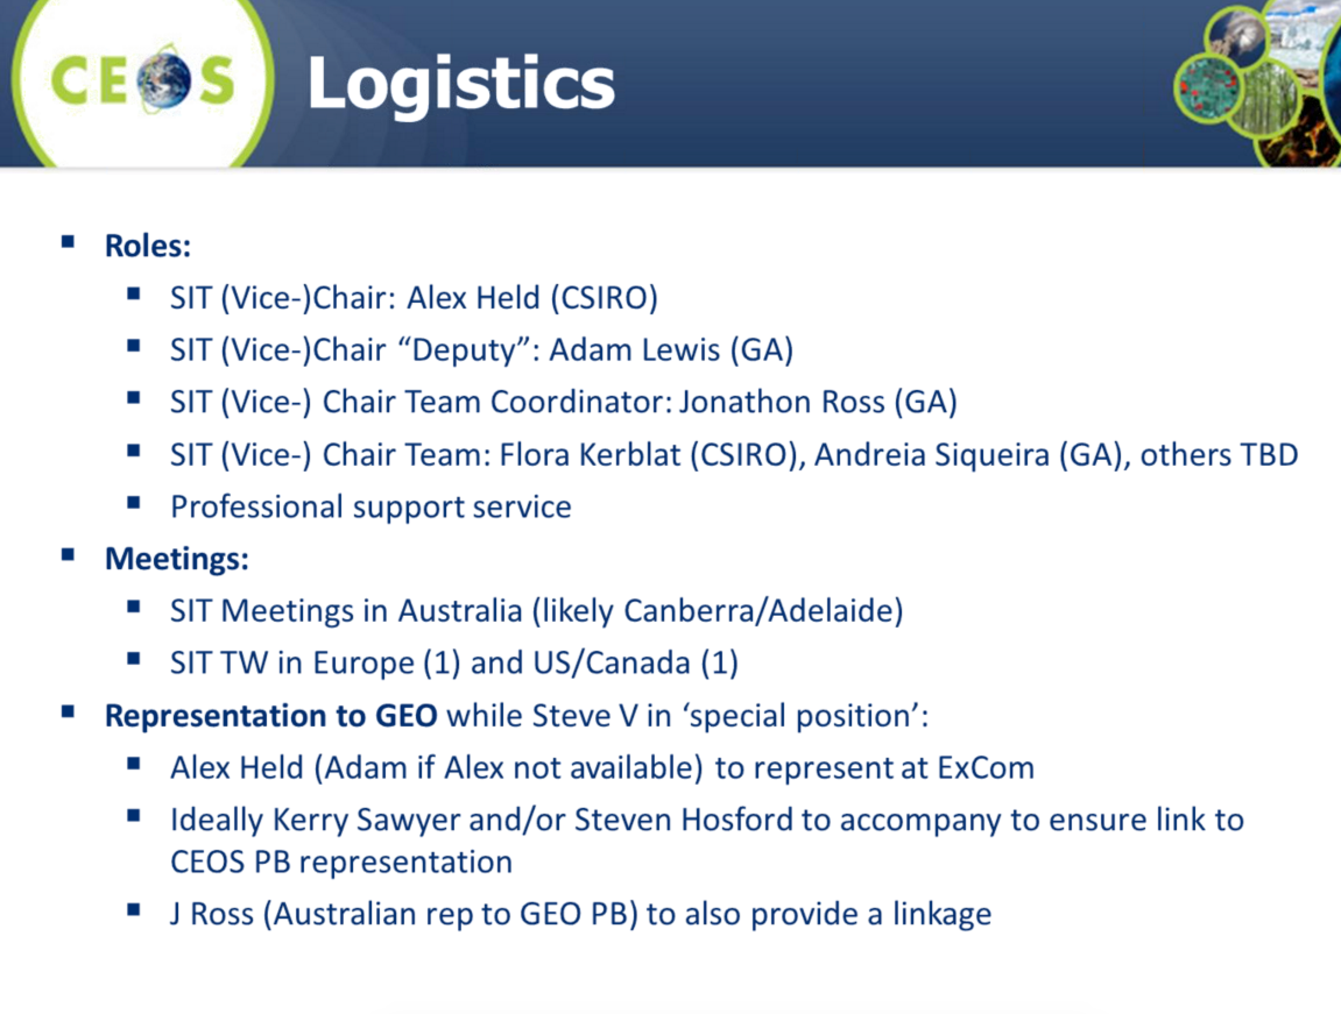
If this proposal is accepted, Alex Held (CSIRO)/Adam Lewis (GA) would represent CEOS at the GEO ExCom.
Jonathon noted that it is unknown how the recently announced Australian Space Agency will impact the role of CSIRO and GA in CEOS, however the commitment and contribution is recognized by the reference group advising the Australian Government on these matters.
228-08 | Jonathon Ross and Steve Volz to coordinate CEOS’ representation at the 41st and 42nd GEO ExCom. | ASAP
228-09 | CEOS Chair Team to reflect the Australian SIT Vice-Chair nomination on the CEOS Plenary agenda. The nomination will be for decision by CEOS Plenary, and a written nomination should be provided as part of the preparatory documents/materials. | ASAP
- AOB
Stephen Briggs (ESA, SIT Chair) noted that the GCOS Steering Committee has discussed the idea of including a permanent space agency (CEOS/CGMS) liaison on the Committee, and he noted that Carolin Richter (GCOS) might raise this idea during CEOS Plenary.

Open CEOS Leadership Positions
Senthil Kumar (ISRO) noted that ISRO should have more to say on the 2020 CEOS Chair position at CEOS Plenary.
Christine Bognar (NASA) suggested (on behalf of the NASA CEOS team) that agencies marked as ‘to be confirmed’ on the open CEOS leadership positions table be asked to confirm their nominations in advance of CEOS Plenary, to open up the opportunity to confer with other agencies prior to Plenary and to also save time during the meeting.
228-10 | CEOS Chair Team to follow up all agencies with nominations marked as TBC in the ‘Open CEOS Leadership Positions’ table ahead of Plenary, with the goal of confirming or removing these nominations before the meeting. | ASAP
EO Handbook on the SDGs
Ivan Petiteville (ESA) reported that the next CEOS EO Handbook on the SDGs is progressing well. Most articles have been received for Part 2, and the editing team are now iterating the inputs with contributors – who represent the full range of SDG stakeholders. A mature draft of Part 1 (context, issues) is complete, and Part 3 (examples of EO for specific Goals) is in formulation. Ivan asked CEOS SEC to anticipate receiving draft materials for review around November 8 (a two-week CEOS SEC review period is planned).
- Next Meeting and Adjourn
Frank Kelly (USGS, CEOS Chair) adjourned the meeting. He thanked everyone for attending and reported that CEOS SEC-229 will take place on October 18 at 09:00 in Salon B/C at the Holiday Inn Rapid City-Rushmore Plaza.

