Minutes V1.0
275th CEOS SECRETARIAT MEETING
Thursday 14 January 2021

Chaired by NASA
Participants
CEO: Marie-Claire Greening
ESA: Ivan Petiteville
EUMETSAT: Robert Husband, Paul Counet
GEO SEC: –
ISRO: Raj Kumar
JAXA: Osamu Ochiai, Yukio Haruyama, Koji Akiyama
NASA: Sandra Cauffman (Chair), Christine Bognar, Andy Mitchell, Stephen Ward, Matthew Steventon
NOAA: Kerry Sawyer
SIT Chair Team: Adam Lewis, Andreia Siqueira
SEO: Brian Killough, Kim Holloway
SST-VC: Christo Whittle, Ed Armstrong
WGCapD: Nancy Searby, Lauren Childs, Yasha Moz
WGClimate: Jeff Privette
WGCV: Akihiko Kuze
WGDisasters: David Green, Dave Borges, Pierric Ferrier
WGISS: Robert Woodcock
- Welcome and Introductions, Review of Agenda
Sandra Cauffman (NASA, CEOS Chair Team) welcomed everyone to SEC-275 and wished everyone a happy and healthy 2021.
Sandra took a few moments to acknowledge that on December 31, 2020, Kerry Sawyer’s term as CEOS Executive Officer (CEO) concluded and Marie-Claire Greening’s two-year term has commenced. Sandra thanked Kerry and NOAA for her service. She welcomed Marie-Claire and thanked her and Kerry for working together in recent months to ensure a smooth transition.
Sandra noted that she also wanted to take the opportunity to mention that last December, the SEC bid farewell to Alain Ratier, who retired as Director General of EUMETSAT and as its CEOS Principal. Sandra also noted that in December 2020, three members of the NASA CEOS team whose combined contributions to CEOS amounted to more than 20 years retired: Steve Neeck (P-VC); Jay Al-Saadi (AC-VC) and David Jarrett (LSI-VC).
Prior to proceeding with the meeting, Christine Bognar (NASA, CEOS Chair Team) also wished everyone Happy New Year. She asked the SEC for feedback on the agenda, including any extra items for discussion. No additional topics were raised.

- Action Status
Christine Bognar (NASA, CEOS Chair Team) reviewed outstanding SEC and CEOS Plenary actions and requested updates from the actionees. The following updates were noted:
272-02: CEOS Executive Officer to convene a small group (led by the CEO, and including Brian Killough (SEO), and Jonathon Ross (SIT Chair Team)) to draft a process and policy on the use of logos in CEOS.
Brian Killough (NASA, SEO) reported that a draft of this high-level document was sent with the SEC-275 written reports. Brian asked for feedback via email before SEC-276 on February 18, 2021, when further discussion is planned for inclusion on the SEC agenda. It was agreed that SIT-36 will be the target for finalisation and adoption of this Branding Guidelines document.
274-01: CEOS Chair Team and CEO to review the CEOS Governance and Processes document, External Request Process Paper and the New Initiatives Process Paper to understand the changes necessary to reflect the changes made to the CEO Terms of Reference.
Christine reported that work has started and that an update will be given at SEC-276 on February 18, which is the due date for this action.
Marie-Claire Greening (CEOS Executive Officer) provided updates on a few CEOS Plenary actions:
CEOS-34-15: COAST Ad Hoc Team to coordinate with the SIT Chair on the submission of COAST to the United Nations Decade of Ocean Science for Sustainable Development (2021-2030). This action needs to be done in coordination with the CEOS Secretariat and COVERAGE, per action CEOS-34-20.
COVERAGE was submitted by NASA as an ‘Ocean Shot’ in December, and COAST will be submitted as a Programme to the UN Decade on 15th January by NOAA. Both activities have been submitted under the banner of CEOS. With this, Action CEOS-34-15 will be closed by 15th January. Marie-Claire requested that the SEC inform her if there have been any other ‘CEOS-badged’ submissions to the UN Decade.
CEOS-34-20: COVERAGE, COAST, and SIT Chair Teams to discuss and conclude on how CEOS will coordinate internally and externally on CEOS involvement in the United Nations Decade of Ocean Science for Sustainable Development (2021-2030). Once determined, the SIT Chair will prepare a follow-up letter (in coordination with the CEOS Secretariat) to the IOC identifying the appropriate CEOS contact for matters relating to the Decade.
Marie-Claire said the COAST Ad Hoc Team has requested that this be done soon, including the identification of a single point of contact. Paul DiGiacomo (NOAA) offered to be the point of contact at CEOS Plenary, and this matter is open. Marie-Claire reported that the offer still stands and that she is seeking feedback and a decision from SEC on whether Paul could be identified as the point of contact.
Adam Lewis (GA, SIT Co-Chair) suggested that consideration needs to be given to how Paul will interface with CEOS leadership. Marie-Claire suggested that she could serve as the connection. A discussion followed on whether whoever becomes the designee can act alone as the CEOS representative or whether the person needs to be considered as operating on behalf of some other formal CEOS position (i.e., who would the designee need to keep informed and how do we ensure the necessary reporting structure).
Christine suggested that we might wish to discuss this further on a telecon that includes representatives of the COAST and COVERAGE teams. She added that when these submissions are made, they are done via the national contingent (US in this case). Once accepted, it is important for there to be coordination within CEOS to ensure that everyone is part of the narrative.
Kerry suggested that the mechanism here is similar to the way CEOS contributes to UNFCCC via WGClimate. While submissions are via the national delegations, the CEOS community should still be made aware that the submissions of CEOS activities have been made. She was unclear on whether this was done to the fullest extent possible for these initial submissions.
275-01 | CEOS Executive Officer to organise a teleconference between the SIT Co-Chairs, COVERAGE, COAST AHT, and CEOS Chair Team to address CEOS Plenary Action 34-20 and to confirm the mechanics of the role of CEOS representation to the United Nations Decade of Ocean Science for Sustainable Development (2021-2030). | SEC-276
Ivan Petiteville (ESA) and Raj Kumar (ISRO) reported that there were no submissions from ESA or ISRO, respectively, to the United Nations Decade of Ocean Science for Sustainable Development (2021-2030).
Nancy Searby (NASA, WGCapD Chair) noted that being thoughtful about representation in CEOS, GEO and any related UN work plans will be important (e.g., being clear about what is specifically a CEOS contribution).
- SIT Chair Report
Adam Lewis (GA, SIT Co-Chair) reported:
- The discussions regarding CEOS contributions to the UNFCCC Global Stocktake are ongoing. A meeting was held before Christmas and a follow-up discussion is planned for next week.
Sea Surface Temperature Virtual Constellation (SST-VC) Report
Ed Armstrong (NASA, SST-VC Co-Lead) reported on SST-VC developments:
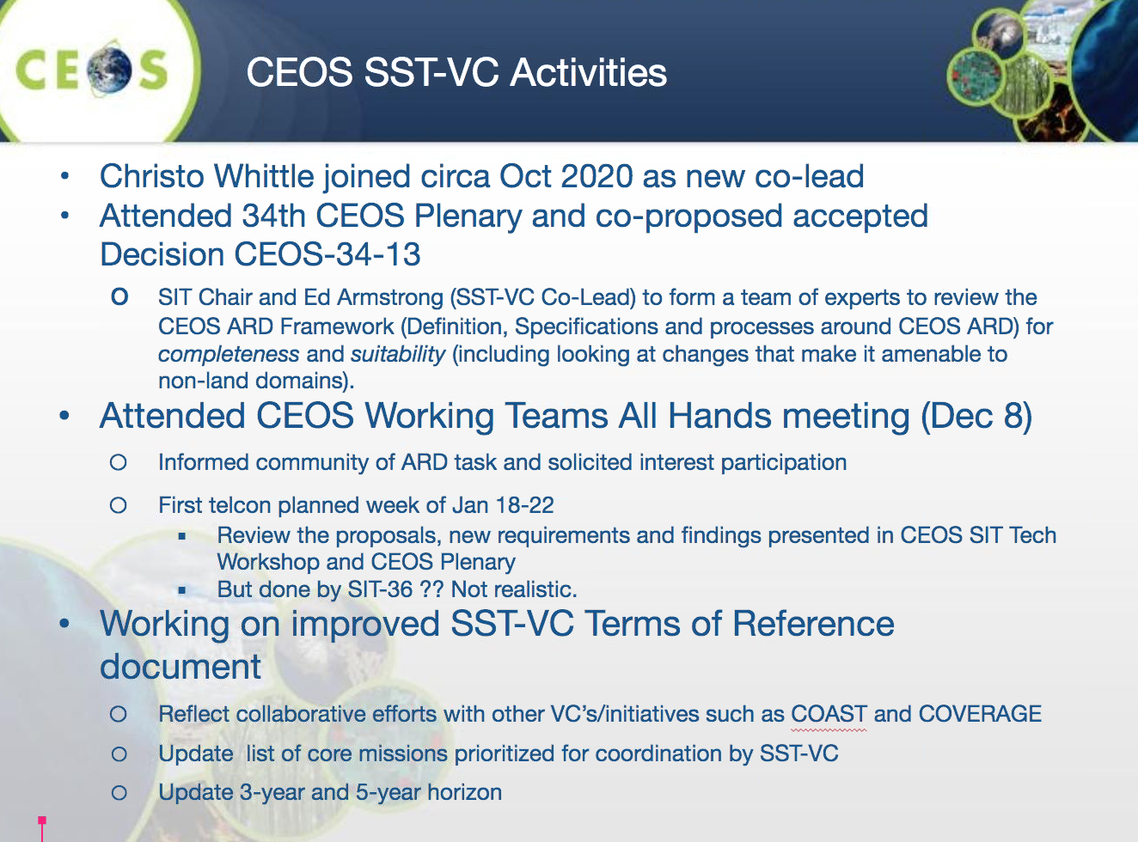
- Ed reported that a teleconference is planned for next week on the topic of potentially expanding the CEOS ARD Framework beyond the land domain. He notified SEC that the CEOS Plenary Action CEOS-34-13 (noted above) will not likely be completed by SIT-36 (March 2021), and he sought advice on how to manage the expected delay.
Adam Lewis confirmed that he will respond to the poll for the teleconference and can assist with securing responses from others. No issues were noted regarding the notice that the SIT-36 due date for CEOS-34-13 is not feasible.
Christo Whittle (CSIR representing SANSA) introduced himself. Christo is the new Co-Lead of the SST-VC, following the departure of Anne O’Carroll as SST-VC Co-Lead. Christo’s first task is updating the SST-VC Terms of Reference, including to reflect new collaborations such as those with COVERAGE and COAST and the Analysis Ready Data (ARD) effort (including an ARD toolkit for COAST and COVERAGE).
On behalf of the CEOS Chair Team, Christine Bognar (NASA) welcomed Christo and thanked him and Ed for their report.
- CEOS Executive Officer Report
Marie-Claire Greening (CEOS Executive Officer) reported:
- Marie-Claire began her term as CEO from January 1, 2021. She thanked Kerry Sawyer (NOAA) for her help and advice in preparation for her term as CEO.
- CEOS 2021-2023 Work Plan
  - Contributing entities will be contacted in the coming weeks to provide updates on each topic (chapter) in the next edition of the three-year CEOS Work Plan.
  - The objective is to complete the first round review of the entire document and generate a first draft of the CEOS 2021-2023 Work Plan by the end of February for virtual approval before SIT-36.
  - This update to the CEOS 2020-2022 Work Plan will be a ‘light touch’ since the CEOS community did a thorough review and update later in 2020 than originally scheduled due to the COVID-19 global pandemic.
- GEO
  - Planning for the CEOS-GEO bilateral meeting is well underway. The format is expected to be two 3-hour sessions on February 2-3, 2021. CEOS representation will consist of the SIT Chair, CEOS Chair, SEO, CEO and a few thematic experts for specific topics.
  - The meeting will be held virtually. The objective is to use the limited time available to focus on topics for discussion that were mutually agreed in advance. A draft agenda will be distributed on the week of January 18.
  - It was noted that Marie-Claire Greening has been officially announced as the second CEOS Alternate to the GEO Programme Board (PB). She will participate in the GEO PB-19 meeting on January 26-28, 2021.
Sandra Cauffman (NASA, CEOS Chair Team) thanked Marie-Claire for providing CEO continuity and thanked Kerry for all of the support provided to Marie-Claire.
275-02 | Marie-Claire to send Sandra Cauffman the draft CEOS-GEO bilateral meeting agenda, to facilitate CEOS Chair Team coordination. | ASAP
- Working Group Reports
WGDisasters
David Green (NASA, WGDisasters Chair) reported:
- WGDisasters is still seeking a new Data Coordination Team (DCT) Lead. Pierric Ferrier has led DCT activities to date, but a replacement needs to be identified before Pierric becomes WGDisasters Chair at the 2021 CEOS Plenary. To date, no candidates have been identified. This is a critical role for the pilots and demonstrators of WGDisasters. The DCT Lead works with agencies on data contributions and coordinates the collection of important feedback.
- The WGDisasters Wildfire Pilot Scoping Team is meeting regularly and developing an Implementation Plan (IP). A Pilot IP is expected to be shared before CEOS SIT-36, for review and endorsement at the meeting.
- Recently reported on the WGDisasters Flood Pilot to the American Meteorological Society.
- WGDisasters-15 will be a virtual meeting held on March 9-11, 2021.
WGClimate
Jeff Privette (NOAA, WGClimate Vice Chair) reported:
- The main focus for WGClimate is wrapping up the ECV Inventory Version 3 Gap Analysis.
- Other priorities include supporting the AFOLU Roadmap group in converging on its deliverables, and looking at options for the next WGClimate meeting, which is being planned for March, 2021.
WGISS
Robert Woodcock (CSIRO, WGISS Chair) reported:
- Preparation is underway for the next WGISS meeting in April 2021. There will be a special session on cloud data formats, during which feedback from data providers and users will be sought to help inform best practices.
- Establishment of the CEOS Earth Analytics Interoperability Lab (EAIL) is continuing, with a range of initial sample data being collected for a specific region. The EAIL leads will be following up with project teams soon. Ed Armstrong (NASA, SST-VC Co-Lead) expressed interest in being involved in testing.
- A small group has been formed around the topic of Jupyter Notebooks. This team will convene soon to discuss EO best practices for Jupyter Notebooks.
WGCapD
Nancy Searby (NASA, WGCapD Chair) reported:
- Dr. Pham Thi Mai Thy (VAST-VNSC, WGCapD Vice Chair) has indicated that she will not be able to serve as Chair of WGCapD, succeeding Nancy Searby whose term as Chair will end after the 2021 CEOS Plenary. VAST-VNSC cannot offer another candidate to replace her. In accordance with the CEOS Working Group Process Paper, a call has been issued to WGCapD agencies to consider proposing a candidate to fill the role of Chair, as well as possibly proposing a candidate for the upcoming Vice Chair vacancy. WGCapD will continue to work this in consultation with the SEC and CEO.
- Following the December planning call of the Earth Observation Training, Education, and Capacity (EOTEC) Development Network (Dev Net) (formerly known as SCDAB), work continues on the second iteration of the white paper outlining the plans for EOTEC Dev Net in preparation for this topic at the CEOS-GEO bilateral meeting. Efforts to communicate the value proposition of the EOTEC Dev Net are ongoing, including a recent discussion with the Coordination Group for Meteorological Satellites (CGMS) Virtual Laboratory for Training and Education in Satellite Meteorology (VLab). The next version of the white paper is anticipated in February.
- A capacity building assessment survey was sent out on December 11 to the WGCapD community to identify key contributors, their training offerings for various target audiences, and which tools each is using. There were also a few questions to explore stakeholder barriers and how each contributor is overcoming them. The deadline to respond has been extended to January 15, 2021. SEC representatives were asked again to share the survey with their networks.
- Development of the CEOS Webinar Toolkit is ongoing: working to compile components, including the Webinar Creation Guide, Training Best Practices documents, and Webinar Branding graphics. Creation of a needs assessment guide, promotional flyer template, agenda template, storyboard template, presentation template, and promotional draft email template is in progress.
- The WGCapD annual meeting will be held during the week of March 1, 2021. All are welcome to attend.
WGCV
Akihiko Kuze (JAXA, WGCV Chair) reported:
- The Biomass Validation Protocol submitted by the WGCV LPV subgroup is under review and will seek endorsement at SIT-36.
- WGCV members are currently investigating global (for 2023) and local (for 2028) flux estimations using Greenhouse Gas satellite data for COP 26 and the Global Stocktakes, in collaboration with AC-VC members.
- WGCV-49 will be held at the end of June or early July 2021. The meeting will be held virtually over four days. Each day will have a 2-hour session. It is hoped that WGCV-50 can be a face-to-face meeting in Tokyo in early 2022.
- GEO SEC Report
Doug Cripe (GEO Secretariat) was not present. A written report and apology were received in advance.
- SEO Report
Brian Killough (NASA, SEO) reported:
- Open Earth Alliance (OEA) GEO Community Activity: The SEO is making progress on an Open Data Cube (ODC) Amazon Cloud and Google Cloud "sandbox". This free and open data sandbox will take advantage of the new Landsat Collection 2 and Sentinel-2 data on the Amazon Cloud. In addition, the SEO is working on an ODC User Forum, which is expected for release in Q1 2021.
- The ceos.org website has been experiencing issues due to bot attacks. Recovery is underway. Brian informed the SEC that the SEO team can handle any urgent website updates. He also noted that daily backups are being done as a security and prevention measure against data loss.
- AOB, Next Meeting, and Adjourn
CEOS Chair 2022
Ivan Petiteville (ESA) updated the SEC on the status, noting that he had contacted CNES recently. There is no update from CNES on the possibility of their candidacy. Sandra Cauffman (NASA, CEOS Chair Team) noted she had also reached out to CNES before the December holidays, at which point CNES indicated that they need more time. Sandra also noted that Selma Cherchali requested some information and the CEOS Chair provided it. Sandra and Ivan agreed to keep the SEC informed on progress. Christine Bognar asked Ivan if there is another prospect. Ivan said that EUMETSAT might be a possibility, although he reminded the SEC that its new Director-General has only just begun in the role.
Pierric Ferrier (CNES) said that it may be helpful for CEOS to set a deadline for CNES to respond about their decision. Christine Bognar (NASA, CEOS Chair Team) suggested that the next CEOS SEC meeting on February 18, 2021 be the deadline. It gives CNES more time, and addresses the need for CEOS to pursue other possibilities soon. This was agreed.
CEOS MIM Database Summary Reports
Ivan Petiteville (ESA) raised the idea of short quarterly MIM updates circulated to the CEOS community to bring awareness to recent and planned launches and to highlight any changes during the year as to agency plans, at a greater frequency than the annual MIM Database update allows. The proposed format is via email to all on the CEOS mailing lists and/or with the CEOS Newsletter.
The CEOS MIM Database team will review the list of near-term launches and ending missions and seek updates from select agency contacts where a change is anticipated. If an agency had no activities for the time period, then there will be no request for inputs.
No comments were heard. It was agreed that the idea be revisited at the SEC-276 meeting on February 18. In the meantime, the CEOS MIM team will share a sample report with CEOS SEC for comments and suggestions and to support the follow up discussion at SEC-276.
275-03 | Ivan Petiteville to provide a sample of the proposed CEOS MIM Database quarterly summary report. | February 4
Status of CEOS Newsletter No. 56
Yukio Haruyama (JAXA) reported that all articles have now been received. Yukio thanked all contributors for their inputs. Editing will occur in January, with publishing planned for early February.
2021 CEOS Chair Priority Theme
Brian Killough (NASA, CEOS Chair Team) reported that a draft implementation plan has been developed using the inputs received from the CEOS community. The document is almost ready to release for quick review and comment (approximately one week). This short implementation plan lists specific tasks that can be promoted this year to demonstrate and support the NASA CEOS Chair theme of “Space-based Earth Observation Data for Open Science and Decision Support”. The plan is expected to be in place by the end of January.
Next Meeting
Christine Bognar (NASA, CEOS Chair Team) thanked everyone for participating, and in particular, the guests from SST-VC: Ed Armstrong (NASA) and Christo Whittle (CSIR / SANSA).
CEOS SEC-276 will be held on February 18, 2021. The start time for the teleconference will be 7 AM US East.

