**Minutes V1.0**

**336th CEOS SECRETARIAT MEETING**

Tuesday, 17 June 2025

Chaired by UKSA

**Participants**

**CSA:** Frédéric Fournier

**CSIRO:** Amy Parker

**ESA:** Marie-Claire Greening

**EUMETSAT:**  Paul Counet, Jörg Schulz, Robert Husband

**Executive Officer Team:** Steven Ramage, Lefteris Mamais

**GA:** Jonathon Ross, Maggie Arnold

**JAXA SIT Chair Team:** Osamu Ochiai, Mariko Harada, Yuko Nakamura, Satoshi Uenuma, Stephen Ward

**NASA:** Julie Robinson, Christine Bognar, Sid Boukabara

**NOAA:** Mary Ann Kutny, Adria Schwarber

**SEO:** David Borges

**SST-VC:** Misako Kachi, Christo Whittle

**UKSA CEOS Chair Team:** Beth Greenaway, Patrick Gibson, Shaneigh Turner, Matt Steventon, Libby Rose, Harvey Jones

**WGCapD:** –

**WGCV:**  Cody Anderson

**WGClimate:** Wenying Su

**WGDisasters:**  Laura Frulla, Arijit Roy, Marcelo Uriburu Quirno, Ana Medico

**WGISS:**  –

1. **UKSA CEOS Chair Welcome and Action Review**

Beth Greenaway (UKSA, CEOS Chair Team) welcomed participants to SEC-336, and shared apologies from Harshbir Sangha (UKSA, CEOS Chair Team). Beth reviewed the agenda, and no additions or changes were requested by SEC members.

# SIT Chair Report

Osamu Ochiai (JAXA, SIT Chair Team) reported:

* SIT Technical Workshop will be hosted by EUMETSAT in Darmstadt, Germany, from 9-11 September 2025. An invitation letter was sent by the SIT Chair on 5 June 2025, which included links to forms for [registration](https://ceosdotorg.wufoo.com/forms/z7ggbmb0p1h1fc/) and [side meeting requests](https://ceosdotorg.wufoo.com/forms/z1qi9k521d4e5nr/).
* CEOS Secretariat members are invited to share with the SIT Chair Team any topics or issues they would like to see featured in the SIT Technical Workshop 2025 agenda.

**Sea Surface Temperature Virtual Constellation (SST-VC) Report**

Misako Kachi (JAXA, SST-VC Co-Lead) and Christo Whittle (CSIR, SST-VC Co-Lead) reported:

* The joint COAST-VC and SST-VC statement regarding priority coastal areas for extended observation coverage for new ultra-high-resolution thermal infrared instruments was revised, following feedback received at SIT-40 (Fukuoka, Japan; 8-10 April 2025).
* The SIT Chair shared the revised statement of recommendation with CEOS Principals on 20 May 2025, to which NASA provided comments and advised that any request for endorsement should not be handled through the VC but at the next CEOS Plenary.
* The SST-VC and COAST-VC Co-leads conferred with the SIT Chair Team and propose that the statement instead be presented at CEOS Plenary as a recommendation, without seeking endorsement.

*Discussion:*

* Julie Robinson (NASA) reported that NASA agrees with the SST-VC and COAST-VC position that the data would be very valuable. However, any VC making a strong statement that a specific mission should add requirements is not the role of CEOS and is problematic for any agency developing a mission.
* To clarify roles and avoid confusion in the future, Julie suggested a discussion be planned for SIT Technical Workshop 2025 (Darmstadt, Germany; 8-10 September 2025) regarding the types of documentation Virtual Constellations should be presenting to CEOS Principals for endorsement.
* Beth Greenaway (UKSA, CEOS Chair Team) recognised that a clearer definition may be needed regarding what it means for an agency and CEOS to endorse a document.
* Yuko Nakamura (JAXA, SIT Chair Team) noted that COAST-VC and SST-VC have engaged with the community to develop the recommendations, and suggested that the SIT Chair could deliver these recommendations to CEOS Agencies for consideration in planning future missions.
* Christine Bognar (NASA) suggested that recommendations be rephrased so that it is clear they are recommendations to be taken under advisement by CEOS Principals.
* Mary Ann Kutny (NOAA) recognised that the term ‘noting’ is an approach used by other organisations to recognise work done by science committees without Agencies making any implied commitment. CEOS Virtual Constellations should be free to bring forward their most salient scientific recommendations, such that they can be recognised by CEOS Principals.

|  |  |  |
| --- | --- | --- |
| **336-01** | SIT Chair Team to work with NASA, SST-VC and COAST-VC to confirm the plan for the statement regarding priority coastal areas for extended observation coverage for new ultra-high-resolution thermal infrared instruments, including any plan for SIT Technical Workshop 2025. | **SEC-337** |

1. **Nominations for 2027 CEOS Chair**

Beth Greenaway (UKSA, CEOS Chair Team) reported:

* The CEOS Chair has received a positive response from the Norwegian Space Agency (NOSA) regarding potential chairmanship of CEOS in 2027. No formal nomination has yet been received, but it is being discussed.

*Discussion*

* Marie-Claire Greening (ESA) recalled previous interest from SANSA in chairmanship of CEOS and wondered whether this was followed up. Stephen Ward (SIT Chair Team) noted that SANSA was contacted again after SEC-335, however no response was received.

1. **Early Warnings for All (EW4All)**

Mariko Harada (JAXA, SIT Chair Team), Marie-Claire Greening (ESA), and Laura Frulla (CONAE, WGDisasters Chair) reported:

* At SIT-40 (Fukuoka, Japan; 8-10 April 2025), WGDisasters provided an update on the EW4All Subgroup, and an action was taken to share a concept note for an EW4All Workshop.
* On 2 June 2025, a teleconference was held between WGDisasters leadership, the SIT Chair Team, and Executive Officer Team, as well as Marie-Claire Greening (ESA) and Arijit Roy (ISRO, EW4All Subgroup Co-lead) to discuss the scope of the workshop idea. The EW4All workshop proposal was postponed as a result, and an alternative option, a teleconference between WMO, UNDRR, and WGDisasters may now be considered
* The initial EW4All letter sent by WMO to CEOS Members in 2023 included a request to fill out a table of requirements, but this activity has been superseded and is therefore no longer relevant.
* Questions remain around what level of engagement CEOS wants, and whether this is a cross-CEOS activity or remains for now within WGDisasters. WGDisasters believes in the importance of supporting the EW4All initiative, and hence the subgroup will remain an internal body of WGDisasters regardless. Nominations to serve as the second co-chair of the subgroup are welcome.

*Discussion*

* Beth Greenaway (UKSA, CEOS Chair Team) noted that under WGClimate, the UNFCCC Tiger Team is also pursuing actions related to adaptation and resilience, which are closely linked with EW4All.
* Wenying Su (NASA, WGClimate Chair) noted that the UNFCCC Tiger Team’s focus is to align the Research and Systematic Observations (RSO) community with UNFCCC and the Global Stocktake. WGClimate have not yet engaged in the EW4All activity.
* Marie-Claire Greening (ESA) noted that coordination by CEOS leadership is especially important for cross-cutting activities such as EW4All. It is important that high level linkages associated with each CEOS entity are identified and coordinated.

1. **CEOS Presence at the ESA Living Planet Symposium**

Matt Steventon (CEOS Chair Team) reported:

* The SEO and CEOS Communications Team has prepared numerous materials to be displayed at the CEOS exhibition booth at ESA’s Living Planet Symposium (Vienna, Austria; 22-27 June 2025). The [CEOS LPS Schedule](https://docs.google.com/spreadsheets/d/1S3g9d2E1LqbJz0o8bI8fC2hQb-sbjEPhi9lSCT53xjc/edit?gid=0#gid=0) highlights the various CEOS activities across the programme. Matt and David Borges (SEO) thanked ESA for providing the booth space for CEOS.
* The CEOS-ARD Oversight Group will be using Living Planet Symposium to gather feedback from the community regarding the future direction of CEOS-ARD. CEOS-ARD will feature in Session C.06.05 and a [survey](https://docs.google.com/forms/d/e/1FAIpQLSes2512CkoukW5g8cH9sR-HQxAg9lS4wEwnJXFzKXwU_jy2rQ/viewform) has been prepared.
* A poster on the CEOS MIM and the use of it to support disaster monitoring and mitigation will be presented by Marie-Claire Greening (ESA) in session F.02.03.
* Paul Bate (UKSA, CEOS Chair) will attend Living Planet Symposium and represent CEOS at the *“Breaking Barriers by Working Together in Earth Science”* Plenary Session on Tuesday, 24 June 2025. He will also participate in a CEOS in Schools Q&A and photo opportunity with students at the CEOS booth.

1. **CEOS Chair Report**

Beth Greenaway (UKSA, CEOS Chair Team) reported:

* The invitation letter and logistics information for CEOS Plenary 2025 (Bath, UK; 4-6 November 2025) will be disseminated shortly. The CEOS Plenary Youth Event will take place on Tuesday, 4 November 2025, and CEOS Principals have been invited to participate in a student Q&A session at the event.
* On 3 June 2025, the Global Methane Pledge Secretariat hosted a webinar titled *“Satellite Data for Methane Management and International Cooperation: Japan GOSAT and UKSA”*. Patrick Gibson (UKSA, CEOS Chair Team) and Paul Green (NPL) attended on behalf of CEOS and delivered a presentation on the *Common Practices For Quantifying, Reporting, Validating, and Assessing Facility Scale Methane Emissions Using Remote Sensing*.
* CGMS has reviewed the *Common Practices For Quantifying, Reporting, Validating, and Assessing Facility Scale Methane Emissions Using Remote Sensing*. Following final review by WGClimate, the document will be shared with CEOS Principals for virtual endorsement in July 2025. The CEOS Chair Team is recommending virtual endorsement in July so that case studies can be developed and presented at UNFCCC COP-30 (Belém, Brazil; 10-21 November 2025).
* In support of the UKSA CEOS Chair’s *Unlocking EO for Public Service* theme, a call for participation and perspectives has been shared for a dedicated side meeting at SIT Technical Workshop 2025 (Darmstadt, Germany; 9-11 September 2025).
* The students who participated in the CEOS in Schools workshops are now developing posters, which will be displayed in the venue at CEOS Plenary 2025. CEOS in Schools material will be uploaded to the CEOS website shortly. A webinar will be held on 15 July 2025 to discuss the legacy of the CEOS in Schools theme.

## CEOS Executive Officer (CEO) Report

Steven Ramage (CEOS Executive Officer) reported:

* The UN COPUOS draft statement has been circulated via the CEOS Secretariat mailing list.
* Following the drafting and review process coordinated by the Executive Officer, SEO and SIT Chair Team, the response to UNCCD’s letter of enhanced cooperation was sent to UNCCD leadership on 6 June 2025.
* Implementation leadership of the SDG Coordination Group has now officially transferred to the CEOS Executive Officer team. The Coordination Group will next meet on 14 July 2025.
* The Executive Officer continues to engage with potential new members of CEOS, including the Hellenic Space Center in Greece, the Kenyan Space Agency, and the Institute of Space Studies Catalonia. The Hellenic Space Center has drafted a letter to request membership, which will be presented for consideration at CEOS Plenary 2025 (Bath, UK; 4-6 November 2025).

*Discussion*

* Mary Ann Kutny (NOAA) noted that NOAA has some minor comments on the draft UN COPUOS statement, which will be provided to the CEOS Executive Officer by Friday, 20 June 2025.

## CEOS Systems Engineering Office (SEO) Report

David Borges (SEO, NASA) reported:

* With CEOS Chair, SIT Chair, and Secretariat concurrence secured via email following SEC-335, CEOS SDG Coordination Group Implementation Leadership has transitioned from the SEO to the Executive Officer team.
* The SEO continues to troubleshoot issues with the delivery of mail sent via the CEOS mailing lists. Concurrently, the SEO team is undertaking a landscape analysis and exploring other distribution list platform options to determine if a wholesale shift to alternate software is preferable.
* Over the past several years, multiple CEOS groups have approached the SEO to ask if CEOS has a formal process to secure Digital Object Identifiers (DOI) for documents. The SEO has developed a proposal to address these requests through the use of Zenodo – a free platform operated and managed by CERN (European Council for Nuclear Research). CEOS SEC is asked to review this proposal:

|  |  |  |
| --- | --- | --- |
| **336-02** | CEOS Secretariat to review the [SEO’s proposal for the use of Zenodo](https://drive.google.com/file/d/1-KPzJZD99aygGMr2feb4ydMIRE3ZA0y6/view?usp=sharing) and provide feedback to the SEO (David Borges). Approval to move forward with implementing the proposal will be sought at SEC-337. | **SEC-337** |

**CEOS Session at IGARSS 2025**

Jonathon Ross (GA, 2026 CEOS Chair Team) reported:

* IGARSS 2025 will be held in Brisbane, Australia, on 3-8 August 2025.
* CSIRO and GA are major sponsors of the event, and will host a special session: [*CEOS - The world's space agencies working together and with industry to serve science and society*](https://www.2025.ieeeigarss.org/tie_events.php#space-ceos). The session will introduce CEOS and its technical work, the global impact CEOS Agencies have made, and the historical, current, and future Australian involvement in CEOS.
* Agency representatives attending IGARSS are invited to participate in this session.

## Working Group Impacts and Key Issues for Discussion

**WGCapD**

Dan Matsapola (SANSA, WGCapD Chair) sent apologies for not being able to attend SEC-336.

Marie-Claire Greening (ESA) noted that ESA has nominated Christoph Aubrecht to serve as WGCapD Vice Chair for 2026, and subsequently WGCapD Chair for 2027-2028. ESA thanks SANSA for extending Dan Matsapola’s term as Chair for 2026 to enable Christoph to become more familiar with the Working Group before commencing the WGCapD leadership role at the 2026 CEOS Plenary, if his nomination is approved by Principals at this year’s Plenary.

**WGClimate**

Wenying Su (NASA, WGClimate Chair) reported:

* WGClimate attended the CGMS-53 Plenary (Evian, France; 3-5 June 2025), where the WGClimate Chair presented the Working Group’s accomplishments and future plans. WMO expressed appreciation for the timely delivery of the [*Space agencies’ response to the GCOS 2022 Implementation Plan*](https://ceos.org/document_management/Working_Groups/WGClimate/Documents/Space_Agency_Response_GCOS-IP_2024_v1.0.pdf) and the close collaboration established between WGClimate and GCOS. This document will be continually reviewed and updated by WGClimate, ensuring it remains up to date with current activities.
* WGClimate and WGISS will discuss Essential Climate Variable (ECV) specifications, discoverability, and archival, as well as explore the possibility of using ECVs as a demonstrator for interoperability.
* Several WGClimate members will participate in the 62nd session of the Subsidiary Body for Scientific and Technological Advice (SBSTA) (Bonn, Germany; 16-26 June 2025).
* The WGClimate UNFCCC engagement Tiger Team will soon begin drafting key messages for Earth Information Day at UNFCCC COP-30 (Belém, Brazil; 10-21 November 2025). They will also start drafting the *CEOS-CGMS Statement on Progress in Supporting UNFCCC Needs for Global Observations*, to be delivered by Australia at the 63rd SBSTA session, held alongside COP-30.
* WGClimate is in the process of updating its Terms of Reference to better align with current activities.

**WGCV**

Cody Anderson (USGS, WGCV Chair) reported:

* The upcoming WGCV-55 meeting (Hyderabad, India; 8-11 July 2025) will feature sessions dedicated to ISRO cal/val activities, the FRM Assessment Framework, Surface Reflectance Quality and Consistency, the CEOS Product Validation Platform (PVP) and WGCV Subgroup reports. There will also be a focus on strengthening collaboration with CEOS-ARD, the WGISS Interoperability Framework, and WMO GSICS.
* A session on Thursday, 10 July 2025 is dedicated to commercial engagement, which will see several local EO companies share their cal/val activities, challenges, and thoughts on opportunities for collaboration with CEOS/WGCV.

**WGDisasters**

Laura Frulla (CONAE, WGDisasters Chair) reported:

* Antonio Montuori (ASI) has submitted a nomination for WGDisasters Vice Chair for 2026-2027, followed by Chair for 2028-2029. This will be presented to CEOS Plenary 2025 for endorsement.
* WGDisasters-24 will be held in San Carlos de Bariloche, Argentina in September 2025, hosted by CONAE. Dates are to be confirmed.
* WGDisasters will present their activities at both LPS and IGARSS.

**WGISS**

Tom Sohre (USGS, WGISS Chair) sent apologies for being unable to attend SEC-336. A written report was provided in advance.

## AOB

**EUMETSAT Topic For Discussion**

Jörg Schulz (EUMETSAT) reported:

* Jörg shared outcomes from CGMS-53 Plenary and Workshop and raised a proposal for CGMS to join the CEOS GST Strategy.
* CGMS is well connected with WMO, which can support the Adaptation aspects of the GST Strategy. Ensuring operational agencies are involved in the GST Strategy may also help ensure necessary products can be provided operationally.
* An action from the CGMS-53 plenary was drafted, but remains open for comment and CEOS feedback:

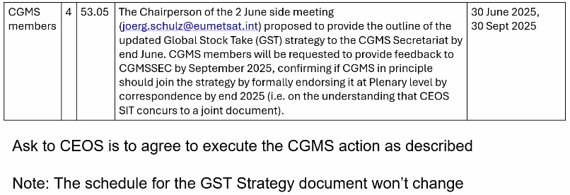

*Discussion*

* Osamu Ochiai (JAXA, SIT Chair Team) noted the contributions proposed are valuable, and should be included in the GST Strategy. However, including CGMS as a co-owner of the document is not appropriate, as the activity is coordinated by the SIT Chair due to the cross-cutting nature of the activity. CGMS is welcome to contribute to the strategy via the joint CEOS-CGMS WGClimate, who are closely engaged in the GST Strategy drafting process.
* Wenying Su (NASA, WGClimate Chair) concurred with Osamu, noting WGClimate can support CGMS members in connecting with the CEOS GST Strategy activity.
* NASA, NOAA and ESA agreed with the SIT Chair’s position to keep the GST Strategy as a solely CEOS-owned document.

**CEOS Newsletter Update**

Satoshi Uenuma (JAXA, SIT Chair Team) reported:

* The schedule for CEOS Newsletter articles for 2025 is shown below. There are 19 topics proposed, substantially more than the usual annual target of 12 articles.
* The CEOS Newsletter can be found at: <https://earth.jaxa.jp/ceos-newsletter/>

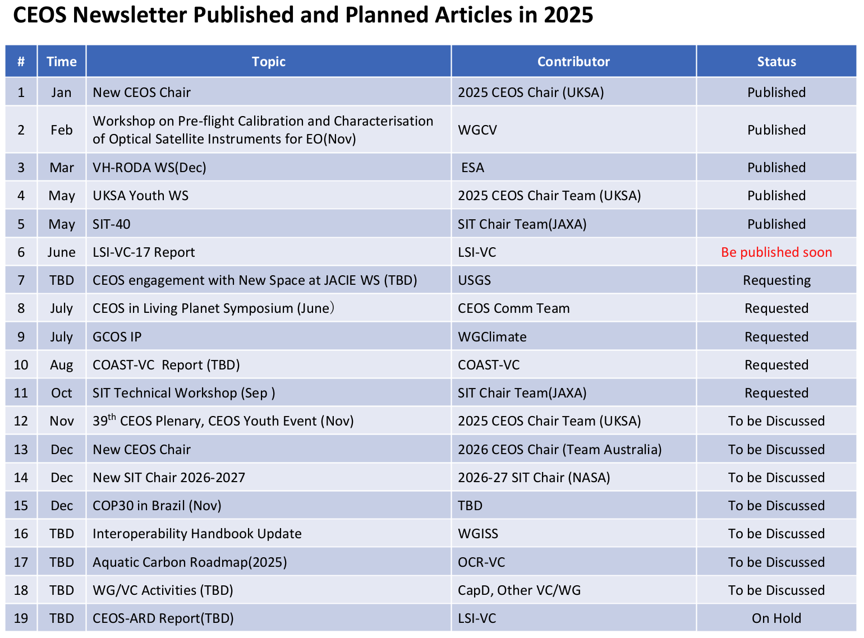

## Adjournment

Beth Greenaway (UKSA, CEOS Chair Team) thanked the participants of SEC-336. The next CEOS Secretariat meeting will be SEC-337, which will be held on 17 July 2025. The plan for SEC teleconferences/meetings leading up to the 2025 CEOS Plenary is as follows (typically Thursday):

|  |  |
| --- | --- |
| SEC-337: 17 July 2025  SEC-338: 21 August 2025  SEC-339: 9 September 2025 *(at 2025 SIT TW)* | SEC-340: 9 October 2025  SEC-341: 4 November 2025 *(at CEOS Plenary 2025)* |

The start time for all teleconferences will be 7 AM U.S. Eastern. If there are face-to-face meetings, the times will be communicated closer to the dates.