Minutes V1.0
349th CEOS SECRETARIAT MEETING
Thursday, 16 July 2026
Chaired by the Australian Bureau of Meteorology (BoM)
Participants
CEOS Chair Team: Agnes Lane (Chair), Alex Held, Jonathon Ross, Maggie Arnold, Amy Parker, Flora Kerblat, Matt Steventon, Libby Rose, Harvey Jones
ESA: Marie-Claire Greening
EUMETSAT: Robert Husband
Executive Officer Team: Lefteris Mamais, Julia Caufape
JAXA: Akiko Noda, Mariko Harada, Yuki Maehira, Hiroyuki Zaitsu, Stephen Ward
SIT Chair Team: Julie Robinson, Michelle Hanssen, Sid Boukabara, Ayia Lindquist
NOAA: Mary Ann Kutny, James Donnellon, Adria Schwarber
NOSA: Ann Mari Fjæraa
SEO: David Borges
UKSA: Patrick Gibson
WGCapD: −
WGCV: Medhavy Thankappan
WGClimate: Wenying Su
WGDisasters: Antonio Montuori
WGISS: Damiano Guerrucci

- Welcome
Agnes Lane (BoM, CEOS Chair Team) welcomed participants to SEC-349. The agenda was reviewed, and no additions or changes were requested.
One open action was reviewed:
- 347-01: CEOS Secretariat members to inform the SIT Chair Team if their agency will be represented at IAC (5-9 October 2026; Antalya, Türkiye) and able to present the CEOS Keynote.
  - The 2027 CEOS Chair, NOSA, has agreed to present the CEOS Keynote at IAC. The action is closed.

CEOS Chair Report
Agnes Lane (BoM, CEOS Chair Team) reported:
2026 CEOS Plenary Agenda
- The 2026 CEOS Plenary agenda has been designed to ensure balanced and comprehensive coverage of key topics. The CEOS Chair team is working closely with the SIT Chair team to align the agenda with the upcoming SIT Technical Workshop, ensuring discussions build on one another and avoid duplication. Side meetings for Plenary can be requested here.
349-01 | CEOS Secretariat to provide initial feedback to the CEOS Chair Team on the draft 2026 CEOS Plenary objectives and agenda. | SEC-350
Adaptation and Resilience Chair Theme
- The editorial advisory team for the adaptation and resilience internal discussion paper recently convened to discuss the draft outline and definitions and chart the path forward. The paper will be refined ahead of the 2026 SIT Technical Workshop and shared with CEOS Principals ahead of the 2026 CEOS Plenary for consideration and discussion at the event. The CEOS Chair is already working with SIT Chair, ESA and the European Commission, and have extended the invitation to other Agencies (JAXA, UKSA and NOSA), as well as to Secretariat members who are invited to nominate additional participants for the editorial team by the end of July.
- The discussion paper will consolidate the results of the adaptation and resilience survey shared with the CEOS community recently. Fifty responses were received, identifying CEOS’ existing contribution to adaptation and resilience, definitions, key challenges and opportunities, and options for future engagement.
- Alex Held and Amy Parker (CSIRO, CEOS Chair Team) participated in the ESA-European Commission Workshop on Adaptation (23-25 June 2026; Harwell, UK). A report from the workshop is anticipated, outlining specific indicators defined by the Global Goal on Adaptation that Earth observation data could support.
CEOS Document Status and Handling Framework
- The CEOS Chair and SIT Chair Teams propose that the CEOS Document Status and Handling Framework be endorsed virtually before the 2026 SIT Technical Workshop, to allow confident planning for both the Technical Workshop and Plenary.
- Lefteris Mamais (CEOS Executive Officer) noted that the framework has been finalised as version 5.0, incorporating feedback from both the Chair and SIT Chair teams. The document will be shared more widely by the end of this week. The accompanying DOI process paper is intended to follow a similar route.
- It was clarified that public CEOS statements to e.g., Conventions, will not qualify for a CEOS DOI as they are made at a certain point in time, within the context of a certain event, and should remain as part of the meeting record in which they were delivered.
DECISION 01 | CEOS Secretariat confirmed the proposal to virtually endorse the CEOS Document Status and Handling Framework and DOI Process Paper in August 2026, to allow for efficient planning and discussions at SIT Technical Workshop and Plenary.

349-02 | CEOS Executive Officer to share v5.0 of the CEOS Document Status and Handling Framework with the Secretariat, for final comments before the virtual endorsement process is initiated. | SEC-350
Second CEOS Water Quality Workshop
- Planning continues for the second CEOS Water Quality workshop to be held on Friday, 11 September, following the 2026 SIT Technical Workshop. The three main objectives for the workshop are to:
  - Advance conceptual alignment by bringing together terrestrial hydrology and water quality communities;
  - Explore the essential variables for water quality and integration of requirements across the system, and how this translates to end users;
  - Extend understanding and identification of issues through the application of “catchment to coast” thinking to real life use cases.
- The team will now focus on finalising the speaker list and external CEOS invitees. A water quality white paper is planned for delivery to the SIT-42 meeting in April 2027.
2028 CEOS Chair
- The CEOS Chair has contacted SANSA, who have confirmed they intend on providing an official written letter to the Chair signalling their interest in becoming the 2028 CEOS Chair, by mid- to late-July.
CEOS In Schools
- An additional CEOS Youth webinar has been scheduled for next week for Argentina, following discussion with CONAE.
- The closing date for student posters and videos is the end of July, but an extension will likely be offered.

SIT Chair Report
Julie Robinson (NASA, SIT Chair Team) reported:
SIT Chair Priorities
- Under the SIT Chair priority, ‘Water Planet - Seeing Earth's Water from Space,’ a survey has been circulated to CEOS members to collect case studies related to integrating multiplatform and multispectral data, to inform the development of best practice guidance. Inputs are requested by August 3, 2026.
2026 SIT Technical Workshop
- The draft objectives and agenda for the 2026 SIT Technical Workshop are open for feedback here, and will be disseminated to CEOS members shortly.
- The agenda does not include the dedicated side meeting day. The SIT Chair has instead opted for a day of workshop sessions, built around a singular narrative. There will however be rooms available for small, closed side meetings on Tuesday if needed.
- SEC-351 will be held on the morning of Tuesday 15 September, before the EO Data Providers Collaboration Forum.
- Registrations for the SIT Technical Workshop are requested by August 7, 2026.
Earth Observation Data Providers Collaboration Forum
- The SIT Chair team is planning an Earth Observation Data Collaboration Forum, in response to Action SIT-41-04. The forum will convene representatives from CEOS agencies, Working Groups, and Virtual Constellations, along with invited Earth Observation data provider companies that CEOS agencies have a relationship with, to discuss the evolving linkages between civil and private sector Earth observation systems.
349-03 | CEOS Secretariat to suggest and provide contact details for invitees to the Earth Observation Data Providers Collaboration Forum to the NASA SIT Chair Team. | July 28
- Co-leadership of the Biodiversity Virtual Constellation (B-VC) will transition from Gary Geller (NASA/JPL) to Yoseline Angel (NASA/GSFC) on August 1, 2026.
- The International Coordination Group for Spaceborne Synthetic Aperture Radar (ICGS-SAR) is continuing to develop the documentation required for it to transition to a SAR VC. Documentation will be shared for discussion and review at the 2026 SIT Technical Workshop.
Ocean Surface Topography Virtual Constellation (OST-VC) Report
OST-VC leadership were not present at the meeting.

Discussion on CEOS and CGMS Topics of Common Interest
Sid Boukabara (NASA, SIT Chair Team) reported:
- At the 54th CGMS Plenary (2-4 June 2026; Seoul, Republic of Korea), a number of topics were raised that have relevance to CEOS. In particular, two new groups were created: An International Earth Surface Working Group and a Wildfire Task Force. Sid made an intervention on behalf of CEOS to note that these are very similar to existing CEOS activities, and that it would be prudent for CEOS and CGMS leadership to discuss, to avoid overlaps and consider potential synergies.
- It was clarified that the Earth Surface Working Group specifically aims to improve the assimilation of channels that are impacted by the Earth’s surface into models, which differs significantly from the scope of LSI-VC. The Wildfire Task Force has potential overlaps with the LSI-VC Wildfire subgroup.
- Other potential CEOS/CGMS synergies were identified, including overlap between the CGMS International Precipitation Working Group (IPWG) and CEOS P-VC:
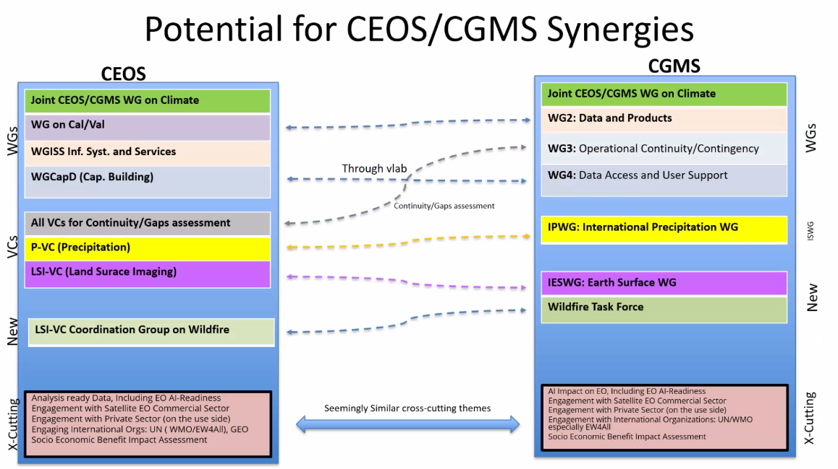
- Topics for discussion with CGMS will include ensuring efficiency of resources (personnel, travel, administration), lessons learned from the joint Working Group on Climate, potential synergies, and opportunities for routine coordination.
- The CEOS Chair and SIT Chair teams would like to meet with CGMS leadership in late September 2026 to discuss the outlined issues, and request SEC input before that time to shape the discussion.
349-04 | CEOS SEC to provide the SIT Chair team with inputs and thoughts on CEOS and CGMS Topics of Common Interest to inform further discussions, including at SIT TW and with the CGMS Secretariat in the late September timeframe. | SEC-350
Discussion
- Alex Held (CSIRO, CEOS Chair) recognised the expanding scope of CGMS into the applications of EO data for Earth science and system prediction, which will raise more areas for collaboration with CEOS.
- From a WGClimate perspective, Wenying Su (NASA, WGClimate Chair) noted that the joint Working Group is more efficient at leveraging resources and expertise from space and meteorological agencies but presents a higher workload for leadership to report to both CEOS and CGMS meetings.
- Medhavy Thankappan (GA, WGCV Vice Chair) recalled that WGCV already works closely with the Global Space-based Intercalibration System (GSICS), a joint initiative of WMO and CGMS. WGCV regularly attends GSICS meetings and jointly operates the CEOS-GSICS FRMsat Task Team (formerly SITSat Task Team).

CEOS Executive Officer Report
Lefteris Mamais (CEOS Executive Officer) and Julia Caufape (CEOS Executive Officer Team) reported:
- Coordination with the Spanish Space Agency (AEE) is ongoing, with the preparation of a formal application underway. Pakistan’s Space & Upper Atmosphere Research Commission (SUPARCO) met with the Executive Officer Team on 2 July to discuss the CEOS membership process and plans for a formal application.
- Development of the manuscript and presentation for CEOS’ keynote to IAC 2026 (5-9 October; Antalya, Türkiye) is ongoing ahead of the 14 September deadline. The storyboard has been prepared, and the CEOS Executive Officer is coordinating with the CEOS Chair, SIT Chair, and incoming CEOS Chair (NOSA), who will deliver the presentation.
Discussion
- Jonathon Ross (GA, CEOS Chair Team) noted that the 2026 CEOS Plenary will include a session to celebrate CEOS’ achievements in the last year. Secretariat members are encouraged to respond to the Executive Officer’s call for inputs, expected sometime in the coming months.

CEOS Systems Engineering Office (SEO) Report
David Borges (NASA, SEO) reported:
- Regarding Action SEC-347-03, a letter to ISO has been drafted to officially change the CEOS point of contact for ISO to the SEO, with support from the WGISS and WGCV Chairs. The SEO requested the CEOS Chair send the letter following SEC-349.
349-05 | CEOS Chair to send the letter to ISO regarding updating of the CEOS points of contact. | July 24
- SEO attended the 135th Open Geospatial Consortium (OGC) Technical Meeting (1-4 June 2026; Helsinki, Finland) and proposed the creation of a new OGC Analysis Ready Data Domain Working Group (DWG), on behalf of the CEOS-ARD Oversight Group. The proposal was accepted and seconded during the closing plenary. Geoscience Australia, NASA and EarthDaily are prepared to volunteer as the three required DWG Co-Chairs. The CEOS-ARD Oversight Group leads are currently drafting a new Charter document.
- SEO has secured a small CEOS exhibition booth for IGARSS 2026 (9-14 August; Washington, D.C., USA) and will be presenting two papers addressing developments on EO-GPT and CoveLib. Any CEOS members planning to attend IGARSS in-person are encouraged to reach out to the SEO for coordination purposes.
- Working Group Impacts and Key Issues for Discussion
WGCapD
WGCapD leadership was not in attendance.
WGClimate
Wenying Su (NASA, WGClimate Chair) reported:
- The WGClimate proposal for themes for the 2026 Earth Information Day (EID) will include:
  - Plenary session topics: State of the Climate and the Global Climate Observing System; the EO Handbook on Adaptation and Resilience, and new missions and capabilities.
  - 2-3 thematic sessions, potentially including AI and Adaptation.
  - A poster session (virtual or printed, to be displayed throughout COP-31) highlighting case studies from the EO Handbook.
- WGClimate is coordinating with GCOS and WMO to ensure aligned EID proposals. The submission deadline for proposals is August 1, 2026.
- The CEOS-CGMS SBSTA statement is being written, with a complete draft expected to be circulated to the Secretariat ahead of SEC-350 (August 20), with comments due by September 18. The final version will be circulated to CEOS for virtual endorsement on 28 September, before submission to UNFCCC at the end of October. The four key themes of the statement will be: Adaptation and Resilience, Greenhouse Gas Observations, Climate Finance, and Aquatic Observations. Suggestions for other key themes for the statement are welcome.
WGCV
Medhavy Thankappan (GA, WGCV Vice Chair) reported:
- WGCV met on 1 July to discuss a definition of ‘supersite’, following discussion at WGCV-56 outlining the need for a generic definition across domains. The task aims to account for existing definitions from the WGCV and CEOS community.
- The WGCV Surface Reflectance Quality and Consistency project continues to develop guidance for increasing harmonisation and interoperability between satellite data products. The guidance developed will serve as an Interoperability Demonstrator activity for WGISS.
- The venue for WGCV-57 has been confirmed. The meeting will be hosted by GISTDA at the Space Krenovation Park (SKP) in Sri Racha, Thailand, from 16-19 February 2027.
- WGCV is finalising the Quality, Authenticity, and Provenance initiatives for the 2026 CEOS-ARD Strategy.
WGDisasters
Antonio Montuori (ASI, WGDisasters Vice Chair) reported:
- The implementation plans for the new WGDisasters Pilot Proposals (Wildfires, Landslides, Biodiversity and Drought) are being drafted and will be presented at WGDisasters-26 (14-18 September 2026; Rome, Italy). A final report for the Flood Pilot will be presented at the WGDisasters-26 meeting.
- Six sites from the Geohazard Supersites and Natural Laboratories (GSNL) initiative are currently under renewal.
- Collaboration is planned with WGCapD, to support the pilot projects and increase capacity building.
- Discussion is ongoing between WGDisasters, WGISS, the SIT Chair team, and GSNL to progress the Resilience Interoperability Demonstrators and EO-GPT Demonstrator.
- WGDisasters-26 will be supplemented by a Workshop on Disasters & Risk open to national and international scientific communities.
WGISS
Damiano Guerrucci (ESA, WGISS Vice Chair) reported:
- WGISS is continuing to integrate various data catalogues into the WGISS Connected Data Assets.
- The Federated Authentication and Authorization White Paper activity is also progressing.
- Discussions were initiated with LSI-VC and the CEOS-ARD Oversight group on the ‘decision ready data’ concept, based on the action SIT-41-04. Discussion will continue during the 2026 SIT Technical Workshop.
- The Data Citation White Paper (DATA-26-01) draft is under review by WGISS members.
- Work on the Digital Twin white paper continues, including a draft CEOS definition for Digital Twins together with a literature review of past CEOS Agency definitions.
- NASA will host WGISS-62 in Colorado, USA, 26-30 October 2026.
- A topic on the Satellite Tasking API (STAPI) initiative was proposed for the SIT Technical Workshop’s EO Data Collaborator Forum.

AOB
2026-2027 CEOS Newsletter Plan
Yuki Maehira (JAXA) shared the proposal for CEOS Newsletter publications for the period August 2026 - April 2027. The leads of relevant CEOS entities will be contacted in advance to provide inputs for the articles.
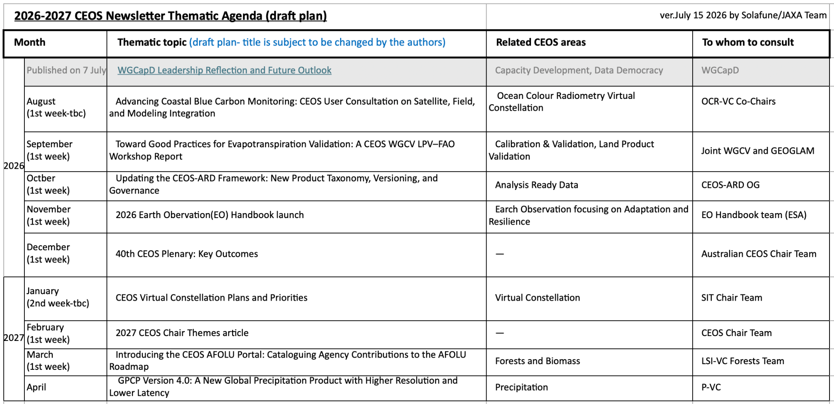
349-06 | Secretariat to provide feedback to JAXA regarding the proposed CEOS Newsletter publication schedule and topics for 2026-2027. | July 31
CEOS Statements to UN Conventions
Alex Held (CSIRO, CEOS Chair) noted that statements are being prepared for UNCCD COP-17 (17-28 August 2026; Ulaanbaatar, Mongolia) and UNCBD COP-17 (19-30 October 2026; Yerevan, Armenia). The final version of the statement to UNCCD COP-17 is being prepared and will be shared with the Secretariat for review soon. The B-VC Co-leads are preparing the statement for UNCBD COP-17.

Adjournment
Agnes Lane (BoM, CEOS Chair Team) thanked the participants of SEC-349. The next CEOS Secretariat meeting will be SEC-350 on Thursday, 20 August 2026. The plan for CEOS SEC teleconferences/meetings leading up to the 2026 CEOS Plenary is as follows (typically Thursday):
350: 20 August 2026  351: 8 September 2026 (SIT TW 2026) | 352: 8 October 2026  353: 3 November 2026 (at 2026 CEOS Plenary)
The start time for all teleconferences will be 7 AM U.S. Eastern. If there are face-to-face meetings, the times will be communicated closer to the dates.

