Minutes V1.0
351st CEOS SECRETARIAT MEETING
Tuesday, 8 September 2026
Chaired by CSIRO
Participants
CEOS Chair Team: Alex Held (Chair), Jonathon Ross, Agnes Lane, Matt Steventon, Libby Rose
ESA: Marie-Claire Greening
EUMETSAT: Paul Counet, Robert Husband
Executive Officer Team: Lefteris Mamais, Julia Caufape
JAXA: Osamu Ochiai, Yuki Maehira, Hiroyuki Zaitsu, Pushkar Kopparla
SIT Chair Team: Julie Robinson, Sid Boukabara, Michelle Hanssen Lindquist, Stephen Ward
NOAA: James Donnellon, Adria Schwarber
NOSA: Ann Mari Fjæraa, Dag Anders Moldestad, Vigdis Lonar, Ola Nordbeck, Ole Morten Olsen
SEO: David Borges
UKSA: Beth Greenaway
WGCapD: Dan Matsapola, Christoph Aubrecht
WGCV: –
WGClimate: Wenying Su
WGDisasters: Antonio Montuori
WGISS: Nitant Dube, Damiano Guerrucci

- Welcome
Alex Held (CSIRO, CEOS Chair) and Julie Robinson (NASA, SIT Chair team) welcomed participants to Washington D.C. and to SEC-351.
The revised CEOS Governance and Processes document was virtually endorsed last week, following the closing of the review period without disagreement. The document is now in effect and has been published on the website. The CEOS Chair team thanks all CEOS colleagues for their contributions to the refinement over the last year.

GST Strategy Way Forward
Jonathon Ross (GA, CEOS Chair team) recalled the tremendous amount of work done by the Global Stocktake Study Team under JAXA’s SIT Chair leadership to develop a comprehensive document. Activities have been embedded into the CEOS Work Plan; however, the CEOS Chair would like to ensure that the work is formally recognised. The refinements to the CEOS Governance and Processes document and procedures regarding documents allow a way forward for CEOS Acknowledgement.
The CEOS Chair intends to seek virtual Acknowledgement of the document before CEOS Plenary, with the document text mostly unchanged. There are a couple of clarifications to be made in line with the new governance processes, including adjustments to the title, author list, and executive summary. The title will be refined to clarify that it is a report of the 2025 GST Study Team to CEOS, for acknowledgement. The minor editorial change to the executive summary will clarify that the document is a report to CEOS.
Next week, the CEOS Chair team will circulate the document to CEOS SEC to confirm the minor changes, before distribution to all CEOS Principals for their virtual acknowledgement shortly thereafter.
351-01 | CEOS Chair team to circulate the amended GST document to SEC for a short review of the editorial changes before distribution to CEOS Principals for acknowledgement. | 18 September 2026

Standardised CEOS Document Cover Pages
David Borges (NASA, SEO) reported on the SEO team’s effort to introduce more consistent corporate branding to documents, providing consistency and a shared identity. Complementing the new CEOS DOI process, standardised cover pages will be introduced, along with standard text on the inside cover to explain the difference between a document that is Endorsed / Acknowledged. The cover template allows full flexibility in the background image for variety and author expression, with standardised logo placement and cover text. There are a few different logo colour variations to accommodate different backgrounds.
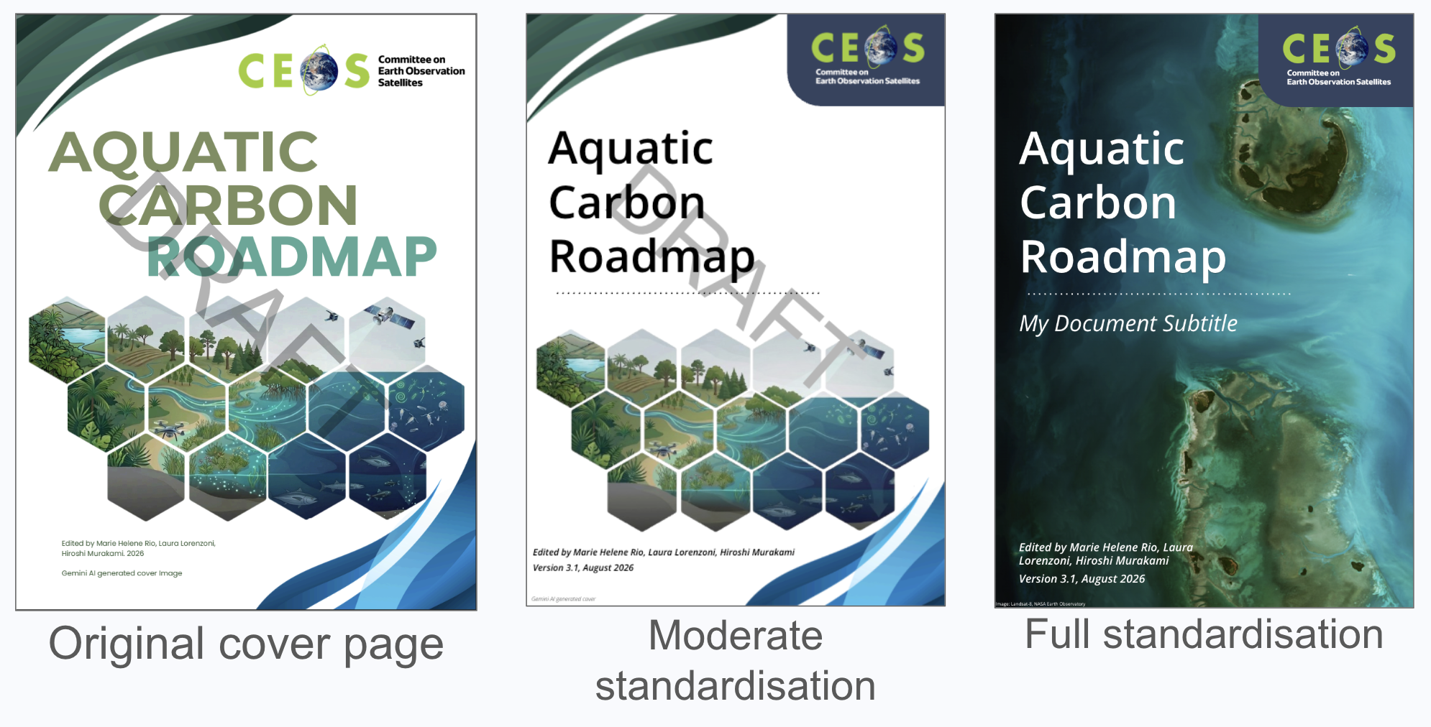
Discussion
Julie Robinson (NASA, SIT Chair team) recommended CEOS commit to disallowing AI-generated imagery for covers and documents, noting the broader conversations about AI and satellite imagery, provenance, trust, etc. CEOS Agency image repositories provide a deep catalogue of copyright free EO imagery that can be used for covers, negating the need for a CEOS managed image repository.
It was agreed that a full image credit should be included on the second page, in addition to the shorter acknowledgement on the front cover. This should provide a link to the original source. The front page will not indicate whether a document is Acknowledged or Endorsed, since this needs additional context / understanding and is better covered on the second page with more words.
DECISION | CEOS SEC adopted the cover template, noting the need for proper crediting, acknowledgement for images, endorsed/acknowledgement
351-02 | SEO team to distribute the new cover page guidelines and examples to CEOS. | SEC-352

CEOS Membership Application Updates
Lefteris Mamais (CEOS Executive Officer) reported that Agencia Espacial Española (AEE) has provided a nearly final membership application, which is now awaiting signature by management. There has been no further communication from the Space and Upper Atmosphere Research Commission (SUPARCO, the national civil space agency of Pakistan).
The CEOS Chair team has requested that the cut-off for new membership applications be four weeks before the CEOS Plenary.

CEOS 2026 Successes Presentation for CEOS Plenary
Lefteris Mamais (CEOS Executive Officer) reported that a 9-minute slide deck is being developed for Plenary to communicate CEOS successes and achievements over the past year. The template is being developed such that it can be re-used for future years and different audiences. The narrative will be built around the SIT Chair team’s value chain work and focus on six main elements: A year of delivery – and what CEOS is for; From coordination to benefit; Delivered in 2026, with the difference each output made; Faces of impact; The voice of satellite Earth observation; What this year tells us.
Discussion
CEOS Principals are the main target audience, with the objective being to show the impact of their investments in the CEOS Work Plan. The intent for the CEOS Plenary is to provide a sense of momentum and context for the items that follow. There will also be the traditional, more formal review of progress on the CEOS Work Plan later in the Plenary agenda.
It was suggested that the CEOS Comms team be engaged in the development of the presentation to leverage past work and experience. Likewise, close engagement with the CEOS working teams will be critical.

Statements for External Fora and Conventions
Alex Held (CSIRO, CEOS Chair) recalled that ESA delivered a statement to the United Nations Convention to Combat Desertification (UNCCD) COP17 meeting in late August on behalf of CEOS. This is the first time CEOS has delivered a statement to UNCCD. The Biodiversity Virtual Constellation (B-VC) has now also drafted a CEOS statement to the UN Convention on Biological Diversity (CBD), which will be delivered in October to COP17. It is proposed that ESA will again deliver the statement on behalf of CEOS, since ESA is the only CEOS agency accredited as an intergovernmental observer organisation to the Conferences of the Parties to the CBD.
Wenying Su (NASA, WGClimate Chair) noted that the draft CEOS-CGMS statement to SBSTA was distributed to CEOS SEC on September 1. Any feedback is requested by Friday Sept 18. The text will then be finalised and then shared with CEOS and CGMS for virtual endorsement around the end of September. Once endorsed, WGClimate will prepare a shortened version for verbal delivery by the Norwegian delegation.
351-03 | SEC to provide feedback on the draft CBD statement prepared by the Biodiversity Virtual Constellation (B-VC) before it is distributed to CEOS. Comments and suggested edits should be added directly in the linked document, which will then be shared with B-VC. | 11 September 2026
351-04 | CEOS Chair team to share the CBD COP17 statement with the CEOS community following the review by SEC. | 24 September 2026
351-05 | WGClimate leadership and the CEOS Comms Team to compile best practices for official CEOS Statements, drawing on the extensive experience of WGClimate in preparing the CEOS statements to SBSTA. This should include guidance on appropriate vocabulary and conventions, delivery mechanisms and delegations, submission practices, and necessary review cycles. | SEC-352
- 2026 EO Handbook Update
Marie-Claire Greening (ESA) reported that the 2026 EO Handbook is ready to be submitted for printing, which will have it ready for CEOS Plenary and other events towards the end of the year. SEC Agencies will each receive a number of copies, and those attending Plenary will receive a copy. Other agencies will be offered the opportunity to request print copies. UNFCCC COP-31 is a paper free event, and hence they will not be handed out there. However, there will be an opportunity for stakeholders to request a print copy to be mailed.
The web version of the EO Handbook will be ready in mid-October, which should allow some content to be shared at the Pacific pre-COP in late October.
DECISION | The CEOS Secretariat agreed that the 2026 EO Handbook can go to print.
- Executive Officer Continuity
The European commitment to support the Executive Officer will conclude at the end of 2027. As per the timeline agreed at the 2022 CEOS Plenary, the role is then the responsibility of a non-SEC agency for 2028-2029.
The topic has been added to the CEOS Plenary agenda, where Principals will be briefed with an overview of the role and opportunities, both for the agency and the individual. SEC members are encouraged to raise the topic with agencies from their respective regions and to consider contingencies. Osamu Ochiai (JAXA) recalled that JAXA is committed to the next rotation, 2030-2031.
351-06 | CEOS Chair team to send a communication to Principals ahead of Plenary regarding the Executive Officer continuity agenda item. | 2026 CEOS Plenary
- SIT Chair Continuity
Julie Robinson (NASA, SIT Chair team) sent a note to CEOS agencies following SEC-350 regarding the open SIT Vice Chair position. The last three SIT Vice Chairs were ESA, JAXA, and NASA. All other agencies are invited to consider the role, recalling there are options to spread the workload (e.g., the 2026 CEOS Chair consortium from Australia). Prospective SIT Chairs are encouraged to reach out to the NASA SIT Chair Team with any questions.
- Final SIT Technical Workshop Preparation
Julie Robinson (NASA, SIT Chair team) noted the EO Data Provider Collaboration Forum being held today. SEC thanked NASA for their work constructing a progressive agenda for the Technical Workshop, which prioritises the workshop format and group discussion.

AOB
SANSA have provided their official letter to nominate for the role of 2028 CEOS Chair and will provide a presentation at Plenary. The CEOS Chair team is maintaining the line of communication.

Adjournment
Alex Held (CSIRO, CEOS Chair) thanked participants of SEC-351. The next CEOS Secretariat meeting will be SEC-352 on Thursday, 8 October 2026. The plan for CEOS SEC teleconferences/meetings leading up to the 2026 CEOS Plenary is as follows (typically Thursday):
352: 8 October 2026 | 353: 3 November 2026 (at 2026 CEOS Plenary)
The start time for all teleconferences will be 7 AM U.S. Eastern. If there are face-to-face meetings, the times will be communicated closer to the dates.

