Sep 10, 2016

**CEOS Water Constellation Feasibility Study Report**

**（Preliminary Draft）**

**Contributors to the Report**

This report was prepared by members of the CEOS Water Strategy Implementation Study Team (WSIST) and experts from the water community, many of whom are members of the GEO Integrated Global Water Cycle Observations (IGWCO) Community of Practice. Contributions include chapters, sections, paragraphs, useful suggestions, and review comments.

(Contributors list will be developed)

**Table of Contents**

1. Introduction

1.1 Background

1.2 Linkages with major international agreements

1.3 Purpose of the CEOS Water Constellation Feasibility Study

1.4 Audience

1.5 Approach of the Feasibility Study

1.6 Assessment of user needs

1.7 Contents for precipitation and soil moisture

2. Relationships among priority water cycle variables

3. Existing and planned satellite observations for precipitation and soil moisture

3.1. Precipitation (Ralph, Bob, George)

1. Confirm the validated requirements
2. Define a list of missions confirmed as contributing to the requirement

c. Assess gaps at 2016 and 2021

d. Possible coordination of CEOS missions (up to 3 scenarios)

e. High level cost benefit statements

3.2. Soil moisture (Jerry, TBD)

1. Confirm the validated requirements
2. Define a list of missions confirmed as contributing to the requirement

c. Assess gaps at 2016 and 2021

d. Possible coordination of CEOS missions (up to 3 scenarios)

e. High level cost benefit statements

3.3 Evapotranspiration

1. Confirm the validated requirements
2. Define a list of missions confirmed as contributing to the requirement

c. Assess gaps at 2016 and 2021

d. Possible coordination of CEOS missions (up to 3 scenarios)

e. High level cost benefit statements

3.4. River discharge

1. Confirm the validated requirements
2. Define a list of missions confirmed as contributing to the requirement

c. Assess gaps at 2016 and 2021

d. Possible coordination of CEOS missions (up to 3 scenarios)

e. High level cost benefit statements

3.5. Surface water storage

1. Confirm the validated requirements
2. Define a list of missions confirmed as contributing to the requirement

c. Assess gaps at 2016 and 2021

d. Possible coordination of CEOS missions (up to 3 scenarios)

e. High level cost benefit statements

3.6. Groundwater

1. Confirm the validated requirements
2. Define a list of missions confirmed as contributing to the requirement

c. Assess gaps at 2016 and 2021

d. Possible coordination of CEOS missions (up to 3 scenarios)

e. High level cost benefit statements

4. Priority water cycle variable synergistic observation feasibility (For all team members and associated experts, voluntary inputs and ideas are invited)

5. Recommendations on the Virtual Water Constellations

6. Way forward

7. Appendix

**1. Introduction**

* 1. **Background**

This report was prepared by the Committee on Earth Observation Satellites’ (CEOS) Water Strategy Implementation Study Team (WSIST) to provide a response to the GEOSS Water Strategy. The Group on Earth Observations (GEO), which coordinates the development of the GEOSS Water Strategy, issued the Strategy at the GEO-Plenary X in January 2014 and requested that CEOS and other organizations provide observations and information services to respond to the Strategy’s recommendations related to observational systems. CEOS WSIST prepared the CEOS response to the Strategy’s recommendations (CEOS Water Strategy), which was approved by the 29th CEOS Plenary held in Kyoto on November 4-5, 2015. The Plenary decided to extend WSIST for one year in order to implement the actions proposed in the CEOS Water Strategy, including a feasibility study (FS) of the CEOS Virtual Water Constellation (GEOSS Water Strategy recommendation C.1):

*“The feasibility of developing a Water-Train satellite constellation should be assessed. This suite of satellites would be modelled after the A-Train, providing a space segment of an observation system that would capture all fluxes and stores of the water cycle using a diverse suite of platforms and instruments. This system would operate as a Virtual Water Cycle Constellation.”*

WSIST agreed to focus on six high-priority variables associated with the water cycle: precipitation, soil moisture, evaporation/evapotranspiration, river discharge, surface water storage, and ground water. WSIST carried out a gap analysis of individual observation systems for the parameters and this combined observation system. The goal of the FS is to address all six parameters and optimize the integrated observation system. Given the complexity of assessing the interactions between all six variables, WSIST proposed a step-wise approach at the SIT-30 meeting held in Frascati, Italy on April 18, 2016. Based on this proposal, members agreed that WSIST would start with the precipitation-soil moisture case study and then expand to other variables.

* 1. **Linkages with major international agreements**

The Virtual Satellite Constellation for water cycle observations considered by this FS will directly address the space component of the GEOSS Water Societal Benefit Area (SBA). It will also support the following major international agreements:Sendai Framework for Disaster Risk Reduction 2015-2030 (March 2015): The water cycle satellite constellation will help understand disaster risks at national/local levels and regional/global levels by collecting, analyzing, managing, and using relevant data and information. The Constellation would support access to multi-hazard early warning systems, particularly in the case of floods and drought.

Transforming our world: the 2030 Agenda for Sustainable Development (September 2015): The water cycle satellite constellation will support Goal 6 of the Sustainable Development Goals (SDGs): Clean water and sanitation, and its relevant targets and indicators.

Paris Agreement (December 2015): Article 7 (Adaptation) (c) calls for strengthening scientific knowledge on climate, including research, and systematic observation of the climate system and early warning systems in a manner that informs climate services and supports decision-making. The FS will directly address systematic observation of the climate system and early warning systems.

Ramsar Convention: This intergovernmental treaty provides the framework for national action and international cooperation for the conservation and wise use of wetlands and their resources. The Convention includes all lakes and rivers, underground aquifers, swamps and marshes, wet grasslands, peatlands, oases, estuaries, deltas and tidal flats, mangroves and other coastal areas, coral reefs, and all human-made sites such as fish ponds, rice paddies, reservoirs, and salt pans. Their observation is necessary for understanding and managing these sites.

* 1. **Purpose of the CEOS Water Constellation Feasibility Study**

The FS aims to provide an assessment of the value and feasibility of a constellation that could measure water cycle components and synchronize them in time and space. The FS assesses options for providing this integrated capability. At present, the water cycle measurements are taken from different platforms with widely varying measurement techniques at different intervals, resolutions ,and sampling strategies, making their synergistic use very difficult.

The FS will lead to an understanding of the connections among observing systems for individual variables in terms of requirements and capabilities and will form a framework that will enable new missions to be more effectively coordinated with existing and planned missions. In the longer term, the Study could provide a basis for planning that anticipates where new satellite missions could make the greatest contribution to the study of the water cycle. For example, new agendas for climate change, sustainable development, biodiversity, and disaster risk reduction will all place new requirements on the existing and planned observational system. In some cases, measurements of an individual variable will be key to meeting international requirements and, in other cases, a mix of variables will be needed to monitor conditions. The overall effort could lead to more valuable measurements since they will be compared and integrated with measurements taken in the same time and space framework, thereby providing more accurate assessments of all aspects of the water cycle. This framework could also provide the basis for assessing economic benefits of adding a sensor on a planned mission versus the launch of a new platform dedicated to one or two water cycle variables. It may also help ensure that new missions such as the Surface Water and Ocean Topography (SWOT) or Gravity Recovery and Climate Experiment II (GRACE-II) missions are implemented in a way that allows maximum benefit for all water cycle variables.

The links between applications and international conventions have already been introduced. Primary applications of these integrated observations would include: improvements in flood prediction, warning, and monitoring; drought monitoring and prediction; assessment of water resource availability on all time scales; and environmental monitoring in remote areas where development is taking place but no measurements are available. Closing the water cycle is an essential research activity that supports all of these applications. Water cycle closure is expected to contribute to better hydrologic modelling, which will in turn provide better soil moisture, runoff, and aquifer recharge predictions and lead to new and more reliable operational services. Additionally, many of these parameters could help improve weather and climate model initializations, leading to more accurate predictions.

**1.4 Audience**

The main audience for this report is CEOS and its member organizations, hereafter referred to as CEOS Agencies. The report will serve primarily as an internal document to highlight priorities, identify opportunities for improved coordination and synergy, and guidance in planning future water-related missions. Some of the ideas and discussions are expected to filter into documents, surveys, and other priority-setting exercises. Depending on the robustness of the results and the perceived value of the methodology used to achieve them, this experience may be documented in scientific literature.

**1.5 Approach of Feasibility Study**

The FS is primarily a gap analysis on current and future observation systems based on the priority variables that were documented as Essential Water Variables (EWVs) in the GEOSS Water Strategy and which will be recognized as Essential Climate Variables (ECVs) by GCOS as of 2017. Gaps were identified by comparing their observation requirements and current and planned observation capabilities. Countermeasures are proposed to fill identified gaps. In addition to single-variable gap analysis, the FS considers the combined capabilities of those parameter observation systems. After the gap analysis, analysis and discussion focuses on identifying actions to fill the gaps between the combined requirements and capabilities, with optimization of the entire integrated observation system to cover the six high-priority variables.

Recognizing the difficulty of trying to address interactions among all the variables, WSIST began its analysis with a case study of precipitation and soil moisture observation systems and their potential synergistic observation system. Observation requirements for precipitation and soil moisture are based on existing statements of requirements and then compared with relevant existing and planned CEOS satellite missions’ capabilities. The report makes specific recommendations for CEOS to address gaps. For the gap analysis, CEOS Principals emphasized the importance of a sampling study; this will be given due consideration.

Based on the success of this approach, the technique has been applied to the other four variables.

**1.6 Assessment of user needs**

A very critical part of this effort is to determine what users actually require in terms of measurements to identify where needs can be met by combining data products, datasets, and even aspects of observational systems. Addressing the needs identified by the GEOSS Water Strategy is very important. A thorough review was recently undertaken as part of GEO Task US-09-01a: Critical Earth Observations Priorities-Water Societal Benefit Area, US-09-01a (Task Lead: Lawrence Friedl, USA/NASA; Water SBA Analyst: Sushel Unninayar, UMBC, 2010) (hereafter referred as “GEO Water SBA requirements”). The review articulates the critical Earth observation priorities for the Water SBA. The report addresses four sub-areas associated with terrestrial hydrology and water resources: surface waters, underground waters, forcings on terrestrial hydrological elements, and water quality/use. The study addresses the “demand” side of observation needs and priorities. More than 200 papers and reports were analyzed by experts, who also considered global, regional and local aspects of observational requirements. They also assessed requirements for derived information products relevant to the management of terrestrial water resources and the terrestrial water cycle.

**1.7 Contents**

The following sections address the case study of precipitation-soil moisture synergistic observation system;

Section 1 Introduction

Section 2 Relationships among priority water cycle variables

Section 3 Existing and planned satellite observations for priority water cycle variables

Section 3.1 Precipitation

Section 3.2 Soil moisture

Section 3.3 Evapotranspiration

Section 3.4 River discharge

Section 3.5 Surface water storage

Section 3.6 Groundwater

Section 4 Priority water cycle variable synergistic observation feasibility

Section 5 Recommendations on the Virtual Water Constellation

Section 6 Way forward

**2. Relationships among priority water cycle variables**

Promoting water cycle constellation reduces flood and drought risks (Contribution by T. Koike)

Climate change has a significant impact on regional river discharge and water availability, which is most important for water resource managers and policy-makers. By 2050, drought-affected areas will likely increase in some water-stressed regions, while flood risks are likely to increase in some wet areas. Under this circumstance, it is critical to integrate the knowledge of the atmosphere and hydrology communities for improved prediction capability related to available water resources and possible hazards (floods and droughts).

In order to develop an integrated understanding and monitoring capability, we need a better way of representing the actual conditions at any point in time. This can come through observational systems, or through data assimilation, or some combination of both. Developing an integrated observing system calls for an understanding of the relationships and potential synergies between the measurements of different variables. The second approach, which has seen major advances over the past two decades, uses models and data assimilation systems to integrate information, especially where observational systems are inadequate or too rigid to adjust to new demands. Assimilation systems can be used to interpolate data, generate estimates of variables that are currently not measured (e.g., root zone soil moisture), and produce spatially uniform fields that facilitate large-scale analysis. Furthermore, prediction systems rely on assimilation systems for their initial conditions; hence, advances in this area will lead to improvements in predictive capability.

Distributed hydrological models (DHMs) can provide explicit distributed representation of the spatial variation and physical descriptions of runoff generation and routing in river channels from basin to continental scales. Land surface models (LSMs) express credible representations of water and energy fluxes in the soil-vegetation-atmosphere transfer system. The coupling of LSMs and DHMs has improved land surface representation, benefiting the streamflow prediction capabilities of hydrological models and providing improved estimates of water and energy fluxes into the atmosphere. Introducing a dynamic vegetation model (DVM) into the LSM-DHM coupled model develops an eco-hydrological model to calculate river discharge, groundwater, energy flux, and vegetation dynamics as diagnostic variables at the basin scale within a distributed hydrological modelling framework.

Land data assimilation systems (LDAS) consisting of a LSM as the model operator, a radiative transfer model (RTM) at microwave region as the observation operator, and several assimilation schemes can considerably improve soil moisture and surface fluxes. By using a LSM coupled with a DVM as the observation operator, a new LDAS has been developed for simulating simultaneously surface soil moisture, root-zone soil moisture, and vegetation dynamics. It assimilates passive microwave observations that are sensitive to both surface soil moisture and terrestrial biomass.

Coupling an LDAS and a mesoscale atmospheric model can introduce the effects of land surface conditions on the atmospheric circulation. Furthermore, a coupled land and atmosphere data assimilation system (CALDAS) can overcome the drifts owing to predicted model forcing (i.e., solar radiation and rainfall) and then improve representation of cloud distribution and associated rainfall events.

A water cycle constellation, especially for rainfall and soil moisture, can integrate satellite observation data into these sophisticated hydrological models and assimilation systems to improve flood and drought prediction capability and contribute to water-related disaster risk reduction.

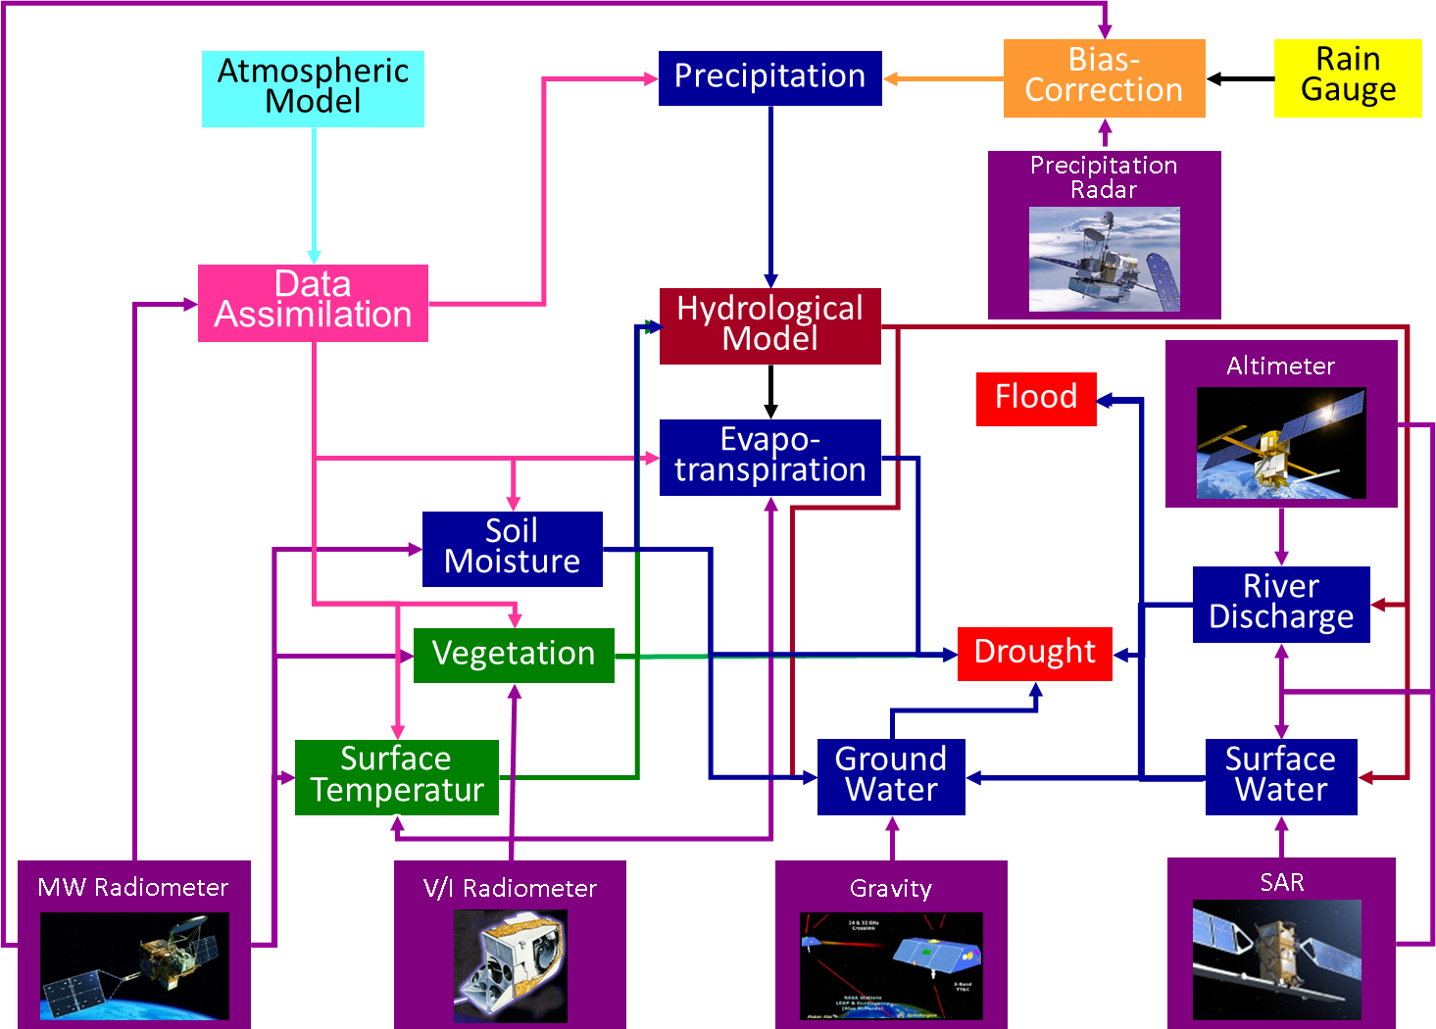

**Figure 2.1** Water cycle variables and their relationships

**3. Existing and planned satellite observations for precipitation and soil moisture**

**3.1 Precipitation (Ralph, Bob, George)**

Precipitation has a very direct and significant influence on the quality of human life in terms of meeting critical needs, such as water for drinking and agriculture. Timely, high-quality precipitation measurements, with global, long-term coverage and frequent sampling, are crucial to understanding and predicting the Earth’s climate, weather, global water, and energy cycle processes and their consequences for life on Earth. Improved observations of precipitation, their reporting, and their timely distribution are central to meeting the needs outlined in Section 3.1 a.

Precipitation is liquid or solid water that falls to the surface from the atmosphere. It is associated with a wide variety of coherent atmospheric phenomena, from small convective showers to continental-scale monsoons. Organized precipitating systems have precipitation rates ranging from less than 1 mm/hour to more than 100 mm/hour, spatial scales from less than 1 km to more than 1000 km, and temporal scales of minutes to seasons. Their modes of variability include diurnal, synoptic, intraseasonal, seasonal, annual, and inter-annual.

Research has shown that a lack of adequate observational data limits the ability to quantify precipitation inputs and, consequently, limits the ability to close water budgets. The amount, rate, and type of precipitation largely determine our freshwater supply. The physical characteristics of liquid and solid water in the atmosphere, including droplet and ice size, shape, and temperature, are crucial to determining the nature of precipitation. Ideally, precipitation observations should provide not only the actual amount reaching the ground, but also the associated vertical hydrometeor structure. Latent heating, which results from the condensation of water vapour into clouds and precipitation, is an important forcing function for large-scale atmospheric circulation. Precipitation falling into the ocean affects ocean salinity and significantly impacts atmosphere-ocean interactions on inter-annual time scales. Over land, the frequency and intensity of precipitation strongly influences critical aspects of surface hydrology, including runoff, soil moisture, and streamflow. Extremes in precipitation occurrence and intensity, which drive floods and droughts, have an enormous impact on human society, agriculture, and the natural environment.

**a. Confirm the Validated Requirements**

* with clarity of what are the most critical requirements and why

GEO Water SBA requirements for precipitation are provided in Table 1.1. The wide range of requirements, varying by use, is apparent. It should be noted that these are requirements for aggregated data products. All specifications are application(s)-dependent, particularly latency. The upper limit to accuracy specifications typically refers to the “desired” figure, not operational availability.

**Table 1.1**. GEO Water SBA requirements. Source: GEO task US-09-01a: Critical Earth Observations Priorities. Legend: L=Local, R=Regional, G=Global, RT=Real Time, DT=Delayed Time.

|  |  |  |  |  |  |
| --- | --- | --- | --- | --- | --- |
| Variable | Horizontal  Resolution | Time  Resolution | Vertical  Resolution | Accuracy | Latency |
| Precipitation | L: 1km | L: 1 hour | N/A | 0.1 mm/5%  Also stated variably as: 0.1 mm/hour to 1 mm/hour or 0.5 mm/hour to 3 mm/hour; 0.5 mm/day to 5 mm/day; 2 mm/day to 10 mm/day | 0.1 hour to 6 hour  3-24 hour; 1-2 days; 7-30 days or RT and DT (App. Dependent) |
| R: 10 km | R: 3 hour |
| G: 50 km to 100 km to 500 km | G: 1 day |
| Also stated variably as 5 km to 50 km, etc. | Also stated variably as: 0.08 hour to 0.5 hour; 1 hour to 12 hours, or 1 day to 3 days |

The report “Systematic Observation Requirements for Satellite-based Data Products for Climate, December 2010, GCOS-154”(hereafter referred as “GCOS-154”) provides GCOS ECV precipitation requirements; horizontal resolution (25 km), temporal resolution (Monthly [resolving diurnal cycles and with statistics of 3 hourly values]), accuracy (10% of daily totals; 0.1 mm), stability (5% of daily totals [regional scale]). Rainfall has such high societal importance that monitoring its averaged and detailed spatial and temporal variability is critical to all societies. For these impact-related applications, a typical accuracy of about 10% of daily totals is given. For stability, there is a target value of 5% to determine regional, long-term trends.

The report “2015 Update of CEOS-CGMS Actions in the Response to GCOS IP, May 2015” compared requirements and existing or planned capabilities of the observation system for the GCOS/ECV (please see Appendix A). GCOS/ECV provides requirements on soil moisture accuracy (0.1 mm), stability (5%), and horizontal resolution (50 km) only.

WMO-SOG describes satellite observations combined with in-situ observations that provide improved information, which can be used for flood forecasting (see Appendix A).

**b. Define a list of missions confirmed as contributing to the requirement**

Existing and planned mission capabilities are listed in Appendix A, Tables 1.1 and 1.2.

The initial GPM-era constellation consists of microwave imagers (DMSP F15 SSMI [limited]; DMSP F16, F17, F18, and F19 SSMIS; GCOM-W1 AMSR2; GPM GMI) and microwave sounders (NOAA-18, NOAA-19, Metop-A, and Metop-B MHS; Megha-Tropiques SAPHIR; SNPP ATMS).

For DMSP, F-19 failed recently on orbit and F-20 is in storage but it will likely not be launched. F-18, F-17, and F-16 are in service beyond their designed lifetimes. F-15 and F-14 are not functioning properly. The impending loss of DMSP microwave radiometers in early-morning orbit will significantly reduce sampling of the diurnal water cycle, making it necessary to rely more heavily on sounders for precipitation remote sensing. Such a shift in data source will degrade the overall quality of the precipitation data set since sounders are not optimally designed for precipitation rate retrieval due to their variable footprint size (in contrast with the fixed footprint size of conical scanners), their channel selection (focused more on absorption bands for sounding than on window bands which are more suited for precipitation remote sensing), and the lack of polarization information (which provides additional information since precipitation tends to depolarize the signal from the lower atmosphere).. In addition, the lower sampling rate will degrade the constellation’s ability to provide the 3-hourly observation interval at all times of day, which is considered the minimum to effectively monitor most precipitation events.

GPM constellation satellites consist of a GPM core satellite carrying DPR and GMI and international partners’ satellites carrying MWIs and MWASs. It is a challenge to maintain this constellation and its datasets.

GCOM-W was originally planned as a three-generation satellite program. The first GCOM-W satellite was launched in 2012. Recognizing the significant role of AMSR-2 and its predecessor, Aqua/AMSR-E, for climate research and operational services in the world, the Japanese government decided to accelerate its study of the GCOM-W follow-on mission in 2016. The AMSR-2 follow-on mission will be a very similar MWI mission and it may be improved by the addition of 183 GHz (currently under consideration). The type of satellite sensor is very important. For example, a standard MWAS scans perpendicular to the satellite track, creating a continuously varying Earth incidence angel that causes footprints at each angle away from the nadir to take a different size and shape and precludes the use of polarization information. The MWIS are strongly preferred.

The Chinese Academy of Science is studying WCOM (details to be provided). No information is available in CEOS DB and CGMS national reports.

Various global precipitation maps are produced by combining satellite datasets with gauge data (see Table 2.1) and by combining input data from several satellite sensor types (see Table 2.2). The combination of geostationary and LEO satellites and in-situ data allow the geospatial consistency of satellite data to be combined with high-frequency in-situ observations.

Infrared data from geostationary satellites that supplement microwave precipitation information (and enables the refresh and latency requirements to be met) are provided by NOAA (currently GOES-13 over the Pacific Ocean and western Americas and GOES-15 over the Atlantic Ocean and eastern Americas), EUMETSAT (currently METEOSAT-10 over Europe/Africa and METEOSAT-7 over Central Asia), and JAXA (Himawari-8 over East Asia and the Western Pacific). These capabilities will be maintained in the long term and will even be enhanced: the next-generation GOES, with significantly improved spatial, temporal, and spectral coverage will launch in late 2016. EUMETSAT will deploy Meteosat Third Generation (MTG) beginning in 2020 and will replace METEOSAT-7 with the more advanced METEOSAT-8 in early 2017. Other nations’ geostationary satellites might contribute in the future as well.

**Table 2.1**. [Combination datasets with gauge data](http://www.isac.cnr.it/~ipwg/data/datasets1.html). Source: CGMS/I`WG, <http://www.isac.cnr.it/~ipwg/data/datasets.html>. Datasets are produced by combining input data from several sensor types, including satellite sensors and precipitation gauges.



**Table 2.2.** Satellite combination datasets. Source: CGMS/I`WG, <http://www.isac.cnr.it/~ipwg/data/datasets.html>). Datasets that are produced by combining input data from several satellite sensor types*.*



**c. Assess gaps at 2016 and 2021**

Figure 3.1.1 provides the precipitation mission timeline.

The GPM-core satellite is at a 65 degree inclined orbit, providing diurnal cycle observation. The CEOS Precipitation Virtual Constellation (P-VC) is studying the post-GPM mission.

In 2016, three-hour global coverage requirements were marginally met at all times of day with the existence of the DMSP early orbit. However, in 2021, the disappearance of DMSP will create a large gap in observation options for 5 AM to 9 AM and 5 PM to 9 PM. This gap will be only covered by GEO satellites. This fallback position of using less-accurate data will degrade precipitation fields and affect other variables that are derived from precipitation.

**Fig. 3.1.1.** Precipitation mission timeline.



**Fig. 3.1.2.** Geostationary TIR mission timeline.



Figure 3.1.3 provides the results of a precipitation observation sampling analysis in 2016 and 2021 (Yamaji 2016).

Considerable degradation of MWI resampling from 2016 to 2021 is apparent. By including MWAS, resampling will be improved.

**Figure 3.1.3**. Precipitation observation sampling analysis in 2016 and 2021.

(Source: Yamaji 2016)

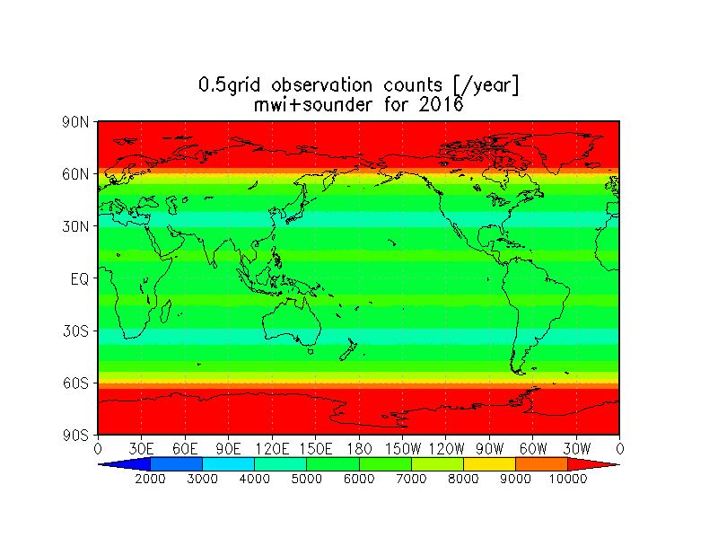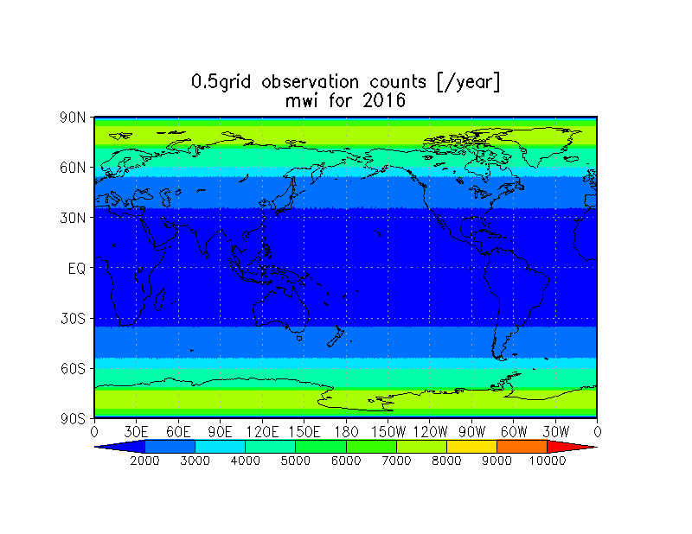

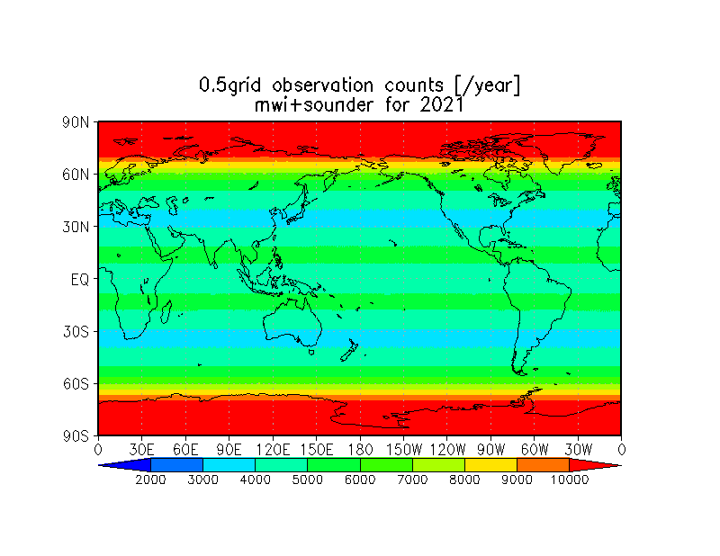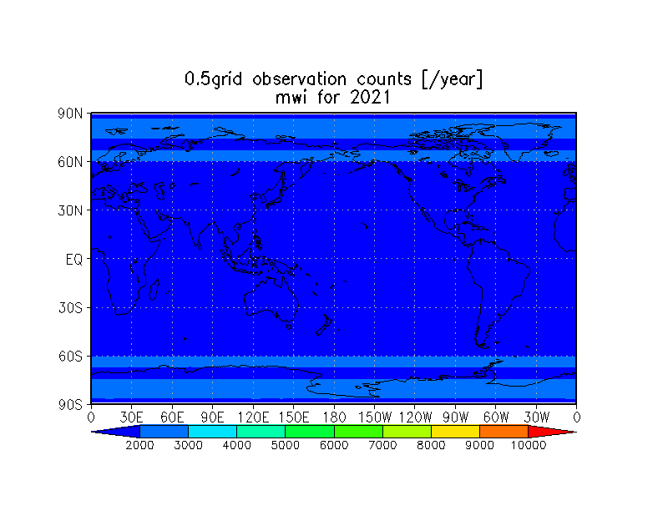

**Figure 3.1.4.** Daily sampling times vs latitude.

(Source: Yamaji 2016)

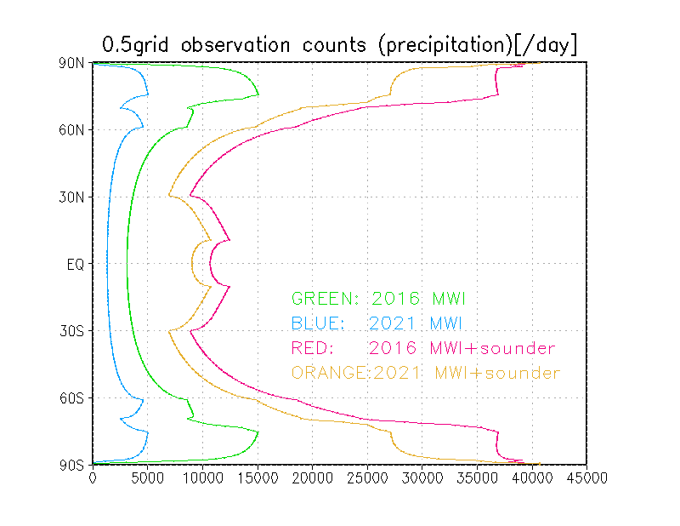

**d. Possible coordination of CEOS missions (up to 3 scenarios)**

Coordination within confirmed missions: Efforts should be made to coordinate with China and Russia to provide their FY, METEOR MWI, and MWAS data for use in estimating precipitation.

Addition of new missions: The Japanese government is studying the follow-on mission to GCOM-W AMSR2. JAXA and NASA are also studying the possibility of a post-GPM mission.

JAXA’s focus for the post-GPM study includes concepts of advanced DPR with high sensitivity, small satellite constellations carrying radars, and future geostationary precipitation radars.

**e. High level cost benefit statements**

Coordination with China and Russia would require only a small investment within the current program’s budget. There may be some expense associated with developing tools incorporate datasets into Western systems.

GCOM-W AMSR follow-on mission: several tens of millions of US dollars to a few hundred million US dollars, depending on the scope of development (instrument and satellite bus)

post-GPM: very large (several hundred million US dollars).

**3.2　Soil moisture (Jerry)**

Soil moisture plays important roles in climate and water resources management. In particular, it modifies the partitioning of incoming radiative energy into sensible and latent heat fluxes and the partitioning of precipitation between infiltration, runoff, and evaporation. Soil moisture must be accurately represented in hydrologic and land surface models because of its key role in environmental processes—for instance, in runoff generation during a precipitation event and, consequently, in flood forecasting. At climate time scales, soil moisture, together with sea surface temperatures, is a critical boundary condition controlling fluxes to the atmosphere (Seneviratne et al., 2010).

Soil moisture is also a predictive factor for summer precipitation over continents in model experiments and has an effect on convective precipitation events over arid zones. In general, soil moisture becomes a critical forcing function for continental areas during the summer months, when potential evaporation rates are at a maximum but water availability is limited due to dry conditions. However, quantifying the importance of soil moisture in stimulating summer convection has been hampered by the lack of suitable long-term datasets with high-resolution observations both in time and space.

For water management applications, the agricultural and forest communities are interested in soil moisture because it is critical for plant growth. The vigour and productivity of vegetation is determined by the rate at which plants accumulate mass, which depends on photosynthesis and transpiration rates, and which in turn is partly driven by the plants’ ability to rapidly access and uptake water. Soil moisture-vegetation-evaporation interactions from critical links between the water and carbon cycles. Agricultural communities therefore have a vested interest in accessing reliable soil moisture data, as it provides insight not only into vegetation health, but can also be used as a tool to effectively coordinate water and irrigation management. As a consequence of its influence on vegetation health, soil moisture also plays a significant role in the availability of fuel moisture in woody vegetation and therefore is also a critical variable in fire spread modelling, which supports a further focus on environmental hazard prediction.

1. **Confirm the validated requirements**

* with clarity of what are the most critical requirements and why

GEO Water SBA requirements for soil moisture are provided in Table 3.2.1.

**Table 3.2.1**　GEO Water SBA requirements for soil moisture. Source: GEO task US-09-01a: Critical Earth Observations Priorities. Legend: L=Local, R=Regional, G=Global.

|  |  |  |  |  |  |
| --- | --- | --- | --- | --- | --- |
| Variable | Horizontal  Resolution | Time  Resolution | Vertical  Resolution | Accuracy | Latency |
| Soil Moisture | L:0.1 km to 1 km | L/R: 1 to 6 hrs (1-10 d for vadose zone) | 10 cm Res. to 1 m depth; 30-100 cm for vadose zone or to depth of water table | 0.02 m3/m3 Or stated variably as 5 g/kg to 10 g/kg to 50 g/kg. Other units also used: Pascals, or cm/mm per 100 cms, or g/kg | Stated variably as NRT or 0.5 d to 1 d; 1-5 days to 10 d to 30 d to 144 d to 720 d (App. Dependent) |
| R: 10 km | R:1-3 d to 1 week; |
| G:50 to 100 km to 500 km | G:1 to 30 d to 3 months for some applications |
| [Also stated variably as 0.01 km to 250 km for some applications] |  |

“Systematic Observation Requirements for Satellite-based Data Products for Climate, December 2010, GCOS-154”provides GCOS ECV soil moisture requirements; horizontal resolution (50 km), temporal resolution (daily), accuracy (0.04 m3/m3), and stability (0.01 m3/m3/year). The targets are set for an accuracy of about 10% of saturated moisture content and stability of about 2%of saturated moisture content.

2015 Update of CEOS-CGMS Actions in the Response to GCOS IP, May 2015 compares requirements and existing or planned capabilities of the observation system for the GCOS/ECV (please see Appendix A).

WMO-SOG-H indicates that none of the instruments provide a satisfactory combination of spatial resolution and repeat cycle (two to three days). AMSR data comes close to providing soil moisture or land wetness information that may be marginally useful for meso-scale modes, but data timeliness remain challenging. The ASCAT surface soil moisture product is the first truly operational satellite soil moisture product that may be used for NWP, flood forecasting, and other time-critical applications.

The current soil moisture requirements are suited to climate users who want to estimate energy fluxes. However, many users in the agricultural sector are not satisfied with current soil moisture data because they do not represent soil moisture in the plant root or vadose zone. While these values can be estimated using models, there is always debate about how reliable the values are.

**b.　Define a list of missions confirmed as contributing to the requirement**

Appendix A (Tables 2.1 and 2.2) provides the existing or planned capabilities of relevant CEOS missions for soil moisture measurement.

Soil surface layer temperature, especially measured at a frequency of 37 GHz, is a key parameter for good soil moisture retrievals. (check this fact>) Passive and active microwave measurements in the low microwave spectrum (1 GHz to 10 GHz) are now providing operational products at medium resolution.

For passive instruments, ESA’s SMOS and NASA’s SMAP operate in the L-band (approximately 1. 4 GHz). JAXA’s GCOM-W AMSR2 has 6 GHz and 10 GHz channels. Active remote sensing data used in soil moisture estimates come from EUMETSAT’s ASCAT and CSA’s Radarsat-2.

Radar remote sensing provides very high-resolutiondata that can be used to estimate soil moisture and agricultural parameters. The radar signal depends on many factors: geophysical, biophysical, and the radar system. Previous satellitessystem limitations were wavelength, the number of independent radar measurements (under-determined), and temporal frequency.

Expectations for SAR lower frequency (L-band) and multiple polarizationscould lead to improved soil moisture retrievals.

Models can be used to extend the utility of soil moisture measurements. In Canada, Environment Canada (EC) and Agriculture and Agri-Food Canada (AAFC) are actively working on a soil moisture retrieval algorithm using a physically based model,the Integral Equation Model (IEM) and multi-polarization and multi-angle data from RADARSAT-2.

(Planning of Sentinel-1 as SMAP active mission alternative)

Thermal infrared satellite sensor observations has great potential for evapotranspiration and soil moisture observations. Based on Martha Anderson’s ALEXI model development and applications (Anderson et al, 1997, 2011), a GOES Evapotranspiration and Drought (GET-D) product system has been developed and made operational at NOAA NESDIS. Conceptually the retrieval of soil moisture information from TIR-based energy balance methods is connected to how available energy is partitioned between sensible (H) and latent heat (LH) fluxes in the mid-morning hours. In general, wet soil moisture conditions leads to increased LH (decreased H) and a depressed morning surface temperature amplitude, while dry soil moisture conditions lead to decreased LE (increased H) and an increased morning surface temperature amplitude. ALEXI’s main driver to solve energy partitioning at the surface is the mid-morning surface amplitude making it a unique opportunity to provide accurate soil moisture information from TIR observations (Hain et al. 2009, 2011). Figure X. shows a comparison of ALEXI (TIR), MW and LSM soil moisture anomalies for Jun-August period for 2006 to 2008 over CONUS, TIR shows good correspondence with LSM and MW methods, and at times better correspondence with LSM soil moisture over regions of dense vegetation cover, where MW methods have been shown to have limited accuracy. Importantly, TIR methods provide information at much higher spatial resolution than MW methods, while sacrificing temporal resolution due to their clear-sky retrieval constraint. Another noted advantage of TIR methods is the ability to sense soil moisture signals from non-precipitating water sources such as irrigation and groundwater influences (Hain et al. 2015). Therefore, a synergistic approach between TIR and MW methods may have the greatest potential to provide the most accurate representation of soil moisture from remote sensing platforms. Future applications of ALEXI are being developed to ingest surface temperature observations from Ka-band MW sensors to provide an “all-sky” mapping of soil moisture from ALEXI, therefore, providing an energy-balance assessment of the current soil moisture state from MW observations which may supplement current direct retrievals of SM from MW observations.

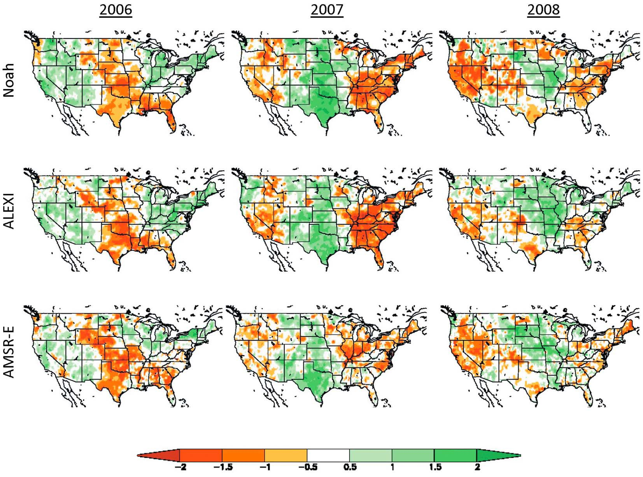

**Figure 3.2.2** Standardized seasonal (JJA) anomaly composites for 2006-2008 for Noah LSM soil moisture (top), ALEXI TIR soil moisture (middle) and AMSR-E MW soil moisture (bottom).

**c. Assess gaps at 2016 and 2021**

Figure 3.1.1 provides the soil moisture mission timeline.

ESA’s SMOS and NASA’s SMAP missions have demonstrated the value of global soil moisture measurements and currently use L-band passive microwave technology to accurately determine soil moisture in all conditions. In addition, multi-channel radiometers estimate land surface temperature (particularly from the Ka-band) under clear and cloudy conditions. The primary limitation to current passive microwave technology is partial resolution (approximately 40 km for L-band).

For passive instruments, there is no follow-on plan for SMOS and SMAP. A GCOM-W AMSR2 follow-on is being studied by JAXA. Considering the uncertainty of these instruments' operation in the year 2021, planning for these mission follow-ons should be reinforced.

**Figure 3.1.1**.　Soil moisture mission timeline.



Figure 3.2.2 provides a soil moisture observation sampling analysis for 2016 and 2021 that considers SMOS, SMAP, GCOM-W, METOP-A, and METOP-B ASCAT. Comparing missions in 2016 and 2021, only SMOS (earliest launch among the three missions) was excluded from the simulation. Since there are no confirmed follow-on plans for SMOS, SMAP, and GCOM-W, there is a considerable risk of gaps in 2021.

**Figure 3.2 2.** Soil moisture observation sampling analysis for 2016 and 2021.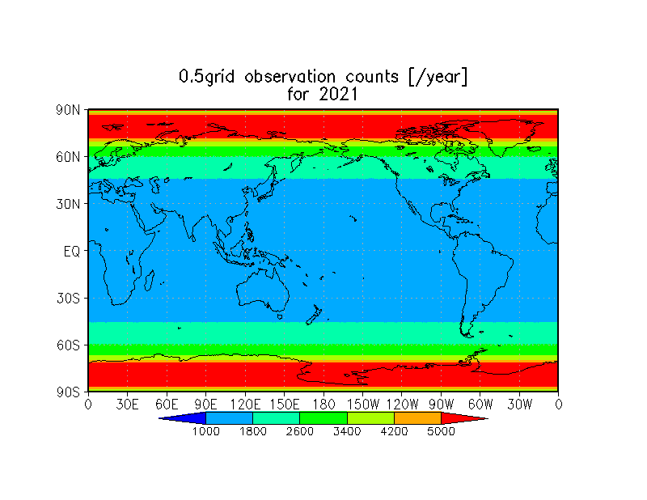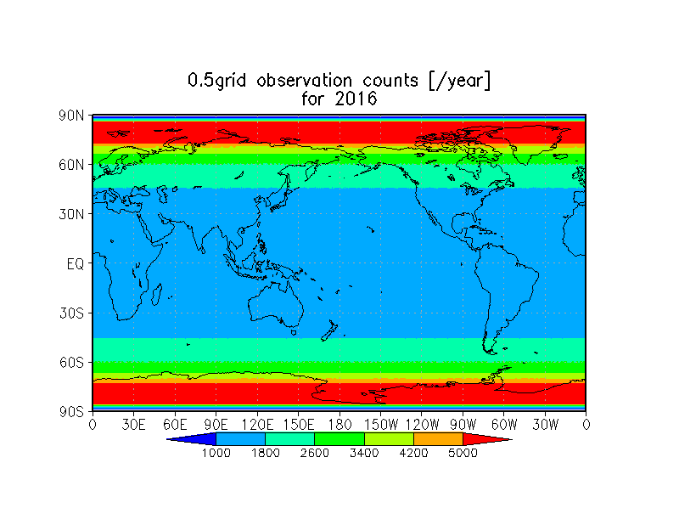

1. **Possible coordination of CEOS missions (up to 3 scenarios)**

Coordination within confirmed missions: Follow-on missions of SMOS and SMAP should be studied.

Addition of new missions: JAXA is studying the follow-on mission to GCOM-W AMSR2. JAXA and NASA are also studying a post-GPM mission that could provide relevant information for estimating soil moisture.Applications of SAR for estimating soil moisture should be promoted.

**e. High level cost benefit statements**

* Rough cost estimate and benefits for each scenario

**3.3 Evapotranspiration (Jerry, Selma)**

Evapotranspiration (ET) consists of processes of evaporation from soils and transpiration from plants (and plant canopies.) ET is the second-largest component (after precipitation) of the terrestrial water cycle at the global scale, since ET returns more than 60% of precipitation that falls on land back to the atmosphere. It is an important energy flux since land ET uses up more than half of the total solar energy absorbed by land surfaces. In semi-arid to arid systems, ET can account for over 90% of water loss. It is important to monitor ET fluxes to assess global climate change's impacts on ET. Although it is not considered as an ECV in the latest GCOS Implementation Plan, the GEOSS Water Strategy recognizes it as an Essential Water Variable.

ET is used for water management in agricultural systems. ET estimates can be applied to the assessment of water use in irrigation planning and monitoring. In some U.S. states, satellite ET maps are used to determine where irrigation has taken place and whether the insurance claims for crop losses due to a lack of irrigation water are valid. However, ET modelling and remote sensing estimates at the continental and global scales need significant improvements to enable better water resources management, drought impact mitigation, and climate change adaptations.

**a. Confirm the validated requirements**

The user requirements for ET provided in the GEO task report (GEO Task US-09-01a: Critical Earth Observations Priorities, Water Societal Benefit Area, GEO User Interface Committee, 2010) are given in Table 3.3.1. It should be noted that these requirements are for aggregated data products.

**Table 3.3.1**. GEO Water SBA requirement for evapotranspiration (with ET requirements for agriculture was added by Selma [tbc]). Source: GEO task US-09-01a: Critical Earth Observations Priorities, Water Societal Benefit Area, GEO User Interface Committee, 2010.

|  |  |  |  |  |  |
| --- | --- | --- | --- | --- | --- |
| Variable | Horizontal  Resolution | Time  Resolution | Vertical  Resolution | Accuracy | Latency |
| Evaporation/Evapotranspiration | L:1 km 60 m (Agriculture) | L:1 to 6 hrs  1-2 d (Agriculture) | Surface (E), and LS veg cover or canopy height for ET | 0.1 mm or 5%. Also stated in units of grams of H2O/m2/d | Generally Not specified. Or, RT (W/Precip) for point data assimilation/water budget models |
| R:10 km | R:1d |
| G:50 to 100 km to 200 km | G: 1 d to 1 m |

Despite the inability to measure evapotranspiration directly via remote sensing, it is nevertheless possible to measure datasets and processes that are needed to estimate evapotranspiration. More accurate estimation of evapotranspiration will require a new perspective on how multi-source measurements and models can be combined.

For ET, the NRC Decadal Survey recommended facilitating estimation of the diurnal cycle of evaporation over land and ocean surfaces with errors (at temporal resolutions sufficient to resolve the diurnal cycle) of less than 30 W/m2 at 10-km resolution, and over the open ocean with accuracy of 5 W/m2 for spatial resolution of 1 degree (about 100 km).

Remote sensing of land radiometric surface temperature (LST) is critical to all current schemes for remotely estimating evapotranspiration. LST is directly related to the sensible heat component of the energy balance and is thus inversely proportional to latent energy and evaporation rates. Thermal remote sensing can provide an integrated look at land surface evaporation, although the choice of overpass times is critical for providing the most representative estimate (mid-afternoon radiant heating of the land surface provides the most useful signal). For some purposes, data from geostationary satellites can also be used to derive LST and surface ET every hour under cloud-free conditions (GEO Water SBA requirement).

Participants at the 2015 Workshop on Evapotranspiration Mapping for Water Security held in Washington, DC recommended the time integration of ET for maps representing ET over daily, weekly, monthly, and longer time periods, based on ET obtained as “snapshots” determined on the day of a satellite overpass. Daily, weekly, monthly, and growing season ET maps are essential inputs to water resources management, water rights management, irrigation management, and hydrologic process modelling. ET "snapshots" require cloud-free image pixels.

For spatial resolution, imagery collected in the visible and near-infrared wavelengths at 30 m or finer spatial resolution, coupled with approximately 100 m or finer thermal imagery, is required to produce ET information for individual fields where water is managed at the field level. The requirement to measure the effects of human activity on ET varies at the field level. ET measurements derived from satellite data at spatial resolutions greater than 100 m are valuable for regional drought monitoring, hydrologic modelling, and other applications.

The frequency of surface measurements is affected by cloud cover. When estimating ET over extended time periods, we need information for any one point every 32 days (at a minimum) to follow the evolution of vegetation and water availability. Field-scale ET mapping requires multiple Landsat-type satellites. Imaging every two days with eight 180 km Landsat satellites or four 360 km Landsat satellites can mitigate cloud cover by significantly increasing the probability of obtaining a cloud-free pixel value at least every 32 days (Allen, 2015).

MODIS or Landsat data with one-day latency are not regularly available. USGS uses four-hour latency for quick looks, with occasional delays. One-day latency is an acceptable and fair requirement.

Programmes for the measurement of ET should explicitly analyze the trade-off between ET observations and modelling and evaluate in some detail whether different methods and data products might meet requirements better that single-approach satellites to meet the L, R, and G requirements. This is particularly relevant when looking at the two broad objectives: understanding the global terrestrial water cycle and providing useful information to water managers.

Examples of ET measurements for climate purposes include those published in Raghuveer and Vinukollu, et al. (2011). Their article discusses three process-based approaches for estimating global evapotranspiration using multi-sensor remote sensing data.

**b. Define a list of missions confirmed as contributing to the requirement**

CEOS satellite missions relevant for ET are listed in Table 3.3.2.

**Table 3.3.2**. Summarized observation capabilities of CEOS missions for estimating ET.

|  |  |  |  |  |
| --- | --- | --- | --- | --- |
| Variable | Horizontal  Resolution | Time  Resolution | Accuracy | Latency |
| Evaporation/Evapotranspiration | GEO: 3-10 km  MODIS: 1 km  VIIRS: 750 m, 375 m  Sentinel-3 SLSTR: 1 km  OLCI: 300 m  GCOM-C/SGLI: 1 km, 250 m  LANDSAT: 30 m, 100 m  CBERS: 40 m, 80 m  ISS/ECOSTRESS: 100 m | sub-hourly  daily  daily  daily  daily  16 days  26 days  diurnal cycle | 10%? | 1 day |

Missions such as ECOSTRESS, which provides field-scale ET data at different times of day from the International Space Station, provide the observations required to enhance our understanding of the evolution of ET throughout the day.

Closing the water budget using only satellite data is possible. Dr. Matt Rodell worked on this topic and his study should be cited in the report. Ultimately, it’s hard to obtain ET data via satellite that is accurate enough to close the water budget. Generally, ET estimates on a global basis have +/- 30% uncertainty.

Dr. Toshio Koike’s research has shown that land data assimilation could be helpful for ET. We need to be able to rely on data assimilation systems for appropriate data outputs. The inputs must necessarily also be accurate to obtain reliable outputs. The data should also be cross-referenced with multiple other variables, as should the data outputs.

**c. Assess gaps at 2016 and 2021**

As noted in Section 3.3a, LST is a critical variable for producing space-based ET data products. Consequently, the satellite support for ET focuses on LST measurements.

Landsat and MODIS are expected to be stable for the next few years at least. AQUA and VIIRS can be counted on for high-resolution observations if we lose MODIS and Terra in the next few years. Sentinel-3 SLSTR and OLCI also provide long-term LST data that can complement medium-resolution LST measurements.

**Figure 3.3**. Land surface temperature (LST) mission timeline.



**d. Possible coordination of CEOS missions (up to 3 scenarios)**

**Improved coordination within confirmed missions**

Coordination of CEOS LST missions (at high spatial or low temporal scale (LANDSAT), moderate spatial/temporal scale (MODIS), and low spatial/high temporal resolution (geostationary satellites) would improve ET estimation from local to the global scale.CEOS LSI-VC is working on this task.

Responsible agencies need to process LST datasets from satellites and make them available so that the products can be used to map ET in near-real time. This would involve a higher revisit time (four days) for LST observations, which are needed at high resolutions (finer than 100 m) to compensate for data loss from clouds and water management requirements. This requires multiple LANDSAT-type satellites in orbit to provide imaging at a four-day revisit interval.

**Addition of new missions**

**e. High level cost benefit statements**

* Rough cost estimate and benefits for each scenario

**3.4 River discharge (John W. Jones, Richard Lawford, Wolfgang Grabs)**

From a water management perspective, streamflow measurements are essential for designing and operating engineering works (dams, reservoirs, river regulation, etc.) because they provide various water-related services (navigation, flood protection, water supply for irrigation, municipal or industrial water use, and ecosystem management). Streamflow measurements also promote healthy aquatic ecosystems. Extreme flow conditions (high or low flows) create requirements for better resiliency of water management infrastructures and management systems. River discharge provides an integrated signal of the horizontal water fluxes for larger regions and hence represents the range of chemical inputs. Streamflow also serves as a medium for many biological and chemical processes and affects aquatic habitats and the sustainability of ecosystem services.

From a scientific perspective, runoff and streamflow are important elements of the water cycle because they integrate across precipitation, evapotranspiration, soil moisture, and groundwater over a basin. River discharge measurements are a reliable measurement of the global water cycle. As a result, it is a very important variable to maintain for practical water and habitat management reasons and for use in calibrating and evaluating hydrological and coupled land-atmosphere models.

Unfortunately, in-situ observations of discharge are presently lacking over significant portions of the Earth’s surface (figure 3.4.1) sharing of data collected at gauges islimited. Requirements for discharge are provided in Table 3.4.1.

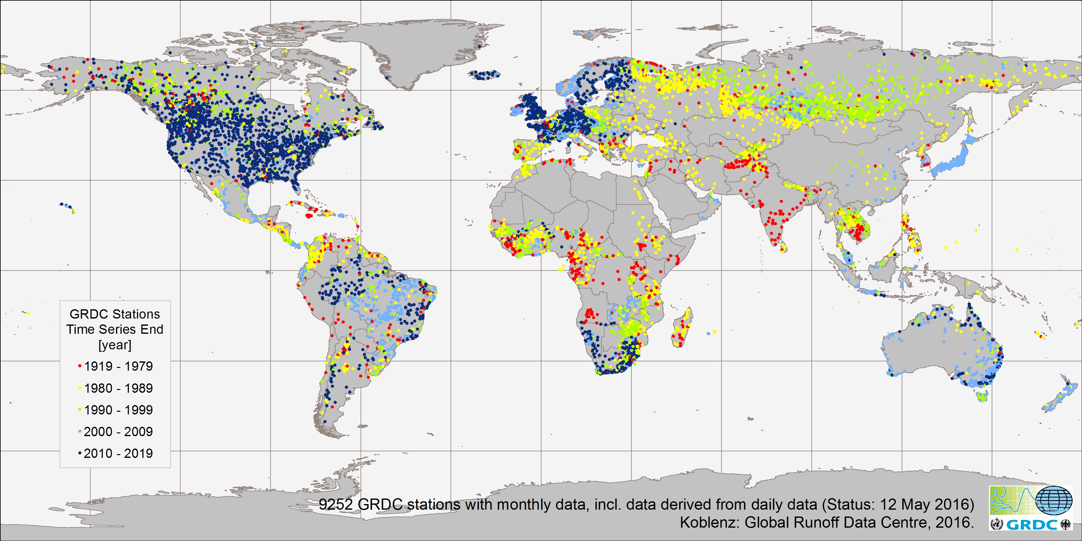

**Figure 3.4.1.** The global distribution of in-situ gauges for the important hydrologic measurement of river discharge is not uniform. Remote sensed measurements can compliment this network to help fill gaps in current knowledge and future monitoring capacity.

**a. Confirm the validated requirements**

**Table 3.4.1**. GEO Water SBA requirements for river discharge.

|  |  |  |  |  |  |
| --- | --- | --- | --- | --- | --- |
| Variable | Horizontal  Resolution | Time  Resolution | Vertical  Resolution | Accuracy | Latency |
| Discharge | L: point data or estimates for 1km-10km stream lengths | L: 1 to 6 hrs. | N/A | 5%-10%; Units: m**3/sec. or feet**3/sec. | Hourly to daily (NRT) for Point Data; Daily for Gridded.  Or: Hours to Ds to Mthly [App. Dep.] |
| [River Basins]  G: 50-200 km for gridded or Global | R/G: 1-10 day, Or 1 day to 1 month [App. Dep.] |

The requirements shown in Table 3.4.1 reflect traditional data collection capabilities (for local and point data) and the current or perceived near-term capabilities of satellite remote sensing. Observation and latency resolutions also depend on the application used.

The value and feasibility of adopting the requirement for six-hour observations of streamflow needs further assessment. While discharge is typically recorded in-situ with higher frequency in well-established in-situ networks, particularly at the international level, the operational publication of discharge records is more often at daily time steps under best conditions. Acquiring--let alone processing and quality assuring--in-situ data creates greater latency in discharge measurements. As a result, for example, WMO typically uses daily or monthly observations with an average latency of one year or more.

Given the state of knowledge and technology, the currently achievable accuracy may be below that listed as required in Table 3.4.1. While the application of satellite altimetry to river and lake stage estimation has been demonstrated, sampling (as opposed to imaging) nature and spot footprint sizes of current and planned altimeters are a primary limitation to spatial and temporal resolution in practice. For example, the WMO-SOG for Hydrology and Water Resources provides that in some regions, satellite-derived water-level observations based on altimeters are available only for particular large rivers. They may be used in quasi-operational mode for major basins--that is, where rivers are wide. Even so, the quality of those observations has yet to be fully determined and the capability to meet requirements for accuracy (as listed in Table 3.4.1) remains unverified.

It was proposed that this Feasibility Study should adopt as a goal a one-day latency user requirement as the standard for all terrestrial satellites.

Very high resolution and minute-by-minute data are most useful for emergency situations (discussed subsequently).

**b. Define a list of missions confirmed as contributing to the requirement**

Figure 3.4.2 provides a list of relevant CEOS missions contributing to runoff monitoring.

To estimate discharge to relatively high levels of accuracy, data on the height (stage) or slope of water surfaces are needed. Altimeter missions can measure the water level of major rivers and can therefore contribute to estimating river discharge. Among them, SWOT, which is currently scheduled to launch in 2020, will be the first altimeter designed with requirements that include monitoring in-land and coastal water heights and extents.

**Figure3.4.2.** Capabilities of relevant CEOS missions for surface water storage.

|  |  |  |  |  |  |
| --- | --- | --- | --- | --- | --- |
| Variable | Horizontal  Resolution | Time  Resolution | Vertical  Resolution | Accuracy | Latency |
| Discharge | (altimeter)  SWOT<100m  (Optical)  MODIS: 1 km,  Landsat: 30m  Sentinel 2: 10m. 20m  (SAR)  ALOS2: Lband 10m. 60m  Sentinel-1: Cband 9m, 20m, 50m  RADARSAT-2  RCM | 21 days  daily  18 days  10days  14 days  12 days  24 days  12 days |  |  |  |

Using SWOT and other altimeters, existing gauge networks may be supplemented with virtual gauge stations whose locations will be based on the selection of appropriately-sized surface water features that fall within the known trajectories of existing and planned altimeter systems such as SWOT. SWOT has as a design objective the measurement of heights for rivers wider than 100 m. Repeat, systematic estimation of heights at these locations, given the accuracy and latencies associated with the altimeter-based approaches, would be used to fill in sparse discharge and storage data networks.

It is important to note that such measurements are by no means a substitute for in-situ data collection networks. The two technologies remain not only complementary, but also dependent. The availability of in-situ data on stage/discharge remains critical for purposes of remote sensing method development and accuracy assessment.

The concept and benefits of a virtual constellation have been previously discussed (section X.X.X). The WMO’s Flash Flood Guidance System (FFGS), which has global coverage, provides an example of the potential for the fusion of virtual constellation satellite data with complementary in-situ measurements for assimilation into simulation models to provide decision support. Flash floods are among the world’s deadliest natural disasters, with an average of more than 5,000 lives lost annually and significant detrimental social, economic, and environmental impacts. Accounting for approximately 85% of flooding cases, flash floods also have the highest mortality rate (defined as the number of deaths per number of people affected) among different classes of flooding (e.g., riverine and coastal). Urban areas are particularly sensitive to heavy rain events due to the large proportion of the area that is covered with impervious surfaces and the tendency in some cities to offer little or no storm drainage. Hence, WMO is implementing the FFGS in technical cooperation with the Hydrologic Research Centre (HRC) in San Diego, CA and with financial support from USAID. It is expected that the system’s coverage will reach over 1 billion people by mid-2017.

Through a regional implementation approach, the main objective of the FFGS is to reduce vulnerability to hydrometeorological disasters, specifically flash floods, by developing and implementing flash flood guidance systems that provide timely and accurate flash flood warnings. An important and innovative characteristic of the FFGS is the integration of multiplatform observations, including satellite-based data on precipitation, soil moisture, and land cover, in-situ observations, and other static databases, as drivers in a multi-model-based computational core that can calculate a number of warning products at the local scale. Technical elements of the FFGS include the operational use of bias-corrected satellite precipitation fields and physically based hydrologic modelling to determine flash flood guidance and flash flood threat. Real-time estimates of high-resolution satellite precipitation data are routinely available globally on an hourly basis (section X.X.X) and can be integrated with real-time ground radar and in-situ observations (where available). Operational satellite-based soil moisture observations are ready to be integrated in the overall system in support of the physically based soil moisture accounting models (section X.X.X). The system allows the National Hydrological and Meteorological Services (NMHSs) to use local nowcast/short-term-forecast methods to issue warnings, including local forecaster adjustments. The system provides flash flood information over lead time scales from three to six hours and for basins on the order of 100 km2. The FFGS by itself is a diagnostic tool. However, forecasting is afforded through the application of numerical weather prediction models to result in the extension of flash flood threat prediction to 48 hours. More information on the FFGS can be obtained here: http://www.wmo.int/ffgs and <http://www.hrcwater.org>.)

The WIST’s assessment of requirements identified an additional aspect of river water flow for which satellite remote sensing is extremely well-suited and information is critically needed: flood extent, or the land surface area inundated by river flood waters. River flood extent, not discharge per se, is vitally important information in the cases of flood mitigation and response. Irrespective of the availability of river discharge data, in the event of flooding, timely information on the extent of floodwaters can greatly improve the safety and effectiveness of mitigation and rescue operations. Following flood events, information on flood extent can be used to more accurately assess damages and target recovery resources. And floods create conditions during which in-situ measurements are generally inadequate, reinforcing the need for remotely sensed information. The need for high temporal resolution is greatest in the case of floods. Several satellite-based methods are available on demand to map the extent of flooding in floodplains or large riverine systems and the duration flooding. These methods include visual, infrared, and radar sensors. And some satellites are especially useful for mapping flood extent on a daily basis. For example, MODIS provides flood information at a spatial resolution of 250 metres on (potentially) a daily basis in the form of rapid response data provided by NASA’s LANCE system. Several satellite-based methods using data from optical, infrared, and radar sensors are available to map the extent of flooding as well as flood duration in floodplains or large riverine systems. Spatial resolution requirements are less stringent than those for discharge, while in the case of disaster response in particular, short latency is of critical importance. Advances in data sharing achieved through the development of an international charter for disaster response provide an example (citation). However, shortcomings in data processing requirements during disaster events continue to challenge response effort effectiveness, pointing to the need to develop data creation and distribution systems that share value-added products (analysis-ready data) to user communities that don't have extensive remote sensed data processing resources or exploitation experience.

**c. Assess gaps at 2016 and 2021**

Measurements from space that will be useful in providing space-based measurements are expected to be about the same now as they were in 2021. However, some missions will be more specifically directed at streamflow measurement (e.g., SWOT). Unfortunately, the 21-day repeat timeframe associated with the SWOT system falls well below confirmed sub-monthly temporal resolution requirements, but will be useful for many applications including water resources assessment and sub-seasonal variability of water resources availability..

To estimate discharge with high levels of accuracy, stage has been measured in-situ and used in combination with in-situ-measured volume, velocity, and channel hydraulic characteristics (for example, channel bottom shape and roughness) for the determination of the stage-discharge relationship at the gauging site (rating curve).. The current inability to reliably measure channel hydraulic characteristics such as bathymetry, particularly in the case of turbid waters or canopy-obscured channels, represents a major information gap. The increased availability of remotely sensed data from optical, polarimetric RADAR, and altimeters will all contribute to the continued development of relationships between observable variables and necessary channel parameters.

The development of new systems should be based on the recognition that satellite and in-situ observations complement one another (as opposed to being competitive).

The altimeter mission timeline is given in Figure 3.4.2. From the satellite observation point of view, revisit time is an issue.

**Figure 3.4.2**. Altimeter mission timeline.



**d. Possible coordination of CEOS missions (up to 3 scenarios)**

Coordination within confirmed missions: The combination of SWOT and other existing altimeter missions to improve revisit time should be studied.

The combination of SWOT and data from GPM (section X.X.X) and combined active passive soil moisture data (section X.X.X) should be studied.

Addition of new missions:

**e. High level cost benefit statements**

Rough cost estimate and benefits for each scenario

**3.5 Surface water storage (John W. Jones, Richard Lawford)**

Water stored on the land surface influences the flux of water from the land surface to the atmosphere, the infiltration of water to deep soil moisture and groundwater layers, and the runoff of water into the stream network. Over X% of the land surface is covered by lakes and other water bodies, which evaporate significant amounts to the atmosphere, especially in late summer and fall. These water bodies provide habitats that ensure biodiversity and serve as primary freshwater sources for humans. Changes in natural surface water storage provide important indicators of underlying hydrological processes due to natural or human-induced changes. Largest storage features are often well-monitored and regulated. Yet exchange of information useful for global- and regional-scale (particularly trans-boundary) modelling and resource management is lacking. These data are often considered proprietary and are usually not shared. Water storage in lakes, rivers, floodplains, and wetlands) are particularly poorly monitored. High-spatial resolution satellite remote sensing of surface water area and stage, when combined with information on elevation and bathymetry, make it possible to estimate changes in volume of water in these features.

Water in the form of snow and glacier is stored on the land surface and is part of the surface water storage that is available for use in agriculture and domestic water supply. At more northern latitudes, snow is critical because it provides spring moisture that is used in agriculture and meets other water supply needs. Snow Water Equivalent (SWE) is used to represent the moisture available in the snow pack. At mid and high latitudes, the snow that accumulates in the mountains provides much of the water used to irrigate crops during the growing season. Consequently, SWE measurements are extremely useful for predicting spring and summer water supplies and flood potential in these areas. Ground ice reduces the infiltration into and the migration of water through soils, reduces the amount of water that can be stored in soils, and increases the runoff generated from melting snow.

Seasonally and permanently frozen lands also are very sensitive to climate change because warming affects wetland patterns, methane gas releases, slumping and disruptions to built infrastructure, and transport and access, among other hazards and costs. In addition, monitoring the trend and rate of mountain glacier retreat is important for assessing the impacts of climate change and predicting its potential long-term effects on the availability of freshwater in the summer months.

**a. Confirm the validated requirements**

The GEO Water SBA requirements for surface water storage are shown in Figure 3.5.1.

**Figure 3.5.1.** GEO Water SBA’s requirements for surface water storage.

|  |  |  |  |  |  |
| --- | --- | --- | --- | --- | --- |
| Variable | Horizontal  Resolution | Time  Resolution | Vertical  Resolution | Accuracy | Latency |
| Surface Water Storage | L/R: 1-40 km  G: 50 km to 100 km  Also stated as Polygons | 1wk to 1m  Or 30 d to 90 d or Monthly to Annual [App. dep] | N/A | 10-20 cm (level) or 5%. Units for other quantities (area, depth, volumetric) include Km**2; meters; m3/s | 1wks-1m For L/R 30d to 90d  for R/G |

Indicated regional (R) and global (G) requirements for spatial resolution are supported by the observation that much of the world’s freshwater storage volume is contained in the largest water features (provide and reference Birkett figure here). Monitoring these large features is important for regional-to-global modelling and trans-boundary resource management negotiation. However, the WSIST team recognized that consultations with users were limited in the case of SWOT. Smaller water features important for watershed discharge at local and even regional scales (Viger and others) or for habitat assessment at more local scales are not represented. For remote sensing to benefit modelling and resource management for these applications at more local scales, smaller water features must be detected and monitored. Once users become accustomed to SWOT’s new capabilities, their expectations will increase. The WSIST team believes that a 1 km spatial resolution is possibly too much for global observations but requirements for local observations could be met for resolutions as small as 250 metres to 500 metres or finer. Figure 3.4.2 provides a list of CEOS-relevant missions that can contribute to surface water storage.

(Note: we need a table of the requirements for SWE data)

**b. Define a list of missions confirmed as contributing to the requirement**

Capabilities of CEOS-relevant missions for surface water storage are given by Figure 3.5.2.

**Figure 3.5.2** Capabilities of CEOS-relevant missions

|  |  |  |  |  |  |
| --- | --- | --- | --- | --- | --- |
| Variable | Horizontal  Resolution | Time  Resolution | Vertical  Resolution | Accuracy | Latency |
| Surface Water Discharge and Flood Extent | (altimeter)  JASON-2  ICES/GLAS  SWOT<100m  (Optical)  MODIS: 1 km,  Landsat: 30m  Sentinel 2: 10m. 20m  (SAR)  ALOS2: Lband 10m. 60m  Sentinel-1: Cband 9m, 20m, 50m  TerraSAR-X, Xband, 1m  RCM (RADARSAT Constellation Mission). Cband; 1 to 100m | 10 days  21 days  Daily  8-16 days  10days  14 days  12 days  11 days  Varies with latitude (3 to 21 days) | N/A |  |  |

(Source: Augmentation of table provided in GEOSS Water Strategy)

In the case of surface water storage, SWOT mission plans reflect a clear focus on priority issues. For example, it plans to provide systematic monitoring of the 1,000 largest reservoirs in the world with routine access in near real time (less than 30 days) to vector elevation data. The large size of these reservoirs guarantees that one month is a sufficient temporal sampling and that a one-month delay guarantees timely data access for monitoring. The data product will thus be restricted to the largest reservoirs and low data latency (SWOT SRD). This criterion is reinforced by the recognition that the largest reservoirs contain the majority of stored surface water. It also makes the monitoring of freshwater for purposes of global and large region climate and hydrologic modelling relatively tractable. Current SWOT design plans also target the detection and height estimation for waterbeds that are 250 metres in size or larger. SWOT will provide data with high horizontal resolution. Therefore, as with discharge, remote sensing of surface water stage for surface storage features will provide some insight into volume storage change at even local scales. The strengths and weaknesses of these methods and their associated uncertainties require further investigation. Presently, the ability of the ICES/GLAS instrument to provide accurate measurements of lake levels is being tested. Also, as with discharge, to most accurately estimate changes in water volumes in lakes and reservoirs, high spatial resolution satellite remote sensing of surface water area must be combined not only with stage, but also with information on terrain elevation and bathymetry (“topobathy”). As with gauge-based data on discharge channel geometry for rivers, this information is not available for much of the world’s reservoirs. For locations where topographic data have been collected in the absence of overlying water, remotely sensed measurements of surface water extent can be used to estimate volume. Hypsometry derived from repeat satellite measurements of surface area in combination with digital terrain models can yield valuable information on storage changes even though total absolute storage is unknown. See for example, the Hydroweb (http://hydroweb.theia-land.fr/hydroweb/view/b9b9422d-bd5f-5677-a93f-5dded346463c?lang=en&basin=Nile&lake=tana) Methods to estimate the bathymetry of shallow waters through optical remote sensing under optimal conditions (relatively clear water) are emerging, bt they are difficult to employ in locations with turbid water, dark water substrates, and overhanging vegetation canopies.

Many activities are underway to monitor surface water extent using moderate-resolution satellites such as Landsat and Sentinel-1. Examples include Geoscience Australia’s Water Observations from Space (WOFS) and the USGS Dynamic Surface Water Extent (DSWE) initiative (Figure 3.5.2). In the absence of adequate information on storage volumes for small undocumented reservoirs, the satellite-measured area has been correlated with known volumes for select water features to parameterize a physically based hydrologic model at the regional scale (Viger et al., 2011). This initial research relating storage feature volume to area requires replication, additional application, and more robust examination before its feasibility and utility are appropriately evaluated. Finally, estimation of wetland surface water extent (Jones, 2015), water heights (Kim et. al., 2014), and, therefore, storage volume present particularly difficult challenges and related techniques remain unexplored.

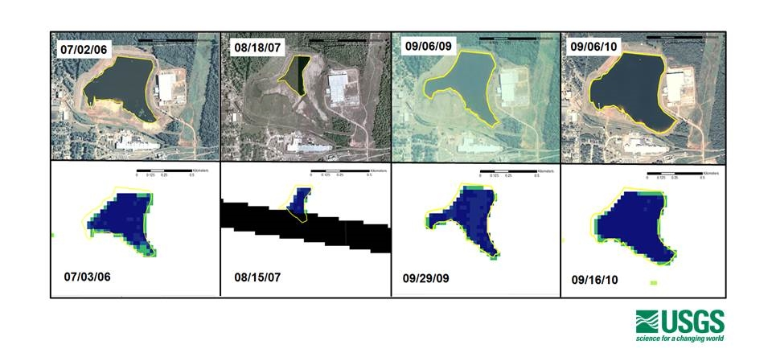

**Figure 3.5.2.** A single pond’s surface water extent on various dates as seen in USDA aerial photography (top) and as detected by the provisional USGS Dynamic Surface Water Extent (DSWE) model using Landsat Thematic Mapper and Landsat Enhanced Thematic Mapper image inputs (bottom).

The U.S. Department of Agriculture's Foreign Agricultural Service (USDA-FAS), in co-operation with NASA and the University of Maryland, are routinely monitoring lake and reservoir height variations for many large lakes around the world. Called G-Realm, the programme utilizes NASA, CNES, ESA, and ISRO radar altimeter data over inland water bodies in an operational manner (see <http://www.pecad.fas.usda.gov/cropexplorer/global_reservoir/> for more information).

**c. Assess gaps at 2016 and 2021**

Sampling analysis for 2016 and 2021.

**d. Possible coordination of CEOS missions (up to 3 scenarios)**

As with other EWVs, the fusion of optical and radar systems for the purpose of surface water storage monitoring is at the experimental stage. It will continue to mature along with the greater availability of radar data to complement freely available data from optical systems such as Landsat and Sentinel. The combined use of these data sources to estimate surface water extent improves temporal resolution and helps overcome impacts of cloud cover on optical sensing systems. The goal for data producers is to fill observational gaps using different observational methods to produce the best product possible.

Coordination within confirmed missions

Addition of new missions

**e. High level cost benefit statements**

Rough cost estimate and benefits for each scenario

**f. Cited literature**

Jones, J.W. 2015. Efficient wetland surface water detection and monitoring via Landsat: Comparison with in situ data from the Everglades Depth Estimation Network. Remote Sensing. Vol 7, issue 9, 12503-12538.

Kim, J-W, Z. Lu, J.W. Jones, C.K. Shum, H. Lee and Y. Jia, 2014. Monitoring Everglades’s freshwater marsh water level using L-band synthetic aperture radar backscatter. Remote Sensing of Environment. B. 150 p. 66-81

Viger, Roland, L. Hay, J. Jones and G. Buell (2011) Parameterization of spatially distributed, physically based hydrologic models for ecological flow requirement modeling. USGS SIR. 120 pp.

**3.6 Groundwater (contributed by Matt Rodell)**

Increasingly, societies are relying on groundwater for their freshwater supplies. Groundwater recharge is sensitive to precipitation intensity, evapotranspiration, and the underlying hydrogeology. Groundwater monitoring is necessary to assess the current state of groundwater resources and for predicting its sustainability under different use scenarios. To meet the strategic needs for coordinated groundwater observations, the International Groundwater Assessment Centre (IGRAC; http:www.un-igrac.org) is working toward a Global Groundwater Monitoring Network (GGMN) and developing assessment capabilities for parts of the world where data are not readily available. Since most recharge occurs where there is permanent or temporary surface water storage, there are links between the measurement of surface water storage and estimating groundwater recharge.

**a. Confirm the validated requirements**

**Figure 3.6.1.** Requirements for groundwater observations.

|  |  |  |  |  |
| --- | --- | --- | --- | --- |
| Variable | Horizontal  Resolution | Time  Resolution | Accuracy | Latency |
| Ground Water | L/R: 1 km-10 km  R/G: 50 km to 500 km  Also stated as > 7000 wells for global or density of well sufficient to characterize water storage fluxes to within 20% | 1 week to 3 m to 1 year depending on variability and applications | 5%-7%(Depth to W-table); 20% for fluxes;(cm/s or m3/s etc.); 2 cm equivalent of water | 1 w to 3 m Also stated as TBD-App Depen |

(Source: GEO task US-09-01a: Critical Earth Observations Priorities-Water Societal Benefit Area; L=Local, R=Regional, G=Global)

The GEO Water SBA report includes requirements on groundwater. WMO-SOG-H requirements for groundwater data are shown in Appendix C

Because groundwater tends to respond more slowly to short-term climatic variations than surface water resources, this variable is often not considered to be of first-order importance from a weather perspective. Due to its slow rate of variation, groundwater does not have an optimum observation time. However, in fact, its long-term nature does make it relevant to climate scale analyses. Terrestrial observations are being made but overall global access to groundwater data (rates of recharge and abstraction in particular) is highly limited. Gravimetric observation techniques (such as from GRACE) for very large groundwater bodies are available through data assimilation systems but require integration with higher-resolution and lower latency data in order to be useful for operational applications.

IGRAC a collaborative UNESCO/WMO centre, maintains a groundwater monitoring metadata and data system and contributes to the GEO Water Task. Due to the difficulty of obtaining groundwater data, IGRAC has established the Global Groundwater Monitoring Network (GGMN). The GGMN consists of groundwater specialists who are members of a people network and can bring national data to problems without putting themselves or their data at risk.

**b. Define a list of missions confirmed as contributing to the requirement**

Capabilities of GRACE, GRACE FO, and GRACE-II are provided in Appendix A.

The following table provides GRACE and GRACE-FO capabilities.

Figure 3.6.2 Observation capabillities of GRACE and GRACE-FO.

|  |  |  |  |  |
| --- | --- | --- | --- | --- |
| Variable | Horizontal  Resolution | Time  Resolution | Accuracy | Latency |
| Ground Water | 400 km |  | 1 cm |  |

(Source: GEOSS Water Strategy)

The GRACE satellite’s resolution is no better than 150,000 km2 at mid-latitudes; the stated requirement is 1 km2 for individual aquifers. Although the satellite capability is far less than requirements for horizontal resolution, it should be noted that many regional requirements can be met with data at the current GRACE resolution. GRACE data used for drought monitoring show that these data are related to soil moisture, ET, and vegetation anomalies. Groundwater can be linked with soil moisture and ET through LDAS.

The issue of data latency is being addressed to some degree. A GRACE quick-look product that is expected to have a two-week latency period, compared with the two- to four-month latency of the standard products, is being developed.

GRACE FO has established an application development team. This team is considering applications such as the inter-decadal changes arising from climate change and the over-pumping of groundwater aquifers.

INSAR measurements can provide high spatial resolution information on land subsidence and hence groundwater extraction but they cannot provide a complete measurement of the groundwater signal because aquifer compaction is not elastic.

**c. Assess gaps at 2016 and 2021**

Figure 3.6.3 shows mission timelines for GRACE and GRACE-FO based on the latest information provided by Matt Rodell of NASA.

**Figure 3.6.3.** Gravity mission timeline.



The mission chart shows that GRACE is in service in 2016 and that GRACE Follow-On will be launched in early 2018. GRACE FO will have a laser-ranging system in addition to the standard microwave system for changes in the distance to measure range change between the two satellites, which is the key measurement. The configuration, however, will be nearly identical to the current GRACE mission and will be at an altitude of 500 km in non-sun synchronous orbit (CEOS EO DB). GRACE will survive no longer than the end of 2017 and there will therefore be a gap between GRACE and GRACE FO, but efforts are being made to minimize the effect of such gap.

GRACE-II is now being proposed to the Decadal Survey committee for launch sometime in the late 2020s or early 2030s. Such a mission will be critical for preserving continuity of the climate data records provided by the GRACE series of missions.

In urban areas, the chance for water infiltration is minimal due to buildings, impervious surfaces, and the storm systems that remove the water before it has a chance to infiltrate the soil. There is a great need for groundwater data in urban environments to better understand its role in that environment.

**d. Possible coordination of CEOS missions (up to 3 scenarios)**

**Coordination within confirmed missions**

Minimizing the impact of the mission gap between GRACE and GRACE FO should be strongly encouraged by CEOS.

**Addition of new missions**

A proposed NASA/Germany GRACE-II mission for the Decadal Survey needs should be supported by international research communities and user communities, including GEO.The launch of additional gravimetric missions by other space agencies would create synergies that could potentially increase the spatial resolution and accuracy of the resulting data products. This possibility should be promoted by CEOS.

It should be noted that it is a little more challenging to develop synergistic missions with groundwater than with many other measurements because of the focus on gravimetric measurements. This is an area in which LDAS can play a major role in bringing datasets together.

**e. High level cost benefit statements**

Rough cost estimate and benefits for each scenario

**4. Priority water cycle variable synergistic observation feasibility (For all team members and associated experts, voluntary inputs and ideas are invited)**

**4.1 Define synergistic observation requirements for high-priority parameters**

- What are the new observation requirements for synergistic observation among those high-priority parameters?

Throughout the following discussions references will be made to models as well as observational systems. Models play an increasingly important role in the delivery of information to users. In cases where observational systems are too degraded by budget reductions and satellites do not provide sufficient coverage models can be used to derive desired values from the larger scale environmental conditions that are measured. For example at northern latitudes the official meteorological observational systems struggle to provide a full representation of precipitation they are based on fewer and fewer observation s. In these cases models which process the temperature, humidity, pressure and vertical velocity fields are able to produce prostitution patterns which may be as accurate as anything that can be derived from observations. Models also provide values for unmeasured values I the case of root zone soil moisture and other subsurface estimates when measurements are not possible, Scaling up *aggregation) and scaling down (disaggregation) are made possible through the use of m0dels. In the data assimilation mode models can bring together a wide range of observations from different times and space resolutions to produce accurate representation of fields. Other applications of models involve providing information through diagnostic and predictive applications.

A number of benefits arise from bringing precipitation and soil moisture measurements together in a more coordinated way. Precipitation and soil moisture data can be used together to address specific needs, such as:

Precipitation in numerical weather prediction models: The prediction of precipitation is difficult to achieve in models, in part because precipitation processes are very difficult to represent in a numerical model. This difficulty arises from the plethora of interactions in the air column where the precipitation is forming. Current prediction techniques rely on bulk characteristics of the atmosphere, including the instability in the air column, the amount of moisture in the air column, and the amount of water being supplied to the air column by the underlying surface. Over land, this last variable is often addressed by using a land surface data assimilation system that can intake data on surface wetness in terms of vegetation and soil moisture and take advantage of the correlations that have been demonstrated between the surface moisture and the intensity of the rain events that occur (Reference).

Prediction models run on a six-hour cycle; consequently, it is important to update the information on this cycle. Data assimilation systems offer the opportunity to provide input on a less regular basis since they accumulate the information over a time interval and then produce the fields when they are required.

Prediction of the flood potential from a rain event: heavy rain events are a common cause of floods, particularly at mid and equatorial latitudes. When the surface is saturated, the rain does not have the opportunity to infiltrate the soil and tends to run off. When all of the rain from a heavy rain event runs off, it overloads the storm sewage systems and other infrastructure put in place to deal with floods and can create very dangerous situations.

**4.1.1 Explore the options for meeting more of precipitation requirements when complementing the precipitation parameter measurements with other parameter measurements**

The SMAP best-estimate analysis is produced approximately 2.5 days after real time due to the delay in the CPC Unified global gauge product. This does not meet the requirements for data latency of one day. Improvements in data latency are needed for both precipitation and soil moisture.

SMAP data have been used to estimate rainfall based on the work of Luca Brocca of the Italian Research Institute for Geo-Hydrological Protection. The soil water balance is solved during rain events. SMAP retrievals (as well as SMOS and ASTER soil moisture retrievals) show large increases during heavy rain events but they change more slowly as the soil slowly dries out under no or light precipitation. SMAP retrievals have been shown to work the best in estimating the rainfall. A correlation coefficient of 0.6 existed between SMAP-based precipitation outputs and gauge observations in high-density gauge areas.

**4.1.2 Explore the options for meeting more of the soil moisture requirements when complementing soil moisture measurements with other parameter measurements**

SMAP introduced some new criteria for soil moisture measurements based on the support it provided to a number of meteorological users. These revised requirements are described below.

Resolution: SMAP chose 3 km to resolve convective scale footprints. This resolution is much higher than the 40-km resolution that many applications state is the required spatial scale for soil moisture. Unlike precipitation, beam filling isn't a zero-order problem for soil moisture.  For land surface mapping considerations resolution requirements are mostly a matter of resolving desired features, such as land areas close to water.  The passive SMAP resolution is 36 km, while for AMSR-E 10 GHz it was approximately 40 km.

The SMAP project indicated that a data latency of three hours was needed for NWP assimilation (Escobar). However, the benefit of low latency has not yet been demonstrated for soil moisture, in large part due to the requirements for diurnal surface temperature measurement.

Frequency of measurements: For some irrigation applications, daily values are the most useful. For other applications, observations every two days are sufficient. A high frequency is needed during the occasional rapid increases, while longer intervals are appropriate for slow draw-downs. For most applications where soil moisture and precipitation data are needed to address a problem, there must be an ability to monitor in the rapid increases. Frequent measurements are also desirable because most soil moisture measurement techniques rely on microwave data that cannot be acquired under rain or cloudy conditions,. While sub-daily measurements may be desirable in some situations, they should be combined with surface temperature measurements and optical depth in order to properly reconstruct the diurnal cycle of soil moisture.

Spectral resolution: The L-band has been the preferred choice for SMOS and SMAP.  Radio frequency contamination is a critical factor for all lower frequencies. The footprint and sub-band design cause the synthetic aperture on SMOS to be more susceptible than SMAP to this factor. Even L-band observations experience RF interference in Europe, the Middle East, and China. SMOS and Aquarius lacked RFI mitigation, while SMAP benefited from this new information and implements more mitigation and sub-band tuning.

Information from X-band (10 GHz) is also useful, at least in regions with relatively sparse vegetation. There is a critical need to provide coincident soil moisture and surface temperature (37 GHz channel).

Soil moisture observations have been used in research but have not been used extensively in operations. For example, GLDAS, NLDAS, and MERRA do not currently use soil moisture observations operationally. The SMOPS system being implemented by NOAA and NESDIS will be one of the initial operational retrievals using imager X-, C-, and L-bands in near-real time.  
  
SMOPS is an operational satellite soil moisture processing system used by NOAA to retrieve and merge all currently available soil moisture-capable satellite observations for NOAA and other users. Currently, the ASCAT data derived from SMOPS is used by the U.S. Department of Defence’s weather model. SMOS data derived from SMOPS is used by the U.S. Department of Agriculture’s Foreign Agricultural Service (FAS). The SMOS, SMAP, and merged products used for NCEP NWP model data assimilation research and from GPM and GMI will be added soon. Operational users are expected to provide improved assessments of soil moisture observation requirements.

Sub-daily sampling is not the most important issue for sub-daily soil moisture estimates. For these sub-daily data to be useful, good information on the (strongly) diurnally varying surface temperature is also needed.  These measurements apply to a soil layer average, whose depth depends on the frequency of the satellite channel.

Considering surface temperature as it affects L-band retrievals, Holmes has developed passive Ka-band (37 GHz) algorithms that can be converted to L- and C-band temperature estimates (recall that the depth of the temperature is band-dependent).  With the current complement of passive microwave sensors, Holmes can stitch together surface temperature to get the diurnal cycle of surface energy flux, thereby partitioning latent and sensible heat flux.

L-band retrievals of soil moisture are somewhat affected by heavy rain, so, precipitation is needed to identify areas where soil moisture estimates will be poor.  For data assimilation, the goal is to make sure that the integral of precipitation matches the soil moisture observations.

The optimal sampling time for soil moisture is 6 AM local time because soil temperature is less of an issue just at local dawn.   Soil moisture and precipitation observations could be better coordinated for multiple purposes. For example, GPCP products rely on observations in the 6 AM and 6 PM orbit for calibration.  This orbit has been used as the long-term calibrator for the GPCP precipitation dataset.  With the imminent demise of the DMSP series, there is an urgent need to find a long-term replacement satellite in that orbital slot. A new mission could address both precipitation and soil moisture data needs.

GRACE Follow On appears to be on the schedule and hopefully will provide data for soil moisture and precipitation applications by 2021.

From a soil moisture perspective, the C-band sees vegetation as more transparent in warm conditions because the vegetation gets drier. To monitor this, surface temperatures must be obtained on a more regular and planned basis. Imagers are key to retrieving soil moisture. A recent review of microwave sensors (Huffman, 2016) suggests that a microwave constellation could provide the measurements needed for regular assessments of surface temperatures, soil moisture, and precipitation.

**4.1.3 Explore the options for meeting more of the evaporation/evapotranspiration requirements when complementing evaporation/evapotranspiration measurements with other parameter measurements**

Surface temperatures are critical for the best retrieval of soil moisture; consequently, linking soil moisture and ET calculations derived from surface temperatures could provide opportunities for new applications.     ET can be estimated from the diurnal cycle of surface temperature using several observations at representative time (6 AM, 10 AM). Martha Anderson has had good success in using the Atmosphere-Land Exchange (ALEXI) algorithm to combine surface temperature and flux measurements. 

Prognostic land surface models (such as Noah, CLM, an dSiB2, among others) and diagnostic ALEXI models could be used as a synergistic tool to input satellite observations and meteorological forcing in order to retrieve land surface ET and soil moisture, especially ALEXI (other LSMs require rainfall as input, while ALEXI does not). The ET from ALEXI has been successfully used to derive inverse ET from satellite observations of LST. Synergistic observations of ET and soil moisture could be realized using the ALEXI model.

The repetitive and synoptic capabilities of satellite remote sensing can provide regional ET estimates that are useful when combined with other satellite-based hydrological and ecological measurements (such as groundwater from GRACE, soil moisture and snow-pack from AMSR-2, and surface temperature, leaf area, and land cover data from MODIS and LANDSAT).

Synergies between precipitation, soil moisture, and ET in any combination are important. This could be especially helpful if it translates into coordination of data collection and analysis.

**4.1.4 Explore the options for meeting more of river discharge requirements when complementing river run-off measurements with other parameter measurements**

**4.1.5 Explore the options for meeting more of surface water storage requirements when complementing surface water storage measurements with other parameter measurements**

**4.1.6 Explore the options for meeting more of groundwater requirements when complementing groundwater measurements with other parameter measurements**

Groundwater can be linked with SM and ET through Land Data Assimilation Systems (LDAS).

**4.2 Possible coordination of CEOS missions** Coordination for confirmed missions

Addition of new missions

**4.3 Summary of the Synthesis results**

The comparison of precipitation and soil moisture led to the identification of a number of synergies. Similar synergies were found when the other variables were cross compared with each other. It also became clear that several types of data were needed to address the key applications of these data to floods, droughts and water resource management. The following paragraphs present these relationships in several matrices including an overview matrix and matrices for each of the primary application areas.

Figure 4.3.1 shows the overall matrix summarizing the common applications of the data types in the upper right hand side and the areas where new developments and improvements could be achieved through the sharing of instruments, data sets and supporting data sets that could be applied in different ways. As shown in Figure 4.3.1 if one moves across on the “P” (precipitation) row to the “SM” (soil moisture) column there is a synergy for precipitation and soil moisture arising from applications in the areas of Water Management and Floods. These applications are detailed more fully in Figures 4.3.2 (Floods) and 4.3.4 (Water management). Other synergies in applications can be identified if one selects a row for any variable and move over to the far right of the figure and stops under the variable of interest. For example, “ET” (Evapotranspiration) has a link with “GW” (groundwater) for drought monitoring. Finding synergies in the types of supporting data, sensors and supporting systems comes from taking a row and following it on the left side of the figure to the column in question (for example one could follow the row “ST”(storage)_and move across under “RD” (river discharge) to find the synergies between runoff and water in storage to see that Altimetry and Water level data are identified as two areas where synergies could be built between these variables.

**Figure 4.3.1** Synergies for Water Applicatio s

**Water Applications Needsbenefitting from synergies**

|  |  |  |  |  |  |  |  |  |  |  |  |  |
| --- | --- | --- | --- | --- | --- | --- | --- | --- | --- | --- | --- | --- |
| **Sensors and technologies** |  | **P** | **SM** | **ET** | **RD** | **ST** | **GW** |  |  |  |  |  |
| P |  | Floods, Water Management | Drought, Water Management | Floods Water Management | Floods, Drought, Water Management | Water Management |  |  |  |  |  |
| **SM** | Radar LST  MWI |  | Drought Water Management | Floods | Water Management | Drought |  |  |  |  |  |
| **ET** | High res LST | High res LST  LC Maps |  | TBD | Water Management  Drought | Drought |  |  |  |  |  |
| **RD** | Radar | Radar | TBD |  | Water Management | TBD |  |  |  |  |  |
| **ST** | High res LST | Soil Type and profile map | Surface temp | Altimetry  water level |  | Aquifer  Recharge |  |  |  |  |  |
| **GW** | TBD | Data assimilation | Soil type and profile map | Soil type and profile map | Data assimilation |  |  |  |  |  |  |

Matrices were developed for each of the main application areas (floods, droughts, water management) and are included in Figures 4.3.2 (floods), 4.3.3 (droughts) and 4.3.4 (water management). In each case the applications are expanded in terms of how the information could be applied to strengthen the benefit of the synergies. These matrices include an additional role which indicates the types of instrument, data or mission planning which is needed to develop the synergy. To find the accumulated synergies across all of the variables, one should go to the variable row (e.g. River Discharge (RD)), go across the matrix to the black box and down to the observational synergies. The observational synergies accumulate all of the sensors, systems and data sets identified along this path.

Figure 4.3.2 shows that observations of all of the EWVs contributes to the Prediction and response to floods. Data from satellites play a critical role for informing flood prediction systems, assessing the vulnerability of the environment to heavy rain events (e.g. degree to which soil is saturated and reservoirs are filled or to ice jamming events), and monitoring the extent of the flood and flood damage. The data requirements for this application are quite demanding since data are needed with high frequency, high spatial resolution and low latency to be most effective.

**Figure 4.3.2** Synergies for Flood prediction and recovery applications

**Flood User needs benefitting from synergies**

|  |  |  |  |  |  |  |  |  |  |  |  |  |  |  |  |
| --- | --- | --- | --- | --- | --- | --- | --- | --- | --- | --- | --- | --- | --- | --- | --- |
| **Sensors and technologies’ synergies** |  | **P** | **SM** | **ET** | **RD** | **ST** | **GW** |  |  |  |  |  |  |  |  |
| **P** |  | Flood warning | Water balance | Flood warning  Dam operations | Dam operations | Recharge |  |  |  |  |  |  |  |  |
| **SM** | Radar LST  MWI |  | Vegetation growth  Water balance | Flood impact  Run-off predict | Leakage  Drought | Drought monitoring |  |  |  |  |  |  |  |  |
| **ET** | High res LST | High res LST  LC Maps |  | TBD | Storage water  loss | Drought monitoring |  |  |  |  |  |  |  |  |
| **RD** | Radar | Radar | TBD |  | Storage drainage and refill  Food predict | TBD |  |  |  |  |  |  |  |  |
| **ST** | High res LST | Soil Type and profile map | Surface temp | Altimetry  water level |  | Aquifer  recharge |  |  |  |  |  |  |  |  |
| **GW** | TBD | Data assimilation | Soil type and profile map | Soil type and profile map | Data assimilation |  |  |  |  |  |  |  |  |  |
| **Observation**  **synergies** | Radar, LST, MWI | Radar, LST, LC maps, Soil maps, Data assimilation. | LST, LC maps, Surface Temp., soil maps | Radar, Altimetry, Water levels, soil maps | LST, Soil maps, Altimetry, Data assimilation | Data assimilation |  |  |  |  |  |  |  |  |

Figure 4.3.3 shows the data needed to monitor droughts. As drought represents a more slowly evolving phenomenon, arising from the absence of rainfall, the requirements for frequent observations tends to be lower, although the spatial resolution requirements are still generally high to assess the local impacts of the drought. The focus for drought applications lies in monitoring the development of the drought and measuring its various impacts including the impacts on vegetation and crops, ecosystems and surface and subsurface water storage and flows. The latency for the real-time monitoring of drought and its effects is also large because short-term decisions are often needed to mitigate the impacts of a drought.

**Figure 4.3.3** Synergies for Deought monitoring and drought response

**Flood User needs benefitting from synergies**

|  |  |  |  |  |  |  |  |  |  |  |  |  |  |  |  |
| --- | --- | --- | --- | --- | --- | --- | --- | --- | --- | --- | --- | --- | --- | --- | --- |
| **Sensors and technologies’ synergies** |  | **P** | **SM** | **ET** | **RD** | **ST** | **GW** |  |  |  |  |  |  |  |  |
| **P** |  | Irrigation scheduling  Drought monitor | Water balance | Monitor low flows (drought) | Water avail | Drought monitor and recharge |  |  |  |  |  |  |  |  |
| **SM** | Radar LST  MWI |  | Vegetation growth | Streamflow predict | Leakage from reservoir  Drought | Drought monitoring |  |  |  |  |  |  |  |  |
| **ET** | High res LST | High res LST  LC Maps |  | TBD | Storage water  loss | Drought  monitoring |  |  |  |  |  |  |  |  |
| **RD** | Radar | Radar | TBD |  | Storage drainage and refill | TBD |  |  |  |  |  |  |  |  |
| **ST** | Radar | Soil Type and profile map | Surface temp | Altimetry  water level |  | Aquifer  recharge |  |  |  |  |  |  |  |  |
| **GW** | TBD | Data assimilation | Soil type and profile map | Soil type and profile map |  |  |  |  |  |  |  |  |  |  |
| **Observation**  **synergies** | Radar, LST, MWI, LST | LST, MWI, LC map, Radar, Soil type and profile map, Data assimilation | LST, LC map, Surface temp.  Soil type and profile map | Radar, Altimetry, Soil map | Altimetry  Soil Map  Data assimilation  Surface temp. | Data Assimilation |  |  |  |  |  |  |  |  |

Figure 4.3.4 identifies the specific applications of data for water resource management. It should be noted that often floods and droughts are included in a nation’s water resource management activity so the information must be fully integrated for the delivery of the service. The water management function involves the allocation of water for industrial, agricultural and domestic use, the allocation or preservation of water for ecosystems and for meeting the requirements of negotiated agreement; monitoring the day to day water availability to ensure those requirements can be met and developing longer range plans for water to meet the needs of future developments. Although we have not addressed the issue here, water pollution and treatment is part of water management. Models are used extensively and it is important to ensure that water managers have access to the inputs needed to allow those models to produce timely outputs for reliable decision making. Water management relies on systematic observations that deliver observations over the full range of water variables. Depending on the level at which this management is taking place (national, state or provincial, or local) the requirements for spatial resolution may vary.

**Figure 4.3.4** Synergies for Water resouce management

**User needs benefitting from synergies**

|  |  |  |  |  |  |  |  |  |  |  |  |  |  |  |  |
| --- | --- | --- | --- | --- | --- | --- | --- | --- | --- | --- | --- | --- | --- | --- | --- |
| **Sensors and technologies’ synergies** |  | **P** | **SM** | **ET** | **RD** | **ST** | **GW** |  |  |  |  |  |  |  |  |
| **P** |  | Irrigation water allocation and scheduling | Water balance  Irrigation water allocation and scheduling | Water allocation and treatment | Water allocation  Dam operation | Water Recharge |  |  |  |  |  |  |  |  |
| **SM** | Radar LST  MWI |  | Vegetation  growth | Discharge predict for allocation | Leakage from reservoirs | Aquifer water availability |  |  |  |  |  |  |  |  |
| **ET** | High res LST | High res LST  LC Maps |  | TBD | Storage water  loss | Aquifer water availability |  |  |  |  |  |  |  |  |
| **RD** | Radar | Radar | TBD |  | Storage change and refill stratgey | In mountains, GW discharge |  |  |  |  |  |  |  |  |
| **ST** | Radar | Soil Type and profile map | Surface temp | Altimetry  water level |  | Aquifer  recharge |  |  |  |  |  |  |  |  |
| **GW** | TBD | Data assimilation | Soil type and profile map | Soil type and profile map | Data  assimillation |  |  |  |  |  |  |  |  |  |
| **Observation**  **synergies** | Radar, High res LST, MWI | High res LST, LC Maps, Radar, Soil maps, Data assimilation | Surface temp/LST, LC maps,  Soil maps, | Radar, Altimetry  Soil type and profile map | Radar, soil maps, Surface temp. Data assimilation  Altimetry | Data assimilation,soil maps |  |  |  |  |  |  |  |  |

**5. Recommendations on the Virtual Water Constellations**

The FS demonstrated a viutual water cycle constellation can be constructed with existing and planned components of priority water cycle variable observations, considering synergies among them. Instruments requirement for observing a water variables considering synergies of other variable observations are shown in the following.

Figure 5.1 Components of Virtual Water Constellation

Instrument

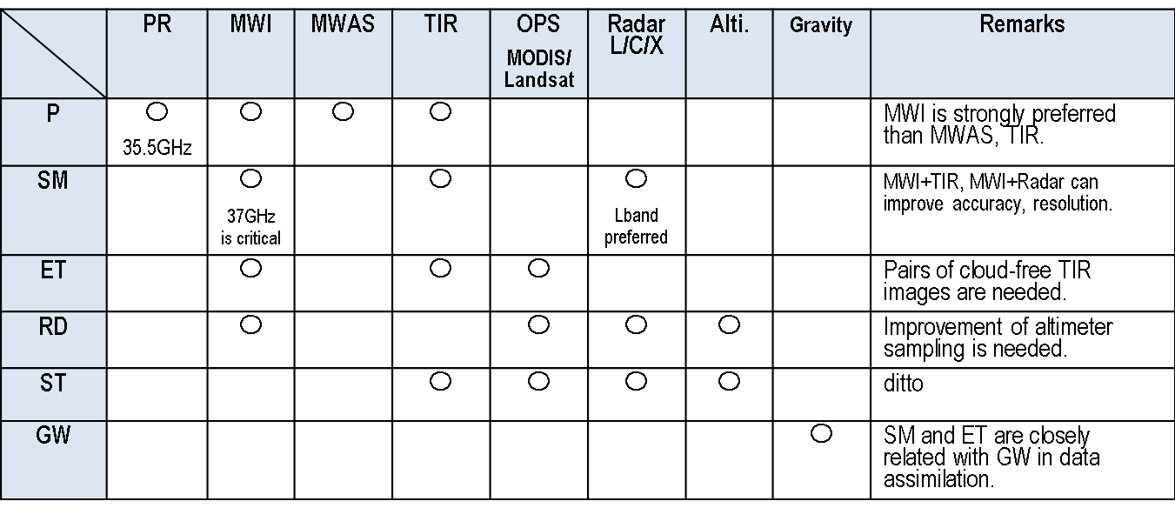

Variable

The following recommendations for the Virtual Water Constellation can be made;

MWI constellation is a key component of the water constellation facing   
impending loss of DMSP/SSMI and AMSR-2 capabilities which will lead to   
significant degradation of the precipitation observation, while it provides a   
potential of monitoring precipitation, soil moisture and evapotranspiration.

* DMSP/SSMI follow-on mission in early morning orbit should be   
  considered.
* SMOS and SMAP follow-on missions should be studied as soil moisture elements of the MWI constellation.
* A larger antenna MWI could fill gap of spatial resolution of soil moisture, SST and snow/ice extent and should be studied.

Coordination of existing and future TIR, optical and L/C/X band radars, altimeter and gravity missions should be studied to contribute to observations of SM, ET, RD and ST.

Revisit time of SWOT type missions need to be improved for monitoring river discharge and surface water storage and other satellites to provide improved real-time services.

GRACE type missions should be continued for groundwater monitoring.

Data assimilation systems should be developed to use actual data in a more optimal way. A broad water constellation that incorporates data assimilation has the potential to more effectively exploit existing and planned assets.

**６. Way forward**

**Appendix**

A Relevant CEOS missions

B GCOS/ECV

C WMO/SOG

1. Relevant CEOS missions

1. Precipitation observations

Table A. 1.1 Microwave Imagers

| Satellite | Organization | Launch (Target) | Mission Life | LST | Instrument | Technical characteristics |
| --- | --- | --- | --- | --- | --- | --- |
| DMSP  F-16 | ditto | Oct 2003 | Oct 2016 | LST: 21:32 | SSM/IS | Waveband: Microwave: 19 - 183 GHz (24 frequencies)  Spatial resolution: 25 x 17 km to 70 x 42 km  Swath width: 1700 km  Accuracy:  Data Access:  Data Format: |
| DMSP  F-17 | ditto | Nov 2006 | Dec 2015 | Altitude: 850 km Period: 101 mins Inclination: 98.7 degree LST: 17:31 Asc./desc.: Ascending | SSM/IS | ditto |
| DMSP  F-18 | ditto | Oct 2009 | Dec 2015 | Altitude: 850 km Period: 101 mins Inclination: 98.7 degree LST: 17:31 Asc/desc: Ascending | SSM/IS | ditto |
| GCOM-W1 | JAXA | May 2012 | May 2017 | Altitude: 700 km Period: 98 mins Inclination: 98.2 degree LST: 13:30 Asc/desc: Ascending | AMSR2 | Waveband: 6.925 GHz, 7.3 GHz, 10.65 GHz, 18.7 GHz, 23.8 GHz, 36.5 GHz, 89.0 GHz  Spatial resolution: 5 - 50 km  Swath width: 1450 km  Accuracy: Sea surface temperature: 0.5 K, Sea ice cover: 10%, Cloud liquid water: 0.05 kg/m2, Precipitation rate: 10%, Water vapour: 3.5 kg/m2 through total column, Sea surface wind speed 1.5 m/s  Data Access: Open Access  Data Format: HDF5 |
| FY-3A | CMA/NRSCC | May 2008 | Dec 2016 | Altitude: 830 km Period: 101 mins Inclination: 98.753 degree Repeat cycle:  LST: 10:10  Asc/desc: Descending | MWRI | Waveband: 12 channels, 6 frequencies: 10.65 GHz, 18.7 GHz, 23.8 GHz, 36.5 GHz, 89 GHz, 150 GHz  Spatial resolution: 7.5 x 12 km at 150 GHz to 51 x 85 km at 10.65 GHz  Swath width: 1400 km  Accuracy:  Data Access: Constrained Access |
| FY-3B | ditto | Nov. 2010 | Dec. 2016 | LST: 14:00 Asc/desc: Ascending | MWRI | ditto |
| FY-3C | ditto | Sep. 2013 | Sep. 2016 | LST: 10:00 Asc/desc: Descending | MWRI | ditto |
| FY-3D | ditto | Dec. 2016 | Dec. 2018 | LST: 14:00 Asc/desc: Ascending | MWRI | ditto |
| FY-3F | ditto | 2019 | 2022 | LST: 14:00  Asc/desc: Ascending | MWRI | ditto |
| FY-3RM | NSMC-CMA | 2020 | 2025 | N/A | MWRI, PR | ditto |
|  |  |  |  |  |  |  |
| GPM | NASA/JAXA | Feb. 2014 | May 2017 | non-sun-synchronous Altitude: 407 km Period: 95 mins Inclination: 65 degree Asc/desc: TBD | GMI | Waveband: 10.65 GHz, 18.7 GHz, 23.8 GHz, 36.5 GHz, 89.0 GHz, 165.5 GHz, 183.31 ± 3 GHz, 183.31 ± 8 GHz  Spatial resolution: Horizontal: 36 km cross-track at 10.65 GHz (required  Swath width: 800 km  Accuracy: 0.65 - 1.5 K  Data Access: Open Access  Data Format: HDF-EOS(HDF5) |
| METEOR-M-N2 | ROSHYDROMET/ROSCOSMOS | July 2014 | 5 years | Sun-synchronous altitude of ~ 825 km, inclination = 98.8º, period = 101.41 minutes, LTAN (Local Time on Ascending Node) at 9:30 hours. | MTVZA-GY | 10.6-183.3 (26 channels)  89 x 189 km – 9 -21 km  1500 km |
| METEOR-M-N2-1 | ditto | 2015 | 5 years | Afternoon orbit? | ditto | ditto |
| METOP-SG-B | EUMETSAT/CNES/ESA | 2022 | 2030 | 817 km | MWI | 18 channels (eight dual-polarised) in the frequency range from 18.7 to 183 GHz, at a spatial resolution from 10 km to 50 km |

Table A.1.2. Microwave Sounder.

| Satellite | Organization | Launch  (Target) | Mission Life | LST | Instrument | Technical characteristics |
| --- | --- | --- | --- | --- | --- | --- |
| NOAA-18 | NOAA | May 2005 | Dec. 2015 | Altitude: 870 km Period: 102.1 mins Inclination: 98.75 degree Repeat cycle:  LST: 14:00  Asc/desc: Ascending | AMSU-A | Waveband: 15 channels, 23.8 - 89.0 GHz  Spatial resolution: 48 km  Swath width: 2054 km  Accuracy: Temperature profile: 2 K, humidity: 3 kg/m2, ice & snow cover: 10%  Data Access: Open Access |
| NOAA-19 | NOAA | Feb. 2009 | Dec. 2015 | Altitude: 870 km Period: 102.1 mins Inclination: 98.75 degree Repeat cycle:  LST: 14:00  Asc/desc: Ascending | MHS | Waveband: 89 GHz, 166 GHz and 3 channels near 183 GHz  Spatial resolution: Vertical: 3 - 7 km, Horizontal: 30 - 50 km  Swath width: 1650 km  Accuracy: Cloud water profile: 10 g/m2, specific humidity profile: 10 - 20%  Data Access: Open Access |
| NPP | NASA/NOAA | Oct. 2011 | Sep. 2020 | Altitude: 824 km Period: 101 mins Inclination: 98.7 degree Repeat cycle: 16 days LST: 13:30  Asc/desc: Ascending | ATMS | Waveband: 22 bands, 23-184 GHz  Spatial resolution: 5.2 - 1.1 degree  Swath width: 2300 km  Accuracy: 0.75 K - 3.60 K  Data Access: Open Access |
| Megha-Tropiques | CNES/ISRO | Oct. 2011 | Dec. 2016 | Non-sun-synchronous  Altitude: 867 km Period: 102.16 mins Inclination: 20 degree Asc/desc: Ascending | SAPHIR | Waveband: 183.3 GHz (6 channels)  Spatial resolution: 10 km  Swath width: 2200 km  Accuracy:  Data Access: Constrained Access |
| METOP-A | EUMETSAT/NOAA/CNES/ESA | Oct. 2006 | Aug. 2018 | Altitude: 840 km Period: 107.1 mins Inclination: 98.8 degree Repeat cycle: 29 days LST: 9:30 Asc/des: Descending | AMSU-A  MHS | Waveband: 22 bands, 23-184 GHz  Spatial resolution: 5.2 - 1.1 degree  Swath width: 2300 km  Accuracy: 0.75 K - 3.60 K  Data Access: Open Access |
| METOP-B | ditto | Sep. 2012 | Sep. 2017 | ditto | ditto | ditto |
| METOP-C | ditto | Oct. 2018 | Oct. 2023 | ditto | ditto | ditto |
| JPSS-1 | [NOAA](http://database.eohandbook.com/database/agencysummary.aspx?agencyID=14) /[EUMETSAT](http://database.eohandbook.com/database/agencysummary.aspx?agencyID=9) / [NASA](http://database.eohandbook.com/database/agencysummary.aspx?agencyID=12) | Jan. 2017 | Mar. 2023 | Altitude: 824 km Period: 101 mins Inclination: 98.75 degree Repeat cycle: 16 days LST: 13:30 Longitude (if geo):  Asc/desc: Ascending | ATMS | Waveband: 22 bands, 23-184 GHz  MW  Spatial resolution: 5.2 - 1.1 degree  Swath width: 2300 km  Accuracy: 0.75 K - 3.60 K  Data Access: Open Access |
| JPSS-2 | ditto | July 2021 | July 2028 | ditto | ATMS | ditto |
| EPS-SG-a | [EUMETSAT](http://database.eohandbook.com/database/agencysummary.aspx?agencyID=9) / [DLR](http://database.eohandbook.com/database/agencysummary.aspx?agencyID=30) / [EC](http://database.eohandbook.com/database/agencysummary.aspx?agencyID=114) / [CNES](http://database.eohandbook.com/database/agencysummary.aspx?agencyID=4) / [ESA](http://database.eohandbook.com/database/agencysummary.aspx?agencyID=8) | 2021 | 2028 | Altitude:  Period:  Inclination:  Repeat cycle: 29 days LST:  Asc/desc: N/A | MWS | Waveband: 25 channels from 23.8 to 229 GHz  Spatial resolution: Footprint size 17 - 80 km (Threshold)  Swath width:  Accuracy: |
| EPS-SG-b | EUMETSAT/CNES/ESA | 2022 | 2030 | 817 km | ditto | ditto |
| FY-3A | CMA/NRSCC | May 2008 | Dec. 2016 | Altitude: 830 km Period: 101 mins Inclination: 98.753 degree Repeat cycle:  LST: 10:10  Asc/desc: Descending | MWAS | Waveband: Microwave: 19.35 - 89.0 GHz (8 channels) |
| FY-3B | ditto | Nov. 2010 | Dec. 2016 | LST: 14:00 Asc/desc: Ascending | MWAS | ditto |
| FY-3C | ditto | Sep. 2013 | Sep. 2016 | LST: 10:00 Asc/desc: Descending | IMWAS | ditto |
| FY-3D | ditto | Dec. 2016 | Dec. 2018 | LST: 14:00 Asc/desc: Ascending | INMAS | ditto |
| FY-3E | ditto | 2017 | 2020 | LST: 10:00 Asc/desc: Descending | INWAS | ditto |
| FY-3F | ditto | 2019 | 2022 | LST: 14:00  Asc/desc: Ascending | INMAS | ditto |
| FY-3G | ditto | 2021 | 2024 | LST: 10:00 Asc/desc: Descending | INMAS | ditto |

Table A.1.3 Infrared Imagers from Geostationary Orbit

| Satellite | Orgnization | Launch  (Target) | Mission Life | Longitude | Instrument | Technical characteristics |
| --- | --- | --- | --- | --- | --- | --- |
| GOES-13 | NOAA | May 2006 (ops April 2010) | April 2015 | 75°W | Imager | Waveband: 5 channels, 0.63, 3.9, 6.48, 10.7, 13.3 μm.  Spatial resolution: 0.5 km (0.63 μm) / 4 km (others) at nadir  Scan schedule: most of North America every 15 min; full disk every 3 h  Accuracy: N/A  Data Access: Open Access |
| GOES-14 | NOAA | June 2009 | Ops date + 7 years | 105°W (in-orbit storage) | Same as GOES-13 | Same as GOES-13 |
| GOES-15 | NOAA | Mar 2010 (ops Dec 2011) | Dec 2016 | 135°W | Same as GOES-13 | Same as GOES-13 |
| GOES-R | NOAA | Nov 2016 (ops date TBD) | Ops date + 10 years | 75°W or 138°W | ABI  GLM | Wavebands: 16 channels, 0.47-13.3 μm  Spatial resolution: 0.5 km (VIS), 1 km (NIR), 2 km (IR) at nadir  Scan schedule: CONUS every 5 min; full disk every 15 min  Waveband: 0.7774 μm  Spatial resolution: 8 km nadir, 14 km edge  Frame rate: 2ms  Data Access: Open Access |
| GOES-S | NOAA | Feb2018 | Same as GOES-R | 75°W or 138°W | Same as GOES-R | Same as GOES-R |
| GOES-T | NOAA | Fall 2019 | Same as GOES-R | 75°W or 138°W | Same as GOES-R | Same as GOES-R |
| GOES-U | NOAA | Spring 2025 | Same as GOES-R | 75°W or 138°W | Same as GOES-R | Same as GOES-R |
| METEOSAT-7 | EUMETSAT | Sep 1997 (ops until 2006; providing INDOEX coverage since then) | Ops date + 5 years | 0°W (until Dec 2006); 57.5ºE (present) | MVRI | Wavebands: 3 channels (0.72, 6.4, 11.5 μm)  Spatial resolution: 2.5 km (VIS), 5 km (others) at nadir  Scan schedule: full disk every 30 min  Data Access: Open Access |
| METEOSAT-8 | EUMETSAT | Aug 2002 (ops ended in Apr 2008 but moved to 41.5°E to replace METEOSAT-7) | Ops date + 7 years | 41.5°E | SEVIRI | Wavebands: 12 channels, 0.6-13.4 μm  Spatial resolution: 1 km (VIS), 3 km (others) at nadir  Scan schedule: full disk every 15 min  Data Access: Open Access |
| METEOSAT-9 | EUMETSAT | Dec 2005 (ops Apr 2007) | Same as METEOSAT-8 | 9.5°E | Same as METEOSAT-8 | Same as METEOSAT-8, except used for Rapid Scan Service only |
| METEOSAT-10 | EUMETSAT | July 2012 (ops Jan 2013) | Same as METEOSAT-8 | 0°W | Same as METEOSAT-8 | Same as METEOSAT-8 |
| METEOSAT-11 | EUMETSAT | July 2015 (in storage until 2018) | Same as METEOSAT-8 | In-orbit storage at 3.4 °W | Same as METEOSAT-8 | Same as METEOSAT-8 |
| MTG-I1 | EUMETSAT | 2020 | Ops date + 8 years | 9.5°E | FCI  LI | Wavebands: 16 channels, 0.444-13.3 μm  Spatial resolution: 1 km (VIS), 2 km (others) at nadir  Scan schedule: full disk every 10 min  Waveband: 0.7774 μm  Spatial resolution: 8 km nadir, 14 km edge  Frame rate: 2ms  Data Access: Open Access |
| MTG-I2 | EUMETSAT | 2023 | Same as MTG-I2 | Same as MTG-I2 | Same as MTG-I2 | Same as MTG-I2 |
| MTG-I3 | EUMETSAT | 2026 | Same as MTG-I2 | Same as MTG-I2 | Same as MTG-I2 | Same as MTG-I2 |
| MTG-I4 | EUMETSAT | 2031 | Same as MTG-I2 | Same as MTG-I2 | Same as MTG-I2 | Same as MTG-I2 |
| Himawari-8 | JAXA | Oct 2014 (ops Jul 2015) | Ops date + 8 years | 140.7°E | AHI | Wavebands: 16 channels, 0.47-13.3 μm  Spatial resolution: 0.5 km (VIS), 1 km (NIR), 2 km (IR) at nadir  Scan schedule: full disk every 10 min  Data Access: Constrained Access (limited by bandwidth; third-party re-distribution permitted) |
| Himawari-9 | JAXA | Late 2016 / early 2017 | Same as Himawari-8 | Same as Himawari-8 | Same as Himawari-8 | Same as Himawari-8 |
| Kalpana-1 | ISRO | Sep 2002 | 2016? | 74.0°E | VHRR | Wavebands: 3 channels, 0.65, 6.40, 11.5 μm  Spatial resolution: 2 km (VIS), 8 km (WV & IR) at nadir  Scan schedule: full disk every hour |
| INSAT-3D | ISRO | Jul 2013 | 7.7 years | 82.0°E | VHRR/2 | Wavebands: 6 channels, 0.65-12.0 μm  Spatial resolution: 1 km (VIS), 8 km (WV), 4 km (others) at nadir  Scan schedule: full disk every 30 min |
| INSAT-3DR | ISRO | Aug 2016 | Same as INSAT-3D | Same as INSAT-3D | Same as INSAT-3D | Same as INSAT-3D |
| INSAT-3DS | ISRO | 2022 | Same as INSAT-3D | Same as INSAT-3D | Same as INSAT-3D | Same as INSAT-3D |
| COMS-1 | KARI | Jun 2010 | 2019 | 128.2°E | MI | Wavebands: 5 channels, 0.65-12.0 μm  Spatial resolution: 1 km (VIS), 4 km (others) at nadir  Scan schedule: full disk every 30 min |
| GEO-KOMPSAT-2A | KARI | 2018 | 10 years | Same as COMS-1 | AMI | Wavebands: 16 channels, 0.455-13.3 μm  Spatial resolution: 0.5 km (0.642 μm), 1 km (other VIS), 2 km (IR) at nadir  Scan schedule: full disk every 10 min |
| GEO-KOMPSAT-2B | KARI | 2019 | Same as GEO-KOMPSAT-2A | Same as GEO-KOMPSAT-2A | Same as GEO-KOMPSAT-2A | Same as GEO-KOMPSAT-2A |
| Electro-L N2 | Roscosmos | Dec 2015 | 7 years | 76.2°E | MSU-GS | Wavebands: 10 channels, 0.57-11.7 μm  Spatial resolution: 1 km (VIS/NIR), 4 km (IR) at nadir  Scan schedule: full disk every 15-30 min |
| Electro-L N3 | Roscosmos | 2017 | Same as Electro-L N1 | TBD | Same as Electro-L N2 | Same as Electro-L N2 |
| Electro-L N4 | Roscosmos | 2019 | Same as Electro-L N1 | TBD | Same as Electro-L N2 | Same as Electro-L N2 |
| Electro-L N5 | Roscosmos | 2024 | Same as Electro-L N1 | TBD | Same as Electro-L N2 | Same as Electro-L N2 |
| Electro-M N1 | Roscosmos | 2025 | 10 years | TBD | MSU-GSM | Wavebands: 20 channels, 0.38-14.25 μm  Spatial resolution: 0.5 km (VIS/NIR), 2 km (0.9-12 μm), 4 (13-15 μm) at nadir  Scan schedule: full disk every 15-30 min |
| Electro-M N2 | Roscosmos | 2026 | Same as Electro-M N1 | TBD | Same as Electro-M N1 | Same as Electro-M N1 |
| Electro-M N3 | Roscosmos | 2029 | Same as Electro-M N1 | 0°W | Same as Electro-M N1 | Same as Electro-M N1 |
| FY-2E | NRSCC | Dec 2008 | 3 years | 86.5°E | S-VISSR | Wavebands: 5 channels, 0.77-12.0 μm  Spatial resolution: 1.25 km (VIS), 5 km (others) at nadir  Scan schedule: full disk every 30 min |
| FY-2F | NRSCC | Jan 2012 | Same as FY-2E | 112.5°E | Same as FY-2E | Same as FY-2E, except used for regional scanning only |
| FY-2G | NRSCC | Dec 2014 | Same as FY-2E | 105°E | Same as FY-2E | Same as FY-2E |
| FY-2H | NRSCC | 2017 | Same as FY-2E | 86.5°E | Same as FY-2E | Same as FY-2E |
| FY-4A | NRSCC | 2016 | 7 years | 86.5°E | AGRI | Wavebands: 14 channels, 0.47-13.5 μm  Spatial resolution: 1 km (VIS), 2 km (NIR), 4 km (IR) at nadir  Scan schedule: full disk every 15 min |
| FY-4B | NRSCC | 2018 | Same as FY-4B | 105°E | Same as FY-4B | Same as FY-4B |
| FY-4C | NRSCC | 2020 | Same as FY-4B | 86.5°E | Same as FY-4B | Same as FY-4B |
| FY-4D | NRSCC | 2023 | Same as FY-4B | 105°E | Same as FY-4B | Same as FY-4B |
| FY-4E | NRSCC | 2027 | Same as FY-4B | 86.5°E | Same as FY-4B | Same as FY-4B |
| FY-4F | NRSCC | 2030 | Same as FY-4B | 105°E | Same as FY-4B | Same as FY-4B |
| FY-4G | NRSCC | 2033 | Same as FY-4B | 86.5°E | Same as FY-4B | Same as FY-4B |
|  |  |  |  |  |  |  |

**2. Soil moisture observations**

Table A.2.1. Microwave Imager.

|  |  |  |  |  |  |  |
| --- | --- | --- | --- | --- | --- | --- |
| Satellite | Organization | Launch  (Target) | Mission Life | LST | Instrument | Technical characteristics |
| SMOS | ESA/CDTI/CNES | Nov. 2009 | Feb. 2017 | Altitude: 758 km Period: 100.0 mis Inclination: 98.44 degree Repeat cycle: 23 days LST: 6:00  Ascending | MIRAS | Waveband: L-Band 1.41 GHz  Spatial resolution: 33 - 50 km d - resampled to 15 km grid  Swath width: Hexagon shape, nominal width 1050 km allowing a 3 day revisit time at the equator  Accuracy: 2.6 K absolute accuracy, RMS 1.6-4 K depending on the scene and the position within the swath  Data Access: Open Access |
| SMAP | NASA/CSA | Jan. 2015 | June 2018 | Altitude: 685 km Period: 98.46 mins Inclination: 98.12 degree Repeat cycle:  LST: 18:00  Ascending | L-band Radiometer  L-band Radar | Waveband: L-band (1.4 GHz)  Spatial resolution: 40 km spatial resolution; 3 days temporal resolution  Swath width: 1000 km swath  Accuracy: 1.3 K accuracy brightness temperature  Data Access: Open Access |
| GCOM-W1 | JAXA | May 2012 | May 2017 | Altitude: 700 km Period: 98 mins Inclination: 98.2 degree LST: 13:30 Asc/desc: Ascending | AMSR2 | Waveband: 6.925 GHz, 7.3 GHz, 10.65 GHz, 18.7 GHz, 23.8 GHz, 36.5 GHz, 89.0 GHz  Spatial resolution: 5 - 50 km  Swath width: 1450 km  Data Access: Open Access |
| GPM | NASA/JAXA | Feb 2014 | May 2017 | non-sun-synchronous Altitude: 407 km Period: 95 mins Inclination: 65 degree Asc/desc: TBD | GMI | Waveband: 10.65 GHz, 18.7 GHz, 23.8 GHz, 36.5 GHz, 89.0 GHz, 165.5 GHz, 183.31 ± 3 GHz, 183.31 ± 8 GHz  Spatial resolution: Horizontal: 32 km x 19 km at 10.65 GHz  Swath width: 885 km  Accuracy: 0.65 - 1.5 K  Data Access: Open Access  Data Format: HDF-EOS(HDF5) |

(Comment by XZ) May add the planned Water Cycle Observation Mission (WCOM) by Chinese Academy of Science. More information will be provided from IGARSS 2016 in July 2016

Microwave radar

|  |  |  |  |  |  |  |
| --- | --- | --- | --- | --- | --- | --- |
| Satellite | Organization | Launch  (Target) | Mission Life | LST | Instrument | Technical characteristics |
| Radarsat-2 | CSA/MDA | Dec. 2007 | Apr. 2019 | Altitude: 798 km Period: 100.7 mins Inclination: 98.6 degree Repeat cycle: 24 days LST: 18:00 Ascending | SAR | Waveband: C band 5.405 GHz.  Spatial resolution: Standard: 27 - 17 x 25 m; Wide: 40 - 19 x 25 m; Fine: 10 - 7 x 8 m; ScanSAR (N/W): 80 - 38 x 60 m / 160 - 172 x 100 m, Extended (H/L): 18 - 16 x 25 m / 60 - 23 x 25 m (4 looks); Ultra-Fine: 4.6 - 2.1 x 2.8 m  Best resolution: 0.8 m  Swath width: Standard: 100 km (including: 20 - 49 degree); Wide: 150 km (including: 20 - 45 degree); Fine: 50 km (including: 30 - 50 degree); ScanSAR (N/W): 300/500 km (including: 20 - 46 / 20 - 49 degree); Extended (H/L): 75/170 km (including: 49 - 60 / 10 - 23 degree); Ultra-Fine: 20 km (including: 20 - 49 degree  Accuracy: Relative Radiometric Accuracy (within a 100 km scene): <1 dB  Data Access: Constrained Access |
| METOP-A | EUMETSAT/NOAA/CNES/ESA | Oct. 2006 | Aug. 2018 | Altitude: 840 km Period: 107.1 mins Inclination: 98.8 degree Repeat cycle: 29 days LST: 9:30 Asc/des: Descending | ASCAT | Waveband: C Band, 5.256 GHz  Spatial resolution: Hi-res mode: 25 - 37 km, Nominal mode: 50 km  Swath width: Continuous; 2 x 500 km swath width  Accuracy: Wind speeds in range 4 - 24 m/s: 2 m/s and direction accuracy of 20 degree  Data Access: Open Access |
| METOP-B | ditto | Sep. 2012 | Sep. 2017 | Altitude: 840 km Period: 107.1 mins Inclination: 98.8 degree Repeat cycle: 29 days LST: 9:30 Asc/des: N/A | ditto | ditto |
| SAOCOM-1A | CONAE/ASI | Dec. 2016 | Dec. 2021 | Altitude: 620 km Period: 97.2 mins Inclination: 97.89 degree Repeat cycle: 16 days LST: 6:12 Ascending | SAR-L | Waveband: L-band (1.275 GHz)  Spatial resolution: 10 x 10 m – 100 x 100 m  Best resolution: 10 m  Swath width: 20 – 350 km  Accuracy: 0.5 dB |
| SAOCOM-1B | ditto | Dec. 2017 | Dec. 2022 | ditto | ditto | ditto |
| Sentinel-1A | ESA/EC | Apr. 2014 | Jan. 2021 | Altitude: 693 km Period: 98.74 mins Inclination: 98.19 degree Repeat cycle: 12 days LST: 18:00  Ascending | C-Band SAR | Waveband: 5.405 GHz  Spatial resolution: Strip mode: 9 m, Interferometric wide swath mode: 20 m, extra-wide swath mode: 50 m, wave mode: 50 m  Best resolution: 9 m  Swath width: Strip mode: 80 km; Interferometric wide swath mode: 250 km, extra-wide swath mode: 400 km, Wave mode: sampled images of 20 x 20 km at 100 km intervals  Accuracy: NESZ: -22 dB; PTAR: -25 dB; DTAR: -22 dB; Radiometric accuracy 1 dB (3 sigma); Radiometric stability: 0.5 dB (3 sigma)  Data Access: Open Access |
| Sentinel-1B | ditto | Apr. 2016 | Apr. 2023 | ditto | ditto | ditto |

3. ET (LST) missions

|  |  |  |  |  |  |  |
| --- | --- | --- | --- | --- | --- | --- |
| Satellite | Organization | Launch | Mission Life | LST | Instrument | Technical characteristics |
| GEO |  |  |  |  |  |  |
| NOAA-18 | NOAA | May 2005 | Dec. 2015 | Altitude: 870 km Period: 102.1 mins Inclination: 98.75 degree LST: 14:00  Ascending | AVHRR | VIS: 0.58 - 0.68 µm, NIR: 0.725 - 1.1 µm, SWIR: 1.58 - 1.64 µm, MWIR: 3.55 - 3.93 µm, TIR: 10.3 - 11.3 µm, 11.5 - 12.5 µm  Spatial resolution: 1.1 km  Swath width: approx. 3000 km. Ensures full global coverage twice daily |
| NOAA-19 | NOAA | Feb. 2009 | Dec. 2015 | ditto LST: 14:00  Ascending | ditto | ditto |
| METOP-A | EUMETSAT/NOAA/CNES/ESA | Oct. 2006 | Aug. 2018 | Altitude: 840 km Period: 107.1 mins Inclination: 98.8 degree Repeat cycle: 29 days LST: 9:30 Descending | ditto | ditto |
| METOP-B | ditto | Sep. 2012 | Sep. 2017 | ditto | ditto | ditto |
| METOP-C | ditto | Oct. 2018 | Oct. 2023 | ditto | ditto | ditto |
| FY-3A | CMA/NRSCC | May 2008 | Dec. 2016 | Sun-synchronous  Altitude: 830 km Period: 101 mins Inclination: 98.753 degree Repeat cycle:  LST: 10:10  Descending | VIRR  Multispectral Visible and Infra-red Scan Radiometer | 10 channels over 0.43 - 10.5 µm  VIS, SWIR, MWIR, TIR  Spatial resolution: 1.1 km at nadir  Best resolution: 1100 m  Swath width: 2800 km  Accuracy: 1.1 km |
| FY-3B | ditto | Nov. 2010 | Dec. 2016 | ditto  LST: 14:00 Ascending | ditto | ditto |
| FY-3C | ditto | Sep. 2013 | Sep. 2016 | ditto  LST: 10:00 Descending | ditto | ditto |
| FY-3D | ditto | Dec. 2016 | Dec. 2018 | ditto  LST: 14:00 Ascending | ditto | ditto |
| Terra | NASA/METI/CSA | Dec. 1999 | Oct. 2019 | Sun-synchronous Altitude: 705 km Period: 99 mins Inclination: 98.2 degree Repeat cycle: 16 days LST: 10:30 Descending | MODIS | VIS - TIR: 36 bands in range 0.4 - 14.4 µm  Spatial resolution: Cloud cover: 250 m (day) and 1000 m (night), Surface temperature: 1000 m  Best resolution: 250 m  Swath width: 2330 km  Accuracy: Long wave radiance: 100 nW/m2, Short wave radiance: 5%, Surface temperature of land: <1 K, Surface temperature of ocean: <0.2 K, Snow and ice cover: 10% |
| Aqua | NASA/JAXA/INPE | May 2002 | Oct. 2019 | ditto LST: 13:30 Ascending | MODIS | ditto |
| Landsat 8 | USGS/NASA | Feb. 2013 | May 2023 | Sun-synchronous Altitude: 705 km Period: 98.9 mins Inclination: 98.2 degree Repeat cycle: 16 days LST: 10:11 Descending | TIRS  OLI | TIR 10.5 µm and 12 µm  TIR  Spatial resolution: 100 m  Swath width: 185 km  Accuracy: Absolute geodetic accuracy of 44 m; geometric accuracy of 32 m or better  VIS - SWIR: 9 bands: 0.43 - 2.3 µm  Spatial resolution: Pan: 15 m, VIS - SWIR: 30 m  Swath width: 185 km  Accuracy: Absolute geodetic accuracy of 32 m; relative geodetic accuracy of 18 m (excluding terrain effects); geometric accuracy of 12 m or better |
| Landsat 9 | USGS/NASA | Jan. 2023 | Jan. 2033 | ditto  LST: 10:00 | TIRS-2 | ditto |
| NPP | NASA/NOAA | Oct. 2011 | Sep. 2020 | Sun-synchronous Altitude: 824 km Period: 101 mins Inclination: 98.7 degree Repeat cycle: 16 days LST: 13:30 Ascending | VIIRS | Waveband: VIS - TIR: 0.4 - 12.5 µm (22 channels)  VIS, NIR, SWIR, MWIR, TIR  Spatial resolution: 400 m - 1.6 km  Best resolution: 400 m  Swath width: 3000 km  Accuracy: SST 0.35 K |
| JPSS-1 | NOAA/EUMETSAT/NASA | Jan. 2017 | Mar. 2024 | ditto LST: 13:30 Ascending | VIIRS | ditto |
| JPSS-2 | ditto | July 2021 | July 2028 | Sun-synchronous Altitude: 833 km Period: 101 mins Inclination: 98.75 degree Repeat cycle: 16 days LST: 13:30 Ascending | VIIRS | ditto |
| Sentinel-3A | ESA/EUMETSAT/EC | Dec. 2015 | Dec. 2022 | Sun-synchronous Altitude: 814 km Period: 100 mins Inclination: 98.65 degree Repeat cycle: 27 days LST: 10:00 Descending | SLSTR | 9 bands in VNIR/SWIR/TIR  VIS, NIR, SWIR, TIR  Spatial resolution: 500 m (VNIR/SWIR), 1 km (TIR)  Best resolution: 500 m  Swath width: 1675 km (near-nadir view), 750 km (backward view)  Accuracy: 0.2 K abs., 80 mK rel. |
|  |  |  |  | ditto | OLCI  Ocean and Land Colour Imager | Waveband: 21 bands in VNIR/SWIR, VIS, NIR  Spatial resolution: 300 m  Swath width: 1270 km, across-track tilt 12.2 degree to the West  Accuracy: 2% abs, 0.1% rel. |
| Sentinel-3B | ditto | May 2017 | Jan. 2024 | ditto  LST 10:00 Ascending | SLSTR | same with Sentinel-3A |
|  |  |  |  | ditto | OLCI | same with Sentinel-3A |
| GCOM-C | JAXA | Dec. 2015 | Dec. 2021 | Sun-synchronous Altitude: 798 km Period: 101 mins Inclination: 98.6 degree Repeat cycle: 3 days LST: 10:30 Descending | SGLI | VIS - NIR: 0.38 - 0.865 µm; SW: 1.05 - 2.21 µm; TIR: 10.8 - 12.0 µm  Spatial resolution: SGLI-VNR: 250 m, 1000 m; SGLI-IRS: 250 m, 500 m, 1000 m  Best resolution: 250 m  Swath width: SGLI-VNR: 1150 km; SGLI-IRS: 1400 km |
| ECOSTRESS | NASA/USGS | 2017 | 2018 | Inclined, non-sun-synchronous Altitude: 407 km Period: 93 mins Inclination: 51.6 degree Repeat cycle: Ascending |  | Waveband: TIR  TIR  Spatial resolution:  Swath width:  Accuracy: |
| CBERS-4 | INPE/CRESDA | Dec. 2014 | Dec. 2017 | Sun-synchronous Altitude: 778 km Period: 100.3 mins Inclination: 98.5 degree Repeat cycle: 26 days LST: 10:30 Descending | IRS | Waveband: 0.5 - 0.9 µm; 1.55 - 1.75 µm, 2.08 - 2.35 µm; 10.4 - 12.5 µm  VIS, NIR, SWIR, TIR  Spatial resolution: PAN, SWIR: 40 m, TIR: 80 m  Swath width: 120 km  Accuracy: |
| CBERS-4A | ditto | 2018 | 2021 | ditto | ditto | ditto |

4. River discharge missions

|  |  |  |  |  |  |  |
| --- | --- | --- | --- | --- | --- | --- |
| Satellite | Organization | Launch | Mission Life | LST | Instrument | Technical characteristics |
| SWOT | NASA/UKSA/CNES | 2020 | 2024 | Inclined, non-sun-synchronous Altitude: 891 km Period:  Inclination: 78 degree Repeat cycle: 22 days | Ka-band Radar Interferometer(KaRIN) | MW, Ka-Band  Spatial resolution:  Vertical resolution is 2 cm  Swath width:  Accuracy: |
| SARAL | CNES/ISRO | Feb. 2012 | Dec. 2018 | Sun-synchronous Altitude: 799 km Period: 100.59 mins Inclination: 98.55 degree Repeat cycle: 35 days LST: 18:00 Descending | AltiKa | Waveband: radar altimeter: 35 GHz (Ka-band)  Spatial resolution:  Swath width:  Accuracy: |
| l Sentinel-3A, B, C | ESA/EC | A: Dec. 2025  B:May2017  C:2020 | Dec. 2022  Jan. 2024  2027 | Type: Sun-synchronous Altitude: 814 km Period: 100 mins Inclination: 98.65 degree Repeat cycle: 27 days LST: 10:00 Asc/desc: Descending | SRAL | Waveband: Dual-frequency radar altimeter, Ku-band, C-band  Spatial resolution: 300 m  Swath width: Profiling  Accuracy: 3 cm |
| Jason-3 | NASA/NOAA/CNES/EUMETSAT | Jan. 2016 | Jan. 2019 | non-sun-synchronous Altitude: 1336 km Period: 112.4 mins Inclination: 66 degree Repeat cycle: 10 days | POSEIDON-3B Altimeter | Waveband: Microwave: Ku-band (13.575 GHz), C-band (5.3 GHz)  Ku-Band, C-Band  Spatial resolution: Basic measurement: 1/sec (6 km along track), Raw measurement: 20/sec (300 m along track)  Swath width: TOPEX/POSEIDON orbit (10 day cycle): 300 km between tracks at equator  Accuracy: Sea level: 3.4 cm |
| Sentinel-6A, B | ditto | A: 2020  B:2025 | 2025  2030 | non-sun-synchronous Altitude: 1336 km Period: 112 mins Inclination: 66 degree Repeat cycle: | Poseidon-4 Altimeter | Waveband: Microwave: Ku-band (13.575 GHz), C-band (5.3 GHz) |

5. Surface water storage

Same as 4.

6．Gravity missions

|  |  |  |  |  |  |  |
| --- | --- | --- | --- | --- | --- | --- |
| Satellite | Organization | Launch  (Target) | Mission Life | LST | Instrument | Technical characteristics |
| GRACE | NASA/DLR/  GFZ/ESA | Mar. 2002 | Sep. 2017 | non-sun-synchronous Altitude: 400 km Period: 94 mins Inclination: 89 degree | GRACE  instrument | Waveband: 24 GHz and 32 GHz  Spatial resolution: 400 km  Accuracy: 1 cm equivalent water |
| GRACE-FO | NASA/GFZ | Feb. 2018 | Feb. 2023 | non-sun-synchronous Altitude: 500 km Period: 90 mins Inclination: 89 degree | GRACE  instrument, LRI, MWI |  |
| GRACE-II | NASA | 2027 | 2032 | Inclined, non-sun-synchronous | TBD |  |

(Source: CEOS database)

**Appendix B: GCOS/ECV**

(2015 Update of CEOS-CGMS Actions in the Response to GCOS IP, May 2015)

**5.3.2 Precipitation**

**Importance of this ECV**

Precipitation affects water supplies, natural vegetation, crops, and tourism. Its variations can lead to environmental hazards in the form of droughts, floods, snow accumulations, hail, and ice. It affects the daily activities of humankind throughout the world. It is a key component of the Earth’s hydrological cycle and, through its release of the latent heat of condensation as it forms, affects the thermal structure and the circulation of the atmosphere.

***5.3.2.1 GCOS/CEOS Action A8; SS: A.2***

**Action:** Ensure continuity of satellite precipitation products.

**Who:** Space agencies.

**Time-Frame:** Continuous.

**Performance Indicator:** Long-term homogeneous satellite-based global precipitation products.

**Annual Cost Implications:** 20-40 M US$(for generation of climate products, assuming missions funded for other operational purposes) (Mainly by Annex-I Parties)

**CEOS Entities:**

• **CEOS Agency Leads**: NASA, JAXA

• **CEOS Agency Contributors**: NOAA, CSA, CNES, ISRO, INPE, EUMETSAT, ESA

• **CEOS Coordination Mechanisms**: Precipitation Virtual Constellation (PC-VC)

**International Coordination Bodies:** TBD

**Associated Organizations:** TBD

**Specific Deliverable #1:**

• The delivery is an initial calibration reference standard for the Global Precipitation Measurement (GPM) mission. The GPM concept centres on the deployment of a “Core” satellite carrying an advanced radar/radiometer system to measure precipitation from space and serve as a reference standard to unify precipitation measurements from a constellation of research and operational satellites.

o To ensure the continuity of this constellation approach, NASA/JAXA will continue the Tropical Rainfall Measuring Mission (TRMM) that has both an imaging microwave radiometer, the TRMM Microwave Imager (TMI) and a Precipitation Radar (PR). This observatory is in a 35 deg. inclined orbit.

o To extend and enhance the ability to intercalibrate constellation radiometers, NASA/JAXA will launch in 2014, the core observatory of the (GPM mission. This observatory will carry both an imaging microwave radiometer, GPM microwave imager (GMI) and a dual precipitation radar (DPR). This observatory will be in a 65 deg. inclined polar orbit.

o JAXA is also contributing the Advanced Microwave Scanning Radiometer-2 (AMSR2) on the Global Change Observation Mission-Water (GCOM-W) to the CEOS PC-VC. Other agencies such as NOAA, EUMETSAT, CNES/ISRO will contribute microwave radiometers in both sun- and non-sun-synchronous orbits (these will be mostly microwave sounders except for Megha-Tropiques, and Special Sensor Microwave Imager/Sounder [SSMI/S] radiometers). While these radiometers are launched and operated for their agencies own needs, they are contributed to the CEOS PC-VC (GPM era constellation) to be included for use in generating consistent precipitation products.

o Radiometers in initial GPM-based PC constellation:

▪ SSMI/S F16, F17, F18, F19, F20 microwave imagers containing both window channels and high-frequency sounding channels. Data are observed by the U.S. DOD satellites and archived at NOAA.

▪ Advanced Microwave Sounding Unit (AMSU)-A/Microwave Humidity Sounder (MHS) sounders for precipitation using mainly the scattering channels. Provided by both NOAA and EUMETSAT.

▪ Advanced Technology Microwave Sounder (ATMS) microwave sounders on both Suomi National Polar-orbiting Partnership (Suomi NPP) and Joint Polar Satellite System (JPSS) which for precipitation use mainly the scattering channels. Provided by both NOAA and EUMETSAT.

▪ Microwave Analysis and Detection of Rain and Atmospheric Structures (MADRAS) microwave imager from the CNES/ISRO Megha-Tropiques tropical mission.

▪ Sounder for Probing Vertical Profiles of Humidity (SAPHIR) microwave sounder

from the CNES/ISRO Megha-Tropiques tropical mission. SAPHIR provides high- frequency sounding channels for precipitation measurements.

o Precipitation Constellation Calibrating Observatory:

▪ During the ad-hoc pre-GPM Precipitation Constellation (PC), the TRMM observatory provides the transfer standard for precipitation products for the PC. This was chosen because of the many match-up opportunities of the TRMM observatory and the polar-orbiting observatories in the constellation.

▪ Beginning with the full PC that starts at the launch of the GPM core observatory

in 2014, the GPM core observatory with its GMI and DPR will be the transfer standard used for creating consistent PC precipitation products. Once again the core observatory, like TRMM, provides many match-up opportunities with other observatories in the constellation.

• **PC characteristics for radiometers in the Constellation**

o Each PC participating agency will provide a point of contact to the PC about its observatory, radiometer and its operation during the life of the mission.

o Each PC participating agency will provide detailed information about the operation, geolocation and calibration of the radiometer that it is providing.

o Each PC participating agency will completely characterize their radiometer and calibration and make such information available to other PC members as well as data users.

o Each PC participating agency will ensure that incidence angle information is available for each pixel of each swath type for their instrument.

• **Characteristics of the PC transfer standard observatory**

o Should contain well-calibrated radiometer with channels from 10 GHz through 183 GHz.

o Should contain well-calibrated precipitation radar that represents the state of the art for characterizing rainfall.

o Should be placed in a non-sun synchronous orbit to facilitate the number of match-up orbit crossovers between the reference observatory and other observatories in the constellation.

o Both calibration and geo-location should be well characterized, tracked, published and the information publicly available.

**Specific Deliverable #2:**

• The deliverable is an instantaneous field of view level 1b calibrated, geo-located brightness temperature (Tb) product from each radiometer in the PC. The key to this delivery is the characterization of the inputs to the deliverable and the stability of the calibration and geolocation.

**Specific Deliverable #3:**

• The deliverable is a consistent PC instantaneous field of view inter-calibrated brightness temperature (Tc) product from each radiometer in the PC as established by applying the transfer standard established from the GPM core observatory.

• Tb products provided by contributors may be calibrated or geo-located according to the needs and requirements of the particular mission. To ensure consistency of PC brightness temperatures all brightness temperatures provided by contributors will be inter-calibrated to meet the standards of this deliverable.

**Specific Deliverable #4:**

• The deliverable is a consistent PC precipitation product containing retrievals at instantaneous field of view based upon PC consistent inter-calibrated Tc. Also, to ensure consistency the retrieval will be based on a well-established Bayesian technique using a physically based *a priori* database constructed from the combined radiometer/radar measurement from the PC GPM core observatory. At latitudes for which the reference observatory measurements are not available, other physical measurements such as those from ground radars, cloud radars and other appropriate physical sources should be used before reverting to profiles generated from cloud resolving models.

• This precipitation retrieval will be performed for all radiometers in the PC. A similar retrieval based on a physically based *a priori* database will be made from imager and sounder radiometers. Appropriate retrievals will be made over ocean, land and coast.

**Specific Deliverable #5:**

• This deliverable provides a global monthly product containing PDF of precipitation intensity based on the instantaneous field of view (IFOV) products delivered in the previously listed deliverable #4.

• While this deliverable is not the end product of the ECV, it is the satellite component that appears most useful for further synthesis with other products.

**Accuracy, stability, horizontal resolution, and vertical resolution**

|  |  |  |  |  |  |
| --- | --- | --- | --- | --- | --- |
| **ECV:**  **Precipitation** | **GCOS/CEOS Action A8** | | | | |
| Property | | | | |
|  | Instantaneous  FOV Tb | Instantaneous  FOV inter- calibrated Tb | Precipitation rate  (Instantaneous FOV) | Precipitation rate  (Monthly) |
| Accuracy | Target | TBD | TBD | TBD | max(10% of daily  totals; 0.1 mm) |
| Planned | TBD | 0.3 K for each  radiometer in  the constellation with respect to the reference radiometer | TBD | TBD |
| Stability | Target | TBD | TBD | TBD | 5% of daily totals  (regional scale) |
| Planned | 1 K | TBD | TBD | TBD |
| Horizontal  resolution (km) | Target | TBD | TBD | TBD | 25 |
| Planned | 5 (Precip.Radar) | 25 | 25 | 100 |
| Vertical  resolution (km) | Target | TBD | N/A | N/A | N/A |
| Planned | 0.25 (Precip.  Radar) | N/A | N/A | N/A |

**Planned activities/time frames to meet deliverables (2011 – 2015)**

TBD

***2015 Update***

Specific Deliverable #1

• TRMM has continued to be operated; it is out of fuel and will be passivized in early 2015 when its orbit decays to a set altitude (325 km). The TMI is operating continuously, while the radar is only available when the altitude is in set ranges.

• GPM was launched into a 65° orbit on 27 February 2014 (UTC), and Day-1 GMI and DPR products were released in stages through the summer.

• The initial GPM-era constellation consists of microwave imagers (DMSP F15 SSMI [limited]; DMSP F16, F17, F18, and F19 SSMIS; TRMM TMI; GCOM-W1 AMSR2; GPM GMI) and microwave sounders (NOAA-18, NOAA-19, Metop-A, and Metop-B MHS; Megha-Tropiques SAPHIR; SNPP ATMS).

• The pre-GPM PC calibrator was the TRMM observatory; it is planned that intercalibration of the TRMM and GPM observatories will allow the entire TRMM-GPM era to be treated as a continuous record, a long time series that is now viewed as critical for the long-term records demanded for societal applications, including climate studies.

• Upon reflection, “completely characterize” seems unachievable for sensors; “carefully” is a reasonable standard that agencies strive to achieve.

Specific Deliverable #2

The satellite operators work through GSICS to ensure calibration and geolocation at Level 1b.

Specific Deliverable #3

The GPM project’s XCal Team developed and maintains intercalibrations of all radiometers to the Core Observatory reference at Level 1c.

Specific Deliverable #4

GPM is developing a physically based Bayesian retrieval system that can be applied to both imagers and sounders, GPROF2014, which is designed to be useful over land, coast, ocean, and frozen surfaces. Independently, NOAA is pursuing a more assimilation-like approach that applies to both imagers and sounders, MiRS.

Specific Deliverable #5

The output of GPROF2014 applied to all the microwave sensors in the constellation is freely available as individual satellite orbits at Level 2 – IFOVs in the original scan/footprint coordinates.

Additional Comments

1. Computations of the precipitation ECV rest not only on the microwave constellation currently considered the CEOS-VPC, but also on the geosynchronous constellation that provides increasingly rich multi-spectral data on relatively fine time intervals. As such, “the constellation” the community needs really encompasses both sets of satellites.

2. The future of the microwave constellation (and even the Indian Ocean segment of the geo-constellation) is open to question. It takes a decade or more to carry a satellite from concept to launch, so it seems essential to have a planning activity as part of the 5-year plan. One can’t open discussions at the end of one 5-year period and assume that satellites will appear to fill the need as legacy satellites age off of the system.

3. The current statement on the necessary number of microwave constellation satellites is that we need the time between observations to be no more than 3 hours. That’s not an average, that’s the maximum. The current uncoordinated collection of satellites makes it hard to achieve this, but we should go for some standard like “75% of gaps be <3 hours”.

Reference

Hou, A. Y., R. K. Kakar, S. Neeck, A. A. Azarbarzin, C. D. Kummerow, M. Kojima, R. Oki, K. Nakamura, and T. Iguchi, 2014: The Global Precipitation Measurement Mission. *Bull. Amer. Meteor. Soc*., **95**, 701–722, doi:10.1175/BAMS-D-13-00164.1

**Soil Moisture**

**5.5.4 Soil Moisture**

**Importance of this ECV**

Soil moisture is an important variable in land-atmosphere feedbacks because of its major effect on the partitioning of incoming radiation into latent and sensible heat and on the allocation of precipitation into runoff, subsurface flow, and infiltration. Soil moisture is intimately involved in the feedback between climate and vegetation, since local climate and vegetation both influence soil moisture through evapotranspiration, while soil moisture and climate determine the type of vegetation in a region. Soil moisture estimates can also assist gas flux estimates in permafrost regions. As a climate impact variable, soil moisture affects agricultural and natural vegetation productivity, the likelihood of flash floods, the management of agricultural and city water, and the spread of vector-borne diseases such as Dengue fever and malaria.

***5.5.4.1 GCOS/CEOS Action T13; SS: T.11***

**Action:** Develop a record of validated globally-gridded near-surface soil moisture from satellites.

**Who:** Parties’ national services and research programmes, through GEWEX and TOPC in collaboration with space agencies.

**Time frame:** 2014.

**Performance indicator** Availability of globally validated soil moisture products from the early satellites until now.

**Annual Cost Implications:** 1-10 M US$ (10% in non-Annex-I Parties).

**CEOS Entities:**

• **CEOS Agency Leads:** ESA

• **CEOS Agency Contributors**: EUMETSAT, NASA

• **CEOS Coordination Mechanisms**: TBD

**International Coordination Bodies:** International Soil Moisture Working Group (ISMWG), GEWEX, TOPC, WCRP Data and Assimilation Committee (WDAC)

**Associated Organizations:** TBD

**Specific Deliverable(s):**

• 30+ years surface soil moisture data record derived from active (European Remote Sensing Satellite-2 [ERS-2] scatterometer, Metop Advanced Scatterometer [ASCAT]) and passive (Scanning Multichannel Microwave Radiometer [SMMR], TMI, Advanced Microwave Scanning Radiometer – EOS [AMSR-E], Windsat, SSM/I) microwave observations. Unit will be in volumetric soil moisture (m3m-3) and alternatively in degree of saturation (%). ESA projects Water Cycle Observation Multi-mission Strategy (WACMOS) [(http://wa](http://wacmos.itc.nl/))c[mos.itc.nl/)](http://wacmos.itc.nl/)) and ESA's Climate Change Initiative (CCI - the soil moisture project)

recently begun in December 2011.

**Accuracy, stability, horizontal resolution, and vertical resolution**

|  |  |  |
| --- | --- | --- |
| **ECV: Soil moisture** | **GCOS/CEOS Action T13** | |
| Property | |
| Soil moisture | |
| Accuracy (m3m-3) | Target | 0.04 |
| Planned | 0.08, Variable, dependent on land cover |
| Stability (m3m-3 per year) | Target | 0.01 |
| Planned | 0.01, Variable, dependent on land cover |
| Horizontal resolution (km) | Target | 50 |
| Planned | 100 km, Variable over time |

**Key activities and time frames to meet deliverables (2011 – 2015)**

• Completion of the ESA project WACMOS (early-mid 2012)

• Climate Change Initiative (CCI) Soil Moisture project (12/2011-11/2014)

***2015 Update***

* + The successful completion of the ESA project WACMOS in 2012 provided the functional design of the CCI SM production system.
  + Building upon the work undertaken in WACMOS, in collaboration with ESA’s CCI SM project, June 2012 saw the release of the first 30+ year, global, soil moisture project derived from active and passive EO data sets.
  + The third data set (product) release of CCI SM v02.1 was made in Sept 2014 providing 35 years of data from 1978 onwards, and is freely available, after registration, via http://www.esa-soilmoisture-cci.org/
  + As provided in the recently authored Product Validation and Intercomparison Report (Nov 2014), available from CCI SM web site (Jan 2015), the CCI SM data set has been successfully, independently, validated and compared against in situ, modelled and other satellite datasets.
  + A review of the CCI phase 1 SM product in January 2014, using the modified bates maturity index of the CORE-CLIMAX project, resulted in an overall score of 3 (Initial Operations Capacity).
  + Since the first product release in 2012 more than 1200 users have registered to date to obtain the product. The product enjoys a global uptake with the majority of users coming from the USA, China and India, and a strong following across the EU, and Australasia. The users focus largely on Climate, Water and Ecosystem issues, although Disaster and Agriculture are also key topics
  + Following the successful completion of CCI SM phase 1 in Dec 2014, phase 2 (CCI SM 2) will start on 1.1. 2015, running to 31.12.2017 and, in close collaboration with user groups, sees the graceful evolution of the implementation of the production system towards an operational system.

***5.5.4.1 GCOS/CEOS Action T13; SS: T.11***

**Action:** Develop a record of validated globally-gridded near-surface soil moisture from satellites.

**Who:** Parties’ national services and research programmes, through GEWEX and TOPC in collaboration with space agencies.

**Time frame:** 2014.

**Performance indicator** Availability of globally validated soil moisture products from the early satellites until now.

**Annual Cost Implications:** 1-10 M US$ (10% in non-Annex-I Parties).

**CEOS Entities:**

• **CEOS Agency Leads:** ESA

• **CEOS Agency Contributors**: EUMETSAT, NASA

• **CEOS Coordination Mechanisms**: TBD

**International Coordination Bodies:** International Soil Moisture Working Group (ISMWG), GEWEX, TOPC, WCRP Data and Assimilation Committee (WDAC)

**Associated Organizations:** TBD

**Specific Deliverable(s):**

• 30+ years surface soil moisture data record derived from active (European Remote Sensing Satellite-2 [ERS-2] scatterometer, Metop Advanced Scatterometer [ASCAT]) and passive (Scanning Multichannel Microwave Radiometer [SMMR], TMI, Advanced Microwave Scanning Radiometer – EOS [AMSR-E], Windsat, SSM/I) microwave observations. Unit will be in volumetric soil moisture (m3m-3) and alternatively in degree of saturation (%). ESA projects Water Cycle Observation Multi-mission Strategy (WACMOS) [(http://wa](http://wacmos.itc.nl/))c[mos.itc.nl/)](http://wacmos.itc.nl/)) and ESA's Climate Change Initiative (CCI - the soil moisture project)

recently begun in December 2011.

**Accuracy, stability, horizontal resolution, and vertical resolution**

|  |  |  |
| --- | --- | --- |
| **ECV: Soil moisture** | **GCOS/CEOS Action T13** | |
| Property | |
| Soil moisture | |
| Accuracy (m3m-3) | Target | 0.04 |
| Planned | 0.08, Variable, dependent on land cover |
| Stability (m3m-3 per year) | Target | 0.01 |
| Planned | 0.01, Variable, dependent on land cover |
| Horizontal resolution (km) | Target | 50 |
| Planned | 100 km, Variable over time |

**Key activities and time frames to meet deliverables (2011 – 2015)**

• Completion of the ESA project WACMOS (early-mid 2012)

• Climate Change Initiative (CCI) Soil Moisture project (12/2011-11/2014)

***2015 Update***

* + The successful completion of the ESA project WACMOS in 2012 provided the functional design of the CCI SM production system.
  + Building upon the work undertaken in WACMOS, in collaboration with ESA’s CCI SM project, June 2012 saw the release of the first 30+ year, global, soil moisture project derived from active and passive EO data sets.
  + The third data set (product) release of CCI SM v02.1 was made in Sept 2014 providing 35 years of data from 1978 onwards, and is freely available, after registration, via http://www.esa-soilmoisture-cci.org/
  + As provided in the recently authored Product Validation and Intercomparison Report (Nov 2014), available from CCI SM web site (Jan 2015), the CCI SM data set has been successfully, independently, validated and compared against in situ, modelled and other satellite datasets.
  + A review of the CCI phase 1 SM product in January 2014, using the modified bates maturity index of the CORE-CLIMAX project, resulted in an overall score of 3 (Initial Operations Capacity).
  + Since the first product release in 2012 more than 1200 users have registered to date to obtain the product. The product enjoys a global uptake with the majority of users coming from the USA, China and India, and a strong following across the EU, and Australasia. The users focus largely on Climate, Water and Ecosystem issues, although Disaster and Agriculture are also key topics
  + Following the successful completion of CCI SM phase 1 in Dec 2014, phase 2 (CCI SM 2) will start on 1.1. 2015, running to 31.12.2017 and, in close collaboration with user groups, sees the graceful evolution of the implementation of the production system towards an operational system.

**5.5.3 Lakes**

**Importance of this ECV**

The world’s 150 largest lakes contain 95% of the water in all the world’s lakes. Most of these large lakes are hydrologically open. The volume of water in lakes reflects both atmospheric (precipitation, evaporation-energy) and hydrological conditions (surface-water recharge, discharge and ground-water tables). Observing lake freeze-up and break-up dates is an important indicator for climate change in boreal and polar regions.

***5.5.3.1 GCOS/CEOS Action T8; SS: T.1.1 and T.1.2***

**Action:** Submit weekly/monthly lake level/area data to the International Data Centre; submit weekly/monthly altimeter-derived lake levels by space agencies to HYDROLARE.

**Who:** National Hydrological Services through WMO CHy, and other institutions and agencies providing and holding data; space agencies; HYDROLARE.

**Time-Frame:** 90% coverage of available data from GTN-L by 2012.

**Performance Indicator**: Completeness of database.  
**Annual Cost Implications:** 1-10 M US$ (40% in non-Annex-I Parties).

**CEOS Entities:**

• **CEOS Agency Leads:** CNES

• **CEOS Agency Contributors**: NASA, NOAA, ESA, ISRO, EUMETSAT

• **CEOS Coordination Mechanisms**: TBD **International Coordination Bodies:** TBD **Associated Organizations:** TBD

**Specific Deliverable(s):**

• Standardized long-term and near-real time surface water height variations from the historical and current suite of satellite radar altimeters. Data should include target location (central latitude/longitude), type (natural or man-made impoundment such as open/closed/ephemeral lake and reservoir), time of measurement, average height, height error, reference frame, mean radar backscatter coefficient and/or freeze/thaw indicator, correction matrix. The matrix should describe which altimetric range and height corrections have been applied, and their assumed errors.

• Standardized long-term and near real time lake surface extent derived from satellite imaging instruments.

**Accuracy, stability, horizontal resolution, and vertical resolution**

|  |  |  |  |
| --- | --- | --- | --- |
| **ECV: Lakes** | **GCOS/CEOS Action T8** | | |
| Property | | |
|  | Lake level | Lake area |
| Accuracy | Target | 50 cm | 5% |
| Planned | 10 cm | 5% |
| Stability (%/decade) | Target | 10 cm | 5 |
| Planned | TBD | TBD |
| Horizontal resolution (km) | Target | N/A | 0.25 |
| Planned | TBD | TBD |

**Key activities and time frames to meet deliverables (2011 – 2015)**

• Require a high resolution map showing location of world’s lakes.

• Require international consensus and cooperation’s on formation and implementation of any

global database.

• Requires formation of dedicated team to ingest, assemble and deliver lake level products.

Near real time applications will require system automation with some manual oversight.

***2015 Update***

Lake level was routinely reported by the ENVISAT altimeter until the end of the mission in May 2012. Lake levels are currently reported by the ISRO Satellite with ARgos and ALtiKa (SARAL) mission.

**Appendix C: WMO SOG-Hydrology and Water Resources**

**Precipitation**

Various meteorological variables including precipitation depth and type are routinely observed on an hourly to daily basis at synoptic weather stations. Global coverage from *in-situ* observations exhibit large regional differences. Exchange of data is achieved in real-time and near real-time mode and subsets of the precipitation measurements made are accessible through global networks and data centres. Increasingly, spatial and temporal coverage of rainfall observations is improving using ground radar techniques. Satellite observations from on-board radars as well as microwave imagers and sounders are also of value and enable precipitation information to be derived on a global scale. Merged data products using direct terrestrial observations and satellite observations are routinely available at the global scale. However, quantitative precipitation observations from satellite measurements at present do not meet accuracy requirements; but when combined with terrestrial observations they provide precipitation estimates with an improving resolution. Information from TRMM satellites and the emerging precipitation network through the virtual constellation network of CEOS provide improved precipitation information that can be used flood forecasting. Major progress is expected from the Global Precipitation Mission (GPM). There is a focus on improving satellite and radar based rainfall information in real-time for use in flash flood forecasting. This is operationally achieved by making use of hydrological S-band Doppler radars and improved satellite-based observations.

As quantitative precipitation forecasting using S-Band Hydrological Radars increase in popularity especially for flash flood forecasting in many countries, improved guidance for calibration and intercomparison of accuracies is required. With regard to satellite-based quantitative precipitation estimation, a mechanism is required to develop front-end products and mainstream precipitation products for operational day-to-day use in National Hydrological Services on a long-term basis.

**Soil Moisture**

The observation of soil moisture or soil wetness (as a proxy for soil moisture) is important for hydrological forecasting in large river basins and likewise for modelling of the land surface module in coupled land-atmosphere models. A number of networks for soil moisture measurements exist in different parts of the globe. The identification of a global *in-situ* network on soil moisture is in an advanced planning stage. This will involve network enhancement by expansion and standardization, dedicated soil moisture missions (support for SMOS, ESA’s soil moisture ocean salinity satellite mission), and improved coordination of soil moisture data network planning, observing standards, and data exchange. The use of advanced scatterometers allows derivation of soil wetness of the first few centimetres that however is only partially useful for hydrological studies and forecasting and need to be augmented by infiltration models, for example. On terrain, soil wetness can also be observed by passive microwave emission radiometry. On a global scale, with a spatial resolution of about 30-50 km, L-Band radar may provide spatial coverage. On a regional basis, a soil moisture index for Europe and Africa is derived from meteorological satellite data; this work is done within the framework of the EUMETSAT Satellite Application Facility for Land Surface Analysis (Land-SAF).

Most of the active and passive microwave instruments provide some soil moisture information for regions of limited vegetation cover. However, under many conditions remote-sensing data are inadequate, and information regarding moisture depth remains elusive. Unfortunately, none of the instruments provide a satisfactory combination of spatial resolution and repeat cycle time (2 to 3 days). The AMSR data comes close to providing soil moisture or land wetness information that may be marginally useful for meso-scale models but the timeliness of these data remains challenging.

Satellite coverage provides information on the state of the land and on land processes. This information is of considerable benefit for agriculture; forestry; surface transport management, and the monitoring of ecological and hydrological systems. The Surface Soil Moisture L2 product is derived from the Advanced Scatterometer (ASCAT) data and given in swath geometry. This product provides an estimate of the water saturation of the 5 cm topsoil layer, in relative units between 0 and 100 [%]. The algorithm used to derive this parameter is based on a linear relationship of soil moisture and scatterometer backscatter and uses change detection techniques to eliminate the contributions of vegetation, land cover and surface topography, considered invariant from year to year. Seasonal vegetation effects are modelled by exploiting the multiple viewing capabilities of ASCAT. The ASCAT surface soil moisture product is thus the first truly operational satellite soil moisture product that may be used for Numerical Weather Prediction (NWP), flood forecasting and other time-critical applications.

**WMO-SOG-H**

**Surface Water Discharge**

Discharge is typically calculated at a particular location in a river, but represents the water running off from the entire catchment into the river above that location. It is derived from a measured water level (stage) converted to discharge by means of a rating curve developed for the particular channel cross-section at which the water level is measured, or by more accurate-theoretical methods where possible (e.g. rated weirs. Rating curves can be theoretically derived, but are generally empirically developed from a series of discharge measurements, and then extended graphically to flows at stage heights for which the discharge has not been measured. Flow in a channel can be influenced by factors such as changes in land use, withdrawal for water use, or contributions from artificial water storage reservoirs; thus, weather is not the only variable affecting discharge. The quality of discharge measurements is also impacted by unstable controls at the measuring point and in some cases tidal influences. On a global scale, terrestrial hydrological observations are not available for all catchments and are generally unavailable or of poor quality in remote and mountain areas. Access to hydrological data is often impeded by a number of factors including fragmentation of data holdings at the national level and access restrictions. Two new approaches to global monitoring are the planned implementation of the Hydrological Applications and Runoff Network (HARON) in cooperation with the WMO, GCOS, GRDC and facilitated by GEOSS and the WMO Commission for Hydrology proposal for a WMO Hydrological Observing System (WHOS). Likewise, the WMO’s WHYCOS Programme contributes to the improvement of surface hydrological networks, but usually based on a specific need for hydrological information, such as flood forecasting and warning or water resources management. On a local basis, satellite derived water-level observations based on altimeters are available for some large rivers and can now be utilized for major basins (wide rivers) and lakes in a quasi-operational mode. The quality of such observations is yet to be fully determined and *in-situ* observations for calibration are essential. Several satellite-based methods are available on demand to map the extent of flooding in floodplains or large riverine systems as well as the duration of flooding, including visual, IR and radar sensors. However, in general, hydrological observations from spacecraft are not available for any given location on a daily basis owing to the geometry of spacecraft orbits. In most instances, it may only be possible to obtain data once every two to three weeks at a specific location which is a serious constraint.

**Surface water storage**

This variable is directly related to the volume of freshwater stored in lakes, reservoirs and wetlands. Again storage volume is usually derived by measuring the height of the water in the lake or reservoir and then converting this to a volume using a height versus storage volume curve derived from elevation data or information on the topography beneath the water body. There is also the issue of water storage in river channels, flood plains and large estuaries which is more of a challenge to measure continuously. While terrestrial observations are being made for lakes and reservoirs (levels of lakes and reservoirs, volumetric observations), space-based observations such as those derived from altimetric observations are also becoming more readily available. However, these are water level elevation values only and, without the relevant storage height-volume curves, do not provide information on the actual amount of water within the lake or reservoir. Generally, observations are not yet available for wetlands, large floodplains and estuaries. This may change with improved digital elevation data. The availability of surface water storage fluxes for the major lakes and reservoirs would contribute to a more accurate modelling of lateral fluxes in climate circulation models. The fluxes would be best derived from the storage volume data rather than changes in height only. Presently, the ability of the ICES/GLAS instrument to provide accurate measurements of lake levels is being tested. Again, *in-situ* records are invaluable. However, many observational uncertainties still exist with regard to flow retention in dams, reservoirs, lakes and wetlands; the evaporative loss of water from storage surfaces; and seepage to groundwater stores.

**Groundwater storage**

Groundwater storage is also a difficult variable to measure as usually it is the height of the groundwater level that is recorded and the volume/water availability derived from pump testing and geographical analyses. Groundwater fluxes have a major influence on the dynamics of the global hydrological cycle as they represent water coming back into the surface water realm through pumping or springs and also water flowing from the surface water to groundwater via recharge of aquifers. Because groundwater tends to respond more slowly to short-term climatic variations than surface water resources, this variable is often not considered to be of first-order importance from a climate perspective. However, in fact, its long term nature does lend it to be of importance in longer time scale analyses. Terrestrial observations are being made but overall global access to groundwater data (rates of recharge and abstraction in particular) is highly limited. IGRAC has compiled global level information on groundwater resources. Gravimetric observation techniques (such as from GRACE) for very large groundwater bodies are available but yet to be fully proven in operational circumstances. The use of GOCE data is being explored.

Reference

Additional ET observation Platforms: Towards and integrated observation Capability, Rick Allen, Prof. Water Resources Engineering, Univ. Idaho, Kimberly, Idaho,

nderson, M. C., J. Norman, G. Diak, W. Kustas, and J. R. Mecikalski, 1997: A two-source time-ingrated model for estimating surface energy fluxes using thermal infrared remote sensing, Remote Sens. Environ., 60, 195-216.

Anderson, M. C., W. Kustas, J. M. Norman, C. R. Hain, J. R. Mecikalski, L. Schultz, M. P. González- Dugo, C. Cammalleri, G. d'Urso, A. Pimstein, and F. Gao, 2011: Mapping daily evapotranspiration at field to continental scales using geostationary and polar orbiting satellite imagery, Hydrol. Earth Syst. Sci., 15, 223-239,doi:10.5194/hess-15-223-2011.

Hain, C.R., J.R. Mecikalski, and M.C. Anderson, 2009: Retrieval of an Available Water-Based Soil Moisture Proxy from Thermal Infrared Remote Sensing. Part I: Methodology and Validation. J. Hydrometeor., 10, 665–683.

Hain, C. R., W. T. Crow, J. R. Mecikalski, M. C. Anderson, and T. Holmes, 2011, An intercomparison of available soil moisture estimates from thermal infrared and passive microwave remote sensing and land surface modeling, J. Geophys. Res., 116, D15107,doi:10.1029/2011JD015633.

Hain, C. R., W. T. Crow, M. C. Anderson and M. T. Yilmaz, 2015: Diagnosing Neglected Soil Moisture Source/Sink Processes via a Thermal Infrared-based Two-Source Energy Balance Model, J. of Hydrometeor., 16, 1070-1086.

Huffman, G., 2016:

Holmes, T.,

Seneviratne et al., 2010