MINUTES OF THE 2016 CEOS SIT TECHNICAL WORKSHOP
14th-15th September 2016
Oxford, UK
Main SIT Technical Workshop Discussion Points, Outcomes and Actions
- CEOS should advocate that GEO take leadership in establishing high-level relationships with key partners (e.g. Development Banks, the UN system).
- In order to better understand current working-level coordination, a brief review of CEOS agency interactions with Development Banks and the UN system should be conducted.
- The CEOS Data Cube 3-Year Work Plan will be presented to Plenary.
- The CARD4L land “analysis ready data” definition will be presented to Plenary for endorsement.
- Stakeholders are asked to complete the CEOS Information Systems survey by the end of October.
- The Future Data Architectures (FDA) ad hoc team will make a Plenary request for a one-year extension to focus on medium- and long-term recommendations.
- The Non-Meteorological Applications (NMA) ad hoc team will present their final report to Plenary, including the identification of opportunities.
- Several opportunities for further data support to GFOI were identified (e.g. JAXA, CONAE, CNES).
- Agencies to consider contributing to the continuity of resources for the SDCG for GFOI secretariat.
- The final WSIST Feasibility Study will be presented to Plenary, and an accompanying Hyperspectral Water Quality study will be completed by the end of the year. Following the completion of these two studies, the broader coordination of water activates will be considered (e.g. via GEOGLOWS).
- It was agreed to plan for a biennial CEOS Carbon Workshop.
- The overall CEOS approach to carbon action coordination was reviewed, and it was agreed that an update should be provided in 2017, and a follow-up review in 2018.
- It was agreed to recommend to Plenary that the CEOS-CGMS coordination of CO₂ observations be handled within existing AC-VC activities, and that additional CEOS and CGMS agency participation be invited to reflect this activity, as required.
- CSIRO to coordinate a small team to review the GEO Work Programme contents in relation to the UN Sustainable Development Goals (SDGs) prior to CEOS Plenary.
- SIT Chair will communicate the discussion around a projected gap in passive microwave radiometer observations for SST to CEOS Plenary.
- It was agreed that the WMO Polar Space Task Group (PSTG) covers polar sea-ice observations well, but that an increase in SAR observation coordination may be of benefit.
- It was agreed that if a new CEOS VC were to be proposed (e.g., in relation to CO₂ or polar sea-ice observations) that the existing CEOS VC process paper should be followed.
- The COVERAGE proposal was welcomed, and it was agreed that the ocean VCs will review it, liaise with the team, and bring an update to SIT-32 on a proposed way forward (including via a special Plenary session, if needed).
- WGClimate is coordinating the preparation and review of a space agency statement to SBSTA for COP22, and will also prepare a poster for the event.
- It was noted that the candidates for the roles of 2018 CEOS Chair (effective after the 2017 CEOS Plenary) and the CEOS Executive Officer and Deputy CEOS Executive Officer (each effective no later than December 31, 2017) need to be identified.

Welcome and Opening Remarks
Stephen Briggs (SIT Chair/ESA) welcomed all participants attending the 2016 SIT Technical Workshop in person and via web-conferencing. He summarised the overall structure and agenda for the workshop.
- Advancement of the CEOS Virtual Constellations (VCs) and Working Groups (WGs);
- Debate of the preliminary conclusions and recommendations of the two Ad-hoc Teams established by CEOS Chair for 2016 – on Future Data Architectures and Non-meteorological Applications of Next-generation Geostationary Satellites;
- Review progress and status across key thematic areas of the Expected Outcomes, in particular items due for decision or action at Plenary:
- Climate Monitoring, Research, and Services;
- Carbon Observations, Including Forested Regions (incl. GFOI and SDCG, Carbon Strategy) – with a Carbon Strategy side meeting proposed for Monday 12th;
- Observations for Agriculture (incl. GEOGLAM);
- Observations for Disasters;
- Observations for Water;
- Capacity Building, Data Access, Availability and Quality;
- Support to Other Key Stakeholder Initiatives and Outreach to Key Stakeholders;
- GEO-XIII Plenary;
- Reporting to COP22;
- UN Sustainable Development Goals (SDG) process;
- Continuation of several of the SIT-31 Themes in relation to several of the above, including: existing Thematic Acquisition Strategies, Future Partnerships, the relationship with GEO and coordination in relation to new requirements through GEO, and Future Data Architectures and removing obstacles to data uptake;
- Discussion of any CEOS organisational issues that require coordination prior to CEOS Plenary; and,
- Identification of main discussion points and anticipated outcomes of the 30th CEOS Plenary in Brisbane.

2016 and 2017 Chair Themes
2016 Plenary Themes
Alex Held (CEOS Chair Team/CSIRO) presented a summary of 2016 Plenary themes and stressed that CSIRO wishes to emphasise discussion time and strategic issues. The main objectives proposed are:
- Review the conclusions and recommendations of the two Ad-hoc Teams established by the CEOS Chair for 2016 and decide CEOS follow-up;
- Consider developments since UNFCCC COP21;
- Review the GCOS-CEOS relationship and documentation process;
- CEOS thematic acquisition strategy review – in particular Carbon and Water;
- Review progress of, and provide direction on, CEOS engagement with key stakeholder initiatives; and
- Continuation of the SIT-31 strategic discussions on future partnerships and priorities with development banks, the UN system, and ‘data giants’.
Adam Lewis (GA) queried how to guarantee discussion time in Plenary and Alex replied that he hoped the agenda design would ensure the necessary format to encourage debate. Beth Greenaway (UKSA) noted that prior knowledge of the (many and varied) discussion topics will be necessary in order to allow for full briefing of delegates.
2017 CEOS Chair Team Themes
Frank Kelly (USGS/Incoming CEOS Chair) presented a summary of 2017 CEOS Chair Team themes, noting that they intend to promote two Chair-led initiatives:
- Implementation of the Future Data Architectures report recommendations; and
- An initiative on moderate resolution sensor interoperability, in particular between Landsat and Sentinel-2.
The 2017 objectives include:
- Maintain and build upon current processes and accomplishments;
- Ensure continuity and coherence of CEOS activities;
- Ensure that the priorities and themes identified by the current Chair (CSIRO) and the current SIT Chair (ESA) are supported and further developed through 2017;
- Pursue conclusions and recommendations of the two ad hoc teams which have been operating in 2016 on:
  - Future Data Access & Analysis Architectures; and,
  - Non-meteorological Applications for Next Generation Geostationary Satellites.
A short paper has been shared with the CEOS community to solicit feedback and participation in the Chair’s initiatives ahead of the 2016 Plenary. No new structures are proposed with the work being undertaken within existing groups. Feedback is encouraged on the USGS initiatives paper.
A brief discussion followed.
- Steve Volz (SIT Vice Chair/NOAA) asked whether we might broaden the interoperability discussion to include more sensor types and applications. Frank replied that USGS would like first to focus on a limited scope pilot that could be expanded in due course. It was noted that the moderate resolution interoperability work will look at a framework for data interoperability and pursue a case study with relevant CEOS groups and agencies.
- Brian Killough (CEOS SEO/NASA) noted that GFOI pilot activities can also contribute in the area of SAR interoperability. A number of other groups (e.g. OCR-VC, WGDisasters) have indicated interest in the Chair initiatives.
Frank thanked the group for the discussion and again stressed the need for focus in 2017 to ensure concrete progress, and he looks forward to welcoming CEOS to the USGS-hosted plenary on 18th – 20th October 2017 in Rapid City, South Dakota.
SITTWS-2016-01 | CEOS Agencies | CEOS Agencies to provide the USGS CEOS Chair Team with comments on the Proposed 2017 CEOS Chair Initiatives paper | COMPLETE  Final paper submitted by USGS for Plenary.
 | Rationale: USGS CEOS Chair team hopes to finalise their initiatives paper in early October to allow for circulation well before CEOS Plenary.

Future Partnerships
Stephen Briggs (ESA) introduced a discussion on future partnerships for CEOS, noting that it is intended to serve as a background for many other topics on the agenda, and to take stock of trends and future directions – so that CEOS can best serve needs of its membership and support future role of government EO programmes in service of society. Several motivations were noted, including:
- identifying opportunities and challenges for partnerships that need strategic attention;
- accommodating the arising need for geospatial data, non-expert users with policy-oriented problems;
- considering consequences for “data management”; and,
- considering resources to reflect these and review priorities for remainder of current SIT Chairmanship.
He reviewed the SIT-31 discussion on the evolving nature of CEOS and its partnerships.
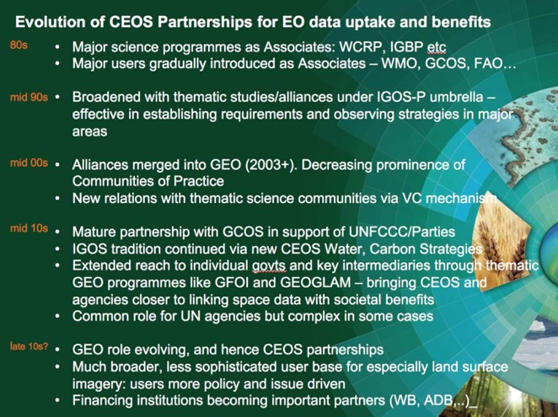
Stephen noted some trends and observations to be aware of in the organisation, particularly as a result of the loss of IGOS-P and its replacement by GEO. For example, we hope to see greater participation of finance institutions in GEO in future, Internet giants (e.g. Google, Amazon) are changing expectations of users, and CEOS is increasingly involved in user-facing initiatives.
Stephen noted that there are different models for CEOS partnerships - independently, and via GEO. GFOI and GEOGLAM and GCOS all provide lessons learned. Space agency programmes are often not properly reflected in agency national government’s development aid activities. Better linkages and strategies are required in that area. GFOI is a microcosm of many of these issues and is pioneering some of these relationships, including with the Internet giants and aid programmes.
Stephen concluded by noting that the new GEO strategy documents and approach, together with more recent emphases promise to deliver in these areas but process still ongoing. A new engagement strategy, and more broadly an approach to development of an initiative-based GEO system, is under discussion at ExCom, with great potential for both engagement and delivery. CEOS is engaged but also needs to see outcomes from GEO.
A brief discussion followed.
- Brian Killough (NASA) suggested that WGCapD might look at direct engagement of development banks. Ivan Petiteville (ESA) noted the role of the World Bank in the Recovery Observatory project. He questioned whether a project-based or strategic top-down approach would be optimal for CEOS. Mark Dowell (EC/JRC) noted that the CGMS relationship is also a key partnership for CEOS, as well as in situ data providers.
- Stephen noted the difficulty of establishing a high-level agreement between CEOS and (for example) the World Bank. CEOS could look to GEO to establish a modus operandi for development bank participation in the EO programmes addressing grand challenges. He noted the possibility of a more structured relationship with commercial providers as well. He also noted that agreements with in situ data providers would be more difficult to establish.
- Osamu Ochiai (GEOSEC) noted that the World Bank is a GEO Participating Organisation, and that Barbara Ryan has been working on relationships with development banks, including inviting them to GEO Plenary, and also working on cataloguing their EO activities in order to identify opportunities. Stephen noted that cross-project coordination within the development banks is not always efficient, and so both bottom up and top down approaches to relationship formation is beneficial. He also noted that the World Bank has shown interest in engaging with GEO, for instance in urban-related matters.
- Steve Volz (NOAA) noted that some coordination on principles of engagement and communication might help streamline the process, and help CEOS initiatives learn over time and improve interactions. Stephen agreed that this would be helpful.
- Stephen Ward (SIT Chair Team) noted that one of the reasons this was raised at SIT-31 was to try and establish some cross coordination across CEOS initiatives. In some way, this is replacing some of the activities that the IGOS-P had established before it was absorbed into GEO.
- David Green (NASA) noted that we should also consider relationships with NGOs, beyond the development banks. Stephen Briggs noted that NGOs are often the groups on the ground, funded by development banks, as is the case often with disasters. Alex Held (CSIRO) agreed, noting that they often work with other groups that are often unaware of the benefits they can get from satellite EO.
- Steve noted, based on their experience with CGMS, the difficulty in converting a demonstrated capability to a defined observing requirement and communicating this early to data providers.
- Mark noted that EC development funding is fairly well integrated to relevant geospatial data activities.
SITTWS-2016-02 | SIT Chair | SIT Chair to perform a brief review of CEOS activities linked to development banks (e.g. World Bank, regional development banks) and UN agencies, including an exchange of experience between CEOS Agencies on their own activities, to help facilitate cross CEOS coordination | SIT-32  To be initiated after CEOS Plenary.
 | Rationale: It was agreed that it would be useful to understand all of the points of interaction that CEOS has with development banks and UN agencies as a first step towards better coordination.

CEOS Data Cube Initiative
Brian Killough (NASA) reviewed some the background of the CEOS Data Cube initiative, noting that optimising uptake of increasingly available and temporally dense data series is a major driver.
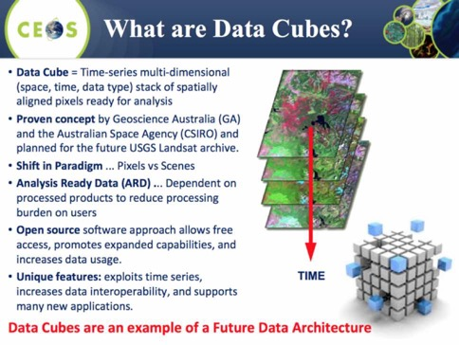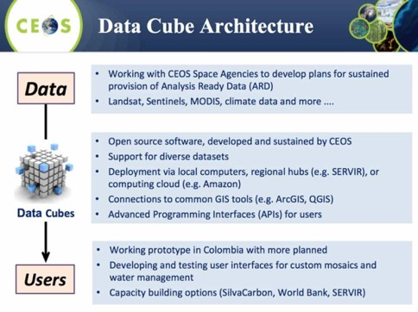
Brian stressed that the CEOS Data Cube initiative is still quite formative, but hopes that as it develops it will help reduce the barriers to the uptake of satellite EO. He reviewed a pilot application on water detection, stressing that in this case the Data Cube has enabled the leveraging of the dense time series available from the likes of Landsat and Sentinel-2.
He summarised a Work Plan developed for the initiative in order to try and capture the objectives, to coordinate internally, and to communicate externally.
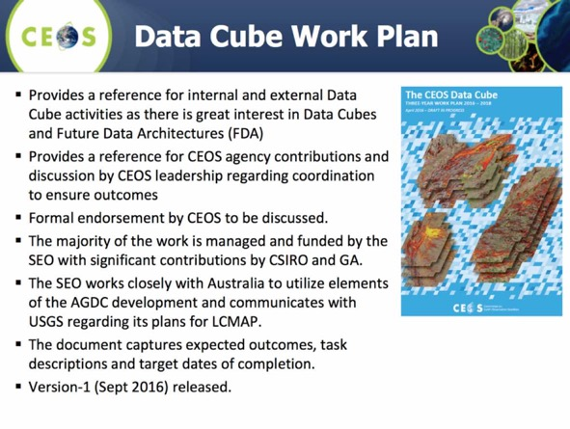
The Work Plan includes five areas of Data Cube activity:
- Core Technology;
- Data Preparation and Formatting;
- User Requirements and Engagement;
- Capacity Building; and,
- Prototypes (e.g. Colombia, Kenya, Lake Chad, Asia Mekong, Balkans, Switzerland incl. UN GRID, Disasters pilot).
Brian noted that the objective is not to develop the application layer, but to provide the space data to that application layer via the Data Cube (e.g. API) to power those applications allowing the user to focus on the application development. There needs to be a strong user counterpart to make these pilots a success, and for some of these prototype efforts the counterpart has been uncertain and variable.
He explained the example of Colombia, which SEO and CSIRO are supporting, where government (IDEAM) and Andes University teams have made considerable progress in learning how to create and use Data Cubes. The main application areas are land change detection and water detection. They have recently announced that they will be using the Data Cube approach to underpin their reporting to UN REDD.
Brian noted that the SEO will ask Plenary for endorsement of the Work Plan, reflecting an organisational commitment to look closer at how Data Cubes can help. He noted that it will be important in future to identify resources to support the effort, and hopes the Work Plan will enable agencies to identify where they might engage. At present NASA (via the SEO), CSIRO, Geoscience Australia, and USGS are contributing to activities that support the effort.
Several discussion points were raised.
- Brian stressed that additional contributions are welcome from other CEOS agencies in support of Data Cube tasks, noting that needs include need new data ingestors (e.g. agency satellite data streams, in situ, climate data), regional trainers, application tools and prototype support.
- Stéphane Chalifoux (CSA) asked about how new data and acquisitions are fed into to the Data Cube, and Brian noted that efforts are underway to ensure the Data Cube ingestor software can automatically update (i.e. maintain with new acquisitions) the data stack.
- Ivan Petiteville (ESA) noted that there is potential for a wide variety of fields that could benefit from this activity, and suggested that VCs and WGs could consider how to contribute.
- Adam Lewis (GA) noted that there is a need to ensure this effort is coordinated with other, parallel efforts. He stressed that we need to continue to share technical solutions and progress towards standards, and where appropriate have common approaches.
- Vardis Tsontos (NASA/JPL) noted that there are a lot of use cases in the oceanographic domain (e.g. sea level) where the Data Cube-like solutions could be useful and are being developed. Brian noted that the initial focus is on terrestrial applications, but that in future these applications could be envisioned. Stephen Briggs suggested that there are lessons to be learned in both directions, and options on how to manage this were discussed (e.g. a SIT Chair Task, CEOS Chair Task, via the Data Cube / SEO team).

Analysis Ready Data
Adam Lewis (GA) presented a summary of LSI-VC efforts on analysis ready data (ARD), noting that it is now referred to as CEOS Analysis Ready Data for Land (CARD4L). CARD4L includes a General Description and Technical Specifications, with the latter just in development now. Adam explored the rationale for ARD, including to best exploit the variety of data sources for generation of dense time series. Adam sketched out the directions for the specifications and how these might evolve. They will include general metadata, quality info, measurement, and geolocation corrections.
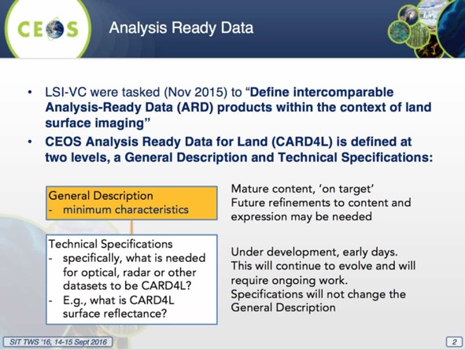
LSI-VC believes that many data users will be better off, and more able to make practical use of CEOS data products because they will not need to pre-process the data. Even sophisticated users invest a large proportion of their effort into data preparation. Other benefits include:
- CARD4L will enable CEOS agencies to better provide interoperable data that can be used for time-series analysis because the data are stackable as time-series and measurement-based;
- CARD4L will help users to overcome the challenges of big EO data, by removing the need for users to pre-process larger and larger data volumes; and,
- CARD4L will lead toward more interoperable data between like instruments (eg., Landsat-OLI and Sentinel-2 MSI), supporting CEOS Constellations.
Increased participation is needed in LSI-VC to progress the CARD4L work, including technical specifications (e.g. radar). The draft Plenary decisions sought by LSI-VC are as follows:
- NOTE the work of the Land Surface Imaging Virtual Constellation to produce a high level definition of analysis ready data (CARD4L) which will deliver significant benefits to many users by removing common pre-processing steps;
- ACCEPT the high level definition of CARD4L (CEOS Analysis Ready Data for Land) presented by the LSI-VC; and,
- ENDORSE LSI-VC to continue work to trial and validate the definition, developing specifications that map CEOS agency missions and instruments to CEOS Analysis Ready Data products through the LSI-VC.
Stephen Briggs asked how LSI-VC sees the work being carried forward, and Adam noted that he sees this continued by the VC with broader expertise brought in from CEOS agencies and groups. It was agreed that the draft Plenary outcomes accurately captured the current status and opinion.

LSI-VC User Requirements Survey
Bianca Hoersch (ESA) presented a summary of a user requirements survey conducted by LSI-VC, noting that one of the key objectives was to facilitate coordinated and optimized land surface imaging contributions from CEOS agencies to enable access to fundamental measurement products in support of confirmed/validated requirements linked to adopted CEOS priorities. They are working to draw together validated requirements identified by downstream user communities to identify opportunities to better optimize, and increase resilience of, land surface imaging programs; and, identify current and potential data gaps (both in terms of geographic and temporal coverage, and in land monitoring requirements).
The survey looks at existing capabilities with input from a number of agencies (e.g. ESA, NASA, CSA, USGS) following up to an action from SIT-31 (SIT-31-11). The survey looked at a number of processes, including the one followed by the CEOS ad hoc Working Group on GEOGLAM, and are proposing that this approach be taken for future activities.
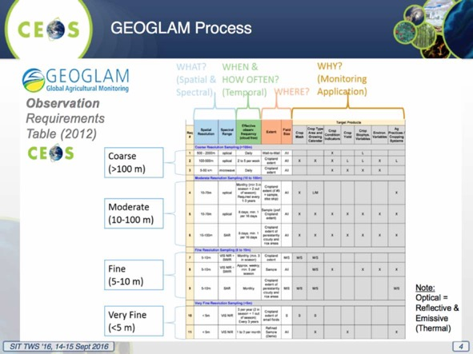
The proposed approach is:
- LSI-VC exploring adoption and generalization of the CEOS ad hoc Working Group on GEOGLAM approach to apply to other thematic areas;
- Ensuring capture of both observational requirements and downstream product/service requirements;
- Utilize existing ad hoc teams for eliciting requirements from communities of practice and augment as needed; and,
- Plan to look at CEOS Carbon Strategy for pilot implementation.
Several discussion points were raised.
- Stephen Briggs (SIT Chair) noted that the approaches developed for CEOS support to GFOI and GEOGLAM can certainly be generalised, and asked if this may become an LSI-VC function. Bianca noted that this makes sense, but that there has been plenty of years of effort put into these activities which LSI-VC does not currently have access to. Ivan reminded that similarly to both GFOI and GEOGLAM, WGDisasters has set up a dedicated group (the Data Coordination Team) to coordinate the observational requirements of all WGDisasters’ activities. Stephen stressed the importance of a strategic approach to the problem of requirements coordination.
- Steven Volz (NOAA) asked about the model for capturing both observational requirements and downstream product/service requirements, and Bianca noted the GEOGLAM approach worked backwards from required downstream products.
- Jenn Lacey (USGS) hoped there would be more clarity on the way forward after LSI-VC has undertaken their carbon requirements case study. Stephen Plummer (ESA) volunteered to help LSI interpretation of the carbon requirements.

CEOS Information Systems Survey
Ivan Petiteville (ESA) reported on an ongoing survey conducted as part of ongoing efforts to improve the services offered by several core CEOS information services: the EO Handbook and CEOS Database; COVE; and CEOS Data Policy Portal. Ivan outlined the contents of the survey and some of the suggestions arising for improvements (e.g. external interfaces, missing/additional information) and initial responses.
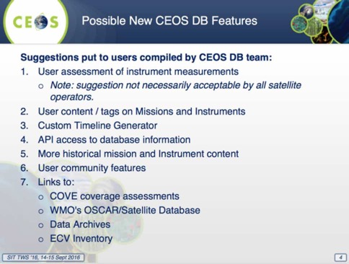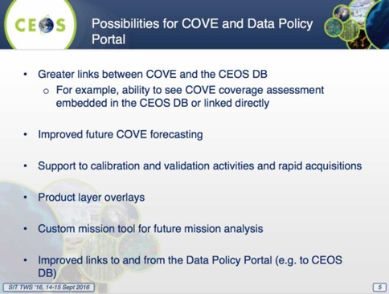
The survey remains open at https://www.surveymonkey.com/r/ceos-info-systems and all CEOS Agencies and their user bases are invited to provide responses and suggestions.
Several discussion points were raised.
- Jenn noted the potential link to LSI-VC gap analysis, that at LSI-VC-2 Brian gave a good summary of current capabilities, and they are carrying an LSI-VC action to provide suggestions.
- Stephen Briggs (ESA) noted that in order to realise the full potential of these tools, CEOS groups should provide inputs reflecting the current needs and activities. He also suggested that partner and user organisations are also being engaged, for example GEO.
SITTWS-2016-03 | All CEOS Information Systems stakeholders | All CEOS stakeholders invited to respond to the CEOS Information Systems Survey in support of future improvements https://www.surveymonkey.com/r/ceos-info-systems. This should include users of the EO Handbook, CEOS Database, COVE, and the CEOS Data Policy Portal | October 2016  Survey closing end of October, with a summary at Plenary and full results for SIT-32.
 | Rationale: The survey team is seeking a broad response from across the community, and would like all stakeholders to respond.
SITTWS-2016-04 | Ivan Petiteville | Ivan to work with GEO Secretariat to seek inputs to the CEOS Information Systems Survey from their user community, and to improve the representativeness of the response | COMPLETE  GEOSEC has posted on their website and also via social media
 | Rationale: The survey team would like to ensure the user community perspective is reflected in the response, and would like to enlist GEO’s support to reach out.

Future Data Architectures (FDA)
Stephen Ward (SIT Chair Team) introduced the presentation of the Future Data Architectures (FDA) study, noting that this effort was initiated at the last CEOS Plenary and this is the first major report out from the group. Alex Held (CSIRO) reviewed the origins of the FDA Team, noting that one of the overall objectives was to survey opportunities and challenges around operating environment:
- Ability of developing countries to realise the potential value of satellite EO for the big global agendas: Sendai Framework, Global Goals for Sustainable Development;
- Desire to have solid concrete opportunities to develop partnerships with development banks and UN institutions (including in reference to above);
- Challenges around supporting next generation of climate applications (incl. stepping up support for next phase of GCOS, but also supporting countries to establish systems to report on their commitments which could be quite varied); and,
- Challenges around promoting uptake by industry/value-adders, working together to lower technical barriers to enable industry to really get to work - ideally in a way that supports the CEOS concept that users having access to an international constellation of systems (not just stovepiped systems) is a good thing.
Tom Cecere (USGS) reported the work of the FDA ‘tiger team’ which has taken the report forward, noting that there have been contributions from a number of agencies and individuals. He noted the report covers:
- Section 1 – Introduction;
- Section 2 – Current Trends and developments in EO systems architecture and applications;
- Section 3 – The challenge and opportunity of changing user expectations and increasing EO data volume, variety and velocity on EO systems architecture;
- Section 4 – The Future of EO Data Architectures; and,
- Section 5 – Conclusions & Recommendations.
Tom reviewed the contents of the report.
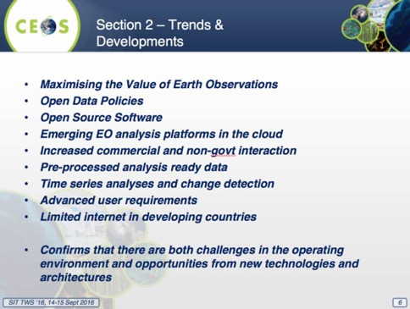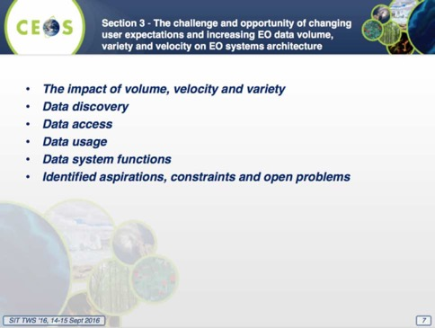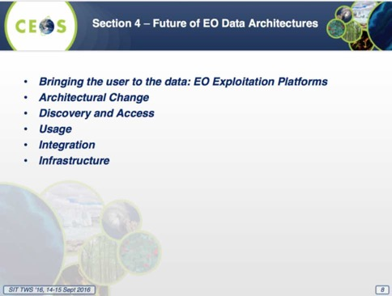
Jonathon Ross (CEO/GA) reviewed the preliminary Conclusions and Recommendations of the report, stressing that CEOS groups would benefit from reviewing it in detail.
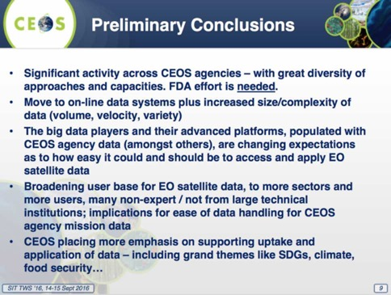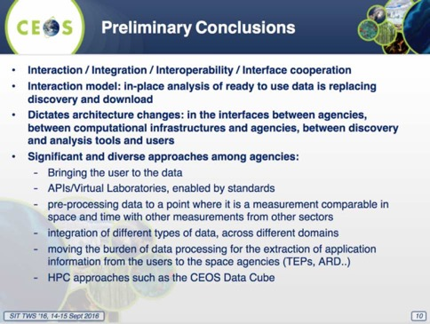
Jonathon noted that future data architectures will consist of multiple approaches to cover all circumstances and uses, and this will involve some sensitive and strategic discussions. The realisation of dense time series applications requires improved interaction, integration, and interoperability, and the expectations of the communities that CEOS seeks to support are changing. With technology changing rapidly, agency initiatives will be most successful if they do not happen in a vacuum. There will be no ‘single system’ or ‘single stack’ solution - the challenge for CEOS is how do we work together to take advantage of these opportunities and, in doing so, realise benefits for CEOS Agencies and make things simpler for users. It was noted that across the CEOS community, there are varying views on the role and benefits of engaging the private sector, and that the needs and expectations of different countries and projects are diverse.
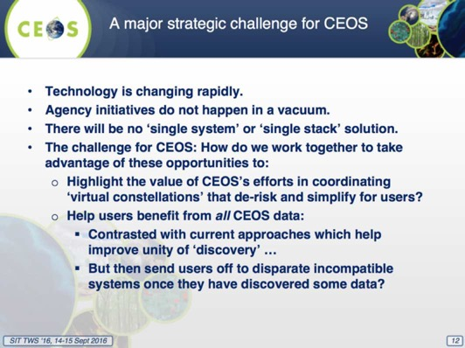
Stephen reviewed the next steps, noting that the team proposes to break down recommendations as short, medium and long term, with only short-term recommendations included in the 2016 Report to Plenary. USGS and CSIRO are willing to take the team forward through 2017, subject to Plenary approval, to develop medium and long-term recommendations. CEOS has pilots, prototypes, and enabling technology work underway within SEO, LSI-VC, GFOI, and WGISS and the team recommends these be progressed and accelerated, as they will provide valuable real world lessons to inform the bigger picture discussions.
It is proposed to continue and support existing WGISS efforts on data discovery search engine optimization (search relevancy, keyword search, persistent identifiers), access common standards for interoperability of product formats (metadata/data) and Application Program Interface (API), and exploration of emerging ‘big data’ services including cloud computing.
It is also proposed to tie together several existing FDA-related activities by undertaking a small scale pilot in the GFOI context involving the generation of ARD by several CEOS agencies for a CEOS Data Cube instance. Much of the work is already underway and could be blended successfully to demonstrate to CEOS agencies and users the value of some of these FDA topics. The work can proceed in parallel with the 2017 work to complete the FDA report.
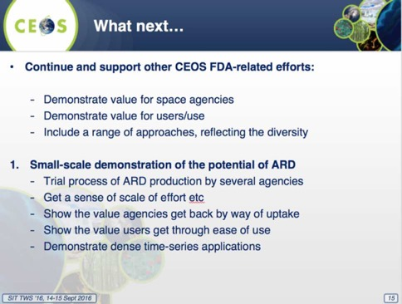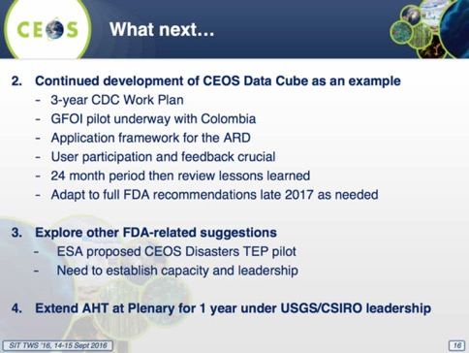
Several discussion points were raised.
- Mirko Albani (ESA) suggested that CEOS should avoid being prescriptive in terms of specific implementations as there is a large diversity of users with different needs. Data Cubes and Exploitation Platforms are good examples, but the report should focus on common approaches leaving agencies the flexibility in their implementation. Stephen agreed that this was a key point, and the proposed next steps are only the beginning of a long and diverse implementation phase which could stretch years. He noted that CEOS is a voluntary framework to which agencies may subscribe or not as they decide on the value.
- Vardis Tsontos (NASA/JPL) noted that currently it is a period of intense experimentation at JPL in this area, and pulling insights from people’s experience (both negative and positive) would help with uptake. Stephen noted that another example would be welcome, but capacity is currently limited and so resources would need to be in place. Brian Killough (NASA) noted that these experiences could be reflected in the report.
- Steven Hosford (CNES) asked about the composition of the group (members from 4 countries, 3 agencies), and it was noted that this was a function of those who responded to the call for inputs - it has not been a survey process that has sought to discover all existing activities. Steven Briggs recalled that the membership is open to any volunteer.
- Jorge Vazquez (NASA/JPL) noted that future missions (e.g. SWOT) present significant challenges with data volume and velocity.
- Steve Volz (NOAA) noted that there are similar activities going on in NOAA. He also spoke in support of the short term report, with the extension, noting that this initial step has done a good job in driving out the initial questions.
- Alex noted that in the next year, there will be scope to expand, and include some case studies that highlight what has been achieved to date and to help prioritise future coordination efforts.
- Andrew Mitchell (NASA) noted that there will be a cloud computing workshop at the following week’s WGISS meeting, and they will publish a summary report that can be provided to the study team.
- Ivan Petiteville (ESA) suggested it would be useful to see a work plan to help understand how all these threads fit together.
Stephen Briggs noted that based on the discussion, the Workshop supports the continuation of the ad hoc Team and the pilot activities and that this should be communicated to the CEOS Chair in preparing Plenary.

Non-Meteorological Applications
Ken Holmlund (EUMETSAT) presented a summary of the Non-Meteorological Applications (NMA) study, reviewing the study background and objectives.
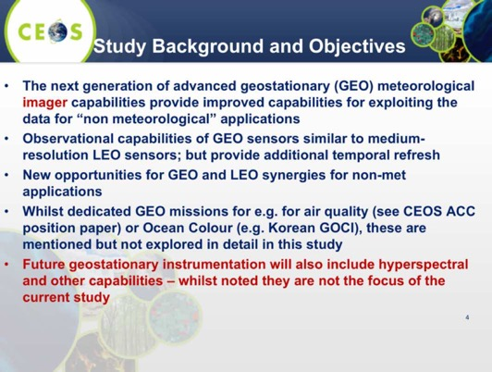
The aim of the study is a report that provides comprehensive and pragmatic guidance to CEOS on new opportunities arising from next generation geostationary satellites and GEO-LEO synergies. He reviewed the study outline, noting that there has been significant discussion of the recommendations in recent days, and these are likely to be phrased as ‘opportunities’, in part because resources for the implementation of recommendations would remain to be coordinated.
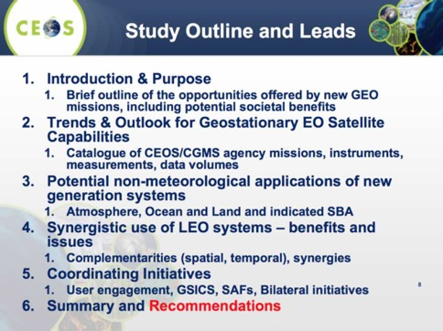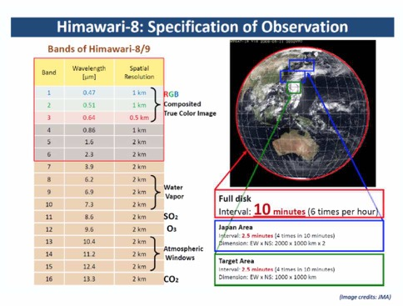
Ken noted that part of the impetus for this study has been the launch and operation of Japan’s Himawari-8, which started in mid-2015. He showed several other examples which show promise (e.g. aerosols and volcanic ash, ocean current eddies using ocean colour, fire radiative power). He highlighted the case of fire radiative power shows that temporal resolution enables new information to be derived which would be missed by a LEO source like MODIS.
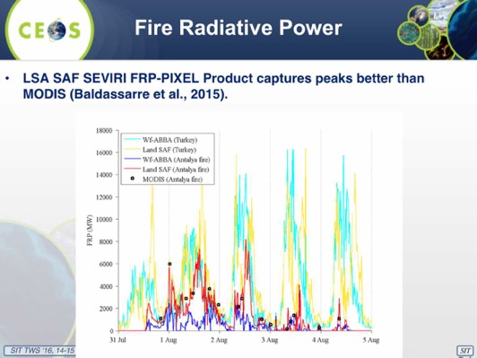
The study compares the capabilities of synergistic use of GEO and LEO systems.
- Spatial Resolution Geo imagers have roughly twice the footprint than medium resolution LEO instruments;
- Temporal Resolution Full disk every 10 min vs 2-4 times daily, Significant for rapidly developing or changing situations;
- Spectral elements Similar between GEO and medium resolution LEO, Calibration accuracy: IR comparable, VIS as well with some limitations; and,
- View/Illumination LEO has variable view angles and depending on mission illumination conditions, GEO has fixed viewing geometry and variable illumination conditions.
Ken reviewed some of the draft conclusions of the study.
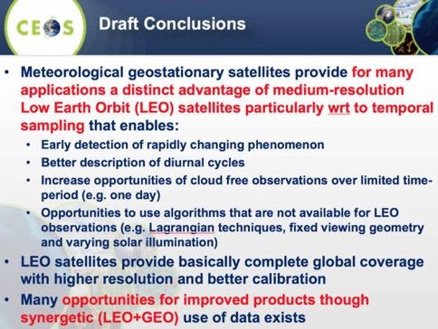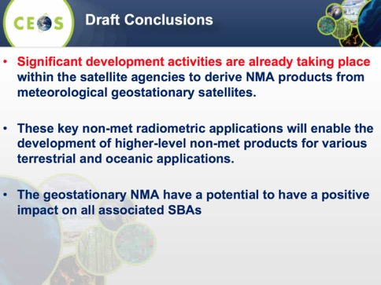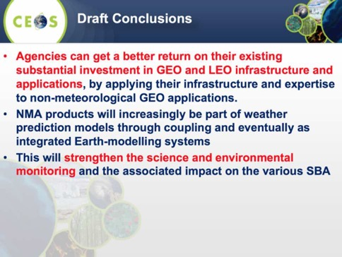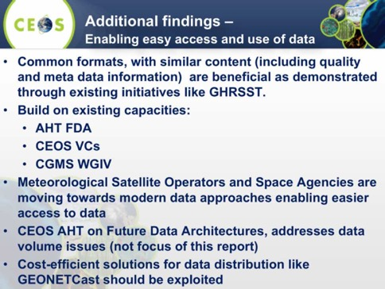
There are opportunities to achieve better integration and uptake of non-met GEO observations across the full range of Earth observation applications opportunities including:
- Consider exploring collaborative efforts for algorithm development and intercomparison activities (consistent GEO-ring);
- Seek opportunities to broadly engage with the EO-community and LEO science teams to foster the collaborative development of advanced algorithms and to identify potential non-met applications for coordinated GEO-ring implementation;
- Consider how the “Analysis-Ready Data” concept would apply to GEO-LEO integration;
- Continue working towards the operational delivery of NMA geophysical products to achieve quasi-global consistent coverage, particularly radiometric products that underpin downstream products;
- Study the suitability of GEOs to contribute to ECVs/CDRs and UN SDGs in detail; and
- Consider identifying a suitable pilot project within existing coordination activities.
There are also opportunities for calibration and validation (e.g. product consistency, in situ validation, infrastructure, cross-calibration), and outreach (e.g. leveraging existing promotion and training opportunities). Several discussion points were raised.
- Shizu Yabe (JAXA) noted that Australia and Japan have been conducting a joint activity focused on non-meteorological applications, with two workshops taking place to date. The second workshop was held last week, and focused on hotspot and haze monitoring, and ocean colour and SST monitoring. The activity is seeking opportunities for cross-validation work, and identified the need to strengthen interaction with user communities.
- Mark Dowell (EC/JRC) noted that the spectral resolution (at least in the visual range) for GEO imagers is not as high as for the LEO imagers, and this should be recognised. Ken noted that the spectral widths of the bands for the GEO imagers will impose some limitations.
- Adam Lewis (GA) noted that Geoscience Australia is doing work on fires, and they have some experience they are willing to share.
- Steve Volz (NOAA) noted the natural next step would be to report out to CGMS Plenary in 2017.
Stephen Briggs noted that this report is a useful ‘case book’ of what this next generation of GEO imagers will be able to contribute. He noted that the report should be presented to CEOS Plenary for endorsement and for Plenary to consider appropriate follow-on activity.

GEO Status
GEO Secretariat Update
Osamu Ochiai (GEOSEC) provided an overview of GEO activities. Current themes and priorities are:
- planning the transition to the next decade;
- recognition of GEO’s convening power – Members, POs, Development Banks, Foundations, emerging Commercial Sector;
- evolution & recognition of policy mandates for GEO; and,
- the new Strategic Plan with new programmatic mechanisms – community activities, foundational tasks, initiatives and flagships.
Osamu highlighted the restructuring of the GEO Water tasks, noting that Rick Lawford is supporting this process alongside a new GEOSEC water expert. He noted that they are considering consolidating multiple tasks into a smaller number of integrated tasks. AquaWatch (focused on water quality issues) has been added as a relevant Community of Practice, alongside the existing IGWCO CoP. There has been slow progress on the SBA Requirements task GD-08.
A draft implementation plan has been developed for the SDG task GI-18. GEOSEC is working on external interfaces like statistical agencies as national users of SDG info. GEO has joined the UN Inter-agency Expert Group on the SDG indicators framework. Progress will be reported to GEO-XIII Plenary.
Stephen Briggs (ESA) stressed the increased activity on the SDG front, and noted that there seems to be continued confusion around both CEOS and GEO Water Strategies and there is a pressing need to integrate our activities with respect to water.
GEO Programme Board Report
Jonathon Ross (CEO) provided a status update from the GEO Programme Board (PB), noting that its key roles are providing stewardship of the GEO Work Programme, and being proactive in ensuring cross coordination between tasks. CEOS is represented by Stephen Briggs, Ivan Petiteville, and Jonathon Ross.
Jonathon noted that so far, the PB has taken the approach of trying to lift the standard of tasks and proposals gradually, for example, in some cases governance arrangements for proposals are left to be determined. There is a need to monitor extent to which ‘cross cutting’ topics (e.g. climate, capacity building) are addressed. He noted that there has been some confusion around the designation of Flagships. He noted that the terrestrial in situ field needs intervention and attention (e.g. more Trust Fund investment) and increased involvement of the existing players. Unlike land, Jonathon reminded that ocean, atmosphere and space observations are supervised respectively by GOOS, WMO and CEOS/CGMS.
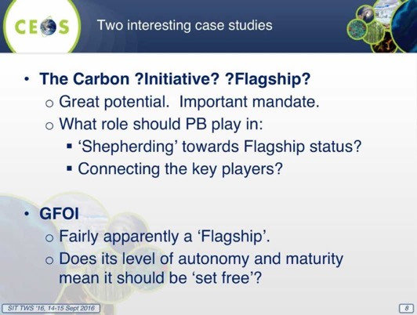
There has been a review and reshuffling of a number of tasks in the Work Programme. In particular, he reported that the PB felt there were too many Foundational Tasks, and the GEO Executive Committee asked PB to prioritize them.
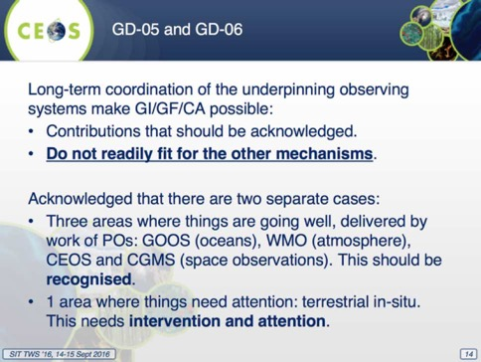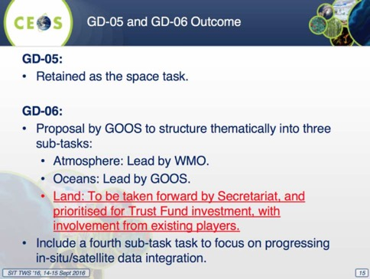
There has been a lot of discussion around the PB Terms of Reference, some of which are still being addressed.
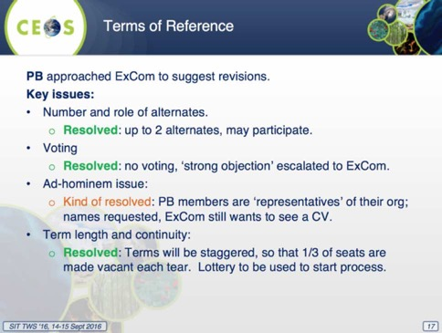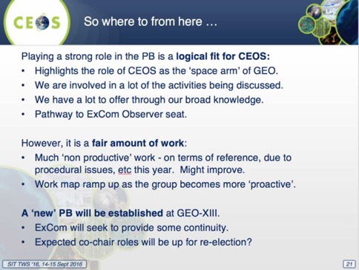
Jonathon reviewed the future direction and engagement model for CEOS with GEO.
- CEOS has re-nominated for next three years, using existing names for Principal and Alternates.
- We will ‘update’ the details of our PB representatives consistent with internal protocols, e.g. SIT Chair transitions, CEO transitions, SEC processes.
- Principal CEOS PB Rep will be duty of SIT Chair, consistent with SIT Chair ToR.
Several discussion points were raised.
- Stephen noted that the GD-08 task was originally established at the insistence of CEOS, and CEOS has resisted the dilution of the task by attempting to add the data applications dimension.
- Mark Dowell (EC/JRC) asked about the ‘original GD-08 task’ (on the SBA user requirements), and how it is currently progressing, and Stephen noted that it made good early progress, and now it has stalled.
- Astrid Koch (EC) asked about GD-07 on GCI Development and the role the EC might play, and Jonathon confirmed the EC role will remain, but will be refactored into a new activity.
- Paul DiGiacomo (NOAA) noted that the GEO AquaWatch activity is seeking to create a water quality monitoring service. It is separate and distinct as it crosscuts the land and ocean boundary, and there is a clear role for CEOS in the coordination of satellite observations.
GEO Executive Committee Report
Stephen recalled that CEOS was admitted as one of three GEO PB Observers to ExCom (along with WMO and GOOS). He noted that observer status has no practical disadvantage for CEOS as it is treated as all others on the Board. He also noted that there has been a strong interaction between ExCom and the PB in both directions, and that ExCom has met twice this year.
Stephen noted there is a significant change in approach to GEO implementation since the discussion at the ExCom-37 meeting. There is no desire to change formal objectives, but the perception and implementation of GEO is being significantly and positively redirected, led by USA.
Two subsequent subgroups were set up: a Strategy Group, led by USA; and, an engagement strategy group (led by EC (Jack Metthey), following rejection of the engagement paper from GEOSEC. CEOS is represented on both groups and we are seeing very positive progress in both areas.
The consequence of the changes are that GEO is more outward facing, and objective oriented. The SDGs have been selected as first driving force for study, but this is only the start of more objective-focused effort. The recent PB meeting included very good discussion and ongoing actions. The next data points will be at ExCom-38 and GEO Plenary-XIII. Stephen announced that the engagement of the Commercial Sector will be the subject of a specific session at the GEO-XIII Plenary.

CEOS Support to GEO Thematic Areas
GFOI and SDCG
Stephen Ward (SDCG SEC) presented a summary of the activities of GFOI and CEOS support via SDCG, covering the conclusions and recommendations of the SDCG Global Data Flows study, data coverage issues, and GFOI and SDCG strategy and operations. He summarised the conclusions of the Global Data Flows study.
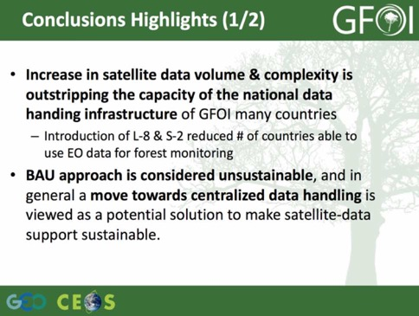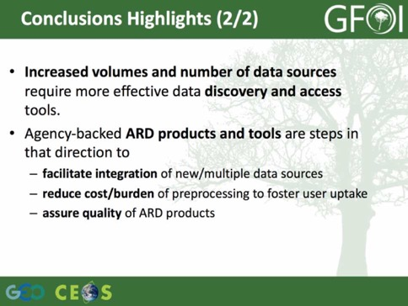
The study made a number of recommendations, currently divided into three groupings: Space Data Providers; Capacity Building Partners; and, Users and Countries. These recommendations are believed to be complementary and supportive of Future Data Architecture (FDA) work.
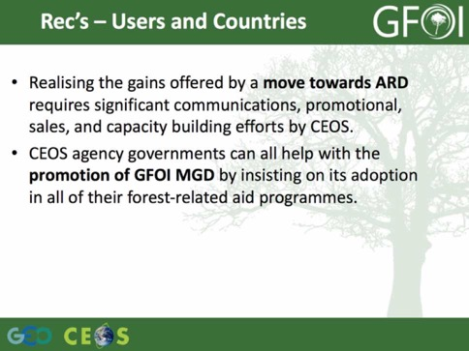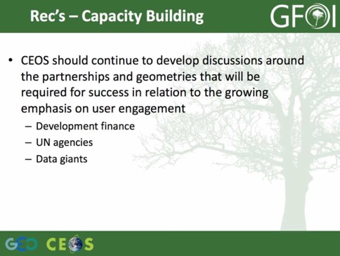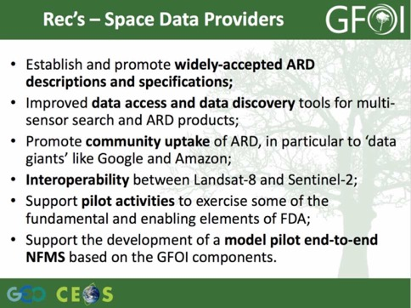
Stephen reviewed several data requests discussed at the recent SDCG-10 meeting to be flagged to SIT and CEOS agencies. He noted that most of these requests related to historical coverages which are required to enable the establishment of national baseline forest maps, and reviewed those requests as discussed at SDCG-10.
- JAXA to make JERS-1 mosaics available online and to continue ALOS series systematic global acquisitions;
- CONAE to confirm the planned free and open availability of SAOCOM-1A data GFOI purposes;
- CNES World Heritage programme making SPOT 1-5 data available. Helpful surrogate for ground truth since 1986; fill regional gaps in Landsat historical record - particularly over Africa; and,
- We encourage all CEOS space agencies to assist CNES in repatriation of SPOT 1-5 data to CNES to be consistently processed and readily available to the global community.
Stephen reviewed the operational status of SDCG and GFOI, noting that there is some risk with the end of Australia’s role as co-lead of GFOI at the end of 2016. Currently the Australian co-lead is supporting the GFOI Office, the development of the Methods and Guidance, and providing funding for administrative support to SDCG.
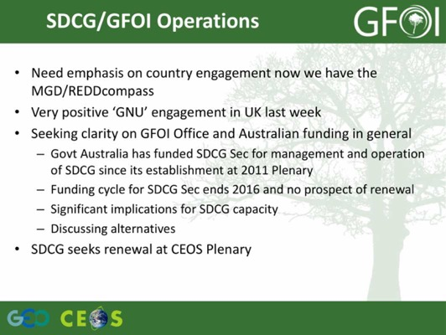
Several discussion points were raised.
- Stephen Briggs (ESA) noted that CEOS agencies need to investigate options to support the operations of the SDCG with current resources for secretarial support about to lapse.
- Stephen Briggs also noted that there are a couple of points that need to be addressed in order to formally see GFOI established as a GFOI Flagship.
SITTWS-2016-05 | USGS and ESA | USGS and ESA (as SDCG co-Chair agencies) to circulate a call for CEOS Agencies to consider options to support the operations of the SDCG with current resources for secretarial support about to lapse | COMPLETE  Outcome to be reported at Plenary.
 | Rationale: The secretariat of the SDCG is currently supported by the Australian government as a part of its contribution as GFOI Co-Lead. However, this support is ending at the end of 2016, after which SDCG will be without secretariat support.
Stephen Briggs noted Jim Pennman’s recent, sudden, and unexpected passing, and recognised the tremendous contribution he made to GFOI as a whole in leading the development of the Methods and Guidance documents.
Agriculture
Brad Doorn (NASA) presented a summary of recent GEOGLAM activities, and outlined the overall status of coordination with GEO. He also reported that GEOGLAM is working on a new organisational framework for GEOGLAM, based on a request from their agricultural stakeholders, who clearly and explicitly value the role of satellite data EO.
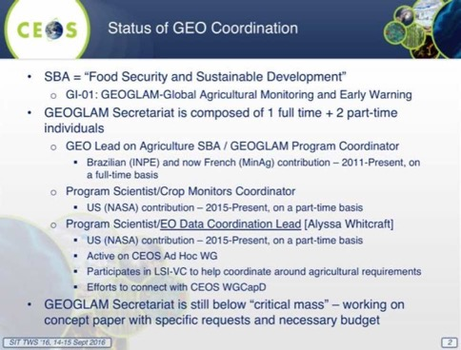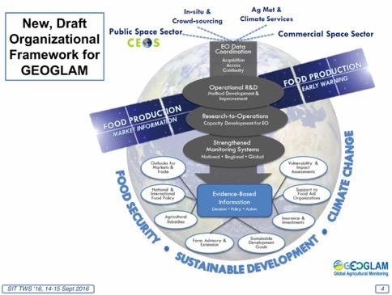
Brad noted that GEOGLAM has been recognised by the G20, most recently at the G20 Agricultural Ministers meeting (Xi’an, China, 3 June 2016).
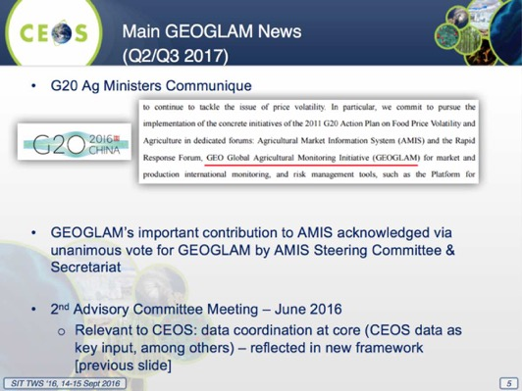
Brad reviewed the main GEOGLAM news.
- Interaction with LSI-VC – application of GEOGLAM’s EO Data Requirements Development and Evaluation Framework for other land applications;
- Our 4th international Rangeland and Pasture Productivity (RAPP) workshop took place in South Africa (city of Tshwane, Pretoria), late June 2016;
- GEOGLAM Latinoamérica: training event in June 2016 in Bogota spurring interest for new usership of EO for agricultural monitoring;
- GEOGLAM launching “AfriGLAM”; and,
- CNES supports Asia-RiCE activities in GEOGLAM (Thuy LeToan, CESBIO).
Brad reported on the upcoming “reboot” of GEOGLAM EO data requirements. The requirements aren’t static, and will be refined to account for evolution of “best practices” and new data streams, the RAPP data requirements, incorporating in situ and agro-met with space-based EO requirements toward “Methods & Guidance” type documentation for GEOGLAM, and including community effort to define “analysis ready data” for agricultural monitoring applications. This effort will start at the JECAM meeting (Kiev, Oct 2016), culminating in Q2 2017 session (TBC: ESRIN, May 2017).
Brad noted that based on agricultural data requirements, the private sector is going to need to be engaged, and he suggested that this is a discussion that CEOS should have in future.
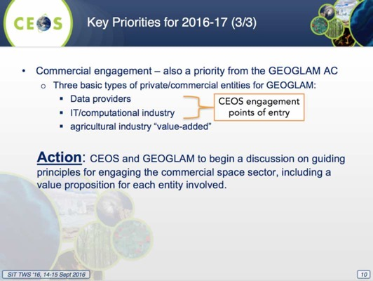
Several discussion points were raised.
- Adam Lewis (GA) noted that the commercial provider position on the free distribution of data needs to be clarified, and that the overhead required to manage licenced data makes it not worthwhile. He noted that with DMCii they managed to secure an open data licence.
- Steven Hosford (CNES) noted we need to be careful to make a distinction between commercial data and space agencies that have developed satellites and have them operated commercially. The agencies can provide data for the earlier, scientific R&D phase, but the challenge is how to transition supply to operations.
- Steve Volz (NOAA) agreed that a consistent approach to commercial data would be valuable.
- Stephen Briggs noted that this is likely to change in the next five years as more lightweight, nimble data providers come online.
Disasters
Stéphane Chalifoux (CSA) provided an update on the status of the Disasters activities, noting the CEOS imagery support to the recent Italian earthquake. From Stéphane’s perspective, the exercise raised issues around the role of EO, especially in order to sustain a monitoring activity and the organisational issues around supply for a crisis.
The Flood, Seismic Hazards, Volcano, and Recovery Observatory (RO) pilots are progressing very well with positive feedback from end users. These end-to-end projects (expected to conclude in 2017) engage users to demonstrate the benefits of satellite EO to all phases of Disaster Risk Management (DRM).
The Flood Pilot demonstrates effective application of EO to the full cycle of flood management at all scales. Three regional pilots are showcasing end user benefits of frequent high spatial resolution observations (Caribbean, Southern Africa, Mekong/Java).
The Seismic Risk Pilot demonstrates how satellite EO can be used to improve seismic monitoring and response to seismic events, with an EO-based global strain map (main focus on Turkey, Himalayas and Andes) and an exploitation platform for large data set analysis (e.g. strain map, supersites).
The Volcano Pilot improves coordination of satellite data acquisition over volcanoes, demonstrates efficiency of EO-based monitoring methodologies as a complement to in situ measurements, and supports and continues the GSNL initiative.
CEOS Agencies continue to ensure readiness to activate the Disaster RO for a one-time demonstration in the 2016–2017 period. WGDisasters is working with GFDRR/World Bank and the Government of Malawi, on a Malawi Demonstrator to validate applications relevant to recovery needs, including development of specific tools tailored to provide easy access to data over affected areas (pre-event data, response data and coordinated post event acquisitions).
The new Landslide Pilot demonstrates the effective exploitation of EO data and technologies to detect, map, and monitor landslides, in different physiographic and climatic regions. The Landslide Pilot will focus on two primary regions (Nepal and the Pacific Northwest in North America) and five experimental regions (Southeast Alaska, Cuba and Caribbean, Sri Lanka/ India, China, Norway).
A hardcover “glossy” report is being prepared for early 2017 to showcase success in each thematic area. Partnerships are being elaborated with end users and other interested stakeholders with a view to defining a path to sustainability; regional organisations will be engaged through new initiatives, such as GEO-DARMA. From a CEOS perspective, the long‐term outcome of GEO‐DARMA is to foster use of EO data and EO-based risk information by end users, and to increase awareness within donor agencies of EO solutions. One of the major tasks during the early Concept phase will be to select projects and related user needs to be implemented as a priority. A Sub-group will be formed within WG Disasters, and a secretariat is being organized. The proposal is being reworked and approach to partners to begin this October/November.
Water
Chu Ishida (JAXA) presented a summary of CEOS Water Strategy Implementation Team’s (WSIST) activities, and in particular the Water Constellation Feasibility Study (FS) report. He noted that the FS is in response to the GEO Water Strategy recommendation C1.
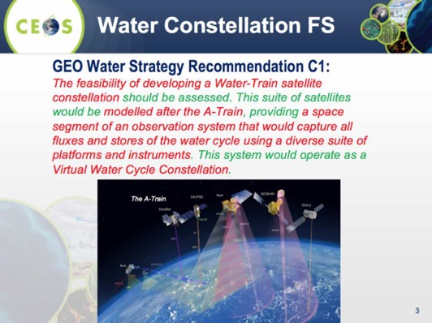
Chu noted that the FS has reviewed the most recent user requirements from GEO’s US-09-01a (Critical Earth Observations Priorities-Water Societal Benefit Area), as well as the GCOS ECV requirements, and WMO Statement of Guidance (SOG). The study identified a MWI imager gap, as well as synergies amongst some variables.
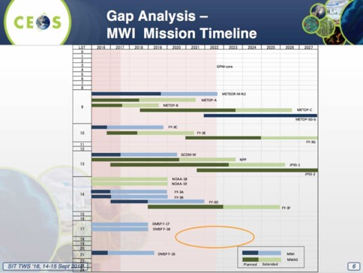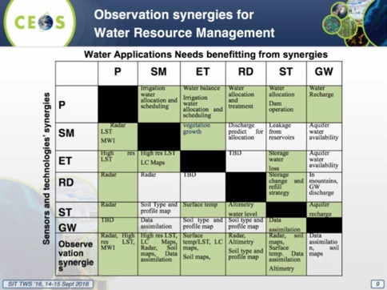
Chu reviewed several points about a proposed water satellite constellation arising from the FS.
- Necessary components for water constellation already exist in current and future plans;
- MWI constellation is a key component for retrieving precipitation, soil moisture and ET. Prospective gaps of FO missions of AMSR-2, DMSP-19/ SSMI, SMOS and SMAP need to be addressed;
- TIR, optical and L/C/X band radars can be optimized to contribute to observations of SM, ET, RD and ST;
- Revisit time of SWOT type missions need to be improved for monitoring river discharge and surface water storage;
- GRACE type missions should be continued for groundwater monitoring; and,
- Data assimilation systems should be developed to use actual data in a more optimal way.
Chu reviewed the draft recommendation for CEOS Plenary:
- to endorse the CEOS Water Constellation FS report; and,
- to consider next steps by the April 2017 CEOS SIT meeting to address recommendations of the water cycle FS and remaining CEOS Water Strategy actions (C2 to C9).
He reviewed the overall status of the CEOS response to the GEOSS Water Strategy recommendations.
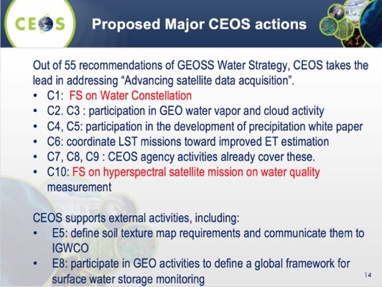
Several discussion points were raised.
- CEOS support to C1 and C10 were noted, and the progress being made was recognised.
- Stephen Briggs raised the question of whether the requirements from the GEOSS Water Strategy are still as relevant, and stressed that space agencies should ensure that their response to the items beyond C1 and C10 should be clearly linked to current requirements.
- Jonathon Ross (CEO/GA) noted that the core element of the FS being conducted for C1 is around coordination mechanisms for different observations. Stephen Briggs noted that he views C1 as largely complete, and to be submitted in due course. He noted that C10 will be responded to by SIT-32 (April 2017, if not sooner).
- Steven Neeck (NASA) raised the issue of endorsing the draft FS study, which is incomplete and contains some strong recommendations for new sensors that CEOS agencies may not be able to address. He suggested tempering the language around some of those recommendations. He also agreed with Stephen Briggs’ comment around addressing additional actions without clear drivers.
- It is unclear what activity C2 and C3 are calling for, and before CEOS takes any further action, we should assess where GEO is going. It was noted these items address GEO Work Programme tasks that are no longer in place. Jonathon noted that C2 and C3 were NOAA contributions, but confirmed that it is not clear they still exist.
- Jonathon confirmed that C4 and C5 are being worked by P-VC.
- With reference to C6 (ET), it appears there may be more in-depth and current activities that should be considered. Jonathon confirmed that LSI-VC was going to include this in their work plan, but it is not clear they can follow through in the near term. John Remedios (UKSA) noted that the discussion around improved ET estimates may not yet be mature enough to proceed.
Stephen Briggs noted that the outstanding action from this discussion is to look forward to receiving the FS report, and that this will be valuable in outlining what would need to be responded to in the next 20 years to address the water cycle monitoring questions
SITTWS-2016-06 | Water Strategy Implementation Study Team (WSIST) | WSIST to present the results of the Water Constellation Feasibility Study Report | 30th CEOS Plenary  Included under item 2.3 on the Plenary agenda.
 | Rationale: The feasibly study is nearing completion, and needs to be concluded to address CEOS Water Strategy action C1 and to progress the broader CEOS efforts on the coordination of water observations.
SITTWS-2016-07 | WSIST Feasibility Study Team | WSIST Feasibility Study Team to present a progress report on the hyperspectral water quality satellite mission study | 30th CEOS Plenary  Included under item 2.3 on the Plenary agenda.
 | Rationale: This study addresses CEOS Water Strategy action C10, and is expected to be concluded in time to present at SIT-32.
GEOGLOWS
Brad Doorn (NASA) briefly discussed the early beginnings and objectives of the proposed GEO Global Water Sustainability (GEOGLOWS) initiative. He emphasized that GEO has only just begun to develop GEOGLOWS, and that it could take a couple of years. Much more discussion is required, and the related global coordination will be complex.
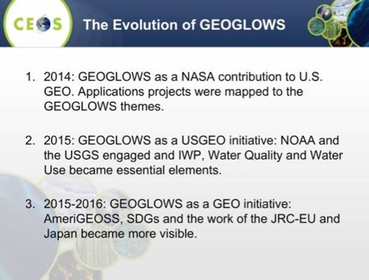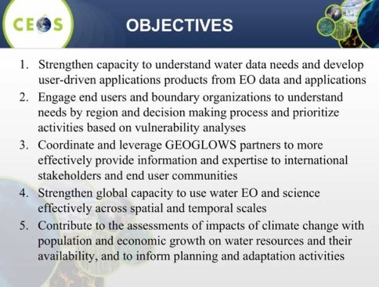
Brad reviewed the proposed structure of GEOGLOWS.
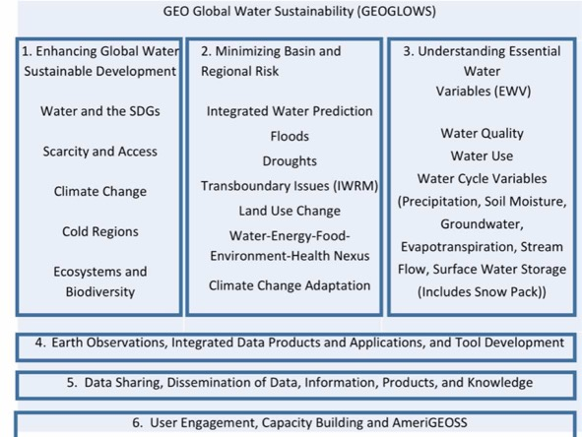
Several discussion points were raised.
- Kerry Sawyer (NOAA) asked about the ‘Essential Water Variables’, and Brad noted that they are not currently defined. However, they reflect an effort to try and capture the variables to be measured.
- Ivan Petiteville (ESA) asked about the linkage between GEOGLOWS and the GEO Water SBA. Brad noted that GEOGLOWS does not seek to capture all the required needs for the Water SBA users.
- Mark Dowell (EC/JRC) noted that the list of water variables is large, and noted there are good reasons that water quality is separate as it crosses ocean and inland domains. He suggested that for SIT-32 it would be good to get an overview of the AquaWatch initiative which is the water quality counterpart, in addition to reviewing the hyperspectral water quality study being completed as a part of water strategy action C10. Stephen Briggs noted we need to be careful not to duplicate GEO’s efforts too closely, though there is a role to ensure coordination of water observations from space.
- Paul DiGiacomo (NOAA) noted that AquaWatch is led by a number of CEOS Agencies, as well as by the satellite data component. He noted that the IOCCG remote sensing of water quality report includes consideration of both users and satellite data providers.
Carbon
Stephen Briggs noted that the ongoing response to the CEOS Carbon Strategy, and stressed there is a need to include a reference to this work in the GEO Work Programme. He noted that a proposal called GEO Carbon was approved as an initiative at last week’s Programme Board meeting. He noted that the GEO initiative has broad implications and an ambitious scope, but that it does helpfully bring together a suite of activities in relation to carbon. He noted it is research-oriented and links well to the CEOS Carbon Strategy.

GEO-XIII Plenary Preparations and Inputs
Jonathon Ross (CEO) reported on preparations for the GEO-XIII Plenary. GEO-XIII is the first Plenary following the endorsement of the GEO Strategic Plan 2016-2025 and will be in St. Petersburg 7-10 November 2016. This is the week following CEOS Plenary and so the normal preparation time will be condensed, which will require greater pre-coordination.
CEOS Delegation is subject to US government travel orders being finalised but includes at this stage: Frank Kelly, Jonathon Ross, Steve Labahn, Brian Killough. Stephen Briggs, Ivan Petiteville, Astrid Koch, possibly Steve Volz and others may attend in their various capacities.
The objectives of GEO Plenary are:
- Reflect upon implementation of the GEO Strategic Plan 2016-2025 and the Mexico City Ministerial Declaration.
- Showcase Flagships, Initiatives and Foundational Tasks as success stories, inviting additional contributions.
- To strengthen engagement … with a focus on NGOs, Foundations, Development Banks, UN Organizations and with the commercial sector … [through] GEO’s Engagement Strategy.
- To approve the 2017-2019 Work Programme.
- To identify common challenges, trends and/or gaps faced by the community.
There will be no general session for reading of Member/PO Statements, but there will be special panel sessions on 'implementation of the GEOSS' and ‘Flagships’. There are some interesting topics including: GEO Engagement Strategy and Engagement Priorities; Commercial Sector Engagement; GEO Engagement with the SDG Agenda.
Jonathon summarised the preparation required for GEO Plenary:
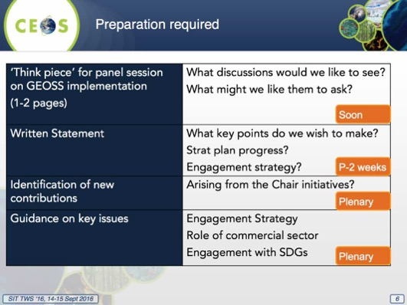
Three GEO engagement objectives are being discussed.
- One Establishing GEO as a unique international organization that ensures that Earth observation (EO) underpins global decision-making.
- Two Ensuring strong advocacy for broad, open data policies and practices.
- Three Establishing GEOSS as a global reference for Earth observation systems, data and information.
Jonathon reviewed the next steps towards GEO Plenary.
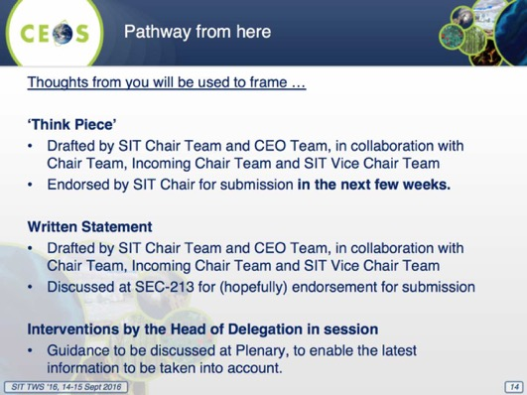
Stephen noted that there is an opportunity to feed into the CEOS interventions for GEO Plenary.

UN Sustainable Development Goals Approach and Process
Alex Held (CSIRO) reviewed the background of the UN Sustainable Development Goals (SDGs), and the current status of CEOS support.
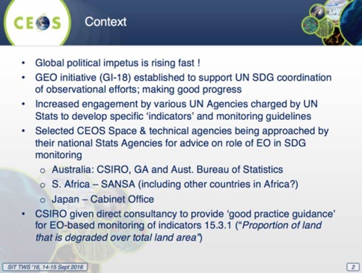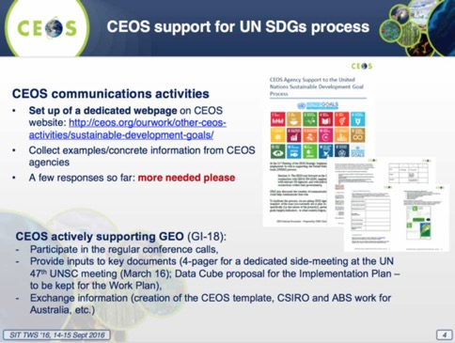
Alex reminded the group of the decision regarding CEOS support to the SDGs from SIT-31.
Decision 3: ‘The CEOS way forward on the UNSDGs will be undertaken in conjunction with GEO & UN-GGIM, supplemented by a top-down dialogue with relevant UN Agencies and with individual CEOS Agencies making connections within their governments.’
Alex noted there are a number of examples of broader EO support to the SDGs from CEOS and other space agencies, including via SDCG and GFOI, and support from CSIRO, ESA, AEM (Mexican Space Agency), and JAXA. Alex reviewed a proposal to Plenary on the way forward for CEOS on SDGs.
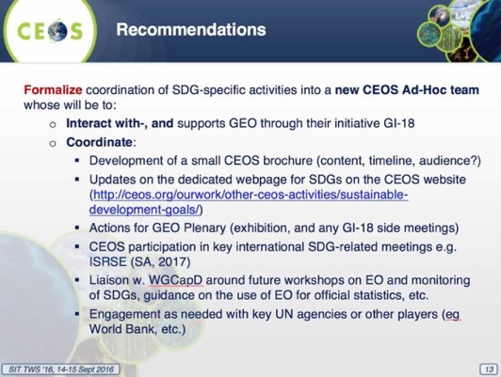
A brief discussion followed.
- Stephen Briggs (ESA) raised the question of whether CEOS should support this activity via a formal team, led by CSIRO, and this was agreed.
- Stephen noted that in the short term, between now and Plenary, a small group exercise was needed to review the GEO Work Programme to ensure space agency contributions are properly reflected, and to ensure that where the Programme references the SDGs, they are correctly reflected. He noted that this is not likely a big job as there are only 50 SDGs activities, and only half involve space data. He called for volunteers for the team (to be led by CSIRO), and Marc Paganini (ESA), Kerry Sawyer (NOAA), Jonathon Ross (GA), Erik Wood (USGS), Flora Kablat (CSIRO), Chu Ishida (JAXA), and Ivan Petiteville (ESA) were identified. This team is a short term measure to be concluded before Plenary.
SITTWS-2016-08 | CSIRO | CSIRO to coordinate a small team to review the GEO Work Programme contents in relation to the SDGs. The team should confirm that where the Programme references space agency contributions, they are properly reflected. The team should also look at the SDGs themselves, to ensure they are properly referenced. Volunteers for the team include Marc Paganini (ESA), Kerry Sawyer (NOAA), Jonathon Ross (GA), Eric Wood (USGS), Flora Kerblat (CSIRO), Chu Ishida (JAXA), and Ivan Petiteville (ESA). | 30th CEOS Plenary  On hold - action has not progressed as the GEO Programme Board (PB) are undertaking a similar task.
 | Rationale: It was agreed in discussion that CEOS should review the GEO Work Programme references to space agency contributions, and references to the SDGs between the SIT Technical Workshop and CEOS Plenary to ensure the contributions and references are correctly reflected. This review will be a part of the background for deciding at Plenary the way forward for CEOS support.

Synthesis Update from VC/WG Day
Jean-Louis Fellous (SIT Chair Team) presented a summary of the VC/WG day held on Tuesday, noting that this was the third such meeting. He reviewed the main topics covered on the day:
- Harmonizing Cal/Val activities;
- INSITU-OCR;
- Connected Data Assets and coordination of data exchange;
- WGISS Interoperability Standards Architecture; and,
- The VC-WG marketplace.
Paul DiGiacomo (NOAA) introduced the INSITU-OCR (International Network for Sensor Inter-comparison and Uncertainty assessment for Ocean Color Radiometry) initiative aimed at integrating and rationalizing inter-agency efforts on satellite sensor intercomparisons and uncertainty assessment. This is being done in support of remote sensing products with particular emphasis on requirements addressing the generation of ocean colour Essential Climate Variables as proposed by the Global Climate Observing System (GCOS).
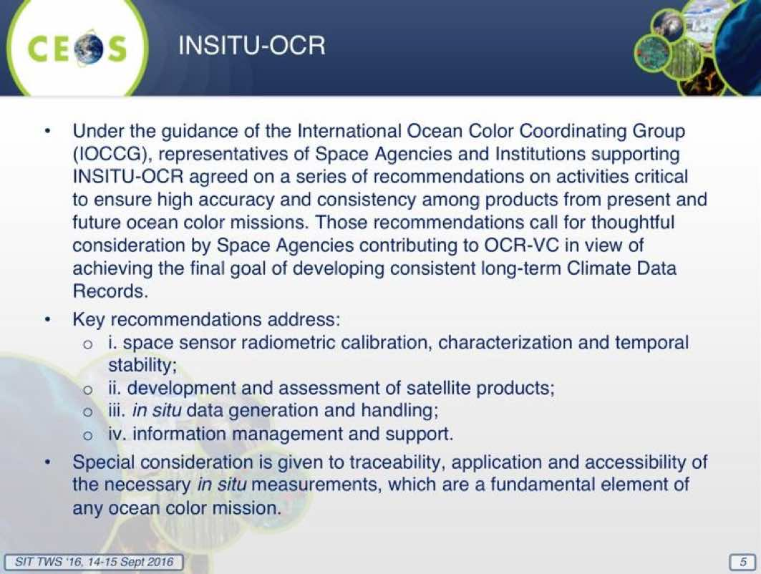
Jean-Louis summarised the discussion that took place on harmonizing Cal/Val activities.
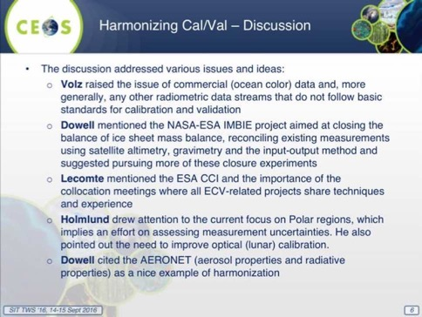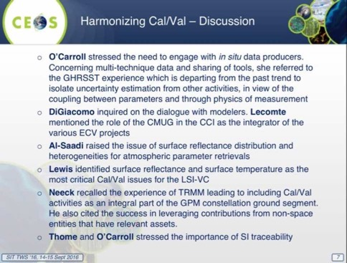
Andrew Mitchell (NASA) presented a summary of WGISS activities as reflected in the CEOS Work Plan 2016-2018 (DATA-2, VC-1, VC-25) and the GEO Work Program (GD-7/2 and GD-2).
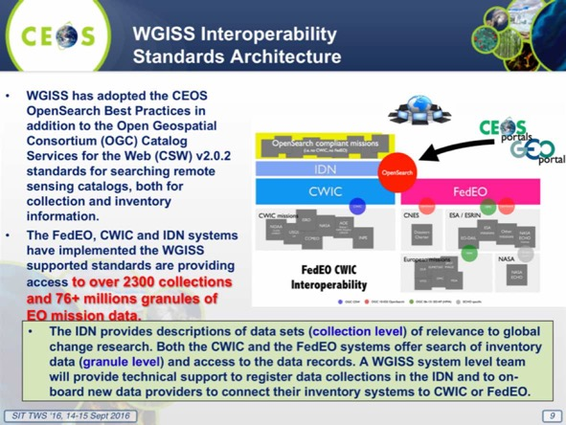
Andrew noted they asked a series of questions about the needs of other VCs and WGs, and in response to feedback, they are going to look at the creation of a carbon science focused data portal. He reviewed the status of several CEOS 2016-2018 Work Plan actions.
- DATA-2: Full representation of CEOS Agency datasets in the IDN and accessible via WGISS Interoperable Standards Status: WGISS began discussions with ISRO and the following Australian centres in order to get their data accessible via WGISS interoperable standards (i.e. IDN, CWIC). (Geosciences Australia / CSIRO / Bureau of Meteorology /Australian National University &National Computational Infrastructure). New entries were added to the IDN from ESA, EUMETSAT, and JAXA datasets.
- VC-1: List of Relevant Datasets from VCs Status: WGISS is requesting updated list from the VCs.
- VC-25 Increase the visibility of land surface imaging data holdings Status: WGISS will work in conjunction with the LSI-VC to ensure relevant datasets are visible through WGISS Interoperable Standards.
Jean-Louis reported that Albrecht von Bargen moderated a ‘marketplace’ session where VCs and WGs shared their ideas for various cross-cutting initiatives and projects.
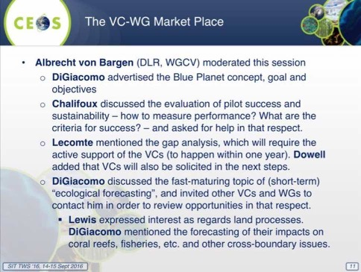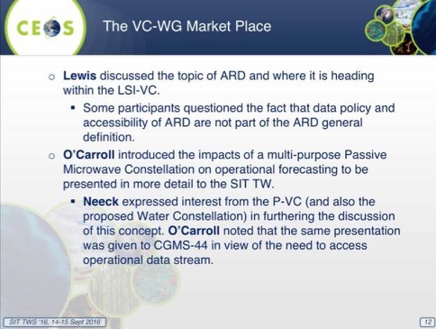
Jean-Louis reported that Albrecht von Bargen introduced two WGCV-related items for endorsement by Plenary:
- New WGCV Terms of Reference; and
- Nomination of a new WGCV Vice-Chair.
Anne O’Carroll (EUMETSAT) presented a summary of recent information compiled by the SST-VC and GHRSST on the impact of a Multipurpose Passive Microwave Constellation on operational analyses and forecasts. Anne reported a recent satellite oceanography user workshop, and noted the materials are available online: https://www.ghrsst.org/ghrsst/Meetings-and-workshops/satellite-oceanography-user-workshop/.
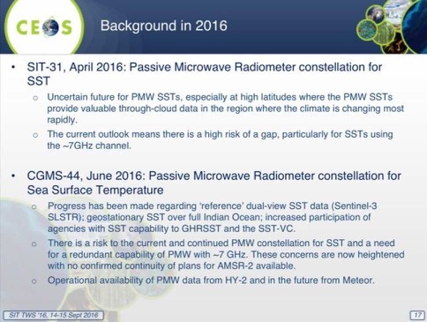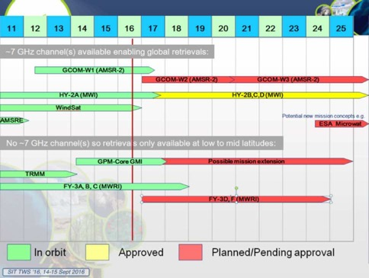
Anne reviewed the status of a number of the key missions (e.g. GCOM-W, GPM Core, Coriolis, HaiYang-2, FengYun-3). She reviewed several analyses looking at AMSR-2 data at very high latitudes, an important range for analysis as observations sparse here, and the analysis suggests microwave data is likely to improve SST feature resolution in regions of persistent cloud cover, though future work is required to verify.
Anne reviewed an analysis of the impact of Windsat SST on operational Mean Global Daily SST (MGDSST), noting that assimilating this data had significantly reduced error.
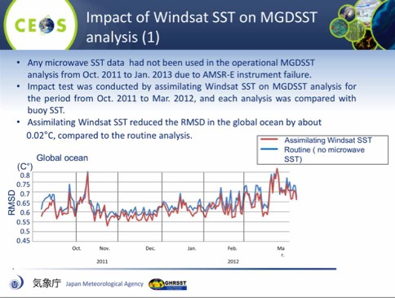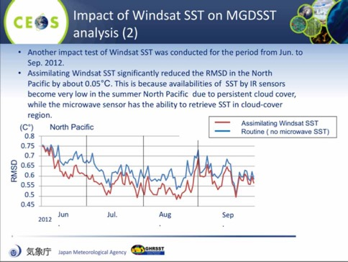
Ann summarised the results of global Forecast Ocean Assimilation Model (FOAM) trials, noting that:
- Modelling experiments were carried out to test AMSR2-JAXA SST data in FOAM system;
- The global average results show that differences between experiments were minimal;
- Error statistics show that all experiments performed well; and,
- Results at the end of the simulation period show that the largest SST differences between the experiments were found at high latitudes.
She reviewed the summary of main points for CEOS Plenary:
- Use of Passive Microwave Radiometers (PMW) for SST retrievals is an essential component of global constellation of SST sensors;
- Provides temperature of ocean under clouds, not possible from infrared sensors, albeit with poorer spatial resolution. Important in high-latitude regions and in areas of extensive and persistent cloud cover or in case of a large volcanic event;
- Impact studies of SST analyses / ocean forecasts show PMW needed for:
  - Verification of SST analyses (and inter-comparisons) at the poles;
  - Aerosol regions (robust to IR sensitivity displayed in these regions);
  - Improves feature definition (e.g. fronts) esp. where persistent cloud;
  - Impact studies show improvement in RMSD (e.g. 0.02K global to 0.05K regional). Particularly important at high latitudes; and,
  - Retrievals of Ocean Surface Salinity Measurements give better performance when using SST analyses including PMW data (e.g. Meissner et al, TGRS-2016-00278).
Anne noted that currently there are risks and gaps identified in constellation, therefore continuity and redundancy of PMW for SST continues to be sought. She reviewed text for a draft action:
- Given the current risk to the current and continued PMW constellation for SST and the need for a redundant capability of PMW with ~7 GHz (frequency needed for SST measurements at high latitudes), CEOS is requested to coordinate and encourage its agencies to ensure the continuation of the existing capability and to facilitate the coordination of agencies to ensure continuity and redundancy of PMW for SST; and,
- Impact studies have shown that these data are particularly important for SST analyses and ocean models at high latitudes, aerosol regions, persistent cloudy regions, feature definition and overall contribute to an improvement in ocean forecast skill.
Several discussion points were raised.
- Steve Neeck (NASA) asked if the group had done any prioritisation of the anticipated gaps in observations, and Anne noted that the priority is on high latitude observations (e.g. AMSR-2), though all are a priority. Steve noted that NASA expects that based on fuel, GMI will operate well into the future (i.e. 15 years), but this doesn’t take any instrument anomalies into account, and is also latitude limited. Steve noted that the P-VC has also noted the gap introduced by the end of AMSR-2, and added P-VC support to the SST-VC analysis.
- Stephen Briggs (ESA) welcomed this analysis, and noted that this is exactly the kind of analysis that CEOS should be doing, and the issue should be raised at CEOS Plenary. He also recommended that the outcome of this study should be presented at CGMS Plenary in 2017.
Stephen welcomed the benefit of the dedicated VC/WG day, which helped to focus and clarify the working level discussion.
SITTWS-2016-09 | SIT Chair | SIT Chair to communicate the recommendations from the SST-VC gap analysis on Passive Microwave Radiometers (PMW) to CEOS Plenary | 30th CEOS Plenary  Included under item 7.6 on the Plenary agenda.
 | Rationale: It was agreed that SIT Chair should communicate the recommendations of the SST gap analysis study during the SIT Chair report to CEOS Plenary.

Polar Sea-Ice Virtual Constellation
Stephen Briggs (ESA) reported on the discussion held at CGMS in June around the need for better coordination of polar sea ice and ocean observations, and polar observations in general. Stephen noted that this issue was raised during the International Polar Year (IPY), and this led to the formation of the Polar Space Task Group (PSTG, which met this week at ESA/ESTEC and is co-led by ESA and WMO). Previously, it was felt that the need for coordination of polar activities was met by the PSTG, but the question was raised again this past June.
Stephen noted that if it is felt that a CEOS Virtual Constellation is part of the solution, then the CEOS Virtual Constellation Process should be followed. He noted this is a bottom-up process where the community makes a proposal around a particular area of interest. The process considers proposals on a case-by-case basis, where a new Constellation may be proposed by two or more CEOS Agencies. The process has two phases: Phase I an Initial Proposal to the SIT with a request to determine CEOS Agency interest in a possible Constellation; and, Phase II a Full Proposal for SIT approval, including an Implementation Plan.
Stephen noted that the initial proposal was to create a polar sea ice Constellation, and that his views are that the PSTG is currently serving the coordination function, and if an additional group is required (e.g. VC), then the proposal would need to come from the community.
Several discussion points were raised.
- Paul DiGiacomo (NOAA) agreed that the existing PSTG efforts are adequate for coordination, though he did stress that coordination amongst the existing oceans VCs could be improved, and this cross-coordination could help to address some of the polar observations issues.
- Paul noted that he sees the oceans VC gap as being the sea surface roughness SAR group (e.g including Europe, Canada, Japan, India), and this group could also address some of the polar observations issues in concert with the other oceans VCs. Ken Holmlund (EUMETSAT) noted that there is a scatterometry group which may be able to address some of these needs.
- Paul noted that the polar activities are also in scope of the Blue Planet.
- Ken noted that this request stems from the lack of consistent products around sea ice. He suggested this should be brought back to the community, and if there is a specific need then a VC could be established.
- Jean-Louis Fellous (SIT Chair Team) noted that this is a topic that is currently high profile, and is one of the key indicators of climate change, which makes this a very important issue.
- Kerry Sawyer (NOAA) noted that one of the PSTG priorities is to look at floating ice, and to propose improved agency collaboration on the topic.
- Mark Dowell (EC/JRC) noted that there is some value in the coupling between the science and operational communities.
- Steven Hosford (CNES) noted that the PSTG is principally agencies (not necessarily space agencies), and whether the VC structure would be helpful in organising that group, where the PSTG group has a much larger scope. Stephen noted that if that community comes back saying there is a specific need for a polar sea ice constellation, then they can come back with a proposal.
Stephen concluded by noting that CEOS would be willing to entertain a community-led proposal for a new VC, but given the existence of the PSTG, does not appear to be the highest priority at present. He suggested that the PSTG could be asked to focus on passive microwave observations of polar ice.
SITTWS-2016-10 | Stephen Briggs | Stephen Briggs to communicate the discussion on polar sea ice observations to PSTG, noting that the SIT TWS considered the question and if the PSTG considers it to be of value, they should prepare a proposal for CEOS consideration following the VC process | September 2016  Communications haven’t yet been sent (as of Plenary).
 | Rationale: CEOS would be willing to entertain a community-led proposal for a new VC, but given the existence of the PSTG, this does not appear to be the highest priority at present. It was suggested that the PSTG could be asked to increase emphasis on passive microwave observations of polar sea ice in order to address that coordination gap.

Carbon Meeting Outcomes and Next Steps
Mark Dowell (EC/JRC) reviewed the history and background of the CEOS Carbon activity, noting that this activity is truly cross-cutting within CEOS, impacting most VCs and WGs.
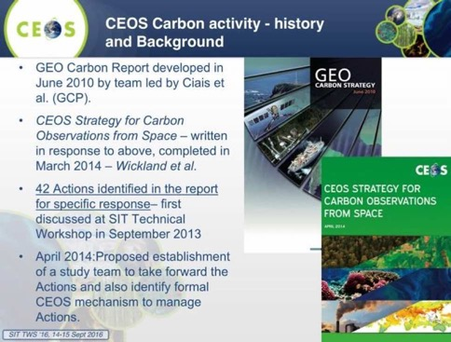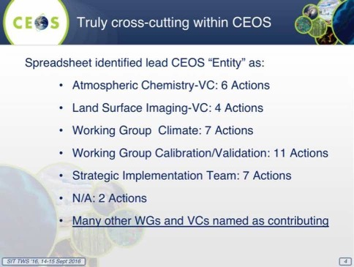
Mark noted that this is effort is relevant to the outcomes of COP21 (Paris Agreement Article 7 (7c)), as well as the conclusions of SBSTA, and there is an expectation that space and observing communities will respond to these outcomes at some level. It is addressed by an action in the CEOS Work Plan by CARB-8 and CARB-12 (support for definition of a potential GEO Carbon Flagship).
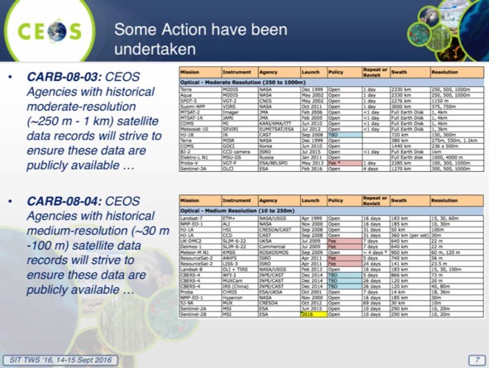
Mark reported that the third Carbon from Space Workshop was held in January 2016 (Exeter), with more than 80 experts present to review and discuss the existing scientific knowledge gaps and research priorities areas for the carbon cycle. The objectives of the workshop were:
- Implementation of recommendations of the CEOS Strategy for Carbon Observations from Space;
- The development of the GEO Flagship on Carbon and Greenhouse Gas and the other coordination projects related to carbon cycle (e.g., IG3IS, the North American Carbon Programme); and,
- The review and refocusing of the Global Carbon Project on its move from ESSP and IGBP to Future Earth.
Mark reviewed the proposed way forward discussed during the three-hour carbon session held in conjunction with the VC-WG day:
- Forego the “traffic light” approach to monitoring and review Carbon Action for some time [Although we will internally keep an overview of overall progress];
- Focus on a number (5-7) of WG and VC proposed initiatives;
- These will also act as “prototypes” for number of crosscutting aspects related to the Carbon Action implementation i.e.:
  - Initiatives addressing multiple Actions;
  - Initiatives across multiple CEOS entities VCs & WGs;
  - Initiatives addressing multiple thematic examples from the same Carbon Action;
  - Initiatives which “CEOSize” efforts previously undertaken within a specific CEOS Agency or through bilateral efforts; and,
- In parallel we would continue several supporting activities: GEO Carbon Flagship engagement, mapping Agency level projects onto Carbon Actions, 2 yr CEOS Carbon Workshop.
He reviewed an initial list of initiatives to be focused on, noting that there may be others that arise or are proposed.
- ACC: aiming for a white paper on a GHG constellation;
- WGClimate: focusing their gap analysis work on carbon-specific ECVs;
- WGISS: on a carbon data portal to facilitate the discoverability and accessibility of ECV products and space-borne CDRs relevant for the carbon actions;
- WGCV: reported on their internal management and reporting on relevant actions;
- NASA: on cal/val and production of biomass products from CEOS missions – based on previous bilateral initiative; and,
- JAXA: on the opportunity to engage with IPCC Inventories and promote satellite EO.
Each of these initiatives was reviewed.
1: ACC
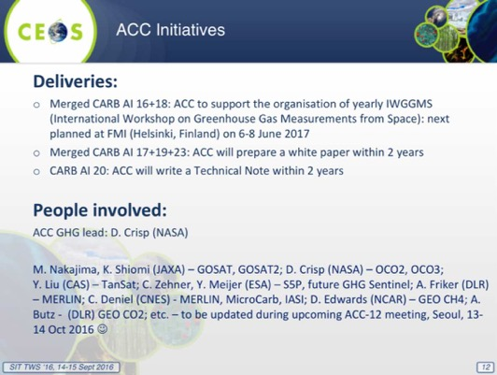
Stephen Briggs (ESA) noted that this was discussed at some length during the VC/WG day, and it appears as though AC-VC have made a good start. He asked if there’s a chance we could have something (e.g. a draft progress report) in the next two years, and Claus Zehner (ESA) agreed that a draft would be possible, adding that CO₂ and CH₄ should be addressed together. It was agreed that an interim report on this activity is requested within the next two years.
2: WGClimate
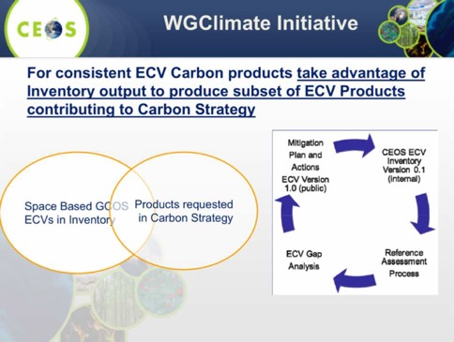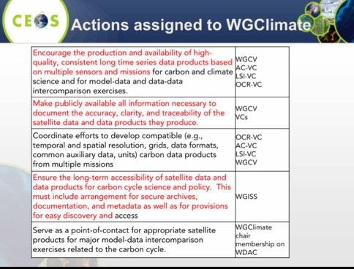
Mark noted the overlap between the gap analysis being done within WGClimate with the on-going work on the ECV Inventory, and then carbon portal within WGISS looking at dataset access. Ken Holmlund (EUMETSAT) noted that this effort will probably need to go beyond the mapping of the ECVs
3: WGISS
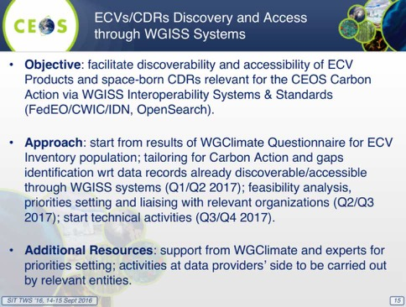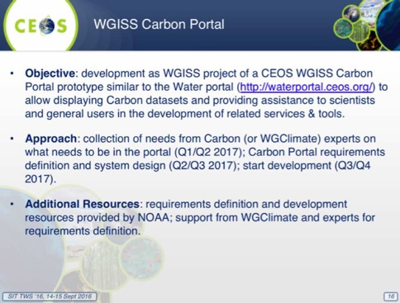
4: NASA
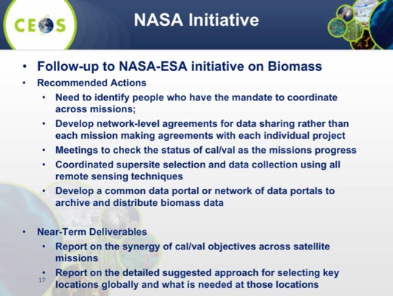
It was noted that the NASA initiative is a follow-up to the NASA-ESA initiative on biomass. A brief discussion followed.
- Beth Greenaway (UKSA) asked if Shaun Quegan has been involved, and Mark noted he has been involved. Stephen noted that the R&D component of GFOI may be making a related Horizon 2020 proposal and Shaun is involved in that.
- Alex Held (CSIRO) noted that ESA is also funding a GEO Wiki and this could be a place to store the calibration and validation data.
- Stephen noted that biomass is one of the key terrestrial ECVs in the updated GCOS IP.
- Stephen Plummer (ESA) noted that WGCV includes a focus area on biomass.
- Albrecht confirmed that WGCV have gone through a detailed analysis of how the Carbon Strategy relates to the WGCV subgroups, and have agreed to come back with a short term plan on how to deal with these actions. Mark will discuss with Kurt Thume and Albrecht to have something concrete to bring back to Plenary.
6: JAXA
Masatoshi Kamei (JAXA/RESTEC) reviewed the UNFCCC & IPCC Inventory Task Force (TFI) activity, noting there the proposal is to engage the TFI on how satellite data can support their activities. He noted that the TFI process of updating their guidelines is underway and will complete in 2019, and this may represent an opportunity to ensure satellite data is reflected in the verification guidelines. Representing satellite capabilities in these guidelines is important to ensure the role of satellite data is well understood, and facilitate the uptake of the data by the user community.
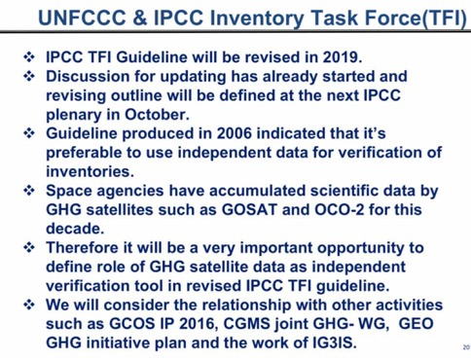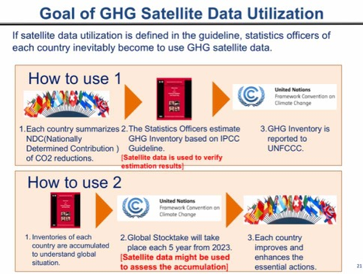
Stephen Briggs noted that this initiative is quite helpful, though it is not clear there is an immediate action. However it underscores the importance of ensuring that the way observations are made available is consistent with IPCC. Several discussion points were raised.
- Simon Eggleston (GCOS) noted that at present the TFI guidelines indicate that only ground based observations can be used, and confirmed that unless something on satellites is added to the guidelines, then only these ground measurements will be used. He noted that the IPCC tends to look only at what has been published and is available. Stephen Briggs stressed the importance of ensuring that what space community is doing is consistent with IPCC, and noted that the land use/forestry analogue is important.
- Claus Zehner (ESA) noted that we have to be very careful about how we communicate satellite capabilities to verify GHG measurements. He cautioned against overselling, and noted that at present the contribution is very limited.
- Mark agreed, noting we need to be careful to stress that there is a broad observing system, of which satellites provide one contribution, but major contributions come from in situ measurements.
- Stephen Briggs noted there may be a feedback look to the countries to help improve their NDCs based on additional satellite data, and Stephen Plummer confirmed this is part of the approach to be explored in the GEO initiative.
- John Remedios (UKSA) noted that there is a lack of clarity within the community around how these guidelines work, and there would be some benefit to developing a common CEOS understanding, rather than starting with each space agency individually making their own assessment. He suggested this could be something that the AC-VC group helps with.
- Stephen Briggs suggested that we need to ensure policy anchors for these kinds of activities. He noted that the GEO Carbon activity review decided to implement as an initiative rather than a GEO Flagship, and that given the complex policy environment, this is likely a good decision until the activity matures. Stephen Plummer agreed, noting that the scope is very broad, and that GFOI has taken eight years to develop – and it is not nearly as challenging as global carbon.
- Mark noted that CEOS should be able to make a positive contribution to the GEO Carbon activity, but that CEOS also has other motivating factors that are pushing us to coordinate better. He doesn’t expect GEO to be the place where satellite EO pushes forward into carbon. Stephen Briggs suggested that GEO will be on the of the places, but that GCOS and other science projects will also make a contribution, and that this approach is consistent with the leads of the GEO Carbon initiative.
Mark reviewed the proposed points to raise with CEOS Plenary on the CEOS Carbon strategy implementation.
- Plenary to agree on overall approach i.e. a smaller number of dedicated activity addressing multiple Actions
- Update would be provided at Plenary added at Plenary 2017, process to be review at Plenary 2018
- Additional initiatives could be added at any point if critical mass and resources available
- Plenary to comment on initial Initiatives proposed
- Big omissions we should follow-up on
- Generous offers of dedicated resources welcome
- Additional comments welcome on:
- Organisation of dedicated CEOS Carbon Workshop (across WGs and VCs) first one Q3 2017 – then every 2 yrs
- GEOCarbon Flagship engagement and involvement with other external stakeholders
Stephen Briggs noted that it is difficult to put together the timelines on how things will play out, and that it might be useful to have a one slide summary of how these activities fit together. Mark agreed to include this in the package for Plenary.
SITTWS-2016-11 | Mark Dowell | Mark Dowell to present the way forward for CEOS on the coordination of Carbon observations, indicating a focus for the short-term on the 5-7 VC/WG initiatives presented at the SIT Technical Workshop | 30th CEOS Plenary  Included under item 4.2 on the Plenary agenda. (GEO Carbon initiative is item 4.6.)
 | Rationale: The workshop reviewed the various VC/WG initiatives underway in support of the coordination of carbon observations, and it was agreed that these should be presented to CEOS Plenary as the way forward.

CEOS-CGMS Coordination on Atmospheric CO₂ Observations from Space
Stephen Briggs (ESA) reported that the request for CEOS to discuss CEOS-CGMS coordination on atmospheric CO₂ observations comes from the last CGMS Plenary in June. Stephen agreed to raise the issue at this Workshop to consider where joint action might be appropriate. He noted that there are three options CEOS could consider: establishing a dedicated Virtual Constellation; asking the existing AC-VC to provide the coordination function; or, setup a joint group between CGMS and CEOS (e.g. like WGClimate).
Stephen noted that he wasn’t aware until recently that AC-VC was addressing this topic in a coherent way, and proposed that this be carried forward through the VC. He suggested that CEOS write to CGMS noting that the AC-VC activity, and invite and encourage other CGMS agencies and members who are not already involved to join. He noted that many of the likely interested CGMS parties are already represented in the AC-VC.
A brief discussion followed.
- Ken Holmlund (EUMETSAT) agreed with Stephen’s suggestion, noting that we need to avoid creating too many new activities, and suggested that AC-VC is a good foundation to build upon. He suggested we should also look at how to strengthen data access between CGMS and CEOS, perhaps via collaboration on a pathfinder or prototype.
- Ken suggested that an open invitation to CGMS members to participate be extended, and also noted there’s a risk that the group is or becomes too satellite mission oriented. He noted that this activity could also grow to address some of the issues raised by Mark during the CEOS Carbon Strategy and Carbon from Space Workshop discussions.
- Ken suggested sharing this discussion with CGMS, and considering how and when to hold a meeting to initiate the activity.
- Claus Zehner (ESA) suggested that the activity will likely start with the satellites, but the vision is to include the ground based and modelling communities. He noted that we need to differentiate the anthropogenic from the natural emissions.
- Steve Volz (NOAA) agreed that including the modelling community is key. He agreed that the approach via AC-VC is reasonable, and that this activity is more research then operational at the moment. He underscored the importance of ensuring the operational agency perspective is reflected, and that representatives from these agencies are involved and included.
- Stephen noted that this is more research focused at present because the current relevant missions are research missions.
Stephen suggested that this discussion be formally reported to CEOS Plenary, noting the Workshop agreement that the coordination of Atmospheric CO₂ observations take place within the existing AC-VC, and that a request be transmitted by Plenary and via CGMS for additional membership AC-VC to reflect these additional activities. He also asked that Mark include this in his Carbon Strategy timeline.
SITTWS-2016-12 | Stephen Briggs and Ken Holmlund | Stephen Briggs and Ken Holmlund to communicate the outcomes of the discussion on CEOS-CGMS coordination on Atmospheric CO₂ Observations from Space. | September 2016
 | Rationale: It was agreed that the AC-VC should be the basis for the CEOS response, with a formal and open invitation for participation extended to interested additional CGMS participants, and it should be pursued in conjunction with the climate workshop 2017.

GCOS IP and Update on CEOS Response
GCOS Status
Simon Eggleston (GCOS) provided an update on GCOS activities, noting an open review of the GCOS IP received over 1300 comments which are currently being reviewed and addressed. The final version of the report will go to the GCOS Steering Committee in early October, and then if accepted will be forwarded almost immediately for COP22 (Marrakesh) in November.
Simon noted the Plan itself is presented in two parts: a background; and, more detailed actions on domains and ECVs. The detail on requirements provided by the Satellite Supplement was extended to the in situ measurements in an effort to provide formal requirements for all ECVs. The Plan is also broader, looking at the needs of adaptation (e.g. high resolution products from modelling/re-analysis), and also providing some guidance to countries on local monitoring in support of downscaling models and other applications.
Stephen Briggs (ESA) added that this process has been accelerated following the status report to COP21, with the Implementation Plan and Satellite Supplement updates delivered in the same year.
CEOS-CGMS Response to the Updated GCOS IP
Pascal Lecomte (ESA) reviewed the overall schedule for the CEOS-CGMS response.
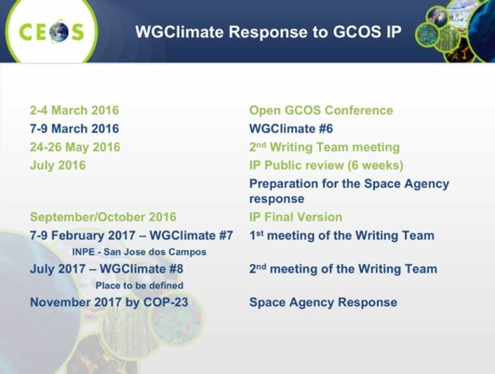
Pascal noted that as soon as the final version is submitted to the GCOS Steering Committee the reference version for the response will be available. There will be a first meeting of the writing team in February 2017 at WGClimate #7, and a second meeting at WCGlimate #8 in July 2017. The space agency response is expected to be delivered by COP23 (November 2017). He noted that this will be a space agency response, rather than a CEOS-CGMS response specifically.

COP22 Related Issues
Pascal Lecomte (ESA) noted that space agency reporting to COP21 SBSTA consisted of a statement supported by a 10-page report. For COP22 the proposal is to have only a SBSTA statement because there are many activities in progress following COP21 and the group is not in a position to prepare another 10-page report for COP22. An updated report is planned for COP23, along with the updated space agency response to the GCOS IP.
Mark Dowell (EC/JRC) agreed with this approach, noting that the GCOS relationship is symbiotic and that this year the focus with SBSTA should be on GCOS’s updated IP, and then next year the focus can be on the space agency response in support of GCOS. He noted that GCOS is a SBSTA observer, but that CEOS is always represented by one of the parties (e.g. a country), and this provides a different emphasis and impact. He also stressed the importance of briefing national delegations, including the importance of GCOS this year.
Pascal noted that the draft of the SBSTA statement has been prepared by the WGClimate core team, and review by the CEO and CEOS SEC is being undertaken. This will be followed by a final review by CEOS Principals, and the final statement has to be sent to SBSTA by 2nd November. The statement will be delivered by the US delegation as the CEOS Chair country.
Pascal noted that COP22 is taking place in parallel with GEO-XIII Plenary. He noted that he (ESA) and NASA will be present. He noted an ESA side event on REDD+ will be held there. There will likely be a Marrakesh (COP22) statement by heads of agencies being organised by CNES.
Pascal reviewed EarthInfo Day, noting:
- an opportunity to provide at COP22, and every subsequent year, an up-to-date picture of the status of the climate and current future outlook;
- an opportunity to optimise engagement and connect information and requirements between the science community, Parties and all stakeholders at the COP to benefit the negotiation process and the implementation of the Paris Agreement and its goals;
- It could be a central underpinning for the global stocktake (Article 14) and support it to become a process of dynamic and continuous learning that informs and motivates acceleration of progress based on the best available science; and,
- Furthermore, information relating to climate prediction would be useful for risk assessment and management operations at regional level and of non-Party stakeholders such as business and cities.
The Day will include interactive presentations and poster sessions on:
- Status of the climate - current observations of climate variables and indicators;
- The global carbon budget;
- Regional information, particularly in regards to Africa (for COP 22);
- Sectoral information to support adaptation; and,
- New developments and opportunities including (for COP 22):
A brief discussion followed.
- Mark raised the issue of timing of the development of the statement, noting the text will have to be approved before CEOS Plenary.
- Stephen Briggs (ESA) added concern about the poster timing, and Pascal noted this can be printed at the last minute before COP22.
- Kerry Sawyer (NOAA) noted that in the past CEOS has prepared some talking points to be included in the national delegations support of CEOS, and she agreed to work with Pascal on developing these.
- Mark suggested that it may be good to focus the poster on what is new in the GCOS IP, orienting to the direction that GCOS going, including new ECVs. Stephen Ward noted the spreads at the back of the EO Handbook prepared for COP21 (Paris) could be used.
Stephen Briggs noted the progress in space agency engagement with the COP process over the past 10 years.
SITTWS-2016-13 | WGClimate | WGClimate to coordinate the preparation and review of a SBSTA-45 statement for COP22 | 30th CEOS Plenary  Draft statement has been prepared and circulated, and coordination with US delegation for presentation is on going.
 | Rationale: It was agreed that while a full report to SBSTA would only be made every other year, as invited by SBSTA, the CEOS-CGMS WGClimate would prepare a statement to be made to SBSTA-45 in conjunction with COP22.

2016 Plenary Preparations
Caroline Bruce (CSIRO) presented a summary of plans for the 30th CEOS Plenary, to take place 1st – 2nd November at the Brisbane Convention and Exhibition Centre, Brisbane, Australia. Side meetings will take place on Monday 31st October, and a STEMx Town Hall Event will take place Thursday 3rd November. The Thursday event is aimed at promoting collaboration, innovation, STEM (Science, Technology, Engineering and Mathematics) and the geospatial industry, and CEOS will have a booth at the event. She asked that CEOS agencies consider nominating staff and/or materials to be included as part of the booth.
Caroline reviewed the key dates in preparation for Plenary:
- 17th October: endorsement documents due; and,
- 24th October: presentations due.
She stressed that in order to achieve good discussion, it is important that materials are made available well in advance.
SITTWS-2016-14 | CEOS Agencies | CEOS Agencies to consider nominating representatives to staff the CEOS booth at the STEMx event, which will be held the day after the CEOS Plenary and/or provide high-level CEOS-related materials for the booth (slides, videos, etc.). | 30th CEOS Plenary
 | Rationale: CEOS Chair has organised an outreach event for the Thursday following CEOS Plenary (3rd November), and agency contributions are welcome.

Future CEOS Chairs
Alex Held (CSIRO) noted that coordination of future CEOS Chairs is ongoing, and that the 2018 CEOS Chair will be announced at CEOS Plenary. The 2018 cycle is expected to be a European or African agency, and will be confirmed by ESA and EUMETSAT as the regional CEOS SEC agencies.
Astrid Koch (EC) noted that the EC appreciates the offer to be CEOS Chair for 2018, but has to do some internal paperwork before it can confirm. This is currently with the highest level of management within the EC, looking at staffing, resources and budget, and she will share definite answer as soon as it is known. Astrid confirmed that Philippe Brunet is expected to attend Plenary.
Alex noted that for 2019 CEOS Chair, an agency from the Asian region will be confirmed by CSIRO (as CEOS Chair) and JAXA (as regional SEC agency). They are still looking for candidate agencies, with Korea, China, and Vietnam being considered.
A brief discussion followed.
- Stephen Briggs (ESA) noted he was personally very pleased to see the EC considering taking a stronger role in CEOS.
- Adam Lewis (GA) asked about future planning on for the CEO/DCEO role. Alex indicated that there has been no response to calls for nominations. The current CEO and DCEO terms end at Plenary 2017, and it would be desirable to have an overlap with any incoming nominee. It was agreed these roles are quite important in providing a resource and continuity for CEOS as it pursues its broadened agenda.
SITTWS-2016-15 | CEOS Agencies | CEOS Agencies to consider nominating staff for the CEO and/or DCEO role in future | 30th CEOS Plenary
 | Rationale: The terms of the current CEO and DCEO are ending at the 31st CEOS Plenary (2017).

COVERAGE
Vardis Tsontos (NASA/JPL) reviewed the CEOS Ocean Variables Enabling Research and Applications for GEO (COVERAGE) proposal, providing a brief overview of the initiative, and following the CEOS new initiative process paper. In support of this proposal, a separate paper has been provided on the CEOS website.
Vardis noted that COVERAGE is a response to the need for improved, unified access to data from the 4 CEOS ocean Virtual Constellations, and to improve access/integration of multivariate, multi-platform ocean observations. It aims to provide thematically organized observations in a common frame, available in near real-time where possible in support of GEO Blue Planet initiative in particular. It was conceived at a CEOS Strategic Implementation Team meeting in Pasadena in 2013.
He stressed that the COVERAGE proposal is a low footprint R&D, and that no new VC or WG will be required. It is intended to provide a coherent focal point for promoting the advancement of data coordination needs consistent with CEOS programmatic objectives. They invite the interest and participation from other CEOS agencies in this effort. He suggested that internal stakeholders include Ocean VCs, WGISS, and externally GEO-Blue Planet, UN/IOC GOOS.
Vardis stressed that COVERAGE aligns with the CEOS objective of achieving better integration across the full range of Earth observations from space-based to in situ. He also noted alignment with 2016-2018 CEOS Work Plan elements 3.6. (Capacity Building, Data Access, Availability and Quality) and 3.8 (Support to Other Key Stakeholder Initiatives), as well as two of the GEO Blue Planet objectives. The initiative seeks to enable wider use of ocean satellite data, and utilize emerging data management and cloud capabilities.
The vision is to promote international collaboration via CEOS and GEO-Blue Planet engagement for a global COVERAGE “portal product” developed around a priority set of community driven use cases. In particular, COVERAGE aims to assemble and present satellite and in situ ocean data in a compelling web-based format to demonstrate the value added of multivariate ocean data integration is support of science, applications, and public engagement. The end goal is to develop a data rich platform for delivery and access to integrated, analysis ready ocean data. In addition they would like to include some value added data services and capabilities (e.g. web visualisation, rapid sub-setting, data colocation and matchup, dynamic re-gridding). He cited the NASA Sea Level Change portal as an example of the final product.
Vardis stressed that this effort is not starting from scratch, and that a number of tools are already being developed internally at NASA on an open source basis. Over the past 18 months, they have implemented a pilot application for Sargasso Sea Commission to ensure that the development is user-driven and effective.
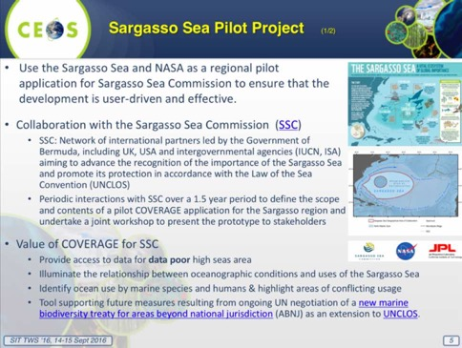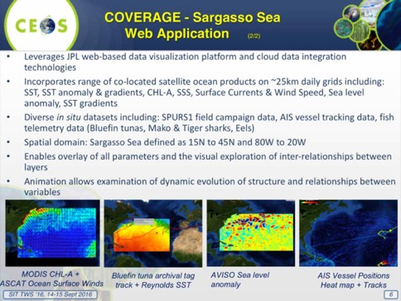
Vardis noted that the overwhelming consensus from a recent COVERAGE-Sargasso workshop and UN presentation was that COVERGE was a useful and accessible data integration platform. He reviewed the future steps for COVERAGE:
- Circulation of paper within CEOS Ocean VCs and WGs for comment;
- Confirm interest and in-principle agency support for and contributions to the proposed activity;
- Possible updated proposal paper incorporating broader CEOS agency feedback and contributions circulated to Principals at least 2 weeks prior to Plenary (mid-Oct. 2016);
- Presentation and discussion at 30th CEOS Plenary, Brisbane, Oct-Nov, 2016; and,
- COVERAGE envisaged as a 3-year R&D commitment within CEOS towards an “operational” capability by the end of 2020.
Several discussion points were raised.
- Phillipe Escudier (CNES) noted that the proposal was very interesting, and they have a similar proposal in France and would be happy to exchange experience and he will pass this information along to his colleagues. Vardis noted they are also interested in activities like Ocean Data Lab.
- Adam Lewis (GA) noted that Australia would be very interested, and are currently planning the next five years of investment in this area and would like to boost use of remote sensing as a whole.
- Mark Dowell (EC/JRC) noted that a second generation of the World Ocean Assessment (WOA) is under consideration, and a long term target could be to maxamise the benefit of COVERAGE as a key contribution. Vardis noted he wasn’t aware of the second WOA, but would welcome these kinds of linkages.
- Jorge Vazquez (NASA/JPL) noted that one of the goals is to ensure that the datasets are easy to use, similar to ARD.
- Paul DiGiacomo (NOAA) noted this proposal is an opportunity to bridge and converge the four ocean VCs. He noted that from the Blue Planet perspective integration is the first objective, and there is a clear need for this integration. He noted that within Blue Planet, CEOS and GOOS are working together on achieving this convergence. The challenge is how to put the activity in the broader CEOS context, and suggested that over the next six months in preparations for SIT-32 the ocean VCs schedule a series of telecons to establish mutual priorities for this collaboration. He suggested that OCR-VC would be very supportive of this proposal, but that further details remain to be worked out and his preference would be to bring it back to SIT-32.
- Vardis suggested that we need to separate implementation details from overarching proposal, and that they are seeking to use the current momentum to try and get it off the mark. He noted they are happy to work on specifics to make group comfortable the proposal is meeting its needs.
- Astrid Koch (EC) agreed that the proposal should be reviewed and considered by the oceans VCs.
- Anne O'Carroll (EUMETSAT) noted that it’s a very interesting proposal, but agreed that it should be discussed amongst the other oceans VCs.
- Ivan Petiteville (ESA) noted that CEOS Plenary would likely be too soon to see endorsement, but that there could be a special Plenary session during the SIT-32 meeting in April 2017 to consider endorsement.
Stephen Briggs (ESA) noted that it seems the oceans VCs are prepared to work together to move this effort forward, recognising that the proposal is still formative. He expressed appreciation for the group in following the process outlined in the new initiatives paper. He suggested working towards a decision during a mini-Plenary session at SIT-32, and this was agreed.
SITTWS-2016-16 | Ocean VCs and interested WGs | Ocean VCs, and interested Working Groups, to formally review the COVERAGE initiative proposal paper and work with the proponents to identify a consensus way forward for any future CEOS initiative that may be considered in this area | SIT-32
 | Rationale: Given the proposed scope of COVERAGE activity, buy-in from the relevant CEOS Entities will be required.
SITTWS-2016-17 | Vardis Tsontos, Jorge Vazquez, and Paul DiGiacomo | Vardis Tsontos, Jorge Vazquez, and Paul DiGiacomo to organise telecon(s) with the Oceans VCs in preparation for SIT-32 to discuss and coordinate the way forward on the COVERAGE proposal relative to the GEO Blue Planet Initiative, presenting an updated version of COVERAGE for consideration as a formal CEOS initiative and contribution to GEO/Blue Planet at the SIT-32 meeting | SIT-32
 | Rationale: It was agreed that if the COVERAGE proposal is to move forward, it will need to be coordinated with both the existing Oceans VCs as well as with CEOS support to Blue Planet.

Closing Session
Stephen Briggs (ESA) reviewed the discussion, outcomes, actions, and conclusions of the Workshop. He noted that it had been a very good forum which allowed for detailed discussion of a number of technical issues which helped to inform the way forward. He thanked Jean-Louis Fellous and Mark Dowell for their organisation of the VC/WG day, and the carbon day.
Alex Held (CSIRO) thanked the SIT Chair Team for their hard work, coordination, and leadership.

2016 SIT Technical Workshop Participants
Organisation | Participant | Organisation | Participant
CSA | Stéphane Chalifoux | NASA/SEO | Brian Killough
CNES | Steven Hosford | NASA | Christine Bognar
CNES | Phillipe Escudier | NASA | Steven Neeck
CSIRO | Alex Held | NASA | Brad Doorn
CSIRO | Caroline Bruce | NASA | Hank Margolis
CSIRO | Rob Woodcock (GTM) | NASA | Andrew Mitchell
CSIRO | Alex Held | NASA | Kurtis Thome
CSIRO | Flora Kerblat | NASA | David Green
DLR | Albrecht von Bargen | NASA | David Jarrett
EC | Astrid-Christina Koch | NASA | Vardis Tsontos
EC | Mark Dowell | NASA | Jorge Vazquez
EC | Zoltan Szantoi | NASA | Jeffery Masek
ESA | Stephen Briggs | NASA | Wenying Su
ESA | Pascal Lecomte | NASA/SEO | Kim Holloway
ESA | Ivan Petiteville | NOAA | Steve Volz
ESA | Stephen Plummer | NOAA | Kerry Sawyer
ESA | Claus Zehner | NOAA | Paul DiGiacomo
ESA | Bianca Hoersch | NSMC-CMA | Xiang Fang
ESA | Jean-Louis Fellous | NSMC-CMA | Qiang Guo
ESA | Stephen Ward | NSMC-CMA | Zhe Zu
ESA | George Dyke | SANSA | Jane Olwoch
ESA | Mirko Albani | UKSA | Beth Greenaway
ESA | Carmen Comparetto | UKSA/NCEO | John Remedios
EUMETSAT | Ken Holmlund | UKSA | Nigel Fox
EUMETSAT | Robert Husband | UKSA | Emily Gravestock
EUMESAT | Anne O'Carroll | USGS | Frank Kelly
GCOS | Simon Eggleston | USGS | Steven Labahn
GEO Secretariat | Osamu Ochiai | USGS | Tom Cecere
GEO Secretariat | Gary Geller (WebEx) | USGS | Jenn Lacey
GEO Secretariat | Vanessa Allen (WebEx) | USGS | Eric Wood
GA | Adam Lewis
GA/CEO | Jonathon Ross
JAXA | Shizu Ogawa
JAXA | Chu Ishida (GTM)
JAXA | Yoshinori Yoshimura
JAXA/RESTEC | Masatoshi Kamei
(WebEx) indicates remote participation via WebEx.

2016 SIT Workshop Actions
V0.0
No. | Actionee | Action | Due date
SITTWS-2016-01 | CEOS Agencies | CEOS Agencies to provide the USGS CEOS Chair Team with comments on the Proposed 2017 CEOS Chair Initiatives paper | COMPLETE  Final paper submitted by USGS for Plenary.
 | Rationale: USGS CEOS Chair team hopes to finalise their initiatives paper in early October to allow for circulation well before CEOS Plenary.
SITTWS-2016-02 | SIT Chair | SIT Chair to perform a brief study of CEOS activities linked to development banks (e.g. World Bank, regional development banks) and UN agencies, including an exchange of experience between CEOS Agencies on their own activities, to help facilitate cross CEOS coordination | SIT-32  To be initiated after CEOS Plenary.
 | Rationale: It was agreed that it would be useful to understand all of the points of interaction that CEOS has with development banks and UN agencies as a first step towards better coordination.
SITTWS-2016-03 | All CEOS Information Systems stakeholders | All CEOS stakeholders invited to respond to the CEOS Information Systems Survey in support of future improvements https://www.surveymonkey.com/r/ceos-info-systems. This should include users of the EO Handbook, CEOS Database, COVE, and the CEOS Data Policy Portal | October 2016  Survey closing this week, with a summary at Plenary and full results for SIT-32.
 | Rationale: The survey team is seeking a broad response from across the community, and would like all stakeholders to respond.
SITTWS-2016-04 | Ivan Petiteville | Ivan to work with GEO Secretariat to seek inputs to the CEOS Information Systems Survey from their user community, and to improve the representativeness of the response | COMPLETE  GEOSEC has posted on their website and also via social media
 | Rationale: The survey team would like to ensure the user community perspective is reflected in the response, and would like to enlist GEO’s support to reach out.
SITTWS-2016-05 | USGS and ESA | USGS and ESA (as SDCG co-Chair agencies) to circulate a call for CEOS Agencies to consider options to support the operations of the SDCG with current resources for secretarial support about to lapse | COMPLETE  Outcome to be reported at Plenary.
 | Rationale: The secretariat of the SDCG is currently supported by the Australian Government as a part of its contribution as GFOI Co-Lead. However, this support is ending at the end of 2016, after which SDCG will be funding for dedicated secretariat support.
SITTWS-2016-06 | WSIST Feasibility Study Team | WSIST Feasibility Study Team to present the final water constellation Feasibility Study results | 30th CEOS Plenary  Included under item 2.3 on the Plenary agenda.
 | Rationale: The feasibly study is nearing completion, and needs to be concluded to address CEOS Water Strategy action C1 and to progress the broader CEOS efforts on the coordination of water observations.
SITTWS-2016-07 | WSIST Feasibility Study Team | WSIST Feasibility Study Team to present a progress report on the hyperspectral water quality satellite mission study | 30th CEOS Plenary  Included under item 2.3 on the Plenary agenda.
 | Rationale: This study addresses CEOS Water Strategy action C10, and is expected to be concluded in time to present at SIT-32.
SITTWS-2016-08 | CSIRO | CSIRO to coordinate a small team to review the GEO Work Programme contents in relation to the SDGs. The team should confirm that where the Programme references space agency contributions, they are properly reflected. The team should also look at the SDGs themselves, to ensure they are properly referenced. Volunteers for the team include Marc Paganini (ESA), Kerry Sawyer (NOAA), Jonathon Ross (GA), Eric Wood (USGS), Flora Kerblat (CSIRO), Chu Ishida (JAXA), and Ivan Petiteville (ESA). | 30th CEOS Plenary  On hold - action has not progressed as the GEO Programme Board (PB) are undertaking a similar task.
 | Rationale: It was agreed in discussion that CEOS should review the GEO Work Programme references to space agency contributions, and references to the SDGs between the SIT Technical Workshop and CEOS Plenary to ensure the contributions and references are correctly reflected. This review will be a part of the background for deciding at Plenary the way forward for CEOS support.
SITTWS-2016-09 | SIT Chair | SIT Chair to communicate the recommendations from the SST-VC gap analysis on Passive Microwave Radiometers (PMW) to CEOS Plenary | 30th CEOS Plenary  Included under item 7.6 on the Plenary agenda.
 | Rationale: It was agreed that SIT Chair should communicate the recommendations of the SST gap analysis study during the SIT Chair report to CEOS Plenary.
SITTWS-2016-10 | Stephen Briggs | Stephen Briggs to communicate the discussion on polar sea ice observations to PSTG, noting that the SIT TWS considered the question and if the PSTG considers it to be of value, they should prepare a proposal for CEOS consideration following the VC process | September 2016  Communications haven’t yet been sent (as of Plenary).
 | Rationale: CEOS would be willing to entertain a community-led proposal for a new VC, but given the existence of the PSTG, this does not appear to be the highest priority at present. It was suggested that the PSTG could be asked to increase emphasis on passive microwave observations of polar sea ice in order to address that coordination gap.
SITTWS-2016-11 | Mark Dowell | Mark Dowell to present the way forward for CEOS on the coordination of Carbon observations, indicating a focus for the short-term on the 5-7 VC/WG initiatives presented at the SIT Technical Workshop | 30th CEOS Plenary  Included under item 4.2 on the Plenary agenda. (GEO Carbon initiative is item 4.6.)
 | Rationale: The workshop reviewed the various VC/WG initiatives underway in support of the coordination of carbon observations, and it was agreed that these should be presented to CEOS Plenary as the way forward.
SITTWS-2016-12 | Stephen Briggs and Ken Holmlund | Stephen Briggs and Ken Holmlund to communicate the outcomes of the discussion on CEOS-CGMS coordination on Atmospheric CO₂ Observations from Space. | September 2016
 | Rationale: It was agreed that the AC-VC should be the basis for the CEOS response, with a formal and open invitation for participation extended to interested additional CGMS participants, and it should be pursued in conjunction with the climate workshop 2017.
SITTWS-2016-13 | WGClimate | WGClimate to coordinate the preparation and review of a SBSTA-45 statement for COP22 | 30th CEOS Plenary  Draft statement has been prepared and circulated, and coordination with US delegation for presentation is on going.
 | Rationale: It was agreed that while a full report to SBSTA would only be made every other year, as invited by SBSTA the CEOS-CGMS WGClimate would prepare a statement to be made to SBSTA-45 in conjunction with COP22.
SITTWS-2016-14 | CEOS Agencies | CEOS Agencies to consider nominating representatives to staff the CEOS booth at the STEMx event, which will be held the day after the CEOS Plenary and/or provide high-level CEOS-related materials for the booth (slides, videos, etc.). | 30th CEOS Plenary
 | Rationale: CEOS Chair has organised an outreach event for the Thursday following CEOS Plenary (3rd November), and agency contributions are welcome.
SITTWS-2016-15 | CEOS Agencies | CEOS Agencies to consider nominating staff for the CEO and/or DCEO role in future | 30th CEOS Plenary
 | Rationale: The terms of the current CEO and DCEO are ending at the 31st CEOS Plenary (2017).
SITTWS-2016-16 | Ocean VCs and interested WGs | Ocean VCs, and interested Working Groups, to formally review the COVERAGE initiative proposal paper and work with the proponents to identify a consensus way forward for any future CEOS initiative that may be considered in this area | SIT-32
 | Rationale: Given the proposed scope of COVERAGE activity, buy-in from the relevant CEOS Entities will be required.
SITTWS-2016-17 | Vardis Tsontos, Jorge Vazquez, and Paul DiGiacomo | Vardis Tsontos, Jorge Vazquez, and Paul DiGiacomo to organise telecon(s) with the Oceans VCs in preparation for SIT-32 to discuss and coordinate the way forward on the COVERAGE proposal relative to the GEO Blue Planet Initiative, presenting an updated version of COVERAGE for consideration as a formal CEOS initiative and contribution to GEO/Blue Planet at the SIT-32 meeting | SIT-32
 | Rationale: It was agreed that if the COVERAGE proposal is to move forward, it will need to be coordinated with both the existing Oceans VCs as well as with CEOS support to Blue Planet.

