MINUTES OF THE
2018 CEOS SIT TECHNICAL WORKSHOP
13-14 September 2018
Darmstadt, Germany
Main Workshop Outcomes
Climate and Carbon Observations
- A proposal for structured collaboration between CEOS and CGMS on Greenhouse Gas (GHG) monitoring to be taken forward by the CEOS-CGMS Working Group Climate (WGClimate) was discussed and will be refined before being presented to Plenary for endorsement.
- WGClimate and AC-VC will jointly progress implementation of the GHG Constellation White Paper activities.
- Review period for the Second Order Draft of the IPCC Guidelines for National Greenhouse Fas Inventories has closed and inputs on the Final Government Distribution via national governments January-March 2019.
Data
- Progress across the Future Data Architectures (FDA) areas of focus (ARD, Data Cubes, EO Platforms, User Metrics, Data Analytics) was reviewed, with the proposed way forward focusing on cross-group coordination.
- Analysis Read Data (ARD) is no longer a desire of global users but is now becoming a requirement and an expectation. LSI-VC, along with WGCV is progressing the development and fostering implementation of CARD4L.
- WGISS is progressing the Carbon Community Portal to facilitate the discoverability and accessibility of Essential Climate Variable (ECV) products and space-borne Climate Data Records (CDRs).
- The Systems Engineering Office (SEO) has been asked to engage in the GA-lead Digital Earth Africa, and have requested that Brian Killough be the CEOS representative pending Plenary endorsement.
User Engagement Activities
- Five options for the Sustainable Development Goals (SDG) ad hoc Team (AHT) were presented at CEOS SIT-33 for discussion and decision at CEOS Plenary, with preference from the AHT leadership for creation of a third thematic Working Group.
- Data provision for new Disasters initiatives endorsed at SIT-33 is being progressed by WG Disasters, with the exception of CSA.
- CEOS support for GFOI Phase 2 is now being developed with increased user focus. There are opportunities to promote emergent CEOS Agency data streams (e.g. biomass, L-band SAR).
- GEOGLAM is moving towards operations which is changing and expanding data requirements, and the AHWG will request an additional year for consultation at Plenary.

Oceans and Water Cycle
- COVERAGE has completed a review of candidate interagency satellite data products across the four ocean Virtual Constellations (SST, Winds, SSH, Ocean Color) for inclusion in a set of global baseline products.
- SST-VC reports that Passive Microwave continuity may be bolstered by Copernicus (CIMR) and JAXA (AMSR2 follow-on) in the 2022-2025 timeframe.
- OST-VC is updating its altimetry user requirements addressing evolving user needs, swath altimetry, and recommending an “operational constellation” in support of the long-term sea level record.
- OSVW-VC noted discussions underway on OSVW data exchange with Chinese agencies.
- An invitation-only 3-day Freshwater from Space Workshop is being organized to work towards providing CEOS Agencies with consolidated user requirements on measurable parameters.
VC, WG, and AHT Sustainability
- Adjustments to CEOS Work Plan reporting were proposed and will be trialed for CEOS Plenary.
- The SDCG, GEOGLAM, and SDG ad hoc Teams will request one year extensions at Plenary.
- A proposal for a joint way forward for the LSI-VC, SDCG, and GEOGLAM groups was presented which would see them consolidate as of Plenary 2019, with a detailed plan to be presented at Plenary.
Partnerships
- The changes at GEO Secretariat will likely have an impact on CEOS, and task reporting status should be brought up to date to ensure the correct information is taken into account.
- The GEO Secretariat Director should be engaged as early as possible in a CEOS-GEO leadership-level dialogue, including for the January-February CEOS-GEO Work Planning coordination meetings.
- A transition plan for sustained GEO-LEO activities within CEOS will be considered for SIT-34.
Work Planning and Close
- The process for updating the 2019-2021 CEOS 3-Year Work Plan was agreed.
- Likely Plenary decision items on the CEOS Carbon Strategy, the GHG White Paper, and Digital Earth Africa were raised during the workshop.
- The objectives of VNSC as CEOS Chair were presented, including an activity to expand Vietnam Data Cube to a Mekong river basin regional scale activity, and incorporating additional ARD data streams.

Session 1: Welcome and Introduction

Welcome and SIT Chair Introduction
Alain Ratier (EUMETSAT) welcomed the participants to EUMETSAT, and Steve Volz (NOAA, SIT Chair) reviewed the main topics and the agenda. Steve reviewed the role of the TW in the CEOS Calendar including following up on SIT-33 topics, assessing progress and the status of the CEOS Work Plan, and work recommendations to be taken to Plenary. The objectives of the 2018 Workshop include:
- Continue Virtual Constellation (VC)/Working Group (WG) coordination discussions, from the VC/WG Day, July tag-ups, and SIT-33, with a focus on identifying SIT and Plenary level actions required to support the optimization of resource allocation and utilization, and on sustaining tangible outputs.
- Review the progress of the ad hoc Teams (AHTs) since SIT-33, and identify SIT and Plenary level actions required. Revisit the topic of AHT life cycles, both in general, and with a focus on preparing for the annual renewal of their mandates at Plenary.
- Update on the way forward for CEOS on the coordination of climate observations including on greenhouse gasses (GHGs) (e.g., AC-VC papers, joint CEOS-CGMS activities), the ECV Inventory and gap analysis, IPCC Inventories).
- Update on the way forward on data-related activities including the evolution of the Future Data Architectures (FDA) AHT and its activities, CEOS and Open Data Cubes activities, and LSI-VC’s work on Analysis Ready Data (ARD), and CARD4L (including potential expansion beyond land).
- An update and discussion around the CEOS approach to key partnerships, including CGMS, WMO, and GEO.
- Address CEOS organizational matters, including leadership continuity, CEOS Chair transition, and improvements to the annual CEOS Work Plan update process and status of deliverables in preparation for CEOS and GEO Plenaries.
Kerry Sawyer (NOAA, SIT Chair Team) reviewed the SIT-33 actions to be addressed at the Workshop.
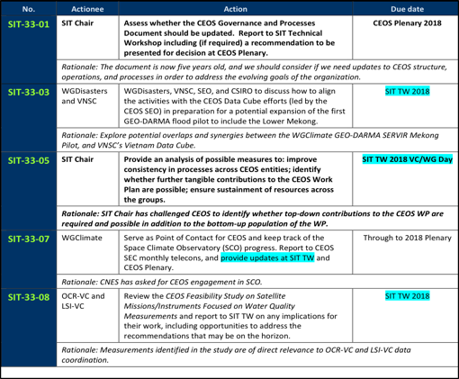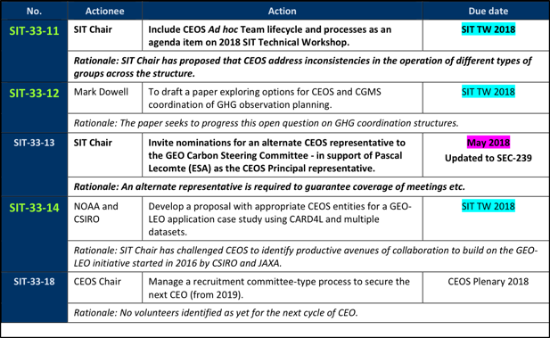
Kerry and Steve highlighted the need to identify a new CEO once Steven Hosford’s term ends at Plenary 2019.

Review of Chair Priorities
Mauro Facchini (COM, CEOS Chair Team) presented the 2018 CEOS Chair Initiatives and status of activities in achieving the initiatives:
- supporting and further developing priorities and themes of past Chairs through 2018;
- understanding and implementing common priorities and coordination with the SIT Chair (NOAA);
- rationalization of on-going activities: progress has been made on both the FDA activities and the LSI-VC/GEOGLAM/GFOI-SDCG discussions on consolidating and ensuring longer term continuity to these activities; and,
- laying the foundation for an international CO₂ and GHG monitoring system including the AC-VC white paper on an optimum constellation for CO₂ and GHG monitoring, and a Carbon Workshop was at Joint Research Centre (Ispra) in June 2018.
Mauro noted that on data issues, the COM has worked to introduce the new Copernicus DIAS as an enabling element for operational implementation of services, CEOS pilot projects and other small-scale demonstrators; the CEOS Chair Teams hopes to demonstrate ARD on demand and Data Cube on demand at CEOS Plenary.
Mauro noted that CEOS Plenary in Brussels (Palais des Congrés) will take place 17th-18th October 2018, with the 16th for side sessions. He encouraged all planning to attend to register.

Review of VC/WG Day Outcomes
Steve Volz (NOAA, SIT Chair) reviewed the outcomes of the VC/WG day (held 12 September) which featured three parallel sessions: Data, Oceans and Water Cycle, and Climate.
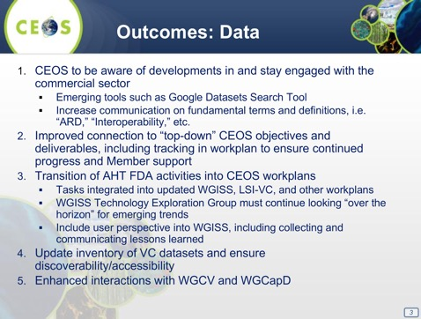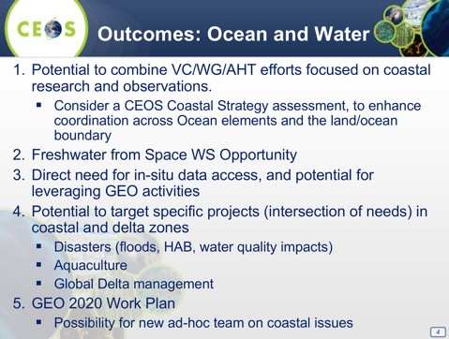
A brief discussion followed:
- Brad Doorn (NASA) noted that the emergence of the SWOT mission was part of what drove the discussion around a CEOS group focused coastal zones, as well as potentially a CEOS Coastal Strategy.
- Marc Paganini (ESA) noted that the coastal zone is quite important from the SDG perspective, and engagement with a coastal group would be good.
- Mark Dowell (COM) flagged the need to identify links to GEO Blue Planet with any future coastal activity.
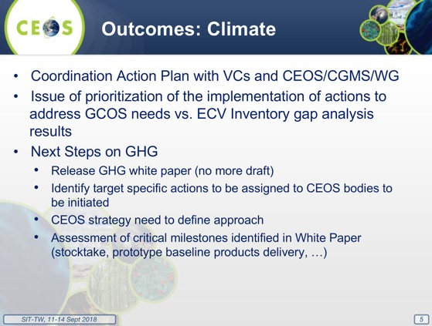
A brief discussion followed:
- Jörg Schulz (EUMETSAT) noted that the coordinated action plan, organization and resources remain to be discussed. He noted there will be further discussion on the GHG topic later in the Workshop.
- Ben Veihelmann (ESA) noted AC-VC work plan activities on harmonization between U.S. and European ozone datasets.
- Mark also noted this year’s reporting to COP and SBSTA-49, and that at last year’s SBSTA, GHG observations from satellites were recognized for the first time. This is good timing for the development of the AC-VC White Paper as we have an opportunity to highlight the main messages of the paper into our statement to SBSTA. Mark also reminded the group of the CEOS Carbon Strategy which remains relevant, and is being advanced by CEOS groups.
- Ewa Kwiatkowska (EUMETSAT) noted that the initial focus appears to be on atmospheric and terrestrial GHG, but that marine and aquatic variables are also important for carbon monitoring.
- Jörg noted that the WGClimate will take the broader set of variables into consideration to include connections between oceans and carbon, Mark highlighted that the CEOS Carbon Strategy did address oceans interfaces.

Session 2: Climate and Carbon Observations
Steve Volz (NOAA, SIT Chair) introduced the session, noting the focus on climate, carbon, and also the AC-VC White Paper, next steps, and actions.

Working Group Climate (WGClimate)
Jörg Schulz (EUMETSAT, WGClimate Chair) reported:
- EUMETSAT will provide the CEOS/CGMS Statement on Coordinated Response to UNFCCC Needs for Global Observations to SBSTA-49 on behalf of the CEOS Chair, VNSC, who is not able to attend COP-24;
- The statement will be sent to CEOS and CGMS Secretariats by 28 September for review and endorsement at Plenary; to be sent to UNFCCC Secretariat by 26 Nov 2018;
SITTW-2018-01 | WGClimate Chair | Manage process of review and submission of CEOS statement to SBSTA-49. | 26 Nov 2018
 | Rationale: Incoming CEOS Chair unable to attend SBSTA-49/COP-24 and WGClimate has agreed to give the CEOS/CGMS Statement.
- UNFCCC also welcomes a report from CEOS with a bit more detail, which would be considered as an official submission to the SBSTA. This will comprise a report of progress on WGClimate work and GHG – will use the executive summaries from gap analysis report and GHG white papers;
- On the action from 31st CEOS Plenary (31-01: WGClimate to explore development of a brief, consolidated statement of space agency contributions in support of each Article of the Paris Agreement), WGClimate consulted GCOS and GEO that performed similar analysis in their areas; the WG will apply categorization of Paris Agreement articles as depicted by GCOS and will develop a short note; this will be sent to CEOS SEC by 28 September for review and endorsement at Plenary.
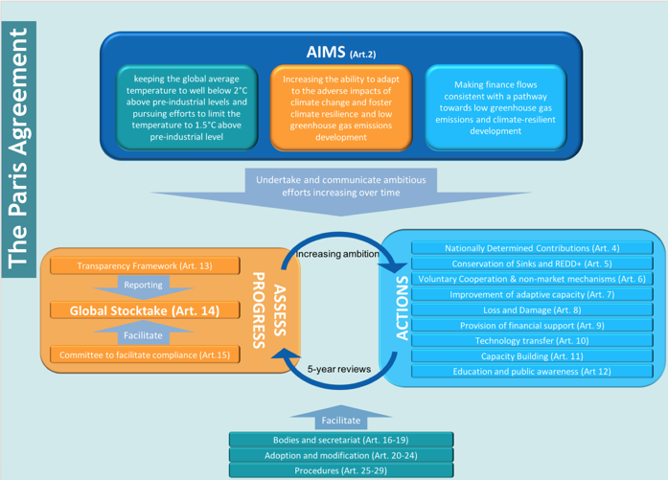
- GCOS plans a multi-panel meeting on 18-22 March 2019 in Marrakech, Morocco. This will be back-to-back with WGClimate and WCRP Data Advisory Council; WGClimate is interested in the planning of a GCOS Science Conference, and the updated GCOS Status Report and Implementation Plan;
- Both CEOS and CGMS endorsed the ECV gap analysis;
- Update of the ECV Inventory will start 1 October; the Inventory is fully compatible with GCOS 2016 IP; the next gap analysis will update all generic parts, changes to ECV products addressed in cycle#2, and some ECV products not addressed in cycle #2 but explicitly addressed in GCOS IP actions;
- climatemonitoring.info is the public entry point for access to the ECVI;
- Telecons are planned with all VCs to address Actions and understand VC/WG capabilities with the target to make arrangements for the update of the CEOS Work Plan 2019-21;
- WGClimate Chair was appointed as liaison to the CNES Space Climate Observatory (SCO) initiative at the last SIT meeting; CNES has invited agencies to the first international meeting on the Space Climate Observatory in Bremen, Germany from 3 to 4 October 2018, in conjunction with the 69th International Astronautical Congress.

CEOS Chair Greenhouse Gas (GHG) Workshop
Mark Dowell (COM, CEOS Chair Team) reported on the GHG Workshop held on 18-19th June at Joint Research Centre (JRC), Ispra. There were around 40 attendees in total, from nine CEOS Members and three CEOS Associates.
The objective of the Workshop was “placing the space segment in the broader context of a fully sustained system for CO₂ monitoring”. It brought together different stakeholders to define best practices and synergies, exploring common approaches to some of the system development, and seek strong engagement with stakeholders such as CGMS and CEOS Associate members such as the WMO. The Workshop was organized from a CEOS Space Agency point-of-view, with an emphasis on extracting and documenting best practices on interactions between CEOS Agencies and counterparts working on modelling, in situ, and inventory. It sought to identify open issues and develop some specific recommendations on efforts that CEOS Agencies could target in the future.
There was a discussion on terminology and scope, with a wide variety of views and perspectives, and the scope agreed was:
- Help countries improve their estimates of CO₂ and CH₄ emissions and removals in support of their Nationally Determined Contributions (NDCs) under the Paris Agreement; and,
- Provide an additional mechanism for validating the consistency between reported emissions and output from the system.
The overall system and architecture was also reviewed.
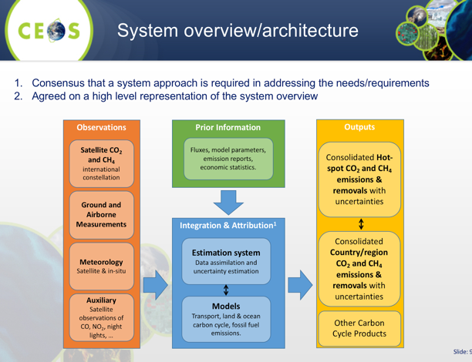
The Workshop also identified items for attention in the areas of critical elements for sustainability of the space segment, quality control of data, and interactions between space and modelling (e.g., observation simulation experiments - OSSEs), in situ, and Inventories.
A question was asked about how actions that are relevant to CEOS entities are being followed up outside the Workshop and the response was that for the conclusions are actually not actions but recommendations that could be folded into the CEOS Work Plan.
The draft minutes of the Workshop can be found here.
SITTW-2018-02 | CEOS Chair | Circulate the Carbon Workshop minutes to the CEOS mailing lists. | 20 Sep 2018
 | Rationale: Background for GHG issues to be debated at Plenary.

CEOS Carbon Strategy
Mark Dowell (COM, CEOS Chair Team) reported, noting CEOS Work Plan action CARB-15 to implement a prototype carbon data portal to facilitate the discoverability and accessibility of ECV products and space-borne CDRs, and provide data and services to the carbon science community of both CEOS and GEOSS. The latest version (August 2018) is with the Carbon Team for review/feedback, and the next steps are to improve discoverability of ECV/CDR key datasets, and to open the portal to wider user community for feedback (target end October 2018).
Mark provided an update on the CARB-19 and CARB 16 actions, both under the WGCV LPV Subgroup and CEOS LPV Super Sites, noting that CARB-19 is closed.
Mark noted there is an increasingly strong policy demand for coordinated provision of information on GHGs (both from UNFCCC/SBSTA and GCOS) and this has strong synergies with the successful existing collaboration between CEOS and CGMS on more traditional Systematic Observations (ECVs, CDRs). The ad hoc collaboration between CEOS and CGMS Agencies in preparing the draft white paper on the GHG Constellation has proved to be effective, and brought complementary competences to the existing team. A number of options, first presented at the 31st CEOS Plenary, then revised and presented at SIT-33 and CGMS-46 propose a more structured collaboration on GHG monitoring, taking advantage of existing CEOS (and CGMS entities) resulting in considerable added-value.
Identifying a plan to advance the relationship with CGMS for an operationally implemented and sustained observation capability was one of the COM Chair priorities. Four options for CEOS-CGMS coordination on GHG monitoring have been discussed.
- Continue ad hoc collaboration in context of CEOS Carbon Strategy Actions e.g. as-in joint efforts on AC-VC Whitepaper
- Establish a sub-group (with dedicated resources) in context of existing standing WG i.e. Joint WG on Climate
- Extend the current CEOS Atmospheric Composition Virtual Constellation to be a Joint CEOS-CGMS Virtual Constellation
- Establish a dedicated Joint WG specifically on Carbon/GHG observations
After discussion at various meetings over the past year, options 2 and 3 were identified as preferred, with a leaning towards option 2.
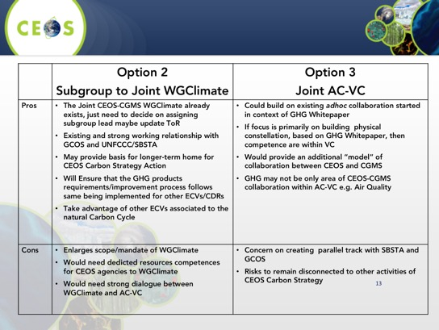
CGMS-46 confirmed, “its interest in pursuing a more structured collaboration with CEOS on GHG monitoring and provide comments or preferences on the options presented”, and agreed an action and a recommendation.
CGMS-46 Action: JWGClimate to complete their analysis of the feasibility of establishing a subgroup on CO2/GHG in JWG Climate
Recommendation: CGMS to recommend to the CEOS Chair the establishment of a subgroup within JWGClimate for the coordination of greenhouse gas monitoring activities.”
Mark noted that based on the discussions of the past few days, a possible hybrid solution could be considered. This solution may address the need to leverage the interface to UNFCCC via the WGClimate, as well as continue efforts within AC-VC which are required to support the way forward.
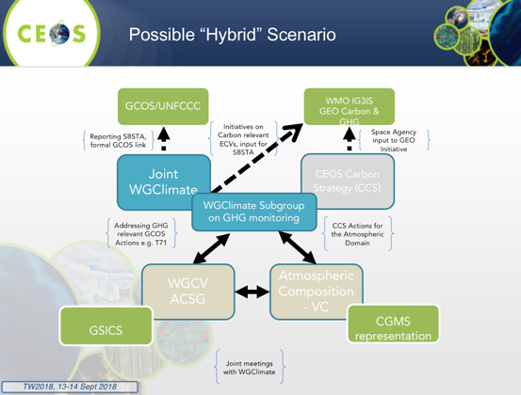
Mark noted that there are additional plans and information which will be refined between now and Plenary, and presented for endorsement.
CEOS Plenary will be asked to decide on the optimal structure, approach and schedule for CEOS-CGMS collaboration in the area of GHG observations and monitoring.
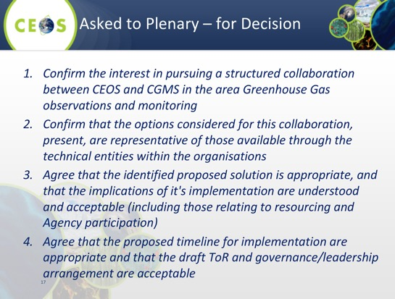
A brief discussion followed.
- Paul Counet (EUMETSAT) noted that at CGMS-46 recognized the value of the Joint WGClimate, and in particular reporting to UNFCCC, and that the Group has the capacity to provide a coordination function though more resources are likely required. Mark noted that the Plenary package would also include a clear justification for any additional resources required.
- Steve noted that quantifying resource requirements will be important in planning the way forward.
- Ivan Petiteville (ESA) noted that ESA would support the hybrid solution, and that they have related-activities within AC-VC that should be included. He also noted that the group’s size and resources would need to be at a realistic level to ensure a good outcome.
- Carolin Richter (GCOS) stressed that there is a strong partnership between GCOS, CEOS, and CGMS, and noted the GCOS mandate on climate reporting and the “subcontracting” of space agency contribution reporting to CEOS. There is an opportunity for CEOS and CGMS to highlight their capabilities and deliverables to an ongoing GCOS global stocktake activity, as well as around closing observations of natural cycles such as the carbon or water cycles.
- Steve asked about the proposed timeline for implementation, and Mark clarified that the timeline presented addresses establishment of governance rather than execution of the tasks.

AC-VC GHG White Paper
David Crisp (NASA) reported, noting that CEOS Chair commissioned the AC-VC to define the key characteristics of a global architecture for monitoring atmospheric CO₂ and CH₄ concentrations and their natural and anthropogenic fluxes from instruments on space-based platforms to: reduce uncertainty of national emission inventory reporting, to identify additional emission reduction opportunities and provide nations with timely and quantified guidance on progress towards their emission reduction strategies and pledges (NDCs), and to track changes in the natural carbon cycle caused by human activities (deforestation, degradation of ecosystems, fire) and climate change (drought, temperature stress, melting permafrost and changes in ocean thermal structure and dynamics). The AC-VC White Paper compiles inputs from 83 authors across 45 organizations, and the Paper contents and structure were explained.
Other points included:
- To transition from a series of scientific experiments to an operational constellation designed to provide end users with products and services, CEOS should work with CGMS and other partners;
- To define requirements for space-based atmospheric products that can support GHG inventories, CEOS should work with: stakeholders in the GHG inventory and policy communities (in particular the UNFCCC);
- CEOS should work with CGMS and other partners to define requirements and implementation strategies that will provide: a prototype system that delivers harmonized observations and XCO2 and XCH4 estimates from the existing fleet of CO₂ and CH₄ satellites and a prototype atmospheric CO₂ and CH₄ flux product that can provide a baseline atmospheric CO₂ and CH₄ inventory for use in the 2023 stock take; and,
- CEOS should integrate products from space-based systems to create a harmonized, global, space-based record of atmospheric CO₂ and CH₄ spanning the period from 2009 – 2021.
The proposed CEOS actions are:
- Create linkages with the ground-based GHG measurement community and stakeholders in the inventory and policy communities (in particular the UNFCCC), to refine the requirements and implementation approach;
- Exploit the capabilities of the CEOS Member Agencies, Coordination Group on Meteorological Satellites (CGMS) and the WMO Integrated Global Greenhouse Gas Information System (IG3IS) to integrate available and planned space-based sensors into a constellation that can provide prototype space-based CO2 and CH4 product in time to inform the bottom-up inventories for the 2023 global stock take; and
- Use the lessons learned from the development of this prototype product to refine the requirements for a future, purpose-built, operational, space-based constellation that more completely addresses the objectives cited above in time to support the 2028 global stock take.
The AC-VC GHG White Paper is complete and ready for review by the CEOS entities, and Dave offered one week to allow comments to the White Paper, and the next step will be to submit the final White Paper to CEOS Plenary. AC-VC supports the proposal to transfer the implementation responsibility to a (new) CO₂/CH₄ subgroup within WGClimate, and will continue to support synergistic GHG and atmospheric composition observations and modeling efforts.
A brief discussion followed.
- Steve stressed the importance of feedback on the White Paper within a week in order to meet the deadline for Plenary materials.
- Carolin asked about the next steps following the finalization of the paper. David noted that the paper has been widely circulated, and engagement with the Inventory community has started and will be important.
- Mark noted that this effort fits well with current WGClimate activities. He also noted that this document should be made available broadly, and the lack of ability for CEOS to provide an official citation for the document is a potential issue. John Remedios (UKSA) agreed, and noted that other international agencies can provide citations.
- John noted the 2021 milestone is quite tight, and David noted that this is only achievable because it can leverage existing and ongoing activities. He also noted that engagement with the Inventory community will be key, and these can be built via links with the Scientific Inventory community and their connections to the operational Inventory community. David also noted that the product will not be perfect, but might be the best product available to developing countries in 2021.
- Steve asked if the paper would presented for endorsement at the Plenary, and Mark noted they would like to push for endorsement but this should be discussed and agreed before the close of the Workshop, Kerry noted that it will be important to find the correct language for endorsement/acknowledgement at Plenary and agreed to review how previous CEOS reports were presented for endorsement.

IPCC Guidelines

Osamu Ochiai (JAXA) provided an update on the IPCC Guidelines for National Greenhouse Gas Inventories:
- The current status and timeline was shown; in the second order draft (SOD) there were some positive developments for EO data: small chapters and subheadings related to satellite observation are added; satellite retrievals are recognized to cover large areas of the atmospheric column; cited the projects and papers which showed potential for estimating or qualifying GHG emissions by satellites (GOSAT, OCO-2, SCIAMACHY);
- The SOD also recognizes challenges: verifying GHG inventories by satellites with inverse models still has technical (and financial) challenges and in the experimental stage; capabilities will be enhanced by future missions (TROPOMI, GOSAT-2, GeoCarb, and TanSat);
- Final Government Distribution (FGD) Review period is 14 January – 10 March 2019; only governments may submit comments (CEOS Agencies may do so through their governments); and,
- For operational use of satellite retrieval with inverse models after the IPCC guidelines refinement in 2019, CEOS should play an important role of calibration and validation for current and future missions.
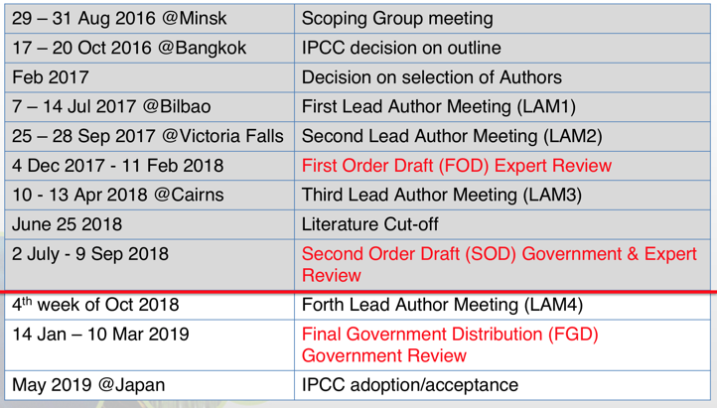
A brief discussion followed.
- Ivan suggested the inclusion of Sentinel-5P observations into the review process, and Mark noted this may be possible via the Commission's comments.
- Mark asked about how many of the comments submitted on the FOD were reflected in the SOD, and Osamu noted that there were small changes to the comments, but most appear to have been reflected.
- Jonathon Ross (GA, SIT Vice Chair Team) suggested that if CEOS comments are submitted by multiple governments, they may have a greater chance of being accepted.
- Osamu referenced the differences between the global stock take and nationally determined contributions, and noted it’s not clear there are any guidelines for the determined contributions, but the IPCC does provide guidelines for the global stock take.
SITTW-2018-03 | Osamu Ochiai | Coordinate suggested CEOS Agency inputs to the IPCC Final Government Draft for the IPCC Guidelines for National GHG Inventories. | Jan 2019
 | Rationale: CEOS Agencies may still influence the text via their governments.

Session 3: Data

CEOS Chair FDA Workshop
Michael Berger (COM, CEOS Chair Team) presented a summary of the Workshop, noting there was a wide range of agency activities including the integration of cloud services to improve efficiency of operations, and develop a user-base. There are significant transitional risks need to be mitigated in the process, including around the application and infrastructure transfer to cloud, becoming proficient in the use of cloud services, and managing risks around vendor lock-in. Several other main points were reviewed:
- Analysis Ready Data (ARD) and Data Cube services are seen as an important catalyst to support increasing adoption of free, full, and open data. There is a need to maintain momentum on ARD and build on progress to date.
- The core tasks for public service agencies are around service and data provision, data quality, stewardship, and archiving.
- There is a clear need for common architectural model and terminology.
- There are significant cost and performance optimizations possible through intelligent choice of cloud services, though there are privacy and data protection concerns which need to be understood and addressed.
Steve Volz (NOAA) asked if the different implementations we are seeing are driven by the need for an agency or what is possible, or by a lack of understanding, and Michael suggested they were driven by what is possible.
Future Data Architecture (FDA)
Nicolaus Hanowski (ESA, FDA AHT Co-Lead) presented a summary of progress across five areas of focus since CEOS Plenary 2017, as well as recommendations for how to move forward.
- ARD are key to facilitate and foster EO data uptake especially by user communities, which are not comprised of EO data specialists.
- Data Cubes A large variety of Data Cubes have emerged. The "CEOS Data Cube" initiative aims at utilizing CEOS Agency resources, global partnerships, satellite data, and CEOS organizational groups for further improving data access, data preparation, and data analysis for all users of satellite data.
- EO Platforms The concept of virtual data exploitation environments (providing data, tools, processing options, etc.) based on public/commercial infrastructures (e.g. cloud resources) constitutes a broader set of initiatives with the capacity to integrate ARD and data cube components.
- User Metrics Resources Inventory User metrics are important in the quantitative and qualitative assessments of the attractivity and impact of the various CEOS FDA initiatives. Together with an up-to-date inventory of EO resources available through the CEOS community. This should lead to improved harmonization and programmatic planning.
- Data Analytics was identified early in the FDA process as a neglected theme in terms of CEOS coordination. Improved data analysis is also seen as a key driver to increase the usability and use of Earth Observation data, in particular by user communities, which have not been acquainted with EO.
Nic reviewed a set of proposed next steps for discussion including additional consultation of extended FDA AHT group, the definition of CEOS side meetings, integration of considerations of “New Space” actors (e.g. results from satellite interoperability workshop of Planet, Radiant Earth, MAXAR, …), and detailing of roadmap for CEOS plenary (incl. visualization).
A brief discussion followed.
- Steve Volz (NOAA) asked about the integration of FDA activities into other CEOS side meetings and whether this impacts the scope of the existing meetings. Nic suggest that this integration is more focused ensuring coordination across groups on FDA-related themes.
- Steve Labahn (USGS) noted that they have reached out to WGISS to drive some of the proposed interaction that the FDA AHT.
- Osamu Ochiai (JAXA) noted that at the GEO Programme Board last week, Gilberto Câmara raised the question of data aggregators, and whether this is a space agency responsibility. Nic noted that space agencies should ensure data quality and integrity, and there is also a question around data access policies and legislation.
- Adam Lewis (GA) asked about the expected continuity of the FDA AHT and whether it will continue. Nic noted that the continuity should be realized via integration with the other CEOS groups who are picking up the work. Steve Volz confirmed that the FDA AHT is not expected to request another year at Plenary.
- Mauro Facchini (COM) noted there is a need to promote datasets and services outside our community, and also to facilitate access, and this is part of the driver for DIAS.
- Ivan Petiteville (ESA) suggested that CEOS, particularly WGISSnominate a representative to participate in the GEO Expert Advisory Group (EAG) since one of the goals of the EAG is to provide guidance on how to implement a results-oriented GEOSS, and Mirko Albani (ESA) agreed with this idea.
SITTW-2018-04 | SIT Chair | Propose WGISS participation in the GEO Expert Advisory Group. | 30 Sep 2018
 | Rationale: Because this EAG is tasked with providing guidance on how to implement a results-oriented GEOSS, it would be beneficial to have a WGISS representative participate in the EAG.

Analysis Ready Data (ARD)
Jenn Lacey (USGS, LSI-VC Co-Lead) reported on the key outcomes from the LSI-VC-6 and LSI/SDCG/GEOGLAM joint meeting last week at JRC.
- CARD4L: agreed a process for updating the PFS (Product Family Specifications); gathered and presented substantial inputs for the first update cycle; agreed LST focus for the surface temperature PFS; reviewed plan for further SAR PFS: backscatter, polarimetric, and interferometric; agreed WGCV peer review process for CARD4L product assessments and identified next steps for initial assessments and confirmation of the procedure (by LSI-VC-7, Feb 2019); agreed an approach for further promotion of the CEOS ARD concept; will progress the CARD4L stock take and get this information online;
- Lessons learned from Planet ARD workshop: substantial interest and energy being put into simple, interoperable satellite data by the private/nonprofit sector; ARD is a game-changer for application of large-scale machine-learning approaches to satellite imagery; growing commercial land surface imaging sector good for space agencies;
- Key overlaps between SDCG, GEOGLAM, and LSI-VC on CARD4L pilots and establishing links to user communities (for feedback, promotion, etc.) – priority areas for collaboration; and,
- Agreed a joint position on the continuity of the SDCG and GEOGLAM AHTs and the relation to LSI-VC going forward (to be discussed during the SIT Technical Workshop).
Jenn noted that ARD is no longer a desire of global users, but is now becoming a requirement and an expectation. She summarized the CARD4L framework, as well as a proposed assessment process developed in cooperation with WGCV.
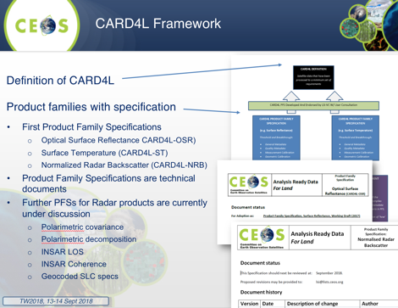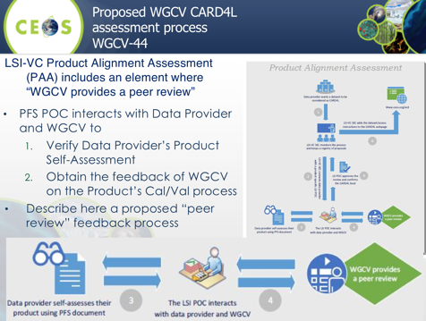
Jenn noted that CEOS needs to make it easier for global users to get ARD, and that a number of activities are foreseen in a comprehensive and successful CEOS strategy on ARD. CARD4L is the first in a number of possible ARD thematic product definitions. An ARD Stock Take and Outlook is needed to assure user investment confidence. LSI-VC maintains a CARD4L webpage where current and future CARD4L datasets can be identified. The strategy will also address self-assessments, pilots, and feedback to mature the PFSs, as well as communication and promotion activities.
She noted that CARD4L will be promoted at the ESA Living Planet Symposium and IGARSS where GA (Andreia Siqueira) will coordinate. To promote CARD4L with users, space agencies and others, LSI-VC sees the need for a general communications package, and LSI-VC SEC (Matthew Steventon) has developed a draft set of messages.
A broad CEOS strategy on ARD is beyond the scope of LSI-VC alone, so the SIT Vice Chair (Alex Held) has agreed to further develop a discussion paper as a channel for community consultation and discussion at future CEOS meetings.
SITTW-2018-05 | SIT Vice Chair | Develop a discussion paper on a broad CEOS ARD Strategy. | SIT-34
 | Rationale: SIT Vice Chair has adopted the CEOS ARD strategy as a priority theme for their term.
A proof of concept example is proposed in response to action SIT-33-14 that will include GEO and LEO products acquired over a brief (20-day interval) for an ARD grid cell located within the Conterminous USA The primary emphasis of this GEO/LEO effort will be to provide technical guidance for development of a formal proposal in response to the action. A land application case study, Multi-Sensor Monitoring of Vegetation Condition, was selected for this example as this effort is being initiated within the CARD4L effort of the Land Surface Imaging-Virtual Constellation. An example from May 2017 combining data from Landsat OLI, MODIS, VIIRS, Sentinel-2 MSI, and GOES-16 ABI was shown.
Adam noted the importance of a communication strategy as part of the CEOS strategy.
Dan Lindsay (NOAA) raised the potential to add a file format requirement to ARD as this may help to ease data access, and Jenn noted there’s a need to balance around how prescriptive to be.
Ivan noted there is not a unique definition of ARD, and asked about the strategy to engage the private sector in the definition of ARD. Jenn noted there was some engagement at the recent Planet workshop, but that there is also a need to confirm the PFS before rolling out a full communications strategy. Adam noted that engagement by participating in high profile forums to build awareness.

Working Group on Information Systems and Services (WGISS)
Mirko Albani (ESA, WGISS Chair) presented a summary of WGISS activities and updates to CEOS Work Plan Deliverables throughout the presentation. He highlighted the Data Stewardship Best Practices Document, which is available and should be applied by CEOS Agencies. He noted there is a large amount of data accessible via the WGISS Connected Data Assets (CDA) which is maintained and operated in coordination among different agencies and implements the OpenSearch Interoperability Best Practice defined in WGISS. CDA provides a single entry point for GEO (GEOPortal) to discover and access CEOS Agencies data.
There is also an effort to facilitate discoverability and accessibility of ECV Products and space-borne CDRs relevant for the CEOS Carbon Action via WGISS Interoperability Systems and Standards. The approach has been to start from results of WGClimate Questionnaire for ECV Inventory population, and then tailoring the response to the Carbon Strategy actions and gaps identified
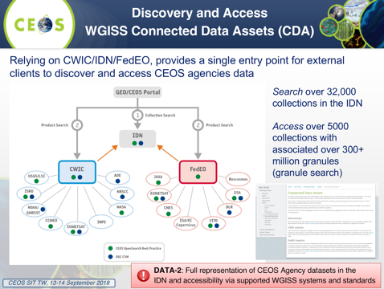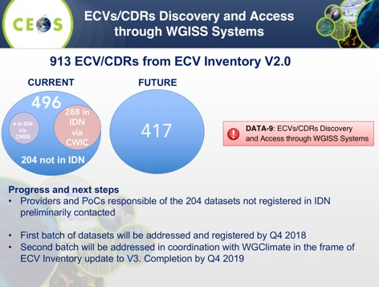
The WGISS Carbon Community Portal is being developed with the objective to implement a prototype carbon data portal to facilitate the discoverability and accessibility of ECV products and space-borne CDRs. The portal will seamlessly access data both in CWIC and FedEO to provide necessary data and services to the carbon science community of both CEOS and GEOSS.
WGISS conducted an FDA workshop in April, and is planning another in October with a focus on GEOSS-WGISS Interoperability. The group has also been holding webinars on data search and discovery, data cubes, python, OGC standards, and development methods.
Cooperation with a number of other groups is active, including the CEOS Carbon Team, all the other WGs, the SEO, CGMS (e.g. CGMS Working Group IV Global Data Dissemination), and ESIP. Several areas for collaboration with the VCs were identified during the VC/WG Day.
Mirko noted that WGISS participation is stable (average 20 people), with nominations open for the WGISS Vice Chair for the period October 2019 – October 2021.
Ivan noted that WGISS is a good example for groups of how to work across CEOS groups.
Jonathon Ross (GA, SIT Vice Chair Team) noted the importance of the FDA activity. He asked about the best practice documents, around implementation and benefits being reported. Mirko noted feedback from users on the best practice documents (e.g. from China), and there are an increasing number of partners using OpenSearch across a number of agencies and regions.

Data Cubes
Brian Killough (NASA, SEO) provided an update on Open Data Cube (ODC, www.opendatacube.org) and CEOS Data Cube activities, noting the founding participants of the ODC include several CEOS members (GA, CSIRO, NASA-SEO (with AMA), USGS, and UK-Catapult). The project is open source with code available online: https://github.com/opendatacube. Brian noted that the CEOS Data Cube (CDC) is an ”extension” of the ODC goals to demonstrate data cubes around the world and maximize the impact of CEOS satellite data. The ODC is focused on ARD, user needs, and global capacity building, and has attracted significant interest from the new GEO Secretariat Director. He noted several other key points:
- The Africa Regional Data Cube was launched in May 2018 for five countries (Kenya, Tanzania, Sierra Leone, Senegal, Ghana), and is initially based on Landsat ARD, with S1, S2 and ALOS coming soon, and support from Amazon (donated cloud services) and GPSDD (training).
- Digital Earth Africa (DEAfrica) is a new initiative to develop a full-continent EO program based on the ODC; the effort is led by Stuart Minchin (GA) and Steven Ramage (GEO). A Steering Committee has been formed to serve as an advisory body to provide inputs and recommendations on institutional arrangements, stakeholder engagement and operational plans and they have specifically requested that Brian be the CEOS representative on the Steering Committee due to relevant experience with the Africa Regional Data Cube (ARDC). This will be presented at Plenary for endorsement by Principals;
- Data Cubes with CEOS ARD are having a global impact, Switzerland is using their Data Cube to develop new snow detection algorithms and develop time series snow coverage maps; UK-Rhea (commercial company) is using the Data Cube to develop a drought monitoring system for Uganda; and Uruguay is using the Data Cube to adjust their water sampling approach to coincide with satellite overpasses in order to improve water quality data in their reservoirs;
- The Data Cube pilots are an ideal way to prove the benefits of ARD, there is a growing interest in radar data, but few users understand its benefits or know how to use this data; Data Cube pilots are a great place to demonstrate open source radar algorithms on ARD; CEOS needs to make it easier for global users to get ARD; and,
- One goal of WGCV efforts is also to ensure consistency across users of L1 data products; GSICS community as well as the VCs and other WGs are needed to help define both the work itself and the pathways to solutions; the challenge is developing approaches suitable to address inclusion of a range of user needs (data cubes, ARD, CDRs, etc.) while spanning sensor-related challenges (data gaps, sensor constellations, smallsats and cubesats, commercial providers, etc.).
A brief discussion followed.
- Steve Volz (NOAA) asked about the use of data that is restricted access in the ODC. Brian noted that the ALOS mosaics they are using in the Data Cube are free and open, and to date he has not tested on commercial data. There is nothing stopping a Data Cube user to use their own commercial data. Adam noted that the ODC is separate from the dataset.
- Simona Zoffoli (ASI) asked about regional thematic Data Cubes, and Brian confirmed these are certainly possible. He noted that they have worked on a Cube in the Lake Chad area which covers four countries. Jonathon noted there are challenges scaling to regional, but these tend to be governmental and organizational rather than technical.
- Marc Paganini (ESA) noted that ESA’s TEPs have big user communities, and also enable analytics in the cloud. Marc asked about DEAfrica and the plans for the data handling, and Brian noted the challenges of infrastructure scale are being worked. He noted that DEAfrica has confirmed it will not use a commercial cloud provider.

Working Group on Calibration and Validation (WGCV)
Kurt Thome (NASA, WGCV Chair) reported, noting that WGCV supports multiple CEOS Work Plan items related to FDA and ARD and interoperability. He noted several other key points:
- Work is underway towards establishing a community agreed reference(s) for level 1 top-of-atmosphere radiances/reflectances; consistency of similar top-of-atmosphere products between sensors is a good first step in ensuring interoperability of downstream products; although it is difficult to recognize physically-based differences from those caused by calibration differences;
- On the GEO-LEO front, WGCV has supported previous concept works for interoperability between LEO and GEO; the GSICS community has demonstrated this capability for the meteorological sensors; WGCV is working with GSICS to broaden the reach of these approaches to non-meteorological platforms; the challenge is determining the best approach for downstream products; and,
- One goal of WGCV efforts is also to ensure consistency across users of L1 data products, with the key challenge being developing approaches suitable to address inclusion of a range of user needs (data cubes, ARD, CDRs, etc.) while spanning sensor-related challenges (data gaps, sensor constellations, smallsats and cubesats, commercial providers, etc.).
A brief discussion followed.
- Adam Lewis (GA) noted the engagement of WGCV in the CARD4L assessment process, and the increasing importance of the role of validation.
- Ivan Petiteville (ESA) asked about the interaction with GSICS, and Kurt noted that the GSICS collaboration has helped address problem areas.
- Jörg Schulz (EUMETSAT) asked about supporting calibration of satellite data using NWP model outputs, rather than using ground data. Kurt confirmed they do use modelling approaches when it helps get to the best answer, and GSICS has been quite helpful in this regard.

Session 4: User Engagement Activities

Support to Sustainable Development Goals (SDGs)
Marc Paganini (ESA, SDG AHT Co-Lead) reviewed the history of the SDG ad hoc Team, noting that the future of the Team remains to be decided. Alex Held presented five options for the group at CEOS SIT-33 for discussion and proposed decision at CEOS Plenary. The 2018-19 work will focus on:
- Support to GEO’s EO4SDG activity;
- Collecting and centralizing information from individual CEOS Agency work programs relevant to SDGs;
- Promoting space-based EO data as a key source of data for use by national statistic offices (NSOs) to monitor and report on specific SDG indicators, and encourage CEOS Agencies to proactively contact their national governments in the Voluntary National Review processes;
- Identify areas where SDG indicator development work has the potential to result in broader applicability (e.g. supporting the SDG / target, and sustainable development policies);
- Develop activities – including capacity building - with external stakeholders (GEO, NGOs, UN entities, development banks) to join the efforts in the space world to help monitor and achieve the SDGs;
- Develop communications material (with the SEO’s support) to better inform CEOS Space Agencies and external stakeholders about the critical role of EO space data in the SDG process; and,
- Participating in the GEO Land Degradation Neutrality (LDN) initiative, including: assisting the UNCCD with the provision and deployment of EO datasets, country support, capacity building, and EO tools and platforms so that countries can effectively monitor and report on SDG indicator 15.3.1.
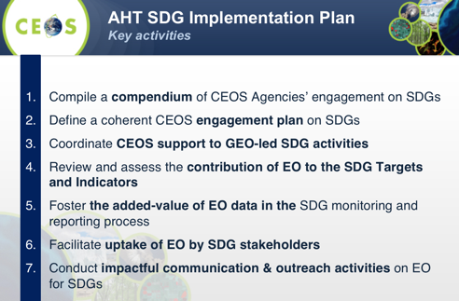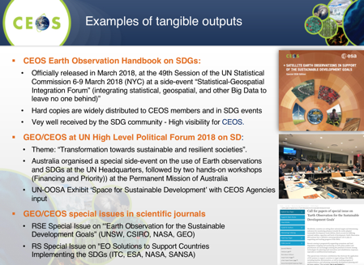
Marc noted the AHT will initiate a CEOS-level assessment mapping which VCs/WGs/AHTs might address each of the relevant SDG targets/indicators and which might address SDG cross-cutting activities (e.g. data access, data cubes tailoring for SDGs, online platforms for SDGs).
He noted the ad hoc Team considers it important for CEOS to have a solid or “permanent” structure dedicated to the SDGs and proposes a third thematic Working Group within CEOS (with Climate and Disasters) responding to the three top priorities of GEO and the main Global Societal Agendas for consideration in 2020. The mission would be to enable the integration of satellite observations in the 2030 Agenda on Sustainable Development, for the benefit of all countries, leaving no one behind, and maximizing CEOS Agencies return on investment. Critical mass of membership and resources, obviously, need to be addressed with CEOS Agencies.
Marc also noted that it is very important to identify a third AHT Co-Lead and this will also be presented to Plenary for consideration/decision.
A discussion followed.
- Ivan Petiteville (ESA) raised the changing focus of GEO around SDGs (e.g. no SDG Expert at the GEO Secretariat), and asked whether CEOS should consider engaging the agencies who are the custodians.
- Jonathon Ross (GA) noted that the feedback at the High Level Political Forum was positive, and suggested other Agencies reaching out to their governments to participate.
- Mark Dowell (COM) provided an update on the EO Handbook on SDGs, noting they have distributed this document within the European Union to all the ministries that deal with the SDGs, and they have received positive feedback from across the organization.
- Adam Lewis (GA, SIT Vice Chair Team) asked how well the AHT is addressing the core role of identifying unique contributions CEOS can make to progressing the SDGs. Marc noted the activities over the past two years are not exactly in line with the typical CEOS mandate, and they are trying now to align activities within CEOS and GEO to explore what CEOS as a community can contribute. He noted the example of agencies that are involved in the SDGs but are not CEOS members, and where we don’t have the resources to engage.
- Steve Volz (NOAA) stressed that going forward we need to understand clearly the unique CEOS contribution.
- Argyro Kavvada (NASA) noted that one of the key contributions is around understanding of satellite data specifications and capabilities to integrate into SDG indicator development workflows.
It was confirmed that the likely recommendation to Plenary will be to extend the SDG AHT for another year.

Observations for Disasters
Simona Zoffoli (ASI, WGDisasters Chair) provided a status update on WG disasters Work Plan 2018-2020, including the status of the initiatives endorsed at the last SIT-33 and SIT-33-03.
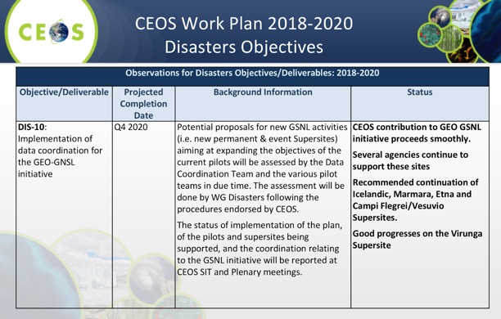
She reviewed the status of the remainder of the CEOS Work Plan actions: DIS-12 (Report on survey of donors for post-2017 operation of a Recovery Observatory; DIS-15 (Support for GEO-DARMA identification of major hazards and DRR issues for each selected region); DIS-16 (Report on Landslide Pilot and follow-on actions; and, DIS-17 (Demonstrators Implementation Plan).
Simona reported on SIT-33-03 on alignment of activities on CEOS Data Cube efforts between WGDisasters, VNSC, SEO, and CSIRO on the GEO-DARMA flood pilot to include the Lower Mekong).
- After SIT-33 WG disasters chair promoted the starting of exchange of information between GEODARMA secretary and Alex Held (CSIRO);
- CSIRO shared summary of Vietnam Data Cube activities;
- CSIRO (A. Held, M. Paget) attended WG Disasters meeting number 10 by telcon and presented CEOS Open Data Cube and Vietnam Data Cube;
- Plan to set up a telecon between CSIRO and ADPC lead Peeranan Towashiraporn leading the GEODARMA Mekong Flood project in Myanmar; and,
- Awareness on Vietnam data cube initiative will be useful in elaborating the extension of the GEODARMA project to other Mekong areas.
On data provision for the new initiatives endorsed at SIT-33, data request plans for the three initiatives are being progressed within the WG. It was noted that all agency contributions that were proposed at SIT-33 were confirmed except for CSA (still under discussion).
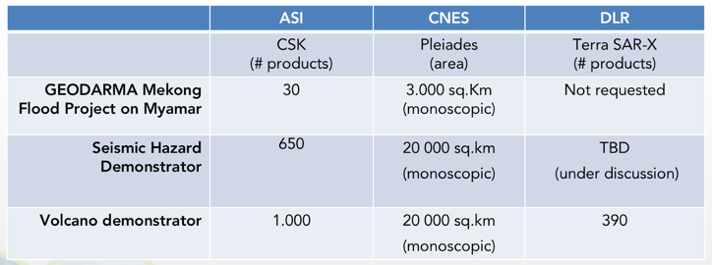

Ivan noted the potential for the combination of GEO and LEO orbiting platforms for disasters, and Simona noted they have been exploring this idea.

Observations for Forests
Osamu Ochiai (JAXA, CEOS Lead for GFOI) provided an update on GFOI developments, including Phase 1 outcomes and Phase 2 context. He noted that GFOI Phase 1 was data-driven, while Phase 2 aims to be user-driven. CEOS contributions to GFOI Phase 1 were significant, and the plan for Phase 2 is now being developed with the former Space Data Component renamed the ‘Data Component’, and its scope broadened.
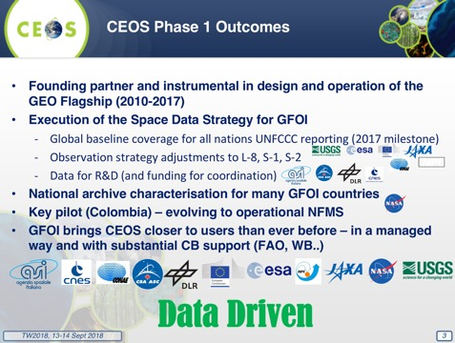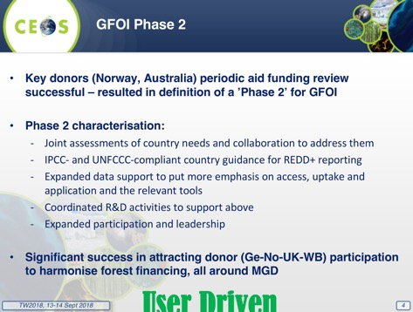
Osamu noted several CEOS considerations for GFOI Phase 2:
- Expanded participation brings in major forest donor governments and provides opportunity to ensure EO aspects benefit (UK and DE both have active space agencies);
- Multiple CEOS Agencies planning new biomass data-streams of direct policy relevance;
- Core GFOI business is the coordination among the donors and capacity builders. CEOS must continually engage to ensure representation of its issues and the ensuing benefits; and,
- World Bank wishes to co-lead with CEOS through their Forest Carbon Partnership Facility (FCPF) projects (result-basis payment).
There are several challenges facing SDCG which need to be addressed:
- Reduced participation and engagement from CEOS Agencies;
- Co-Leads capacity (beyond attendance); and,
- Operating capacity (SEC provided for first 5 years by the Australian Government).
The way forward for the CEOS engagement with GFOI depends on whether a critical mass of Agencies exists to continue a stand-alone group (such as SDCG or some evolution of it), as well as the provision of capacity for the management of that group and for the execution of the Work Plan targets. There are a number of perceived opportunities for CEOS in GFOI Phase 2 which need to be considered: Biomass; Work Bank cooperation; new early warning module; tools and services emphasis; ARD engagement; and new donor-driven R&D program.
Osamu presented the options developed for the way forward for CEOS support to GFOI noting that no particular option is promoted at this time.
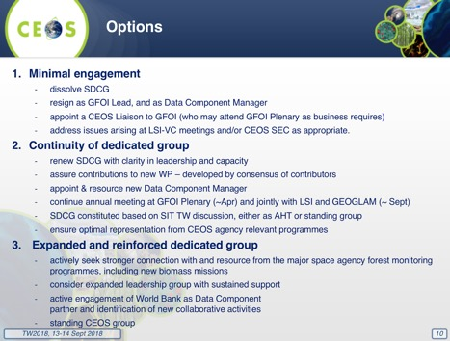
A brief discussion followed.
- Nancy Searby (NASA) noted that the SERVIR team has been working on a SAR biomass methodology document that can be shared.
- Steve Volz (NOAA)asked about the need for agency buy-in, and Osamu noted that for GFOI Phase 1 there was strong buy in, but for Phase 2 support has been dropping. Stephen Ward (SDCG Sec) noted that Agencies have been dropping off, but we did have the recent good news that USGS is seeking to re-join SDCG. He also noted that additional Agencies to support the biomass push would be required.
- Mark Dowell (COM) suggested that we need to think about how to integrate the GFOI activities with the reporting to UNFCCC. Agriculture, forest, and other land use are extremely prominent in the Paris Agreement, and will be part of reporting, and if we want to represent all the space agencies are doing we should consider how to reflect GFOI contributions in this area. Stephen agreed, and noted that the new SDCG Work Plan seeks to accelerate the policy relevance of biomass missions - though this will require some work.
- Steve asked about the option to be brought forward to Plenary, noting that options 2 and 3 are the most likely. He suggested addressing this during the AHT discussion tomorrow.

Observations for Agriculture
Brad Doorn (NASA, GEOGLAM AHWG Co-Lead) provided an update on the activities of the GEOGLAM ad hoc Working Group, reviewing how the GEOGLAM requirements work has evolved over time.
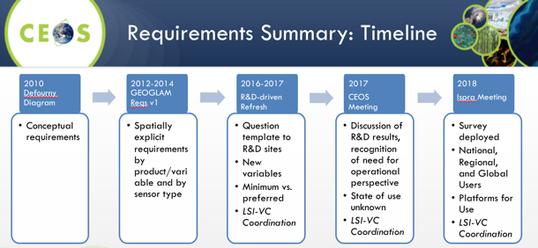
The initial focus of the GEOGLAM group was on science and research, and this led to a narrower set of requirements. As GEOGLAM moves towards operations, the requirements have expanded beyond just EO towards calibration, capability building, and other support. These expanded requirements lead to a request for an additional year for the AHWG in order to consolidate these requirements. The updated requirements have a much broader scope, including supporting variables (e.g. soil moisture, ET, water).
Brad provided several other updates:
- The GEOGLAM Workshop on Cloud Computing and Knowledge Management was held on 29-31 August 2018 in Sanya, China where a Task Force was established for coordinating cloud computing with a focus on developing country capacity building; Community Algorithms and Tools will be shared via a GEOGLAM TEP (Thematic Exploitation Platform) with the EU targeting ESA funding for that; GEOGLAM Best Practices documentation is being given priority;
- Within the GEOGLAM organization (outside CEOS) they have established an active EO Data Coordination and Management Thematic Coordination Team (TCT) to formulate next steps on ARD+ and GEOGLAM Essential Agricultural Variables (EAVs); the EAVs are likely an extension of the GCOS ECVs, with GCOS covering perhaps 80% of the variables needed to be specified; and,
- The GEOGLAM ad hoc Working Group will ask CEOS Plenary for a 1-year extension of its operation in order to formulate the response to the GEOGLAM requirements.
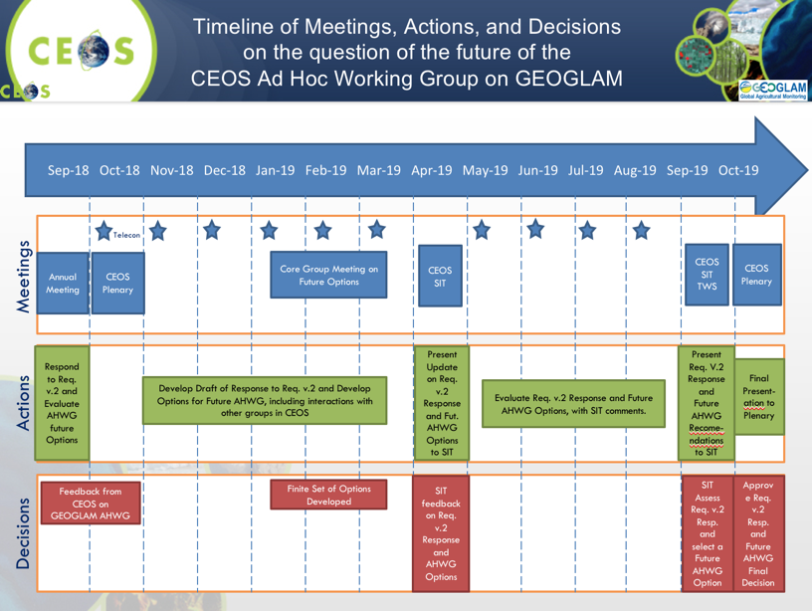
A brief discussion followed.
- Steve Volz (NOAA) asked about the evolution of the CEOS-GEOGLAM organization, and whether the GEOGLAM is likely to require a smaller interface to CEOS in order to be sustainable. Brad noted that he believes there needs to be some kind of permanent agriculture point of contact (GEOGLAM and others) within CEOS to address these issues. At present GEOGLAM is pretty robust and well supported at the GEO Secretariat (Canada, Germany, and China). There is always likely to be a role for CEOS and its Agencies to educate the users on evolving technology.
- Nancy Searby (NASA) asked if there are new measurements coming online which would impact GEOGLAM’s decision to focus on LSI-VC. Brad noted that the group learned a lot after the first requirements, and there could be additional parameters that come out of the updated requirements.
- Brad noted there is also a discussion to be had on GEO reporting and the interface there, to ensure that the support being provided is clear.

Session 5: Oceans and Water Cycle

Advancement of the COVERAGE Initiative
Vardis Tsontos (NASA) reviewed the history of the COVERAGE initiative, noting that CEOS endorsed it at SIT-32 (April 2017, Paris) as a three year pilot project and a cross-cutting, collaborative effort within CEOS beyond data sharing relevant to the four Ocean Virtual Constellations (SST, OST, OCR, OSVW) and GEO projects (MBON, Blue Planet) to enable more widespread use of ocean satellite data in support of applications.
Vardis added, addressing actions COV-1 through COV-6:
- COVERAGE responds to known needs of the ocean community for improved, more integrated data access for societal benefit in support also of SDGs (14 in particular) relating to marine biodiversity and sustainable/ecosystem-based resource management;
- COVERAGE aims to develop a data-rich platform for more seamless delivery of analysis ready ocean data to demonstrate the value added of multivariate ocean data integration in support of science, applications, and public engagement;
- An Advisory Board has been developed with cross-agency and stakeholder representation from NASA, NOAA, CNES, EUMETSAT, Copernicus-CMEMS, Australian Bureau of Meteorology, Integrated Marine Ocean Observing System, Sargasso Sea Commission, CEOS Ocean VCs, and WGISS; three meetings held to date;
- The team has completed a review of candidate interagency satellite data products across the 4 ocean VC parameters (SST, Winds, SSH, Ocean Color) for inclusion as a coherent set of 0.25 degree, global baseline products for COVERAGE; and,
- Pilot Applications are being defined in Support of GEO-MBON and Blue Planet with a focus on Biological & Resource Management Communities.
Mark Dowell (COM) asked whether linkages had been made to the UN World Oceans Assessment 2 which was getting underway when COVERAGE was endorsed at SIT-32 in Paris. Vardis noted that they have not yet, but this is more possible now that the platform has started to develop.

SST-VC
Ken Casey (NOAA, SST-VC Co-Lead) presented a brief background of the SST-VC, and reviewed its main activities for 2017/2018.
- The VC has focused on two actions in the CEOS Work Plan: VC-1 (List of Relevant Datasets from VCs), and VC-19 (Documented Plan for the SST Virtual Constellation); plus coordination on PMW
- On VC-35, the group recently presented on Passive Microwave (PMW) SST to ECMWF/ESA workshop on using low frequency passive microwave measurements in research and operational applications. (More information here.); and
- The group has welcomed new members Sujuan Wang (CMA), Chu-Yong Chung (KMA), and Ed Armstrong (NASA), and just received commitment from SANSA.
Ken reviewed the status of the two CEOS Deliverables.
Ken provided an update on the progress on PMW (VC-35):
Significant progress has been made in the last year, organizing the community and advocating for Passive Microwave (PMW) continuity. The SST-VC notes progress with two, complementary missions that if successfully put into operations will fill the looming gap in PMW imagery. One is the ESA Copernicus Imaging Microwave Radiometer (CIMR) (https://cimr.eu/). CIMR's focus on low frequency, high resolution (10 km real aperture at 6.9GHz and <5 km at 18.7 GHz) channels would result in a step-change in EO capability with potential to revolutionise SST and sea ice monitoring from space. While not yet a fully approved mission, CIMR is promising and is currently in Phase A/B1, with phase B2 in preparation. The second area of progress is from JAXA on the AMSR2 follow-on mission, AMSR3. AMSR3 entered the pre-project phase in September. AMSR3 will have almost the equivalent sensor specification in antenna size and channels as the current AMSR2 on board the GCOM-W satellite, except additional higher frequency channels (166, 183GHz) to improve solid precipitation retrievals and water vapor analysis in NWP will be included. Both AMSR3 and CIMR have proposed launches in the 2022-2025 timeframe. The two missions are highly complementary and would provide an unprecedented coverage and revisit of the global ocean and high latitude sea ice conditions.
In addition, a draft CGMS report on PMW just received further illustrates the successful cross-agency coordination on the need for PMW continuity and redundancy (an excerpt from this report is included in the CEOS deliverables database for action VC-35).
(Shortly after the presentation, the SST-VC discussed over email possibly closing this action. Since the SST-VC has successfully coordinated the agencies and community input on PMW, the SST-VC recommends closing the action VC-35. The SST-VC will continue to monitor the situation, track progress, and raise any concerns through CEOS and other venues as needed.)
A brief discussion followed.
- Steven Hosford (ESA/CNES, CEO) asked about the PMW continuity issue, and Ken noted that there has been progress, but he’d need to follow-up with Anne O'Carroll on the current status and possible closure of VC-35. (As noted above, the SST-VC discussed the possible closure of VC-35 shortly after the presentation and recommends that it indeed be closed. While these missions are not yet formally approved, the coordination and advocacy has taken place, both missions are moving forward in their approval processes, and SST-VC will continue to monitor progress and raise any new actions needed if progress stalls).
- Mark noted that the proposed Copernicus expansion missions can’t be considered accepted at this point. He asked if the SST-VC White Paper address the generation of ECVs, and Ken wasn’t able to confirm. (Ken confirmed via email that yes, indeed, the SST-VC white paper includes the requirements needed to generate ECVs, from both a constellation perspective and from the perspective of the necessary supporting in situ measurements and data management systems).
- Paul Counet (EUMETSAT) noted that CGMS Agencies have been looking at the feasibility of ensuring the continuity of SST PMW measurements, and this activity is still being pursued, Paul indicated he would share the two-page report from WIGOS on this topic.

OST-VC
Remko Scharroo (EUMETSAT, OST-VC Co-Lead) presented on the recent activities of the OST-VC, reviewing the history of inter-agency cooperation.
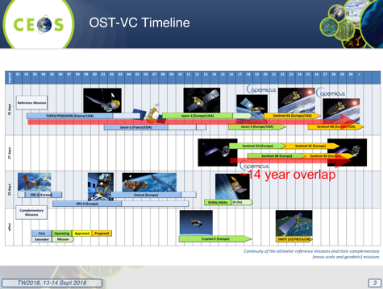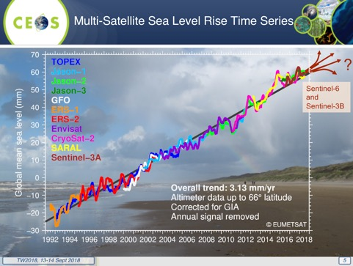
The current constellation User Requirement Document (URD) is the 2009 “Next 15 years of altimetry” report. An update is underway, with the objective to complete this work in 2018–2019. This has been supported by early work by CNES phase 0 study (mix nadir/swath, global UR analysis), and coordination CNES-ESA (swath altimeter for operational oceanography => URD SAOO). The contents of the update will likely address:
- Analysis of user needs: systematic + exploratory;
- Swath altimetry + nadir altimetry: combined;
- Recommendation for an “operational constellation” (targets: Copernicus Next Gen, China altimetry program);
- Recommendation for additional science missions in complement; and,
- Multiple applications: mesoscale monitoring, polar oceans, long-term record for sea level rise.
Remko noted that in future links with other observables (e.g. SST, OC) will be important for sustainability, and reviewed the status of the current OST-VC constellation.
- Sentinel-3B has been launched (27-day repeat cycle, 98.5º inclination), providing Altimetry, Ocean Colour, SST, and will be interleaved with Sentinel-3A ground-track end of 2018;
- Jason-2 moved to second end-of-life orbit (~400 days repeat) after first being moved to “geodetic orbit” in 2017, and has been interleaved with previous ground track since 18 July 2018; and,
- At time of Sentinel-3A launch it was planned to launch Sentinel-3B straight into its interleaved orbit, so no Sentinel-3A and -3B tandem mission, but with the help of ESA, EUMETSAT, and OST-VC recommended to management to have a tandem mission first. This was agreed, and is already paying off in detecting small inter-satellite (processing) differences.
Steve Volz (NOAA) asked if they are planning to add mention of links to the other ocean observables to the updated URD, and Remko noted that with the utility demonstrated by having three measurements on Sentinel-3, users are likely to add this to their requirements.
Further discussion also presented a challenge to OST-VC – to prepare deliverable(s) for the 2019-2021 CEOS Work Plan because the OST-VC is the only entity that does not have a single deliverable.

OSVW-VC
Stefanie Linow (EUMETSAT, OSVW-VC Co-Lead) reported, noting that the Ocean Surface Vector Wind Virtual Constellation (OSVW-VC) fosters the availability of best quality ocean surface vector wind data for applications in short, medium, and decadal time scales in the most efficient manner through international collaboration, scientific innovation, and rigor. Currently, the OSVW Constellation is mainly anchored by the scatterometer missions of EUMETSAT and ISRO, with a large number of upcoming Chinese scatterometer missions.
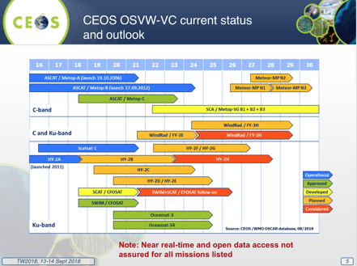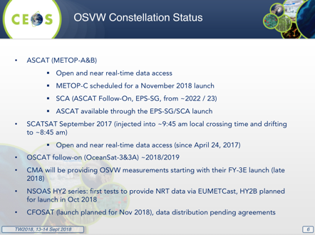
At least 3 scatterometers in orbit are designed to roughly meet WMO requirements (observations every 6 hours), with one instrument in a non-sun-synchronous orbit is for sampling the diurnal cycle, better mid-latitude sampling, and providing inter-calibration. A meeting was recently held with the Microwave Sensors SubGroup of WGCV Identify requirements for calibration/cross-calibration of scatterometers for OSVW to identify priorities for future work, organize the focus group, and plan future work.
Paul Counet (EUMETSAT) noted that there are discussions on a trilateral agreement with EUMETSAT, CNES, and CNSA underway around data exchange on CFOSat, and it is expected these data will be shared.

OCR-VC
Ewa Kwiatkowska (EUMETSAT, OCR-VC Co-Lead) highlighted the links between OCR-VC activities and the CEOS Work Plan.
3.1: Climate Monitoring, Research, and Services (contributions to GEO)
- Revision of OCR Essential Ocean Variables for GOOS (observational requirements);
- Planned update of OCR ECVs for the next GCOS IP (based on data record importance & availability);
- Lake ECVs under development (SIT-33-08 Feasibility study for Water Quality measurements); and,
- Recommendation for update of WGClimate OCR ECV inventory to include missing datasets during the cycle 2 gap analysis.
3.2: Carbon Observations, Including Forested Regions
- Recommendation for stronger emphasis on aquatic biology, biogeochemistry, ecology and harmonization with “CEOS Strategy for Carbon Observations from Space”; and,
- “Aquatic Carbon From Space” special journal issue under discussion at IOCCG.
3.5: Observations for Water
- IOCCG recent report “Earth Observations in Support of Global Water Quality Monitoring”; and,
- IOCCG reports – contribution to “CEOS Strategy for Water Observations from Space” and “CEOS Feasibility Study on Satellite Missions/Instruments Focused on Water Quality Measurements”.
3.7: Capacity Building, Data Access, Availability and Quality
- IOCCG Summer Lecture Series - 25 June - 6 July 2018 (Villefranche);
- IOCS-2019 Symposium development underway – 9-12 April, Busan, South Korea (NASA OCRT meeting 8 April 2019); and,
- Recommendation for COVERAGE to include variables beyond chlorophyll & increase spatial resolution <0.250.
Ewa reviewed the response to action SIT-33-08, noting that the CEOS Feasibility Study on Satellite Missions/Instruments Focused on Water Quality Measurements is harmonized with IOCCG reporting “Earth Observations in Support of Global Water Quality Monitoring”. She noted the strong requirement for consistent quality of EO data, including Analysis Ready Datasets (ARD) from many sources, e.g. Copernicus, USGS-Google Earth Engine, ESA, Calimnos (Globolakes) Open Data Cube, UNESCO WQ Portal, as well as in situ measurements for validation and product development. There is also a strong requirement for education, training, capacity building. All these requirements are being addressed by the IOCCG and OCR-VC.
The Feasibility Study has impact on OCR observational and mission requirements, particularly for dedicated radiometric quality, spectral coverage, and spatial resolution, though the group is looking for opportunities for coordination with other VCs/EO communities to harmonize observational requirements and develop joint mission requirements.
Ewa reviewed the recommendations generated in response to VC-09: International Network for Sensor Inter-comparison and Uncertainty Assessment (INSITU-OCR). She reviewed the work of the OCR-Implementation Team, which has pursued modular implementation of the White Paper. There are a number of coordinated cross-agency activities between NASA, ESA, CNES, NOAA, JRC, and EUMETSAT in support of System Vicarious Calibrations. The agencies are also working on collaboration on space instrument accuracy and stability to maximize the quality of OCR data records.
There has been support and promotion of geostationary OCR activities, with KIOST-GOCI first demonstrating the benefits of geoOCR. Early geoOCR activities are underway at various agencies, e.g. CNES OCAPI, NASA GEO-CAPE, and are reporting on accomplishments/lessons learned. This is of relevance to CEOS Strategic Directions, and the group is looking for coordination with other VCs/EO-communities for harmonization of observational and mission requirements.
Exploration of measurements beyond the passive multi-band radiometry is being coordinated across Agencies examining advantages of other measurements for aquatic biological/biogeochemical/ecological retrievals, e.g.: Hyperspectral spectroscopy – e.g. NASA PACE; Lidar – white paper in preparation, initial demonstrations with CALIPSO; and, Polarimetry – white paper in preparation, POLDER experience, PACE. They are looking for coordination with other VCs/EO-communities for harmonization of observational requirements and development of joint mission requirements, e.g. atmospheric communities (aerosols and clouds).
It was noted that the name of ocean color radiometry is a bit misleading because radiometry includes more than oceans – seas, coastal zones, estuaries, inland waters.
A brief discussion followed.
- Mark Dowell (COM) noted that from the perspective of the CEOS Carbon Strategy, the door is always open for new actions as the new CEOS Work Plan is prepared. He also noted that if the implementation of items in the Carbon Strategy could be improved, suggestions and advice would be welcome.
- Nancy Searby (NASA) asked about the target groups for capacity building efforts, and noted there is a possible overlap with WGCapD activities in this area.

P-VC
Steve Neeck (NASA, P-VC Co-Lead, via GoToMeeting), noted that the P-VC was one of the four prototype VCs established in 2007, and the original focus was on the GPM constellation coordination, summarized the P-VC Work Plan item status, as well as the status of CEOS Work Plan items VC-17 and VC-18.
- P-VC is planning a response to recommendation #14 in the 2018 ECV Gap Inventory Gap Analysis Report, with an update planned for SIT-34; and,
- NASA is in the process of effecting a change in the P-VC Co-Chairmanship through standard CEOS practices.
A brief discussion followed.
- Ivan Petiteville (ESA) thanked Steve Neeck for his leadership of P-VC over all these years.
- Steve Volz asked about the potential for small satellites for P-VC constellation continuity, and whether this might impact continuity gap analysis. Steve Neeck noted that it’s probably too soon to say, but there is promise, and it should be clearer in the next couple of years following a sustained evaluation of the technology.
Steven Hosford (ESA/CNES, CEO) noted the importance of reporting Work Plan progress in the deliverables database in preparation for CEOS Plenary. The deadline for these updates is the end of September.
SITTW-2018-06 | All Responsible CEOS Entities | Report WP progress in the CEOS Deliverables Database (ceos-deliverables.org) in preparation for CEOS Plenary. | 30 Sep 2018
 | Rationale: In line with SIT Chair priorities, close monitoring of CEOS's progress against the annual work plan is critical to ensuring a correctly functioning organization.

Freshwater from Space
Alex Held (CSIRO, SIT Vice Chair Team, via GoToMeeting) reported:
- A 3-day Freshwater from Space Workshop is proposed with the objective of providing CEOS Agencies with consolidated user requirements on parameters measurable from space that help in assessment of land-based freshwater characteristics and dynamics. The Workshop will focus on six water variables.
- There are three co-leads: Alex Held and Arnold Dekker (CSIRO), and Selma Cherchali (CNES), and a program committee of 25 experts. Invitees will be 40-50 experts drawn from the user community, technical experts in space-based Earth observation techniques, and international coordination initiatives.
- The meeting will be held 13-15 November at IHE, Delft, Netherlands, with support from Netherlands Space Office.
A brief discussion followed.
- Steve Volz (NOAA) asked about responses received and whether there is value in the Agencies encouraging participation. He asked if Alex can share the invitee list, then organizations can follow-up within their agencies.
- Steve also asked if the agenda had been shared, and Alex confirmed it had not yet been shared. Steve suggested sharing it may help to promote participation, and Steven Hosford noted that part of the objective of making it an invitation-only workshop was to ensure a focused discussion.
- Werner Balogh (WMO) noted their cross-cutting task team is meeting this coming week to discuss a proposal to draft a report on UN decadal ocean science applications, and encouraged linkages to this team and effort.
SITTW-2018-07 | CEO | Share the invitee list and draft agenda for the Freshwater from Space Workshop with CEOS SEC and other relevant Principals to encourage participation by Agency representatives. | 30 Sep 2018
 | Rationale: Agency support in securing registration of invitees.

Session 6: VC, WG, and AHT Sustainability

CEOS Resources Utilization
Steve Volz (NOAA, SIT Chair) reflected on the governance of CEOS, noting the related SIT-33 action (33-01) to, “Assess whether the CEOS Governance and Processes Document should be updated. Report to SIT Technical Workshop including (if required) a recommendation to be presented for decision at CEOS Plenary.” The rationale for the action is that the document is now five years old, and we should consider if we need updates to CEOS structure, operations, and processes in order to address the evolving goals of the organization. Steve briefly gave an overview of the CEOS governance documents.
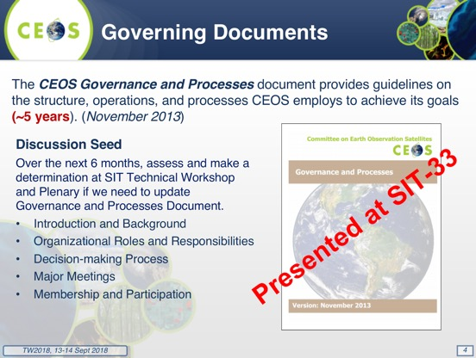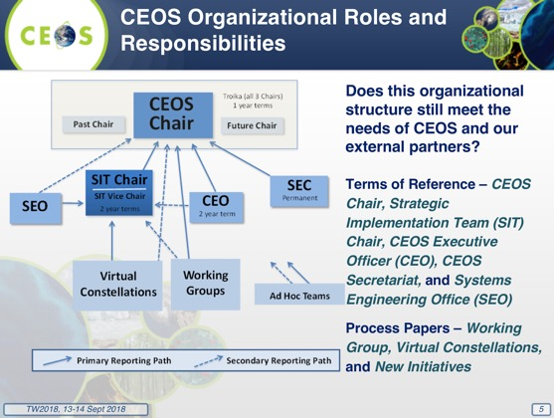
Steve provided an overview of the CEOS decision-making process from the Governance and Processes document with the objective of assuring CEOS selects the appropriate set of new activities to pursue and consistently meet its current commitments.
Steve reviewed the discussion following from SIT Action 33-05 to, “Provide an analysis of possible measures to: Improve consistency in processes across CEOS entities; Identify whether further tangible contributions to the CEOS Work Plan are possible; Ensure sustainment of resources across the groups.”
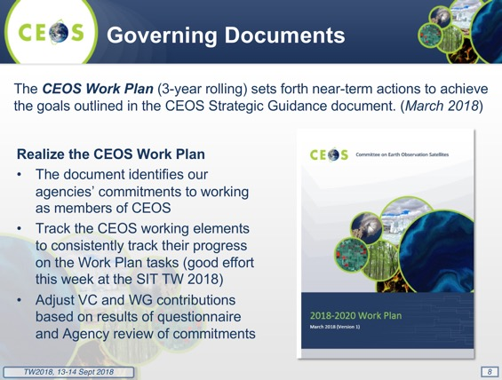
Steve reviewed some insights from VCs, WGs, and AHTs July tag-ups.
- How do VCs support and enable Agencies to make right decisions when CEOS does not have a budget - agencies do;
- CEOS is looking for translation and integration activities from VCs - are CEOS leaders asking the right questions of the VCs?;
- Tenure for individual VC Co-leads – assess the feasibility of proposing a formal VC Co-Lead Rotation scenario - Could rotation of Co-leads increase buy-in from community and encourage engagement? Or create same recurring difficulties in identifying WG leadership?;
- Consistency of climate variables and consistency across measurements – key coordination opportunity for CEOS - CEOS as a data integrator;
  - GEO Sec Director stated last week that space agencies have ceased to be the most important providers of data to GEO – now the data aggregators are more important; more important than getting the latest image from a space agency;
- Subsuming of AHTs to permanent WGs (FDA AHT as example);
- Expansion of scope of ARD to observations beyond land – where would ARD be best housed?;
- Increased coordination with other external partners such as CGMS – e.g. WGCapD is interested in collaborating with CGMS because of maturity in capacity building activities;
- Need to focus on space coordination for the identified requirements - Cross-agency, cross-sensor coordination;
  - Responsibility of Agency representatives participating in AHTs/AHWGs/and VCs to ensure sufficient connection to their agency colleagues to accomplish coordination tasks; all should be supported by Agency Principals;
- Definition of AHT success and plan for a sustainable existence are critical - requests from GFOI and GEOGLAM communities for commitments of CEOS support; and,
- CEOS-level assessment/mapping of which VCs/WGs/AHTs are/could address each of the EO-relevant SDGs and the sustainability of efforts.
Steve reviewed the question of how CEOS reports on Work Plan progress, and reviewed some of the historical approaches taken. He noted the history of changes, and the lack of process consistency, and reviewed a potential procedure for reporting and Work Plan development,
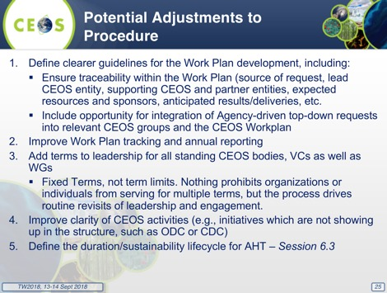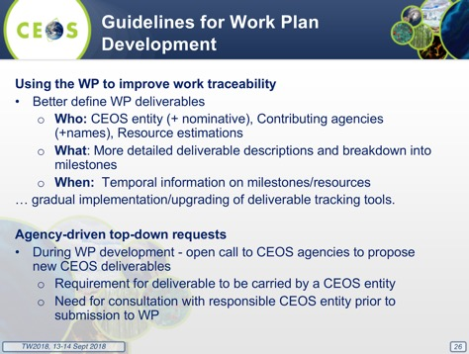
Steve proposed an action on CEO to propose a standard approach to CEOS WP progress report to plenary and “test drive” it this year. This would include reporting metrics would include all Work Plan deliverables. A Plenary focus would be on adjustments needed based on performance against plans to address those which do not report progress, and those which do not follow defined timeline. Ideally, this would include some assessment of the rationale for the performance shortfall (resources, change in direction, external factors, …).
Steve also reviewed a suggestion to establish Leadership Terms for all CEOS Standing Elements, suggesting updating virtual constellations reference paper to include governance, including leadership selection.
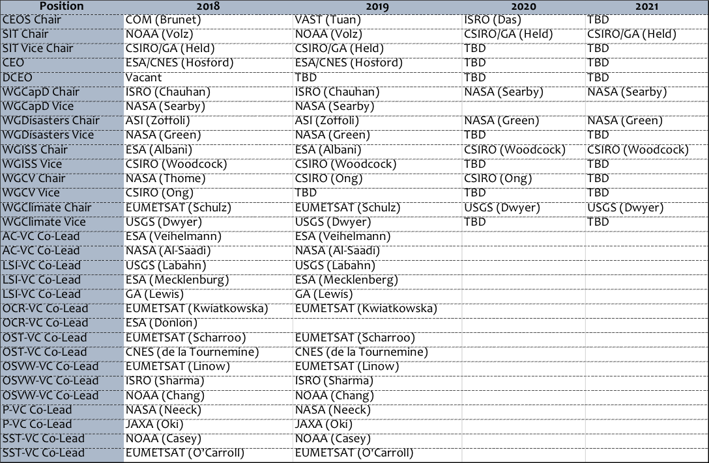
A brief discussion followed.
- Brian Killough (NASA, SEO) noted that the CEOS Deliverables website is not always kept up to date (www.ceos-deliverables.org/task_manager/tasks), and some cases points of contact are not assigned.
- Steve stressed that the Work Plan needs to be kept updated, and that it is an important public document for CEOS.
- Steven Hosford (ESA/CNES, CEO) noted that the Deliverables website reflects the current CEOS Work Plan.
- Steve Labahn (USGS) noted that a clear expectation for success (e.g. tangible outcome) for each of the Deliverables would be helpful and opportunities to report more frequently for VCs would be useful, Steve Volz suggested a need to keep visibility on deliverables up throughout the year, not just during SIT meetings and Plenaries.
- Ivan Petiteville (ESA) noted that initially reporting was a challenge due to a lack of tool, but the tool has not changed the reporting response. When he was CEO, he did a lot of the follow-up and status updates himself (e.g. emails, phone calls). He noted something similar has been seen with the GEO Symposium, and there they have suggested that active management is required.
- Adam Lewis (GA) noted that CEOS has structured itself organically, and this does have some advantages including the spreading of risk and resources. Becoming more codified in practice can sometimes get in the way of the overall goal of aligning our efforts.
- Jonathon Ross (GA) noted that if this is going to be put to Plenary, then more clarity and a very explicit ask will be required to ensure that Principals understand the resources that will be required. He noted that top-down activities should be tabled and discussed at SIT, and then Work Plan endorsement should be sought from Plenary. Steven Hosford (ESA/CNES, CEO) noted that this is what is being proposed, and a new activity would not get into the Work Plan without endorsement and a resource confirmation. It is important that we consider tracking and reporting at Plenaries to empower Principals to take responsibility for the deliverables and to highlight that if the deliverable is important to CEOS and to agencies, then the agencies will need to properly resource their people to complete the tasks.
- Brian proposed working with the CEO to look at the current database and put forward some options for improvement in information and reporting.
- Mauro Facchini (COM) asked about what will be proposed at Plenary, and what specific changes are being requested. Steve Volz noted that VC lead terms and a process reorganization are the main items.
- Nicolaus Hanowski (ESA) noted that the process structure may have become too complex, and that much of the process has been driven by individuals and individual decisions. He suggested making activities more specific and assigned to specific individuals.
- Mark Dowell (COM) noted the example of the CEOS Carbon Strategy implementation, with a distributed Work Plan and a thin coordination layer.
SITTW-2018-08 | SEO CEO | Review the CEOS Deliverables Database, including linkages to GEO WP, and suggest improvements in information and reporting via CEOS SEC. | SIT-34
 | Rationale: Significant scope for consistency improvements year-to-year identified in analyses presented at SIT TW.

SITTW-2018-09 | CEO SIT Chair | Review and revise reporting and tracking practices for CEOS WP activities. | SIT-34
 | Rationale: Significant scope for consistency improvements year-to-year identified in analyses presented at SIT TW.

Ad hoc Team (AHT) Lifecycles
Stephen Ward (SIT Chair Team) summarized the response to action SIT-33-11 to, “Include CEOS ad hoc Team lifecycle and processes as an agenda item on 2018 SIT Technical Workshop.” The objective was for CEOS to address inconsistencies in the operation of different types of groups across the structure.). He noted that a discussion paper was prepared to respond to the action, and this has been posted on the Workshop website.
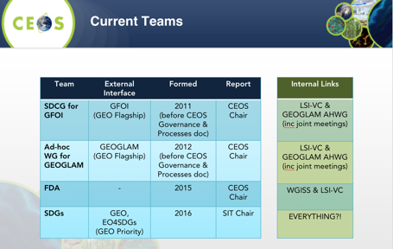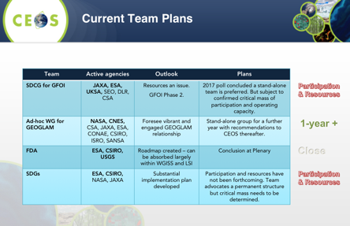
Stephen noted that the AHTs have provided an effective and efficient mechanism to scope and progress new topics for CEOS and there have been some consistency improvements lately in processes and reporting across the VCs, WGs, and AHTs. There is likely further scope for consistency in reporting - e.g. a curated reports item to monthly SEC that covers all CEOS groups.
Three of the current AHTs propose to progress:
- SDGs has lots of plans but needs participation and capacity;
- GEOGLAM wants a year’s grace to formulate way forward; and,
- SDCG is shaping its role within GFOI Phase 2 & taking stock of agency participation and support.
Current annual processes should be adequate for review but perhaps need more active application and management.
SITTW-2018-10 | Co-Leads of SDCG, GEOGLAM AHWG, SDG AHT | Prepare to request a one-year extension to their term or present preferred options of continuity at CEOS Plenary. | CEOS Plenary
 | Rationale: These three groups have indicated a desire to continue operations and have identified a preferred path forward.
Steve Labahn (USGS) then gave a presentation on proposal for the future of SDCG, GEOGLAM, LSI-VC, and FDA. He summarized the discussion at the joint LSI/SDCG/GEOGLAM meeting the week prior to the SIT TW in JRC that impacts the way forward for some of the ad hoc Teams. He noted that SDCG for GFOI and GEOGLAM teams are “ad hoc”, yet have existed for many years and have demonstrated significant contributions to GEO flagships. The continued annual approvals create uncertainty in the CEOS support to GEO Flagships. Most agree that there is a need for a permanent solution.
He reviewed the three options considered during the joint meeting:
- Status Quo – Continued annual renewal of ad hoc Teams;
- Create one (or more) new WGs or VCs to address Forests and Ag; and,
- Merge Forest/Ag groups into LSI-VC (now or later).
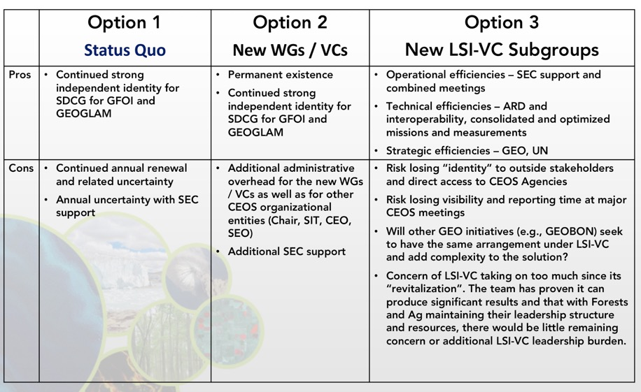
The proposed solution is summarized as:
- LSI-VC: maintains existing work (ARD, Interoperability), adds new Forests and Ag subgroups;
- SDCG for GFOI: transition to a new LSI-VC Forests Subgroup;
- GEOGLAM: transition to a new LSI-VC Ag Subgroup; and,
- FDA: transition with tasks moved to WGISS, LSI-VC, and SEO.
Steve outlined the proposal for reporting and meetings, noting that the topical subgroups (Forests and Agriculture) continue to have their own focused meetings, as needed, and we would continue an annual joint meeting, bringing together LSI-VC, Forests, and Agriculture groups together. The Forests and Agriculture Subgroup reports to CEOS Plenary would be made as part of the GEO session (reporting on GEO Flagship contributions). He reviewed the timeline for the proposal:
- SIT-TW (September 2018): Present proposal for review and comment;
- Plenary (October 2018): Request annual renewals for GEOGLAM and SDCG for GFOI, and review proposal and prepare for a decision to merge groups into LSI-VC with an updated LSI-VC Terms of Reference to follow;
- SIT-34 (April 2019): Present a new LSI-VC Terms of Reference for review; and,
- Plenary (October 2019): Final decision
A brief discussion followed.
- Kerry Sawyer (NOAA) noted that Working Groups require a letter from a prospective Chair candidate agency confirming agency commitment to WG leadership and resources required for secretariat support, if secretariat support is required by the candidate agency (not all WGs require a secretariat), while this is the not the case for ad hoc Teams and Virtual Constellations. This is identified in the Working Group Process Paper. She suggested that if the requirement exists for a formal secretariat for the LSI-VC, it could be confirmed in a similar way. She did not imply that all VCs and AHTs would be required to commit to having a funded and resourced secretariat but instead offered an option to ensure that the secretariat funding, which appears to be required for the LSI-VC and the two subgroups, be committed by agencies willing to lead the LSI-VC.
- Steve Labahn noted that the secretariat support should not be a driving factor, but should be up to the VC or AHT based on whether they see benefit to pursuing the group’s objectives.
- Steve Volz noted that if VCs require secretariat support, this may need to be codified in CEOS governance.
- Mark Dowell (COM) noted that whether secretariat support is required or not for an AHT does not appear to be formally defined in the CEOS Governance documents. Investments in capacity to achieve the AHT’s objectives and should be left up to the Team and the Agencies backing the effort.
- Mark noted that the lack of consistency in reporting (e.g. from the VCs) means that important topics may be missed. He suggested that CEOS Chair and SIT Chair could gather requests for input to SEC teleconferences from WGs, VCs, and AHTs, and decide which items there is time to report on.
- Brad Doorn (NASA) noted the reason the GEOGLAM ad hoc WG wanted to take a year to confirm its continuity plans was to share the proposal with the GEOGLAM Project Office and let them provide feedback on the change, and to coordinate it with other changes to GEOGLAM governance. This one year does not relate to CEOS internal processes, but more broader community consultation on the change.
- Brad noted the WGDisasters model successful and that we have a freshwater meeting that might turn into a water cycle activity, and questioned how to address these future issues and obtain guidance up front.
- Brian Killough (NASA, CEOS SEO) commented on the need for secretariat support, noting it is up to ad hoc Teams to decide what they need to progress their goals. The current discussion is focused on the 6-7 year term for these groups, and the need for a permanent home. He would not support VCs having a permanent secretariat requirement, as there is a need to maintain the flexibility there. He also supported Steve Labahn’s option 3, and the idea of bringing the groups together once a year to discuss common issues.
- Ivan Petiteville (ESA) supported Brian’s comment, noting as a former WGISS and WGDisasters Chair, the cost of secretariat support has been an issue in ensuring continuity. The different WGs and VCs have different workloads and work at different paces, and it is risky to impose systematic requirements for support, as it may rule out some agencies. Ivan would prefer to give AHTs and VCs the choice about how they organize, otherwise this may mean some agencies can’t take on leadership roles and give flexibility that may be beneficial to CEOS.
- Tim Stryker (USGS) also supported Brian and Ivan, noting this discussion is evidence of a very successful conversion of a VC, as it provides strength for LSI-VC going forward, and also addresses the issue with two AHTs. He also supports Steve Labahn’s Option 3.
- Adam Lewis (GA) also supported Brian and Ivan, and is looking for an arrangement that allows LSI-VC to continue its transformational work such as CARD4L and interoperability. He noted that the next tasks are requirements and gap analysis which will involve close work with thematic teams.
- John Remedios (UKSA) agreed with Adam, and noted that the groups should be focused on outputs and outcomes, and decisions around the support model (e.g. secretariat) should remain independent and not a firm requirement.
- Mark confirmed that the Commission also supports Option 3.
Steve Volz noted that he agrees with the benefits around operational efficiencies in LSI-VC, SDCG and GEOGLAM AHWG but worries that we are creating an operational VC. Steve Volz noted the next example could be an operational oceanography entity, and we need to take any next step fully aware of the currently ongoing discussions. He agreed with the timeline presented, and noted there is also a need to define success criteria for an operational VC.
SITTW-2018-11 | Co-Leads of LSI-VC, SDCG, GEOGLAM AHWG | Bring to CEOS Plenary the proposed path for the new structure for the three groups’ activities. | CEOS Plenary
 | Rationale: The joint meeting at JRC had significant debate and provided a recommendation for the GFOI and GEOGLAM AHTs to be housed under LSI-VC within the year.

Session 7: Partnerships

Engagement with GEO
Kerry Sawyer (NOAA, SIT Chair Team) reported, noting that the lead agencies of the three GEO Work Plan initiatives and community activities need to prepare task summaries and provide the summary to the GEO Secretariat as soon as possible.
Foundational Tasks
- GEOSS Satellite Earth Observation Resources [Lead & Contributor (NOAA and ESA/CNES)]
- Capacity Building Coordination [Lead & Contributor (NASA, USGS)]
Community Activity
- Earth Observations for Disaster Risk Management [Lead & Contributor (ASI)]
Kerry noted that GEO-XV Plenary will take place 29 October to 1 November in Kyoto, Japan with the CEOS Delegation being:
- Pham Anh Tuan as Head of Delegation; and,
- Kerry Sawyer, Steven Hosford, Brian Killough.
A CEOS Booth will be coordinated by Brian Killough, and the following CEOS Side Events will be on 30 October. There will be CEOS side events focused on applying the Open Data Cube Technology to the Sustainable Development Goals, organized by Jonathon Ross, and Earth Observations for Disaster Risk Reduction organized by WGDisasters. Additionally, Kerry encouraged all to attend the SDG side event to support CEOS contributions to the EO4SDG initiative.
Kerry noted a GEO Expert Advisory Group (EAG) has been established to advise the GEO Secretariat Director, with 25 persons from academia, space agencies, other GEO Members and Participating Organizations. It will meet in conjunction with GEO Programme Board meetings through to 2019 Plenary.
Kerry noted that GEO Secretariat Staffing is reorganizing responsibilities which may have direct effect on CEOS. She briefly reviewed the GEO Work Programme update schedule.
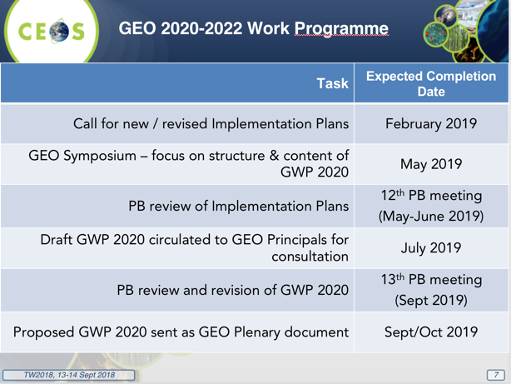
Christine Bognar (NASA) noted there may be an opportunity with the new GEO leadership to revisit some of the discussion around support to activities like GFOI or GEOGLAM, and it was agreed that it would be valuable to extend a personal invitation to Gilberto to attend Plenary, Kerry also suggested it would be helpful to include a reminder of the annual CEOS-GEO Work Planning coordination meeting in February in the letter.
Brian Killough (NASA, SEO) reminded the group that he is organizing a CEOS booth for GEO Plenary, and would welcome suggestions for content.
SITTW-2018-12 | CEOS Chair | Invite GEO Secretariat Director to CEOS Plenary to underscore the desire for a CEOS-GEO leadership-level dialogue and encourage continuation of annual bilateral CEOS-GEO meeting. | 21 Sep 2018
 | Rationale: GEO Secretariat Director has changed and CEOS should stress the convention of the CEOS-GEO engagement and yearly Work Planning meeting.

SITTW-2018-13 | SIT Chair CEO | Manage process of review and submission of CEOS written statement and interventions for GEO Plenary. | CEOS Plenary
 | Rationale: Ensure clarity on CEOS positions in the context of changes to GEO direction under new GEO Secretariat Director.

GEO-LEO Activities Update
Dan Lindsey (NOAA) reported, noting there were several SIT-33 actions regarding GEO-LEO.
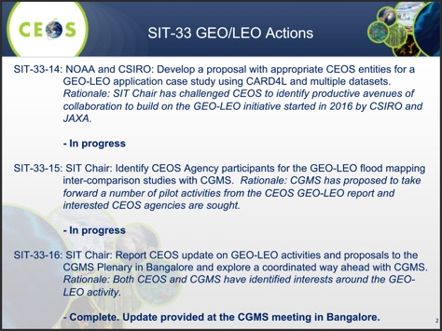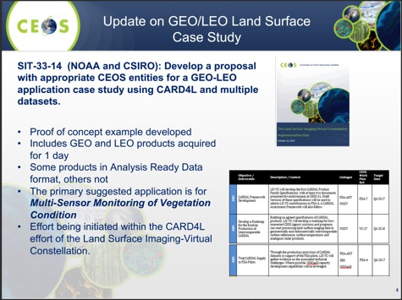
Dan noted the next steps for the SIT-33-14 action were to: consider extending prototype to 20 days to allow for comparisons of greenness change; VCs and WGs are requested to consider their respective contributions (e.g., additional data/products) for the next step, a formal proposal as requested in response to SIT-33-14; and, coordinate with CSIRO and consider another case study in their region of interest.
Regarding the Flood Monitoring Initiative, some comments and suggestions arose from recent Side Meetings, including working with WGDisasters on a flood pilot, considering additional data sources beyond just VIIRS and Geo Imagers (e.g., SAR), coordinating with WGCapD, and involving GEO.
SITTW-2018-14 | NOAA | Coordinate with WGDisasters and WGCapD on the flood monitoring initiative for GEO-LEO. | SIT-34
 | Rationale: Significant potential and interest identified during the SIT TW.
Dan reported on SIT-33-15:
- Vietnam has expressed interest in participating. Will provide SAR data sets to help address challenges in tropics;
- JAXA recommends engaging JMA – this will be done at the Asia Oceania Meeting in Indonesia next month (KMA will be engaged too); and,
- Planning to discuss with Vietnam and Indonesia at AOMSUC in Jakarta from user perspectives.
Dan reviewed some next steps on GEO-LEO:
- Finalize LSI-VC CARD4L proposal to present to Plenary factoring in CSIRO interests in a second case study in their area;
- Coordinate possible participation by WG Disasters and WGCapD, VNSC, JMA, KMA, others on Flood Mapping Project and report Progress to Plenary and to CGMS; and,
- Survey VCs on examples of other possible GEO/LEO blended products of interest.
Adam Lewis (GA) noted the potential of future GEO-LEO fire applications.
Steve Volz (NOAA) suggested we need to consider how the GEO-LEO activity would sit within the CEOS structure if it becomes permanent.
SITTW-2018-15 | SIT Chair | Develop a transition plan, as appropriate, for sustained GEO-LEO activities into existing CEOS entities. | Draft for SIT-34  Final for SIT TW 2019
 | Rationale: GEO-LEO initiative is seen as a future priority by SIT Vice Chair and we should ensure consistency with the process improvements under discussion.

WGCapD Capacity Building Activities
Nancy Searby (NASA, WGCapD Vice Chair) presented, noting WGCapD’s linkages to CEOS Work Plan with 11 deliverables, and providing a brief status update.
Global Activities: CB-28, 30, 31: MOOCs on Radar Backscatter, SAR applications, LCLUC - expected in 2019; and, CB-29: Webinar series on multiple topics, e.g. GEOGLAM and disasters.
Regional Activities (training in GEO regions); CB-20 AmeriGEOSS; CB-26 AfriGEOSS; CB-27 AOGEOSS; and, CB-32: Regional hands-on training in land cover land use change.
Nancy reviewed some of the outcomes from CGMS VLab including around the training calendar, resource library, and best practices. They agreed to share numerous best practices, e.g. training methods, translation approaches, use of Creative Commons license, and discussed how to take the training networks (WMO/CGMS VLab, CEOS WGCapD, UN space education and training, GEO) that overlap but have different missions and work in concert. They agreed to follow progress on WMO Global Campus’ implementation of their resource library revision expected fall 2018, VLab’s approach to entering resources, and learn from them while exploring other approaches with WGISS, to meet periodically, e.g. every 6 months, and to pursue implementation of EUMETSAT implementation of training calendar used also by VLab and WMO Global Campus.
Nancy noted they agreed to pursue implementation of EUMETSAT implementation of training calendar used also by VLab and WMO Global Campus, and will bring this to Plenary for consideration. There will be a white paper for discussion regarding engaging partner CB networks, looking at space agencies with presence in developing regions, and international organizations (e.g. UNOOSA, UNESCAP, GEO, CGMS, WMO).

Session 8: Work Plan and Closing
CEOS Work Planning
Steven Hosford (ESA/CNES, CEO) reviewed the purpose of the CEOS Work Plan, noting that it is one of CEOS’s four Governing documents, and records the near-term actions of all CEOS entities. There is a focus on ensuring Work Plan deliverables are consistent with CEOS goals and are achievable, defined in agreement between the CEOS entities (actionees) and CEOS leadership (Principals). Deliverables are considered for termination if they are no longer aligned with strategic goals, no longer benefit stakeholders, or are no longer feasible or affordable.
To enable Plenary reporting, CEOS 2018-2020 Work Plan updates should be provided by all CEOS entities by 30th September, with the Plenary report focused on overview and statistics and issues for specific attention. CEOS entities submitting WP deliverables are asked to indicate links to GEO Work Programme elements where applicable.
Steven reviewed some suggestions to improve the tracking process that have been put forward:
- More frequent email reminders from CEO? (past year approx. 1 per month);
- Scheduled 15/30 minutes telephone calls (between 30th November - 15th December) to provide leads with a “hard deadline”;
- Regular reporting into SEC on feedback status;
- Provide CEOS entity leads with more visibility on WP development schedule; and,
- Provide a clear message to CEOS entity leads on when their input is required – a “Heads up” to be communicated at all WG/VC/AHT meetings.
Steven reviewed the annual Work Plan update cycle.
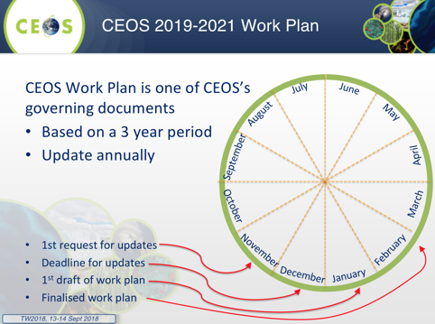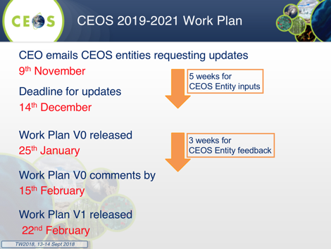

A brief discussion followed.
- Ivan Petiteville (ESA) noted it would be helpful to identify which CEOS deliverables are supporting the three GEO engagement priorities.
- Mark Dowell (COM) noted that WGClimate does not have a direct interface to GEO (e.g. no SBA), and the GEO workshop earlier this year was focused on mitigation, where WGClimate is focused on monitoring. Steve Volz) noted this is a complementary response.
- Ken Casey (NOAA) noted there may be areas for the SST-VC is supporting GEO, but their focus is also on monitoring and so the linkage is not strong.
- Steve Labahn (USGS) also agreed the same for LSI-VC, but linkages to GEO are harder.
- Kerry Sawyer (NOAA) noted that the activities the VCs accomplish are in support of GEO under the GEOSS Satellite Earth Observation Resources Foundational Task, and Ken agreed that the high-level connection is there, but it is a challenge to make detailed connections.
The timeline for update proposed by Steven was agreed.

Plenary Decision Items
Steve Volz (NOAA, SIT Chair) presented a summary of items gathered from Workshop presentations and discussion that are for likely decision at Plenary.
CEOS Carbon Strategy
- Confirm the interest in pursuing a structured collaboration between CEOS and CGMS in the area Greenhouse Gas observations and monitoring;
- Confirm that the options considered for this collaboration, present, are representative of those available through the technical entities within the organizations;
- Agree that the identified proposed solution is appropriate, and that the implications of its implementation are understood and acceptable (including those relating to resourcing and Agency participation); and,
- Agree that the proposed timeline for implementation are appropriate and that the draft ToR and governance/leadership arrangement are acceptable.
AC-VC GHG White Paper «Endorsement» language
Language from 2014 endorsement of the CEOS Carbon Strategy, provided solely as template for language to be considered for proposed endorsement of the AC-VC GHG White Paper - “Plenary endorsed the CEOS Strategy for Carbon Observations from Space. It was emphasized that the "actions" contained in the report should be interpreted as recommendations. A study of their implementation feasibility, including an assessment of compatibility with CEOS resource availability and oversight arrangements, will be carried out by an ad hoc Carbon Strategy Implementation Study Team (SIT actions 29-14 and 29-15).”
Digital Earth Africa
A new Steering Committee has been formed to serve as an advisory body to Digital Earth Africa (new data cube initiative) to provide inputs and recommendations on institutional arrangements, stakeholder engagement and operational plans. They have specifically requested that Brian Killough (NASA, SEO) be the CEOS representative on the Steering Committee due to relevant experience with the Africa Regional Data Cube (ARDC). This is seen as a prototype to Digital Earth Africa. NASA supports this role.
A brief discussion followed.
- David Crisp (NASA) suggested acknowledging that both WGClimate and AC-VC will be involved in progressing the AC-VC GHG White Paper.
- Kerry noted the need to be clear that ‘endorsement’ of the White Paper is not seen to commit agency resources to its implementation.
- The Digital Earth Africa representative nomination request from Brian Killough will be taken to Plenary during the SEO report.
- Mark suggested that we need to consider how we might address requests we expect incoming from GEO on biodiversity, and Steve Volz suggested we address that during a SEC meeting.

Review of Actions
Stephen Ward (SIT Chair Team) lead a review of the actions agreed at the Workshop.

Incoming CEOS Chair Priorities
Vu Anh Tuan (VNSC) presented a summary of their CEOS Chair priorities for 2019, noting that the first priority will be to ensure continuity of identified CEOS priorities, including:
- Land Surface Imaging and its applications through LSI-VC activities, including Analysis Ready Data;
- CEOS support to GFOI and GEOGLAM;
- CEOS Data Cube (CDC) activities;
- Laying the foundation for an international CO₂ and GHG emission monitoring system to make a fundamental contribution to monitoring CO₂ and other GHG emissions globally; and,
- Following the recommendations on Future Data access and analysis Architectures (FDA).
Tuan noted VNSC would like to reduce complexity and difficulty of handling large and technical datasets via initiatives like Analysis Ready Data, Open Data Cube, and by leveraging Copernicus Data Information Access Services. They would like to advance the Vietnam Data Cube (VDC), with a focus on applications related to forest monitoring, rice monitoring and Water quality monitoring, with a goal of expanding VDC to a Mekong river basin regional scale activity.
Objective: to enhance contribution and cooperation of the CEOS agencies in the region, to identify potential Earth Observation users and to respond effectively to their needs by achieving integration across the full range of Earth Observations, by promoting the sharing of CEOS agency data, and by improving access to and use of such data.
The two themes for applications will be:
- Carbon Observations: including forested regions: to coordinate EO observations to support the effective monitoring and management of the forests in the region, through its ad hoc Space Data Coordination group for GFOI, in support of the development of national forest monitoring and measurement, reporting and verification (MRV) systems
- Observations for Agriculture: in line with the CEOS ad hoc Working Group on GEOGLAM, and within the GEOGLAM Asia-Rice regional network, a key focus will be addressed on the practical use of CEOS data, especially SAR for rice crop monitoring in Asia.
There will also be related activities for training and capacity building, and building a regional observatory.
A brief discussion followed.
- Astrid Koch (COM) welcomed the initiatives from VNSC and looks forward to supporting implementation.
- Brian Killough (NASA) noted the broad range of activities the VNSC plan addresses, and also looks forward to supporting.
- Steve Volz (NOAA) asked about the VN Data Cube, and whether there is a SE Asia Data Cube in planning or discussion. Tuan noted that the Mekong River Commission (MRC) is seen as a suitable counterpart for a multiple country pilot, and VNSC and the MRC are progressing a supporting MOU.

CEOS Plenary Preparations
Astrid Koch (COM, CEOS Chair Team) reported that the Plenary will take place 17th-18th October 2018, with the 16th of October for side sessions, in Brussels at the Palais des Congrés. Participants are to register on the CEOS website as soon as possible: http://ceos.org/meetings/32nd-ceos-plenary/ A logistics document is available on the CEOS website, and hotel reservations should be made as soon as possible.
Plenary objectives will include:
- a review CEOS carbon efforts, including the CEOS Carbon Strategy actions that have been taken forward by various CEOS groups (e.g. AC-VC GHG Constellation White Paper, GFOI/SDCG, the way forward organizationally on GHG observations coordination, including with CGMS as appropriate);
- confirm the way forward on the GEO-LEO initiative, and next steps for the FDA tasks; and,
- evaluate and provide direction for the CEOS Virtual Constellations and Working Groups and their activities and provide guidance on CEOS support to other key stakeholder initiatives where required.
There will be a Plenary session to provide an opportunity for agencies to speak about their plans and strategy in relation to CEOS, and requests for Agency and Partner updates are invited by Friday the 21st of September.
Adam Lewis (GA) asked if the agency reports are open to both CEOS Members and Associates, and Mark confirmed that both are invited to present. Steve Volz asked for guidance around the agency report duration, and Astrid noted the expectation was approximately 10 minutes.

SIT Chair Closing Remarks
Steve Volz noted SIT-34 will be held 1-5 April 2019, University of Miami, Miami, Florida in the Norman Alumni Center. He closed the Workshop with thanks to EUMETSAT and Paul and Sylwia’s team for their generous hosting.

APPENDIX A
Attendees
Organization | Name | Organization | Name
ASI | Simona Zoffoli | NASA | Brian Killough
COM | Mauro Facchini | NASA | David Borges
COM | Michael Berger | NASA | Brad Doorn
COM | Mark Dowell | NASA | David Jarrett
COM | Astrid Koch | NASA | Christine Bognar
CSA | Paul Briand | NASA | Andrew Mitchell
CSIRO | Alex Held (GTM) | NASA | Steve Neeck (GTM)
DLR | Albrecht von Bargen | NASA | Vardis Tsontos
ESA | Mirko Albani | NASA | Jorge Vazquez
ESA | Marc Paganini | NASA | David Crisp
ESA | Ivan Petiteville | NASA | Nancy Searby
ESA | Nicolaus Hanowski | NASA | Kurt Thome
ESA | Ben Veihelmann | NASA | Argyro Kavvada
ESA/CNES | Steven Hosford | NOAA | Steve Volz
EUMETSAT | Paul Counet | NOAA | Kerry Sawyer
EUMETSAT | Robert Husband | NOAA | Kenneth Casey
EUMETSAT | Ewa Kwiatkowska | NOAA | Dan Lindsey
EUMETSAT | Jörg Schulz | NOAA | Albert DeGarmo
EUMETSAT | Stefanie Linow | NOAA | Jeffrey Privette
EUMETSAT | Remko Scharroo | NOAA | Charles Wooldridge
GA | Adam Lewis | NOAA | Stephen Ward
GA | Jonathon Ross | NOAA | George Dyke
GCOS | Carolin Richter | UKSA | Bertie Archer
GEO Secretariat | Akiko Noda (GTM) | USGS | Steve Labahn
JAXA | Osamu Ochiai | USGS | Jenn Lacey
JAXA/RESTEC | Masatoshi Kamei | USGS | Tim Stryker
NCEO | John Remedios | VNSC | Vu Anh Tuan
 |  | WMO | Werner Balogh

