STATUS OF GFOI AND THE CEOS ENGAGEMENT

Version 1.1, 28 August 2018

IN SUPPORT OF SIT TW DISCUSSION

Introduction
This discussion paper has been developed to inform a discussion among CEOS agencies interested in supporting the CEOS engagement with GFOI. Whilst GFOI has been developing momentum and support through its evolution to a ‘Phase 2’, the CEOS agency participation and capacity for its group appointed to interface to GFOI - the dedicated Space Data Coordination Group (SDCG) – has been reducing.
With the discussion on Ad-hoc Teams at the coming SIT TW, with the development of a new SDCG 3-Year Work Plan, and with the context of the GFOI Phase 2, it is an opportune time to renew the CEOS engagement and to take stock of what resources are available going forward – and therefore the optimal structure for our participation.
Context
CEOS was a founding partner of the GFOI initiative, dating back to our active participation in the GEO Forest Carbon Tracking (FCT) task more than 10 years ago. The effort has been directed by a Space Data Strategy developed to ensure the necessary data flow from CEOS missions to national forest monitoring systems. Achievement of the necessary annual global baseline coverage for all countries to report to UNFCCC was a major milestone claimed by SDCG in 2017 with the availability of several core data streams such as Landsat-8, Sentinel-1, Sentinel-2 and the annual mosaic of ALOS PALSAR. The space data strategy has also resulted in:
- Provision of available coverage information for individual countries;
- Dedicated support to select countries for identification and access to the data necessary for their national reporting;
- Ongoing operation of a data scheme for support of GFOI R&D activities, including data that might otherwise be available on commercial terms.
Further outcomes that have resulted from the SDCG Work Plan are:
- Establishment of EO pilot activities – notably in Colombia and Vietnam, for the establishment of CEOS Data Cube systems in support of national forest monitoring systems; Colombia are advancing particularly well and expect to base their entire operational system on the basis of the CEOS pilot;
- Joint capacity building workshops with the USGS SilvaCarbon programme to help progress individual country practitioners on their journey with application of EO data for forest monitoring;
- Initiation of a new GFOI Early Warning module, aimed at ensuring consistent and comparable approaches to the multiple systems emerging to avoid deforestation, and which heavily rely on EO satellite data.
For the CEOS agencies concerned, GFOI provides a well-managed and coherent community interface that helps direct their forest and climate-related programmes.

Phase 2 of GFOI

GFOI has entered its second Phase with a refreshed structure and stronger focus on user countries. The logic of the GFOI Methods and Guidance and IPCC-compliant methods appears to be extremely appealing to the major forest donor countries and institutions with UK, Norway and Germany all declaring intention to utilise GFOI processes to direct and coordinate their respective activities and funding. ESA, World Bank and UK have also joined as a lead in the second phase. The World Bank declared itself willing to co-lead the new Data Component alongside CEOS. The recent Data Component planning meeting in Tokyo has provided a common sense of purpose among GFOI Partners in moving into GFOI Phase 2 and understanding the role of space data, along with a greater emphasis on the tools and services to help countries access and apply the data.

Overall, the future for GFOI looks extremely vibrant as it attracts donor activity and the central role of CEOS in ensuring the global annual baseline coverage is broadly recognised. CEOS puts the ‘O’ in GFOI.
SDCG EXEC has long maintained a 3-year Work Plan for SDCG in order to communicate its activities within both GFOI and CEOS. This has recently been updated (currently draft) to reflect the directions and emphasis apparent in Phase 2 of GFOI and the needs and opportunities for space data. The main threads of the new Work Plan being:
- Continuation of the global baseline coverage, but with expansion to include the new generation of biomass instruments, seeking to accelerate the policy-relevance of these data-streams including through early provider-user dialogue; this includes: SAOCOM series (CONAE); TanDEM-L (DLR); NISAR (ISRO and NASA); BIOMASS (ESA); GEDI and MOLI lidars (NASA and JAXA); ALOS-4 (JAXA); ICESAT-2 (NASA);
- Greater emphasis on tools and services for discovery, access and application of the data – within the GFOI framework to develop shortlists of recommended data and tools;
- Including technical exchange opportunities among GFOI countries on issues such as CEOS Data Cube for forest monitoring;
- Support to the new GFOI Early Warning activity, which will be critically dependent on space data supply;
- Establishment of a GFOI reference community for feedback and engagement in CEOS Analysis Ready Data standards and pilots;
- Coordination with the GFOI R&D Component on a new R&D programme to address technical obstacles to space data application.
SDCG sees significant benefits for CEOS and space agencies with an active interest in forest monitoring through our active participation in GFOI, as it develops a critical mass in Phase 2. This includes close engagement with IFIs such as World Bank for sustainment of country capabilities, as well as the logical links through to IPCC and UNFCCC thanks to the GFOI Methods and Guidance.
SDCG Participation and Capacity
The CEOS contribution to GFOI, managed by the dedicated Space Data Coordination Group (SDCG), benefited enormously from the contribution of the Govt of Australia in the period from set-up of SDCG at the Lucca CEOS Plenary in late 2011 through to the Brisbane Plenary in late 2016. That budget provided substantial resourcing of up to 0.5 FTE (full-time equivalent) for the management and execution of SDCG business, and the contributions of CEOS agencies in addition were built upon and around that foundation. With the loss of that resource, CEOS must adapt to the new geometry and realities of capacity to ensure a sustained, effective interface to GFOI.
The availability of the budget for SDCG SEC has resulted in the SEC undertaking a larger than usual share of responsibilities of the group, some of which might normally be undertaken by the Co-Chairs. These resources, combined with a detailed Work Plan and a highly functioning EXEC (extended management group) might be regarded as the driving force behind the SDCG achievements thus far. SDCG SEC has also served in the capacity of Space Data Component Manager, which is a formal title within GFOI for reporting to Component Meetings and to the GFOI Leads Team.
To help clarify the debate on the way forward, the current SDCG SEC has volunteered to step down from both SEC and Data Component Manager duties at CEOS Plenary – having contributed substantial time voluntarily since loss of Australian funding in late 2016.
As of July 2018, the SDCG EXEC membership looks like:
- Joanne Nightingale (UKSA)
- Frank Martin Seifert (ESA)
- Osamu Ochiai (JAXA) who serves as the CEOS Lead for GFOI
- Ake Rosenqvist (JAXA)
- Brian Killough (CEOS SEO)
- Stephen Ward (SEC)
- George Dyke (SEC).
2018 has demonstrated however that it remains difficult for the Co-Chairs themselves to dedicate time to the SDCG Work Plan and this capacity is still badly needed. Hence both Co-Chairs have been seeking support for SEC work within their agencies, but this effort is still not conclusive. At the same time as the loss in management capacity, the participation of CEOS agencies in SDCG has been reducing. Meeting attendance is summarised in the table below and indicates the loss of ASI, CNES and USGS participation during the last year due to personnel rotation and budget issues.

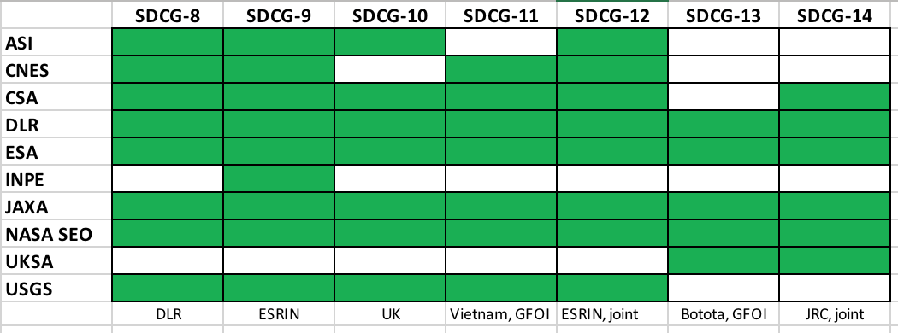
SDCG meeting participation by CEOS agencies

CEOS Engagement with GFOI

The way forward for the CEOS engagement with GFOI depends on whether a critical mass of agencies exists to continue a stand-alone group (such as SDCG or some evolution of it); as well as the provision of capacity for the management of that group and for the execution of the Work Plan targets. CEOS might take the view that with the accomplishment of the global baseline coverage, we can adopt a much more passive view of GFOI engagement, with just a liaison person (likely no longer a GFOI Lead) handling space data related requests from GFOI. It is for individual CEOS agencies to decide as to whether there is sufficient appeal in the GFOI framework to merit the resources required to engage. And for these agencies collectively to decide the best structure for that engagement and to ensure that representation is underpinned by participation of the staff from their agency forest/climate programmes. Given the proposed addition of biomass missions to the SDCG scope, it may require some reconsideration of how to connect to those agency programmes.

To support the anticipated discussion at SIT TW and at Plenary, the following possible models are suggested.
- Minimal engagement.
- dissolve SDCG
- resign as GFOI Lead, and as Data Component Manager
- appoint a CEOS Liaison to GFOI (who may attend GFOI Plenary as business requires)
- address issues arising at LSI-VC meetings and/or CEOS SEC as appropriate.

- Continuity of dedicated group
- renew SDCG with clarity in leadership and capacity
- assure contributions to new WP – developed by consensus of contributors
- appoint & resource new Data Component Manager
- continue annual meeting at GFOI Plenary (~Apr) and jointly with LSI and GEOGLAM (~ Sept)
- SDCG constituted based on SIT TW discussion, either as AHT or standing group
- Ensure optimal representation from CEOS agency relevant programmes

- Expanded and reinforced dedicated group
- actively seek stronger connection with and resource from the major space agency forest monitoring programmes, including new biomass missions
- consider expanded leadership group with sustained support
- active engagement of World Bank as Data Component partner and identification of new collaborative activities
- standing CEOS group

Next Steps
This short paper has served to summarise the status of responsibilities and resourcing of the CEOS contributions to GFOI - with a view to starting a dialogue amongst those agencies keen to support GFOI and to identifying creative ways to collaboratively sustain the effort by adapting responsibilities and resources.
The opportunity of commencement of Phase 2 of GFOI provides a milestone for CEOS to undertake a senior-level review of the wishes and commitment of space agencies for support for GFOI and to design and contribute to structures and processes to realise it. CEOS Principals are invited to respond to the issues raised in this paper and to engage in a group discussion by telcon prior to SIT TW. Further discussion will happen at SIT TW, with a view to conclusion at CEOS Plenary.

