2020 CEOS Strategic Implementation Team Technical Workshop (SIT TW 2020)
7th-11th and 14th-18th September 2020
VIRTUAL ONLY
http://ceos.org/meetings/2020-sit-technical-workshop/

GoToMeeting Connection: TBA
Meeting protocols: TBA
OBJECTIVES AND SCOPE
During SIT-35 the 2020-2021 SIT Chair Team focused on the original vision for SIT, aiming to foster Principal-level discussion and decision making to bring resources to address the significant coordination challenges presented by the harmonisation of observing systems across space agencies. This is bookended by the SIT Technical Workshop, which focuses on more detailed working-level task coordination and preparation for CEOS Plenary.
Accordingly, a series of sessions have been planned, with key objectives including:
    - Supporting progress of the CEOS Chair priorities for 2020 [SIT-35 update];
    - Showcasing the work of the Working Teams and identifying related Plenary issues;
    - Supporting new initiatives and activities arising from the Working Teams (e.g., CEOS-COAST);
    - Supporting those activities related to CEOS relationships (e.g., GEO and its activities, GCOS, UNFCCC);
    - Sharing and understanding progress against the CEOS Work Plan 2020-2022;
    - Progression of the three priority areas outlined in the CSIRO/GA SIT Chair 2020-2021 Prospectus: Analysis Ready Data (ARD), Sustainable Development Goals (SDGs), and Carbon and Biomass; and,
    - Providing overall assurance that issues are ready to be discussed at CEOS Plenary 2020.
In addition, and in light of recent CEOS Agency announcements and the deployment of the COVID-19 Earth Observing Dashboard, a special session on COVID-19 and Space will be included. While this topic does not map to an existing CEOS activity or Plenary outcome, a brief discussion session is scheduled to establish if further CEOS coordination could be beneficial.
Each of the Workshop sessions outlined below will be open to all, though attendance by all to every session is not expected. Each session will be convened and attended by the SIT Chair, though for some sessions the lead has been delegated. It is expected that the majority of participants will attend the Opening Session, and the Final Review. CEOS Principals considering attendance may gain maximum value from attending these higher-level cross-cutting sessions.
Because this year’s Workshop will be held virtually, the formal sessions will be focused on coordination and preparation for the CEOS Plenary. Groups are welcome and encouraged to organise their own side discussions and meetings in preparation for the Workshop to progress their core business.

Meeting at a Glance
Week 1: 7th-11th September 2020
 | Tuesday 8th | Wednesday 9th | Thursday 10th
Hour 1 | 1.1: Opening TW Session  Introduction  Objectives  Agenda and Format Overview | 2.1: Sustainable Development Goals | 3.1: Working Groups Showcase
Hour 2 | 1.2: CEOS Chair Session |  | 3.2: Virtual Constellations Showcase
Hour 3 | 1.3: COVID | 2.2: Analysis Ready Data: Beyond Land
Hour 4 | 1.4: CEOS-COAST |  | 3.3: ‘Open Mic’ Ideas Stage

Week 2: 14th-18th September 2020
 | Tuesday 15th | Wednesday 16th | Thursday 17th
Hour 1 | 4.1: Carbon and Biomass (External) | 5.1: GEO Session | 6.1: CEO Continuity
Hour 2 |  |  | 6.2: SIT TW 2020 Final Review  Wrap Ups from Session Leads  Discussion  Actions to Plenary
Hour 3 | 4.2: Carbon and Biomass (Internal) | 5.2: Analysis Ready Data: CEOS Strategy, and Industry Engagement
Hour 4

Session Timing
 | US East | Europe | Australia East
Hour 1 | 0630 - 0730 | 1230 - 1330 | 2030 - 2130
Hour 2 | 0730 - 0830 | 1330 - 1430 | 2130 - 2230
Hour 3 | 0830 - 0930 | 1430 - 1530 | 2230 - 2330
Hour 4 | 0930 - 1030 | 1530 - 1630 | 2330 - 0030
A 15 minute break will be added during each session on the detailed agenda.
Session Overviews
Overview and details for each session including the title, co-leads, outcomes, links to existing actions.
Tuesday 8th September
Number: Title  Session Prep Lead  Session Chairs | 1.1: Technical Workshop Opening Session  George Dyke  Session Chair: Alex Held, Adam Lewis
Plenary outcomes to support: | - Overall support of the Technical Workshop in preparation for CEOS Plenary.
Objectives for proposed TW session: | - Frame the overall discussion  - Identify Plenary outcomes targeted  - Review the agenda  - Reminder of SIT Chair priorities, progress, activities  - Reminder of the CEOS Work Plan status and related Workshop outcomes
Format, Session(s), and Duration: | - Format: Introductory presentations by the SIT Co-Chairs and CEOS Executive Officer (CEOS Work Plan)  - Review Plenary objectives and discussions and decisions required during the Technical Workshop (CEOS Chair)  - Open Mic Welcome  - Duration: 1h
Agenda: | TBA

Number: Title  Session Prep Lead  Session Chair | 1.2: CEOS Chair Session  ISRO  Session Chair: ISRO
Plenary outcomes to support: | - Framing of overall Plenary objectives and agenda  - DRAFT Plenary objectives here: https://docs.google.com/document/d/1WkgJHKDnRSU9hmrcOqWdMr_rDVTZLGIekynQWO-othU/edit?usp=sharing  - Progressing the 2020 CEOS Chair Initiatives
Objectives for proposed TW session: | - Review the status of the CEOS Chair priority topics for 2020  - Update on plans for CEOS Chair 2022  - Addressing other Plenary and CEOS Chair topics not addressed in other Workshop sessions
Format, Session(s), and Duration: | - Format: Presentation, discussion, questions  - Duration: One session, 1h
Agenda: | - 2020 CEOS Chair Initiatives  - Achievements, outputs, impacts, plans for continuity [20 minutes, presenter TBA]  - Discussion and Questions [20 minutes]

Number: Title  Session Prep Lead  Session Chair | 1.3: COVID from Space  Astrid-Christina Koch/EC, Ivan Petiteville/ESA, Osamu Ochiai/JAXA  Session Chair: TBA
Plenary outcomes to support: | Currently no related CEOS Plenary outcome. May seed a Plenary discussion.
Objectives for proposed TW session: | - Hear from CEOS Agencies with COVID-related activities  - See real use-cases on how data has been used for policy / decision-making  - Initial discussion around the role of the CEOS coordination framework enabling and supporting response and recovery  - Identify any topics that would merit Plenary discussion  - Discuss CEOS sponsorship of the IAC COVID-19 session
Format, Session(s), and Duration: | Format: Brief Update, Open Floor, Questions and Discussion  Duration: One session, 1h
Agenda: | - Updates from CEOS Agencies on COVID-related activities [10 mins each]  - RACE Dashboard – ESA (Ivan/TBC)  - NASA-ESA-JAXA Dashboard – JAXA (Osamu/TBC)  - Copernicus activities – COM (Astrid/TBC)  - Open floor for other agency activities and perspectives [20 minutes]  - Questions, discussion, and Plenary way forward [10 minutes]

Number: Title  Session Prep Lead  Session Chair | 1.4: CEOS-COAST  Paul DiGiacomo, Merrie-Beth Neely  Paul DiGiacomo
Plenary outcomes to support: | Overview of short and mid-term CEOS-COAST pilots, activities, and longer-term strategy.
Objectives for proposed TW session: | - Status update on CEOS-COAST pilot activities, planning and proposals for CEOS-COAST Phase II activities in 2021, and discussion to support Plenary decisions and outcomes (approval for Phase II continuation)  - Discuss Coastal Strategy for CEOS  - Discuss options for post-Plenary continuity of the CEOS-COAST activity (incl. potential links with the SDG-AHT).
Format, Session(s), and Duration: | - Format: Presentations, Discussion  - Duration: One session, 1h
Agenda: | - CEOS-COAST Pilots Update [20 minutes, presenter TBA]  - Post-Plenary Continuity and Longer-Term Strategy [20 minutes, Paul DiGiacomo]  - Discussion and Questions [20 minutes]

Wednesday 9th September
Number: Title  Session Prep Lead  Session Chair | 2.1: Sustainable Development Goals  Flora Kerblat  Session Chairs: Alex Held (SIT Chair rep) and Marc Paganini (SDG AHT Co-Lead and 6.6.1 Co-Lead)
Plenary outcomes to support: | - Approval/Endorsement(?) of Data Supply Analysis and Strategy  - Discussions and Decision on strategic priorities (activities) for CEOS to support SDG process:  - Supporting GEO in its progress towards SDG (through SEC and across all WP activities  - Contributing to GEO SDG Toolkits (EO4SDG) by providing CEOS products, access to tools and more  - Decision on the future outlook of the SDG AHT (AHT renewed, transformed into a permanent mechanism, or dismantled?)
Objectives for proposed TW session: | - Review of Data Supply Analysis and Strategy document and ensure it’s ready for information/endorsement (?) at the Plenary  - Update all on each sub-team progress, in particular demonstrating mature SDG Requirements Tables for each of the 4 indicators/teams  - Showcase SDG monitoring applications (algorithms development) on ODC or DEA  - Refine the list of data, guides and tools to be provided to the GEO SDG Toolkits - incl future activities (main CEOS contribution to GEO on SDG)  - Agree on the preferred option for the future SDG outlook to be proposed at the Plenary (SDG AHT co-leads)
Format, Session(s), and Duration: | 2 hours  Participants envisioned:  - SDG AHT members with 4 co-leads identified to report on each indicator  - CEO  - SEO to report/showcase on ODC algorithms  - External presenters TBC: GEOSEC, UN Agency, Stats rep?
Agenda: | TBA in discussion and prep with SDG co-leads  - Welcome & overview of the session [session co-leads] 5’  - Presentation of Data Supply Analysis and Strategy document (last chance to capture last comments or required update) [SIT Chair] 5’  - for information or endorsement at the Plenary?  - Progress reports from each sub-team (including the SDG Requirements Table as the main deliverable - PPT Templates with required info will be prepared) 5’ each  - 6.6.1 [M. Paganini/A. Carbonniere]  - 11.3.1 [A.Kavvada/?]  - 14.1.1 [E. Smail]  - 15.3.1 [N.Sims]  - Questions & Answers 10’  - Showcase SDG monitoring applications (algorithms development) on ODC or DEA [B.Killough/A.Lewis or N.Mueller?] 10’  - CEOS contributions to SDG Toolkits [ALL led by SDG AHT co-leads and Argie K.] 20’  - GEO needs/requests (AK)  - what and how?  - data, guide/methods and tools  - data flows (CEOS groups?)  - Future SDG AHT outlook (SDG AHT co-leads) 25’  - Why continuing our activities & plan [SDG AHT co-leads]  - Discuss 3-4 options  - Agree on the preferred one (clear argumentation) to be proposed at the Plenary for decision  - Any AOB & adjourn 5’

Number: Title  Session Prep Lead  Session Chair | 2.2: CEOS Analysis Ready Data: Beyond Land  Ed Armstrong, Andreia Siqueira, Matt Steventon  Session Chair(s): Ed Armstrong and TBA. Supported by LSI-VC Leads.
Plenary outcomes to support: | Advance the discussion around an expansion of the CEOS Analysis Ready Data Definition and effort beyond the land domain and assign leads for each of the domains.
Objectives for proposed TW session: | - Review: outcomes from the SST-VC ocean domain ARD survey and what CEOS ARD for SST might look like.  - Have an understanding from CEOS-COAST on how CEOS ARD might fit into their work.  - Share the work on the USGS Aquatic Reflectance Demonstration Product and related Product Family Specification (Chris Barnes / Nima Pahlevan, TBC).  - Explore what changes may be needed to the CARD4L Framework to allow it to go ‘beyond land’, and agree on those steps.  - Present and discuss the proposal to have LSI-VC work with other VCs to generalise the CARD4L Definition so that it is applicable to all domains.  - Identify options to expand the CEOS ARD for Land Framework to Oceans and Atmosphere. Identify leads from non-land areas (Coasts, Ocean, Atmosphere) to work through CEOS ARD for those areas.
Format, Session(s), and Duration: | Format: Presentations, Discussion  Duration: 2h
Draft Agenda: | - Session introduction, context, welcome (SIT Chair)  - SST-VC perspectives on CEOS ARD and findings from the ocean domain ARD survey [VC-20-22]  (Ed Armstrong, SST-VC)  - CEOS-COAST & CEOS ARD (Paul Di Giacomo TBC).  - Aquatic Reflectance Demonstration Product and Product Family Specification (USGS/NASA, Chris Barnes / Nima Pahlevan, TBC)  - Beyond Land: Options to expand the CEOS ARD for Land Framework to Oceans and Atmosphere (Chair: Ed Armstrong, SST-VC)  - Definition  - Other additions to the framework (e.g., advisory notes).  - Options to trial the framework for Coastal, Ocean and Atmosphere data products.  - Wrap-up

Thursday 10th September
Number: Title  Session Prep Lead  Session Chair | 3.1: Working Groups Showcase  ISRO TBC  Session Chair: ISRO TBC
Plenary outcomes to support: | Opportunity for WGs to identify issues and highlights for exposure at Plenary.
Objectives for proposed TW session: | - Hear the latest highlights from the WGs  - Identify WG-related highlights, topics and issues for Plenary
Format, Session(s), and Duration: | - 1h total: 5min/WG x 5 WGs plus discussion time (TBC)
Agenda: | TBA: Possible topics (to be finalised by WG Chairs):  - Wildfires and Working Group Disasters  - WGISS interoperability terminology (Rob)  - Earth Analytics Interoperability Lab (Brian/Rob)  - WGCV CEOS ARD peer review process (Medhavy)

Number: Title  Session Prep Lead  Session Chair | 3.2: Virtual Constellations Showcase  George Dyke  Session Chair: Jonathon Ross
Plenary outcomes to support: | Opportunity for VCs to showcase their work and identify any highlights or issues for the SIT Chair to flag at Plenary.
Objectives for proposed TW session: | - Hear the latest highlights from the VCs  - Identify VC-related Plenary highlights, topics and issues
Format, Session(s), and Duration: | - Duration: 2h total  - 35min: 5min/VC x 7 VCs  - 35min: VC discussion time (allows approx 5min each)  - 50min: General Working Team (VC, WG, AHT) discussion time
Agenda: | - P-VC [Presenter TBA]  - AC-VC [Presenter TBA]  - LSI-VC [Presenter TBA]  - SST-VC [Presenter TBA]  - OST-VC [Presenter TBA]  - OSVW-VC [Presenter TBA]  - OCR-VC [Presenter TBA]  - General Working Team Discussion Time

Number: Title  Session Prep Lead  Session Chair | 3.3: ‘Open Mic’ Ideas Stage  Jonathon Ross  Session Chair: Jonathon Ross
Plenary outcomes to support: | - CEOS activities or issues to be raised at Plenary, not aligned with other agenda items and/or not raised already on the TW agenda.
Objectives for proposed TW session: | - Provide an ‘open mic’ for participants to present on interesting activities or socialise issues for consideration ahead of, or at, Plenary.
Format, Session(s), and Duration: | - Short (3-4 minute) “pitch” presentations  - Open discussion
Agenda: | - Brief introduction  - Open floor to pitches (slots can be pre-requested)  - Remaining time for open discussion

Tuesday 15th September
Number: Title  Session Prep Lead  Session Chair | 4.1 and 4.2: Carbon and Biomass  Stephen Ward  Session Chair: Alex Held or Adam Lewis TBC
Plenary outcomes to support: | - Endorsement of the CEOS Biomass Protocol  - Consideration of the business case for measures to support implementation of the CEOS Biomass Protocol  - GHG Roadmap  - Consideration of the AFOLU Roadmap and debate of actions  - Discussion of the opportunity presented by the UNFCCC Global Stocktake and decision on engagement actions  - Update on the key GCOS processes and documents and CEOS response
Objectives for proposed TW session: | - Further engagement of UNFCCC SEC, including more specificity on how CEOS and agencies should engage in all aspects of the GST process  - Refreshed input from GCOS and identification of any issues for Plenary - discuss additional efficiencies in requirement setting process  - Report on the Biomass Protocol and confirmation of readiness for Plenary endorsement  - Review of the draft business case for support to the Biomass Protocol and discussion on tuning the pitch to Principals  - Review of the draft AFOLU Roadmap and determination of pitch at Plenary. Including suggestions from GFOI.  - Update on the GHG Roadmap and hearing any issues to ask of Plenary  - Discuss synergies between GHG and AFOLU activities and support to Conventions (prep. for a 2021 Workshop)  - Update from WGClimate, notably on ECVI 3.0 and SBSTA plans
Format, Session(s), and Duration: | This session has a significant participation external to CEOS. Invitees include: UNFCCC SEC, GCOS, and GFOI. It is proposed to split the time into two sessions, with the first focused on discussions with our guests, and the second more on internal reporting and Plenary planning. Timing will be:  Session 1: 0615-0845 US East  15 mins break  Session 2: 0900-1030 US East
Agenda: | Session 1  - Introduction (SIT Chair, 5m)  - Heritage and context (WGClimate, 10m)  - Brief GST Process Update (UNFCCC SEC, 10m)  - Brief GCOS Process Update (GCOS, 10m)  - CEOS AFOLU Roadmap (Ochiai, 10m)  - GHG Roadmap (Dowell, 5m)  - GHG - AFOLU synergies (Dowell, 10m)  - Discussion: Climate Data Requirements & Policy processes - optimising the space agency contribution (1h 30m)  - GST process  - GCOS requirements process  Session 2 (Plenary agenda item prep)  - Biomass Protocol & business case (Duncanson, 30 m)  - WGClimate: ECVI 3.0 and SBSTA prep (Schulz, 20m)  - GHG Roadmap (von Bargen?, 15m)  - AFOLU roadmap (Ochiai, 20m)  - Wrap up (SIT Chair, 15m)

Wednesday 16th September
Number: Title  Session Prep Lead  Session Chair | 5.1: GEO Session  Andreia Siqueira, Doug Cripe, Florian Franziskakis  Session Chair: TBA
Plenary outcomes to support: | - Ongoing stewardship of CEOS-GEO relationship  - Make sure requests from GEO are well understood and response from CEOS is endorsed  - Agree on key messages for CEOS to communicate to GEO over coming months
Objectives for proposed TW session: | - To have an update on GEO priorities and directions  - To understand which areas CEOS contributes to the GEO work programme  - To have an overview of emerging requests for support from the CEOS community  - To work with GEO to understand and ensure requests to CEOS Plenary are clear and feasible  - To identify key messages that CEOS may wish to communicate to GEO  - To understand future planned CEOS-GEO actions around global data flows including how GEO can encourage opening up data. In particular the use of in-situ data for training machine-to-machine EO data models.  - Understand and discuss GEO Knowledge Hub and the implications for CEOS in particular ARD collections in commercial clouds
Format, Session(s), and Duration: | Virtual format, one (1) hour presentations, half hour (½) discussion
Agenda: | - Session introduction, context, welcome (5 min)  - Update on GEO priorities and directions - Gilberto Camara/Doug Cripe (10 min)  - Overview on the areas where CEOS contributes to the GEO Work Programme (Wenbo, Craig or Kerry) (10min)  - Emerging requests for support from CEOS Doug Cripe 10 min  - ARD and commercial clouds  - CEOS-GEO actions around global data flows Gilberto Camara (20 min)  - Explore how GEO can encourage opening up data, in particular the use of in-situ data for training machine-to-machine EO data models  - Machine-to-machine Open Data Cubes  - GEO Knowledge Hub and its links to CEOS (Florian Franziskakis & Paola De Salvo) - 10 min  - Discussion (25 min)

Number: Title  Session Prep Lead  Session Chair | 5.2: CEOS Analysis Ready Data Strategy, CEOS ARD and Industry  Andreia Siqueira, Matt Steventon  Session Chair: Steve Labahn (TBC)
Plenary outcomes to support: | - Report on progress of the CEOS ARD Strategy  - Endorsement of the CEOS Analysis Ready Data – Involving the Private Sector paper  - Endorsement of CEOS Interoperability Terminology v1.0 (WGISS)
Objectives for proposed TW session: | Take stock of the CEOS ARD Strategy and progress, and identify any highlights or challenges to be taken to Plenary (e.g., commitments for agencies to submit datasets and engage in the assessment process).  Review the CEOS Analysis Ready Data – Involving the Private Sector paper prior to submission for endorsement at Plenary  Review WGISS work on CEOS Interoperability Terminology and discuss issues to be addressed to allow endorsement at Plenary
Format, Session(s), and Duration: | Format: Presentations, Discussion  Duration: 2h
Agenda: | - Session introduction, context, welcome  - CEOS ARD Strategy implementation  - Private sector paper and private sector engagement: lessons, feedback and next steps  - CEOS ARD Strategy progress update (SIT Chair) 1hr  - roadmap (as presented in the ARD webinar)  - CEOS ARD framework update (advisory notes)  - Private sector paper overview  - Interoperability terminology report overview  - Wrap-up

Thursday 17th September
Number: Title  Session Prep Lead  Session Chair | 6.1: CEO Continuity  ISRO TBC  Session Chair: ISRO TBC
Plenary outcomes to support: | Prepare for the CEOS Plenary organisational matters discussion in relation to CEOS Executive Officer (CEO) continuity.
Objectives for proposed TW session: | - Confirm plans for CEO continuity going into CEOS Plenary  - Discuss any changes to CEOS governing documents under consideration  - Identify actions to be taken between TW and Plenary, including any ‘virtual endorsements’ that may be necessary
Format, Session(s), and Duration: | 1h status update, options, and discussion
Agenda: | TBA

Number: Title  Session Prep Lead  Session Chair | 6.2: SIT Technical Workshop 2020 Final Review  George Dyke  Session Chair: Alex Held, Adam Lewis
Plenary outcomes to support: | All
Objectives for proposed TW session: | - Consolidate Workshop preparation for Plenary  - Provide a wrap-up for the Technical Workshop pitched to an audience of CEOS Agency Points of Contact preparing their Agencies and Principals for CEOS Plenary.  - Finalise any outstanding points that weren’t resolved or addressed during the other Workshop sessions.  - As necessary, confirm CEOS statements/key messages for COP and GEO in the coming months.  - Review actions coming out of the Workshop to Plenary.
Format, Session(s), and Duration: | - Summary presentations for the Workshop session leads, maximum of 15 minutes presentation and 15 minutes discussion each.  - Reference session outcomes and how the session addressed those.  - 3h
Agenda: | TBA

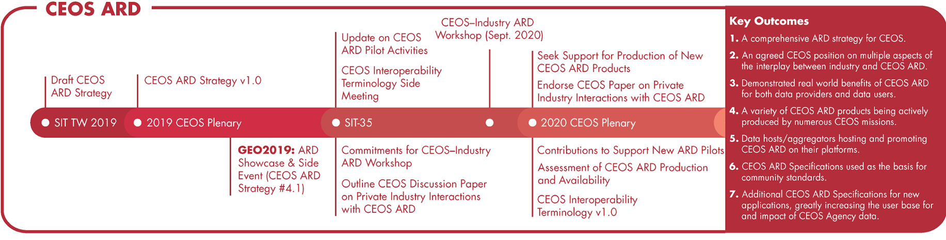
SIT Chair Prospectus Timelines (Through CEOS Plenary 2020)
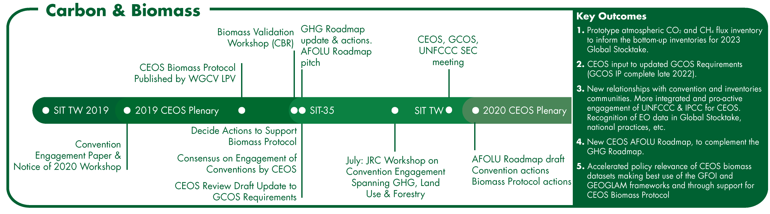
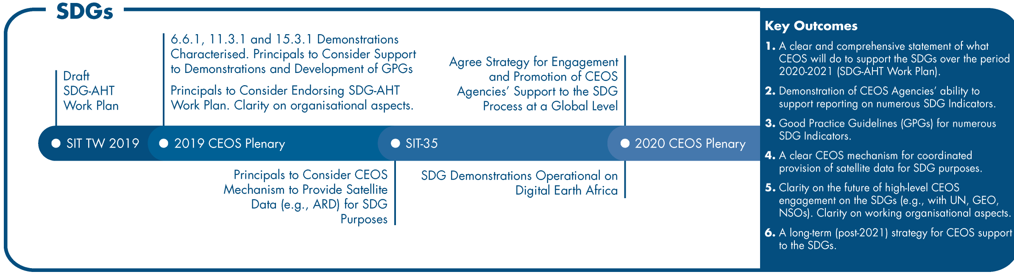
Appendix - Documents and Presentations
Meeting Documents - TBA
Presentations (direct links) - TBA

