MINUTES OF THE 2023 CEOS SIT TECHNICAL WORKSHOP
18-19 October 2023
Version 1.0

Executive Summary
- An update on the Greenhouse Gas (GHG) Roadmap was provided by the GHG Task Team. An action on further connection with WGCapD regarding stakeholder engagement activities, including the relevant actions in the GHG Roadmap, was agreed.
- The new CEOS Database GHG Portal was presented. It was constructed with the support from the GHG Task Team, ESA, and JAXA, and is powered by the CEOS Missions, Instruments and Measurements (MIM) Database. The portal is available at ceos.org/ghg.
- An action was recorded for the GHG Task Team to progress the update of Annex C (action list) of the GHG Roadmap in time for SIT-39 in April 2024. This will provide a refreshed starting point on this topic early in JAXA’s SIT Chair term.
- The CEOS Agriculture, Forestry and Other Land Use (AFOLU) Roadmap will be finalised for endorsement at the 2023 CEOS Plenary. Pending endorsement, the team will create an Action Supplement (for endorsement at SIT-39) to track the implementation of the Roadmap, which will continue to be stewarded by the Forests & Biomass Subgroup of the Land Surface Imaging Virtual Constellation (LSI-VC).
- The Ocean Colour Radiometry Virtual Constellation (OCR-VC) co-leads will present a proposal to develop an Aquatic Carbon Roadmap to the 2023 CEOS Plenary. In collaboration with the SIT Chair, the co-leads will confer with relevant CEOS Principals prior to the 2023 CEOS Plenary to determine if necessary CEOS Agency representation and resources are forthcoming to allow the development of the Roadmap to proceed.
- CEOS Agencies are invited to provide comments on the draft Joint CEOS-CGMS Space Agency Statement to the UNFCCC Subsidiary Body for Scientific and Technological Advice (SBSTA). WGClimate is asked to confer with CEOS Agencies regarding the timetable for review and submission, and to issue the latest draft as soon as possible.
- The 2023 edition of the CEOS Earth Observation Handbook is titled “Space Data for the Global Stocktake”. The goal of the handbook is to develop a broader understanding of the fundamental importance of satellite EO to the information needed to inform all aspects of the Paris Agreement and demonstrate the potential of EO to contribute to countries’ GST reporting. The handbook includes key user stories as inspiration and encouragement and will be published before CEOS Plenary.
- The New Space Task Team’s white paper and recommendations were discussed and an action to finalise the report for potential endorsement at the 2023 CEOS Plenary was agreed. Some CEOS Agency feedback suggested that the New Space Task Team’s recommendations could be reworded in a form to allow implementation through an Action Plan, with assignment and tracking over time. This will be considered for the CEOS Plenary version.
- The Ecosystem Extent Task Team (EETT) was formed at the 2022 CEOS Plenary and tasked with developing a white paper that provides an integrated international perspective on how space-based Earth observations can be used to support ecosystem mapping and monitoring, with a focus on ecosystem extent. The draft white paper was presented and discussed. The EETT white paper’s recommendations cover three areas: User Engagement, Technical Advances, Capacity Building. The paper and recommendations will proceed to the 2023 CEOS Plenary for endorsement.
- The 2024 CEOS Chair, CSA, will prioritise the theme of biodiversity during their chairmanship. CSA will use 2024 to understand the internal and external landscape and seek to arrive at the 2024 CEOS Plenary with a suggested position on potential CEOS commitment to a broader biodiversity strategy. CSA will seek to articulate the fundamental reasons for the topic of biodiversity to figure more prominently in the spectrum of CEOS activities.
- The Ocean Coordination Group (OCG) presented two documents: 1) Needs Assessment for Ocean Coordination Activities for Upcoming Satellite Missions, and 2) List of IOC and Ocean Decade Planned Deliverables from CEOS VCs/WGs/Ad Hoc Teams). These documents will be presented at the 2023 CEOS Plenary as the final outcomes of the OCG, before it is disbanded.
- The COAST Ad Hoc Team presented a proposal to transition to a Virtual Constellation. The COAST-VC Initial Proposal and draft Terms of Reference will be presented for endorsement at the 2023 CEOS Plenary, where an action will be requested to draft and submit the final Terms of Reference and Implementation Plan in time for a final decision at SIT-39 (April 2024).
- At the 2023 CEOS Plenary, WGISS will recommend endorsement of the proposed CEOS Interoperability Framework.
- The CEOS Sustainable Development Goals Coordination Group has been awarded the Participating Organisation award in the 2023 GEO SDG Awards.
- The CEOS Communications Strategy will proceed to the 2023 CEOS Plenary for endorsement. The strategy outlines goals for the coming two years, including for three headline campaigns: 40th Anniversary of CEOS, EO for Biodiversity, and Greenhouse Gas Observations from Space.
- WGDisasters proposes to establish the Global Volcano Early Warning and Eruption Response System (G-VEWERS) and a Pre-operational Recovery Observatory (2024-2026). Data has been requested from various agencies to support the operation of these initiatives. Formal support will be sought at the 2023 CEOS Plenary where these initiatives will be presented for endorsement.
- JAXA will begin its chairmanship of the CEOS Strategic Implementation Team (SIT) at the 2023 CEOS Plenary for a two-year term. Their priorities will focus on GHG observation coordination and climate policy impact, as well as continuing to support ongoing and emerging business. NASA is nominated to serve as SIT Vice Chair during this term, followed by SIT Chair from the 2025 CEOS Plenary.

Session Index
Executive Summary
Session Index
Session 1: Welcome and Core Business
Session 2: GHG Observation Coordination
Session 3: Carbon Roadmaps and Policy Impact
Session 4: GEO-CEOS Relationship
Session 5: New Space
Session 6: Biodiversity
Session 7: Oceans and Coasts
Session 8: Other Business
Session 9: Closing Session
APPENDIX A: Participants
APPENDIX B: Actions Record

Wednesday October 18th

Session 1: Welcome and Core Business

1.1: Welcome, Opening Remarks and Agency Introductions, Agenda Overview
Presenter: Eleni Paliouras (ESA, SIT Chair Team) [presentation]
Shared greetings from Simonetta Cheli (ESA, SIT Chair), who sends her apologies due to her attendance at the ESA Council this week. Eleni welcomed all the participants to ESRIN and noted that there are many interesting discussions planned for the next few days.
Main points:
- Recalled the specific purpose of the TW versus regular SIT meetings and the Plenary. The focus is on working level discussions to set the stage for the Plenary decisions to follow.
- Side meetings provided an additional opportunity to refine inputs for SIT TW and Plenary. There has been commendable attendance and productive discussions. Thanks to all the coordinators and participants.
- Themes for the CEOS Plenary include: endorsement of the CEOS AFOLU Roadmap; actions to address issues and obstacles impacting the Greenhouse Gas Roadmap; endorsement of Ecosystem Extent Task Team’s white paper and recommendations; outputs and conclusion of the CEOS Ocean Coordination Group (OCG); conclusion of the activities of the CEOS Coastal Observations Applications Services and Tools (COAST) Ad Hoc Team and agreement of a way forward for the proposal to consider the establishment of a COAST Virtual Constellation (VC); endorsement of the new CEOS Communications Strategy.
- CEOS Leadership changes to be addressed include welcoming JAXA as SIT Chair for 2024-2025; considering endorsement of NASA for the SIT Vice Chair (2024-2025) and then SIT Chair (2026-2027); considering endorsement of UKSA as CEOS Chair for 2025; welcoming CSA as CEOS Chair for 2024 and discussing CSA’s priorities for the coming year.

1.2: 2023 CEOS Chair Report
Presenter: Pakorn Apaphant (GISTDA, 2023 CEOS Chair) [presentation]
Main points:
- GISTDA main themes have included: supporting CEOS preparations and inputs to the Global Stocktake of the UNFCCC Paris Agreement; supporting exploration of new geometries for space agencies and CEOS with New Space.
- GISTDA hosted a SilvaCarbon workshop in Thailand from 22 February to 2 March 2023 and will hold a ‘Satellite Earth Observation & Carbon Accounting Workshop’ on 14 November ahead of the CEOS Plenary.
- GISTDA has been very active in the New Space dialogue, hosting a variety of related events in Thailand and participating in the CEOS New Space Task Team (NSTT). Events provided key inputs to the NSTT white paper.
- CEOS Plenary will be held in Chiang Rai, Thailand from 14 to 17 November 2023.

Session 2: GHG Observation Coordination
Yasjka Meijer (ESA, GHG TT Lead) provided an introduction to the session. Various connections and relationships exist in this space, and this session will provide an update on each of these. CEOS efforts are directed by the GHG Roadmap. GHG Observation Coordination will be identified as a headline priority for the JAXA SIT Chair term (2024-2025).

2.1: WMO Engagement Update
Presenter: Natalia Donoho (WMO) [presentation]
Main points:
- Lars Peter Riishojgaard (WMO Secretariat) has sent his apology for not being able to attend the meeting.
- GHG fluxes driven by natural processes are often larger than anthropogenic and not explicitly considered.
- WMO and partners are developing Global Greenhouse Gas Watch (GGGW), building on World Weather Watch (WWW) and Global Atmosphere Watch (GAW). Integrated system for surface and space-based observations. Key elements include near real time exchange of observations, 24/7 GHG modelling and assimilation to provide top-down flux estimates.
- Primary outputs are time continuous fields of CO₂ CH₄ and N₂0, and consolidated top-down monthly estimates of GHG fluxes at global 100x100 km resolution, (1x1 km goal).
- Aiming to provide authoritative data for UNFCCC parties, etc.
- The 19th World Meteorological Congress endorsed the concept and requested the development of a detailed cost implementation plan.
- 193 countries have now committed to developing internationally coordinated top-down destinations of GHG fluxes globally, with open access to input and output data.
- GGGW is a critical tool for the implementation of the Paris Agreement. Will be briefed at COP 28 on request of SBSTA.
- Currently drafting the GGGW Implementation Plan. The focus is on the upcoming four-year WMO financial period of 2024-2027.
- The GGGW Modelling workshop was held in Bonn from 19-21 September 2023. The participants at the workshop took the first steps toward designing an “operational” global system composed of national facilities, to ensure that parties to the UNFCCC can obtain the GHG information they need to successfully implement their agreements;
- The GGGW Observation Workshop was held recently in Geneva, from 3-5 October 2023. The aim of the workshop was to provide guidance on the design of a global observing network.
- After several discussions about run-time schedules and data latency, both workshops more or less independently converged on a latency requirement of 72 hours;
- The two main drivers include:
  - Overall requirement for monthly fluxes soon after the end of the past month;
  - Secondary but important use of operational data assimilation as key quality control tool for both space-based and surface-based observing systems;
- The joint Study Group on WMO Greenhouse Gas Monitoring (SG-GHG) is seeking engagement from CEOS in helping to draft a chapter on observations. Yasjka Meijer has been invited to join the team. Natalia thanked Yasjka for his support.
- Access to space-based GHG data will be critical to the success of GGGW; this could be discussed in the context of WMO Resolution 1, either at the Workshop on Core Data in December 2023 or at CM-15 in February 2024.
- Natalia commended the ESA and JAXA teams on the publishing of the CEOS Greenhouse Gas Satellite Missions Portal: https://ceos.org/ghg

Discussion
- Mark Dowell (EC) asked about the methods for resourcing the GGGW, noting the tools such as the Systematic Observations Financing Facility (SOFF). He also asked to what degree these mechanisms are being used to facilitate GGGW.
- Lars Peter (WMO) is not present at the SIT Technical Workshop as he is at a different meeting, lobbying for funding for this activity. GGGW is one of the high priority initiatives of WMO, and a new director will be hired for the activity. It was noted that SOFF will likely be utilised.
- Philippe Goryl (ESA, WGCV Chair) provided comments on the goal for data transparency and asked whether it excludes New Space data for GGGW.
- Natalia Donoho (WMO) noted that the aim is to be open and transparent. WMO, in terms of New Space, will try to be as open and transparent as possible.
- Yasjka Meijer (ESA) noted that CEOS and the GHG TT will be the key partner to ensure space-based data is provided in support.

2.2: International Methane Emissions Observatory (IMEO) Engagement Update
Presenter: John Worden (NASA/JPL) (For Information) [presentation]
Main points:
- CEOS engaged with IMEO via UNEP back in 2021. IMEO’s aim is to detect methane emissions and encourage action to mitigate leaks via the MARS system.
- Open question is how CEOS can better engage and support the activities of IMEO. Looking for agency feedback on this during the SIT Technical Workshop.
- Multiple CEOS Agencies, alongside New Space and NGO mission operators participated at the CEOS-IMEO meeting held in June 2023. The goal of the meeting was to promote collaboration and coordination between global institutions to deliver the prompt, transparent, and trusted methane emissions datasets needed to catalyse global methane emissions reductions.
- Five working groups were defined as a result of the workshop. Observations, Use Cases, Data Integration, Cal/Val/Testing, and a Roadmap Working Groups. CEOS agencies are represented in each of these. Many of these activities overlap with CEOS GHG Task Team and AC-VC activities.
- Issues to note for CEOS include:
  - IMEO offers CEOS the opportunity to get much closer to the users than we are typically able to manage alone.
  - Conversation has been slow with IMEO (distributed and virtual like CEOS).
  - IMEO offers a neutral and productive way to engage our New Space counterparts in a focused fashion. IMEO can support 'best practices' for reporting emissions work; increasing transparency of New Space GHG products required for use in science, policy, and finance.
  - IMEO contributed to the forthcoming EO Handbook and is willing to support side events with CEOS at COP 28.
  - UNEP / IMEO supports emissions validation activities.
  - Should CEOS support the development of emissions validation like current AC-VC efforts?
- Points for discussion for future activities:
  - For the mid to long-term, CEOS / IMEO engagement can support discussions on how to address New Space / IP issues and corresponding data transparency issues;
  - Help define standards for reporting emissions based on satellite data;
  - How can we leverage CEOS/IMEO activities to support emissions for policy? (e.g. UNFCCC COP?)
  - Can we leverage CEOS/IMEO activities to support potential carbon markets by providing transparent and robust GHC information? Or identify pathways for this information to be used?
  - In the short-term, CEOS should continue to engage with IMEO to transfer expertise and knowledge and address emerging concerns via GHG Task Team and AC-VC activities.
Discussion
- Jörg Schulz (EUMETSAT) asked about how the scale of activity in UNEP is funded. Long term relationships need stability on the funding side. It creates a good pathway for users, but needs a stable partner, not sure if that is the case.
- Jörg Schulz (EUMETSAT) suggested that the GHG Task Team might want to integrate the roadmap identified under IMEO into the existing CEOS GHG Roadmap. He has reservations about the overlap with the CEOS-IMEO Roadmap Working Group. It would be beneficial to use existing structures rather than creating a new one.
- Yasjka Meijer (ESA, GHG TT Lead) agreed and disagreed with Jörg's suggestion. The good thing about IMEO is that they have their own resources. The GHG Task Team is not looking at use cases. IMEO is very close to the users and can start from that point. GHG Task Team can be the partner to step in to provide the data.
- John Worden (NASA/JPL) acknowledged that there is some overlap between the GHG Task Team and IMEO Working Groups. However, there are different scopes. IMEO gives key opportunities to engage with users and stakeholders, which is a key differentiator.
- Beth Greenway (UKSA) noted that UKSA has a direct engagement with IMEO. UKSA has purchased some GHGSat data, and over the next 18 months, will be able to task GHGSat to gather needed data. Standards for space data in this area are needed. Managed to get some words into the COP 28 space summit pledge along those lines. UKSA wants to step up and work in this arena and is willing to host a workshop in the UK in 2024 to make some tangible progress in developing such standards.
- Albrecht von Bargen (DLR) noted that he is in close conversation with IMEO regarding use of the EnMAP mission for deriving methane emissions together with TROPOMI. This could be a good example of this type of cooperation, providing a great opportunity for feedback to agencies.
- Osamu Ochiai (JAXA) noted that IMEO’s focus is purely on methane. He added CEOS is more broadly on satellite based GHG monitoring missions. The focus for CEOS should also be global monitoring and not just super emitters.

2.3: Reporting emissions and uncertainties from global top-down and facility scale measurements
Presenter: John Worden (NASA/JPL) [presentation]
Main points:
- A workshop on characterising and reporting emissions estimates was held on 3 July 2023 at the headquarters of CNES. The meeting considered what should be reported to make robust comparisons between satellite-informed emissions estimates and the use of these estimates for science, policy, and financial needs.
- Two use cases were considered:
  - Use Case 1: Regional to global emissions from global mappers.
  - Use Case 2: Facility scale emissions from “plume mappers”.
- Emissions based on Public and New Space observations of CO₂ and CH₄ are increasingly being used for policy. These empirical data are also likely needed for a functioning carbon market.
- Initiation of operational GHG emissions estimates (e.g. CAMS, US GHG Center) and rapid expansion of satellites which report emissions at facility scales (especially New Space) means we need to think carefully about how these emissions are reported.
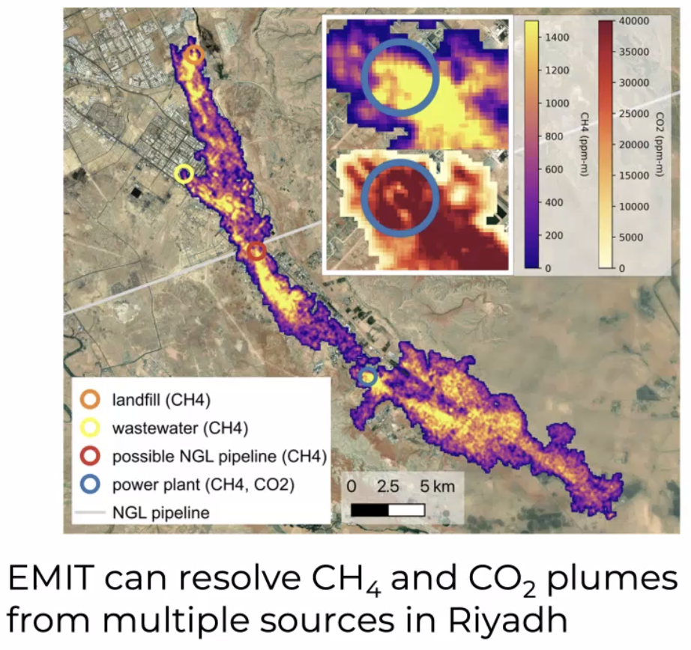
- Regarding Use Case 1, it was recommended that satellite-based emissions reporting from different groups/centres be harmonised, and products should be staged for different users.
- Regarding Use Case 2, CEOS should support transparency of New Space data, if they are to be used for science, policy, and financial markets by developing evaluation metrics for reported concentrations and emissions.
- 10 of 15 current facility scale mappers are from the ‘New Space’ industry. Intellectual Property concerns play a role in transparency of data provenance and processing.
- Evaluation metrics for New Space can be baselined against (operational) products from public missions (e.g. EMIT, and upcoming CO2Image and TANGO). Ongoing work with IMEO and joint ESA/NASA working groups are supporting these efforts.
- It was also recommended that CEOS support the development of machine learning codes to reduce the need to evaluate plume concentrations and increase throughput of emissions reported by public missions.
Discussion
- John Worden (NASA/JPL) noted that some companies are allowed to withhold data, and if used for science this can bias data. What happens if a new space company is bought out - how does that impact the future use of the data?
- John Remedios (UKSA) asked about the emission verification, noting that in the UK, in situ teams have been brought along from expert labs. Has the team thought about how to coordinate effectively with in-country in situ experts?
- John Worden (NASA/JPL) noted the original plan was to measure trace gases, and check whether the trace gas profile matches the column profile. This is useful for validating concentration maps and would be a useful activity. Unsure what the landscape for those activities is going forward.
- Ivan Petiteville (ESA) noted that quality of New Space data is a more general issue we must address across the board, not just regarding GHGs. Long term availability of private data is not ensured, and hence we need public missions to supplement the data. Important initiatives such as climate monitoring need long term availability.
- Mark Dowell (EC) recognised it may be useful to separate the different levels of engagement, into shorter- and longer-term ambitions. Monitoring the usefulness of the use cases, could be quite different to the longer-term ambitions for monitoring capabilities and quality control. Some things are best done at a CEOS level, and others are better done at an agency level.
SIT-TW-2023-01 | Greenhouse Gas (GHG) Task Team is tasked to engage the CEOS Working Group on Capacity Building and Data Democracy (WGCapD) regarding stakeholder engagement activities, including the relevant actions in the CEOS GHG Roadmap. A point of contact from WGCapD should be provided to the Task Team. | SIT-39
 | Rationale: The Greenhouse Gas Task Team coordinates relevant activities from across CEOS and CGMS, and is responsible for implementing the GHG Roadmap. The roadmap includes specific stakeholder engagement actions, for which WGCapD support is needed.

2.4: GHG CEOS Missions, Instruments and Measurements (MIM) Database Portal
Presenter: (Stephen Ward, ESA MIM team) [Presentation]
Main points:
- The GHG Satellite Mission Portal was developed to try and keep track of a very busy sector and to ensure that the public space contribution is understood amongst big claims from the New Space sector.
- The GHG Task Team was instrumental in getting the content correct.
- The portal categorises all known missions into Global GHG Mappers, Facility Scale Plume Mappers, or Operational Sounders. Links to mission profiles in the MIM are provided for each.
- The portal can be accessed at ceos.org/ghg.
- Thanks to the ESA MIM team and GHG Task Team for their help in volunteering to get this output accomplished for CEOS ahead of COP 28.
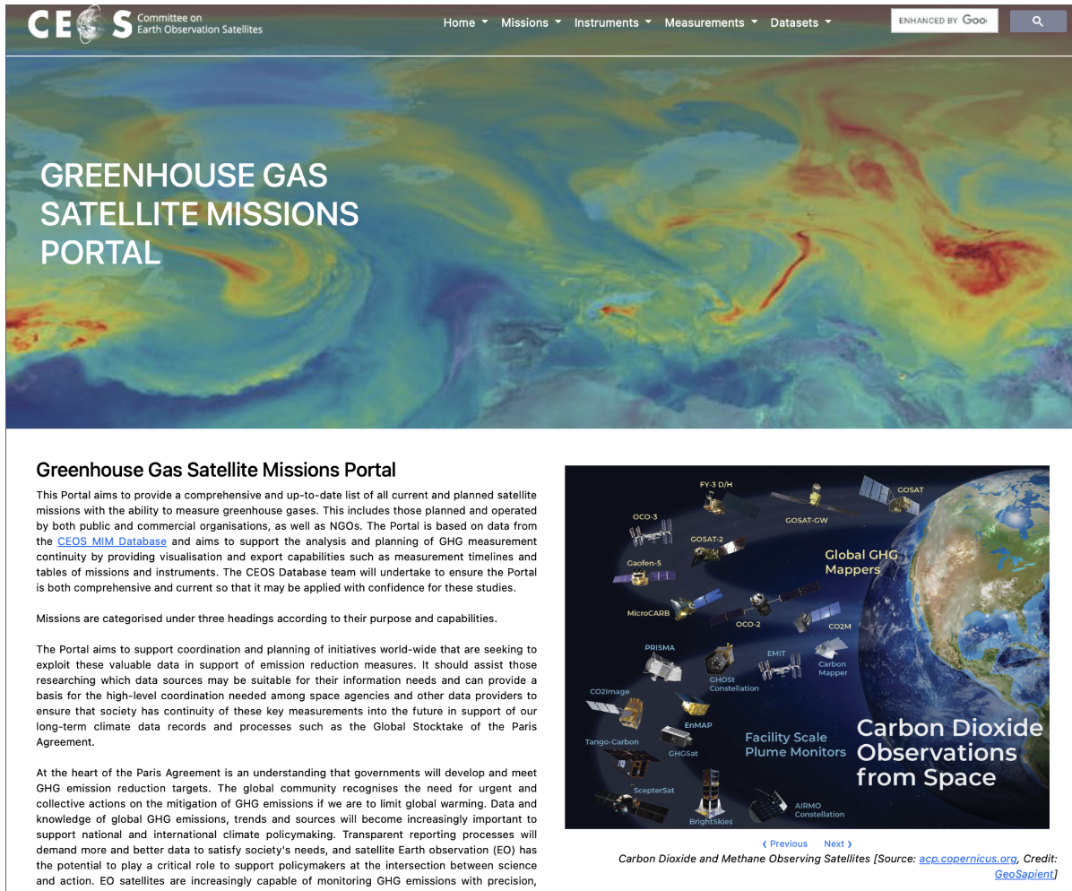
Discussion
- Natalia Donoho (WMO) shared her compliments for the portal, noting the potential for contribution by WMO’s OSCAR/Space. Stephen Ward (ESA MIM Team) noted that the MIM team has been talking with Heikki Pojola from WMO regarding the complementarity with OSCAR.
- Mark Dowell (EC) thanked the ESA and JAXA teams for this contribution of tremendous value. Noted there was an offline analysis completed in November 2021 by GEO, as a one off effort. This was an opportunity to make this type of analysis ‘live’.

2.5: Greenhouse Gas (GHG) Task Team Update
Presenter: Yasjka Meijer (ESA) [presentation]
Main Points
- The GHG Task Team is responsible for maintaining and implementing the GHG Roadmap, which coordinates activities from across CEOS, including WGClimate, WGCV, AC-VC.
- In the GHG Roadmap, there is a list of actions which have been divided into seven thematic areas, each with an assigned lead and deputy.
- The update of the GHG Roadmap was limited to Annex C (action list). It is almost impossible to keep the main text up to date with big advancements in this space. There is ongoing work to implement and update the annex.
- More resources are needed to keep up with the task. There is not as much progress made recently as the team would have liked, due to limited availability of members.
- The goal is to make the actions more actionable and ‘SMART’ (Specific, Measurable, Achievable, Relevant, and Time-Bound).
- The team would like to split actions along scales and between carbon dioxide and methane, since there is a big difference in their measurement and capacity to do so. Different scales have different issues and needs for satellite data, and hence need separate actions.
- GHG Task Team has provided responses to various actions in the GCOS IP Space Agency Response. The main remaining gap is around observations for challenging areas and circumstances (e.g., polar regions in winter – which need to be further justified).
- GHG Task Team has been engaging with WGCV on sustaining GHG Cal/Val networks.
- The Task Team continued engaging with external stakeholders and advocating for CEOS Agencies and their datasets.
- IMEO seeks expertise to coordinate facility scale observations (in general) and then especially for the 'tip-and-cue’. This would be across various operators (commercial, NGOs, philanthropic, public and mixes thereof), where perhaps there is a role for CEOS.
- Five CEOS deliverables were registered within the CEOS Work Plan 2023-2025, and all except the GHG Roadmap update can now be closed. Standards for uncertainty monitoring of flux estimates, and the New Space and GHG product development will be considered ongoing activities.
- JAXA was asked to provide support, during their SIT Chair Term, to provide pressure on individuals to complete the update of Roadmap actions.
- The next steps of the GHG Task Team include:
  - Coordinate activities with the AFOLU Roadmap.
  - Coordinate with the New Space Task Team.
  - Ensure continuity to existing missions.
  - Engage with and ensure CEOS expertise is used in WMO’s GGGW and UNEP’s IMEO.
Discussion
- Ivan Petiteville (ESA) noted the need to ensure that we do not give the impression to the community that we have any ability to lead coordination of commercial sector GHG missions. We can however take steps to help ensure the quality of these observations and ensure complementarity between public and private missions.
- Osamu Ochiai (JAXA, SIT Vice Chair Team) noted that with evolutions in this space, perhaps the GHG Roadmap should be updated. JAXA as incoming SIT Chair will look at the possibility of updating the roadmap.
SIT-TW-2023-02 | GHG Task Team is tasked to complete the update of Annex C (action list) in the GHG Roadmap to support a consolidated overview as a refreshed starting point on this topic for JAXA’s SIT Chair term in time for the CEOS SIT-39 meeting in Tokyo. | SIT-39
 | Rationale: GHG observation coordination is a priority topic for the incoming JAXA SIT Chair, and the GHG Roadmap is the keystone document for this coordination.

- Natalia Donoho (WMO) volunteered WMO’s support for this work and invited CEOS to take note of the upcoming WMO leadership meeting where the Global Greenhouse Gas Watch (GGGW) will be discussed.
- Yasjka Meijer (ESA) noted that CEOS is missing the engagement with users, which is a good potential partnership area with WMO.
- Mark Dowell (EC) recognised the GCOS Implementation Plan 2022 was published recently, where requirements for GHG observations were modified considering the discussions we have had in CEOS over the last few years. This was through the feedback loop facilitated by WGClimate and GCOS. Inventory process and gap analyses has provided valuable feedback to GCOS.

2.6: U.S. GHG Center
Presenter: Argyro Kavvada (NASA) [presentation]
Main Points
- The U.S. GHG Center is a new inter-agency effort, including NASA, EPA (Environmental Protection Agency), NIST (National Institute of Standards and Technology) and NOAA. The center has begun development over the last few months, with a focus on coordinating and integrating GHG data and modelling capabilities across federal and non-federal, domestic, and international entities. The goal is to increase accessibility and usability of this information.
- The platform uses an integrated data system, with a front facing portal. Currently in development, and a beta version will be released soon. Curated data from various platforms, including space, ground, and airborne.
- The center supports the implementation of the national GHG policy. There is a strong focus on building on existing heritage for end-user driven development and delivery of products.
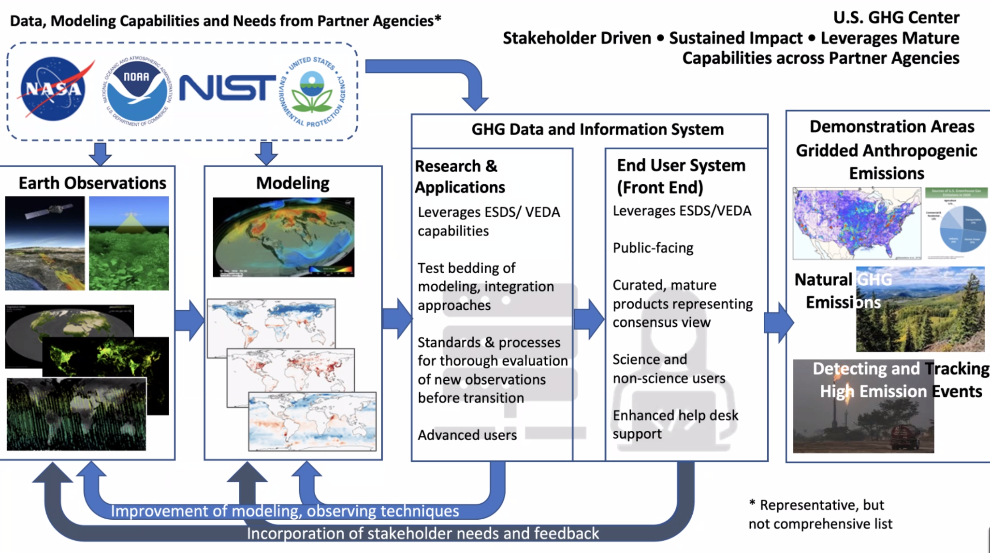
- Various use cases for prototypes are under development, to improve latency and gridding of products. Demonstration area activities also in addition to prototype use cases, which increase links to external stakeholders.
Discussion
- Yasjka Meijer (ESA, GHG TT Lead) recognised it is nice to see these developments and shows the complexity of measuring emissions. This is a nice example for other countries thinking of developing similar facilities. CEOS should be used to coordinate efforts.
- Julie Robinson (NASA) noted that this is something that has happened rather quick, and NASA has lots of experiences to share. The development was policy driven, which is somewhat unusual for the remote sensing sector - usually driven by science questions. The White House has driven this work, as a response to the USA’s return to the Paris Agreement in 2021. Inter-agency partnerships are put under pressure as well. OCO and EMIT missions have made this a particular focus.
- The programme is very focused on user engagement, but due to the policy focus, the users are very different. This takes more resourcing because of the many different stakeholders.
- Mark Dowell (EC) noted they have had some of the same experiences in Europe. The fact that the European Commission President mentioned that the EU should develop a GHG monitoring facility is unusual for the remote sensing sector. The system architecture approach has implications for roles and responsibilities of governments. All CEOS Agencies are learning through individual efforts that this can be challenging. CEOS should have a dialogue on what is successful in building these relationships - this would be a useful input for countries that are seeking to build similar connections.
- Jorge Del Rio Vera (UNOOSA, WGCapD Chair) reiterated the comment regarding policy driven remote sensing. Bringing together science and non-science users. This is clearly a big effort from NASA and the U.S.
Session Close
Yasjka Meijer (ESA) closed the session by noting the following future challenges:
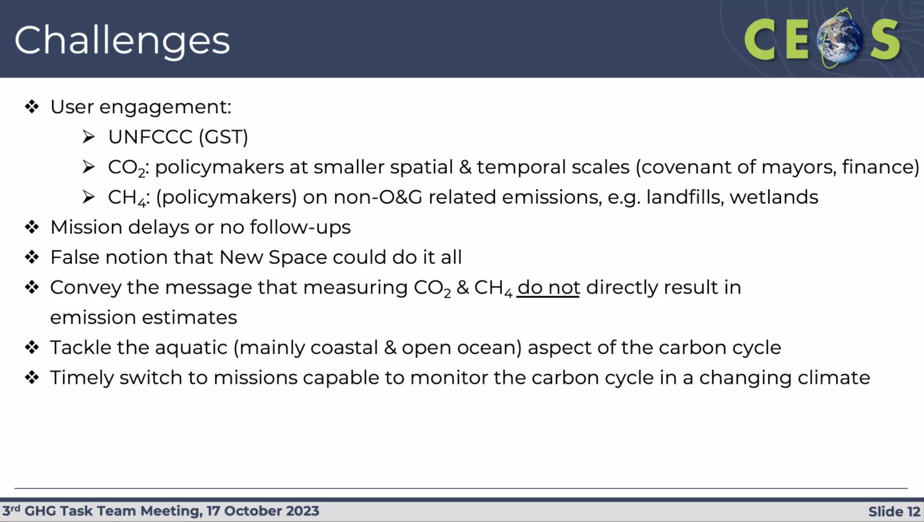
- Osamu Ochiai (JAXA, SIT Vice Chair Team) thanked ESA for supporting these initiatives. JAXA will take on GHG observation coordination as a priority over the next two years, during their SIT Chair term. More information will be provided during agenda item 9.1 tomorrow afternoon regarding the JAXA SIT Chair priorities.

Session 3: Carbon Roadmaps and Policy Impact

3.1: CEOS Agriculture, Forestry and Other Land Use (AFOLU) Roadmap Update and Issues
Presenter: Ben Poulter (NASA) [presentation]
Main points:
- The AFOLU Roadmap has been under development for 3 years and is the result of a broad cooperation across CEOS and beyond. The Roadmap is a deliverable identified in the CEOS GST Strategy.
- A first draft of the roadmap was shared with CEOS for review in May 2023.

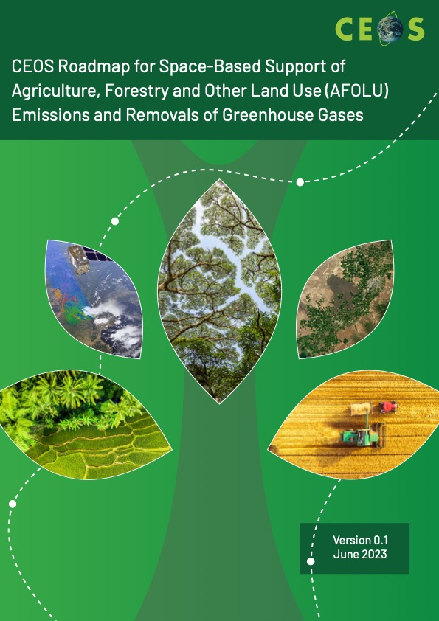 | 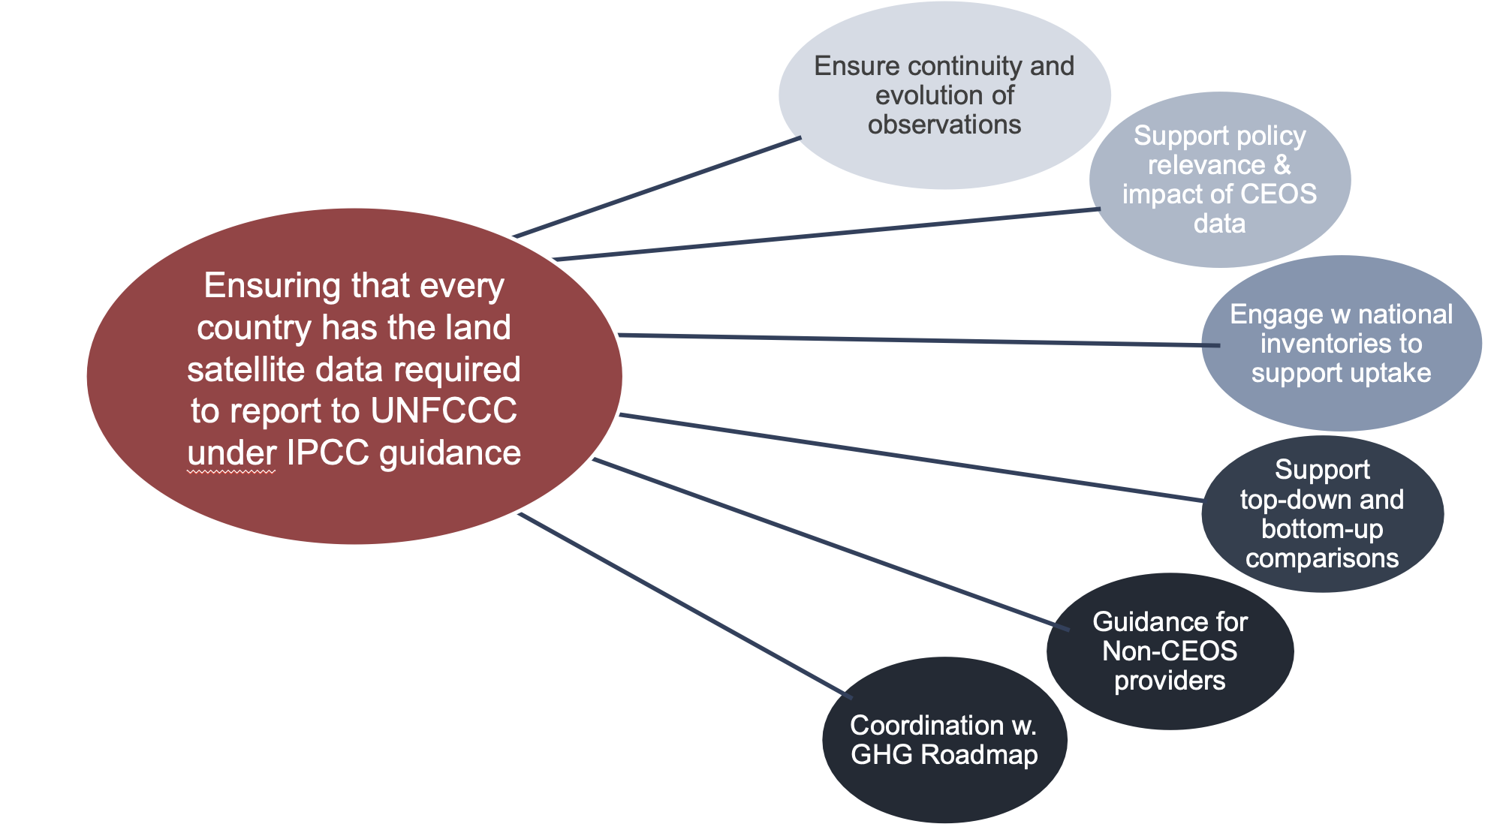
- The overall objective for the Roadmap is to ensure that every country has the land satellite data required to report to UNFCCC under IPCC guidance.
- There are seven main recommendation groupings following the categories per the figure above.
- Next steps include:
  - Hosting a JAXA/ESA/RESTEC/GOFC-GOLD-supported side event on Satellite Observation at COP 28.
  - Developing a set of ‘actions’ as a supplement to implement the Roadmap recommendations, to be completed by SIT-39 (April 2024). Like the CEOS GST Strategy the intention is to have this as a short document that will be the focus of future CEOS updates at the annual meetings, rather than frequent updates to the more expansive Roadmap document.
  - Running an ESA-led Amazonia field campaign with INPE and NASA contributions (2024+)
- The Roadmap will be finalised in time to seek endorsement at the CEOS Plenary 2023 in Chiang Rai, Thailand.

SIT-TW-2023-03 | CEOS Agriculture, Forestry and Other Land Use (AFOLU) Roadmap Team is tasked to bring for endorsement at SIT-39, an AFOLU Roadmap Actions Supplement, as the main instrument for CEOS tracking of AFOLU Roadmap implementation. | SIT-39
 | Rationale: The CEOS AFOLU Roadmap document will be finalised for endorsement at the 2023 CEOS Plenary and is a comprehensive review of the issues. The Actions Supplement will be a brief addition for CEOS to track AFOLU Roadmap implementation. The Actions Supplement will continue to be stewarded by the AFOLU Team in the Land Surface Imaging Virtual Constellation (LSI-VC).

Discussion
- Jörg Schulz (EUMETSAT) noted that some of the recommendations, e.g. 1c, could be actioned together with the WGClimate ECV Inventory. Many variables are already GCOS ECV products. If there are gaps, then we could discuss whether these should be included in the Inventory.
- Ben Poulter (NASA) noted there have been a lot of lessons learned through the biomass harmonisation activity. Challenges exist around how the land sector is treated. There will be some actions related to ECVs that can be worked collaboratively.
- Mark Dowell (EC) noted that the recommendations cover lots of different time scales. Recommendation 2 reflects longer term ambitions, not just for AFOLU but also GHG activities. Partnership with WMO and GGGW might be beneficial. If CEOS can work towards making a strong case for explicit usage of EO datasets in the formal Task Force on National Greenhouse Gas Inventories (TFI) process and guidelines in IPCC and UNFCCC, that would be a big step forward in how space-based datasets can contribute to the reporting process.
- Osamu Ochiai (JAXA, SIT Vice Chair Team) recognised that lots of CEOS agencies have an opportunity to contribute data, including JAXA with the ALOS series. This is a complex space, with lots of use cases. As incoming SIT Chair, JAXA will focus on climate policy impact, and will encourage CEOS Agencies to engage with users and UNFCCC Parties.
- One of the actions the AFOLU Team has been discussing is to engage at the requirements level for specific missions, to maintain continuity for required products. The plan is to create a requirement appendix, and to have a statement linked to those requirements.
- Yasjka Meijer (ESA) asked about the next steps. Assuming this Roadmap is endorsed, will there be a working group / task team? Stephen Briggs (SIT Chair Team) noted this depends on the actions which will develop and will be like how the GHG Roadmap evolved. The need for a coordinating group will depend on the specifics of the actions.
- The draft document remains open for feedback until the CEOS Plenary.

3.2: Biomass Harmonization Team Update
Cambodia Case Study 2024-2025
Presenter: Sylvia Wilson (USGS) [presentation]
Main points:
- SilvaCarbon works to demonstrate uptake of satellite-based data and derived products in countries reporting to the UNFCCC. The work provides national feedback on, and contributes to the refinement of, available products derived from satellite-data (land cover and biomass).
- The main goal is to support the generation of reliable and transparent data for reporting to REDD+, and for countries to enter carbon markets.
- Mangrove mapping workshops have been held in Fiji, Thailand, and Guatemala, while biomass workshops were held in Thailand and Paraguay.
- A new chapter will be added to the GFOI Methods and Guidance Documentation (MGD) on EO-assisted emission factors.
- During the JAXA SIT Chair Term, USGS and JAXA plan an extended case study collaboration in Cambodia to help develop EO-based reporting tools and methods.
Discussion
- Jorge Del Rio Vera (UNOOSA, WGCapD Chair) asked about the format of the Peru workshop. The workshop was held in person and included a field work component.

Harmonizing Biomass Maps With Policy Needs: Development of National Prototypes for the Global Stocktake
Presenter: Laura Duncanson (UMD) [presentation]
Main points:
- This is a coordinated effort between CEOS agencies and users/producers of aboveground-biomass (AGB) maps. This effort is part of the LSI Forest and Biomass Team’s AFOLU activities and is undertaken in collaboration with the WGCV LPV subgroup.
- The purpose is to communicate a clear and consistent message on forest AGB products, especially as the number of different public datasets grow and new missions’ approach (NASA and ISRO’s NISAR, ESA’s BIOMASS, JAXA’s ALOS-4 and MOLI)
- The effort seeks to support the inclusion of EO-derived biomass products in national reporting frameworks (currently missing). The team is creating policy-relevant (IPCC) tables with EO biomass products.
- New ESA Climate Change Initiative (CCI) and GEDI biomass products were released in 2023.
- The activity is supported by the joint NASA-ESA MAAP platform which is an open-science activity that promotes a transparent approach.
- The team recommends continued support of CEOS Member Agency representatives to participate in the biomass harmonisation activity. JAXA as the new SIT Chair will also increase efforts to collaborate with SE Asian countries.
- NASA is supporting a new 3-year Carbon Monitoring System grant focused on bridging the science-policy gap (in Mexico, Ecuador, Senegal, Ghana, among other countries).
- Expanding the CEOS biomass protocol to cover change validation would be highly desirable.
EO Contribution to the GST
Presenter: Joana Melo (EC-JRC) [presentation]
Main points:
- The headline from Joana’s recent paper is: “Satellite-based global maps are rarely used in forest reference levels submitted to the UNFCCC”. The paper compiles information on the use of EO products on land cover, fire, and above-ground biomass to derive carbon flux estimates in forest reference levels from 56 tropical countries submitted to the UNFCCC between 2014–2022. The global forest change (GFC) was the only EO product used to measure land extent and change and was used by almost half the countries. Only two countries used existing EO products for fire mapping. Four countries used biomass maps, although only indirectly, such as for comparing with biomass estimates from field plot measurements or with IPCC defaults. The uptake is limited but improved the measurement, reporting and verification capacity of 22 countries.
- The limited use of most global land EO products underlines the need for developers of EO products to interact with groups responsible for GHG inventories and experts familiar with IPCC guidance so that their products are suitable for national reporting, and thus contribute to more complete aggregated estimates in the Global Stocktake.
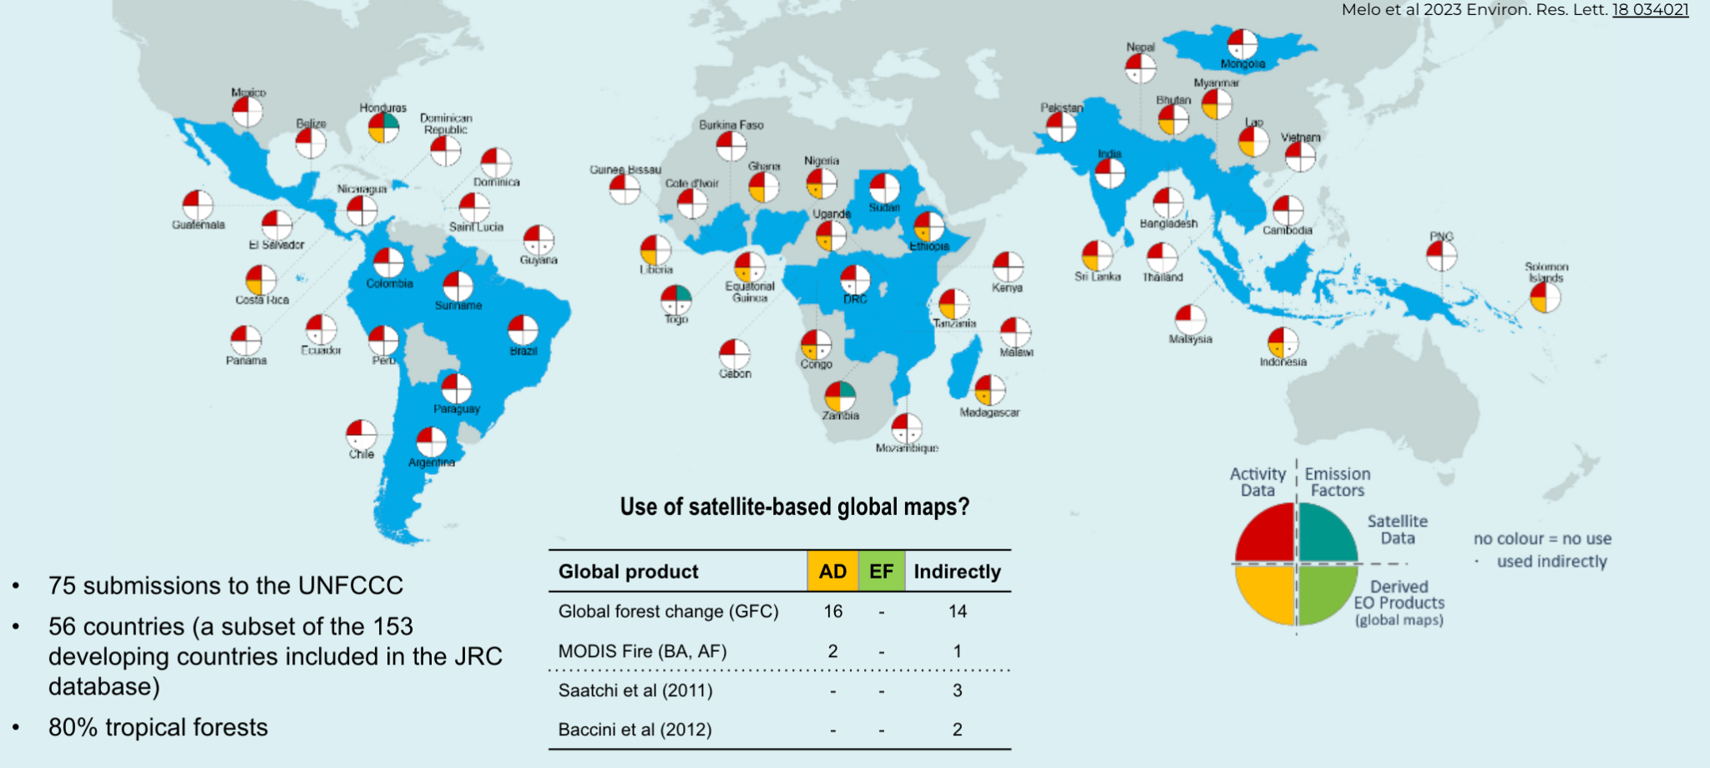
- Contributing to the GST with independent estimates requires adherence to IPCC guidance and national definitions, as well as explaining the differences to GHGI. Conceptual differences in the data reported needs to be explained to policy makers.
- Conflicting messages creates confusion. It is important CEOS can explain the differences in datasets and inventories, as this impacts the uptake of EO data.
- An example from Brazil was shown which demonstrated large discrepancies in results of different methodologies due to different approaches to handling unmanaged forests.
- These and other issues are addressed in the recommendations included in the AFOLU Roadmap.
Discussion
- Stephen Ward (ESA, SIT Chair Team) recognised that every new dataset released reduces the probability that countries will use space data. Even if it is a better, more accurate dataset, it hurts the credibility of what came before. Hope that the biomass harmonisation work will serve as a guiding example, and one that will be followed up during the JAXA SIT term.
- Stephen Briggs (ESA, SIT Chair Team) noted it is not a question of right or wrong methodologies, but how the reporting is defined. IPCC reporting is only done for managed land, which satellite data can’t account for. IPCC doesn’t consider unmanaged land, as countries can’t improve their management practices. There are two reporting systems that aren’t consistent because they are answering different questions.
- Mark Dowell (EC) suggested the goal should be focusing on working together with different communities to refine the guidelines so that they can best make use of EO data that we provide, while also being consistent with reporting requirements.

3.3: Proposal for a CEOS Aquatic Carbon Roadmap
Presenter: Marie-Helene Rio (ESA, OCR-VC Co-lead) [presentation]
Main points:
- Oceans play a major role in the Global Earth Carbon Cycle. Modelling estimates of the global land sink relies on the ocean and atmospheric data.
- Not only is ocean carbon a key constraint to the global carbon budget, but its monitoring is also essential as increasing anthropogenic CO₂ emissions are reducing the pH of oceans (ocean acidification).
- So far, the amount of carbon absorbed by the oceans has increased with emissions. But its future response is not known - can the sink continue to increase, or how will biology change and influence it?
- The proposed Aquatic Carbon Roadmap is the third pillar in the CEOS Strategy to support the Global Stocktake, alongside the GHG and AFOLU Roadmaps.
- Activities towards the roadmap have already begun, with some identified in the CEOS Work Plan.
- Roadmap is proposed to provide a framework and serve as a guiding vision for long term (15+ years) coordination of CEOS agency observations in support of the needs for aquatic carbon information in the context of the CEOS Carbon Strategy. It will cover products to better constrain models, mapping of extent of blue carbon ecosystems, and tools/products/indicators to support policy needs. It will characterise needs, gaps, challenges, and basic observation continuity.
- The development of an Aquatic Carbon roadmap is a very timely, needed, but at the same time very ambitious commitment. The following are the resources needed to develop the roadmap:
  - The contribution and coordination from IOCCG/CEOS OCR-VC agencies will be essential to work towards actual deliverables. Most of these agencies have carbon related activities on which the roadmap will build.
  - Laura Lorenzoni (NASA), Marie-Helene RIO (ESA) and Hiroshi Murakami (JAXA) have been identified as potential coordinators for the roadmap. CEOS Principals will be asked to confirm their commitment.
  - At IOCCG level, an IOCCG Aquatic Carbon from Space Task Force is being initiated (led by Jamie Shutler, University of Exeter, UK and Cecile Rousseaux, NASA GSFC, US) and a Working Group on Primary Production (chaired by Robert Brewin, University of Exeter, UK), which could both support the production of the roadmap.
  - Jamie Shutler, Bob Brewin, and Cecile Rousseau have been identified as potential scientific leaders of the roadmap.
  - The Aquatic Carbon Roadmap will also likely require a degree of coordination and collaboration with AFOLU Roadmap and the GHG Roadmap, for what regards Blue Carbon ecosystems (Wetland/mangroves are part of the AFOLU roadmap). CEOS support is needed to coordinate between the three roadmaps.
- OCR-VC is preparing a 2–3-page paper to support CEOS Principal discussion at CEOS Plenary in November. Will be a short background paper which will cover why a roadmap is needed, what is needed to achieve it, timeframe, identification of stakeholders, participants, basic outline, and roles, etc.
- CEOS Principals will be asked at Plenary to commit representation and resources to develop the Aquatic Carbon Roadmap, including the coordination with the GHG and AFOLU Roadmap activities.
Discussion
- Marie-Helene Rio (ESA, OCR-VC Co-lead) noted that participation in the Blue Carbon Forum is by invite only, and individual invites will be sent out. A draft list of topics has already been prepared.
- Mark Dowell (EC) recognised that on the policy side, there has been a dialogue ongoing in UNFCCC regarding ocean and climate, focused on aspects of the ocean related to the Paris Agreement and the whole UNFCCC process. This could be interesting to look at in terms of support to indicators. Mark offered to share links to information with Marie-Helene.
- Mark also noted the links to the AFOLU and GHG roadmaps, in the context of defining global models and data assimilation. Blue carbon is also involved with the AFOLU activities (mangroves, etc.). The coordination needed across the three roadmaps was highlighted, as there are several activities across the three roadmaps which are aligned.
- Alex Held (CSIRO) asked about the need for geographic representation, or technical expertise, at the Blue Carbon Workshop. Can Australia contribute? Marie-Helene Rio (ESA, OCR-VC Co-lead) noted the team tried to distribute participants of the first list across regions and expertise.
- Yasjka Meijer (ESA) asked about accounting for lateral carbon fluxes from rivers. The roadmap is ambitious and hopes to tackle all these elements. However, the team will see to which extent it can be completed, based on resources.
SIT-TW-2023-04 | Ocean Colour Radiometry Virtual Constellation (OCR-VC) Co-leads, in collaboration with the SIT Chair, will confer with relevant CEOS Principals prior to the 2023 CEOS Plenary to determine if necessary CEOS Agency representation and resources are forthcoming to allow the Aquatic Carbon Roadmap to proceed. | 2023 CEOS Plenary
 | Rationale: Significant Agency investment and effort will be required to undertake this activity. The co-leads are exercising due diligence to ensure the proposed Agency participation and capacity are available to proceed.

3.4: CEOS-UNFCCC Interface and COP 28 Planning
Presenter: Jeff Privette (NOAA, WGClimate Chair) [presentation]
Main points:
GCOS IP Response
- WGClimate-19 was held 16 - 17 October 2023, prior to the SIT Technical Workshop.
- The GCOS Implementation Plan includes recommendations for a sustained and fit for purpose Global Climate Observing System, including water, energy, and carbon cycles. The 2022 version includes the space agency supplement, and fewer, more focused, actions than previous editions.
- WGClimate is working closely with the GCOS Secretariat (via both routine & ad hoc meetings) to respond to the Implementation Plan, including on the clarification of actions, needs and uses.
- The requests coming from the scientific community through GCOS are becoming more mature and tailored.
COP 28 Preparation Including SBSTA Statement
- The draft statement can be viewed here.
- The WGClimate statement to SBSTA for COP 28 aims to educate and advocate CEOS-CGMS findings and recommendations. Key points in the 2023 Statement cover systematic stocktakes, GHG observing advances, AFOLU, new space, and EO in inventories.
- The current draft has been vetted through WGClimate and is now under review by the CEOS and CGMS secretariats. Comments are welcomed until Monday 23, October. CSA will read a condensed version to the SBSTA Plenary at the start of COP 28.
- The COP 28 Earth Information Day will occur on December 3, 2023. WGClimate have been working with SBSTA on the planning of the event, which will include three hours of plenary presentations, followed by one hour of ‘World Cafes’. The UNFCCC Parties are the target audience for the event.
- Susanne Mecklenburg (ESA) will present at the Earth Information Day Plenary on behalf of CEOS and WGClimate, including on the topics of systematic observations for the Global Stocktakes, the AFOLU Roadmap and CEOS-GCOS relationship.
- A Space Leaders’ Summit is being coordinated by UAESA, with some limited participation of space agencies. UAESA has proposed a Space Agency Pledge.
- There will also be a Space Pavilion, sponsored by individual agencies. WGClimate were unable to coordinate in time to meet COP and government deadlines, so will be unable to participate directly. There is extensive coordination required for participating in COP, which can be a barrier to participation. Planning meetings were held in August with Jo Post and Tracy Tollman (SBSTA Secretariat), and they involved CEOS, CGMS, GEO, GCOS, WMO, IPCC-Inventories, and GOOS.
Discussion
- Natalia Donoho (WMO) noted that the GCOS Secretariat is located at WMO Headquarters. Anthony Rea recently left WMO, and WMO is in search of a new Director for Infrastructure.
- Beth Greenaway (UKSA) noted that UAESA approached UKSA in April seeking assistance with the Space Pavilion. The pavilion is quite a large area, right outside of the Blue Zone, purposefully chosen for visibility to official delegates. In addition to space agencies, many space industry representatives will also be present. The pavilion will be open for the whole 14 days of the COP, and UKSA will have a stand. UKSA is proposing to supplement the Space Pavilion with a more inclusive event in the Green Zone, to promote the content in the Space Agencies’ Pledge. Beth extended an invitation to CEOS agencies to join UKSA’s event in the Green Zone.
- The Space Leaders’ Summit will be on the 4th of December and aims to gather 25-30 space leaders. A second version of the pledge is now in circulation for comments.
- Éric Laliberté (CSA) noted that the CSA team will require internal approval before the statement can be read, so all efforts to have the final version as soon as possible would be greatly appreciated.
SIT-TW-2023-05 | CEOS Agencies are invited to provide comments on the draft Joint CEOS-CGMS Space Agency Statement to the UNFCCC Subsidiary Body for Scientific and Technological Advice (SBSTA). WGClimate is asked to confer with CEOS Agencies regarding the timetable for review and submission, and to issue the latest draft ASAP. | 25 October 2023
 | Rationale: The Joint Statement must be finalised urgently ahead of COP 28. Some agencies may need a few weeks to review and approve the texts.

3.5: 2023 CEOS Earth Observation Handbook – Space Data for the Global Stocktake
Presenter: (Stephen Ward, ESA EO Handbook Team) [presentation]
Main points:
- The CEOS EO Handbook and the underlying database were first produced in 1992 for the Rio Summit. The Handbook is used to promote CEOS work and benefits of satellite Earth observations in relation to major policy-related events.
- Recognising the opportunity of the first Global Stocktake, CEOS agreed to develop a new edition to coincide with COP 28 and related Global Stocktake events in late 2023.
- The 2023 edition is titled “Space Data for the Global Stocktake”. It features a foreword by Simonetta Cheli (ESA) and Simon Stiell (Executive Secretary of UNFCCC).
- The goal is to develop a broader understanding of the fundamental importance of satellite EO to the information needed to inform all aspects of the Paris Agreement and demonstrate the potential of EO to contribute to country reporting on NDCs for GST2 in 2028, including key user stories as inspiration and encouragement. Suggestions for Parties on where to get help on using EO data are also included.
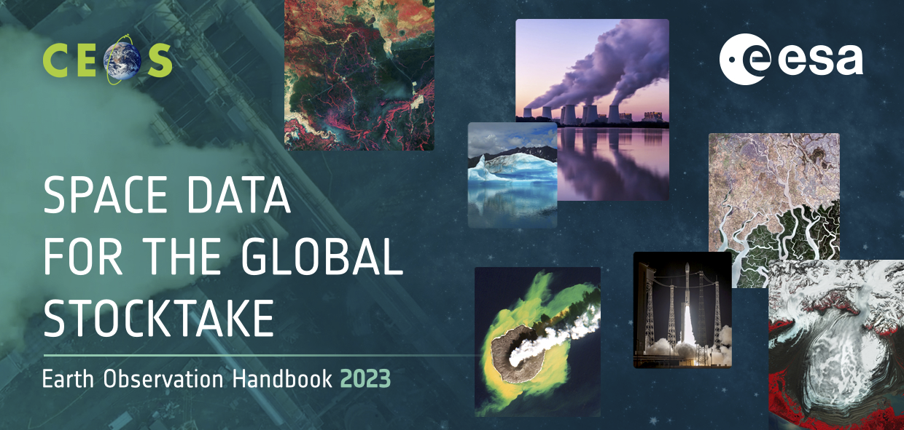
- Part I addresses the importance and impact of space data for the GST, while Part II provides user stories and inspiration for different stakeholders.
- The 2023 EO Handbook will be available in two formats: a high-end ‘scrollytelling’ website (hosted on eohandbook.com), as well as a more expansive and detailed PDF version.
- There were many contributors from across CEOS. ESA shared their thanks to all who contributed.
- The team is looking for opportunities around COP 28 and beyond to promote this resource. CEOS Agencies are asked to contact the ESA team with any suggestions. Agency booths or events would be ideal targets. A short promotional video is in development, as well as a flyer to hand out with key messages and URL. Both can be shared for Agency use at various events.
- The ESA team will provide an announcement to CEOS on release.
- ceos.org/gst is also being maintained and updated. There were numerous updates to articles over the past year, with one new page on the Sentinel-3 World Fire Atlas:
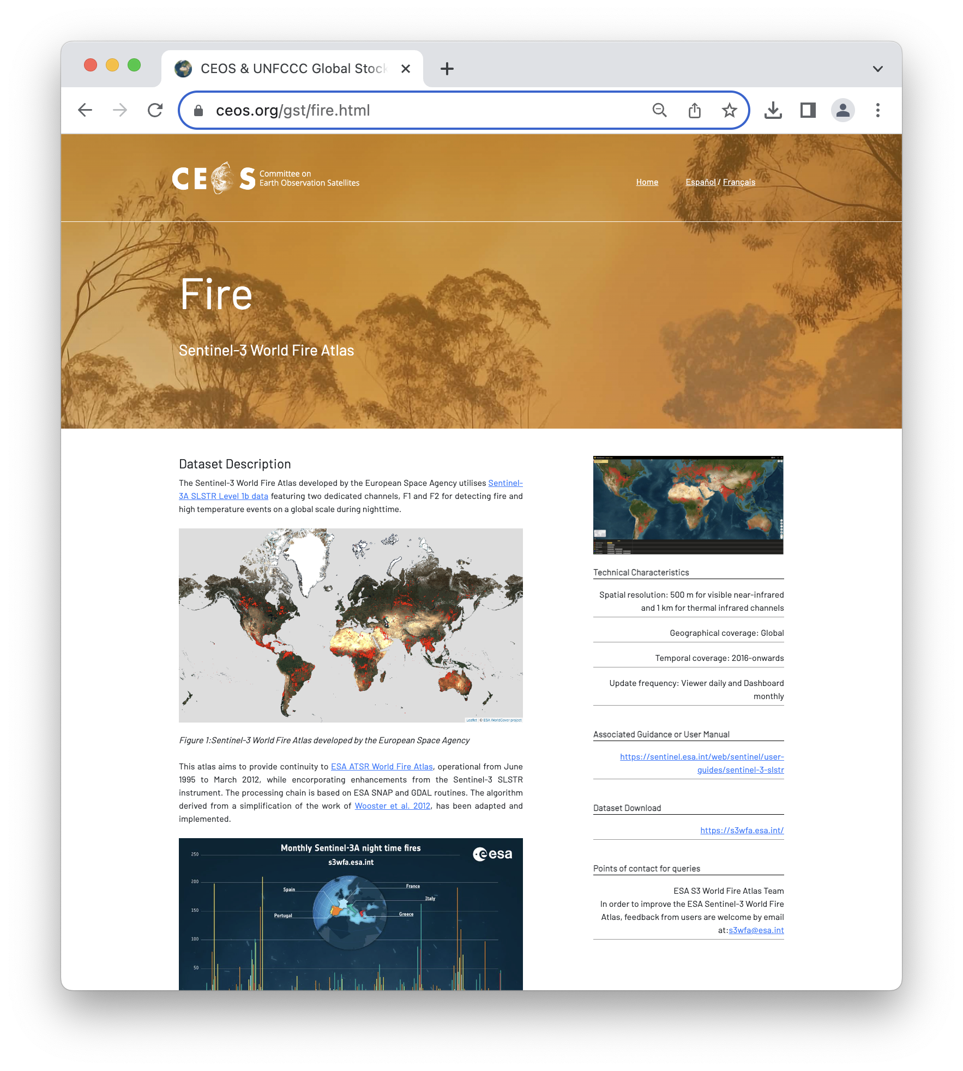

Session 4: GEO-CEOS Relationship

4.1: Session Context Setting Informational Presentation on GEO Post-2025
Presenter: Jonathan Ross, GA [Presentation]
Main points:
- The draft GEO Post-2025 Strategy can be viewed here. A summarised 2-page version is available here.
- The key points within the post-2025 strategy include:
  - Fostering greater integration along the full EO value chain;
  - Implementing a new model, focused on co-design and co-development;
  - Emphasising the need for equity and broader substantive participation;
  - Amplifying advocacy, communications, and resource mobilisation;
  - Expanding focus from EO to the broader concept of Earth Intelligence (EI);
  - Articulates GEO’s mission, vision, and goals for the next ten years around EI.
- The content of the strategy focuses on the ‘polycrisis’ faced by Earth, including climate, pollution, biodiversity, disasters, deforestation, and land degradation.
- GEO hopes to move from ‘Earth Observation’ to ‘Earth Intelligence’, which comprises integrated Earth and social science derived knowledge and insights that inform strategic decisions, build capacities, and empower society to address environmental, societal, and economic challenges. Its design is based on user needs at all scales and at all sectors and integrates Earth observation data, socio-economic data, research and science, citizen observations, Indigenous knowledge and other sources of information and combines this with modelling, predictions, and scenario analysis.
- The strategy outlines five key goals to succeed:
  - Co-produce transformative programs that provide trusted Earth Intelligence (EI);
  - Increase global equity through accessible Earth Intelligence;
  - Integrate new technologies and innovations into Earth Intelligence Services;
  - Increase the participation of the younger generation in the development of Earth Intelligence;
  - Invest in integrated activities to raise awareness and resources for Earth Intelligence.
- A new operating model will also be needed, focusing on accountability and results, representation, financial sustainability, inclusivity, transparency, and participation. A scalable operating model between regional, national, and global scales is needed.
- The strategy will be submitted to the GEO Ministerial Summit in Cape Town in November, where it will hopefully be adopted and endorsed by Ministers. Assuming this occurs, the next step will be to develop an implementation plan to guide progress in executing the Strategy.
Discussion
- Mark Dowell (EC) added that the following GEO Plenary will be held in the February to March timeframe in 2025. This will be the next key milestone for the strategy, especially as 2025 will be the 20th anniversary of GEO.
- Osamu Ochiai (JAXA, SIT Vice Chair Team) noted that the working group to develop the strategy involved 25 members from across data providers to data users.
- Katy Matthews (NOAA) recognised this is a great opportunity going forward to think about the individual roles of the agencies within a national delegation, as well as their role in representing CEOS. CEOS activities should be continued to be brought to the table, to frame and determine the implementation going forward.

4.2: GEO Work Programme
Presenter: Wenbo Chu (GEO Secretariat, Work Programme Officer) [Presentation]
Main points:
- An overview of how CEOS and GEO have been working together was provided. It is a good time to reflect, given the development of the GEO Post-2025 Strategy.
- GFOI, GEO LDN, GSNL, EO4DRM and EO4SDG – CEOS/CEOS Agencies have been on the leadership / steering committees of these groups and have been instrumental in the work of these programmes.
- There is broad CEOS Agency engagement in numerous GEO Work Programme activities, Working Groups and Task Teams.
- CEOS has been continuously sitting on the GEO Programme Board since 2016.
- GEO greatly values the contribution of CEOS and its members and associates. Looking ahead, there are many new opportunities for GEO and CEOS to continue working together.
- CEOS should join the process to shape the new GEO Work Programme.
- Early Warning for All (EW4ALL) presents a new opportunity for engagement. Working through the disasters and climate working groups. CEOS agencies are welcome to join the activity.
- GEO messaging at COP 28 will be around the theme of EO and frontier technologies for climate adaptation, early warning, and nature protection.

4.3: CEOS Sustainable Development Goal (SDG) Coordination Group: An example of the CEOS-GEO Relationship
Presenter: Dave Borges (SEO) [Presentation]
Main points:
- The CEOS SDG Coordination Group formed in 2021, from the basis of the SDG Ad-Hoc Team (established in 2016). The new ‘federated’ approach is coordinated by the SIT Chair and SEO.
- In 2021, the CEOS-GEO Responsibilities guidance document was collaboratively developed. The relationship has now evolved, and the document will have to be revised.
- The GEO Work Programme provides CEOS with one efficient way to work on specific SDG Targets and Indicators.
- Individual GEO Work Programme activity and direct UN Custodian Agency engagement are current reality, and can demonstrate successful methodology (e.g., GEO LDN / UNCCD).
- Maintaining awareness of all SDG activities across GEO without a dedicated Coordination function is a challenge. The former document was written at a time when GEO had a dedicated SDG coordinator, which is a position no longer filled.
- CEOS SDG Coordination Group agreed at yesterday’s side meeting to review CEOS / GEO Responsibilities.
- CEOS should also consider an expansion on how EO data is used - what is coming after the SDGs in 2030? When the SDGs were engineered, they didn’t consider EO data capabilities. We should perhaps start working now to ensure whatever comes next that EO data is considered from the outset.

4.4: GEO BON, GEO Wetlands and EO4EA: Examples of the ESA-GEO Relationship
Presenter: Marc Paganini (ESA)
Main points:
- There is no official CEOS representation to these initiatives. Representation is at the level of individual agencies.
- GEO Wetlands:
  - CEOS Agencies have been involved in the Ramsar Convention well ahead of GEO Wetlands’ establishment in 2017 (JAXA, ESA).
  - The 2 main outputs of GEO Wetlands are a Knowledge Base on how to use EO with EO best practices, and a Geospatial Data Portal.
  - GEO Wetlands was essentially based on European funded projects and on the Global Mangrove Watch. The secretariat of GEO Wetlands was provided by a project funded by the European Commission.
  - GEO Wetlands, with the support of Space Agencies, contributed to the Ramsar STRP report on “The use of Earth Observation for wetland inventory, assessment and monitoring” in 2018 and to the development of the “Ramsar Toolkits for national Wetland Inventory” in 2020.
  - GEO Wetlands failed in mobilising financial resources (getting core funding other than from projects) and in engaging a large international community around the initiative and to promote a more federated approach (in large part due to the limited resources available).
  - After a brief revival opportunity, with staff changes, GEO Wetlands is again on hold. The group, however, has excellent relations with both Ramsar secretariat and STRP. The conditions have never been better for CEOS to engage with Ramsar and GEO Wetlands, to support the top priority of Ramsar which is wetland inventory. The problem remains that without any funded secretariat, it will be difficult for GEO Wetlands to achieve its ambition.
- GEO EO4EA (EO for Ecosystem Accounting):
  - The initiative started in 2019, with the secretariat being funded by Conservation International. Several agencies are already involved (e.g. USGS, NOAA, NASA, EC-JRC and ESA).
  - The implementation strategy of SEEA Ecosystem Accounting highlights the importance of scaling up implementation in countries using Earth Observation.
  - GEO EO4EA never really managed to play a leading role in the implementation of Ecosystem Accounting, probably due again to a lack of resources.
  - However, they managed to involve the SEEA team from the UN Statistics Division and international experts in Ecosystem Accounting, especially from Europe and the US
  - Unfortunately, since last year, Conservation International decided to stop its activities on ecosystem accounting and the initiative is now in standby waiting for a new secretariat. Meanwhile, the Space Agencies (essentially USGS, ESA, NASA and JRC) are still active within the Technical Committee of the SEEA Ecosystem Committee.
  - Both UNSD and the chair of this committee have expressed their interest to have a meeting with CEOS to look for areas of cooperation.
- GEO BON:
  - GEO BON is one of the GEO Flagships, and thus has a well-funded secretariat and large community. The group is well organised and is strongly involved in policy processes with UN CBD and IPBES.
  - Members of GEOBON are very active in the Global Biodiversity Framework (GBF) and the UN CBD. GEO BON is seen by the UN CBD as the organisation that coordinates biodiversity observation globally and is mentioned in many COP decisions. Hence, engaging with GEOBON is a must for CEOS to engage on biodiversity.
  - Space Agencies have actively contributed to GEO BON from its onset, including the development of the paper on EBVs, which was written at ESRIN in 2012.
  - GEO BON has a remote sensing task force; however, they have not been very active recently.
  - Recently GEO BON has started development of GBiOS. ESA and NASA supported the inception workshop.
  - There is also a new leadership of GEO BON, who sees CEOS as a key partner to build GBiOS.
- In summary, Space Agencies and CEOS can benefit from the GEO's "convening power". All of these GEO initiatives have tried to establish relationships with their policy stakeholders, but not all have succeeded to be recognized as a key partner by them. To be recognized as a key partner, the 3 points essential for GEO activities are: 1) to have a fully funded secretariat and a well-established and active governance structure, 2) to engage widely with the community and be recognized as a scientific reference by the policy stakeholders, and 3) to be involved in the science to policy processes. Of the above examples, only GEO BON succeeded in all 3 aspects.
- CBD, UN SEEA and Ramsar all recognise the value of Earth observation for the implementation of their policies and need support for this.
- Recommend that, as part of the priority of the incoming Chair to increase CEOS Policy Footing and Linkages to the Biodiversity Community, we need to analyse how CEOS should organise itself, in the context of the Post-2025 GEO strategy, to be recognised as a key interlocutor by the policy stakeholders.

4.5: GEO Blue Planet: An Example of the NOAA-GEO Relationship

Presenter: Paul DiGiacomo (NOAA)
Main points:
- NOAA-GEO partnership has been productive. The team has been able to draw from GEO Blue Planet expertise for SDG 14.1.1 on coastal eutrophication.
- The proposed COAST Virtual Constellation will provide a more formal mechanism for engagement with GEO Blue Planet, as well as enhance data access.
- For a successful partnership, GEO Blue Planet will need sustained engagement from CEOS Agencies.

4.6: Discussion
Presenter: Marie-Claire Greening (CEOS Executive Officer) [Presentation]
Main points:
- Providing support to GEO is one of CEOS’ four long-term priorities.
- CEOS is a Participating Organisation (PO) to GEO but has a slightly different status than other POs as its ‘Space Arm’. CEOS members are the most prolific data providers.
- CEOS has historically been handled differently than other POs and, up until early 2023, always had a dedicated liaison point at the GEO Secretariat who attended the three main CEOS meetings, Working Group meetings when appropriate, and all monthly CEOS Secretariat teleconferences. This stopped in April 2023, and the load on the CEOS Executive Officer increased significantly.
- SIT Chair and CEO both represent CEOS on the GEO Executive Committee, as well as the Programme Board.
- The following points were raised for discussion:
  - General engagement with GEO and its efficacy.
  - CEOS’s special relationship as the ‘space arm’ of GEO.
  - What CEOS expects from GEO; What GEO expects from CEOS.
  - Implications from the post-2025 GEO strategic vision.

Discussion
- Tim Stryker (USGS) recognised CEOS and GEO are very important to one another. He noted the importance of the question about where the line is drawn between Earth observation and Earth Intelligence. CEOS is interested in decision support, however ‘Earth Intelligence’ may go beyond this mandate, and this may be a consideration for other GEO stakeholders too. Tim also noted the concern about regional fragmentation of GEO. Where in the past, GEO datasets and initiatives were global in nature, there has been recent discussion about separate rules for separate regions and there is a concern this may signal a fragmentation of GEO’s global approach.
- Julie Robinson (NASA) thanked the presenters for this good set of examples to base the discussion on. She appreciated the fact that one of CEOS’ governing documents says CEOS should ‘serve GEO’, but Julie doesn’t see this happen in practice. Bringing together agency priorities is the strength of CEOS, and we should continue to engage with GEO in the same way as other international organisations - GEO shouldn’t be a special priority. CEOS should strive to find cases where we can do things together that benefit both organisations. Should be careful to not diminish CEOS’ own priorities.
- Jorge Del Rio Vera (UNOOSA, WGCapD Chair) shared the multilateral coordination example of EOTEC DevNet, which involves many international groups. The goal is to bring together the networks of the various organisations to share resources.
- Katy Matthews (NOAA) noted that the concept of Earth Intelligence is more about the evolution of the needs of our users, rather than scope creep. Coming from a perspective of a non-scientist, EO data should be integrated with social science for it to be of best use to users. The concept of Earth Intelligence developed from this - i.e., how do we combine EO with data that makes it most useful.
- Ivan Petiteville (ESA) highlighted the call for co-design with the user community. GEO is aware of the needs of the scientific community, as well as the capabilities of space agencies. This connection really helps CEOS, as not all agencies are equipped to interface with the user community.
- Ivan asked about the emphasis on increasing resource mobilisation, and who this was addressed to. Jonathan Ross (GA) noted that this referred to resource mobilisation in the broader sense, for example with GEO being more active in raising funds from philanthropic sources (rather than asking GEO POs for more resources). The net could also be cast wider, e.g. including private sector funding. Mapping these resources to outcomes will be one of the challenges in the implementation plan. He noted Tim’s comments around fragmentation, and that we should try and avoid a situation where big donors attach strings to their funding which undermine GEO.
- Pakorn Apaphant (GISTDA, 2023 CEOS Chair) recognised the timeliness of this discussion, with the representative from GEO present. The discussions on the CEOS-GEO relationship can continue at the upcoming GEO Week and CEOS Plenary.

Thursday October 19th

Session 5: New Space

5.1: New Space Task Team
CEOS New Space Task Team’s White Paper and the specific recommendations.
Presenter: Antonio Ciccolella (ESA) [presentation] [paper]
Main points:
- The topic of “New Space” was introduced by the 2022-2023 CEOS Strategic Implementation Team (SIT) Chair. In response, the CEOS New Space Task Team (NSTT) was established to explore opportunities that bring mutual benefit to all parties, including the identification of concrete initiatives that will drive the agenda forward.
- The objectives and deliverables of the NSTT were:
  - Sharing experience between CEOS Space Agencies, through dedicated sessions at each CEOS meeting attended by CEOS Principals (SIT, SIT Technical Workshop, and CEOS Plenary).
  - Recommend actions within the CEOS framework that aim to enhance the outcomes of CEOS entities (WGs, VCs, AHTs) working with New Space companies.
  - Assess areas and issues that are common among CEOS agencies and that may impact public EO programmes in future.
  - Issue a White Paper summarising findings and recommendations, based on both the information collected during the experience sharing sessions and reporting of specific relevant activities undertaken by CEOS entities.
- Although the experience of “New Space” in Earth observation (EO) is heterogeneous and depends on national policies, strategies, and capabilities, all the participating Agencies, directly or indirectly, support private investments in the space sector (e.g. Small-Medium Enterprise). Motivations range from stimulating space economy and the competitiveness of national industry to the provision of novel products and services complementing the traditional “big” satellite missions. Public Private Partnership (PPP) and anchor tenancy are the most common arrangements methods. The use of commercial data is also being explored for scientific and operational applications, thus creating synergies between industry, academia, and government.
- The New Space Task Team has identified various observation gaps and opportunities where New Space missions could potentially contribute to the focus areas of CEOS, including agriculture, forests and other land use, SDGs, precipitation, climate, disasters, etc. Additionally, numerous opportunities exist for New Space instruments to support science in areas like GNSS, SAR, hyperspectral measurements, etc.
- Cal/Val emerged as a key area where CEOS can support the New Space sector, with many activities under WGCV being relevant to increasing the accuracy and quality of EO data. This is a mutually beneficial area for collaboration where improved data will be more useful for global challenges and scientific applications. Potential WGCV support covers the provision of calibration and validation references, intercomparison of CEOS and New Space data with match-up databases, SI-Traceable Satellite (SIT-Sat) coordination, and the Cal/Val Maturity Matrix.
- CEOS-ARD has led the way in providing a clear definition of ‘ARD’. LSI-VC and the CEOS-ARD Oversight Group are engaging with the commercial sector and exploring collaborations. The Interoperability Framework activity in WGISS will help to chart the next steps regarding EO data interoperability, and this will be a critical piece to increasing interoperability of not only CEOS datasets, but the interoperability of space agency and commercial datasets.
- Governmental EO programmes tend to involve long-term investment and planning and serve as a key technical and programmatic reference for companies in the New Space industry.
- New Space should be seen as augmenting long-term institutional programmes, albeit with reduced quality, rather than replacing them. Data quality is an essential factor for scientific and operational endeavours and needs harmonised assessment methods.
- Business to government (B2G) is prevalent in EO, but business to business (B2B) is increasing in certain areas (e.g. insurance). Business to consumer (B2C) sales are virtually non-existent at present.
- New Space applications are on the rise for some EO disciplines such as carbon monitoring, climate risk reporting etc.
- In line with its objectives, CEOS should seek to play a supporting role within the emerging industrial community, non-exhaustive examples include:
  - Developing common methodologies and practices for data harmonisation, Cal/Val, and expert advisory role for matters relevant to the development of system and services that supply Earth observation data;
  - Addressing methods to assess the data quality of constellations; and,
  - Providing intercomparison opportunities for current CEOS and New Space datasets.
- It is important to consider the Intellectual Property Rights (IPR) and the free and open availability of long-term archives, to ensure transparency and a smooth process for the scientific use of data.
- The draft recommendations of the NSTT are as follows:
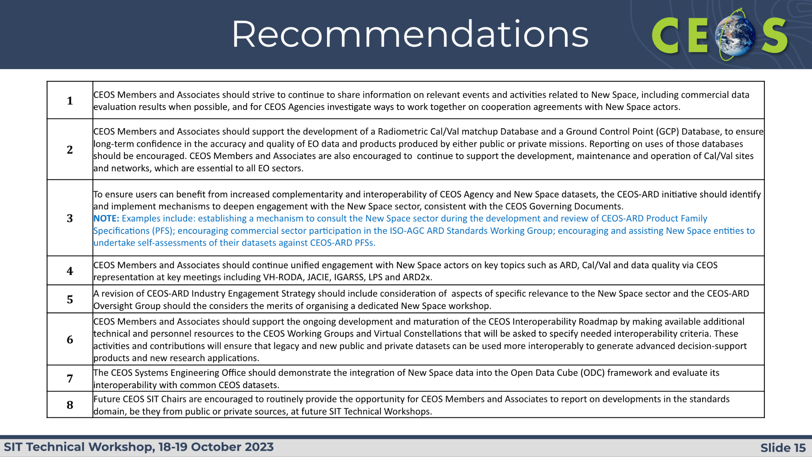
Discussion
- Eleni Paliouras (ESA, SIT Chair Team) expressed gratitude to everyone who has been actively involved in NSTT. She mentioned that recommendations have been under continuous refinement in recent weeks, including a Technical Workshop (TW) side meeting to discuss and refine the recommendations.
- The NSTT has scheduled a teleconference for next week to further deliberate on the topics covered in this session. The objectives of this teleconference are to fine-tune the report and recommendations, as well as to prepare an executive summary for the upcoming CEOS Plenary discussions.
- Ivan Petiteville (ESA) acknowledged that there has been substantial thinking behind the New Space topic, and it is an important topic to many agencies present. He noted that in general the mandate and strength of CEOS Agencies is to focus on supporting research and development, and to focus on the continuity of key missions. He stressed that Agencies need to support users to work alongside data from several different sources and providers, of varying quality and reliability, and this includes data from the New space sector. He also emphasised the need to ensure governments funding CEOS Agencies understand the continuity risks associated with relying on New Space supply exclusively for their data needs and take measures to mitigate the risks.
- It was noted that caution needs to be exercised around the overpromising of the private sector, while emphasising that the caution does not necessarily imply superiority to the public sector. It would be better to promote CEOS initiatives using a language that is easy to understand for individuals without a background in EO. Some Agencies produce reference data which is used to improve the quality of other data sources such as New Space. The strength lies in the synergistic collaboration between public and private sectors. GST and GHG portals are good examples of potential complementarity.
- Stephen Briggs (ESA, SIT Chair Team) thanked the team for putting together a well-structured valuable report, noting that the recommendations are a bit ambitious around cooperation with New Space. This is an opportunity to adopt a more strategic perspective on collaboration. He noted the example of IMEO, where different types of organisations are collaborating. He emphasised that strategic partnerships are an important step above the current pragmatic recommendations. It would be beneficial to look with a more holistic perspective at data provided from all providers to help identify opportunities to elevate the focus above technical collaboration and consider overarching strategic aspects.
- Jorge Del Rio Vera (UNOOSA, WGCapD Chair) pointed out the challenges in keeping up with developments within the New Space sector and asked if there are opportunities to monitor its progress more effectively. He also highlighted concerns related to data archives, emphasising that the continuity of these archives is of interest to many users. Their potential disappearance or degradation could have a substantial impact and requires careful consideration. He stressed the influence of the New Space sector on policy discussions, noting the concept of policy-driven remote sensing, as well as the recent discussions around 5G and X-band SAR interference. Engaging in dialogue with the New Space companies on these topics could play a constructive role in driving progress and solutions.
- Jörg Schulz (EUMETSAT) supported Stephen Briggs's suggestion. He noted that the ‘operational use’ has been weakly reflected in the report and suggested adding from EUMETSAT's experience in radio occultation and NOAA's experiences with data procurement, rights, data levels, and downstream products. He recommended expanding the paper to address data archiving to mitigate risk. He advocated for a more strategic approach and learning from past experiences, such as land surface imaging. Specifically, he suggested that the recommendations, particularly recommendation #1, should be more concrete and actionable, such as exchanging quality assessments among agencies. He also emphasised the value of sharing insights about rights negotiations with commercial companies between CEOS Agencies, suggesting that making this exchange more regular would be highly beneficial and should be addressed before CEOS Plenary.
- Beth Greenaway (UKSA) acknowledged that it is important to consider that the space world has changed. There are many different models for organisations, and complementarity is important. In this sense, recommendation #1 provided by NSTT is valuable, and the expertise of various groups should be valued. It is important to understand what New Space desires from public space agencies. She noted there are knowledge gaps (e.g. in meeting GCOS requirements), and it is important to determine which of those gaps could be filled by New Space. It is also important to be careful in the use of the language, noting that New Space does support, and do, science.
- John Remedios (UKSA) noted that the discussions about access to data and End User Licence Agreements (EULAs) cover similar issues but are not directly linked.
- Eleni Paliouras (ESA, SIT Chair Team) asked if the document is ready to be presented at the Plenary. She noted that NSTT will conclude at the Plenary, along with available resourcing. She asked what should be done with the NSTT report.
- Timothy Stryker (USGS) expressed appreciation for the work on the report. He suggested that in line with Ivan’s comments, a couple more additions would be useful. While recognising the value of a more strategic discussion, he emphasised that striving for perfection should not impede progress. He recommended early engagement with the New Space and commercial sector, rather than prolonged internal discussions. He stressed the need for immediate action and follow-up at a CEOS leadership level, rather than solely relying on engagements occurring at the working levels.
- Natalia Donoho (WMO) noted WMO has an open platform for engagement with the private sector and expressed willingness to collaborate with CEOS to offer support. She mentioned that CGMS and WMO’s Working Group 3 has a good relationship with the private sector. There are several ongoing things that can be supported through collaboration with WMO.
- Jeff Privette (NOAA, WGClimate Chair) underscored the suggestions from Jörg. The first key point to consider is the contract for buying the data that mentions what is being bought. These are black boxes in some cases due to Intellectual Property and it is important to ensure thorough data characterisation, and a clear understanding of what is acquired. The second point is Agencies must maintain a robust ability to calibrate and validate data products in-house to support the trust being invested.
- Éric Laliberté (CSA) added from an Agency perspective, everyone will need to consider New Space when architectures of space solutions are being defined. CEOS needs to interact with New Space and share the approaches with New Space agencies, and this is the approach CSA is taking. CSA fully supports USGS perspective and does not seek perfection but aims to start the interaction. It is important to figure out how to interact best and then evolve into the ‘what’ and details.
- Alex Held (CSIRO) is comfortable with additional recommendations. He noted that as a science agency, CSIRO sees the need for complementarity, especially in activities like AquaWatch, with small water body focus. This application requires finer resolution than many public EO systems can support, and so they will need to go to the commercial sector. From a Cal/Val perspective, it will be important to decide how information will be made available to the commercial sector, noting that CSIRO makes, and intends to make, all Australian Cal/Val data free and open to anyone via the AusCalVal project.
- Jonathan Ross (GA) supports the discussion to make sure the complementarity narrative is clear and strengthened, noting the report should be ready in time for Plenary. Spending another year on the paper is unlikely to lead to much progress. The trust and protection from reputational damage is a big issue for the NSTT to consider.
- Julie Robinson (NASA) thanked the NSTT for a significant amount of work. She noted that NSTT has completed its primary objective which is to increase CEOS awareness of commercial market activities. Julie acknowledged the dynamic nature of the market and suggested that striving for strategic perfection is not required. Instead, she recommended offering targeted services and engaging with New Space through Virtual Constellations (VCs) and Working Groups (WGs), particularly in specific markets. She proposed wrapping up this paper as a stand-alone product, emphasising that the recommendations don't have to be perfect. Julie pointed out that the strongest recommendations are those handed over to WGs or VCs. She highlighted the role CEOS can play as a long-term strategic backbone and expressed readiness to present the paper at the Plenary meeting. She suggested that if the NSTT dedicates the next few weeks to refining the recommendations, they can ensure the document is in a state to be carried forward.
- Charles Wooldridge (NOAA) thanked the NSTT, noting that NOAA has been working with this reality for some time now, trying to work out how to best trade off the strengths and weaknesses of public and private actors. He supported moving forward with the report to Plenary. The report recommendations have been improved since the side meeting, making them more focused and action ready. The discussion at Plenary should focus on strategic topics. He assumes that at some point, a version of this document would be made public, but currently, it is internal. Some work beyond the Plenary might be needed to articulate what messages CEOS wants to share with the New Space and commercial actors as a strategic way forward.
- Osamu Ochiai (JAXA, SIT Vice Chair Team) noted that JAXA as the incoming SIT Chair, is trying to find the way forward for engaging with New Space. He concurred on the need for a strategic approach and the importance of a technical perspective. He supported Julie’s comment that the actions should be distributed to VCs to engage with New Space. GHG is a practical example of New Space engagement and complementarity. JAXA SIT chair will ensure there is an opportunity at upcoming SIT meetings for information sharing on this topic.
- Pakorn Apaphant (GISTDA, CEOS Chair) noted that New Space is a big and important topic, and everything cannot be covered in the report even when there is more time provided. He suggested continuing to share information among CEOS Agencies, starting with the implementation of the actions and recommendations and coming back to a future meeting.
- Stephen Briggs (ESA, SIT Chair Team) recognised the conclusion part of the report is well supported by the proposed way forward. He suggested reviewing the conclusions, seeking better reflection of the conclusions in the recommendations. Some of the recommendations could be combined to create a more flexible and detailed action plan, with actions that will help implement the recommendations effectively. He proposed keeping the report and recommendations semi-permanent, allowing for updates without major rewrites. The plan is to have the recommendations approved at Plenary within a month and then shift the focus to developing an action plan.
- Eleni Paliouras (ESA, SIT Chair Team) suggested that there may be a need for an extended NSTT meeting to reflect on the perspectives presented during the discussions. She noted that some of the input received appears to be somewhat contradictory to what was heard during the side meeting. While some participants called for strategic recommendations, others emphasised the importance of technical and actionable recommendations. The extended meeting would provide an opportunity to reconcile these varied viewpoints and arrive at a more comprehensive approach.
- The Executive Summary could be turned into a standalone document, but it will not be ready for the Plenary. All interested organisations should ensure that they join the NSTT telecon next week.
- It was decided that the NSTT would put forward the report at Plenary. The exact form of the recommendations and idea about an action plan will be discussed further at the NSTT meeting next week.
- Tim Stryker (USGS) shared some USGS Example Slides for Land Imaging and public and private sector complementarity.

SIT-TW-2023-06 | New Space Task Team is tasked to finalise their report and post it on the CEOS Plenary website for potential endorsement at the 2023 CEOS Plenary. The Task Team will confer with the CEOS Chair and SIT Chair on the report’s recommendations, including the possibility of an Actions Supplement to track implementation. | 2023 CEOS Plenary
 | Rationale: There was broad support for the Task Team’s report at the 2023 CEOS Technical Workshop, and the proposal for CEOS Plenary to give its approval to close the task team. Some Agency feedback suggested that the New Space Task Team’s recommendations could be reworded in a form to allow implementation through an Action Plan, with assignment and tracking over time.

Session 6: Biodiversity

6.1: Ecosystem Extent Task Team Recommendations [Slides]
Presenter: Gary Geller (NASA) [presentation][paper]
Main points:
- The goal of the Ecosystem Extent Task Team (EETT) is to assess the utility of EO satellite data for mapping Ecosystem Extent using current and upcoming space-based capabilities.
- The EETT’s objectives are to:
  - Develop a white paper that will provide an integrated international perspective on how space-based Earth observations can be used to support ecosystem mapping and monitoring with a focus on ecosystem extent.
  - Develop specific ideas to further the concepts in the white paper.
  - Explore and propose an initiative to demonstrate the use of EO for ecosystem extent mapping and monitoring.
- The draft White Paper has been circulated for comment, with endorsement targeted at CEOS Plenary. The paper explains the value of EO for ecosystem extent, targeted at CEOS Principals and members of the biodiversity community (particularly the Convention on Biological Diversity and its Parties, and the UN System of Environmental-Economic Accounting.
- For measuring ecosystem extent, different sensor types complement each other, including optical (multispectral and hyperspectral), radar and lidar. Each provides a different view of ecosystem characteristics.
- Current challenges include:
  - Combining data from different types of sensors;
  - Limited availability of value-added products;
  - EO data usability and the technical capacity of users;
  - Measuring ecosystem condition.
- The EETT white paper’s recommendations cover three thematic areas:
  - User Engagement: Increase user engagement with EO and CEOS through workshop(s) and other activities to improve ecosystem extent mapping.
  - Technical advances: Support development of technical advances to improve utilisation of EO for ecosystem mapping.
  - Capacity: Work to increase capacity of biodiversity users to utilise EO for ecosystem mapping and monitoring.
- The EETT has begun planning demonstrators, with results and findings due to be delivered to CEOS Plenary 2024. The goal is to demonstrate the use of EO for ecosystem extent mapping and monitoring. The three demonstrators are:
  - Hudson’s Bay Lowlands – supported by Environment & Climate Change Canada (Jason Duffe).
  - Costa Rica – supported by CNES/INRAE (Sandra Luque).
  - Australian Great Western Woodlands – supported by CSIRO (Shaun Levick).
- All three demonstrators are designed around the use of Data Cubes and combine data from different sensors. They are examples of the types of activities that other CEOS Agencies might be interested in supporting in coming years. Note that the Costa Rica and Great Western Woodlands activities have only just hired their post-docs so progress on these prior to Plenary 2024 will be limited.
Discussion
- Ivan Petiteville (ESA) noted that Environment & Climate Change Canada (ECCC) has submitted a self-nomination to become an Associate member of CEOS. The outcome of this will be decided at CEOS Plenary.
- Steve Covington (USGS) asked about the lack of recognition of the importance of well calibrated data in the white paper. Gary noted that this will certainly affect the quality of outputs and higher-level datasets. The calibration aspect is often a question from the biodiversity community.
- Wim Looijen (NSO) liked the organisation of the recommendations. NSO has several biodiversity projects centred around three topics: nature, water, and agriculture. NSO received several proposals for these topics, which could contribute to demonstrators in future.
- Gary recalled the mission of EETT, which was limited to addressing ecosystem extent and not biodiversity as a whole. The bigger picture is biodiversity, but ecosystem extent is a first step.
- Julie Robinson (NASA) is pleased to see the work this team has done. The White Paper is at a good level for non-specialists. Many CEOS Agencies have new missions approaching which will be able to contribute to this topic, with new observations at higher spatial and temporal resolutions.
- Alex Held (CSIRO) looks forward to the outcomes of the demonstrators. It is important to also consider the potential role of New Space, especially for higher resolution requirements. It will be important to make sure remote sensing is recognised in aspects of the Global Biodiversity Framework (GBF) and indicator frameworks. This took a long time with GFOI and UNFCCC.
- Jorge Del Rio Vera (UNOOSA, WGCapD Chair) noted that it is good to see the capacity building recommendations. WGCapD will be happy to support the implementation.
- Gary noted that in the process of writing the ecosystem extent focused white paper it was impossible not to have some additional thoughts for the broader biodiversity topic and potential longer-term engagement of CEOS. These have been compiled separately and can be shared on request. Recommendations specific to ecosystem extent often also apply to biodiversity more broadly.
- Ivan asked about the need for Level 3 and 4 datasets, noting that Gary mentioned that Level 1 or 2 data products are not easily used by the biodiversity community of users, and they prefer to have information products at a higher level. He asked if these higher-level products are something that CEOS Agencies can produce, or do we need to partner with others that could produce these? How can we establish such partnerships?
- Gary responded that without being able to provide the Level 3/4 products that the biodiversity community want, there will always be a gap. Having space agencies work with partners that can develop these are key, including through funding R&D activities and agencies including NASA and ESA are already doing this. If these products are directly relevant to the GBF Indicators that would be ideal. If software is developed, it also needs a place to live long term and GEO BON’s toolkits could be a suitable home.
- Wim Looijen (NSO) noted this is the objective of NSO’s biodiversity programme – to develop Level 3 and 4 products based on specific user requirements. These will be done only for the Netherlands, but they can be an example of how to move forward globally.

6.2: Canadian Space Agency (CSA) 2024 CEOS Chair Priorities Presentation & Discussion
Presenter: Éric Laliberté (CSA) [presentation]
Main points:
- CSA will prioritise the theme of biodiversity as a singular focus. Biodiversity is a national priority for Canada, noting the Kunming-Montreal Global Biodiversity Framework (GBF) was adopted in 2022. As seen through the EETT’s work, there is clearly a lot of interest in the CEOS community for this topic.
- The co-location of CSA and UN CBD provides an opportunity for closer engagement.
- The CSA team hopes to establish, by the end of 2024, a proposal regarding the future of CEOS and the biodiversity topic.
- The CSA team has held a number of consultation calls with agencies (primarily those active in the Ecosystem Extent Task Team) over the past month to understand the agencies’ involvement in biodiversity activities and to explore opportunities to foster connections and collaborations.
- CSA will undertake several tasks internal to CEOS, generally exploring whether and how CEOS should pursue a broader strategy for biodiversity. The goal is to build on the task team’s work to arrive at CEOS Plenary 2024 for a well-informed discussion on potential CEOS commitment to a broader biodiversity strategy.
- The second set of tasks will have an external focus, aiming to increase CEOS’ understanding of and linkage to the biodiversity policy world, as well as strengthen awareness of the policy community of the potential benefit of EO to biodiversity, which is reportedly not well understood by policymakers and end users in the biodiversity community.
- CEOS Plenary 2024 will be held at the Canadian Space Agency’s headquarters (south of Montreal) on 22-24 October 2024. More information will be shared soon.
Discussion
- Ivan Petiteville (ESA) asked about the organisational structure the CEOS Chair team will use for 2024 to carry out its ambition of articulating the fundamental reasons for the topic of biodiversity to figure more prominently in the spectrum of CEOS activities. CSA confirmed the activity in 2024 will be carried out through discussions convened by the CEOS Chair. No additional CEOS structure is proposed for 2024. Should CEOS agree at the 2024 CEOS Plenary that biodiversity belongs on the CEOS agenda, the specifics related to organisational structure will be debated at that time.
- Julie Robinson (NASA) noted that CEOS already has biodiversity related tasks in the CEOS Work Plan. The EETT was created with a finite set of expectations. The CSA Chair year provides an opportunity for additional conversations. NASA supports Eric’s leadership and agrees with CSA that it is important to consider this other aspect of global change. CEOS will need to define what we think the right idea is regarding the way forward. The example of COAST VC could be a good example to follow. Recognised that these discussions about the way forward for CEOS and biodiversity are more at a strategic level, rather than technical, and hence are likely beyond the expertise of the EETT.
- Alex Held (CSIRO) recalled that before GFOI was established, an ad hoc team was created as a start, until it demonstrated the need for a more permanent home in the CEOS structure.
- Julie Robinson (NASA) rephrased Eric’s proposal, to call a few meetings over the next year to discuss the topic, and then at the Plenary next year arrive for a discussion amongst Principals about the way forward.
- Matt Steventon (CEOS Chair Team) noted that in the priorities paper, CSA identified that the goal is to come to Plenary 2024 with a proposal. 2024 will serve as an information gathering year, through the CEOS Secretariat and direct consultations with CEOS Agencies.
- Mark Dowell (EC) noted that apart from these Principal level discussions, perhaps a more concrete action for the next year is to gather user requirements for this domain. This would help in thinking about how CEOS can most effectively contribute.
- Ivan Petiteville (ESA) suggested that CSA should clearly propose how they plan to organise these discussions at Plenary.
- Julie Robinson (NASA) agreed that Principal level discussion sounds like the right way to move forward on these discussions over the course of 2024.
- Timothy Stryker (USGS) thanked CSA for its 2024 Biodiversity focus and noted USGS will be happy to support the strategic, managerial, and technical means to advance CEOS collaboration and leadership on this crucial topic.
- Éric Laliberté (CSA) advised that delegations should be ready to respond at Plenary to the call for inputs.
- CSA will clarify its approach to developing “a recommended position for a CEOS Plenary 2024 discussion on potential CEOS commitment to a broader biodiversity strategy” in time for the discussion at the 2023 CEOS Plenary.
SIT-TW-2023-07 | CEOS Agencies with interest in supporting the biodiversity domain are invited to contact the incoming CEOS Chair Team at CSA to engage in planning the headline theme for 2024. | 2023 CEOS Plenary
 | Rationale: CSA has reached out to many agencies as part of the Chair year preparation. Further inputs and resource commitments are welcomed.

Session 7: Oceans and Coasts
Charles Wooldridge (NOAA) provided some context for the topics in this session, with the primary goal to support the UN Ocean Decade. An action was recorded at SIT Technical Workshop 2022 to deliver two documents regarding coordination of CEOS ocean-related activities. It is proposed that the group is closed at the 2023 CEOS Plenary, following the delivery of these documents. Generally, it was agreed that coordination of ocean activities can be completed through existing CEOS bodies.
The second item relates to the Coastal Observations Applications Services and Tools (COAST) Ad Hoc Team, in particular the proposed transition to a Virtual Constellation (COAST-VC).

7.1: CEOS Ocean Coordination Group
Presenter: Merrie Beth Neely (NOAA) [presentation] [paper]
- The Ocean Coordination Group (OCG) has responded to action item SIT-TW-2022-14 and will submit two documents to the Plenary as the outcome of the OCG, and for discussion at SIT Technical Workshop today.
- The CEOS OCG – Coordination Needs for Upcoming Ocean-related Missions lists all upcoming ocean-related missions.
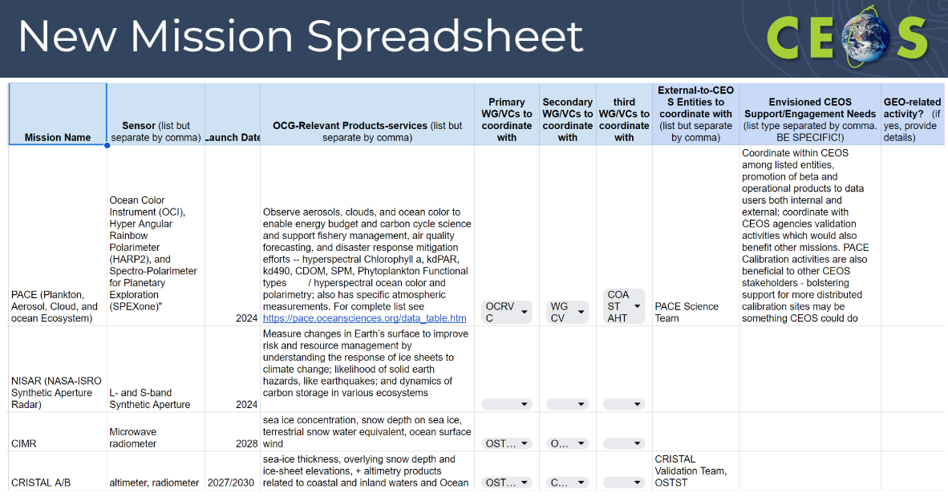
- The CEOS OCG – IOC and UN Ocean Decade Activities spreadsheet lists CEOS Work Plan activities underway (or anticipated) that support the UN Ocean Decade and the International Oceanographic Commission mission. It lists points of contact within CEOS and IOC as well as other details.
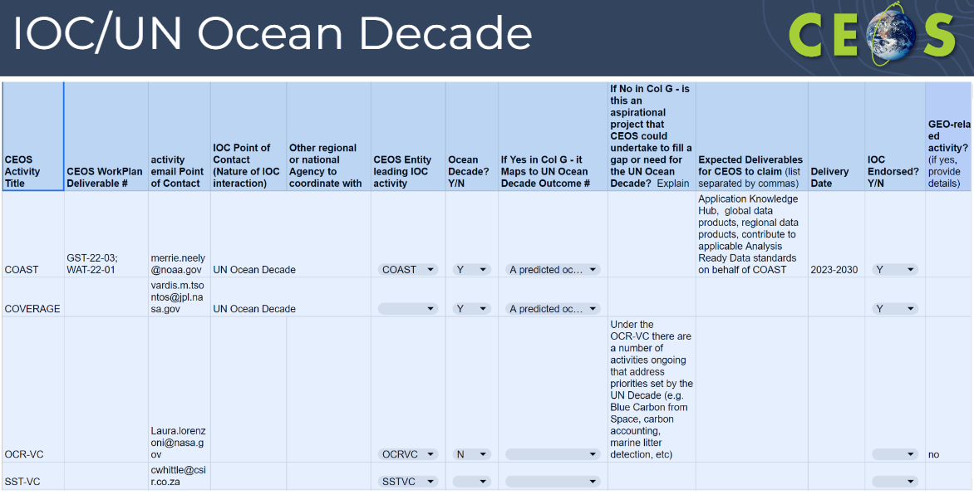
- These documents will help inform where Ocean Coordination within CEOS could benefit the Earth observation community going forward.
- The OCG notes the significant increase in recent and forthcoming ocean remote sensing missions and highlights the need for CEOS, using its existing bodies, to continue to actively work to ensure the maximum utility of that data. The IOC and Ocean Decade engagement will need to be continued to be monitored by CEOS.
- Paul DiGiacomo (NOAA) thanked ESA and Ivan for their initial leadership of the group. There is a compelling need for active coordination of these ocean activities, but currently, it doesn’t warrant a new group within CEOS.
- Many upcoming missions which will be able to support the monitoring of our oceans.
Discussion
- Julie Robinson (NASA) congratulated the group on the work. This level of strategic coordination can be difficult. Ocean coordination was an important discussion to have within CEOS at this time. NASA agrees with the conclusion but noted that it does not minimise the importance of the conversations over the last two years.
- Marie-Helene Rio (ESA, OCR-VC Co-lead) highlighted the important message to continue coordinating between the ocean Virtual Constellations, alongside other ocean related activities, to support the UN Ocean Decade.

7.2: Coastal Observations Applications Services and Tools (COAST) Ad Hoc Team
Presenter: Merrie Beth Neely (NOAA) [presentation][White Paper][ToR]
- The COAST Ad Hoc Team is in its third year of operation and will end at the upcoming CEOS Plenary. The team is proposing that COAST transition to a Virtual Constellation.
- Major outcomes to date include the launch of the Application Knowledge Hub and the development or enhancement of various COAST products, such as Geoscience Australia’s shoreline mapping, NOAA and ISRO’s flooding products and ESA’s physical oceanography products tailored for coastal regions.
- Both ISRO and NOAA have indicated interest to lead the proposed COAST-VC, and the goal would be to find a third co-lead.
- Potential future activities include completing ongoing product development and initiating new projects, encompassing areas such as coastal blue carbon, habitat mapping, and shoreline projects in regions such as the UK and Vietnam. Expanding stakeholder engagement events and co-design efforts in newly identified pilot regions is on the horizon. Additionally, the team would take advantage of the CEOS Analytics Lab capabilities enabled by the SEO.
- The team has submitted a White Paper supporting the transition to a VC alongside draft Terms of Reference and is on track to provide an Implementation Plan by SIT-39.
- The proposed course of action is to discuss the COAST VC White Paper and draft terms of reference today, and then at CEOS Plenary 2023, request an action to draft and submit the final Terms of Reference and Implementation Plan in time for decision at SIT-39.
Discussion
- Paul DiGiacomo (NOAA) noted the team has received some expressions of interest for the third co-lead position.
- COAST-AHT has had exceptional participation in their work, which was demonstrated during the side event on Tuesday. Paul thanked the Virtual Constellations and Marie-Helene for their work to coordinate the upstream data providers on gathering data for the work.
- Alex Held (CSIRO) expressed interest for CSIRO to be involved in some way. From an AquaWatch Australia perspective, there are a lot of activities that could contribute to COAST-VC. Alex will plan to come back to the team by Plenary with specific commitment of resources. AquaWatch Australia involves 15 pilot sites already, 50% of which are coastal sites. CSIRO are keen to see what they can contribute from what has been learned through exercises in combining in situ and satellite data for coastal zones.
- Julie Robinson (NASA) appreciated that coastal regions need a focused effort, since they often involve the need to combine many diverse datasets. This is also a critical area of focus in terms of human impacts. There are many interfaces to other Virtual Constellations, as coasts are the interface of land and water. NASA is not ready to confirm a contribution but will consider one. Hope to make a commitment in future and support the transition to COAST-VC.
- Osamu Ochiai (JAXA, SIT Vice Chair Team) supported Julie’s comment. The JAXA team will look forward to SIT-39, where Principals can discuss the endorsement of COAST-VC. This is a complex endeavour, as there are many instrument types and variables to consider. There are many opportunities, but there is a complexity that needs to be managed.
- Paul DiGiacomo (NOAA) acknowledged Kerry Sawyer’s (NOAA) support to COAST in the past, as well as Marie-Claire Greening (CEO) and Christine Bognar (NASA) for their support.
- Marie-Helene Rio (ESA, OCR-VC Co-lead) noted that OCR-VC is doing a lot which will be relevant to COAST. She thanked the COAST-AHT for making the connection to OCR-VC. Marie-Helene supports the creation of COAST-VC, but noted we will have to carefully coordinate the ocean Virtual Constellations to ensure we are not duplicating efforts.
SIT-TW-2023-08 | NOAA and ISRO, co-leads of COAST, are tasked to incorporate feedback from the 2023 CEOS SIT Technical Workshop into the COAST Virtual Constellation Initial Proposal and Terms of Reference for CEOS Plenary consideration. | 2023 CEOS Plenary
 | Rationale: There was broad support at the SIT Technical Workshop for the COAST Virtual Constellation Initial Proposal and Terms of Reference, and the COAST team is encouraged to finalise the two documents for consideration by the CEOS Plenary.

Session 8: Other Business

8.1: CEOS Missions, Instruments and Measurements (MIM) Database
Presenter: Stephen Ward (ESA MIM Team) [presentation]
Main points:
- The CEOS MIM Database serves as the foundation for CEOS coordination and planning, with its origins dating back to the CEOS EO Handbook in 1992 and the WMO database in the mid-90s, initiated by Don Hinsman.
- ESA plays a key role by providing the database and the Handbook as an ongoing significant contribution to CEOS. To keep the information up to date, an annual survey process is in place.
- Out of the 41 agencies surveyed, there were 32 responses, accounting for a 78% response rate, with 26 of those agencies providing updates. However, there are still nine agencies who did not respond.
- Since 2021, the MIM team has been publishing quarterly update reports.
- The MIM Team has been coordinating with WMO’s OSCAR/Space database to enhance compatibility and complementarity of interfaces. This has extended to linkages with ESA’s EO Portal, as well as NORAD ID and UCS database integration.
- Some non-CEOS missions for certain applications such as the GHG Portal have been included, although the missions are not visible on the public-facing website.
- This database is instrumental in many CEOS and agency applications and analyses.
- User growth has been up over 100% year-on-year.
- Future plans involve strengthening links with other web resources like ESA’s EOPortal and WMO OSCAR. There is also a focus on accommodating commercial missions for specific applications when required.
- The team is planning to refresh the visual interface during 2024.
- The possibility of creating CEOS team pages, like the GHG Portal, is under consideration.
- A consultation process is planned for 2024, but feedback is always welcome at any time.

Discussion
- Natalia Donoho (WMO) recognised the need for OSCAR/Space and MIM to work together and complement each other. WMO is working on redoing some of the OSCAR infrastructure as well.
- Stephen Ward (ESA MIM Team) encouraged this need to work together, noting that the team has been working with Heikki Pohjola (WMO OSCAR), who has been very constructive and pragmatic.
- Jorge Rio Del Vera (UNOOSA, WGCapD Chair) suggested a potential connection to the UN Register of Objects Launched into Outer Space.
- Eleni Paliouras (ESA, SIT Chair Team) recalled that in the context of the New Space Task Team, there was consideration given to adding more commercial elements in the MIM. There were some concerns around the level of effort required to maintain this information as well as the implications of acknowledging these missions in the CEOS Database. As such, this recommendation was not included in the end.
- Timothy Stryker (USGS) noted that USGS maintains a compendium of Earth observing satellites that has a focus on commercial missions (JACIE compendium).
- Stephen Ward (ESA MIM Team) noted the team has thought a lot about the inclusion of commercial missions. The idea isn’t to do this comprehensively, but rather on a sectoral basis (e.g., as done with the GHG Portal). There is a feasibility and opportunity to include some missions provided the scope is appropriate.
- The ESA EOPortal does a good job handling the commercial sector and is a good resource to lean on.
- Alex Held (CSIRO) suggested a new page like the GHG Portal that captures missions suitable for water quality monitoring.
- Éric Laliberté (CSA) shared the recent announcement from the Canadian government to invest $1B in Earth observation. This will mostly be towards the RADARSAT series, including the next edition, which will be called RADARSAT+. The MIM team will work with CSA to have the mission included in the database ahead of the CEOS Plenary.
- Dave Borges (SEO) pointed out that for the COVE (CEOS Visualisation Environment) tool, the SEO has started adding commercial missions, driven by end user requests.
- Charles Wooldridge (NOAA) thanked ESA and the MIM Team. NOAA has some new staff in the system office that supports their future planning efforts, with their own supplementary database. The NOAA team has some thoughts on how to improve the MIM survey process, and the database in general. The NOAA engineering team would be happy to discuss additions, features, etc. for any future revamp of the MIM.
- Steve Covington (USGS) asked about the governmental satellites that are not being updated in the usual survey process due to unresponsive CEOS Agency contacts. He asked how the team deals with these cases. Stephen Ward (ESA MIM Team) noted that public sources of information are used where possible.
- It was noted that the date when records were last updated is stored in the database, but not published on the website. Adding this information could be useful for users. This will be considered as part of the future update to the front-end website.

8.2: CEOS Interoperability Framework
Presenter: Makoto Natsuisaka (JAXA, WGISS Chair) [presentation]
Main points:
- The CEOS Interoperability Framework Roadmap has been developed following the 2022 CEOS Plenary’s delegation of this activity to WGISS. The Framework components, called ‘Factors’ have been identified as follows:
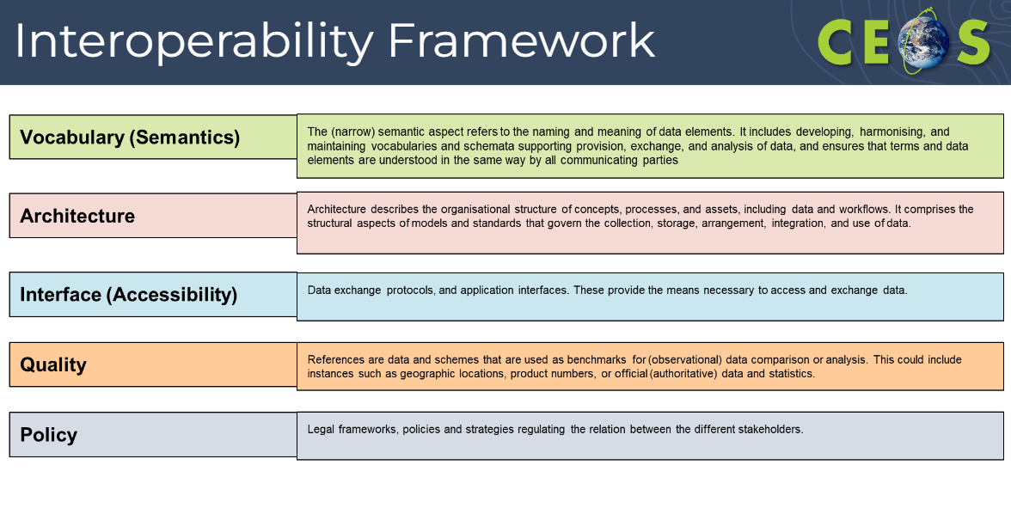
- These Factors have been mapped to existing CEOS Work Plan activities. The purpose is to identify all the activities that are taking place across CEOS which are working towards improved interoperability of Earth observation datasets. Additionally, this is intended to highlight gaps where more work is required to increase interoperability.
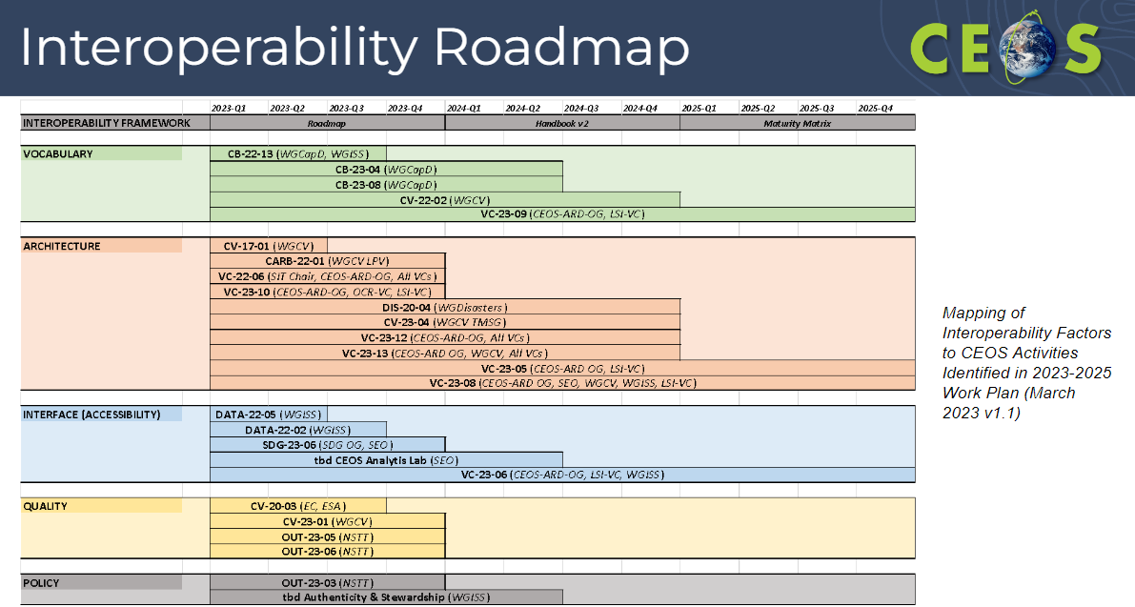
- The next steps include the following:
  - Appointing champions to guide implementation and creating a CEOS Interoperability Handbook 2.0;
  - Defining a matrix to relate activities to the Factors (activities are expected to support more than one Factor);
  - Identifying use cases (Demonstrators) for the Framework and developing a Maturity Matrix to measure improvement and communicate ongoing maturity;
  - Identify gaps and propose new supporting efforts.
- At the 2023 CEOS Plenary, WGISS will recommend endorsement of the proposed endorsement of the CEOS Interoperability Framework Roadmap.

Discussion
- Marie-Claire Greening (ESA, CEOS Executive Officer) noted that the work on developing the Interoperability Framework has been slow due to resource limitations. While the recommendation appears to be a sensible path forward, it is evident that developing the Roadmap further will require significant effort. WGISS should ensure that during the Plenary meeting the CEOS Principals agree to support this work.
- Timothy Stryker (USGS) thanked the WGISS team and acknowledged that the structure, design, and proposed way forward are good. Moving forward will require adequate resourcing. While WGISS will continue to be in a prominent role, it is important to recognise that this is a collective CEOS initiative and requires broad engagement. Interoperability is a key piece and from the technological perspective, it is now an attainable goal. USGS is committed to supporting this activity and hopes that other agencies will do the same.
- Makoto Natsuisaka (JAXA, WGISS Chair) added that this activity is led by Tom Sohre (USGS, WGISS Vice Chair) who will continue contributing to this activity.
- Marie-Claire Greening (ESA, CEOS Executive Officer) noted that the WGISS-56 meeting is being held in Paris next week.

8.3: Precipitation Virtual Constellation (P-VC) Update
Presenter: Christopher Kidd (NASA) [presentation]
Main points:
- P-VC was established in 2007, to set an international framework to guide, facilitate, and coordinate the continued advancement of multi-satellite global precipitation measurement. It is led by NASA and JAXA, with core membership from ESA, ISRO, EUMETSAT, CGMS/IPWG. Two meetings are held each year.
- In March 2023, the NOAA Workshop on Precipitation Estimation concluded that no single observation method can provide global precipitation estimates, sensor diversity requires accurate inter-sensor calibration, frequent and low-latency observations are required, and scientific advances are needed to optimise information content (AI/ML). The workshop developed five recommendations:
  - continuity and expansion of precipitation-capable sensors to achieve hourly to sub-hourly refresh rates;
  - prioritise efficient acquisition of sensor data to provide low latency data;
  - sustain a joint precipitation radar/radiometer capability for inter-calibration;
  - provide an assessment of uncertainty for precipitation measurements;
  - define requirements for establishing robust climate data records;
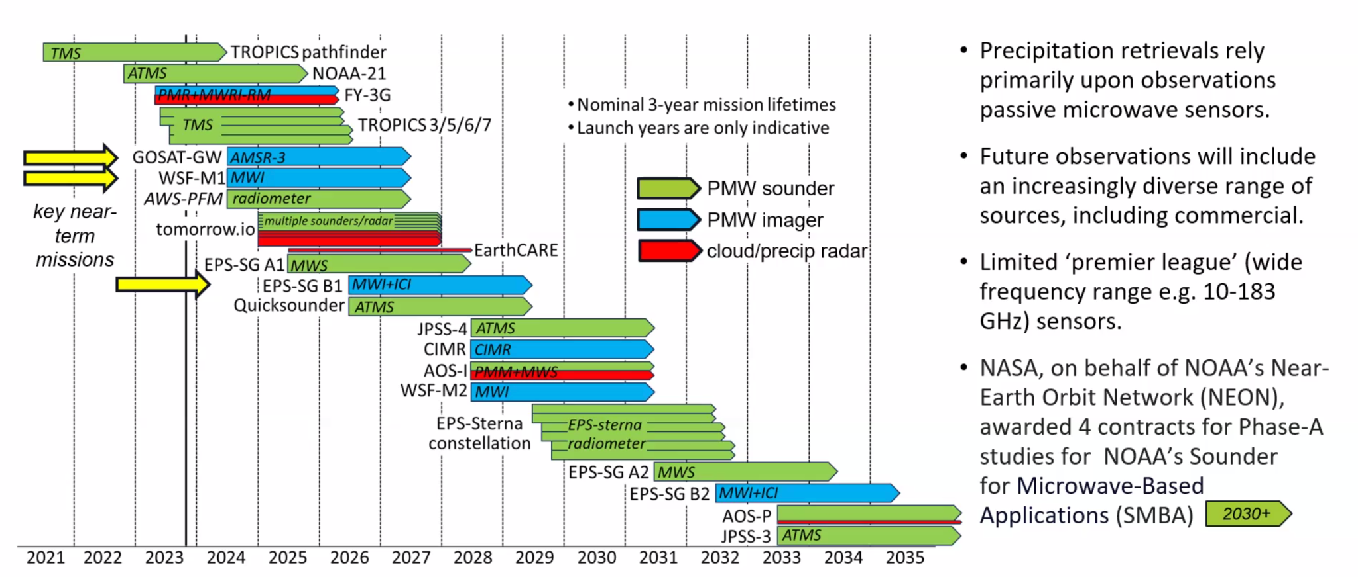
- The current Global Precipitation Measurement (GPM) constellation includes ten satellites, from NASA, JAXA, NOAA, EUMETSAT and US DoD.
- An active solar cycle has resulted in a greater fuel burn, potentially reducing the lifetime of the GPM core observatory. The satellite will undergo an orbit boost on 8 November 2023, which will recover several years of mission lifespan, and allow a potential overlap with the JAXA’s Precipitation Measuring Mission (PMM) (2029+).
- Current predictions are that the mission will remain operational until 2030, after which it will remain in orbit as spare until deorbit is planned.
- NASA’s Precipitation Processing System will continue through to the mission’s end of life and extend beyond for an additional year.
- Operational and legacy missions from GPM’s international partners continue to provide data. Data from new satellites and sensors are being evaluated. Missions in the near future include AMSR-3 and EPS-SG A/B.
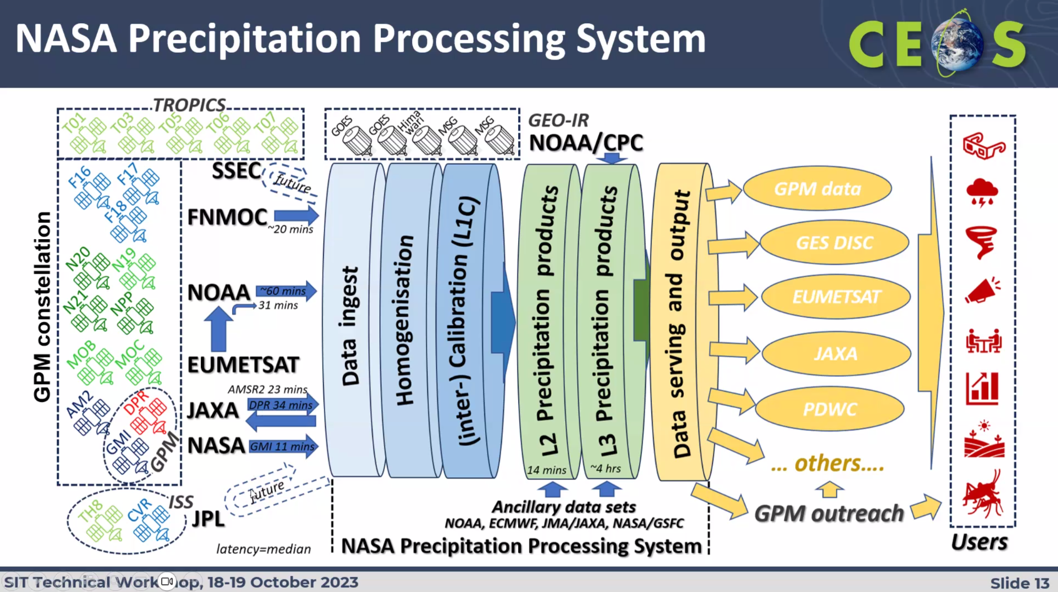
- P-VC Terms of Reference have become outdated and require immediate updating.
- P-VC is still looking at developing CEOS-ARD Product Family Specifications for precipitation.
- The CEOS Interoperability Framework was reviewed at the last P-VC meeting.
- Future opportunities include an increase in the number of sensors and observations, scientific development – leading to improved understanding of the observations, and evolution of new ‘tools’ i.e. AI/ML, for maximising retrieval capabilities.
- Future challenges include ensuring continuity of observations and products especially when dealing with short-duration sensors that require calibration and validation spin-up times. These challenges also stem from the diversity of frequency bands, resolutions, and sampling rates. Moreover, a long-term requirement for a reference mission to support inter-calibration is essential. The increasing presence of radio frequency interference is exerting pressure on shared and protected frequency bands.
Discussion
- Jörg Schulz (EUMETSAT) asked whether the work on defining requirements for CDRs is being done in consultation with GCOS, as GCOS is already working on this topic. Jörg suggested coordinating with GCOS to avoid duplicating efforts. Chris noted that the recommendations made in the NOAA Workshop on Precipitation Estimation report were directed at NOAA and the hope is that they would be taken onboard and actioned. NOAA will follow up with Jörg offline.
- The WGClimate Chair can facilitate coordination with GCOS. For ECV rationalisation, P-VC could provide valuable information into that process and avoid duplication of effort or diverging results.
- With the GPM mission nearing its end of life around 2032/2033, there was a question raised about whether a similar setup for future reference missions will be maintained and whether dual-frequency radar could be a potential goal for these future missions. Chris confirmed that the JAXA PMM mission will feature a dual-frequency radar which is supposed to be flown with a high frequency radiometer. He also noted that there is an ongoing exploration of new sensors and technologies to address any potential gaps in capabilities that may arise in the future.

8.4: CEOS Systems Engineering Office (SEO)
Presenter: Dave Borges (SEO) [presentation]
Main points:
Sustainable Development Goals (SDG) Coordination Group
- The SDG Coordination Group has been awarded the Participating Organisation award in the 2023 GEO SDG Awards. Dave and Flora look forward to accepting the award on behalf of the team in Cape Town in a few weeks.
- The four SDG support sheets are undergoing updates this year, with two expected to be completed by the 2023 CEOS Plenary, and the remaining two to be completed in 2024.
- In support of SDG 15 (indicator 15.3.1 – Land Degradation), the SEO team (Brian Killough and AMA) have completed some preliminary analyses using a new Jupyter Notebook that calculates mean monthly cloud cover over any island region. The intended product is a pixel-level summary in the form of a “heat map” to display mean cloud cover for the year. The preliminary models need to be scaled to operate over the 31 Small Island Developing States (SIDS) countries. Additional work is needed to assess data availability for S1 and commercial datasets.
- SEO has created an ODC examples notebook for SDG Applications, which can be found here.
- In 2024, some topics the team is considering include:
  - UNCCD Land Degradation Neutrality (LDN) Good Practice Guidance (GPG);
  - SDG capacity building support with WGCapD;
  - Communications material / outreach;
  - Biodiversity activity (possibly with the Ecosystem Extent Task Team);
  - Further engagement with UN-GGIM IAEG-SDGs WG Geospatial Information (WGGI);
  - The proposed “Rescuing the SDGs” paper;
  - Joint deliverables with ongoing WG/VC activities;
  - Identification of additional SDG Targets and/or Indicators to support.
CEOS Communications Strategy
- A draft of the new CEOS Communication Strategy is available here for feedback. The CEOS Communications Strategy will be presented at the 2023 CEOS Plenary for endorsement.
- The document outlines the stakeholders in CEOS communications - groups that communication materials should be targeted towards. The stakeholders are broken into internal and external stakeholders.
- The strategy outlines three campaigns to be conducted over 2024-25, in line with CEOS Chair and SIT Chair priorities. The idea is to create a series of materials covering these topics. The proposed themes are the 40th anniversary of CEOS, EO for Biodiversity (supporting CSA’s CEOS Chair priority), and Greenhouse Gas Observations from Space (supporting the JAXA SIT Chair).
- The SEO is responsible for publishing all CEOS communications content. The SEO will rely on CEOS community liaisons, who are volunteers from across the CEOS community to provide light support where possible. The current volunteers are Katy Matthews (NOAA), Chris Barnes (USGS), Flora Kerblat (CSIRO), and Marie-Claire Greening (CEO).
- CEOS Agency communications staff play a role in cross-promoting relevant content, and dedicated points of contact should be provided to the SEO if possible.
- CEOS entities, such as Working Groups and Virtual Constellations, are expected to contribute at least one communication piece each year, to help promote their work and CEOS.
Other SEO Activities
- The SEO has built upon the CEOS Earth Analytics Interoperability Lab (EAIL) to create the CEOS Analytics Lab (CAL). The platform is open for all CEOS entities to use for collaborative working at the technical level, responding to a multi-year need for this type of resource. The platform is available at ceos.org/cal. Dave thanked CSIRO for their support.
- The SEO will represent CEOS on the GEO Infrastructure Development Task Team (GIDTT).
- SEO continues to engage with the Open Data Cube community, including initiatives like Digital Earth Africa and Digital Earth Pacific.
- Recently, some new commercial missions have been included in COVE (the CEOS Visualization Environment).
- The SEO is engaged in CEOS-ARD and working to ensure broad community engagement in the Open Geospatial Consortium’s Analysis Ready Data Standards Working Group. The SEO is undertaking studies related to night-time lights occlusion, which will provide input for the refinement of the related CEOS-ARD Product Family Specification (PFS) and potentially other PFS.
- The SEO is wondering whether a query capability like ChatGPT for CEOS materials would be desirable for the community, to better locate content within the many CEOS documents and online resources.
- Dave thanked JAXA for their continued contribution to CEOS via the publication of the CEOS Newsletter.
- The SEO hosts exhibition booths at important international events, with the next being at GEO Week 2023. All contributions for these events are very welcome.
Discussion
- Marie-Claire Greening (CEOS Executive Officer) thanked NASA for their critical contribution of the SEO to CEOS.
- Jonathan Ross (GA) echoed the thanks for all the support and critical CEOS services that the SEO provides. SEO is the key connective tissue across all of CEOS. Jonathan asked if the CEOS ChatGPT would just review CEOS documents. Dave Borges (SEO) confirmed that CEOS ChatGPT will be internal to CEOS only and can be used for referencing CEOS documents and providing pointers to references.
SIT-TW-2023-09 | CEOS Agencies are encouraged to put their relevant communications experts in contact with the CEOS Communications Team in the SEO to help leverage CEOS communications content in social media. Agencies are also encouraged to suggest content for the CEOS booth at GEO Week on Nov. 6-10, 2023, in Cape Town, South Africa. | 2023 CEOS Plenary
 | Rationale: CEOS Agencies can help elevate CEOS messaging and accomplishments on social media.

8.5: WGDisasters
Presenter: Helene de Boissezon [presentation]
Main points:
Global Volcano Early Warning and Eruption Response System (G-VEWERS)
- The CEOS Volcano Pilot (2014–17) and Demonstrator (2019–23) are a blueprint for global volcano monitoring and early warning.
- Proposed creation of Global Volcano Early Warning and Eruption Response System (G-VEWERS) which is a permanent virtual facility for remote volcano monitoring. It will function on biennial renewable quotas (akin to Supersites) made possible by best-effort contributions from academic institutions, volcano observatories, and space agencies. The aim is to provide a timely response to hazardous volcanic eruptions, tracking of restless volcanoes and background monitoring of quiescent volcanoes. Operational support will be provided by USGS.
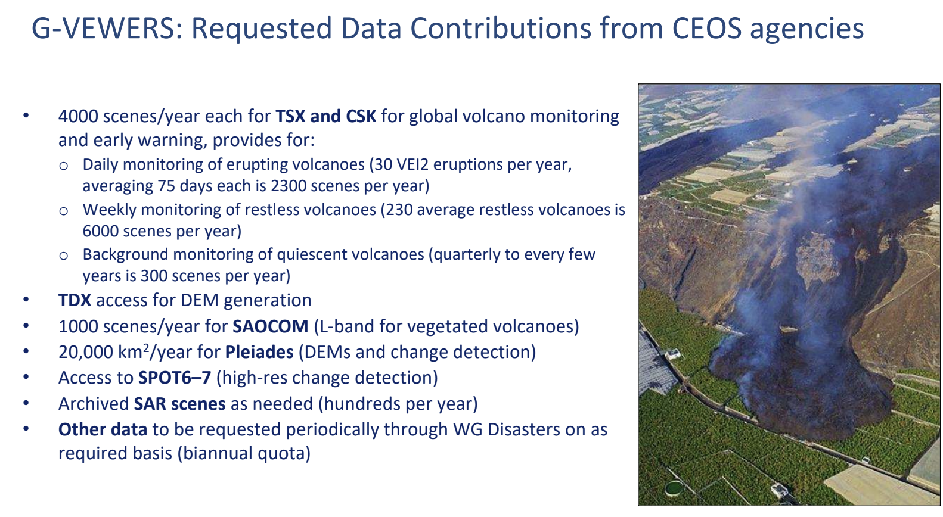
- The outcomes include showcasing how CEOS data can be used to enhance public safety around the world; empowering local volcano observatories and academic institutions to develop new skills and capabilities; enlarging the community of active users of satellite data; and serving as a model for hazards assessment and mitigation.
- The deliverables include a biennial report documenting responses to active eruptions and monitoring; academic presentations and publications; and capacity building.
Pre-operational Recovery Observatory 2024-2026
- Various Recovery Observatory (RO) demonstration activities have taken place and have been well received. Various products are generated, and diverse types of satellite data are made available. There is an excellent collaboration between the stakeholders and the RO team. The RO team is responsive to the emergence of new needs. Products are welcomed by the recovery community to help reconstruction and better prepare for future events.
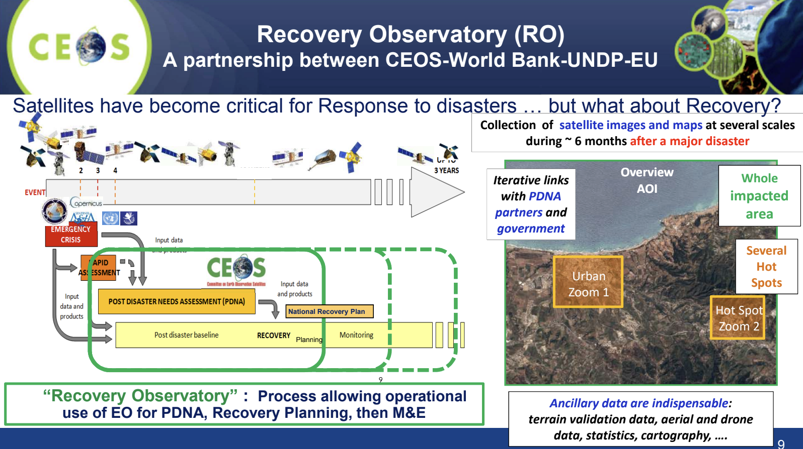
- Proposed to establish a pre-operational Recovery Observatory 2024-2026. Support for the following phases will be the focus of the CEOS Principal decision at 2023 Plenary:
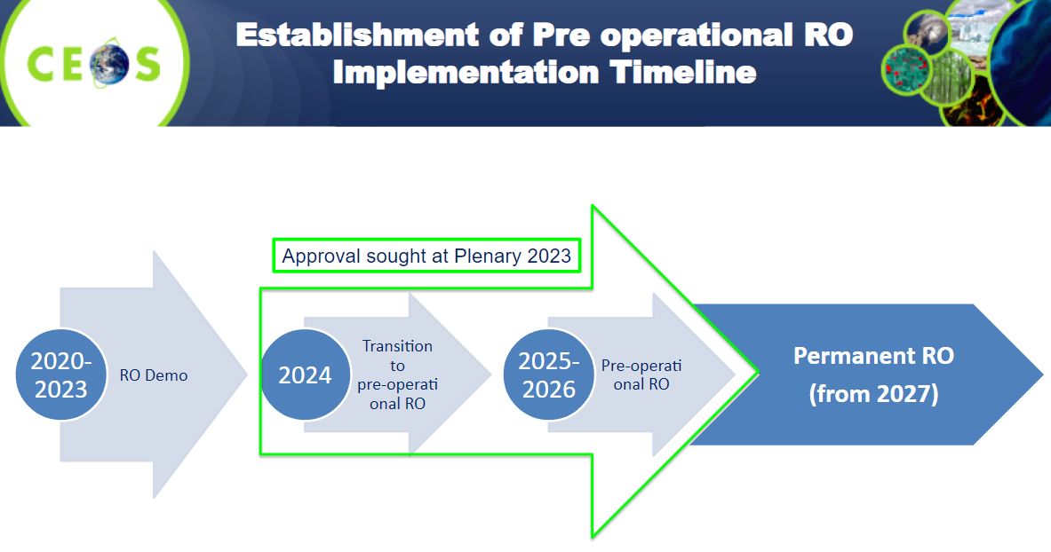
- Success will depend on strong RO Secretariat and RO Liaison functions (transition by 2025/2026 to recovery stakeholders) and capacity building activities.
- Propose to establish capacity to provide two to four Recovery Observatories for the next three years beginning in 2024.
  - Target one event per semester in 2024; one event per quarter in 2025 and 2026;
  - Initially provide resources through ad hoc best-efforts mechanisms as in demonstrators;
  - In Q1/Q2 2024, aim to work with partners to establish mechanisms for the private sector and intergovernmental organisation for RO activation that will be operational in Q1 of 2025:
    - Establish World Bank/Global Facility for Disaster Reduction and Recovery mechanism to activate pre-qualified private sector support in conjunction with capacity building in country;
    - Work with UNDP and UNDP Crisis Bureau to activate UNOSAT on a regular basis for RO activations;
    - Work with the EU to task Copernicus EMS RRM to rapidly respond to recovery intervention requests;
    - Access existing EU framework contracts on PDNAs to ensure PDNAs benefit from satellite support in a coordinated fashion.
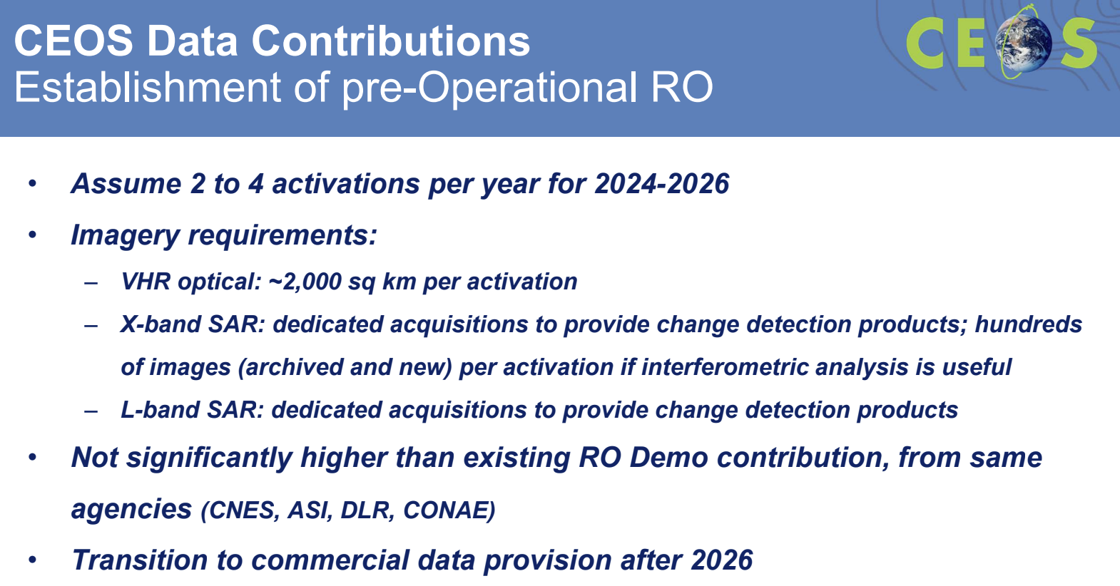
Discussion
- Natalia Donoho (WMO) asked about the possibility of collaborating with the WMO Space programme, specifically the Early Warning for All (EW4ALL) initiative. She suggested there could be an open data call for satellite applications, asking to provide a list of products for specific hazards, including volcanic ash. She expressed her interest in identifying potential opportunities for cooperation.
- WGDisasters has plans to contribute to EW4ALL. Helene suggested having a discussion to explore the practical steps for doing so.
- Ivan Petiteville (ESA) extended congratulations to WGDisasters, the RO team and the volcano team. He noted that these activities, which began a decade ago, serve as a good example of the use of Earth observation data. The user community has also been actively involved. The RO team and CNES have been to Haiti to discuss reconstruction and provided valuable data to local centres monitoring volcanoes.
- Ivan asked about the point “transition to commercial data provision after 2026” in the slides. Ivan noted that WGDisasters has been using a combination of space agency and commercial data since the very beginning of its work. He asked if this transition refers to not using data from public missions.
- Helene noted that the RO will always first rely on data that is free-and-open, however, there are situations where demand for higher resolution and specialised SAR products arises, and it is essential to ensure that these requirements can be met sustainably. The goal is to address these needs within the framework of an operational service, aiming for practicality and efficiency. While striving for the best possible efforts to provide data that is open and freely accessible, preparations should also be made for situations where this might not be possible.
- Ivan Petiteville (ESA) suggested revising the phrasing of the “transition to commercial data” point before the final presentation at the 2023 CEOS Plenary.
- Jorge Rio Del Vera (UNOOSA, WGCapD Chair) reminded participants that the RO is captured in the Space 2030 Agenda from UNOOSA. Jorge noted that having CEOS connect more activities to the objectives of the agenda is helpful and could facilitate resources.

Session 9: Closing Session

9.1: JAXA 2024-25 SIT Chair Priorities
Presenter: Takeshi Hirabayashi (JAXA, SIT Vice Chair) [presentation]
Main points:
- JAXA will take on the role of chair of the CEOS Strategic Implementation Team (SIT) at the 2023 CEOS Plenary for a 2-year term. NASA is nominated to serve as SIT Vice Chair during this term and take on the SIT Chair role at the 2025 CEOS Plenary.
- The incoming JAXA Team has been consulting broadly across the organisation to set outcomes and milestones that are significant and reflect societal needs and CEOS agency priorities.
- JAXA SIT Chair headline priorities are:
  - Climate Policy Impact to address obstacles and opportunities for CEOS agency data, particularly AFOLU/Biomass map datasets, to have maximum impact in the key climate policy processes such as the Global Stocktake of the Paris Agreement;
  - GHG Observations From Space to address coordination for data continuity challenges ahead and developing good practices so that operators of all kinds may contribute to societal needs.
- The JAXA SIT Chair Team will also support existing and emerging CEOS businesses by escalating, elevating, and expediting the CEOS Work Plan activities underway and planned in which CEOS agencies are investing.
- The SIT-39 meeting will be held in Tokyo, Japan on 10-11 April 2024 and the SIT Technical Workshop 2024 will be held in Sydney, Australia during the week of 16 September 2024.

9.2: Thailand CEOS Plenary details
Presenter: Poramet Thuwakham (GISTDA, CEOS Chair Team) [presentation]
Main Points
- The 2023 CEOS Plenary will be a hybrid meeting, allowing both in-person and remote participation.
- 14 November 2023 will be a day for side meetings, a side event seminar, and the welcome reception. Side meetings can be requested here.
- CEOS Plenary meeting will be on 15-16 November 2023 followed by a dinner reception on 16 November.
- The CEOS 2023 “Unseen Space” Exploration event will take place on 17 November 2023.
- Meeting registration form and more information are available at: https://ceos.org/meetings/37th-ceos-plenary/. Please note that the registration closes on October 30, 2023.
- For hotel reservations, please send completed forms to the hotel reservations team at: RSVN.Chiangrai@lemeridien.com. Please send any questions to: Pathamon.NaNakorn@lemeridien.com.
- The event venue and accommodation is Le Meridien Chiang Rai Resort.
- Please contact Poramet Thuwakham for visa letter requests. Email: poramet@gistda.or.th or gistda-ceos-chair-2023@googlegroups.com. Contact No.: +66(0)866586040.
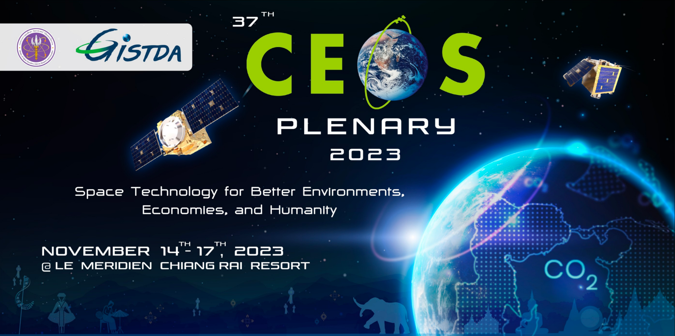

9.3: Meeting Summary and Action Review
Presenter: Stephen Ward (SIT Chair Team)
- The actions recorded during the SIT Technical Workshop 2023 were reviewed.
- The draft document will be circulated to all CEOS Members and Associates shortly so that written feedback can be provided.

9.4: Closing Remarks
Presenter: Eleni Paliouras (ESA, SIT Chair Team)
- This was Eleni’s first time attending the SIT Technical Workshop, and only her second CEOS meeting. This year has been an impressive experience seeing the way people are working together to solve the number of global issues. She expressed her excitement to be part of this team.
- Julie Robinson (NASA) congratulated Eleni on the meeting moderation and thanked ESA for their two years as SIT Chair. She expressed that the meetings were very well run and productive.

APPENDIX A: Participants
* = virtual participation
Agency/Organisation | Name | Agency/Organisation | Name
CNES | Aurélien Sacotte* | JAXA | Makoto Natsuisaka*
CNES/INRAE | Sandra Luque* | JAXA | Mariko Harada
CONAE | Laura Frulla* | JAXA | Misako Kachi*
CSA | Éric Laliberté | JAXA | Takeshi Hirabayashi
CSA | Lucie Viciano | JAXA | Yuko Nakamura
CSIRO | Alex Held | JAXA/RESTEC | Toshi Kamei
CSIRO | Flora Kerblat | NASA | Argyro Kavvada
CSIRO | Shaun Levick* | NASA | Barry Lefer
DLR | Klaus Schmidt* | NASA | Ben Poulter
DLR | Albrecht von Bargen* | NASA | Christine Bognar
EC | Joana Melo | NASA | David Borges
EC | Mark Dowell | NASA | Frederick Policelli
ESA | Alexis Sarraute* | NASA | Julie Robinson
ESA | Angelika Dehn* | NASA | Lawrence Friedl
ESA | Antonio Ciccolella | NASA | Shanna Combley
ESA | Ferran Gascon | NASA/JPL | Gary Geller
ESA | Marc Paganini | NASA/JPL | John Worden
ESA | Marie-Helene Rio | NASA/UMD | Christopher Kidd
ESA | Mirko Albani | NASA/UMD | Laura Duncanson*
ESA | Yasjka Meijer | NOAA | Charles Wooldridge
ESA SIT Chair Team | Eleni Paliouras | NOAA | Emily Smail*
ESA SIT Chair Team | George Dyke* | NOAA | Jeff Privette
ESA SIT Chair Team | Ivan Petiteville | NOAA | Katy Matthews*
ESA SIT Chair Team | Libby Rose | NOAA/NESDIS | Adria Schwarber*
ESA SIT Chair Team | Marie-Claire Greening | NOAA/NESDIS | Paul DiGiacomo*
ESA SIT Chair Team | Matthew Steventon | NOAA/NESDIS | Merrie Beth Neely
ESA SIT Chair Team | Stephen Briggs | NSO | Jappe Jongejan
ESA SIT Chair Team | Stephen Ward | NSO | Wim Looijen
ESA SIT Chair Team | Tatiana Burukhina | UKSA | Beth Greenaway*
EUMETSAT | Christophe Accadia* | UKSA | Danielle Jackson*
EUMETSAT | Jörg Schulz | UKSA | Gracie Lawrence*
EUMETSAT | Robert Husband* | UKSA/NCEO | John Remedios
EUMETSAT | Vinia Mattiolo* | UKSA/NCEO | Svetlana Zolotikova*
GEO Secretariat | Wenbo Chu | UMD | Neha Hunka*
Geoscience Australia | Andreia Siqueira | UNOOSA | Jorge Del Rio Vera
Geoscience Australia | Jonathon Ross | USGS | Sylvia Wilson
GISTDA | Atipat Wattanuntachai | USGS | Timothy Stryker
GISTDA | Pakorn Apaphant | USGS/Aerospace | Steven Covington
GISTDA | Poramet Thuwakham | USGS/KBR | Christopher Barnes
GISTDA | Tanita Suepa | VITO | Sven Gilliams*
JAXA | Hiroshi Suto | WMO | Natalia Donoho
JAXA | Ko Hamamoto*

APPENDIX B: Actions Record

SIT-TW-2023-01 | Greenhouse Gas (GHG) Task Team is tasked to engage the CEOS Working Group on Capacity Building and Data Democracy (WGCapD) regarding stakeholder engagement activities, including the relevant actions in the CEOS GHG Roadmap. A point of contact from WGCapD should be provided to the Task Team. | SIT-39
 | Rationale: The Greenhouse Gas Task Team coordinates relevant activities from across CEOS and CGMS, and is responsible for implementing the GHG Roadmap. The roadmap includes specific stakeholder engagement actions, for which WGCapD support is needed.
SIT-TW-2023-02 | GHG Task Team is tasked to complete the update of Annex C (action list) in the GHG Roadmap to support a consolidated overview as a refreshed starting point on this topic for JAXA’s SIT Chair term in time for the CEOS SIT-39 meeting in Tokyo. | SIT-39
 | Rationale: GHG observation coordination is a priority topic for the incoming JAXA SIT Chair, and the GHG Roadmap is the keystone document for this coordination.
SIT-TW-2023-03 | CEOS Agriculture, Forestry and Other Land Use (AFOLU) Roadmap Team is tasked to bring for endorsement at SIT-39, an AFOLU Roadmap Actions Supplement, as the main instrument for CEOS tracking of AFOLU Roadmap implementation. | SIT-39
 | Rationale: The CEOS AFOLU Roadmap document will be finalised for endorsement at the 2023 CEOS Plenary and is a comprehensive review of the issues. The Actions Supplement will be a brief addition for CEOS to track AFOLU Roadmap implementation. The Actions Supplement will continue to be stewarded by the AFOLU Team in the Land Surface Imaging Virtual Constellation (LSI-VC).
SIT-TW-2023-04 | Ocean Colour Radiometry Virtual Constellation (OCR-VC) Co-leads, in collaboration with the SIT Chair, will confer with relevant CEOS Principals prior to the 2023 CEOS Plenary to determine if necessary CEOS Agency representation and resources are forthcoming to allow the Aquatic Carbon Roadmap to proceed. | 2023 CEOS Plenary
 | Rationale: Significant Agency investment and effort will be required to undertake this activity. The co-leads are exercising due diligence to ensure the proposed Agency participation and capacity are available to proceed.
SIT-TW-2023-05 | CEOS Agencies are invited to provide comments on the draft Joint CEOS-CGMS Space Agency Statement to the UNFCCC Subsidiary Body for Scientific and Technological Advice (SBSTA). WGClimate is asked to confer with CEOS Agencies regarding the timetable for review and submission, and to issue the latest draft ASAP. | 25 October 2023
 | Rationale: The Joint Statement must be finalised urgently ahead of COP-28. Some agencies may need a few weeks to review and approve the texts.
SIT-TW-2023-06 | New Space Task Team is tasked to finalise their report and post it on the CEOS Plenary website for potential endorsement at the 2023 CEOS Plenary. The Task Team will confer with the CEOS Chair and SIT Chair on the report’s recommendations, including the possibility of an Actions Supplement to track implementation. | 2023 CEOS Plenary
 | Rationale: There was broad support for the Task Team’s report at the 2023 CEOS Technical Workshop, and the proposal for CEOS Plenary to give its approval to close the task team. Some Agency feedback suggested that the New Space Task Team’s recommendations could be reworded in a form to allow implementation through an Action Plan, with assignment and tracking over time.
SIT-TW-2023-07 | CEOS Agencies with interest in supporting the biodiversity domain are invited to contact the incoming CEOS Chair Team at CSA to engage in planning the headline theme for 2024. | 2023 CEOS Plenary
 | Rationale: CSA has reached out to many agencies as part of the Chair year preparation. Further inputs and resource commitments are welcomed.
SIT-TW-2023-08 | NOAA and ISRO, co-leads of COAST, are tasked to incorporate feedback from the 2023 CEOS SIT Technical Workshop into the COAST Virtual Constellation Initial Proposal and Terms of Reference for CEOS Plenary consideration. | 2023 CEOS Plenary
 | Rationale: There was broad support at the SIT Technical Workshop for the COAST Virtual Constellation Initial Proposal and Terms of Reference, and the COAST team is encouraged to finalise the two documents for consideration by the CEOS Plenary.
SIT-TW-2023-09 | CEOS Agencies are encouraged to put their relevant communications experts in contact with the CEOS Communications Team in the SEO to help leverage CEOS communications content in social media. Agencies are also encouraged to suggest content for the CEOS booth at GEO Week on Nov. 6-10, 2023, in Cape Town, South Africa. | 2023 CEOS Plenary
 | Rationale: CEOS Agencies can help elevate CEOS messaging and accomplishments on social media.

