CEOS Recovery Observatory

Proposal from the
CEOS Recovery Observatory Oversight Team
(ASI, CNES, ESA, JAXA, NASA)
CEOS DRM Initiative

Version 2
15 March 2014

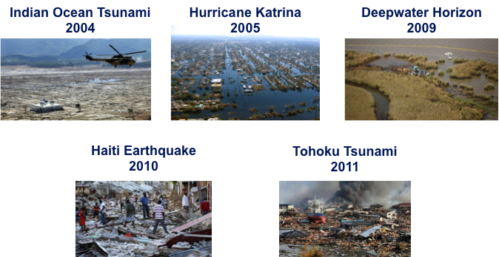

Proposal to Establish a Recovery Observatory
Developed by the Recovery Observatory Oversight Team:
Takao Akutsu (JAXA), Andrew Eddy (Athena Global), Stuart Frye (NASA), Alain Giros (CNES), Steven Hosford (CNES), Chu Ishida (JAXA), Frank Lindsay (NASA), Ivan Petiteville (ESA), Simona Zoffoli (ASI).

Introduction
Over the course of the past decade, the world has seen an unprecedented number of disasters, which are growing both in number and severity of impact. Large populations living in more vulnerable areas has led to record damages and substantial loss of life. The last decade has also been witness to a series of catastrophic events that has each marked us: the deadly Indian Ocean tsunami and Haiti earthquake of 2004 and 2010; the catastrophic flood damages of Hurricane Katrina in 2005 and the Tohoku tsunami of 2011, and the astonishing extent of the environmental impact of the Deepwater Horizon explosion in 2009. These catastrophes are on an impressive scale and have widespread and long-lasting impacts. Recovery after such disasters costs billions of dollars and lasts years, even as long as a decade. While satellite imagery is used on an ad hoc basis after many disasters to support damage assessment and track recovery efforts, there is currently no system to support the coordinated acquisition of data and facilitate its access. After catastophic events of this magnitude, a coordinated approach would maximise the effectiveness of efforts and promote more widespread use of satellite data after smaller events by increasing the awareness of the benefits to be obtained through its use.
The concept of a “Recovery Observatory” was initially born from seeing huge quantities of Earth observation data that are made freely available following major disasters to many different users. These data are made available in an ad hoc manner and through a large variety of platforms, which means that their use both during and after the disaster (when this is authorised) is not optimised. Seeking to optimise the use of collected data, and understanding the value of implementing systematic observations for several years, CNES led the creation of a platform to gather and continue to make available Earth observation data following the devastating Haiti earthquake of January 2010. This project, named KalHaiti, has made great progress over the past three years, and has allowed CNES to identify lessons learned that underscore the importance of working before a catastrophic event takes place, and of working collectively, as a communutiy of agencies, rather than in isolation. A single, coordinated approach supported by advance planning and identified mechanisms to trigger the creation of an Observatory, will greatly increase the efficiency and impact of actions taken following major events. These lessons have led to the creation of the Recovery Observatory Oversight Team and this proposal.
This document seeks to describe a “generic” Recovery Observatory and the schedule for establishing such a platform. It then highlights some of the major issues that must be addressed during the development of this project if it is to be successfully implemented.

- Rationale
A CEOS-led Recovery Observatory, a one-time demonstration in the 2014-2016 period, would allow the development of specific tools tailored to provide easy access to data over affected areas (pre-event data, response data and coordinated post event acquisitions). An organised repository, which serves as a discovery platform for data and products, would allow disaster managers to work in a known environment with advanced satellite products and promote their use to key user communities. Currently, while research shows that EO can be a valuable tool for recovery, DRM stakeholders do not have a clear example of how EO can be used to support Recovery efforts in an optimal scenario for data collection. Until now, sharing has not been put forward in a coordinated manner for any major catastrophes.

- Outcomes and Benefits
The main objective of the proposed Recovery Observatory is to facilitate access to data and products that support recovery from a catstrophic event. A subsidiary benefit for CEOS and satellite data providers will be the development of specific approaches and protocols for using satellite data to support disaster recovery, and raising awareness with the Disaster Risk Management community of the beneftis of a satellite-based approach.

- Challenges
A number of major challenges to the establishment of an Observatory have been identified:
  - Triggering the Observatory
Defining the disasters for which the RO could be triggered. Such a disaster should have a sufficient impact to ensure a long term involvement of the beneficiaries: national governments or international institutions, the scientific communities, NGOs, etc. This impact can be estimated through different parameters such as its location, its geographical extent, the number of victims, affected infrastructures, impact on natural or economic resources, and also the estimated time required for the recovery period. Beyond its impact, the institutional and social context is also an important parameter to be considered. All these conditions must be identified and carefully analyzed in order to be ready to select the most appropriate opportunity for triggering the RO with the highest possible outcome in terms of demonstrating the benefits of remote sensing for risk management and recovery monitoring.

  - Mobilising User Communities
Identifying and mobilizing the communities of users. Ensuring the involvement of end-users in the RO is a key for success but also one of the most difficult challenges because they cannot be precisely known in advance. Our analysis leads us to identify different users categories such as rescue teams, national institutions, scientific communities, NGOs, international bodies, urban planners or even citizens. Some of them are well coordinated at the international level and the dialog for involvement, promotion and operations could be made as that level. Others are more independent and their mobilization around the RO cannot be prepared for every country. A solution for each of these categories must be found and implies the identification of the right partners for each of them (see below for instance).
Finding an appropriate “supranational” partner. Being able to quickly establish links to national and local users is of critical importance for the RO to have maximum impact. Clearly it is not possible to prepare this aspect in advance in all countries. Having an appropriate partner, most probably from within the UN family of organisations, who can provide a formal link to the affected country in the aftermath of a disaster is one way of addressing this issue. The supranational partner is a critical element in establishing a process to approach end users and ensure close contacts after the triggering of the observatory.

  - Developing Generic Acquisition Plans
Building a data acquisition plan. Depending on the kind of catastrophe, its extent, its impact and other parameters, the data types which could be needed for the response and recovery phase may be broad. Identifying the data sources and the best means of accessing them (through a distributed network or through a centralized repository) is of great importance prior the triggering of the RO. The Observatory will define pre-determined scenarios to estimate requirements for EO data before the disaster occurs.

  - Organising/coordinating Infrastructure
In the constitution of a functional RO infrastructure, the emphasis will be placed on the use of diverse components either contributed by agencies or identified among open source elements. It is anticipated that the CEOS Working Group on Information Systems and Services will contribute to identifying suitable elements. Some investments may be required in generic infrastructure. Efforts will be made to find synergies with existing projects within CEOS agencies and to attract interest from major DRM stakeholders. Depending on the timing, it may necessary to implement an initial version of the RO platform that will subsequently be upgraded and adapted.

- Proposed Scope and Organisation
  - A demonstrator
The proposed Observatory would be triggered only once in the 2014-2016 period, as a demonstrator to validate the concept of Recovery Observatories and to showcase how EO can be effectively used to increase the effectiveness of recovery efforts.
A Recovery Observatory such as the one established after the event for Haiti aims to gather and make available as much geospatial data as possible that may be of use in the immediate aftermath of a major disaster and for a period of a number of years after the event. Such an observatory can be considered as a central collaborative resource, providing users’ communities concerned by the event with all the data they need for supporting their activity in the response and recovery phases. Users of the Recovery Observatory belong to rescue teams, NGOs, national ministries, international organizations, urban planning, scientific teams, etc. Even if the Recovery Observatory emphasizes remote sensing data, diverse types of data may be made available ranging from Earth Observation data and derived information products on the event itself and its impact, to socio-economic data on the affected populations. The common theme should be that this data is geospatial (i.e. the data is associated with a position) and that it is of use in helping the response and recovery phase following the disaster. In order to have greatest impact, the Recovery Observatory should be established within weeks after the disaster, should serve as a repository for response related data as well as initiate new acquistions in support of recovery priorities, and should provide a focal point for data gathering from sources both within and outside the Earth Observation community.
The development of the Recovery Observatory would take place in two phases: first, a preparation phase that includes planning and early development, and then an operations phase that covers the Life-cycle of the Observatory.

  - Preparation Phase
Detailed Analysis – until April 2014
Overview of User Needs
There are many types of users, including…
- International users (or stakeholders): international organizations (either governmental like the World Bank or NGOs like the Red Cross) with a mandate tied to supporting recovery from major disasters and a stake in supporting national recovery efforts. Identifying one or several such users that adopt the idea of a Recovery Observatory and are prepared to work with CEOS to have one implemented is critical to success. This organization would be the lead interface with other users immediately after the response phase, and would assist in defining the initial acquisition plan to be adapted from the generic plan prepared before the disaster.

- National users: for major disasters, the national body responsible for civil protection is typically the sole interface for the outside community (hence the idea of privileging a dialogue through an established DRM stakeholder which will have the requisite privileged access - necessary to be able to get people's attention after a major disaster). This body will authorize NGOs and other to work in the recovery area and is responsible for the coordination of recovery efforts. Their buy-in is essential as to be successful the Observatory must address their needs and the needs of their partners.

- Local users: the local end user is the most affected, and may have no resources at all after a major disaster. However, ultimately, the local end user will be the key long-term partner for a recovery observatory. Local end users are typically civil protection agencies or organs of national government with a mandate for reconstruction. Local end users will be the key contact point for international organisations supporting reconstruction and will have the final say on which projects are supported. There needs to be a transition from the pre-trigerring, generic phase to the formal establishment of a dedicated Observatory, so that as the Observatory is triggered, it develops a direct relationship with the local end users. This will ensure the Observatory is meeting needs, and allow it to adjust if necessary.

- Practitioners or intermediary users: CEOS agencies will essentially provide data to the Observatory. Mechanisms must be established to allow participation of partners who can provide value-added products and services. These partners may be universities, government organizations or private companies. These intermediary users often include science or research users who work on data for scientific interest but with outputs that are used by civil protection authorities. In some cases, CEOS contributions may include some value adding contributions or training and capacity development. This needs to be set up in a single comprehensive framework where the roles of partners are made clear before the Recovery Observatory is triggered. Intermediate users should be able to:
  - understand user requirements;
  - from the user requirements identify and generate high level products;
  - help to identify EO data acquisition plan;
  - train the users in the use and interpretation of the derived products and, when possible;
  - try to transfer EO-based methodologies and practices to ensure sustainability EO.
While it is impossible to determine the exact needs of a Recovery Observatory before an event takes place, there are a large number of requirements that are common to all recovery situations after major disasters. Baseline data requirements are required for both EO data and for derived products. These data and products support several different types of activity that change as the recovery phas, and lifetime of the observatory, progresses. A draft categorization of these activities might include:
- Built area damage assessment (initial and later detailed)
- Natural resource and environment assessment
- Reconstruction planning support
- Reconstruction monitoring; and
- Change monitoring.
While there is no need for detailed acquisition plans before the triggering of the Observatory, the preparation phase should include the development of detailed EO data requirements for different types of Observatories: one for a major earthquake, one for a major volcanic eruption, one for a major flood and/or hurricane, and a tsunami. The exact number of scenarios developed will be decided during the detailed analysis phase. Some elements are quite common and involve situational awareness immediately after the event and for the damage assessment period, or involve baselining pre event and post event imagery in a single database. Other products might be specific to the disaster type - historical flood analysis for future flood events, InSAR analysis for strain estimates after earthquake, etc etc. The proposal would include a few such scenarios and scope out the types of data required for each, without identifying specific satellite missions. After the SIT in April 2014, volunteer agencies will indicate a willingness to contribute specific data sets in the event of a triggering.
Overview of Technical Components
The content of the Recovery Observatory needs to be defined by the CEOS partners. It can range from a simple repository of available data to a pro-active acquisition strategy and the development of key value-added products that would support recovery.
Data
It is clear that the volume of data collected during the response phase is, in fact, likely to be much larger than the volume of data collected in the following three to five years. Examples of EO data would include high resolution and very high resolution optical imagery; high and very high resolution radar imagery (X, C and L-bands). Examples of revisit might include once a week for two or three months and once a month for a period of several years, over the affected area. For some disasters such as earthquakes, SAR imagery would be required to develop products such as interferograms. For other disasters, SAR applications may be limited to change detection over built-up areas.
There is a need for data from before and after the event, and if this data is organized as a mosaic coverage of the area for example, with easy access for multiple users, this would allow both large and small users to access data without large capacity needs.
Products
Many end users need products rather than data. It is clear that the Observatory can only be successful if relationships are established to enable the generation of products from the contributed data. The baseline scenarios will determine not only the volume of data but representative products for each type of catastrophe. This allows CEOS to engage in discussions with multilateral stakeholders before an event and establish a framework within which different partners bring complementary contributions.
Infrastructure
In the event that CEOS decides to set up a discovery portal for the Observatory, part of the preparation phase should be dedicated to establishing the generic capability to host the Observatory, detemrining the appropriate informatic tools to include and ensuring standards are in place to receive the data in an easily searchable format. Many CEOS agencies already have plans for exploitation platforms and synergies could be sought between existing projects.
International partner
A critical aspect of the analysis phase is identifying a single or several suitable “supranational” partners who will play an important role as a RO user in themselves but also in establishing links to the national user community. This role is particularly important as, given that the national users will not be known until the RO is to be established, they will provide necessary feedback to CEOS through the development phases.

Preparation – April-October 2014/spring 2015
The goal is to prepare the creation of a Recovery Observatory by working on all the required components in order to have all of them ready before entering “cold storage” and the beginning of the Observatory life-cycle. Numerous aspects have been identified:
• Technical components (website, database(s), processing chains)
• Data provision flows (data types, providers, licenses)
• Agreements with Users communities and partners (intermediary users, science users)
This phase should be closed after a “dry-run” formal exercise has been implemented successfully. The preparation phase will take place in two-steps, thorugh an iterative process, and will be conducted in close collaboration with CEOS WGISS.
During the first phase, beginning in April 2014, WGISS will conduct a summary review of requirements, and sound out potential collaborating agencies who may already have essential ‘building blocks’ through the existence of national projects that can be brought to bear in support of the Observatory. Once the potentail contributions are identified, WGISS will develop a common vision for the Observaotry architecture and set up an initial architecture that will be able to respond to immediate needs in the event of a triggering beginning in November 2014. Contributing agencies within WGISS will also develop a plan for how data would be acquired, handled, stored and distributed in the event of an early trigger. In parallel, WGISS will develop the long-term architecture and implement this by spring 2015.
The Recovery Observatory Oversight Team will remain active by developing data provision flows and seeking, in parallel, to develop ad hoc arrangements for the estbalishment of a generic open license appropriate to satellite imagery that recognises the unique nature of data provided in support of large-scale disaster recovery.
The Team will also lead discussions with international stakeholders to ensure they are actively engaged and prepared to play a role in the actual triggering of the Observatory, by recommending to CEOS specific events where the scale and nature of the disaster lends itself to the creation of an Observatory.

  - Observatory life-cycle
Cold-storage – from November 2014 until triggering
During this phase, CEOS will monitor international events and maintain close contact with international stakeholders that have been identified. We await the occurrence of a disaster corresponding to the defined criteria. As, intrinsically, the components (new sensors, computing technologies, web technologies, communities, international situations, risk management procedures,…) evolve, this time period should be limited and defined in advance.
The duration of the waiting or cold-storage phase cannot be predicted, as it depends on the occurrence of a disaster for which the Observatory is triggered. The initial cold storage period is foreseen for one event in the 2014-2016 period. However, once the infrastructure is established, there is no reason why this period could not be extended, in the event no disaster has been selected by late 2016.

Triggering – in the 10 days following the disaster
The CEOS agencies supporting the Observatory are in many cases also members of the International Charter. It is clear that the Observatory is a useful complement to the Charter, and that for a disaster of the scope envisaged for the Observatory, it is highly unlikely that the Charter would not be activated. For this reason, Charter activation should be a pre-condition for the creation of an Observatory (no Observatory if no Charter activation). There will however be only one Observatory created in the 2014-2016 period, whereas there is on average one Charter activation per week. Other criteria are necessary to determine when an Observatory is triggered.
The magnitude characteristic (exceptional event with far reaching impact in human and/or material terms) should be the first filter. The Observatory should be triggered when the catastrophic nature of the disaster and the scale of the anticipated recovery effort warrant it. This may be a CEOS assessment, or may be the result of a request to CEOS from an outside organisation that agrees to serve as a “filter” to assess which disasters may be the best candidates. Any of the members of the Oversight Team who choose to commit to the preparation of the Observatory could also suggest that the Observatory be triggered and call a teleconference to discuss why, according to predetermined criteria. One of these criteria could (and should) be advice or a request from a designated international DRM body. The Oversight Team would review the triggering scenarios, consider the main 'standard' requirements for the triggering, and establish whether there is critical mass within CEOS for the triggering.
A CEOS management level participation in the activation discussions is a good idea at the very least to associate this level with the decision. The CEO (CEOS Executive Officer) is the right person to manage this interface, however it should be clear that this representative is acting as a conduit for CEOS management (CEOS Chair/ CEOS SIT Chair) and has consulted with them bringing a CEOS management point of view to the RO activation decision.
With this in mind, the triggering mechanism might function as follows:

- Charter activation - Oversight Team members or international DRM stakeholder/partner consider whether or not event is catastrophic and warrants Observatory.
2. If event is considered to be a candidate event in the subjective judgement of any Team member or International Stakeholder, One Oversight Team member or international DRM stakeholder calls teleconference to propose triggering.
3. Oversight Team examines predetermined scenarios developed during preparation phase and looks at triggering criteria, which would include considering advice from DRM stakeholders (and commitment in kind or resources for value added support), looking at the scale and scope of the disaster, and looking at benefit to be derived from establishment of Observatory.
4. Three Oversight Team members, with the agreement of the CEOS Executive Officer in consultation with the CEOS Chair and SIT Chair, representing critical mass/varied contributions of data (according to what was deemed to be required in the preparation scenario) decide they would like to trigger the creation of the Observatory.
5. The Observatory is announced within CEOS with a call for participation.
6. The Observatory is announced publicly, jointly with a DRM partner.

Operations – for a period of 3 to 5 years
The operational phase of the Recovery Observatory should be of a reasonable length, which may depend on the impact of the disaster, and would probably range from 3 to 5 years.

Closing – six months before end
This phase involves closing the Observatory or arranging for its operation by a local partner or international organisation with strong local presence, who might continue to operate the historical data base or supply it with new data to support risk management initiatives.
The review of the activities and outcomes will be presented to CEOS but it should also involve Users Communities and International bodies at the highest possible level.

- Responsibilities of CEOS Members
The main contribution sought from CEOS members is satellite EO data. Observations will include archived data over the affected area from before the event, data acquired during the response period and dedicated observations to support recovery during the duration of the Observatory.
On a voluntary basis, some CEOS agencies may also contribute value-added products (or support for industry to develop such products), hosting services for the repository, tools to support generation of products or other related services.

Building a data acquisition plan
Depending on the kind of disaster, its extent, its impact and other parameters, the data types which could be needed for the response and recovery phase may extend over a wide range. Identifying the data sources and the way to get them is of great importance prior the triggering of the Observatory. From the spatial side, the most suited remote sensing data depends on the sensor type, resolution, swath, acquisition period and also on the targeted applications. The definition of the remote sensing acquisition plan could start with the ECO procedure used in the International Charter which identifies the most suited sensors for a given type of disaster. However, since the applications in the framework of the Observatory can be very different, the option of systematically acquiring data from most of the current flying sensors might also be chosen.
Aside the acquisition of new remote sensing data, gathering archive data on the affected area as well as the possibility of acquiring in-situ data deserve a special consideration. One aim of drafting these acquisition plans as precisely as possible would be to provide the CEOS agencies with a precise view of their commitments in terms of amount of images they should provide to the Observatory.

Developing IT infrastructure
CNES has proposed to lead the IT infrastructure development, working in close collaboration with the WGISS. The plan to develop the infrastructure comprises several elements:
- Technical (shelf software or hardware platforms to use, lack of availability of system components):
  - Maximum re-use of existing blocks
  - The system shall be able to work on a cloud (private or public) or on a single computer
- Calendar (launch date)
  - Version v0 for October 2014
  - Version v1 for late spring 2015
- Contract (industrial policy, framework agreements)
  - Contract will be set up within CNES ACIS framework agreements
- Organizational (localization teams, unavailable resources, partnerships)
  - Objective is to imply as much as possible WGISS and Disasters WG in this development
  - The industrial team will be located in Toulouse.
- Progress followed by teleconfence
- Participation to WGISS meetings, to Disasters WG meetings for review
- Organization of side meeting around SIT meetings and CEOS plenary
- Choice of methods development (prototyping, incremental development)
- Re-use the maximum possible existing products
- Use generic development to remain relevant to diverse situations (GEOSS, Pôle FMT)
  - Incremental Development; possibly Agile method (Scrum) with IceScrum tool
  - Two prototypes will validate the development
- Monitoring of project development:
  - Progress teleconference every 2 weeks with joint WGISS / WGDisasters oversight
  - Regular meetings in the frame of the contract (Agile development)
  - Regular (every 3 month) update of the development plan

Value-added contributions
During the development phase, Team members will document value-added contributions that may be made by CEOS agencies, and mechanims by which outside organisations may make value-added contributions. This will also be discussed with the international stakeholders and partners to identify paths forward to ensure data will be processed and transformed to meet end user needs.

- Case Studies
The following section provides three case studies to be considered as examples of what an Observatory might have looked like over three major events of recent years:
- Haiti earthquake, 2010;
- Great East Japan Earthquake/tsunami Tohoku, 2011;
- Philippine Typoon Haiyan/Yolanda, 2013.
Where appropriate, comments have been added to indicate how the type and quantity of data might differ for an Observatory created for a similar but different event.

  - Haiti earthquake 2010
A 7.0-magnitude earthquake struck Port au-Prince the 12th January 2010 at 4 pm local time causing major casualties and damages, followed by several aftershocks with magnitudes over 5.0.

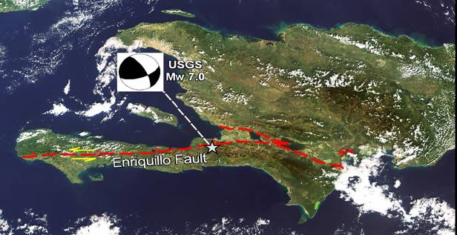 | 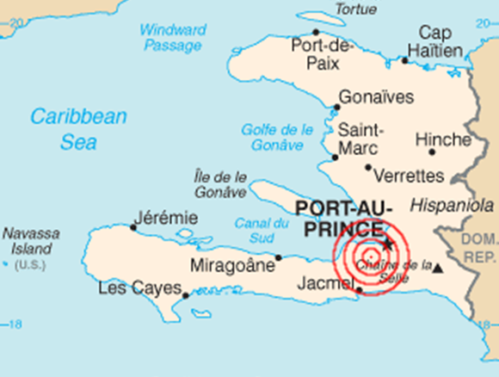
The South-West (Petit-Goave, Leogane, Carrefour cities) and South-East part of Haiti (Jacmel city) were also struck. In the city of Port-au-Prince a large number of buildings such as the palace, government and UN buildings, embassies and hospitals were affected or destroyed. Telecommunications as well as electricity and water supply failed. The earthquake caused more than 220 000 deaths, 310 000 injuries, 660 000 displaced, 210 000 destroyed housing and 105 370 damaged buildings. This is amongst the most destructive disasters of recent years.
One hour after the earthquake (13th January at 23:00 UTC), the Charter was triggered first by the French Civil Protection, then by United Nations-MINUSTAH, followed by Public Safety Canada and the USGS- Earthquake Hazards Program. CNES proposed to the Charter to be Project Manager as the first AU was the French Civil Protection agency.
The GMES’s SAFER project collaborated with the Charter European agencies to provide a specialized Value Adding capacity to produce damage maps. CNES requested immediately the GMS SAFER services and SERTIT from Strasbourg (France) was designed as the main value added provider. DLR –ZKI (German Aerospace Centre's center for satellite-based crisis information) also participated to this effort as BBK (German Federal Office of Civil Protection and Disaster Assistance) had activated the SAFER project for the German Red Cross.

Use of satellite resources:
A huge amount of data were gathered Charter agencies during the event, both pre-event images and post-event images including GEOEYE-1, IKONOS, KOMPSAT-2, QUICKBIRD2, WORLDVIEW1-2, SPOT 5, ALOS AVNIR-2, ALOS PALSAE, TERRASAR, RADARSAT1-2. Several types of crisis products were sent to the 4 Charter Authorized Users and others: Damaged buildings, Damage density evaluation, Visible gathering areas. Between 14th and 22nd of January SERTIT and DLR-ZKI generated 34 value added products, UNOSAT also generated products from US VHR optical for UN entities and shared them within the Charter and SAFER Users.
Some data were also used by French scientists and USGS users for comprehension and measuring of the geophysical event: SPOT, ALOS, plus several specific programming from ESA.
Intense and frequent coordination between Users, Value Adders, CNES Project Manager and the GMS SAFER project took place to take into account the User’s needs (areas and information to be delivered) in the damage mapping activities. Value-added products were used daily to help rescue teams on the ground, but also for briefing meeting with various government authorities at the strategic level.
A comparative analysis carried out by SERTIT between results from GEOEYE and results of a post-disaster needs assessment from Aerial Photographs carried out by UNOSAT, World Bank and JRC) has shown that the coherence assessment per urban block over the city of Port-au-Prince was 69%. This was a very good result if we consider the fact that results from the Charter where delivered on the 15th, 40 hours after the earthquake whereas aerial photographs were acquired starting from January 18th and processed for several weeks after the event.
The Charter provided a highly reactive emergency response just after the event and until 27th January.

Relation to future events:
In the coming months after this earthquake, the French space agency (CNES), with the French Research funding agency (Agence Nationale de la Recherche), funded a project named KAL-Haiti which aims at gathering remote sensing imagery as well as in-situ and other data into a knowledge base.
The KAL-Haiti project consists of 4 partners with CNES as Coordinator. It began in December 2010 with a financing of ANR for 4 years duration. KAL-Haiti is aligned with current activities performed in the partner organizations and includes the CNES ISIS and KALIDEOS Programs which provides improved access for the science and applications community to SPOT and Pléiades’ imagery.
KAL-Haiti database is seen as a shareable resource and can serve as a reference for scientific studies devoted to all phases of risk management (from recovery and mitigation to preparedness) and be used as a basis for helping the reconstruction of the country. The focus is turned to rebuilding the country and for a better understanding of seismic hazard and vulnerability in this zone but also elsewhere.
The project main outcome is a geo-referenced database containing a selection of remotely sensed imagery acquired before and after the disastrous event supplemented with relevant ancillary data, and enriched as possible so with in-situ measurements and exogenous data.
KAL-Haiti database is freely available for scientific studies devoted to risk management and reconstruction tasks in Haiti. The database is accessible to registered users on a per data basis, allowing the traceability of their non-commercial uses. Since the beginning of the project the database is continuously enriched with the acquisition of new high and very high resolution satellite images. The database currently contains a mosaic of SPOT5 2.5m (whole country), VHR and HR optical images Pléiades on specific area, SPOT 5 2.5m C, SPOT5 10m, HRS Spot 5 DEM at 30 m (Haïti S-W), Pléiades DEM 1m (Port-au-Prince), vector/shape file data (road network, watersheds and building location on specific area).

Spot 5
20 monoscopic | Global | 2007-2009 | Bundle panchromatic 2.5m and multispectral 10m, georeferenced
6 monoscopic | Port-au-Prince | 2010-2011
4 monoscopic | Jacmel | 2010-2012
1 monoscopic | Cap-Haïtien | 2013
Pléiades
3 monoscopic | Port-au-Prince | 2011-2012-2013 | 50 cm pansharpened georeferenced
2 tri-stereo | Port-au-Prince | 2012-2013 | Bundle 50 cm panchromatic, 2m multispectral
2 monoscopic | Jacmel | 2012-2013 | 50 cm pansharpened, georeferenced
1 monoscopic | Cap Haïtien | 2012
1 tri-stereo | Cap Haïtien | 2013 | Bundle 50cm panchromatic, 2m multispectral
Note: Pleiades monoscopic are also available in bundle 50cm panchromatic and multispectral 2m
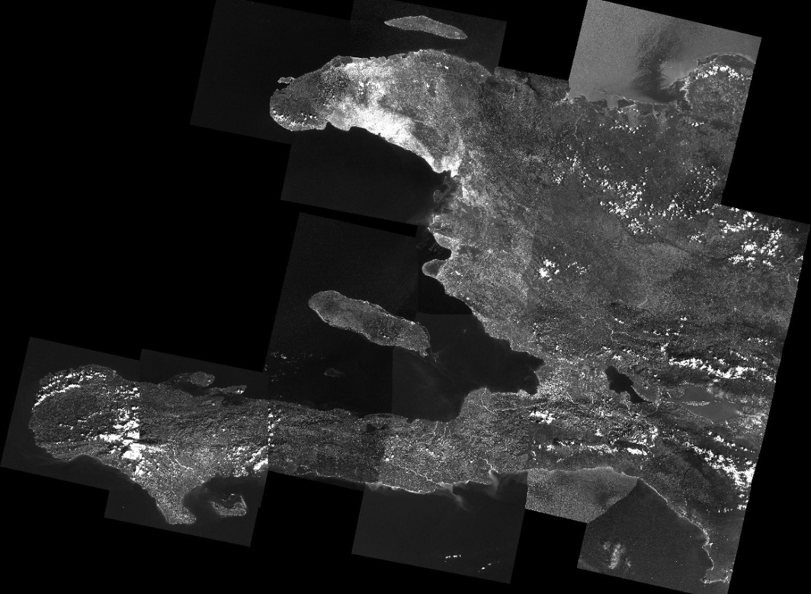
Spot 5 2.5 meter mosaic
Beyond the database itself, the data procurement and processing (data quality assessment and improvement, data accessibility), one KAL-Haiti project activity is to identify the potential uses of such database in the risk management. This requires a users’ community (named “contributors’ community”) that was formed with a large range of scientists to propose methods and solutions with users such as humanitarian crisis managers: international NGO and Haitian local associations, but also all Haitian actors in charge of geographical information and territory management operations. These actors constitute a working group that meets during annual workshops in which projects needs are expressed. This has led to research and applications proposals based on an effective collaboration between users and scientists. The KAL-Haiti project manages satellite data production and delivery, as well as supporting selected applications while mobilizing the project partners and contributors, and provides substantial support to set up research and development activities. These projects are conducted in the field of global risk management and sustainable reconstruction, from geophysical and societal modeling to image analysis, data processing and information management.
The goal is to propose, for each problem which has been identified, the best possible solution involving end-users with real needs in Haiti and the highest-level scientific laboratories. Involvement of Haitian teams or institutes is also considered in order to favor spin-offs. The selected applications are then followed up as usual scientific and technical developments.

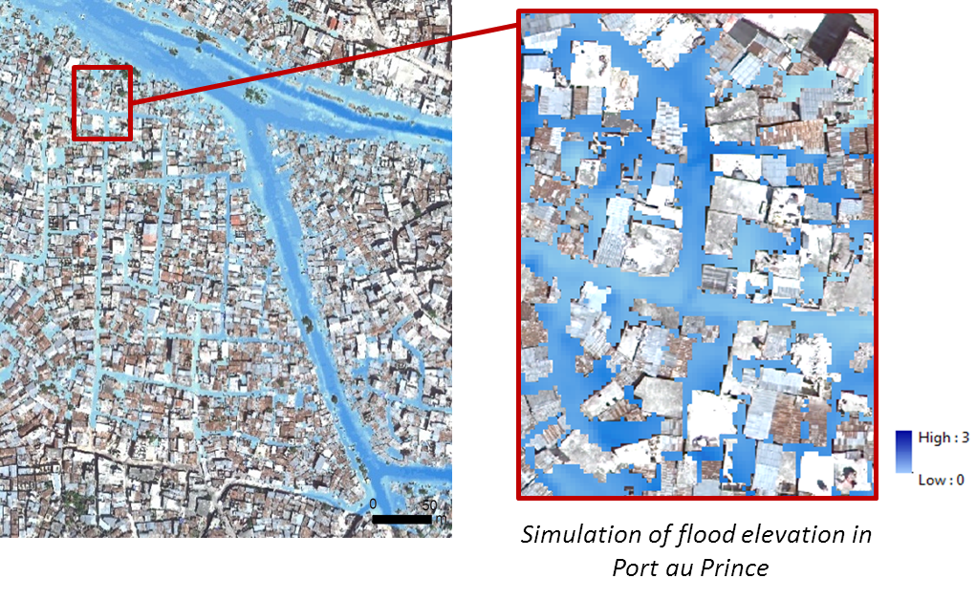
Example of product performed with Worldview 1 image (50 cm) (Sertit/Politecnico Milano)
While the KAL-Haiti project itself enters the last part of the development phase, it will continue to be supported by CNES through the CNES KALIDEOS Programme over the mid to long term (10 years), thus providing a stable environment for contributors involved. The question of extending access to some of the imagery resources to other partners require new solutions (eg. on licensing issues) which may be addressed during the collective development of the Recovery Observatory.

EO Data requirements:
Product  Description | Type of Data  (SAR, optical,  HR, VHR) | Area of Interest (square km) | Frequency of observations over 5 years | Total Data Volume | Comments
Inundation area monitoring  Vulnerability to floods | SAR, optical, VHR and HR | -Port-au-Prince  -Jacmel  -Cap-Haïtien  -Gonaives  -Limonade  -Other depending to users projects | 2/year | Depending on resolution sensor type | Depending expressed users’ needs
Quarries characterization | Optical VHR | -Port-au-Prince  -Haiti North and Centre | 1/year | Depending on resolution sensor type | Depending expressed users’ needs
Vegetation monitoring  (mangroves, forest) | Optical, VHR and HR | -Port-au-Prince  -Jacmel  -Cap-Haïtien  -Gonaives  -Limonade  -Other depending to users projects | 2/year | Depending on resolution sensor type | Depending expressed users’ needs
Urban planning, reconstruction monitoring | Optical, VHR, HR | -Port-au-Prince  -Jacmel  -Cap-Haïtien  -Gonaives  -Limonade  -Other city of interest (from user’s request) | 2/year | Depending on resolution sensor type | Depending expressed users’ needs
Coastline monitoring | Optical, VHR, HR | -Port-au-Prince  -Jacmel  -Cap-Haïtien  -Gonaives  -Other depending to users projects | 2/year | Depending on resolution sensor type | Depending expressed users’ needs
Watershed management  Water cycle (quantitative-qualitative-water resources), | Optical, VHR, HR | -Port-au-Prince  -Jacmel  -Cap-Haïtien  -Gonaives  -Limonade  -Other depending to users projects | 2/year | Depending on resolution sensor type | Depending expressed users’ needs

Note: Port-au-Prince, Jacmel, Cap-Haïtien, Gonaïves and Limonade are cities. We can consider a surface area of 20 x 20 km for each of them.

  - Japanese Tohoku tsunami 2011
Japan’s largest recorded earthquake, of magnitude 9.0, occurred off the Pacific coast of Tohoku at 14:46, March 11, 2011. The epicenter was in the Pacific Ocean (lat. 38.1 deg N, long. 142.9 E) at a depth of 24 km. The earthquake took place at the boundary between the Pacific and continental plates. A tsunami as high as 9.3 m was caused by the earthquake and damaged the coast of East Japan covering Tohoku and Kanto areas. Total inundation area by the tsunami was 561 km2. The earthquake and subsequent tsunami caused the death of 15,833 people, with 2,654 missing, 6,146 wounded, and significant building damage (totally collapsed 126,578, half collapsed 272,305). More than 340,000 people were evacuated and there are still 289,611 are living in evacuation at present.

Use of satellite resources:
JAXA collected 643 scenes of ALOS AVNIR-2 and SAR data from March 12 to April 20 (ALOS ceased its operation on April 20 because of power system failure). Sentinel-Asia and the International Charter were activated on March 11 and more than 5,000 scenes of satellite data were provided, including FORMOSAT-2, THEOS, CARTOSAT-2, TerraSAR-X, RADARSAT-1 & 2, ENVISAT, COSMO-SkyMed, IKONOS, GeoEye-1, Quickbird-2, WorldView-1 & 2, SPOT-4 & 5, Kompsat-2, RapidEye, HJ, LANDSAT-5& 7, EO-1 and Dubaisat. JAXA generated more than 1700 products from satellite data of ALOS, Sentinel-Asia and the International Charter and provided to DRM related ministries, local governments and other DRM related agencies. ALOS standard data were also provided to DRM related users for their own analysis.
In rapid response phase, initially (for initial few days) wide area coverage data were required in order to determine extent of damage. In latter phase (from 3 or 4 days after), very high resolution data were required in order to assess the damage.
For recovery phase, inundation areas were monitored every week. JAXA and the National Applied Research Laboratory (NARL) are now discussing regular observation of the affected areas by FORMOSAT-2 to monitor recovery progress within the Sentinel Asia Step 3 observation scheme.

Relation to future events:
After the Great East Japan Earthquake and tsunami, the Central Disaster Management Council issued national plan for mega earthquakes and tsunamis in the Nankai Trough. There is concern that further earthquakes may occur in the near future. The Nankai Trough earthquake and tsunami are predicted to cause as many as 323,000 deaths (17 times the Great East Japan Earthquake) and an estimate 2,386,000 totally collapsed buildings (18 times Great East Japan Earthquake). The plan includes use of satellite emergency observation to grasp wide damage areas.
After the East Japan Great Earthquake and tsunami, JAXA has been studying satellite observation strategy for the Nankeen Trough earthquake. The plan includes coordinated emergency observations of very wide areas by ALOS-2 and other cooperative foreign satellites based upon bilateral cooperation scheme.
Observation strategy for the recovery phase is yet to be studied, but the regular observations for monitoring the following recoveries are being considered;
-monitoring of effectiveness of removing salt from rice paddy fields (quarterly),
-monitoring of vegetation recovery (quarterly),
-land use replanning and monitoring of city reconstruction (quarterly),
-INSAR monitoring of land crust movement and volcanic activities (6 times a year) to prepare possible second disaster.

It is estimated that this monitoring would span a period of 5 years.

EO Data requirements:
Product  Description | Type of Data  (SAR, optical,  HR, VHR, etc) | Area of Interest (square km) | Frequency of observations over 5 years | Total Data Volume | Comments
Inundation area monitoring | SAR and optical, HR | 1000km x 50km | every week for 3 months | 480 scenes* | *Cloud coverage ratio not included
Salt effect removal monitoring | SAR and optical, HR | 1000km x 50km | quarterly for 5 years | 400 scenes* | *ditto
Vegetation monitoring | optical, HR | 1000km x 50km | quarterly for 5 years | 400 scenes* | *ditto
Land use replanning and city reconstruction monitoring | optical, HR, VHR | 1000km x 50 km (HR)  10km x 10km(VHR)  (selected city) | quarterly to half year for 5 years | 600 scenes* (HR)  TBD (VHR) | *ditto
Crustal deformation monitoring | INSAR | 2700km x 350km* (all Japan) | every two months for 5 years | 240 scenes | *ScanSAR has 350km swath

  - Philippine Haiyan/Yolanda typhoon
On November 8th, 2013, one of recorded history’s strongest typhoons made landfall in the Philippines, causing major damage. Storm surges in excess of 13 feet were reported in Tacloban and Ormoc. Some 5,000 people died, and over 650,000 people were displaced. In the town of Tacloban (220,000 people), entire neighbourhoods have been washed away and flooding has been dramatic, even a half mile from the coast.
The World Bank approved US$500 million quick-disbursing budget support that the government will use in dealing with the short-term recovery and reconstruction efforts. A week after Typhoon Yolanda’s landfall, the government started formulating the recovery and reconstruction plan while humanitarian aid relief efforts were underway. To support the planning process, the World Bank Group deployed its disaster risk management specialists to help the government assess damages and identify priority areas for immediate short-term recovery and reconstruction support. It is clear that integrating EO as a tool for supporting and monitoring recovery would be a valuable addition to the Bank’s efforts in the Philippines.
Unlike the satellite imagery discussed in the Haiti and Japan case studies above, the Phillippines example was predicted with satellite data starting with the Tropical Rainfall Measurement Mission (TRMM) accumulated precipitation and flood/landslide model outputs. This enabled a more rapid response to image affected areas than the other two earthquake induced events. Other NASA Assets including Terra ASTER and EO-1 were tasked specifically for post event assessment coverage.
A stream of images along the path of destruction have been acquired with EO-1, ASTER, Landsat-8 and MODIS in addition to coverage by high-resolution assets pointed at the most highly populated areas along the path from Pleiades-1B, RapidEye, Worldview-1 and 2, SPOT-6, and Geoeye-1. Many locations had pre-existing imagery in addition to post-event acquisitions to enhance change detection.
This link http://www.nytimes.com/interactive/2013/11/11/world/asia/typhoon-haiyan-map.html?_r=1& provides a view of the typhoon path and shows several photographs of Tacloban, but then presents a map based on Open Street Map tools developed under World Bank funding that integrates crowd sourced inputs such as photos and text descriptions with GPS coordinates showing food distribution points, shipping destruction, blocked roads, open supply routes, etc… The EO-1 data acquired over Tacloban was processed to show a water inundation layer and that layer was supplied in OSM format so it can be shown on the same map as the crowd sourced inputs.
Similar to the needs for recovery in Haiti and Japan, a stream of medium to high resolution images are needed periodically over the entire affected area with more frequent collects over high impact areas with dense population. It would be helpful for these images to be provided as map-ready layers in processed formats such as GEOTIFF and KML for raster layers in addition to OSM vector polygons so they can be integrated on the same maps used by the recovery and assessment teams and can be distributed to disaster and humanitarian assistance teams for crowd sourcing corrections and publication of revised layers where the satellite products may not accurately reflect the ground conditions. Problems with satellite map layers such as geolocation accuracy, feature identification and classification, and false detections can be improved by providing tools and techniques for local experts to revise and re-publish satellite-based maps where ground information disagrees with the algorithm outputs from the satellite data.

- Partners (international organisations, DRM stakeholders)
The Recovery Observatory has been conceived from the outset as a partnership between CEOS and DRM stakeholders, especially large international organizations involved in supporting local and national recovery efforts during the aftermath of major events.
As one element of the outside partnership, it is of great importance that the proposed Observatory includes some mechanisms to constantly measure benefits in order to be able to communicate and demonstrate the achieved results to the international community.
The establishment of such a performance measurement system can be the opportunity to forge a working relationship with key stakeholders that could be involved in the triggering decision of an Observatory. Some of the international organisations with strong concern for recovery from major disasters include:

UNISDR:
UNISDR is a major stakeholder with extensive networks of consultation, including regional organisations and platforms, national country platforms, media, international financial institutions, UN organisations, civil society organisations, private sector companies, academia and research institutions, parliamentarians and thematic platforms. While the focus of UNISDR is on disaster risk reduction, proper recovery and reconstruction is critical to avoiding the creation of endemic vulnerabilities.
The UN in general has significant activities tied to disaster and humanitarian relief, sometimes spanning several years for major disasters. “Thanks to the World Food Programme (WFP) and the Food and Agriculture Organization of the UN (FAO), food is made available to those who might otherwise starve. Thanks to the Office of the UN High Commissioner for Refugees (UNHCR) and the International Organization for Migration (IOM), camps and other facilities are set up and maintained for those who have been forced to leave their homes.

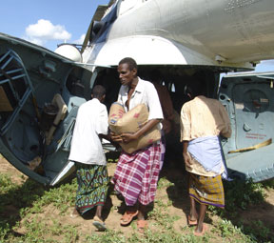
When men, women and children are trapped in the midst of war, the Secretary-General and his representatives help negotiate “zones of peace” for the delivery of humanitarian aid. And UN peacekeepers protect the delivery of that aid — whether provided by members of the UN system or such humanitarian bodies as the International Federation of Red Cross and Red Crescent Societies. The World Health Organization (WHO) helps protect those displaced by natural and man-made disasters from the ravages of disease. The United Nations Children’s Fund (UNICEF), with the aid of such bodies as the International Save the Children Alliance, provides education for children who have been uprooted by calamity. And when it is time to begin rebuilding, the United Nations Development Programme (UNDP) is there to ensure that the recovery process has a firm and stable footing. The humanitarian and disaster-relief efforts of the UN system are overseen and facilitated by the Office for the Coordination of Humanitarian Affairs (OCHA), led by the United Nations Emergency Relief Coordinator. Among its many activities, OCHA provides the latest information on emergencies worldwide, and launches international “consolidated appeals” to mobilize financing for the provision of emergency assistance in specific situations.”

The World Bank:
“The World Bank integrates disaster risk reduction into development strategies primarily through the Global Facility for Disaster Reduction and Recovery.
The Global Facility for Disaster Reduction and Recovery
Reducing Vulnerability to Natural Hazards
Established in 2006 by major donors, the UN, and the World Bank, the Global Facility for Disaster Reduction and Recovery (GFDRR) is a partnership with a mission to mainstream disaster risk reduction (DRR) and climate change adaptation (CCA) in country development strategies by supporting a country-led and managed implementation of the Hyogo Framework for Action (HFA). The GFDRR is managed by the World Bank and consists of 36 countries and 6 international organizations.”
International Federation of Red Cross and Red Crescent Societies:
“Recovery refers to those programmes which go beyond the provision of immediate relief to assist those who have suffered the full impact of a disaster to rebuild their homes, lives and services and to strengthen their capacity to cope with future disasters.
Following a disaster, life-saving assistance is the most urgent need. The rapid provision of food, water, shelter and medical care is vital to prevent further loss of life and alleviate suffering. However, practical experience, backed by research, supports the view that even at this stage, relief must be conducted with a thought to the affected community’s longer-term benefit and certainly should not be prejudicial to it. And as people begin to get back on their feet and rebuild their lives, aid agencies need to help them to strengthen their resilience to future hazards. Just restoring the pre-disaster status quo may inadvertently perpetuate vulnerability. Likewise, development programmes need to take into account existing risks and susceptibility to hazards and to incorporate elements to reduce them. The two approaches are interdependent, complementary and mutually supportive.
The International Federation is a leading humanitarian organization active in post-disaster and post-conflict relief and rehabilitation. Whatever the nature of the disaster – flood, earthquake, industrial accident or civil disturbance – there is an opportunity to link and integrate relief, rehabilitation and development. To do so effectively requires an analysis of the broader political, social and economic context. In structural crises, for instance, the provision of emergency relief should not create social or economic distortions. In a protracted disaster, there may be a need to rehabilitate livelihoods even while the emergency is ongoing. Root causes need to be identified and exposed.
For the International Federation, the key to ensuring that both short-term and longer-term needs are addressed is in supporting and strengthening the capacity of the National Society to work with vulnerable communities.”
The Recovery Observatory relies critically on the involvement of partners such as the stakeholders identified above. Over the course of the preparation phase, agreements will be outlined with at leas tone recognized international stakeholder, which will serve as an external advisor to the Recovery Observatory Oversight Team and be involved in the decision to trigger the Observatory.

- Conclusions
This document has introduced the concept of a Recovery Observatory for helping the response and recovery phase following a disaster and proposed a tentative plan for its implementation. The most important challenges identified so far have also been listed. Analysing the problem in depth and proposing possible options and solutions to these challenges in order to better shape this pilot is still an on-going task which will be finalised during the preparation phase. However, considering the unpredictable occurrence of the disaster for which the Recovery Observatory would be triggered, this pilot is proposed with three main phases: preparation, cold-storage/waiting and operations. This is because a rapid response after a disaster with the expected characteristics has occurred is of utmost importance. Establishing and moving to the operations phase of the Observatory should be a matter of a (very) few weeks after the event. The answer to this challenge is to ‘be prepared’. Effective preparation in advance of triggering will allow the launching a useful Recovery Observatory when it is most needed and will have the greatest impact.

Emergency Disaster Management Headquarters announcement (September 24, 2013)
http://www.worldbank.org/en/news/press-release/2013/12/06/philippines-reconstruction-impact-typhoon-yolanda-world-bank
http://www.un.org/en/globalissues/humanitarian/ consulted December 2013.
Source: http://www.unisdr.org/partners/ifi . See also www.worldbank.org
http://www.ifrc.org/en/what-we-do/disaster-management/from-crisis-to-recovery/

