CEOS SIT-29 Side Meeting Request Form
(to be returned by 14th February)

Meeting venue: Toulouse Space Centre, Toulouse, France
Week at a glance:
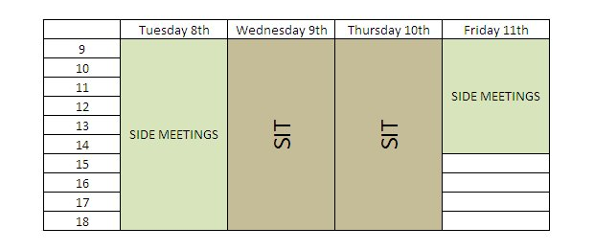

Organising entity / meeting theme _________________________
How many attendees are expected? _________________________
Preferred meeting date, time, and duration? _________________________
What are the meeting audio-visual needs?
Screen ⁮
Projector ⁮
Web conference ⁮
Other (please specify)
____________________________________________________________________________________
Point of Contact for this meeting _________________________________________________________
E-mail address: _______________________________________________________________________

