MINUTES OF THE 30th CEOS SIT MEETING
30th March – 1st April 2015
CNES Headquarters
Paris, France

Main SIT-30 Discussion Points, Outcomes and Actions
The main discussion points, outcomes and actions from the SIT-30 meeting are as follows:
- Agreement that CEOS will prepare and implement a coordinated strategy for engagement with COP21. This strategy will ensure representation during the lead-up to the meeting, and at the meeting itself. It will also ensure that CEOS works through all available channels (e.g. national delegations, GCOS, conferences and events, publications) to ensure an agreed set of key messages on the contributions of satellite Earth Observation data to climate are consistently delivered.
- CEOS materials for SBSTA 42 will be agreed by CEOS SEC in early September 2015, presented for information at the SIT Workshop, and then circulated for a formal virtual endorsement by CEOS Principals before September 30, 2015.
- CEOS agreed that compelling climate case study examples will be provided for the CEOS keynote address to be given at the July 2015 Climate Conference in Paris.
- CEOS Agencies are encouraged to work through their GEO Principal(s), national governments and the relevant Ministries and Departments to optimise participation in this year’s GEO Ministerial.
- Agreement that CEOS should seek permanent observer status on the GEO Executive Committee.
- Confirmed that the Head of a CEOS Delegation for a major conference is authorised to make statements on behalf of CEOS provided the statements are consistent with key messages endorsed by CEOS in preparation for the event.
- CEOS formally acknowledged the successful effort coordinated by the WGDisasters to ensure that satellite Earth observation data was referenced in the Sendai Framework for Disaster Risk Reduction 2015-2030 agreed by governments at the UN World Conference on Disaster Risk Reduction (WCDRR) in Sendai, Japan.
- Agreement to encourage agencies operating ocean colour missions to consider options for the distribution of Level 0 and/or Level 1A ocean colour data.
- Agreement that the VC Leads and WG Chairs will work with the SIT Chair on plans for the VC/WG Day prior to the September 2015 SIT Technical Workshop.
- Acceptance of the LSI-VC Terms of Reference, with an Implementation Plan to be developed for review at the SIT Technical Workshop with a view to potential endorsement at the 2015 CEOS Plenary.
- Endorsement of the SDCG 3-Year Work Plan, with an agreement to present an update addressing the transition to operations at the 2015 CEOS Plenary.
- Endorsement of the SDCG Element 3 (R&D) data acquisition strategy.
- Agreement that a plan for a consolidated CEOS response to the GEOSS Water Strategy be prepared for discussion at the September 2015 SIT Technical Workshop.
- Agreement to identify a qualified senior space agency officer to act as CEOS representative on the GEOGLAM Advisory Committee.

Welcome and Opening Remarks
Jean-Yves Le Gall (President of CNES) welcomed participants to Paris, and to CNES Headquarters. He noted the broad utilisation of Earth observation data in monitoring Earth systems related to climate, disasters, agriculture, and many other areas – and that because no one country or agency can address all requirements, international coordination is essential. He noted progress in the space segment with the launch of Sentinel-1A as the first space element of Copernicus, and changes in the sector as a whole with the emergence of new commercial actors (e.g., Google). Underscoring the need for coordination, Jean-Yves noted that more than half of the GCOS Essential Climate Variables (ECVs) can only be practically monitored from space.
Pascale Ultré-Guérard (SIT Chair) welcomed all participants attending SIT-30 in person and via web-conferencing. She reviewed the objectives of SIT-30 including to address Expected Outcomes for 2015-2017 from the CEOS Three-Year Work Plan, and actions from the 28th CEOS Plenary and SIT-29 including:
- Review and analyse external stakeholder interactions including outputs from the WCDRR in Sendai, preparations for the 21st Conference of the Parties (COP21), and preparations for the 2015 GEO Ministerial and Plenary.
- Advancement of the CEOS Virtual Constellations (VCs) and Working Groups (WGs) covering key issues and required decisions.
- A decision on CEOS land imaging coordination through the Land Surface Imaging VC (LSI-VC).
- Review progress and decisions required across key thematic areas including Climate Monitoring, Research, and Services (incl. WGClimate), Carbon Observations, Including Forested Regions (incl. Carbon Strategy, GFOI and SDCG), Observations for Agriculture (incl. GEOGLAM), Observations for Disasters (incl. WGDisasters), Observations for Water (incl. Water Strategy Implementation Study Team), and Capacity Building, Data Access, Availability and Quality (incl. WGCapD).
- Consideration of the outcomes of key 2014 meetings including the GEO-XI Plenary and COP-20, and a look forward to 2015 meetings.
Participants introduced themselves in a tour de table.
Chu Ishida (CEOS Chair Team, JAXA) noted that the Plenary segment on the SIT-30 agenda would not be needed, and it was removed.

Review of Open Action Items
Stephen Ward (SIT Chair Team) reviewed the open actions from SIT-29, the 2015 SIT Technical Workshop, and the 28th CEOS Plenary in Tromsø that were assigned a deadline of SIT-30. In summary:
- All 28th CEOS Plenary actions are COMPLETE, apart from the two which are due by SIT-30, both of which are scheduled for discussion.
- 18 out of 22 SIT-29 actions are COMPLETE, with two outstanding actions set for discussion/decision/completion at SIT-30.
- 12 out of 20 SIT Technical Workshop 2014 actions are COMPLETE, four are in progress, two are due at SIT-30, and two are outstanding
A summary table can be downloaded from the SIT-30 website and is also included as an appendix of these minutes.

CEOS Priorities for 2015
Jonathon Ross, Deputy CEOS Executive Officer (DCEO) reviewed the CEOS 2015-2017 Work Plan, including the timeline followed in its development.
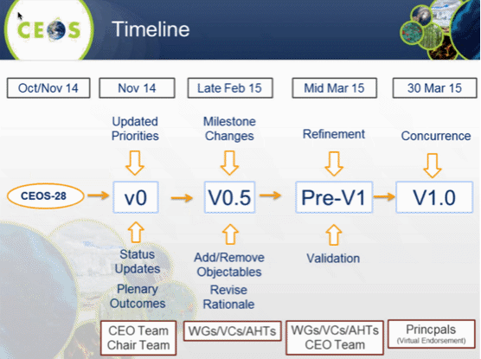
He summarised key changes the Work Plan, which included:
- The addition of a new section on Observations for Water;
- Climate: the addition of a new analysis report on the implications of any post-Kyoto climate treaty, and reporting to SBSTA-43;
- Carbon: implementation of agreed actions in response to the CEOS Strategy for Carbon Monitoring from Space;
- Agriculture: actions in support of GEOGLAM data acquisition, data service prototypes, and data sharing;
- Disasters related data acquisitions, the Recovery Observatory, and DRM pilots including a study of interest for a landslide pilot;
- Data access architecture in support of operational programs, infrastructure, linkages and best practice;
- Virtual Constellations revised Terms of Reference for the LSI-VC;
- Outreach addition of the Special Data Applications Report;
- The move of the CEOS Database and ECV Inventory from Outreach to Capacity Building; and
- Adjustment of actions related to organisation.
Jonathon noted the recent launch of www.ceos-deliverables.org, which will be used to track the status of and progress against the CEOS Work Plan. He noted that CEOS Action leads will be responsible for providing status updates directly on the website.
SIT 30-1 | CEOS Work Plan responsible entities to provide an initial status update for their CEOS-GEO actions using the new ceos-deliverables.org site and thereafter to update the action status at least quarterly | May 2015
Marie-Josée Bourassa, CEOS Executive Officer, (CEO) noted there has been a proposal to update the CEOS Work Plan half-way through the year. The rationale would be that many of the VCs and WGs meet later in the year, after the Work Plan has been set. A brief discussion followed:
- Kerry Sawyer (NOAA) noted there is quite a bit of work required in updating the Work Plan, and the dates for inputs are well known ahead of time. An additional update cycle may be burdensome for those responsible for providing their inputs. Ivan Petiteville (ESA) agreed, noting that the Work Plan should be seen as a living document, and new actions can be managed via the usual CEOS SEC processes.
- Richard Moreno (WGISS, CNES) noted there are opportunities during the year (i.e., SIT conference, SIT Workshop, Plenary, as well as SEC meetings) to propose new actions if required, and that a formal update of the Work Plan is not required.
- John Bates (WGClimate, NOAA) noted that, at the Principal level, the once a year formal update of the Work Plan is appropriate. At the working level, he suggested that less formal approaches would be sufficient.
- Albrecht von Bargen (WGCV, DLR) noted that support from WGCV to the annual update is manageable.
- Kurt Thome (WGCV, NASA) noted that the tool should be aligned with metrics and milestones and not updated based on arbitrary dates.
- Stephen Briggs (ESA) noted that the deliverables tracking tool could provide useful visibility between the higher level objectives and activities of CEOS, and the individual actions, groups, and individuals carrying out the work. Brian Killough (NASA) agreed, noting that currently the tool is able to filter the actions along the lines of the current Work Plan categories.
- Brian noted that they would like to have a 1-2 week review period for the tool, and they plan to circulate password details to individuals in the coming weeks.
- Barbara Ryan, GEO Secretariat Director, noted that as this tool gets developed and implemented, it would be nice if it could be linked more formally to the GEO Work Plan including the possibility for GEO to pull status of activities contributing to GEO in a “quasi-automatic” way.
- Pascale Ultré-Guérard (SIT Chair) thanked Brian Killough and the SEO team for their hard work in creating the tool. She concluded that the deliverable tracking tool would allow CEOS Work Plan activities to be monitored in a flexible manner, with the present system of having a formal validation at the beginning of the year.

UN Framework Convention on Climate Change (UNFCCC) 21st Conference of the Parties (COP21)
Nicolas Bériot from the French Government Ministry of Ecology, Sustainable Development and Energy, summarised COP21 activities, including objectives, preparations, and what will take place during the conference, which will take place on November 30-Dec 11, 2015 in Paris. He noted that more than 20,000 delegates will be hosted, and that France is the facilitator of the conference.
The objectives of the conference are:
- To obtain a long-term constraining universal framework agreement between the parties to the convention;
- Clear commitments from the parties to the convention, including commitments to emissions reductions;
- Commitment to financial support to the Green Fund; and
- A development of the “agenda of solutions” from various communities including government, industry, civil society, and business.
Nicolas noted that Peru is currently the UNFCCC Chair, and France has been working with them to develop the agenda for COP21. Within the French government, there is a high level team of ministers and the Prime Minister supported by a negotiation team of about 40 experts from various domains of which he, himself, is a member.
During the two first weeks of December there will be two parts to the COP21 site – the international side organised by the UNFCCC (blue zone), and the other side organised by the French. Negotiations will take place in the blue zone which will have restricted access, while the French side will be completely open and feature a space dedicated to civil society.
A business summit will be held 20th-21st May at UNESCO/Paris, and on the 22nd of May a Climate Finance Day will take place. In July an international scientific conference called “Our Common Future Under Climate Change” will take place covering topics from climate physics all the way to finance. Further information can be found at www.cop21.gouv.fr
A brief discussion followed:
- Ivan Petiteville (ESA) asked about the best way to inform the COP21 participants about the role and potential contribution of satellites at COP21, and Nicolas noted that bodies like SBSTA provide advice to the negotiators on technical matters like the use of satellites. He suggested that a communications side event in the blue zone may be possible via an agency’s national delegation, and that registration of side events will take place in June.
- Carolin Richter (GCOS) asked if and how the outcomes from the July science conference will be integrated into the COP21 process. Nicolas noted that the basis for the negotiation is the IPCC AR5 report, which forms the common scientific basis for the Paris agreement. This does not stop CEOS, space agencies, and partners like GCOS from forwarding additional information, including via the “agenda of solutions” being developed.
- John Bates (WGClimate, NOAA) asked additional details about the event being prepared for the Grand Palais during COP21, and Nicolas noted that he would share the details.
- Jonathon Ross (DCEO) asked how a reference to the role of satellite data in the negotiating text could be promoted, and Nicolas noted that this should be handled via the national delegations and existing channels.
John Bates then presented background to COP21 and introduced the discussion around CEOS and WGClimate strategic messages.
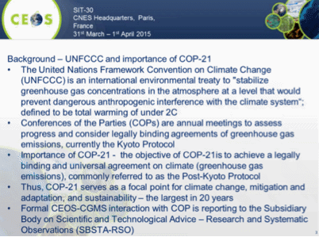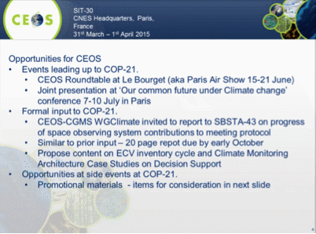
John presented a summary of potential CEOS materials which could be developed or available for COP21.
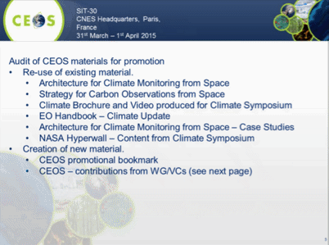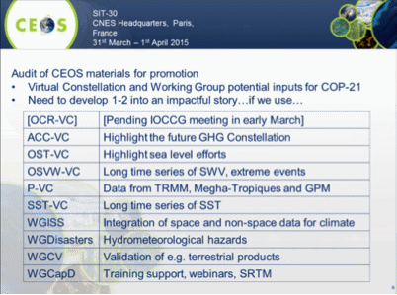
The recent WGClimate meeting discussed the Architecture of Climate Observations from Space (previously Climate Monitoring from Space), where it was agreed that having the word ‘Observations’ in the title was desirable. At the meeting, they reviewed the end-to-end value chain, including strategic messages to go to COP21 that should be discussed during this agenda item.
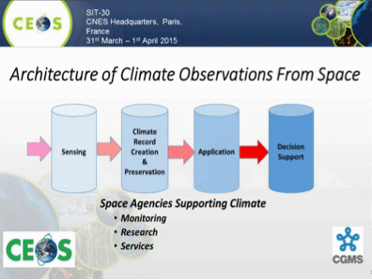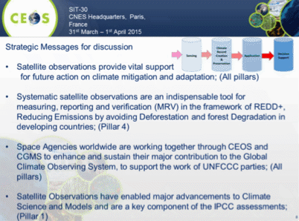
A brief discussion followed:
- John noted that their overall message is derived from the four pillars of the Architecture, and from there messages are tailored for the audience. Ivan noted that in preparing for the WCDRR meeting, they paid close attention to the audience, tailoring messages accordingly.
- Pascale Ultré-Guérard (SIT Chair) noted that the CNES President is planning to use a variety of channels to provide input into the COP21 process, including via events at the Paris Air Show, and the other meetings and events. She noted that CNES is also working through the French delegation to try and ensure that the importance of satellite Earth observation data is conveyed. The messaging should come from key CEOS messages to be agreed here.
- Paul Counet (EUMETSAT) noted that a number of recommendations were captured at last year’s Climate Symposium, and suggested that these messages could be included. Stephen Briggs (ESA) agreed that it would be good to use these materials.
- Mike Freilich (NASA) noted that the strategic messages are spot on, but that CEOS should be more emphatic. For example, stressing that satellites are ‘essential’, and that the research community ‘requires and is ready do use’ satellite data in order to increase understanding. Without being explicit, some interpretation is left up to the reader. He suggested that CEOS consider what successful delivery of these strategic messages looks like, noting that understanding this may help to tune these messages.
- Alex Held (CSIRO) noted that the audience is really the country negotiators, and he stressed the importance of using examples like GFOI to underscore and support the messages.
- Stephen Briggs noted that while making an impact on the negotiating process will be very difficult, the governments engaged in the process are currently thinking about climate. And, this moment presents an opportunity to create ideas in people’s minds about how important the use of satellites can be. He also suggested that the messaging should be focused on outcomes, rather than process and internal concepts like ‘pillars.’
- Stephen Briggs noted the plan to develop a Climate edition of the Earth Observation (EO) Handbook for COP21, and asked for feedback on this idea. He noted that the plan for the publication is to feature the strong partnership between CEOS and GCOS. Mike Freilich asked what impact the previous EO Handbooks had, and Ivan noted that the publication is targeted at someone with a ‘non-EO background’. He noted that 300 copies of the WCDRR Handbook were distributed a month prior to the Sendai conference, targeted to influential people in the disaster risk management community, and based on that, he had several agencies approach him in Sendai to follow up.
- Barbara Ryan (GEOSEC Director) noted that the message on free and open data policy is an important one for the audience to hear. This issue has been discussed in the Ministerial Working Group, where it was noted that a lot of work has been done in this area, but that there is much more work to be done.
- Chu Ishida (JAXA) stressed that the message should be focused to achieve a specific outcome. For example, if the desired outcome is media coverage, then the message should be tailored accordingly. He noted that in the lead-up to the Sendai conference, one of the outcomes from the publication of information on satellite support to disaster risk management was media coverage in major Japanese newspapers.
- Steven Labahn (USGS) noted that often the audience doesn’t care about satellites as tools, but are more interested in top-down outcomes.
- Jane Olwoch (WGCapD, SANSA) suggested that the messages should go further, and make the linkage to themes like livelihoods and poverty. She also suggested that CEOS stresses not just the importance of data products and tools, but also supporting capacity development.
- Naoko Matsuo (JAXA) noted that the Data Applications Report will be ready in time for CEOS Plenary, and will be ready for distribution at COP21.
- Chu Ishida (JAXA) noted that feedback from Margareta Wahlström (Special Representative of the Secretary-General for Disaster Risk Reduction, who wrote a foreword for the WCDRR EO Handbook) was that satellite data is useful in combination with other data sources, and this should be stressed. Stephen Briggs suggested that it would be good to have a high-level member of the negotiating community to write a foreword to a special edition of the EO Handbook for COP21.
- Mike Freilich stressed that there are two different timeframes for outcomes: short-term framing to further inform audiences such as the media, and long-term efforts to bring about recognition of the importance of EO among policy makers.Ivan noted that the strategic messages for Sendai were developed in consultation with other key members of the disaster management community, and they considered Sendai as just the start of the engagement.
Pascale noted that the SIT Chair Team will work to improve the messaging for COP21, and also to clarify the scope and audience for the key messages, and will circulate an update for review, and discussion at SEC-201 (June). She indicated that Jean-Yves Le Gall is also working through the International Academy of Astronautics Heads of Agencies “Summit on Climate Change and Disaster Management” to develop a text crystalizing key climate messages, and that CEOS should feed into and coordinate with this effort in order to maximise space agency impact. She undertook for the SIT Chair Team to coordinate with WGClimate to ensure this is done.
She also noted the need for project management for the preparation of materials for COP21, and John noted that WGClimate discussed this at their meeting last week, but haven’t identified a candidate yet.
SIT 30-2 | SIT Chair to work with WGClimate Chair and CEOS SEC to refine the strategic messages within a text for COP21 and to distribute for review by CEOS Principals | COMPLETE
SIT 30-3 | ESA to plan & develop an EO Handbook with a climate focus for COP21, in consultation with SIT Chair, WGClimate and GCOS, planning circulation in advance to key stakeholders | COP21
SIT 30-4 | WGClimate Chair to work with SIT Chair to identify a coordinator to bring together climate material in preparation of COP21 | April 2015  NOAA nominates Kerry Sawyer
SIT 30-5 | SIT Chair and CEO Team to work with WGClimate to develop a process and timetable for review of the CEOS inputs to SBSTA/COP21 | April 2015
SIT 30-6 | SIT Chair Team to circulate additional details about the COP21 event being prepared for the Grand Palais, Paris, referenced by Nicolas Bériot | May 2015
Preparations for the Scientific Conference
Jean Louis Fellous (SIT Chair Team) presented a summary of the plans for the climate science conference being prepared for July in Paris. He noted that due to the overflow of papers submitted, there will be three keynote presentations given at the UNESCO conference, and the rest of the session will be hosted at CNES. He also noted that Stephen Briggs will give one of the three keynote addresses, a summary of the contribution that satellite data makes to climate observations.
Pascal Lecomte asked how papers can be submitted to the session, and Jean-Louis noted that a number of submissions have been accepted already. The call for abstracts to the conference has closed, but submissions for the session at CNES can be submitted to Jean-Louis.
Stephen Briggs invited all to submit examples of where satellites observations for climate have been important for inclusion in his keynote talk.

SIT 30-7 | CEOS Agencies, Working Groups, Virtual Constellations and Ad-Hoc Teams to provide SIT Chair team with 1 or 2 compelling climate case study examples for use in the Climate Conference in Paris (July 2015) | 25 May 2015  Limited responses – more welcome.

GEO Coordination
Barbara Ryan (GEOSEC Director) presented a summary of GEO Secretariat priorities for 2015.
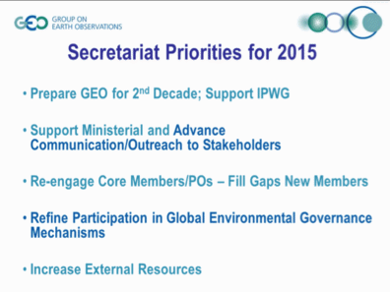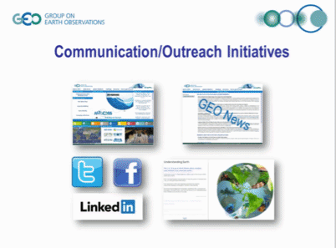
Barbara noted that there has been a recent focus by the GEO Secretariat on engaging the Development Banks (e.g., The World Bank and the International Monetary Fund) with the value proposition being “bridging the gap between observations and information”. She also noted that because GEO is not an observer in UNFCCC, it has to partner with organizations such as GCOS or others to be represented at events like COP21.
Barbara noted that CEOS provides the largest number of data elements in the GEOSS Common Infrastructure (GCI). She also noted that some recent economic analysis has assessed the benefit of the opening of the Landsat archive, and the message to government is that this has been very successful.
GEO Ministerial
Brent Smith (NOAA) presented a summary of preparations for the GEO Ministerial.
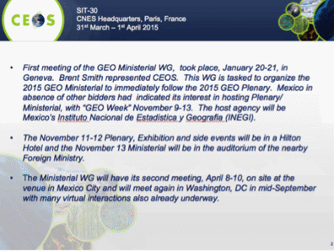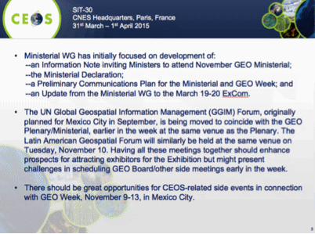
He suggested that a concerted internal strategic approach to the Ministerial by CEOS is required, and suggested that representatives at SIT-30 engage their agency CEOS Principals in the process. He suggested that CEOS Principals should consult with their respective National GEO Member Principals in ensuring that Ministers carrying the Space portfolio receive the information on the GEO Ministerial, and further ensuring that the Minister selected to represent their country is briefed on GEO, the merits of satellite Earth observation and the value of CEOS contributions to GEO.
SIT 30-8 | CEOS Agencies to ensure the GEO Principal(s) in their national governments, and the relevant Ministers and Departments, are aware of the forthcoming Information Note and invitation to the GEO Ministerial | 25 May 2015
SIT 30-9 | CEOS Principals to convey CEOS strategic messages to their national GEO ExCom member (where relevant), emphasising the desire for CEOS to be represented on ExCom | May 2015
GEO Strategic Plan 2016-2025: Implementing GEOSS
Douglas Cripe (GEO Secretariat) presented a summary of the development of the GEO Strategic Plan 2016-2025: Implementing GEOSS, which focuses on the vision and value of GEO, proposed strategic objectives in the key action areas “Advocate, Engage, and Deliver”, core functions of GEO, implementation mechanisms for GEO activities, governance and resources, in addition to implementing GEOSS.
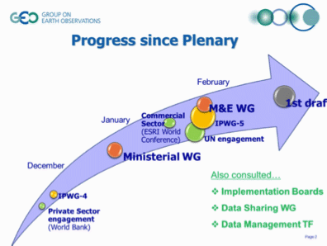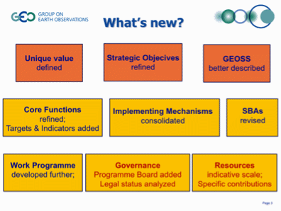
Douglas noted that so far in the development of the Strategic Plan, the focus has been on the ‘evolution’ of GEO, rather than a ‘revolution’. He summarised the main issues and themes addressed.
A brief discussion followed:
- Ivan Petiteville (ESA) asked about the relationship between ExCom and the Programme Board. Douglas noted this was raised at the ExCom meeting a couple of weeks ago, and noted that this relationship is still in the process of being clarified.
- Carolin Richter (GCOS) asked about participation in the GEO Programme Board, and Douglas noted that there aren’t any current restrictions in participation – it would be for the Programme Board to decide, and these details are expected to be further defined in the second draft of the Strategy when the draft Terms of Reference for the Programme Board are included.
- Mike Freilich (NASA) noted that key messages were submitted by CEOS last week. He stressed that it was important for CEOS that space and in situ observations be separated for evaluation purposes. This statement was supported by Brent.
- Brent noted that the integration of observations from diverse sources seems to have been lost. For example, we don’t see much of the integration dialogue within the Communities of Practice that we used to see with IGOS.
- Mike also stressed the role of the GEO Secretariat in defining and leading the interaction with bodies like the UN, donor banks (e.g. The World Bank) so that the interactions with those organisations happen at an appropriate level and do not get delegated down to become the responsibility of Participating Organizations like CEOS. Mike stressed CEOS’ view that engagement with these organisations should be lead by the GEO Secretariat. Douglas noted that a communication has gone out to the GEO Principals advocating that their national governments support GEO engagement with these kinds of bodies. He noted that many GEO member governments provide significant funding to these bodies, and so have are stakeholders.
- Mike Freilich proposed that CEOS make an unambiguous statement to GEO that it should be granted a permanent observer seat on ExCom, commensurate with the significant investment the space agencies have made, and are pledging to make, to the development of GEO and the GEOSS. There was CEOS consensus on this proposal.
- Brent noted that in the past there were numerous GEO committees and boards that CEOS has participated in and/or co-led, and that some of these will wither away with the evolution of GEO. This might well erode CEOS’ influence, and given CEOS’ unique Participating Organization relationship (i.e. explicit alignment of its strategy and work plans with GEO and GEOSS implementation, annual bi-lateral meeting), a permanent CEOS presence on the ExCom would be appropriate. It is not clear that CEOS would be interested in supporting GEO so strongly if it were just one amongst 100 Participating Organisations.
- Simonetta Cheli (ESA) noted that there is a history of mutual reinforcement between CEOS and GEO. CEOS has no equivalent among the other entities within GEO - the scale of its activities, and its added value set it apart and this must be reflected in the new governance scheme. Pascale Ultré-Guérard (SIT Chair) agreed with Simonetta on this point.
- Barbara stressed that the community can be segmented in a number of ways (e.g., type of organisation, thematically), and the next phase of GEO should be driven by what the GEO community wants to accomplish over the next 10 years.
SIT 30-10 | SIT Chair to coordinate with CEO Team and CEOS SEC to conclude the refined CEOS submission to GEO on their draft Post-2015 Strategy, reflecting agreements reached at SIT-30 | COMPLETE

Sendai World Conference on Disaster Risk Reduction
Ivan Petiteville (WGDisasters) presented a summary of activities and outcomes from the Sendai World Conference on Disaster Risk Reduction (WCDRR).
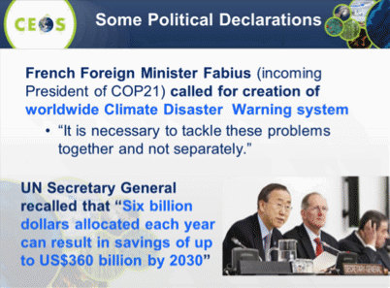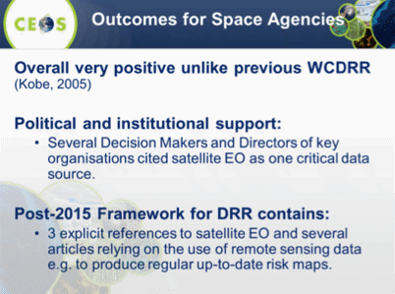
Ivan noted that the role of satellites was cited in the “Sendai Framework for Disaster Risk Reduction 2015-2030” endorsed by the national governments during the conference as well as in several written governments’ statements, which was a sign that the messages had been successfully embedded.
Sendai Framework for Disaster Risk Reduction 2015-2030:
http://www.wcdrr.org/uploads/Sendai_Framework_for_Disaster_Risk_Reduction_2015-2030.pdf
Final GEO Statement video: http://webtv.un.org/meetings-events/conferencessummits/3rd-un-world-conference-on-disaster-risk-reduction-14-18-march-2015-sendai-japan/watch/representative-from-the-group-on-earth-observations-8th-plenary-meeting/4116435102001
He shared some of the lessons learned in the process, stressing that this result comes from a sustained effort by CEOS agencies over the past 2 years. He noted that the Sendai conference should be seen as the starting point of a broader process to significantly foster the use of Earth Observation data products throughout the disaster risk reduction cycle. The working group on Disasters will now focus on contributing to the Sendai Framework for Disaster Risk Reduction 2015-2030.
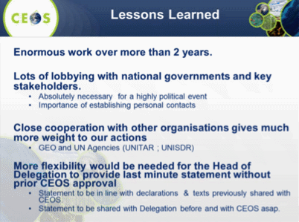
Ivan suggested that the ability of the head of CEOS delegation to have the flexibility to make a statement at conferences like the WCDRR should be clarified. Pascale suggested that if key messages have already been agreed, then the ability of the head of delegation to make a statement around these key messages is within the scope of that role. It was agreed that CEOS authorises the Head of the CEOS Delegation to make statements on behalf of CEOS without requiring the formal approval of each statement from CEOS, provided that the statements are based on key messages endorsed by CEOS prior to the event.
Ivan then shared a few recommendations with a view to preparations for COP21:
- That you need a small, engaged, and dedicated team to formulate and execute the engagement strategy.
- That governments have the key role in the negotiation process, and it can require a lot of effort to find the right person within a given national delegation and then convince them that the messages that CEOS wishes to convey are necessary.
- He noted that engaging with less technical, more political contacts can lend more weight to the case you’re trying to make.

Virtual Constellations
Introduction and Objectives
Jean-Louis Fellous (SIT Chair Team) introduced the Virtual Constellations (VC) session, noting that on the January telecons with the VCs, there had not been many updates reported since the November 2014 CEOS Plenary. This is in part because many of the groups have their main meetings in the March – July timeframe. He reviewed the four main objectives for the VCs and Working Groups from 2014.
- Synergy VCs and WGs
- Encourage more focused exchanges and collaboration between WGs and VCs to support and develop the VCs and thematic WGs; and
- Highlight promising examples involving some WGs and VCs.
- Focus on Deliverables
- Interact with GEO during the development of the next Implementation Plan/Work plan; and
- Seek alignment with GEO Strategic Plan 2016-2025.
- Broaden participation
- Engage more agencies into WG and VC leadership and activities; and
- Revitalize the LSI-VC.
- Linking VCs and Science
- Identify gaps and/or hurdles in these linkages; and
- Work with the sponsors of the relevant scientific groups with a view to build on complementarity, commonalities, and to improve overall coordination and efficiency.
And he reviewed two new objectives proposed for 2015:
- Consolidate progress made so far in preparation for the VC/WG Day in September 2015; and
- Insertion of VC/WG activities in the context of the preparation of COP21, including investigating potential inputs from all VCs and WGs that could be highlighted in that context.
Jean-Louis summarised the outcomes from the January telecons, including:
- Review of the VC mission “roadmaps” (i.e. timeline charts);
- Broadening engagement and interaction with science bodies like OSTST, IOCCG, and GHRSST;
- Discussion of new products around GPM, air quality, and GHG; and
- A change in leadership of AC-VC with Richard Eckman stepping down.
OSVW-VC
Paul Counet (EUMETSAT) reported on behalf of the OSVW-VC co-leads, Paul Chang and Julia Figa Saldana. He noted the successful launch of RapidScat in September 2014, and reviewed other progress and upcoming events. OSVW reported on open actions that were followed up during the January telecom such as IDN updates and the status of RapidScat data access.
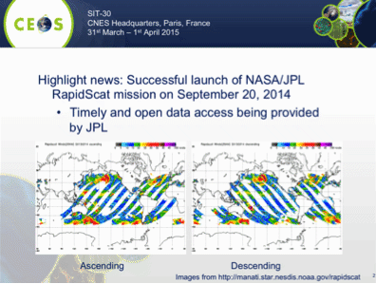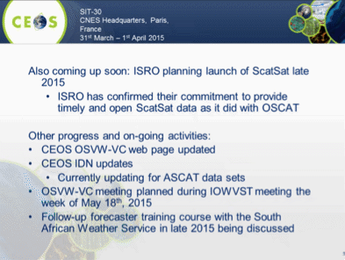
OST-VC
Juliette Lambin (OST-VC, CNES) presented a summary of OST-VC activities, noting interactions with the science community through OSTST. She indicated that some evolution in the organisation of this structure was possible in the coming months and that a closer alignment with the OST-VC was a possible outcome. She reviewed the status of the three actions OSV-VC is responsible for, noting that there are a number of deliverables expected in the second half of 2015.
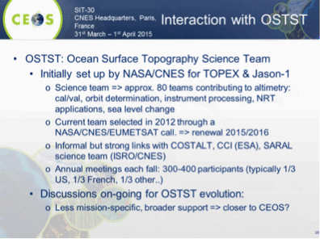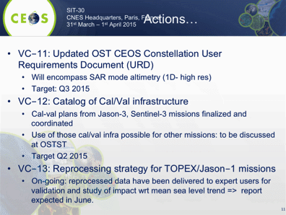
OCR-VC
Paul DiGiacomo (OCR-VC, NOAA) presented a summary of OCR-VC activities, noting the outcomes from the recent IOCCG/OCR-VC meeting. He noted there is currently a gap around geostationary ocean colour sensors, and they would like to see this gap closed by CEOS Agencies.
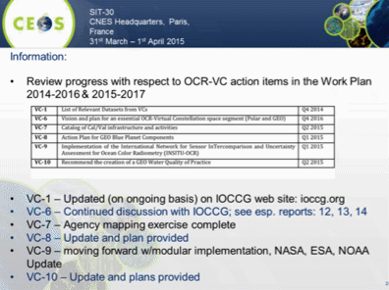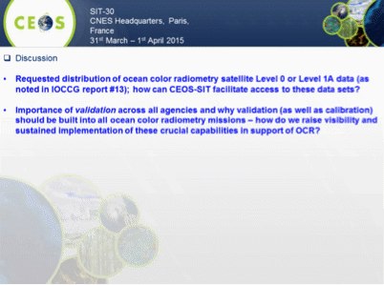
He also noted the request coming out of the IOCCG meeting for the distribution of ocean colour radiometry Level 0 or Level 1A data, and regarding the importance of building in calibration and validation into ocean colour missions.
A brief discussion followed.
- Craig Donlon (ESA) noted that NASA and ESA are currently collaborating on calibration and validation of radiometry data. He noted that the plan is to release some initial money which will be adequate for Sentinel-3 data processing for the time being, but is not going to last the full 20 years required to perform vicarious calibration.
- Craig noted that in principle the Sentinel-3 L0 data could be available, however the utilisation of this data requires significant expertise, and there is a high cost to making it available. A clear use and capable user would need to be identified to justify the cost. He stressed that what is needed in practice is a good L1A product.
- Paul confirmed that the initial focus will be on the L1A data. However agencies that have legacy missions are looking at reprocessing data archives to create compatible time series. They may have the necessary expertise to do the reprocessing and reanalysis. Craig agreed, noting that this reprocessing is a long-term objective, and will likely require international collaboration.
- Alex Held (CSIRO) asked whether the OCR-VC / IOCCG are considering the coming data from the Himawari-8 and GOES-R geostationary platforms. Paul noted that they are looking at these data streams for ocean colour, but they expect these geostationary instruments to provide complementary, rather than mainline, data streams.
- Barbara Ryan (GEOSEC) stressed the importance of engaging the GEO Community of Practice (COP), and Paul noted he is actively working on coordination with participating organisations like the COP.
SIT 30-11 | SIT Chair to send a letter to CEOS Principals whose agencies operate ocean colour missions requesting them to consider distribution of ocean colour radiometry satellite Level 0 or Level 1A, stressing the importance of validation across all agencies and why validation as well as calibration should be built into all ocean colour radiometry missions. SIT Chair will also echo these requests in the report to CEOS Plenary. | May 2015
P-VC
Steven Neeck (P-VC, NASA) presented a summary of P-VC activities, noting the progress on the P-VC Portal, and NRT GPM products.
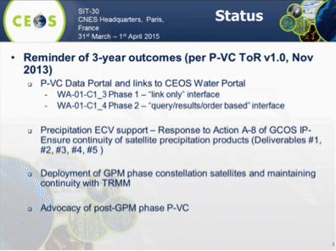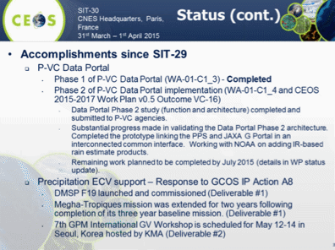
He noted several issues for consideration, but that there was no action requested from SIT at this time. He welcomed the participation of CMA at SIT-30, and hoped this could be translated to engagement at the VC and WG level.
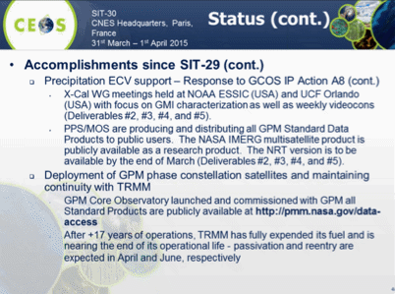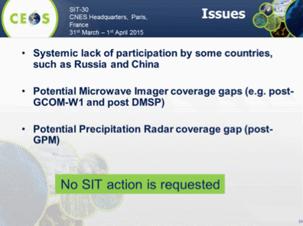
A brief discussion followed.
- Simona Zoffoli (ASI) asked if there was any coordination between the P-VC and WGDisasters, given that the precipitation products could provide valuable information for disaster planners, and Steven noted that he’s not aware of any current connections but agreed this would be a good topic for discussion. Jean-Louis noted that hydrological hazards represent a significant portion of disasters.
- Caiying Wei (CMA) noted they are interested in the global GPM products, and would like to find an expert to connect with the P-VC, and Steven agreed it would be good to identify an active point of contact. P-VC has tried to reach out to CMA in the past, but haven’t received a response. Caiying noted that they have accessed the GPM products, and confirmed they would like to communicate further to understand the technical details.
- Jean-Louis noted it is encouraging that CMA colleagues are willing and interested to participate in VCs and WGs more intensively.
- Barbara noted the work on the CGMS Working Group on Precipitation, and that she was pleased to see this coming together with the P-VC. Steven Neeck noted the three areas that where collaboration has been beneficial to date: gap coverage advocacy, data set availability and discoverability, and joint training activities.
SIT 30-12 | SIT Chair Team to connect CMA to the VC Leads and WG Chairs and to help them explore their participation in the various groups | SIT Technical Workshop 2015
AC-VC
Richard Eckman (AC-VC, NASA) presented a summary of AC-VC 3-Year Outcomes and their main accomplishments.
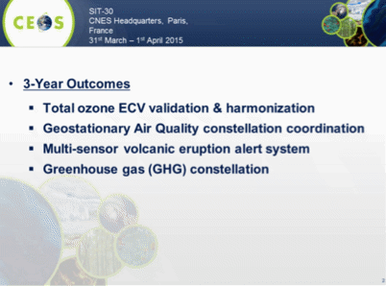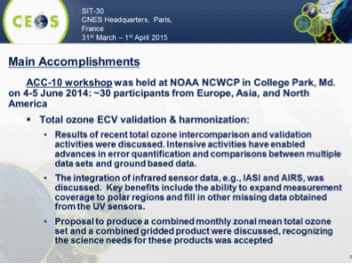
He stressed outcomes in the areas of volcanic ash alerts, and progress in the specification of a Greenhouse gas constellation.
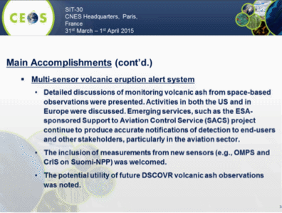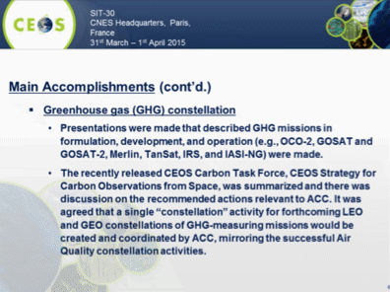
Jean-Louis noted that AC-VC does well covering multiple domains including air quality, ozone, volcanic alerts, and greenhouse gasses.
Richard noted that he will be stepping down as the co-lead of AC-VC, and that Jay Al-Saadi from NASA/Langley will be replacing him as of the SIT Technical Workshop. Pascale thanked Richard for his dedication and commitment to the leadership and development of the AC-VC over the years.
SST-VC
Ken Casey (SST-VC, NOAA) reviewed recent progress towards the SST-VC action items in the CEOS Work Plan.
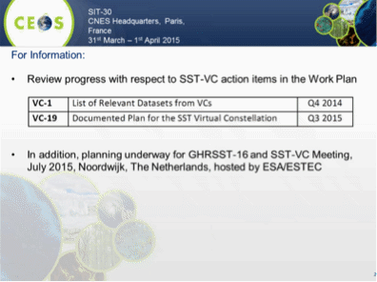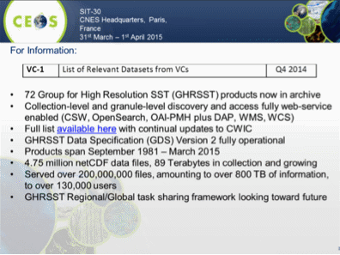
Ken noted that the SST-VC is developing a white paper on the next generation of the VC, covering methodology, space segment, and ground / data management and processing segments. The white paper is expected to be completed in late 2015.
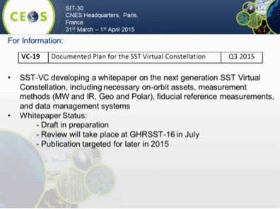
Craig Donlon (SST-VC, ESA) presented a summary of the ongoing SST/Land Surface Temperature (LST) comparison campaign, noting that both ECVs are highly dependent on satellite observations, and that these kinds of comparison campaigns are essential to build confidence in the datasets.
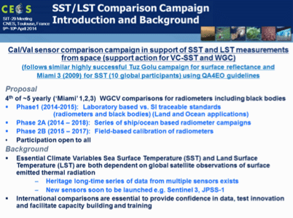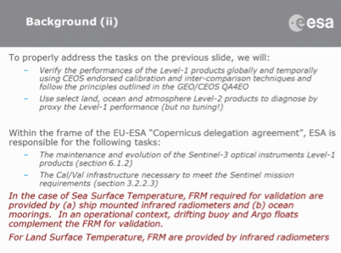
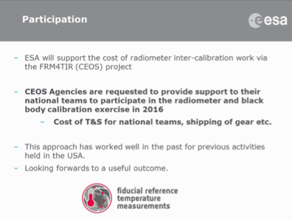
Albrecht von Bargen (WGCV, DLR) noted that the mix of activities within SST-VC is a very nice example of what is possible with group work within CEOS, including in this case collaboration with WGCV.
Virtual Constellation and Working Group Day
Jean-Louis reviewed the proposed agenda for the VC-WG Special Day, planned for 16th September 2015, just ahead of the SIT Workshop in Darmstadt.
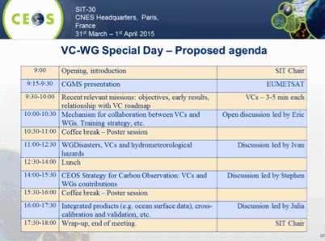
A brief discussion followed.
- Paul DiGiacomo noted he would like to see more time to discuss Blue Planet across the VCs.
- Craig noted that at the last SIT Workshop, there wasn’t enough time for the VCs to sit together and discuss their common issues. He raised the possibility of having a dedicated day for this the day prior to the proposed VC/WG day (15th September).
- Stephen Briggs suggested ensuring links back to CEOS broader strategic drivers and objectives, and noted that this linkage isn’t clear in the current draft. He doesn’t see space for the broader strategic issues to be discussed. He noted that CEOS is struggling to address all the requirements it is presented with, and there is a need to ensure we’re all pulling in the same direction.
- John noted it would be helpful if the expected outcomes were articulated, including particular items in an action plan or strategic plan that might be addressed.
Pascale noted that the objective of the day is to discuss value adding cross cutting activities, and that part of the value added by CEOS is having diverse groups that come together and deliver something different from other international science teams.
She noted that the SIT Chair Team seeks to facilitate the discussion between VCs and WGs but counts on volunteers from the VCs/WGs to define the agenda and steer the discussions.
Pascale proposed a way forward for the VC/WG Day. She invited VC and WG leads to send their comments and proposals based on the proposed agenda to Craig Donlon with copy to SIT Chair Team, and provided some guidelines, with a view to assembling an agenda for presentation to SEC in June. The guidelines include: keep it one-day (16 September); involve all VCs and WGs; identify new cross-cutting, value-adding activities; align with CEOS strategic objectives; and, provide a draft agenda to SIT team by 23 May.
SIT 30-13 | VCs & WGs to develop poster displays and a short presentation of their activities highlighting the most recent mission (for VCs) or major project (for WGs) within their purview to stimulate discussion at the VC/WG Working Day | SIT Technical Workshop 2015
SIT 30-14 | Craig Donlon, on behalf of and in consultation with VC Leads and WG Chairs, to propose an agenda to SIT Chair for the VC/WG Day at SIT Technical Workshop | 25 May 2015

Land Surface Imaging Virtual Constellation (LSI-VC)
Tom Cecere (USGS) presented a summary of the progress of the Land Surface Imaging Virtual Constellation (LSI-VC) Study Team, whose membership consisted of representatives from ESA, USGS, CSA, CNES, EC, NASA, GA, and JAXA.
Tom reminded the group that the LSI Mission Statement is to, “to maximize the value derived from CEOS agency land surface imaging assets and activities by providing an overarching coordination role.” In addition, it is the responsibility of the LSI-VC to, “facilitate coordinated and optimized land surface imaging contributions from CEOS agencies to enable access to fundamental measurement products in support of confirmed/validated requirements linked to adopted CEOS priorities.”
The objectives of the LSI-VC include:
- Promoting sustained and systematic collection of satellite-derived land surface imaging observations by sharing information on future mission development;
- Drawing together validated requirements identified by downstream user communities to identify opportunities to better optimize, and increase resilience of, land surface imaging programs, and to identify current and potential data gaps;
- Coordinating production and distribution of, and ability to analyse, fundamental, non-domain specific, measurements derived from land surface imaging observations; and
- Facilitating maximum utilization of land surface imaging observations through the promotion of common standards making land surface image products more easily discovered and ready for analysis.
Tom note that four proposed focus themes have been proposed:
- Optimizing and harmonizing where feasible global data collections (with an ever increasing volume expected);
- Promoting analysis-ready data (with the goal to minimize the need for the end user to understand satellite/pass/sensor-specific processing);
- Exploring how new approaches to management/analysis of large data structures (e.g. Data Cubes) can be implemented and sustained; and
- Addressing the actions identified for LSI-VC by the CSIST, as a pathfinder to broader approaches to analysing land surface imaging requirements.
Tom stressed the objective of LSI-VC to work with, and not duplicate, activities across CEOS entities, in line with the previous discussion about collaboration and cross-cutting activities.
He noted that the proposal is phased over three years, running 2015-2017.
- Phase 1 – 2015-2016 identify gaps/opportunities in acquisition planning in support of CEOS Carbon Strategy, develop agreed definitions of intercomparable Analysis Ready Data (ARD) products in the context of land surface imaging, engage with implementation of trial ‘data cubes’, and assimilate and incorporate lessons learned from an SDCG for GFOI scoping study for global data flows for long time series land surface imaging data;
- Phase 2 – 2016-2017 pilot approaches and development of road maps (e.g., building toward an integrated set of ARD); and
- Phase 3 – 2017-2018 working toward implementation to meet or exceed the goals established in the 3 year horizon in the Terms of Reference.
Tom reviewed the proposed next steps.
- SIT-30 through May 31, 2015 – socialize the elements of the implementation plan with CEOS Stakeholders (e.g. SEO, WGCV, WG Climate, WG Disasters, SDCG for GFOI, GEOGLAM, WGISS) and begin refining collaboratively.
- SIT-30 through April 30, 2015 – seek confirmation from interested agencies to contribute to the LSI-VC coordination.
- Mid-April – mid-June 2015 - Bi-weekly virtual meetings with the LSI-VC study team to review and further refine the implementation plan and ensure socialization of the plan remains on track.
- June 30, 2015 – final draft of the LSI-VC submitted to SEC through SIT Chair team for consideration.
A brief discussion followed.
- Paul DiGiacomo (NOAA) asked what observations fall in the scope – for example does it just cover Landsat, MODIS, Sentinel, or does it include other sensors like VIIRS. Tom noted that the proposal is to cover all parts of the EM spectrum (including radar) in the scope of land surface imaging. The scope covers up to the delivery of fundamental input products, rather than the development of thematic products.
- Albrecht von Bargen (WGCV, DLR) noted that WGCV has a Land Surface Validation Group (LSVG), that there is a potential overlap in the communities, and so a clear interface within CEOS needs to be defined. Tom agreed, and thanked Albrecht for the feedback, noting that this will be addressed as the process continues. Steven Hosford (SIT Chair Team) noted that the CNES representative to the WGCV LSVG is also involved in the LSI-VC dialogue, and is working to ensure consistency between the two groups.
- Noting the many activities proposed and the limited resources of the LSI team, Ivan Petiteville (ESA) suggested to prioritize the list of activities and queried the potential for overlaps with other groups and activities (e.g. SDCG for GFOI), and suggested that this be kept in focus as further progress is made. Tom agreed with the need for this focus.
- Stephen Briggs (ESA) noted it would be helpful for the group if it focused on a few very concrete activities in the short term, such as Data Cube technology, to help achieve and show early progress, and make an immediate contribution.
Pascale summarised the way forward, noting that LSI-VC should work with the SIT Chair Team to revise and present the updated terms of reference and implementation plan to the SIT Workshop for information, with a view to presenting at Plenary for potential endorsement. She noted that the decision points proposed by LSI-VC for SIT-30 were accepted.
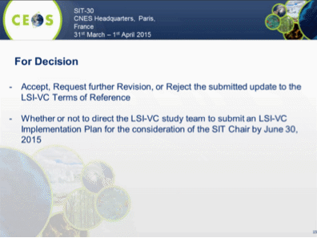
SIT 30-15 | LSI-VC Team to submit an LSI Implementation Plan for distribution by SIT Chair and review by CEOS Agencies, for review at SIT Technical Workshop, and endorsement at CEOS Plenary. | 30 June 2015

Working Groups
WGISS
Richard Moreno (WGISS, CNES) presented a summary of current WGISS activities.
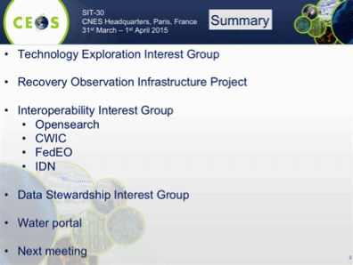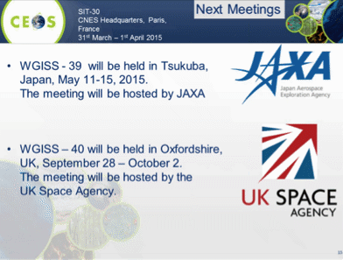
A brief discussion followed.
- Nobuyoshi Fujimoto (JAXA) asked about the risk of proliferation of multiple portals, and Andy Mitchell (WGISS, NASA) noted they have found that having just one portal is not the answer because there are multiple user communities with diverse requirements. The approach they have found works is to create common standards to publicise the existence of datasets and facilitate access to them (CWIC / OpenSearch). This allows diverse user communities to create their own tailored portals.
WGCV
Albrecht von Bargen (WGCV, DLR) presented a summary of the WGCV activities.
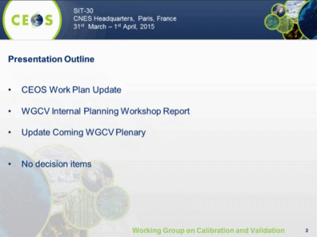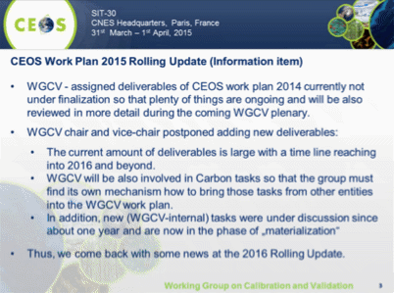
A brief discussion followed.
- Jonathon Ross (DCEO) asked about the linkages between the WGCV internal work plan and the CEOS Work Plan, and whether there will be many items in the WGCV work plan which don’t map to the CEOS Work Plan.
- Albrecht noted that the purpose of the internal work plan is to organise within WGCV, and they work to maintain consistency with the CEOS Work Plan.
WGCapD
Jane Olwoch (WGCapD, SANSA) presented a summary of WGCapD activities and future plans.
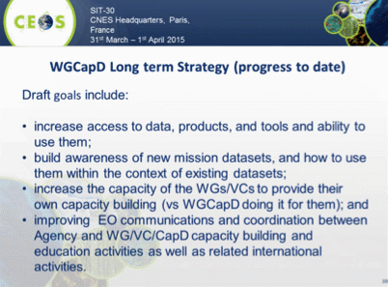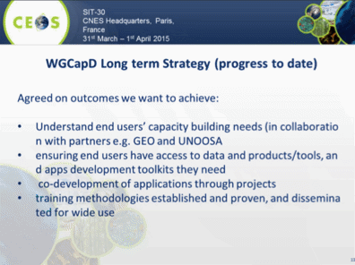
Jane noted that Eric Wood will compete his Chair term at CEOS Plenary, and she will assume the WGCapD Chair role at the conclusion of the 2015 CEOS Plenary. They have received some nominations for Vice Chair, but nominations remain open for now. She also encouraged interested CEOS agencies to join the group.
A brief discussion followed.
- Stephen Volz (NOAA) asked about whether K-12 education is in scope for CEOS. Jane noted that she is not sure if its in scope, but in South Africa they have identified an interest and a need to be addressed, and so they are exploring what might be possible.
WGDisasters
Ivan Petitville (WGDisasters, ESA) presented a summary of WGDisasters activities, noting there are no Actions open, or SIT-30 decisions required. He reported on both single hazard (floods, seismic, and volcanoes), and multi hazard pilot projects underway noting that satellite data has been delivered to all but the two most recent Supersites endorsed by CEOS. And that ESA and NASA are exploring the value of a landslide pilot.
The Recovery Observatory is progressing as planned, is strongly supported by key stakeholders, with v1 of the infrastructure ready and v2 expected in July.
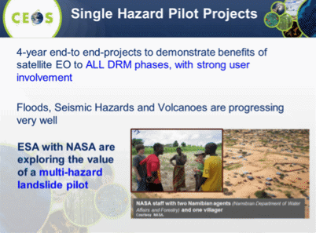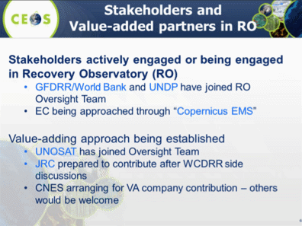
He provided a detailed update on the volcano pilot, noting the human and financial impacts of volcanic eruptions, and stressing that only about 10% of the world’s approximately 1500 active volcanoes are being monitored in some way. Satellite observations can make a significant contribution, but are not currently coordinated or systematic. He cited the example of Cerro Negro de Mayasquer in Chile, where there have been thousands of small earthquakes daily with little historical activity and few ground based observations recorded – but where CEOS data (e.g. interferometry with COSMO-SkyMed and TerraSAR-X data) have been used to find fault geometries and constrain location of magmatic intrusion; the information shared with the Chile Volcanic Observatory resulted in the installation of several GPS ground sensors around the volcano to better monitor its deformation and detect in advance an imminent volcanic eruption.
Ivan summarised the interaction with WGCapD (distance education), and WGISS (Recovery Observatory infrastructure). He also reported on the plans for follow-up post-Sendai, stressing that the successful participation in the conference is only the beginning of partnership between space agencies and DRM stakeholders.
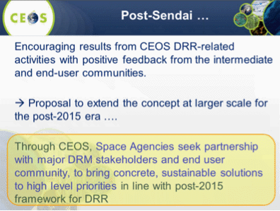
WGClimate
John Bates (WGClimate, NOAA) presented a summary of WGClimate activities.
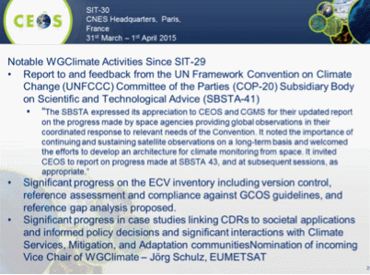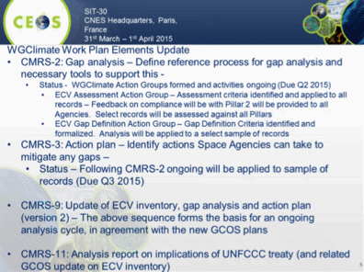
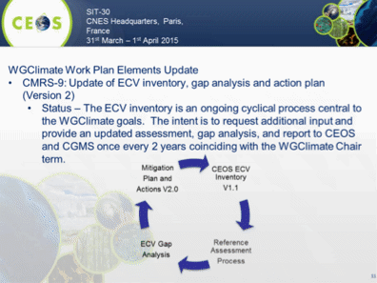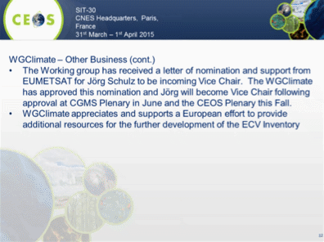
Pascal Lecomte (ESA) noted a number of requests to CEOS agencies:
- A commitment, where appropriate, to participate in WGClimate activities.
- To contribute their agency’s records to the ECV Inventory.
- To assist the SIT in reviewing and updating the CEOS response to the GCOS IP.
- To assist in reviewing the CEOS report to SBSTA.

A brief discussion followed.
- Paul Counet (EUMETSAT) reported European efforts to support the development of the ECV Inventory by developing a proposal linked to the Copernicus Climate Change initiative. The proposal has been accepted, and a full time person will be hosted by EUMETSAT to work with and on behalf of European agencies to support the activities of WGClimate, including the population of the ECV Inventory. The position is funded for at least the next two years, and they expect to have the person in place by August.
- Stephen Volz asked when the ECV pilot will be available for comment. John noted that they do have a work plan with dates and milestones, and that the initial assessment is expected by end Q2-2015, the gap analysis by Q3-2015, and report will be made at Plenary for at least a subset of the ECVs.
- Stephen Briggs noted that GCOS is expecting to produce a Satellite Supplement in their next update cycle. The current expectation is that the Supplement would be completed in 2017. Carolin Richter (GCOS) noted that there have been recent discussions about trying to expedite the Supplement and release it at the same time as the updated GCOS IP (expected end 2016). How this would be achieved remains to be discussed.
- Stephen Briggs asked about the delivery to SBSTA, and John noted there had been an intent in reporting on ongoing activities to SBSTA-41 and asked about how these materials should be reviewed within CEOS.
- Jonathon Ross (DCEO) noted that according to the CEOS governance and processes documents (page 9), the response should be endorsed by Principals. Pascale proposed that the materials for SBSTA be reviewed by CEOS SEC at the beginning of September, presented for information at the SIT Workshop, and then circulated for a formal virtual endorsement by CEOS Principals before the end of September.
- Chu Ishida (CEOS Chair) noted that the last CEOS report to SBSTA was delivered by the Japanese delegation on behalf of CEOS. And John noted that the CEOS Chair will need to work with the Japanese national delegation to coordinate this year’s submission as well.

Space Data Coordination Group for GFOI
Stephen Briggs (CEOS Lead for GFOI, ESA) presented a summary of recent progress in the GFOI initiative, including the recent GFOI component, and GFOI Lead Team meetings in Sydney, Australia.
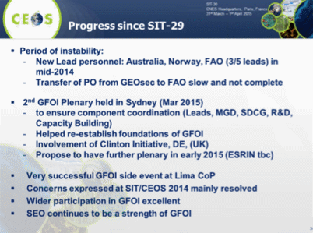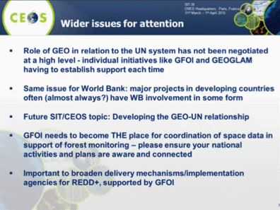
Stephen noted that the GFOI representatives for both Australia and Norway now come from the ministry responsible for policy, which is a positive development.
Stephen Ward (SDCG EXEC) presented a summary of recent SDCG activities, including an update on the global baseline 2014 coverage, and on the roles of the contributing data streams.
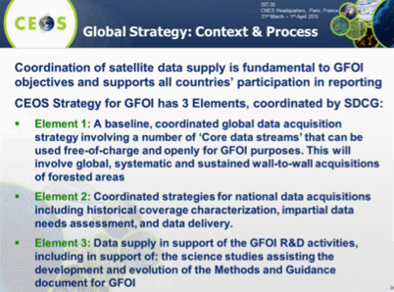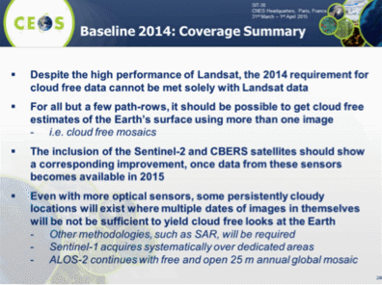
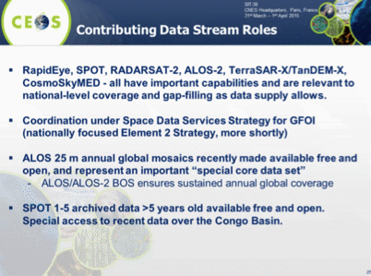
Stephen noted that the updated Global Baseline Strategy (Element 1) was endorsed at SIT-29, with implementation beginning in 2014. He noted that the motivation for establishing the Baseline Strategy was to provide the negotiating community with the confidence that the required satellite data for forest monitoring is being acquired globally in the hope that the availability of data should not be a barrier for policy progress. Implementation of the Strategy continues in 2015, with updates and adjustments being made based on mission status and launch date changes. The strategy for 2015 includes scaling up of the number of countries covered to 68. Stephen asked if there were any objections main updates to the Baseline Strategy for 2015 presented, and none were raised.
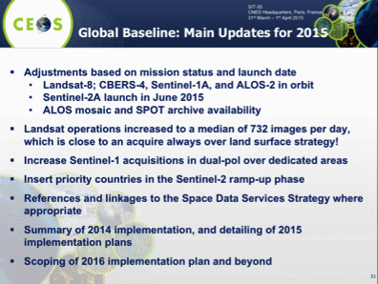
Stephen Ward presented a summary of the SDCG 3-Year Work Plan.
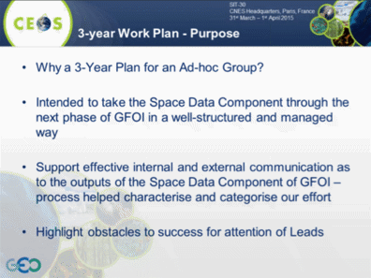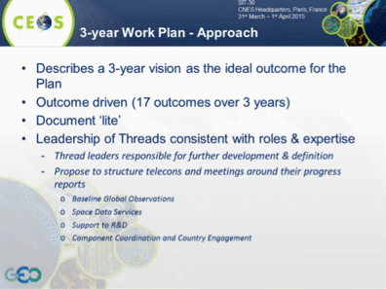
He noted that the Work Plan started by outlining a vision for support to GFOI in three year’s time, and summarised the main points of that vision.
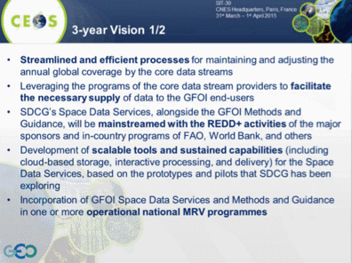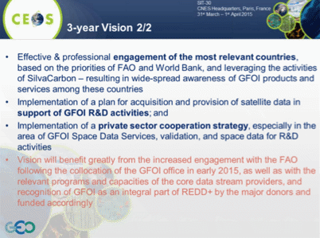
Stephen requested the endorsement of the SDCG 3-Year Work Plan.
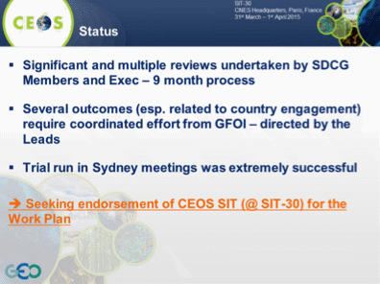
A brief discussion followed.
- Albrecht noted that DLR has forwarded a statement on the 3 Year Work Plan prior to the meeting. “DLR acknowledges the very important work and good progress of the SDCG in support of GFOI. With the advent of GFOI, there is a unique opportunity for CEOS to demonstrate its usefulness for global change challenges (in this case Reducing Deforestation and Forest Degradation) that must not be missed. It is of utmost importance that CEOS works as closely as possible with partners such as FAO to achieve this. However, DLR is a bit concerned about the growing gap of the forward planning of this group with its initial mandate. The SDCG Terms of Reference clearly stipulate that “SDCG is not intended to be an open-ended arrangement for support of GFOI operations; but it is anticipated that as the institutional arrangements and capacity for GFOI and its Project Office develop, the SDCG functions will transition into these structures”. DLR fully acknowledges that there is the need for continued SDCG work, especially as the GFOI structures are being established slower than anticipated. Nevertheless we feel that, while maintaining and further developing the partnerships with FAO, but also World Bank and other implementation mechanisms, there should be a clearer perspective on the transition of SDCG’s accomplishments to the operational world. In conclusion, DLR proposes that the SDCG 3 Year Plan 2015-2017 is amended with such a transition perspective and an updated/amended version of SDCG 3 Year Plan 2015-2017 should be presented to CEOS-Plenary for information.”
- Albrecht clarified that DLR is OK to endorse the 3-Year Work Plan today, but would like to see this clarification presented at Plenary. Stephen Ward confirmed that SDCG would be pleased to take these comments into account and amend the 3-year Work Plan as proposed.
- Stephen Briggs agreed that we would like to see GFOI more fully integrated into mainstream initiatives like UN-REDD and others, that GFOI is not a CEOS-lead activity in the long term, and he fully endorses the concept the transition to an operational implementation. However, even if it is entirely run through the UN-REDD process, they will always require multiple data streams from CEOS agencies, and so there will always be a need for some sort of a coordination group.
- Stephen Briggs noted that the time horizon for the groups activities require continuity beyond the normal one-year timeframe of ad hoc groups, and while we don’t want to setup perpetual ad hoc mechanisms, the three-year planning timeframe is still required.
- Simona Zoffoli (ASI) asked about the Work Plan task on engagement with the private sector (#14). Stephen Ward noted that Germany has proposed to host a special event for commercial providers around SDCG-8 in September to try and address commercial data coordination issues and support. He noted that CSA would also consider hosting a commercial provider event.
With the comments received, Pascale noted that the SDCG 3-Year Work Plan has been endorsed.
Stephen Ward presented a brief summary of the CEOS Data Acquisition Strategy in support of GFOI R&D (Element 3).
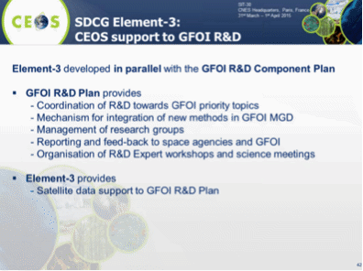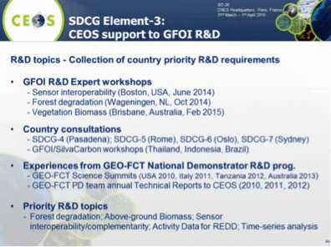
Stephen Ward noted that SDCG is seeking endorsement for the Element 3 Strategy.
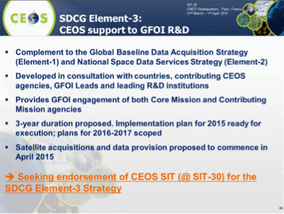
Pascale noted that no discussion points were raised, and the GFOI R&D acquisition strategy was endorsed.
Stephen Ward presented an overview of future GFOI plans.
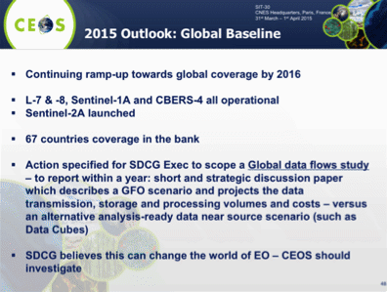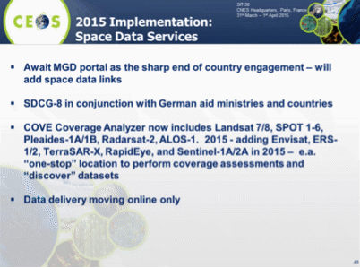
Mike Freilich noted that NASA has been funding work analogous to some of the data services, and this work should be reviewed to see if can be leveraged.
Brian Killough (SEO) presented a brief update they have been doing on pilots and prototypes in support of the SDCG.
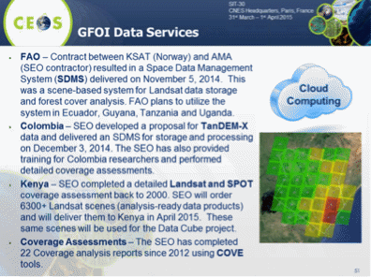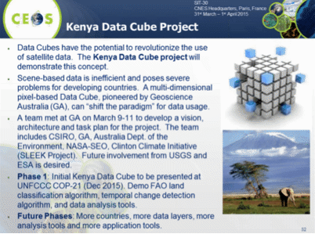
Stephen Ward summarised the next steps for SDCG.
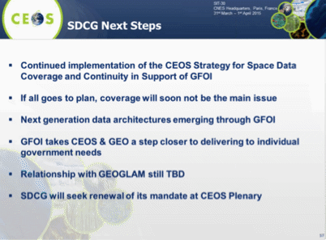
SIT 30-16 | SDCG Exec to work with DLR to ensure that the SDCG 3-Year Work Plan reflects the discussion at SIT-30 regarding the scope of CEOS efforts for GFOI and the eventual transition to operational entities. The amended Plan will be submitted to CEOS Plenary for information. | CEOS-29
SIT 30-17 | Core and contributing data stream providers to work with SDCG to implement the 3 Elements of the Space Data Strategy for GFOI in 2015 | End 2015

CEOS Carbon Strategy
Stephen Briggs (ESA) reviewed the latest progress on the CEOS Carbon Strategy.
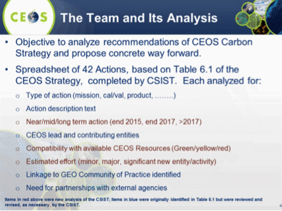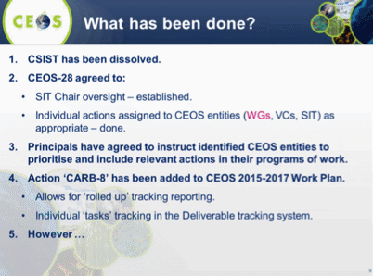
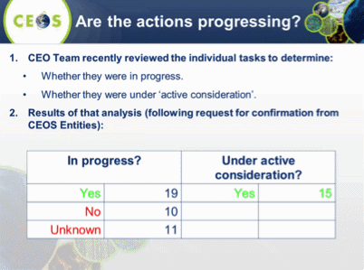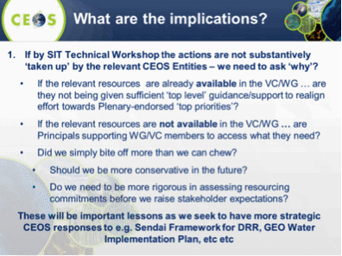
A brief discussion followed.
- Albrecht von Bargen (WGCV, DLR) asked about lessons learned in taking a top down approach to planning, including consideration of available resources.
- John Bates (WGClimate, NOAA) agreed, noting that we are going to have the same issues with future initiatives like the water strategy, and others. He suggested that this may be an area where GEO could help establish priorities.
- Stephen Briggs noted that in the case of Climate, GCOS has done the hard work of formulating an implementation plan around observational requirements. And that in the case of Carbon, the Carbon Task Force (CTF) did this work based on the GEO Carbon Strategy.
- Mike Freilich (NASA) noted that in cases where CEOS member agencies have a hand in producing the original strategy documents, we should take responsibility for ensuring that the recommendations can be implemented, even if the implementation timeframes are long. Stephen Briggs noted that to some extent, the original strategy documents should be aspirational, but implementation needs to be considered at some level.
- Alex Held (CSIRO) noted that there is sometimes confusion about what CEOS can offer, and Mike agreed this needs to be clearly articulated. For example, a common request of CEOS in the GFOI activity is the provision of commercial high resolution data, which CEOS itself cannot provide, and CEOS agencies can generally only provide for R&D efforts.

Water Strategy Implementation Study Team
Chu Ishida (JAXA) presented a summary of recent activities by the Water Strategy Implementation Study Team (WSIST).
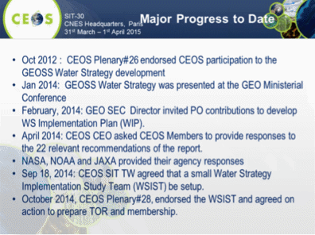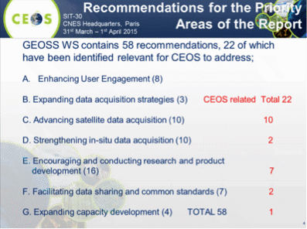
Chu noted that the next steps for WSIST include the identification of a Chair, and coordination with VCs and WGs on the contributions they can make.
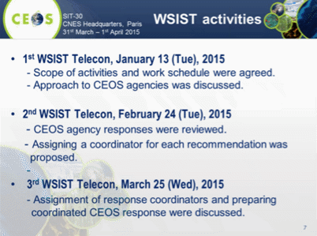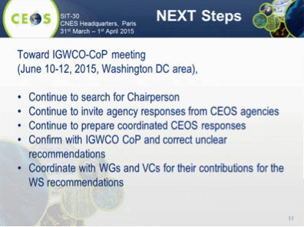
Pascale Ultré-Guérard (SIT Chair) suggested that a potential way forward would be to come to the SIT Technical Workshop with a consolidated proposal. Chu confirmed this was the aim.
SIT 30-18 | WSIST to propose a consolidated CEOS response to GEO Water Strategy; and VCs and WGs requested to provide support | End August (for SIT Tech Workshop)

GEOGLAM
Brad Doorn (NASA) presented a summary of the CEOS ad hoc Working Group on GEOGLAM, acknowledging his co-lead Selma Cherchali (CNES). He noted that one of the main developments since SIT-29 was the addition of NASA and CNES as CEOS Co-Leads for GEOGLAM, strengthening of the GEOGLAM governance structures, and confirmation of a CEOS role in GEOGLAM governance.
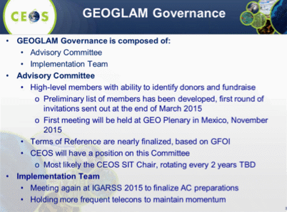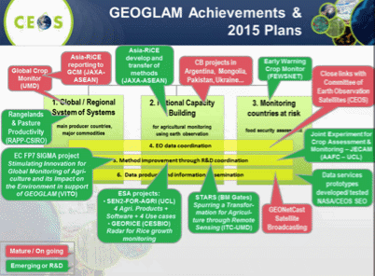
Brad noted that several Data Services prototypes are being worked on by CEOS (SEO) in support of JECAM and Asia-RiCE.
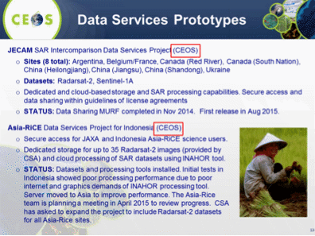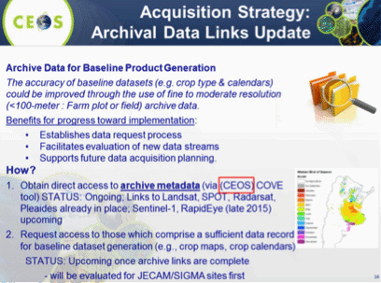
Brad noted that the way forward actions from Plenary are either complete or in progress, and reviewed the way forward from SIT-30.
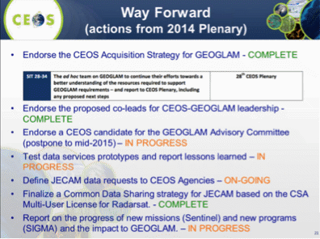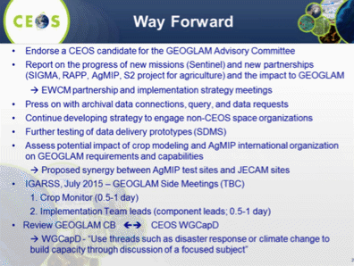
Brad noted that CEOS will need to identify a PoC for the GEOGLAM Advisory Committee.
A brief discussion followed.
- Kerry Sawyer (NOAA) asked about the relationship between JECAM and GEOGLAM. JECAM has been formally included in GEOGLAM, and currently runs somewhat autonomously as the R&D component. Brad noted that JECAM activities are always going to be necessary to support GEOGLAM, and that the JECAM sites will likely always remain a feature of GEOGLAM, even as capabilities being developed are transitioned to operations.
- Jane Olwoch (WGCapD, SANSA) noted that WGCapD would like to work with GEOGLAM on capacity building aspects.
- Stephen Briggs (ESA) noted that in the case of GEOGLAM, the governance will probably involve more people, and asked if a single CEOS representative would be sufficient. Brad noted that GEOGLAM is driven by the major users of the data, and there is a need to distinguish between data users and providers. He suggested that CEOS should be represented by one representative, but that national space agencies should also seek representation through their stakeholders (i.e., national ministries and programs).
- Pascale Ultré-Guérard asked how frequently the GEOGLAM Advisory Committee will meet, and Michel Deshayes (GEOSEC) noted this hasn’t been decided, but would likely be just once a year.
SIT 30-19 | SIT Chair to work with the co-leads of the CEOS Ad-hoc Working Group on GEOGLAM to identify a CEOS representative to the GEOGLAM Advisory Committee | End April

Data Applications Report
Naoko Matsuo (JAXA) presented the overall concept, and current stats of the CEOS Data Applications Report being lead by JAXA.
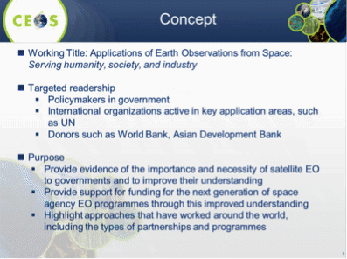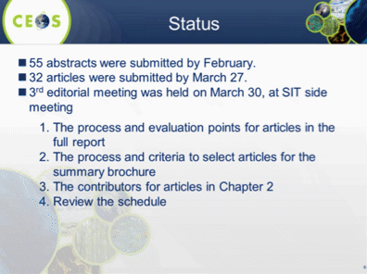
Naoko outlined the process and shared the outcomes of the recent DAR team meeting.
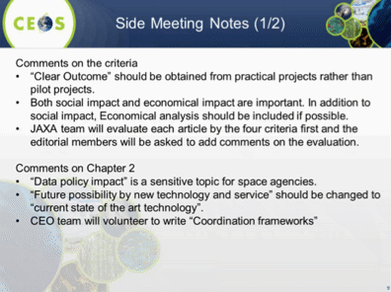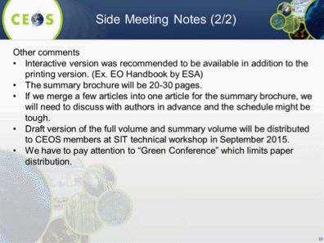
She summarised the development schedule from now until publication before Plenary.
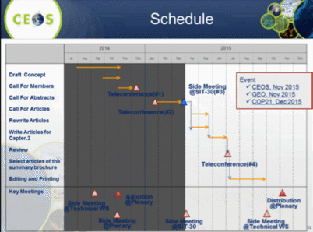
Chu Ishida (CEOS Chair) noted that good progress is being made, but more new application types are required, and the editorial team will be pursing this objective.
A brief discussion followed.
- Ivan Petiteville (ESA) suggested applying the review criteria in a flexible manner in order to encourage more volunteers to submit articles. Chu confirmed that if an article addresses the feedback provided by the editorial team, there is no reason to expect that it would not be printed.
- Albrecht von Bargen (WGCV, DLR) asked if the summary report will merge articles from the full report. Chu confirmed some merging and combination may be considered for the summary brochure, but not for the full report, and that the original authors would be consulted in the process.

UN Strategic Development Goals
Chu Ishida (CEOS Chair) presented a summary of recent discussions around the UN Strategic Development Goals (SDG), and noted that JAXA has been engaged in the dialogue.
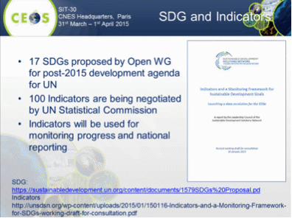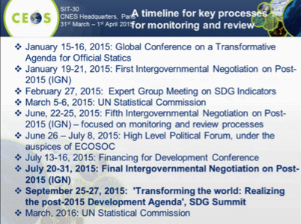
Chu asked that any agency interested in the proposed April 21 SDG side event contact him by the beginning of next week.

Key Messages for CEOS Response to GEO Implementation Plan (IP)
Marie-Josée Bourassa (CEO) presented a summary of the changes to the CEOS key messages in response to the GEO IP based on recent discussion. The key messages were edited live, and final revisions were agreed.
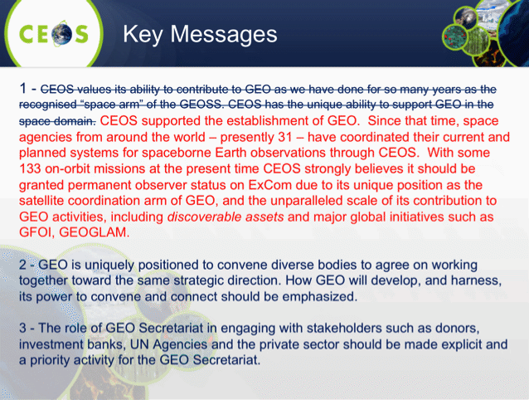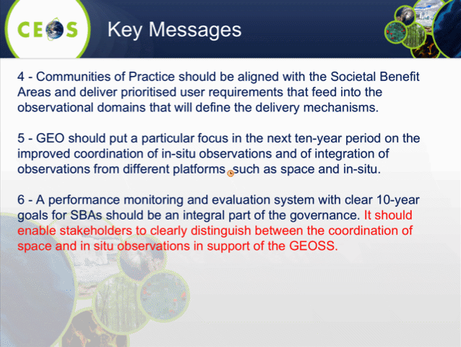
Marie-Joseé reviewed the draft GEO-related actions for follow-up from SIT-30.
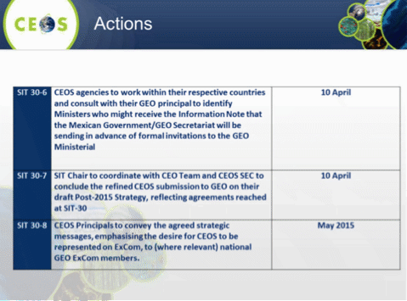
It was noted that the deadline for the first action will be moved to 15th April.

CEOS Communication Report
Brian Killough (SEO) reported on four topics related to CEOS communications.
- CEOS Website update was released in January. A large majority of the site transition has been completed, but some updates are still in progress.
- The Document Management System is up and running well, with a folder structure similar to the CEOS website, and credentials have been provided to a number of people.
- The Meeting Registration Tool is in place, but hasn’t been used to date. They are working on a new version based which will be ready in the next week. It will be available to any meeting organisers interested, and will provide an automated registration process.
- The CEOS Deliverables Tracker is under review for a couple of weeks, and is expected to be ready for use in a few weeks. The current site can be browsed at www.ceos-deliverables.org.

29th CEOS Plenary
Nobuyoshi Fujimoto (JAXA) presented a summary of the plans for CEOS Plenary in Kyoto. The first announcement for Plenary will be circulated in May, and registration and a first draft of the agenda will be available in June-July.
A Data Applications Symposium will be planned for the 2nd of November in Tokyo, followed by the CEOS Plenary in Kyoto 4th-6th. And this will be followed by the GEO Plenary 11th-12th November in Mexico.
Nobuyoshi noted that in order to make the most of the time available, the CEO/DCEO will work with the WGs and the SIT Chair Team for the VCs, to make reporting as efficient as possible.
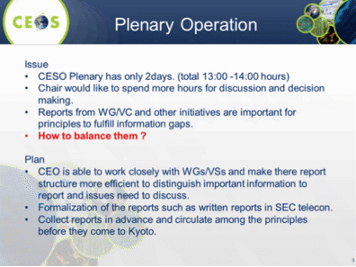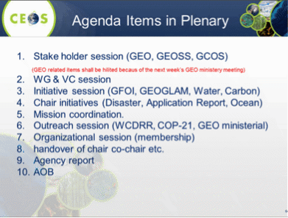
Nobuyoshi summarised the plans for the EO Symposium.
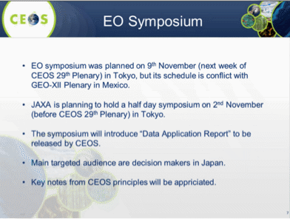
Alex Held (CSIRO) noted they are considering a two and a half day CEOS Plenary in Australia in 2016, but planning remains preliminary.

SIT-29 Closing Business
Review of Actions
Stephen Ward (SIT Chair Team) reviewed the draft Actions, which are embedded as an appendix to the minutes.
John Bates (WGClimate, NOAA) noted that the WGClimate has a lot to do in the lead up to COP21, and so can’t make a clear resource commitment to the EO Handbook. Steven Hosford noted that the principal actionee was not WGClimate. Stephen Briggs (ESA) confirmed that the action is on ESA to lead the production of the Handbook, and there are many sub-steps that are not included. Ivan Petiteville (ESA) noted that the bulk of the activity will not fall to WGClimate, but will be done within the ESA editing team, and then circulated to CEOS SEC for final comments. He also noted that the first step will be to prepare a top level schedule with milestones, including a proposed review process.
Paul DiGiacomo asked that the questions he raised during the OCR-VC around L0 / L1A data, and ensuring a proper in situ validation program of the ocean colour sensors be included as actions for response. Jean-Louis Fellous (SIT Chair Team) suggested that they could write a letter advocating on behalf of OCR-VC, and Steven Hosford (SIT Chair Team) confirmed CNES would be OK to take this action on. Jean-Louis suggested these would also be good topics for the September 2015 SIT Technical Workshop.
SIT Technical Workshop
Pascale Ultré-Guérard (SIT Chair) confirmed that the VC/WG day will be held on the 16th September, and the Workshop will be held on the 17th and 18th, hosted by EUMETSAT in Darmstadt, Germany. Additional details will be will be circulated in due course.
Meeting Close
Pascale thanked all who participated in the meeting, in person and connected via telecon. She noted that the meeting was an important opportunity for the CEOS community to share information, review the status of our activities and provide steering for these with the decisions taken. She stressed that the interaction with major stakeholders will continue this year, as, after Sendai, much work is to be done in preparing for the GEO Ministerial and COP21.
Pascale thanked those who helped in preparing for the meeting, including the CEOS Chair, CEO/DCEO, and Mireille Paulin, Danielle Barrère, and the rest of the SIT Chair Team for their planning and preparations.
Pascale adjourned SIT-30.

SIT-30 Participants
Organisation | Participant | Organisation | Participant
ASI | Laura Candela | JAXA | Chu Ishida
ASI | Simona Zoffoli | JAXA | Nobuyoshi Fujimoto
CNES | Pascale Ultré-Guérard | JAXA | Naoko Matsuo
CNES | Jean-Louis Fellous | JAXA | Kazuya Suenaga
CNES | Steven Hosford | JAXA | Yoshio Toukaku
CNES | Richard Moreno | JAXA/RESTEC | Masatoshi Kamei
CNES | Juliette Lambin | Ministry of Ecology, Sustainable Development and Energy/France | Nicolas Bériot
CNES | Mireille Paulin | NASA | Mike Freilich
CNES | Danielle Barrère | NASA | Christine Bognar
CNES | Selma Cherchali | NASA | Richard Eckman
CNES | Cécile Vignolles | NASA | Steven Neeck
CNES | Phillipe Escudier | NASA | Brad Doorn
CNES | Daniel Martinez | NASA | Justin Tilman
CNES | Stephen Ward | NASA | Yonsook Enloe
CNES | George Dyke | NASA | Andrew Mitchell
CSA/CEO | Marie-Josée Bourassa | NASA | David Jarrett
CSIRO | Alex Held | NASA | Kurtis Thome
DLR | Albrecht von Bargen | NASA | David Green (GTM)
EC | Astrid-Christina Koch | NASA/SEO | Brian Killough
ERTD | Cathy Dubois | NASA Europe/US Embassy Paris | Gib Kirkham
ESA | Simonetta Cheli | NOAA | Stephen Volz
ESA | Stephen Briggs | NOAA | Brent Smith
ESA | Ivan Petiteville | NOAA | John Bates
ESA | Pascal Lecomte | NOAA | Kerry Sawyer
ESA | Craig Donlon (GTM) | NOAA | Paul DiGiacomo
EUMETSAT | Paul Counet | NOAA | Ken Casey (GTM)
EUMETSAT | Robert Husband | NSC | Einar-Arne Herland
GA/DCEO | Jonathon Ross | NSMC/CMA | Caiying Wei
GCOS/WMO | Carolin Richter | NSMC/CMA | Jinlong Fan
GEO Secretariat | Barbara Ryan | SANSA | Jane Olwoch
GEO Secretariat | Michel Deshayes | UMD/GEOGLAM | Alyssa Whitcraft
GEO Secretariat | Osamu Ochai | USGS | Steven Labahn
GEO Secretariat | Douglas Cripe (GTM) | USGS | Tom Cecere
(GTM) indicates remote participation via GoToMeeting.

CEOS SIT-30 Actions

V1.0

No. | Action | Due date
SIT 30-1 | CEOS Work Plan responsible entities to provide an initial status update for their Actions using the new ceos-deliverables.org site and thereafter to update the status at least quarterly | May 2015
SIT 30-2 | SIT Chair to work with WGClimate Chair and CEOS SEC to refine the strategic messages within a text for COP21 and to distribute for review by CEOS Principals | COMPLETE
SIT 30-3 | ESA to plan and develop an Earth Observation Handbook with a climate focus for COP21, in consultation with SIT Chair, WGClimate and GCOS, planning circulation in advance to key stakeholders | COP21
SIT 30-4 | WGClimate Chair to work with SIT Chair to identify a coordinator to bring together climate material in preparation of COP21 | April 2015  NOAA nominates Kerry Sawyer
SIT 30-5 | SIT Chair and CEO Team to work with WGClimate to develop a process and timetable for review of the CEOS inputs to SBSTA/COP21 | April 2015
SIT 30-6 | SIT Chair Team to circulate additional details about the COP21 event being prepared for the Grand Palais, Paris, referenced by Nicolas Bériot | May 2015
SIT 30-7 | CEOS Agencies, Working Groups, Virtual Constellations and Ad-Hoc Teams to provide SIT Chair team with 1 or 2 compelling climate case study examples for use in the Climate Conference in Paris (July 2015) | 25 May 2015  Limited responses – more welcome.
SIT 30-8 | CEOS Agencies to ensure the GEO Principal(s) in their national governments, and the relevant Ministers and Departments, are aware of the forthcoming Information Note and invitation to the GEO Ministerial | 25 May 2015
SIT 30-9 | CEOS Principals to convey CEOS strategic messages to their national GEO ExCom member (where relevant), emphasising the desire for CEOS to be represented in the GEO Executive Committee | May 2015
SIT 30-10 | SIT Chair to coordinate with CEO Team and CEOS SEC to conclude the refined CEOS submission to GEO on their draft Post-2015 Strategy, reflecting agreements reached at SIT-30 | COMPLETE
SIT 30-11 | SIT Chair to send a letter to CEOS Principals whose agencies operate ocean colour missions requesting them to consider distribution of ocean colour radiometry satellite Level 0 or Level 1A, stressing the importance of validation across all agencies and why validation as well as calibration should be built into all ocean colour radiometry missions. SIT Chair will also echo these requests in the report to CEOS Plenary. | May 2015
SIT 30-12 | SIT Chair Team to connect CMA to the VC Leads and WG Chairs and to help them explore their participation in the various groups | SIT Technical Workshop 2015
SIT 30-13 | VCs & WGs to develop poster displays and a short presentation of their activities highlighting the most recent mission (for VCs) or major project (for WGs) within their purview to stimulate discussion at the VC/WG Working Day | SIT Technical Workshop 2015
SIT 30-14 | Craig Donlon, on behalf of and in consultation with VC Leads and WG Chairs, to propose an agenda to SIT Chair for the VC/WG Day at SIT Technical Workshop | 25 May 2015
SIT 30-15 | LSI-VC Team to submit an LSI Implementation Plan for distribution by SIT Chair and review by CEOS Agencies, for review at SIT Technical Workshop, and endorsement at CEOS Plenary. | 30 June 2015
SIT 30-16 | SDCG Exec to work with DLR to ensure that the SDCG 3-Year Work Plan reflects the discussion at SIT-30 regarding the scope of CEOS efforts for GFOI and the eventual transition to operational entities. The amended Plan will be submitted to CEOS Plenary for information. | CEOS-29
SIT 30-17 | Core and contributing data stream providers to work with SDCG to implement the 3 Elements of the Space Data Strategy for GFOI in 2015 | End 2015
SIT 30-18 | WSIST to propose a consolidated CEOS response to GEO Water Strategy; and VCs and WGs requested to provide support | End August (for SIT Tech Workshop)
SIT 30-19 | SIT Chair to work with the co-leads of the CEOS Ad-hoc Working Group on GEOGLAM to identify a CEOS representative to the GEOGLAM Advisory Committee | End April

CEOS SIT Workshop, SIT-29 & Plenary Action Status as of SIT-30

SIT Technical Workshop 2014

No. | Action | Due date
SITWS-2014-01 | CEOS Chair to circulate an updated version of the CEOS-28 Plenary agenda for comment | SEC-193  COMPLETE
SITWS-2014-02 | WGCapD to approach the VCs and WGs to identify capacity building Points of Contact, and to support the promotion of their activities. These points of contact are to be added to a new CEOS mailing list to be used for promotion and coordination. | CEOS-28  IN PROGRESS
SITWS-2014-03 | All entities within CEOS (CEOS Chair, SIT Chair, CEO, SEO, WGs, VCs, ad hoc teams) to provide a 2 minute video describing their activities and role. This content will be used in the first instance foßr internal awareness and as first inputs to a webinar infrastructure | SIT-30  “Faces of CEOS” videos to be recorded in the margins SIT-30 are part of this effort
SITWS-2014-04 | WGDisasters, in coordination with WGISS, and the GEO Data Sharing Working Group to explore the possibility of developing a “common” data licence – with a test case for data sharing issues faced by WGDisasters. | CEOS-28
SITWS-2014-05 | Jonathon Ross and Tom Cecere to coordinate an evaluation team to perform the analysis of options for the future of LSI-VC proposed in the “Position Paper on Options for Future of Land Imaging Coordination within CEOS”, and present the results at CEOS Plenary | CEOS-28  COMPLETE
SITWS-2014-06 | John Bates to follow-up with Espen Volden on potential inputs on GFCS-relevant projects and programs to the upcoming GFCS implementation coordination meeting. | COMPLETE
SITWS-2014-07 | VC and WG Leads to organise a VC/WG Working Day, in conjunction with the 2015 SIT Workshop | IN PROGRESS  Initial details to be presented at SIT-30 under agenda item #8 and #19
SITWS-2014-08 | SIT Chair Team to work with the VC and WG leads in preparing for the 2015 VC/WG Working Day, taking into account the outcomes from the 2014 Working Day. | IN PROGRESS  Initial details to be presented at SIT-30 under agenda item #8 and #19
SITWS-2014-09 | Jean-Louis Fellous to work with Craig Donlon to review options to improve reporting, focused on progress and not process for the 2015 VC/WG workshop | IN PROGRESS  Initial details to be presented at SIT-30 under agenda item #8 and #19
SITWS-2014-10 | WGCapD to take into account the outputs of Topic #2 of the VC/WG Day in the development of their 2015-2017 CEOS Work Plan objectives/deliverables | COMPLETE
SITWS-2014-11 | CEOS agencies to send nominations for members of a Water Strategy implementation study team to Kerry Sawyer. Study team to report back at SIT-30 | 26 September  COMPLETE  WSIST will report during SIT 30 agenda item #13
SITWS-2014-12 | SIT Chair team to include a report from the Water Strategy implementation study team on the SIT-30 agenda | SIT-30  COMPLETE  WSIST will report during SIT 30 agenda item #13
SITWS-2014-13 | SIT Workshop participants to send comments on the Carbon Strategy Implementation Study Team action item analysis table to Kerry Sawyer and Stephen Briggs | 26 September  COMPLETE  CEOS Carbon Strategy will be discussed under SIT 30 agenda item #12
SITWS-2014-14 | John Bates to report on WGClimate’s willingness to coordinate the implementation of the CEOS Carbon Strategy actions | COMPLETE  Being coordinated with the Carbon Strategy Implementation Team
SITWS-2014-15 | Brian Killough to work with the CEOS ad hoc Working Group on GEOGLAM on some options for the renaming of the group | 7 October  CLOSED  Name will be retained
SITWS-2014-16 | Craig Donlon to share information on FRMs (Fiducial Reference Measurements) with Brian Killough, with reference to Brian’s role as Task Coordinator of the GEO Infrastructure-01 Earth Observing Systems (IN-01) task. | COMPLETE
SITWS-2014-17 | Kerry to circulate the updated draft written summary of CEOS-CGMS climate activities provided by John Bates to CEOS SEC for comment | COMPLETE  Sent Sep 20 2014
SITWS-2014-18 | Interested agencies to provide a requests for agency reports and side meetings to the CEOS Chair Team | COMPLETE
SITWS-2014-19 | Kim Holloway to coordinate the CEOS update website group in developing a social media strategy for CEOS | SIT-30
SITWS-2014-20 | CEO and CEOS SIT Chair to work with Jane Olwoch on the possible scoping for CEOS support for emerging space agencies | CEOS-28 Proposed new date: SIT-WS 2015

SIT 29

No. | Action | Due date
SIT 29-1 | CEOS and SIT Chairs to write to GEO Co-Chairs to: a) provide the CEOS view on the future of GEO b) offer our service to GEO and to interact with the IPWG on the development of the IP, and c) to request Observer status at EXCOM | End May 2014  COMPLETE
SIT 29-2 | VCs to consider developing training activities in their field, following the example of the OSVW-VC, involving the corresponding science groups, in collaboration with WGCapD and possibly with external partners (e.g., COSPAR, GxOS, WCRP) | Initial ideas – SIT Chair tag up telecons  (June 2014)  COMPLETE
SIT 29-3 | OCR-VC to provide a detailed account of the implementation and coordination issues submitted to SIT-29 (with appropriate references) with a view to resolving them prior to SIT Technical Workshop | SIT Chair tag up telecons  (June 2014)  COMPLETE
SIT 29-4 | SIT Chair Team to work with volunteer CEOS Agencies to present a position paper at the SIT Technical Workshop on how to address CEOS contributions to Land Surface Imaging Agencies | SIT Technical Workshop  (September 2014)  COMPLETE
SIT 29-5 | SIT Chair to prepare a SIT Technical Workshop agenda item regarding the relationship between VCs & WGs and the respective science groups, to be coordinated during the next series of SIT Chair tag-up telecons – and including gaps and bottlenecks which could be acted upon | SIT Chair tag up telecons  (June 2014)  SIT Technical Workshop  (September 2014)  COMPLETE
SIT 29-6 | VCs & WGs to ensure that their respective websites are updated with current information | SIT Technical Workshop (September 2014)  COMPLETE
SIT 29-7 | VCs & WGs to review their membership and leadership with a view to encourage broader participation by CEOS Agencies | SIT Technical Workshop  (September 2014)  COMPLETE
SIT 29-8 | SIT and CEOS Chair to approach CEOS Agencies and potential new Members with a view to broaden participation in and leadership of CEOS activities | CEOS-29  IN PROGRESS
SIT 29-9 | CEOS Agencies invited to nominate volunteers for the new CEOS website study group (end April); and SEO to implement the new CEOS website, including document management system | CEOS-28  COMPLETE
SIT 29-10 | Core data stream providers (USGS, ESA, INPE/CRESDA, CSA, CONAE) to work with SDCG to implement the global baseline data acquisition strategy for GFOI in 2014 | End 2014  COMPLETE
SIT 29-11 | SDCG to work with the SEO, contributing Agencies, and FAO to develop prototypes of the Space Data Services for GFOI and report on the outcomes of pilot projects with several countries | CEOS-28  COMPLETE
SIT 29-12 | SDCG to define and develop the third Element of the CEOS Data Strategy for GFOI (acquisitions for R&D) for presentation and endorsement at SIT-30 | SIT-30  IN PROGRESS  Being presented for endorsement during SIT 30 agenda item #12
SIT 29-13 | WGISS and WGCapD to liaise with SEO and SilvaCarbon respectively to review the GFOI Space Data Services plans and to provide guidance, review and support of its progress | CEOS-28  COMPLETE  WGCapD – Reported activity during SEC-192 telecon
SIT 29-14 | CEOS Chair to prepare Draft ToRs for the ad hoc Carbon Strategy Implementation Study Team for approval at CEOS SEC-189 | CEOS SEC-189  COMPLETE
SIT 29-15 | CEOS Principals to provide nominations for participation in the ad hoc Carbon Strategy Implementation Study Team | COB 18th April  COMPLETE
SIT 29-16 | CEOS ad hoc Working Group on GEOGLAM to work with the GEOGLAM community to develop an update to the CEOS Acquisition Strategy for GEOGLAM for endorsement | CEOS-28  COMPLETE
SIT 29-17 | WGDisasters to proceed with the three new supersites and relevant CEOS Agencies encouraged to support data supply | Ongoing  CLOSED
SIT 29-18 | WGDisasters to implement the strategic data acquisition plan in support of the flood, seismic hazard, and volcano DRM pilot and Recovery Observatory requirements | Ongoing  CLOSED
SIT 29-19 | WCDRR Task Team to implement the CEOS plan for engagement in WCDRR. CEOS Agencies to comment on the two supporting documents (Strategic Messages and Voluntary Commitments) | March 2015  COMPLETE
SIT 29-20 | CEOS Agencies to interact with their relevant government participants in WCDRR to ensure representation of the CEOS key messages at the regional platforms and Preparatory Committee meetings | Through to March 2015  COMPLETE
SIT 29-21 | CEOS Chair and Incoming Chair, supported by WGClimate and other stakeholders, to prepare the CEOS representation and report for SBSTA-41 in late 2014. The report will be confirmed at CEOS Plenary | CEOS-28  COMPLETE
SIT 29-22 | SIT and CEOS Chairs to work with stakeholders to develop a strategy to prepare for COP21 in late 2015 in Paris | Report to  CEOS-28  IN PROGRESS  To be discussed under SIT 30 agenda item #4

28th CEOS Plenary

No. | Action | Due date
28-01 | CEOS SIT Chair to discuss with the GEO Secretariat the need to ensure that the very successful CEOS contributions to GEO Task IN-01 are accurately reflected in the GEOSS evaluation process that GEO communicates to ministers and national policy-makers at its Plenary. | GEO-XI  COMPLETE
28-02 | CEO, in consultation with the CEOS Chair and CEOS Agencies, to develop written and verbal interventions for the GEO-XI Plenary that will:  - Emphasise the overarching role of CEOS in coordinating international cooperation on space-based Earth observing systems for GEO;  - Reaffirm the very successful CEOS contributions to GEO to date, based on the sustained investments of CEOS Agencies;  - Emphasise the need for a formalised level of CEOS participation in the GEO Governance framework that reflects its unique role and the scale of its contributions; and  - Underscore the CEOS position that any revised SBA structure accurately reflects the full range of global community needs, and provide a vehicle for the structured and coherent collection of GEOSS requirements. | GEO-XI  COMPLETE
28-03 | CEOS Chair to send a letter to CEOS Agencies inviting nominations for participation in the LSI VC, and including a description of the preparatory activities to reconstitute the LSI VC (see Plenary Action 28-04), with a due date for receipt of nominations of 15th November 2015. | 5th November 2015  COMPLETE
28-04 | The LSI-VC, led by Tom Cecere (USGS), to prepare a draft Implementation Plan, based on the "Space Segment Coordination" option and including a proposed update to the LSI-VC ToRs, for review prior to, and discussion at, SIT-30. | SIT-30  IN PROGRESS  To be discussed under SIT 30 agenda item #9
28-05 | CEOS Chair to send a letter to CEOS Agencies seeking nominations for the upcoming vacant position of Co-Chair of the SDCG for GFOI | 15th November 2014  COMPLETE
28-06 | SIT Chair in conjunction with the relevant WGs and VCs, to determine by SIT-30 whether appropriate implementation arrangements are in place for all actions associated with the CEOS Strategy for Carbon Observations from Space | SIT-30  IN PROGRESS  To be discussed under SIT 30 agenda item #12
28-07 | CEOS Chair to inform the GEO IGWCO Chair that: i) CEOS considers that the GEO Water Strategy is a relevant guidance document for CEOS activities, ii) based on the first expression of interest of CEOS Agencies, CEOS is establishing a Water Strategy Implementation Study Team to define its potential contribution to the implementation of the Strategy | 15th November 2014  COMPLETE
28-08 | CEOS Chair, with the support of the CEO, to develop Terms of Reference for a Water Strategy Implementation Study Team and, once available, write to CEOS Agencies to solicit nominations for participation in this Study Team | 2nd December 2014  COMPLETE
28-09 | CEOS Chair to deliver the draft structure of the planned CEOS Data Applications Report to CEOS Agencies | 5th November 2014  COMPLETE
28-10 | CEOS Agencies to deliver abstracts for contributions to the planned CEOS Data Applications Report to the CEOS Chair, together with nominations for participation in the editorial team | 30th November 2014  COMPLETE

