MINUTES
31st CEOS STRATEGIC IMPLEMENTATION TEAM MEETING (SIT-31)
v1.1
19–20 April 2016
ESA/ESRIN, Frascati, Italy
Main outcomes from the 31st CEOS SIT meeting:
- During a dedicated Plenary session, NOAA was confirmed as the 2016-2017 SIT Vice Chair. NOAA will then serve as 2018-2019 SIT Chair (commencing at the 2017 CEOS Plenary).
- The CEOS-GEO relationship was discussed, and it was agreed that it offers value to both parties and continues to be a priority. GEO’s accommodation of CEOS’s requests for Participating Organizations to make a greater contribution to GEO governance and leadership was acknowledged.
- It was agreed that the preferred model would be GEO leveraging its ‘convening power’ to improve high level interaction with UN agencies and development banks, rather than CEOS establishing such relationships on a project-by-project basis, and that this is an important topic for CEOS.
- CEOS’s ongoing support to key GEO initiatives was affirmed (e.g. GFOI, GEOGLAM).
- CEOS support to GEO Blue Planet initiative and the G7 Oceans Initiative was affirmed.
- CEOS will approach the UN-SDGs in conjunction with GEO and UN-GGIM, including a top-down dialogue with other relevant UN agencies and individual CEOS Agencies connecting via their governments.
- An overview of the GCOS 2016 update plans, and the CEOS response was discussed and the impact and opportunities arising from COP21 and the Paris Agreement for space agencies was affirmed.
- CEOS noted the Delhi Declaration addressing the role of satellites in climate monitoring.
- CEOS acknowledged the alignment of its activities with the potential value that new actors adopting satellite data (e.g. ‘Internet giants’) can offer, and CEOS Agencies affirmed their ongoing commitment to be active long-term stewards of the data.
- CEOS Agencies agreed on the critical need to provide stable, quality controlled, accessible products that are processed to the furthest extent possible to facilitate user uptake and analysis of satellite EO in key global and regional agenda such as the SDGs and Sendai Framework, and to promote uptake by a broader range of users (i.e. small, medium), including through provision of properly defined Analysis Ready Data (ARD).
- LSI-VC and the SEO will develop a definition of CEOS ARD and present it for adoption at the 2016 CEOS Plenary.
- Progress on the CEOS Strategy for Carbon Observations from Space actions was acknowledged as slow. It was agreed to hold a dedicated meeting on the topic in conjunction with the 2016 SIT Technical Workshop.
- Guidance was given to the Water Constellation Feasibility Study team to look at existing studies (e.g. GPM follow-on), consider precipitation sampling requirements, and ensure a connection with the GEO Water Resources Management SBA and other water-related activities (e.g. GEOGLOWS).
- The unique role CEOS has in identifying thematic areas where there are synergies between user community requirements, and the importance of engaging in GEO Work Plan task GD-08 on SBA data requirements in this capacity was agreed.
- The positive response to, and uptake of Copernicus Sentinel data to date was recognised, with an opportunity for user feedback identifying areas for improvement. Plans to increase data distribution capacity were welcomed (e.g. via international mirror sites, Collaborative Ground Segments).

1. Welcome and Opening Remarks
Volker Liebig (ESA, Director of EO Programmes) welcomed participants to the 31st meeting of the CEOS Strategic Implementation Team (SIT) and to the European Space Agency’s ESRIN establishment. He noted that Europe has several exciting milestones approaching, with both the acceptance review of Sentinel-5P and the launch of Sentinel-1B. The volume of downloads of Sentinel-1A and Sentinel-2A data globally to date have been encouraging. Volker noted that ESA remains a strong supporter of CEOS and SIT since ESA’s strategies for EO are often in line with the ambitions of CEOS, including a strong interest in supporting society’s needs for climate information, disasters, water, and food security. Volker noted that water, in particular, will be an increasingly critical societal and international issue and that space agencies should ensure space technology plays its part in finding solutions.
Participants introduced themselves in a tour de table.

SIT Chair Term Themes and SIT-31 Objectives
Stephen Briggs (SIT Chair) welcomed all participants attending SIT-31 in person and via web-conferencing. He reviewed the SIT Chair Priorities for 2016-2017, noting that SIT-31 is the first of a series of SIT meetings over the next two years, and that the SIT Chair is seeking continuity across the meeting sequence in order to enable Agencies to engage with important strategic topics. The topics covered in the agenda represent the themes and priorities for the next two years of ESA’s SIT Chair term:
- Ensure successful advancement of ongoing CEOS commitments and deliverables, finding solutions for issues and obstacles facing existing priority initiatives.
- Ensure full access to, and exploitation of Copernicus Sentinel data.
- Further develop the relationships with IPCC and UNFCCC to support observation of climate indicators in the context of the new global Paris Agreement on climate change.
- Maintain and strengthen strategic partnerships with key actors, in particular UN agencies, development banks, international programmes and agencies.
- Support GEO as it moves into its next decade, using the substantial contributions of CEOS within GEO to support improvements in GEO’s effectiveness and governance.
- Support initiatives proposed by the CEOS Chairs in 2016 and 2017.
Stephen reviewed several issues that require attention to ensure CEOS is well positioned for future opportunities and challenges:
- Future Strategic Partnerships to foster uptake and application of government-sponsored EO programmes in support of key challenges (e.g. forestry, food security, water resource management, climate, disaster risk reduction);
- Thematic Observing Strategies how to manage the existing, and emerging, thematic observational strategies in relation to these sectors, considering the CEOS Agencies’ resources;
- Future Data Architectures and big data stakeholders in relation to strategic partnerships and thematic observations;
- New Opportunities for EO satellite data in support of major new initiatives such as the Sendai Framework for Disaster Risk Reduction, delivery of the 2030 Agenda for Sustainable Development, and the Paris Agreement; and,
- Management how to adjust CEOS priorities and resources to respond to challenges and opportunities arising.

2. CEOS Plenary Session

CEOS SIT Vice Chair Nominations and Call for Endorsement
Alex Held (CSIRO) introduced a brief CEOS Plenary session, noting that the objective is to nominate and endorse a CEOS SIT Vice Chair for 2016-2017. The SIT Vice Chair would then be expected to assume the SIT Chair role for 2018-2019 (effective from CEOS Plenary 2017).

Alex noted that NOAA has nominated for SIT Vice Chair 2016-2017, and opened the floor for any objections and endorsements. ESA, EUMETSAT, NASA, USGS, DLR, JAXA, CMA, and CNES all expressed strong endorsement for NOAA.
Steve Volz (NOAA) thanked CEOS for their support and noted NOAA’s resolve to support and progress the many important CEOS initiatives including the Carbon and Water strategies, Blue Planet, the CEOS Chair initiatives, as well as CEOS interactions with international organizations such as GEO, GCOS, and UN Agencies and to continue to enhance the value of CEOS as a global provider of trusted, accurate, and actionable environmental information.
Stephen Briggs (SIT Chair) thanked NOAA for their nomination and looked forward to working closely with NOAA over the coming years.
Decision 1 | During a dedicated CEOS Plenary session, NOAA was endorsed as the SIT Vice Chair for 2016-2017 and subsequently SIT Chair for 2018-2019. Steve Volz will serve as SIT Vice Chair and subsequently SIT Chair for NOAA.

3. Strategic Directions and Partnerships

Introduction
Stephen Briggs (SIT Chair) noted that the purpose of the session is to take stock of trends and future directions for CEOS and EO in general, identifying opportunities and challenges that need strategic attention, and considering, if necessary, adjustment of priorities and resources to reflect these and other set priorities for the two years of ESA’s SIT Chairmanship. The history of the CEOS organisation and its membership and key partnerships was explained as the context for some of the main trends to be discussed.
Stephen noted that CEOS Associate engagement has decreased (around six of the 28 are regularly involved in CEOS Plenaries) - perhaps reflective of the emergence of GEO, which has replaced direct CEOS engagement with these communities.
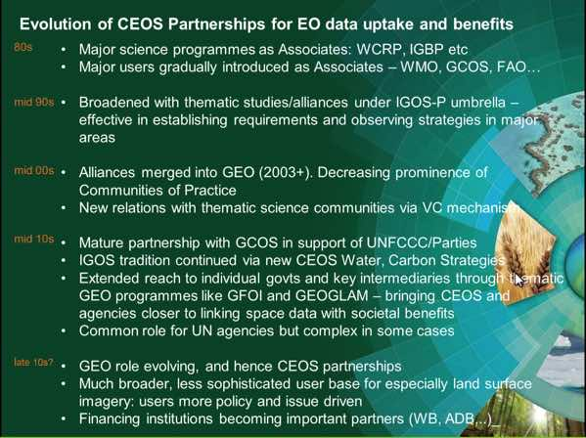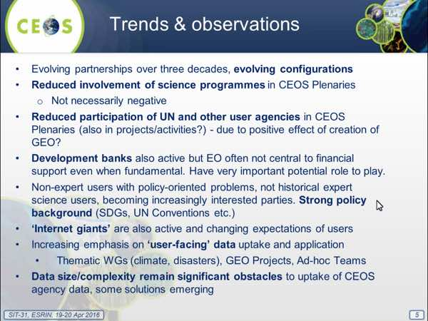
Stephen proposed two discussion topics to cover during the course of SIT-31.
- Should, and if so how might, CEOS establish a more systematic interaction and integration of UN agency and CEOS agency activities in areas of common interest? Is this the role for GEO in establishing a more strategic geometry for EOS programmes and the UN system? Is this the best route for CEOS?
- How could CEOS work through GEO to achieve greater strategic integration of political & financial support for our data uptake initiatives, including with international donor bodies such as World Bank, regional development banks? How can we ensure both the success in relation to UN Agencies of GEO, and CEOS’s role in it?
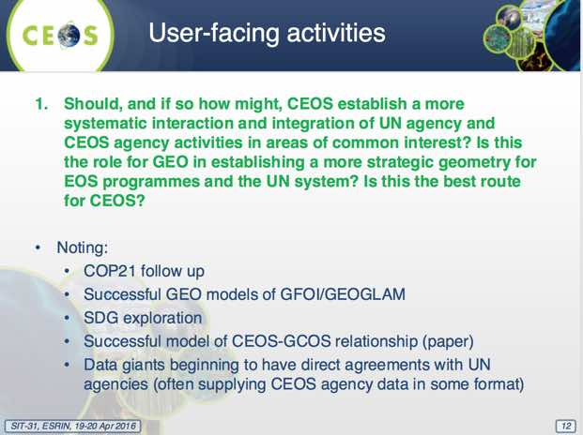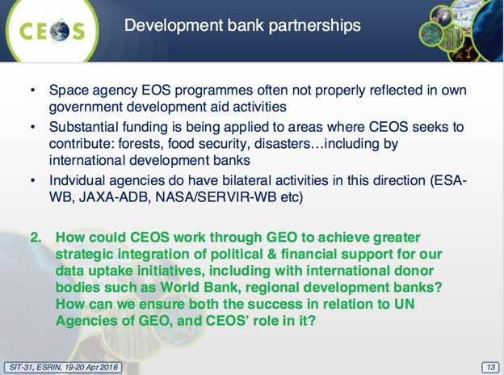
Stephen noted that these discussion points will be revisited during SIT-31, but also over ESA’s full SIT Chair term. He highlighted examples of key CEOS partnerships including GEO-DARMA, GFOI, and GCOS, noting these examples show there are a number of approaches and models to working with other institutions (e.g. independently as space agencies, via GEO).

4. GEO and GEO Initiatives

GEO Framework Update and Outlook
Barbara Ryan (GEO Secretariat Director) reviewed GEO’s vision and objectives, which focus on ensuring that society’s decisions and actions are informed by coordinated, comprehensive and sustained Earth observations and information. GEO aims to achieve this vision by:
- improving and coordinating observation systems;
- advancing broad open data policies/practices;
- fostering increased use of EO data and information; and
- building capacity.
Barbara noted that this is a unique period in GEO’s history, with the next decade of activities (2016-2025) being defined. In November 2015 a new Strategic Plan with new programmatic mechanisms was endorsed including community activities, foundational tasks, initiatives, and flagships. The convening power of GEO, the importance of increasing linkages to development banks, foundations, and the emerging private sector have been highlighted as key areas for GEO in future. CEOS is now a member of the GEO Programme Board (PB), which is responsible for defining and driving the work programme through which GEO achieves its strategic objectives. CEOS was selected to be an observer to the GEO Executive Committee.
Barbara reviewed the GEO SBAs noting the addition of a new SBA on Infrastructure and Transport Management. She also noted the absence of a Climate SBA, which was deemed by GEO Plenary to be a cross-cutting area that will be touched upon by activities under all of the other SBAs. GEO’s role in cross-cutting activities related to climate change has been recognised by SBSTA.
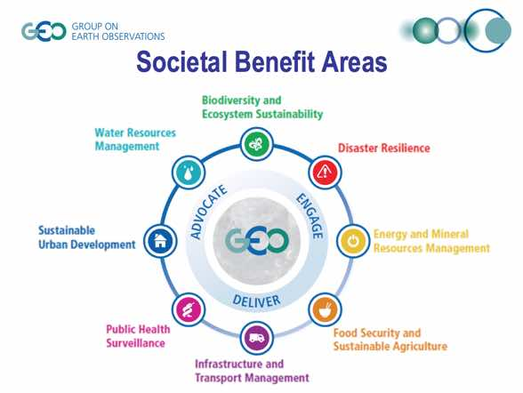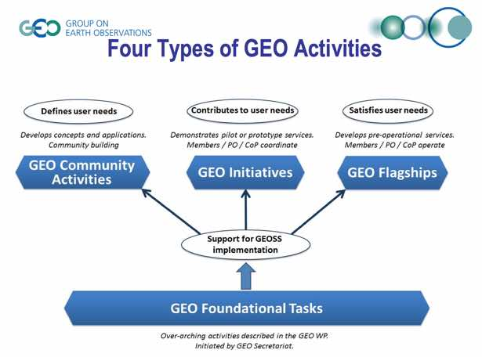
Barbara noted individual national statistical agencies will track progress against the UN Sustainable Development Goals (SDGs) through a series of indicators currently under discussion between governments, and making the connection between space agencies and the in-country statistical agencies is key to progressing the SDGs. A recent GEO-UN roundtable (7 March 2016) included 16 UN and international organisations and was an effective step in progressing the relationship among GEO and UN agencies.
Barbara reported that GEO will seek a renewed mandate from the G20 for GEOGLAM in November, and that the importance of GEO was highlighted in an October 2015 G7 communiqué. This policy recognition underscores the original vision for GEO, and has resulted from leverage of ongoing efforts by its membership.
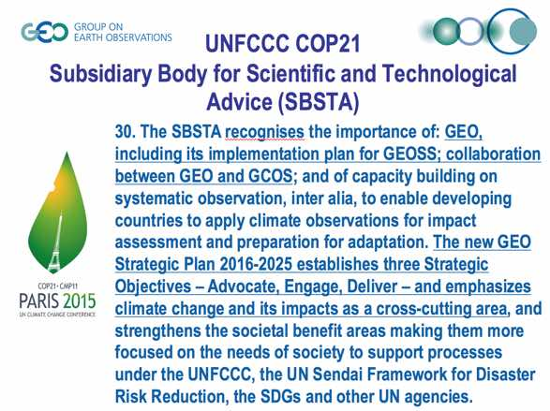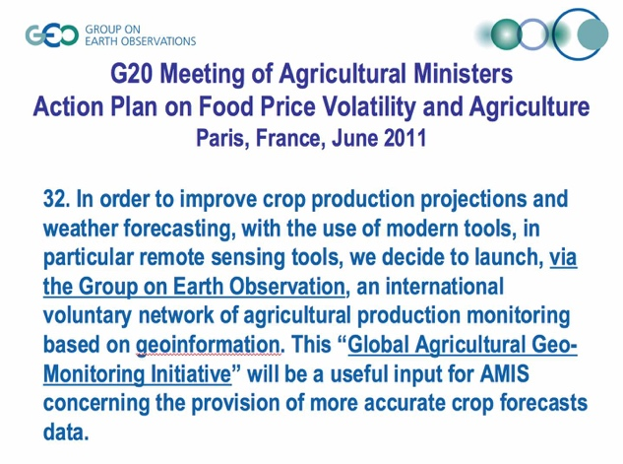
Barbara reviewed a few key trends that will likely be important in future, including encouraging broad national participation to try and break down silos, the evolution of the Copernicus data policy, and growth of GCI usage (in 2014 there were 500K visits, in 2015 that grew to 2.5M, and in the three months of 2016 there have already been 3M).
She noted the GEO Work Programme Symposium will take place 2-4 May 2016 in Geneva, and that the GEO-XIII Plenary will be held 9-10 November in St. Petersburg, Russia.
A discussion followed:
- Stephen Briggs (SIT Chair) noted that there is now a GEO task aimed at defining the observational requirements for the SBAs (referred to as ‘GD-08’), and that one key goal of the GEO Work Programme Symposium is to define a process for collecting requirements from user communities. He noted the past example of how IGOS-P collected requirements.
- Steve Volz (NOAA) asked why we have an SBA for infrastructure and transportation if there are no tasks contributing to benefits in that area. Barbara noted that SBA areas were decided based on impact to society and then linked to existing tasks. She noted the role of the Programme Board in fostering new activities to address gaps.
- Stephen Briggs noted that CEOS is firmly engaged in the governance of GEO, with observer status to the GEO Executive Committee, and representation on the Programme Board. It should be recognised that GEO has made a lot of effort to address the requests of CEOS, and CEOS now has an obligation to make the most of the opportunity.
- Brian Killough (NASA) asked about GEO’s relationship with the development banks, and Barbara noted that they have been working to engage with banks in Latin America, Asia (Asian Development Bank), and The World Bank. The World Bank has indicated their willingness to act as a coordinating body.
- Barbara sees support to the delivery of the UN-SDGs as a point that the development banks could focus on, and Brian noted they could be key capacity building partners where specific projects have been identified.
- Brian asked about CEOS capacity to engage with The World Bank, and technology partners (‘Internet giants’), and suggested that WGCapD and WGISS could have roles to play.
- Steve Volz asked about GEO’s capacity to support sustained interaction with end users and other stakeholders, and Barbara replied that GEO has a small (20 person) Secretariat who are well positioned to establish and maintain communication channels, with implementation covered by GEO Members and Participating Organizations working with external funding and implementing partners.
- Andy Mitchell (NASA) noted use of the CEOS IDN as the connection to the GCI, and the work that has been done to automate that connection.
- Mark Dowell (EC/JRC) suggested CEOS needs to be involved in GEO’s definition of SBA requirements (i.e. GD-08) to ensure that they are formulated in a format that allows CEOS and space agencies to effectively respond. Barbara noted that Giovanni Rum is coordinating GD-08, and has reached out to a number of agencies to discuss requirements during the Work Programme Symposium. She noted that a number of senior CEOS representatives will join this meeting.
- Mark noted the apparent lack of a mechanism to deal with the cross-cutting nature of climate requirements, and Barbara noted that GEO relies on GCOS to provide a coordination forum, and that more could be done around the definition of climate activities.
- Stephen Briggs noted it would be useful if GEO could establish partnerships and set the high level interaction with UN agencies and development banks, rather than having ad-hoc and individual arrangements each time CEOS and GEO needs to establish partnerships with these agencies.
Stephen Briggs concluded the discussion, noting that GEO has responded to CEOS’s request for governance representation, and he hopes to see the benefit of these decisions bear fruit in the coming years.

GFOI Status and Issues
Stephen Briggs noted the various recent leadership changes within GFOI. Masanobu Shimada of JAXA is now the CEOS lead for GFOI, Thomas Harvey is heading the GFOI Office, and Anssi Pekkarinen is the new GFOI Lead from the FAO. He gave a brief status report.
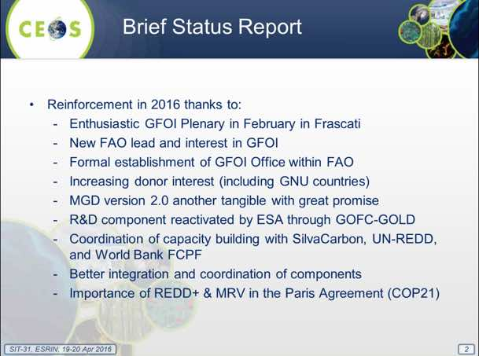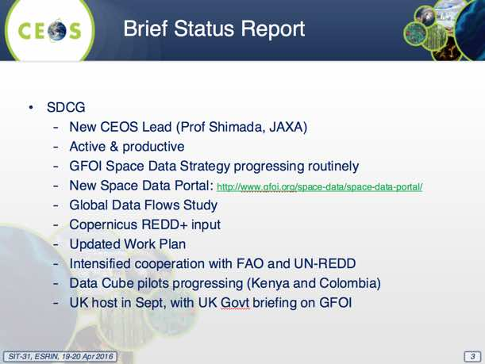
Stephen Ward (SDCG SEC) reported, noting that SDCG is providing the following documents to SIT-31:
- SDCG Element-3 Strategy: Satellite Data in Support of Research and Development (R&D) Activities v2.0 (for endorsement);
- Global Data Flows – Progress Report (for information);
- Baseline Global Acquisition Strategy For Satellite Data 2015 Implementation Report (for information);
- SDCG 2016-2018 Work Plan Draft (for information, will seek endorsement at 2016 Plenary & renewal of SDCG); and
- GFOI Strategy Document (for information).
Frank Martin Seifert (ESA) summarised the updated SDCG Element-3 Strategy: Satellite Data in Support of Research and Development (R&D) Activities v2.0 being presented for endorsement. He also reviewed the Baseline Global Acquisition Strategy For Satellite Data 2015 Implementation Report, noting that Landsat was the main workhorse again in 2015 and is soon expected to be joined by Sentinel-2A, once its commissioning phase is complete.
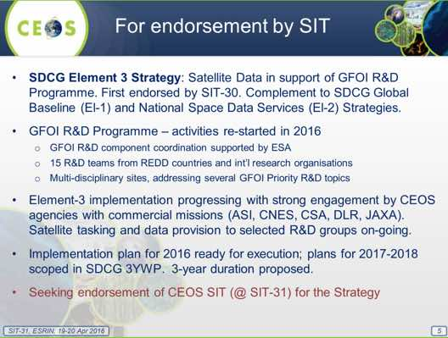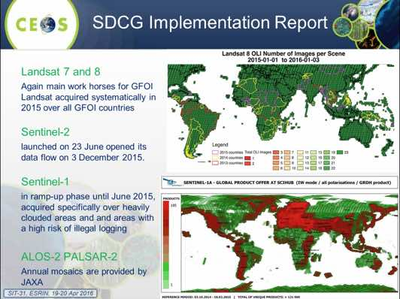
Stephen Ward summarised the status of acquisitions for GFOI, noting that the overall dialogue has shifted from concerns about data availability to how to remove obstacles to data uptake. He raised the following issues from SDCG for the attention of SIT:
- Due to the growing data volumes, a shift in the approach for the delivery of data to users is required. The Global Data Flows Study, which remains in progress, looks at possible scenarios and solutions. The Study has received positive feedback from countries and The World Bank on the obstacles to uptake of space data.
- SDCG sees significant strategic value in the working level initiatives in relation to ARD and the Data Cube, and believes these have significant potential to reduce obstacles to data uptake.
- The Australian funding cycle for GFOI ends as of 31 December 2016, and potentially impacts all aspects of engagement and support, including Australia’s role as a GFOI Lead, the development of the Methods and Guidance Documents (MGD, including the web application REDDCompass), and support to the Space Data Component through provision of the SDCG Secretariat. CEOS (as a GFOI Lead) should be aware, and consider the implications.
- Part of the focus of SDCG in 2016 is on an end-to-end demonstration of GFOI services with one or two countries in association with FAO and the GFOI Office.
- In support of the GFOI Global Baseline Acquisition Strategy, more frequent C-band SAR (dual-polarisation) observations over the world’s forested areas are required to make an effective contribution to REDD+, as well as to deforestation early warning systems.
A brief discussion followed:
- Einar-Arne Herland (NSC) emphasised the importance of the GFOI activity. He noted the Copernicus User Forum Global Land Service roadmap for future Copernicus services for REDD+. There is reference to GFOI and the MGD in the concept note, which represents a very important achievement for GFOI.
- Steve Volz asked whether the private sector has been engaged. And whether SDCG sees a gap in the approach advocated by GFOI, and that being taken by the private sector and others.
- Stephen Briggs noted that offerings like the Global Forest Products (produced by Matt Hansen) presented by Global Forest Watch are very accessible to users, but are not suitable for REDD+ reporting. Despite clear statements about the limitations of these products, there is confusion as to their suitability in the community, and they are frequently referenced by national forestry officials. He noted that one of the main objectives of GFOI has been to establish the MGD in order to promote approaches and products advocates suitable for formal reporting. Key to promoting update of GFOI approaches is the establishment of partnerships, and the GFOI Office is working in this direction.
- Stephen Ward agreed, noting that GFOI is a leading illustration of the need for GEO and CEOS to consider the collaboration with the big data actors with ambitions in common areas of interest. This also stresses the need for space agencies to consider alternate future data architectures with more emphasis on cloud computing and storage and ease of information extraction by end users.
Stephen Briggs called for endorsement of the SDCG Element-3 Strategy: Satellite Data in Support of Research & Development (R&D) Activities v2.0, and it was endorsed.
Frank Martin noted that Stephen Briggs’ replacement as the CEOS Lead for GFOI is Shimada-san of JAXA, and thanked Stephen for his years of support and service in fostering and promoting GFOI.
Decision 2 | SIT-31 endorsed the SDCG Element-3 Strategy: Satellite Data in Support of Research & Development (R&D) Activities v2.0.

GEOGLAM Status and Issues
Selma Cherchali (CNES) presented a summary of recent GEOGLAM activities, noting that it will request a renewal of its mandate from the G20 in November. This will include an enhanced focus on food security, and smallholder systems.
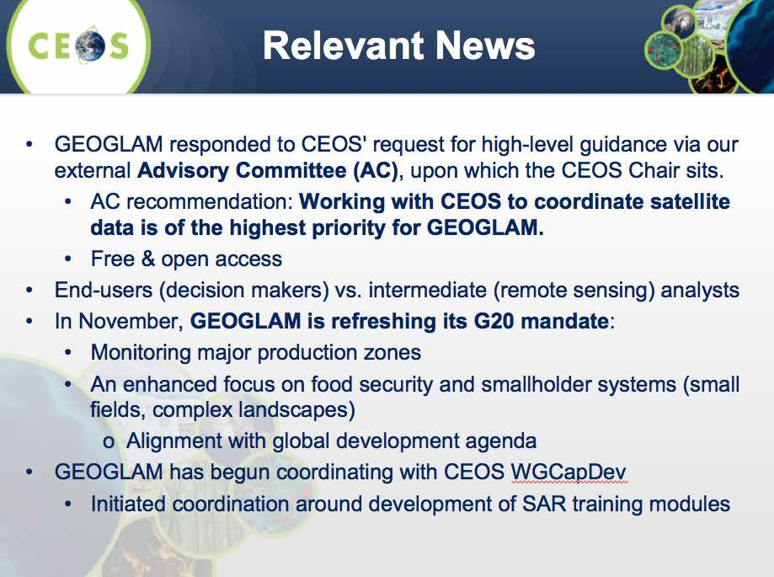
Brad Doorn (NASA) noted two strategic issues that GEOGLAM is raising for SIT consideration:
- Improving data access and utilisation (fulfilling GEOGLAM data requirements, and Analysis Ready Data for GEOGLAM); and,
- Promoting SAR data for agricultural monitoring.
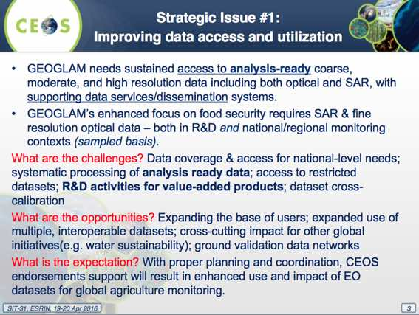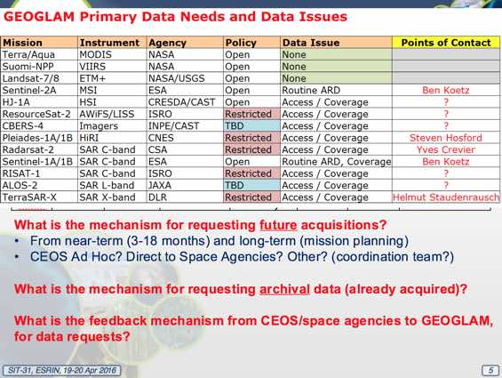
Brad noted that a GEOGLAM Data Requirements Submission Tool has been created which allows GEOGLAM users to self-report requirements for satellite data (both new acquisitions and archive data). He also requested that agency points of contact for GEOGLAM data needs and issues be identified.
Brad noted that GEOGLAM requests SIT to consider how CEOS might:
- establish mechanisms and processes for meeting GEOGLAM requirements;
- increase EO data utilisation by non-traditional users, especially in countries with poor internet connectivity, a lack of computational power, and limited experience with EO utilisation;
- facilitate access to data in support of generating improved baseline datasets (crop masks and crop calendars); and
- engage GEOGLAM in mission planning stages.
A brief discussion followed:
- Ivan Petiteville (ESA) suggested that the GEOGLAM ad hoc Working Group could consider approaches such as those employed by the SDCG for GFOI and the WGDisasters Data Coordination Team as examples of data coordination.
- Ivan asked about the GEOGLAM data requirements tool, and how requests are filtered and prioritised. Brad noted the intention is that these requirements are provided directly by the users (only one submission has been received to date), and that there is a follow-up dialogue with the user around preparedness before any data request would be forwarded.
- Osamu Ochiai (GEO Secretariat) noted the recently announced availability of ASTER archive data, and asked how this will impact the GEOGLAM initiative. Selma acknowledged there are several potential uses, and that the data requirements table will be updated accordingly.
- Pascale Ultré-Guérard (CNES) asked about the origin of the data requirements submission tool and whether this was specific to GEOGLAM, and Brad replied that the GEOGLAM Secretariat prepared the tool for GEOGLAM.
- Pascale asked about future planned interaction with the LSI-VC, GEOGLAM, and the SDCG for GFOI, and Stephen Briggs noted that the split of responsibilities between these groups is a key strategic topic for CEOS that remains to be resolved when the time is right.
SIT-31-01 | CEOS Agencies asked to co-operate with an anticipated GEOGLAM Secretariat request for identification and confirmation of Points of Contact in relation to data acquisition planning & data access requests for GEOGLAM | GEOGLAM Secretariat | May 2016

Blue Planet Update
Paul DiGiacomo (NOAA) reviewed the objectives of the GEO Blue Planet Initiative:
Objective 1: Provide foundational support to the Earth observing community by bringing together the numerous and diverse ocean, coastal and inland water observation organisations and programmes.
Objective 2: Identify gaps in user needs and develop end-to-end services (i.e. support the development of GEO Flagship services).
Paul stressed that Blue Planet needs high-level stakeholder representatives to support implementation. He noted that within the next year the focus will be on strategic communications and engagement, establishment of a management structure, updating the Implementation Plan, and building the Blue Planet community. In the next three years the focus will be on increased communication and coordination within the ocean observing community and with end users, and beginning the development of end-to-end services.
SIT-31-02 | Paul DiGiacomo to liaise with Blue Planet in relation to the space data needs associated with their initial implementation phase activities | Paul DiGiacomo | SIT Tech Workshop

Other CEOS Actions in GEO WP
Jonathon Ross (GA, CEO) presented a summary of CEOS contributions to GEO, with CEOS contributing to more than half of GEO’s activities. He noted that CEOS contributes to one third of GEO Initiatives, and almost two thirds of likely GEO Flagships, leads foundational tasks like GD-05, and makes major contributions to other foundational tasks

The increasing contribution of CEOS to the leadership and governance of GEO is a significant opportunity for CEOS to contribute to the success of GEO. This may not be strictly core ‘CEOS business’, but it reflects the notion that the success of CEOS is closely linked to the success of GEO.5. United Nations Framework Initiatives

UN-WCDRR
Stéphane Chalifoux (CSA) reported, noting that:
- WCDRR 2015 was a very significant event in relation to global action on disaster response and preparedness issues; and
- WGDisasters has three thematic pilots underway (floods, volcanoes, seismic hazards), as well as the Recovery Observatory project.
He reviewed the status of the CEOS Disaster Risk Management Pilots and Recovery Observatory, including the linkage to WCDRR.
Activity | WCDRR Linkage
Flood Pilot | Floods most prevalent disaster globally; compelling satellite-based approach would offer major step forward
Volcano Pilot | Pilot demonstrates clear, measurable ability to reduce risk, but requires global application.
Seismic Hazards Pilot | Pilot shows science can improve hazard understanding; needs closer linkage to WCDRR, possibly through GSNL.
Recovery Observatory (RO) | RO strong tool to promote resilient recovery; requires plan for broader, more systematic application.
Landslides Pilot | Not established.
Four questions were raised for SIT consideration:
- Pilots will be reviewed by Plenary in October 2017 – what are the expectations of CEOS for pilot reporting? Are there any specific concerns or interests?
- Pilots are on-track to achieve significant success in some areas – what is the CEOS vision for sustainability of successful activities within or outside CEOS?
- Pilots have formed strong partnerships with organisations outside CEOS (GFDRR/World Bank, UNDP, Universities) – how should CEOS encourage continuity of these relationships outside the pilot activity?
- What is the best mechanism to directly link positive pilot outcomes to sustainable services tied to Sendai Framework implementation?
Ivan Petiteville (ESA) reviewed the CEOS pilot and lobbying efforts for the 3rd UN WCDRR (2015), noting that the Sendai Framework for Disaster Risk Reduction 2015-2030 marked the first time satellite EO has been explicitly incorporated in such a decadal plan of action. It was also a significant opportunity to raise the profile of satellite EO in the disaster risk management community. Following the Sendai WCDRR, CEOS and GEO SEC developed a new GEO initiative, GEO Data Access for Risk Management (GEO-DARMA), which was incorporated in the GEO Work Programme in 2016.
A brief discussion followed:
- Ivan noted the importance of partner organizations (e.g. UN agencies) contributing according to their competencies and mandates, and that CEOS had observed some conflict with some UN agencies seeking to take on a space agency coordination role. Stephen Briggs (SIT Chair) noted it is important for CEOS to ensure that the right partners are identified with the right roles.
- Jonathon Ross (GA, CEOS) noted the importance of GEO-DARMA showing concrete progress now that the conceptualization process had been successfully concluded, and that all stakeholders must engage in order to ensure that the GEO Programme Board approves it as a GEO initiative.
- Barbara Ryan (GEO Secretariat) believes GEO can be a vocal advocate for CEOS in the case of disasters, and noted the Secretariat is seeking a secondee to work on the Disaster Resilience SBA. GEO is encouraging UN agencies to engage around the CEOS table, and in some cases these agencies are already CEOS Associate members.
- Steve Volz asked about criteria for determining when and how successful CEOS pilots would transition to operations. Stéphane responded that WGDisasters plans to present the criteria at CEOS Plenary, one year ahead of the end of the pilot activities.
- Stephen Briggs noted the need to define space agencies’ role in a DRM pilot once it is deemed ‘successful’ and that there should be an evolution of the role of space agencies as an activity develops.
- Mark Dowell (EC/JRC) noted that disasters is the only area where there is both a standing CEOS Working Group and a proposed Initiative within GEO. He noted this is in contrast to ad-hoc groups such as the SDCG for GFOI, and the GEOGLAM ad hoc Working Group, and asked whether a standing group provides unique value over an ad-hoc group. Stephen Briggs noted that both GFOI and GEOGLAM were initiated within GEO, and CEOS responded with the establishment of the ad-hoc groups. He would hesitate to add any additional standing thematic groups to CEOS at this stage for fear or proliferating unnecessary structure.
- Ivan added that WGDisasters started as an ad-hoc group, but was transitioned to a standing Working Group in an effort to consolidate the many ongoing activities, and to provide more structure - the Group now has between 80 and 90 active contributors.
- Ivan also stressed that it is not the goal of CEOS to lead GEO-DARMA in future, and it is hoped another entity - such as The World Bank - might take over the coordination of the activity.

United Nations Sustainable Development Goals
Marie-Josée Bourassa (CSA) introduced the United Nations Sustainable Development Goals (SDGs). Unlike the Millennium Development Goals (MDGs), SDGs are defined and officially approved by nations. The indicator framework is currently being established and will define the what, who, and how of monitoring. The UN Statistical Commission has drafted 231 global indicators organised into three tiers based on conceptual clarity, methodology and standards, and regularity of production generation, and a geospatial information subgroup has been established. (Provisional Proposed Tiers for Global SDG Indicators as of 24 March 2016: http://unstats.un.org/sdgs/files/meetings/iaeg-sdgs-meeting-03/Provisional-Proposed-Tiers-for-SDG-Indicators-24-03-16.pdf) To date, CEOS consideration of strategies to ensure space data can support the SDG agenda has taken place in coordination with GEO and UN-GGIM.
Alex Held (CSIRO) noted CSIRO has been working with the Australian Bureau of Statistics as part of the Task Team on Satellite Imagery and Geo-Spatial Data for the Big Data UN Global Working Group, and that they are taking the opportunity to align the work with the CEOS effort on SDGs. He also noted that some development banks are considering aligning funding grants with SDG outcomes, and are becoming more aware that EO can contribute to activities they support through monitoring.
Alex reviewed the outcomes from the SIT-31 SDG side meeting.
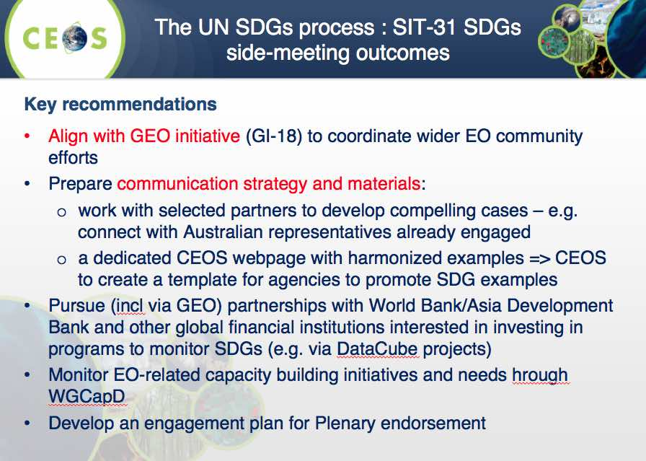
A brief discussion followed:
- Carolin Richter (GCOS) noted that the SDGs are driven from the top-down, while the goals will be realised from the bottom-up. She noted that GCOS was asked to lead the SDG on Climate by UN, and there is a corresponding lead for each SDG within the UN.
- Mark noted that use of satellite data to monitor change has been included in the land degradation-related SDG from the outset.
- Mark added that UN agencies have been identified for the climate, land degradation, and oceans-related SDGs, and Marc Paganini (ESA) confirmed that these leads have been published in the SDG documentation.
- Jonathon noted the potential for confusion around the coordination efforts of CEOS, GEO, UN-GGIM, and Stephen Briggs agreed on the need for these efforts to be well aligned.
- Stephen Briggs suggested that CEOS open a dialogue when appropriate with the relevant UN body on each of the SDGs in a bottom-up effort to establish an appropriate role for satellite EO data. He noted the discussion in the side meeting around the role for the development banks and their potential application of the SDGs in relation to approval of donor aid funds, and Stephen Coulson (ESA) suggested that the role of banks in the SDG context very much remains to be determined.
Decision 3 | The CEOS way forward on the Global Goals for Sustainable Development (i.e. UN-SDGs) will be undertaken in collaboration with GEO & UN-GGIM, supplemented by a top-down dialogue with relevant UN Agencies and with individual CEOS Agencies making connections within their governments.

6. Coordination of Climate Observations

Coordination of Climate Observations
Carolin Richter (GCOS) reviewed GCOS’s role in curating and coordinating activities related to the Essential Climate Variables (ECVs) across the community, noting that the GCOS Implementation Plan (IP) will be updated in 2016.
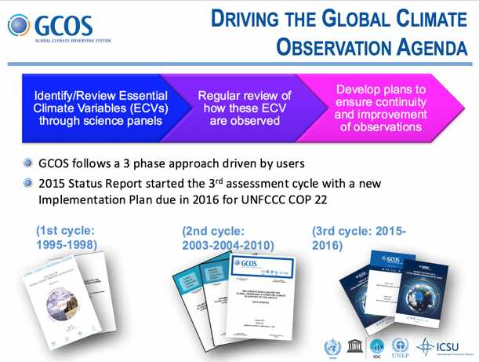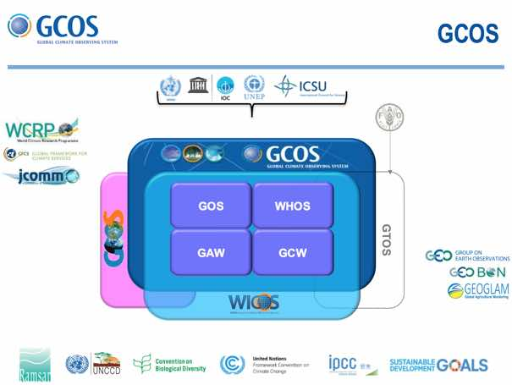
She noted that GCOS delivered a report on the Status of the Global Observing System for Climate and a draft outline of the new GCOS IP to COP21, with the final update of the IP to be presented at COP22. The GCOS Open Science Conference was held 2–4 March 2016. Some key outcomes were the:
- need for an extensive set of relevant climate indicators;
- need for long-time series of climate records which will reliably draw up the budgets for energy and carbon;
- continued importance and need for in-situ observations;
- improved observations of ocean and land surface stress, latent heat flux and sensible heat flux;
- need for climate research to exploit the full potential of global climate observing systems; and,
- the need to include biology in any description or modelling of the climate system.
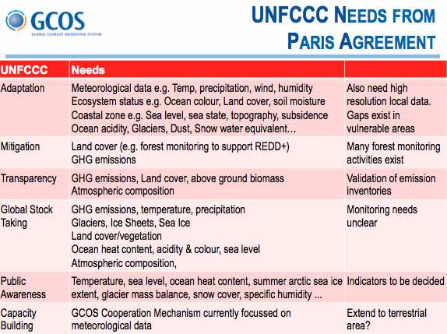
The new GCOS Implementation Plan will broaden its scope to address global environmental cycles (e.g. energy, carbon and water), and take into account the UN Sustainable Development Goals, climate services, climate indicators, and the relevant outcomes of discussions during COP21. It will include recommendations on measurement requirements for both mitigation and adaptation, will lay out a new strategic approach to further implementation, and will introduce a section on cross-cutting disciplines and on scientific and technological challenges.
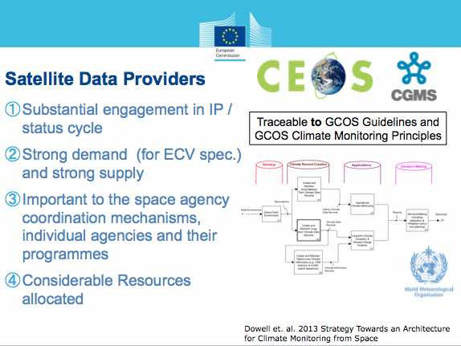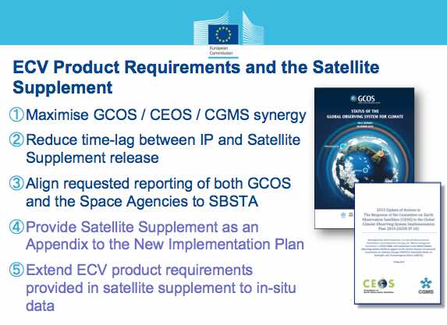
A brief discussion followed:
- Jane Olwoch (SANSA) asked about the users of the ECVs, and Carolin responded that they are used by the climate community. She also noted that CEOS VCs are responsible for coordinating the production of products and data records based on the ECVs. Jane suggested that CEOS could take a more active role in promoting the ECVs, and Carolin agreed.
- Mark Dowell (EC/JRC) noted that Part 1 of the GCOS Implementation Plan is targeted at policy makers, while Part 2 is a requirements annex intended for technical implementation (e.g. by space agencies). He noted that the intention was to extend the table of ECVs in the annex to include some in-situ requirements, and that the annex would no longer be called the “Satellite Supplement” but would instead be referred to as “ECV Product Requirements.”
- Stephen Briggs (SIT Chair) noted that the GCOS-CEOS relationship is working very well, based on a clearly defined set of requirements for agencies.
COP21 Outcomes and the Paris Agreement
Pascal Lecomte (ESA, WGClimate Chair) reviewed the main outcomes of COP21, noting that there were several new approaches agreed, and a focus on science and measurable long term outcomes.
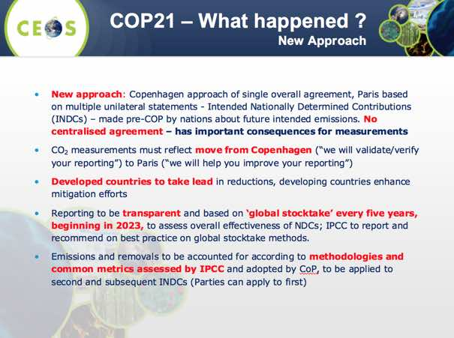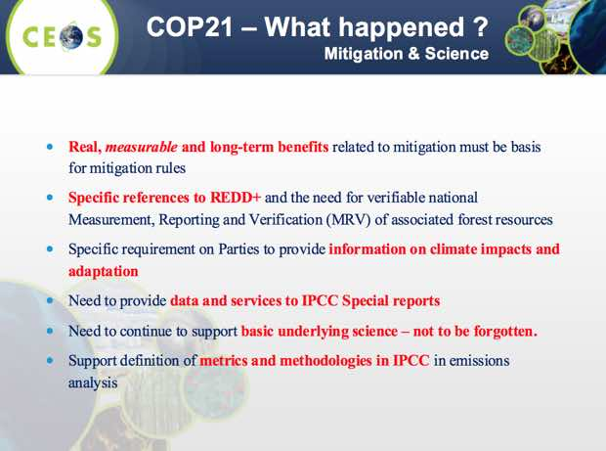
He noted that CEOS was well represented at COP21, and presented a summary of the potential roles for space agencies in climate observations and services arising from discussion there and in the follow-up.
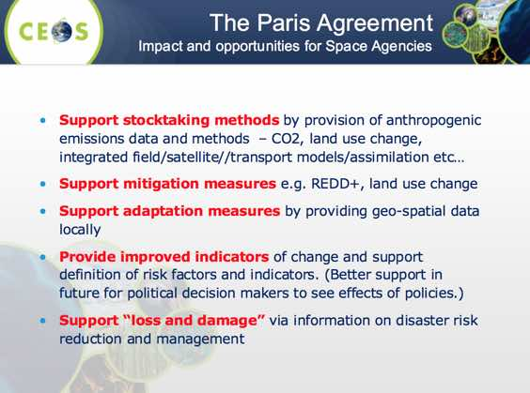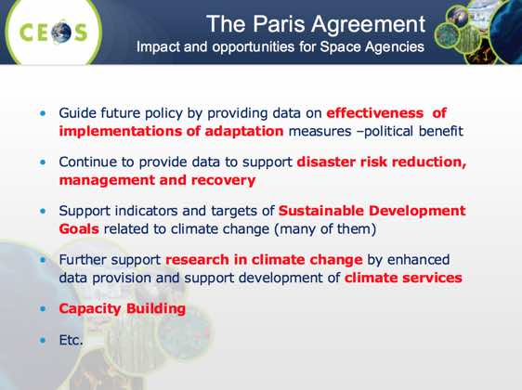
A brief discussion followed:
- Ivan Petiteville (ESA) asked whether there is a centralised agency in charge of interfacing with the various actors to foster the execution of the Paris Agreement, and Pascal indicated there is not.
- Mark noted that support to stocktaking, mitigation, and adaptation measures is consistent with the broadened scope of GCOS, and that the Paris Agreement’s outcomes will flow to CEOS through GCOS.
- Josef Aschbacher (ESA) noted that ESA is working with the EC on the study of the future Copernicus space segment, and a future mission (e.g. Sentinel-7) could be related to greenhouse gases like CO₂.
- Stephen noted that there are a whole range of measures that space agencies can take to support the Paris Agreement, and that GCOS is focusing on what is needed globally rather than locally. He noted that the Paris Agreement is a good opportunity for space agencies to formulate their response, and it is fortunate that it coincides with the update of the GCOS IP and the CEOS response.
Delhi Declaration
Pascale Ultré-Guérard (CNES) presented a summary of the new Delhi Declaration proposed by Jean-Yves Le Gall (CNES) and Kiran Kumar (ISRO) at the occasion of the Asia-Pacific Remote Sensing (APRS) Symposium in New Delhi, focusing on the role of satellites for climate monitoring (in particular greenhouse gasses). This declaration complements the Mexico Declaration approved by Space Agencies at the IAC in September 2015. She explained that she does not expect major changes from CEOS-SIT since the text has already been submitted to the head of Space Agencies, and that this version is taking into account the main comments received so far.
A brief discussion followed:
- Stephen Briggs (SIT Chair) suggested that some of the post-COP21 opportunities presented by Pascale could be reflected in the declaration.
- Steve Volz (NOAA) noted that item four doesn’t mention operational satellites, and suggested a sample of both operational and research satellites should be referenced. Pascale noted that the list was shortened as it was too long, and was focused on those satellites monitoring greenhouse gases. She also noted that the conclusion of the paragraph was that the current suite of satellites is useful, but not sufficient.
- Alain Ratier (EUMETSAT) suggested that the declaration should be reviewed for consistency with the diplomatic statements coming out of the Paris Agreement, and this should be done by CNES - being closest to the diplomatic process.
- Steve Volz also asked who the intended audience was for the declaration and Pascale answered that the Delhi Declaration was more of a political tool that could be used at COP22 as official text, much like the text from the September 2015 Mexico City Declaration.
SIT-31-03 | CNES, in coordination with ISRO, to consider comments raised at SIT-31 in providing feedback to finalisation of the Delhi Declaration | CNES | COMPLETE

ECV Inventory and Climate Architecture
Pascal Lecomte reviewed the current ECV Inventory development and update cycle.
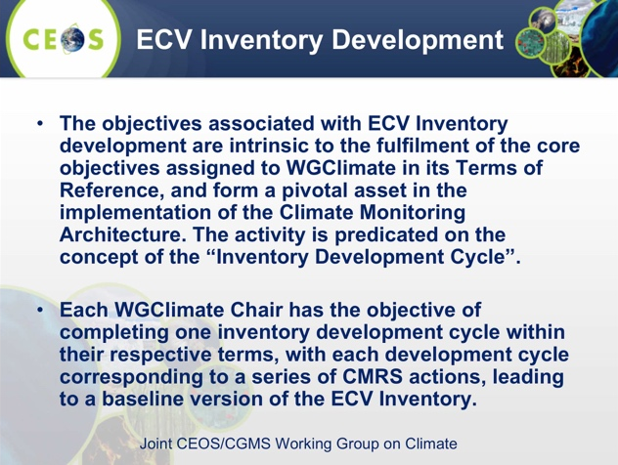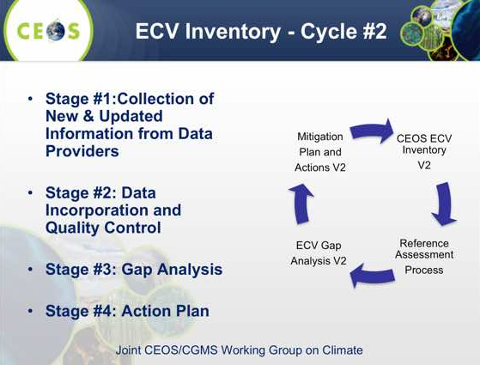
He noted that ECV Inventory development and release cycles coincide with the two-year term of each WGClimate Chair, correspond to a series of Climate Monitoring, Research and Services (CMRS) actions, and result in a new baseline version of the Inventory. The Inventory describes the current and planned monitoring capability, provides details of the records, attempts to establish traceability consistent with the GCOS principles, requirements and guidelines, and supports gap analysis.
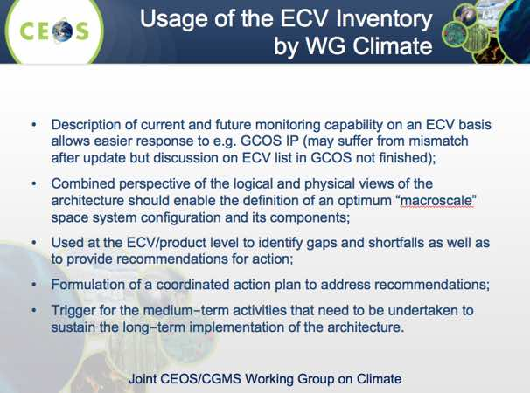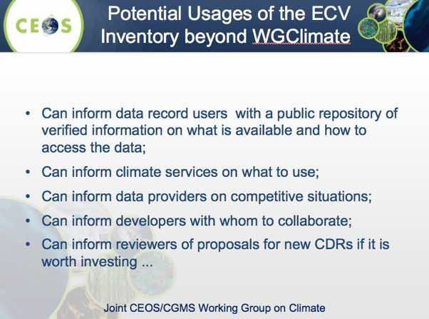
The second cycle of Inventory population is underway, and is available here: http://climatemonitoring.info/wgclimate.
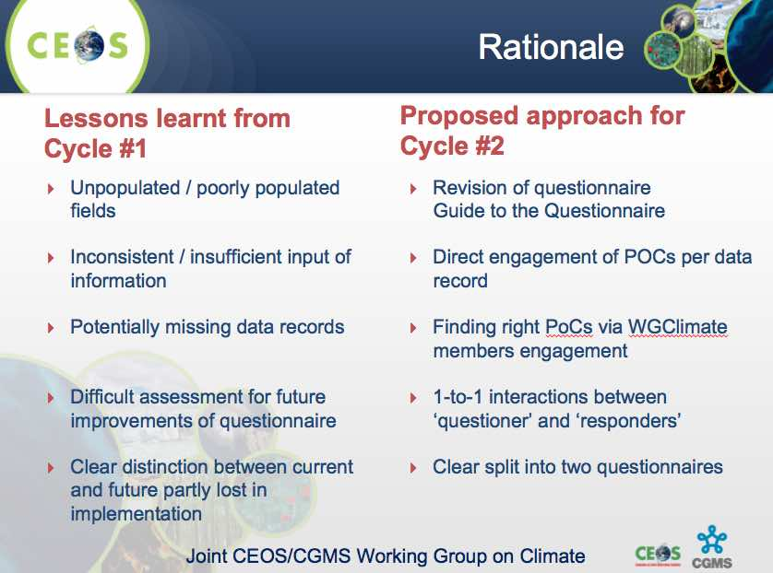
Pascal reported that a nominee for the 2018-2019 WGClimate Vice Chair needs to be identified by 31 January 2016 to be confirmed at the WGClimate #7 meeting (February 2017), and presented for endorsement at CGMS (May 2017) and CEOS (October 2017) Plenaries. It was noted that the convention agreed was to alternate the WGClimate Chair between the operational and research agencies, and so this next nominee should represent a research agency.
Pascal also noted that the WGClimate gap analysis groups require support from the VCs and other CEOS entities, and that WGClimate will reach out to CEOS and CGMS agencies seeking support for the development of the space agency response to the GCOS IP.
A brief discussion followed:
- Andy Mitchell (NASA) asked about the traceability of the ECV Inventory to missions, and Pascal noted he doesn’t believe that this iteration of the Inventory is ready for that level of integration.
- Barbara Ryan (GEO Secretariat) asked if we could take the ECV Inventory approach and apply it to the other thematic areas. Stephen noted that while it would be ideal, building this kind of database is difficult to achieve at present. The current approach is to focus on climate to keep the problem manageable, and because it links to a firm problem that is facing the community. He advocated restricting the effort to a few (approx. 2-4) application areas to keep the challenge manageable before trying to address the question of general analyses.
SIT-31-04 | Agencies to submit nominations for the WGClimate Vice Chair position to be confirmed at the WGClimate meeting in February 2017, submitted for endorsement at CGMS Plenary 2017 (Q2 2017), and CEOS Plenary 2017 (October 2017), and to assume the WGClimate Vice Chair role as of endorsement from CEOS Plenary 2017 for 2018-2019. By convention, nominations from ‘R&D’ agencies are to be given preference for this rotation. | CEOS Agencies | Nominations by 31 January 2017

7. Data Architectures and Enhanced Exploitation
Stephen Briggs (SIT Chair) summarised some of the current trends in land imagery data architectures, noting that the increasing number of innovative ways to access and exploit satellite data being produced by CEOS Agencies has important implications.
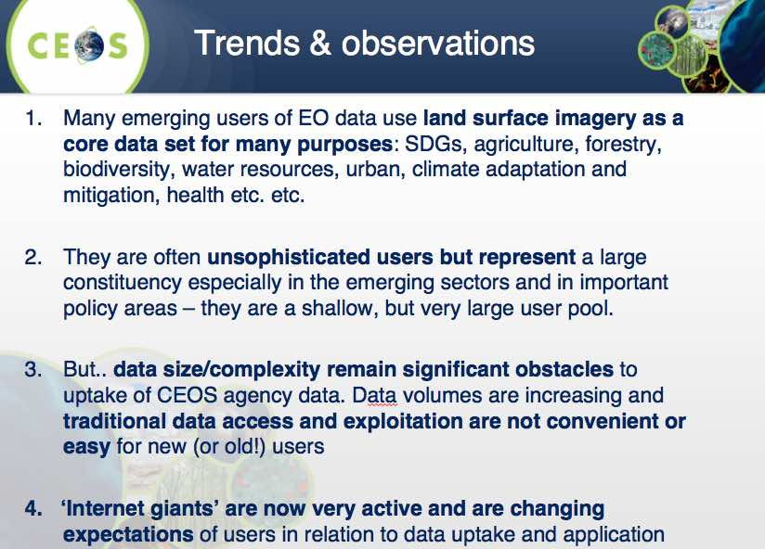
Four topics were raised for discussion:
Discussion topic #1: Given the increasing activity of commercial cloud storage and processing players (such as Amazon and Google) in the uptake and application of CEOS Agency missions, what should be the reaction of CEOS Agencies? How can agencies take advantage of their entry into the game?
Discussion topic #2: How will government programmes co-exist with these trends? What is the impact on the nature of agency ground segments? Do we need novel partnerships with commercial sector?
Discussion topic #3: Analysis Ready Data (ARD) has potential to support CEOS data uptake efforts. SEO has started a draft ARD description document to support effective coordination and standardisation efforts at this early stage. Should CEOS establish a strategic and top-down approach to ARD – supporting SEO activity and building on it?
Discussion topic #4: If we wish to pursue with SEO, how might CEOS Agencies further support the lead of the CEOS SEO to seize the opportunities ahead?
Analysis Ready Data (ARD)
Stephen Briggs noted that the current scope for CEOS ARD is limited to land surface imagery, and that we are not seeking the best solution, but an optimised solution that meets the needs of the greatest number of people.
A discussion followed:
- Jenn Lacey (USGS) noted that LSI-VC and the SEO has been working on a draft definition of Analysis Ready Data (ARD), and expects to present this to CEOS Plenary for endorsement.
- Brian Killough (NASA/SEO) noted that he sees the definition as a top-down, high level description to enable the community to communicate around minimum processing levels, without making it overly prescriptive. He noted the goals of increasing ease of data use while achieving suitable accuracy to enable decision-making and facilitate interoperability. Brian noted that within the last year, USGS has started supplying ARD data systematically, and that preliminary discussions are underway to try and achieve the same for Sentinel-2 (and also Sentinel-1) in future.
- Mark Dowell (EC/JRC) confirmed that Sentinel-2 ARD products have been in the Copernicus work programme for a number of years, and includes the development of Level-3 products via the Copernicus Global Land Service (GLS).
- Albrecht von Bargen (DLR) added that ARD products should maintain a clear link to the geophysical parameter.
- Jonathon Ross (GA) noted discussions of ARD within the Australian user community have been challenging, with many users having to agree on a common approach to the systematic generation of surface level products, and having to make ‘unpopular’ decisions or compromises.
- Stephen Ward (SIT Chair Team) noted that in this current era where data supply is abundant, free, and open, there is a role for space agencies to enable sensor agnostic applications via more pre-processing.
- Tom Cecere (USGS) noted that the space agencies should take on this kind of processing so end users don’t have to. He added that ARD is not only helpful for less experienced users but also those that are performing large analyses over very large areas, scales, and time series.
- Henri Laur (ESA) noted that ARD is one solution, but there are other solutions that ESA hopes to see reflected in the Future Data Architectures (FDA) Study. Defining ARD is only one component, and the capacity to process and host the data also need to be considered.
Stephen Briggs summarised the discussion on ARD, noting that there is general agreement that:
- increased user-friendliness through ARD would promote use of EO data;
- CEOS needs to consider a definition of ARD such that agencies can provide compliant data products, and that there are some agencies (e.g. USGS) already doing this;
- other agencies (e.g. ESA) are working toward a definition of ARD; and
- the ability for provider agencies to systematically and sustainably produce ARD needs to be considered as it may lead to additional requirements and a processing burden on their product development chain.
Accessibility, Processing, and Infrastructure
- Rob Woodcock (CSIRO) noted that accessibility should be a key consideration, and that opening up access (e.g. API access) has opened up EO analysis capabilities to a much broader audience.
- Paul DiGiacomo (NOAA) noted that CEOS Agencies should consider (e.g via the FDA Study) potential efficiencies in processing data where it is stored, rather than having it downloaded for processing.
- It was noted that bringing the algorithm to the data repository is the approach being pursued by ESA.
- Brian noted that big data actors (e.g. Google, Amazon) present a great opportunity to promote uptake of satellite data. He noted that for the Data Cube, the SEO is supporting local infrastructure deployment, deploying to regional data hubs (e.g. SERVIR), and via commercial cloud hosting services. Andy added there may be a business cases for storage and processing of data, but that space agencies should always remain the stewards of the data.
- Alex Held (CSIRO) stressed that when considering possible infrastructure solutions, things will vary greatly by user, and user needs should not be considered static. He suggested that early in development cycles, commercial cloud hosting may allow for rapid deployment, but in time and with successful demonstration of service, investment in local/national infrastructure may make more sense.
- Steve Volz (NOAA) noted that NOAA are partnering with commercial cloud providers to take advantage of their infrastructure, and that in many cases space agencies can't compete with their data distribution capabilities. He noted that in some cases, NOAA ends up ‘co-branded’ with some of these distribution partners, and potential brand dilution is a consideration.
- Alain Ratier (EUMETSAT) noted that in the case of emergency information, system reliability and legal issues need to be considered, and Steve stressed that in the US, NOAA issues the official alerts directly via their networks.
- Henri noted that there needs to be certainty around data sovereignty, and to date Europe has maintained in-house data processing and storage capabilities in order to provide this certainty.
- Mark noted that CEOS Agencies are all pushing their own programmes, but the important common denominator is promotion of free and open data.
Stephen Briggs summarised the final conclusions of each of the discussion points, noting that this had been a useful debate to help scope the issues, and that overall addresses a key challenge for an important subcategory of applications and data. He noted that users will make decisions based on whatever data is available, even if it is not processed to an appropriate level, and there is an opportunity to improve the quality of data users are utilising, as well as the user experience by pursuing some of these topics.
Discussion topic #1: Commercial cloud storage and processing players and discussion topic #2: Impact on the nature of agency ground segments and partnerships with commercial sector - overall it is felt that CEOS activities are in alignment with the emergence of these new actors. CEOS Agencies will remain the ultimate stewards of the data, and are best served by providing stable, quality controlled, accessible products that are processed to the furthest extent possible to facilitate user uptake and analysis without attempting to become producers of a wide variety of true ‘end use’ products, where ownership by users (e.g. local government agencies) is critical.
Discussion topic #3: Potential uptake role for Analysis Ready Data - it is agreed that there is a strong potential role for ARD, and it noted that efforts are currently underway within CEOS (e.g. LSI-VC, CEOS SEO) to develop a high-level working definition of ARD.
Discussion topic #4: Further CEOS agency support to the CEOS SEO - a number of different implementation options were discussed around the issue of data sovereignty (e.g. local hosting, national capacity), and commercial cloud computing services. It is noted that user needs vary case-by-case, and by phase of application development, and that their infrastructure and implementation decisions vary based on these factors, and therefore any solutions developed by CEOS (i.e. SEO) need to be as flexible and adaptable as possible.
SIT-31-05 | LSI-VC and SEO to collaborate to further develop the CEOS Analysis Ready Data (ARD) definition document with support from interested CEOS Agencies | LSI-VC Co-Leads, SEO | SIT Tech Workshop
Stephen Briggs summarised the main discussion points on the first day of SIT-31.
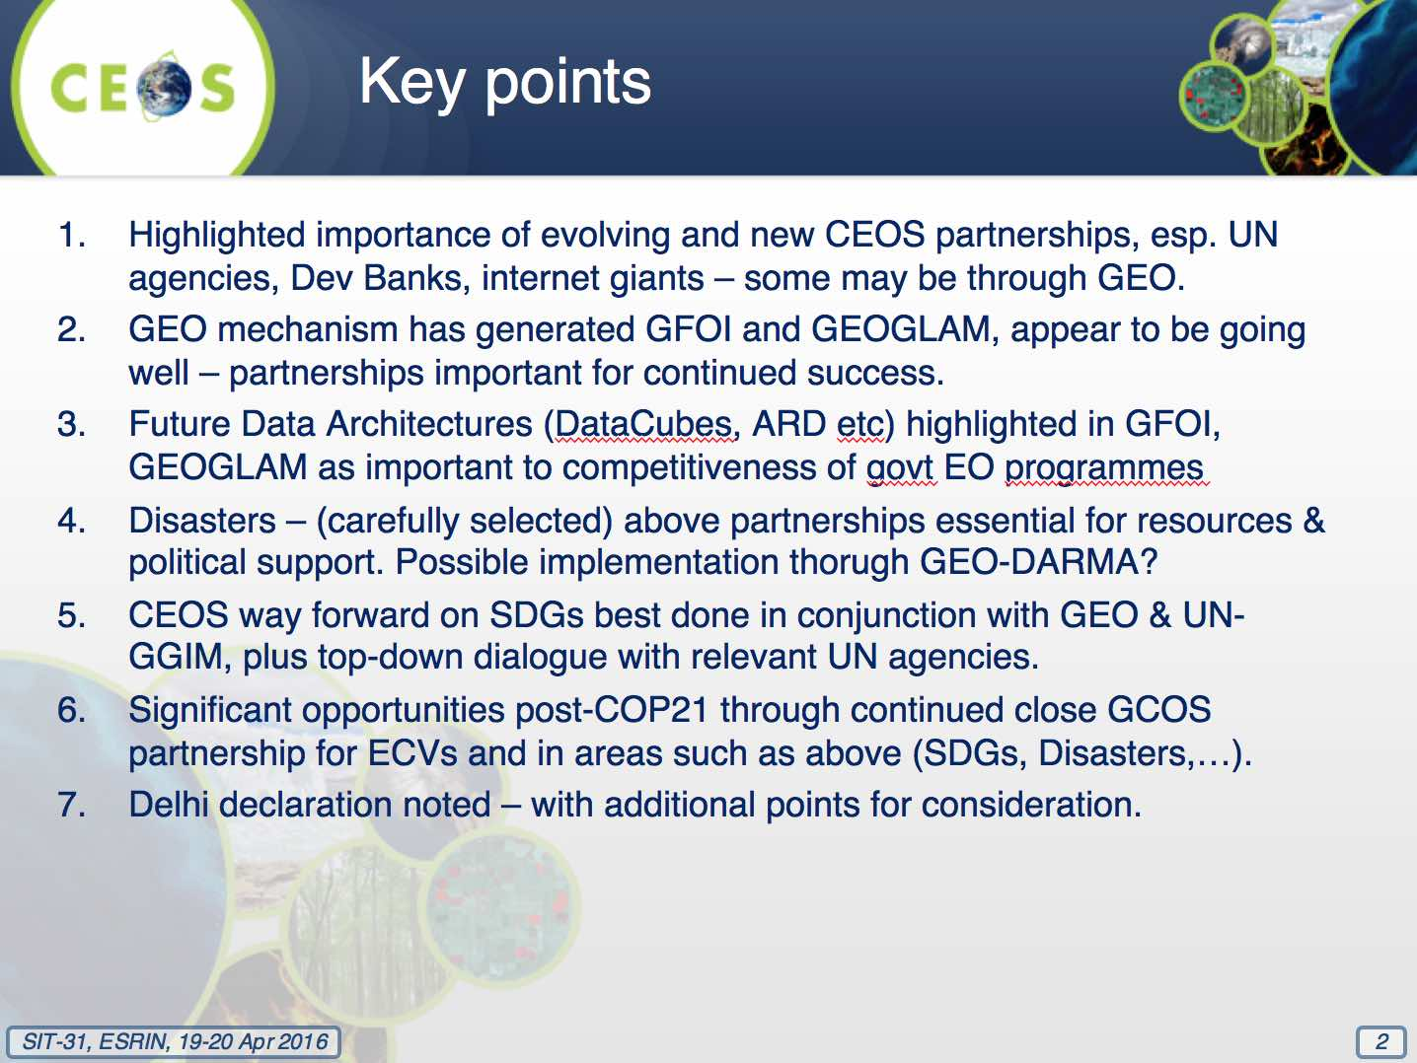

8. Thematic Observing Strategies

CEOS Carbon Strategy
Mark Dowell (EC/JRC) reviewed the heritage and status of the CEOS Strategy for Carbon Observations from Space which was completed in March 2014, and identified 42 actions for response by CEOS Agencies. Many of these actions are cross-cutting, and coordination of these efforts across VCs and WGs is covered by the 2016-2018 CEOS Work Plan objective CARB-8. In addition, CARB-12 calls for CEOS support to the definition of a potential GEO Carbon Flagship.
Mark noted that as of the 2015 SIT Technical Workshop (last September), limited progress had been reported, in part reflecting the overall large scale of the strategy. The VCs and WGs confirmed that they understand the actions, and that internal planning and resource assessment is under way (with no resource limitations currently identified). The SIT Technical Workshop noted that the broad scope of some of the actions presented challenges for planning a response.
At the 2015 Plenary, VCs and WGs were reassured that Principals understand that finishing many of the actions is a long-term effort and that a flexible approach is appropriate. At Plenary, and stressing the need to build momentum, the SIT Vice Chair suggested that the VCs and WGs focus on achievable near-term (1 year) steps to show some progress, and that Principals be engaged to establish their support for these proposed next steps. VCs and WGs agreed to propose such next steps with a 1-year time horizon, for consideration at SIT-31.
Mark reviewed discussion at the 3rd Carbon from Space Workshop (January 2016), and noted that a draft position paper coming out of the Workshop is expected shortly.
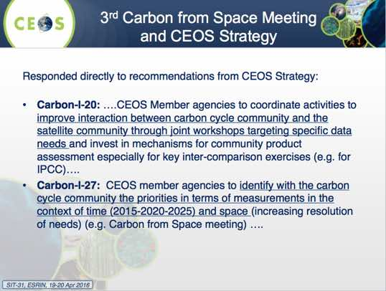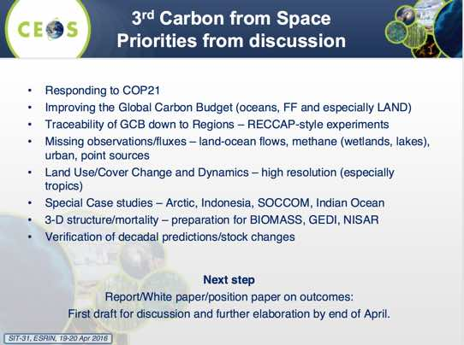
Mark provided an update on on-going activity within the SST-VC on developing and validating air-sea greenhouse gas exchange products. He also reported that WGCV has setup a small ad hoc team to define the way forward on their Carbon Strategy actions, and tasks are being defined based on sub-group inputs.
Mark reviewed recent discussion in WGClimate on their response to the CEOS Carbon Strategy, noting that they expected to be able to address at least three of the actions by taking advantage of the ECV Inventory gap analysis process.
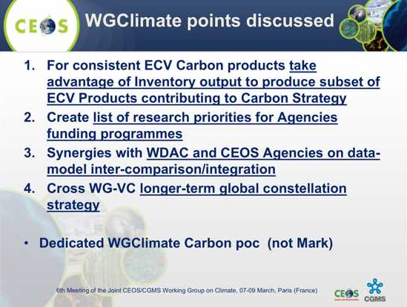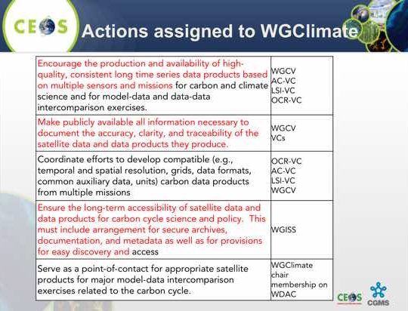
He noted a proposed joint WGCV-WGClimate validation task looking at, “... each of the relevant variables in each of the domains CEOS will work with the carbon science community to assess the current provision of validation data in terms of quality (defined by protocols (e.g., WGCV LPV protocols) and/or maturity matrices (e.g., WG Climate)) and spatial and temporal coverage”.
Finally, Mark reviewed the CEOS link to the proposed GEO Carbon Flagship (being coordinated under CARB-12), and reviewed the summary and discussion points.
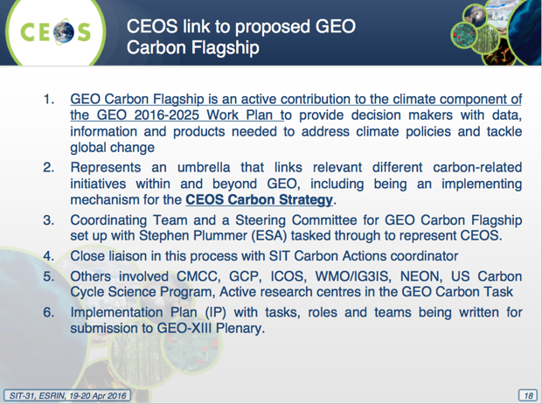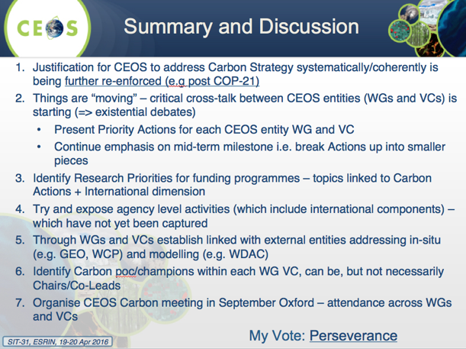
A brief discussion followed:
- Albrecht von Bargen (DLR) noted that the WGs rely on a large science community and need a bottom-up approach, while during the past five years CEOS has worked its Carbon efforts from the top-down. There is a need for a middle ground, as well as clear links between the scientific efforts and the top down requirements. Stephen Briggs (SIT Chair) noted that establishing these linkages can be complex, and can delay progress.
- Claus Zehner (ESA) noted the two separate actions asking for a GEO and a polar constellation, and that ACC-VC would prefer to have a single action/constellation. Mark noted that if these two actions were addressed in one response, this would be suitable. Barbara Ryan (GEO Secretariat) suggested that representatives from GEO and WMO activities be included in follow up discussions. Claus also indicated that the AC-VC is setting up a greenhouse gases sub-constellation within AC-VC.
- Stephen Briggs proposed to arrange a dedicated meeting focused on the Carbon Strategy in conjunction with the 2016 SIT Technical Workshop.
- Stephen Briggs stressed the clear science community focus of this activity, and Mark suggested this is an example of science being used in a policy context.
- Mark asked if the WGs and VCs had identified any clear obstacles to making progress in time for a Carbon Strategy meeting in September, and none were raised.
SIT-31-06 | WGs and VCs to identify a Point of Contact to serve as interface for routine reporting on implementation of the CEOS Strategy for Carbon Observations from Space | WG Chairs, VC Leads | May 2016
SIT-31-07 | SIT Chair Team (Pascal Lecomte) will coordinate with Mark Dowell to arrange a Carbon Strategy meeting at the time of the SIT Technical Workshop in Oxford in September 2016 | Pascal Lecomte | SIT Tech Workshop

CEOS Water Strategy
Chu Ishida (JAXA) presented an update on implementation of the CEOS Strategy for Water Observations from Space, which was endorsed at CEOS Plenary 2015. The Strategy is based on 22 of the 58 actions identified in the GEO Water Strategy. Chu noted that two feasibility studies were proposed as the focus for 2016 - one on a water constellation (C.1) and the other on a hyperspectral mission for water quality (C.10).
The water constellation Feasibility Study (FS) team has prepared a Work Plan and is working on scoping an achievable approach to the study. Six key water cycle parameters have been identified, with an initial emphasis on synergies between precipitation and soil moisture agreed.
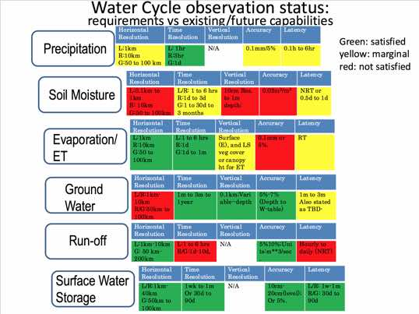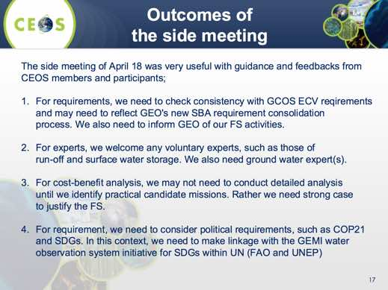
Chu reviewed the outcomes from the side meeting held prior to SIT-31. He reviewed the resulting requests to SIT:
- to acknowledge steady progress of the FS and provide any guidance and advice on the FS approach;
- encourage water experts of CEOS Agencies to support the FS; and
- encourage engineering analysis support of CEOS Agencies for the FS.
A brief discussion followed:
- Stephen Briggs noted that water is one of the new GEO SBAs, and future requirements may arise from this GEO activity. He noted the need to link the requirements with political drivers (e.g. UN SDGs), translate those into societal requirements, and then finally into technical requirements, and this parallel activity makes things challenging.
- Mike Freilich (NASA) questioned whether the simultaneity of water cycle observations on a scale of seconds to minutes provided by a ‘water train’ formation flying constellation is required and preferred. Applying the constellation constraint complicates possible solutions, and he suggested that it could be referred to as a water cycle ‘suite’ of missions if the constellation requirement didn’t apply. Chu noted that the proposed water constellation is different from the A-train in the requirement for simultaneous observations, and that these requirements should be assessed before any final decisions are reached.
- Stephen Briggs noted the importance of water cycle observations is not in dispute, but the linkages between the political drivers and technical requirements need to be articulated. Mike agreed, noting that fresh water, and water quality in particular, are perhaps the most immediate impacts on society arising from changes to the environment. He suggested that the case for the importance of water has been made, and stretching to make linkages to other activities (e.g. atmospheric composition) needn't be a focus.
- Alain Ratier (EUMETSAT) stressed that EUMETSAT hoped that GCOM-W2 will go ahead, but noted that other CEOS Agencies could also implement this technology. He agreed that the ‘A-train’ arrangement may not necessarily be the best thing for precipitation, and that optimised sampling may be more important and should be included in the feasibility study.
- Mike noted that there have been studies of sampling requirements and these should be reviewed, for example those looking at GPM follow-up missions. He also suggested that the feasibility study should look at the extent to which GPM measurements are currently being put to use.
- Kerry Sawyer (NOAA) noted that the CEOS Water Strategy was responding to the GEOSS Water Strategy Report (WSR), and GEO was supposed to prepare a Water Implementation Plan, following the WSR. Now GEO is moving forward with a new water initiative called GEOGLOWS (GI-20), with no indication that a Water Implementation Plan is expected. Kerry questioned how all these water initiatives and activities are related and suggested there is a need to ensure they are connected, especially when CEOS is in the midst of the Feasibility Study in response to the WSR. Stephen Briggs agreed, noting that there is a need to ensure the CEOS Water Strategy is consistent with the new SBA requirements being developed under GD-08.
- Stephen Ward (SIT Chair Team) asked if a consistent requirements process will be maintained within GEO, and Barbara responded that she hopes this will be the process, but that GEO’s limited dedicated resources mean it needs to rely on the community to ensure this consistency.
SIT-31-08 | WSIST Water Constellation Feasibility Study team to ensure precipitation sampling requirements are included in their analysis, in coordination with P-VC | WSIST | SIT Tech Workshop
SIT-31-09 | WSIST Water Constellation Feasibility Study team to stay connected to the GEO Water Resources Management SBA developments within GEO Work Programme Foundational Task GD-08 and to ensure that new requirements reflect previous efforts on which CEOS response is based | WSIST | Plenary

Coordination of Thematic Observations
George Dyke (SIT Chair Team) reviewed a study of thematic acquisition coverage to which has CEOS committed. The study was conducted by the SIT Chair Team and SEO to inform discussion on the following questions:
- What are the current and future resource requirements to address those commitments and the adequacy of CEOS resources?
- Does CEOS capacity allow it to take on new commitments?
- What does it mean for CEOS to endorse/commit to one of these strategies?
- What do we mean when we refer to our capacity to respond to them? The capacity of the agency observing systems or of the CEOS management layer to track fulfilment of the requirements?
George noted that the study looked at acquisition strategies endorsed by CEOS for several initiatives.
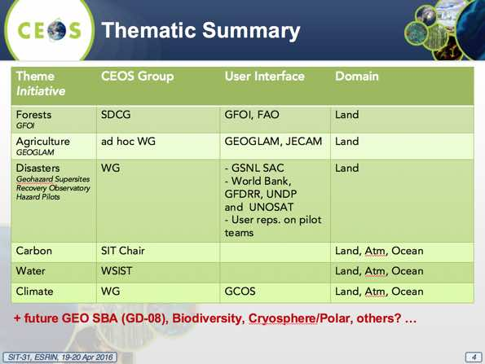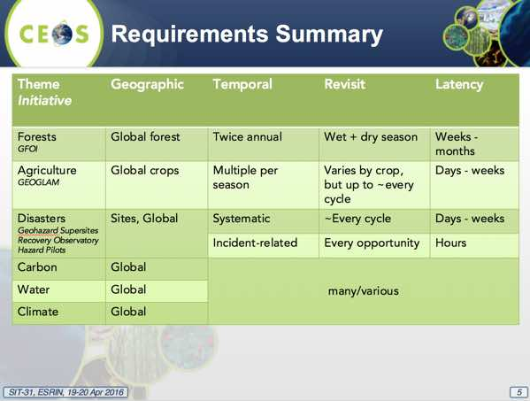
He noted that this preliminary analysis found that in general that the CEOS response to the more contained requirements of GFOI, GEOGLAM and WGDisasters is working well. These activities also have comparatively clear and engaged counterparts in the user community. Requirements for disasters comprise a big mix of data, which includes a significant commercial component and diverse coverage requirements.
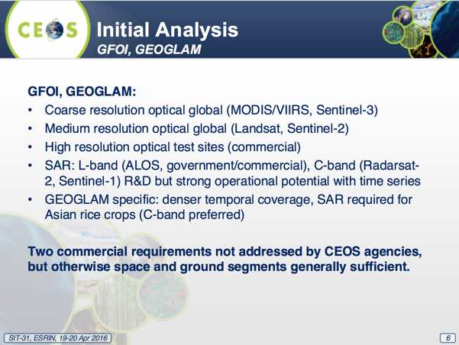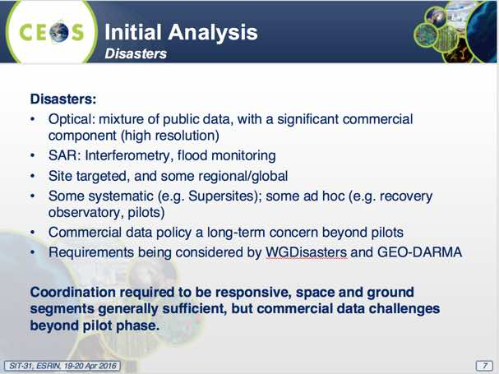
Requirements for water, carbon, and climate are much more heterogeneous, with a diversity of level of detail and requirement types. In the cases of water and carbon, there are also questions around internal CEOS coordination, as well as external counterparts.
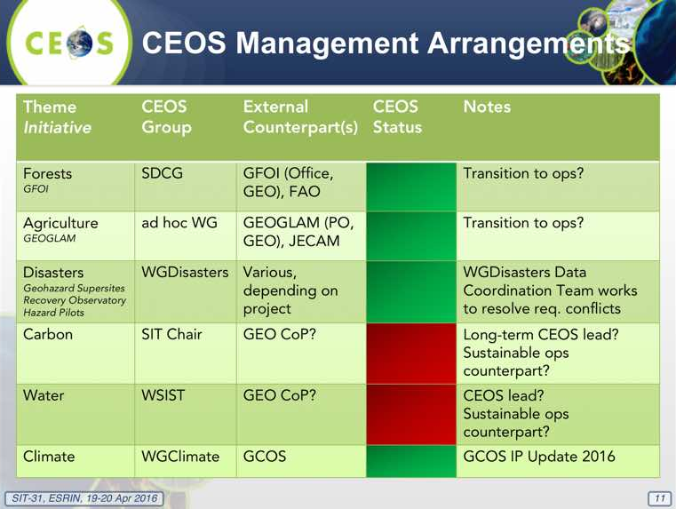
George noted that there may be additional opportunities for synergies, citing an example where data acquired over the Mekong Delta has had uses for both GEOGLAM (Asia-RiCE) as well as flood monitoring. He also stressed that the study concluded CEOS must be clear when interacting with user communities to stress that it generally cannot provide support in accessing commercial data beyond R&D.
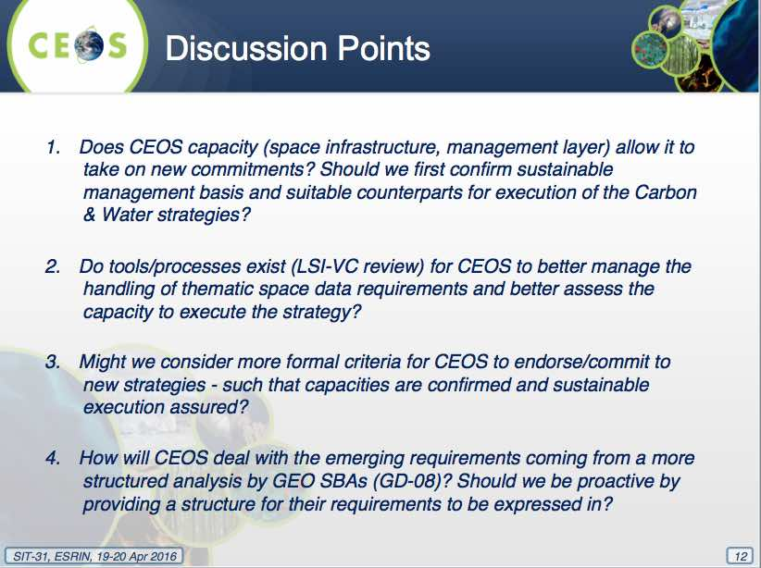
A brief discussion followed:
- Stephen Briggs noted the key question is whether CEOS is in a position to deal with new requests, and if so how should it do so.
- Mike suggested that the role of CEOS should be to identify areas where there are synergies between user community requirements, and as a first priority should focus on what small changes could be made to existing capabilities and acquisition strategies to accommodate new requirements. Where gaps are identified, the focus could then be on new capabilities required. He noted that CEOS is the only body that has an overview across this many activities, and it could potentially provide a great service to the community by using this overview to coordinate activities.
- Mark noted that the space agencies received a very good assessment in the GCOS Update prepared in 2015. He agreed that CEOS should focus on making the most of existing assets before looking at new capabilities - for example where there is overlap, the requirements in the CEOS Strategy for Carbon Observations from Space compared to those of the ECVs are almost identical.
- Stephen Briggs agreed, noting that CEOS should differentiate between requirements that can be addressed with existing systems vs. those like the Water Strategy which are raising the need for new missions. Mike noted that in the case of the water study, it's not yet obvious that new missions are necessarily required.
- Kerry noted that CEOS endorsed a New Initiatives Process Paper in May 2014, and this may go a long way to addressing the third discussion point (formal criteria for endorsing new initiatives).
- Ivan Petiteville (ESA) noted that the successful cooperation between CEOS and GCOS has been made possible not only by good and clear requirements, but also that the group has provided a forum that CEOS could interact with closely as the requirements and response were developed. He stressed that it is important to keep this approach in mind as CEOS interacts with GEO on the development of SBA-derived requirements under GD-08. In addition, he noted that the previous example of synergy between GEOGLAM (Asia-RiCE) and flood monitoring demonstrated the advantage of having CEOS people aware of requirements from several projects supported by CEOS instead of those of a single project.
- Frank Martin Seifert (ESA) cited ongoing coordination between GEOGLAM and GFOI (e.g. the need for dual polarisation SAR acquisitions over the Mekong Delta), and also between seismic studies and forestry in South America.
- Stephen Briggs noted that LSI-VC has the potential to serve as a coordination body for new requirements (e.g. biodiversity), and also to help assess conflicts and coverage potential. He is comfortable that CEOS has the capacity to address new requirements, in particular where there is overlap with existing activities. He encouraged GEO to progress GD-08, and suggested that the IGOS-P process and documents could be a good reference. Mike agreed, and cautioned against loading LSI-VC too quickly before it is able to establish itself.
- Stephen Briggs noted that in the case of GFOI and GEOGLAM, CEOS can be confident we are dealing with real users, and Barbara agreed, noting that GEOGLAM is engaged politically and with national departments of agriculture. He noted that with water and carbon, the user community interaction and counterparts for CEOS need to be clarified.
George noted that LSI-VC has been asked to conduct a brief study of how CEOS Agencies managed their requirements internally.
SIT-31-10 | SIT Chair team to review the CEOS New Initiatives Process Paper, and consider its applicability, in preparation for discussions of how to handle requirements arising from GEO Work Programme Foundational Task GD-08 | SIT Chair team | SIT Tech Workshop
Tools and Processes for Requirements Management and Coordination
Bianca Hoersch (ESA) introduced a brief analysis based on a short survey on tools or processes used by a selection of agencies to manage multiple requirements in the specification and operation of their missions. She reviewed inputs received so far (from ESA, NASA, CSA, and USGS).
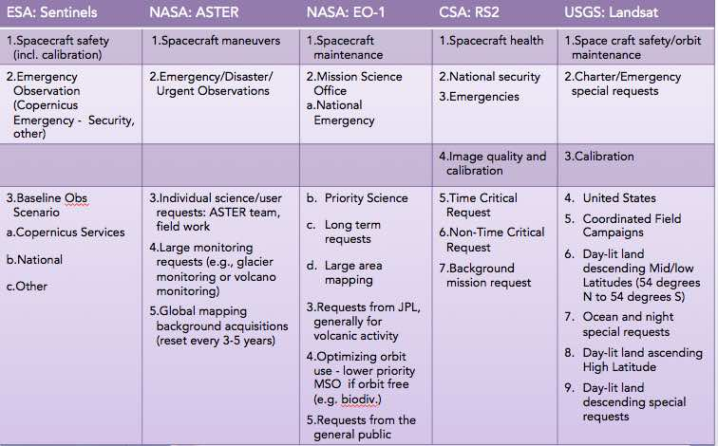
She noted that Landsat acquisitions are systematic, and Sentinel-2 is progressing towards systematic acquisitions, and there is not much additional capacity available to address requirements not already addressed. She noted that Landsat is operated according to a Long Term Acquisition Plan (LTAP), and that Sentinel-1 and -2 are being focused on a 6- to 12-month acquisition planning processes.
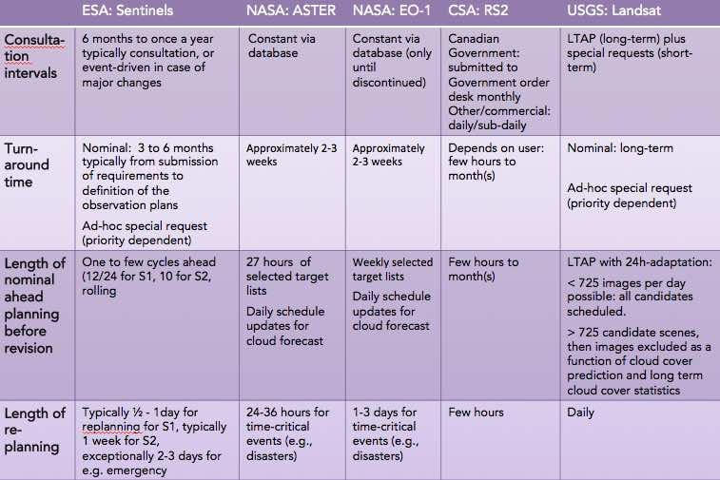
Bianca noted that each agency has submitted examples of the software tools used for acquisition planning, taking into account acquisition areas (e.g. shape files), as well as operational and ground station capabilities and constraints.
A brief discussion followed:
- Stephen Briggs agreed that for Sentinel-2 and Landsat, the missions are near capacity and not many additional requirements can be addressed.
- Bianca noted that Sentinel-1 mission planners are already in the process addressing the requirements of GFOI and GEOGLAM. Stephen Briggs noted that with Sentinel-1 there is still the potential for acquisition mode conflicts.
SIT-31-11 | SIT Chair to circulate the LSI-VC survey on requirements management tools and processes to CEOS Agencies for their response | SIT Chair team | COMPLETE

9. CEOS Virtual Constellations and Working Groups

VC Leads and WG Chairs Issue Reports
Jean-Louis Fellous (SIT Chair Team) presented a synthesis report of VC and WG achievements and plans. (The following subsections present a brief summary of the key points from each report. For further details, please refer to the presentation file.)
WGISS
WGISS-41 was co-located with WGCV-40 in Canberra, Australia, in March. During the meeting both Working Groups (WGs) agreed to jointly address their CEOS Carbon actions via a work breakdown structure that allows the management of priorities and resources.
WGISS is also supporting the Future Data Architectures (FDA) report as well as the creation of guidelines/standards on Data Cubes and Analysis-Ready Data (ARD). A 1-2 day FDA workshop will be held during WGISS-42 in September 2016. WGISS also continues supporting the WGDisasters Recovery Observatory (RO), and have completed the WGISS Water Portal.
WGISS was added to be a contributor to the 2016 GEO Work Programme Foundational Task GD-07, Subtask 2 (GCI Development), and GD-02 (GCI Operations). As contributors, they will continue to advocate for CEOS agency mission data to be contributed to the implementation of GEOSS via WGISS interoperable systems and standards, as well as maintain the Connected Data Assets website to provide up-to-date metrics for IDN, CWIC and FedEO.
WGCV
WGCV-40 included a number of topical sessions on atmosphere, land surface, carbon action items, the CEOS Chair initiatives and validation metrics; and saw significant interaction between the WG and other bodies including WGISS, LSI-VC, SST-VC, OCR-VC, and the FDA AHT. Reports from the WGCV subgroups were positive and indicative that the WGs activities lie somewhere between stable and growing.
The Terms of Reference of the WG are currently being revised and will be submitted for endorsement at the 2016 CEOS Plenary. Eight actions from the 2015-2017 CEOS Work Plan have been closed, four remain open, and two are currently delayed.
WGCV have noted that the definition of new top-down CEOS activities (e.g. Carbon) are sometimes in conflict with the basic activities of WGs, which are staffed on a ‘best efforts’ basis and often more suited to bottom-up activities (e.g. science communities, subgroups). WGCV and WGISS have discussed this issue, and are exploring approaches to best incorporate top-down CEOS activities into Working Group activities.
The 41st WGCV Plenary will be hosted by JAXA 5-7 September in Tokyo, in conjunction with a meeting of the SAR subgroup.
WGDisasters
The WGDisasters Plenary was held in Bonn, 8-10 March, during which results and achievements from pilots and subgroups were reviewed. New members from ROSKOSMOS, NRSC, and AGEOS have also been welcomed to the WG.
Members of the WG will participate in the Satellite Data for Enhanced Risk Management and Reduction – Innovative Technologies and Future Applications side meeting at the 2016 Understanding Risk Forum in order to promote the outputs and results of the WG and to strengthen collaborations with key stakeholders.
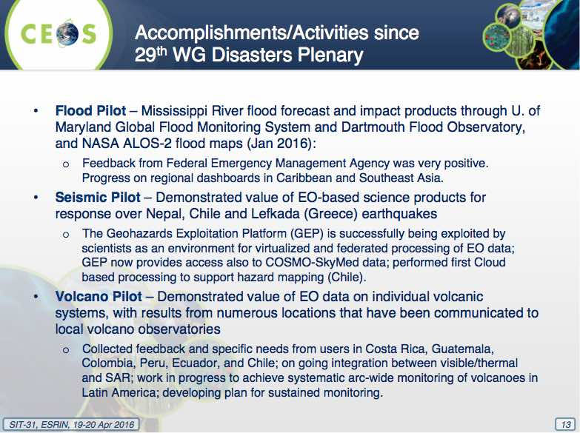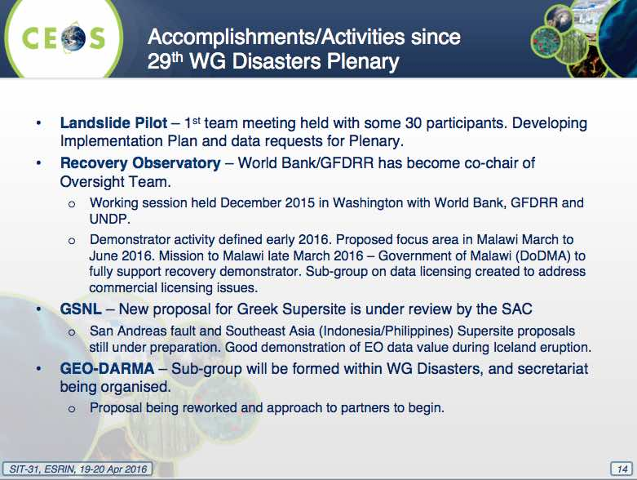
WGCapD
WGCapD continues to work to increase access to data, products, and tools (e.g. via targeted training workshops), to build awareness of new mission datasets, and to support CEOS WGs and VCs with their own capacity building initiatives. The group continues to contribute to the GeoCaB Portal, which aims to increase the awareness of the capacity building inventory across both CEOS and GEO.
Other 2016 activities include:
- building awareness and demonstrating the value and applications of EO to teachers, students and practitioners in major conferences (starting with an event during the ESA Living Planet Symposium in 2016 and ISRSE in 2017);
- continuing to identify and provide appropriate e-learning courses in relevant applications;
- surveying CEOS capacity building activities, compiling a task report on capacity building in CEOS, and producing a best practice in capacity building document; and,
- holding two SAR training workshops in Zambia and Gabon (dates TBC), which have been supported financially by ESA and UNOOSA.
OSVW-VC
The most recent meeting of the VC was in conjunction the International Ocean Vector Winds Science Team (IOVWST) meeting, held 19-21 May in Portland, USA. Questions posed during the meeting included whether the current OSVW constellation is sufficient, what the priority of the OSVW community is (elaboration of data standards, though increased resources are required to do so), and whether there any particular advocacy/actions from the OSVW community that would be helpful for the space agencies (scatterometer/AMSR-3 capability for GCOM-W2).
The IOVWST recommendation for at least three scatterometers in orbits designed to roughly meet WMO requirements, and in addition, one instrument in a non-sun-synchronous orbit to help with the diurnal cycle was reviewed. A user requirements document is being prepared for the next IOVWST meeting to be held in Q2 2016.
In summary, topics of importance identified by OSVW-VC are:
- the need to continue to advocate for open and timely data access commitments from China and Russia for their planned OSVW missions;
- to encourage JAXA and ISRO to continue pursuing a joint scatterometer and AMSR-3 sensor package for GCOM-W2; and,
- the standardisation of data, formats and the representation of measurement uncertainty may benefit from additional resources supporting the IOVWST.

LSI-VC
Since the endorsement of its new Implementation Plan and Terms of Reference at CEOS Plenary 2015, LSI-VC has been working to establish a strong and engaged membership, and a clear Work Plan to address its initial objectives.
A successful first meeting (LSI-VC-1) was held 22-24 February 2016 at ESA ESRIN, and included a joint session with the SDCG for GFOI. LSI-VC-2 is tentatively planned for 20-22 July in the US.
One of the first tasks LSI-VC led was a survey and short report (as presented during SIT-31) on the tools/processes used by large space agencies to manage multiple different requirements and stakeholders.
An initial LSI-VC Work Plan has been defined based on the LSI-VC Implementation Plan. The LSI-VC Work Plan consists of five main task areas:
- Increase the visibility of land surface imaging data holdings.
- Identify gaps in/opportunities for acquisition planning in support of the CEOS Carbon Strategy.
- Define inter-comparable Analysis-Ready Data (ARD) products within the context of land surface imaging.
- Engage in the implementation of trial data cubes.
- Long-term LSI-VC strategy and vision.
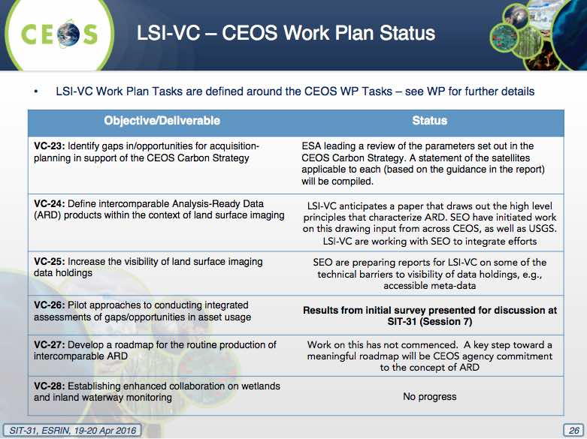
SST-VC
The SST-VC continues to work to address action VC-1, and 81 GHRSST products are now archived. In response to action VC-19, the first draft of a white paper covering the next generation SST-VC should be ready by May 2016, and will likely be adopted in June following final discussion at the next SST-VC meeting (10 June in Washington D.C.). ISRO joined the SST-VC in October 2015.
SST-VC has identified an issue with the continuity and redundancy of 6-7 GHz channel passive microwave radiometer instruments.
OST-VC
The Ocean Surface Topography Science Team (OSTST) international meeting was held 20-23 October, 2015 in Reston, USA. Splinter meetings were held on systems performance (orbit, measurements, corrections), altimetry data products, science outcomes, and outreach. In addition to the analysis of data from the Topex/Poseidon-Jason series, data analyses from other international missions bringing reciprocal benefits were welcomed.
The recent launches and operationalisation of Jason-3 and Sentinel-3A represent major milestones for the future of the OST constellation, which currently consists of Jason-2 (moving to an interleaved Jason-3 orbit), Saral/Altika (in two-year extended operations), CryoSat (applicable to OST as well as ice topography), and HY-2 (although operations are suspended). This current configuration satisfies the requirements set out in the CEOS OST-VC requirement document.
In 2016, new OST-related Announcements of Opportunity are expected from NASA and CNES/EUMETSAT. The OST-VC will next meet at the OSTST meeting, to be held 30 October – 4 November in La Rochelle, France. A catalogue of Cal/Val infrastructure and the strategy for the next generation, high resolution OST-VC will be discussed.
Decision 4 | CEOS Agencies agreed to contribute to the development of scenarios for a new generation of high resolution ocean surface topography constellation, following the next meeting of the OSTST and OST-VC in La Rochelle (October 2016).
P-VC
The P-VC Data Portal has been released and is being updated with further partner datasets. The portal is accessible at: http://pvcportal.pps.eosdis.nasa.gov.
P-VC continues to support the generation of ECV precipitation products, with the GPM constellation remaining stable with full observational capabilities. The next scheduled additions are JPSS-1 and MetOp-C in 2017 and 2018 respectively. P-VC is working to ensure that vital ECV measurements continue in the future, with the submission of U.S. Decadal Survey white papers on a combined cloud and precipitation processes mission concept and an end-to-end water cycle mission concept.
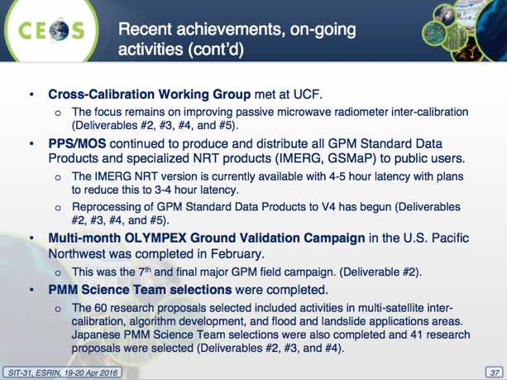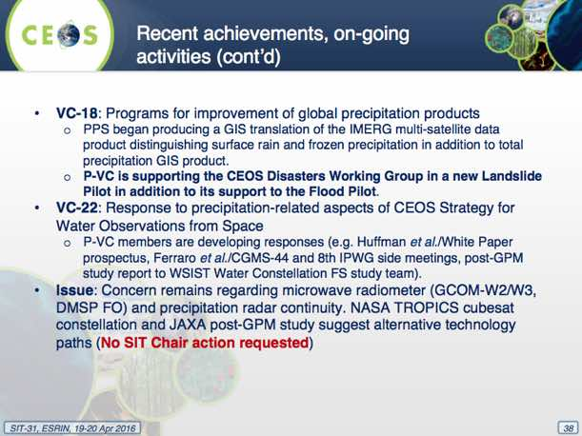
While no SIT action was requested, concern remains around microwave radiometer (GCOM-W2/W3, DMSP follow-on), and precipitation radar continuity. The NASA TROPICS cubesat constellation and JAXA’s post-GPM study both suggest alternative technology paths.
ACC-VC
ACC-VC is addressing total ozone dataset validation and harmonization (VC-2) and in 2015 delivered papers on inter-comparison results and European/U.S. long-term data sets. A new VC-2 deliverable on nadir profile intercomparisons and long term (1979-present) combined (Europe and U.S.) total ozone data sets is scheduled for completion in late 2017. A new white paper defining geophysical validation needs for the air quality constellation is also being written (in response to VC-3) for delivery in mid-2017.
Greenhouse gas constellation coordination continues as an ongoing activity, and ACC-VC (specifically the GHG subgroup) is in the process of deciding specific deliverables based on the CEOS Strategy for Carbon Observations from Space. ACC-VC has run into obstacles as some of the tasks assigned are directly actionable, while with others ACC-VC can play only a supporting role (e.g. establishing a space-based GHG constellation).
ACC-12 will be held the week of 10 October in Seoul, South Korea, and this will be the first ACC meeting held outside of Europe or the U.S.
OCR-VC
OCR-VC delivered their overall Blue Planet implementation plan in April 2016 and remains actively engaged in the initiative, including through leadership and participation in the 3rd Blue Planet Symposium to be held in the U.S. in Spring/Summer 2017. The OCR-VC will play a significant role in the GEO Blue Planet Initiative, cross-cutting its foundational as well as service components.
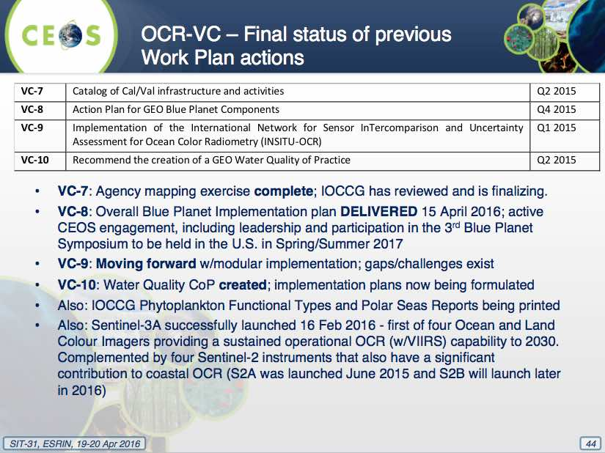
Ready access to Level 0 and Level 1A ocean colour radiometry data remains a challenge and an item of significant concern for the OCR-VC.
Jean-Louis recalled the letter of July 2015 sent to agencies that have (or plan to have) ocean colour missions requesting they consider distribution of Level 0 and Level 1A mission data. Jean-Louis added that NASA already fulfils this requirement. Formal replies were only received from ESA and NOAA (and from CNES via email). The NOAA and CNES responses were in the affirmative, and ESA indicated there was no plan or resources to deliver this data. The SIT Chair will follow up with EC per guidance received from ESA.
SIT-31-12 | CEOS Agencies to complete the outstanding OCR-VC request to reply with regard to L0/1A ocean colour data access | CEOS Agencies | June 2016  SIT Chair (Jean-Louis Follous) preparing draft letter to agencies
SST-VC: Passive Microwave Redundancy/Continuity Issue
Anne O’Carroll (EUMETSAT) presented on behalf of SST-VC, reporting that the use of Passive Microwave Radiometers (PMW) for Sea Surface Temperature (SST) retrievals is an essential component of the global SST constellation. PWM facilitates the retrieval of SST despite cloud cover, which is not possible using infrared sensors (albeit with poorer spatial resolution). PWM SST measurements are also particularly important in high-latitude regions and in cases of large volcanic events.
PMW gaps have been identified in the future of the SST constellation, and SST-VC seeks to raise awareness and set in motion efforts to ensure the continuity and redundancy of PMW instruments for SST. Anne added that both the 7 and 11 GHz channels are required, and the outlook for continuity is summarised in the following chart.
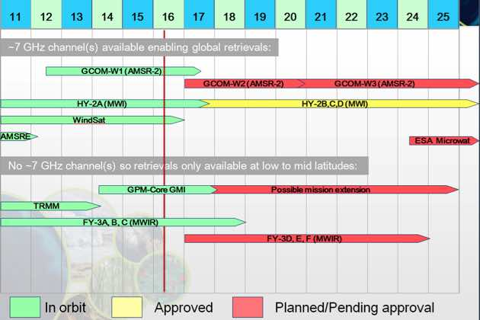
The timeline shows that many of the global missions (those with a 6-7 GHz channel) are coming to an end very shortly. The 6-7 GHz channel is particularly important for the higher latitudes, as this channel results in a much more stable response across all temperatures – particularly important for cooler temperatures. The 6.9 and 7.3 GHz frequencies are also critical to alleviating issues with Radio Frequency Interference (RFI).
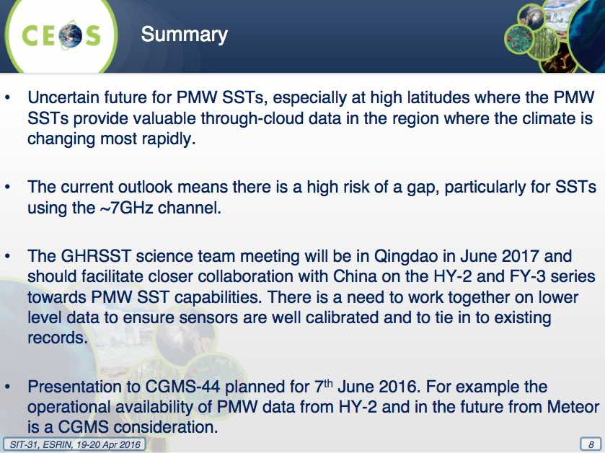
Given the current risk to the current and continued PMW constellation for SST and the need for a redundant capability of PMW with ~7 GHz, CEOS is requested to coordinate and encourage its agencies to ensure the continuation of the existing capability and to facilitate the coordination of agencies to ensure continuity and redundancy of PMW for SST.
Discussion:
- Craig Donlon (ESA) noted that in some parts of the world, PMW is the only option due to persistent cloud cover, and that it is a major input to Climate Data Records.
- Mike Freilich (NASA) asked whether a wide-swath microwave radiometer that does not have 7 GHz channels would be useful in the 2020 timeframe, and it was confirmed that it would be useful, though the 7GHz measurements are critical, especially at higher latitudes.
- Mike noted that GMI-2 is in planning, and asked if it would be a significant contribution despite not including the 7 GHz channel, and Anne confirmed it would be very useful.
- Weiying Cai (NSMC/CMA) noted that an upcoming meeting in Qingdaoa would be a good opportunity to discuss further. He noted that FY-3 only has 10 GHz, and that derived SST products will be distributed by CMA.
Jean-Louis summarised the discussion, noting that CEOS Agencies are requested to consider how to resolve this issue. The SST-VC is urged to use every opportunity, including CGMS-44 and the planned meeting in Qingdao, China in 2017, to progress toward a solution, and to report on status at the next SIT Technical Workshop and/or CEOS Plenary.
SIT-31-13 | CEOS Agencies to consider the need for continuity and redundancy of Passive Microwave Radiometers for SST highlighted by SST-VC, providing relevant input to and SST-VC to enable them to provide an update on the 6-7 GHz PMW continuity situation at SIT Technical Workshop, and/or CEOS Plenary. | CEOS Agencies | SIT Tech Workshop
OST-VC New Generation of Altimetry Constellation
Phillipe Escudier (CNES) reported that implementation of the OST-VC constellation is well underway, fulfilling the needs of large-scale and larger meso-scale monitoring which is adequate to feed the current configuration of the Copernicus Marine Environment Monitoring Service as well as scientific uses. However new societal, scientific and operational uses are emerging which will require a breakthrough improvement of the space and time resolution (currently approx. 100 km, 10 days, which misses a significant portion of ocean dynamics) of the altimetry Virtual Constellation.
A new generation of constellation has to be defined and CNES, ESA and other agencies have initiated preliminary analyses. An encouragement from SIT Chair to EUMETSAT to support the development of this updated URD would be helpful.
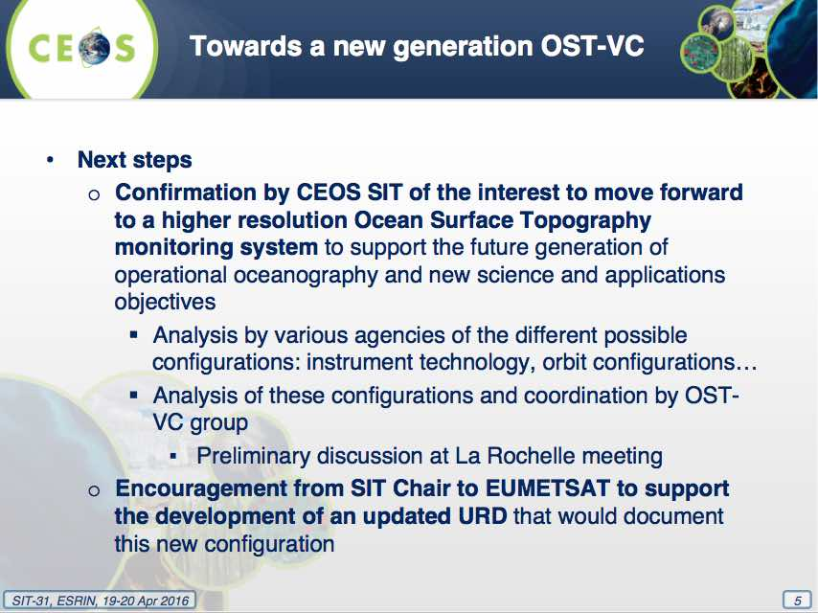
A brief discussion followed:
- It was noted that direct (i.e. in situ) measurements of ocean current are valuable, and that altimetry is just one component of ocean surface topography.
- Craig Donlon (ESA) supported the proposed way forward, and encouraged analysis of the numerous technologies under consideration to try and find the best compromise between user requirements and technical capacity.
- Jean-Louis raised the question of what new societal, scientific and operational uses are emerging, and how these are addressed by what can be modelled.
- Barbara Ryan (GEO Secretariat) noted that the GD-06 task now addresses in-situ coordination, and they would welcome additional examples where coordination is required.
- Alain Ratier (EUMETSAT) noted they are ready to support the process but require involvement of other groups, including the scientific community.
Jean-Louis summarised the discussion, highlighting the importance of substantiating the user needs, recognising the value in the collaborative study of user requirements (and the resulting document), and encouraging contributions by EUMETSAT and other agencies involved in the OST-VC to this discussion.

10. Copernicus Sentinel Data Uptake and Application

Sentinels Space and Ground Segment Status
Alessandra Tassa (ESA) gave a brief introduction to Copernicus and the Sentinel series of satellites. Some example products were demonstrated, including interferometry, agriculture, polar ice drift, and the application of Sentinel-1A time series for rice monitoring in the Mekong Delta. It was noted that ESA provides access to near-real time data (from 3 hours after acquisition), as well as non time-critical data (within 24 hours) via the Sentinels Scientific Data Hub (https://scihub.copernicus.eu/). All data is provided on a free and open basis, with 500,000 products available to date.
Paul Counet (EUMETSAT) reviewed Sentinel-3 activities, including support to ESA during the on-orbit commissioning phase, as well as maintenance and evolution of flight operations (including mission planning), and operation of the Sentinel-3 Marine Data Centre following on-orbit commissioning.
For Sentinel-3, the Level 1 data is generated and distributed both by ESA and EUMETSAT, and there is a split of responsibility at Level 2 (Marine by EUMETSAT, Land by ESA). Level 2 products are expected to be available online in early 2017, with NRT EUMETCast products broadcast over commercial telecommunication satellites, with full coverage of Europe and Africa. A terrestrial distribution approach will also be used, with agreements signed with NOAA and Geoscience Australia to date.
CEOS initiatives were invited to provide their feedback on the access and uptake of Sentinel data in CEOS activities.

GFOI, GEOGLAM
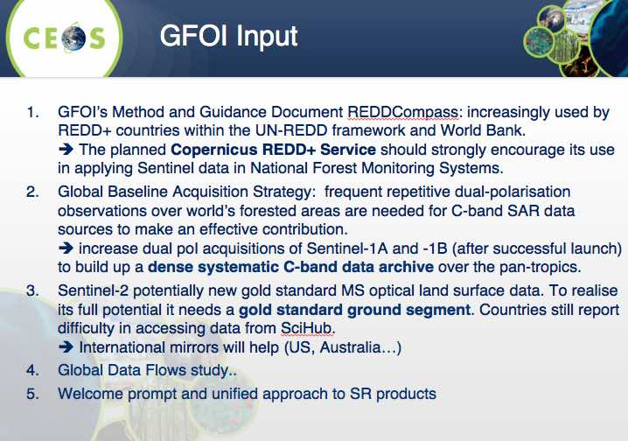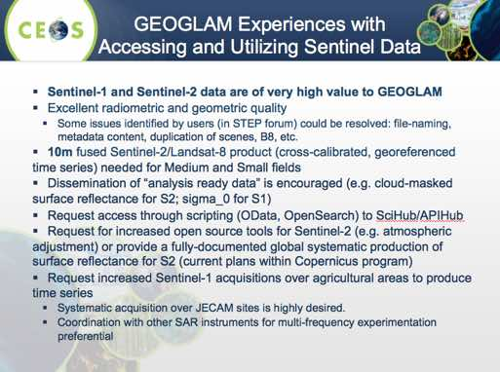
Stephen Briggs (SIT Chair) noted that from the GFOI and GEOGLAM inputs, it is clear that there is a demand for the supply of higher-level products (e.g. ARD).
USGS

Steve Labahn (USGS) noted the internet connection to the Sentinel-2 archive is problematic, and has slowed the progress.
Bianca Hoersch (ESA) suggested there are other options for downloading large volumes of data, such as API Hub. Sentinel-2 is in the process of decreasing revisit from 30 to 20 days. Systematic production of surface reflectance products from Sentinel-2 is the intention and is in progress.
Geoscience Australia
Jonathon Ross (GA) reported that Australia has signed agreements with the European Commission and ESA to establish a regional data access and analysis hub. It has three objectives: support internal government requirements; enhance access to satellite EO data for research, industry and civil society; and to facilitate regional access to data – reducing the burden on the European archive. The data will be co-located with MODIS, Landsat and Himawari; creating a rich resource of data for the user community. Jonathon thanked ESA/EC for their support and cooperation.
A brief discussion followed:
- Steve Volz (NOAA) noted that Sentinel-1 has proven very useful for ice and oil spills.
- Jonathon noted that in future, file redistribution stats will not give us the full picture of data use as the reliance on ‘downloading’ of data decreases with the emergence of Data Cube and similar infrastructures.
- Mark Dowell (EC/JRC) noted that the Copernicus Global Land Service will be working on the generation of some level 3 global mosaic products, and possibly thematic products, and that implementation arrangements are currently being put in place.
- Josef Aschbacher (ESA) said he was happy to see the uptake of data by various initiatives worldwide. He noted data distribution capacity is expected to grow via deployment of Collaborative Ground Segments, as well as via national distributors. He stressed that the EC is the point of contact for countries interested in getting access to Copernicus Sentinel data beyond the regular web interface and portals.

11. SIT-31 AOB, Action Item Review, and Closing
GOOS G7 initiative report
Albert Fischer (UNESCO) reviewed the heritage of GOOS, noting they work closely with GCOS, and have the same sponsors. GOOS has developed a Framework for Ocean Observation which specifies a set of Essential Ocean Variables derived from requirements, and negotiated by feasibility.
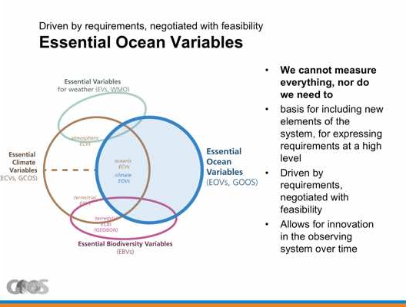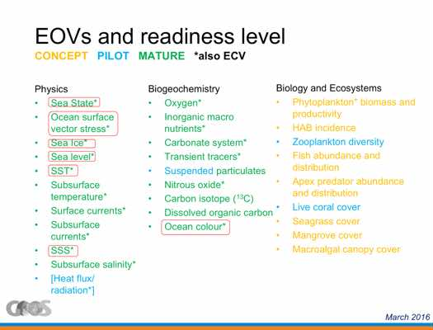
Albert reviewed the G7 Oceans Initiative, which aims to provide a sound international framework to provide international access to data, and to produce regular authoritative assessments of the state of the ocean, in order to:
- make sense and improve projections of global and regional-scale long-term change and variability;
- sustain the productive capacity of ocean ecosystems under increasing human pressure;
- promote the sustainable use of marine ecosystem services; and,
- increase resilience of human population and economic infrastructure to marine-related disasters.
He reviewed potential recommendations that are being formulated (but not yet final) for the G7 Science and Technology Ministers meeting (15-17 May 2016, Tsukuba, Japan) and at the G7 Summit (26-27 May 2016, Ise-Shima):
- Enhanced global sustained ocean observing system.
- Improved and resourced World Ocean Assessment.
- Promotion of data and information sharing, using the GEOSS data infrastructure.
- Strengthen collaborative approaches to managing regional seas, including developing sustained observing capacity.
- Streamline legal access for marine scientific research in areas under national jurisdiction (starting with G7).
- Engage commercial shipping industry in ocean observation.
He suggested a potential role for CEOS for discussion.
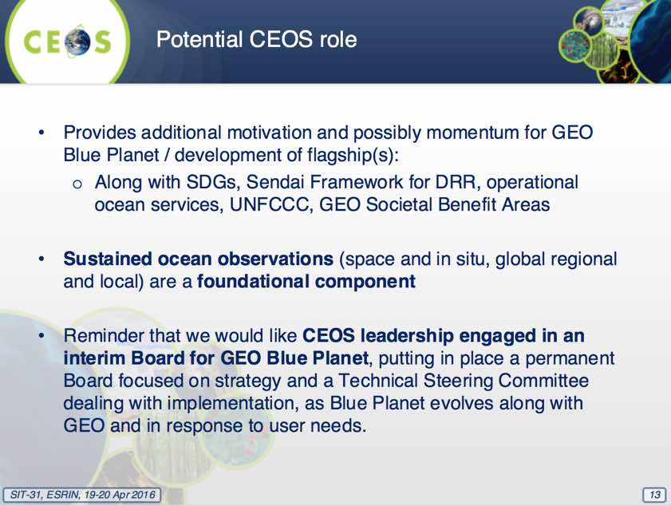
A brief discussion followed:
- Stephen asked how this fits with the Blue Planet initiative, and Albert noted that he hopes if the G7 countries support this initiative, then they will put some resources behind that commitment, and that those resources would be aligned with the Blue Planet initiative.
- Paul DiGiacomo (NOAA) noted that the G7 initiative is a good opportunity to provide the means to enhance observing capabilities by expanding and broadening networks, and adding capabilities. He noted he has worked within the US to try and ensure the G7 initiative is linked to Blue Planet. He suggested that this should be discussed within the Blue Planet ad-hoc steering committee, before moving forward with CEOS engagement.
- Kerry Sawyer (NOAA) compared the G7’s role in Blue Planet to the role the G20 is playing for GEOGLAM in providing political backing.
- Carolin Richter (GCOS) noted that without GOOS, and without the atmospheric component of the WMO, there would not be any GCOS. She noted that no analogous coordination framework exists for terrestrial observations with the demise of the Global Terrestrial Observing System (GTOS), and this is an issue she is working to address.
- Stephen noted that GTOS hasn’t been effective for the past 10 years, and so the community (e.g. GEO, WMO, FAO) need to consider suggestions for appropriate vehicles to take the lead on this.
- Paul noted the importance of terrestrial observations for coastal zone work, to understand coastal watershed.
SIT-31-14 | SIT Chair team, in cooperation with GCOS, to prepare a short paper for SIT Technical Workshop on how to mitigate the loss of the Global Terrestrial Observing System (GTOS) | SIT Chair team | SIT Tech Workshop
2016 SIT Technical Workshop
Stephen noted that the 2016 SIT Technical Workshop will take place Wednesday-Thursday 14-15 September in Oxford, UK. There will be meetings of the ad hoc Teams on Monday 12, and a dedicated VC/WG day on Tuesday 13.
Stephen explained the overall purpose for the SIT Technical Workshop in the context of the CEOS calendar. CEOS Plenary is a forum where whole of CEOS (‘holistic’) issues are discussed, whilst the SIT meetings (e.g. SIT-31) are strategic in nature, and the SIT Technical Workshop is technical in nature and intended as preparation for Plenary. The Workshop is also an opportunity to take stock of progress before the various important meetings at the end of the calendar year (e.g. SBSTA, COP).
Finally, Stephen noted that there is a block booking for Workshop accommodation in Oxford which is being booked on a first-come, first-served basis - with a deadline of 30th June. Booking information can be found on the CEOS website: http://ceos.org/2016-sit-technical-workshopaccomodation/ .
30th CEOS Plenary
Caroline Bruce (CSIRO) gave a brief overview of the 30th CEOS Plenary, which will be held Tuesday-Wednesday 1-2 November 2016 at the Brisbane Convention & Exhibition Centre (BCEC) in Brisbane, Australia. Side meetings will take place on Monday 31 October (30 also available if necessary).
Caroline noted that the Chair Team will circulate a draft agenda and call for inputs in time, and asked that any special requests for agenda topics be made well in advance. She noted that a CEOS ‘Town Hall’ Event and Panel Discussion is being organised for 3rd November in collaboration with Geoscience Australia and University of Queensland, and asked those interested to consider participating when making travel arrangements. Further details will be announced and made available on the CEOS Plenary website in due course.
Caroline encouraged participants to begin making visa and travel arrangements, and noted that further information is available on the CEOS website: http://ceos.org/meetings/30th-ceos-plenary/. She invited any questions via email (caroline.bruce@csiro.au).

Review of Actions
Stephen reviewed the draft table of actions, noting the importance of sustaining efforts and themes over the long-term, and that ESA and SIT Vice Chair (NOAA) will work together closely to ensure the necessary continuity.
Barbara Ryan (GEO Secretariat) noted the importance of encouraging agencies to make linkages within their own national statistical organisations and UN-GGIM contacts in relation to the UN-SDGs.

SIT-31 Closing Remarks
Stephen closed the meeting, noting that increased understanding of the CEOS-GEO future relationship will continue to be important moving forward. The relationship is strong, and he looks forward to working together with GEO over the next couple of years to implement the Work Programme. He noted that GEO has responded to many of the key points raised by CEOS, and this is appreciated.
He noted that:
- the discussion about how CEOS might improve its handling of requirements has been useful, and the renaissance of the LSI-VC very important, and positive;
- the VCs and WGs session was good, and the key messages on SST and OST received;
- the Copernicus session was positive and encouraging, with several common ideas identified between the European approach, and the approach of other agencies; and
- the discussion between GOOS and the Blue Planet initiative was important and pleasing.
Stephen thanked everyone for their attendance and participation, and Alex Held (CSIRO) thanked ESA for their generous hospitality.

List of Participants
Organization | Participant | Organization | Participant
CNES | Pascale Ultré-Guérard | GEOGLAM/GEO Secretariat | Michel Deshayes
CNES | Selma Cherchali | GEOGLAM/UMD | Alyssa Whitcraft
CNES | Phillipe Escudier (WebEx) | GEOGLAM/JECAM | Ian Jarvis
CONAE | Laura Frulla | ISRO | Ali Khan Imtiaz
CSA/DCEO | Marie-Josée Bourassa | JAXA | Yoshimura Yoshinori
CSA | Stéphane Chalifoux | JAXA | Naoko Matsuo
CSIRO/CEOS Chair | Alex Held | JAXA | Kei Ohyoshi
CSIRO | Flora Kerblat | JAXA | Chu Ishida (WebEx)
CSIRO | Caroline Bruce | JAXA/RESTEC | Masatoshi Kamei
CSIRO | Rob Woodcock | NASA | Mike Freilich
CSIRO | Matthew Steventon | NASA | Christine Bognar
DLR | Albrecht von Bargen | NASA | Brad Doorn
EC/JRC | Mark Dowell | NASA | Steven Neeck
ESA | Stephen Briggs | NASA | Ruth Neilan
ESA | Simonetta Cheli | NASA | Kurtis Thome
ESA | Ivan Petiteville | NASA | Wenying Su
ESA | Craig Donlon | NASA | Andrew Mitchell
ESA | Claus Zehner | NASA | David Jarrett (WebEx)
ESA | Pascal Lecomte | NASA/CEOS SEO | Brian Killough
ESA | Jean-Louis Fellous | NASA/CEOS SEO | Kim Holloway
ESA | Josef Aschbacher | NOAA | Steve Volz
ESA | Stephen Coulson | NOAA | Kerry Sawyer
ESA | Bianca Hoersch | NOAA | Paul DiGiacomo
ESA | Frank Martin Seifert | NOAA | Chuck Wooldridge
ESA | Henri Laur | NSC | Einar-Arne Herland
ESA | Mirko Albani | NSMC/CMA | Weiying Cai
ESA | Stephen Ward | NSMC/CMA | Jinlong Fan
ESA | George Dyke | NSMC/CMA | Fang Xiang
EUMETSAT | Alain Ratier | SANSA | Jane Olwoch
EUMETSAT | Paul Counet | UKSA | Emily Gravestock
EUMETSAT | Robert Husband | UKSA | Chris Hall (WebEx)
EUMETSAT | Anne O’Carroll (WebEx) | UNESCO/GOOS | Albert Fischer
GA/CEO | Jonathon Ross | US Dep. of State | Fernando Echavarria
GCOS | Carolin Richter | USGS | Jenn Lacey
GEO Secretariat | Barbara Ryan | USGS | Steve Labahn
GEO Secretariat | Osamu Ochiai | USGS | Tom Cecere
(WebEx) indicates remote participation via WebEx.

Record of Actions and Decisions from CEOS SIT-31

No. | Action | Actionee | Due Date
SIT-31-01 | CEOS Agencies asked to co-operate with an anticipated GEOGLAM Secretariat request for identification and confirmation of Points of Contact in relation to data acquisition planning & data access requests for GEOGLAM | GEOGLAM Secretariat | May 2016
SIT-31-02 | Paul DiGiacomo to liaise with Blue Planet in relation to the space data needs associated with their initial implementation phase activities | Paul DiGiacomo | SIT Tech Workshop
SIT-31-03 | CNES, in coordination with ISRO, to consider comments raised at SIT-31 in providing feedback to finalisation of the Delhi Declaration | CNES | COMPLETE
SIT-31-04 | Agencies to submit nominations for the WGClimate Vice Chair position to be confirmed at the WGClimate meeting in February 2017, submitted for endorsement at CGMS Plenary 2017 (Q2 2017), and CEOS Plenary 2017 (October 2017), and to assume the WGClimate Vice Chair role as of endorsement from CEOS Plenary 2017 for 2018-2019. By convention, nominations from ‘R&D’ agencies are to be given preference for this rotation. | CEOS Agenices | Nominations by 31 January 2017
SIT-31-05 | LSI-VC and SEO to further develop the CEOS Analysis Ready Data (ARD) definition document with support from interested CEOS Agencies | LSI-VC Co-Leads, SEO | SIT Tech Workshop
SIT-31-06 | WGs and VCs to identify a Point of Contact to serve as interface for routine reporting on implementation of the CEOS Strategy for Carbon Observations from Space | WG Chairs, VC Leads | May 2016
SIT-31-07 | SIT Chair Team (Pascal Lecomte) will coordinate with Mark Dowell to arrange a Carbon Strategy meeting at the time of the SIT Technical Workshop in Oxford in September 2016 | Pascal Lecomte | SIT Tech Workshop
SIT-31-08 | WSIST Water Constellation Feasibility Study team to ensure precipitation sampling requirements are included in their analysis, in coordination with P-VC | WSIST | SIT Tech Workshop
SIT-31-09 | WSIST Water Constellation Feasibility Study team to stay connected to the GEO Water Resources Management SBA developments within GEO Work Programme Foundational Task GD-08 and to ensure that new requirements reflect previous efforts on which CEOS response is based | WSIST | Plenary
SIT-31-10 | SIT Chair team to review the CEOS New Initiatives Process Paper, and consider its applicability, in preparation for discussions of how to handle requirements arising from GEO Work Programme Foundational Task GD-08 | SIT Chair team | SIT Tech Workshop
SIT-31-11 | SIT Chair to circulate the LSI-VC survey on requirements management tools and processes to CEOS Agencies for their response | SIT Chair team | COMPLETE
SIT-31-12 | CEOS Agencies to complete the outstanding OCR-VC request to reply with regard to L0/1A ocean colour data access | CEOS Agencies | June 2016  SIT Chair (Jean-Louis Follous) preparing draft letter to agencies
SIT-31-13 | CEOS Agencies to consider the need for continuity and redundancy of Passive Microwave Radiometers for SST highlighted by SST-VC, providing relevant input to SST-VC to enable them to provide an update on the 6-7 GHz PMW continuity situation at SIT Technical Workshop, and/or CEOS Plenary. | CEOS Agencies | SIT Tech Workshop
SIT-31-14 | SIT Chair team, in cooperation with GCOS, to prepare a short paper for SIT Technical Workshop on how to mitigate the loss of the Global Terrestrial Observing System (GTOS) | SIT Chair team | SIT Tech Workshop
31st CEOS STRATEGIC IMPLEMENTATION TEAM MEETING
v0.1h
19th - 20th April 2016
Frascati, Italy

No. | Decision/Outcome
Decision 1 | During a dedicated CEOS Plenary session, NOAA was endorsed as the SIT Vice Chair for 2016-2017 and subsequently SIT Chair for 2018-2019. Steve Volz will serve as SIT Vice Chair and subsequently SIT Chair for NOAA.
Decision 2 | SIT-31 endorsed the SDCG Element-3 Strategy: Satellite Data in Support of Research & Development (R&D) Activities v2.0.
Decision 3 | The CEOS way forward on the Global Goals for Sustainable Development (i.e. UN-SDGs) will be undertaken in collaboration with GEO & UN-GGIM, supplemented by a top-down dialogue with relevant UN Agencies and with individual CEOS Agencies making connections within their governments.
Decision 4 | CEOS Agencies agreed to contribute to the development of scenarios for a new generation of high resolution ocean surface topography constellation, following the next meeting of the OSTST and OST-VC in La Rochelle (October 2016).

