32nd Strategic Implementation Team Meeting

MEETING THEMES, OBJECTIVES, and DRAFT AGENDA

DRAFT VERSION 1.2 (21st April 2017)

26th-27th April 2017

ESA Headquarters, Paris, France

During its 2016-2017 CEOS SIT Chair term, ESA seeks to:
- Ensure the successful advancement of ongoing CEOS commitments and deliverables, identifying and addressing issues and obstacles impacting each priority initiative;
- Ensure full access to, and exploitation of Copernicus Sentinel data;
- Further develop, with the joint CEOS-CGMS WGClimate and through GCOS, the relationships with IPCC and UNFCCC required to support observation of climate indicators in support of the Paris Agreement;
- Maintain and improve effectiveness of our strategic partnerships, including with UN agencies, Development Banks, international programmes and agencies; the effective functioning of GEO, and CEOS within it, is a high priority in this; and,
- Support for the initiatives proposed by the CEOS Chairs in 2016 and 2017.
To inform and drive towards outcomes from its two-year term, the SIT Chair Team proposes that the SIT-32 agenda assess the status and directions of these themes, taking into account developments over the past year. The continued implementation of the Copernicus program, as well as the ongoing activities of existing and new CEOS data users has affirmed that the role of government-sponsored civil Earth observation (EO) programmes has changed significantly since the establishment of CEOS in 1984. The pace of change appears likely to accelerate in the future, and this will change the nature of what space agencies require of CEOS. CEOS Principals/Designees are asked to come prepared to discuss the following topics and questions under the SIT Chair themes:
Strategic Partnerships
- Review the CEOS and space agency experience linked to development banks and UN agencies, which are often central to international coordination of governments in domains that are emerging as priorities for government EO programmes. The context can be complex and varies by topic/agency. Can CEOS, and/or GEO, establish more strategic and high-level modus operandi for productive partnerships in these areas?
- The scope of the CEOS-GEO relationship and how CEOS can both complement and leverage the strengths of GEO. SIT-32 will reflect on the ongoing changes in GEO strategic priorities, governance and structure, and report CEOS progress in influencing and supporting the GEO 2016-2025 Framework.
- Address the three strategic priorities endorsed by the GEO-XIII Plenary: 2030 Agenda for Sustainable Development, Climate Change – Greenhouse Gas Monitoring (Paris Agreement), and Disaster Risk Reduction (Sendai Framework), while noting the CEOS-GCOS-UNFCCC collaboration discussed below.

Success of Ongoing CEOS Business
- How should CEOS deal with new and evolving requirements coming from GEO or other quarters? For example, in relation to the coordination of observations of the Water Cycle (GEOGLOWS), Carbon Cycle, forest and agriculture, oceans, and in support of the UN Sustainable Development Goals.
- What is the role of LSI-VC in the coordination of land-based observations, including stewardship of the processes within CEOS that might provide a more structured approach to implementing and managing multiple sets of requirements and observing assets?
- Specific requests of SIT from the existing CEOS priorities GFOI and GEOGLAM - to help address strategic obstacles and opportunities for success.
- Coordination potential and requirements for additional topics, for example polar sea ice and atmospheric carbon.
CEOS Climate Observations
- Assessment of the implications and opportunities arising from the Paris Agreement, and follow-up at COP-22, and the necessary evolution of the key relationships: CEOS-GCOS-UNFCCC.
- Report on the next phase of the CEOS-GCOS documentation and the Essential Climate Variable (ECV) inventory and Climate Architecture.
- Progress towards the VC and WG activities in support of the CEOS Carbon Strategy.
- Discuss the latest need for coordination to replace the work of the under-resourced GTOS.
- Establishment of climate indicators
Copernicus Sentinel Data Uptake
- Report on the latest ground and space infrastructure developments and update on any access and exploitation issues raised at SIT-31.
Future Data Access and Analysis Architectures
- Progressing the agenda of the Ad-hoc team continued in 2017 and ensuring the necessary high level support from CEOS and its agencies
- Report on the progress, including the generation of analysis ready data in support of specific CEOS projects
2017 Initiatives
- Further develop the CEOS support strategy for the UN Sustainable Development Goals (UN SDG); report on the CEOS Chair Interoperability initiative; and follow-up on the CEOS Information Systems Survey.
Some of these topics and questions can be answered in short order, whilst others will require long term attention and effort – to the end of the SIT Chair Term and beyond. SIT-32 will contribute to these next steps, and that the dialogue will continue across the 2017 SIT Technical Workshop, the 2017 CEOS Plenary, and onto the NOAA SIT Chair term in 2018-2019.

Tuesday 25th April – Side Meetings
Security Information:
Participants in the SIT-32 and side meetings will be required each day to present a valid identification document (e.g. passport) at the ESA Security Office (located at the entrance of ESA HQ) to receive a magnetic badge. Visitors are requested to wear their magnetic badge in a visible location while inside the ESA HQ building.
Side Meeting Schedule
Meeting | Time | Contact | Location
Troika Meeting (CSIRO, USGS, EC, ESA, NOAA) | 09:00 – 10:00 | CEOS Chair | Plenary Room A (4th floor)
Future Data Architectures Ad Hoc Team | 10:00 – 12:00 | CEOS Chair | Plenary Room A (4th floor)
COVERAGE Discussion | 10:00 – 12:00 | J Vazquez, V Tsontos, E Lindstrom | BO114
Engagement with UNFCCC and IPCC | 10:00 – 12:00 | Y Nakamura | BO153  (1st floor)
Lunch | 12:00 – 13:00 | Note prompt timing for the lunch break required to avoid delays.
CEOS Data Cube | 13:00 – 14:30 | B Killough | Plenary Room A (4th floor)
UN SDG Ad Hoc Team | 13:30 – 15:00 | MJ Bourassa | BO153  (1st floor)
CEOS Ad Hoc WG on GEOGLAM Working Meeting | 14:30 – 16:00 | S Cherchali | Plenary Room A (4th floor)
CEOS SEC-223 | 15:00 – 16:00 | CEOS Chair | BO114
Joint LSI-VC/SDCG/GEOGLAM Meeting | 16:00 – 17:00 | S Ward | Plenary Room A (4th floor)

In addition, room B301 (3rd floor) will be available to the CEOS participants as a working room, on 26 and 27 April, and room B0154 (1st floor) on 25 April. Please contact Carmen if you wish to book that room for a specific time slot.

SIT-32 Social events:
Welcome Cocktail (25 April): ESA Headquarters, from 18:00 to 19:00.

Host Dinner (26 April):
Immediately after the meeting, there will be a guided tour of Mona Bismarck American Centre, followed by a hosted dinner. The tour will start at 19:00 (7 pm).  The Mona Bismarck American Centre is located 34 Avenue de New York, near the Jardins du Trocadero | 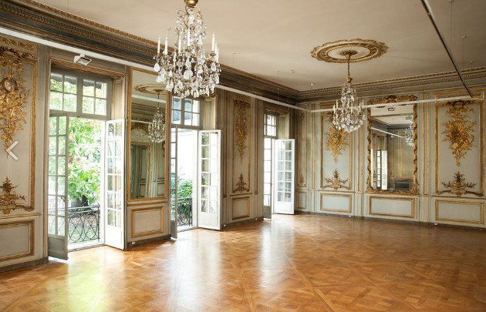
It is a nice 2,3 km (1.4 mile) walk from ESA HQ. Otherwise, you may take the underground (“metro” in French) at the Cambronne station (line 6, direction Charles de Gaulle Etoile), get out at the Trocadero station and then walk 750 m (0.5 mile). | 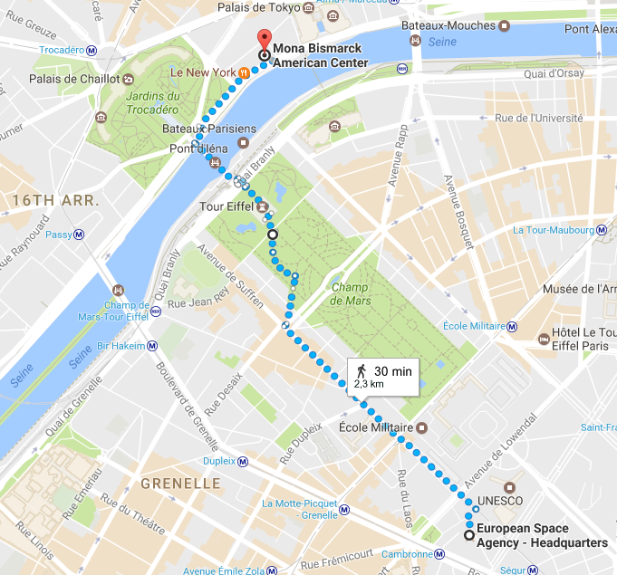

Transport/Directions:

The SIT-32 meeting and preceding side-meetings will be held at ESA Headquarters (Paris, France) located in the area of the Eiffel Tower.

 | European Space Agency Headquarters  8 -10 Mario Nikis  75015 Paris | Phone: + 33 (0)1 53 69 77 12  ESA web site: www.esa.int
Nearest Metro (Underground) stations: Line 6 'Cambronne' or Line 10 'Segur'
A map can be found in appendix.

Wednesday 26th April – SIT-32 Day 1
Security Information: See Above.
Day 1 WebEx: See Appendix.
Coffee and Registration | 08:30 – 09:00  30m

# | Item / Presenter |  | Time  Duration
Session: Introduction
1 | Welcome (S Briggs)  - Logistics (I Petiteville)  - Tour de table (S Briggs) |  | 09:00 – 09:15  15m  Discussion
2 | SIT Chair Term Themes and SIT-32 Objectives (S Briggs)  - SIT Chair Objectives  - Agenda Overview |  | 09:15 – 09:30  15m  Discussion
Session: CEOS Plenary (USGS to Chair this Session as CEOS Chair)
3 | COVERAGE – Building an Ocean VC Data Product (E Lindstrom) |  | 09:30 – 09:45  15m  Decision
Session: Strategic Partnerships
Key Questions:
Do CEOS Agencies agree on the trends identified in CEOS activities and relationships?
Should we emphasise particular partnerships and/or explore new ones?
Are their strategic directions CEOS should chart to serve Members in the coming 10 years?
4 | Introduction and Recap (SIT Chair) |  | 09:45 – 09:55  10m  Discussion
5 | Development Finance Partnerships (SIT Chair)  - Agency survey and interviews  - Example programs |  | 09:55 – 10:10  15m  Discussion
6 | ESA International Financial Institutions Partnerships (S Coulson) |  | 10:10 – 10:25  15m  Discussion
Break (inc. Group Photo) |  |  | 10:25 – 10:45  20m
7 | Discussion - Strategic Partnerships incl. Dev. Finance  - Role for GEO and CEOS-GEO interaction  - How to use agency expertise  - How to move forward |  | 10:45 – 11:15  30m  Discussion and Decision
Session: Future Data Access and Analysis Architectures
Update from and strategic feedback to the Ad-hoc Team on FDA
SIT decision on the topics that the FDA team should scope out in more detail based on the strategic analysis presented.
8 |  | FDA AHT Update (Co-Chairs)  - 2016 Recap  - 2017 status and outlook  - LSI-VC: Progress on ARD  - Guidance and confirmation on SIT on priority topics | 11:15 – 11:40  25m  Discussion and Decision
9 |  | FDA Discussion | 11:40 – 12:00  20m  Discussion and Decision
Lunch (ESA cafeteria)  Note prompt timing for the lunch break required to avoid delays. |  |  | 12:00 – 13:00  60m
10 |  | CEOS Chair Moderate Resolution Interoperability Initiative (J Lacey) | 13:00 – 13:15  15m  Discussion
11 |  | MRI Discussion | 13:15 – 13:30  15m  Discussion and Decision
Session: GEO and GEO Initiatives

Updates on GEO Status and future. Prospects for GEO thematic coordination activities and any corrective actions required to ensure successful geometries. Future for evolution of requirements processes through the GEO framework. Update on key CEOS stakeholder activities of GFOI, GEOGLAM and Blue Planet.
12 | GEO Framework Update and Outlook, including highlighting of GEO priorities (B Ryan) |  | 13:30 – 13:50  20m  Discussion
13 | CEOS View on GEO Developments and Outlook (SIT Chair)  (incl. prospects for requirements and thematic coordination activities in GEO) |  | 13:50 – 14:00  10m  Discussion
14 | Discussion – GEO and GEO Initiatives  - Prospects for thematic coordination activities under GEO (Carbon, Water, Oceans, etc.)  - CEOS representation on Flagship/Initiative Advisory Groups  - CEOS representation on GEO ExComm and Programme Board |  | 14:00 – 14:30  30m  Discussion and Decision
15 | GFOI Status and Issues (S Ward) |  | 14:30 – 14:45  15m  Discussion
16 | GEOGLAM Status and Issues (S Cherchali) |  | 14:45 – 15:00  15m  Discussion
17 | Blue Planet Update (E Smail) |  | 15:00 – 15:10  10m  Discussion
18 | Other CEOS Actions in GEO WP (CEO/SIT Chair)  - CEOS Actions in GEO WP (CEO)  - Report on World Cover 2017 Meeting, March 14-16 (SIT Chair)  - Coordination of terrestrial observations - report on progress (SIT Chair) |  | 15:10 – 15:30  20m  Discussion
Break |  |  | 15:30 – 15:45  15m
Session: UN Initiatives
Updates on UN-led initiatives of special interest to CEOS, including in relation to the SDGs and to disasters. (UNFCCC features in a dedicated climate session).
19 | UN-SDG  - GEO approach to SDGs (10min) (B Ryan)  - Process Update (MJ Bourassa)  - CEOS Way Forward and Work Plan (A Held) |  | 15:45 – 16:15  30m  Discussion and Decision
20 | UN-WCDRR  - Process Update and CEOS Way Forward (I Petiteville)  - CEOS support to the Sendai Framework (S Chalifoux) |  | 16:15 – 16:40  25m  Discussion and Decision
21 | Discussion - UN Initiatives Session |  | 16:40 – 16:55  15m  Discussion and Decision
Session: Thematic Observing Strategies
Strategic consideration of emergence and status within CEOS of the many acquisition requests and reflection on CEOS capacity and ability to manage multiple parallel requirements. What thematic coverage has CEOS committed to? What are the current and future resource requirements to address those commitments and the adequacy of CEOS resources? Does CEOS capacity allow it to take on new commitments?
22 | GEO Water Coordination  - GEOGLOWS Ambitions and how to proceed (B Ryan)  - GEO Aquawatch Update (E Smail) |  | 16:55 – 17:15  20m  Discussion and Decision
23 | CEOS Water Strategy  - Hyperspectral Water Quality Report C.10 (A Held) |  | 17:15 – 17:25  10m  Discussion
24 | Discussion and Required Actions  - CEOS approach to water observations |  | 17:25 – 17:35  10m  Discussion and Decision
25 | Rationalising CEOS land imaging activities  (SIT Chair Team/S Ward)  - Concurrence on September joint meeting plans |  | 17:35 – 17:50  15m  Discussion and Decision
26 | SIT-32 Day 1 Closing Remarks (S Briggs) |  | 17:50 - 18:00  10m  Discussion
Adjourn |  |  | 18:00

19:00 - Guided Tour and Hosted Dinner, at Mona Bismarck American Centre.

Thursday 27th April – SIT-31 Day 2

# |  |  | Item / Presenter | Time  Duration
Session: Coordination of Climate Observations
Evolution of the key relationships: CEOS-GCOS-UNFCCC
Next phase of CEOS-GCOS documentation, GCOS IP16 satellite supplement
Scope for Carbon supplement
ECV inventory and Climate Architecture directions and schedule
27 |  |  | GCOS Status and Outlook (C Richter) | 09:00 – 09:10  10m  Discussion
28 |  |  | CEOS Climate Coordination Update (P Lecomte)  - CEOS-CGMS Response to GCOS IP 2016  - ECV Inventory and Climate Architecture | 09:10 – 09:30  20m  Discussion
29 |  |  | IPCC Task Force on National Greenhouse Gas Inventories (TFI) Engagement Status (A Suzuki) | 09:30 – 09:45  15m  Discussion
30 |  |  | CEOS Carbon Strategy Implementation Update (M Dowell)  - Status of seven VC/WG initiatives | 09:45 – 10:25  40m  Discussion
31 |  |  | Discussion - Coordination of Climate Observations | 10:25 – 10:40  15m  Discussion
Break |  |  |  | 10:40 – 11:00  20m
Session: CEOS VCs and WGs: Issues for Attention/Decision of SIT-32
Addressing key issues identified during SIT Chair telecons.
32 |  | VC Leads and WG Chairs Issue Reports (JL Fellous)  - Overview (JL Fellous)  - SST MW radiometer continuity  - WGDisasters Coordination Efforts (S Chalifoux)  - Endorsement: GSNL San Andreas Fault Natural Laboratory  - Endorsement: GSNL Hawaii Supersite Biennial report  - Endorsement: Geohazards Lab Concept  - For comment: DRAFT Pilot final reports: Flood, Seismic Hazards and Volcano |  | 11:00 – 12:00  60m  Discussion and Decision
Lunch (ESA cafeteria)  Note prompt timing for the lunch break required to avoid delays. |  |  |  | 12:00 – 13:00  60m
Session: Copernicus Sentinel Data Uptake and Application
33 |  | Copernicus Sentinels  - Space and Ground Segment Status (I Petiteville and P Counet)  - Space Strategy for Europe (also known as SS4E) (10 min) (A Koch) |  | 13:00 – 13:30  30m  Discussion
34 |  | Discussion:  - Inputs from CEOS Initiatives (VCs, WGs, AHTs etc.) on Access and Uptake of Sentinel Data in CEOS  - Actions and update since SIT-31 survey |  | 13:30 – 14:15  45m  Discussion
Session: SIT-32 AOB, Actions, and Closing
35 | AOB:  - CEOS Information Systems Survey Follow up (I Petiteville) (10m)  - 31st CEOS Plenary (CEOS Chair) (5m) |  |  | 14:15 – 15:00  45m  Discussion
36 | 2018-2019 CEOS SIT Chair Proposed Priorities (S Volz) |  |  | 15:00 – 15:10  10m  Discussion
37 | Future CEOS Chair Initiatives (A Koch) |  |  | 15:10 – 15:20  10m  Discussion
38 | Review of Actions (SIT Chair Team) |  |  | 15:20 – 15:35  15m  Discussion
39 | SIT-32 Closing Remarks (S Briggs) |  |  | 15:35 – 16:00  25m  Discussion
Adjourn |  |  |  | 16:00

Map
