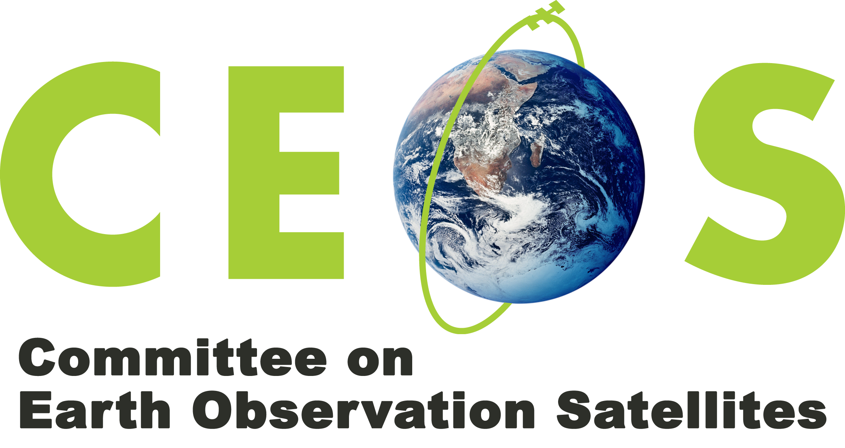

DRAFT - WORKING DOCUMENT (v1 Feb 2017, v2 early March 2017, v3 28/03/2017)
Terms of Reference (Implementation plan in a separate document)

Terms of Reference
Ad hoc team on the United Nations Sustainable Development Goals (AHT SDG)

The 30th CEOS Plenary established a CEOS Ad hoc team on the Sustainable Development Goals (AHT SDG).

These Terms of Reference, which follow the December 2016 concept note prepared by the CEOS Secretariat, have been reviewed and discussed during the first meeting of the AHT SDG in Washington DC on 8-9 March 2017.

Background

On 1 January 2016, the 17 United Nations (UN) Sustainable Development Goals (SDGs) and the 169 targets of the 2030 Agenda for Sustainable Development — which were adopted by world leaders in September 2015 — officially came into force.
Collectively, the Sustainable Development Goals and Targets enable countries and the global community to measure, manage, and monitor progress on the three interconnected elements of sustainable development: economic growth, social inclusion and environmental sustainability. They provide new norms to integrate the principles of sustainable development into country policies and programs.

Remotely sensed observations acquired from satellites are fundamental to understanding Earth system functioning and the effects of natural and human induced changes on the global environment. The 2030 Agenda for Sustainable Development clearly highlights the importance of using Earth observation: “... We will promote transparent and accountable scaling-up of appropriate public-private cooperation to exploit the contribution to be made by a wide range of data, including earth observation and geo-spatial information, while ensuring national ownership in supporting and tracking progress.”

Achieving these goals and meeting the targets require many different actors to take action at all levels, from global, to national and local scales. These efforts and activities can be informed, targeted and assisted by Earth observation satellite data and products.

Before the official adoption of the Sustainable Development Goals and Targets, the UN System undertook a comprehensive effort to assess how to monitor progress towards the SDG targets. A global indicator framework was adopted by the UN Statistical Commission at its forty-seventh session in March 2016. This indicator framework allows to monitor progress on the SDG targets, inform policy and ensure accountability of all SDG stakeholders. It provides a management tool that supports implementation of development strategies as well as reporting on progress. Again, satellite Earth observations can play an important role in supporting generation of meaningful information on progress that can inform the global indicators.

Reflecting the extent of the SDGs themselves, the 2030 Agenda ‘landscape’ involves a complex and diverse group of actors. These actors have varying degrees of awareness and knowledge of the value satellite Earth observations can offer. Thoughtful coordination and engagement are essential to build a greater understanding of the value of satellite observations among these actors. It is crucial to present Earth observation related topics using tools and terms that can be understood by a wide range of audiences, including non-experts in this field.

The UN System has established a range of formal processes for achieving the goals and monitoring progress towards the targets, which a particular focus to supporting least developed economies and leaving no one behind. These processes include the coordination of international efforts and the sharing of best practices. At international level, UN agencies play a crucial coordinating role as custodian of the SDG indicators, for the compilation and monitoring of global indicators but also as a support to the countries on the indicator implementation. National governments, regional structures, NGOs, the private sector and many others are also key players in these processes.

Engagement in the 2030 Agenda (or SDGs)

CEOS has chosen, for the present, to align its engagement with the SDG agenda mostly through the intergovernmental Group on Earth Observations (GEO) and on a case by case basis directly with the custodian UN agencies as well as with individual countries through their National Statistical Offices (NSOs) and relevant ministries.

The approach to channel CEOS efforts on SDGs mainly through GEO aims to benefit from and leverage GEO's unique "convening power", through which most Earth Observation actors can be engaged within a single internationally coordinated framework. It helps provide a single entry point and consistent communication vehicle to stakeholders for connecting with the EO community.

GEO is currently engaging in the SDG agenda through three complementary channels, with which CEOS will principally liaise:
- Through the work of the GEO Programme Board (CEOS is a member), to help develop the GEO Work Programme in a manner that ensures that GEO's work aligns with stated GEO priorities, including the SDG agenda, which was explicitly called out by Ministers at GEO's Mexico Ministerial Summit in 2015. The Programme Board, through a subgroup dedicated to SDGs, will proactively ensure optimal alignment and will address any critical ‘gaps’.

- Through implementation of the GEO Engagement Strategy, endorsed at GEO-XIII in 2016, which identifies the SDG agenda as one of only three priority areas for coordinated and proactive engagement across the entire GEO community. A detailed Engagement Implementation Plan is now being developed by the GEO Secretariat under the guidance of the GEO Executive Committee.

- Through a specific SDG-targeted GEO Initiative "Earth Observations in service of the 2030 agenda for Sustainable Development" (EO4SDGs). The GEO EO4SDGs Initiative explores, through a series of pilot projects, how Earth observation and geospatial information can be embedded into national development and monitoring frameworks for the SDGs. The initiative undertakes also a number of efforts to understand how best to engage with UN structures and processes, and to build capacity within key institutions on how to use EO for SDG-related purposes.

Rationale for a CEOS ad-hoc team on SDGs

Considering the evolving landscape of the 2030 agenda for sustainable development, it is essential for CEOS to remain flexible in how it organises itself to engage with the SDG agenda. Reflecting this, and the need to channel and coordinate considerable efforts existing amongst its member agencies, CEOS Principals have agreed to utilise initially an ad hoc team effort. CEOS will also give Principal-level consideration to a suitable long-term approach to engaging with the SDG agenda that will run at least until 2030.

Mission Statement and Objectives

In this complex and evolving environment, the AHT SDG must take stock of the UN processes in place for the SDG implementation and of the existing participants and stakeholders, and focus its activities around the unique role that CEOS should play as a coordination body of satellite EO efforts in support to the full realisation of the SDGs.

The AHT SDG will assess, showcase and promote EO contribution to both SDG targets and indicators. The focus of the AHT will not only be on the SDG indicators that have been defined to monitor progress towards the SDG targets, but also to explore how EO can define new indicators. The EO contribution to the SDG targets will be equally addressed by the AHT SDG, in two ways: first as a means to support countries achieving their targets, and second to help the UN system refine its global indicator framework when targets are only partially covered by the currently defined indicators.

The objectives of the AHT SDG therefore are to:
- Coordinate the efforts of CEOS agencies and communicate CEOS support to the SDG processes, by undertaking a number of activities, including those promoted by GEO, that showcase the important role of satellite Earth observation for the full realisation of the SDGs:
  - Generating, exploring and promoting use cases, including those from existing GEO Flagships and Initiatives where CEOS is a partner or a leader.
  - Coordinating the production of communication materials on ‘EO best practices in support to the 2030 Agenda for Sustainable Development’ as a mean to engage and mobilize SDG stakeholders around the use of EO data, products and tools.
- Provide a forum for sharing/communicating EO best practices in support to the SDGs, providing easy access to methodological development, tools and platforms, and discoverability of global/regional data sets.
- Analyse new opportunities for satellite-based EO to support SDGs Targets and Indicators (new methods, new data, new indicators)
- Engage with other relevant authoritative stakeholders outside the UN system, which provide support to the SDG realisation (e.g. the Global Partnership for Sustainable Development Data (GPSDD), GreenFund, World Bank Group, etc.)
- Use CEOS assets and bodies to build user capacity at all levels of the SDG implementation.

Leadership

The AHT SDG has three ‘co-chairs’, each from a CEOS Agency originating from a different geographical region, consistent with the global nature of the SDG agenda.
The geographic regions will be:
- Americas
- Asia/Oceania
- Africa/Europe

Each co-chair will serve for a term of one year, with the possibility of extension by CEOS Principals.

Membership

A call for nominations has been issued to all CEOS Agencies in December 2016.

The participation is open to all CEOS Agencies that are willing to support and contribute to activities that are in scope with the AHT SDG mission and objectives. Agencies need to contact directly the co-chairs to be integrated in the CEOS Ad-Hoc Team on SDGs.

--------------------------------------- End of Terms of Reference ----------------------------------------------

