**The 33rd Meeting of the CEOS Strategic Implementation Team (SIT-33)**

**24th-25th April 2018**

**University of Colorado**

**Boulder, CO, USA**

**AGENDA v1.3**

[**ceos.org/meetings/sit-33**](http://ceos.org/meetings/sit-33/)

***\*\* HIGHLIGHTS IN PRESENTER COLUMN NEED CONFIRMATION. Each agenda item will be further defined as: “for information, for discussion, for decision.”\*\****

At SIT-33, we intend to focus on two of the 2018-2019 SIT Chair Priorities:

* Ensuring the efficient execution of existing SIT responsibilities addressing Working Group (WG) and Virtual Constellation (VC) continuity, sustainability, and outputs, including: undertaking gap analyses for each VC, to support ongoing and likely upcoming strategic Agency observatory decisions; seeking observations from VCs and WGs on best practices and possible modifications to existing practices; and supporting the activities of the CEOS *ad hoc* Team on Sustainable Development Goals by identifying targets and indicators relevant to each VC. Specifically, we will address the outcomes of the VC and WG Questionnaires that were shared with the current and one-generation removed leaders of the VCs and WGs in January.
* Improving and clarifying CEOS relationships with CGMS, GEO, and WMO by identifying coordinated activities and, where appropriate, holistic interaction emphasizing the unique values of each organization. We will address a mapping of CEOS priorities with the 2017-2019 GEO Work Programme, identifying areas where support and commitment from CEOS agencies is requested, as well as how those activities are captured in the CEOS 2018-2019 Work Plan, which will also be endorsed at SIT-33.

Additionally, we will continue discussion on key activities addressing decisions and actions from the 31st CEOS Plenary including the Water Feasibility Study, CEOS freshwater observation strategy, and the advancement of ongoing CEOS commitments and support to other global initiatives such as climate activities.

The *Strategic Directions and Partnerships for CEOS Discussion Paper* is provided as supporting document to the agenda.

The agenda is structured such that **Day 1 (Tuesday 24th)** is focused on the transfer of information, communicating agency near-term and long-term future plans, emerging activities, and building common understanding of implementation activities across CEOS through the Virtual Constellations and Working Groups.

**Day 2 (Wednesday 25th)** is focused on broader strategic discussions, linkages across CEOS work, mapping the work of CEOS to other partners (e.g. GEO), and concluding CEOS business.

**Monday 23rd** is reserved for side meetings.

**Monday, 23 April 2018**

*Side Meetings.*

*1665 Central Campus Mall, University of Colorado, Boulder, Boulder Colorado 80309*



**Tuesday, 24 April 2018**

*Implementation status, sharing of information, building common understanding.*

*University Memorial Center Room: 235, 1669 Euclid Avenue Boulder, CO 80309*

***Registration: 8:30 – 9:00***

|  |
| --- |
| ***Session 1: Welcome and Introduction*** |

| # | Time  *Duration* | Topic | Presenter |
| --- | --- | --- | --- |
| 1.1 | 9:00 – 9:05  *5 min* | Opening Remarks | Steve **Volz**, SIT Chair (NOAA) |
| 1.2 | 9:05 – 9:20  *15 min* | Welcome | Eric **Kihn**, Director NCEI-CCOG |
| 1.3 | 9:20 – 9:30  *10 min* | *Tour de Table* Introductions | **All** |
| 1.4 | 9:30 – 9:40  *10 min* | SIT Chair 2018-2019 Priorities and SIT-33 Objectives | Steve **Volz**, SIT Chair (NOAA) |
| 1.5 | 9:40 – 9:50  *10 min* | CEOS Chair Remarks, Introduction, and Overview | Mauro **Facchini**, CEOS Chair, (COM) |
| 1.6 | 9:50 – 10:10  *20 min* | U.S. Decadal Survey | Graeme **Stephens**, (CIRA), Art **Charo** (NSF) |
| 1.7 | 10:10 – 10:40  *30 min* | Discussion on Future Mission Planning   * Copernicus Next Generation * JAXA Global EO Contributions * NOAA Satellite Observing System Architecture (NSOSA) | **All** |

***Group Photo and Coffee Break: 10:40 – 11:00, 20 minutes***

|  |
| --- |
| ***Session 2: Work Planning*** |
| *As a part of the core CEOS business and mission, and in the frame of CEOS support to GEO, review existing Work Plans to try and identify opportunities for coordination and optimization.*  ***Key Questions:***  *How do SIT-33 discussions related to the CEOS Work Plan and GEO Work Programme?*  *What areas can CEOS be expected to contribute in the future and how do these relate to the CEOS Work Plan?* |

| # | Time  *Duration* | Topic | | Presenter | |
| --- | --- | --- | --- | --- | --- |
| 2.1 | 11:00 – 11:10  *10 min* | | Return to First Principles   * Refresher on CEOS Mission and Strategic Goals and Objectives | | Kerry **Sawyer**, SIT Chair Team (NOAA) |
| 2.2 | 11:10 – 11:25  *15 min* | CEOS Work Plan 2018-2020   * Review and Framing for SIT-33 | | Steven **Hosford**, CEO (CNES/ESA) | |
| 2.3 | 11:25 – 11:40  *15 min* | CEOS Priorities and the 2017-2019 GEO Work Programme   * Mapping CEOS activities * Sustaining existing support * Land Degradation Neutrality Initiative Proposal | | Kerry **Sawyer**, SIT Chair Team (NOAA) | |
| 2.4 | 11:40 – 12:00  *20 min* | Discussion   * Areas where CEOS Agencies will be asked to support GEO WP * How to capture in the CEOS WP | | **All** | |

|  |
| --- |
| ***Session 3: Virtual Constellations*** |
| *Support tangible and sustainable outcomes from CEOS Virtual Constellations by providing an opportunity to air key issues, identify barriers to progress, and discuss ways to overcome those barriers. Reflect on findings from the recent VC questionnaires and telecons.*  ***Key Questions:***  *How does CEOS best ensure continuity and sustainability of VCs?*  *What outputs are the VCs delivering? What additional outputs are needed or could they deliver?*  *What are the gaps within and between VCs that need to be addressed? How can they be addressed?*  *What obstacles are being raised by the VCs? And can they be resolved? If so, how?*  *Can, and how can the work of the VCs be mapped to future CEOS agency mission planning processes?* |

| # | Time  *Duration* | Topic | Presenter |
| --- | --- | --- | --- |
| 3.1 | 12:00 – 12:20  *20 min* | Session Introduction   * VC questionnaire process and outcomes * CEOS Priorities for WGs and VCs * Identify challenges faced by the groups in sustaining and improving their activity | Steve **Volz**, SIT Chair (NOAA) |
| 3.2 | 12:20 – 12:30  *10 min* | SST-VC: Sea Surface Temperature  ***Plenary Action 31-07***  ***SIT TWS Action 2017-19*** | Ken **Casey**, SST-VC Co-Lead (NOAA) |
| 3.3 | 12:30 – 12:40  *10 min* | OSVW-VC: Ocean Surface Vector Wind | TBA |
| 3.4 | 12:40 – 12:50  *10 min* | OCR-VC: Ocean Colour Radiometry | TBA |
| 3.5 | 12:50 – 1:00  *10 min* | OST-VC: Ocean Surface Topography  ***SIT TWS Action 2017-16*** | TBA |

***Lunch: 1:00 – 2:15, 75 minutes***

|  |
| --- |
| ***Session 3: Virtual Constellations (continued)*** |

|  | Time  *Duration* | Topic | Presenter |
| --- | --- | --- | --- |
| 3.6 | 2:15 – 2:25  *10 min* | P-VC: Precipitation | *Steve* ***Neeck****, P-VC Co-Chair (NASA)\** |
| 3.7 | 2:25 – 2:35  *10 min* | AC-VC: Atmospheric Composition  ***SIT TWS Action 2017-15*** | David Crisp (NASA) TBC |
| 3.8 | 2:35 – 2:45  *10 min* | LSI-VC: Land Surface Imaging  ***Plenary Action 31-06*** | Jenn **Lacey**, LSI-VC Cio-Chair (USGS) |
| 3.9 | 2:45 – 2:50  *5 min* | Discussion   * Main discussion to follow WG session | **All** |

|  |
| --- |
| ***Session 4: Working Groups*** |
| |  | | --- | | *Support tangible and sustainable outcomes from CEOS Working Groups by providing an opportunity to air key issues, identify barriers to progress, and discuss ways to overcome those barriers. Reflect on findings from the recent WG questionnaires and telecons.*  ***Key Questions:***  *How does CEOS best ensure continuity and sustainability of WGs?*  *What outputs are the WGs delivering? What additional outputs are needed or could they deliver?*  *What obstacles are being raised by the WGs? And can they be resolved? If so, how?*  *Can and how can, the work of the WGs support the VCs, as well as current and future CEOS Work Plan and GEO Work Programme items?* | |

| # | Time  *Duration* | Topic | Presenter |
| --- | --- | --- | --- |
| 4.1 | 2:50 – 3:00  *10 min* | Session Introduction   * WG questionnaire process and outcomes * CEOS Priorities for WGs and VCs | Steve **Volz**, SIT Chair (NOAA)  Mark **Dowell**, CEOS Chair Team (COM) |
| 4.2 | 3:00 – 3:10  *10 min* | WGCapD: Working Group on Capacity Building and Data Democracy | Nancy **Searby**, WGCapD Vice Chair NASA) |
| 4.3 | 3:10 – 3:20  *10 min* | WGCV: Working Group on Calibration and Validation | Kurt **Thome**, WGCV Chair (NASA) |
| 4.4 | 3:20 – 3:40  *20 min* | WGDisasters: Working Group on Disasters   * Introduction of Demonstrators | Simona **Zoffoli**, WGDisasters Chair (ASI) |
| 4.5 | 3:40 – 3:50  *10 min* | WGISS: Working Group on Information Systems and Services | Mirko **Albani**, WGISS Chair (ESA) |
| 4.6 | 3:50 – 4:05  *15 min* | WGClimate: CEOS/CGMS Working Group on Climate   * Gap Analysis Report and Coordinated Action Plan   ***Plenary Action 31-01*** | Jörg **Schulz**, WGClimate Chair (EUMETSAT) |

***Coffee Break: 4:05 – 4:20, 15 minutes***

|  |
| --- |
| ***Session 3/4: Virtual Constellations and Working Groups Wrap-up*** |

| # | Time  *Duration* | Topic | Presenter |
| --- | --- | --- | --- |
| 3.10/  4.7 | 4:20 – 4:50  *30 min* | VC and WG Discussion   * Sustaining activity * WG framework support to VCs * Support to agency mission planning * Broader observing strategy * 2018 activities | **All** |

|  |
| --- |
| ***Session 5: Emerging and On-going Activities*** |
| *Review of several emerging opportunities for CEOS engagement from the GEO Work Programme, as well as across the community.*  ***Key Questions:***  *What are the requirements of new and emerging activities around aquatic ecosystems and freshwater observations from space? Can these be addressed by CEOS capabilities, and if so, should they? How?*  *What are the next steps that CEOS can be taking in support of the Paris Declaration?*  *How is CEOS engaging with the IPCC Inventories process?*  *What, if any, new CEOS resources and Partnerships may be required to support engagement in these emerging activities?* |

| # | Time  *Duration* | | Topic | | Presenter |
| --- | --- | --- | --- | --- | --- |
| 5.1 | 4:50 – 5:00  *10 min* | | Feasibility Study for Aquatic Ecosystem Observations  ***Plenary Action 31-04*** | | TBA |
| 5.2 | 5:00 – 5:15  *15 min* | | Freshwater from Space Observation Strategy  ***Plenary Action 31-05***  ***Plenary Decision D-04*** | | Alex **Held**, SIT Vice Chair (CSIRO) |
| 5.3 | 5:15 – 5:25  *10 min* | Paris Declaration | | Juliette **Lambin** (CNES) | |
| 5.4 | 5:25 – 5:40  *15 min* | Proposed CEOS Way Forward with the Paris Declaration | | Jörg **Schulz**, WGClimate Chair (EUMETSAT) | |
| 5.5 | 5:40 – 5:50  *10 min* | | IPCC Engagement Update  ***SIT TWS Action 2017-06*** | | Osamu **Ochiai** (JAXA) |
| 5.6 | 5:50 – 6:10  *20 min* | | Discussion   * Way forward on new activities | | **All** |

***Adjourn***

***7:00 pm: Hosted Reception at Carelli’s Restaurant***

**Wednesday, 25 April 2018**

*Strategic discussion, planning and linking of work, mapping to partnership priorities.*

*University Memorial Center Room: 235, 1669 Euclid Avenue Boulder, CO 80309*

|  |
| --- |
| ***Recap*** |

| # | Time  *Duration* | Topic | Presenter |
| --- | --- | --- | --- |
|  | 9:00 – 9:10  *10 min* | Synopsis from Day One | Steve **Volz**, SIT Chair (NOAA) |

|  |
| --- |
| ***Session 6: Ad Hoc Teams*** |
| *Review progress and key issues being faced by CEOS Ad Hoc Teams (AHTs) and discussion on sustainability of the AHTs and plans for the future.*  ***Key Questions:***  *What concrete steps can be taken in support of FDA activities? And how does this related to existing Work Plans? What is required to promote and systematically generate ARD?*  *What are the next steps for CEOS in supporting the advancement of the SDGs?*  *How does CEOS sustain and progress its commitments to GEO Flagships such as GFOI (via SDCG), and GEOGLAM (via the AHT)? What resources and actions are required?* |

| # | Time  *Duration* | Topic | Presenter |
| --- | --- | --- | --- |
| 6.1 | 9:10 – 9:30  *20 min* | Session Introduction   * Review of structure and discussion of sustained approach to future of AHTs | Steve **Volz**, SIT Chair (NOAA)  Mauro **Facchini*,*** CEOS Chair (COM) |
| 6.2 | 9:30 – 9:45  *15 min* | FDA: Ad Hoc Team on Future Data Architectures   * Take stock of progress on ARD | FDA Co-Lead (ESA, USGS, or CSIRO) |
| 6.3 | 9:45 – 10:00  *15 min* | SDG: Ad Hoc Team on Sustainable Development Goals   * CEOS Actions Related to the SDG * CEOS Relation with all the UN Agencies * GEO Report on Engaging UNOOSA   ***SIT TWS Action 2017-21*** | TBA  GEOSEC (TBC) |
| 6.4 | 10:00 – 10:15  *15 min* | SDCG: Ad Hoc Space Data Coordination Group for the Global Forest Observations Initiative (SDCG for GFOI)   * Resourcing action follow-up | Osamu Ochiai, GFOI Lead for CEOS (JAXA) (TBC) |
| 6.5 | 10:15 – 10:25  *10 min* | GEOGLAM: Ad Hoc Working Group on the Group on Earth Observations (GEO) Global Agricultural Monitoring (GEOGLAM) Initiative | Brad **Doorn**, GEOGLAM AHT Co-Lead (NASA) |
| 6.6 | 10:25 – 10:40  *15 min* | Discussion | **All** |

***Coffee Break: 10:40 – 11:00, 20 minutes***

|  |
| --- |
| ***Session 7: Partnerships*** |
| *How should CEOS be developing its partnerships, in particular with CGMS, GEO, and GCOS, to advance and reinforce common interests.*  ***Key Questions:***  *How does CEOS effectively and efficiently take its carbon actions forward?*  *Could GEO-LEO combined products be promoted within CGMS?*  *What is the joint CEOS-GCMS way forward on GHG monitoring?*  *How does CEOS support GEO and its various sub-entities? Are there improvements to be made in this support?* |

| # | Time  *Duration* | Topic | Presenter |
| --- | --- | --- | --- |
| 7.1 | 11:00 – 11:10  *10 min* | Session Introduction   * SIT Chair objectives | Steve **Volz**, SIT Chair (NOAA) |
| 7.2 | 11:10 – 11:30  *20 min* | Carbon   * Review of GHG White Paper * Review Options for CEOS-CGMS Collaboration on GHG Monitoring * GEO Carbon Initiative   ***SIT TWS Action 2017-05***  ***SIT TWS Action 2017-08***  ***SIT TWS Action 2017-17***  ***SIT TWS Action 2017-18*** | Mark **Dowell** , CEOS Chair Team (COM)  David Crisp (NASA) (TBC)  Pascal Lecomte, CEOS Rep to GEO-C Steering Committee (ESA) (TBC) |
| 7.3 | 11:30 – 11:40  *10 min* | GCOS Update | Stephen **Briggs**, GCOS |
| 7.4 | 11:40 – 11:55  *15 min* | GEO/LEO Combined Products   * Potential focus with CGMS * GEO Capabilities for Research | TBA |
|  | **11:57** | **Sentinel-3B Launch** | **ESA and EUMETSAT** |
| 7.5 | 12:10 – 12:20  *10 min* | International Financial Institutions and Overseas Development Aid Action Item Closure  ***Plenary Action 31-03***  ***Plenary Decision D-02***  ***SIT TWS Action 2017-23*** | ESA (TBC) |
| 7.6 | 12:20 – 12:30 | GEO Update | Barb **Ryan**, GEO Secretariat Director (TBC) |
| 7.7 | 12:30 – 12:40  *10 min* | Support to GEO   * CEOS Participation in GEO Entities (e.g., Programme Board and Subgroups, Executive Committee, Steering Committees) | Steven **Hosford**, CEO (CNES/ESA) |

***Lunch: 12:40 – 2:00, 80 minutes***

|  |
| --- |
| ***Session 7: Partnerships (continued*** |

| # | Time  *Duration* | Topic | Presenter |
| --- | --- | --- | --- |
| 7.7 | 2:00 – 2:30  *30 min* | Discussion   * Potential CEOS-CGMS collaboration * Preparations for CGMS-46 (ARD, WGISS, Carbon, Joint GHG Proposal) * Ensure mutual benefit of partnerships | **All** |

|  |
| --- |
| ***Session 8: CEOS Plenary*** |

| # | Time  *Duration* | Topic | Presenter |
| --- | --- | --- | --- |
| 8.1 | 2:30 – 2:40  *10 min* | Plenary Business Items   * Endorsement of WGCapD Terms of Reference * Endorsement of WGClimate Terms of Reference * Endorsement of Gap Analysis Report an Coordination Action Plan * CEOS 2018-2020 Work Plan Endorsement (TBC) | Mauro **Facchini**, CEOS Chair (COM) |
| 8.2 | 2:40 – 3:00 | Planning for CEOS Plenary   * What Decisions to Need to be Brought to Plenary | Steve **Volz**, SIT Chair (NOAA) |

|  |
| --- |
| ***Session 9: Review of Main Points, AOB, CEOS Leadership, Closing*** |

| # | Time  *Duration* | Topic | Presenter |
| --- | --- | --- | --- |
| 9.1 | 3:00 – 3:20  *20 min* | Review and Discussion of Main Points   * Revisit of SIT Chair strategic directions and partnerships * VC/WG next steps to TWS * Partnership next steps: carbon, GEO/LEO * Supporting GEO Items Arising for Discussion | Steve **Volz**, SIT Chair (NOAA)  **All** |
| 9.2 | 3:20 – 3:30  *10 min* | Any Other Business   * Agreed agenda additional items | **All** |

***Coffee Break: 3:30 – 3:50, 20 minutes***

|  |
| --- |
| ***Session 9: Review of Main Points, AOB, CEOS Leadership, Closing (continued)*** |

| # | Time  *Duration* | Topic | Presenter |
| --- | --- | --- | --- |
| 9.3 | 3:50 – 4:00  *10 min* | CEOS Leadership Status and Any Issues   * CEOS Chair * SIT Chair / Vice Chair * VCs * WGs * AHTs | Steven **Hosford**, CEO (CNES/ESA) |
| 9.4 | 4:00 – 4:10  *10 min* | Purpose and Objectives of Big Data Workshop | Martin **Ditter**, CEOS Chair Team (COM) |
| 9.5 | 4:10 – 4:20  *10 min* | Review of SIT-33 Actions | SIT Chair Secretariat |
| 9.6 | 4:20 – 4:40  *20 min* | SIT Chair Closing Remarks   * Plans and outlook for SIT Technical Workshop | Steve **Volz**, SIT Chair (NOAA) |

***Adjourn***

**Location**

A logistics package can be downloaded from the SIT-33 website.

* SIT-33 website: [ceos.org/meetings/sit-33](http://ceos.org/meetings/sit-33/)
* Logistics Information package: [click here](http://ceos.org/document_management/Meetings/SIT/SIT-33/2018%20SIT-33%20Meeting%20Logistics.pdf).

SIT-33 will take place at:

University Memorial Center Room: 235

1669 Euclid Avenue Boulder, CO 80309

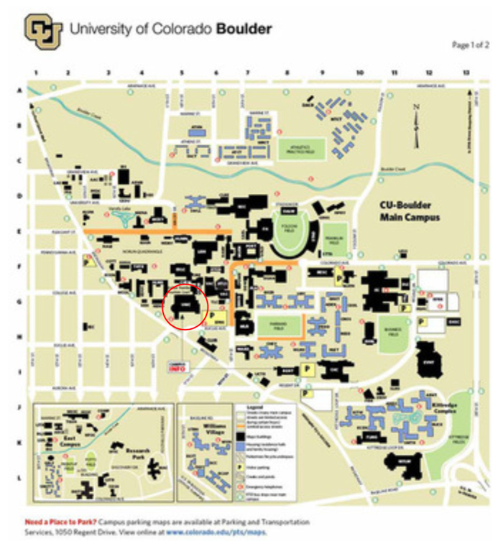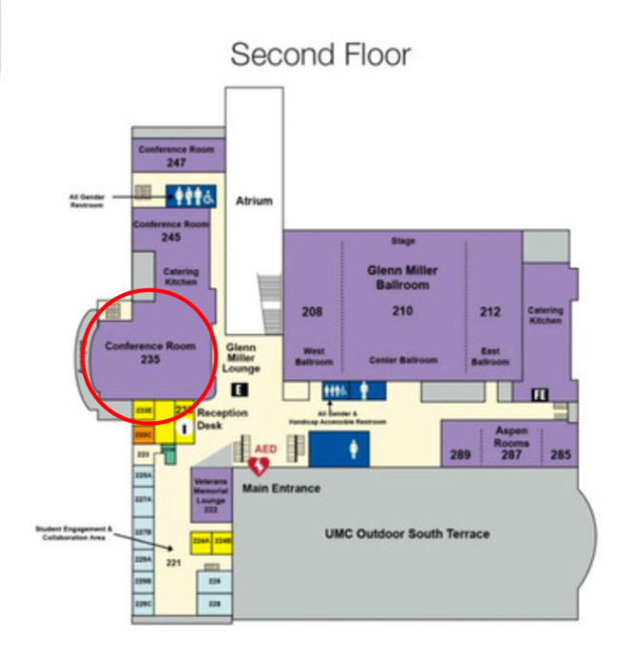

**Audio Connection Details**

TBA