For Discussion by the 2019 CEOS SIT-34

CEOS Working Group on Capacity Building and Data Democracy (WGCapD)

CB-37 Deliverable White Paper: Proposal to coordinate Capacity Development to support of the 2030 Agenda of Sustainable Development, the Sendai Framework for Disaster Risk Reduction and the Paris Agreement

Version 1.0, 22 March 2019

- Introduction

The Sustainable Development Goals (SDGs) that comprise the 2030 Agenda for Sustainable Development combined with the targets of the Sendai Framework for Disaster Risk Reduction and the commitments of the Paris Agreement for Climate Change contribute collectively to the overall global development goals, which are expected to be realized on national, regional and global scales. Space-based data and geospatial information are essential for implementation, monitoring and realization of these goals. This has been brought out in documents made available by regional/global organizations such as the Regional Centers for Space Science and Technology Education, affiliated to the United Nations the Group on Earth Observation (GEO) and the Committee on Earth Observation Satellites (CEOS) highlighting case studies, success stories and implementation approaches to reach the targets for realizing the SDGs in a systematic way. These organizations have also stressed the need to build highly qualified human resources who have access to software/hardware capacity to exploit the geospatial information data for development planning and decision-making, especially in developing countries. This call for action is further supported by faster digital connectivity, free access to long-term archived satellite data and data from current satellite missions, open-access geographic information systems and cost-free access to advanced spatial analysis tools to support real-time decision making.

Despite these advances in the technologies, data policies and noteworthy capacity building efforts made by various organizations, several challenges remain. The most important ones are the availability of funding and expert trainer resources to deliver effective capacity building. In many cases, the capacity building efforts are undertaken by these organizations independently. This implies high possibilities of duplication of efforts and of missing opportunities to build upon the capacity that has been already been built. In addition, despite several training programs conducted at various levels, there are many developing countries that do not have the capacity to utilize, analyze and interpret the geospatial information for their national development and importantly for their ability to manage natural disasters for risk reduction and mitigation plans. It is also challenging to inform the potential trainees in time due to lack of sharing large and inconsistent lists of such trainees contact banks, which are now locally available with individual organizations.

- Purpose

The purpose of this proposal is to outline a coordinated capacity building framework to enhance the benefits of capacity building efforts focused on training human resources and building the institutional capacity of beneficiary and concerned agencies and organizations for regional readiness to use geospatial information for implementation of the SDGs, targets and commitments of the global development agendas with a coordinated support of regional sustainable development members, inter-governmental information sharing mechanisms and international development and technical organizations.

- Benefits of coordinated Capacity Development:

The advantages of coordinated capacity development are many. Some of these are as follows: 1) reduction of duplicated efforts and building of synergies, 2) effective management of financial and expert resources by pooling – sharing the budget and coordinated arrangement of subject matter expertise that includes identifying persons who can effectively communicate in the region/country specific languages; in this, inclusion of national and international NGOs and civil societies as partners would be an added advantage, especially for identifying subject experts and for framing national and region specific themes; 3) sharing and joint research on software tools and methodologies developed by various agencies and partners of organizations; this would generate a set of innovative solutions needed for the country specific projects and requirements; 4) sharing resource bank of trainees across cooperating organizations and work out a mechanism to communicate on CB programs to maximize the effort; and 5) highlighting clearly the roles of each organization and their connected geospatial information regional and global services in terms of data warehousing or web-portals to provide clearly synergetic resources from the users’ point of view.

- Proposed framework to coordinated CB:

The framework proposed here consists of four phases, as shown in Figure.

Harmonization Phase: The cooperation of organizations for collaborative capacity building starts with broader exchange of information of capacity building working groups of global organizations and institutions (UNOOSA, CEOS, GEO, CGMS, WMO etc.), regional organizations and professional societies connected with geospatial information and technologies. Regional organizations, such as UNESCAP, AOGEOSS, APRSAF, ASEAN, as in the case of AO regions, together with space agencies and International NGOs (INGOs) may possess the knowledge for the regional current scenario and required actions to implement SDGs. Engaging national, regional and international professional societies engaged in remote sensing and Geoinformatics may benefit the effort.

An essential component of the harmonization of capacity development efforts would be a common database that records the capacity development interventions in each country conducted by all the contributing organizations. Such a database would allow to identify synergies and duplications and would allow countries themselves to review what capacity development they have already received and how they could best utilize those interventions in the framework of their national capacity development strategies. The database would also support a quantitative analysis of capacity development interventions through a results-based management approach. The WMO Country Profile Database could be an example or core of such a capacity development database. It is acknowledged that development of the database would be a considerable effort requiring some resources. However, without a method to record capacity development interactions, it will be difficult to harmonize, analyze and evaluate capacity development efforts, on the basis of which future capacity development activities could be planned more efficiently and effectively, thus ensuring real progress.

Planning Phase: To make the coordinated capacity building effective, it is essential to set up a Technical Advisory Board (TAB). This board may have its core members from global and regional organizations, to chalk out overall plans. This may include representatives from the professional societies as observers. The objective of the TAB is to assess region-specific requirements in realizing the SDG implementation, and identify curriculum development needed for short and long-term capacity building programs. The curriculum, which would be developed by members of participating organizations, should comprise a) core technical support on the use of EO in SDG realization, b) research and knowledge sharing, c) intergovernmental planning and regional practices and d) resources pooling and management.

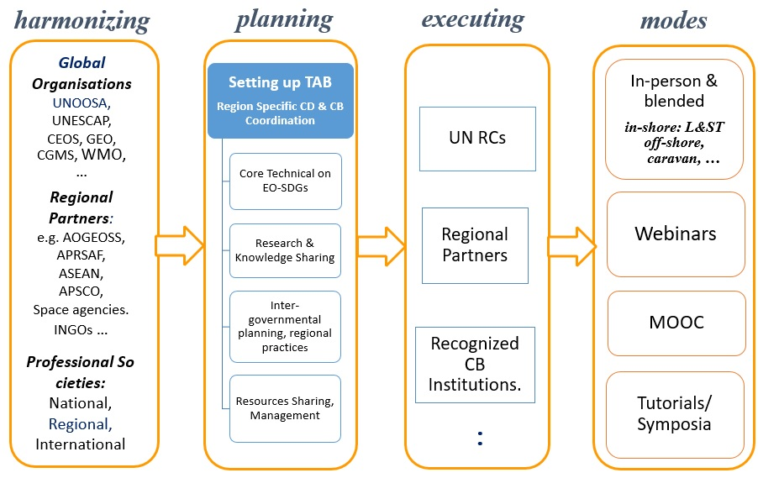
Figure. Proposed framework for coordinated capacity building

While capacity development and technical support is a priority for most countries, recognizing that research and knowledge-sharing, through regional cooperation platforms remain important supporting actions. This forms the planning stage of the capacity building.

- CB on Core technical competence: The development of human capacity and provision of technical tools to support selected methodologies is the core-training element for reaching each of the SDGs. The objective is to develop capacity and provide technical support to access, analyse and utilize Earth observation data and information, particularly for countries in the regions with special needs and those with limited capacity to use space applications.
  - Provide technical support to access and easily understand information and research related to space applications;
  - Develop a common understanding and work towards developing standards on spatial scale, temporal characteristics and cartographic elements with regard to space applications;
  - Provide technical support on integrating space applications with citizen science, mobile technology and other digital innovations, other sources of data and existing geospatial data platforms for evidence-based decision support.

- CB on Research and knowledge-sharing: Research and knowledge-sharing (RKS) activities are critical in further establishing the significant role that space applications can play in supporting actions under the different thematic areas. RKS is expected to deliver on
- the use of space applications and advanced technologies to support sustainable development;
- overcoming the barriers to utilizing space applications, including historical analysis of experiences to inform future recommendations development;
- the exchange of experts, professionals and resource personnel on space applications to support knowledge-sharing, and
- Engaging with youth to stimulate research and take advantage of innovations from young entrepreneurs through hackathons, scientific projects etc.

- Intergovernmental planning and regional practices: Connecting capacity building efforts with the end-user community is vital to the success of the SDGs implementation. To this end, existing regional practices and their lacunae in handling critical situations may need to be assessed for modifications through training and building the capacity. Efforts have been constantly made such as UN-ESCAP organising regional Ministerial Conferences to bring all the countries in the AP region to appraise the needs and benefits of the SDGs. Specific CB planning and practices followed must include:
  - Collect, share and promote good practices and experience on space policies and legislation, particularly those that support regional cooperation;
  - Raise awareness of the benefits and the barriers to accessing space applications at the policy and senior government levels;
  - Raise awareness among senior decision-makers of the importance of providing long-term support for staff who have been trained in order to build institutional capacity;
  - Facilitate discussion, cooperation and promote good practices in the use of satellite data, tools, products and applications for sustainable development and encourage resource allocation at the national and regional levels;
  - Work with existing intergovernmental mechanisms, and international and technical organizations to share satellite data and information to support their relevant agendas, coherent with the thematic areas identified in the Plan of Action and the Sustainable Development Goals;
  - Given the increasing commercialization of space applications, promote and facilitate discussions with private and commercial entities to support and continue Governments’ access to satellite data and products for sustainable development.

Execution Phase: In the execution of planned CB efforts, it is important to note that the well-established capacity building centres and institutions having proven their contributions in building human resources can be trusted upon in carrying out the task of building the human and required resources capacity. Some of these include the six established UN-affiliated Regional Centres, Institutions associated in capacity building such as IIRS, INPE, SANSA, GISTDA, etc. can form the platform to execute the plan of regional capacity building for UN-SDGs. The basic aspect of choosing these nodal points is that they have already well established facilities to carry out long term training that would contribute to developing trainers for the region in future. They may have established good practices to deliver the expected capacity building effectively in short term face-to-face or online training programs as well. Their connectivity with potential organisations and government departments is important to pool the right human resources for training.

Delivery Modes: There are a variety of modes to conduct the proposed capacity building efforts. In-shore (in-person, in-person blended with live stream) training for long-term and short-term courses, off-shore and/or caravan training to efficiently cover the countries in the regional scale. This would include an approach that develops model courses that can be adapted and reproduced in all regions, as well as structured self-directed courses using the e-content. Also, the enhancement of learning communities through tools and opportunities is to exchange best practices and collaborative problem solving. In addition, time-to-time training on advanced methods through global webinar series on selected topics, development of massive open online courses through distance learning mode with required e-content material for SDGs and implementation needs and making use of opportunities for discussions and tutorials through International conferences and symposia conducted in coordination with national and international professional societies.

Prepared by Senthil Kumar, Sergio Camacho and Nancy Searby

