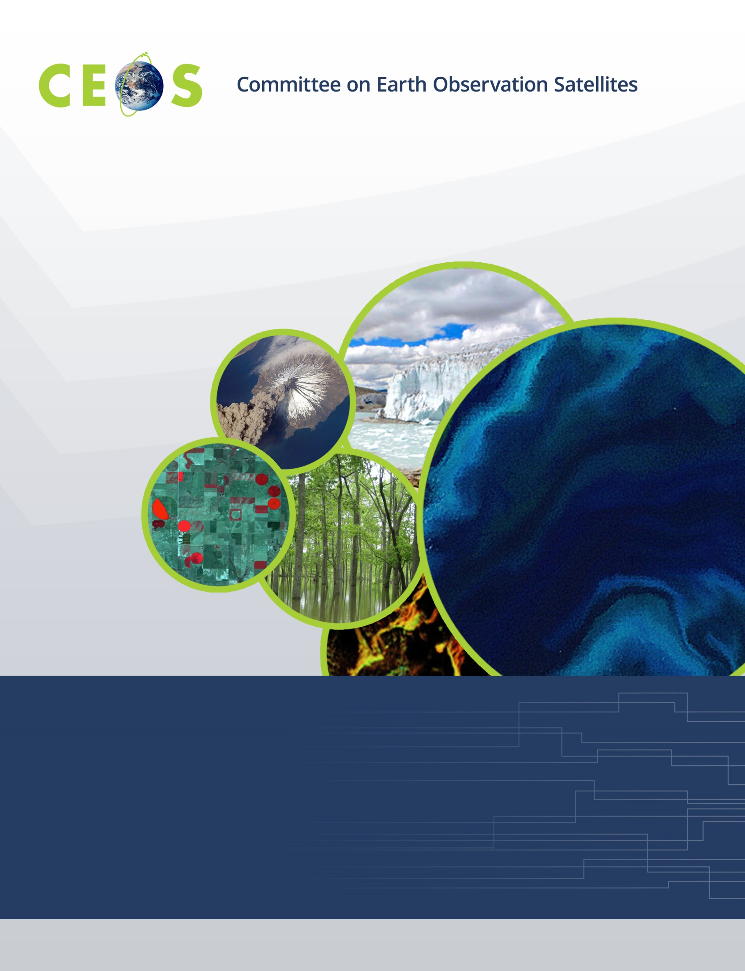
Earth Observation Training, Education and Capacity Development Network (EOTEC DevNet) Initiation Plan
CEOS Deliverable CB-20-05/CB-46 – “Establishment of the Space Capacity Development Advisory Board”, renamed to EOTEC DevNet
Mar 10, 2021
1. Executive Summary

A gap exists in the coordination of the efforts to strengthen sustained capacity and use of Earth observations (EO) to meet user needs in support to the sustainable development agenda. Currently, multiple networks contribute to EO capacity development. Each of these groups includes many contributors across a global network. Each has overlapping interests and existing relationships that can be further coordinated and leveraged to bring the power of EO to more users. In addition to these networks, the United Nations system has multiple related networks whose focus may include use of EO but often have broader training objectives and/or specific target audiences.

The Earth Observation Training, Education, and Capacity Development Network, or EOTEC DevNet, can improve coordination and enhancement of EO space-based asset providers and training providers in support of key global development outcomes. Part of the CEOS Work Plan 2020-2022, the EOTEC DevNet initiation plan begins with a two-year pilot with WGCapD initiating a new Task Team, called the EOTEC DevNet Task Team, to implement EOTEC DevNet tasks. Upon evaluation of the pilot, including approaches to sustainability, the open initiative may then be based elsewhere in the network. It is proposed that the EOTEC DevNet be jointly led by CEOS WGCapD, GEO CD-WG, CGMS VLab, WMO, and UNOOSA, along with their affiliated training centers, e.g. CSSTEAP and CRECTEALC. Key partners will be added as the relevant networks continue to connect.

Why should we begin the EOTEC DevNet initiative? By creating leadership coordination meetings and a practitioner community among capacity building professionals that serve as a marketplace to facilitate information and knowledge flows, greater global and regional communication will be enabled between the participants in the multiple networks. Through greater communication, EOTEC DevNet will improve strategic and ad hoc coordination of activities. Through systematic assessment of relevant capacity development resources and current state of skills to use them, gaps will be identified, and approaches developed to close the gap, leading to improved application of EO to meet the sustainability framework goals by 2030.

To implement EOTEC DevNet, initial actions are for each of the leading organizations to work within their respective governance structures to gain approval and support of participation, prepare an estimate of effort required, and host the first official EOTEC DevNet regional meetings in June 2021 and leadership convening in September 2021. Building off of the recent WGCapD-10 Annual Meeting regional discussions, it is recommended that EOTEC DevNet will pilot floods as the initial case study for coordination across networks.

2. Purpose & Background

A gap exists in the coordination of the efforts to strengthen sustained capacity and use of Earth observations (EO) to meet user needs in support to the sustainable development agenda. Currently, multiple networks contribute to EO capacity development, as excerpted from their linked websites:

- The Committee on Earth Observation Satellites (CEOS) Working Group for Capacity building and Data Democracy (WCapD) aims to raise awareness of the value of EO data products and services to user communities, including support to locate and access data, products, and tools, and targeted training workshops.
- Established by the World Meteorological Organization (WMO) and the Coordination Group for Meteorological Satellites (CGMS), the Virtual Laboratory for Training and Education in Satellite Meteorology (VLab) is a global network of specialized training centres and meteorological satellite operators working together to improve the utilisation of data and products from meteorological and environmental satellites. Within the WMO, VLab contributes to the Space Programme`s objective to promote availability and utilization of satellite data and products for weather, climate, water and related applications to WMO Members.
- The GEO Capacity Development Working Group (GEO CD-WG) facilitates GEO’s efforts on capacity development, promoting the principle of co-creation and providing conceptual support to the design, development, implementation and evaluation of capacity development activities. With a focus on end-user engagement, this group aims to strengthen the capacity of organisations and individuals to fully utilize open Earth observations data and tools.
- The WMO Education and Training Programme connects people and institutions to the learning opportunities necessary for well-functioning meteorological, hydrological and climate services. The Education and Training Programme assists the National Meteorological and Hydrological Services (NMHSs) to develop staff members with needed qualifications and competencies.
- As part of the United Nations Office for Outer Space Affairs (UNOOSA)’s work to promote international cooperation in the peaceful use and exploration of space, United Nations Platform for Space-based Information for Disaster Management and Emergency Response (UN-SPIDER) and other UNOOSA efforts like its secretariat for the International Committee on Global Navigation Satellite System function and the United Nations Programme on Space Applications (PSA) strengthen the capacity of developing countries to use space science technology and applications for development by helping to integrate space capabilities into national development programmes. UN-SPIDER develops solutions to address the limited access developing countries have to specialized technologies that can be essential in the management of disasters and the reducing of disaster risks.

Each of these groups includes many contributors across a global network. Each has overlapping interests and existing relationships that can be further coordinated and leveraged to bring the power of EO to more users.

Still other networks are focused on a thematic perspective, and may or may not include using EO as part of their approaches to strengthen capacity to achieve the sustainable development agenda. For example, as excerpted from their linked website, the Paris Committee on Capacity-building (PCCB) Network is envisioned as a voluntary association of interested stakeholders engaged in climate-related capacity-building who can share information on good practices of their work, contribute to the work of PCCB in fulfilling its mandate, and seek to connect with their peers across sectors and regions.

The Earth Observation Training, Education, and Capacity Development Network, or EOTEC DevNet, can improve coordination and enhancement of EO space-based asset providers and training providers in support of key global development outcomes. The 2030 Agenda for Sustainable Development, as well as the Paris Agreement on Climate Change, and the Sendai Framework for Disaster Risk Reduction 2015-2030 present clear indicator methodologies incorporating EO. The network has a unique opportunity to convene stakeholders from government, civil society, and private sectors that are working to apply EO in support of the three sustainability frameworks.
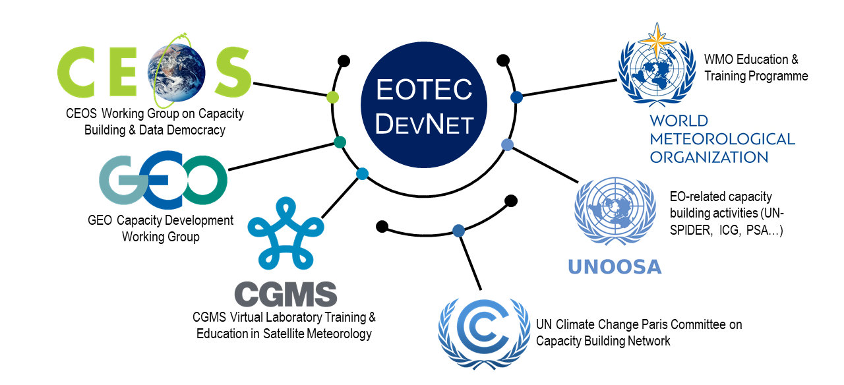
Figure 1: Concept of the EOTEC DevNet network of networks.

The foundational basis for this group – together with the concept of organizing capacity building networks to collaborate on use of EO to advance global sustainable development - was formally published in February 2020 in Space Policy, authored by Senthil Kumar, Sergio Camacho, Nancy Searby, Joost Teuben, and Werner Balogh. This CEOS deliverable proposes to initiate EOTEC DevNet as a pilot for two years, with WGCapD supporting the Secretariat function. Upon evaluation of the pilot, including approaches to sustainability, the open initiative may then be based elsewhere in the network.

3. Development of the EOTEC DevNet initiative

The table below shows the chronology of the development of the EOTEC DevNet initiative.

Date | Activity
Dec 2019 |  | Deliverable CB-20-05/CB-46 developed to establish the Space Capacity Development Advisory Board and included in the 2020-2022 CEOS work plan
Feb 2020 |  | Manuscript published in Space Policy calling for the establishment of the SCDAB
Mar 2020 |  | Small organizing and coordination team – CEOS WGCapD (ISRO, NASA, VNSC), UN CRECTEALC, WMO, and GEO – begins to meet monthly to discuss options, conduct research, and identify paths forward
Apr 2020 |  | Value proposition statement drafted
May 2020 |  | Conducted research around organizations conducting capacity building activities relating to four SDGs (Goals 2, 4, 7, and 11)
Aug 2020 |  | Identified scenarios for how to approach engaging participants in the endeavor
Sep 2020 |  | Identified a nexus of the sustainability frameworks on which to focus – vulnerability assessments, disaster risk reduction plans, and climate adaptation/mitigation & resilience plans
Oct 2020 |  | Renamed the effort from SCDAB to EOTEC DevNet
Jan 2021 |  | Gathering feedback from capacity building network participants
Feb-Mar 2021 |  | Review by CEOS and the CEOS-GEO Bilateral Meeting
Mar 2021 |  | Regional coordination meetings held in alignment with the CEOS WGCapD-10 Annual Meeting. Focused conversation around needs assessment and gaps for flooding.

The EOTEC DevNet organizing team is currently made up of: Nancy Searby [NASA, WGCapD Chair, and Co-Chair of the GEO Capacity Development Working Group (CD-WG)], Sergio Camacho [Regional Centre for Space Science and Technology Education for Latin America and the Caribbean (CRECTEALC)], Joost Teuben [GEO CD-WG Coordinator], Ken Holmlund [WMO Space Programme], Jorge Del Rio Vera [UNOOSA], Prakash Chauhan [ISRO Indian Institute of Remote Sensing and CSSTEAP], Argie Kavvada [NASA, CEOS Sustainable Development Goals (SDG) Ad Hoc Team, and GEO Earth Observations for SDGs], Pham Thi Mai Thy [VNSC and WGCapD Vice Chair and GEO CD-WG participant], Steven Ramage [GEO Secretariat], Albert DeGarmo [NOAA, AmeriGEO] Lauren Childs-Gleason [NASA and WGCapD Secretariat], Christine Mataya [NASA and WGCapD Secretariat], and Yasha Moz [NASA and WGCapD Secretariat]. Feedback has been sought from CGMS VLab leadership.

4. Objectives & Participants

The overall objective of the EOTEC DevNet is to integrate the value and use of the assets viewing Earth from space into education, training, and capacity development of post-secondary school participants, post-secondary school teachers, and working professionals from multiple sectors (including government decision-makers) to help achieve the goals of the global sustainability frameworks. In the two-year pilot phase, focus on the nexus of the sustainability frameworks in the areas of disaster risk reduction planning, climate adaptation and mitigation planning, and associated human vulnerability assessments will identify and help standardize application of EO data in these plans and assessments as well as identify capacity development gaps and overlaps to empower members to take action to address them.

To accomplish these objectives, three elements of the network are:
- Periodic leadership coordination meetings with the heads of related capacity development networks –
  - Identifies gaps in capacity development and needed skills in the research and operational communities using space-based Earth observation data that should be addressed by the capacity building networks;
  - Exchanges information on current and upcoming education, training, and capacity development activities and supporting resources; and
  - Coordinates where feasible to avoid counterproductive duplication of effort and to more effectively respond to user needs.
- Periodic community of practice meetings in each region, aligned with GEO regions, with those engaged in education, training, and capacity development
  - Identifies and shares resources, best practices, and lessons learned that can feed organizational plans and actions discussed at the leadership coordination meetings;
  - Provides a forum to discuss latest assets viewing Earth from space; education, training, and development approaches; and
  - Enables relationships to be made and strengthened across the community.
- Ongoing needs assessments, including capacity gaps and overlaps, in use of EO in disaster risk reduction planning, climate adaptation and mitigation planning, and associated human vulnerability assessments
  - Assesses EO tools, applications, and related capacity development resources; and
  - Assesses current state of skills to use these resources.

EOTEC DevNet participants plans to include satellite and space asset providers, e.g. CEOS and CGMS members, and training, education, and capacity development providers, e.g. GEO members as well as those from UNOOSA, WMO, and other interested practitioners.

Why should we begin the EOTEC DevNet initiative? By creating leadership coordination meetings and a practitioner community of practice among capacity building professionals that serve as a marketplace to facilitate information and knowledge flows, greater global and regional communication will be enabled between the participants in the multiple networks. Through greater communication, EOTEC DevNet will improve strategic and ad hoc coordination of activities. Through systematic assessment of relevant capacity development resources and current state of skills to use them, gaps will be identified, and approaches developed to close the gap, leading to improved application of EO to meet the sustainability framework goals by 2030.

5. Proposed Framework

The organizing committee reviewed the 2030 Agenda for Sustainable Development, the Paris Agreement on Climate Change, and the Sendai Framework for Disaster Risk Reduction 2015-2030 to identify the overlaps where EOTEC DevNet can make an impact to focus initial efforts.
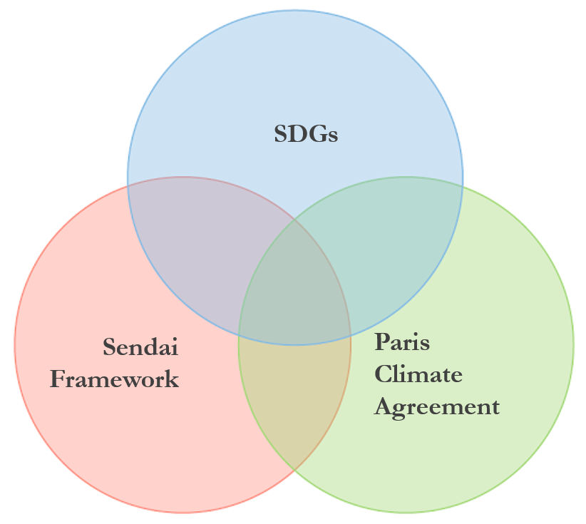

Figure 1. Sendai Framework mapping to Sustainable Development Goals

Figure 2. Intersections of the Sendai Framework, UN SDGs, and Paris Climate Agreement

Figure 3. Building capacity in the UNFCCC process
(https://unfccc.int/topics/capacity-building/the-big-picture/capacity-in-the-unfccc-process)

Figure 1 shows common elements between the Sendai Framework and the SDGs. Figure 2 shows the concept of identifying the overlap between the three frameworks, and Figure 3 shows the approach to building capacity in the UNFCCC process. Based on review of the three frameworks, three areas common to all three were identified:

- Disaster Risk Reduction Plans
- Climate Adaptation/Mitigation & Resilience Plans
- Related Vulnerability Assessments, e.g. vulnerability to extreme weather events and floods

The EOTEC DevNet organizing team has chosen to focus on these areas over the next two years to determine if EOTEC DevNet can make a positive impact in related capacity development. The initial focus for phase one is on flooding.

6. Proposed Approach

Organization
WGCapD has supported the convening of the organizing team meetings thus far. It is proposed that WGCapD initiate an EOTEC DevNet Task Team during this EOTEC DevNet pilot phase. It is proposed that the EOTEC DevNet be jointly led by CEOS WGCapD, GEO CD-WG, CGMS VLab, WMO, and UNOOSA, along with affiliated training centers, e.g. CSSTEAP and CRECTEALC. Key partners will be added as the relevant networks continue to connect.

Key Connections to Networks:

- CEOS WGCapD: EOTEC DevNet provides an opportunity for CEOS space agency members and associate members to connect with regional and national capacity builders. Comments received have been broadly supportive, pending the commitment of sufficient and adequate resources. WGCapD offers the connection to space agencies and new information relating to EO missions and services. EOTEC DevNet furthers CEOS activities to increase its engagement of users and support their decision making needs.

- WMO/CGMS VLab: The WMO/CGMS VLab currently works to build the skills of operational meteorologists to use the latest satellite information. EOTEC DevNet can help identify gaps and opportunities between the operational community an upcoming satellite products, e.g. the GEO LEO SAR flood pilot is of mutual interest to CEOS and CGMS.

- GEO CD-WG: The Capacity Development Working Group sees benefit and value added and already has multiple overlaps with CEOS and the other contributors. EOTEC DevNet could enhance capacity building offerings for the GEO community.

- WMO: The EOTEC-DevNet initiative addresses an important gap in the coordination of various capacity building, outreach and training activities across the full value chain from space-based observations to down-stream services and end-users. WMO’s long-term goals and strategic objectives embrace a comprehensive earth-system approach, with a vision to ensure sustainable development through the best possible services, whether over land, at sea or in the air. WMO is therefore strengthening its engagement with the satellite data providers to ensure the benefits of the space-based observations are maximized. WMO is supportive of this initiative and in a strong position to contribute not only through the establishment of the user requirements and training, but also for the engagement with the national National Hydrological and Meteorological Services as well as other relevant entities e.g. as covered by the WMO Disaster Risk Reduction Programme, the Flash Flood Guidance System and the Education and Training Programmes.

- UNOOSA: Managing and implementing the programme on the peaceful uses of outer space, aimed at strengthening international cooperation in space activities and the use of space science and technology for achieving sustainable development, UNOOSA promotes international cooperation in the exploration and peaceful uses of outer space for economic, social, and scientific development. UNOOSA takes into account the interests and needs of developing countries, with and between governmental entities, including space agencies, intergovernmental and non-governmental organizations, and the private sector, and builds national capability and promotes integrated space technology applications. UNOOSA has been active in supporting WGCapD and fully supports the establishment of EOTEC DevNet. UNOOSA management is considering ways to engage further. The EO-related capacity building activities within UNOOSA see links between their work and the efforts of EOTEC DevNet. The International Committee on GNSS, the Programme on Space Applications, and UN-SPIDER have communities of practice that would contribute and benefit from participation in the broader network of networks. The Regional Centres such as CSSTEAP and CRECTEALC have been engaged since the beginning and would continue to support EOTEC DevNet’s establishment and implementation.

Participation
Participants invited to the regional meetings will include EO providers and those engaged in training, education, and capacity building activites in each region. Past participants in WGCapD-organized regional meetings have included regional and national training centers and organizations, universities, and groups engaged in capacity development programs. Using a “network of networks” approach, each individual network, e.g. CEOS WGCapD, has been inviting those they are working with. Results from WGCapD’s survey of EO and training providers and barriers to EO use will be used to identify and invite additional participants.

Convenings
EOTEC DevNet’s leadership network will meet each year, rotating between in-person and virtual meetings on an annual basis. The first in-person meeting would take place around the planned VLab meeting in Germany in September 2021 and a virtual meeting would take place in fall of 2022.

WGCapD regional meetings, aligned with GEO regions, started in September 2020 and have expanded from WGCapD regional members to include both EO and training providers in each region in December 2020, with the most recent regional meetings taking place in March 2021 at the WGCapD 10th annual meeting. It is envisioned that these regional community of practice meetings will transition into EOTEC DevNet regional communities of practice over the next year. The communities of practice will enable sharing about the substantial work ongoing, lessons learned, good practices, and gaps and overlaps. The cadence of these regional meetings will be tested to figure out the best arrangement, with a goal to meet 1-2 times in the rest of 2021 and the next series of regional meetings in June 2021.

7. Next Steps & Timeline

Participation in Capacity Development Meetings
Each network has their own meetings. Overlapping participants will keep the leadership connected between annual meetings. Network meetings include:

- CEOS WGCapD: meeting every year in-person; monthly virtual meetings; currently hosting regional meetings every 3-4 months, however these regional meetings would transition into EOTEC DevNet meetings that would take place every 4-6 months.
- WMO/CGMS VLab Management Group meetings currently meet every 2 years in-person and quarterly through virtual meetings.
- GEO CD-WG meetings with the full WG are planned periodically, e.g. twice a year. Engagement regionally with regional initiatives is being planned.
- WMO’s Disaster Risk Reduction Programme, the Flash Flood Guidance System and the Education and Training Programmes convene periodic meetings, including regional associations.
- UNOOSA’s International Committee on GNSS, the Programme on Space Applications, and UN-SPIDER have communities of practice and their own periodic meetings.

Phases & Next Steps
Phase 1: Now through CEOS Plenary (October 2021)
- Formation of a task team that expands upon the work and contributions of the initial organizing team.
- Analyze WGCapD survey results and identify additional leadership and regional community of practice participants – continue outreach.
- Develop Theory of Change and monitoring and evaluation approaches to measure the impact of EOTEC DevNet.
- Continue to develop concept of operations, define resource and effort requirements, and identify support sources for the pilot stage.
- Network leads will work within their respective governance structures to gain approvals and confirm support of participation.
- Coordination and logistics for initial regional meetings & leadership meeting: confirm dates, develop invitation list, plan agenda, and conduct outreach.
- Host regional meetings in June 2021 and leadership meeting in September 2021.
- Define the scope of the pilot activity collecting training, education, and capacity development gaps, overlaps, and resources relating to the pilot topic of floods. Gaps include skills gaps in users’ abilities to use satellite and other space-based asset data. Training resources include actual training materials and approaches, use cases, and evidence that people are using satellite information successfully.
- Identify ways to collect training, education, and capacity development gaps, overlaps, and resources that inform disaster risk reduction planning, climate adaptation and mitigation planning, and associated vulnerability assessments that use satellite and other space-based asset data.
- Summarize Phase 1 results to inform respective network planning and the global stocktake.

Formal Signing Event: coordinate a signing ceremony for leadership organizations at or near the timeframe of the CEOS Plenary (Oct).

Phase 2: Post-CEOS Plenary (October 2021 – March 2023)
- Implement approaches to collect training, education, and capacity development gaps, overlaps, and resources that inform disaster risk reduction planning, climate adaptation and mitigation planning, and associated vulnerability assessments.
- Develop plans to address gaps using existing resources and/or by identifying network partners who can develop new ones.
- Track metrics to determine value of continuing EOTEC DevNet beyond a two year pilot phase.
- Create a sustainability plan to ensure the initiative can continue to grow beyong the pilot phase if evaluation deems it to be successful.
- Summarize Phase 2 results and report to the network partner leadership to inform the future of EOTEC DevNet.

7. Summary

A gap exists in the coordination of the efforts to strengthen sustained capacity and use of Earth observations (EO) to meet user needs in support to the sustainable development agenda. Currently, multiple networks contribute to EO capacity development. These overlapping roles and existing relationships can be further coordinated and leveraged to bring the power of EO to more users. The Earth Observation Training, Education, and Capacity Development Network, or EOTEC DevNet, is proposed as a means to improve coordination and enhancement of EO space-based asset providers and training providers of key global development outcomes. This two year pilot will test out the value of the proposed network of networks approach.

