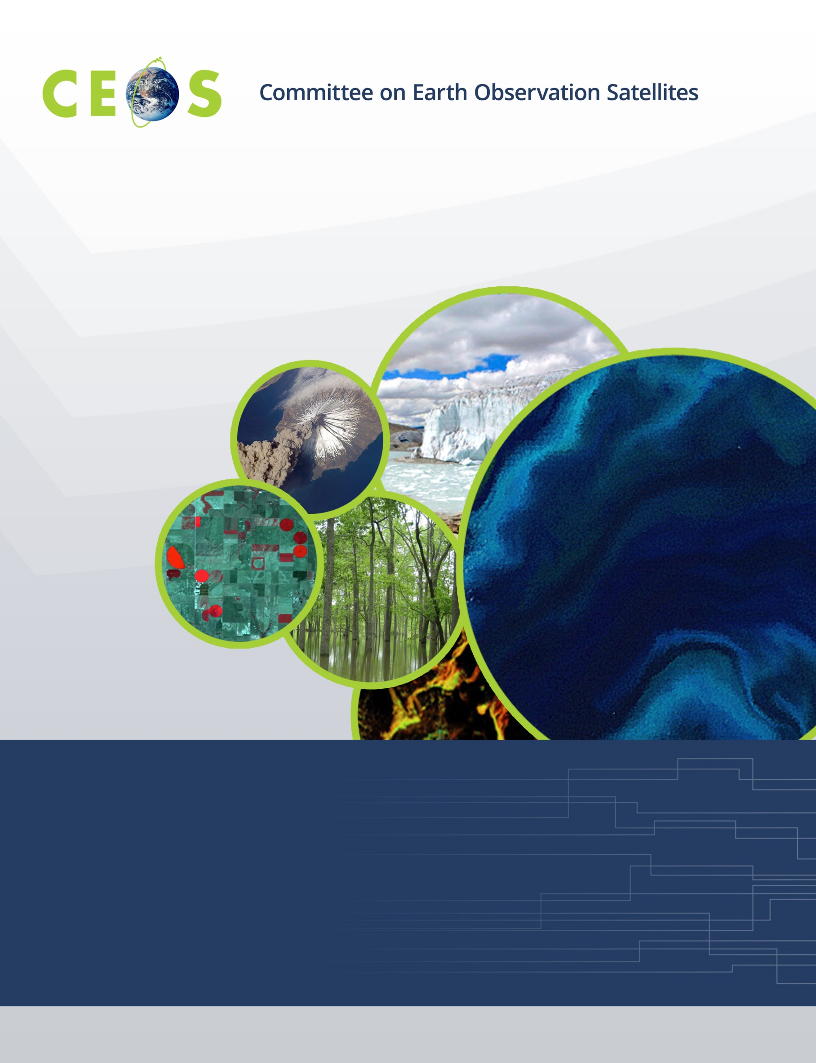
Earth Observation Training, Education and Capacity Development Network (EOTEC DevNet)
CEOS Deliverable Report for CB-20-05/CB-46 – “Establishment of the Space Capacity Development Advisory Board”
Jan 28, 2021
1. Executive Summary

A gap exists in the coordination of the efforts to strengthen sustained capacity and use of Earth observations (EO) to meet user needs in support to the sustainable development agenda. Currently, multiple networks contribute to EO capacity development. Each of these groups includes many contributors across a global network. Each has overlapping interests and existing relationships that can be further coordinated and leveraged to bring the power of EO to more users. In addition to these networks, the United Nations has multiple related networks whose focus may include use of EO but often have broader training objectives and/or specific target audiences.

The Earth Observation Training, Education, and Capacity Development Network, or EOTEC DevNet, can improve coordination and enhancement of EO space-based asset providers and training providers in support of the key global development outcomes. This CEOS deliverable proposes to initiate EOTEC DevNet as a pilot for two years, with WGCapD supporting the Secretariat function. Upon evaluation of the pilot, including approaches to sustainability, the open initiative may then be based elsewhere in the network. It is proposed that the EOTEC DevNet be jointly led by CEOS WGCapD, GEO CD-WG, and CGMS VLab with initial key partners WMO, UNOOSA, and affiliated training centers, e.g. CSSTEAP and CRECTEALC. Key partners will be added as the relevant networks continue to connect.

Why should we begin the EOTEC DevNet initiative? By creating leadership coordination meetings and a practitioner community of practice among capacity building professionals that serves as a marketplace to facilitate information and knowledge flows, greater global and regional communication will be enabled between the participants in the multiple networks. Through greater communication, EOTEC DevNet will improve strategic and ad hoc coordination of activities. Through systematic assessment of relevant capacity development resources and current state of skills to use them, gaps will be identified, and approaches to close the gap developed, leading to improved application of EO to meet the sustainability framework goals by 2030.

2. Purpose & Background

A gap exists in the coordination of the efforts to strengthen sustained capacity and use of Earth observations (EO) to meet user needs in support to the sustainable development agenda. Currently, multiple networks contribute to EO capacity development, as excerpted from their linked websites:

- The Committee on Earth Observation Satellites (CEOS) Working Group for Capacity building and Data Democracy (WCapD) aims to raise awareness of the value of EO data products and services to user communities, including support to locate and access data, products, and tools, and targeted training workshops.
- Established by the World Meteorological Organization (WMO) and the Coordination Group for Meteorological Satellites (CGMS), the Virtual Laboratory for Training and Education in Satellite Meteorology (VLab) is a global network of specialized training centres and meteorological satellite operators working together to improve the utilisation of data and products from meteorological and environmental satellites. Within the WMO, VLab contributes to the Space Programme`s objective to promote availability and utilization of satellite data and products for weather, climate, water and related applications to WMO Members.
- The GEO Capacity Development Working Group (GEO CD-WG) facilitates GEO’s efforts on capacity development, promoting the principle of co-creation and providing conceptual support to the design, development, implementation and evaluation of capacity development activities. With a focus on end-user engagement, this group aims to strengthen the capacity of organisations and individuals to fully utilize open Earth observations data and tools.

Each of these groups includes many contributors across a global network. Each has overlapping interests and existing relationships that can be further coordinated and leveraged to bring the power of EO to more users. In addition to these networks, the United Nations has multiple related networks whose focus may include use of EO but often have broader training objectives and/or specific target audiences. For example, as excerpted from their linked websites:

- The WMO Education and Training Programme connects people and institutions to the learning opportunities necessary for well-functioning meteorological, hydrological and climate services. The Education and Training Programme assists the National Meteorological and Hydrological Services (NMHSs) to develop staff members with needed qualifications and competencies.
- As part of the United Nations Office for Outer Space Affairs (UNOOSA)’s work to promote international cooperation in the peaceful use and exploration of space, United Nations Platform for Space-based Information for Disaster Management and Emergency Response (UN-SPIDER) and other UNOOSA efforts strengthen the capacity of developing countries to use space science technology and applications for development by helping to integrate space capabilities into national development programmes. UN-SPIDER develops solutions to address the limited access developing countries have to specialized technologies that can be essential in the management of disasters and the reducing of disaster risks.

Still other networks are focused on a thematic perspective, and may or may not include using EO as part of their approaches to strengthen capacity to achieve the sustainable development agenda. For example, as excerpted from their linked website, the Paris Committee on Capacity-building (PCCB) Network is envisioned as a voluntary association of interested stakeholders engaged in climate-related capacity-building who can share information on good practices of their work, contribute to the work of PCCB in fulfilling its mandate, and seek to connect with their peers across sectors and regions.

The Earth Observation Training, Education, and Capacity Development Network, or EOTEC DevNet, can improve coordination and enhancement of EO space-based asset providers and training providers in support of the key global development outcomes. The 2030 Agenda for Sustainable Development, as well as the Paris Agreement on Climate Change, and the Sendai Framework for Disaster Risk Reduction 2015-2030 present clear indicator methodologies incorporating EO. The network has a unique opportunity to convene stakeholders from government, civil society, and private sectors that are working to apply EO in support of the three sustainability frameworks.
Figure 1: Concept of the EOTEC DevNet network of networks.

The foundational basis for this group – together with the concept of organizing capacity building networks to collaborate on use of EO to advance global sustainable development - was formally published in February 2020 in Space Policy. This CEOS deliverable proposes to initiate EOTEC DevNet as a pilot for two years, with WGCapD supporting the Secretariat function. Upon evaluation of the pilot, including approaches to sustainability, the open initiative may then be based elsewhere in the network.

3. Development of the EOTEC DevNet initiative

The table below shows the chronology of the development of the EOTEC DevNet initiative.

Date | Activity
Dec 2019 | Deliverable CB-20-05/CB-46 developed to establish the Space Capacity Development Advisory Board and included in the 2020-2022 CEOS work plan
Feb 2020 | Manuscript published in Space Policy calling for the establishment of the SCDAB
Mar 2020 | Small organizing and coordination team – CEOS WGCapD (ISRO, NASA, VNSC), UN CRECTEALC, WMO, and GEO – begins to meet monthly to discuss options, conduct research, and identify paths forward
Apr 2020 | Value proposition statement drafted
May 2020 | Conducted research around organizations conducting capacity building activities relating to four SDGs (Goals 2, 4, 7, and 11)
Aug 2020 | Identified scenarios for how to approach engaging participants in the endeavor
Sep 2020 | Identified a nexus of the sustainability frameworks on which to focus – vulnerability assessments, disaster risk reduction plans, and climate adaptation/mitigation & resilience plans
Oct 2020 | Renamed the effort from SCDAB to EOTEC DevNet
Jan 2021 | Gathering feedback from capacity building network participants

The EOTEC DevNet organizing team is made up of: Nancy Searby [NASA, WGCapD Chair, and Co-Chair of the GEO Capacity Development Working Group (CD-WG) responsible for the subgroup focused on dissemination events and monitoring, evaluation], Senthil Kumar [retired Centre for Space Science and Technology Education in Asia and the Pacific (CSSTEAP)], Sergio Camacho [Regional Centre for Space Science and Technology Education for Latin America and the Caribbean (CRECTEALC)], Joost Teuben [GEO CD-WG Coordinator], Werner Balogh [WMO Space Programme], Prakash Chauhan [ISRO Indian Institute of Remote Sensing and CSSTEAP], Argie Kavvada [NASA, CEOS SDG Ad Hoc Team, and GEO Earth Observations for Sustainable Development Goals], Pham Thi Mai Thy [VNSC and WGCapD Vice Chair and GEO CD-WG participant], Steven Ramage [GEO Secretariat], Lauren Childs-Gleason [NASA and WGCapD Secretariat], Christine Mataya [NASA and WGCapD Secretariat], and Yasha Moz [NASA and WGCapD Secretariat]. Feedback has been sought from CGMS VLab leadership.

4. Objectives & Participants

The overall objective of the EOTEC DevNet is to integrate the value and use of the assets viewing Earth from space into education, training, and capacity development of post-secondary school participants, post-secondary school teachers, and working professionals from multiple sectors (including government decision-makers) to help achieve the goals of the global sustainability frameworks. In the two-year pilot phase, focus on the nexus of the sustainability frameworks in the areas of disaster risk reduction planning, climate adaptation and mitigation planning, and associated human vulnerability assessments will identify and help standardize application of EO data in these plans and assessments as well as identify capacity development gaps and overlaps to empower members to take action to address them.

To accomplish these objectives, three elements of the network are:
- Periodic leadership coordination meetings with the heads of related capacity development networks –
  - Identifies gaps in capacity development and needed skills in the research and operational communities using space-based Earth observation data that should be addressed by the capacity building networks.
  - Communicates current and upcoming education, training, and capacity development activities and supporting resources
  - Coordinates where feasible to avoid counterproductive duplication of effort and to more effectively respond to user needs; and
- Periodic community of practice meetings in each region, aligned with GEO regions, with those engaged in education, training, and capacity development –
  - Identifies and shares resources, best practices, and lessons learned that can feed organizational plans and actions discussed at the leadership coordination meetings;
  - Provides a forum to discuss latest assets viewing Earth from space; education, training, and development approaches; and
  - Enables relationships to be made and strengthened across the community.
- Ongoing needs assessments, including capacity gaps and overlaps, in use of EO in disaster risk reduction planning, climate adaptation and mitigation planning, and associated human vulnerability assessments
  - Assesses EO tools, applications, and related capacity development resources
  - Assesses current state of skills to use these resources

EOTEC DevNet participants plans to include satellite and space asset providers, e.g. CEOS and CGMS members, and training, education, and capacity development providers, e.g. GEO members as well as those from UNOOSA, WMO, and other interested practitioners.

Why should we begin the EOTEC DevNet initiative? By creating leadership coordination meetings and a practitioner community of practice among capacity building professionals that serves as a marketplace to facilitate information and knowledge flows, greater global and regional communication will be enabled between the participants in the multiple networks. Through greater communication, EOTEC DevNet will improve strategic and ad hoc coordination of activities. Through systematic assessment of relevant capacity development resources and current state of skills to use them, gaps will be identified, and approaches to close the gap developed, leading to improved application of EO to meet the sustainability framework goals by 2030.

5. Proposed Approach & Framework

The organizing committee reviewed the 2030 Agenda for Sustainable Development, the Paris Agreement on Climate Change, and the Sendai Framework for Disaster Risk Reduction 2015-2030 to identify the overlaps where EOTEC DevNet can make an impact to focus initial efforts.
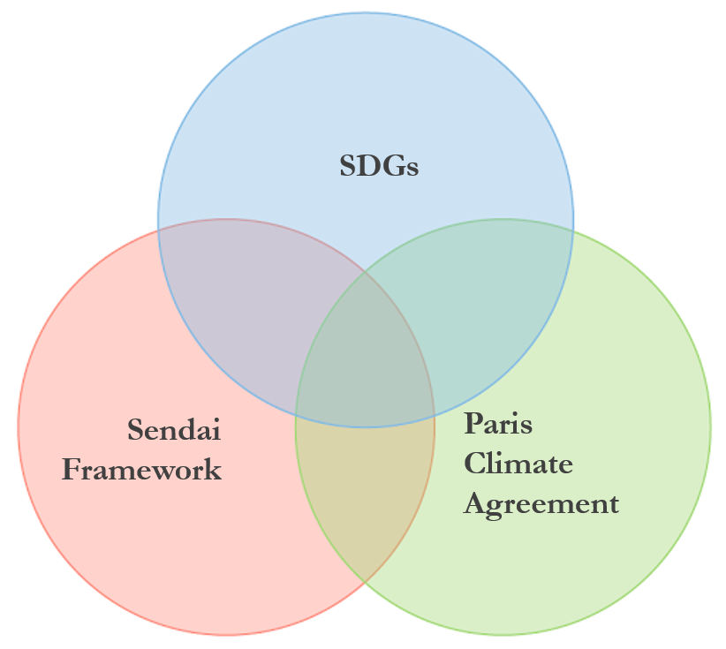
Figure 2. Intersections of the Sendai Framework, UN SDGs, and Paris Climate Agreement
Figure 1. Sendai Framework mapping to Sustainable Development Goals

Figure 3.Building capacity in the UNFCCC process
(https://unfccc.int/topics/capacity-building/the-big-picture/capacity-in-the-unfccc-process)

Figure 1 shows common elements between the Sendai Framework and the Sustainable Development Goals. Figure 2 shows the concept of identifying the overlap between the three frameworks, and Figure 3 shows the approach to building capacity in the UNFCCC process. Based on review of the three frameworks, three areas common to all three were identified:

- Disaster Risk Reduction Plans
- Climate Adaptation/Mitigation & Resilience Plans
- Related Vulnerability Assessments, e.g. vulnerability to extreme weather events and floods

The EOTEC DevNet organizing team has chosen to focus on these areas over the next two years to determine if EOTEC DevNet can make a positive impact in related capacity development.

6. Next Steps & Timeline

Organization

WGCapD has supported the convening of the organizing team meetings thus far. It is proposed that WGCapD continue to serve the Secretariat function during this EOTEC DevNet pilot phase. It is proposed that the EOTEC DevNet be jointly led by CEOS WGCapD, GEO CD-WG, and CGMS VLab with initial key partners WMO, UNOOSA, and affiliated training centers, e.g. CSSTEAP and CRECTEALC. Key partners will be added as the relevant networks continue to connect.

Participants invited to the regional meetings will include EO providers and those engaged in training, education, and capacity building activites in each region. Past participants in WGCapD-organized regional meetings have included regional and national training centers and organizations, universities, and groups engaged in capacity development programs. Using a “network of networks” approach, each individual network, e.g. CEOS WGCapD, has been inviting those they are working with. Results from WGCapD’s survey of EO and training providers and barriers to EO use will be used to identify and invite additional participants.

Convenings

EOTEC DevNet’s leadership network will meet each year, rotating between in-person and virtual meetings on an annual basis. The first in-person meeting would take place around the planned VLab meeting in Germany in September 2021 and a virtual meeting would take place in fall of 2022.

WGCapD regional meetings, aligned with GEO regions, started in September 2020 and have expanded from WGCapD regional members to include both EO and training providers in each region in December 2020. It is envisioned that these regional community of practice meetings will transition into EOTEC DevNet regional communities of practice over the next year. The communities of practice will enable sharing about the substantial work ongoing, lessons learned, good practices, and gaps and overlaps. The cadence of these regional meetings will be tested to figure out the best arrangement, with a goal to meet every four months in 2021.

Participation in Capacity Development Meetings

Each network has their own meetings. Overlapping participants will keep the leadership connected between annual meetings. Network meetings include:

- VLab Management Group meetings currently meet every 2 years in-person and quarterly through virtual meetings.
- CEOS WGCapD: meeting every year in-person; monthly virtual meetings; regional meetings every 4 months to transition to EOTEC DevNet meetings.
- GEO CD-WG meetings with the full WG are planned twice a year. Subgroup meetings are planned monthly. Engagement regionally with regional initiatives is being worked out.

Next Steps

- Analyze WGCapD survey results and identify additional leadership and regional community of practice participants.
- Develop Theory of Change and monitoring and evaluation approaches to measure the impact of EOTEC DevNet.
- Develop concept of operations and identify support sources for the pilot stage.
- Confirm initial leadership meeting dates, develop invitation list, and plan first meeting.
- Finalize timing for regional meetings, plan agenda, and invite participants.
- Solicit and collect training, education, and capacity development resources in the areas of disaster risk reduction plans, climate adaptation/mitigation plans, and related vulnerability assessments that use satellite and other space-based asset data. Training resources could include actual training materials, use cases, evidence that people are using satellite information successfully, for example.
- Assess skills gaps in users’ abilities to use satellite and other space-based asset data in the areas of disaster risk reduction plans, climate adaptation/mitigation plans, and associated vulnerability assessments to inform their contributions to the global stocktake.
- Develop plans to address gaps using existing resources and/or by developing new ones.
- Track metrics to determine value of continuing EOTEC DevNet beyond a two year pilot phase.
- Create a sustainability plan to ensure the initiative can continue to grow beyong the pilot phase if evaluation deems it to be successful.

7. Summary

A gap exists in the coordination of the efforts to strengthen sustained capacity and use of Earth observations (EO) to meet user needs in support to the sustainable development agenda. Currently, multiple networks contribute to EO capacity development. These overlapping roles and existing relationships can be further coordinated and leveraged to bring the power of EO to more users. The Earth Observation Training, Education, and Capacity Development Network, or EOTEC DevNet, is proposed as a means to improve coordination and enhancement of EO space-based asset providers and training providers of key global development outcomes. This two year pilot will test out the value of the proposed network of networks approach.

