MINUTES OF CEOS SIT-39 – 10-11 April 2024

Executive Summary
- All actions from the 2023 CEOS Plenary that were due at SIT-39 have been successfully closed.
- An overview of the progress on the CEOS 2024-2026 Work Plan was presented. The final draft for electronic endorsement will be sent out by April 18, 2024 with the due date for electronic endorsement on May 2, 2024.
- The Biomass Harmonisation project aims to include EO biomass products in national reporting frameworks, which are currently missing. Despite the availability of space-based biomass estimates, they are not yet being utilised in national UNFCCC reporting.
- SilvaCarbon work supports the AFOLU Roadmap, assisting countries to uptake EO datasets for monitoring and reporting.
- CEOS Agencies are asked to review and provide feedback on the AFOLU Roadmap Actions to the LSI-VC Forest and Biomass team.
- The CSA CEOS Chair is exploring a post 2024 Strategy for CEOS and Biodiversity, aiming to increase policy footing and linkages to the biodiversity community. The CEOS Chair and Ecosystem Extent Task Team (EETT) are tasked with refining the role and responsibilities of a potential CEOS Biodiversity Working Group by continuing consultations with external stakeholders such as UN CBD, GEO BON and others.
- The EETT demonstrators are progressing well. The Hudson Bay Lowlands project commenced in 2023, while the Costa Rica Tropical Forests and Great Western Woodlands projects began considerably later so are not as far along. All three projects have secured funding to continue beyond 2024 and can serve as pilot activities for future CEOS Biodiversity efforts.
- TNFD anticipates establishing a public data facility adhering to defined data principles, focusing on methodological and quality standards. They seek collaboration with CEOS to provide datasets directly to their facility, streamlining data sourcing.
- The establishment of a new COAST Virtual Constellation as defined by the submitted Terms of Reference and Implementation Plan documents was approved. CEOS Agencies are invited to nominate representatives to participate in the newly formed COAST-VC.
- GEOGLAM requested greater CEOS agency-wide support for the Essential Agriculture Variables.
- SIT Chair will coordinate a continued discussion of CEOS strategy for climate policy impact, engaging WGClimate, other relevant CEOS groups and experts, and external stakeholders. An update will be brought to the 2024 SIT Technical Workshop.
- IGES, IPCC and UNFCCC Secretariat presented their perspectives on Space-based Earth Observation Community Role and Strategy, including outcomes from GST1.
- ECMWF has submitted a nomination for Vincent-Henri Peuch to serve as Vice-Chair of WGClimate for 2025-26, and Chair for 2027-28.
- Priorities for CEOS from WMO’s 15th Session of Consultative Meetings on High-Level Policy on Satellite Matters (CM-15) include connecting with EW4All, collaboration with the commercial satellite sector (CGMS WGIII), G3W and an update of the WIGOS 2040 Vision document.
- The decision was made to update the CEOS Greenhouse Gas Roadmap, driven by changes in the operating context and new requirements from G3W and IMEO. A draft will be presented at SIT TW and subsequently for endorsement at the 2024 CEOS Plenary.
- It is important to coordinate between the GHG, AFOLU, and Aquatic Carbon Roadmaps, including through consultation with stakeholders involved in developing the CEOS Aquatic Carbon Roadmap.
- Further CEOS support for the UN Sustainable Development Goals will be discussed with the CEOS Secretariat, as it is one of CEOS's four key priorities.
- SIT-40 is scheduled to take place in Japan during the week of April 7, 2025. The 2025 SIT Technical Workshop will be hosted by EUMETSAT in Darmstadt, Germany, during the week of September 8, 2025. The 2025 CEOS Plenary is set for Bath, UK, during the week of November 3, 2025.

Session Index
Executive Summary
Session Index
Session 1: Welcome and Opening Session
1.1: Welcome and Opening Remarks
1.2: SIT-39 Objectives and Action Review
1.3: CEOS 2024-2026 Work Plan
Session 2: Agriculture, Forestry and Other Land Use (AFOLU) Activities
2.1: Biomass Harmonisation Project and Lessons for Space Agencies
2.2: AFOLU National Demonstrator Activities
2.3: CEOS AFOLU Roadmap Action Status
Session 3: Existing and Emerging Business
3.1: CEOS Chair Biodiversity Priority
3.2: Ecosystem Extent Task Team (EETT) Demonstrators
3.3: Taskforce on Nature-related Financial Disclosures (TNFD)
3.4: COAST Virtual Constellation
3.5: GEOGLAM Agricultural Observation Requirements
Session 4: Climate Policy Impact
4.1: Session Introduction
4.2: New Approaches and Strategies for the Space-based Earth Observation Community
4.3a: UNFCCC Secretariat Perspectives on Observation Community Role and Strategy, including for GST2
4.3b: Space-based Earth Observation Community’s Role in the Policy Process
4.4: Space-based Earth Observation Impact on UNFCCC COP/GST Process – Reflections Following COP28/GST1
4.5: WGClimate Perspectives and Updates
4.6: Climate Policy Impact Closing Discussion
Session 5: Day 1 Recap and Brief Discussion, Day 2 Outlook
5.1: Day 1 Recap
5.2: Day 2 Objectives and Agenda
Session 6: Existing & Emerging Business II
6.1: Virtual Constellation/Working Group Issues & Discussions
6.2: WMO Update
6.3: Commercial Sector Issues [presentation]
Session 7: Greenhouse Gas Observations
7.1: Session Introduction
7.2: CEOS Greenhouse Gas Roadmap Update
7.3: International Methane Emissions Observatory (IMEO) Activities and CEOS Cooperation
7.4: Emission Measurement Best Practices and Standards
7.5: GHG Continuity Coordination and Focus
7.6: WMO Global Greenhouse Gas Watch (G3W) and CEOS Cooperation
7.7: GHG Observations Closing Discussion
Session 8: Other Business and Wrap-Up
8.1: CEOS Aquatic Carbon Roadmap Update
8.2: CEOS Sustainable Development Goals (SDG) Coordination Group Update
8.3: CEOS Communications Update
8.4: International Coordination Group for Spaceborne Synthetic Aperture Radar (ICGS-SAR) and CEOS Agency Engagement
8.5: NASA’s Earth Science to Action Strategy
8.6.0: Any Other Business
8.6: SIT-39 Wrap-up
APPENDIX A: Attendees
APPENDIX B: Actions & Decisions Record

Wednesday April 10th

Session 1: Welcome and Opening Session

1.1: Welcome and Opening Remarks
Presenters: Hironori Maejima (JAXA, SIT Chair) [presentation]
Main points:
- Osamu Ochiai (JAXA, SIT Chair Team) welcomed everyone to Tokyo for the 39th meeting of the CEOS Strategic Implementation Team (SIT) and introduced Hironori Maejima, who has inherited the chairmanship of the CEOS Strategic Implementation Team (SIT) for 2024-2025 from Takeshi Hirabayashi.
- Hironori Maejima introduced himself as the new SIT Chair, and presented the JAXA priorities for 2024-2025, which remain as presented at the 2023 CEOS Plenary. The headlines are “Climate Policy Impact of Earth Observation Data” and “Coordination of Greenhouse Gas Observations”.
- The SIT Chair recognises that there is a substantial amount of other excellent work occurring across CEOS, and the SIT Chair Team will continue giving these activities representation at SIT meetings.
- Principals were invited to introduce members of their delegation attending in person and online. The full list of participants can be found in Appendix A.

1.2: SIT-39 Objectives and Action Review
Presenter: Osamu Ochiai (JAXA, SIT Chair Team) [presentation]
Main points:
- Reviewed the main topics of SIT-39.
- There will be a substantial discussion in Session 4 on Climate Policy Impact. The session will reflect on the first Global Stocktake (GST) of the Paris Climate Agreement which occurred in 2023, and discuss strategies for increasing impact for the second GST in 2028. Key players and experts, including representatives from UNFCCC, IPCC, WMO, and specialists from IGES, the Institute for Global Environmental Strategies, have been invited to SIT-39 to share their insights on lessons learned from the first GST and recommendations for the second.
- Session 2 will cover CEOS Agriculture, Forestry and Other Land Use (AFOLU) activities including the CEOS AFOLU Roadmap Action Supplement that was requested by Principals at the 2023 CEOS Plenary. The session will hear the latest on CEOS Agency efforts around biomass harmonisation and consider the valuable lessons learned that may be more broadly applicable.
- Session 7 will focus on Greenhouse Gas Observations from Space, and discussions will be facilitated by David Crisp and Hiroshi Suto from the JAXA SIT Chair Team. As international initiatives and private sector engagement in greenhouse gas observation have been increasing, CEOS will consider its collaborations with these entities and reevaluate the CEOS Greenhouse Gas Roadmap and the requirements of future observation plans. CEOS will also discuss how best to respond to observation and data provision requests from international initiatives, including WMO’s Global Greenhouse Gases Watch (G3W) and the International Methane Emission Observatory (IMEO).
- Reviewed the CEOS Plenary actions that were due at SIT-39:
  - CEOS-37-01: CEOS AFOLU Roadmap Team to create an action supplement to track implementation of CEOS AFOLU Roadmap endorsed by 2023 CEOS Plenary. The action is in progress and will be covered under item 2.3 during the AFOLU Activities session. The action will be closed.
  - CEOS-37-04: P-VC Leads to develop and present updated P-VC Terms of Reference (ToR) for review and potential endorsement at SIT-39. P-VC will present an updated ToR during item 6.1 of the Existing and Emerging Business session. The action will be closed.
  - CEOS-37-05: CEOS WG Chairs and VC Co-leads to review their key documents featured on ceos.org/observations and provide updates to SIT Chair Team. This is an ongoing task. Updates are welcome at any point in time. The SIT Chair Team will continue updating this page as needed. The action is closed.
  - CEOS-37-06: CEOS Agencies to coordinate with the CEOS EETT Leads if interested in contributing a Demonstrator for Ecosystem Extent mapping activity. Progress updates will be discussed under item 3.2 during the Existing & Emerging Business session. The action is closed.

1.3: CEOS 2024-2026 Work Plan
Presenter: Steven Ramage (CEOS Executive Officer) [presentation]
Main points:
- Thanked everyone for welcoming the new CEOS Executive Officer Team, including Steven, Irena Drakopoulou, and Lefteris Mamais, to the role in early 2024. Also thanked Marie-Claire Greening (ESA, former CEOS Executive Officer) for her support in ensuring a smooth transition between the teams.
- The four key governing documents that primarily guide the work of CEOS are the CEOS Terms of Reference, CEOS Strategic Guidance document, CEOS Governance and Processes document and CEOS Work Plan.
- The CEOS Executive Officer is the custodian of all CEOS Governing Documents, including the annual update of the 3-year CEOS Work Plan and the definition and monitoring of the deliverables it informs.
- Detailed work is defined as deliverables. Deliverables are outlined in the Work Plan, and are reconciled and tracked in the CEOS Deliverable Tracking Tool. Updates can be provided directly in the Deliverable Tracking Tool.
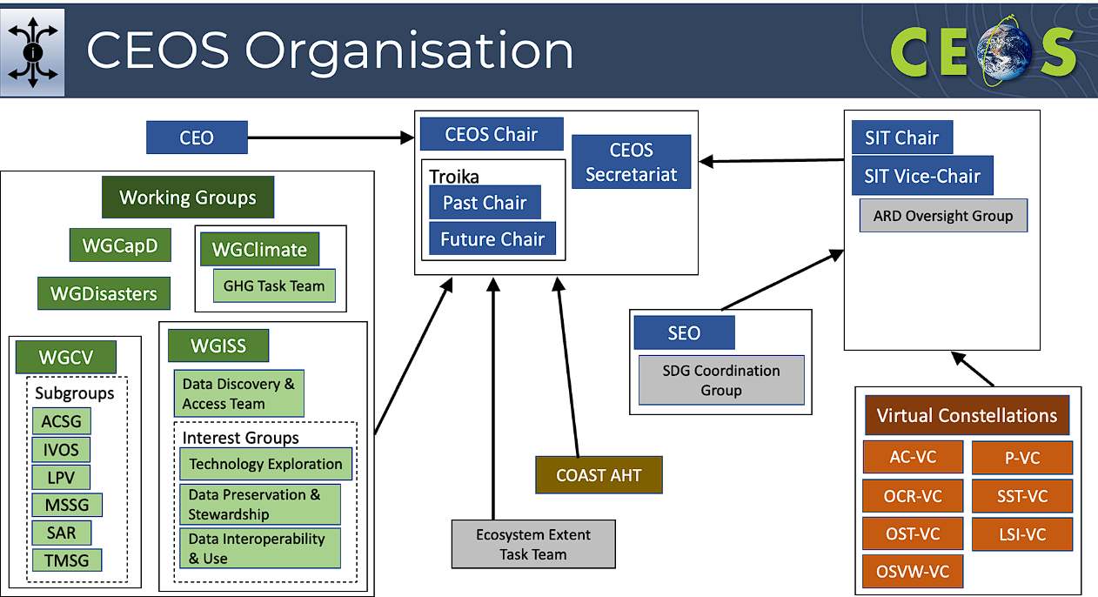
- An overview of the progress of deliverables from the 2023-2025 CEOS Work Plan was provided.
- The 2024-2026 Work Plan attempts to link deliverables to the Essential Variables which have been established across various communities, including Climate (ECVs), Biodiversity (EBVs) and Agriculture (EAVs).
- Other areas to link across the Work Plan are the New Space and commercial activities, the WGISS Interoperability Framework, and various pilots and demonstrators. There are also a number of roadmaps and strategies which cover different areas in the Work Plan.
- Steven acknowledged everyone who contributed to the 2024-2026 CEOS Work Plan.
Main discussion points:
- Osamu Ochiai (JAXA, SIT Chair Team) thanked CNES for their effort in 2022 to set up a sustainable solution for the CEOS Executive Officer role.
- Selma Cherchali (CNES) recognised this was a joint coordination effort from many Agencies, and thanked EUMETSAT for implementing the agreed plan.
- Osamu thanked EUMETSAT, as well as the other European Agencies who contributed support for the CEOS Executive Officer role for 2024-2025.
- Stephen Volz (NOAA) thanked the CEOS Executive Officer for highlighting the linkages across the CEOS Work Plan. This is a key value of the Work Plan – not just serving as a compilation of individual efforts, but as a means of enabling a well integrated organisation. It was further noted that some of the Virtual Constellations are very active, while several are quite dormant with few deliverables or stated tasks, despite active developments in their communities. Stephen asked if that is because their work is instead taking place in various science teams, or due to a lack of direction from CEOS leadership and awareness of these broader linkages across the organisation. Stephen added that CEOS should reflect on all existing elements of the CEOS structure and consider whether they are essential elements if they are not appropriately reflected in the CEOS Work Plan with clear deliverables or tasks.
- Stephen also recalled the outcomes of the New Space Task Team and suggested that while WGISS is making good progress on its Interoperability Framework, there should be a component of the WGISS work plan specifically related to CEOS interaction with the commercial sector on data interoperability standards and best practices. He suggested that WGISS is the most appropriate group to be addressing these topics on behalf of CEOS and its constituent groups.
- Beth Greenaway (UKSA) noted that UKSA plans to review the final Work Plan in detail, and appreciated the extra time to review.
- Osamu recognised that there are several other subsections that need to be reviewed and some activities are missing. More inputs are needed from CEOS to accurately reflect the work being undertaken by each group.
- Stephen Ward (SIT Chair Team) noted that the SIT Chair Team always seeks to ensure good representation of Virtual Constellation activities in the CEOS Work Plan through periodic consultation calls, including those undertaken earlier in 2024. The representation remains highly variable across the different Virtual Constellations, and it may be that some of the Virtual Constellation Co-leads do not see their CEOS role as a priority amongst their many efforts.
- Osamu noted that it has been agreed by the CEOS Secretariat that final inputs should be collected by April 16, 2024 with the final draft sent out by April 18, 2024. The date for virtual endorsement will be May 2, 2024.

SIT-39-01 | CEOS Executive Officer team to undertake an assessment of the level of activity of all CEOS constituent groups. Consideration should be given to their representation in the CEOS Work Plan and activity more generally, as well as their interactions with other CEOS entities. The CEO will report findings to the 2024 SIT Technical Workshop and facilitate a discussion. | SIT TW 2024
 | Rationale: CEOS should reflect on all existing elements of the CEOS structure and consider whether they are essential elements if they are not appropriately reflected in the CEOS Work Plan with clear deliverables or tasks.

DECISION 01 | Final inputs for the 2024-2026 CEOS Work Plan should be collected by April 16, 2024, and the final draft for electronic endorsement sent by April 18, 2024. The date for electronic endorsement will be May 2, 2024.

Session 2: Agriculture, Forestry and Other Land Use (AFOLU) Activities
Osamu Ochiai (JAXA, SIT Chair Team) provided an overview of the session, with the focus being on the AFOLU Roadmap endorsed at the 2023 CEOS Plenary.

2.1: Biomass Harmonisation Project and Lessons for Space Agencies
Presenters: Julie Robinson (NASA), Laura Duncanson (UMD/NASA) [presentation]
Main points:
Julie Robinson (NASA) presented an introduction:
- Biomass is a key example of a climate related variable observable from space. In 2017, the WGCV Land Product Validation (LPV) subgroup was tasked with developing a biomass protocol, which NASA has been working to implement.
- Missions such as GEDI, ICESAT-2, NISAR and BIOMASS have necessitated more coordination on this topic, especially around the products these missions generate. While open-source data is crucial, understanding barriers to its adoption is equally important. This theme spans multiple domains and will be discussed further throughout the meeting. Effective data utilisation hinges on its usefulness, usability, and adoption.
- NASA hopes that the work done by Laura and her team will provide an example and facilitate further discussion.
Laura Duncanson (UMD/NASA) reported on the Biomass Harmonisation Project:
- The biomass harmonisation work was undertaken as a component of the AFOLU Roadmap in collaboration with WGCV Land Product Validation (LPV) subgroup.
- The work aims to communicate a clear and consistent message on forest above-ground biomass (AGB) products, especially as the number of public datasets grows.
- Despite the availability of space-based biomass estimates, they are not yet being utilised in national UNFCCC reporting. However, space-based activity data, typically from multispectral optical satellites like Landsat and Sentinel-2, are frequently used in reporting activities.
- Countries have diverse needs for biomass data, including UNFCCC reporting, carbon credits, fluxes, conservation, and restoration impact. Nations with robust National Forest Inventories (NFIs) are less likely to use EO Biomass maps directly for national reporting but may seek precision enhancement, gap filling, degradation reporting, validation, or sub-national activities. Hence, tailored solutions, co-created with each country's technical teams, are essential due to varying data availability and needs
- Trust in EO biomass product quality is hindered by the lack of a globally representative reference dataset, necessitating national validation.
- Ensuring data continuity is another key barrier, with consistency in methods vital for long-term reporting frameworks. Transparency, repeatability, and consistency are essential, with open science practises critical for capacity development. Published guidance documents for EO biomass data use are generally lacking.
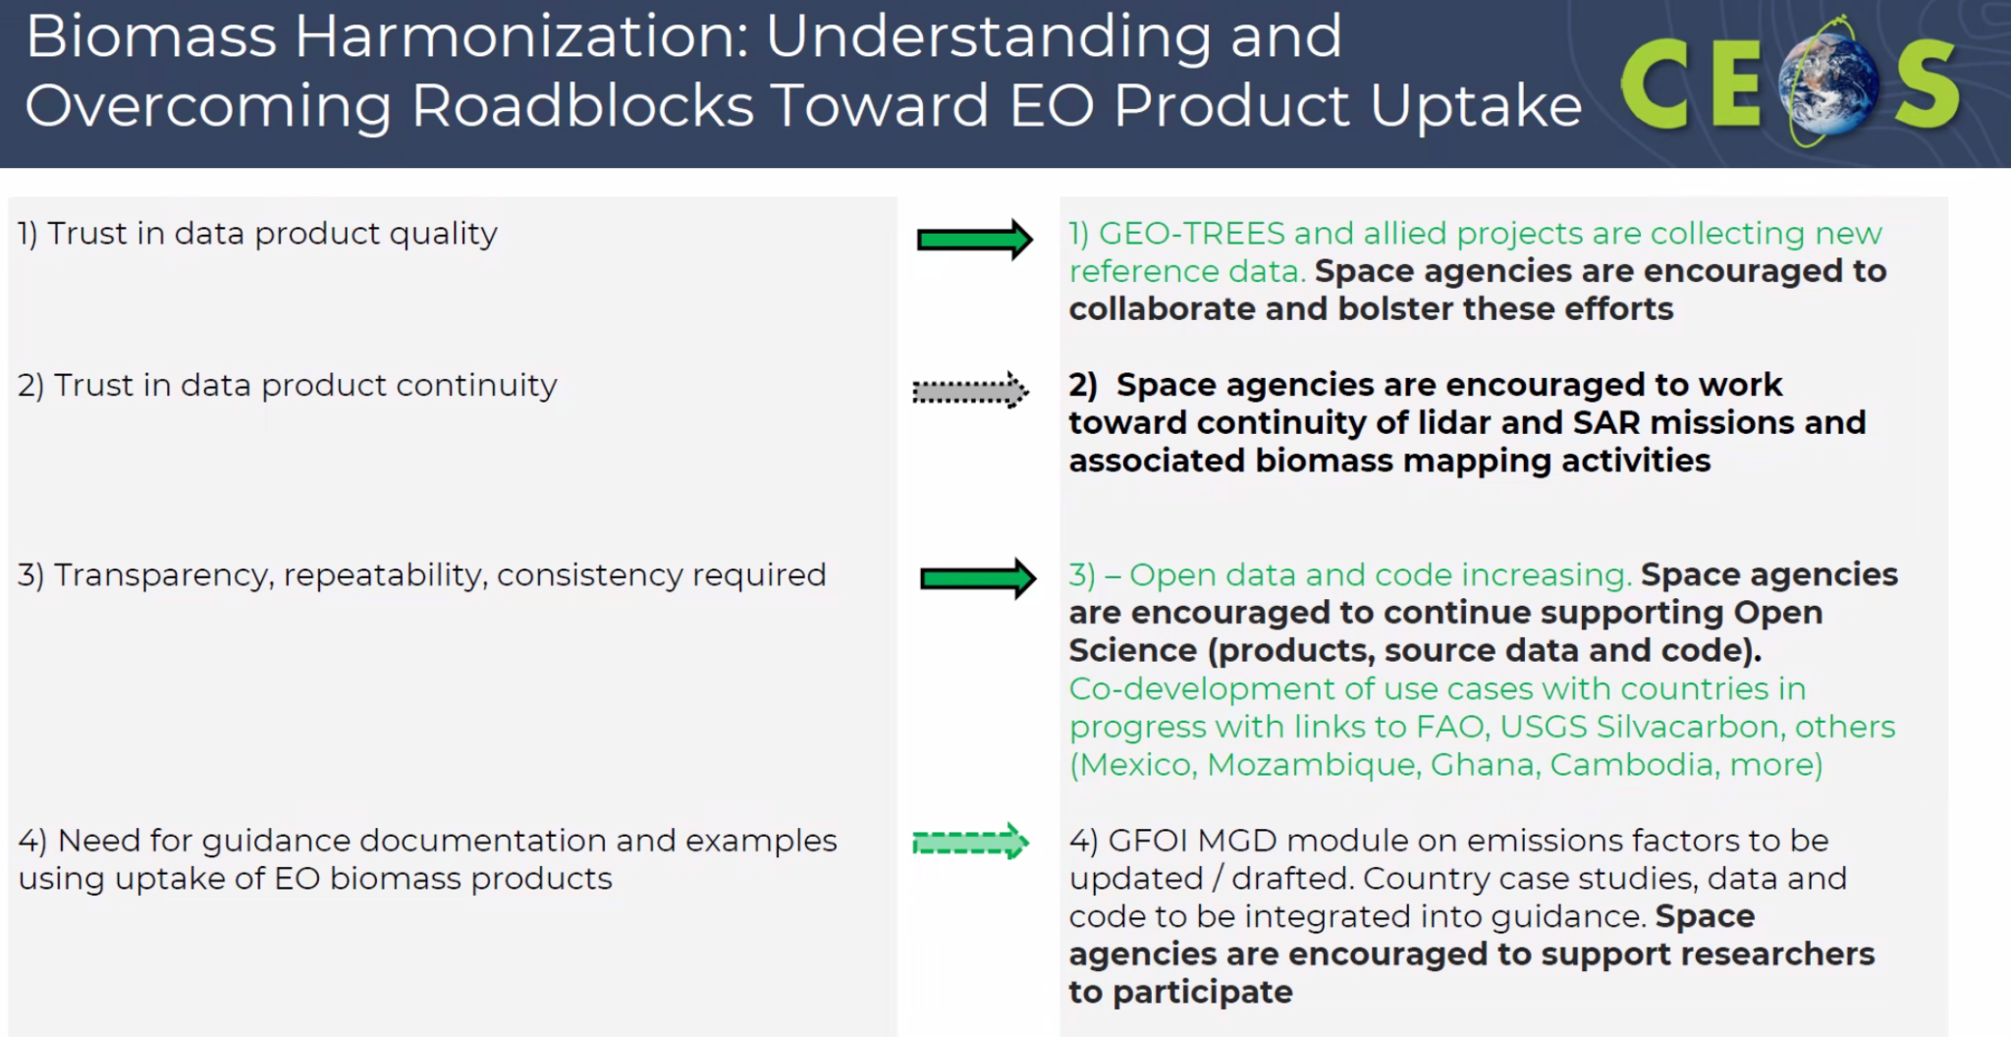
- Continued space agency support is critical to ensure the greatest impact.
Main discussion points:
- The SIT Chair anticipates that the biomass harmonisation project will be an important deliverable under the climate policy impact theme. CEOS needs to take a stepwise approach, starting by understanding the uncertainties of various maps. JAXA wants to encourage this activity, and work towards eventually integrating these types of products into policy frameworks.
- Selma Cherchali (CNES) recognised the clear need for high quality data, but questioned how CEOS can respond to the diversity of needs around the world for different types of products. Additionally, GEO-TREES, supported by CEOS Agencies, supports the validation of biomass products with over 100 sites globally.
- Laura Duncanson (UMD/NASA) noted that progress is being made at the global level, but there are several steps to be done to get to the desired level of data quality. GEO-TREES is providing crucial support for the framework and funding to fill some of the gaps. Space agencies have a key role in coordinating with GEO-TREES and amongst CEOS Agencies themselves.
- Regarding the differing country needs, Laura pointed to the West African example. The LPV Biomass Protocol was recommended, which led to acquisition of the necessary ground data. These decisions need to be made with country support and dialogue. GEO-TREES will be helpful for global calibration and validation but this needs to be complemented by further active engagement at the country level.
- Selma Cherchali (CNES) mentioned CNES is funding and hosting the GEO-TREES international programme office for two years, however CEOS needs to discuss at some point the continuity of this capability.
- Takeshi Hirabayashi (JAXA, SIT Chair Team) noted that, since last year, JAXA have launched a new project to develop biomass maps for Japan and South-East Asia to support UNFCCC reporting and carbon credits. JAXA is starting with Cambodia and Thailand, but would like to expand to other countries in the future.
- JAXA has also been creating global mangrove maps since 1994. ALOS-4 is expected to launch in 2024, which will increase the accuracy of the map.
- Stephen Volz (NOAA) recognised that the best observations and methods are used for traceable and verifiable products. However, the missions are research missions with no guaranteed continuity, limiting trust in the datasets. Are missions with assured continuity such as Landsat considered, perhaps as a proxy, even if less tuned to biomass measurements?
- Stephen added that all demonstration areas mentioned are countries without their own EO capability. Are countries with their own EO capabilities using these products for their reporting?
- Laura noted that to her knowledge, biomass products are not being used by countries operating these missions. Those countries often have their own mature systems with lots of other available data streams. Regarding the use of multispectral operational missions, these are used for change measurements due to the long time series available. However, the uncertainty of these estimates are much higher.
- Julie Robinson (NASA) added that in the US, GEDI data contributes to the US National Forest Inventory. However, the 2023 product did not incorporate all GEDI data, leading to an extension of the GEDI mission to ensure the data can be incorporated into the next iteration of the product.
- Alex Held (CSIRO) recognised that the journey to get EO data products into UN policy frameworks is a long one, but encouraged the biomass harmonisation team to keep working on it. For many years, CEOS worked with GFOI to get references to EO in the good practice guidance documents. Demonstrating long term continuity of products would go a long way at the policy level, as countries can be very conservative about investing in data sources without guaranteed continuity.
- Sandro Federici (IPCC) noted the IPCC table that Laura showed contained values for above ground biomass, including the average value and standard deviation. He clarified that the standard deviation represents variability, not the error in calculating aboveground biomass. When using the average value, it's important to consider possible errors, and uncertainty arises from the distribution of values from various sources.
- Chisa Umemiya (IGES) noted their participation in the Technical Assessment of the REDD+ Forest Reference Level in March 2024. The country reviewed did not have national forest inventory data on the ground. Could such countries still use EO biomass data products?
- Laura noted that while biomass maps are available, datasets without local validation data will result in less trust. Without official guidance referencing EO biomass maps, countries hesitate to use them, especially if lacking suitable validation, risking their review outcomes.
- Osamu Ochiai (JAXA, SIT Chair Team) acknowledged the need for further work and anticipates an update on progress at future SIT meetings.

2.2: AFOLU National Demonstrator Activities
Presenters: Sylvia Wilson (USGS/SilvaCarbon) [presentation]
Main points:
- This activity contributes to the CEOS AFOLU Roadmap. The overarching goals are to:
  - Demonstrate uptake of satellite-based data and derived products in country reporting to the UNFCCC
  - Contribute to the Biomass effort with data and input from countries
  - Provide national feedback on, and contribute to the refinement of, available products derived from satellite-data (land cover and biomass).
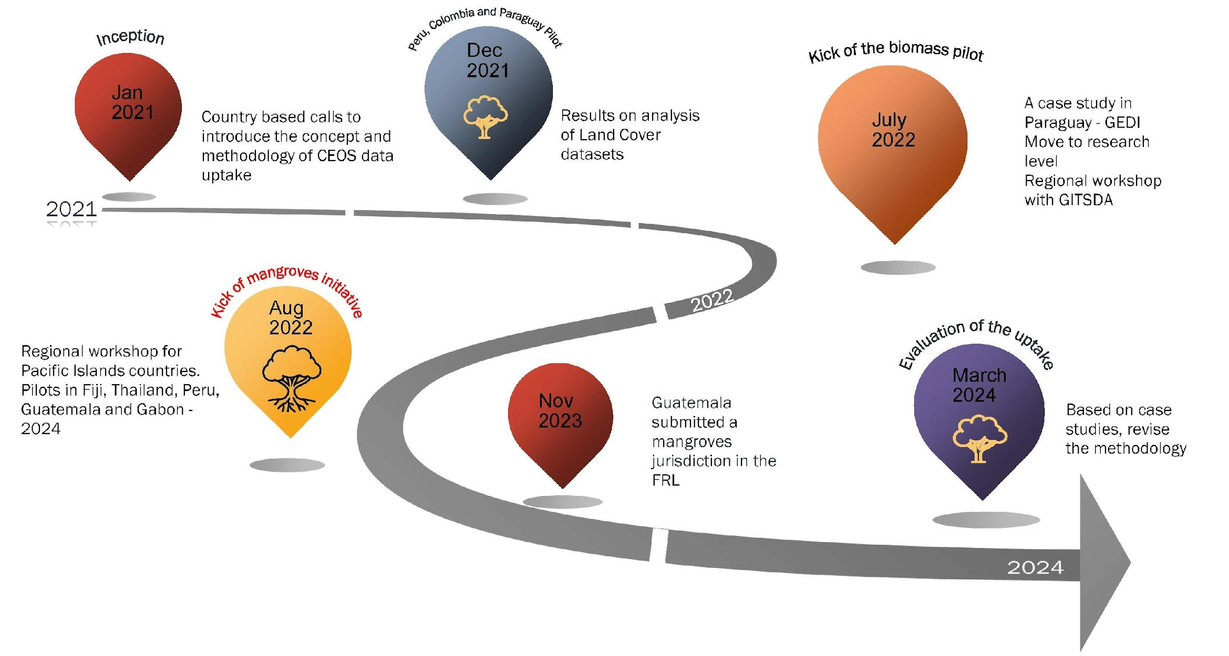
- The Guatemala case study saw an improved carbon balance, and revised submission of Forest Reference Levels as a result of this engagement. The study also saw the inclusion of mangroves as a new jurisdiction in reporting. Increased spatial sampling provided by EO data was a key driver.
- In the Gabon case study, clear disparities were noted between the country and global level data. The study identified a larger forest sink than indicated by the global product.
- Different targets exist for this type of information, considering carbon markets and UNFCCC reporting, each with distinct standards, approaches, and impacts. CEOS needs to consider informing stakeholders on both sides, and understand their connection.
- A joint USGS-JAXA workshop is being organised in Cambodia in June 2024.
Main discussion points:
- Tanita Suepa (GISTDA) noted GISTDA’s interest in biomass and carbon mapping from space for Thailand. In 2023, a workshop related to mangroves was organised under GISTDA’s term as CEOS Chair. GISTDA will continue learning from SilvaCarbon and is keen to continue the collaboration.

2.3: CEOS AFOLU Roadmap Action Status
Presenter: Osamu Ochiai (JAXA, LSI-VC Forests and Biomass Subgroup) [presentation]
Main points:
- The AFOLU Roadmap is a framework for long-term coordination of agency programmes in support of the needs of society for Agriculture, Forestry and Other Land Use (AFOLU) related information, with a particular focus on the needs and ambition cycle of the Global Stocktake of the 2015 Paris Climate Agreement. It is a guiding vision for long-term space agency coordination around AFOLU, and an effective means for communicating the intentions of CEOS. It addresses basic observation continuity and necessary agency coordination to achieve goals of sustained land-imaging of land-use and land cover change and biomass estimates.
- The Roadmap was endorsed at the 2023 CEOS Plenary, and an action was assigned to develop a suite of actions deriving from the seven recommendations of the Roadmap.
- The AFOLU team is comprised of four thematic AFOLU teams: Above-Ground Biomass (AGB) led by Laura Duncanson and Neha Hunka, Land Cover (LC) led by Martin Herold, Wetlands and Mangroves led by Ake Rosenqvist and Richard Lucas, and Agriculture supported through GEOGLAM.
- Actions across all recommendations broadly fall into three categories:
  - Those pertaining to presently available data to support AFOLU procedures as in the 2006 IPCC Guidelines for National GHG Inventories vol.4, and their 2019 Refinement.
  - Actions to develop new or improved products that would allow more accurate and/or easier implementation of the IPCC Guidelines.
  - Actions to facilitate greater interaction with the GHG Roadmap and hence improve characterisation of land management emissions through the Monitoring and Verification System (MVS) based on satellite-based atmospheric inversions.
- The draft content from the Actions Supplement was presented. CEOS Agencies are invited to review and feedback on the AFOLU Roadmap Actions, especially those with current or future relevant missions.
- The AFOLU Roadmap Team will reflect feedback in updated Actions ahead of the 2024 SIT Technical Workshop.
- The AFOLU Roadmap Actions Supplement will be a living document that will be updated annually to reflect context, progress and requirements.
- The Ministry of Education, Culture, Sports, Science, and Technology (MEXT) is leading JAXA's new Biomass Map project, which is being implemented by JAXA. The project, running from JFY 2023 to JFY 2025, focuses on developing methods to calculate terrestrial carbon budgets, conducting carbon budget calculations at the watershed scale, creating and validating country-level forest biomass maps, and experimenting with forest carbon credit accounting.
Main discussion points:
- JAXA recognises the significant role that EO can play in reducing uncertainties in the AFOLU sector. Lidar and hyperspectral data will further enhance the value of EO. Ensuring the continuity of underlying observations is critical. The SIT Chair encourages all agencies to do a thorough review of the Actions Supplement.
- Stephen Volz (NOAA) expressed concerns about tracking progress on the actions outlined for all CEOS members, emphasising the need for specificity regarding the relevant CEOS members for each action.
- Osamu Ochiai (JAXA, SIT Chair Team) noted that the AFOLU roadmap team are key people for the actions, and suggested that Agency representatives to the LSI-VC Forests & Biomass Subgroup should take the responsibility for clarifying actionees and tracking progress.
- Julie Robinson (NASA) highlighted the challenges faced by CEOS when dealing with complex sets of stakeholders, using the example of Biomass and AFOLU. Different groups have varied uses for the data, such as economic drivers, carbon stocks, biodiversity, and ecosystem services, which further vary across countries. This complexity is compounded by the diversity of sensing technologies, which traditionally belong to different disciplines. CEOS needs to clarify whether its work is for internal purposes or for stakeholders, and if the latter, to specify who those stakeholders are.
SIT-39-02 | CEOS Agencies to review and provide feedback on the AFOLU Roadmap Actions to the LSI-VC Forest and Biomass Subgroup team. | May 2024
 | Rationale: The LSI-VC has provided a first draft of the actions proposed to track implementation of the CEOS AFOLU Roadmap. Agencies investing in the supporting missions are especially encouraged to consider whether the actions support their mission planning/justification.

Session 3: Existing and Emerging Business

3.1: CEOS Chair Biodiversity Priority
Presenter: Eric Laliberte (CSA, CEOS Chair) [presentation]
Main points:
- Biodiversity is the headline theme for CSA for their term as CEOS Chair in 2024. The objectives are to outline a pathway to a more formal status for biodiversity within CEOS, to identify how satellite data could support the development of Essential Biodiversity Variables (EBVs) and to identify how satellite data could support the implementation of the new Global Biodiversity Framework (GBF) targets.
- Eric thanked CEOS members for their strong support to this activity.
- On the external facing priority, the overall objective is to strengthen synergies for a lasting relationship between biodiversity actors.
- UNCBD will host a hybrid preparatory workshop to discuss areas of collaboration in Montreal on June 10-11, 2024. Following this, CSA will host a hybrid "Biodiversity Dialogue" at CSA HQ in September 12-13, 2024 during which recommendations stemming from June workshop will be confirmed and included in one broad document - to be agreed upon by all participants, and used as the content for a statement to enhance and structure coordination of activities between international biodiversity actors.
- This document will be presented to CEOS Agencies for review at the 2024 CEOS Plenary.
- A side meeting was held earlier in the week to discuss the internal CEOS aspect of the priority. The side meeting concluded that Biodiversity should likely become a new Working Group.
Main discussion points:
- Julie Robinson (NASA) noted that the discussion at the Biodiversity side meeting was grappling with the overall theme of how CEOS can respond to demand for EO data, similar to other areas such as climate. Biodiversity is considered the second most pressing global environmental issue after climate change, and various stakeholders are asking for CEOS assistance. This aligns with the model of WGDisatsers and WGClimate. Julie suggested EETT be tasked with looking at a Working Group model, and ensuring the consultation and connection with stakeholders.
- Tim Stryker (USGS) asked whether there are any plans to have CEOS representation at the upcoming UN Convention on Biological Diversity (UN CBD) COP-16.
- Eric Laliberté (CSA, CEOS Chair) suggested this be discussed at the next CEOS Secretariat meeting (SEC-321), however CEOS representation may be limited as the first week of UN CBD COP-16 unfortunately overlaps with the 2024 CEOS Plenary.
- Stephen Volz (NOAA) emphasised the importance of CEOS contribution to COP-16, recognising any discussions should involve UN CBD and GEO BON to ensure CEOS adds value to existing efforts.
- Selma Cherchali (CNES) stressed that CEOS should not overlook this important global issue at the international level, especially in the context of how EO can support the Global Biodiversity Framework indicators. CEOS should review the outcomes of the EETT demonstrators at the 2024 CEOS Plenary before determining the direction of biodiversity beyond the EETT.
- John Remedios (UKSA) noted CEOS should understand what others are doing with EO data in the biodiversity space. Common question that comes from that community is the role that EO can have, and CEOS should attempt to quantify the contributions.
- Eric noted that CSA has initiated a dialogue with GEO BON to understand ongoing efforts, and explore how CEOS can contribute. These dialogues will help build understanding and address related questions.
- Alex Held (CSIRO) seconded Selma’s comment, noting there is an active request from potential EO users. CEOS should not dwell on the framework for too long before making a decision on how to work with UN CBD.
- The CEOS Chair Team will continue consulting with UN CBD, GEO BON and other external stakeholders to investigate the potential tasks for a Biodiversity Working Group, ensuring the role for CEOS in this space is clear.
SIT-39-03 | CEOS Chair and Ecosystem Extent Task Team to refine the role and responsibilities of a potential CEOS Biodiversity Working Group by continuing consultations with external stakeholders such as UN CBD, GEO BON and others. | SIT TW 2024
 | Rationale: CEOS Chair team has been undertaking a study and consultation process in support of a Post-2024 Strategy for CEOS and Biodiversity. The Chair will bring recommended next steps to the SIT Technical Workshop (September 17-19, 2024), taking into account the originally envisioned end of the Ecosystem Extent Task Team at the 2024 CEOS Plenary (October 22-24, 2024).

3.2: Ecosystem Extent Task Team (EETT) Demonstrators
Presenter: Gary Geller (NASA/JPL, CEOS EETT Co-Lead) on behalf of demonstrator Leads: Jason Duffe (Environment Canada), Shaun Levick (CSIRO), Sandra Luque (INRAE/CNES) [presentation]
Main points:
- All three demonstrator activities are underway, with the Hudson Bay Lowlands project starting in 2023, while the Costa Rica Tropical Forests and Great Western Woodlands projects started considerably later so are not as far along. All three have funding to continue past 2024, and can serve as pilot activities for whatever form Biodiversity takes within CEOS in the future.
- Biodiversity refers to the variety of life on Earth, encompassing genes, species, and ecosystems.
- The Ecosystem Extent Task Team (EETT) was formed at the 2022 CEOS Plenary, a white paper was endorsed at the 2023 CEOS Plenary, and the demonstrator outcomes will be presented at the 2024 CEOS Plenary.
- Various presentations and discussions have been conducted with Working Groups and Virtual Constellations since Plenary 2023, including WGISS-57, WGCV-53, WGDisasters-21, and LSI-VC-15. The team is planning to publish a scientific journal paper based on the White Paper targeting in the Remote Sensing in Ecology and Conservation journal.
- All three demonstrators are designed around data cubes, combine data from different sensors and are cutting edge activities.
- The Hudson Bay Lowlands in Canada serves as one of the Demonstrator sites, led by Jason Duffe (ECCC). The selected site, Wapusk National Park, spans 11,475 km². The objective is to create a detailed ecosystem map of the diverse landscape within the site, while also estimating the size of each ecosystem. The potential applications of this endeavour include biodiversity assessments, conservation planning, and studies on carbon cycling. This project utilises the CEOS Analytics Lab, provided with support from the SEO.
- ALOS-2 PALSAR-2 data has been obtained over Wapusk National Park, courtesy of JAXA. Efforts are ongoing to understand processing requirements for the CEOS Analytics Lab.
- Collaboration with Parks Canada and GEO BON on Hudson's Bay Lowlands and closely related projects will remain a priority.
- The second demonstrator is located within Costa Rica's Tropical Forest. It examines the conservation potential of secondary forests in human-modified tropical landscapes and compares intact and disturbed old-growth forests. Key questions focus on assessing biodiversity indicators using forest ecosystem extent, evaluating secondary forests using satellite imagery and field data, and predicting biodiversity measures from spectral information.
- The third and final demonstrator is based in the Great Western Woodlands in Australia, which represent the largest remaining area of temperate woodlands on Earth, boasting significant biodiversity and cultural values. However, they face growing pressure from climate change and land-use intensification. High-quality maps of ecosystem extent are crucial for informing conservation, restoration, and adaptation strategies.
Main discussion points:
- Selma Cherchali (CNES) thanked Gary for his coordination efforts and the whole EETT for the progress to date. CNES is dedicated to support these efforts beyond the 2024 CEOS Plenary both at CEOS and national levels.
- Beth Greenaway (UKSA) noted the UK is supporting biodiversity mapping work, including mapping whale movements. UKSA is working in the GEO context and plans to bring their efforts to CEOS to find synergies.

3.3: Taskforce on Nature-related Financial Disclosures (TNFD)
Presenter: Catherine Armour (TFND) [presentation]
Main points:
- The Taskforce for Nature-related Financial Disclosures (TNFD) aims to enable organisations, companies, financial institutions and broader TNFD stakeholders to effectively manage the dependencies and impacts of nature related risks and opportunities through a portfolio of data-centric initiatives that align with and support the adoption and active use of the TNFD Framework.
- Access to reliable, verified, nature-related data that is fit for purpose and able to be made available on a global scale hinders the adoption and effectiveness of the Framework.
- TNFD plans to establish a distributed access public data facility as a global entry point to a federated/decentralised data exchange to connect nature related data products and services provided by contributing organisations, both public and private. The datasets must meet the defined ‘data principles’ - certain methodological and quality standards, providing a ‘single source of truth’ on nature-related data. This is the area TNFD wishes to collaborate with CEOS on.
- The hope is that CEOS can provide datasets directly to their facility, rather than sourcing non-homogeneous datasets.

3.4: COAST Virtual Constellation
Presenter: Paul DiGiacomo (NOAA, COAST Co-Lead) [presentation]
Main points:
- The documents relating to the proposal for COAST Virtual Constellation were delivered to CEOS Principals ahead of SIT-39, in line with the Virtual Constellation Process Document.
- COAST Virtual Constellation would address specific needs related to remote sensing and new product development at the land-ocean boundary, which are not currently met by other forums.
- It complements the work of existing CEOS Virtual Constellations and Working Groups, offering support for user engagement in priority science areas when required. Moreover, COAST is an IOC-endorsed contribution from CEOS to the UN Ocean Decade, fostering connections to GEO Work Programme Activities, and advancing CEOS priorities, such as biodiversity conservation.
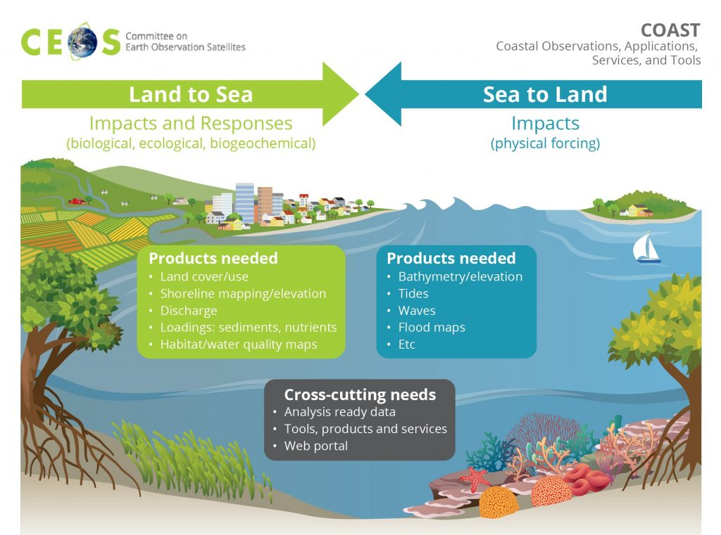
- CNES has agreed to serve as the third co-lead, joining NOAA and ISRO, with Aurelien Carbonniere leading the effort.
- Collaborations and partnerships have been established with other Virtual Constellations and Working Groups.
- Future COAST activities include expanding coastal product development, focusing on areas such as coastal blue carbon/habitat mapping and shoreline mapping, as well as exploring new pilot regions in the Arctic.
- The utilisation of the CEOS Analytics Lab will continue to the extent enabled by the SEO.
- Requested approval of the COAST transition to a Virtual Constellation (VC), now with CNES as the 3rd co-lead, as well as the Final Terms of Reference and Implementation Plan for COAST-VC.
- Invited all CEOS Agencies to nominate members for COAST-VC.
Main discussion points:
- Hironori Maejima (JAXA, SIT Chair) highlighted the significance of coastal zones in the interaction between human activities and the environment. EO is expected to play a significant role in this area. The SIT Chair Team received the Terms of Reference and Implementation Plan by the deadline, and confirmed that all requirements were satisfied.
- Selma Cherchali (CNES) thanked NOAA for their efforts over the past year in following the process to propose COAST-VC. CNES supports the approach and endorses the creation of COAST-VC, noting a user driven approach will be critical for driving the priorities of the group. The group should continue to ensure complementarity with other Virtual Constellations, WGDisasters, WGClimate and CEOS Biodiversity efforts.
- Selma added that France is hosting the UN Ocean Conference in Nice, in June 2024. CEOS should support this major event.
- Alex Held (CSIRO) endorsed the COAST-VC Terms of Reference and Implementation Plan and noted a number of activities in CSIRO are of relevance, including the AquaWatch Australia programme. CNES and CSIRO are also planning a joint activity in New Caledonia which will be of relevance to COAST-VC. Depending on outcomes from the activity, CSIRO anticipates bringing such a pilot site in New Caledonia to COAST-VC as a demonstration site.
- Paul Counet (EUMETSAT) appreciated the progress made by the COAST Ad Hoc Team and supported the endorsement of COAST-VC, emphasising the importance of remaining focused on the objectives of CEOS.
- Jonathan Ross (Geoscience Australia) highlighted the significance of the coastal zone as a hotspot where major challenges converge. Coordinated and systematic work across the whole value chain is necessary. Geoscience Australia will continue to support COAST-VC.
- Julie Robinson (NASA) thanked the COAST Ad-Hoc Team for their efforts in reaching this point and expressed satisfaction with how the discussions matured. NASA plans to identify a member to join COAST-VC in the coming months and stressed continued innovation is needed in this area. NASA endorsed the creation of COAST-VC.
- Stephen Volz (NOAA) thanked all for the endorsement and appreciated the constructive criticism over the last 18 months. The process of discussions helped clarify and solidify the objective of this focus area. The initiative involves collaboration with the operational side and end user while developing research and ensuring long term continuity.
- Ake Rosenqvist (JAXA) questioned how areas of overlap should be handled, noting the example of mangroves, which is currently handled within LSI-VC, but is clearly a coastal ecosystem.
- Paul DiGiacomo (NOAA, COAST Co-Lead) supported mangroves work remaining within LSI-VC. There is interest in developing Global Mangrove Watch products as a COAST-VC pilot, however the activity would still be led by LSI-VC.
- Laura Candela (ASI) supported the creation of COAST-VC, and noted ASI plans to nominate a representative to join the group in the coming months.
- SIT-39 approved the creation of the COAST Virtual Constellation (COAST-VC), and endorsed the associated Terms of Reference and Implementation Plan.

DECISION 02 | CEOS Principals endorsed the establishment of a new COAST Virtual Constellation, as presented in the Terms of Reference and Implementation Plan documents submitted for endorsement at SIT-39.

SIT-39-04 | CEOS Agencies are invited to nominate representatives to participate in the newly-formed COAST VC. | Jun 2024
 | Rationale: COAST VC addresses the Land-Ocean boundary remote sensing and new product development needs not being addressed in other fora. CEOS Principals, CEOS WGs, and VCs are encouraged to name a representative to ensure representation and crosscutting engagement.

3.5: GEOGLAM Agricultural Observation Requirements
Presenter: Alyssa Whitcraft (LSI-VC GEOGLAM Subgroup) [presentation]
Main points:
- GEOGLAM needs support from CEOS Agencies for the Essential Agriculture Variables (EAVs).
- Sven Gilliams is the new GEOGLAM Secretariat Director.
- Since GEOGLAM was created by the G20, the mandate has been reaffirmed a number of times, and supports national reporting, Sendai Framework for Disaster Risk Reduction, the UN Sustainable Development Goals (SDGs), and Land Degradation Neutrality.
- CEOS is a key partner of GEOGLAM, to ensure data delivery for various projects.
- The Essential Agriculture Variables (EAVs) are the satellite-based “building blocks” that in combination with one another and/or other non-EO information support actionable, policy-required information on the state, change, and forecast of agricultural land use and productivity.
- There was not a lot of space agency representation in the definition of the EAVs.
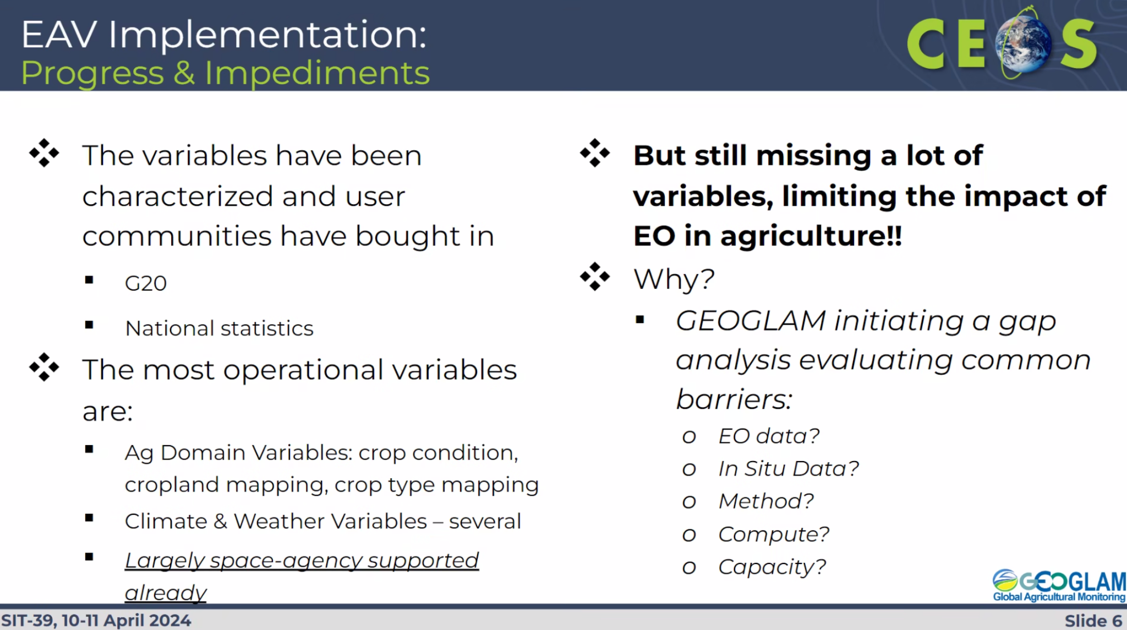
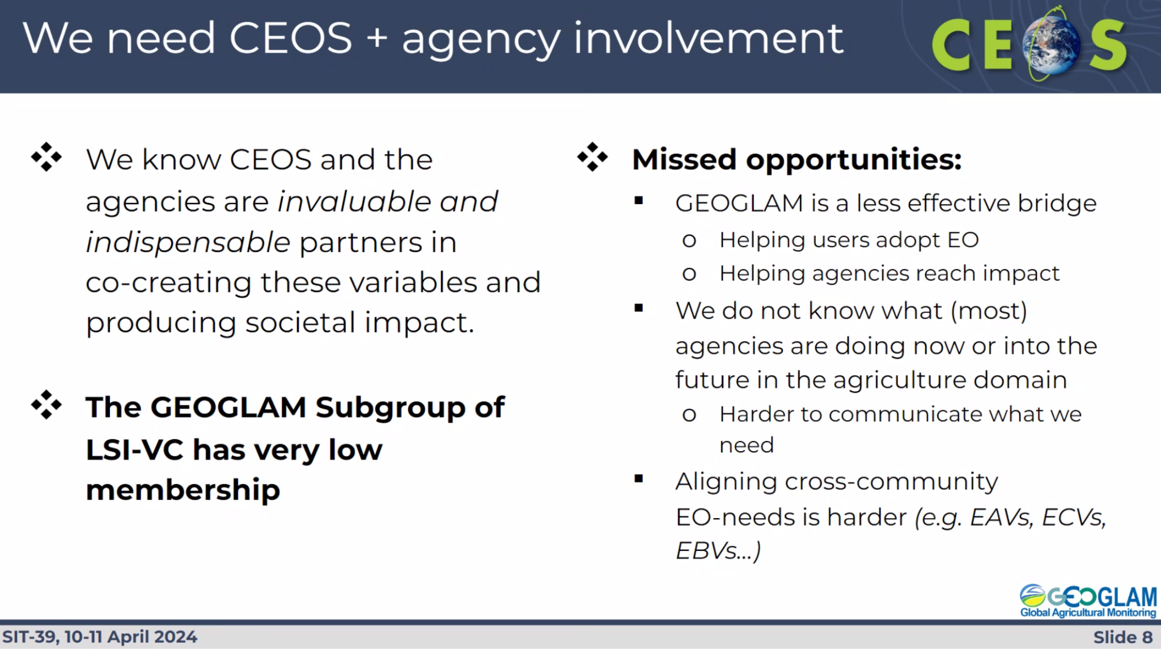
- Agencies were asked to identify individuals to contribute to the LSI-VC GEOGLAM subgroup, who would support a roadmap of agency support for the EAVs, and identify agency activities around agriculture.
Main discussion points:
- Stephen Volz (NOAA) recognised that membership of the LSI-VC GEOGLAM Subgroup is very small, noting there was concern expressed about the visibility of this group since its creation.
- Tim Stryker (USGS) concurred stating that the main issue is the insufficient participation. LSI-VC is a suitable home, but needs more capacity.
- Alyssa Whitcraft (LSI-VC GEOGLAM Subgroup) recognised that when the team was previously an ad hoc team, there also wasn’t a large amount of engagement from CEOS Agencies. When the subgroup was formed, the action was for CEOS to iteratively respond to the requests from GEOGLAM when they emerged. This time has now come, and whether or not the subgroup was successful remains to be seen what results from this.
- Julie Robinson (NASA) noted NASA has supported GEOGLAM for over a decade, and emphasised the urgency of addressing climate driven changes in farming approaches within CEOS. Agriculture may need higher representation in the CEOS organisational chart to best support food security initiatives.
- Shin-ichi Sobue (JAXA) noted that JAXA is on the mailing list for the LSI-VC GEOGLAM Subgroup, but struggles with resource allocation to participate. JAXA is active on the GEOGLAM side with Asia-RiCE and methane emissions for rice paddies. Most of the work is done on the GEOGLAM side but there is a lack of coordination with CEOS.
- John Remedios (UKSA) noted the importance of the agriculture sector and encouraged CEOS to prioritise this area. He suggested a workshop approach as a first step to address the diverse challenges in agriculture related EO activities.

SIT-39-05 | CEOS Agencies to identify points of contact to contribute to the LSI-VC Subgroup on GEOGLAM (GEO Global Agricultural Monitoring initiative). | Jun 2024
 | Rationale: At SIT-39, GEOGLAM asked CEOS for greater CEOS agency-wide support for the Essential Agricultural Variables and to reinforce CEOS agency representation and contributions in the GEOGLAM Subgroup of the LSI-VC to facilitate both of these objectives
SIT-39-06 | SIT Chair to confer with LSI-VC and its GEOGLAM Subgroup leads regarding the visibility of CEOS Agriculture activities. | Jun 2024
 | Rationale: There is a need to ensure that Agriculture continues to be suitably represented in the CEOS organisation, meeting agendas, and three-year work plans.

Session 4: Climate Policy Impact

4.1: Session Introduction
Presenter: Osamu Ochiai (JAXA, SIT Chair Team) [presentation]
Main points:
- The objective of this session is to discuss the Climate Policy Impact priority of the SIT Chair, which aims to address obstacles and opportunities for CEOS Agency data to have maximum impact in key climate policy processes such as the Global Stocktake of the Paris Climate Agreement.
- Despite considerable efforts invested by CEOS and its agencies in the climate sphere, recent disappointments in policy processes prompted a reflection on stakeholder engagement strategies.
- The Global Stocktake of the Paris Climate Agreement is a data-driven exercise where the observations community can excel.
- For the first Global Stocktake (GST1), CEOS collaborated with WMO, GCOS, and other stakeholders, delivering critical national-scale global budgets for GHG emissions.
- However, challenges persist, such as the limited use of CEOS-derived global products in forest reporting to UNFCCC and user confidence issues in competing products from different agencies. Pilot national GHG products developed for GST1 had minimal traction compared to IPCC inputs. These challenges underscore the need for strategic reconsideration and coordination within CEOS to enhance its impact on climate policy processes.
- The session includes guest presentations from IGES and UNFCCC Secretariat.

4.2: New Approaches and Strategies for the Space-based Earth Observation Community
Presenter: Mark Dowell (European Commission) and Wenying Su (WGClimate) [presentation]
Main points:
- Systematic observations have been written into the policy reporting process since the establishment of UNFCCC in 1992. GCOS has supported the coordination of these observations in support of UNFCCC.
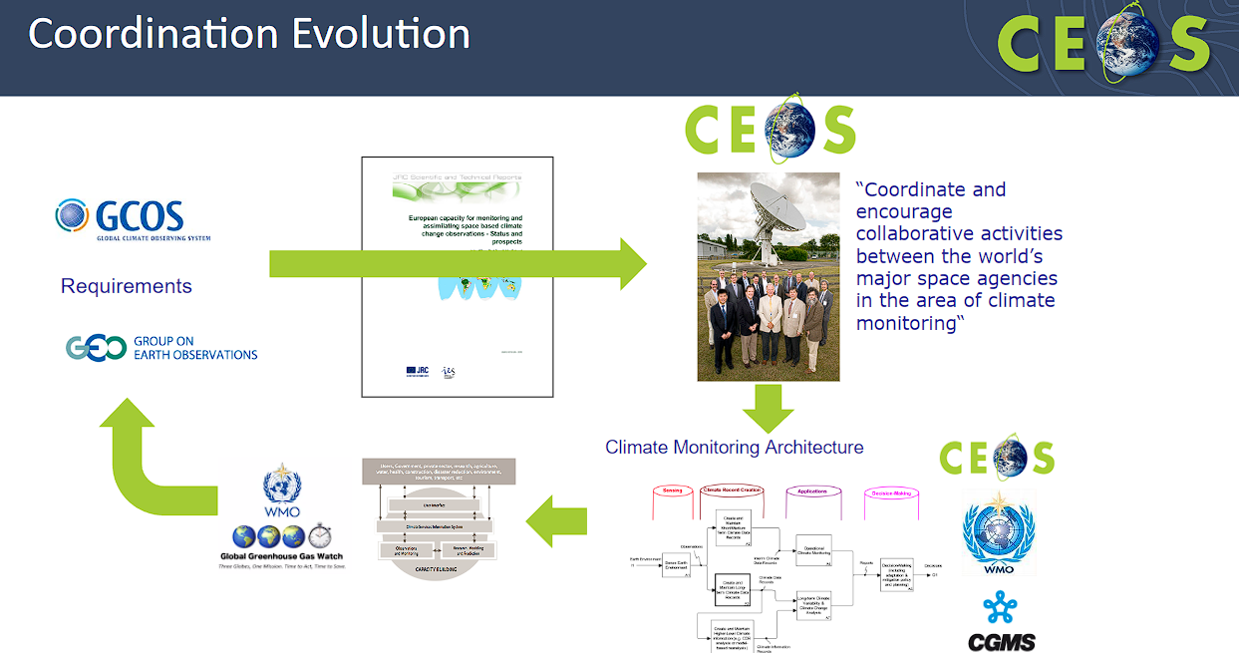
- A holistic value chain approach is needed to trace observations from the data collection to the applications and the policies they inform.
- Climate policy is evolving from using EO for monitoring, to using EO for reporting and verification. This includes for emission reduction, preserving carbon sinks, cross-convention synergies, and loss and damage and associated attribution.
- Emerging priorities include:
  - Developing early warning systems and addressing loss and damage with attribution.
  - Engaging the modelling community, particularly with Dynamic Vegetation Global Models (DVGM) and Biosphere-Atmosphere Exchange Models.
  - Developing an integrated system that encompasses Greenhouse Gas (GHG), Agriculture, Forestry, and Other Land Use (AFOLU), and Aquatic sectors.
- Engagement with UNFCCC/SBSTA on Earth Information Day should include longer-term plans. The whole Systematic Observations community (including CEOS & CGMS) need to develop a coordinated plan for the Earth Information Days, including developing milestones for individual COPs to work towards a longer-term ambition.
- CEOS should regularly engage with stakeholders such as WMO, GEO and UNFCCC.
- Three questions were raised for discussion:
  - Where can CEOS (and CGMS) provide the greatest added value, on climate, as the space-arm of the Systematic Observation community?
  - How should we structure our engagement with stakeholders – both peers and users?
  - How should we structure and prioritise activity internally to address these issues?
Main discussion points:
- Takeshi Hirabayashi (JAXA, SIT Chair Team) highlighted that JAXA worked with CEOS members to ensure satellite observations were reflected in the 2019 Refinement of Guidelines for National Inventory Reporting. JAXA has worked to improve the use of ALOS of GOSAT data in national reporting through national inventory demonstrations. At past UNFCCC COP meetings, JAXA worked with other CEOS members to facilitate collaborations and arrange various events, however the uptake of satellite EO data remains low. Hirabayashi-san suggested establishing a forum for coordination between both CEOS members and other stakeholders outside of CEOS.
- Beth Greenaway (UKSA) emphasised the importance of ensuring the fundamentals of measuring and monitoring the Earth. CEOS needs actionable steps to address the identified issues, considering the increasing demands for different forms of information from various stakeholders, including commercial organisations and the public sector. Hence, CEOS should ensure the information is delivered in a more impactful way. Clear traceability is important considering the significant investment and new regulations involved.
- Beth highlighted surprising resistance from the in-situ community during Earth Information Day, and CEOS should try to engage the in-situ community in the discussions.
- Beth also recognised the profoundness of the Space Summit pledge, which showed the potential of space for climate. CEOS could explore ways to contribute to monitoring progress towards the goals outlined in the pledge. CEOS also has a formal space at SBSTA, and should make sure to use this to the greatest impact.
- The volume of actors in climate initiatives is another area Beth suggested CEOS could work on. The role of CEOS should be clearly decided, and clearly communicated to other actors.
- Stephen Volz (NOAA) emphasised the importance of defining what success looks like for CEOS and identifying the unique contributions from CEOS. The long term goal is to have everyone use satellite data. In the short term, it is essential to address strengths and weaknesses, including uncertainties and calibration/validation issues. Comparing satellite data with country estimates and facilitating iterative improvements over time is vital for progress.
- Stephen also highlighted the importance of addressing continuity and sustainability of data streams, which has, so far, not been done well from a product perspective. Building confidence in the product and ensuring continuity of information by integrating various data sources are essential steps forward.
- Jörg Shultz (EUMETSAT) mentioned the 2013 Architecture for Climate Monitoring report published by WMO, with contributions from CEOS and CGMS. The second pillar of the report focused on data, which led to applications in the third pillar and eventually policy in the fourth. Success requires attention to all pillars, but CEOS could be most effective concentrating between the second and third pillars.
- Jörg also noted that the scientific community is increasingly emphasising the theme of water. CEOS should discuss climate topics beyond carbon. Addressing water concerns also links with food security.
- Natalia Donoho (WMO) noted that WMO has been engaging with CEOS for a long time through GCOS and WGClimate. With a new Secretary General prioritising climate action and effective partnerships, WMO also looks forward to collaborating with CEOS and WGDisasters on initiatives like Early Warning for All (EW4All). WMO welcomes the proposal for regular CEOS-WMO meetings, recognising the potential to engage directly at the Secretary General level, underscoring the importance of space agencies to WMO.
- Eric Laliberté (CSA, CEOS Chair) suggested that to improve impact, CEOS should showcase the benefits of CEOS data to reach the long term goals.
- Rob Sturgiss (IPCC) noted the IPCC guidelines encourage national inventories to use imagery, and CEOS Agencies should collaborate with national inventory agencies directly to ensure satellite data is being used. Rather than providing different datasets to those provided by IPCC, EO data could be used to assist in the verification of IPCC datasets.
- Stephen Volz (NOAA) highlighted the challenges faced when attempting to alter established methodologies. However, countries struggling to provide any data are eager to find solutions, including EO-based solutions. Specific use cases from these countries could demonstrate how EO data can be used for GST reporting, and hopefully lead to more uptake.
- Julie Robinson (NASA) highlighted the value of remote sensing due to its scalability. CEOS should be careful to provide user-driven solutions, delivering data where it is requested and needed. Continuity and sustainable measurements are also important, as they can help build the case for long term measurement strategies.
- Selma Cherchali (CNES) noted the Space Climate Observatory (SCO) has developed over 75 use case projects in collaboration with key local stakeholders. Selma agreed with the sentiment to broaden the focus beyond carbon to include water related initiatives. There is a strong demand for SCO projects related to water and extreme events, and CNES can connect these to related CEOS projects.
- John Remedios (UKSA) suggested having closer collaboration with national delegations to ensure that space observations contribute effectively to policy discussions regarding GST. UKSA is trying to work more closely with the national delegation. John emphasised the importance of demonstrating tangible results and noted that UKSA may need to work with WMO to extract valuable insights, addressing both research and systematic agendas.
- Jeff Privette (NOAA, WGClimate Chair) noted that WGClimate requirements stem from various sources such as GCOS, scientists, and modellers, underscoring the need to recognise satellite products as part of the larger community.
- Jeff recognised that at NOAA, the focus has shifted towards services and ground-level projects. There is an opportunity through SCO to bridge the gap between climate services and engage in real climate action at a smaller scale, rather than the UNFCCC policy process. Despite encountering initial challenges, SCO has successfully established meaningful connections with grassroots organisations for mitigation and adaptation.
- Mark Dowell (EC) acknowledged the valuable comments and suggestions made during the discussion. Mark emphasised the importance of long-term thinking and ensuring coordination across the various CEOS Virtual Constellations and Working Groups, beyond WGClimate.

4.3a: UNFCCC Secretariat Perspectives on Observation Community Role and Strategy, including for GST2
Presenter: Annett Moehner (UNFCCC Secretariat) [presentation]
Main points:
- The Paris Agreement goals cover mitigation, adaptation and finance.
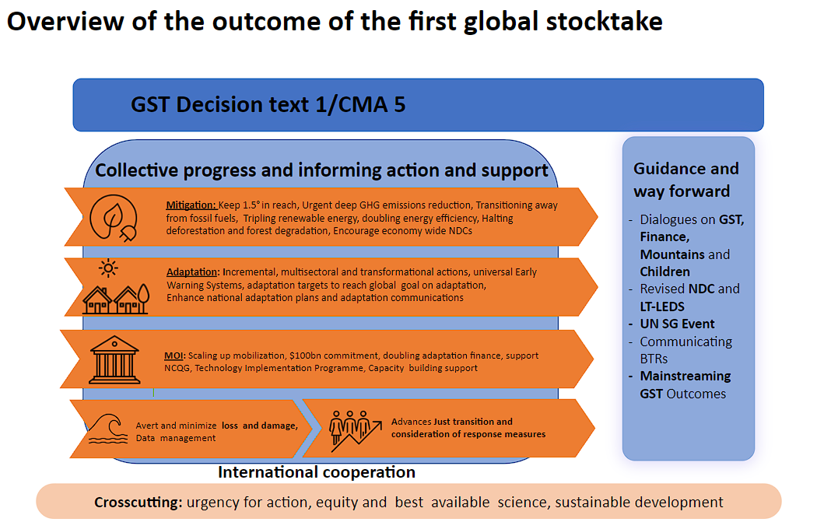
- Following the first global stocktake, UNFCCC is enhancing action and support, and encouraging international cooperation at the political and technical level.
- The role of the observation community lies within mitigation, to monitor progress, and adaptation, for early warning services.
- The observations community should continue to engage with Parties during Earth Information Day at the COP sessions.
- There is still a lack of knowledge regarding the availability of various datasets, tools, and services.
Main discussion points:
- Natalia Donoho (WMO) noted that her colleague Gianpaolo Balsamo will present on the WMO Global Greenhouse Gas Watch (G3W) and CEOS Cooperation tomorrow. However, there was a lack of active engagement from the space community at COP-28’s Earth Information Day. WMO is closely examining this matter to find a resolution.
- Annett Moehner (UNFCCC Secretariat) noted that all UN agencies are facing resource challenges. Annett expressed hope that CEOS could assist in disseminating vacancy announcements from UNFCCC to ensure representation from the space community at the UN level.

4.3b: Space-based Earth Observation Community’s Role in the Policy Process
Presenter: Giacomo Grassi (EC-JRC, remotely from Italy) [presentation]
Main points:
- The relative importance of the land carbon dioxide sink will increase with time, as emissions decrease.
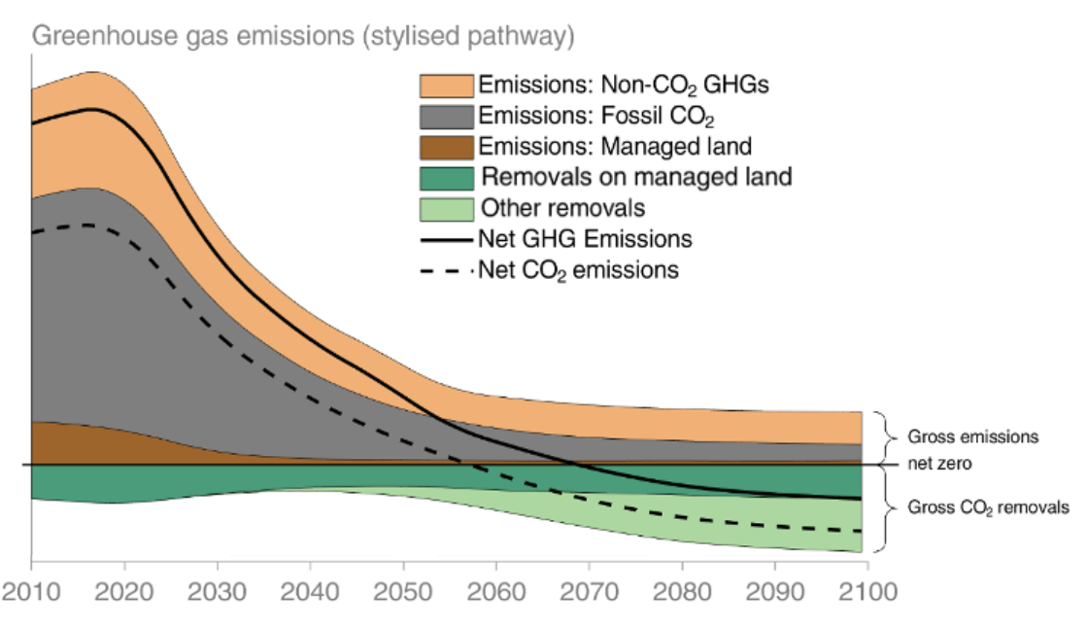
- Deforestation increased over the past twenty years, but national inventories are reflecting the opposite.
- Land Use, Land-Use Change and Forestry (LULUCF) is an overall source, however there is a big discrepancy in what is reported in national inventories, due to the different accounting methods. This undermines the trust of the EO data.
- There is a need to reconcile how global models and national inventories define these parameters. This was highlighted in the UNFCCC synthesis report for the Global Stocktake (2023): "Adjustments should be made where any comparison between LULUCF data reported by countries and the global emission estimates of the IPCC is attempted."
- The IPCC Expert meeting on reconciling land use emissions to be held from 9 to 11 July 2024 in Ispra will seek to develop a common understanding of the land emissions gap, set the basis for greater collaboration between communities, and outline steps forward to ensure greater comparability between future IPC products during AR7 and national GHG data.
- Earth Observation community can assist with the closing of this gap between the global and national land use emission estimates by:
  - Providing more consolidated results for tree cover change, carbon stocks and changes, and inverse models;
  - Connect better with NGHGIs to better understand the requirements and aggregation.

4.4: Space-based Earth Observation Impact on UNFCCC COP/GST Process – Reflections Following COP28/GST1
Presenter: Akibi Tsukui (IGES, remotely from the UK) [presentation]
Main points:
- The Global Stocktake (GST) assesses the collective progress towards achieving the goals of the Paris Climate Agreement every 5 years. The first GST took place in 2023.
- Parties are not yet collectively on track towards achieving the purpose of the Paris Agreement and its long-term goals. Human activities, principally through emissions of greenhouse gases, have unequivocally caused global warming of about 1.1C. Urgent action and support are needed to achieve the 1.5 degree target. A wide range of topics are included as opportunities to accelerate climate action and close the gaps such as new agreements on energy systems, accelerating and substantially reducing non-CO2 emissions, carbon market approaches, etc.
- Space-based Earth Observation contributed to GST1 with written inputs and technical dialogue feedback. The decision included the following:
  - Recognises that [---] the need to enhance coordination of activities by the systematic observation community (paragraph 49)
  - Encourages the scientific community to continue enhancing knowledge on and addressing knowledge gaps in adaptation and availability of information on climate change impacts, including for monitoring and progress, and to provide relevant and timely inputs to the second and subsequent global stocktakes (paragraph 183)
  - Invite the IPCC [---] to provide relevant and timely information for the next global stocktake (paragraph 184)
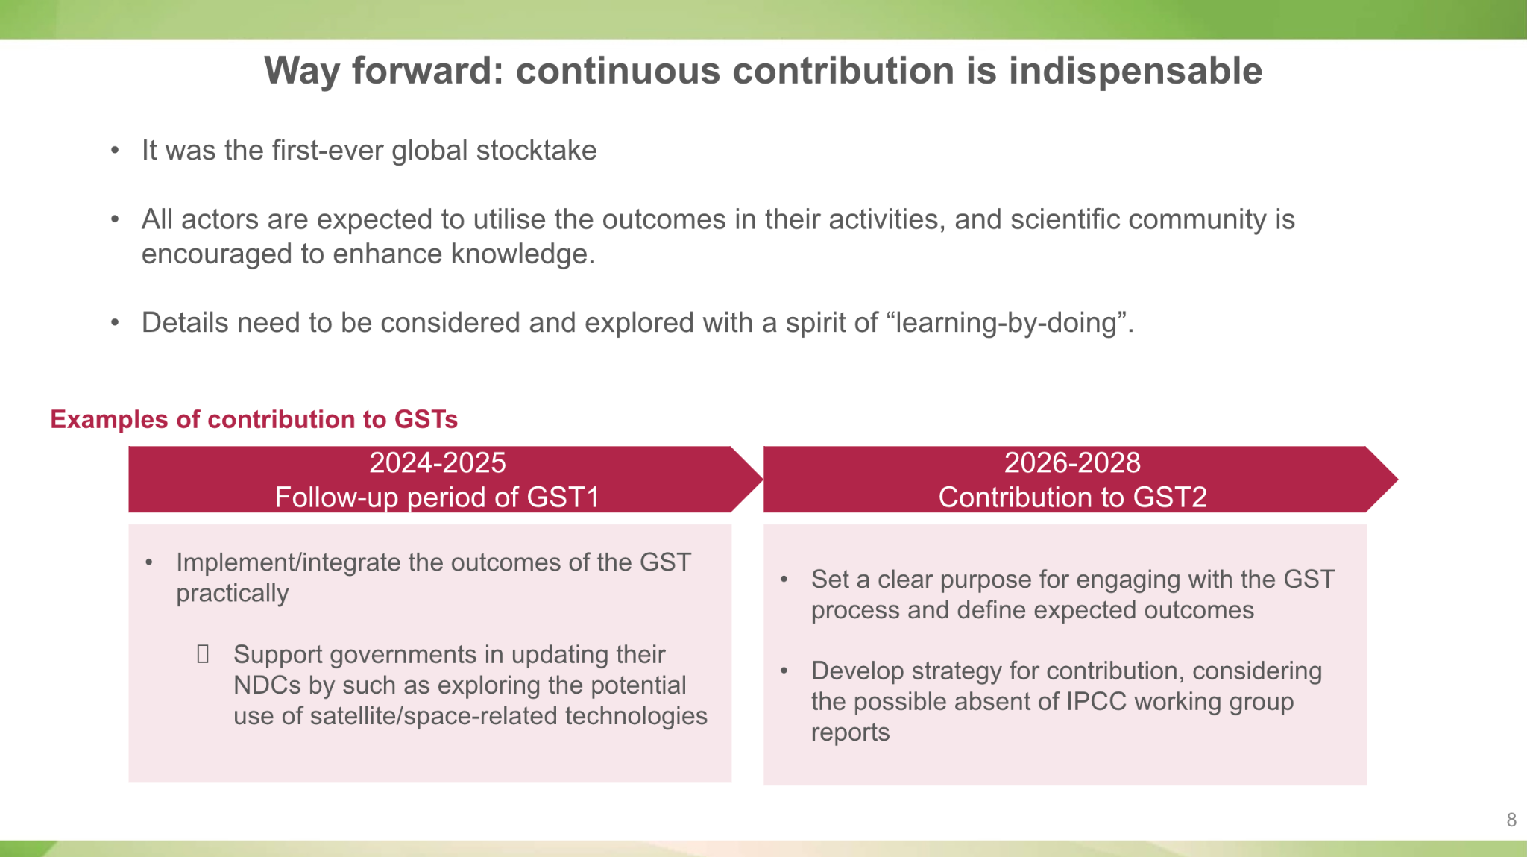
Main discussion points:
- Osamu Ochiai (JAXA, SIT Chair Team) noted that an update of the existing CEOS Strategy to support the Global Stocktage is probably necessary.
- John Remedios (UKSA) asked whether there is a necessity to consolidate findings from the space community to present a synthesised version. CEOS could explore alternative methods beyond the technical dialogue, to ensure evidence reaches policy makers effectively.
- Akibi Tsukui (IGES) agreed that consolidating information is critical. There was an overwhelming number of submissions from non-state actors without sufficient time for digestion. It would be beneficial if the space-based observation community could deliver a consolidated submission and explore additional opportunities for collaboration.
- Jörg Schulz (EUMETSAT) echoed the need for consolidating information and conducting a stocktake of the community’s efforts. It is important to showcase future impacts, particularly in relation to the IPCC report, to ensure broader awareness among relevant stakeholders. There might not be another IPCC report in time for GST2, and CEOS should consider a broader approach, reaching beyond the observation community.
- Annett Moehner (UNFCCC Secretariat) mentioned there is an open call for submissions to partisan observers aimed at refining the procedures. Parties requested having a shorter technical analysis time frame and more time for reflection due to the overwhelming volume of information received, hence further synthesising information is important.
- Annett added that the expected outcome of GST2 is that there won’t have been much work done. It is important to provide possible solutions and the next steps by finding champions amongst parties who can ensure the community has a prominent role.
- Julie Robinson (NASA) highlighted that CEOS submissions are treated as equivalent with other non-state actor submissions. Is the lack of formal engagement between CEOS and IPCC hindering communication? Without state collaboration, the work could potentially be targeting the wrong end user.
- Akibi Tsukui (IGES) noted that assessing is only one aspect of the GST process, the other is the actionable next steps. Supporting the government using satellite technology is one practical action. There is a challenge in identifying end users for the GST, considering the vast number of countries involved. With the limited time, the IPCC report served as a fundamental data source. It is important to demonstrate the differences between CEOS and IPCC dataset.
- Takeshi Hirabayashi (JAXA, SIT Chair Team) noted that IGES is co-located with the IPCC TFI Secretariat, and hence JAXA is committed to enhancing the relationship with IGES.

4.5: WGClimate Perspectives and Updates
Presenter: Jeff Privette (NOAA, WGClimate Chair)[presentation]
Main points:
- WGClimate prepared the CEOS-CGMS Statement to SBSTA at COP-28 and delivered it to CSA to present as the CEOS Chair.
- Welcomed new WGClimate members from GISTDA, SANSA, USGS and UKSA. Thanked those agencies for nominating individuals to help grow the participation of WGClimate.
- The purpose of the Space Agency Response to the GCOS Implementation Plan (IP) is to describe the needs and gaps in the Global Climate Observing System (GCOS). The GCOS IP is produced every 5-6 years. In 2022, GCOS provided 16 actions, each with multiple activities. WGClimate is addressing this with a two-phase response, having addressed 21 activities in 2023 (which were more straightforward) and addressing a similar number in 2024 (which are more complex). The submission to CEOS and CGMS Principals is expected by mid-2025.
- The ECV inventory serves as a unique international compendium of metadata for known Climate Data Records (CDRs). It ensures that future space observation architecture will meet the necessary requirements for generating CDRs, and is increasingly utilised as an authoritative CDR library for end-users, researchers, and developers.
- New CDR definitions are expected to be submitted for endorsement later this year.
- A nomination has been received for WGClimate Vice-Chair for 2025-2026, and subsequently WGClimate Chair for 2027-2028: Vincent-Henri Peuch of ECMWF. WGClimate intends to submit the nomination to CGMS and CEOS Plenaries for approval later this year.
- NOAA has nominated Xiwu 'Jerry' Zhan to support LSI-VC and AFOLU initiatives as former LSI-VC NOAA representative, Kevin Gallo, has retired.
Main discussion points:
- Stephen Volz (NOAA) recommended that WGClimate, as the joint CEOS-CGMS Working Group, should be engaged in CEOS Climate Policy Impacts initiatives going forward. Any resourcing issues should be brought to the attention of Principals for resolution.
- Mauro Facchini (EC) noted that Vincent-Henri Peuch (ECMWF) works with the Copernicus service, and is in charge of climate change and atmosphere services. The European Commission supports his nomination. ECMWF works to increase the visibility of EO in climate policy aspects.
- Mauro added that the European Commission is working closely with the Directorate-General of Climate and Environment to understand how EO fits into the policy side.

4.6: Climate Policy Impact Closing Discussion
Presenter: Osamu Ochiai (JAXA, SIT Chair Team)[presentation]
Main points:
- SIT-39 is a first step-back to take stock and allow Principal debate about the next steps for CEOS . Considerably more discussion is needed, including with partners, given the significance of this topic.
- The SIT Chair proposes to continue the discussion throughout the year by assembling a volunteer task force of experts to develop the arguments for SIT Technical Workshop, and bring a report to CEOS Plenary for further consideration by Principals. This would include discussions with UNFCCC, IPCC and other external stakeholders.
- The focus for this task force would be on necessary updates to CEOS GST Strategy Actions. Any GHG observation issues raised at the GHG side meeting would also be considered, as well as other non-GST issues as appropriate.
- This needs to be discussed with relevant CEOS groups such as WGClimate, LSI/AFOLU, GHG and agency experts.
- The SIT Chair will develop a simple Terms of Reference for Principal review after SIT-39 and add the topic to the SIT Technical Workshop agenda item and report to the CEOS Plenary 2024.
Main discussion points:
- Tim Stryker (USGS) supported the idea of a task force and noted that USGS will nominate a representative.
- Paul Counet (EUMETSAT) supported the visibility on climate initiative, however the Terms of Reference for the task force should be clear and focused on the goals. While the effort could be led by the SIT Chair, it is important to take advantage of the existing bodies within CEOS, and avoid duplication of resources. There should be a clear association with WGClimate as they will ultimately be responsible for implementing any recommendations.
- Osamu Ochiai (JAXA, SIT Chair Team) acknowledged the necessity of having WGClimate involved.
- Beth Greenaway (UKSA) suggested determining clear actions that can be taken, noting the current description which appears to encompass a wide range of activities involving many different actors. Clarity is needed on the purpose of the initiative to ensure that participation is appropriate.
- Selma Cherchali (CNES) echoed the support for previous comments, emphasising the need to engage WGClimate, and avoiding any duplication of effort or additional experts.
- Stephen Volz (NOAA) questioned the necessity of developing new Terms of Reference. The SIT Chair has the right to work on this initiative as they see fit, collaborating with members from across CEOS. Investing time in developing terms of reference could be unnecessary and detract from addressing the actual issue.
- Julie Robinson (NASA) recognised there are some challenging issues that need to be discussed at Plenary level. Top level support needs to be provided for the Working Groups to address the challenges with the GST.
- Yasjka Meijer (ESA, CEOS Greenhouse Gas Task Team Lead) expressed uncertainty about the desired outcomes of the initiative. It is unclear how and where CEOS could contribute effectively to the GST. The GST process itself may be primarily a paperwork exercise and may not inherently incorporate observations, however it is important to explore the complementarity that CEOS can bring to the process. For example, providing annual insights could offer a unique potential value that complements the five year GST process.
- Mark Dowell (EC) noted that a significant decision point revolves around whether to focus solely on the GST process or extend efforts beyond it. The GST Strategy would form the basis of CEOS support for the former, the should continue SIT Chair to lead this forward. CEOS should reconsider its position along the value chain and determine the stakeholder community accordingly. Mark stressed the importance of coordination and leveraging existing structures without reinventing the wheel.
- Klaus Schmidt (DLR) suggested finding a good balance between existing structures before developing a new group. DLR supports this initiative and is willing to contribute.
- Osamu Ochiai (JAXA, SIT Chair Team) concluded that the SIT Chair will continue to operate within its mandate, providing the interface and connection between the various groups without the need for changes to CEOS mechanisms or new Terms of Reference. The initiative will remain with the SIT Chair, consulting with various parties as needed.
- The recap presented a number of possible questions for CEOS to consider in continuing this discussion:
  - What lessons learned from GST1 and what changes to our CEOS GST Strategy and actions?
  - Any impact from these changes to the role for operational agencies and our relationship with WMO/CGMS?
  - How might we answer the call for a unified SO community approach to UNFCCC/GST?
  - Beyond the GST, are there climate policy processes and stakeholders we should engage with?
  - Any changes to the balance of effort within WGClimate?
  - What actions are required for the necessary linkages between GHG, AFOLU and Aquatic Carbon?
  - How should our national engagement efforts evolve and be linked to above?

SIT-39-07 | SIT Chair to coordinate continuation of the discussion on the CEOS strategy for climate policy impact, engaging the WGClimate, other relevant CEOS groups and experts, as well as external stakeholders, with the objective to bring an update to the SIT Technical Workshop (September 17-19, 2024) and propose an agenda item for the 2024 CEOS Plenary. | SIT TW 2024
 | Rationale: Climate Policy Impact is a headline priority for the two-year SIT Chair Term, and the intent is to continue the discussions initiated at SIT-39 in support of long-term strategy planning
SIT-39-08 | CEOS Agencies are invited to comment on the draft scoping questions presented at SIT-39 in order to focus and progress the climate policy impact discussion and strategy planning. | May 2024
 | Rationale: SIT-39 recognized that, given the scope and scale, CEOS must define and align a manageable scope and focus for the climate policy discussions.

Thursday April 11th

Session 5: Day 1 Recap and Brief Discussion, Day 2 Outlook

5.1: Day 1 Recap
Presenters: Osamu Ochiai (JAXA, SIT Chair Team) [presentation]
Main points:
- Reviewed the decisions and actions from Day 1.
- The SIT Chair will continue working on methods to improve coordination on the Climate Impact Policy, however without a ‘task force’.
Main discussion points:
- Julie Robinson (NASA) suggested clarifying in the biodiversity action mentioning some sort of extension of the EETT is needed to ensure continuity of the work before a new structure is defined (Working Group or otherwise).
- Stephen Volz (NOAA) suggested including a specific agenda item on the Climate Policy topic in the monthly SEC meeting agenda.
- Tim Stryker (USGS) requested that Agencies interested in these discussions but who are not part of the SEC also be included when relevant.
- Eric Laliberté (CSA, CEOS Chair) noted that on the biodiversity topic, as the CEOS Chair strives to strengthen relationships with external stakeholders, the Chair called upon CEOS Agencies to ensure that national level Biodiversity agencies have an understanding of the importance of EO. Beyond working from Secretariat to Secretariat at an international level, Eric suggested working on a national level.

5.2: Day 2 Objectives and Agenda
Presenters: Osamu Ochiai (JAXA, SIT Chair Team) [presentation]
Main points:
- Provided an overview of Day 2 Objectives and Agenda.

Session 6: Existing & Emerging Business II

6.1: Virtual Constellation/Working Group Issues & Discussions
Precipitation Virtual Constellation (P-VC)
Presenter: Chris Kidd (NASA) [presentation]
Main points:
- P-VC was established prior to the launch of the GPM mission in 2014, to coordinate satellite precipitation measurements from the range of available sensors. The GPM mission is the realisation of the P-VC and provides a focus for a strong international precipitation community through the NASA and JAXA science teams, as well as the International Precipitation Working Group (IPWG) of CGMS.
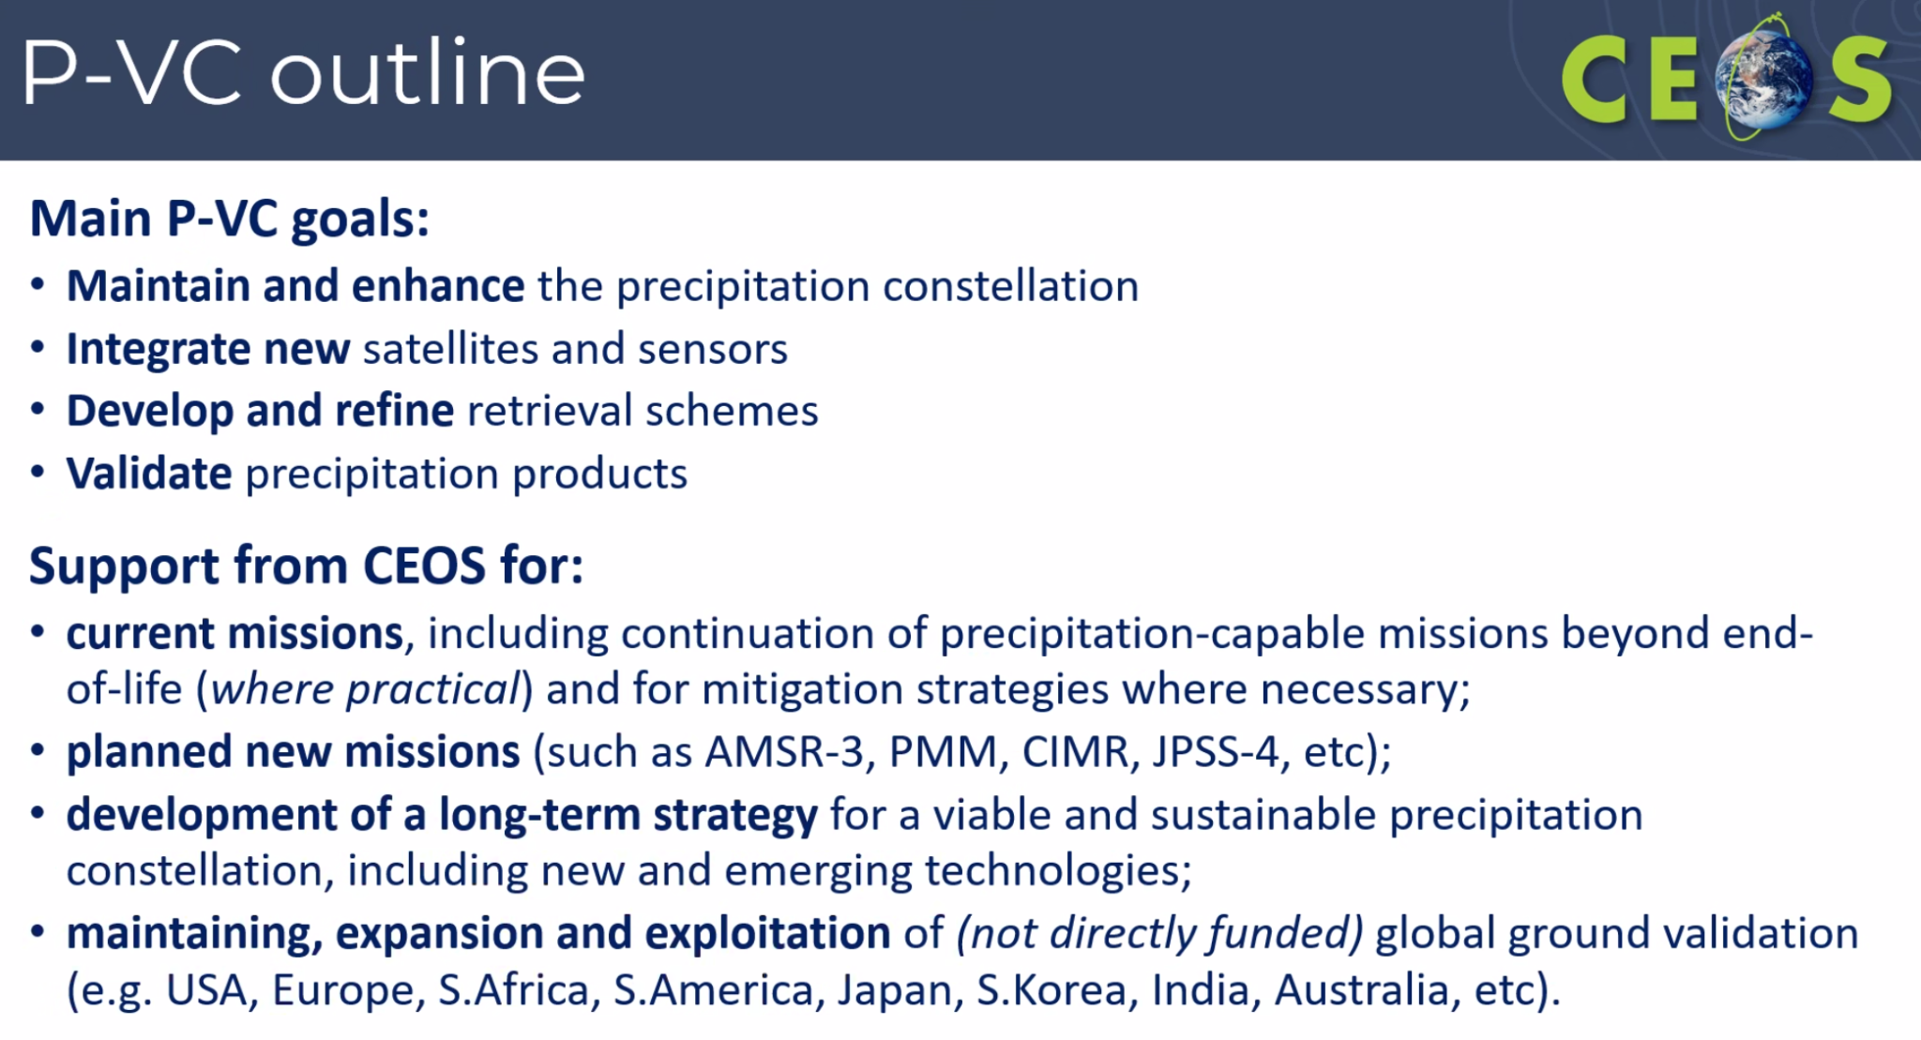.
- P-VC is an evolving success story. In 1985, precipitation measurements from space were only available on a six day revisit. Now, measurements are available 8-12 times a day.
- GPM Core Observatory underwent an orbital boost in November 2023, ahead of its 10th anniversary in February 2024.
- NASA’s TROPICS constellation has two operational satellites, with one more under calibration.
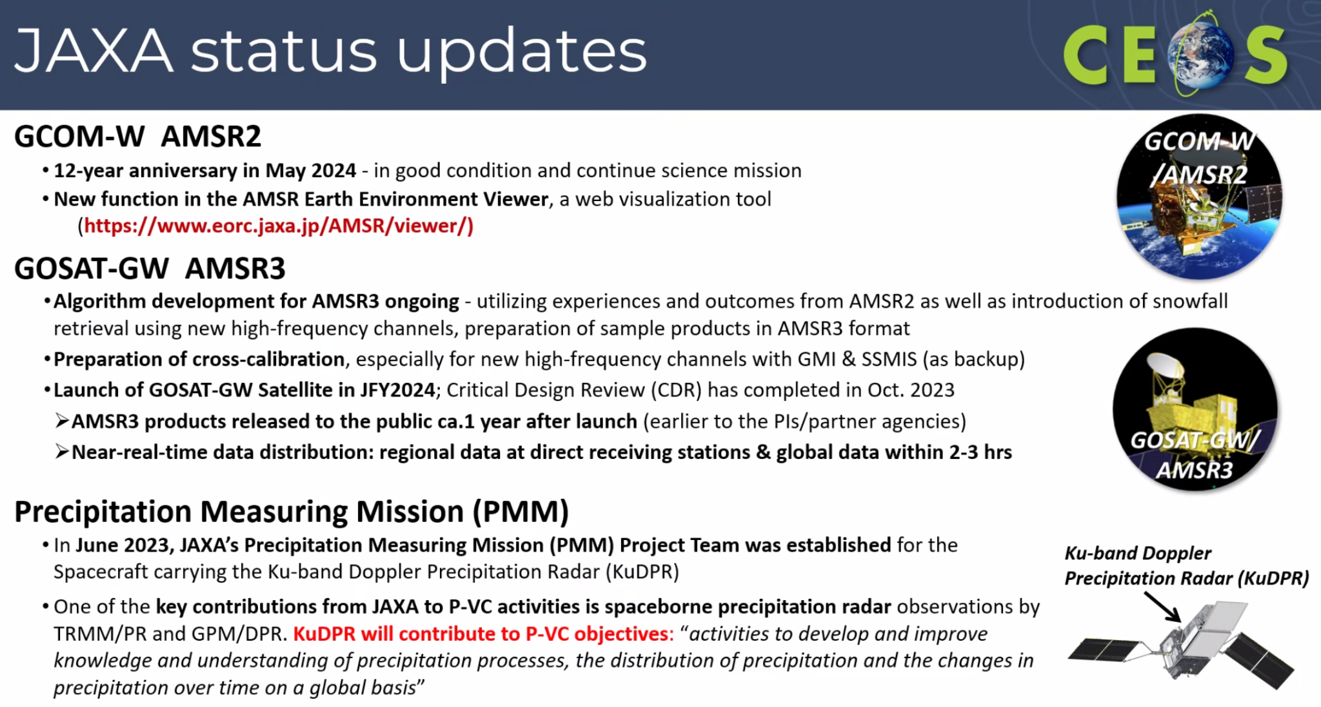
- EarthCare is planned to be launched in May 2024, and will provide three dimensional global distributions of cloud and aerosol to contribute to precise understanding of climate change.
- P-VC’s primary goals remain the same. The revisions to the Terms of Reference primarily relate to updating the available precipitation-capable missions, and the associated 3 and 5 year horizon goals.
- In addition, representatives from new agencies have been included including CNES, ESA, EUMETSAT and ISRO.
- Precipitation missions already have mature processing systems in place, which produce well used products. The main agencies and organisations already comply with existing data standards. The question remains as to whether to formalise these standards within the CEOS-ARD framework.
Main discussion points:
- Hironori Maejima (JAXA, SIT Chair) thanked the various CEOS Agencies for nominating new members to P-VC, and suggested continuing the ARD discussions with commercial providers to understand whether there is interest in formal CEOS-ARD standards.
- Marie-Claire Greening (ESA) endorsed the updated terms of reference for P-VC on behalf of ESA, and noted Thorsten Fehr will serve as the new ESA representative to P-VC.
- Selma Cherchali (CNES) endorsed the updated ToR and underlined CNES involvement in the Global Precipitation Mission (GPM), primarily through the Megha-Tropiques mission. CNES is also working with NASA and JAXA on the Atmospheric Observing System, and has worked jointly with ESA on the EarthCARE cal/val plan..
- Paul Counet (EUMETSAT) agreed with the future plans presented by Chris.
- Julie Robinson (NASA) commended P-VC for its effective collaboration efforts, both, formally and informally, particularly in weather prediction. NASA endorsed the Terms of Reference, especially emphasising the importance of incorporating new measurements to better understand precipitation.
- Stephen Volz (NOAA) noted the absence of any reference to emerging commercial companies, such as tomorrow.io.
- Chris Kidd (NASA) responded that the Terms of Reference do mention the integration of the commercial sector, but action cannot be taken until the data is assessed. There are opportunities and challenges that arise from utilising data from commercial sources.
Land Surface Imaging Virtual Constellation (LSI-VC): ESA PolInSAR Recommendations
Presenters: Ake Rosenqvist (JAXA) [Presentation]
Main points:
- Fully polarimetric, quad-polarisation (QP), data provides information about both backscatter amplitude and backscatter phase - for each polarisation combination (HH/HV/VH/VV). Time-series of QP data enables interferometric analysis of changes in polarimetric phase (PolInSAR).
- Multi-frequency (multi-wavelength) data enables enhanced retrieval of target structural parameters, as the wavelength is directly correlated with target size.
- Despite great potential, Polarimetric SAR and multi-frequency research and applications are still underdeveloped. There is a scarcity of consistent time-series of polarimetric data for research and development, alongside the complexity of polarimetric processing making it a high entry level for new users.
- CEOS capacity exists to cover this area, with a large number of current and imminent CEOS missions with polarimetric (QP) capacity spanning all radar frequency bands.
- The recent technology developments with wide observation swaths, fine spatial resolution and high speed downlink means there is significantly improved capacity for routine QP observations.
- ESA has been undertaking biannual PolInSAR workshops for more than 20 years. JAXA, CONAE, CSA and ISRO have national PolInSAR programmes.
- A recommendation from the 2023 PolInSAR workshop was brought to LSI-VC, and dedicated sessions were held on this topic at LSI-VC-14 and LSI-VC-15.
- LSI-VC recommend that CEOS Agencies:
  - Establish a PolInSAR reference site network;
  - Conduct dedicated polarimetric observations over these PolInSAR reference sites, including the integration of polarimetry in strategic background mission observation plans.
  - Simplify data access for research and development, perhaps via the CEOS Analytics Lab. Support development of CEOS-ARD compliant polarimetric products.
Main discussion points:
- Julie Robinson (NASA) was not aware of this initiative within LSI-VC. NASA will nominate a representative to work with the PolInSAR team.
- Tim Stryker (USGS) thanked Ake for his work in this domain within LSI-VC. There are several opportunities for further engagement and coordination.
- Takeo Tadono (JAXA) supported the initiative and noted JAXA provides a variable InSAR product for a number of parameters, which provides a good opportunity to collaborate with other CEOS Agencies.
- Ake Rosenqvist (JAXA) recognised that CONAE also supports this work and already undertakes these measurements.
- Eric Laliberté (CSA, CEOS Chair) asked whether the second portion of the actions are mentioned in the CEOS Work Plan. Ake noted they are not currently, but it should be included.
SIT-39-09 | Relevant CEOS Agencies are asked to designate a point of contact for engagement in the LSI-VC Polarimetric Interferometric Synthetic Aperture Radar (PolInSAR) Team, which includes support for systematic observations over Reference Sites. | Jun 2024
 | Rationale: There are a number of current and imminent CEOS missions with polarimetric (QP) capacity and LSI-VC seeks to maximise the opportunity.
SIT-39-10 | LSI-VC to ensure that its PolInSAR work is captured in the CEOS 2024-2026 Work Plan, including the suggested PolInSAR Reference Sites; coordination of multi-sensor QP observations with Agency points of contact; and the establishment of a PolInSAR repository. | Apr 2024
 | Rationale: SIT-39 acknowledged that this is an emerging work thread in LSI-VC that should be captured in the CEOS 2024-2026 Work Plan. The CEO Office was also asked to ensure inclusion in the referenced Work Plan.
CEOS-ARD Strategy 2024
Presenters: Matt Steventon (CEOS-ARD Secretariat) for Ferran Gascon (ESA, CEOS-ARD Oversight Group Lead) [Presentation]
Main points:
- CEOS Analysis Ready Data (CEOS-ARD) are satellite data that have been processed to a minimum set of requirements and organised into a form that allows immediate analysis with a minimum of additional user effort and interoperability both through time and with other datasets.
- User demand is key to develop Product Family Specifications, and the ARD Oversight Group relies on the Virtual Constellations to reflect the user demand of ARD products for their specific domain.
- The CEOS-ARD Strategy 2024 is an update to past editions from 2019 and 2021 to reflect on the progress to date, take stock of future directions and needs, and confirm our strategy for the next few years. The goal is to have a broad portfolio of CEOS-ARD that is easily discovered, accessed and utilised.
- The strategy activities are categorised into six broad themes:
  - CEOS-ARD Availability, Product Diversity, and Representation
  - Framework and Specification Advancement
  - Discovery, Access, Utilisation, and Interoperability
  - Community Engagement
  - Research, Test Cases, and Pilot Activities
  - Commercial Engagement
- CEOS-ARD has been a great success. It catalysed a growing movement and recognition of the importance of providing satellite EO data that is easier to use.
- CEOS should maintain leadership of the satellite Earth observation Analysis Ready Data concept and its definition through CEOS-ARD.
- The CEOS-ARD Oversight Group plans to present the updated strategy for endorsement at CEOS Plenary 2024, after discussion at the 2024 SIT Technical Workshop.
Recap of other Virtual Constellation issues
Presenters: Osamu Ochiai (JAXA, SIT Chair Team)[presentation]
Main points:
Atmospheric Composition (AC-VC)
- The CEOS Work Plan includes new deliverables, including follow-up actions from the 2019 whitepaper on Air Quality Validation and the 2022 whitepaper on PM2.5.
- Efforts are underway to enhance measurements of air quality in the global south, with an invitation extended to southern hemisphere agencies to join and contribute to this initiative.
- The next meeting of AC-VC is scheduled to take place in the United States during the third quarter of 2024, ideally before the 2024 CEOS Plenary, the week of October 22, 2024.
Land Surface Imaging (LSI-VC)
- LSI-VC-15 was held last week. A discussion was held to address the high-level product needs of thematic communities, particularly Essential Climate Variables (ECVs) and Essential Biodiversity Variables (EBVs). To accommodate the expanded scope, considerations were made for expert appointments to LSI-VC Subgroups.
- Technical discussions and advancements on the specification of land CEOS-ARD were also addressed, aiming to accommodate high-resolution EO datasets and improve interoperability through CEOS-ARD STAC Extensions. A GitHub repository has been initiated to help foster better community engagement.
- LSI-VC members play a significant role in the OGC/ISO ARD Standards Working Group, ensuring alignment with CEOS-ARD.
- Plans were outlined for the Surface Reflectance Quality, Equivalency, and Consistency Project, aiming to further enhance interoperability of CEOS-ARD datasets.
Ocean Colour Radiometry (OCR-VC)
- The Aquatic Carbon Roadmap (Item 8.1) is the main priority of OCR-VC.
- The white paper on System Vicarious Calibration (SVC) infrastructures to support Climate-quality OCR data records is nearly finalised and is set for publication soon.
- Collaboration with the LSI-VC is ongoing to extend the Aquatic Reflectance ARD Product Family Specification (PFS) to oceans, to develop a unified specification for inland, coastal, and open waters. The International Ocean Colour Coordinating Group (IOCCG) is scheduled to convene from 22nd to the 26th April 2024, where the next steps will be discussed.
Ocean Surface Topography (OST-VC)
- The OST-VC White Paper ‘A Coordinated International Satellite Altimetry Virtual Constellation: Toward 2050’ is nearing completion and a draft will be presented at the 2024 SIT Technical Workshop.
- OST-VC is currently missing membership from China and nominations are welcomed.
- Annick Sylvestre-Baron of CNES is retiring in April 2024 and will be replaced by Yannice Faugere from CNES. Yannice is already well-known by the OST Science Team and has been an active member of the community for many years.
Ocean Surface Vector Winds (OSVW-VC)
- IOVWST will meet in May 2024, which will be the first in-person meeting since the pandemic. IOVWST is the primary forum for subject matter experts.
- OSVW-VC is looking at collaborations with COAST-VC, in particular for coastal surface winds.
Sea Surface Temperature (SST-VC)
- SST-VC is seeking more engagement from existing members and additional membership from CONAE, CSA, and INPE.
- SST-VC is looking for areas to collaborate with COAST-VC, ensuring no overlap in work
Precipitation (P-VC)
- Thanked Chris for already presenting the update.

6.2: WMO Update
Presenters: Natalia Donoho (WMO) [presentation]
Main points:
- The World Meteorological Organization (WMO) Space Programme includes five key areas: integrated space-based observing system; availability and use of satellite data and products; capacity building and user engagement; space weather coordination; and coordination for the use of radio frequency spectrum.
- The 15th Session of the Consultative Meetings on High-level Policy on Satellite Matters (CM-15) was held at WMO on February 6-7, 2024, which aimed to facilitate a formal and substantive communication between leadership of space agencies and representatives of the WMO.
- Six key topics were raised during the roundtable discussion, focusing on:
  - Increasing benefits of satellite data for Developing Countries
  - High Data Volumes
  - Coordinated Involvement of the Private Sector
  - Coordination for Greenhouse Gas Monitoring
  - WIGOS Vision
  - AI Technology for Improved Satellite Data Exploitation
- The fifth high-level session of the Open Consultative Platform (OCP-HL-5) will be held on June 13, 2024, during Executive Consult-78 (EC-78). This will provide a dialogue mechanism between WMO and the private sector and academy, focusing on key challenges with long-lasting impacts on WMO and its Members, which can only be addressed by engaging all stakeholders, including the public, private and academic sectors.
- There have been some updates of the WIGOS Manual, WIGOS Guide, and Guidelines on Best Practices for Achieving User Readiness for new meteorological Satellites. There is also a plan for the update of the WIGOS Vision 2040 (WMO-No. 1243) and the High-level Guidance on the Evolution of GOSs during 2023–2027. CEOS Agencies are invited to review these changes alongside their national delegations to WMO.
Main discussion points:
- Julie Robinson (NASA) appreciated the opportunity to meet the new WMO leadership at CM-15. WMO had expressed the need for support on Early Warning for All (EW4All). Should WGDisasters contribute to addressing this requirement?
- Natalia Donoho (WMO) noted that WMO welcomes any products and applications from CEOS that could be provided to the EW4All team. This needs to be mapped against the requirements of various countries. Previously, WGDiasters worked on an ad-hoc basis with EW4All. A meeting with WGDisasters, CEOS leadership and WMO should be organised to discuss how CEOS can best support this initiative.
- Marie-Claire Greening (ESA) recognised that WGDisasters are aware of EW4All and are considering the best approach to support.
- Laura Frull (CONAE, WGDisasters Chair) noted that WGDisasters is working on this topic, with a dedicated session at the last WGDisasters meeting.
- Osamu Ochiai (JAXA, SIT Chair Team) highlighted the need to improve communication on topics such as G3W and EW4All. CEOS should work out the best method and channels to communicate, and should discuss with WMO more in detail.

SIT-39-11 | SIT Chair to confer with WGDisasters Chair and Vice Chair regarding potential CEOS contributions to the UN’s Early Warnings for All (EW4All) initiative. | SEC-321
 | Rationale: The objective is to identify potential CEOS contributions to the EW4All to be communicated to the UN and through WMO.

6.3: Commercial Sector Issues [presentation]
CEOS New Space Task Team Recommendations and Impact on the CEOS 2024-2026 Work Plan Presenters: Marie-Claire Greening (ESA)
Main points:
- The New Space Task Team was initiated as a SIT Initiative under the ESA Chairmanship. The Task Team had a term of one year, and produced a white paper and recommendations as a summary of the findings.
- New Space was also on the agenda for most Working Group meetings last year as well.
- New Space White Paper presented three recommendations to CEOS Plenary:
  - In view of augmenting the scientific and operational potential of long-term, institutional programmes, CEOS Members and Associates should act collectively in using the CEOS mechanisms to identify and support potential complementary capabilities enabled by New Space and other commercial actors.
  - CEOS Members and Associates should strive to continue to share information on relevant events and activities related to New Space, including commercial data evaluation results when possible. CEOS Agencies should also investigate ways to work together on cooperation agreements with New Space actors, possibly including common lines to take on end-user licence agreements and Intellectual Property Rights (IPR) issues.
  - Cooperation and collaboration opportunities should be sought to facilitate interoperability between private and public sector data and future CEOS SIT Chairs are encouraged to routinely provide the opportunity for CEOS Members and Associates to report on developments in the standards domain, be they from public or private sources, at future SIT Technical Workshops.
- Deliverables were included in the 2024-2026 CEOS Work Plan, as agreed at the 2023 CEOS Plenary.
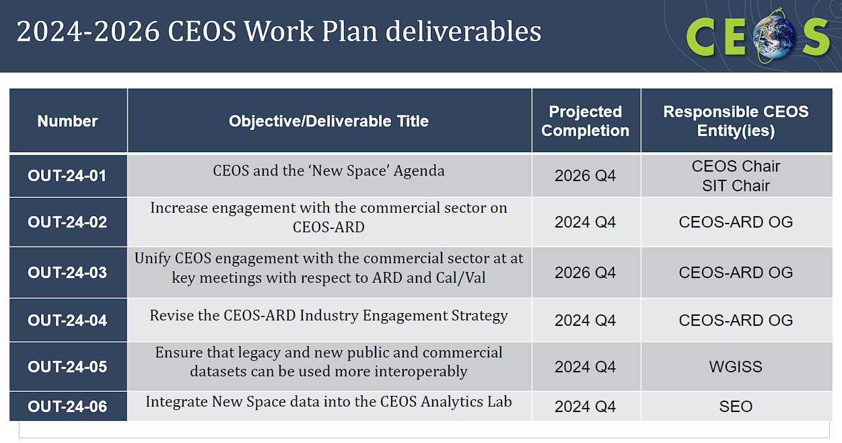
Main discussion points:
- Beth Greenaway (UKSA) highlighted that efforts like the Methane standards initiative led by NPL involves the commercial sector, however the work is not captured within the CEOS Working Groups. CEOS should consider ways to improve documentation of these types of cross-sector collaboration activities more effectively.
- Stephen Volz (NOAA) noted the CEOS Virtual Constellations connect to the commercial sector by domain. However, perhaps there is a need for more broader engagement from CEOS.
- Marie-Claire Greening (ESA) noted that within the White Paper, it was recommended that all the Working Groups and Virtual Constellations engage with the commercial sector. Coordination is needed, but it has to come from each Working Groups and Virtual Constellations about what level of engagement is appropriate. CEOS Work Plan is a good place to start, and any agency is invited to put forward deliverables in the Work Plan.
- Eric Laliberté (CSA, CEOS Chair) noted the first action includes an outward facing statement from CEOS to the commercial sector, which would address NOAA’s comment. The goal is to develop a CEOS Commercial Engagement Strategy, to provide a clear framework to encourage the engagement, and also provide the mandate and clear context for which the Working Groups and Virtual Constellations can engage.
- Tim Stryker (USGS) added that this initiative is just the beginning of the process, CEOS should maintain continuous engagement with the commercial sector. Working Groups and Virtual Constellations are already engaging productively, at the technical level, ensuring engagement with industry partners.
Report on Tokyo LSI-VC Industry Engagement Session
Presenters: Matt Steventon (LSI-VC Secretariat) on behalf of Steve Labahn (USGS, LSI-VC Co-Lead)
Main points:
- Six Japanese companies attended the workshop on 5 April 2024, from all along the data value chain.
- Some of the companies were already engaging with CEOS-ARD, with data providers Synspective and AxelSpace currently reviewing CEOS-ARD specifications, with interest in submitting self assessments.
- There is a clear potential use case for CEOS-ARD specifications to guide data procurement.
- The companies focus on improving data quality, where they look to CEOS Agencies for support. They are existing users of RadCalNet.
- Overall, it was a positive and engaging workshop, and the companies expressed interest in joining LSI-VC and CEOS-ARD discussions more regularly.
- This is the first workshop, with others planned alongside future LSI-VC meetings. There is also potential for a follow up workshop around SIT-40 in 2025.
CEOS Analytics Lab (CAL) Commercial Data Interoperability Study
Presenters: Dave Borges (NASA, SEO)
Main points:
- The CEOS Analytics Lab (ceos.org/cal) is an open workspace to provide a collaborative technical workspace for CEOS, built with support from CSIRO.
- A deliverable was included in the New Space white paper: SEO should demonstrate the integration of New Space data into CEOS Analytics Lab and evaluate its interoperability with common CEOS datasets.
- There will be analysis of both optical and SAR datasets, and comparing commercial and CEOS datasets.
- The goal of this work is to improve understanding of commercial image quality as compared to public imagery datasets, and evaluate cross-platform interoperability and accessibility of commercial datasets.
- For the optical side, key considerations and challenges include sensor variation, processing biases, situational factors and data compliance with CEOS-ARD specifications.
- The first step will be to complete ‘mock’ self-assessments of the commercial datasets against the CEOS-ARD specifications.
Main discussion points:
- Beth Greenaway (UKSA) noted that the assessment work sounds similar to the assessments done by ESA’s Third Party Mission programme. CEOS should be careful on categorising datasets as ‘good’ or ‘bad’ and avoid phrases like ‘CEOS Policy’.
- Dave Borges (NASA, SEO) would be willing to learn more about the Third Party Mission assessment process. The aim of this analysis is to find the interoperability pain points, and CEOS will not be endorsing datasets.
- Stephen Volz (NOAA) liked the idea of the mock self-assessments and suggested to also include good and bad examples that will demonstrate the ability to improve one's own products.
- Eric Laliberté (CSA, CEOS Chair) highlighted that WGCV works on assessment procedures to assess the quality of the data coming from both CEOS and commercial missions.
- Tim Stryker (USGS) recognised that the efforts are not duplicative of the work done by WGCV. As government agencies are very discrete about the quality sensitivities, it is important to be careful in how the data is viewed and categorised.
- Philippe Goryl (ESA, WGCV Chair) noted a methodology developed by ESA and NASA to assess commercial data was presented at WGCV-53, in March 2024. At the WGCV level, there is strong support for matchup databases and assessments of radiometry. Philippe has been discussing with the SEO on the best way to support the CEOS Analytics Lab and the ingestion of data.
USGS Update
Presenters: Tim Stryker (USGS)
Main points:
- USGS actively supports coordination between space agencies and the commercial sector, including through LSI-VC, CEOS-ARD, WGISS and WGCV.
- Sustainable Land Imaging (SLI) Program Partnership considers commercial data, and stresses the complementarity of the two sources.
- USGS is undertaking a project to ensure tax payers are only paying for commercial data once, and the data can be shared across US Government agencies.
- The 2030 Challenge aims to address the increasing volume of both public and private EO datasets, posing questions on how to manage data more effectively and seamlessly. The challenge highlights the need for the US Government to avoid duplicating efforts and instead focus on leveraging the entire value chain.
- The recent JACIE workshop had sessions on commercial EO data quality, improved calibration techniques, and standardising evaluation methodologies. Counterpart of the JACIE workshop is VH-RODA on the European side.
- The Landsat Value-Adders Forum was hosted by GA and USGS on March 1, 2024 in Sydney, Australia, with local industry partners.
- USGS is considering the possibility of a workshop similar to the LSI-VC Commercial Workshop held last week, based in the US and aligned to the joint WGISS/WGCV meeting in October, 2024. WGISS is an important CEOS entry point for the commercial sector to understand data interoperability.
- There is scope for more commercial and New Space engagement at higher levels of CEOS, and USGS is willing to support.
Main discussion points:
- Dave Borges (NASA, SEO) noted that Cody Anderson (USGS) is serving as the WGCV Vice Chair, and led elements of JACIE. The next CEOS Quarterly revisit, to be published in the coming weeks, will include an introduction from Cody.
- Eric Laliberté (CSA, CEOS Chair) noted that CEOS has been approached by OGC for better coordination between the two organisations. One of the topics discussed was the interest in jointly discussing data quality, interoperability, and measurement sustainability which ties into data policy and usage.
- Tim Stryker (USGS) concurred with the need for better coordination. Tim noted that colleagues from LSI-VC and CEOS-ARD have been involved with OGC but have encountered some challenges.

Session 7: Greenhouse Gas Observations

7.1: Session Introduction
Presenters: David Crisp (SIT Chair Team) and Hiroshi Suto (JAXA, SIT Chair Team) [presentation]
Main points:
- Different types of space-based data are needed to track carbon dioxide (CO2) and methane (CH4) emission sources and natural sinks on different scales across the globe. Both point source and wide area mapping missions are needed.
- On national and regional scales, space-based GHG measurements can provide a transparent way to develop national inventories, assess collective progress toward national GHG emission reduction goals, and track changes in natural sources and sinks due to human activities and climate change.
- On the scale of large urban areas such as a city, space-based GHG data can track changes to approximately 70% of all anthropogenic GHG emissions.
- For individual facility scale, space-based GHG data can monitor emissions from fossil-fired power plants and pipeline leaks.
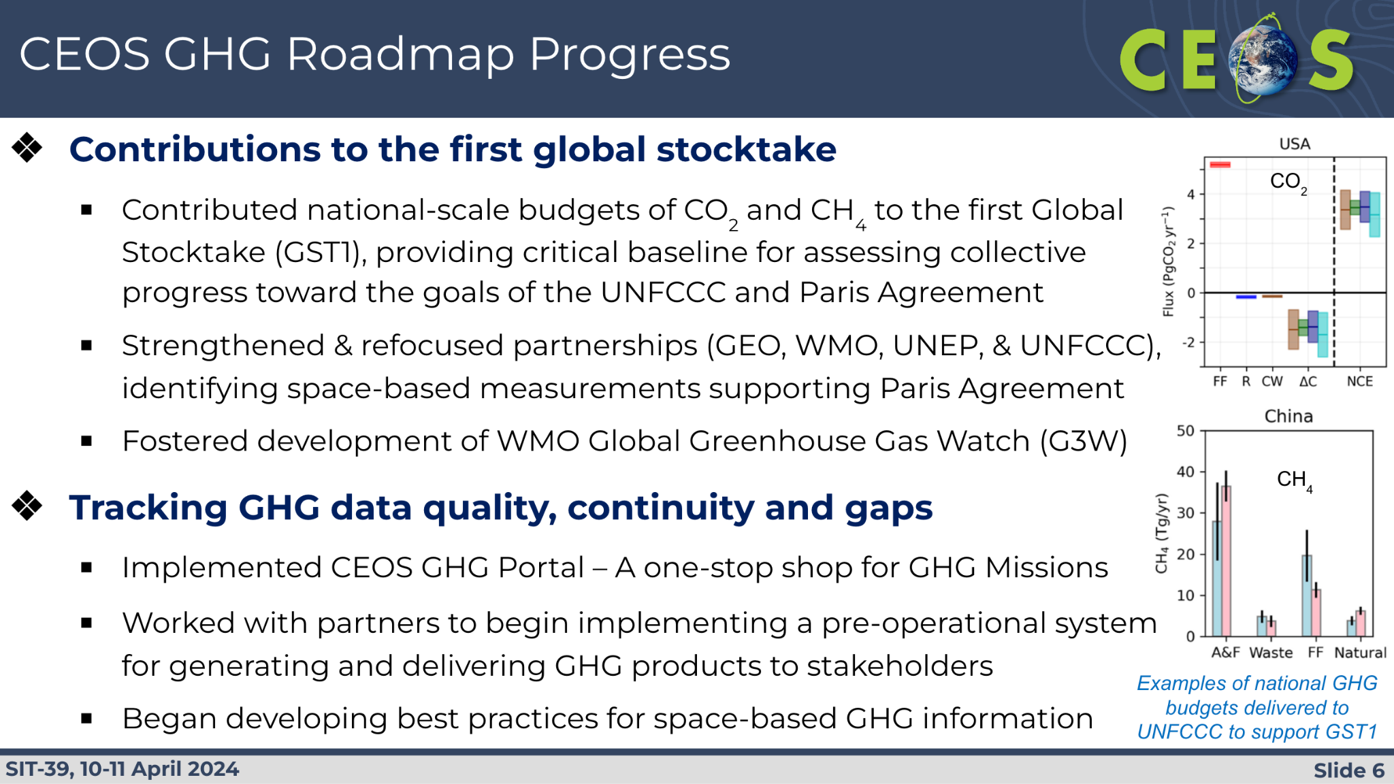
- There have been a number of major developments since the CEOS GHG Roadmap was approved:
  - The first Global Stocktake (GST1) was executed. Thus far, there has been limited use of scientific observations and data across the board. CEOS products provide a critical baseline for use in future GSTs.
  - WMO is implementing G3W to support regional and national GHG MVS where CEOS and its member agencies are expected to play a major role.
  - UNEP established the International Methane Emissions Observatory (IMEO) including its Methane Alert and Response System (MARS) to track large methane leaks.
  - CEOS Agencies are preparing to launch MicroCarb, GOSAT-GW, and CO2M missions.
  - Non-governmental players are playing an increasing role in space-based measurements of GHGs and other climate variables. 12 GHGSat satellites have launched, MethaneSAT launched in early 2024, and other missions are planned for launch soon, including Carbon Mapper.
  - 155 nations committed to the Global Methane Pledge to reduce anthropogenic methane emissions by at least 30% from 2020 levels by 2030.

7.2: CEOS Greenhouse Gas Roadmap Update
Presenters: Yasjka Meijer (ESA, GHG Task Team Lead)[presentation]
Main points:
- GHG Task Team is responsible for implementation of the GHG Roadmap update, and stimulates and monitors GHG related activities across the various CGMS and CEOS Working Groups including WGClimate, WGCV, AC-VC and WGCapD.
- Area leads and deputies have been appointed for each of the seven thematic areas in the actions annex (Annex C) of the GHG Roadmap.
- Active participation is still missing from WGCapD and CGMS Working Groups. Now that GHG TT is moving towards operational work, it is very important to involve CGMS.
- Last year, the GHG TT updated the action list through a comprehensive review across all areas, including prioritisation. Progress has also been made towards product standardisation..
- The development of the CEOS GHG Missions Portal provides a centralised overview of GHG missions.
- Significant steps have been taken in the realm of New Space, facilitating increased utilisation of their data.
- CEOS representatives are actively involved in supporting the implementation plan of the WMO Global Greenhouse Gas (GHG) Watch initiative. Activities from the GHG Roadmap may transition to G3W gradually. Defining operational interfaces between CEOS and G3W is essential during implementation of G3W.
- CEOS members are participating in working groups for the IMEO and collaborating to enhance these efforts further. The aim is to position CEOS as the trusted partner for space-based observations up to Level 2 data, with expectations for gradual operationalisation beyond Level 2.
- IMEO has identified that a useful contribution from CEOS Agencies would be tasking hyperspectral missions to provide more detailed information about an observed plume, as these are not typically standard products of these missions.
- As a result of these recent developments, a full revision of the GHG Roadmap is required due to recent developments. Principals are invited to nominate individuals to support the update process.
Main discussion points:
- Ake Rosenqvist (JAXA) highlighted that JAXA has initiated a project on mapping wetland inundation, which is a natural source of methane. The aim is to improve estimates by utilising time series of L-band data over major river basins.
- Argyro Kavvada (NASA) expressed interest in supporting the GHG Roadmap efforts. NASA is developing methane plume products using the EMIT sensor on board the ISS. Their products are an initial effort to map methane plumes in specific areas, with further efforts directed towards providing methane emission rates through the GHG Centre in collaborations with cal/val aspects.
- Stephen Volz (NOAA) supported updating of the GHG Roadmap but was concerned about the scope of the work and the timeline through to the 2024 SIT Technical Workshop and the CEOS Plenary.
- David Crisp (SIT Chair Team) noted that the GHG TT is trying to narrow the scope to specifically capture new requirements and scopes without undergoing major layout changes.
- Yasjka Meijer (ESA, GHG Task Team Lead) acknowledged the ambitious schedule, but believed it is manageable due to the restriction of scope.
- Beth Greenaway (UKSA) agreed that updating the Roadmap is timely, emphasising the need to allocate resources in a proportionate way. Actions would be a key area to focus on.
- Sylvia Wilson (USGS) emphasised the importance of coordination between the GHG and AFOLU Roadmaps.
SIT-39-12 | GHG Task Team of the Joint CEOS-CGMS WGClimate to work on an update of the CEOS-CGMS GHG Roadmap for discussion at the SIT Technical Workshop in preparation for potential endorsement at the 2024 CEOS Plenary. | 2024 Plenary
 | Rationale: SIT-39 acknowledged that changes in the operating context and user requirements dictate the need for an update to the CEOS GHG Roadmap.

DECISION 03 | SIT-39 agreed that an update of the CEOS GHG Roadmap should be completed for discussion at the SIT Technical Workshop in preparation for potential endorsement at 2024 CEOS Plenary. Note that the document will need to be made available in advance for CEOS Agency review.

7.3: International Methane Emissions Observatory (IMEO) Activities and CEOS Cooperation
Presenters: Cynthia Randles (IMEO) [presentation]
Main points:
- United Nations Environment Programme’s (UNEP) IMEO aims to provide the data required to target methane reductions at the speed and scale needed to achieve climate goals.
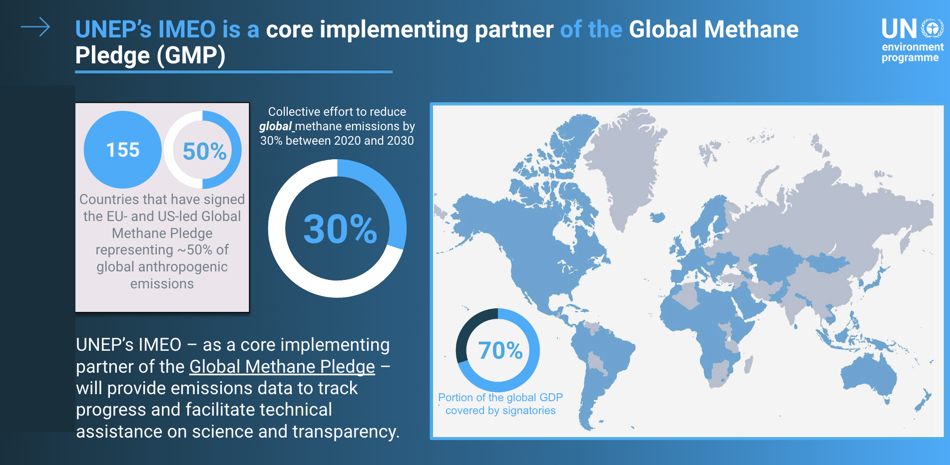
- The oil and gas sector presents readily achievable opportunities for lowering carbon emissions, offering mutual benefits which can be implemented with minimal cost for substantial benefit.
- Satellite data holds a significant importance for IMEO due to the scale and availability of data. The imagery is striking, and serves as a good communications tool, making an invisible situation clear to operators and the public.
- IMEO is interested in two types of products: ‘alerting’ products and ‘reporting’ products. Alerting products prioritise low latency and high localisation accuracy, over emission estimate accuracy.
- Accounting products provide information that governments and companies can use to understand their own emissions and perhaps report them at company level.
- IMEO is already developing Level 4 products using data provided by CEOS Agencies, adhering to core principles of product transparency.
- The UNEP IMEO’s public portal increases transparency by sharing methane plumes detected using public satellites. A beta version of the portal has been recently released, showcasing methane hotspots detected by instruments like TROPOMI, locations of IMEO science studies, and methane plumes from TROPOMI alongside high-resolution images.
- IMEO’s Methane Alert Response System (MARS) provides rapid and actionable data to stakeholders. More than 200 plumes have been detected by MARS so far, each causing stakeholders to be notified.
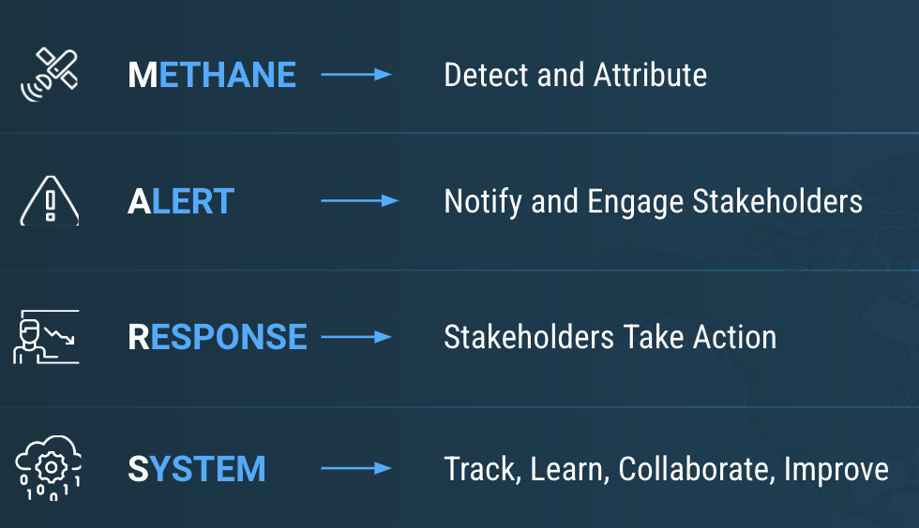
- UNEP IMEO is both a user of publicly available satellite data (L1 to L2) and a producer of satellite data products (L4) from high-resolution plume imagers. UNEP IMEO sees CEOS as a trusted, key partner in implementing its mission.
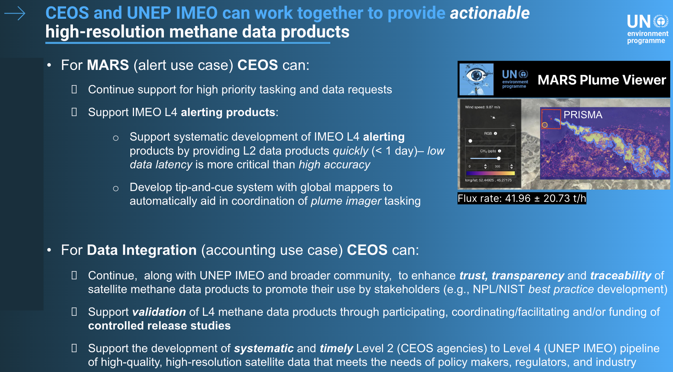
Main discussion points:
- Yasjka Meijer (ESA, GHG Task Team Lead) welcomed the collaboration between CEOS and IMEO. The request for support is likely being echoed within agencies, emphasising the need for a mechanism to manage this collaboration between CEOS, IMEO and CEOS Agencies.
- Dave Crisp (SIT Chair Team) noted that GHG Task Team is updating the roadmap to also accommodate the interface with IMEO. CEOS should designate a specific person as a key interface point for this purpose. This individual should be allocated a small amount of resources to support this interface including funding for travel to meetings and other related expenses.
- Stephen Volz (NOAA) asked how IMEO gathers datasets. Is there a portal through which datasets can be explored, perhaps with AC-VC?
- Cynthia Randles (UNEP IMEO) noted that the process is currently manual.
- Dave Crisp (SIT Chair Team) acknowledged that data access should be reflected in the second version of GHG Roadmap.
- Argyro Kavvada (NASA) noted the US GHG Centre is thinking about ways to provide data to support these efforts.
- Dave Crisp (SIT Chair Team) noted that IMEO would be producing the first near real time GHG product. Although primarily intended for alerts, resulting in lower accuracy, it represents a significant and specific demand. Many existing GHG missions and data systems were not originally designed to meet such demands, suggesting that future mission planning should include this aspect. For some missions, it may be possible to provide an addition to the standard product processing to cover this low latency requirement.
- Yasjka Meijer (ESA, GHG Task Team Lead) noted that CO2M will be the first operational GHG monitoring mission. The challenge is to balance the science with operational needs. CEOS has been working to provide accurate plume measurements, however IMEO is asking for quick measurements with high probability.
- Stephen Volz (NOAA) highlighted the diversity of data sources available, including operational, research and commercial sources, each with its own method of access. Efforts should be made to leverage existing data flows and enhance others, noting that some systems like Sentinel and GOES are already accessible, while others may require additional architectural considerations.
- Flora Kerblat (CSIRO) asked about the connection with the Sustainable Development Goals (SDGs), noting there is an indicator directly linked to measuring total GHG emissions. Can EO data support this indicator, and could CEOS work on another EO support sheet in support of it?
- Cynthia Randalls (UNEP IMEO) noted that while the data primarily focuses on point sources, efforts are underway by various groups to integrate IMEO's data into their inversion models. Although the data may not directly align with SDG indicators, it is accessible to interested parties, and as IMEO systematically produces more data, its utility is expected to increase for SDG reporting.
- Julie Robinson (NASA) noted the release of research quality products such as EMIT plume detection have been able to improve measurement accuracy. One of the great things about working with G3W is being able to continue to refine the process.
- Ake Rosenqvist (JAXA) asked about the role of natural emission monitoring, especially around permafrost melt.
- Cynthia Randalls (UNEP IMEO) noted that the focus is solely on human emissions with the primary objective being producing data that can create action.
- Barry Lefer (NASA, AC-VC Co-Lead) encouraged IMEO to go beyond oil and gas, and include other sources such as landfills in future work.
SIT-39-13 | The GHG Task Team of the Joint CEOS-CGMS WGClimate was asked to reflect the requests from UNEP IMEO in the 2024 update of the CEOS GHG Roadmap. | 2024 Plenary
 | Rationale: UNEP IMEO requirements are among the key factors driving a 2024 update of the CEOS GHG Roadmap.

7.4: Emission Measurement Best Practices and Standards
Presenters: John Worden (NASA/JPL) [presentation]
Main points:
- The Global Methane Pledge (GMP) was launched at UNFCCC COP26 in 2021 by the European Union and the United States. At present, it has been signed by 150 countries, and aims to reduce methane emissions by 30% between 2020 and 2030.
- Methane is a much stronger GHG than carbon dioxide, and may also be easier to reduce as well. Known remediation efforts can be applied to managed sources such as landfills and fossil emissions.
- Four years into the global methane pledge, it is not clear whether the global observing system can make the required measurements.
- Satellite based top-down emissions estimates supporting the GST could be critical to resolve model and inventory discrepancies that might disrupt policy selected decarbonisation pathways.
- Carbon dioxide and methane fluxes are composed of area sources such as forests and wetlands (length scales from 1 km to 1000’s of km) and facility scale sources (10’s of metres to 1km). Hence, multi-scale observations are needed.
- There are a number of applicable missions for monitoring methane across this variety of scale. Despite this massive improvement in GHG observing capacity, additional measurement systems are needed to resolve changes in carbon fluxes for major gaps such as oceans, cities and extreme events.
- WMO G3W, UNEP IMEO, Copernicus CAMS and US GHG Centre each have satellite based GHG emissions estimates at radically different scales, requiring different estimation approaches and therefore different best practices.
- Best practices are needed to build trust that emissions reported based on public and commercial datasets can be used to track all aspects of the carbon cycle that affect CO2 and CH4.
- The best practices aim to provide a community accepted practice or methodology for quantifying emissions. They will help ensure emissions are reproducible from reported products and algorithms, and have a well characterised verification, validation, and uncertainty quantification (VVUQ) with traceability to a reference measurement.
Paul Green (UK NPL) reported on the work on methane reporting documentary standards:
- New legislation in the UK is aimed at curbing emissions from oil and gas, and the corporate world is also being asked to report on their emissions. As a result, there is a huge market for methane emissions data. With public and private sector satellites, along with downstream product developers, standards and auditing schemes are needed to ensure data quality.
- In May 2023, UK NPL published an auditing scheme report, developed in close collaboration with NIST and the US GHG centre, alongside WGClimate and GHG Task Team.
- UKSA and NPL hosted an event at COP-28 on monitoring methane for space and developing an internationally recognised standard.
- NPL hosted a UKSA-sponsored methane reporting standards workshop on February 26-28, 2024. Many CEOS Agencies and industry stakeholders attended, with the goal to formulate a standards structure, identify practical requirements and impediments and set out the programme roadmap and timelines to keep pace with a rapidly evolving sector.
- Looking to create compliance-determinable best practise for the methods and reporting of satellite-derived methane products. ‘Documentary standards’ are more stringent than best practices, allowing for objective certification of compliance.
- Standard will be agile, not static, to allow evolution of approach & focused on methods and reporting, not a static threshold performance basis. It will also need to have graded compliance to the documentary standards, with documentary standards specific for individual use cases.
- The outline of the standards is anticipated by December 2024, with details filled in by 2025, in time for COP30 and the 2025 CEOS Plenary hosted by UKSA.
- CEOS can act in a coordinating role (in the vacuum of other candidates) in this relatively immature phase but should be open to stepping back as the initiative matures and suitable stakeholders assume roles.
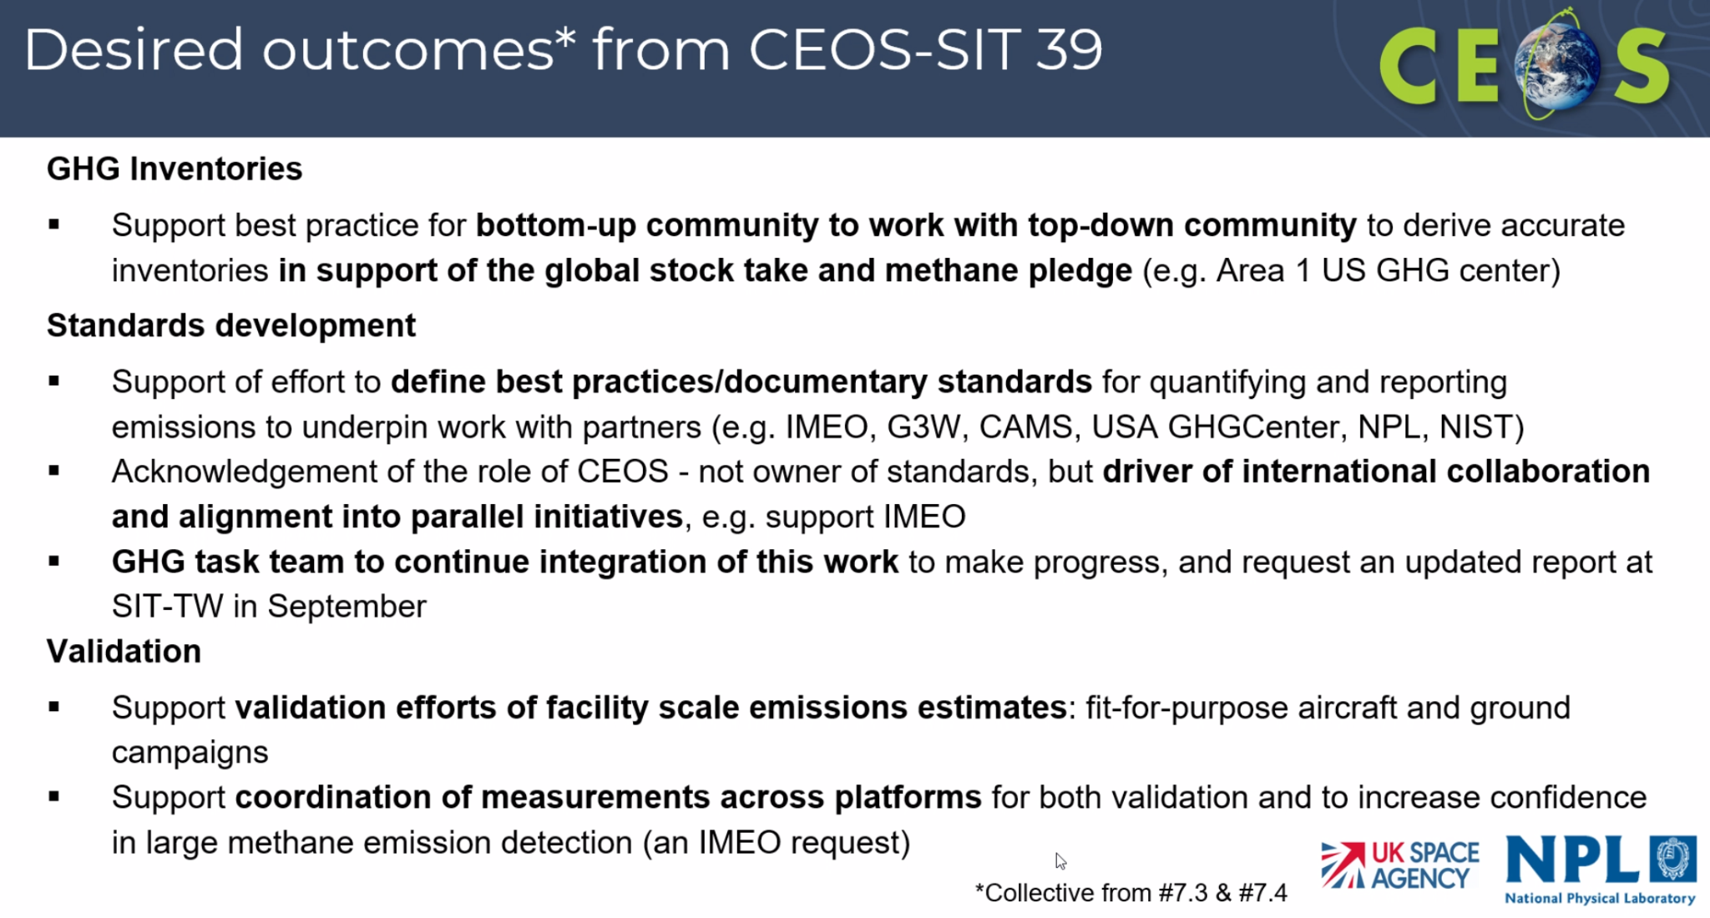
Main discussion points:
- Dave Crisp (SIT Chair Team) expressed the need to formalise efforts by developing best practices and standards for the different types of measurements. A framework should be in place before the SIT Technical Workshop, noting that it will likely be a 12-month effort to define the underlying standards.
- Osamu Ochiai (JAXA, SIT Chair Team) noted the need to confirm private sector reaction to this initiative. How are companies such as GHGSat intending to standardise their products?
- Paul Green (UK NPL) highlighted that the driver for the timeline is the commercial missions, as compliance with international standards is good for their business models.
- Beth Greenaway (UKSA) suggested engaging with countries and negotiators by warming up the community through the statement to SBSTA this year, emphasising the need for real action.
- Dave Crisp (SIT Chair Team) suggested that if CEOS took a proactive approach, they could also include standards for traceability and transparency, encouraging open science.
- Marie-Claire Greening (ESA) recognised the suggested timeline is highly ambitious however certain points necessitate such urgency. It is important to conduct these efforts within the context of CEOS, leveraging ongoing initiatives and activities across CEOS. It is also ambitious to reach Level 4, noting this is not usually within the scope of CEOS.
- John Remedios (UKSA) stressed the immediacy from the private sector driven by their desire to get their data out in a way that people trust it. With four years already elapsed since the initiation of the methane pledge, there's a pressing need for proactive measures.Acknowledgment of the necessity for collaborative efforts was also emphasised.
- Julie Robinson (NASA) highlighted the dynamic nature of the field and noted four major tasks were outlined in the previous presentations, all with a sense of urgency. How should CEOS effectively allocate tasks within the various groups to ensure collective success? Perhaps the CEOS Secretariat can continue this discussion over the coming months.
- Yasjka Meijer (ESA, GHG Task Team Lead) noted the plan for the GHG Roadmap is to define a draft outline soon to agree on the overarching themes, with details to be filled in as the work progresses toward the 2024 SIT Technical Workshop. Regarding the standards work, CEOS has an important role in standard setting. It would be good if IMEO could also endorse the standards, underscoring the importance of collective success.
- Mark Dowell (EC) asked about the implementation of the standards across CEOS Agencies, especially regarding data from commercial sources. The private sector expects quality assurance in implementing these standards across the Agencies.
- John Worden (NASA/JPL) noted the EMIT team is represented at NASA CSDA. CEOS should ensure that these discussions are inclusive of all public facing efforts.
- Gianpaolo Balsamo (WMO) emphasised the importance of working on the timing and prioritisation aspects of the Roadmap. While understanding what needs to be done and how to do it is crucial, knowing when to implement these actions is equally vital. Standards are important for effective data management, and WMO stands ready to support CEOS on this topic.
- Yasjka Meijer (ESA, GHG Task Team Lead) clarified that the goal is not to develop a standard but rather a standard documentation. By narrowing down the various documentation and ensuring precision in writing, the aim is to avoid ending up with multiple products. ESA, NASA and JAXA have exemplary standards for their missions which would serve as a good starting point.
SAFE CH4Rice (Methane) Project
Presenters: Shin-ichi Sobue (JAXA)[presentation]
Main points:
- Asia-Pacific Regional Space Agency Forum (APRSAF) Space Applications for Environment (SAFE) projects aim to enhance multilateral collaboration from bilateral collaboration, promote data, tools and knowledge sharing, and capacity building to address regional common issues.
- The CH4Rice project was proposed by VNSC and approved in 2022 with the objective of estimating methane emission from paddy rice fields. L-band, full polarisation SAR data (from ALOS-2 PALSAR-2) is used to identify the existence of water under rice.
- Study areas have been initiated in Indonesia, Thailand, India, Japan, Philippines, Bangladesh and Vietnam, with support from local space agencies.
- In 2019 and 2020, the CEOS Chairs (VNSC and ISRO respectively) prioritised rice mapping topics, which are being utilised with CH4Rice.
- Future plans for collaboration with the CEOS SIT Chair Initiative include:
  - Sharing SAFE CH4Rice project results rice with CEOS to support the GHG measurement best practices efforts.
  - Collecting data requirements and input into the discussions of Essential Agricultural Variables (EAVs).
  - Discussion with public and/or private sector, international initiatives and programmes (e.g. IMEO) and other stakeholders to maximise the use of CH4Rice project results for methane monitoring, reporting and verification, as well as carbon credits towards climate change mitigation
Main discussion points:
- Dave Crisp (SIT Chair Team) recognised the potential for glint mode observations to detect strong signals from rice fields. However, this has not been tested, due to lack of in situ information. CH4Rice could provide an opportunity to gather ground data and coordinate such efforts during overpasses.

7.5: GHG Continuity Coordination and Focus
Presenters: Hiroshi Suto (JAXA, SIT Chair Team) and Dave Crisp (SIT Chair Team) [presentation]
Main points:
Hiroshi Suto (JAXA, SIT Chair Team) presented on GHG mission coordination:
- The GHG satellite missions portal aims to provide a comprehensive and up-to-date list of all current and planned satellite missions with the ability to measure greenhouse gases. This includes those planned and operated by both public and commercial organisations, as well as NGOs. The portal is based on data from the CEOS MIM Database.
- Space-based GHG measurements can provide transparent, traceable, independent assessments of emissions and collective progress toward the mitigation and adaptation goals of the Paris agreement.
- Stakeholders have varied requirements concerning space-based greenhouse gas (GHG) measurements:
  - The UNFCCC demands sector-specific annual or biennial national-scale inventories of emissions with high accuracy and traceability to internationally recognised standards like IPCC-TFI.
  - The UNEP International Methane Emissions Observatory (IMEO) Methane Alert Response System (MARS) seeks low-latency alerts for significant methane emissions from fossil fuel extraction, transport, and use.
  - The World Meteorological Organization (WMO) Global Greenhouse Gas Watch aims for accurate, traceable, global 1° x 1° gridded GHG concentrations and fluxes at monthly intervals.
  - The carbon cycle science community requires concentration and flux data with precision, accuracy, resolution, and coverage to quantify climate forcing and the response of land biosphere and ocean sources and sinks to human activity and climate change.
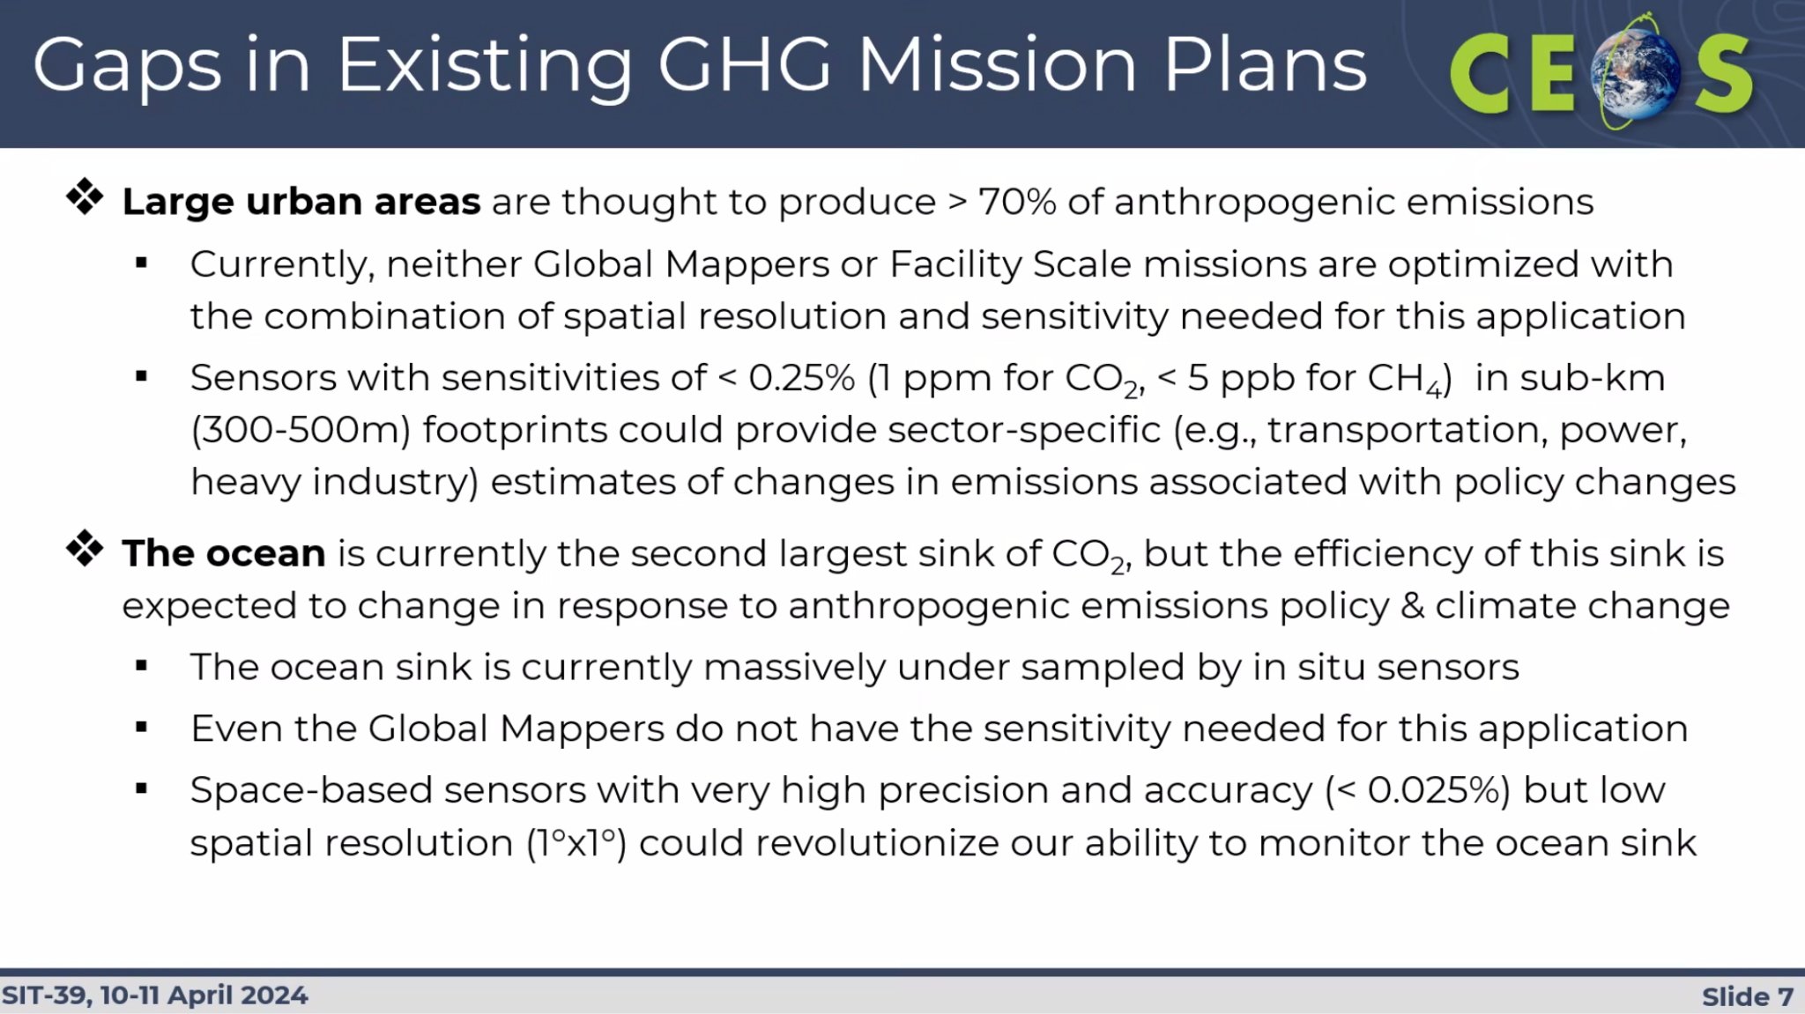
- No single class of satellite GHG sensor can address all of these applications. Global mappers and facility scale are complementary.
Dave Crisp (SIT Chair Team) presented on strategic goals for the second Global Stocktake:
- Encouraged Principals to get the next generation of GHG observing missions launched as soon as possible, as the current generation is past its lifetime.
- CEOS should continue to support WMO G3W and IMEO MARS, producing products to meet their requirements.
- Global mappers and facility scale monitors need to be coordinated to yield sector-specific estimates for the most intense carbon dioxide and methane sources.
- CEOS should work with the UNFCCC to demonstrate a pre-operational system to deliver sector-specific, national-scale space-based CO2 and CH4 budgets to support GST2 by 2026;
- The SIT Chair Team will need to continue to coordinate across CEOS to achieve these goals. An active GHG Task Team under WGClimate is needed to implement the GHG Roadmap actions and manage interfaces with all stakeholders.
Main discussion points:
- Wenying Su (NASA, WGClimate Vice-Chair) suggested working on the interface with CGMS agencies to ensure the operationalisation of GHG monitoring. As a joint Working Group, WGClimate is willing to facilitate and provide external stakeholder engagement elements through SBSTA and UNFCCC.
- Kiyoto Tanabe (IGES) noted that in the context of strategic goals, the IPCC TFI is mentioned, but not other IPCC products. The situation is very dynamic, and IPCC assessment reports may not be done in time for GST2.
- Dave Crisp (SIT Chair Team) clarified that the omission was not intentional but rather focused on addressing a specific gap identified in the planning and during the first Global Stocktake. CEOS is committed to continue contributing to the other IPCC activities even though they are not specifically highlighted.
- Rob Sturgiss (IPCC) commented on the scope of the task that was presented, noting that IPCC has a process for emissions estimates. Governments responding to the Paris Agreement are focused on anthropogenic emissions only since that is what can be controlled. This is a big problem for the inverse modelling approaches, and perhaps CEOS should focus more on providing useful products for policy makers.
- Dave Crisp (SIT Chair Team) recognised CEOS can play a significant role in the quality assurance and control of product, and help IPCC to assess specific progress towards the goals of the Paris Agreement.
- Jörg Schulz (EUMETSAT) noted the analysis has highlighted a couple of weaknesses in the overall system. WGClimate is still completing its gap analysis and will seek to reflect these insights in this work going forward.
- Jörg expressed concerns about the lack of a longer term perspective on measurement continuity. Applications should be prioritised, however it cannot be done with the existing and planned sensors. CGMS should be engaged to ensure long term operational planning. CO2M addresses some issues, but not all. A similar strategy should be taken with AFOLU requirements.
- Stephen Volz (NOAA) noted this list of specific tasks is a mixture of long and near term perspectives and suggested CEOS to focus on actionable items such as cal/val. Cross calibration is an immediate action that can improve the measurements, which is also an area where CEOS has significant influence. For the long term, the focus extends beyond individual satellites to sustaining the entire observing system, with realistic goals set for the GST3 timeframes.
- Julie Robinson (NASA) highlighted the exclusion of three major NASA missions which are relevant for the timelines discussed: SBG, Earth Systems Explorer and PACE for measuring aquatic carbon.
- Natalia Donoho (WMO) noted that during the 2024 INFCOM meeting, there will be an item to discuss the WIGOS Vision 2050, with a hope to have that finalised by 2027. CEOS is invited to engage with WMO on this topic. .
- Yasjka Meijer (ESA, GHG Task Team Lead) asked whether operational agencies are considering GHG missions. In Europe, Copernicus programmes are contributing but he is not sure whether it will happen across the world.
- Takeshi Hirabayashi (JAXA, SIT Chair Team) announced that Japan plans to launch GOSAT GW in 2024. This is in collaboration with EUMETSAT and NOAA, including a data sharing agreement. The JAXA SIT Chair Team will continue leading CEOS through this topic.

7.6: WMO Global Greenhouse Gas Watch (G3W) and CEOS Cooperation
Presenters: Gianpaolo Balsamo (WMO/G3W) [presentation]
Main points:
- WMO plays a role as a global coordinator for member countries harmonising and supporting the work done across national meteorological and hydrological services.
- The Early Warning for All (EW4All) flagship initiative will ensure every person on Earth is protected by lifesaving early warning systems by 2027.
- The Global Greenhouse Gas Watch (G3W) initiative aims to address critical information gaps on greenhouse gases, via an integrated operational framework that optimally combines Earth observations with earth system models using data assimilation and artificial intelligence techniques to reduce uncertainty in assessing the efficacy of climate action.
- G3W will provide timely, policy-relevant information on GHGs concentrations and fluxes to allow countries to assess both the natural and human influence on climate change.
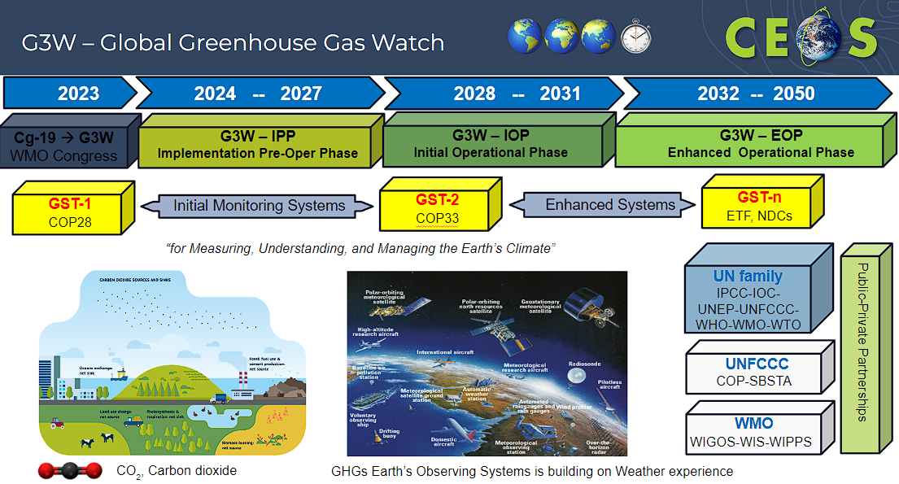
- In 2024-27, as part of the G3W Implementation and Pre-operational Phase (IPP), it is crucial the space-based remote sensing components are well coordinated to ensure global coverage. This coordination is made possible thanks to the collaborative efforts of CEOS and CGMS.
- The draft recommendations for CEOS to support G3W are:
  - EO satellite-based and surface-based requirements need to satisfy G3W operating centres.
  - Regular updates communicating existing and upcoming GHGs public and private satellites capabilities is a necessity.
  - G3W cal/val activities should be co-developed in collaboration with satellite agencies and national and regional efforts.
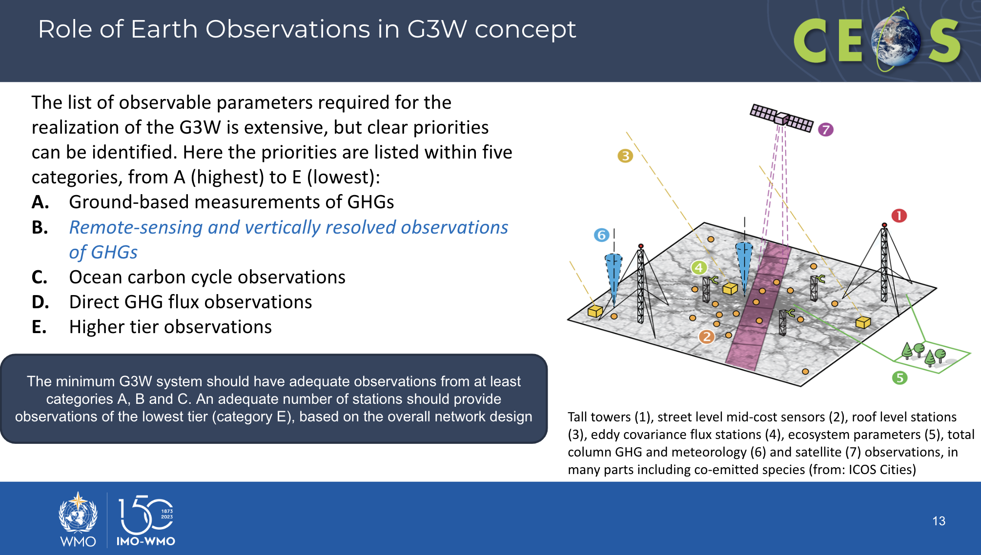
- The G3W Implementation Plan will be presented to INFCOM-3 and EC-78.

7.7: GHG Observations Closing Discussion
Moderator: David Crisp (SIT Chair Team) [presentation]
Main points:
- Progress on the roadmap is consistent with expectation. There is some work to be done to prepare for the second Global Stocktake and to fully exploit capabilities.
- CEOS Agencies should fully support ongoing missions and expedite deployment of future missions to create interoperable products that optimise resolution and coverage and ensure GHG data continuity.
- Efforts to cross-calibrate and cross validate GHG products should be supported to facilitate delivery of interoperable products that enable cross-mission data continuity.
Main discussion points:
- Stephen Volz (NOAA) suggested the SIT Chair Team identify where specific resources are needed.

Session 8: Other Business and Wrap-Up

8.1: CEOS Aquatic Carbon Roadmap Update
Presenters: Marie-Helene Rio (ESA, OCR-VC Co-Lead) [presentation]
Main points:
- The development of the Aquatic Carbon Roadmap is included in the CEOS Work Plan, with a due date of Q4 2025.
- Both the GHG and AFOLU Roadmaps have a strong focus on the major milestones of the first and second Global Stocktakes (2023 and 2028), and how remote sensing data can effectively support these by providing means to monitor carbon emissions and removals, based either on a top-down approach (GHG Roadmap) or a bottom-up approach (AFOLU Roadmap).
- The Aquatic domain forms the third part of this series of Roadmaps, to cover the entire Earth climate sphere.
- The ocean acts as a significant carbon sink, the coastal ocean hosts crucial blue carbon ecosystems while inland waters store, sequester, and transport carbon.
- The Aquatic Carbon Roadmap aims to provide a framework and serve as a guiding vision for long term (~ 15+ years) coordination of CEOS agency observing programmes in support of the science and policy needs for Aquatic carbon related information in the context of the CEOS carbon strategy.
- The roadmap will also contribute to the Global Stocktake needs, characterise data gaps and challenges, and highlight the importance of remote sensing for carbon assessments.
- The team is led by Marie-Helene Rio (ESA), Laura Lorenzoni (NASA) and Hiroshi Murakami (JAXA), and includes scientific experts Jamie Shutler (University of Exeter), Bob Brewin (University of Exeter), Cecile Rousseaux (GSFC-NASA) and Kelsey Bisson (NASA).
- Two ESA aquatic carbon projects have commenced in the last six months, the Satellite-based observations of Carbon in the Ocean: Pools, fluxes and Exchanges (SCOPE) project, and the Coastal Blue Carbon project.
- The team’s objective is to have the consolidated outline and book captains assigned before the next IOCCG Committee Meeting which will be held on April 24 - 26, 2024, where a dedicated discussion point is planned on the CEOS Aquatic Carbon Roadmap to endorse the proposed outline and book captain assignments.
- The team is actively working on the organisation of the upcoming joint ESA-NASA Coastal Blue Carbon From Space ISSI Forum, to be held May 14-17, 2024, in Bern, Switzerland​​. The outcome of the forum will be a community White Paper identifying the main gaps and opportunities related to the use of space-borne data to support Coastal Blue Carbon science and policy needs, and will also include a roadmap towards filling the identified research gaps. This will directly support the CEOS Aquatic Carbon Roadmap.
Main discussion points:.
- Sylvia Wilson (USGS) emphasised the significance of mangroves as an important topic within the CEOS Aquatic Carbon Roadmap, and will require close coordination with the AFOLU roadmap. Mangroves can be classified as either wetlands or forest ecosystems, but not both, which is determined by individual countries. The choice of classification complicates carbon markets.
- Marie-Helene Rio (ESA) recognised the need for coordination, and noted the team plans to cross-reference with the AFOLU and GHG Roadmaps where appropriate.
- Osamu Ochiai (JAXA, SIT Chair Team) noted that the SIT Chair Team will ensure coordination, and proposed discussing this issue when a draft roadmap is presented.
SIT-39-14 | The SIT Chair will confer with the leads of the CEOS GHG, AFOLU, and Aquatic Carbon Roadmaps to: 1) open channels for necessary linkages; and 2) establish how the Aquatic Carbon Roadmap schedule will determine what is feasible and when. | Jun 2024
 | Rationale: The CEOS entities concerned recognise the need for such linkages, as well as the need for consultation with those engaged in the nascent effort to develop a CEOS Aquatic Carbon Roadmap.

8.2: CEOS Sustainable Development Goals (SDG) Coordination Group Update
Presenters: Dave Borges (SEO, NASA) [presentation]
Main points:
- SDGs are adopted as one of CEOS’ four strategic priorities. This is handled by the SDG Coordination Group, with strategic leadership by the SIT Chair, and implementation led by the SEO.
- There are various SDG goals, targets and indicators of relevance to EO, with a mapping done in collaboration with GEO a few years ago.
- SDG EO Support Sheets have been developed by CEOS for the four most relevant Indicators to EO, following a number of analyses with the global EO community agreeing on those where CEOS contribution was deemed most useful.
- UNCCD and GEO-LDN have a strong connection between CEOS SDG CG and these stakeholders. There are some CEOS Work Plan actions to address specific requests.
- The SDG Coordination Group will work in 2024 with the UN-GGIM IAEG-SDG Working Group on Geospatial Information (WGGI) on their paper “Rescuing the SDGs”.
- There are a number of areas where CEOS could support policy impact for sustainable development. For the 2030 Agenda, Earth observations were classified as "Non-Traditional Data Sources", which has led to an uphill battle to integrate EO into the policy process. Opportunities exist to advocate for an increased role of EO in any future sustainable development framework.
- SDGs are the least resourced of all four CEOS strategic priorities, with only a small handful of individuals and agencies contributing.
- With CEOS Agency support, and new Indicator EO Support Sheets could be created in collaboration with other Working Groups or Virtual Constellations.
- Does CEOS want to pursue SDG policy impact at Strategic Priority level?
Main discussion points:
- Osamu Ochiai (JAXA, SIT Chair Team) thanked NASA for supporting the SEO in leading the SDG Coordination Group. The support sheets are a great asset developed by the group.
- Ake Rosenqvist (JAXA) asked among the different indicators across different goals, how many could be supported by EO data?
- Dave Borges (NASA, SEO) noted that the indicators included in slide 2 are the ones which could be supported by EO. SDG Coordination Group have followed up with individual Working Groups to receive support on joint deliverables, but not much progress has been made.
- Julie Robinson (NASA) sees similar problems as encountered with UNFCCC, that if the data is classified incorrectly then it cannot make an impact. Julie agreed to the approach regarding the opportunity to solidify EO as a fundamental data source for a future sustainable development strategy. CEOS should be able to support EO Support Sheets for climate and biodiversity indicators, as these were key issues discussed this week.
- Marie-Claire Greening (ESA) noted that the EO Support Sheets have been a really positive output from CEOS, and CEOS should continue to use this mechanism. UN COPUOS should be utilised to have a dialogue at that level, including with the Space 2030 agenda.
- Eric Laliberté (CSA, CEOS Chair) indicated the significance of the last question “Does CEOS want to pursue SDG policy impact at Strategic Priority level?”. It is CEOS Principal responsibility to ensure that the SDG Coordination Group has the necessary resources available to address the priority. This topic should be discussed further at future CEOS Secretariat meetings.
- Mark Dowell (EC) highlighted that the key aspect is engagement with national statistics institutes. In eastern Europe, there is an increasing appetite to see applicability of EO beyond SDGs, with the Warsaw Declaration or similar initiatives as potential avenues for advancing this goal.
- Osamu Ochiai (JAXA, SIT Chair Team) highlighted the importance of working not only within CEOS but also with national statistics offices to promote the benefits of EO, and encouraged all CEOS Agencies to reach out to their respective national statistics offices.
SIT-39-15 | CEOS Chair and SEO to engage the CEOS Secretariat meetings on the matter of invigorating support for SDGs more broadly across the CEOS organisation (Members and Associates). | Jun 2024
 | Rationale: Support for UN Sustainable Development Goals is one of the four key priorities of CEOS.

8.3: CEOS Communications Update
Presenters: Dave Borges (SEO, NASA) [presentation]
Main points:
- As per the Communication Strategy endorsed at the 2023 CEOS Plenary, in 2024 CEOS Communications will focus on three campaigns: 40th Anniversary of CEOS, EO for Biodiversity, and Greenhouse Gas Observations from Space.
- The team is planning a number of items for the 40th Anniversary of CEOS, including news articles “From the Archives”, a story map of CEOS Plenary over the years, and a ‘Faces of CEOS’ video featuring interviews with CEOS Principals.
- The team wants to put together a compelling video to celebrate the 40th anniversary, and are asking for resources from Agency media teams to support this initiative.
- The impact of CEOS will be highlighted through a series of cards to be posted on social media and used in CEOS materials for years to come. These will focus on the four key CEOS Priorities, as well as highlighting work from each CEOS entity.
- Social media metrics are on the rise, with all metrics having increased in comparison to the previous period.
- New lapel pins are in production, and will be brought to the 2024 SIT Technical Workshop and Plenary.
- The SEO is supporting CEOS at a number of outreach events, including SatSummit and IGARSS 2024. A CEOS Exhibition Booth will be hosted at IGARSS, and content is welcomed from all CEOS entities to be displayed at this booth. SEO also intends to have a booth at the next GEO Week in March 2025.

8.4: International Coordination Group for Spaceborne Synthetic Aperture Radar (ICGS-SAR) and CEOS Agency Engagement
Presenters: Eric Laliberté (CSA, CEOS Chair) [presentation]
Main points:
- ICGS-SAR was established in 2018 to improve the international coordination of spaceborne Synthetic Aperture Radar (SAR) missions. Two workshops have been held so far, one in 2018 at CalTech, California, USA, and another in 2022 at ESRIN, Frascati, Italy. The next workshop is planned for November 2024, in Japan.
- There are many similarities between CEOS and ICGS-SAR goals, aspirations, and objectives, with ICGS-SAR’s objective to maximise science and societal returns from SAR missions.
- The membership includes representatives from CEOS Agencies operating or developing SAR missions including ASI, CONAE, CSA, DLR, ESA, ISRO, JAXA, and NASA as well as from key user and research groups.
- More information on the group can be found here.
- There are three Working Groups and three Thematic Areas, with some clear overlaps with CEOS groups.
- There is an opportunity for better coordination and connection with ICGS-SAR and CEOS, noting many overlaps in participation and potential for duplicated efforts.
- Closer coordination will also allow ICGS-SAR to have a more direct connection to CEOS Principals.
- At a minimum, the goal is to ensure effective communication and awareness by CEOS Principals of the activities of ICGS-SAR. To achieve this, ICGS-SAR could explore the possibility of establishing an official point of contact to CEOS. Representation should be invited to SIT, SIT Technical Workshop and CEOS Plenary, with regular reporting opportunities.
- CEOS Principals with representation in ICGS-SAR should discuss the best approach to coordination within their Agency.
Main discussion points:
- Paul DiGiacomo (NOAA, COAST-VC Co-Lead) noted that COAST-VC is interested in utilising SAR data for coastal zone applications, especially to complement optical data. COAST-VC should be added to the list of potential collaboration opportunities.
- Tim Stryker (USGS) appreciated any additional communication that can be made. USGS would welcome participation of ICGS-SAR at CEOS meetings and engagement within LSI-VC.
- Shin-ichi Sobue (JAXA) serves as the Co-Chair of ICGS-SAR and is aware of the importance of coordinating and collaborating with CEOS, particularly with WGCV SAR subgroup and LSI-VC. A CEOS representative would be welcomed at the November 2024 workshop in Japan.
- Julie Robinson (NASA) thanked Eric for highlighting this gap, and supported a lightweight approach to enhance coordination.
- Stephen Volz (NOAA) noted that ICGS-SAR was formed in 2018, consisting entirely of CEOS members, and that there is a challenge in determining where SAR should fit within the CEOS structure.
- Shin-ichi Sobue (JAXA) recognised the main objective of the group is to coordinate SAR tasking and data provision to users with key users being involved. JAXA plans to invite additional members to the workshop from the Asia-Pacific region, some who are not CEOS members, and commercial players as well.
- Stephen Volz (NOAA) noted that programme and mission coordination is the role of a Virtual Constellation. The current structure has clarified upstream coordination, but there could be potential issues downstream.
- Eric Laliberté (CSA, CEOS Chair) noted that the ICGS-SAR group is clear on ensuring that there is no duplication of efforts. The CEOS Chair will extend an invite to ICGS-SAR to present at the 2024 CEOS Plenary, and also ensure representation at their workshop in November 2024.

8.5: NASA’s Earth Science to Action Strategy
Presenters: Dr. Sid Boukabara (NASA) [presentation]
Main points:
- NASA’s Earth Science Strategy was released recently and updated for the first time in almost 20 years.
- The strategy addresses some of the issues that have been raised at SIT-39 this week about ensuring impact and societal value of EO data.
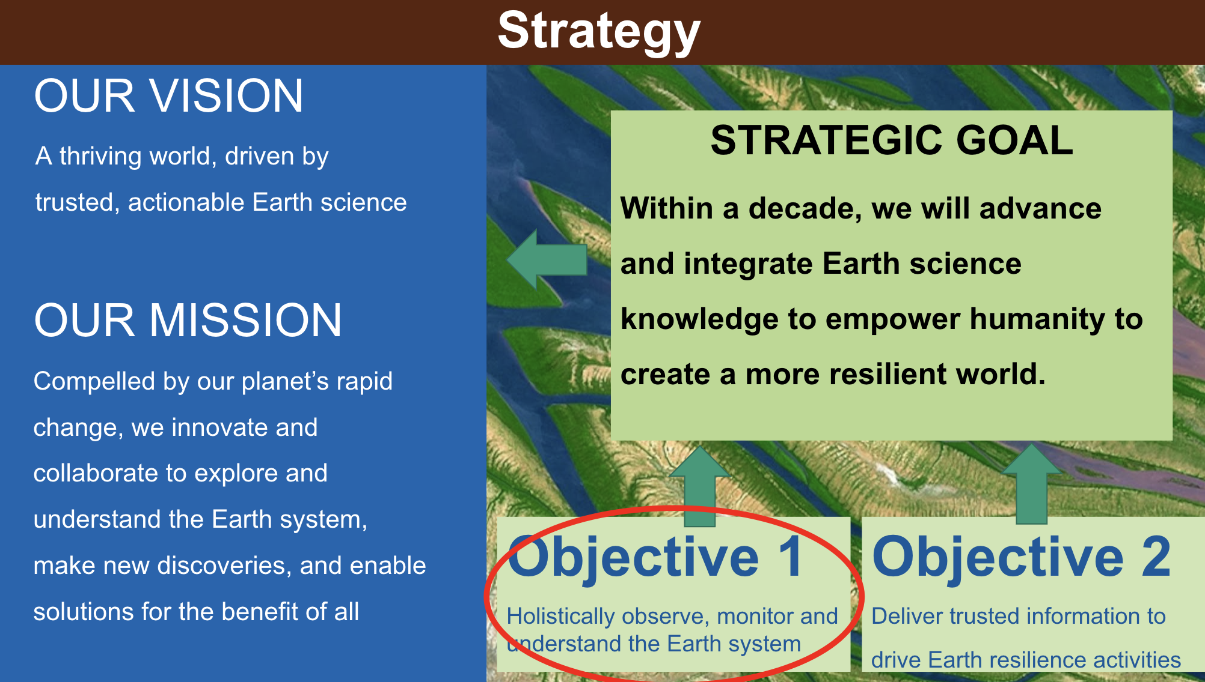
- The strategy identifies 16 systems that sustain the wellbeing of humanity, including biodiversity, agriculture, greenhouse gases, urbanisation, disasters and wildfires.
- Partnership and international coordination will be key to achieve the NASA Earth Science-To-Action Strategy.

8.6.0: Any Other Business
An opportunity was provided to raise any other issues.
- Tim Stryker (USGS) noted that SIT-39 marks the last CEOS meeting for Steve Labhan (USGS). Steve has done outstanding work during his leadership of LSI-VC, and USGS is committed to finding a replacement for his co-lead position. There is an interest from other agencies to supplement the LSI-VC leadership, which will be coordinated within the Virtual Constellation. Tim thanked Steve for his leadership and participation within CEOS over many years.
- Osamu Ochiai (JAXA, SIT Chair Team) thanked Steve for his contributions to CEOS.
- Steve Labhan (USGS, LSI-VC Co-Lead) thanked Tim Stryker and CEOS, acknowledging CSA for being the bookends of his CEOS career, as his very first CEOS meeting was in Montreal, Canada and now this is his last meeting with CSA as the CEOS Chair. The collective goal of CEOS is to achieve something greater than what individuals agencies can accomplish alone. He is proud of the work accomplished during his time with CEOS, including that of the LSI-VC and CEOS-ARD.
- CEOS thanked Steve for his efforts and contributions over many years.
- Beth Greenaway (UKSA) noted UKSA is starting to plan for their term as CEOS Chair, and wants to inspire the next generation during their year as CEOS Chair. They plan to scope this initiative with CEOS members and organise several teleconferences in the coming months. Those interested in participating are encouraged to contact UKSA.
- Julie Robinson (NASA) congratulated JAXA and the SIT Chair Team for hosting a productive meeting, setting a high standard for NASA’s upcoming term. Julie thanked Hirabayashi-san for his leadership over many years in CEOS, and for the smooth transition to Maejima-san.

8.6: SIT-39 Wrap-up
Presenters: Stephen Ward (SIT Chair Team) and Osamu Ochiai (JAXA, SIT Chair Team) [presentation]
Main points:
- Reviewed the Actions and Decisions from Day 2. The full list of Actions and Decisions will be shared for feedback in the coming days.
- The 2024 SIT Technical Workshop will be held on September 17-19, 2024 in Sydney, Australia, hosted by CSIRO and Geoscience Australia.
- JAXA is targeting the week of April 7, 2025 for SIT-40, with the venue yet to be decided. JAXA is aware that the dates may conflict with Space Symposium, but unfortunately this is the best option.
- EUMETSAT has offered to host the SIT Technical Workshop 2025 in Darmstadt, Germany. The tentative week for this is September 8, 2025. CEOS should check this date to avoid any conflicts.
- Hironori Maejima (JAXA, SIT Chair) thanked the participants for the two days of intensive discussions and contributions. This meeting served as an opportunity to set the stage for the next two years, with lively and fruitful discussions involving both CEOS and external stakeholders. The SIT Chair Team appreciated the valuable inputs received from everyone and reiterated the commitment to continue the discussions over the coming months. This meeting marked the first SIT meeting hosted by JAXA and feedback on the structure of the meeting is welcomed.
- Maejima-san wished all the participants an enjoyable remainder of their trip in Tokyo and a safe journey home.

DECISION 04 | SIT-39 confirmed approximate dates for the 2025 major CEOS meetings as follows:  - SIT-40 will be held in Japan (location TBD) during the week of April 7, 2025.  - 2025 SIT Technical Workshop (hosted by EUMETSAT in Darmstadt, Germany) during the week of September 8, 2025.  - 2025 CEOS Plenary 2025 (in Bath, UK) during the week of November 3, 2025.

APPENDIX A: Attendees
* = virtual participation
Agency/Organization | Name | Agency/Organization | Name
ASI | Laura Candela | JAXA | Hironori Maejima
CEOS Executive Office | Steven Ramage | JAXA | Yuki Etoh
CEOS Executive Office | Lefteris Mamais* | JAXA/EORC | Kazuhisa Tanada*
CEOS Executive Office | Irena Drakopoulou* | JAXA/RESTEC | Satoshi Uenuma
CNES | Selma Cherchali | JAXA/RESTEC | Yukio Haruyama
CNES | Aurélien Sacotte* | JAXA/RESTEC | Toshi Kamei
CONAE | Laura Frulla* | JAXA/RESTEC | Teppei Sato
CONAE | Ana Medico* | JAXA/soloEO | Ake Rosenqvist
CSA | Eric Laliberté | Ministry of Education, Culture, Sports, Science and Technology | Aya Takatsuki
CSIRO | Flora Kerblat | NASA | Gary Geller
CSIRO | Alex Held | NASA | Julie Robinson
DLR | Klaus Schmidt* | NASA | Christine Bognar
EC-JRC | Joana Melo* | NASA | Sid Boukabara
EC-JRC | Giacomo Grassi* | NASA | David Borges
EC-JRC | Simone Rossi* | NASA | Wenying Su
ECMWF | Vincent-Henri Peuch* | NASA | Argyro Kavvada
ESA | Marie-Claire Greening | NASA | Barry Lefer
ESA | Yasjka Meijer | NASA JPL/Caltech | John Worden
ESA | Philippe Goryl* | NASA/UMD | Christopher Kidd
EUMETSAT | Paul Counet | NASA/UMD | Laura Duncanson*
EUMETSAT | Jörg Schulz* | NCEO/UKSA | John Remedios
European Commission | Mark Dowell* | NIES | Hiroshi Tanimoto
European Commission | Mauro Facchini* | NOAA | Paul DiGiacomo
European Commission | Hugo Zunker* | NOAA | Charles Wooldridge
European Commission | Astrid Koch* | NOAA | Katy Matthews
GA | Sarah Pound | NOAA | Shoba Kondragunta*
GEOGLAM | Alyssa Whitcraft | NOAA NCEI | Jeff Privette*
Geoscience Australia | Jonathon Ross | NOAA NESDIS | Stephen Volz
GISTDA | Tanita Suepa | NPL UK | Paul Green
GISTDA | Poramet Thuwakham | NSMC CMA | Jinlong Fan
IGES | Akibi Tsukui* | SIT Chair Team | David Crisp
IGES | Kiyoto Tanabe | SIT Chair Team | Matt Steventon
IGES | Chisa Umemiya | SIT Chair Team | Stephen Ward
IPCC TFI | Rob Sturgiss | SIT Chair Team | Libby Rose
IPCC TFI | Takeshi Enoki | TNFD | Catherine Armour
IPCC TFI | Sandro Federici | UKSA | Niall Bradshaw
ISRO | Nitant Dube* | UKSA | Patrick Gibson
JAXA | Takuji Kubota | UKSA | Harshbir Sangha
JAXA | Mariko Harada | UKSA | Beth Greenaway
JAXA | Hiroshi Suto | UMD | Neha Hunka*
JAXA | Akiko Noda* | UNEP IMEO | Cynthia Randles
JAXA | Osamu Ochiai | UNFCCC | Annett Moehner*
JAXA | Yuko Nakamura | US Department of State | Fernando R Echavarria
JAXA | Ko Hamamoto | USGS | Steve Labahn
JAXA | Takeshi Hirabayashi | USGS | Tom Sohre
JAXA | Misako Kachi | USGS | Timothy Stryker
JAXA | shinichi sobue | USGS | Sylvia Wilson
JAXA | Takeo Tadono | USGS | Kelly Bruno
JAXA | Hiroshi Murakami | USGS/Aerospace | Steven Covington
JAXA | Makoto NATSUISAKA | USGS/KBR | Christopher Barnes
JAXA | Kei Oyoshi | USRA-JAXA | Tomohiro Oda
JAXA | Yousuke Ikehata | WMO | Natalia Donoho
JAXA | Kei Shiomi* | WMO | Gianpaolo Balsamo*

APPENDIX B: Actions & Decisions Record
ACTIONS

SIT-39-01 | CEOS Executive Officer team to undertake an assessment of the level of activity of all CEOS constituent groups. Consideration should be given to their representation in the CEOS Work Plan and activity more generally, as well as their interactions with other CEOS entities. The CEO will report findings to the 2024 SIT Technical Workshop and facilitate a discussion. | SIT TW 2024
 | Rationale: CEOS should reflect on all existing elements of the CEOS structure and consider whether they are essential elements if they are not appropriately reflected in the CEOS Work Plan with clear deliverables or tasks.
SIT-39-02 | CEOS Agencies to review and provide feedback on the AFOLU Roadmap Actions to the LSI-VC Forest and Biomass Subgroup team. | May 2024
 | Rationale: The LSI-VC has provided a first draft of the actions proposed to track implementation of the CEOS AFOLU Roadmap. Agencies investing in the supporting missions are especially encouraged to consider whether the actions support their mission planning/justification.
SIT-39-03 | CEOS Chair and Ecosystem Extent Task Team to refine the role and responsibilities of a potential CEOS Biodiversity Working Group by continuing consultations with external stakeholders such as UN CBD, GEO BON and others. | SIT TW 2024
 | Rationale: CEOS Chair team has been undertaking a study and consultation process in support of a Post-2024 Strategy for CEOS and Biodiversity. The Chair will bring recommended next steps to the SIT Technical Workshop (September 17-19, 2024), taking into account the originally envisioned end of the Ecosystem Extent Task Team at the 2024 CEOS Plenary (October 22-24, 2024).
SIT-39-04 | CEOS Agencies are invited to nominate representatives to participate in the newly-formed COAST VC. | Jun 2024
 | Rationale: COAST VC addresses the Land-Ocean boundary remote sensing and new product development needs not being addressed in other fora. CEOS Principals, CEOS WGs, and VCs are encouraged to name a representative to ensure representation and crosscutting engagement.
SIT-39-05 | CEOS Agencies to identify points of contact to contribute to the LSI-VC Subgroup on GEOGLAM (GEO Global Agricultural Monitoring initiative). | Jun 2024
 | Rationale: At SIT-39, GEOGLAM asked CEOS for greater CEOS agency-wide support for the Essential Agricultural Variables and to reinforce CEOS agency representation and contributions in the GEOGLAM Subgroup of the LSI-VC to facilitate both of these objectives
SIT-39-06 | SIT Chair to confer with LSI-VC and its GEOGLAM Subgroup leads regarding the visibility of CEOS Agriculture activities. | Jun 2024
 | Rationale: There is a need to ensure that Agriculture continues to be suitably represented in the CEOS organisation, meeting agendas, and three-year work plans.
SIT-39-07 | SIT Chair to coordinate continuation of the discussion on the CEOS strategy for climate policy impact, engaging the WGClimate, other relevant CEOS groups and experts, as well as external stakeholders, with the objective to bring an update to the SIT Technical Workshop (September 17-19, 2024) and propose an agenda item for the 2024 CEOS Plenary. | SIT TW 2024
 | Rationale: Climate Policy Impact is a headline priority for the two-year SIT Chair Term, and the intent is to continue the discussions initiated at SIT-39 in support of long-term strategy planning
SIT-39-08 | CEOS Agencies are invited to comment on the draft scoping questions presented at SIT-39 in order to focus and progress the climate policy impact discussion and strategy planning. | May 2024
 | Rationale: SIT-39 recognized that, given the scope and scale, CEOS must define and align a manageable scope and focus for the climate policy discussions.
SIT-39-09 | Relevant CEOS Agencies are asked to designate a point of contact for engagement in the LSI-VC Polarimetric Interferometric Synthetic Aperture Radar (PolInSAR) Team, which includes support for systematic observations over Reference Sites. | Jun 2024
 | Rationale: There are a number of current and imminent CEOS missions with polarimetric (QP) capacity and LSI-VC seeks to maximise the opportunity.
SIT-39-10 | LSI-VC to ensure that its PolInSAR work is captured in the CEOS 2024-2026 Work Plan, including the suggested PolInSAR Reference Sites; coordination of multi-sensor QP observations with Agency points of contact; and the establishment of a PolInSAR repository. | Apr 2024
 | Rationale: SIT-39 acknowledged that this is an emerging work thread in LSI-VC that should be captured in the CEOS 2024-2026 Work Plan. The CEO Office was also asked to ensure inclusion in the referenced Work Plan.
SIT-39-11 | SIT Chair to confer with WGDisasters Chair and Vice Chair regarding potential CEOS contributions to the UN’s Early Warnings for All (EW4ALL) initiative. | SEC-321
 | Rationale: The objective is to identify potential CEOS contributions to the EW4ALL to be communicated to the UN and through WMO.
SIT-39-12 | GHG Task Team of the Joint CEOS-CGMS WGClimate to work on an update of the CEOS-CGMS GHG Roadmap for discussion at the SIT Technical Workshop in preparation for potential endorsement at the 2024 CEOS Plenary. | 2024 Plenary
 | Rationale: SIT-39 acknowledged that changes in the operating context and user requirements dictate the need for an update to the CEOS GHG Roadmap.
SIT-39-13 | The GHG Task Team of the Joint CEOS-CGMS WGClimate was asked to reflect the requests from UNEP IMEO in the 2024 update tof the CEOS GHG Roadmap. | 2024 Plenary
 | Rationale: UNEP IMEO requirements are among the key factors driving a 2024 update of the CEOS GHG Roadmap.
SIT-39-14 | The SIT Chair will confer with the leads of the CEOS GHG, AFOLU, and Aquatic Carbon Roadmaps to: 1) open channels for necessary linkages; and 2) establish how the Aquatic Carbon Roadmap schedule will determine what is feasible and when. | Jun 2024
 | Rationale: The CEOS entities concerned recognise the need for such linkages, as well as the need for consultation with those engaged in the nascent effort to develop a CEOS Aquatic Carbon Roadmap.
SIT-39-15 | CEOS Chair and SEO to engage the CEOS Secretariat meetings on the matter of invigorating support for SDGs more broadly across the CEOS organisation (Members and Associates). | Jun 2024
 | Rationale: Support for UN Sustainable Development Goals is one of the four key priorities of CEOS.

DECISIONS

DECISION 01 | Final inputs for the 2024-2026 CEOS Work Plan should be collected by April 16, 2024, and the final draft for electronic endorsement sent by April 18, 2024. The date for electronic endorsement will be May 2, 2024.
DECISION 02 | CEOS Principals endorsed the establishment of a new COAST Virtual Constellation, as presented in the Terms of Reference and Implementation Plan documents submitted for endorsement at SIT-39.
DECISION 03 | SIT-39 agreed that an update of the CEOS GHG Roadmap should be completed for discussion at the SIT Technical Workshop in preparation for potential endorsement at 2024 CEOS Plenary. Note that the document will need to be made available in advance for CEOS Agency review.
DECISION 04 | SIT-39 confirmed approximate dates for the 2025 major CEOS meetings as follows:  - SIT-40 will be held in Japan (location TBD) during the week of April 7, 2025.  - 2025 SIT Technical Workshop (hosted by EUMETSAT in Darmstadt, Germany) during the week of September 8, 2025.  - 2025 CEOS Plenary 2025 (in Bath, UK) during the week of November 3, 2025.

