TERMS OF REFERENCE
FOR THE
CEOS PRECIPITATION VIRTUAL CONSTELLATION
VERSION 3.0.3 (final draft)
LAST UPDATED: 1 April 2024

CONSTELLATION NAME: The Precipitation Virtual Constellation (P-VC).

MISSION STATEMENT & OBJECTIVES:
The P-VC exists was established to sustain and enhance a systematic capability to observe, measure, and validate global precipitation (rainfall and snowfall) across the agencies providing precipitation-capable satellites. These observations are central to understanding the distribution and characteristics of precipitation, its role in the hydrological/water cycle and its impact on the climate system.
Accurate and timely knowledge of global precipitation is needed for improving predictive skills for high-impact weather events such as hurricanes, floods, droughts, and landslides, management of freshwater resources and supporting analyses of the interconnectivity with the Earth System (for example, crop yields and fire susceptibility). The spatial and temporal variability of precipitation necessitates the combination of data from multiple satellites to ensure sufficient observations to provide representative sampling across the range of the space and time scales required by the research, operational, and application-driven user communities.
The P-VC has the following strategic objectives to address this aim:
- Provide a coordination mechanism to harmonize precipitation-capable satellite systems, data collection, processing and delivery, retrieval algorithms, and calibration/validation infrastructures;
- Serve as a programmatic point of contact for precipitation measurements, addressing issues which go beyond the individual mission programmes;
- Coordinate activities to develop and improve the knowledge and understanding of precipitation processes, the distribution of precipitation and the changes in precipitation over time on a global basis; and
- Supporting and engaging the scientific and operational user communities.

CHARACTERISATION OF THE MEASUREMENTS AND DATA COLLECTIONS WITHIN SCOPE:
The geophysical parameters concerning the P-VC relate to the vertical profile, instantaneous rate and accumulation of both liquid and solid precipitation. For example, global gridded long-term products of hourly accumulated precipitation at 25-km or finer resolution are needed to satisfy directly the full range of requirements for precipitation measurements according to the Global Climate Observing System (GCOS) Satellite Supplement (2010 Update).
Precipitation measurements from multiple satellite sensors are currently being utilised by the P-VC to address current action items. These include passive microwave (imager, sounder) sensors and active microwave (radar) systems in low Earth orbit, combined with visible/infrared observations on geostationary platforms. Visible/infrared systems on low Earth orbiting platforms are also of interest. Central to the P-VC activities is the Global Precipitation Measurement (GPM) mission led by NASA and JAXA, but with many international partner agencies. Data from the GPM mission and partner missions (see tables below) combine to provide observations of global precipitation every 3 hours, 90% of the time: inclusion of geostationary infrared data provides a minimal level of skill in the merged satellite product. Long-term data sets are also considered for precipitation studies, starting with the 10-year record of SMMR in 1978. Other satellite-based precipitation-capable observations are currently collected, such as those from Russian and Chinese passive microwave sensors, but are not routinely available or disseminated. Finally, surface precipitation data, primarily gauges, but including radar data and other specialized observations, are essential to anchoring, calibrating and validating satellite observations. The best global, long-term datasets are combinations of satellite and gauge observations.

CHARACTERISATION OF THE SPACE SEGMENT CONCERNED:
The core missions (and sensors) that are currently (as of 2024-02-01) the priority for coordination efforts by the P-VC are shown in Table 1, Table 2 and Figure 1 below.
Table 1: Microwave sensors contributing to the precipitation constellation. The current precipitation constellation missions are highlighted in bold. (*retrieval resolution is that of the NASA GPROF scheme)
Satellite | Agency | Sensor/number |  | Channels | Retrieval resolution
Active microwave instruments
GPM | NASA/JAXA | DPR | x1 | 13.6/35.5 GHz | 5.4 x 5.4 km
Passive microwave imagers
GPM | NASA/JAXA | GMI | x1 | 10.7-183.31 GHz | 10.9 x 18.1 km*
DMSP F16,17,18 | US DoD | SSMIS | x3 | 19.35-183.31 GHz | 45 x 74 km*
GCOM-W | JAXA | AMSR2 | x1 | 6.7-89.0 GHz | 14 x 22 km*
Passive microwave sounders
NOAA-19 METOP-B,C | NOAA/EUMETSAT | MHS | x3 | 89.0-183.31 GHz | 17.12 x 21.64 km*
SNPP | NASA/NOAA | ATMS | x1 | 23.0-183.31 GHz | 16.51 x 16.22 km*
NOAA-20, -21 | NOAA | ATMS | x2 | 23.0-183.31 GHz | 16.51 x 16.22 km*

Table 2: Current geostationary vis/IR sensors: those that current contribute to the global 30-minute 4 km IR imagery are highlighted in bold. (All of these provide multi-channel vis/IR observations with temporal sampling of 15 minutes or better, and < 4km at sub-satellite point).
Satellite | Agency | Sensor | Longitude | Channels/number |  | Sub-satellite resolution
GOES-14 (backup) | NOAA | IMAGER | 108°W | Vis/IR | x5 | 1 km / 4 km
GOES-16 (GOES-East) | NOAA | ABI | 75.2°W | Vis/IR | x16 | 0.5 km / 2 km
GOES-17 | NOAA | ABI | 104.7°W | Vis/IR | x16 | 0.5 km / 2 km
GOES-18 (GOES-West) | NOAA | ABI | 137.0°W | Vis/IR | x16 | 0.5 km / 2 km
Meteosat-9 (IODC) | EUMETSAT | SEVIRI | 45.5°E | Vis/IR | x12 | 1 km / 3 km
Meteosat-10 | EUMETSAT | SEVIRI | 0° | Vis/IR | x12 | 1 km / 3 km
Meteosat-11 | EUMETSAT | SEVIRI | 9.5°E | Vis/IR | x12 | 1 km / 3 km
Himawari-8 | JMA | HMI | 140.7°E | Vis/IR | x16 | 0.5 km / 2 km
Himawari-9 | JMA | HMI | 140.7°E | Vis/IR | x16 | 0.5 km / 2 km

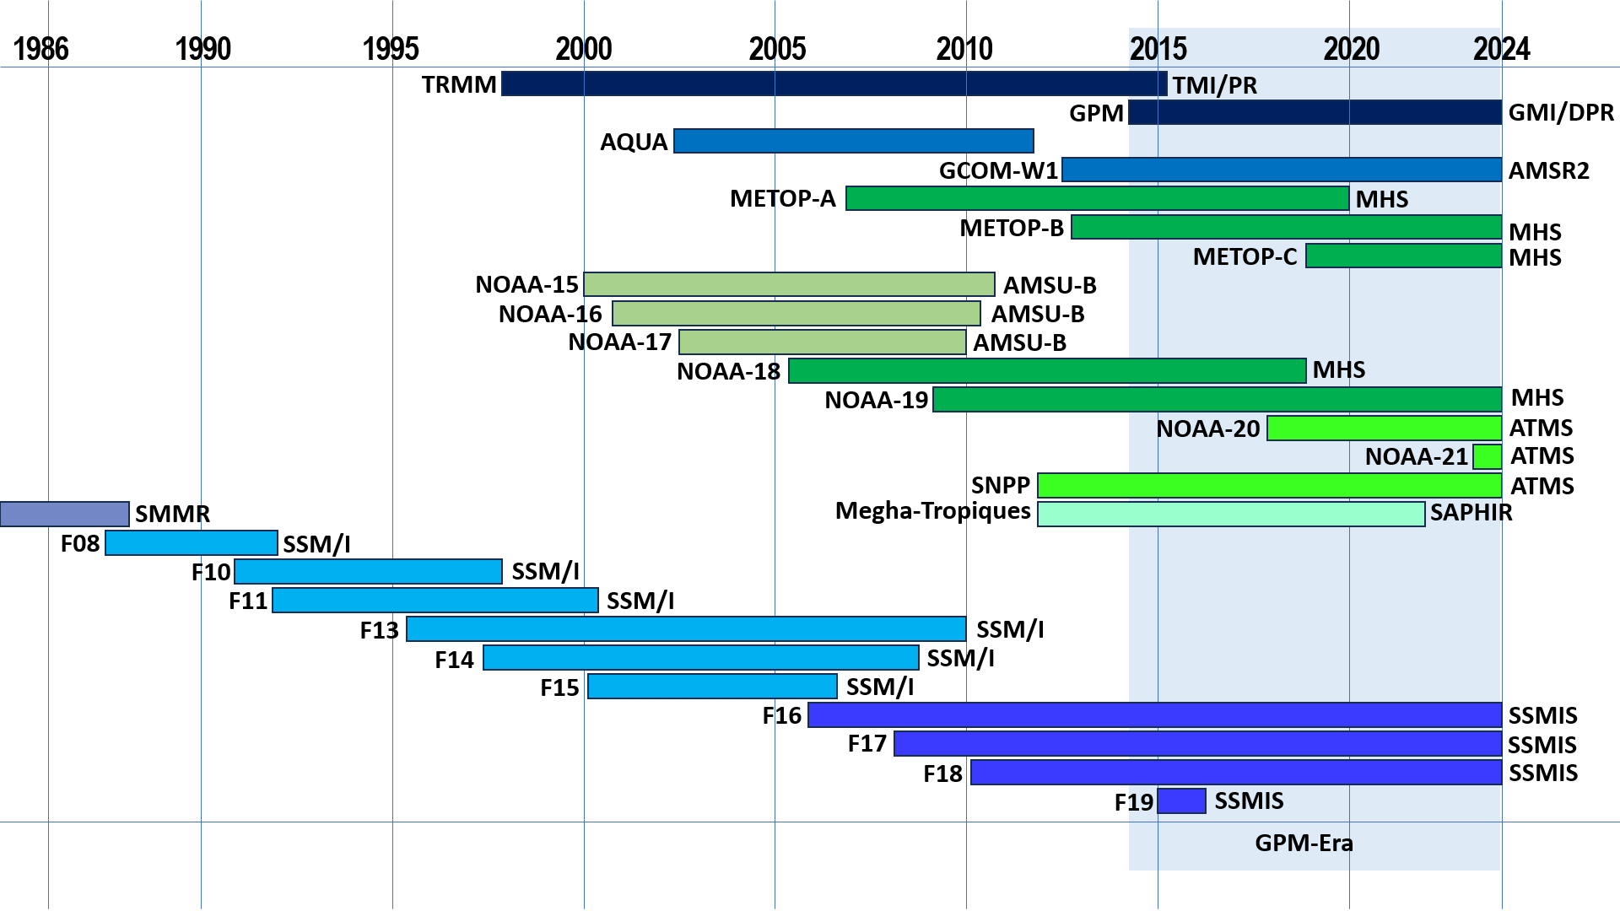
Figure 1: Timeline of satellites and sensors that have contributed to the Global Precipitation Measurement mission that forms the basis of the Precipitation Virtual Constellation. TRMM and GPM (dark blue bars at the top) represent the only missions dedicated to precipitation measurements. Instruments on the far right are those still actively contributing to the P-VC.

Other current missions of interest to the P-VC include new missions with PMW capabilities, such as TROPICS, STP-H8, FY-3G, as well as low Earth orbiting missions with visible/infrared sensors to complement observations made by Geostationary missions, particular over the Polar regions.
Future planned missions also of interest, include the: EPS-SG-A (MWS), EPS-SG-B (MWI and ICI), EarthCARE (CPR), MTG-I (FCI & LI), QuickSounder (ATMS), LWS (SMBA), GOES-U (ABI and GLM), WSF-M (US DoD), FY-3 F/G (MWRI & MWHS), FY-3I (RainRadar & MWRI), Meteor M N2-1/-2 and N3 (MTVZA), Meteor M3 series (Advanced MTVZA), PMM (DR), GOSAT-GW (AMSR3), and CIMR.

ACTIVITIES, OUTCOMES AND DELIVERABLES:
The activities of the P-VC fall within the two following areas:
- Generating global precipitation products that are of the highest quality, exhibiting long-term stability, and which are suitable for climate studies: To sustain and enhance an accurate and timely global precipitation data record, fit for the purpose specified by GCOS for the monitoring of precipitation as an essential climate variable (ECV).

- Improving precipitation retrievals through multi-sensor inter-calibration of data, use of merged data products from multiple sensors, the evaluation of different multi-sensor precipitation products and refinement of merged precipitation products.

Specific outcomes and deliverables are:
Precipitation ECV support in CEOS Response to GCOS Action A-8 (provision of precipitation data to the Global Precipitation Climatology Centre)
To ensure continuity of satellite precipitation products, the following requirements have been identified:
- Sustain and enhance the constellation of satellites carrying microwave radiometers (both imagers and sounders) and precipitation radar(s).
- Provide well characterized and stable Level 1B calibrated, geolocated brightness temperature (Tb) products from each constellation radiometer.
- Inter-calibrate brightness temperature (Tc) products using a high-quality satellite-based sensor as a reference standard.
- Generate precipitation products, including multi-satellite combined datasets, using mature, well documented and defined retrieval schemes.

The P-VC has overseen the evolution of the constellation of precipitation-capable satellites to ensure continuity across missions. Currently the GPM Core Observatory and its constellation embodies the CEOS P-VC through the collection, delivery and processing of data in near-real time from many different precipitation-capable missions, together with support for science and outreach. The P-VC recognizes the on-going requirement beyond the end of the GPM mission for a sustained and enhanced constellation of precipitation-capable satellites and a high-quality calibrator in order to continue and enhance the scientific and societal benefits that the current system has nurtured.
The P-VC has identified the following high-level outcomes and deliverables on 3- and 5-year horizons.

 | 3-year horizon | 5-years or more horizon
Space Segment | Sustain current precipitation constellation of passive microwave sensors. | Support for future missions, such as PMMAOS, CIMR etc.
 | Support, evaluate and incorporate new technology missions, such as AMSR3, WSF-M, QuickSounder, TROPICS and EarthCARE into the P-VC portfolio of interest. | Development of a long-term sustainable framework for a robust precipitation constellation and calibrator to ensure data continuity.
Ground Segment & Information Systems | EPS-SG data systems development and operational production of inter-calibrated Tb and precipitation data products for research and operational users.  Development of ground system and support for the NOAA LEO/NEON precipitation constellation. | Integration of new sensor data into current operational product delivery system.
 | Improve and refine operational precipitation retrieval schemes from both radiometer and radar sensors for research and operational users, such as the Level 2 precipitation products and the merged IMERG, CMORPH2 and GSMaP Level 3 products. | Improved methodology for products from multiple satellites extending these techniques to include the generation of Level 4 multi-source precipitation products
 | Extend cross-calibration of Tb products for both legacy and new sensors in line with current methodology. | Continue to explore avenues to obtain reliable/resilient data stream of PMW data from agencies in Russia and China.
Products & Services | Deliver cross-calibrated multi-sensor Tb and precipitation products including deliverables produced in response to GCOS Action A-8. | Enhanced cross-calibrated multi-sensor products including deliverables produced by P-VC members in support of the Precipitation ECV and GCOS.
 | Ensure continuity of products from each P-VC radiometer, providing multi-satellite climate quality and NRT precipitation rate and accumulation products, providing free and open availability of precipitation products in support of CEOS- GEO Actions WA-01-C1_3 and WA-01-C1. | Development of a long-term strategy for observations, data assimilation and modelling.
 | Engage with surface gauge data providers to improve this source for both long-term use in combined satellite-gauge data sets and calibration/validation work | Engage with surface radar data providers to improve access to available sites across various climate zones.
 | Engage with data archive sites to promote data discovery by the wider community of potential users | Participate in exercises to document fitness for use for specific applications.
 | Use P-VC data products in analytical models/tools with societal benefits in Water (LDAS), Weather (NWP, nowcasting short-term forecasting), Climate, Disasters (JTWC, GFAS, GFMS, Landslide, flood and drought hazard forecasting), Health (MMS/GSAT), and Agriculture (FAS, FEWS, AGRMET) areas. | Expanded use of P-VC data products in analytical models/tools for societal benefits and applications.
 | Engage with the precipitation communities, such as the CGMS IPWG, for best practices and current activities for ongoing international collaborations.

Reports to the CEOS Strategic Implementation Team (CEOS SIT) from the VCs will emphasize progress towards achievement of these outcomes and deliverables and the issues and obstacles for SIT attention.

IMPLEMENTATION AND COORDINATION ISSUES TO BE ADDRESSED BY SIT:
Achievement of the P-VC objectives requires the following implementation and coordination issues to be addressed by the SIT:
- The necessary CEOS agency participation in the coordination of mission-planning and continuity: operation and continuation of a constellation of space-based measurements of global precipitation; configuration and maintenance of such a constellation in a “rolling wave” fashion ensuring measurement continuity through planned future missions and coordination of orbits. Specific near-term actions are to:
- Integrate GOSAT-GW AMSR3 to provide measurement continuity with GCOM-W AMSR2 (JAXA).
- Deliver and integrate PMW sensors on the EUMETSAT EPS-SG satellites, including the Microwave Imager (MWI), Microwave Sounder (MWS) and Ice Cloud Imager (ICI) (EUMETSAT).
- Delivery and integration of the PMW ATMS sensor on the NOAA QuickSounder, which will fill a critical temporal gap in the existing PMW constellation.
2. Support for data exchange and access: request that relevant agencies make precipitation data and related information continuously and easily available to potential users through international cooperation and coordination activities, making products easily available to operational users including researchers, weather and climate forecast modelers, operational agencies and decision makers. Specific near-term actions are to develop and implement approaches to obtain FY-3 MWRI and Meteor M N2 MTVZA data on a routine and timely basis.
3. CEOS agency participation in providing a common framework for data processing hardware systems, software, data and data exchange, e.g., development of an ARD product family specific for precipitation.
4. Participation in programmes for improving global precipitation products (with respect to algorithm development, outputs and user requirements) using multi-satellite and multi-agency data through coordination between P-VC partners. These innovations would follow item 2 (above) in making products easily available to operational users including researchers, weather and climate forecast modelers, operational agencies and decision makers.

SCHEDULE:
Further detail on the overall schedule outlined in the 3-year horizon is shown in the table below.

Activity (or outcome) | Milestone | Target Date
Space segment implementation | Launch of the new satellite missions with precipitation capabilities, such as GOSAT-GW, EPS-SG-A/B, QuickSounder, WSF-M | End 2026
Ground segment | Implementation of new/enhanced precipitation retrieval schemes for Level 2 and Level3 products, together with validation of products with surface reference data sets. | Sep 2026
Products and services | Community engagement though liaison with CGMS IPWG. | End 2026

MEMBERSHIP AND LEADERSHIP:
Current Co-Leads are:
JAXA, Takuji Kubota (kubota.takuji@jaxa.jp)
NASA, Chris Kidd (chris.kidd@nasa.gov)
And the following CEOS agencies are actively involved in P-VC:
CNES, Adrien Deschamps (Adrien.Deschamps@cnes.fr) (started 2024)
CSA, TBD
ESA, Thorsten Fehr (Thorsten.Fehr@esa.int) (started 2024)
EUMETSAT, Vinia Mattioli (Vinia.Mattioli@eumetsat.int) (started 2024)
ISRO, Neerja Sharma (neerjasharma@sac.isro.gov.in) (started 2024)
NOAA, Huan Meng (huan.meng@noaa.gov)
Current Co-Chairs of the International Precipitation Working Group (CGMS)
Takuji Kubota (JAXA) (kubota.takuji@jaxa.jp)
Christian Kummerow (CSU) (christian.kummerow@colostate.edu)

The P-VC is seeking increased participation from CMA/NSMC and Roshydromet. The U.S. Naval Research Laboratory (NRL) is also an active participant in the P-VC but is not a CEOS agency. In addition, the two co-chairs of the WMO CGMS sponsored International Precipitation Working Group are included in the core P-VC membership to ensure better coordination between CGMS and CEOS activities. Researchers in the academic community are also active within the PC, and participate and support many of the PC projects. The user community is represented within the PC by members of CGMS-IPWG, GCOS, GEWEX, and WCRP/IGWCO. Identification of the agencies involved, the proposed or current lead agencies and individuals, and relevant partners outside CEOS.

RESOURCES
Projects relating to P-VC activities receive funding from a number of sources including relevant agency mission science teams and competitive research opportunities. These include CNES, ESA, EUMETSAT, GPCC, INPE, ISRO, JAXA, NASA Applied Sciences Program, NASA MEaSURES, NASA PMM, and NOAA. Other groups, such as the IPWG, provide a focus for the developer and user community activities.

