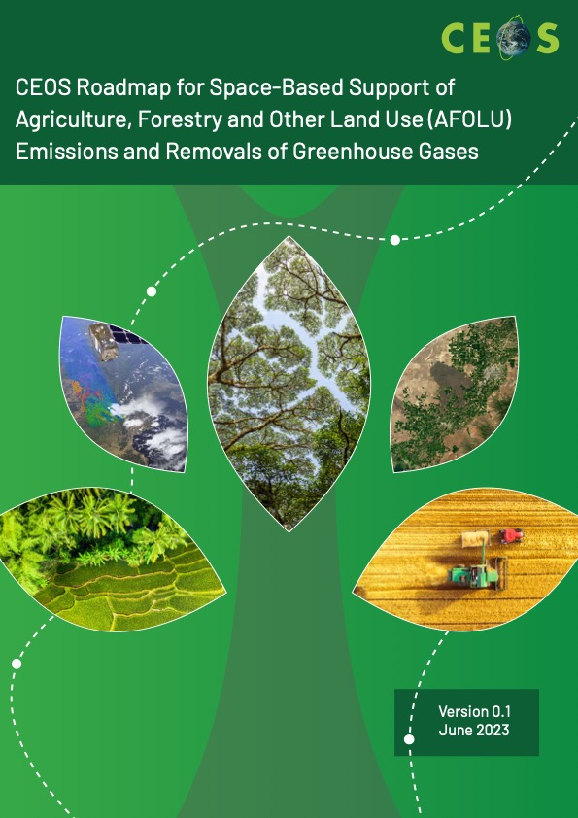
Table of Contents
1. Key objectives 2
2. Introduction 3
3. Remote sensing contribution 6
3.0 Cross-walking land cover definitions 6
3.1 Key products 8
3.2 Activity data 10
3.3 Emission and removal factors 19
4. Approaches to estimate AFOLU-related emissions/removals 25
5. Perspective on CEOS GHG roadmap 29
6. Capacity building & user engagement 30
7. Forward looking to 2035+ 33
8. References 34
Annex A: Table of Recommendations 42
Annex B: Authors 44
Annex C: List of Acronyms 45

1. Key objectives
To provide a framework for long-term (+15 years) coordination of Committee on Earth Observation Satellites (CEOS) agency observing programmes in support of the needs of society for Agriculture, Forestry and Other Land Use (AFOLU)-related information, with a particular focus on the needs and ambition cycle of the Global Stocktake of the 2015 Paris Climate Agreement.

To serve as a guiding vision for long-term space agency coordination around AFOLU. The Roadmap will 1) characterize the needs, services and applications required and 2) the products and observing systems that it can support; and 3) explain the need to plan for ground segment, space segment and services.

An effective means for communicating the intentions of CEOS to society, the United Nations Framework Convention on Climate Change (UNFCCC) and the national inventory community to provide remote sensing observations to inform AFOLU-related greenhouse gas emissions and removals.

Address basic observation continuity and the necessary agency coordination to achieve goals of sustained land-imaging of land-use and land cover change (i.e., activity data) and biomass estimates (to support the definition of emissions factors).

Box 1: Greenhouse-gas emission and removal measurements covered by AFOLU reporting includes carbon dioxide (CO₂), methane (CH₄) and nitrous oxide (N₂O). The measurement process estimates separately the emissions and removals of each gas from AFOLU activity data and emissions factors. The guidelines provided by the Intergovernmental Panel on Climate Change (IPCC) describe in detail the process of integrating activity data with emissions factors to estimate, for each sector, emissions and removals. The IPCC guidelines provide an approach that contributes aggregated information (i.e., by country) with generalized emissions factors that are representative of large regions, and activity data generated by statistical sampling of landscapes. The CEOS AFOLU roadmap provides traceability between remote-sensing derived spatially disaggregated activity data and emissions factors to be used to support estimating emissions and removals for national greenhouse gas inventories and for comprehensive monitoring of AFOLU-related greenhouse gases.

The Roadmap has used expert opinion to define the policy needs and assumed AFOLU information needs for the Paris Agreement and the first Global Stocktake (2023) to the 2035+ timeframe on the assumption that this can inspire and drive the generation of a space agency response to define and plan for the 2035 observing system that can:
- Generate the 2035 observing system required to address the AFOLU information needs of society, e.g., the Paris Agreement and the ‘modalities, procedures and guidelines (MPGs)’ to operationalize it.;
- Integrate AFOLU with top-down Greenhouse Gas (GHG) approaches for seamless Monitoring, Reporting and Verification (MRV) support;
- Consider the technologies and systems needed to realize this observing system;
- Identify the stakeholders required at different stages of the value chain to ensure it can be sustained in the long-term (i.e. users, service providers, data product producers, observation providers);
- Determine the technology development programmes and investments needed by space agencies to achieve them; and
- Consider the programmatic commitments that will be needed to get there.

2. Introduction
Parties to the UNFCCC came together at their annual Conference of Parties in 2015 (COP21) in Le Bourget, Paris, and signed an accord that recognised the need for action by humanity to reduce the increase in greenhouse gases through a cooperative and constructive framework. This accord is known as the Paris Agreement^{[1]}. The Paris Agreement aims to strengthen the global response to climate change in the context of sustainable development and efforts to eradicate poverty through addressing mitigation, adaptation and finance by:

● Holding the increase in global average temperature to well below 2 °C above pre-industrial levels and to pursue efforts to limit the temperature increase to 1.5 °C above pre-industrial levels,
● Increasing the ability to adapt to the adverse impacts of climate change and foster climate resilience and low greenhouse gas (GHG) development
● Making finance flows consistent with a pathway towards low GHG emissions and climate resilient development.

The Paris Agreement will also be implemented to reflect equity and the principle of common but differentiated responsibilities and respective capabilities in the light of different national circumstances.

The mechanisms of the agreement were quite different from those considered at previous meetings of the Parties. Individual countries would be required to submit their anthropogenic emission reduction goals as part of their Nationally Determined Contributions (NDCs) every five years. Progress in reducing emissions would be measured through an Enhanced Transparency Framework (ETF) and stocktaking process, with a view to achieving the ambitions of the Agreement set out above.

It is worth noting in passing that there is already a very strong implied requirement for systematic observations in the aims set out above through the explicit link of future temperature rise to current GHG emissions. This is explored further in Section 4 concerning the IPCC and its procedures.

The biosphere plays a critical role in climate change by cycling greenhouse gases (GHGs) between the land and atmosphere. Each year, terrestrial ecosystems remove an amount of carbon dioxide (CO₂) that is roughly the equivalent of one third of annual fossil fuel emissions, thus mitigating the rise in atmospheric CO₂ emissions. However, agricultural activities are also responsible for methane emissions from livestock and manure management and rice agriculture, and nitrous oxide emissions from fertilizer applications. When the three gases are combined, emissions from forestry and agriculture are larger than CO₂ removals and contribute to 15-25% of total GHG emissions.

The monitoring of terrestrial GHGs is key to understanding the Earth system and also for mitigating climate change. Since 2010, the Global Carbon Project (GCP) has carried out carbon, methane and nitrous oxide budget activities to document all natural and anthropogenic sources and removals. Every five years, the IPCC Assessment Report (AR) reviews the literature to review how well we understand the fluxes of CO₂, CH₄, and N₂O in explaining changes and trends in atmospheric growth rates. These assessments address uncertainties in GHG sources and sinks by comparing the estimates with the growth of concentrations in the atmosphere.

For policy purposes, Parties to the UNFCCC are required to submit statistics on anthropogenic GHG emissions and removals. Annex 1 countries provide these emissions annually in National Inventory Reports that follow a Common Reporting Format (CRF) for energy, Industrial Processes and Product Use (termed IPPU), agriculture, land-use, land-use change and forestry (termed LULUCF), and waste. Non-annex countries provide summaries of emissions and removals less frequently in their Biennial Update Reports (BUR). The parties follow the IPCC Guidelines (established in 2006 and most recently updated in 2019) that describe how to combine activity data and emission factors with three ‘Tiers’ of uncertainty (i.e., 1, 2, or 3). A major difference between the UNFCCC inventory approach and the IPCC AR and GCP reports is that the countries provide estimates for managed lands given that the reporting is specific for anthropogenic activities.

Since the Paris Agreement went into effect in 2016, there is an increasing need to provide more accurate and precise GHG inventories, provide support to non-Annex 1 countries committed to the Enhanced Transparency Framework (ETF) reporting, and better understand differences between non-inventory and inventory-based approaches. Part of this urgency is that GHG concentrations are rising at increasing rates and the capacity for the carbon budget to ensure global temperatures stay below 2ºC warming above pre-industrial levels is being rapidly depleted with 1.5 ºC warming expected to be exceeded by 2030. At the same time, countries have pledged to a 50% reduction in GHG emissions by 2030 in order to reach net-zero emissions by 2050. Hence, improved measurement, reporting and verification (MRV) is essential to meeting these targets. The Paris Agreement also implemented a mechanism called the Global Stocktake, the first of which will take place in 2023 and every five years thereafter. This will provide the opportunity to assess global collective progress in three thematic areas; mitigation, adaptation, and the financial means of implementation and support. The Global Stocktake provides the 'ratchet mechanism' to evaluate whether nationally-determined contributions are sufficient to reach the goals of the Paris Agreement. MRV will play an essential role in the process.

Box 2: When used in the context of the UNFCCC, MRV refers to the framework for ‘measurements, reporting and verification’ which will be superseded by the ETF, and is defined by a set of specific guidelines. These guidelines are designed to measure greenhouse gas reductions from specific mitigation activities. In contrast, the atmospheric greenhouse gas observation community uses in situ or satellite retrievals of greenhouse gas concentrations to estimate and monitor land-atmosphere fluxes and their changes from year-to-year and over time. We distinguish the two uses of MRV by using MRV for UNFCCC and GHG+ in the context of top-down approaches.

With this background, we provide a roadmap that describes how satellite remote sensing can support GHG information needs for inventories and GHG+. The roadmap was initiated in 2020, following the Global Stocktake Strategy document endorsed by the CEOS. The Strategy document made a series of 10 recommendations, including one for a GHG roadmap that describes how atmospheric inversions can support the inventory process. A discussion paper (Ochiai et al 2023) prepared by the Land-Surface Imaging Virtual Constellation (LSI-VC) Forests and Biomass Team following CEOS SIT35 provided further guidance. The roadmap presented here, the CEOS Agriculture, Forestry and Other Land Use (AFOLU) Roadmap, provides a 'bottom-up' perspective through identifying opportunities for satellite-based activity data and emission factors to estimate CO₂, CH₄, and N₂O emissions and removals.

The roadmap identifies key remote sensing based products developed primarily from satellite missions led by space agencies and the private sector that are being used or have potential to be used for GHG emissions and removals reporting (Figure 1). Satellite observations from optical missions are particularly useful as they provide time series on spatial patterns of land use and land cover change over at least four decades. Existing and planned radar and lidar missions are allowing the retrieval of vegetation biomass and gridded products are providing useful in documenting global patterns in biomass stock change. These products have potential to support national GHG inventories that need to adhere to IPCC guidelines using stock-change or gain-loss methodologies and can also provide spatially disaggregated independent estimates of emissions and removals. The remote sensing products are global in scope, and can play an important role in capacity building for developing countries involved in Reduced Emissions from Deforestation and Forest Degradation (REDD+).

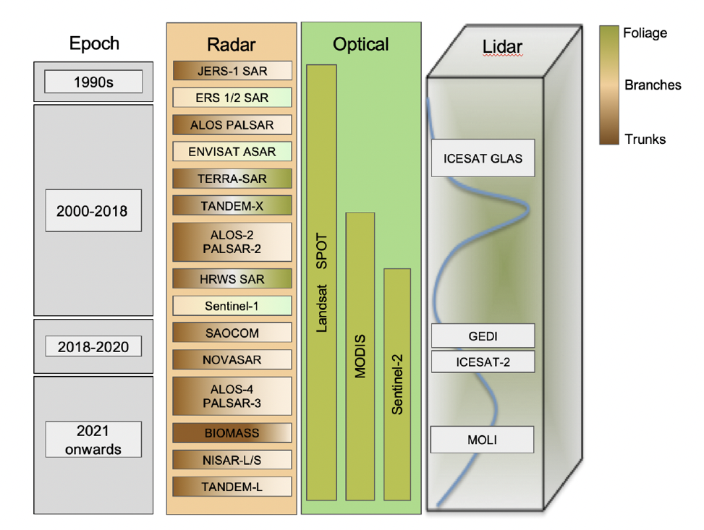
Figure 1: Reproduced from Ochai et al., (2023) showing the development of radar, optical and lidar instruments to retrieve emission factor and land cover change data from the 1990s to planned missions.

Following the presentation of remote-sensing activity data and emissions factors, the roadmap provides a guide for how AFOLU and GHG roadmaps can be further integrated to support a full GHG+ perspective which itself is a vision for 2035+ and integrates initiatives underway by other public and private organizations to better coordinate GHG observations and monitoring. These include integrating remote sensing observations with in situ monitoring networks, process models and inventories to produce low-latency, spatially disaggregated, and high accuracy and precision estimates of the role of the biosphere in determining GHG emissions and removals.

Finally, a series of recommendations are provided to help initiate the roadmap and to serve as a guide for active implementation by the CEOS agencies and partners (see Annex A). These recommendations are intended to be revisited and evaluated with regular cadence at CEOS-supported technical workshops and plenaries.

3. Remote sensing contribution

3.0 Cross-walking land cover definitions
UNFCCC and IPCC definitions of anthropogenic GHG emissions include three categories: Fossil Fuel Emissions (FFEs; i.e. emissions resulting from all forms of combustion of fossil fuels, for whatever purpose), Industrial Processes and Product Use (IPPU) and emissions and removals arising from changes in land use in ‘managed landscapes’. For GHG inventories, following the IPCC guidelines, the concept of ‘managed land’ is used as a proxy for anthropogenic effects.

In the IPCC inventory process, FFEs are derived from detailed bottom-up estimates of fuel consumption and are calculated at a national level considering the consumption of all mined and imported fossil fuels (coal, oil, gas etc.). Emissions and removals from LULUCF, within AFOLU, are computed from two major input variables namely:

- The extent of observed or reported changes in land use within and between six categories (forestlands, croplands, grasslands, wetlands, settlements and other lands) defined in the IPCC guidelines
- GHG emissions factors (i.e. the amount of GHGs emitted or removed from the atmosphere per unit area of change of land use between the categories defined in a).

Land use and land use change can be derived from one of three sources: (i) statistical data from the national agency, (ii) statistical aggregates from a sample of geolocated points, extrapolated to the national coverage or (iii) by comprehensive and inclusive land use maps, geospatially disaggregated, derived with from local survey or from satellite imagery by whatever means (interpretation, classification methods). There are also several levels of detail which can be reported (so-called Tiers) that carry increasing detail about the land transformations.

At the most general level (Tier 1), land cover is divided between the set of six land cover categories. Emissions factors resulting from transitions between these classes are based on IPCC prescribed values and do not reflect subtleties, e.g., changes in local varieties of crops or local growing conditions that may be reflected in higher level Tier 2 or Tier 3 data. At the level of detail required by Tier 1, and indeed beyond, relevant data on land cover can be supplied from satellite observations and to levels that are considered sufficiently accurate, reliable and repeatable.

The six land use classes used by the IPCC are quite broad, and direct mapping from satellite sensor data is often problematic as the states and dynamics of the constituent classes are often complex and diverse. Arguably the most complex is wetlands, which in the context of the roadmap can occur under any IPCC land use category, across all major biomes, from the wet and dry tropics to deserts, high mountains and the arctic, and in settings ranging the intertidal zones of coastal landscapes (e.g., mangroves, saltmarshes) to high mountain regions (e.g., bogs, fens). As a result of this complexity, the taxonomies used for targeting the mapping of land covers often do not align with the IPCC categories, with this reducing the capacity to document from satellites. However, one exception is the Food and Agriculture Organisation (FAO) Land Cover Classification System (LCCS; Figure 2),which is a globally applicable but locally relevant and has 10 classes at the broadest level that can be translated directly into the six IPCC categories (Figure 3; see Lucas et al., 2022). The FAO LCCS is widely used as the default taxonomy in Earth observation science, and its use in national to global mapping has been demonstrated for multiple years for Wales (Planque et al., 2020) and Australia (Owers et al., 2022), but its standardized use for IPCC reporting has yet to be fully recognised.

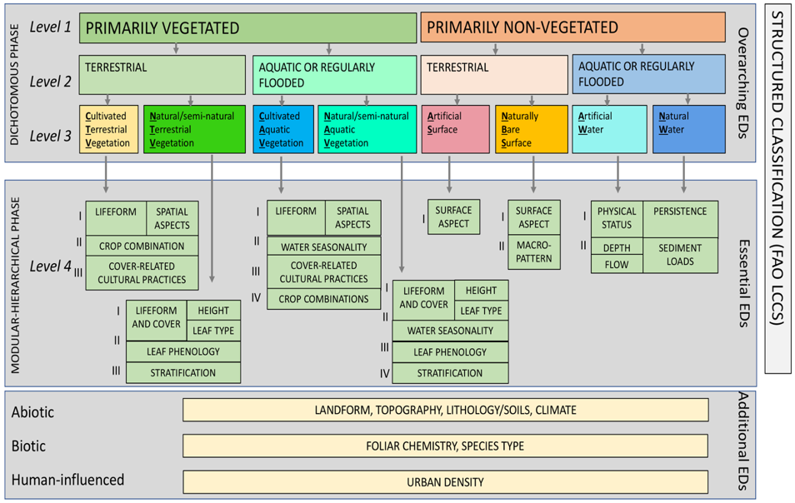
Figure 2. The Food and Agriculture Organisation (FAO) Land Cover Classification System (LCCS) Version 2.0, differentiating between overarching environmental descriptors (broad land cover classes) and those that are essential for constructing the taxonomy or providing additional information (e.g., on vegetation biomass, canopy cover or height, crop type or water temperature).

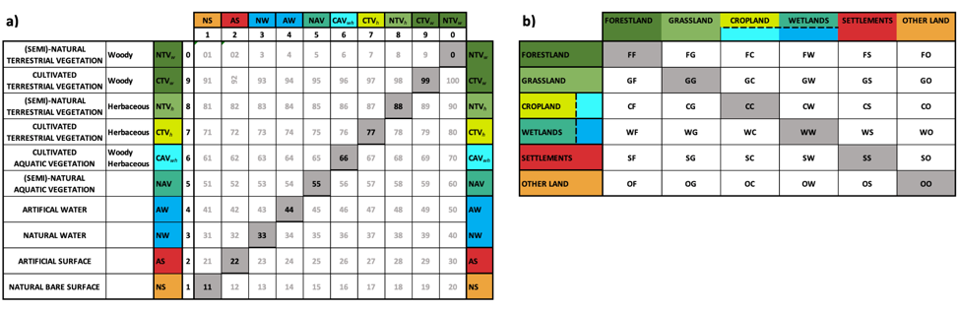

c)
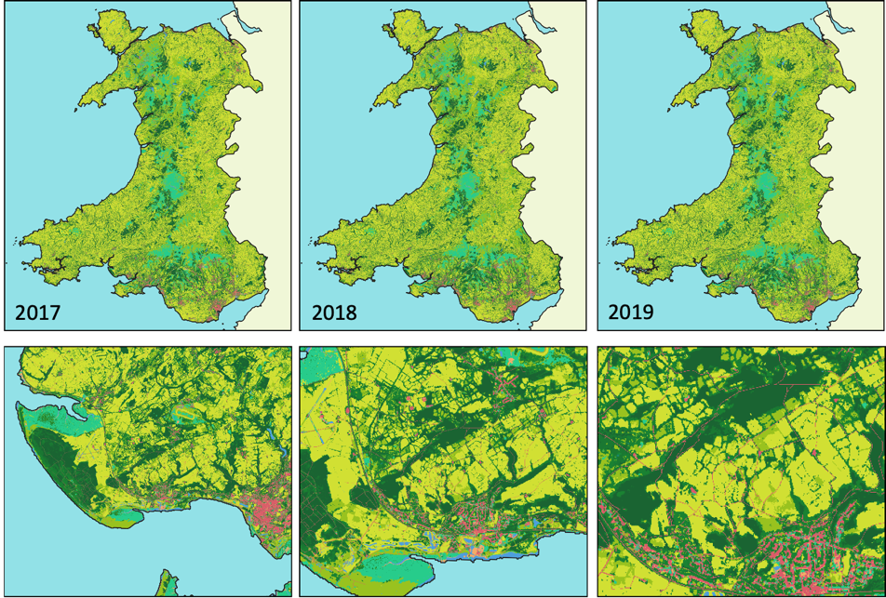
Figure 2: The translation between the Food and Agriculture Organisation (FAO) Land Cover Classification System (LCCS) taxonomy (a) and the IPCC AFOLU Classes (b). c) Maps of the same LCCS classes generated for Wales (UK) for 2017, 2018 and 2019 using a globally applicable approach and highlighting capacity to generate IPCC transition matrices at a national level (See b) for legend) (Lucas et al., 2022). Note that cultivated aquatic vegetation is not included in the maps as an uncommon and non-extensive class.

Once mapped or quantified (by area), these land cover data can be combined with emissions factors to allow FFEs due to LULUCF to be computed and included in the national inventories. Moreover, the changes in the standing above ground biomass (AGB) between land cover classes can increasingly be assessed from satellite sensor data, with this complementing or potentially supplementing prescribed values. In such cases, the change in AGB that relates directly to GHG emissions or removals between any two epochs of observation can be directly inferred, and need not be taken from prescribed values, which these are often derived from more general statistical data.

3.1 Key products
Land cover and change data are essential for national GHG inventories, estimating activity data and to global AFOLU modelling and assessments. Several space agencies and programs are producing relevant data and products with different characteristics and for various purposes. These include the input data for national GHG inventories for activity data estimation following the IPCC Good Practice Guidance; for improved global AFOLU and modelling assessments using long-term harmonized land cover change data, and for enhancing consistency and comparability of national GHG inventories and global GHG estimates for the UNFCCC Global Stocktake.
In support of Global Stocktake activities, different land cover products are being developed. The land cover products vary from one another in terms of the time period they represent, the spatial resolution, the frequency of observations, and the thematic classes used to define land cover. Thus the choice of land cover data used to inform greenhouse gas emission analysis for AFOLU depends on user needs, such as the scale of analysis (local to global), the type of approach used (i.e., stock change versus gain-loss), the Tier requirements, and other factors.
For example, the Worldcover dataset is characterized by having the most detailed spatial resolution available globally (10 m) and independently validated. It can contribute to detailed land cover and landscape studies, and for climate change adaptation assessments. Worldcover is currently available for the year 2020 and being updated for 2021. The Copernicus Land Cover dataset (C3S) is available globally at 100-m resolution, from 2015-2019, and is supported by the Copernicus Land Monitoring Service and suitable for regional AFOLU analyses. Further updates are expected over the course of 2022. The ESA CCI-LC provides 300-m resolution information on annual land cover from 1992-onwards, developed as part of the Copernicus Climate Service to support climate and Earth system modeling needs. The HILDA+ dataset is available at 1-km resolution, annually from 1960-2020, and combines FAO statistics with multiple remote sensing sources of data to provide global AFOLU land cover change information (i.e. for use in climate and earth system models). More detailed information is provided in the following on the CEOS Global Stocktake (GST) portal (https://ceos.org/gst/land.html), describing the methodologies used for each land cover product, their uncertainties, applications, plans for continuity, and data access. Other land cover datasets discussed in the roadmap include Google Dynamic World, ESRI Global Land Cover Map, Global Forest Watch, Global Land Cover 10-m (GLC10), and Global Land Cover Mapping and Estimation (GLANCE).
In light of the current status of land cover data, the following community activities are proposed to enhance the use of land cover data for AFOLU assessments and the GST:
1. Improved global land cover/use change data for AFOLU assessments and the GST: this is to stimulate further investments in global and national level land cover analysis and assessments. Aim is to improve available global land cover and use change datasets, to ingest them in global, regional and national AFOLU assessments and aid the Global Stocktake processes by harmonizing between national and global-level estimation. There should be a focus on including more land use and land management categories with consideration given to the use of structured taxonomies such as the FAO LCCS.
2. Combining land change and biomass map data for GHG flux estimation: there is need for a more stringent approach incorporating different data sources from Earth Observations, on-the ground and statistical data sources. The World Resources Institute’s (WRI) Harris et al., (2021) forest flux model is a relevant example that should be expanded to include more land cover/use changes for data-driven flux estimation.
3. Developing an improved global managed land (IPCC proxy) layer: the lack of an up to date, spatially-explicit data layer for managed land as defined by countries in their GHG inventories is a major hurdle in linking global and national AFOLU estimates. There will be an effort to reconcile available national and global data sources and provide a “best-available” data layer.
4. Integrating land change and wetlands monitoring efforts and products: Most wetland/peatland and related land changes are still poorly monitored and addressed in global AFOLU analysis and in national GHG inventories. The aim here is to use increasing detail from Earth Observation approaches to allow for better detection of different wetland types assessing changes related for GHG estimation. In recent years, maps of mangrove extent globally have been produced for multiple years (Bunting et al., 2018) although there is still room for improvement. However, maps of comparable or better accuracy are required for most wetland types.
5. Community comparison of 10-m global land cover datasets: with different global 10 m land cover datasets in evolution, there is need for a community comparison and validation. The aim is to highlight and understand differences and make it easier for user to decide which map to use for a certain purpose. A comparison concept needs to be developed and reference datasets established and combined to underpin this assessment evolving the main partners involved in the evolution and validation of the various products.

3.2 Activity data
Forests
Following the IPCC GPG, two types of data are required in forest monitoring; area change (i.e. Activity Data, AD) and change in stock (Emission or removal Factor, EF) for that forest. These two types of information can be measured and reported using ground data, however, the AD and increasingly also EFs can also be derived from EO data. Maps can be useful in that they provide spatial and temporal information which can help to understand the complexity of issues related to forest dynamics but for IPCC reporting national estimates with confidence intervals will need to be provided.
As for all LULUCF reporting, tracking of land areas and changes is key, and this can be done using three approaches:
- Approach 1: Only reporting total area for each land category without information on change or spatial information
- Approach 2: Extraction of from-to changes between land categories, typically from a change matrix
- Approach 3: Spatially explicit tracking of changes based on sampling or wall-to-wall techniques.
Approach 3 requires maps/ geospatial data, whereas it is possible to report using approach 1 and 2 without maps. Reporting using Approach 2 does not necessarily require a map, and the result is a non-spatially-explicit land-use/cover conversion matrix. The input data required for this, can be from a land use database for example, or can be obtained through sampling or other methods (IPCC 2006a). Where remote sensing data are used for this approach (e.g., Very High Resolution (VHR) or HR), observations from multiple time-periods can be visually assessed or classified using computer-based approach in order to derive land-use/cover and changes. In this case a sample based approach would be required, and some information on sampling is provided in Annex 3A.3 of Chapter 3 of Volume 4 of the 2006 IPCC Guidelines for National GHGI (IPCC 2006b).
Key reporting requirements from the GPG are that estimates should be (1) “neither over- nor underestimates so far as can be judged,” and (2) “uncertainties are reduced as far as is practicable” (IPCC 2006c). Calculating unbiased GHG emission estimates that comply with these reporting principles often requires interpretation of national and independent data sources including global datasets and harmonization of data is essential to be able to integrate these datasets. An understanding of the accuracy of datasets is also required and should be made available in order to meet transparency requirements. So when wall-to-wall satellite data is required, there is still a need for adjustment of the data, which needs to be done with ground / other validation data (e.g,. VHR/HR satellite images as discussed in relation to Approach 2). Guidance has been produced on how this can be carried out, and this includes examples of sampling strategies which should be applied (GFOI). The methods provided mean that the map-classification errors which will bias results where the pixels from a map are simply counted are removed, due to the application of a sample-based estimator. Several steps need to be taken. Firstly, the appropriate sampling design should be used, and several considerations are outlined in the guidance. Secondly, the correct inference type should be selected. In the absence of expert knowledge on this topic, it is recommended to select a probability sample and implementing design-based inference is recommended. Finally, the response design should be determined.
VHR/HR data are a useful resource in both the above contexts as reference/validation data however, a tool to manage this process can be useful. As examples, VHR data can be accessed and visualized in the FAO Collect Earth and Collect Earth Online tools, which form part of their OpenFORIS (FAO) suite of tools. Collect Earth provides data from Google Earth, Bing Maps and GEE, so that users can analyze this imagery in a user-friendly tool. A sampling grid, following the required sampling strategy can be imported, and from there fast, accurate and cost-effective assessments can be made.
When looking at country reported data, there have been substantial improvements in national forest monitoring capacities around the globe. Forest area monitoring using remote sensing at good to very good levels increased from between 2005-2020. The uptake of EO-data and related capacity improvements are more widespread in the tropics, which can be linked to continued international investments for forest monitoring especially in the context of reducing emissions from deforestation and forest degradation in tropical countries (REDD+)[Nesha et al., 2021, Nesha et al., 2022]. This important achievement would have not been possible without the provision of free- and open satellite data from several CEOS partners.
Looking forward, one should also recall the fact that EO-based products are often not directly used by countries (Melo et al., 2023). A gap remains between what can be achieved in the research domain and what is required to support policy making and meet reporting requirements. There are no unique solutions for all, as there is not one dataset that serves all users in terms of definition and type of measurements, geographic area, and uncertainty requirements and whether there is need for the most recent up to date forest area estimate or assess the long-term trend. The research and user communities should embrace the potential strength of evolving EO opportunities in combination to provide for these varying needs and to ensure continuity for long-term data provision which one-off research missions cannot provide.
From a technical perspective, it is recommended by CEOS and its partners to improve the EO-based forest and forest area change estimation to address the following points with priority:
- Move from generic forest area change to land use change and linking forest changes with those of other IPCC land use categories and thus to a broader AFOLU estimation and reporting.
- Increasing the timeliness of providing forest change information to use the key advantage of EO-data being able to provide rapid information and national and global levels
- Develop approaches that provide both quality statistical estimates of forest area changes (i.e. from stratified area estimations) and forest change maps, which is important for GHG inventories to support reporting obligations and national policy developing and implementation.
- Linking forest area and land use changes and estimations of emissions and removals; including a link to space-based biomass estimations and evolving carbon modelling (see section below)
- Use EO-based data to improve forest characterization and different forest types incl. planted/natural, young vs. old-growth (forest age), different species/ecosystem types etc.
- Make use of EO-data to better link national data (i.e. those from GHG-I) and the global level in the context of the global stock-take
Agriculture
It is estimated that the food system contributes 18-37% of historical GHG emissions (Rosenzweig et al., 2021). Agriculture accounted for 25% of the global GHG emissions in 2018 and this percentage is rising (Rosenzweig et al., 2021, Tubiello et al. 2021). However, for agriculture to meet the nutrition requirements of a growing global population, it is estimated that production must increase by 60% above 2006 levels by 2050 (FAO 2016). These increases must occur on an increasingly constrained and degraded land resource base that is experiencing changes in climate that are marked by extremes. Consequently, agriculture has global significance for both climate mitigation and sustained food security.
While agriculture is a major GHG contributor there also exist agricultural practices and technologies that can reduce GHG emissions and, in some cases, sequester more carbon in the soil than they emit. For both adaptation to and mitigation of climate change impacts, accurate, timely information is critical for meeting the challenge of addressing nutritional needs while reducing GHG contributions from the sector. EO and EO-derived information are already major assets for climate adaptation and mitigation information and will be a key asset for the Global Stocktake at the global scale, as well as Nationally Determined Contributions (NDCs) at the national scale.
Agriculture has been a major focus of EO research and operational development for more than 40 years. The effort has evolved from a discovery research focus utilizing scientific missions (e.g. LACIE and AgRISTARS, Pinker et al. 2003), to the current day where operational monitoring systems employing EO mission data are supporting policy and program decisions around the world (e.g., the G20 GEOGLAM). The IPCC has identified many information and knowledge gaps related to food availability, food system resilience, mitigation, and trade-offs between GHG emissions and food production (IPCC 2014 and IPCC 2019). Taken together, this long legacy of research and development in EO, the existing EO for agriculture communities that are well-organized and collaborative (e.g. GEOGLAM), the availability of open EO data, advances in computing systems, and openly available analytical applications means that many of these gaps can now be addressed in whole or part by operational EO solutions. Among the largest remaining challenges to large-scale EO-application is achieving sufficient access to high quality in situ data which is particularly the case for less developed nations.

The Opportunity for EO Based Agriculture Monitoring
Monitoring the state and change in land use and management practices is a fundamental requirement to understanding the complex web of social and bio-physical challenges associated with agriculture. This understanding is necessary for the development of appropriate policy, program, and reporting responses that support effective GHG reduction and climate change mitigation and adaptation, while maintaining an adequate and high quality food supply. Contributions from EO may include monitoring land cover, land use, and land management state and change. Global data sets of agricultural crop production systems (including cropland extent, crop rotations, cover crop utilization/duration/biomass accumulation, and tillage practices), rangeland grazing areas (including quality, intensity of use, and management) can make a significant contribution to the AFOLU, and the Global Stocktake, and agricultural NDCs at the national level, and in some cases mitigation practices at the farm level. The main areas in which EO can contribute are crop productivity, agricultural land cover and use, management practices, biomass burning and soil carbon.
- Agriculture Land Cover and Land Use: State and change monitoring is critical for understanding AFOLU dynamics and their impact on climate change, and vice versa. The IPCC identified this information as a major gap and highlighted the need for improved global high spatial resolution data sets of crop production systems and grazing areas (IPCC 2014). In addition to global crop productivity monitoring (via condition assessment and yield forecasting), cropland and crop type mapping are among the most mature applications of EO for agriculture.
- Crop Condition: Near-real time monitoring of crop productivity is critical to understanding the impact of climate shocks on local and global food chains within season and throughout time. The IPCC’s report on Climate Change and Land (IPCC 2019) identifies key knowledge gaps around food availability, resilience, mitigation, and trade-offs in decision making. Operational EO is already important in the support of proactive climate adaptation decision making. The GEOGLAM Crop Monitor for Early Warning (CM4EW) is already making a significant impact on global food security by providing near real time assessments of crop production, largely from satellite EO. At the national level GEOGLAM has been working with less developed nations (LDC’s) to co-develop their own crop monitoring systems using open data and tools. Where implemented these systems have proven to be an effective climate adaptation measure by informing proactive policies and programs. Building on this experience GEOGLAM is now working with the UNFCCC to develop supplemental guidance for the National Adaptation Plans (NAP).
- Agriculture Management Practices: Management practices have been identified by the IPCC as a major gap. Information requirements relate to nutrient application, pest management, irrigation, cover crop utilization, structural conservation management (e.g. strip and buffer cropping), and crop residue management (tillage and burning, see next sub-bullet). The IPCC points out that this information provides “improved understanding of the mitigation potential, interplay, and costs as well as environmental and socio-economic consequences of land use-based mitigation options such as improved agricultural management” (IPCC 2014). This has become one of the most active arenas of EO application research and development, particularly with the advent of commercial satellites with increased temporal and spatial resolution coupled with the adoption of sustainability commitments by actors throughout the agricultural value chain.
- Agricultural Biomass Burning: A widely used practice globally during harvesting, post-harvesting, and preparatory (pre-planting) periods that has profound effects on local and regional air quality (Korontzi et al., 2006). Agricultural land use is responsible for at least 8-11 % of global fire events worldwide (ibid) and at least 3 % of carbon emissions worldwide (van der Werf et al, 2010). Even so, current methods under report and therefore underestimate the agricultural emissions from agricultural burning by missing small and short duration fires (Lasko et al., 2017; highlighting this as an important area for further research). Satellite sensor data have revolutionized the field of burned area mapping, active fire mapping, and fire emissions estimation (Boschetti et al., 2020), but further work is needed to close the gap in understanding agricultural fire dynamics and their impacts on carbon (dioxide and monoxide), methane, nitrogen dioxide, sulphur dioxide, and particulate matter emissions. Their impacts on microclimate and human health also need to be recognised.
- Soil Carbon: Estimates of Soil Organic Carbon (SOC) stocks and fluxes are an important yet poorly constrained component of the global carbon-climate system. Monitoring soil carbon dynamics is key to understanding climate mitigation efforts, and “Smart Farming” practices can help to sequester significant quantities of carbon. Models that relate agricultural practices to carbon sequestration are well established ( e.g., EPIC, APSIM, DSSAT, ecosys, Cropsys, and DNDC). Satellite data can provide important information on the land management and use essential agriculture variables (EAVs) required to parameterize and update these models. Some of the key inputs, mentioned above, include crop type; tillage intensity and type; crop residue, crop yield and crop biomass.

Essential Agricultural Variables Supporting Climate Change Monitoring
To address the need for quantitative information on agriculture land cover, land use, and management practices, a set of Essential Agricultural Variables (EAVs) are being developed by the GEO Global Agricultural Monitoring (GEOGLAM) initiative. The EAV concept is consistent with the GCOS Essential Climate Variables (ECVs). Indeed, several of the variables essential for agriculture are identified as ECVs, and where they do intersect with the EAVs the ECV definitions are referenced, minimizing new effort and amplifying the voice behind core variable requirements. EAV definitions are in progress and once complete in 2022, they will be used to define the requirements for operational systems to generate information products in support of AFLOU, the Global Stocktake and higher resolution NDC’s. This approach has been tested using the crop type map variable within the context of the ESA WorldCereal project.
Based on the EAV work, Table 1 identifies which climate critical measurements can be provided by EO along with the characterisation of each in terms of coverage, spatial resolution, and revisit frequency.
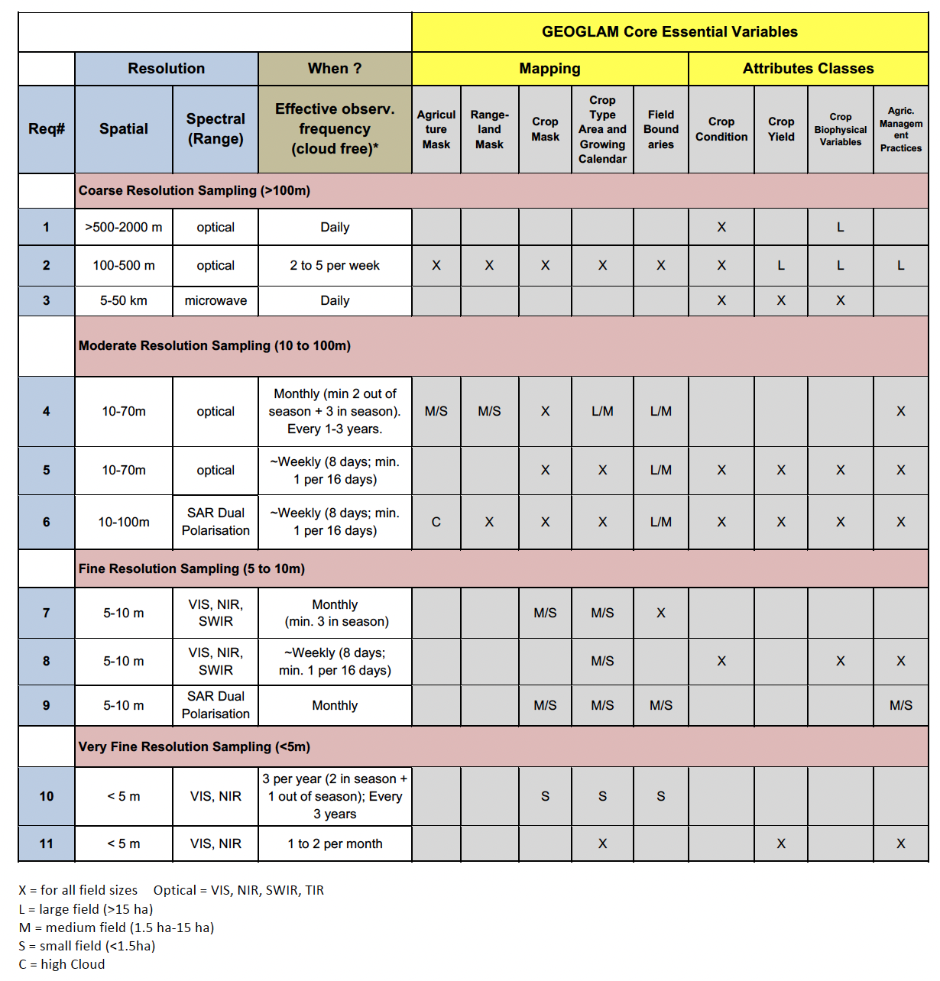
Table 1: Many current satellite missions can be used to meet the needs of AFOLU, and several are already employed in operational systems. Using the requirements categories employed in Table 1, Table 2 provides a list of the current and future satellite missions that can be used to derive climate relevant variables in support of AFOLU.
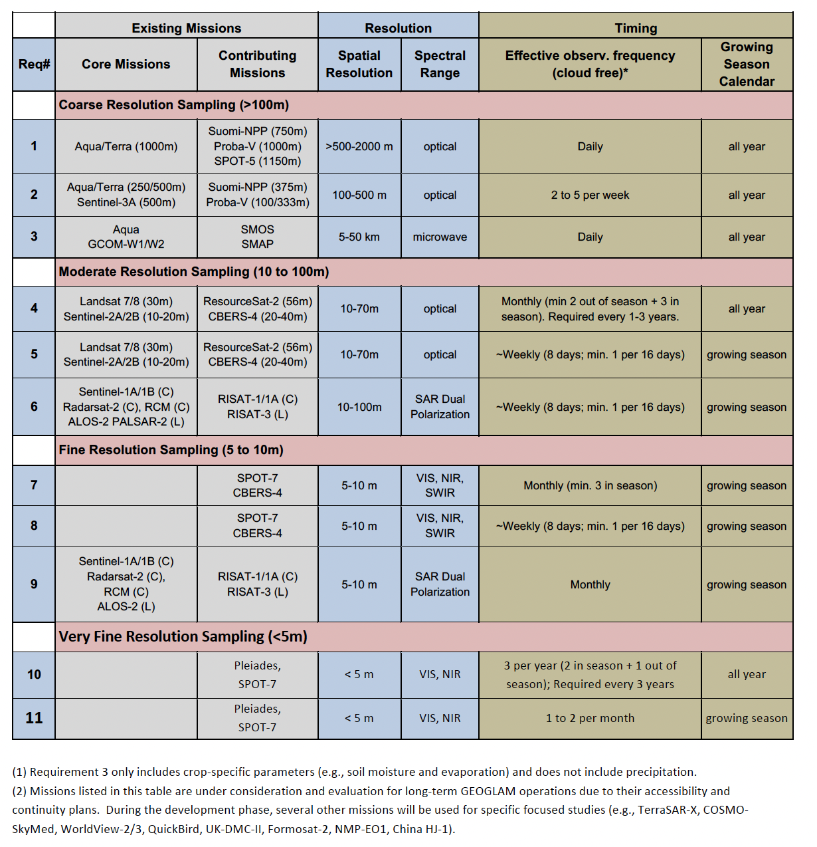
Table 2: Specific missions support Agriculture applications related to land use and land cover.

Existing Products
Over the last couple of decades, considerable effort has been devoted to developing moderate to coarse scale global land cover products (summarized in Table 1) based on imagery from a single year or accumulated over several years. Most of these regard agriculture as being a single map class, without providing information on crop type, agricultural management, field sizes, seasonality, crop rotations, etc. Evolution of multiple satellite sensors, data availability and methods hinder comparison among products, which limits their use in change detection. However, more recent work by the Copernicus Land Service is focussed on developing annual assessments and 5-year change products. The first change product was released in 2020 based on 2016 to 2019 annual products and at 100 m resolution (https://land.copernicus.eu/global/products/). Similarly a cropland change product generated by Potopov et al. (2021), quantifies global cropland change from 2003-2019. These new products approach the requirements of the IPCC and the needs for AFOLU on land cover change in the Global Stock Take.

A major step towards global land cover monitoring was realised by the ESA WorldCover project which demonstrated that land cover maps can be produced within 3 months of the end of a year (https://esa-worldcover.org/en). The dataset uses 11 classes at 10 m resolution and has an overall accuracy of 74.4% (WorldCover Product Validation Report v1.1). In the WorldCover product, agriculture can be a component of cropland, grassland (pasture, uncultivated cropland in reference year), shrubland or tree cover classes (greenhouses are considered built-up). In the cropland class, it is seen as a general yearly class (WorldCover Product User Manual v1.0). This does not reflect the dynamic nature of agriculture, which can have between one and three cropping seasons within any year. To provide more information for the agricultural class, the ESA WorldCereal project has just produced the first global seasonally updated cropland and crop type map at 10 m resolution. Perhaps more important for monitoring purposes, ESA’s WorldCereal project is the first open-source and cloud-agnostic (implementable on any cloud infrastructure provider) systematic approach to create global seasonal cropland extent and crop type maps. Capable to produce, within one month after the end of each season per Agro-ecological zone, maps that include a 10 m temporary cropland, as well as maize and wheat crop type maps and irrigated and active cropland maps based on the current open and freely available data sets from Sentinel 1, Sentinel 2 and Landsat 8. The products for the 2021 seasons have been produced and validated e.g., global user's and producer's accuracies for the annual temporary crops product are 88.5% and 92.1%, respectively, and the data and code are publicly available. WorldCereal has also built the first global reference database for agricultural monitoring. Data collection and gathering efforts are streamlined and harmonized in close collaboration with the GEOGLAM In Situ Data Working Group, and the WorldCereal datasets will be managed by the GEOGLAM community when the initiative ends. The project has produced multi-temporal/seasonal datasets for 2021 and, more importantly, will leave a post-project legacy of an open source system and reference database. The GEOGLAM community is exploring options to operationalize the system, expand the system to cover more crops, and develop change products through time.
Grasslands
The IPCC states that the category of grasslands encompasses “... rangelands and pasture land that are not considered Cropland. It also includes systems with woody vegetation and other non-grass vegetation such as herbs and bushes that fall below the threshold values used in the Forest Land category. The category also includes all grassland from wild lands to recreational areas as well as agricultural and silvi-pastural systems, consistent with national definitions.” (IPCC 2019).

According to the IPCC's guidelines for national GHG inventories (IPCC 2006, 2019b), all land is divided into two categories: managed and unmanaged. The distinction of managed land was created to differentiate the impact of human activities from natural effects on GHGs and only managed lands are reported on. When it comes to grasslands, it’s in many cases impossible to determine the difference between managed and unmanaged grasslands and therefore all grasslands are considered managed (Ogle et al. 2018).

Within the managed grasslands class, grasslands can be considered degraded or improved. Improved grasslands are those that have undergone management practices to increase productivity, such as fertilization, irrigation, or species improvement. Grasslands that are not improved are considered nominally, moderately, or severely degraded. Degraded grasslands may have reduced vegetation cover, altered species composition, and decreased productivity relative to native or nominally managed grasslands.

The remote sensing needs for grasslands inventory reporting primarily center around land use state and change, degradation status, agricultural management practices, and fire. Remote sensing products in these areas should be accurate and comprehensive, have high spatial and temporal resolution, and follow consistent and transparent methods that ensure the data is comparable between regions and over time. Importantly, error assessments that accompany EO products allow that error to be accounted for in inventories, but currently many products lack these kinds of uncertainty estimates.

As an example of the successful application of remotely sensed data inputs for grassland inventories, the US national GHG inventory manages Tier 3 reporting on grasslands that leverage several EO products. US land use and land use change maps are supported by the Forest Inventory and Assessment (FIA) program and the National Resources Inventory (NRI), with gap-filling from the Landsat-based National Land Cover Dataset (NLCD). The grassland fluxes are modeled using the DAYCENT biogeophysical model. The model previously used Enhanced Vegetation Index (EVI) from MODIS, but will transition to VIIRS instrument, taking advantage of efforts to ensure continuity between the missions that allow for a long time series (the first year of reporting is 1990). The role of EVI in the US national GHG inventory is set to be improved and extended in partnership with NASA. Additionally, there are plans to evaluate and potentially improve the model with evapotranspiration data being created by USDA and incorporating SMAP data from NASA. Notably, like many countries, the US inventory lacks any detailed information on grassland management that could serve to further improve estimates.
Settlements
The IPCC’s land-use category includes all developed land, including transportation infrastructure and human settlements of any size. This includes impervious land covers (e.g., paved surfaces and buildings associated with construction and development activities), as well as urban vegetation (e.g., trees grown along streets, public parks, and lawns and golf courses). Urban development and associated settlements are among the most visible manifestations of human modification of the landscape, are typically unidirectional changes (i.e., result in permanent landscape modification), and have substantial impacts on local and regional hydrology, habitat fragmentation, and carbon and greenhouse gas fluxes. However, given the settlements land-use category includes such diverse land cover characteristics, synoptic, consistent mapping and monitoring of settlements at a regional/national, much less a global scale, is challenging.

Remote sensing offers both synoptic coverage and multi-modal approaches for mapping and monitoring settlements and associated urban development. The Global Human Settlement Layer (GHSL), produced by the Joint Research Centre (JRC) in cooperation with the European Commission (Schiavina et al. 2019; Freire et al. 2016), provides global gridded information on various measures of human presence on the landscape, including population density maps at 30-meter resolution and multi-class settlement maps at 1-km resolution. GHSL production is based on multiple sources of remote sensing data (primarily Sentinel Earth Observation Data), in combination with census and population data. The European Space Agency (ESA) and the German Aerospace Center (DLR), in collaboration with Google Earth Engine, have jointly developed the World Settlement Footprint from Sentinel data, providing global high-resolution settlement data. The World Settlement Footprint – Evolution, provides global moderate-resolution data on change in settlement footprints (Marconcini et al. 2020). In addition to these datasets focused solely on urban development and settlement, multiple global land-cover products have been produced recently that include a basic representation of “developed” lands, with thematic definitions which overlap with the IPCC settlements category to various degrees. ESA’s WorldCover (Zanaga et al. 2021) and ESRI Land Cover (ESRI 2023) both provide Sentinel-based land cover with a single “developed” class.

Many remote-sensing based national/regional land-cover products are available with classes relevant to categorizing settlement. However, different data sources, thematic definitions, and temporal profiles limit comparability and aggregation of disparate datasets. Additional challenges facing consistent mapping and monitoring of settlements include the difficulties of distinguishing settlement land use based on land covers identifiable from remote sensing data that may be similar spectrally to non-settlement land covers (e.g., distinguishing between urban lawns and parks, vs. non-managed grass and vegetation cover). While most mapping of land cover/land use and settlements have relied on optical remote sensing, radar data are increasingly used in land cover/land use and settlement mapping (e.g., ESA’s WorldCover), potentially improving our capability to map complex human landscapes associated with settlement.

Wetlands
Inland and coastal wetlands can play an important role in both climate mitigation and adaptation. Hence there is an urgent need for comprehensive and up-to-date geospatial information on their extent (including by type), biomass and health, to produce reliable estimates of emissions and removals from these ecosystems. Wetlands, in the context of the CEOS AFOLU roadmap (and similarly to the IPCC Wetlands Supplement; IPCC 2013), can occur under any IPCC land-use category. Examples include mangrove forests (Forest Land IPCC category), peatlands (Forest Land or Wetland IPCC category, depending on their management) and seagrass meadows (Wetlands IPCC category). This thematic area can complement and contribute to the other AFOLU thematic areas, specifically land use and biomass, providing scientific information (data and methods) that consider the special characteristics of these important and carbon-rich ecosystems.

Mangroves
Mangroves are forested intertidal ecosystems that occur naturally along shallow coastlines, primarily in the tropics and sub-tropics. Mangroves perform critical landscape-level functions related to climate, biodiversity, regulation of freshwater, nutrients and sediments, and constitute important pools for carbon storage (Kaufmann et al., 2020). In the NIR reporting, some countries report mangroves in the forest category and some report as wetlands. For example, the USA NIR includes a height threshold to determine if mangroves are wetlands or forested.
For countries that do not operate their own national mangrove monitoring systems, a dataset suitable for use for proxy mangrove activity data is the Global Mangrove Watch, GMW v3.0 (Bunting et al., 2022). Derived from a combination of optical (Landsat, Sentinel-2) and radar (JERS-1 SAR, ALOS PALSAR, ALOS-2 PALSAR-2) satellite data, the GMW is a public open geospatial dataset of global mangrove extent at 25-m ground resolution. Global mangrove time-series maps (e.g., Figure 3) are to date available for 11 annual epochs between 1996 and 2020, with yearly updates from 2021 and onwards to follow. The GMW is used by the United Nations Environment Program (UNEP) as the default mangrove dataset for reporting on the Sustainable Development Goal (SDG) indicator 6.6.1 (Change in the extent of water-related ecosystems over time) (UNEP 2023).
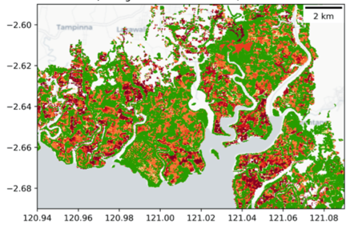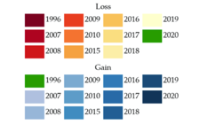
Figure 3. Global Mangrove Watch (v3.0) Mangrove Activity Data (Sulawesi, Indonesia). From Bunting et al. (2022)
Provided in both standard vector (shape files) and raster (GeoTiff) formats, the GMW maps can be directly ingested in open source GIS systems (such as e.g., QGIS) and used to derive disaggregated and geospatially explicit estimates of national or regional mangrove losses and gains on an annual basis.

Users should be aware that the GMW is a global-scale dataset, generated with a single methodology applied over all regions and, as such, the accuracy of the maps may vary between locations. Factors such as satellite sensor data availability, mangrove species composition, growth/degradation stage, the level of fragmentation and environmental conditions (e.g., tidal inundation) all influence the accuracy.

Peatlands
Peatlands comprise a wide variety of wetland vegetation types (e.g. bogs, fens, mires, forested and non-forested swamps, etc.) and hydrological states (e.g. flooded, non-flooded, frozen, etc.), occurring mainly across the boreal zone and in the tropics and, to a lesser extent, temperate zones where many have been lost or degraded.
The broad definition of peatlands poses a major challenge to mapping and monitoring through Earth observations and there is thus a scarcity of high quality maps of global peatland extent and changes. The most detailed global maps released by the Global Peatlands Database (2022), PEAT-ML (Melton et al. 2022) and PEATMAP (Xu et al. 2018) have been assembled from a combination of different data sources including, for example, soil maps, databases, and in situ data, and are at a spatial resolution of 0.5 – 5 arc minutes (~ 1 – 10 km at the Equator).
Regional maps at higher spatial resolution, based on parameters derived from EO data (e.g. Digital Elevation, surface wetness indices, vegetation spectral signatures) and field data have recently been developed over some of the main tropical peatlands in Indonesia (Anda et al. 2021), the Congo Basin (Crezee et al. 2022) and in Peru (Hastie et al, 2022). With the availability of such baseline datasets on peatlands, there is potential for monitoring changes in their extent using time series of both optical and radar EO data, with these then used as Activity Data proxies.
A further consideration is that the presence of peat is used to establish their extent but this is often not visible from Earth observing sensors. Hence, contextual information supported by ground observation networks might be needed to support better assessment of peatlands.

3.3 Emission and removal factors
Forest biomass
Forests are both a sink for carbon through sequestration during photosynthesis and a source through deforestation, degradation and fires. Estimating carbon stocks and changes globally with space-based instruments has the potential to be the most cost-effective, consistent and transparent contribution to the UNFCCC. In the UNFCCC COP-25, CEOS stated that they were in the process of “coordinating the use of multiple satellite missions with novel capabilities to determine above ground biomass” and noted that EO data “offer new prospects and will enable more direct estimates in support of forest and carbon emission reporting, including for global stocktake. ...”. Within the Paris Agreement, several articles make reference to EO data, with these including Art. 3,4 (the National Determined Contributions; NDCs), Art. 5 (Conserve and enhance sinks and reservoirs of GHG including forests, Art. 13 (Transparency framework and GHG reporting, and Art. 14 (Global Stocktake (GST) assessment of collective process).

The upcoming decades are expected to see a vast number of forest carbon estimates published in the form of AGB maps (i.e., the density of aboveground biomass per unit area), derived from a suite of current and planned satellites/sensors (Table 3), and with methods ranging from statistical modeling to artificial intelligence. Further, the capability of repeat-measurements from these instruments, which allows higher temporal forest carbon monitoring, may aid targeted emission mitigation strategies in the future. For example, the ESA Climate Change Initiative (CCI) maps are being or will be produced for multiple epochs (2005/7, 2010, 2015/16, and annually for 2017-2022), and the GEDI mission (currently off-orbit) is expected to come back online during 2024. Both these mission products have the potential to support forest carbon change assessments. In the future, the upcoming ESA BIOMASS, NASA–ISRO Synthetic Aperture Radar (NISAR), JAXA Multi-footprint Observation Lidar and Imager (MOLI) and Advanced Land Observing Satellite-4 (ALOS-4) will cover a combination of new radar and laser data, broadening the spectrum of wavelengths and polarizations available for forest monitoring. Technology in the New Space, comprising commercial sector satellites, has also advanced fast and promised high-level data products in the form of forest carbon maps in the upcoming years (e.g. announced by Planet at Planet Explore 2023 (https://www.planet.com/)). Maxar multispectral images from the QuickBird-2, GeoEye-1, WorldView-2 and WorldView-3 are now being used to map the biomass of individual trees at sub-continental scales (Tucker et al. 2023)

Table 3: A list of current and expected non-commercial missions relevant to the estimation of forest carbon stocks and changes.

Mission | Funding Agency | Launch Date (Expected) | Data Type (main obs mode) | Measurement Resolution | Geographic Domain
ALOS-2 PALSAR-2 | JAXA | 05/2014 | L-band SAR  (DP) | 3-10 m stripmap 25-50 m ScanSAR | Global
ICESat-2 | NASA | 09/2018 | 532 nm photon counting lidar | 13m footprint aggregated to 100m transect | Global
SAOCOM 1A/B | CONAE | 10/2018  08/2020 | L-band SAR  (DP & QP) | 5-10 m stripmap 30-100 m TOPSAR | Global
GEDI | NASA | 12/2018 | 1064 nm waveform lidar | 25m circular footprint | ISS (+/- ~51.6º)
ALOS-4 PALSAR-3 | JAXA | 2024 | L-band SAR  (DP & QP) | 3-10 m stripmap 25 m ScanSAR | Global
NISAR | NASA- ISRO | 2024 | L-band SAR (DP) | 3-10 m depending on mode | Global
BIOMASS | ESA | 09/2024 | P-band SAR (QP) | 60 x 50 m with >6 looks | Global except W Europe and N America
MOLI | JAXA | 2024 | 1064 nm waveform lidar | 25 m circular footprint | ISS (+/- ~51.6º)
TanDEM-L | DLR | TBD | L-band SAR (DP & QP) | Down to 5 x 7 m | Global
Copernicus HPCM ROSE-L | ESA / EC | 2027 | L-band SAR (DP) | TBD | Global

As the science of carbon estimation from space advances, however, it is evident that the output forest AGB maps have discrepancies between themselves (Figure 4) and in comparison to national-level reports (e.g. Figure 5). The differences between maps arise partly because of differences in the mapping input-data, methods, models, and forest/non-forest definitions. More concerningly, published maps often do not have common analytical frameworks for the estimation of uncertainty, with some accounting for sample and model variability during the estimation process, and others accounting for just model residuals at the end of the estimation process. Further, systematic disagreements between the maps need to be evaluated by independent data sources (i.e., reference data provided by in situ forest plot measurements, supplemented by data from ecological research teams or AGB estimates from airborne lidars). If the local systematic errors, and the precision of the maps is known, they can be transparently compared and calibrated for local-use. If tests against reference data indicate that a given map is accurate for a region or biome, then countries could be advised to use this knowledge when exploiting the maps in national reporting.

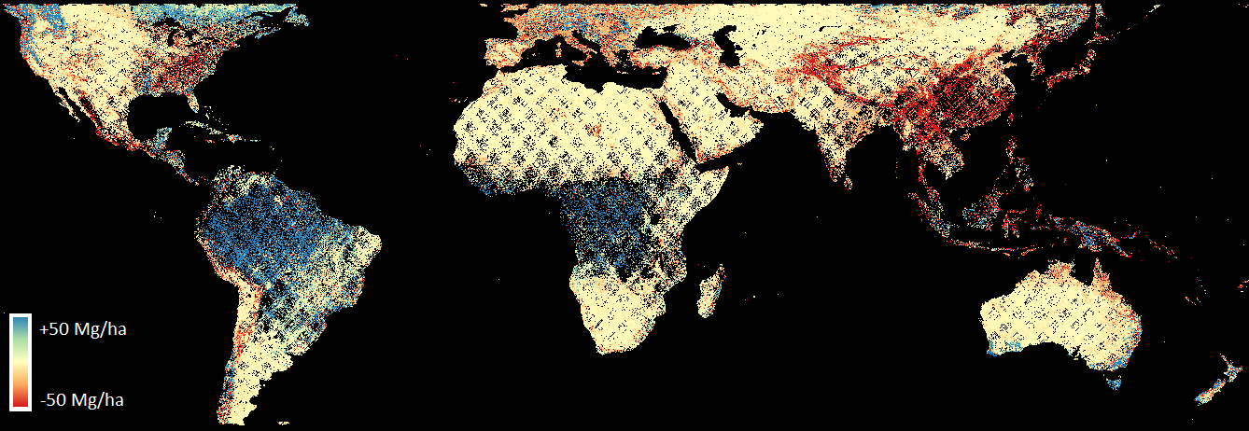
Figure 4: Difference in the aboveground biomass density (i.e. Mg/ha) estimated in the ESA CCI Biomass 2018 product and the GEDI L4B product at 1 km x 1 km grid cells. The largest differences are observed in the tropical belt.

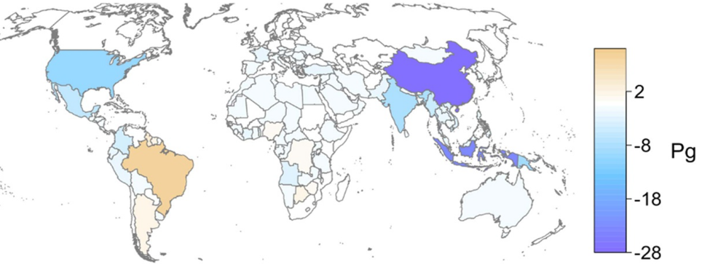
Figure 5: Difference in the total aboveground biomass stock reported in UN-FAO Forest Resource Assessment (FRA) reports and estimated using data collected by the GEDI instrument (reproduced from Dubayah et al. 2022).

Any policy-revelation decisions to be made with space-based AGB products requires the harmonization of the maps with policy guidance and individual country-level requirements. The IPCC Guidelines for National Greenhouse Gas Inventories (NGGI; IPCC 2006; IPCC 2019) recommends transparent and consistent accounting of various sources of uncertainty, including the variability in input training data, in model parameters and their residuals, and an estimation of systematic errors. These guidelines are designed so that “reported numbers are neither over- nor under-estimates, and uncertainties are reduced as far as is practicable''. As a step towards satisfying the conditions in these guidelines, various international teams under CEOS are now coordinating to harmonize and standardize definitions, transparency and usability of space-based AGB maps. The envisioned long-term goal is not necessarily to fuse existing products, but to harmonize each one of them with policy needs and set the stage for AGB estimates from the future missions to be seamlessly incorporated in policy reporting.

To achieve common ground in the integration of space-based AGB maps into national-level reporting, an initial step in ‘biomass harmonization’ has been to make a suite of products freely visible and available on a single platform. These products include global AGB maps for 2020 developed by the Jet Propulsion Laboratory (JPL), ESA’s CCI Biomass project and the GEDI Science team, together with a continental map for Africa from the UK National Centre for Earth Observation (NCEO) and a pan-boreal map from the ICESat-2 Science Team. This is being undertaken as an open science activity on the joint NASA/ESA Multi-mission Algorithm and Analysis Platform (MAAP); a summary of these products can be found on the Biomass Harmonisation Dashboard (https://earthdata.nasa.gov/maap-biomass/). The ‘biomass’ harmonization activity also includes a basic tool (plot2map) that uses a global collection of reference data to estimate systematic biases in maps. A parallel initiative to support the process of map calibration/validation is Geo-Trees (https://geo-trees.org/project/), that aims to establish high-quality global Biomass Reference Measurement sites (BRM) (Figure 6), with standardized and transparent measurement protocols that will enhance space-based forest AGB estimation (Labrière et al. 2022). Such BRMs, if realized, must be targeted in the tropical areas where lack of in situ data is greatest and the systematic differences between AGB maps largest.

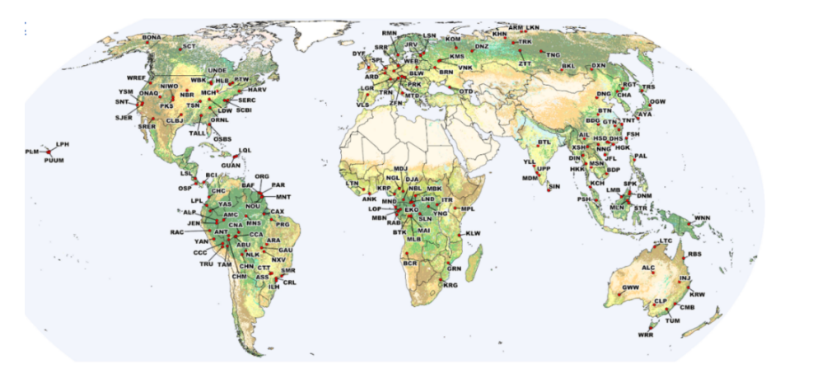
Figure 6: Potential global locations and partners of the Geo-Trees Biomass Reference Measurement sites (BRM) (Labrière et al. 2022).

Overall, the roadmap for Biomass Harmonization over the next few years aims to set the stage for AGB estimates from the future missions to be incorporated in policy reporting for the collective ambition of reducing forest carbon emissions. This will be achieved by (1) intercomparing EO-derived AGB map products and associated uncertainties, (2) evaluating product uncertainties by validation using reference, (3) testing a suite of approaches to improve AGB map estimates and finally (4) co-developing tools and protocols to facilitate the uptake of AGB map products for national reporting. These steps can inform a protocol for a common analytical framework for EO-based AGB estimation from future missions.

Mangrove biomass
Mangroves have the capacity to sequester and store large amounts of carbon in their above ground mass but also below ground due to the slow decomposition rates of organic matter in their inundated, anoxic soils. Once disturbed and exposed to oxygen through diking and draining, oxidation occurs quickly, and the stored carbon is released rapidly to the atmosphere. In contrast to many terrestrial forests, the root systems of some mangroves species are above ground and can support substantial amounts of biomass, with these increasing with maturity.
The Global Mangrove Distribution, Aboveground Biomass, and Canopy Height dataset (Simard at al. 2019) from the NASA Carbon Monitoring System was derived from SRTM Digital Elevation Model and spaceborne Lidar (ICESat GLAS), correlated with region specific allometric models. It is provided at 30 m spatial resolution. While representing the state of the global mangroves for a single year 2000, the dataset represents the most comprehensive global mangrove dataset suitable for use as proxy for mangrove Emission Factors. A refined version of the dataset is under development, based on digital elevation data from the TanDEM-X mission for the baseline year of 2015 and with a spatial resolution of 12 m. Global maps of forest biomass are also being generated through ESA’s CCI Biomass for multiple years (currently 2010, 2017, 2018 and 2019) and offer potential for quantifying changes.
Complementing the above-ground component data, the Global Mangrove Watch Platform (GMW 2023) also provides a global map of mangrove Organic Carbon Stock (OCS), derived from the Soil Organic Carbon dataset by Sanderman at al. (2018). OCS is predicted at 0–200 cm depth and provided at 30-m spatial resolution.

Peatland biomass
The vast majority of peatland carbon is stored as below-ground biomass, composed of dense, wet layers of dead and partially decomposed organic matter built up over thousands of years, with exceptionally slow decomposition rates due to the anoxic conditions in the permanently waterlogged soil. While peatlands cover only about 3–4% of the Earth's land surface (UNEP 2022), they are estimated to hold somewhere between 18–89% of global terrestrial C biomass (Minasny et al., 2019).
The wide uncertainty range is partly due to the challenge in mapping peatland extent, but chiefly because peat carbon storage is closely correlated with peat depth, which typically requires access to extensive in situ measurements to model and estimate.
While global maps of peat thickness are lacking however, the fine resolution regional maps over the peatlands in Central Africa (ROK, DRC, see Figure 7), Peru and Indonesia (Crezee et al. 2022b; Hastie et al, 2022; Anda et al. 2021) mentioned above, have been derived using a combination of EO data and extensive field measurements, and provide disaggregated estimates of peat thickness. For the countries they cover (ROC, DRC, Peru, Indonesia) they constitute the best available proxy data for Emission Factors for peatlands.
Other countries have also developed their own peatland maps, with an example being Wales (UK), where extent, thickness and emissions have been measured or estimated.
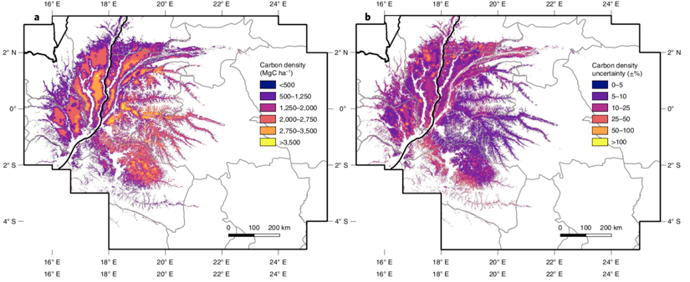
Figure 7. Peat carbon density (left) and uncertainty (right) in ROC and the DRC. (Crezee, 2022a).

Recognising the urgent need for improved geospatial data of global peatland extent and carbon storage, and actions toward the conservation, restoration, and sustainable management of peatlands, the Global Peatlands Initiative, GPI, launched the Global Peatlands Assessment at the UNFCCC COP27 in 2022, calling for the development of data systems on peatland extent, condition and uses, to inform policy planning and regulations (UNEP 2022).

Trees outside forests
In recent years, the mapping of trees outside forests has been enabled through a combination of high-resolution imagery and machine learning techniques (Brandt et al., 2020, Li et al., 2023). In particular, convolutional neural networks have proven successful in recognizing the crown shape of shrubs and trees in open-canopy forests and savannas over large spatial extents (i.e., national to biome scale). Using commercial imagery such as Worldview, over 9.9 billion individual trees and shrubs were mapped throughout the Sahel and new allometric models applied to estimate canopy, stem and root biomass of every individual (Tucker et al., 2023). At national levels, canopy-recognition approaches have been shown to work for closed and open-canopy forests, providing new insights into biomass distributions across different forest types (Mugabowindekwe et al., 2023). These same approaches have recently been used to estimate the biomass of trees outside forests in temperate regions, where studies in Europe have shown at country level, trees outside forests make up to 10% of natural biomass (Li et al., 2023).
Crop, range and grasslands
In order to accurately report on greenhouse-gas emissions in croplands and grasslands (rangelands), tier 3 reporting often relies on sophisticated processed-based biogeochemical models such as DAYCENT or DNDC. However, these models can be further improved by incorporating Earth observation (EO)-derived products related to key factors such as soil moisture, land cover/land use, weather data, vegetation productivity, and biomass estimation. Such data could provide a more comprehensive and accurate estimation of GHG emissions from agricultural systems.

Improvements to biomass products could also significantly benefit tier 1 and 2 reporting. While there are several products available for forests, there are currently limited options for croplands and grasslands. There are not as many biomass products available for croplands and grasslands as there are for forests. Spawn et al. (2020) have created a harmonized product for above and belowground biomass for the year 2010. By harmonizing several inputs into a comprehensive representation across vegetation types, this product provides an imminently usable resource for estimating biomass from grasslands and croplands.

4. Approaches to estimate AFOLU-related emissions/removals
IPCC approach
The remote sensing based data products described in Section 3 that can be used as activity data (ha yr⁻¹) and emissions factors (tCO₂e ha⁻¹) are the basis for estimating emissions and removals (tCO₂e yr⁻¹). These data products can be mapped to IPCC variables (Table 4) and combined in a series of increasingly complex modeling approaches to provide Tier 1, 2 or 3 estimates, with Tier 3 considered to have highest accuracy and precision. The IPCC Guidelines for the AFOLU sector provide two high-level approaches to estimate stock-changes referred to as 'stock-difference' and 'gain-loss'. The stock-difference method compares changes in biomass from one time point to another, to assess carbon stock changes translated into emissions or removal estimates. In this method, the area of land in each land category at times (t) t1 and t2 is identical. On the other hand, the default gain-loss method estimates the net balance of additions to and removals from a carbon stock in all land categories. For example, changes in biomass carbon stocks on land i converted to land j is estimated by the difference between the biomass stocks of j immediately after the conversion and the biomass stocks of i (B_{AFTER} - B_{BEFORE}, t d.m. ha⁻¹yr⁻¹) multiplied by the area change of land i to land j (AD_{ij}, ha yr⁻¹; i and j are country specific strata). This initial change in biomass stocks between categories is increased by the average annual biomass growth (ΔC_{G}) and decreased by the average annual biomass losses due to wood removals or disturbances (ΔC_{L}, t d.m.ha⁻¹yr⁻¹) on the land in the year of conversion (t d.m. ha⁻¹yr⁻¹). The decision on which approach to use is based on the availability of data, with most GHG inventories submitted to the UNFCCC using the default gain-loss approach. When national data is not available, Tier 1 methods are applied and default values are used. For forest land, for example, the IPCC Guidelines provided default values for estimating the variables for the ‘gain-loss’ method using globally available sources, distinguishing climate domain, ecological zone, continent, forest age structure, and for plantation or natural forests.
Table 4. Variables used in the IPCC equations for estimating carbon stock changes in the AFOLU sector (Volume 4, Chapter 3, IPCC 2006). The first five variables correspond to the gain-loss method while the last two are used in the stock-difference method.
Variable | Description | Equation from the IPCC 2006 Guidelines
B_{AFTERi} | biomass stocks on land type i immediately after the conversion, t d.m. ha⁻¹ | Equation 2.16
B_{BEFOREi} | biomass stocks on land type i before the conversion, t d.m. ha⁻¹ | Equation 2.16
AD_{ij} | area of land remaining in the same land-use category, or area of land use i converted to land-use j in a certain year, ha yr⁻¹ | Equation 2.9,
ΔC_{G} | annual increase in carbon stocks in biomass due to growth on land converted to another land-use category or in land remaining in the same land-use category by vegetation type and climatic zone, in t C yr⁻¹ | Equation 2.7, 2.9
ΔC_{L} | annual decrease in biomass carbon stocks due to losses from harvesting, fuel wood gathering and disturbances on land converted to other land-use category or in land remaining in the same land-use category, in t C yr-1 | Equation 2.7, 2.11
C_{t1} | carbon stock in the pool at time t₁, t C | Equation 2.5 and 2.8
C_{t2} | carbon stock in the pool at time t₂, t C | Equation 2.5 and 2.8

In addition to considerations on the method selected by countries in their reporting, other IPCC factors need to be considered when handling and presenting satellite-based data products or maps, including national definitions, spatial resolution, temporal coverage and temporal resolution. Failing to consider a single one of these factors can render the data products unsuitable for uptake in national reporting to the UNFCCC and make the global independent estimates so conceptually different to the aggregated GHG inventories that they may fail to inform the Global Stocktake process. For example, the managed land proxy adopted by the IPCC Guidelines as a pragmatic approach to exclude natural fluxes and the national definitions of what constitutes a forest and other land uses are country specific. Grassi et al. (2023) quantified a large difference of 6.7 GtCO₂ yr⁻¹ in global land-use CO₂ fluxes between the ensemble mean of the bookkeeping models used in the IPCC assessment reports (Canadell et al., 2021), and the estimates from the aggregated NGHGIs. After adjustment to be conceptually more comparable, the two sources show that the LULUCF sector is an increasing sink, and the order of magnitude of fluxes is relatively similar with an average for the past two decades of a little under 2 GtCO₂ yr⁻¹ removed from the atmosphere. While satellite-based data products serve multiple purposes, in the context of contributing to the Global Stocktake, similar reconciliation when presenting the data (or adherence to the IPCC guidelines) is encouraged.

Hybrid IPCC-Earth Observation approach
In 2021, Harris et al. (2021) introduced a global data integration framework (GFOI Methods and Guidance 2020) for monitoring forest GHG emissions and removals that follows similar “gain-loss” methods for reporting net carbon stock changes as those used by many countries in reporting LULUCF fluxes to the UNFCCC as part of their national GHG inventories. Rather than relying on country data that can be inconsistent, incomplete and statistical rather than spatial in data format, Harris et al. incorporate data into this framework derived from satellite, lidar and ground observations to develop a geospatially explicit, bottom-up monitoring system of forest emissions and removals mapped at 30 m resolution. The framework was designed to enhance science-policy coordination around methods and data and includes several of the EO-based data products summarized above. It was designed to be flexible enough to accommodate new sources of data as they come online and as the state of the science matures.

Activity data used in this approach are tree cover extent, loss and gain from Hansen et al. 2013 (updated annually on Global Forest Watch). Drivers of tree cover loss (Curtis et al. 2018) and MODIS burned areas (Giglio et al., 2016) are used to separate observed loss of tree cover into deforestation (conversion to a new land use) vs. other forms of forest disturbance that lead to emissions (forestry activities, wildfires). This distinction is important for determining the carbon pools included in emission factors under an IPCC approach. Data sources for developing emission factors include aboveground biomass in the year 2000, root to shoot ratio, soil organic carbon, mangrove specific biomass and soil, peat.

Options remain limited for data-driven, satellite-based monitoring approaches for developing accurate and spatially explicit removal factors. This is because methods development thus far has been focused on mapping biomass at a single point or period in time, driven largely by the need to develop deforestation emission factors under the MRV agenda of REDD+. In general, these approaches cannot yet accurately separate the signal of subtle gains in forest biomass resulting from changes in forest stand dynamics over time from the relatively large uncertainties of static biomass maps (Arevalo et al. 2023). Therefore, as a first step to mapping forest carbon removals, Harris et al. applied a “stratify and multiply” approach based on stratifying global forests by continent, age, and type (primary/intact, secondary, regrowth, planted, agroforestry and tree crops) and applying removal factors derived from compiling repeated NFI data or field plots especially in the tropics.

The data integration framework was designed to be flexible and updatable. As such, several short-term improvements and enhancements have been implemented since the original publication. Regarding improved activity data, these include updated tree cover loss through 2022 and gain through 2020, improved spatial attribution of forest (Tyukavina et al. 2022), and improved mapping of peat extent as summarized above for Congo Basin, Peru and Indonesia, and globally (refs). For emission factors, updated GWPs from IPCC AR6 for estimating non-CO₂ emissions from fire and spatially explicit allocation of root biomass (ref).

Longer-term data improvements are focused on improving maps of the spatial and temporal dynamics of forest carbon removals in undisturbed stands ranging in age from young to old growth forests, for example by deriving removal factors from space-for-time approaches (e.g. Heinrich et al. 2023) and/or developing spatially explicit matrix models (Liang et al. xxx) trained using in situ repeated measurement inventory data to simulate stand-level forest population dynamics and associated forest carbon dynamics. Efforts are also underway to expand this data integration approach beyond forests to map all AFOLU fluxes globally including emissions from croplands (Carlson et al. 2016) and livestock (Herrero et al. 2017).

Dynamic Global Vegetation Models
By a Dynamic Global Vegetation Model (DGVM) we mean a gridded process-based model that calculates the individual and net fluxes that comprise the carbon balance of the land surface, and in which vegetation and soil properties evolve dynamically through time. DGVMs therefore provide a key element in understanding and quantifying changes in atmospheric CO₂. Although originally designed to be driven solely by climate, with all internal processes being parameterised, they have increasingly been required to simulate observed temporal variations in atmospheric CO₂. To do so they must dynamically adjust to externally imposed land use and land use change. Friedlingstein et al. (2022) list 17 DGVMs that meet this condition, which is the key link to AFOLU activities. Also relevant is the CASA Light Use Efficiency Model coupled to the GFED4 fire databases (van der Werf et al., 2017), which calculates land-atmosphere C fluxes using a process-based approach and is directly driven by a range of satellite-derived variables.

While realistic modeling of observed land C fluxes requires DGVMs to represent actual human management activities, the carbon consequences for vegetation and soils are calculated according to the internal processes within each individual DGVM. This includes plant growth and mortality, plant and soil respiration in both natural and managed landscapes, and natural disturbance (such as wildfires). Hence the amount of biomass available in a grid cell is a property of each individual model and the emissions due to LUC cannot be parameterised by simple "emissions factors" (as in the IPCC approach to producing national GHGIs). Instead the emissions arise from a complex interplay between local climate, model parameters, and the rules adopted when allocating carbon from the vegetation affected by LUC. Hence the emissions calculated by DGVMs are much more fine-grained that can be captured by the emission factor concept.

Because DGVMs account for ambient environmental conditions, such as atmospheric properties, they include the indirect human-induced and natural effects of LUC, not just the direct human-induced effects. The indirect effects come from human-induced environmental changes, such as temperature and precipitation changes, atmospheric CO₂ concentration and nitrogen deposition, whereas natural effects include climate variability and natural disturbances, such as wildfires. National GHGIs based on direct observation according to IPCC guidelines implicitly include such indirect and natural effects. Hence, in principle, their estimates of the emissions (positive and negative) from managed land should be consistent with those from DGVMs. However, currently the net global anthropogenic land emissions estimated from GHGIs is about 4 GtCO₂ yr⁻¹ lower than those from an ensemble of DGVMs (Grassi et al., 2018 and see Schwingshackl et al., 2022).

There are conceptual and practical reasons why DGVMs and NGHGIs are likely to disagree on both the carbon emission and sink terms arising from LUC. One concerns the fate of carbon lost due to deforestation or forest degradation. This needs to be assigned to immediate emissions, long-lived wood products and residual coarse woody debris, and the proportions of each differ between different models. These three components have different rates of emissions to the atmosphere. In addition, the extracted wood may be transported elsewhere, so is removed from the local or regional carbon balance, and will not give rise to local emissions. A second is that DGVMs vary in the parameters used when calculating quantities such as vegetation growth, mortality, above and below ground carbon allocation, litter fall, soil respiration etc. Hence the sizes of the carbon pools vary between models, which has immediate consequences when calculating carbon emissions under LUC, and their dynamics also vary, with differing values of carbon residence times. Thirdly, DGVMs vary in the range of processes they include and how they include them, for example, nitrogen deposition and fire (both on managed and unmanaged land, and whether used as part of land management or not).

Nonetheless, DGVMs can play an important role in closing the apparent large discrepancy between emissions estimates from GHGIs and Integrated Assessment Models (IAMs), which the IPCC uses to explore scenarios and pathways of future changes. Comparisons with historical data show that IAM estimates of the global net anthropogenic land emissions exceed those from GHGIs by about 5.5 GtCO₂ yr⁻¹. However, DGVM-based estimates of the indirect human-induced and natural effects of LUC (which are not in the IAMs) can explain the whole of this discrepancy (Grassi et al., 2021[a1] ).

Global datasets and spatially explicit models, such as those used in the Global Carbon Budgets (GCB; Friedlingstein et al., 2020, 2021), can make a valuable contribution to the GST by providing an independent, low latency (i.e., near-real time) and consistent way of linking global to national GHG budgets (Hegglin et al., 2022, Bastos et al., 2022). Several studies have already aimed at linking national inventories to global approaches, both for atmospheric inversions (e.g., Chevalier et al., 2021, Deng et al., 2022, Byrne et al., 2023) and land carbon flux models (DGVMs and bookkeeping models) (e.g., Grassi et al., 2018).

A key challenge in using global budgets, such as that from the GCB, is that they contain large uncertainties in: (i) the spatial distribution of surface GHG fluxes, at the scale of large regions, and even more over small regions or countries due to model structural differences, parameter values and model input data; (ii) the LULCC and management input datasets used to estimate corresponding fluxes by bookkeeping models and Dynamic Global Vegetation Models (DGVMs); (iii) the attribution of fluxes to human vs. natural processes, or to managed/unmanaged lands; (iv) definitions used to account for different fluxes.

Despite the enormous development and expansion of Earth Observation (EO) networks and satellite platforms to monitor Essential Climate Variables (ECVs) in the past decades (Popp et al., 2020), many of which are relevant to the global carbon cycle, EO data are still underused in NGHGI and BK/DGVM approaches (Bastos et al., 2022). Recent case-studies have called for (and shown) the potential of) deeper integration of EO data in models used to quantify different terms of carbon budgets and attribute them to specific processes (e.g., Thais et al., 2021, Heinrich et al., 2021, Bultan et al., 2022, Fawcett et al., 2023). One of the main challenges in the use of (satellite) EO data directly being that it only allows estimating instantaneous fluxes, while legacy fluxes are needed.

Bookkeeping approaches
Bookkeeping approaches (BK) model carbon losses and gains following LULCC based on land-use and land-cover type specific C densities and response curves following transitions (e.g., transitions between various natural and managed vegetation types, croplands and pastures). Unlike DGVMs, they do not simulate carbon stocks but use observational data to assign carbon densities to given cover types, such as literature-based biome-level values and inventory data. Hence, BKs do not include the effect of changing environmental factors, such as climate and CO₂ fertilization, on vegetation growth rates and soil respiration. The carbon stored in vegetation and soils before and after a change in land-use is tracked using literature-based response curves that describe the decay of vegetation and soil carbon, including transfer to product pools of different lifetimes, and carbon uptake due to regrowth. Secondary forests and long-term degradation of primary forest can be represented in terms of reduced values of above-ground biomass and soil carbon stocks; forest management practices, such as wood harvests, can also be included. Models differ in their parameters, response curves, LULCC forcing and spatial detail of transitions and fluxes.

In general, bookkeeping models have relied on statistical surveys and generalized global to regional emission factors to estimate carbon emissions and removals. More recently, integration of remote sensing activity data as the underlying driver, i.e., replacing FAOSTAT with Land-Use Harmonization dataset (Chini et al., 2020), to estimate emissions, see Hartung et al., 2021. Remote sensed emission factors are also being evaluated as part of the book-keeping model workflow (Bastos et al., 2021), replacing generalized biomass estimates with values more representative of a wider range of ecosystem types, e.g., Bultan et al., 2022.

5. Perspective on CEOS GHG roadmap
Approaches used to estimate AFOLU emissions and removals rely on the activity data and emissions factors described in the previous sections. In contrast, changes in atmospheric concentrations can be used to provide a top-down constraint on emissions and removals using atmospheric inversion approaches. The CEOS GHG Task Team has been carrying out pilot top-down assessments as part of the CEOS GST activity to demonstrate how atmospheric constraints can inform country-level sectoral emission and removal estimates (see Deng et al., 2022, Byrne et al., 2022). Atmospheric inversions can be done mainly independent from the data used in the bottom-up approaches in AFOLU, and thus provide a useful basis for comparison and quantification of uncertainties.

In the context of the GST, comparisons between top-down (CEOS GHG) and bottom-up (CEOS AFOLU) must take into account several systematic differences. These include differences in i) the resolution of sectors responsible for emissions and removals, ii) the spatial resolution of each approach in the context of country size, iii) definitions used for the managed land proxy by each country, and iv) the treatment of the land-ocean-aquatic-continuum fluxes.

6. Capacity building & user engagement
The user engagement activities contribute to the main goals of the AFOLU roadmap through the collaboration between the CEOS agencies engaged in land surface and carbon process observation and the domestic GHG inventory analysts and land measurement experts in the context of the UNFCCC, as well as capacity building programs and country practitioners. The activities are led by USGS SilvaCarbon and are leveraged by the program's partner network and well-established relationship with Government institutions. The overarching goals are to:
- Establish the needs and requirements for using space-based data and derived products to report carbon emissions from the AFOLU sector.
- Provide national feedback on, and contribute to refining available products derived from satellite data.
- Demonstrate the uptake of products in UNFCCC processes, including in domestic GHG inventories submitted to the Convention, which are input to the Global Stocktake.

The use of space data by GHG inventory teams for the first Global Stocktake provide numerous examples of data and products used at the moment. Lessons learned and best practices from these existing examples (e.g., Melo et al, 2023) complemented with examples from active research are used in the preparatory work of the AFOLU task team for the engagement activities. Regional workshops and development of case studies or demonstrations are planned ahead of the new cycle of submissions starting in 2024, which will be an input to the 2028 Global Stocktake. These activities are to be implemented in a collaborative interface of national and global monitoring experts, including LULUCF GHG inventory experts, to facilitate the understanding of the differences between global and domestic estimates which follow the IPCC guidance.

The coordination developed by space agencies for AFOLU efforts (see the CEOS Global Stocktake data portal) is strengthened by the engagement with national GHG inventory teams and experts. The collaborative interface between global and national land monitoring experts will coincide with the transition from the current MRV framework to the more stringent reporting requirements of the Paris Agreement, and its Enhanced Transparency Framework (ETF). The activities are led by the USGS SilvaCarbon Programme and articulated with the GFOI capacity building initiatives. They are also leveraged by SilvaCarbon’s partner network and well-established relationship with Government institutions responsible for reporting to the UNFCCC. The objectives of this collaborative framework are to:
- determine needs and requirements regarding the potential use of space-based data and derived products for specific IPCC variables, following IPCC guidance and principles;
- test and improve existing datasets;
- address some of the outstanding issues that hinder the use of products by national teams; and
- provide examples of the practical implementation of the 2019 Refinement to the 2006 IPCC Guidelines.

First results from the collaborative work between global and national land monitoring experts and LULUCF experts reviewing GHG inventories include:

- Preparation of regional workshops
In 2023, two regional workshops organized by SilvaCarbon/CEOS took place in Paraguay (2022) and Thailand (2023), providing forested countries with valuable opportunities to access global and pantropical datasets for biomass estimation and mangrove extension. Additionally, the Silvacarbon program conducted bilateral activities in selected countries to test global products. SilvaCarbon is currently testing global datasets in Solomon Islands, Paraguay, Colombia, Guatemala, Peru, Vietnam, Laos, and Gabon. The next workshop is being planned for September 2023 in Gabon. In the regional workshops, national technical teams presented their current methods and NFIs, invited independent experts to introduce and discussed the IPCC guidance and requirements; and remote sensing experts and scientists from CEOS agencies showed their different mapping data and methods. The dialogue begins in the workshops but continues at national scales in working clusters composed of national experts, global experts, and experts nominated by national teams to the UNFCCC roster to achieve the objectives listed above. Below there are some examples of the current efforts using global datasets in countries.
- Paraguay example: country-specific EO calibration (recalibration of GEDI to NFI; Bullock et al, submitted). CEOS & UNFCCC Global Stocktake
- GLAD Global Map uptake in Peru, Colombia and Guatemala CEOS & UNFCCC Global Stocktake
- Peru examples: EO as auxiliary data to improve precision in NFI estimates (validation with NFIs; increased precision).
- West Africa example: improved EO calibration (improving local reference data to improve EO models).
- Mexico: temporal gap-filling of NFIs.
- Solomon Islands - potential for using EO data when no other data is available.
- Vanuatu - potential for using EO data when no other data is available.
- Laos and Vietnam - improving calibration of GEDI based pantropical datasets.

A second activity includes an overview of the use of satellite-based global maps in domestic GHG inventories and reporting to the UNFCCC (Melo et al, 2023). This activity developed a baseline to assess progress on the uptake of satellite-based global maps in the next cycles of the Global Stocktake as a needed reflection from the EO community on what we are delivering, which is an essential step to influencing policy. The evidence shows that all developing countries use satellite data, mainly Landsat and imagery accessed through the Collect Earth platform, to develop national estimates of AD (Figure 8). However, the use of global maps is very limited, and for biomass maps the use is only indirect, for example as a verification tool used for domestic quality control or by the expert LULUCF reviewers.

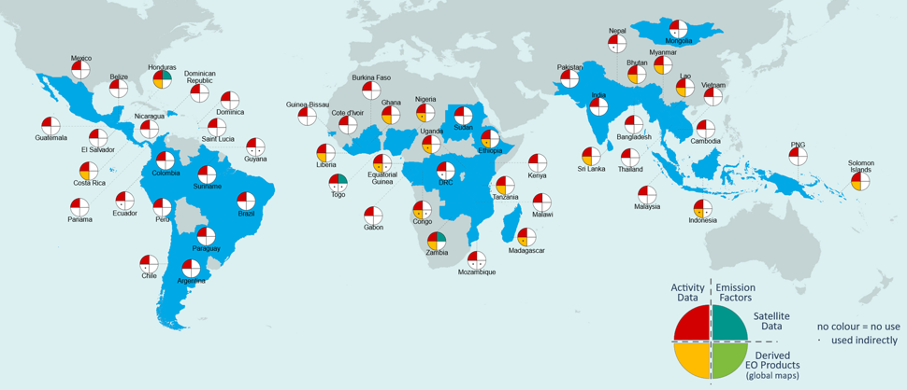
Figure 8. Analysis of use of EO data in forest reference level submissions to the UNFCCC by developing countries between 2014 and 2022. The color scheme in the quadrant charts shows the use of satellite data (e.g. Landsat imagery) and derived EO products (or global maps) to directly derive activity data (AD, left-hand quadrants in red and yellow respectively), and emission factors (EF, right-hand quadrants in teal and green respectively). Indirect uses of EO products are represented with a • mark in a quadrant (e.g. use for validation, to justify decisions) (source: Melo et al., 2023)

Similar collaborative activities to demonstrate the uptake of satellite-based data products in national reporting and for climate policy applications can be implemented with teams from developed countries. Especially given that examples of fully complete and spatial GHG inventories are also rare (or even nonexistent) for Annex I countries and there is political will to support existing systems with satellite-based data

Lessons learned and recommendations:
Recommendations from testing biomass maps

- Calibration is challenging due to the limited amount of NFI pantropical data. There are many global and pantropical biomass maps, and all then differ in their biomass estimate, given different volumes by different maps in the same areas. Usually, the uncertainty of these maps is calculated at a global scale. The discrepancies between global and pantropical biomass maps are a common challenge in carbon accounting. Therefore, it can be difficult for country officials to decide which biomass map suits their specific needs and circumstances. Ultimately, the choice of biomass map will depend on each country's particular needs and priorities. It may be helpful for country officials to consult with experts in the field of carbon accounting and measurements to determine which biomass map is most suitable for their needs.

- Some of the maps don't fit the requirements for reporting. Therefore, it may be necessary to develop guidelines and standards for biomass mapping to ensure that future maps meet the requirements for carbon emission reporting. For example, establishing minimum standards for validation.

- Harmonization is no longer possible. While achieving complete harmonization may be difficult, steps can still be taken to improve the accuracy and reliability of biomass mapping and carbon emission reporting.

- Lifetime of the satellite information is uncertain: GEDI has made significant contributions to our understanding of forest structure and carbon storage, and the instruments it is on pause for a time. Satellite data uncertainty is a factor that will play a role in countries using a global product considering the risk that there would not be a future iteration.

Recommendations from testing mangroves maps:

- Calibration: Calibration can improve estimates' accuracy and precision and ensure they are consistent with ground-based measurements. However, a limited amount of National Forest Inventory (NFI) data are available for mangroves. To have more calibration data, the SilvaCarbon program provides training on protocols to collect mangrove inventory data (above and below-ground biomass). It is a complex issue due to the difficulty and cost of mangroves NFI. It recommended that the CEOS group keep this as a priority and invest in mangroves' ground-based data.

- Field inventories: Given that most of the carbon stored in mangroves is underground, conducting field inventories that include below-ground biomass measurements may be necessary to estimate carbon stocks and emissions accurately. A combination of remote sensing data and field inventories can provide a more comprehensive picture of carbon stocks and emissions for this ecosystem.

- Combining activity data and emission factors: It can be challenging to combine activity data (such as land-use change) with emission factors (such as carbon stock changes), particularly for complex ecosystems like mangroves. Improved methods are needed to integrate these data sources and produce accurate estimates of carbon emissions.

- Reporting ambiguity: There may be ambiguity around where to report mangroves, particularly concerning the Greenhouse Gas Inventory (GHGi) and the REDD+ annex. Clear guidelines are needed to ensure that mangroves are written consistently and accurately in the forest or wetlands classes.

- Linking with databases: Finally, it is recommended to connect mangrove global maps developers with programs with historic ground-inventory data, such as the SWAMP carbon database. This can help the new iteration of mangrove maps.

7. Forward looking to 2035+
The recommendations from this Roadmap provides guidance for near, medium and long term support of remote sensing for the Paris Agreement and Global Stocktake. By near-term, the Roadmap identifies operational missions, mature modeling approaches, and pathway for engaging with stakeholders in the inventory community to address the first Global Stocktake in November 2023. Medium term recommendations are made in line with supporting the second Global Stocktake in 2028, with reference to planned missions and sustained land imaging, as well as adoption and development of new models to support AFOLU. Long term recommendations look toward 2035+, a period when the NDC’s achieve emissions reductions of 50%, and when a new generation of GHG satellites are in orbit, and when regular-annual inventories are provided to the UNFCCC. At the same time, the recommendations acknowledge the emergence of New Space and the role of the commercial sector in providing very-high resolution optical and radar imagery to support imaging spectroscopy, land surface feature mapping, and enable deep learning and artificial intelligence algorithms to detect changes in land-use and land cover and to estimate emission factors. For example, the Blue Carbon ecosystem app developed between The Nature Conservancy and Planet provides changes in mangrove and seagrass carbon stocks easily accessible to the inventory and climate mitigation and adaptation community (https://tnccaribgis.users.earthengine.app/view/blue-carbon-explorer).

Looking forward, we will move into a world where a system is required in post 1.5-degree C world, rapidly on its way to net zero emissions. In this world, the carbon cycle will be changing due to climate change. Therefore, we shall aim to evolve into a system capable of observing the carbon cycle in a changing climate. A GHG+ observing system that integrates GHG’s and AFOLU to carry out both the UNFCCC reporting requirements and to also detect the climate-carbon responses. For the 2035+ timeframe, we will need to identify science needs (modeling, integration, new/sustained missions). From a CEOS perspective, the GHG and AFOLU roadmaps need to become integrated at the 5-year timeframe.

In addition to recommending the AFOLU Roadmap, the CEOS Strategy to Support the Global Stocktake also recommended an AFOLU themed field campaign. Recommendation #4 states that “CEOS should consider, in conjunction with modelers, setting up one or more focused observational campaigns in the areas suggested above, or others, as a major contribution to the understanding of the trends of GHG emissions from natural sources in key areas”. Such a campaign can leverage the recommendations laid out in Annex A, in particular to support engagement between the CEOS and inventory communities, to explore synergies of operational and planned missions using aircraft instruments, enable and mature modeling approaches, and to include non CO₂ gases such as CH₄ and N₂O.

The recommendations are intended to adapt and evolve as the IPCC and the Global Stocktake revise guidelines and identify new areas for research and applications. The Earth system is changing rapidly and thus revisiting observing systems and their ability to detect, monitor and quantify climate impacts is required. Climate policy and the emphasis between mitigation, adaptation, loss and damage, is also dynamic, and requires the recommendations in the Roadmap to be flexible and adaptive. The observing landscape is also changing rapidly, with CEOS partners such as WGClimate, the World Meteorological Organization, GCOS, the World Climate Research Program establishing their own definitions and/or frameworks for GHG+, along with efforts from the private sector, i.e., ClimateTrace.

8. References
Anda, M., Ritung, S., Suryani, E., Sukarman, Hikmat, M., Yatno, E., Mulyani, A., Subandiono, E.S., Suratman, and Husnain. (2021). Revisiting tropical peatlands in Indonesia: Semi-detailed mapping, extent and depth distribution assessment. Geoderma, 402, 115235. https://doi.org/10.1016/j.geoderma.2021.115235.

Arévalo, Paulo, Alessandro Baccini, Curtis E. Woodcock, Pontus Olofsson, and Wayne S. Walker. Continuous Mapping of Aboveground Biomass Using Landsat Time Series. Remote Sensing of Environment 288 (2023): 113483. https://doi.org/10.1016/j.rse.2023.113483.
Bastos, A., Ciais, P., Sitch, S. et al. On the use of Earth Observation to support estimates of national greenhouse gas emissions and sinks for the Global stocktake process: lessons learned from ESA-CCI RECCAP2. Carbon Balance Management, 17, 15 (2022). https://doi.org/10.1186/s13021-022-00214-w.

Boschetti, Luigi, David P. Roy, Louis Giglio, Haiyan Huang, Maria Zubkova, and Michael L. Humber. Global Validation of the Collection 6 MODIS Burned Area Product. Remote Sensing of Environment 235 (2019): 111490. https://doi.org/10.1016/j.rse.2019.111490.
Brandt, M., Tucker, C. J., Kariryaa, A., Rasmussen, K., Abel, C., Small, J., Chave, J., Rasmussen, L. V., Hiernaux, P., Diouf, A. A., Kergoat, L., Mertz, O., Igel, C., Gieseke, F., Schöning, J., Li, S., Melocik, K., Meyer, J., Sinno, S., Romero, E., Glennie, E., Montagu, A., Dendoncker, M., & Fensholt, R. (2020). An unexpectedly large count of trees in the West African Sahara and Sahel. Nature, 587(7832), 78-82. https://doi.org/10.1038/s41586-020-2824-5
Bultan, S., Nabel, J.E.M.S., Hartung, K., Ganzenmüller, R., Xu, L., Saatchi, S., Pongratz, J. (2022). Tracking 21st century anthropogenic and natural carbon fluxes through model-data integration. Nature Communications, 13(1), 5516. https://doi.org/10.1038/s41467-022-32456-0.
Bunting, P., Rosenqvist, A., Hilarides, L., Lucas, R.M., Thomas, N., Tadono, T., Worthington, T.A., Spalding, M., Murray N.J., Rebelo L-M. (2022). Global Mangrove Extent Change 1996–2020: Global Mangrove Watch Version 3.0. Remote Sensing, 14(15), 3657. https://doi.org/10.3390/rs14153657.

Byrne, B. DF Baker, S Basu, M Bertolacci, KW Bowman, D Carroll, A Chatterjee, F Chevallier, P Ciais, N Cressie, D Crisp, S Crowell, F Deng, Z Deng, NM Deutscher, M Dubey, S Feng, O Garcia, DWT Griffith, B Herkommer, L Hu, AR Jacobson, R Janardanan, S Jeong, MS Johnson, D Jones, R Kivi, J Lui, Z Liu, S Maksyutov, JB Miller, SM Miller, I Morino, J Notholt, T Oda, CW O’Dell, Y-Sk Oh, J Ohyama, PK Patra, H Peiro, C Petri, S Philip, DF Pollard, B Poulter, M Remaud, A Schu, MH Sha, K Shiomi, J Storng, C Sweeny, Y Te, H Tian, VA Vlaxo, M Vrekoussis, T Warneke, JR Worden, D Wunch, Y Yao, J Yun, A Zammit-Mangioin, N Zeng.. 2022. National CO2 budgets (2015-2022) inferred from atmospheric CO2 observations in support of the Global Stocktake. Earth System Science Data Discussions, 1-59.
Carlson, K. M., Gerber, J. S., et al. (2016). Greenhouse gas emissions intensity of global croplands. Nature Climate Change, 7(1), 63-68. https://doi.org/10.1038/nclimate3180
Chevallier, F. (2021). Fluxes of Carbon Dioxide From Managed Ecosystems Estimated by National Inventories Compared to Atmospheric Inverse Modeling. Geophysical Research Letters, 48(14), e2021GL093565. https://doi.org/10.1029/2021GL093565
Committee on Earth Observation Satellites (CEOS) & Coordination Group for Meteorological Satellites (CGMS). (2020). CEOS/CGMS global constellation for greenhouse gas observations roadmap V2.3. Retrieved from https://ceos.org/observations/documents/CEOS_CGMS_GHG_Constellation_Roadmap_V2.3_cleaned.pdf.
Copernicus Land Monitoring Service. Global land products. Retrieved from https://land.copernicus.eu/global/products/.
Crezee B. (2022a) Spatial distribution, carbon stocks and diversity of peat swamp forests in the central Congo Basin. (Doctoral dissertation). School of Geography, The University of Leeds, UK. Retrieved from https://etheses.whiterose.ac.uk/32358/.
Crezee B., Dargie G.C., et al. (2022b) Mapping peat thickness and carbon stocks of the central Congo Basin using field data. Nature Geoscience Vol 15, 639-644. https://doi.org/10.1038/s41561-022-00966-7.
Curtis, P. G., Slay, C. M., Harris, N. L., Tyukavina, A., & Hansen, M. C. (2018). Classifying drivers of global forest loss. Science, 361(6407), 1108-1111. https://doi.org/10.1126/science.aau3445.
Deng, Z., Ciais, P., et al. (2022). Comparing national greenhouse gas budgets reported in UNFCCC inventories against atmospheric inversions. Earth System Science Data, 14(4), 3601–3619. https://doi.org/10.5194/essd-14-3601-2022
Dubayah, R., Armston, J., Healey, S. P., Bruening, J. M., Patterson, P. L., Kellner, J. R., Duncanson, L., Saarela, S., Ståhl, G., & Yang, Z. (2022). GEDI launches a new era of biomass inference from space. Environmental Research Letters, 17(9), 095001. https://doi.org/10.1088/1748-9326/ac8694.
ESRI 2023. Sentinel 2 10-meter Land Use / Land Cover. https://livingatlas.arcgis.com/landcover/
European Space Agency. WorldCover. Retrieved from https://esa-worldcover.org/en
European Space Agency. (2021). WorldCover Product User Manual v1.1. Retrieved from https://worldcover2020.esa.int/data/docs/WorldCover_PUM_V1.1.pdf.
European Space Agency. (2021). WorldCover Product Validation Report v1.1. Retrieved from https://worldcover2020.esa.int/data/docs/WorldCover_PVR_V1.1.pdf.
Fawcett, Dominic, Stephen Sitch, Philippe Ciais, Jean Pierre Wigneron, Celso H. L. Silva-Junior, Viola Heinrich, Christelle Vancutsem, et al. “Declining Amazon Biomass Due to Deforestation and Subsequent Degradation Losses Exceeding Gains.” Global Change Biology 29, no. 4 (2023): 1106–18. https://doi.org/10.1111/gcb.16513.
Freire, Sergio; MacManus, Kytt; Pesaresi, Martino; Doxsey-Whitfield, Erin; Mills, Jane (2016): Development of new open and free multi-temporal global population grids at 250 m resolution. Geospatial Data in a Changing World; Association of Geographic Information Laboratories in Europe (AGILE). AGILE 2016.
Friedlingstein, P., and co-authors. (2020). Global carbon budget 2020. Earth System Science Data, 12, 3269–340. https://doi.org/10.5194/essd-12-3269-2020.
Friedlingstein, P., an co-authors. (2021). Global carbon budget 2021. Earth System Science Data Discussions,1-60. https://doi.org/10.5194/essd-2021-386.
Friedlingstein, P., Jones, M.W., O’Sullivan, M., Andrew, R.M., Hauck, J., Olsen, A., Peters, G.P., Peters, W., Pongratz, J., Sitch, S., Le Quéré, C. (2022). Global Carbon Budget 2022. Earth System Science Data, 14, 4811–4900. https://doi.org/10.5194/essd-14-4811-2022.
GFOI. Summary of country experiences and critical issues related to estimation of activity data. Retrieved from https://www.reddcompass.org/documents/184/0/ActivityData_Inference_FAQ.pdf/8e93e100-c46b-4ff9-946b-6d0972fd50da
Giglio, L., Schroeder, W., & Justice, C. O. (2016). The Collection 6 MODIS active fire detection algorithm and fire products. Remote Sensing of Environment, 178, 31-41.
Global Mangrove Watch. (2023) Home. Retrieved from https://www.globalmangrovewatch.org/.
Grassi, G., House, J., Kurz, W.A., Cescatti, A., Houghton, R.A., Peters, G.P., Sanz, M.J., Viñas, R.A., Alkama, R., Arneth, A., Bondeau, A., Denton, F., Fader, M., Federici, S., Friedlingstein, P., Jain, A.K., Kato, E., Kautz, M., Keenan, T., Klein Goldewijk, K., Lin, E., Lu, X., Masera, O., Mbow, C., Ngugi, M., Ogle, S., Patenaude, G., Piao, S., Rossi, S., Smith, P., Stehfest, E., Stocker, B.D., and Valentini, R. (2018). Reconciling global-model estimates and country reporting of anthropogenic forest CO2 sinks. Nature Climate Change, 8, 914-920. https://doi.org/10.1038/s41558-018-0283-x.
Grassi, G., House, J., Denton, F., Federici, S., and Kurz, W.A. (2021). Critical adjustment of land mitigation pathways for assessing countries’ climate progress. Nature Climate Change, 11, 425-434. https://doi.org/10.1038/s41558-021-01033-6.
Grassi, G., Schwingshackl, C., Gasser, T., Houghton, R. A., Sitch, S., Canadell, J. G., Cescatti, A., Ciais, P., Federici, S., Friedlingstein, P., Kurz, W. A., Sanchez, M. J. S., Viñas, R. A., Alkama, R., Bultan, S., Ceccherini, G., Falk, S., Kato, E., Kennedy, D., … Pongratz, J. (2023). Harmonising the land-use flux estimates of global models and national inventories for 2000–2020. Earth System Science Data, 15(3), 1093–1112. https://doi.org/10.5194/essd-15-1093-2023
Greifswald Mire Centre (2022), Global Peatland Database. Retrieved from https://greifswaldmoor.de/global-peatland-database-en.html.
Hansen, M. C., Potapov, P. V., Moore, R., Hancher, M., Turubanova, S. A., Tyukavina, A., Thau, D., Stehman, S. V., Goetz, S. J., Loveland, T. R., Kommareddy, A., Egorov, A., Chini, L., & Justice, C. O., and Townshend, J. R. G. (2013). High-Resolution Global Maps of 21st-Century Forest Cover Change. Science, 342(6160), 850-853. https://doi.org/10.1126/science.1244693.
Harris, N.L., Gibbs, D.A., Baccini, A., Birdsey, R.A., de Bruin, S., Farina, M., Fatoyinbo, L., Hansen, M.C., Herold, M., Houghton, R.A., Potapov, P.V., Requena Suarez, D., Roman-Cuesta, R.M., Saatchi, S.S., Slay, C.M., Turubanova, S.A., Tyukavina, A. (2021) Global maps of twenty-first century forest carbon fluxes. Nature Climate Change, 11:234-240.
Hastie, A., Coronado, E.N.H., Reyna, J., Lähteenoja, O., Roucoux, K. H., Baker, T. R., Del Castillo Torres, D., Honorio Coronado, E. N., Palomino, J., Tansey, K., Malhi, Y., Phillips, O. L., & Rödig, E. (2022). Risks to carbon storage from land-use change revealed by peat thickness maps of Peru. Nature Geoscience. Advance online publication. https://doi.org/10.1038/s41561-022-00923-4.
Heinrich, V.H.A., Dalagnol, R., Cassol, H.L.G., Rosan, T.M., de Almeida, C.T., Silva Junior, C.H.L., Campanharo, W.A., House, J.I., Sitch, S., Hales, T.C., Adami, M., Anderson, L.O., Aragão L.E.O.C.(2021) Large carbon sink potential of secondary forests in the Brazilian Amazon to mitigate climate change. Nature Communications, 12, 1785. https://doi.org/10.1038/s41467-021-22050-1.
Heinrich, V. H. A., Vancutsem, C., Dalagnol, R., Grainger, A., Martius, C., & Verchot, L. V. (2023). The carbon sink of secondary and degraded humid tropical forests. Nature, 615, 436-442. https://doi.org/10.1038/s41586-022-05679-w

Hegglin, Michaela I., Ana Bastos, Heinrich Bovensmann, Michael Buchwitz, Dominic Fawcett, Darren Ghent, Gemma Kulk, et al. Space-Based Earth Observation in Support of the UNFCCC Paris Agreement. Frontiers in Environmental Science 10 (2022). https://doi.org/10.3389/fenvs.2022.941490.

Heinrich, Viola H. A., Ricardo Dalagnol, Henrique L. G. Cassol, Thais M. Rosan, Catherine Torres de Almeida, Celso H. L. Silva Junior, Wesley A. Campanharo, et al. Large Carbon Sink Potential of Secondary Forests in the Brazilian Amazon to Mitigate Climate Change. Nature Communications 12, no. 1 (March 19, 2021): 1785. https://doi.org/10.1038/s41467-021-22050-1.

Herrero, Mario, Philip K Thornton, Brendan Power, Jessica R Bogard, Roseline Remans, Steffen Fritz, James S Gerber, et al. Farming and the Geography of Nutrient Production for Human Use: A Transdisciplinary Analysis. The Lancet Planetary Health 1, no. 1 (April 1, 2017): e33–42. https://doi.org/10.1016/S2542-5196(17)30007-4.
Hurtt, G. C., Chini, L., et al. (2020). Harmonization of global land use change and management for the period 850–2100 (LUH2) for CMIP6. Geoscientific Model Development, 13(11), 5425-5464. https://doi.org/10.5194/gmd-13-5425-2020
IPCC. (2013). 2013 Supplement to the 2006 IPCC Guidelines for National Greenhouse Gas Inventories: Wetlands. Intergovernmental Panel on Climate Change. https://www.ipcc.ch/publication/2013-supplement-to-the-2006-ipcc-guidelines-for-national-greenhouse-gas-inventories-wetlands/
IPCC. (2006). 2006 IPCC Guidelines for National Greenhouse Gas Inventories. H.S. Eggleston, L. Buendia, K. Miwa, T. Ngara, and K. Tanabe (Eds.). IGES, Japan.
IPCC. (2006b). 2006 IPCC Guidelines for National Greenhouse Gas Inventories. H.S. Eggleston, L. Buendia, K. Miwa, T. Ngara, and K. Tanabe (Eds.). IGES, Japan.
IPCC. (2006c). 2006 IPCC Guidelines for National Greenhouse Gas Inventories. H.S. Eggleston, L. Buendia, K. Miwa, T. Ngara, and K. Tanabe (Eds.). IGES, Japan.
IPCC. (2013). 2013 Supplement to the 2006 IPCC Guidelines for National Greenhouse Gas Inventories: Wetlands (Hiraishi, T., Krug, T., Tanabe, K., Srivastava, N., Baasansuren, J., Fukuda, M., & Troxler, T. G. (Eds.)). Retrieved from https://www.ipcc.ch/publication/2013-supplement-to-the-2006-ipcc-guidelines-for-national-greenhouse-gas-inventories-wetlands/
IPCC. (2019). 2019 Refinement to the 2006 IPCC Guidelines for National Greenhouse Gas Inventories. Retrieved from https://www.ipcc.ch/report/2019-refinement-to-the-2006-ipcc-guidelines-for-national-greenhouse-gas-inventories/
Intergovernmental Panel on Climate Change. (2021). Chapter 5: Climate information for regional impact and risk assessment. In IPCC Sixth Assessment Report: Climate Change 2021: The Physical Science Basis (pp. 717-811). https://www.ipcc.ch/report/ar6/wg1/downloads/report/IPCC_AR6_WGI_Chapter05.pdf

Kauffman, J. Boone, Maria Fernanda Adame, Virni Budi Arifanti, Lisa M. Schile-Beers, Angelo F. Bernardino, Rupesh K. Bhomia, Daniel C. Donato, et al. Total Ecosystem Carbon Stocks of Mangroves across Broad Global Environmental and Physical Gradients. Ecological Monographs 90, no. 2 (2020): e01405. https://doi.org/10.1002/ecm.1405.
Li, S. 2023. Deep learning enables image-based tree counting, crown segmentation, and height prediction at national scale. PNAS NEXUS, 2(4):pgad076.
Liu, J, Z., Grassi, G., Albergel, C., Tubiello, F. N., Perugini, L., Peters, W., & Chevallier, F. (2022). Comparing national greenhouse gas budgets reported in UNFCCC inventories against atmospheric inversions. Earth System Science Data, 14(4), 1639-1675. https://doi.org/10.5194/essd-14-1639-2022.
Korontzi, S., McCarty, J., Loboda, T., Kumar, S., & Justice, C. (2006). Global distribution of agricultural fires in croplands from 3 years of Moderate Resolution Imaging Spectroradiometer (MODIS) data. Global Biogeochemical Cycles, 20(2).
Labrière, N., Schepaschenko, D., Chave, J., Ciais, P., Hérault, B., Scipal, K., ... & Verchot, L. V. (2022). Toward a forest biomass reference measurement system for remote sensing. Global Change Biology, 28(6), 1216-1228. https://doi.org/10.1111/gcb.16058
Lasko, K., Vadrevu, K. P., Tran, V. T., Ellicott, E., Nguyen, T. T. N., Bui, H. Q., & Justice, C. (2017). Satellites may underestimate rice residue and associated burning emissions in Vietnam. Environmental Research Letters, 12(8), 085006. doi: 10.1088/1748-9326/aa751d
Liang, X., Wang, Y., Pyörälä, J., Kukko, A., Kaartinen, H., Jaakkola, A., ... & Hyyppä, J. (2019). Forest in situ observations using unmanned aerial vehicle as an alternative of terrestrial measurements. Forest Ecosystems, 6(1), 20. https://doi.org/10.1186/s40663-019-0173-3
Liu, D., Wang, T., Peñuelas, J., and Piao, S. (2023). Drought resistance enhanced by tree species diversity in global forests. Paper presented at EGU General Assembly 2023, Vienna, Austria, April 24-28, 2023. Abstract retrieved from https://doi.org/10.5194/egusphere-egu23-4068.
Lucas, R. M., German, S., Metternicht, G., Schmidt, R. K., Owers, C. J., Prober, S. M., Richards, A. E., TetreaultCampbell, S., Williams, K. J., Mueller, N., Tissott, B., Chua, S. M. T., Cowood, A., Hills, T., Gunawardana, D., McIntyre, A., Chognard, S., Hurford, C., Planque, C., Punalekar, S., & 10 othersClewley, D., Sonnenschein, R., Murray, N. J., Manakos, I., Blonda, P., Owers, K., Roxburgh, S., Kay, H., Bunting, P. & Horton, C. (2022). A globally relevant change taxonomy and evidence-based change framework for land monitoring, Global Change Biology. 28, (21) 6293-6317.
Marconcini, M., Metz-Marconcini, A., Ureyen, S., Palacios-Lopez, D., Hanke, W., Bachofer, F., Zeidler, J., Esch, T., Gorelik, N., Kakarla, A., Paganini, M., Strano, E., 2020. Outlining Where Humans Live, The World Settlement Footprint 2015. Scientific Data 7, Article 242.

McGlynn, Emily, Serena Li, Michael F. Berger, Meredith Amend, and Kandice L. Harper. “Addressing Uncertainty and Bias in Land Use, Land Use Change, and Forestry Greenhouse Gas Inventories.” Climatic Change 170, no. 1 (January 10, 2022): 5. https://doi.org/10.1007/s10584-021-03254-2.
Melo, L., et al. (2023). The role of land-use change in driving the variability of the Amazonian carbon sink. Environmental Research Letters, 18(2), 024015.
Melton, J. R., Chan, E., Millard, K., Fortier, M., Winton, R. S., Martín-López, J. M., Cadillo-Quiroz, H., Kidd, D., & Verchot, L. V. (2022). A map of global peatland extent created using machine learning (Peat-ML). Geoscientific Model Development, 15(6), 3173–3193. https://doi.org/10.5194/gmd-15-3173-2022.
Minasny, B., Berglund, Ö., Conolly, J., Hedley C., de Vries, F., Gimona, A., Kempen, B., Kidd, D., Lilja., H., Malone, B., McBratney, A., Roudier, P., O'Rourke, S., Rudiyanto, Padarian, J., Poggio, L., ten Caten, A., Thompson, D., Tuve, C., Widyatmanti, W., (2019). Digital mapping of peatlands – A critical review. Earth-Science Reviews 196, 102870. https://doi.org/10.1016/j.earscirev.2019.05.014.
Mugabowindekwe, M., Brandt, M., Chave, J., et al. (2023). Nation-wide mapping of tree-level aboveground carbon stocks in Rwanda. Nature Climate Change, 13(1), 91-97. https://doi.org/10.1038/s41558-022-01544-w
Nesha, K., Herold, M., De Sy, V., Duchelle, A. E., Martius, C., Branthomme, A., Garzuglia, M., Jonsson, O., & Pekkarinen, A. (2021). An assessment of data sources, data quality and changes in national forest monitoring capacities in the Global Forest Resources Assessment 2005–2020. Environmental Research Letters, 16(5). https://doi.org/10.1088/1748-9326/abf142.
Nesha, T.R., et al. (2022). Spatially explicit assessments of forest carbon stocks and emissions in South and Southeast Asia. Environmental Research Letters, 17(5), 054054.
Ochiai, O., Poulter, B., Seifert, F.M., Ward, S., Jarvis, I., Whitcraft, A., Sahajpal, R., Gilliams, S., Herold, M., Carter, S., et al. (2023). Towards a roadmap for space-based observations of the land sector for the UNFCCC global stocktake. iScience 26, 106489. 10.1016/j.isci.2023.106489.
Ogle, S. M., Domke, G., Kurz, W. A., G., Kurz, W.A. et al. (2018). Delineating managed land for reporting national greenhouse gas emissions and removals to the United Nations framework convention on climate change. Carbon Balance and Management, 13(1), 9. https://doi.org/10.1186/s13021-018-0095-3.
Owers, C. J., Lucas, R. M., Clewley, D., Planque, C., Punalekar, S., Tissott, B., Chua, S. M. T., Bunting, P., Mueller, N. & Metternicht, G. (2021). Living Earth: Implementing national standardised land cover classification systems for Earth Observation in support of sustainable development, Big Earth Data. 5(3), 368-390.
Owers, C. J., Lucas, R. M., Clewley, D., Tissott, B., Chua, S. M. T., Hunt, G., Mueller, N., Planque, C., Punalekar, S. M., Bunting, P., Tan, P. & Metternicht, G. (2022). Operational continental-scale land cover mapping of Australia using the Open Data CubeIn: International Journal of Digital Earth. 15(1), 1715-1737.
Planque, C., Punalekar, S., Lucas, R., Chognard, S., Owers, C. J., Clewley, D., Bunting, P., Sykes, H. & Horton, C. (2020). Living Wales: Automatic and routine environmental monitoring using multi-source earth observation data. In K. Schulz, U. Michel, & K. G. Nikolakopoulos (Eds.), Earth Resources and Environmental Remote Sensing/GIS Applications XI (Proceedings of SPIE - The International Society for Optical Engineering; vol. 11534, p. 115340C). SPIE.
Popp, T., Hegglin, M.I., Hollmann, R., Ardhuin, F., Bartsch, A., Bastos, A., Bennett, V., Boutin, J., Brockmann, C., Buchwitz, M., Chuvieco, E., Ciais, P., Dorigo, W., Ghent, D., Jones, R., Lavergne, T., Merchant, C.J., Meyssignac, B., Paul, F., Queganm S., Sathyendranath, S., Scanlon, T., Schröder, M., Simis, S.G.H., & Willén, U. (2020). Consistency of satellite climate data records for earth system monitoring. Bulletin of the American Meteorological Society, 101, E1948–E1971.
Potapov, P., Turubanova, S., Hansen, M., Tyukavina, A., Zalles, V., Khan, A., Song, X.-P., Pickens, A., Shen, Q., & Cortez, J. (2021). Global maps of cropland extent and change show accelerated cropland expansion in the twenty-first century. Nature Food, 3. https://doi.org/10.1038/s43016-021-00429-z.
Rosan, T.M., Goldewijk, K.K., Ganzenmüller, R., O’Sullivan, M., Pongratz, J., Mercado, L.M., Aragao, L.E.O.C., Heinrich, V., Randow, C.V., Wiltshire, A., Tubiello, F.N., Bastos, A., Friedlingstein, P., Sitch, S.(2021). A multi-data assessment of land use and land cover emissions from Brazil during 2000–2019. Environmental Research Letters, 16, 074004. https://doi.org/10.1088/1748-9326/ac08c3.

Rosenzweig, Cynthia, Francesco N. Tubiello, David Sandalow, Philippe Benoit, and Matthew N. Hayek. Finding and Fixing Food System Emissions: The Double Helix of Science and Policy. Environmental Research Letters 16, no. 6 (June 2021): 061002. https://doi.org/10.1088/1748-9326/ac0134.
Sanderman, J., Hengl, G., Fiske, K., Solvik, M., Adame, F, Benson, L, Bukoski, J., Carnell, P., Cifuentes-Jara, M., Donato, D. (2018). A global map of mangrove forest soil carbon at 30 m spatial resolution. Environmental Research Letters, 13, 055002. https://doi.org/10.1088/1748-9326/aabe1c.
Schiavina, Marcello; Freire, Sergio; MacManus, Kytt (2019): GHS population grid multitemporal (1975, 1990, 2000, 2015) R2019A. European Commission, Joint Research Centre (JRC) DOI: 10.2905/42E8BE89-54FF-464E-BE7B-BF9E64DA5218. PID: http://data.europa.eu/89h/0c6b9751-a71f-4062-830b-43c9f432370f
Schwingshackl, C. 2023. Differences in land-based mitigation estimates reconciled by separating natural and land-use CO2 fluxes at the country level, One Earth, 5, 1367–1376.
Simard, M., Fatoyinbo T., Smetanka C., Rivera-Monroy V.H., Castaneda E., Thomas N., and Van der Stocken T. (2019). Global Mangrove Distribution, Aboveground Biomass, and Canopy Height. ORNL DAAC, Oak Ridge, Tennessee, USA. https://doi.org/10.3334/ORNLDAAC/1665.

Tubiello, Francesco N., Cynthia Rosenzweig, Giulia Conchedda, Kevin Karl, Johannes Gütschow, Pan Xueyao, Griffiths Obli-Laryea, et al. Greenhouse Gas Emissions from Food Systems: Building the Evidence Base. Environmental Research Letters 16, no. 6 (June 2021): 065007. https://doi.org/10.1088/1748-9326/ac018e.
Tucker, C., Brandt, M., Hiernaux, P., Tagesson, et al. (2023). Sub-continental-scale carbon stocks of individual trees in African drylands. Nature, 615(7861), 80–86. https://doi.org/10.1038/s41586-022-05653-6
Tyukavina, A. et al., 2022. Global trends of forest loss due to fire, 2001–2019. Frontiers in Remote Sensing. https://doi.org/10.3389/frsen.2022.825190.??
United Nations Environment Programme (2022). Global Peatlands Assessment – The State of the World’s Peatlands: Evidence for action toward the conservation, restoration, and sustainable management of peatlands. Main Report. Global Peatlands Initiative. United Nations Environment Programme, Nairobi. https://www.unep.org/resources/global-peatlands-assessment-2022.
United Nations Environment Programme (2023). Sustainable Development Goals, Indicator 6.6.1: https://www.unep.org/explore-topics/sustainable-development-goals/why-do-sustainable-development-goals-matter/goal-6-2.
United Nations Framework Convention on Climate Change. (2023). Roster of Experts. Retrieved from https://www4.unfccc.int/sites/roestaging/Pages/RosterOfExperts.aspx
van der Werf, G. R., Randerson, J. T., Giglio, L., Collatz, G. J., Mu, M., Kasibhatla, P. S., Morton, D. C., DeFries, R. S., Jin, Y., & van Leeuwen, T. T. (2010). Global fire emissions and the contribution of deforestation, savanna, forest, agricultural, and peat fires (1997–2009). Atmospheric Chemistry and Physics, 10, 11707-11735. https://doi.org/10.5194/acp-10-11707-2010
van der Werf, G.R., Randerson, J.T., Giglio, L., van Leeuwen, T.T., Chen, Y., Rogers, B.M., Mu, M., van Marle, M.J., Morton, D.C., Collatz, G.J., Yokelson, R.J., and Kasibhatla, P.S. (2017). Global fire emissions estimates during 1997–2016. Earth System Science Data, 9, 697–720. https://doi.org/10.5194/essd-9-697-2017.
Xu, W., et al . (2018). PEATMAP: Refining estimates of global peatland distribution based on a meta-analysis. Catena, 160, 134–140. https://doi.org/10.1016/j.catena.2017.09.017.
Zanaga, D., Van De Kerchove, R., Daems, D., De Keersmaecker, W., Brockmann, C., Kirches, G., Wevers, J., Cartus, O., Santoro, M., Fritz, S., Lesiv, M., Herold, M., Tsendbazar, N.E., Xu, P., Ramoino, F., Arino, O., 2022. ESA WorldCover 10 m 2021 v200. https://doi.org/10.5281/zenodo.7254221

Annex A: Table of Recommendations

Thematic Area | Audience | Recommendation
Recommendation 1: Ensure long-term continuity for missions providing activity data and emission factors | CEOS | 1a: Support continuation of remote sensing missions that provide land cover change and biomass change information to encourage adoption into inventory workflows and guidance documents.  1b: Explore harmonization of land cover and biomass datasets to provide temporal continuity and to fill gaps in spatial coverage.  1c: Evaluate the existing and planned program of record to identify missions, and mission gaps, in supporting land cover change and biomass estimates.
Recommendation 2: Coordination with IPCC and UNFCCC | IPCC TFI | Recommendation 2a: Develop a protocol or best-practice guidance to the use of EO-based estimates of AGB in support of national estimation, reporting and climate policy support, including guidance on use of spatially disagregated land cover change and biomass estimates in inventories.  Recommendation 2b: Support CEOS calibration/validation protocols, and the establishment of Forest Biomass Reference Measurement sites (e.g. Geo-Trees) and explore links with national plot-based monitoring.  Recommendation 2c: Aligning on terminology and analytical frameworks of uncertainty assessments, and the release of AGB estimates, within CEOS agencies.  Recommendation 2d: Develop traceability for land cover definitions (FAO LCCS taxonomy) and harmonization with national definitions used in inventories.  Recommendation 2e: Provide near-real time updating and low latency in providing land cover/use change and biomass data (GCOS)
Recommendation 3: Enable dialog between inventory practitioners and CEOS community | SilvaCarbon | Recommendation 3a: National inventory team training (partnership with GFOI for tropical countries)  Recommendation 3b: Dedicated country demonstrations / field campaigns for better ground/space data integration  Recommendation 3c: Support NFI teams and review experts accessing independent estimates derived from satellite EO in the context of the Enhanced Transparency Framework  Recommendation 3d: Explore opportunities for uptake of EO data for more spatial and timely GHG inventories
Recommendation 4: Support efforts to reconcile bottom-up, top-down, and inventory estimates of GHG emissions and removals | CEOS/IPCC | Recommendation 4a: Develop datasets to enable reconciling atmospheric-inversions, process-based models, and inventories, including development of administrative data (i.e., spatial approximations of the managed land proxy), inclusion of trade fluxes, and integration of land-ocean-aquatic flux datasets (LOAC)  Recommendation 4b: Support development of integrated workflows that more seamlessly combine atmospheric inversion and AFOLU methodologies for consistency in emissions and removals estimates.  Recommendation 4c: Support the inclusion of methane and nitrous-oxide in comprehensive GHG measurement frameworks.  Recommendation 4d: Develop guidance on the application of bookkeeping and DGVM modeling to reach consistency in emission and removal estimates.
Recommendation 5: Systematically target activities to support IPCC land cover classes |  | Recommendation 5a: Support in definitions, crosswalking categories (ie FAO vs IPCC) to remote sensing products, AFOLU vs LULUCF definitions, emergence of country specific cover/use types and recognition of blue carbon ecosystems
Recommendation 6: New Space partnerships | CEOS | Recommendation 6a: Expanding land use and biomass monitoring to other land use types and trees outside forests  Recommendation 6b: Explore the use and applications of open-source science tools and cloud computing to facilitate data and code sharing.
Recommendation 7: GHG+ | CEOS | Recommendation 7a: Coordinate CEOS AC-VC and LSI-VC working groups to explore reconciliation of GHG emissions and removals estimates from satellites and models.  Recommendation 7b: Communication between CEOS and WMO to facilitate and support the development of a Global Greenhouse Gas Observing System.

Annex B: Authors
- Lead
  - Benjamin Poulter (NASA Goddard Space Flight Center)
- Co-Leads
  - Osamu Ochiai (JAXA)
  - Frank-Martin Siefert (ESA)

- Contributors
  - Clement Albergel (ESA)
  - Stephen Briggs (ESA)
  - Mark Dowell (EC-JRC)
  - Laura Duncanson (University of Maryland)
  - Sven Gilliams (VITO)
  - Nancy Harris (WRI)
  - Martin Herold (GFZ)
  - Neha Hunka (University of Maryland)
  - Heather Friendship-Kay (Aberystwyth University)
  - Ian Jarvis (GeoGlam)
  - Richard Lucas (Aberystwyth University)
  - Yasjka Meijer (ESA)
  - Joana Melo (EC-JRC)
  - Shaun Quegan (University of Sheffield)
  - Ake Rosenquist (JAXA)
  - Frank-Martin Seifert (ESA)
  - Lindsey Sloat (WRI)
  - Terry Sohl (USGS)
  - Daniela Requena Suarez (GFZ/WUR/GFOI)
  - Stephen Ward (JAXA)
  - Alyssa Whitcraft (University of Maryland)
  - Silvia Wilson (USGS)

Annex C: List of Acronyms
AD : Activity Data
AFOLU : Agriculture, Forestry and Other Land Use
AGB : Aboveground Biomass
CEOS : Committee on Earth Observation Satellites
CH₄ : Methane
CO₂ : Carbon dioxide
DGVM : Dynamic Global Vegetation Model
EAV : Essential Agriculture Variables
EF : Emission Factors
ECV : Essential Climate Variables
EO : Earth Observations
ESA : European Space Agency
FAO : Food and Agriculture Organization
IPCC : Intergovernmental Panel on Climate Change
JAXA : Japanese Aerospace Exploration Agency
JRC : Joint Research Council
GCB : Global Carbon Budget
GCOS : Global Climate Observing System
GEDI : Global Ecosystem Dynamics Investigation
GHG : Greenhouse Gas
GLANCE Global Land Cover Mapping and Estimation
GMW : Global Mangrove Watch
GPG : Good Practice Guidelines
GST : Global Stocktake
IAM : Integrated Assessment Model
LCCS : Land Cover Classification System
LUC : Land Use Change
LULCC : Land Use and Land Cover Change
MRV : Monitoring, Reporting and Verification
NASA : National Aeronautics and Space Administration
NFI : National Forest Inventory
NGGI : National Greenhouse Gas Inventory
N₂O : Nitrous Oxide
REDD+ : Reduced Emissions from Deforestation and Degradation
UNFCCC: United Nations Framework Convention on Climate Change
USGS : United States Geological Service
WRI : World Resources Institute

The use of managed land as a proxy for anthropogenic effects was adopted in the IPCC Good Practice Guidance for LULUCF and is maintained in the 2006 IPCC Guidelines and 2019 Refinement to the 2006 Guidelines. In the context of GHG inventories, “managed land” is, therefore, broadly defined as “ land where human interventions and practices have been applied to perform production, ecological or social functions.” (see, for example, page 1.5, Chapter 1, Volume 4, 2006 Guidelines)
https://ceos.org/observations/documents/CEOS_CGMS_GHG_Constellation_Roadmap_V2.3_cleaned.pdf

