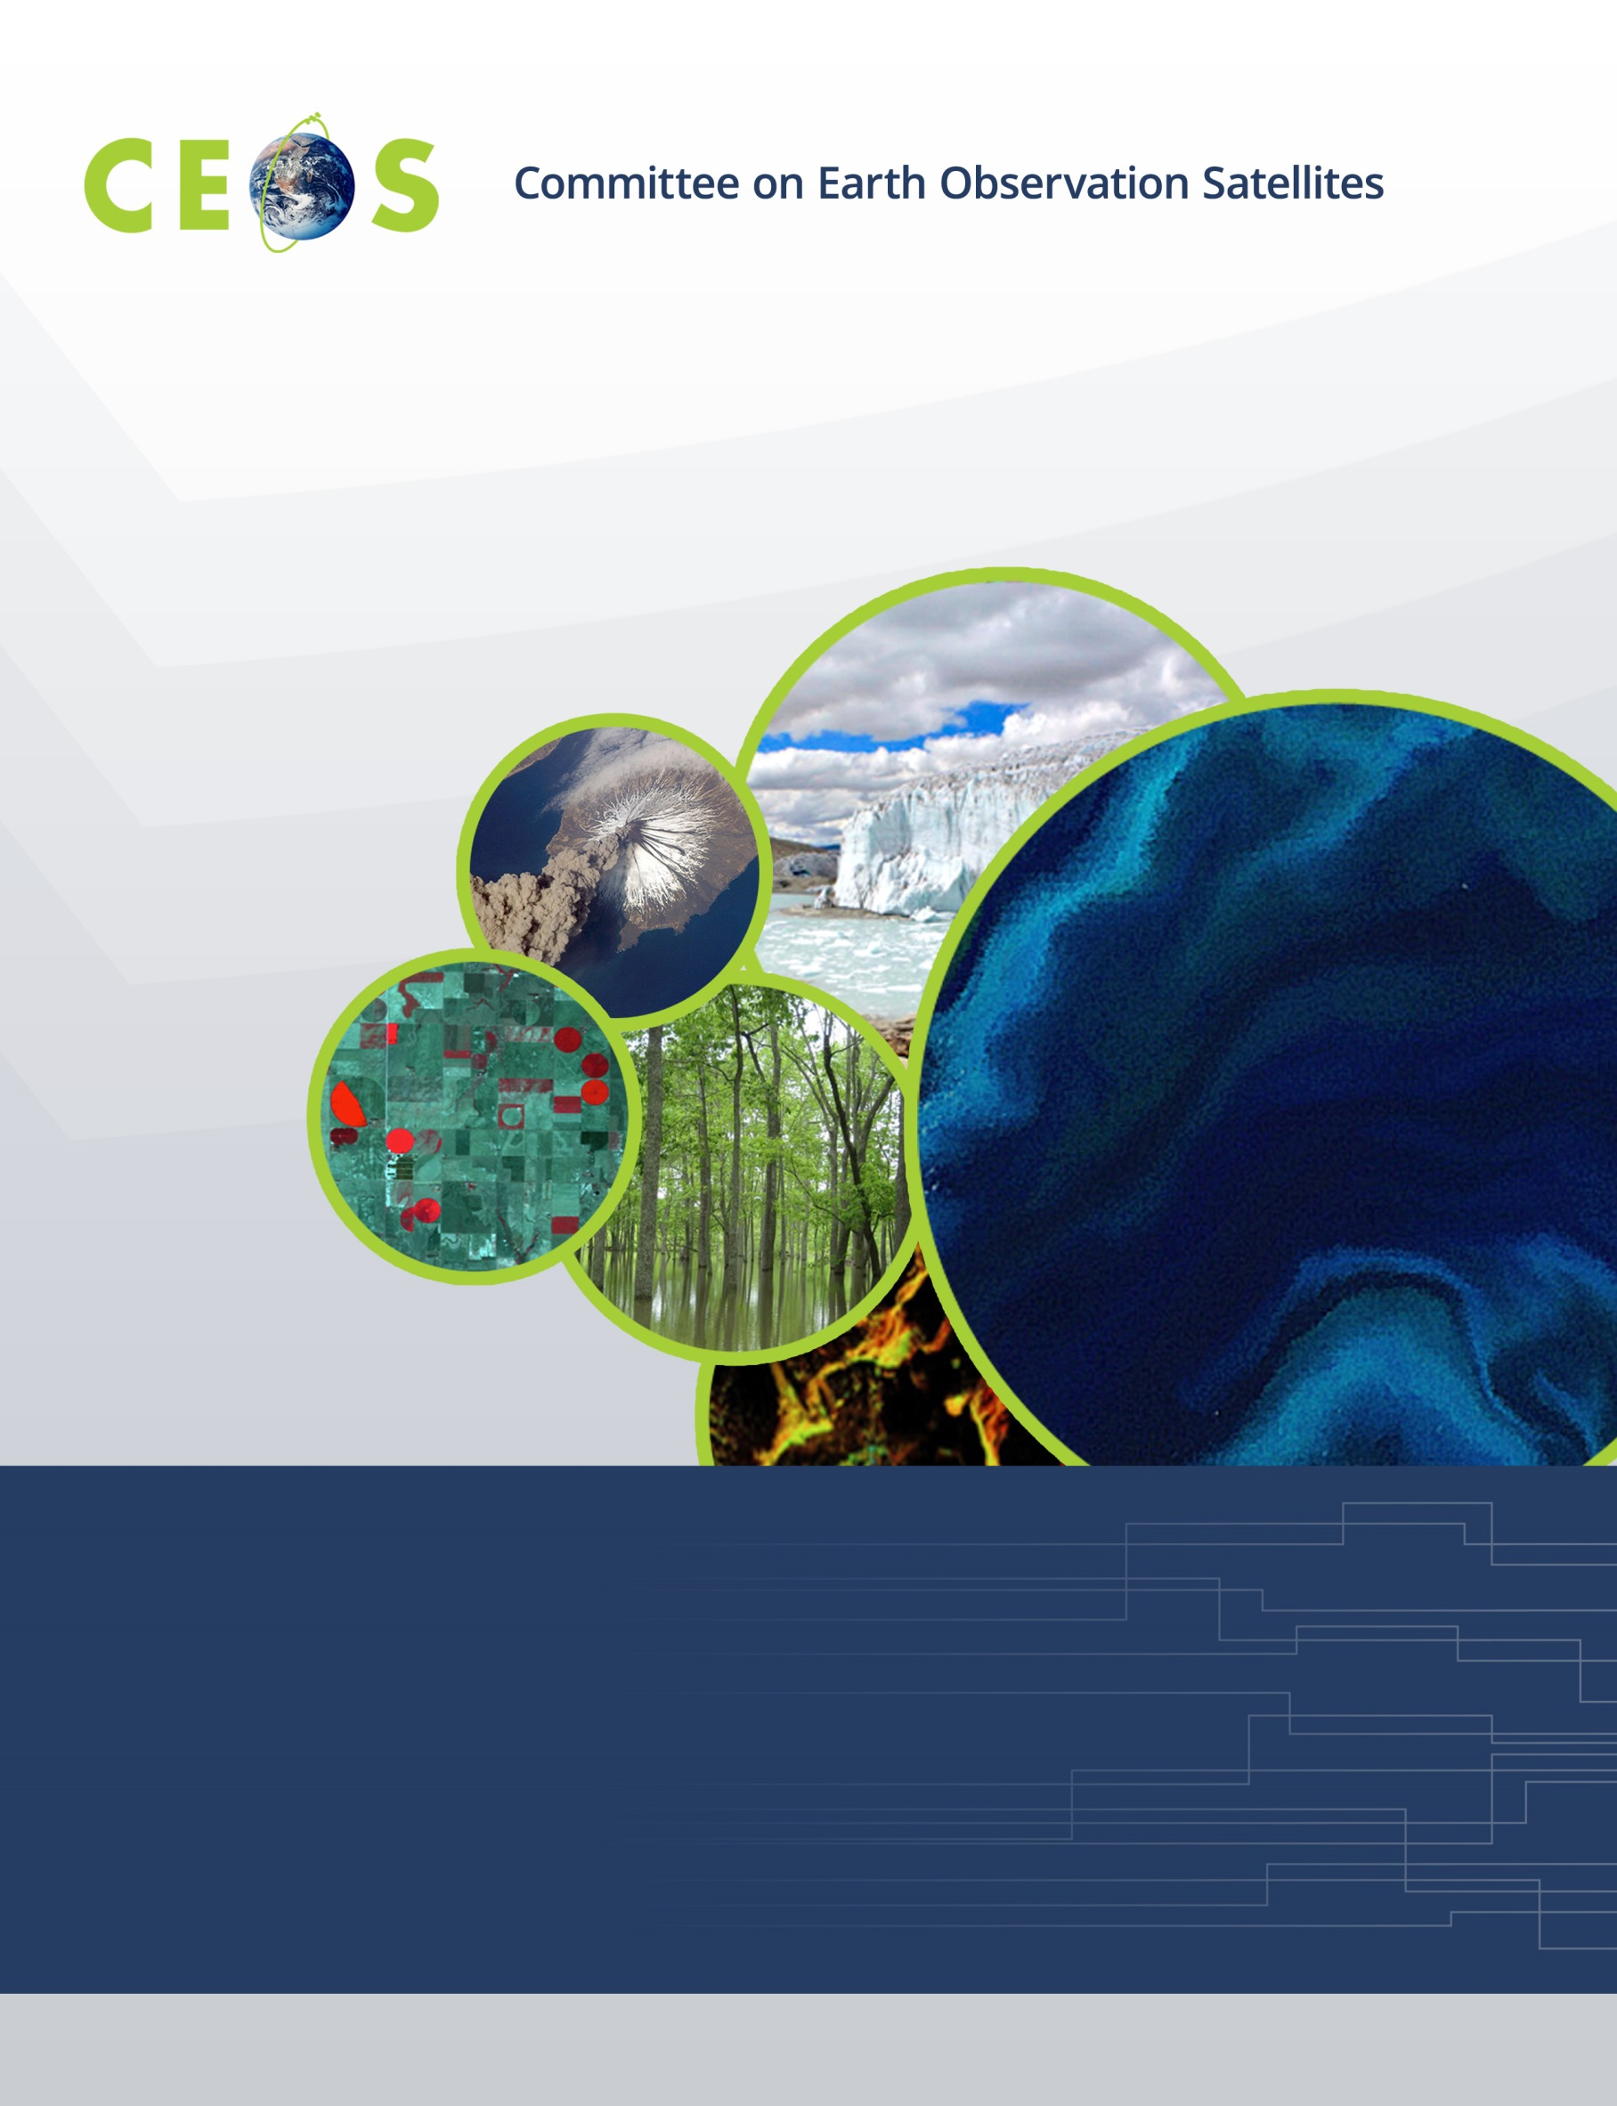

The Land Surface Imaging Virtual Constellation
Implementation Plan
October 14, 2015

Introduction

The CEOS Land Surface Imaging Virtual Constellation (LSI-VC) recently prepared revised Terms of Reference in accordance with the decision made at the 28th CEOS Plenary (2014) to refocus the group. The revised LSI-VC Terms of Reference provide high-level guidance on the LSI-VC’s new direction (Table 1).
 | 3-Year Horizon | 5-Year Horizon
Space Segment | Aggregate and analyze multiple sets of validated, domain-specific requirements to identify gaps and opportunities for optimization and improve interoperability and complementarity  Optimize and harmonize CEOS Agency global data collections, as much as possible. | Harmonize acquisition plans across major international land surface imaging programs to support validated domain-specific requirements
Ground Segment and Information Systems | Explore architectures for future distribution that would potentially enable the analysis of very large land surface imaging datasets, trialed across at least three nations/regions  Stimulate an environment conducive to the creation of analysis-ready data to enhance usage and exploitation of the CEOS data portfolio for land surface imaging | Establish the framework for an architectural network with the capability to analyze very large land surface imaging datasets
Products and Services | Produce 1-2 compatible, non-domain-specific measurement products derived from one sensor and produced by multiple agency systems | Produce 4-5 compatible, non-domain-specific measurement products derived from 3-4 sensors and produced by multiple agency systems

Table 1. High-Level Guidance on the LSI-VCs new direction, as presented in the revised LSI-VC Terms of Reference.
This Implementation Plan outlines the specific activities the LSI-VC plans to undertake over the next three years, working toward the 3-Year Horizon Guidance presented in the Terms of Reference.
In preparing this Implementation Plan, consideration has been given to:
- The desire to address pressing issues of strategic concern to CEOS and CEOS Agencies.
- The need to work with the resources that CEOS Agencies can realistically contribute
- The need to re-build momentum by implementing solutions that work, increasing CEOS Agency buy-in and contributions.
- The need to build and reinforce strong linkages with other CEOS Entities, such as those identified in the Terms of Reference.

Definitions

In the context of this document, the following definitions apply:

Validated Domain–Specific Requirements — The spectral, temporal, and geographic coverage requirements defined by specific CEOS Working Groups (WGs) and the Group on Earth Observations (GEO) initiatives in order to accomplish their objectives. Examples of these groups/initiatives include:

- The Global Forest Observation Initiative (GFOI)
- The GEO GLobal Agricultural Monitoring initiative (GEOGLAM)
- The CEOS-CGMS (Coordination Group for Meteorological Satellites) WG on Climate (WGClimate)
- The CEOS WG on Disasters (WGDisasters)

These requirements advance specific applications of the current constellation and, potentially, CEOS Agency missions planned over the next 3-5 years.

For example, cloud cover can make tropical forest monitoring with optical satellite data quite challenging. A reasonable "requirement" from the forest monitoring community through GFOI could be to monitor the forests in the humid tropics every six months (presence, changes, health, etc.). CEOS Agency resources, such as satellites with Synthetic Aperture Radar (SAR) instruments would likely be sought to meet such a requirement. The job of the LSI-VC would be to:

- Collect these requirements across various WGs and initiatives,
- Identify the CEOS Agency assets that help fulfill such requirements,
- Assess if/where gaps in coverage occur, and
- Determine how CEOS Agencies might work collectively to help mitigate those gaps.

Non-Domain-Specific Products — Validated data products from specific sensors that have undergone higher-order processing. Examples include:

- surface reflectance
- land surface temperature
- gamma-nought

These products may also be documented, standardized and cross calibrated—working with the CEOS WG on Calibration and Validation (WGCV), the CEOS-CGMS WGClimate, the CEOS WG on Information Systems and Services (WGISS), and the CEOS Systems Engineering Office (SEO)—to make them as useful as possible to CEOS and, potentially, the broader global community (they can be provided once and used many times).

Services — The identification and documentation of the characteristics of analysis-ready data. Such characteristics will include:

- Geographic reference,
- Gridding/resolution,
- Spectral corrections, and more.

The LSI-VC Focus

The LSI-VC will focus on developing and implementing coordinated solutions across the following four themes:

- Optimizing global, increasingly high-volume data flows
- Promoting analysis-ready data and minimizing the need for end users to understand satellite/pass/sensor-specific processing
- Exploring ways to implement and sustain new approaches to managing and analyzing large data structures (e.g. Data Cubes)
- Addressing the actions identified for the LSI-VC by the CEOS Carbon Strategy Implementation Study Team (CSIST) to discover broader approaches to analyzing land surface imaging requirements

Phase 1 Activities (~ 2015-2016)

The LSI-VC will conduct its activities using a phased approach; the outcomes from each phase will lay the groundwork for the subsequent phase.

Objective/Deliverable | Description / Context | Linkages
Identify gaps in/opportunities for acquisition-planning in support of the CEOS Carbon Strategy | In support of the CEOS Carbon Strategy, analyze validated land carbon observation requirements and identify the gaps in and opportunities for optimization across CEOS Agency missions. | SEO  WGClimate
Define intercomparable Analysis-Ready Data (ARD) products within the context of land surface imaging | Analysis-Ready Data (ARD) are ready for use without the need for instrument-specific, pass-specific, or spacecraft-specific corrections. These data greatly lower the barriers to using land surface imaging data and make downstream chains more robust.  Because ARD are non-domain-specific, they can be provided once and used many times, which is important, given the high volume of data that exist within the land surface imaging domain.  This work will include the identification of Fundamental Data Records that would form a foundation for ARD, such as:  - Surface reflectance  - Surface temperature  - SAR gamma-nought products | SEO  WGCV
Increase the visibility of land surface imaging data holdings | Significant progress has already been made to improve the visibility of CEOS Agency data through existing tools such as The CEOS-WGISS Integrated Catalog (CWIC) and the Federated Earth Observation Missions Pilot (FedEO).  The LSI-VC will conduct a gap analysis of land surface imaging missions and datasets and work with LSI-VC Agencies, the SEO, and WGISS to encourage increased visibility of existing and future land surface imaging data. Close partnerships with WGISS and the SEO will be critical to ensure this effort complements existing activities. | WGISS  SEO  WGCapD
Engage in the implementation of trial Data Cubes | The KenyaCube project being delivered by the SEO under the auspices of CEOS’ Ad Hoc Space Data Coordination Group for the Global Forest Observations Initiative (SDCG for GFOI) offers significant potential for lessons learned on future models for distributing and providing access to land surface imaging data.  The LSI-VC will provide information to this SEO-driven activity and monitor progress from the perspective of evaluating the future satellite data preparation needs for operational implementation.  Other related systems being implemented by other LSI-VC Agencies such as Geoscience Australia (GA), the United States Geological Survey (USGS), and the European Space Agency (ESA) will also be monitored as described above. | WGISS  SEO
Perform a scoping study for global data flows for long time series of land surface imaging data | Land surface imaging datasets are very large and, as noted above, providing entire datasets to every end user is not technically feasible. Relying on single global data centers may not be technically or financially feasible in the short term either.  The LSI-VC will support an SDCG for GFOI-led activity exploring how data flows can be optimized to minimize costs and maximize data accessibility for end users and the potential for regional data hubs. The LSI-VC will engage in this activity from the perspective of future architectures that will work most efficiently across domains.  This activity, combined with lessons learned from Data Cube implementations, will develop and begin to articulate ideas for future access of land surface imaging data. | SEO  SDCG for GFOI

Phase 2 Activities (~2016-2017)

Objective/Deliverable | Description / Context | Linkages
Pilot approaches to conducting integrated assessments of gaps/opportunities in asset usage | Building on the work for land carbon, develop and pilot an approach to analyzing multiple sets of domain-specific requirements and identifying gaps/ opportunities for optimization.  This effort will integrate validated requirements for forestry, carbon, climate, and agriculture and identify potential continuity issues for land surface observations from space via CEOS Agency assets. | SEO  GEOGLAM  WGDisasters
Develop a roadmap for the routine production of intercomparable ARD | Building on the agreed definitions of ARD from Phase 1, develop a roadmap for how interested CEOS Agency missions/programs can start processing land surface imaging data with geometrically/radiometrically intercomparable surface reflectance, surface temperature, and potentially equivalent radar products. | SEO  WGCV
Assess lessons learned from Data Cube implementations (including , Australian Geoscience Data Cube, etc.) and global data flows studies | Land surface imaging data volumes are significant, and applications increasingly require the ability to work iteratively with full continental- (or greater) scale archives.  Traditional approaches to the distribution and preparation of land surface imaging data do not address these challenges; the data are too big to move once, let alone multiple times.  Review lessons learned from a number of initiatives to identify the way forward, including a “Best Practices” document for consideration by land surface imaging agencies in future systems design. | WGISS  SEO  SDCG for GFOI
Pilot large data set distribution covering three regions | Implementation of this activity will be based on Phase 1 findings. | SEO  WGISS
Establishing enhanced collaboration on wetlands and inland waterway monitoring | Take initial steps to identify and coordinate CEOS Agency efforts to develop/harmonize wetlands and inland waterway satellite observations and the non-domain specific products required for the development of wetland and inland waterway data products.  This activity supports the CEOS Carbon Strategy and will help establish ongoing inter-agency communication. | WGCV  SEO

Phase 3 Activities (~ 2017-2018)

Objective/Deliverable | Description / Context | Linkages
Continue to develop approaches for integrated assessments of gaps/opportunities in asset usage | Building on the Phase 2 pilot, implement a broader approach to analyzing multiple sets of domain-specific requirements and identifying gaps/opportunities for optimization.  Identify any potential continuity issues for land surface observations from space made by CEOS Agency assets. | SEO  SDCG for GFOI  GEOGLAM  WGClimate  WGDisasters
Begin implementing steps toward the routine production of intercomparable ARD | Where procedures are well-defined and mature, interested CEOS Agency missions/programs may pilot the implementation of the roadmap produced in Phase 2 to demonstrate the routine production of intercomparable ARD across multiple CEOS Agency systems. | SEO  WGCV
Establishing enhanced collaboration on wetlands and inland waterway monitoring | Continue to identify and coordinate CEOS Agency efforts to develop/harmonize their wetland and inland waterway satellite observations and develop wetland the non-domain specific products required for the development of inland waterway data products.  This activity supports the CEOS Carbon Strategy and will establish ongoing inter-agency communication. | WGCV  SEO

