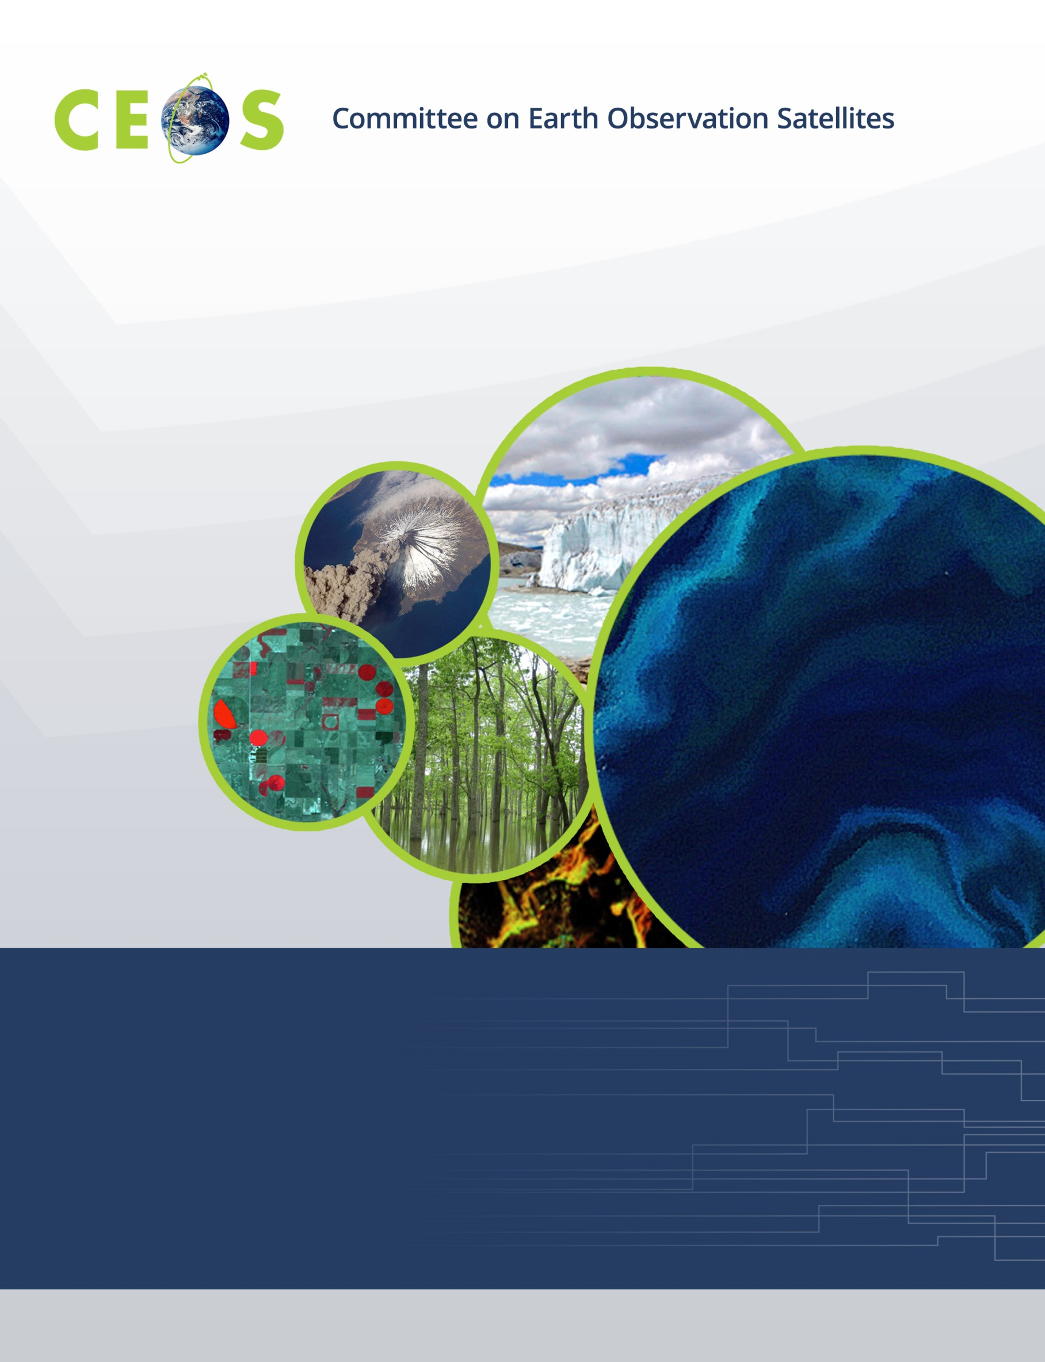

Working Group on Information Systems & Services (WGISS)
Terms of Reference (October, 2015)

Terms of Reference:
CEOS Working Group on Information Systems and Services (WGISS)

Purpose
This section includes a high-level vision and scope of work for WGISS and describes the contribution to the CEOS Programme.
The overall purpose of WGISS is to facilitate (CEOS) data and information management, and to support the provision of services for both data providers and data users. WGISS will address in particular the description, maintenance, discovery, access, and utilization, including archiving and long-term preservation, of space borne Earth observation data and supporting ancillary and auxiliary data, enabling improved operability and interconnectivity of information systems and services.
Overall goals are to:
- Enable Earth observation data and information to be more accessible and usable to both data providers and data users world-wide through international coordination;
- Foster easier exchange of Earth observation and related data and information to meet the requirements of users and data providers;
- Foster the development of best practices and encourage the development of interoperable services that exploit space-borne Earth observation data; and
- Enhance the complementarity, interoperability and standardization of Earth observation data and information management and services with other types of geospatial data such as in-situ data;

Organization
This section specifies the duration of the WGISS’ existence, who leads it, the duration of leadership, how membership is determined, and how the activities are funded.
WGISS was formed in 1995 as a working group of CEOS.
WGISS members consist of those persons designated by CEOS members and associates to participate in the work of WGISS. The exchange of information among members and associates is invited and encouraged at all meetings and a reasonable amount of time is allowed on the agenda to facilitate this.
All activities of WGISS are funded by its members and associates. Each participant is responsible for seeking and obtaining support and funding from his or her organization. Each participant undertakes activities on a “best effort” basis. WGISS aims to focus the contribution of each participant and to maximize the benefit of the activity to each member or associate involved. Similarly, the review procedures for each activity provide a record of the benefits to the contributing agencies, thus justifying funding and securing continued participation.
WGISS is coordinated under the direction of a chair supported by a secretariat funded by the chair’s organization. The chair is responsible for organizing the semi-annual meetings, producing minutes or notes of those meetings, monitoring actions and reporting to the CEOS Plenary and to the CEOS SIT. It is the responsibility of the chair to take account of the direction and requirements of the Plenary and SIT, to introduce appropriate external partner agendas relevant to WGISS work, to hear from activity leaders concerning recommendations of technical strategic direction and progress of technical implementations and demonstrations, to plan and coordinate appropriately, and to provide "top-down" guidance of WGISS activities.
General WGISS management issues are addressed by an executive committee (WGISS Exec) made up of the WGISS chair, vice-chair, secretariat, and the leaders of the various Activity Teams. The WGISS Exec holds regular teleconferences (approximately monthly) to facilitate the smooth operation of WGISS.

Objectives
This section lists the WGISS’ long-term objectives, intended outcomes or outputs, and measures of success. These items can be listed in bullet form.
WGISS receives strategic direction and specific requests for work from CEOS Plenary and CEOS SIT. Much of this input concerns providing support for the implementation of the CEOS Implementation Plan for GEOSS. WGISS provides reports on progress in achieving its objectives and also provides recommendations to the CEOS Plenary and CEOS SIT to help guide them in their strategic decision-making. WGISS also responds to requests for information and support from liaison and other organisations, including requests to support the implementation of GEO and CEOS Tasks.
WGISS activities fall into three main areas:

Support for CEOS:

WGISS takes strategic direction from the CEOS Plenary and from the CEOS Strategic Implementation Team (SIT). WGISS responds to “Actions” given by the Plenary and SIT, and strives to shape its work towards meeting CEOS Plenary, SIT and agency requirements. WGISS also responds to requests from GEO as directed by CEOS.

Addressing issues related to data management, access and use:
a) WGISS exploits the knowledge and experience of its members by producing recommendations, guidelines, and best practices concerned with all aspects of data and information management.
b) Data Access is concerned with ensuring data users have easy and efficient ways of discovering and accessing data through the exploitation of standard protocols and the harmonising of search and data retrieval processes.
c) User Services and Applications Support, which tends to focus on external interactions. WGISS supports the development of global services for users of Earth observation and related non-satellite data through coordination of infrastructure development and encouraging the development of services based on international standards.

Knowledge Exchange:

An important aspect of the WGISS activities is to encourage knowledge exchange and to ensure that the information it generates is made easily available to users, and to ensure that it receives relevant information from related organisations in a timely and efficient manner. WGISS activities are coordinated across CEOS agencies and adequately promoted.

Stakeholders
Key external & internal stakeholders
The internal stakeholders of WGISS tend to be the data managers within the Space Agencies who are concerned with the preservation and the accessibility of data.
WGISS also interacts with a broad range of stakeholders who are interested in seeing efficient data access and the provision of interoperable services. These include the other Working Groups, Virtual Constellations and other Ad-hoc Groups working within CEOS, together with external organisations, such as GEO, the Global Spatial Data Infrastructure Association (GSDI), the Consultative Committee for Space Data Systems (CCSDS), ICSU Committee for Data for Science and Technology (CODATA), commercial satellite data providers, and relevant bodies within the UN.

