CEOS Data Cube Testing of the
Australian Water Detection from Space (WOFS) Algorithm
October 2016

The CEOS Systems Engineering Office (SEO) recently completed testing of the Australian Water Detection from Space (WOFS) algorithm (Reference: Mueller, N., et al,2016) using sample “version 2” data cubes over 3 regions in Kenya, Colombia and Cameroon. The results are summarized here. WOFS is a 23-step band-based decision tree that classifies pixels as water or non-water with 97% overall accuracy. This water management product provides critical insight into the behavior of surface water over time and in particular, the extent of flooding. It should be noted that no additional filtering was performed using confidence layers to constrain the results based on terrain slope or known surface classes. The SEO only used the primary 23-step band-based classification for their analyses.

Case #1: Lake Baringo over central Kenya

Data Preparation
- Landsat 7, January 2005 to April 2016, Path=169, Row=60
- 169 original scenes (202 GB of data) … 169 time “slices” with <70% cloud cover
- 1x1 degree Data Cube “stack” with annual storage unit “chunks”
- 3710 x 3710 x 169 = 2.3 billion pixels total
- Pixel Resolution = 30 meters
- 37 GB NetCDF data cube volume (~ 5:1 compression)

Data Analysis
- 3.5 GHz Intel processor (4-core), 64GB RAM, Linux computer
- Computation time of 1-2 minutes for an annual analysis and ~30 minutes for a full time series (11+ years) analysis

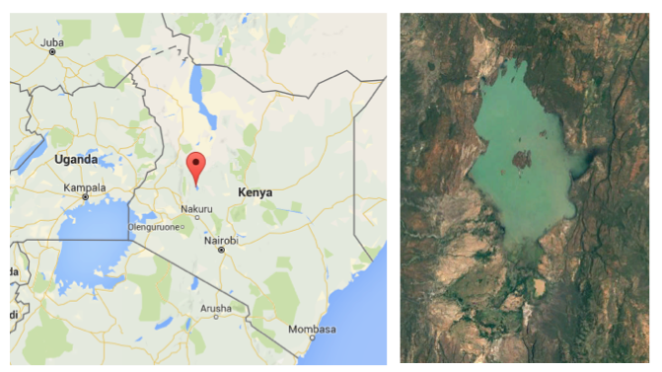

11-Year Time Series WOFS Analysis Results

The pixel-level results below show the percent of observations detected as water over the 11-year time series (January 2005 through April 2016). The percentage calculation is based on the total number of water observations divided by the number of clear observations in the time series. Neighboring pixels may have a different “normalization” due to cloud cover variation. This output produces higher percentage values that are likely more representative of the actual water conditions over the time series.

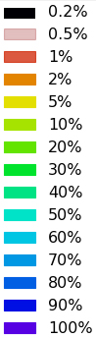
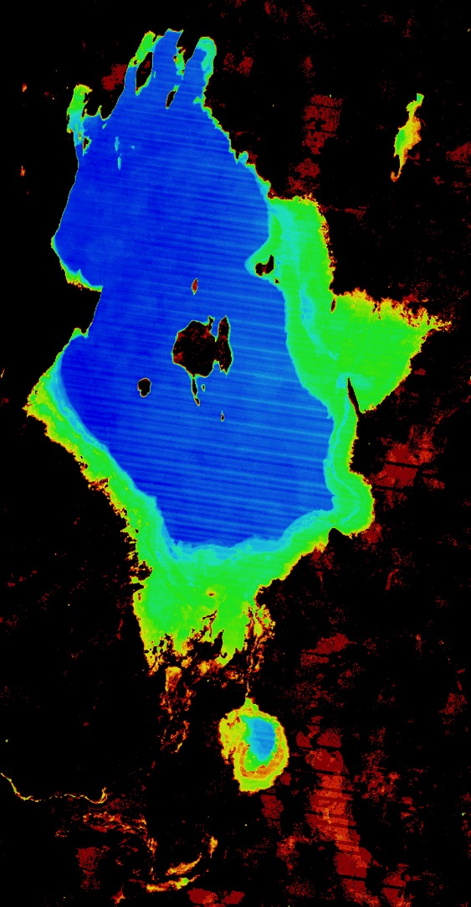

WOFS Analysis Results comparison with Google Earth Engine Aqua Monitor

The WOFS analysis results were compared with the Google Earth Engine Aqua Monitor: (http://www.aqua-monitor.appspot.com). The Aqua Monitor results (left), also based on Landsat data, look nearly the same as the WOFS results (right). Light blue pixels show where land has been changed into surface water over the time series (2005 thru 2015). The WOFS results using a Data Cube have a significant advantage over the Aqua Monitor tool. The Landsat data is “analysis-ready” and atmospherically corrected, which leads to more accurate results. The user also has access to all of the pixel-level information for any portion of the time series. Finally, the output shows the existence of water at any time during the analysis period.

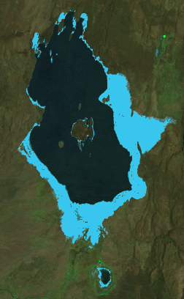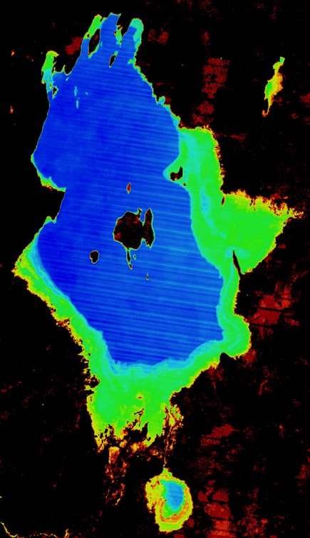

The results below show the number of times the area was observed (top) and the number of times water was detected over the region (bottom). Due to image overlap and cloud cover, the WOFS analysis results can vary across a region. These additional analysis results are helpful when evaluating the final results.

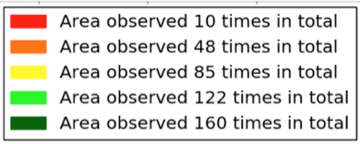

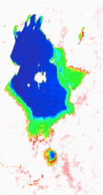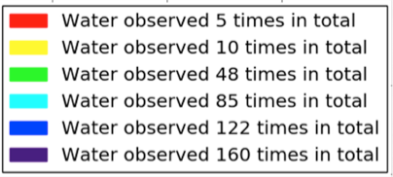

Annual WOFS Analysis Results

The results below show the extent of detected water for specific years. These annual results are valuable for identifying historic extreme conditions and validating the output. The extreme drought in 2006 and the extreme floods in 2013 are easily seen. In addition, the short dry season period of 2016 did not detect any water in the plain areas surrounding the lake, as expected.

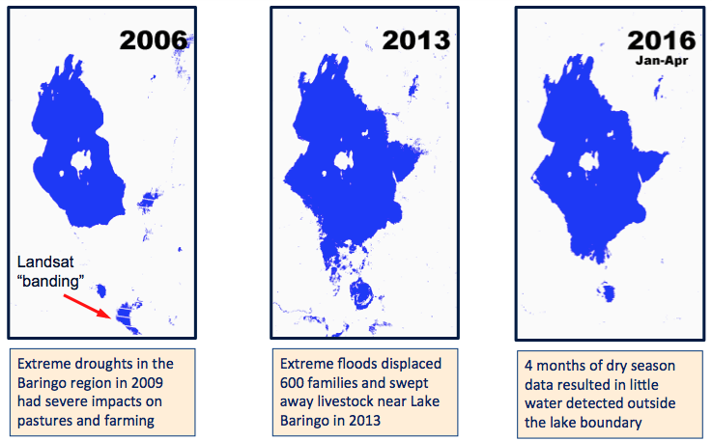

WOFS Water Detection Algorithm comparison with the Landsat CFmask Water Mask

The results below show the similarities and differences between WOFS and the common Landsat CFmask algorithm, which is part of the Landsat product package. The more sophisticated 23-step band-based WOFS algorithm is able to detect water in contaminated lakes, whereas the CFmask algorithm does not detect these lakes. One example is shown below for Lake Solai in Kenya.

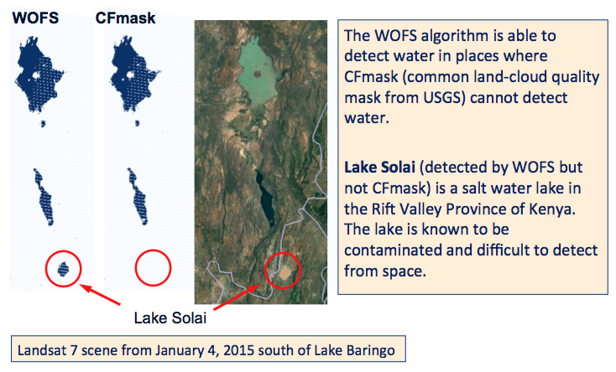

Case #2: Central Colombia Rangelands

4-5 degree North Latitude, 71-72 deg West Longitude … see images below
Meta River (middle) and Rio Cravo Sur River (top left)
GEOGLAM Rangelands (RAPP) Region in Carimagua, Colombia (red pin)
* Image on right is from Landsat-8 on 25-Jan-2016

Data Preparation
- Landsat 7, January 2000 to April 2016, Path=6, row=57
- 110 original scenes … 110 time “slices” with <70% cloud cover
- 1x1 degree Data Cube “stack” with annual storage unit “chunks”
- 3710 x 3710 x 110 = 1.5 billion pixels total
- Pixel Resolution = 30 meters
- 25 GB NetCDF data cube volume

Data Analysis
- Analyses performed on the Amazon Cloud (AWS) using a c4.8xlarge “instance”
- AWS setup has 36 “virtual CPU” units, 60 GB memory, 300 GB SSD and 2 TB EBS storage.
- Computation time of 5 to 41 seconds for the annual products and ~6 minutes for a full time series (15+ year) analysis

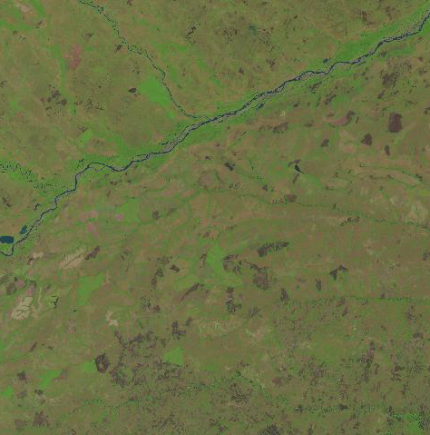
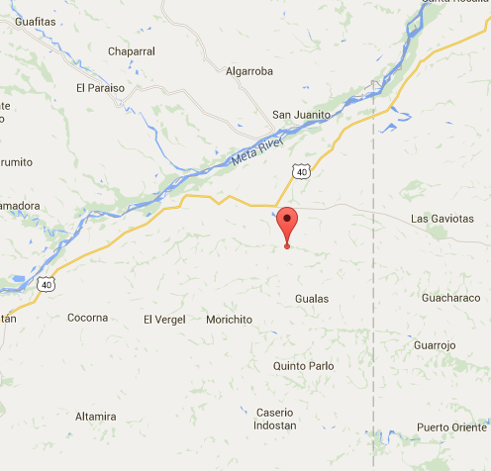

15-year Time Series WOFS Analysis Results

The pixel-level results below show the percent of observations detected as water over the 15-year time series (January 2000 through April 2016). The percentage calculation is based on the total number of water observations divided by the number of clear observations in the time series. Neighboring pixels may have a different “normalization” due to cloud cover variation. This output produces higher percentage values that are likely more representative of the actual water conditions over the time series.

It is clear from these results that the Meta River (main river from the bottom-left to the top-right of the image) is not persistently water and has many regions that are water <50% of the time. The plain regions to the north of the Meta River detected water very infrequently <10% of the time which would explain annual rainy seasons. A more detailed view of the Rio Cusiana and Meta River split (near Bramadora) is shown on the bottom-right.

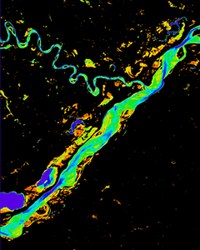
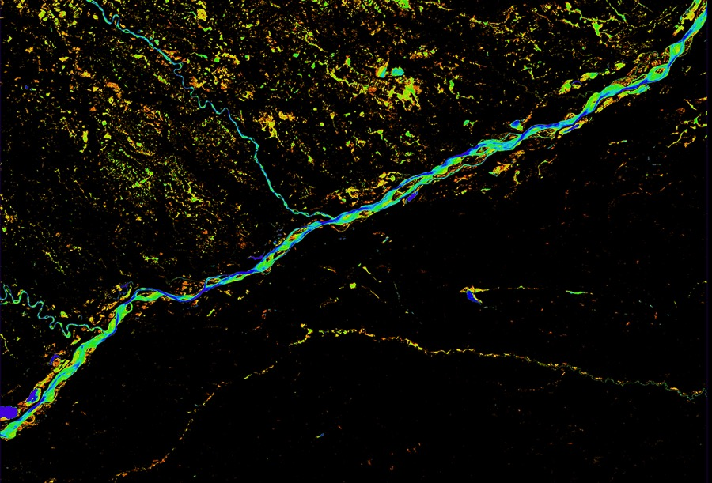

The results below show the number of times the area was observed (top) and the number of times water was detected over the region (bottom). Due to image overlap and cloud cover, the WOFS analysis results can vary across a region. These additional analysis results are helpful when evaluating the final results.

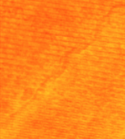

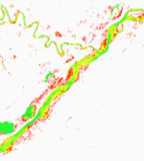

Case #3: Lake Chad, Cameroon, Africa

Data Preparation
- Landsat 7, Path=185, Row=51
- January 2006 to December 2015, 10 years
- Latitude Range: 12.75 to 13.0 deg, Longitude Range: 14.25 to 14.5 deg
- 99 original scenes (19.3 GB), but data cube region is a subset of the scene area
- 0.25 x 0.25 degree Data Cube “stack”
- 906 x 923 x 99 = 82 million pixels
- Pixel Resolution = 30 meters
- Data Cube Size = 1.2 GB

Data Analysis
- 1.2 GHz Intel processor (8-cores), 64-bit, 66GB RAM, Linux computer
- Computation time of 38 seconds for a full time series (10 years) analysis

Background: Lake Chad is a historically large and shallow (10m maximum), lake in Africa, which has varied in size over the centuries. According to the United Nations, it shrank by as much as 95% from 1963 to 1998 primarily due to increased demand from the local population. Lake Chad is economically important, providing water to more than 68 million people living in the four countries surrounding it (Chad, Cameroon, Niger, and Nigeria) on the edge of the Sahara Desert.

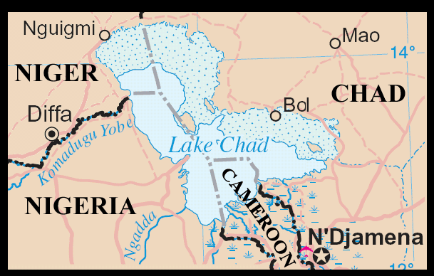

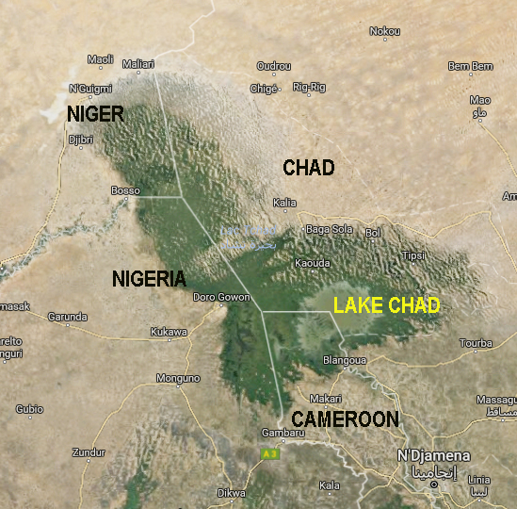

History of Lake Chad
Images from Landsat from 1984 to 2015 (Path-Row = 185-51)

Landsat 5, October 1984 Landsat 5, October 1991
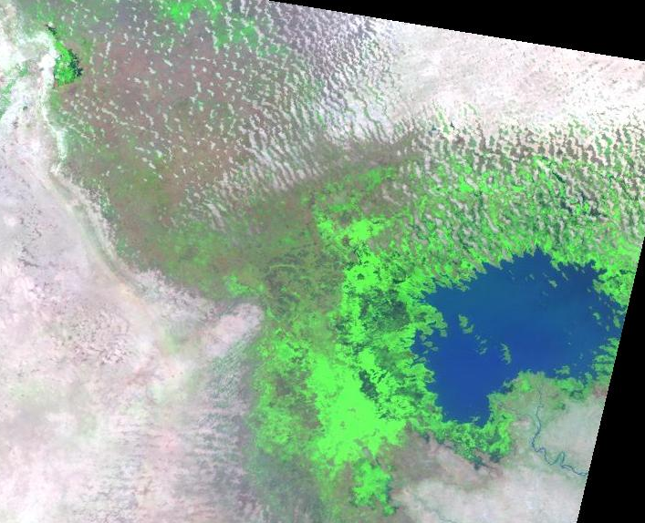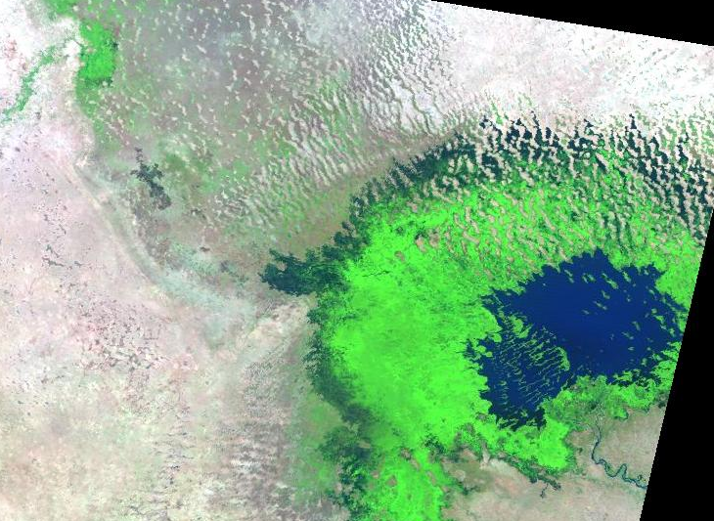

Landsat 7, October 1999 Landsat 7, October 2005
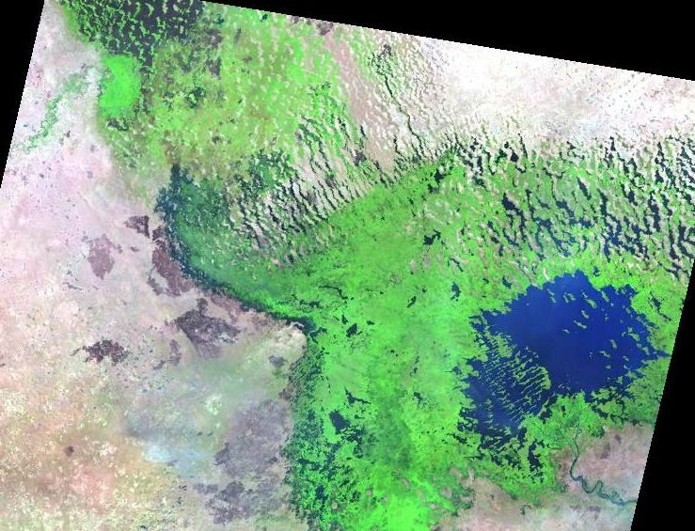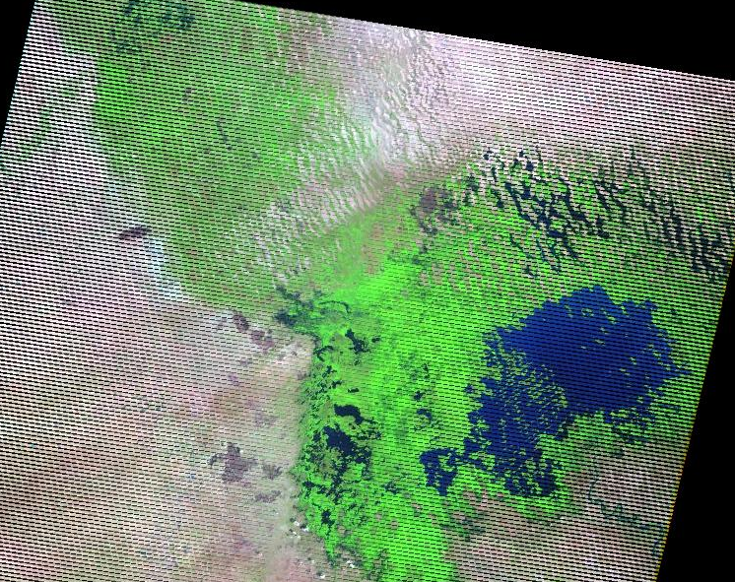

Landsat 7, December 2010 Landsat 7, December 2015
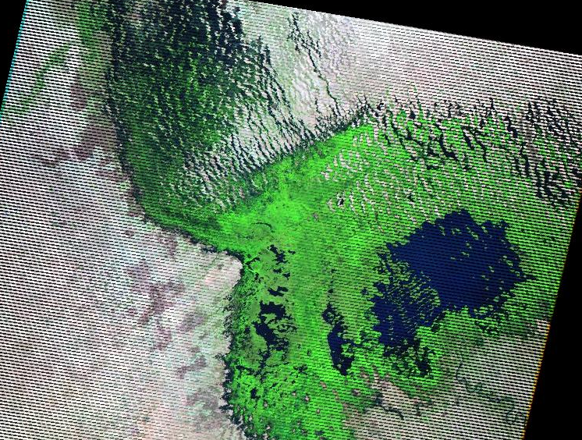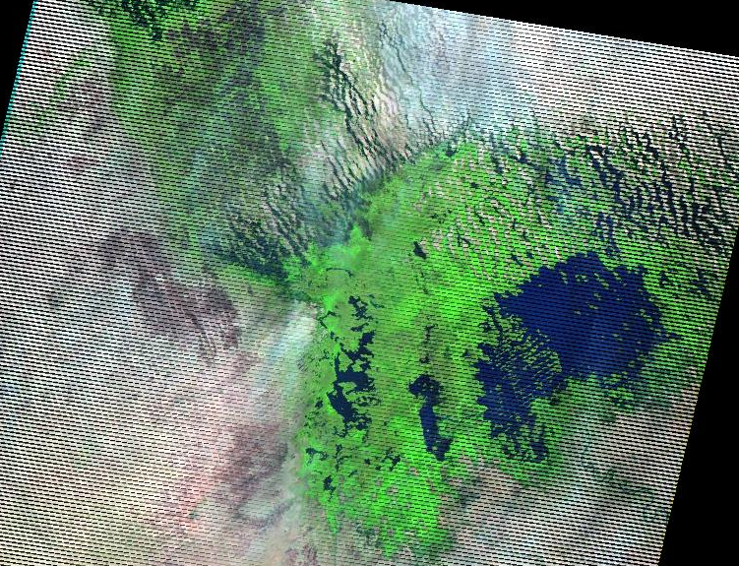
Landsat-8 September 2016 (most recent clear image)

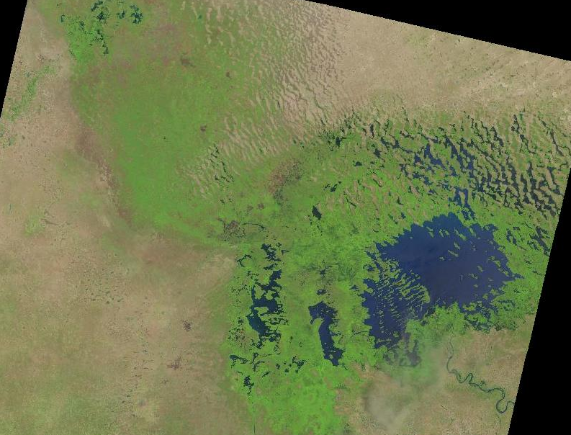

Reference: http://www.cblt.org/en/history-lake-chad-basin

Lake Chad follows an annual cycle. The beginning of the rainy season in the upper basin (May-June) gives rise to floods (August-September), which fill up Lake Chad (October-January) before evaporation associated with the end of the flow, leads to a drop in the water level. The contributions of the Chari-Logone system vary widely, from single to double inputs and sometimes more, similar to Sahelian rainfall.

After a decline in rainfall from 1968, the year 1973 dramatically introduced a cycle of drought. Very low flood levels led to the drying up of Lake Chad, including the entire north basin. Other severe droughts were experienced in 1984 and 2008. In addition, much as elsewhere in the Sahel, there has been a slight increase in rainfall since the late 80s and mid-90s. With the exceptional rainfalls of 2012, a change is expected, albeit a small one, in the configuration of Lake Chad.

Thus, Lake Chad’s rhythms vary greatly, depending on a host of factors such as: the timing and amount of rainfall in the Sudanian and Sahelian areas; the previous fill level, vegetation, etc. In conclusion, a difference of just a few dozen centimeters from one flood to another, results in several tens of thousands of acres being covered or uncovered, the coast retreating several kilometers, the islands being flooded.

Analysis Region: A small data cube (0.25 deg square) was created for the southern portion of Lake Chad in Cameroon. This is a region of high change, as it includes the Chari River which provides over 90% of the lake's water. This river can be found in the analysis results on the central eastern border of the data cube.

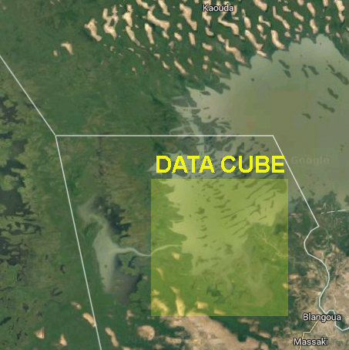

10-year Time Series WOFS Analysis Results

The pixel-level results below show the percent of observations detected as water over the 10-year time series (January 2006 through December 2015). The percentage calculation is based on the total number of water observations divided by the number of clear observations in the time series. Neighboring pixels may have a different “normalization” due to cloud cover variation. This output produces higher percentage values that are likely more representative of the actual water conditions over the time series.

These results demonstrate the variation in lake extent with significant change in the western region near the border of Nigeria. The Chari River can be seen originating from the middle-right of the image and then producing “forks” of entry into the larger lake. Though much of the lake is persistent water over the time period, there are low plain regions in the south where water was infrequently detected (2% to 20% of the time), likely due to annual rainy seasons.

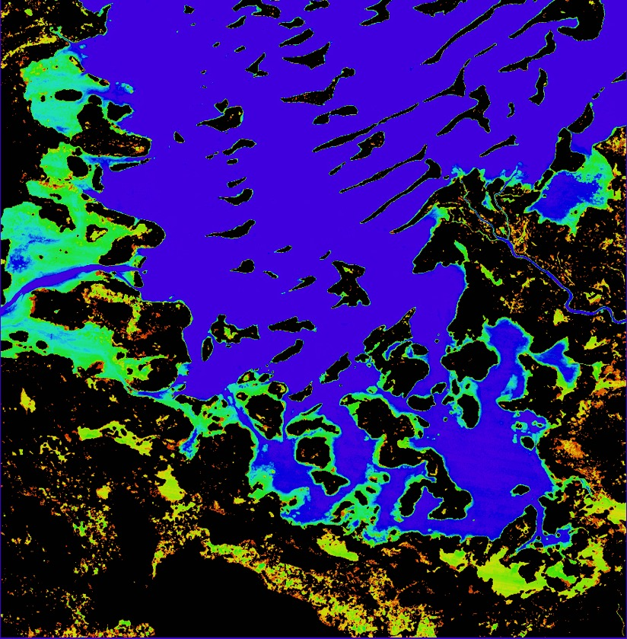

The results below show the number of times the area was observed (top) and the number of times water was detected over the region (bottom). Due to image overlap and cloud cover, the WOFS analysis results can vary across a region. These additional analysis results are helpful when evaluating the final results. The results below (top figure) indicate low cloud cover for this region, as the area was observed 99 times for nearly all locations. One small differences are seen in locations of the Landsat-7 scan-line error, due to lack of data. The bottom figure also shows that water was observed 99 times in the central portion of the lake. The infrequent water observations at the bottom of the figure indicate up to 5 water observations in the 10-year analysis.

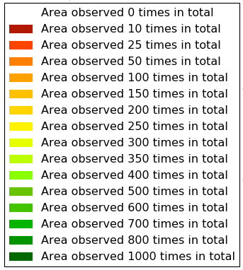

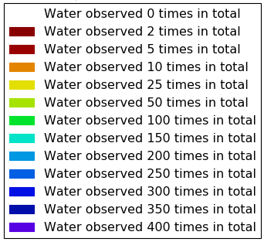

Statistical Analysis Results

Figure 1 (below) shows the observed water area over time for the full analysis region. These results indicate a consistent trend (red line) in desertification (decreased surface water area) over the 10-year time period resulting in an average loss of 1.4 hectares of water per day. The data also shows the impacts of the drought period in late 2008, as the lake area was generally lower after 2009.

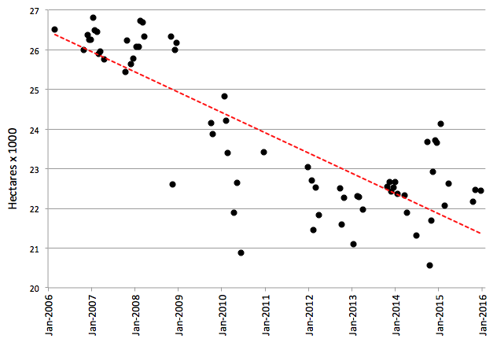

Figure 1. Observed water area (hectares) vs. time (years)

* Seven (7) data outliers were removed from this figure due to cloud cover and scan-line errors which resulted in water area that significantly differed from the rest of the data.

Figure 2 (below) shows the percent of total area that is classified as water per month over the 10-year time period. The rainy (Monsoon) season (highlighted in green) is typically from May to September with the heaviest rains in July (28% of annual amount) and August (33% of annual amount). No clear scenes were available over this region for the month of August during the entire 10-year time period due to extreme cloudiness. Therefore, the values for August were interpolated in the figure below. These results show the highest water area is found after the rainy season. The lowest water area is found in the months before the rainy season.

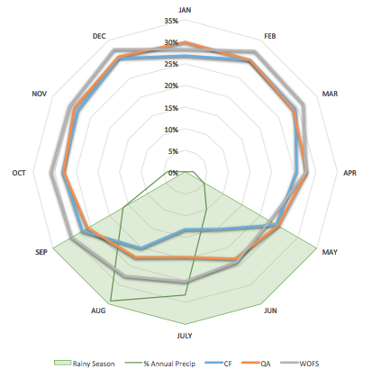

Figure 2. Percent of Total Area that is Classified as Water per Month

Figure 2 also shows the differences between three water detection algorithms. We observe slightly more water detected with the WOFS algorithm (WOFS) as compared to CFMASK (CF) and ACCA (QA). The CFMASK and ACCA results are found in the surface reflectance datasets from USGS and are often used by the community for simple land/water/cloud distinction. WOFS observes higher water classification because it considers mixed water-vegetation pixels to be water, which is quite common in Lake Chad during the rainy season. In addition, CFMASK and ACCA use decision trees to prospectively label pixels in the scene and then validates or discards those labels according to scene-wide statistics which lowers the CFMASK and ACCA results in cloudy scenes.

