 | Analysis Ready Data  For Land | Product Family  Specification:  Normalised Radar Backscatter

Document status
Draft for review. This draft needs review by experienced Radar data users.
May 15 2017 – target date to close Version 1 after first round of comment.
July 31 2017 – target date to close Version 2 after second round of comment.
Sept 6 2017 – target date to submit Version 3 to CEOS SIT for endorsement as a working draft specification
Document history
Version | Date | Description of change | Author
0.0.2 | 23-03-2017 | Zero Draft based on materials discussed in and leading up to LSI-VC-3, provided by SEO and others. | Adam Lewis
0.1.0 | 18-04-2017 | Various revisions to structure | Adam Lewis
1.0.0 | 18-04-2017 | Included material provided by Brian Killough / SEO reflecting input from a range of SAR experts / users. | Adam Lewis
1.0.1 | 20-04-2017 | Edits reflecting feedback from SEO, change to the figure / table in ‘guidance’; removed item 4.2 which appeared redundant; moved reference to definitive ephemeris to a note under item 4.1; added reference to speckle under table 3 (radiometric corrections) | Lewis and Killough

Description
Product family title: Radar Backscatter (CARD4L-Radar)
Applies to: Data collected by synthetic aperture radar sensors.
Abstract
Inter-comparable synthetic aperture radar imagery enables a growing range of applications of radar data that draw on multiple observations from multiple instruments and viewing modes. The necessary data preparation steps are well established in the literature (see Guidance section) and have been demonstrated in practice. This CARD4L product specification reflects these data preparation steps.
CARD4L-Radar product will enable a set of new, generalist, users to access and apply these data in geographical analyses to produce improved products, thus increasing the impact of CEOS Agencies’ data. The CARD4L product is not relevant to interferometric studies.

Requirements

General Metadata
These are metadata records describing a distributed collection of pixels. The collection of pixels referred to must be contiguous in space and time. General metadata should allow the user to assess the overall suitability of the dataset, and must meet the following requirements:
 | Item | Threshold requirements | Target requirements
1.1 | Traceability | Not applicable | Data must be traceable to SI reference standard. For further information see, for example, http://l-a-b.com/information/traceability/  Note 1. Relationship to 3.2. Traceability requires an estimate of measurement uncertainty.
1.2 | Metadata machine readability | Metadata is provided in a structure that enables a computer algorithm to be used to consistently and automatically identify and extract each component part for further use. | As threshold, but metadata is formatted in accordance with ISO 19115-2.
1.3 | Data collection time | The start and stop time of data collection is identified in the metadata, expressed in date/time, to the second, with the time offset from UTC unambiguously identified. | Acquisition time for each pixel is identified (or can be reliably determined) in the metadata, expressed in date/time at UTC, to the second.
1.4 | Geographical area | The surface location to which the data relates is identified, typically as a series of four corner points, expressed in an accepted coordinate reference system (e.g.,WGS84). | The geographic area covered by the observations is identified specifically, such as through a set of coordinates of a closely bounding polygon. The location to which each pixel refers is identified (or can be reliably determined) expressed in projection coordinates with reference datum.
1.5 | Coordinate reference system | The metadata lists the coordinate reference system that has been used. | As threshold
1.6 | Map projection | The metadata lists the map projection that has been used, and any relevant parameters required in relation to use of data in that map projection. | As threshold
1.7 | Geometric correction | Metadata not required.  The user is not explicitly advised of the geometric correction source and methods. | The metadata describes the geodetic correction methods used, including reference database and ancillary data such as elevation model(s) and reference chip-sets. DOIs are used.
1.8 | Geometric accuracy | Metadata not required.  The user is not provided with results of geometric correction processes pertaining to the dataset | The metadata includes metrics describing the assessed geodetic accuracy of the data, expressed units of the coordinate system of the data. Accuracy is assessed by independent verification (as well as internal model-fit where applicable). Uncertainties are expressed as root mean square error (RMSE) or Circular Error 90% Probability (CEP90).
1.9 | Instrument | The instrument used to collect the data is identified in the metadata. | As threshold, but including a reference to the relevant CEOS Missions, Instruments and Measurements Database record.
1.10 | Sensor Acquisition Mode(s) | The operating modes of the instrument, such as wide-scan | As threshold.
1.11 | Sensor calibration | Not required.  The general metadata does not include sensor calibration details | Sensor calibration details / parameters are identified in the metadata, or can be accessed using details included in the metadata.  Note 1: for example, a calibration parameter file located through a DOI.
1.12 | Radiometric accuracy | Not required. The general metadata does not include specific information on the radiometric accuracy of the data. | The metadata includes metrics describing the assessed absolute radiometric accuracy of the data, expressed as absolute radiometric uncertainty relative to a known reference standard (e.g., pseudo-invariant calibration sites)  Note 1: for example, this may come from comparison with rigorously collected in situ measurements
1.13 | Algorithms | All algorithms, and the sequence in which they were applied in the generation process, are identified in the metadata. | As threshold, but only algorithms that have been published in a peer-reviewed journal, and are openly available to users of the data, are identified.  Note: It is possible that high quality corrections are applied through non-disclosed processes. CARD4L does not per-se require full and open data and methods.  DOIs for each algorithm are identified in the metadata. The versions of the algorithms are identified.
1.14 | Ancillary data | The metadata identifies the sources of ancillary data used in the generation process, ideally expressed as DOIs.  Note 1: ancillary data includes DEMs, aerosols etc. data sources | As threshold, but the ancillary data is also available for free online download, contemporaneously with the product.
1.15 | Processing chain provenance | Not required. | The metadata includes a description of the processing chain used to generate the product, including the versions of the software used.
1.16 | Data access | The metadata identifies the location from where the product can be retrieved, expressed as a DOI.  Note 1: Manual and offline interaction action (e.g. log in) may be required. | The metadata identifies an online location from where the data (including any available new records) can be consistently and reliably retrieved by a computer algorithm without any manual intervention being required.  Note 1: Some manual interaction action may be required in the first instance (‘one off’ basis) to establish ongoing access to the data.
1.17 | Overall data quality | Not applicable | Machine-readable metrics describing the overall quality of the data are included in the metadata  Note: is this necessary ?

Per-pixel metadata

The following minimum metadata specifications apply to each pixel. Whether the metadata are provided in a single record relevant to all pixels, or separately for each pixel, is at the discretion of the data provider. Per-pixel metadata should allow users to discriminate between (choose) observations on the basis of their individual suitability for application.
 | Item | Threshold requirements | Target requirements
2.1 | Metadata machine readability | Metadata is provided in a structure that enables a computer algorithm to be used to consistently and automatically identify and extract each component part for further use. | As threshold, but metadata is formatted in accordance with relevant international standards (ISO 19115-2).
2.2 | No data | Pixels or grid cells that do not correspond to an observation (‘empty pixels’) are clearly flagged. | As threshold.

Radiometric corrections
The following requirements must be met for all pixels in a collection. The requirements indicate the necessary outcomes and to some degree the minimum steps necessary to be deemed to have achieved those outcomes. Radiometric corrections must lead to normalised measurement(s) of backscatter intensity.
 | Item | Threshold requirements | Target requirements
3.1 | Measurements | Gamma-0 (ϒ₀) backscatter coefficient is provided for each polarisation pair (e.g. HH, HV, VV, VH)  Note: transformation to the logarithm decibel scale is not required or desired as this step can be easily completed by the user if necessary. | As for Threshold
3.2 | Beta-0 calibration | Radiometric calibration for Beta-naught values using published parameters and instructions of the data provider. | As for Threshold
3.3 | Noise removal | Thermal noise removal (Sentinel-1)  and GRD border noise removal (Sentinel-1) to remove overall scene noise and scene edge artefacts, respectively. | As for Threshold.
3.4 | Terrain Corrections | An ellipsoid-model is used to determine calculate ϒ₀ , with adjustments for local terrain through incident angle correction factors. | Superior adjustments are made for terrain by modelling the local illuminated reference area (Small, 2011) to produce a radiometrically terrain corrected (RTC) ϒ_{0,} . This will have increased terrain flattening and improved comparability (more accurate measurements).
3.5 | Accuracy | No uncertainty data are provided | Uncertainty (e.g., bounds on ϒ₀ ) information is provided. SI traceability is achieved

Note: Speckle filtering is not addressed here, as this process removes noise but adds "blurring" to features and reduces resolution. Some users may desire this processing step, but it is not generally accepted as a common product for the majority of applications.

Geometric corrections
Geometric corrections must place the measurement accurately on the surface of the Earth (that is, geolocate the measurement) allowing measurements taken through time to be compared.
 | Item | Threshold requirements | Target requirements
4.1 | Accuracy | Sub-pixel accuracy is achieved in relative geolocation, that is, the pixels from the same instrument and platform are consistently located, and in thus comparable, through time.  Sub-pixel accuracy is taken to be less than or equal to 0.5 pixel radial root mean square error (rRMSE) or equivalent in Circular Error Probability (CEP) relative to a defined reference image.  Relevant metadata must be provided under 1.7 and 1.8  Note 1. The threshold level will not necessarily enable interoperability between data from different sources as the geometric corrections for each of the sources may differ. Therefore this may be too low a bar to meet the objectives of CARD4L  Note 2. Orbit ephemeris updates may be required prior to any orthorectification steps to ensure accuracy | Sub-pixel accuracy is achieved relative to an identified absolute independent terrestrial referencing system (such as a national map grid).  Relevant metadata must be provided under 1.7 and 1.8  Note 1: This requirement is intended to enable interoperability between imagery from different platforms that meet this level of correction, and with non-image spatial data such as GIS layers and terrain models. Given the importance placed on  Note 2: In practice, a Geocoded Terrain Corrected (GTC) product is expected to meet this requirement. Corrections for the local illuminated reference area will also require accurate geo-location.
Guidance
This section aims to provide background and specific information on the processing steps that can be used to achieve analysis ready data. This Guidance material does not replace or over-ride the specifications.
Introduction to CARD4L
What is CEOS Analysis Ready Data for Land (CARD4L) products?
CARD4L products have been processed to a minimum set of requirements and organized into a form that allows immediate analysis with a minimum of additional user effort and interoperability both through time and with other datasets.
CARD4L products are intended to be flexible and accessible products suitable for a wide range of users for a wide variety of applications, including particularly time series analysis and multi-sensor application development. They are also intended to support rapid ingestion and exploitation via high-performance computing, cloud computing and other future data architectures. They may not be suitable for all purposes, and are not intended as a ‘replacement’ for other types of satellite products.
When can a product be called CARD4L?
The CARD4L branding is applied to a particular product once:
- that product has been assessed as meeting CARD4L requirements by the agency responsible for production and distribution of the product.
- that assessment has been peer reviewed by the CEOS Land Surface Imaging Virtual Constellation in consultation with the CEOS Working Group on Calibration and Validation.
Agencies or other entities considering undertaking an assessment process should contact the co-leads of the Land Surface Imaging Virtual Constellation (hyperlink).
A product can continue to use CARD4L branding as long as its generation and distribution remain consistent with the peer-reviewed assessment.
What is the difference between Threshold and Target?
Products that meet all threshold requirements should be immediately useful for scientific analysis or decision-making.
Products that meet target requirements will reduce the overall product uncertainties and enhance broad-scale applications. For example the products may enhance interoperability or provide increased accuracy through additional corrections that are not reasonable at the threshold level.
Target requirements anticipate continuous improvement of methods and evolution of community expectations which are both normal and inevitable in a developing field. Over time, target specifications may (and subject to due process) become accepted as threshold requirements.
Procedural examples
Processes to produce Threshold Normalised Radar Backscatter CARD4L-Radar
The following general process would typically be applied to produce CARD4L-Radar Threshold.
- Apply the best possible orbit parameters to give the most accurate GRD (ground range detected) product possible. These will have been projected to an ellipsoidal model such as WGS84.
- Apply instrument calibrations to produce Beta-naught values
- Remove thermal noise
- Apply ellipsoidal incidence angle and local incidence angle corrections to give Threshold level terrain-flattened Gamma-naught backscatter
- Apply geometric terrain corrections (ortho-rectify)
These steps have been applied, for example, in global ALOS PALSAR products as described by Shimada et. al, 2014. Clearly, these steps alone do not produce, for example, the meta-data expected of a CARD4L product.
The following additional processes could be applied to produce CARD4L-Radar Target
- Apply full Radiometric Terrain Correction by modelling the illuminated area using a digital elevation model (also known as a digital height model or a digital surface model), giving direct estimates of the Gamma-naught normalisation areas.
- Convert calibrated Beta-naught values to Gamma-naught values.
These steps are outlined in Small (2011). Through the use of a rigorous terrain-based model of the geometry of illumination and backscatter improved terrain flattening is achieved and issues of lay-over and foreshortening are addressed. The resulting data are more highly comparable through time, across viewing geometries (ascending / descending) and between sensors. Clearly, these steps alone do not produce, for example, the meta-data expected of a CARD4L product.
Specific examples
Processes to produce Threshold Radar Backscatter CARD4L-Radar for Sentinel-1
These are based on ‘typical’ processing of Sentinel-1 data, and can be completed using the Sentinel Tool Box provided by ESA (courtesy Brian Killough, SEO and others listed in the graphic).
- Orbit Updates applied to include the definitive ephemeris for improved geolocation
- Remove GRD Border Noise - Removes processed artifacts at scene edges where non-zero noise values exist.
- Remove Thermal Noise – Removes thermal noise using thresholds. Not a significant correction, but commonly used by most users.
- Radiometric Calibration - Converts raw data to backscatter intensity (beta-0 output)
- Radiometric Terrain Correction - Radiometric normalization (terrain flattening) using DEM data (gamma-0 output)
- Speckle Filter – Removes noise but adds blurring to features and reduces resolution. This may be applied as an “advanced ARD” product for select users.
- Geometric Terrain Correction - Orthorectification using DEM topography data (gamma-0 output in preferred grid projection)
A summary of these steps is given below
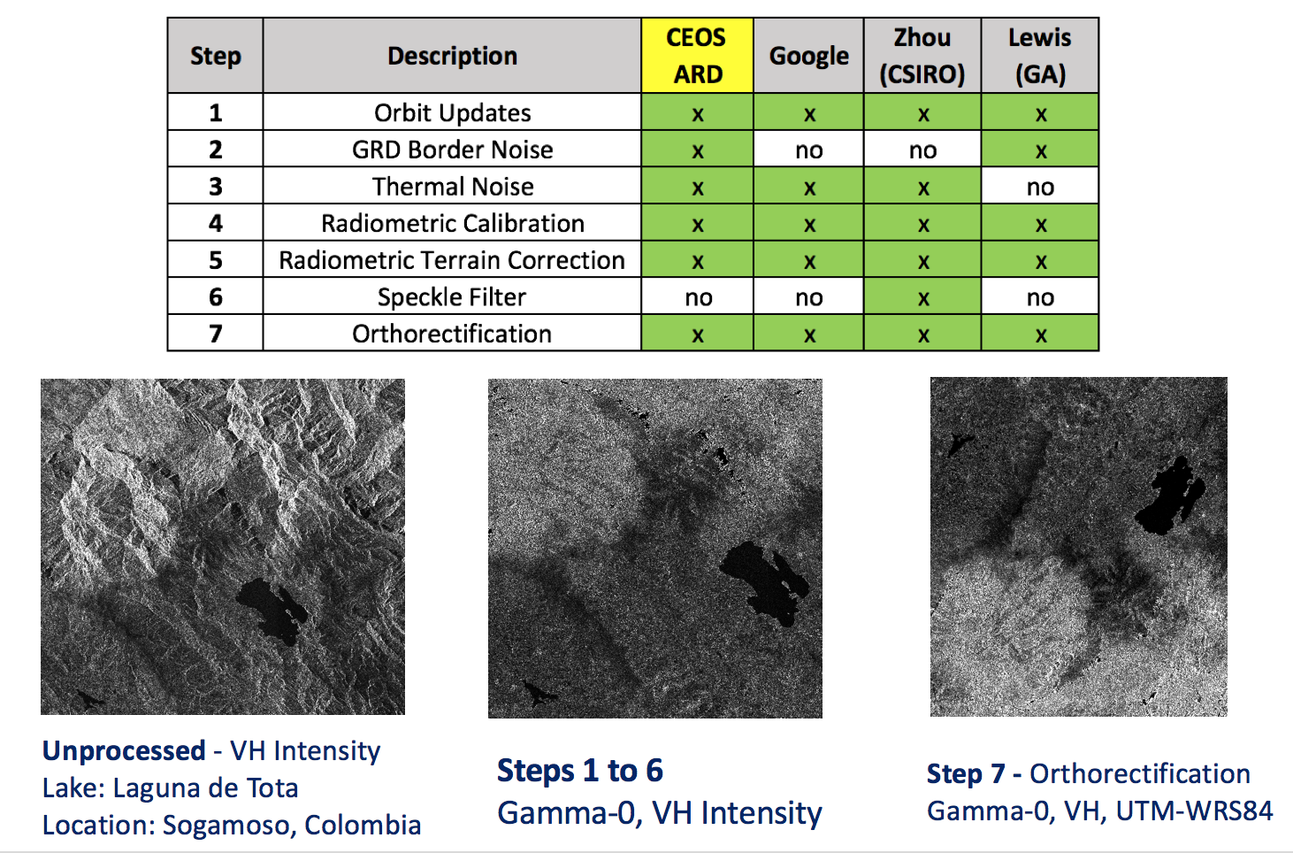
(Image courtesy B. Killough, SEO)

Reference papers
The following papers provide scientific and technical guidance:
Small, D. (2011). Flattening Gamma: Radiometric Terrain Correction for SAR Imagery. IEEE Transactions on Geoscience and Remote Sensing. 49 (8), AUGUST 2011 3081;
Shimada, M., Takuya Itoh, T., Motooka, T., Watanabe, M., Shiraishi, T., Thapa, R., Lucas, R. cMasanobu et al., (2014) New global forest/non-forest maps from ALOS PALSAR data (2007–2010). Remote Sensing of Environment 155 (2014) pp13–31.

