Minutes v1.0
LSI-VC-11 Teleconference #2: Increasing Utility and Impact of LSI-VC and CEOS-ARD
18 May 2022

Participants
CNES: Mireille Paulin
ESA: Ferran Gascon, Stephen Ward
EC/JRC: Peter Strobl
GA: Medharvy Thankappan, Andreia Siqueira
GISTDA: Sitthisak, Panu
JAXA: Takeo Tadono, Ake Rosenqvist
KARI: Seok Weon Choi, Daehoon Yoo, Dong Han Lee
LSI-VC Sec: Matt Steventon, Libby Rose
NOAA: Kevin Gallo
SEO: Brian Killough
USGS: Steve Labahn, Tim Stryker, Chris Barnes
The presentation slides compiled for this meeting are here.
Introduction
The Co-Leads welcomed everyone back to the second day of LSI-VC-11. Matt Steventon (LSI-VC Secretariat) reviewed the agenda for today's call, and reviewed the actions taken yesterday on the first day of LSI-VC-11.
Peter Strobl (EC/JRC, LSI-VC Co-Lead) suggested a change to LSI-VC-11-05, asking that all be invited to join the ESA project on DGGS. Ferran Gascon (ESA) recommended that the ESA project be restricted to USGS, and instead suggested establishing a subgroup for LSI-VC on DGGS through which the project can be discussed. It was agreed that this topic should be discussed at LSI-VC-12 in September.
LSI-VC-11-07 | Matt to add an agenda item on DGGS and the potential for an LSI-VC subgroup on this topic for LSI-VC-12. | LSI-VC-12
Regarding LSI-VC-11-06, and gridding requirements for all CEOS-ARD, Steve Labhan (USGS, LSI-VC Co-Lead) questioned whether there is an accuracy argument, and whether geolocated data is sufficient for stackability. Peter noted that the products should be gridded such that they can be immediately stacked. If ARD goes into a data cube, the data doesn’t necessarily have to be orthorectified as it is resampled anyway. We need to make sure the next step of resampling within the data cube can be tracked, which should be reflected in the metadata.
New Space SIT Chair Priority
Stephen Ward (ESA SIT Chair Team) reported:
- Commercial companies are launching many more missions and the proportion of CEOS Agency EO satellites is decreasing.
- There are new business models creating change in the industry, in particular utilising cloud computing.
- At SIT-37 in March, the preliminary session on New Space raised a lot of interest, and the SIT Chair looks forward to discussing further in depth at SIT TW in September. Some discussion points include:
  - Considering how New Space missions and data systems, in combination with CEOS agency capabilities, can help further the CEOS priority thematic observing strategies, including climate (UNFCCC, Paris agreement, GCOS ECVs and the GST), disaster response (Sendai framework), and the SDGs.
  - Understanding how New Space capabilities could address current or projected gaps, or more cost-effectively satisfy selected requirements.
  - Identifying the steps necessary to ensure future missions are fit for purpose to meet these requirements. These might include collaboration on data quality standards, calibration and validation, calibration transfer, adoption of common standards for data discovery, mixing and application – including CEOS-ARD standards.
  - Defining measures for CEOS to take as part of an engagement strategy to address the opportunities identified and to communicate them to industry and the associated data characteristics that will be needed.
- The deep heritage of CEOS Agencies can be leveraged to engage the commercial sector, including through the standards we have developed, the legacy infrastructure for cal-val, and the SI Traceability Satellite (SITSAT) efforts by CEOS Agencies.
- Any interested individuals and agencies are encouraged to reach out to the SIT Chair Team on this topic.
Discussion
- Steve Labhan (USGS, LSI-VC Co-Lead) noted that this topic has been on USGS’s mind for quite awhile, and the approach taken by the SIT Chair Team is in line with their thinking.
- For several years, USGS has been working on user needs analyses, looking where gaps exist and how New Space might fill them. Initial analysis shows that high resolution optical, hyperspectral, and SAR are areas where gaps exist that commercials could help fill. LSI-VC could help with collective engagement.
- A broader question for CEOS is how to allow/engage commercial entities. The VCs are quite flexible, but it can be difficult for higher level CEOS fora. This is perhaps a good discussion for SIT TW.
- We might want to look at getting access to data to fill user needs. There are additional commercial organisations providing back-end support (cloud computing etc.). Perhaps CEOS should break down the sector and engage in different areas. The SIT Chair Team does intend to address this.
- An industry day should be in CEOS’s vision/roadmap for New Space engagement, however we should make sure CEOS internally organised first.
- The idea of a half day at SIT TW would be welcomed by USGS and would be very helpful for CEOS as a whole. It would be beneficial to spend some time at LSI-VC-12 thinking about what the LSI can bring to the discussion.
LSI-VC-11-08 | Steve to share the US gap analysis work with the SIT Chair team, if possible. | ASAP
- Steve shared the compendium produced through the JACIE work, that provides characteristics of many commercial missions. This could be complementary to the MIM Database, and we could see if these can work together in the future.
- Stephen noted the work undergoing to create an Australian contribution on data integrity, by creating an open and free cal-val service using the infrastructure and tools available around CEOS. This would take the USGS JACIE work, alongside the MIM Database and Cal-Val tools, to hopefully get industry engaged in characterising and calibrating their data. It would involve something like a CEOS office for data integrity, with an operational website and available tools, which would help commercial entities engage CEOS and tools in characterising their data.
- ESA is strongly interested in supporting the efforts in this direction, noting that the VH-RODA forum facilitates debates on these topics.
LSI-VC-11-09 | All to look at the New Space and Future CEOS slides and give feedback to Stephen Ward / SIT Chair team within two weeks if they have any thoughts for SIT TW. Especially Slide 7. | CLOSED
- Is there any top down directive from agencies regarding New Space, for example leaving a domain of measurements to commercial and focus on research? There have been some US policies along these lines, revolving mainly around resolution. Some of this is evolving and being re-opened for discussion. There is a sense that we want to use commercial data providers to supplement governmental missions.
- The U.S. has had successive national EO plans, that directs agencies to maximise their use of commercial EO data. The Biden Administration hasn’t issued anything new just yet, but the agencies don’t expect anything to change drastically.
- NOAA is radically revising its architecture to include commercial data buys, which will impact how many satellites they launch. There are a lot of new constellations being announced frequently, even if only a fraction of these make it to space, there will still be a lot of satellites.
- Peter Strobl (EC/JRC, LSI-VC Co-Lead) questioned whether CEOS has a definition for New Space. It would be worthwhile to define this, to have everyone aligned so we are talking about the same thing.
Standardisation Topic
Matt Steventon (LSI-VC Sec) reported:
- There has been a push for formal standards to be created for ARD, and the ARD Oversight Group has heard from IEEE and ISO-OGC. Having any standards be based on CEOS-ARD would be ideal.
Discussion
- Tim Stryker (USGS) noted that it was interesting to hear yesterday about what data providers think. Creating formal standards doesn’t lock data providers into a particular approach, but it's always good to have a formal benchmark. These formal standards are things that industry does follow, which is ISO’s mission - to harmonise the standard for better technology uptake.
- IEEE & OGC help move standards along, but it's the governments formally represented to the groups that make the decision. These governments need to be informed on what is going on in CEOS.
- With ISO-OGC, CEOS already has standing, and we can provide direct input rather than going through national representatives. However, it is unclear as to what CEOS engagement means.
- Peter Strobl (EC/JRC, LSI-VC Co-Lead) noted he is closely involved in OGC.
- CEOS representation to standards bodies needs to be more coordinated. Currently this is a bit ad hoc, with different individuals and groups represented.
- Main leverage that CEOS has is that we are feeding the geospatial community with by far the largest share of data. If CEOS can agree on standards and push them through the formal process, we can use this leverage to maintain control.
- Regarding the coordination of representation in standards discussions, the CEOS-ARD Oversight Group should organise this, while keeping the SIT Chair aware.
- Ferran Gascon (ESA) noted there is a distinction between what the PFS cover and what a standard would potentially cover, summarised below.
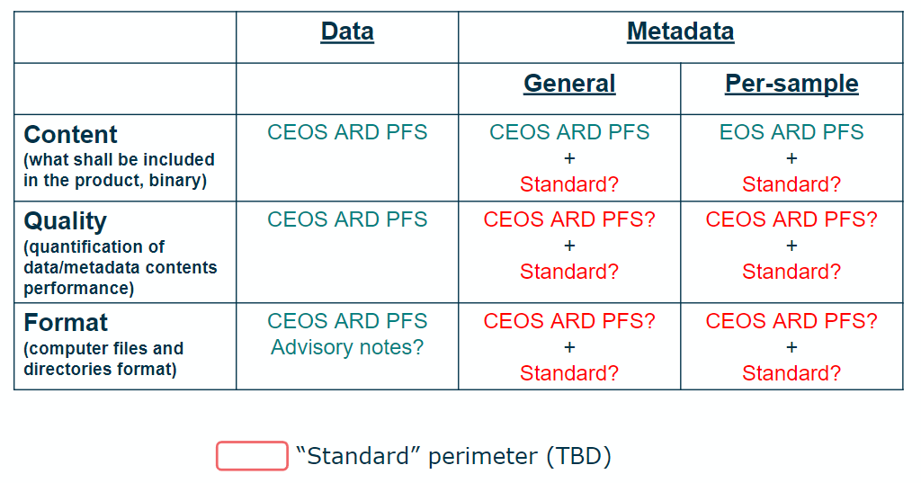
- There are different aspects of interoperability: semantic, structural, syntactic, and system. Interoperability only truly works if you cover all the aspects. From OGC experience, we will have to bring together groups that look at these different aspects, and make sure they all work together to make sure products are fully interoperable.
- Ferran noted that for certain domains, the standard will need to cover all aspects, but for others the standards can just look at the metadata. Another aspect is data quality, which we haven’t covered much in the PFS. This is something to consider for the future to increase interoperability. Some reflection is needed on what we want to cover. Defining this is necessary before discussing at length with IEEE/ISO-OGC.
LSI-VC-11-10 | Matt to confirm the perimeter targeted by ISO-OGC and IEEE for their ARD standards work, to understand more specifically what it will cover: data / metadata / content / quality / format. | ASAP  Email sent. Continuing to explore the level of CEOS engagement.
PFS Updates
Matt Steventon (LSI-VC Sec) reported:
- The Surface Reflectance and Surface Temperature PFS annual review is currently ongoing. The group has raised a number of points for discussion on the annual review process:
  - How to keep track of what products are assessed at which PFS version. If a data provider has to resubmit with each review, this would create unnecessary work for the review team.
  - The geometric correction requirements are hard to achieve for high-resolution sensors. How should this be addressed in the PFS?
Discussion
- The target is to get the SR & ST PFS ready for LSI-VC-12 in September. Where applicable, the changes will be applied across all the PFSs, to make them as consistent as possible.
- Ake Rosenqvist (JAXA) noted that for the SAR PFSs, the metadata specifies that the product is compliant with a particular version of the PFS (linked to the URL of the corresponding PFS on the CEOS/ARD website). This would be good to do across all the PFS.
- The DOI should point to not just the most current PFS, but any PFS for which there has been a product assessed. It should be clear that the product is compliant with a certain version of the PFS, as products that were compliant with a previous version might not be compliant with the current version. Updating the PFS such that a product is no longer compliant will be avoided where possible, but going down the path of standardisation could require updates to the PFS.
- Peter Strobl (EC/JRC, LSI-VC Co-Lead) suggested another other option, if there is an update, then perhaps products should be reassessed. This would help with consistency across the PFS.
- For data providers that create CEOS-ARD on-the-fly (e.g. Sinergise), making small changes can be simple, but for those who have an archive, it will be hard on those data providers to re-processes to be compliant with the current PFS. Perhaps data providers could have the choice between re-submitting and being compliant with an older version. The yearly updates would make the re-processing unfeasible.
- We should reassess the frequency of planned PFS updates, as annual updates are too frequent to make re-processing viable. For ISO-OGC, they don’t update every year, normally about every 5-10 years, and never more frequently than 3 years.
- We should distinguish between a review and an update. The annual review can monitor the standards development, but only publish a new standard version when really necessary.
- Steve Labhan (USGS, LSI-VC Co-Lead) suggested comparing the current PFS and the update that emerges at the end of the review process to see the types of changes made. It is felt that a majority of the changes being made are not substantial – the only substantial one so far is for data providers to provide their assessment of radiometric accuracy.
LSI-VC-11-11 | SR/ST PFS annual review group to consider the way forward for ‘annual’ updates, noting the need for stable PFS, updates only on an as needed basis, etc. | Confirm at LSI-VC-12 / ARD OG on the approach going forward
- Ake noted that some clarifications provided in the annual review process would not necessarily warrant a new version. Changes to the Target requirements may generally also be okay, while changes to the Threshold could affect a data provider’s CARD4L compliance.
- Regarding the geometric correction specifications and high-resolution sensors, the distinction between accuracy and uncertainty should be made clear. Specifying accuracy means we also need a reference to what it is being compared to. Without specifying accuracy, data providers can provide the uncertainty they have in location. Peter recommended against specifying an absolute quantitative limit.
- ESA is working on their Ground Control Point (GCP) library, which will start systematically providing geometric reference comparisons around the globe. Once this is available, we could then standardise the error as we can refer to a common reference.
- Ake noted that for the SAR products, the threshold requirement for geometric accuracy is "An estimate of the absolute localisation error is provided as bias and standard deviation, provided in slant range/azimuth, or Northing/Easting." This opens up the door for high-resolution sensors. The user can then decide if this is good enough for their purposes. For the Target requirement, there could be a numerical value. The SAR team is currently assessing what could be a suitable Target for the geometric accuracy.
- It was suggested to do something similar for the optical PFS, as this approach seems to fit more with the overall CEOS-ARD mission to document the data specifications. It is unclear where the specific 0.5-pixel rRMSE number came from.
LSI-VC-11-12 | Andreia to send a summary via email regarding the issue of geometric correction accuracy and the current specification’s unsuitability for high-resolution sensors. She will seek thoughts from the team on how to resolve this problem with the PFS, noting the SAR team’s approach to this requirement. | ASAP
Closing
Matt thanked all for attending and contributing to the discussions. LSI-VC-11 Teleconference #3 will be held on Thursday the 19th of May, at 7am US East.

