Minutes v1.0
12th Meeting of the CEOS Virtual Constellation for Land Surface Imaging (LSI-VC)
8-9 September 2022
ESA ESRIN, Frascati, Italy

Participants
CNES: Richard Moreno
CONAE: Laura Frulla*
DLR: Jonas Eberle*, Katrin Molch*
ESA: Ferran Gascon, Philippe Goryl, Clement Albinet, Damiano Guerrucci,
Pasquale Lorusso
EC-JRC: Peter Strobl
GA: Medhavy Thankappan*, Andreia Siqueira*
GEOGLAM: Ian Jarvis, Alyssa Whitcraft*
GISTDA: Sitthisak Moukomla, Panu Srestasathiern
ISRO: Hari Priya Sakethapuram*, Bimal Bhattacharya*, Suresh Kumar*
JAXA: Takeo Tadono*, Ake Rosenqvist*
LSI-VC Sec: Matt Steventon, Stephen Ward, George Dyke
SEO: Brian Killough, Dave Borges
Sinergise: Grega Milcinski, Marko Repse
UKSA: Sarah Cheesbrough
USGS: Steve Labahn, Tom Sohre, Chris Barnes
DE Africa: Adam Lewis*
* indicates online

Thursday, September 8
Session 1: Welcome and Introductions
Welcome [Slides]
Peter Strobl (EC-JRC, LSI-VC Co-Lead) welcomed participants to the meeting. Matt Steventon (LSI-VC Secretariat) provided an overview of the substantial progress since the last in-person meeting. The status in 2019 was as follows:
- No CEOS-ARD Datasets (now seven with around seven more soon)
- First CEOS-ARD Strategy was in development (now on version 2).
- Only three PFS (now seven)
- No subgroups (Forests & Biomass, GEOGLAM).
- No CEOS-ARD Governance Framework
- No CEOS-ARD Oversight Group, nor thought of ARD beyond land (now have Aquatic Reflectance and Ocean Radar Backscatter PFS).
There was a roundtable of introductions of participants both in person and online.

Action Review
Matt reviewed the actions from LSI-VC-10 and LSI-VC-11. Updates were made directly in the tracking tables.
Session 2: CEOS-ARD for Land (CARD4L)
New PFS: Nighttime Lights Surface Radiance (NSLR) [Slides]
Brian Killough (NASA) reported:
- The new Nighttime Lights Surface Radiance PFS is a derivative of the SR PFS and is presented at LSI-VC-12 for endorsement.
- The Nighttime Light Surface Radiance PFS applies to data in the VIS/NIR wavelengths at resolutions of 10m to 1km. The specs are similar to optical surface reflectance with several modifications and additions to account for lunar radiance and atmospheric scattering.
- Coordinated by Brian Killough (CEOS SEO, NASA) with detailed support from Miguel Roman (Leidos), Bhaskar Ramachandran (NASA GSFC) and Zhousen Wang (NASA GSFC). Overall, a team of around 20 people have contributed.
- The VIIRS Day-Night Band (DNB) or NASA’s Black Marble is the best example dataset for this PFS. NASA is planning to migrate this dataset to the AWS cloud by the end of 2022.
- The CEOS SEO has downloaded and tested this dataset for one location (Port Vila, Vanuatu) and has completed a preliminary PFS assessment. 25 out of 26 threshold requirements have been met. 33 of 40 target requirements have been met.
- The CEOS-ARD process uncovered that traceability and uncertainty measures were present in the VIIRS dataset, but until this point, this was not clearly captured in the metadata. This has been an unforeseen benefit of the CEOS-ARD process.
Discussion
- Nighttime light datasets are often used for urban assessments. Black Marble Dataset has perhaps been underutilised and it is hoped that the CEOS-ARD assessment will help put it in a better more usable form and increase uptake.
- DOI references in the metadata are suitable. Metadata priority are machine readable elements. DOI is sufficient for additional reference materials. Things that are static should be in the metadata.
- It was noted that sensor calibration (1.11) is listed as not being required for Threshold level compliance. However, this is a radiance product, so it needs calibration. It is required in the SR PFS.
- Terrain occlusion was raised (2.10). VIIRS has a very wide angle, so it is likely that occlusion would occur. Occlusion metrics is a requirement for Target only. Brian will follow up with the team on why occlusion metrics are not covered by the Threshold requirement.
- There was a discussion on partial occlusion and defining the point at which a pixel is considered occluded. This is particularly relevant for low resolution images. Knowing the percentage occlusion and having that present in the metadata could be helpful (for all types of data). This is DEM dependent. It was suggested that the PFS shouldn't make the distinction of what is a significant level of occlusion.
- As with other aspects of the various specifications, the key question is whether occlusion has, or could have, a significant impact on the measured value. It would be helpful to have an analysis done for a NLSR dataset as a trial.
- NASA datasets are broadly migrating to include STAC metadata and according to Brian COG is looking to be the future data format standard.
- The geometric accuracy parameter (1.8) was questioned – specifically, why it is not required for Threshold. It is needed to be able to stack through time in a meaningful way. This is the same in the SR PFS. Likewise for 1.7 (geometric correction methods) are not required for Threshold. An action was recorded to investigate.
LSI-VC-12-01 | Brian to follow up with the Black Marble team regarding the specifics of the terrain occlusion point and why this was considered not applicable. Brian will ask whether the occlusion percentage could be added to the metadata and ask the team about the expected impact of terrain occlusion at global scale. | COMPLETE  The SEO addressed this issue with the Black Marble team. They agreed it may be an issue in extreme locations, but further analysis is required. As of now, terrain occlusion is not part of the metadata. A presentation on the status of the PFS and ARD compliance will be given at Pecora on October 27.
LSI-VC-12-02 | SEO team to analyse the impact of partial terrain occlusion with the Black Marble dataset and to report back as input to LSI-VC-12-03. This analysis will use the NASA DEM and the VIIRS Black Marble viewing geometry to determine how many pixels are partially occluded and the impact on the dataset in certain parts of the world (e.g., are there cities where the terrain occlusion could be significant?). | IN PROGRESS  The CEOS SEO team plans to analyse the impact of partial terrain occlusion. This analysis will use the NASA DEM (30 metres) and the VIIRS viewing geometry to determine how many pixels are partially occluded and the impact on the dataset in certain parts of the world (e.g., high terrain cities such as Gatlinburg, TN or Boulder, CO). This will be completed in early 2023 and reported at the LSI-VC-13 meeting.
LSI-VC-12-03 | Brian and Matt to coordinate a CEOS-ARD Oversight Group discussion around the way the PFS currently handle terrain occlusion and to consider how to better document the specifics of this parameter. | After LSI-VC-13  This action cannot be completed until LSI-VC-12-02 is complete.
LSI-VC-12-04 | Andreia and Matt to add notes to the tracking spreadsheet for the PFS review process around 1.11 (radiometric calibration) and 2.10 (terrain occlusion). | COMPLETE  Completed September 2022
LSI-VC-12-05 | Sarah to send Brian details of Chinese and UK nighttime lights missions that might generate products that are applicable for assessment against the new PFS. | COMPLETE  Sarah and the Black Marble team (NASA) have provided information on future missions relevant to nighttime lights. These include: China’s SDGSAT-1 (launched Nov. 2021) with nighttime observations (http://www.sdgsat.ac.cn/) to support the UN SDGs. The spatial resolution is Panchromatic: 10m; RGB: 40m. They just released the data to the public (http://data.sdgsat.ac.cn/). ESA will likely be providing funding support for NOEMI (an Earth at Night mission concept). This is the first phase (Pre-phase A) before making a selection for small ESA missions.
LSI-VC-12-06 | Ferran to share information about the DLR mission that might produce a Nighttime Lights Surface Radiance type product. | COMPLETE  DLR does not plan to launch a dedicated nighttime light mission. However, a mission is being considered by a team, including DLR, for the next "ESA Scout Missions" call (link).
LSI-VC-12-07 | Brian to share the final Nighttime Lights Surface Radiance PFS document to lsi@lists.ceos.org, provide another opportunity for final critical comments (1 week), and note that virtual endorsement will be assumed after that point. The PFS will then be shared with USGS for the editorial review and subsequently published online. | COMPLETE  PFS endorsed and posted on the CEOS-ARD website.
LSI-VC-12-08 | LSI-VC Leads to consider how to re-open the discussion regarding how the PFS address geometric uncertainty and absolute/relative accuracy (note parameters 1.8, 1.7, and 4.1 in the SR PFS). WGCV support (incl. TMSG) will be needed. This should be considered in the frame of the CEOS Interoperability Framework. | LSI-VC-13
LSI-VC-12-09 | Matt to add LSI-VC-12-08 to the WGCV-51 agenda. | COMPLETE  Peter will add a reference in his interoperability slides for the joint WGCV-WGISS meeting.
New PFS: Ocean Radar Backscatter (ORB) [Slides]
Clement Albinet (ESA) reported:
- The Ocean Radar Backscatter (ORB) PFS has been shared and is presented to LSI-VC-12 for endorsement.
- The ORB is a derivative of the NRB PFS, with specific changes to address the specifics of oceans, e.g. DEM is not applicable.
- ORB is effectively a simplified version of the NRB product: Geoid-corrected backscatter, expressed as sigma-nought for each polarisation. Changes relative to the NRB PFS include Geoid incidence angle image, land masks, etc.
- As with the other radar PFS, the ORB is accompanied by an XML metadata specification.
- Endorsement of the ORB PFS was requested, as is an editorial check of the PFS.
LSI-VC-12-10 | Matt and Clement to coordinate a final email to lsi@lists.ceos.org sharing the ORB PFS, providing a 1 week window for critical final comments, and noting that virtual endorsement will be assumed after that point. The PFS will then be shared with USGS for the editorial review and subsequently published online. | COMPLETE  PFS endorsed and posted on the CEOS-ARD website.
CEOS-ARD Assessments [Slides]
Medhavy Thankappan (GA) reported:
- WGCV-49 agreed that full peer review panels would only be assembled for a Target level assessment, in an effort to accelerate reviews.
- Review panels have a two-year term. WGCV will discuss renewals at the next WGCV meeting (Oct. 2022).
- Will need to assemble a SAR review panel, given interest in SAR products and the assessments on the horizon. Currently have optical and hyperspectral panels assembled.
- Pipeline of products means we need more resources for assessments, and to provide redundancy for Medhavy.
  - Steady stream of CEOS-ARD submissions coming through now.
  - No redundancy or back-up identified for WGCV POC.
  - Recruitment for assistance with CEOS-ARD evaluations in progress at GA.
  - Seeking back-up for WGCV PoC at WGCV-51 Plenary next month.
Discussion
- The team commended and thanked Medhavy for his great effort with the assessments and for his work as the LSI-WGCV POC and liaison.
- Since we are looking towards standards, Peter noted that it is not the role of standards bodies to undertake assessments against their own standards, as we do with CEOS-ARD. This is usually a service offered by third parties. While WGCV is our compliance checker for now, in time we need to reconsider this dynamic and potentially take CEOS out of that compliance loop. Doing so may require changes to the PFS to make assessments clearer.

PFS Update Process [Slides]
Andreia Siqueira (GA) reported:
- Currently, a review of LSI-VC PFS is carried out on a yearly basis. Updates are based on feedback from both users and data providers. Have had consultation teleconferences to agree on changes. The process is inclusive.
- Normalised Radar Backscatter, Polarimetric Radar and Aquatic Reflectance PFS were endorsed in 2022. Surface Reflectance and Surface Temperature PFS were endorsed back in 2019. These PFS then underwent minor updates in mid-2020. Changes were applied across all optical PFS to ensure consistency. This included Aquatic Reflectance which was still in development in 2020.
- During past LSI-VC meetings, a number of points have been raised for consideration in future updates, including versioning, terminology, update frequency, and high resolution datasets.
- Noting the issues with frequently (i.e., annually) updating PFS, the following approach was proposed:
  - LSI-VC continues to receive feedback from the community and regularly consults.
  - All new information and feedback will be kept by the LSI-VC Secretariat.
  - Ideally updates will be no more frequent than 3 years.
  - PFS update process will only start when there are significant changes. Changes should be consistent with feedback received from the community and in accordance with the PFS template.
Discussion
- There was a discussion about the means for collecting feedback. More public calls for feedback were suggested, as well as using the CEOS-ARD website to collect inputs.
- Andreia will continue working with the LSI-VC Secretariat to collect and catalogue feedback in the register.
- It was noted that product development and revisions at agencies take place on timescales of 5 years or so. PFS updates shouldn't be much more frequent than that sort of time scale.
- Ivan agreed on the need to better define what a ‘significant change’ means. In particular, because each change has cost and implementation implications. Changes should only be made to PFS when absolutely required. Update process should include consultation with those whose implementation tasks and work are impacted by decisions to change the PFS.
- Peter noted standards as an example: standards bodies use a panel of stakeholders to collect feedback and they have the authority to decide what a significant change is. Standards are then updated and the assessments are required to be undertaken again to meet the latest version. This is not a trivial process. Need to engage data providers in the update process and discussions around updates. Need to have a forum for agencies, VCs, etc. to be involved in the process and decide when an update occurs.
- It was suggested that “With the aim of minimising the number of updates” be added to any guidelines around the PFS update process.
- Noting that the register acts as a ‘parking lot’ for issues that will be addressed in the next update, it was suggested that publishing interim versions / informal draft releases would allow data providers to be forward-compliant and give new data providers the ability to see what is coming down the pipeline and get out ahead of them. This would be desirable given the long lead times in designing and producing dataset releases. At the very least, details of the upcoming changes / potential changes (the ‘parking lot’) should be publicly communicated (e.g., via website, but not headline visibility).
- Drafts of the most recent updates should be made public via the website.
- Don't suggest using a x.1 release model. Prefer a draft release, draft-1, etc.
LSI-VC-12-11 | CEOS-ARD Oversight Group to consider an update to the CEOS-ARD Framework that would capture the agreed wording around the PFS update process. This will capture the agreement regarding cadence, draft versions, publicising upcoming changes via the website, etc. This will be applicable to all PFS. | November 2022  Will be raised at a meeting of the CEOS-ARD Oversight Group.
Session 3: Agency Updates on Land Surface Imaging and Analysis-Ready Data
JAXA [Slides]
Takeo Tadono (JAXA) reported on ALOS-3, ALOS-4 PALSAR-3, plans for open release of ALOS-2 PALSAR-2 ScanSAR, and the PALSAR/PALSAR-2 NRB global mosaic products.
Takeo also reported that JAXA is seeking CARD4L NRB v5.5 compliance at THRESHOLD level for SAR data products from ALOS-2 PALSAR-2. Self-assessment form and sample products submitted to LSI-VC (Matt) and WGCV (Medhavy) on August 27, 2022.
Discussion
- ALOS data will be moving to the cloud and the hope is that COG format will be used for improved discovery and access.
- There is a partial STAC extension for CARD4L NRB, and v5.5 is STAC compliant (https://github.com/stac-extensions/card4l).
- Planning for a GEO Week release of ALOS-2 ScanSAR archive. Hoping to have the data in the cloud by then, but not sure of the exact status across GEE, AWS. A press release will clarify closer to the release.
DLR [Slides]
Jonas Eberle (DLR) reported updates on the EnMAP surface reflectance product and the Sentinel-1 ARD NRB product jointly developed by DLR and ESA. There will be a meeting before the WGCV SAR subgroup meeting to discuss this further. The Sentinel-1 product uses a multi-SAR processor.
Discussion
- The multi-SAR processor used for Sentinel-1 could theoretically be used for other datasets. Processing of additional datasets is not foreseen at the moment, but it would be logical to use a common processor.
LSI-VC-12-12 | Jonas to check if the feedback on ARD gathered by DLR through their exchanges/workshops with users can be shared with CEOS. | November 2022
- Noted the emergence of different CEOS-ARD products for the same missions, via different processes. Suggested that we need to give this more thought, for example around topics like interoperability, cataloguing, documentation, duplication of effort, etc. It was noted that NASA, ESA, DLR and ASF noticed this and decided to work together on this product to avoid divergence with this product at least. We need to make it clear that two different CEOS-ARD for the same sensor are not necessarily interoperable. Peter suggests this needs to be part of the data package, in the metadata, so it is searchable. Specification for metadata that makes data interrogatable/automated and accessible for specific user needs.
- In general, accuracy and traceability / uncertainty aspects of the PFS need work to make datasets more interoperable. Needs to also be reflected in metadata to allow for automated interrogation. This will allow users to determine whether products are suitable for their applications. We can’t quantitatively set limits on accuracy, etc. We currently have one single data quality parameter, but might need to think about expanding this and making it more consistent across the PFS.
USGS [Slides]
Steve Labahn (USGS) reported:
- Noted Landsat 9 was launched from Vandenberg Space Force Base on 27 September 2021. The “First Light” image was of an area along the northwest coast of Australia.
- Noted Landsat 7 orbit was lowered for potential refuelling demonstration of OSAM-1.
- Steve Covington noted Landsat 7 shifting orbit and change of Local Solar Time, provides the opportunity for an assessment of what this type of change makes to products.
- Landsat Collection 2 (CEOS-ARD/CARD4L compliant data) has been released in the commercial cloud in AWS with improved radiometry, geometry, metadata and access relative to Collection 1.
- Aquatic Reflectance (AR) PFS has been finalised and endorsed. It is focused on inland water bodies and coastlines. There is interest in expanding it to ocean bodies to broaden the AR PFS. USGS conducted an initial self-assessment of the provisional Landsat AR product and several enhancements are still needed to become Threshold-level CEOS-ARD/CARD4L compliant. USGS released Landsat 8-9 Collection 2 Level-2 Provisional Aquatic Reflectance products on 9 May 2022. Please contact USGS EROS Customer Services with any questions or feedback about these products.
Discussion
- The Aquatic Reflectance product will be an operational product eventually. USGS HQ is pushing this, but needs more feedback from the user community. The data represents 10-20% of the total archive, so is a relatively light data processing burden. The algorithm does have to be moved to the operational production side which represents some effort. The current version is focused on the coastal region, though comparisons with open ocean development products are ongoing.
- Pre-processed aquatic reflectance is the plan for the operational product, not on demand.
- The Copernicus 30m DEM will be used for Collection 3 processing. Collection 3’s biggest change will be BRDF processing (almost guaranteed). Not expecting the change from C2 to C3 will be as big an adjustment as moving from C1 to C2 was. The C1 to C2 migration had a lot of consistency checks and efforts to make it ‘cloud-ready’.
- There was a discussion around cross-cloud data access and use. This will be a significant challenge moving forward and CEOS should have a grasp on how its users might need to work in order to efficiently access various data sources across various cloud locations. The CEOS SEO plans to test this concept and report back to CEOS.
Geoscience Australia [Slides]
Andreia Siqueria (GA) reported:
- The National Space Program for Earth Observation (NSPEO) is currently focusing on engaging the new Australian government.
- The Australian Space Agency’s Earth Observation from Space Roadmap has been providing a clear sense of priorities for the space sector, and a map for industry to coordinate and build world-leading capabilities and technologies that support jobs and critical services into the future.
- Geoscience Australia has restructured its Space Division. It has established the Satellite Land Imaging Collection (SLIC) branch to coordinate its activities under the NSPEO program with a key focus on cross-calibration and international collaboration.
- GA continues to support the CEOS-ARD Strategy through LSI-VC and WGCV.
- Alice Springs ground station is now a certified Landsat Ground Network (LGN) station for Landsat 7, 8 and 9. A certification process is underway to certify a second 9m antenna for all Landsat missions.
- GA is supporting applications of space technologies in the Indo-Pacific region as part of the Earth Observation for Climate Smart Innovation project (EOCSI).
- Transition of the Digital Earth Africa program is ongoing. GA will continue to support the transition and governance of DE Africa until June 2023.
- GA has been working to deploy ARD from Landsat and Sentinel-2 using the same code base.
Discussion
- The GA Landsat and Sentinel-2 code base performs BRDF and terrain illumination corrections. These are key gaps with the USGS Collection 2. GA has strong user community linkages and these are identified as priorities by users.
- BRDF results in a step change in radiometry and has a significant impact on end users. Its addition necessitates re-teaching of any ML algorithms, for example.
NASA [Slides]
Mark Carroll (NASA) reported on the NASA Earthdata Cloud:
- Managed commercial cloud for NASA Earth observation on AWS.
- Improves the efficiency of NASA’s data system operations, while maintaining a free and open data policy.
- Initially architected for NASA DAACs (application and mission data ingest, archive, distribution).
- Operational in July 2019. Common Metadata Repository (CMR) Application, Earthdata Search Application, 6 PB of Sentinel-1 mission data.
- As of May 2022, there is 23 PB of mission data in EDC with a plan to onboard 50 out of 75 top datasets by Q4 CY 2022, establishing an initial ‘data lake’. This is a five-year plan that started two years ago.
- Earthdata Cloud Platform is a NASA General Application Platform (NGAP), a multi-account Infrastructure-as-a-Service (IaaS) cloud platform operating on Amazon Web Services (AWS) under a single Earth System Data and Information System (ESDIS) owned top level ‘payer account’, providing shard cloud service and controls to EOSDIS. ESDIS managed and EED operated.
- The platform maximises autonomy, flexibility and has shared services and control.
- Earthdata Cloud Cookbook is a curated collection of tutorials, open and available through GitHub
- More information can be viewed at http://earthdata.nasa.gov
Discussion
- Estimating egress cost is difficult. Currently in a wait and see mode. Hoping that users will come closer to the data and use it where it sits. USGS noted that for them this has been a slow transition (i.e., users adapting to that new approach of working in the cloud vs. downloading data). USGS found there are still high volume egress customers. USGS offered to share experiences from their shift to the cloud.
- ESA collaborating with NASA on MAAP, the objective being to support the exploitation of NISAR, GEDI and Biomass data. Investigating how to bring processing closer to the data. Objective is to create a global biomass map.
- Missing today is a seamless way for users to source data from multiple locations and do any processing where the data is located. Cloud agnosticity and cross-cloud access and use will be a key topic in future.
ESA [Slides]
Ferran Gascon (ESA) reported:
- The Sentinel-2 High Level Operations Plan (HLOP) has been updated, and this has improved coverage in a number of areas including the Pacific Islands.
- Assessment of S2-Landsat harmonised and fused products pilot production over Belgium.
- Development of a new aquatic Reflectance layer within Level-2A product is targeted to be compliant with AR PFS.
- Exploring feasibility of using Digital Global Grid System (DGGS) for S2
- Considering new product format evolutions: STAC metadata, Zarr, JSON metadata, etc.
- New data access service for all Sentinels and Copernicus Contributing Missions (CCMs) will begin towards the end of this year and is planned to be operational by mid next year.
- Sentinel-2 Collection 1 is being reprocessed using latest processing baselines for full S2 Level-1C and Level-2A products. Data will be distributed through the DIAS platforms (CREODIAS, Mundi and ONDA) starting from Q4 2022 and completed by Q1 2023. It will be fully compliant to CEOS-ARD.
- VH-RODA 2022 Workshop will be held from 7 November to 10 November 2022. ARD is one of the dedicated topics for this workshop.
Discussion
- Brian noted his work with Sentinel Hub, which plans to use CREODIAS. ESA was supporting the DIAS, but now there is the shift to a new data access service for all Sentinels and Copernicus Contributing Missions (CCMs). The DIAS will not disappear – the best way to understand their long-term plans would be to speak with the DIAS providers.
- There were questions about cloud providers and maintaining provenance for CEOS Agency data. The shift is positive, as long as it is done in a controlled and managed way. It is a measure of success. CEOS Agencies need to be concerned with presenting their data in the best form possible and encouraging others to take the data and run with it, while maintaining traceability back to the authoritative data. And to provide tools to work with it correctly.
- Certifying authenticated copies of data will be a growing concern and problem. Maintaining provenance and a chain of any alterations is key.
- Boundary with CEOS agency data is provision to the cloud, unclear what is happening on the other side of the fence. The CEOS SEO is undertaking some efforts to understand the other side – the last mile to the user.
- Two levels of authoritative validation check: 1) authorised replica copy, 2) end user validation check with some sort of tool.
- Noted example of DE Africa having a copy of the USGS Landsat data, but it is not certified with SHA (Secure Hash Algorithm) checks. SHA values can be provided from the USGS side, but then there is the question of resourcing such a verification. Verifying whole scene files is easy enough, as the hash checks can be done at scene level, but what if the pixels are stored in some other way?
- Cross-cloud data access and discovery and authoritative data certification are possibly two blocks of the proposed CEOS Interoperability Framework.
NOAA [Slides]
Kevin Gallo (NOAA) reported:
- ProxyVis is a tool which makes use of fused images from the full GEO ring. It is currently focused on ocean applications, but land uses are under consideration.
- NOAA’s Weather and Climate Toolkit currently includes imagery and data products from GOES-16 and GOES-17. It includes standard GOES land products such as Land Surface Albedo and Land Surface Temperature.
- NOAA-NCEI software for the toolkit transforms weather and climate data into common web and GIS-ready formats. It supports common formats including NetCDF, GRIB, AREA, GeoTIFF (32 bit float), including local or remote data.
- NOAA Open Data Dissemination Program includes over 220 NOAA datasets on the Cloud Service Providers (CSPs) Platforms. This is currently under development.
- NOAA is a participant in the Group for High Resolution SST (GHRSST) and SST-VC efforts that include plans to submit several datasets and associated PFS for consideration of ARD compliance.
- JPSS-2 launch has been planned for 1 November 2022. It will carry the following instruments: Advanced Technology Microwave Sounder (ATMS), Cross-track Infrared Sounder (CrIS), Visible Infrared Imaging Radiometer Suite (VIIRS) and the Ozone Mapping and Profiler Suite (OMPS).
- Kevin is retiring by the end of September and wishes the LSI-VC continued success. He anticipates that NOAA will nominate a replacement.
Discussion
- The team thanked Kevin for all of his contributions and wished him all the best for the future.
- Kevin reported that a Sea Surface Temperature (SST) PFS has been developed and subsequent self-assessments are planned. This is linked to GHRSST and led by Ed Armstrong and Ken Casey.
LSI-VC-12-13 | Matt to follow up the Sea Surface Temperature PFS and self-assessment developments with Ed Armstrong and Ken Casey. | October 2022
Mexican Space Agency [Slides]
Adrian Guzman (AEM) reported on a proposal being discussed for the MexSAT Imaging Constellation:
- The proposal is being developed as a public-private partnership, supported by KARI and South Korean Nano-Satellite Manufacturer, TelePIX.
- Part of international organisation called CELAC Small Satellite
- Aims to provide a better understanding of landscapes at local, regional and global scale.
- The top priority is to have a sustained and enhanced land imaging program for Mexico.
- Also considering alternative implementations that enables the collection of global, moderate-resolution data with a full range of spectral capabilities.
- The goal of this project is to understand how the level of coverage can be maximised with a global network of satellites.
Discussion
- It was noted that the program is considering CEOS-ARD from the outset, which is positive.
- AEM is looking for CEOS Agency and LSI-VC guidance and also collaboration opportunities. AEM is keen to contribute to the ecosystem. Listening to LSI-VC is a great help in planning and making the best investment for their new program. Guidance from CEOS Agencies on cloud hosting is a great help in particular.
ISRO [Slides]
Hari Priya Sakethapuram (ISRO) reported:
- ISRO is considering CEOS-ARD assessment for data from its current and next generation SAR satellites, as well as how this data can be utilised in emerging applications such as machine learning and Data Cubes.
- Software tools have been developed to create radiometric and polarimetric products across a variety of sensors from current satellites (incl. RISAT, Novasar, etc.) and airborne sources, as well as the upcoming NISAR mission.
Discussion
- Steve Labahn asked about links to the Resourcesat team’s work on CEOS-ARD, and Hari Priya confirmed the teams have been collaborating and that there was someone from the Resourcesat team online today. This includes work on SAR and optical co-registration in the same Data Cube.
LSI-VC-12-14 | Hari Priya to share a summary of all of ISRO’s self-assessments that are in the pipeline, so they can be reflected on the website. | IN PROGRESS  Steve Labahn followed up with the ISRO team at a recent meeting. The Resourcesat-2/2A Surface Reflectance product has been added to the ceos.org/ard table as a result.
GISTDA [Slides]
Sitthisak Moukomla (GISTDA) reported:
- Mou confirmed that THAICHOTE (THEOS-1) is still in operation. Launched in 2008, it is still producing useful data.
- Large amounts of data have been collected in GISTDA’s archive. The pain points for using the data include the new technologies being expensive for the Thai government and end users (e.g., farmers). The data quality is another issue. Government data is not provided to the private sector.
- Setting up a prototype product called ‘Sphere’ that will be accessible to all Thai people. This was initiated by Dr Pakorn to provide geospatial services to the community. Sphere comprises the Data Cube, GISTDA Map API, and GISTDA Base Map.
- For ARD and Data Cube, GISTDA plans to make THAICHOTE (THEOS-1) data compliant to CEOS-ARD specifications. The overall platform has been developed and further advancements in AI/ML functionality will be progressed in FY 2023.
- GISTDA welcomes guidance from LSI-VC regarding progressing the Sphere platform and making THAICHOTE (THEOS-1) data compliant with CEOS-ARD.
Session 4: CEOS-ARD Impact Report / Website
Proposal: Demonstrating the Value of CEOS-ARD – Case Study Compendium
Matt Steventon (LSI-VC Secretariat) recalled a discussion paper on demonstrating the value of CEOS-ARD, which proposed a compilation of case studies. This idea has evolved into a new section of the CEOS-ARD website, since this would be a very flexible approach, allowing new case studies to be added when available. He showed a pilot of the pages, which include a few sample case studies courtesy of Digital Earth Africa: https://ceos.org/ard/impact/.
Discussion
- Overall the idea was welcomed. This will be a handy reference and useful resource for demonstrating the impact of our efforts.
- It was suggested that prioritisation should be given to case studies that are multi-source and built on long time series data. These are uniquely enabled by CEOS-ARD.
- Sarah suggested a consistent format / template for articles to make it easy for contributors.
Session 5: Commercial (New Space) Engagement
Discussion: Commercial (New Space) Engagement [Slides]
Steve Labahn (USGS, LSI-VC Co-Lead) presented:
- When it comes to considering ‘New Space’ USGS is looking at the whole scope of the EO chain from acquisition to applications to data delivery, etc.
- There is perhaps a bit of irrational exuberance in the ‘New Space’ EO market at the moment. Studies show that the market likely cannot sustain so many new companies. There are a lot of missions filling a lot of niches, and it is a challenge to work out which companies will stick and where to invest time and energy engaging.
- At SIT Technical Workshop, USGS will suggest that CEOS consider forming an ad hoc Governance Task Team for Leveraging Commercial Space Products and Services, or similar. This is based on the principle of shared value between the public and private sectors in delivering public benefit and is proposed as a means for initial CEOS member dialogue, with subsequent involvement of commercial service providers at a dedicated public, international meeting. There are multiple topics for consideration, e.g.:
  - Upstream and downstream services.
  - Authoritative data, quality assurance, ‘fitness for purpose’.
  - Shared returns to national economies’ commercial service providers.
  - Integrated approach to long-term operational continuity (e.g., meteorological, land imaging).
- In support of future mission development, USGS and NOAA have been working on a user needs elicitation process. Focused on geophysical parameters and key applications. Supporting Landsat Next development primarily at the moment.
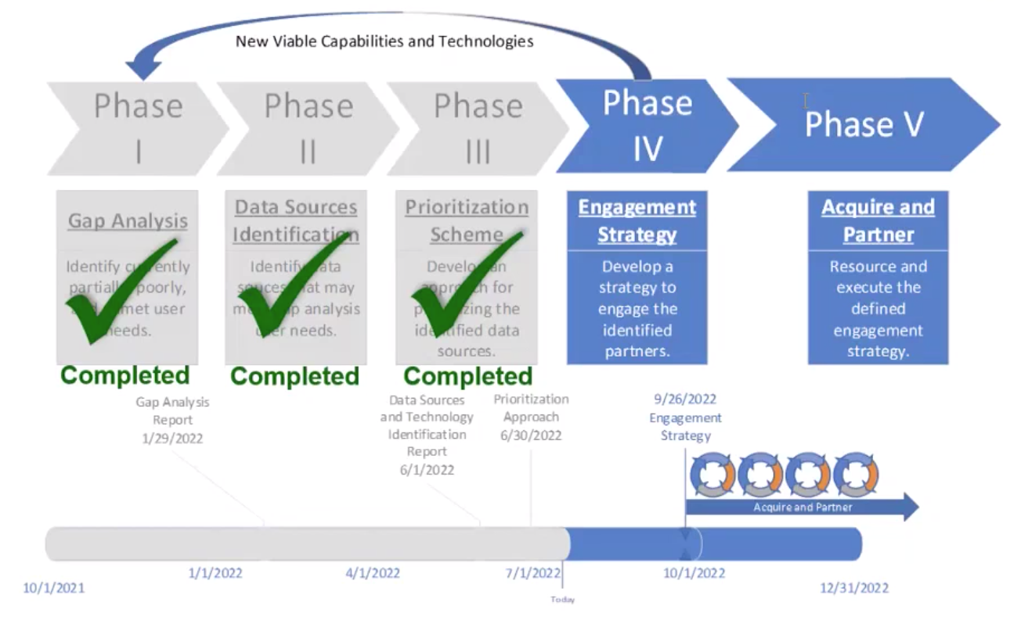
- The USGS database is closed and internal, but the scheme and approach might be shareable. It leverages the MIM Database and aims to go beyond describing capabilities and capture what products are generated by missions, their frequency, whether they are free and open, etc.
- Three major gap areas identified are radar imagery, hyperspectral/imaging spectroscopy, and high resolution optical. Next steps are to align this inventory of missions and sensors against those areas, and undertake a prioritisation scheme to analyse which missions would fit those gap areas.
- The EC Knowledge Centre on Earth Observation (KCEO) is a very useful source of user needs.
- A clear view of “user needs” is a very difficult thing to achieve. User needs should drive the definition of “analysis-ready” and therefore ARD.
- Commercial companies including ‘New Space’ are reliant on the reference measurements provided by long-term programs like Landsat and Copernicus.
- Data interoperability, calibration and validation, and ARD will be pillars to any future “CEOS Strategy for New Space”.

Friday, September 9
The actions and decisions from Day 1 were reviewed and revised.
There was a discussion about the PFS Template development in the CEOS-ARD Oversight Group, and whether this is progressing and still seen as relevant. The PFS Template is still ‘active’ and the next version, one that incorporates more thematic domains, is being discussed and developed. A template PFS is still seen as very useful for building a sense of unity and consistency. Deciding the appropriate level of detail and how to accommodate many different data types is a challenge, but one the Oversight Group considers important. With such a heterogeneous group of products it is difficult to reach consensus. Even if the resulting template is very high-level, it should still have a lot of utility.
It was suggested that perhaps a template is needed for each ‘Level’ of data targeted. This could perhaps overcome some of the issues that have been raised in the discussions of the Oversight Group. This would require us to define the levels for which we want interoperability. Most of the current PFS come from the Level 2 area. Having a template to ensure interoperability at that specific level, without constraining anything above or below it, could be a good way forward.
LSI-VC-12-15 | Matt to compare existing PFS with the template and see what the common denominators are between them. | December 2022
Session 6: LSI-VC Vision and Objectives [Slides]
Matt Steventon (LSI-VC Secretariat) presented:
- Proposing a new Vision and more specific Objectives to help us clarify and organise our goals, broaden the ‘umbrella’ of LSI-VC activities, increase representation of all team members and their own priorities, and define our next CEOS Work Plan inputs.
- LSI-VC Vision Proposal: Sensor agnostic land surface data from all missions, achieving a coherent single data stream that enables characterisation of change on the Earth’s surface through time.
- Proposed Objective #1: Promote uptake and ease the use of land surface imaging datasets via an efficient CEOS-ARD for Land process.
- Proposed Objective #2: Move CEOS agency and other data providers' land surface imaging datasets along the interoperability spectrum, with a view to a future of sensor agnostic land surface data from all missions.
- Proposed Objective #3: Respond to CEOS land surface imaging priority needs, including on observation and mission continuity, gaps and requirements, observing strategies, and other technical topics.
- Assuming that these Vision and Objective statements are agreed, the proposal is to segment our work into three clear work packages. Keeping in mind inputs like AFOLU Roadmap, GEOGLAM EAVs, CEOS-ARD Strategy, Interoperability Framework, etc.:
  - Work Package 1: Responding to AFOLU Roadmap & GEOGLAM EAV Requirements
  - Work Package 2: CEOS-ARD for Land (CARD4L)
  - Work Package 3: Improving LSI Interoperability
- It was noted that a lot has changed since the LSI-VC Terms of Reference were last updated, and once the above are agreed this document will also have to be updated. It was also noted that the CEOS Virtual Constellation Process Paper includes a short description of the LSI-VC that will also need to be updated.
Discussion
- The overall goal of this group should be to truly develop a Land Surface Imaging virtual constellation that addresses user needs globally, including data usability, access, etc.
- Ian noted that the Essential Variables approach has been key to responding to policy drivers such as climate, disasters, agriculture, etc. This helps to simplify and prioritise across the value chain, as well as map between variables and required observations.
- LSI-VC’s mission and applications should reflect CEOS’ priorities of climate, disasters, and SDGs.
- The harmonisation of acquisition plans (listed in the current LSI-VC Terms of Reference) is a catch all statement of intent which helps focus, scope, and guide the VC’s activities.
- In the past, supply and access to data has been the challenge, whereas now the challenge is really how to manage a plentiful supply of data.
- Some streamlining of the vision may help to avoid confusion and intervention from the broader CEOS community. Striving for ‘coherent’ data is a good goal, but when you dig into it most end users have different definitions of this term. Including the word ‘observations’, rather than a ‘single data stream’ may be a useful simplification.
- Better coordination and complementarity of CEOS agencies’ LSI missions should be the overall goal. Complementarity has long been a CEOS priority, and requires significant effort to achieve.
- Vision statement could be more user oriented, where the draft statement is more of a technical definition.
- Sensor agnostic observations are ultimately what is required to enable interoperability, and this happens at the application level.
- Goal is to improve the enablement of multi-source, multi-modal access and exploitation.
LSI-VC-12-16 | Stephen to share the CEOS Virtual Constellation Process Paper for information. The description of LSI-VC in this paper will need to be updated consistent with changes to our LSI-VC Terms of Reference (ref: LSI-VC-12-18). | COMPLETE
- Regarding Objective 3, this is the requirements thread from the existing LSI-VC Terms of Reference. Requirements start from user needs, which lead to mission and data requirements. User needs are a function of consultation with the information consumers, where requirements are the language that is used for the development of sensors. These two things are distinct, with a translation process in between. System requirements are built on user needs, but these user needs should not be confused with system requirements.
- ‘Expert elicitation’ is a process intended to elicit user needs, which can then be translated into requirements. In the past this has included SDCG’s work on GFOI, and in future AFOLU and Essential Agriculture Variables.
- Often the end users are remote sensing experts, and so in many cases they do have remote sensing expertise – but this should not be assumed.
- Ivan noted the need in the past for a ‘satellite supplement’ in response to the GCOS Implementation Plan. The role of this supplement was to help translate the user needs expressed by GCOS into requirements that CEOS can then respond to.
- The CEOS Work Plan will need to be updated later this year, and it would be helpful to ensure broad representation of the LSI-VC team and their priorities.
Decision 1 | The LSI-VC team agreed with the proposal to revise/produce statements of LSI-VC’s Vision, Objectives and Work Packages to better organise, coordinate and distribute the work of LSI-VC moving forward.

LSI-VC-12-17 | Matt to share an online document with the draft descriptions of the LSI-VC Vision, Objectives and Work Packages, for iteration by the team. | November 2022
LSI-VC-12-18 | LSI-VC Leads to initiate an update of the LSI-VC Terms of Reference once the Vision, Objectives and Work Package descriptions are updated. | Target endorsement of updated LSI-VC Terms of Reference at SIT-38 (March, 2023)  In addition to confirming updates to LSI-VC’s objectives, etc. in our Terms of Reference, we will take the opportunity to reaffirm our leadership and to propose an update to the LSI-VC description in the CEOS Virtual Constellation Process Paper.
LSI-VC-12-19 | Matt to add Land Surface Temperature (LST) measurement continuity for Climate Data Records (CDRs) to the LSI-VC ‘requirements’ work package, and reconnect with WGClimate leadership to follow up the suggestion from the September 2019 joint session in Alaska (LSI-VC-8/WGClimate-11). | November 2022
Session 7: Interoperability Work Thread: CEOS Interoperability Framework
Introduction: Proposed CEOS Land Surface Imaging Interoperability Framework [Slides]
Peter Strobl (EC-JRC, LSI-VC Co-Lead) presented on the proposal for a CEOS Interoperability Framework, which is described in the discussion paper:
- Peter noted that the ‘Six Faces of the Data Cube’ paper could be a suitable place to start, rather than going back to more generic interoperability frameworks. Substantial thinking has already been done to break down the problem into these six ‘faces’.
- The semantic piece of the framework, covering terminology, taxonomy, and ontology is critical. We need consistent terminology in our work on ARD and interoperability, as well as across CEOS generally if we are to make progress. We are already seeing these difficulties in our effort on a PFS template.
- CEOS’ processing Level definitions are one example of an area where better definitions and consistency across CEOS are much needed, especially if we are trying to implement an Interoperability Framework:
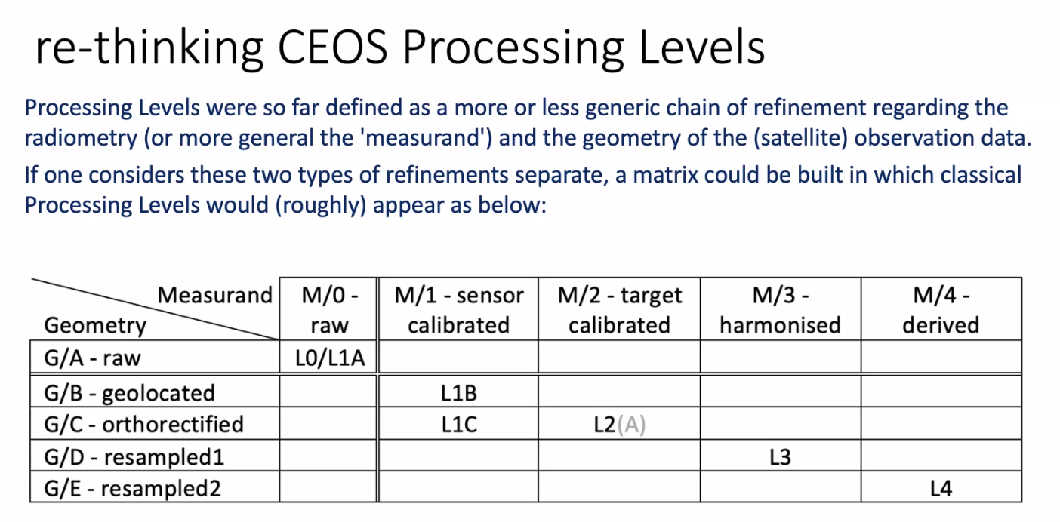
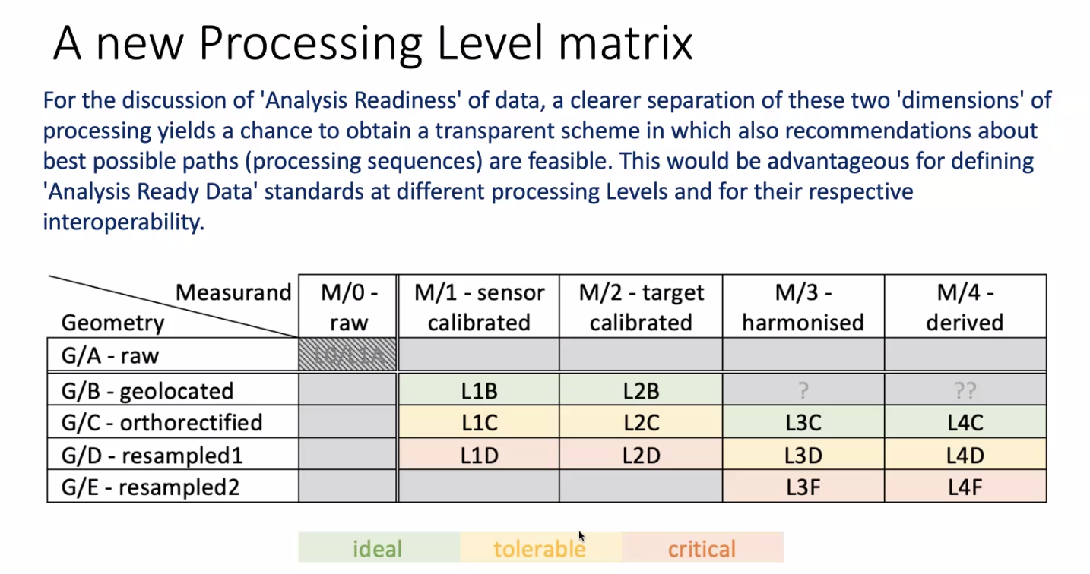
Discussion
- Matt suggested using the Level definition discussion above at SIT as a demonstration of the types of issues we are grappling with, and to demonstrate why we need an Interoperability Framework. It is the correct level for SIT consumption and demonstration of what the problem is.
- Need to get the CEOS house in order when it comes to terminology. All agree it is important. Need to make sure that CEOS leadership understands and commits. Interoperability Framework needs to identify all of the pieces. All underpinned by the terminology.
- Ivan questioned the fact that there is a long heritage of Level definitions, and that if these were to be updated, there would need to be an effort to make sure that there is no confusion between the new and old levels.
- Damiano noted that catalogues are becoming more federated. WGISS is also discussing terminology and is generally on board with the Interoperability Framework and terminology ideas.
- There was a discussion about the best location in the CEOS organisational structure for the Interoperability Framework to be developed. It is important that it allows participation from various CEOS groups including WGCV, WGISS, VCs, etc. but without creating too much organisational overhead. It was agreed that the best approach would be an Interoperability Task Team within LSI-VC – this will provide maximum flexibility and also ensure that LSI-VC maintains control over the Interoperability Framework.
Decision 2 | LSI-VC proposes that CEOS develop an Interoperability Framework.
Decision 3 | At SIT Technical Workshop, LSI-VC will present the idea of an Interoperability Framework, demonstrate the type of issues we are facing, and seek agreement to propose a CEOS Plenary action for LSI-VC to flesh out the concept with other interested parties (e.g., WGISS, WGCV) and come back with a concrete proposal for SIT-38 consideration in March 2023.
Decision 3 is what was presented to CEOS SEC-296, so CEOS leadership should be well aware:
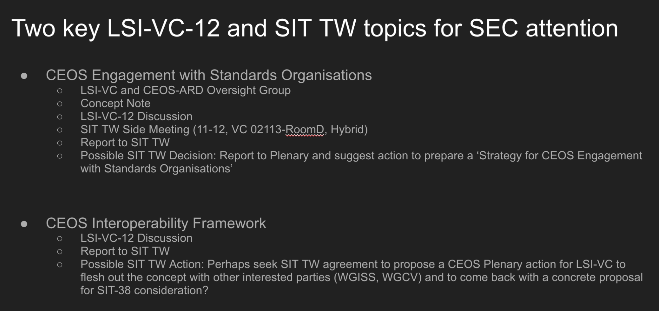

LSI-VC-12-20 | Matt to make a call for participants for an Interoperability Task Team within LSI-VC. | November 2022
Session 8: Requirements Work Thread: Forests, Biomass, AFOLU Roadmap
Forests & Biomass Subgroup Updates [Slides]
Frank Martin Seifert (ESA) reported:
- ESA’s WorldCover provides a new baseline global land cover product at 10 m resolution for 2020 based on Sentinel-1 and 2.
- Biomass harmonisation exercise is being carried out with ESA 2020 CCI Biomass, NASA 2020 GEDI Biomass and NASA 2020 JPL Biomass. Trying to look at common validation procedures to harmonise the maps that could be presented to the policy sector.
- National User Engagement is focused on Latin America, Africa and South East Asia. Had a workshop in Paraguay in June that covered validation of global maps for national reporting.
- WorldCereal provides full global coverage with 10 m mapping and provides information on major agricultural crops like barley, wheat and maize.
- Fourth Carbon from Space Workshop is planned as a hybrid meeting to be held on 25-28 October 2022 in ESRIN.
- UNFCCC COP27 will be held in Sharm-EI-Sheikh, Egypt on 6-18 November, 2022.
Discussion
- An approach is needed around authoritative end products. This is a key part of the interoperability framework discussion (legal aspect). Certain schemes will need certain benchmarking and standards.
- In the CEOS context, the WGCV LPV subgroup undertakes thematic validation activities.
- Digital Earth Africa is looking at hosting a biomass map for the African continent. Working with Mozambique and the Central Africa Republic to try and ingest it into their work streams.
AFOLU Roadmap Update [Slides]
Stephen Ward reported:
- 2020 CEOS Plenary agreed to a CEOS AFOLU Roadmap, as an initiative in support of the UNFCCC Global Stocktake Process. A discussion paper was prepared by the LSI-VC Forests & Biomass Team.
- Major accomplishments of 2021 include:
  - Assessment of the latest AFOLU products that could be readied for COP-26.
  - Coordination with SIT Chair Team and GHG Team on the new CEOS GST Portal as a unified point of entry to explain and offer data.
  - New engagement axis with national inventory users, building on our GFOI experience and in the spirit of the ambition cycle of the Paris Agreement to learn and grow together.
  - Significant input to the Systematic Observation report on mitigation, adaptation and means of implementation sections.
- Focus in 2022 and 2023 is towards the development of a CEOS AFOLU Roadmap document. The objectives of the document are to provide a framework for long-term (15+ years) coordination; guide a vision for long-term space agency coordination around AFOLU; an effective means for communications to society, UNFCCC, national community etc.; address basic observation continuity and the necessary agency coordination to achieve it.
- The three dimensions that will be addressed are global assessments and syntheses, national climate policy and actions, and GHG inventories.
- Need expert champions to volunteer to get this done in the year ahead.
Discussion
- Density of observations in 2035 will be overwhelming. This sort of application is exactly the challenge that USGS is trying to adapt to currently. More data, more resolution, more bands, shorter revisits, numerous other missions – it is a challenge.
- Accuracy and integrity of data is a key angle. It will become an increasingly important legal topic. Need to look into the future and see what that landscape might be like and work out how CEOS agencies will respond to it. Both the observation requirement aspects as well as the legal aspects, etc.
- The AFOLU Roadmap aims to have CEOS agencies consider the system that has to be in place to support the desired scenario in 2035, and to identify steps to get there.
- Need to get better at agreed and harmonised datasets for users. Noted example of there being around 20 different Forest / Non-forest maps. Biomass is a great first case. Unified and harmonised products to be a priority in general.
- AFOLU Roadmap is not just considering the technical aspects, but also political and organisational.
- Noted EO Handbook for 2023 and CEOS GST Portal updates – chance to show what EO and CEOS can do in support of UNFCCC including the GST.
Session 9: Requirements Work Thread: GEOGLAM and Essential Agriculture Variables (EAVs)
GEOGLAM Subgroup Updates [Slides]
Alyssa Whitcraft (GEOGLAM) reported:
- GEOGLAM Capacity Development Guidance Document seeks to share evidence-based good practices around capacity development to serve as a resource for organisations (including CEOS Agencies) seeking to support GEOGLAM. The key messages are that any capacity development activities should start at project conceptualization and have an emphasis on co-development, co-design, and co-production.
- Revised GEOGLAM data requirements table will include product information and a level of prioritisation and linking of variables to policy. Linking policy to observation requirements needs an integrator. Policy and decision support drive the data requirements. Essential Agriculture Variables (EAVs) are intended to be the integrators. They integrate the data-to-decisions cycle. Information produced by the GEOGLAM community can help support a multitude of policy targets.
- Expect an updated “GEOGLAM Requirements'' in 2023. There will then need to be a CEOS Strategic Response. The last iteration was in 2019.
- The EAV website was launched this year: agvariables.org
Ian Jarvis (GEOGLAM) reported on in situ data coordination:
- Have been developing the GEOGLAM In Situ Data Coordination Strategy Guidance and Work Plan for 2022 and Beyond. Noted upcoming workshop in November and welcomed LSI-VC members to join.
- Adopting a data lifecycle management approach where EAVs drive user needs. Assessing and endorsing the in situ products and making sure they are accessible. Will be beneficial through the space agencies sponsoring some projects.
- actors influencing food insecurity can be expected to increase. Earth observation will need to play an increasing role to inform policies and programs. Key actions to rise to the challenge: Need for sustained solutions with long term continuity; Scale up co-development efforts to less developed nations; Better integration across sectors and science domains.
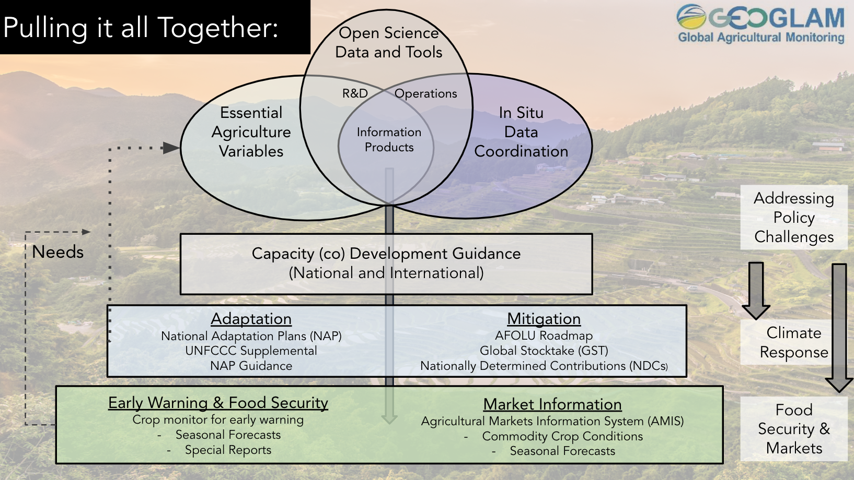
- Summary of actions and decision:
  - Possible endorsement of GEOGLAM Capacity Development Document at the 2022 CEOS Plenary?
  - What does CEOS need/want to do about the EAVs?
      - Endorsement, or wait for the requirements and CEOS response?
      - There will likely be more CEOS WGCV LPV and EAV interactions.
  - Need to find a mutual way forward on the “A” in AFOLU during the AFOLU Workshop on Monday, 12 September 2022.
Capacity Development Discussion
- There was a discussion around the proposed CEOS endorsement of the GEOGLAM Capacity Development Guidance Document. It was noted that because this is not a document prepared by CEOS, endorsement by CEOS is not appropriate. The suggested way forward is for CEOS to consider the document and, if appropriate, prepare a response.
- It was noted that CEOS and space agencies contributed to the document, mostly via WGCapD involvement. It was suggested that the linkage be clarified. Regardless, the document doesn’t sound like it fits the competencies of space agencies and is therefore not appropriate for CEOS Plenary endorsement.
- It was clarified that endorsement is not really the important part – GEOGLAM would just like the guidance in the document to be taken on board by space agencies to ensure more effective capacity development support for GEOGLAM from CEOS space agencies. Co-development projects are the priority, rather than top-down approaches, which have been common in the past. Providing the document so that agencies can reference it and ensure their funding is well directed.
- The document is yet to be circulated to CEOS/LSI-VC.
EAV Discussion
- Ian's perspective is to use the AFOLU team to make the first steps on initial gap analysis work. Hoping that GEOGLAM schema and lexicon could inspire. Thinking we could work the ‘satellite supplement’ for the EAVs together in the LSI-VC GEOGLAM subgroup.
- There are 40 or so EAVs, with around 10 also being ECVs. EAVs have a lot of things that are very specific to agriculture that are not covered at all by the ECVs. There’s not a lot of overlap.
- Integrating across many policy needs and taking an end user approach with the EAVs.
- Ian is presenting EAVs to GCOS later this year and looking at collaboration opportunities. Looking at developing a common lexicon/approach to these types of activities for other communities. Distinct set of variables to meet a variety of needs.
- There are both technical challenges to address, and also the challenge of sustaining these efforts over time.
- Suggested starting to map the EAVs to products, e.g., in terms of product level, and dependencies that exist. It was agreed that this is a doable task. Alyssa noted that the interdependencies have already been mapped as a part of the EAV development process.
LSI-VC-12-21 | LSI-VC GEOGLAM Subgroup Leads to share the interdependency mapping that has been developed in the Essential Agricultural Variable (EAV) process. LSI-VC to consider this input and make a mapping to existing CEOS ‘Level’ definitions. | December 2022
- EAVs are defined as scale-independent. Temporal, spatial and spectral scales instead come from the cross-walk to policy needs. The approach has been to remove the scale until it is matched with policy needs. This means that EAVs can be applied to multiple policy needs.
- In summary, the LSI-VC GEOGLAM Subgroup will utilise the AFOLU team effort as a mechanism for moving the EAV/requirements work forward. Will work on the observation requirements in close collaboration with LSI-VC and talk about how agencies respond. Iterative and collaborative development is critical.
- Alyssa will be at Pecora and possibly CEOS Plenary. Will consider side meeting opportunities.
Session 10: CEOS Engagement with Standards Organisations
Discussion on CEOS Engagement with Standards Organisations [Slides]
Matt Steventon (LSI-VC Secretariat) presented the motivations and history of the discussions around standardisation of some of the concepts of CEOS-ARD:
- Overwhelming feedback from industry (VH-RODA, JACIE, LPS, ARD2x) that formal standards are needed for ‘ARD’. Difficult to implement CEOS-ARD into operational workflows without backing of standards. Government and commercial sectors will likely not reference documents and commit funds unless they have gone through an open standard process (formal peer review, etc.)
- Standards built on the foundation of CEOS-ARD would be helpful and increase the reach of the concepts of CEOS-ARD.
- If CEOS doesn’t engage it’s becoming clear these efforts will proceed regardless (e.g., via OGC/ISO). CEOS should be in the driver’s seat. CEOS, with its long heritage, experience and expertise has a key role to play in defining ARD for the community.
- A discussion is planned for the SIT Technical Workshop, covering the questions below. This is an opportunity for LSI-VC discussion as input for that side meeting.
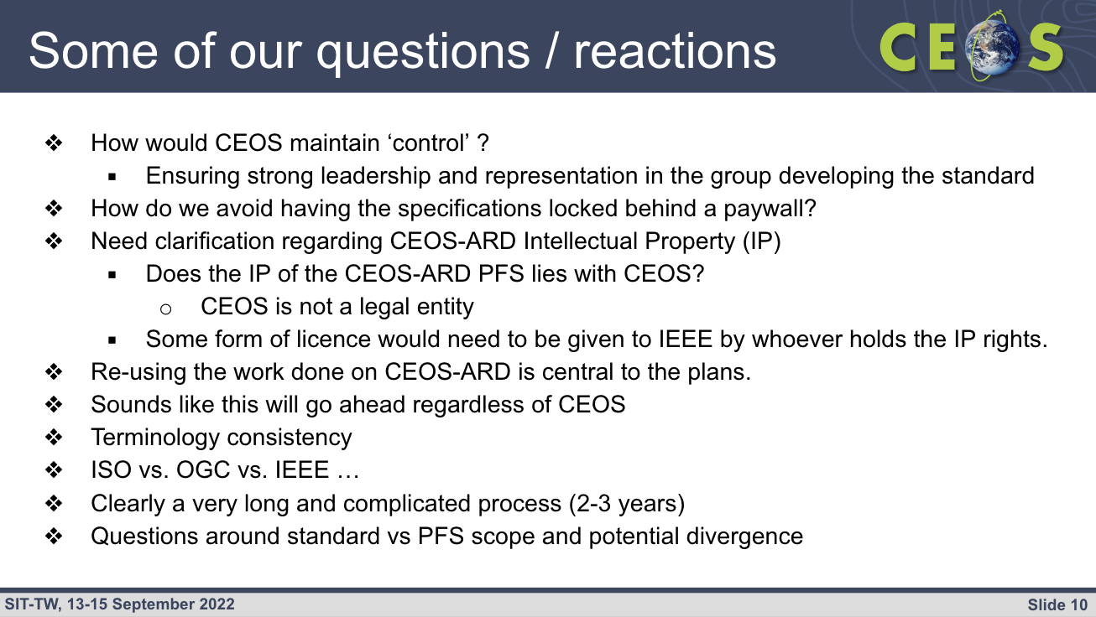
Discussion
- Suggested that the main objective and motivation of engaging on ARD standards is that we want to stay in the discussion. We need to be across all potential avenues and discussions, be it OGC, ISO, IEEE, etc.
- It was suggested that we should certainly be active in OGC, and have governmental representation at ISO. It doesn’t have to be all of the LSI agencies, but having some representation will help bolster influence (which has waned in recent years as more countries, companies, and organisations have become active).
- It was suggested that we might want to take a step back and consider clearly our objectives in engaging, rather than just acting in fear of missing out. Also need to consider the perimeter of the product that we want to constrain (format, metadata, quality information, etc.). We need to understand our motivations, i.e., what we want to do and why.
- Hear consistently that commercial entities are not willing to work towards CEOS-ARD because the specifications are not grounded in a formal standard. The commercial sector is only able to move ahead with the certainty provided by standards. Without a standard, specifications cannot be referenced in a procurement, for example.
- There is an effort within OGC to define an ARD standard, and another group within USGS is involved in promoting it. Brian has spoken to them as well after they reached out. Harmonisation with other OGC specifications would be another benefit. OGC provides a means for development of an ISO standard as well.
- Engagement with these organisations takes resources. This will take real money to get it done and if we want to do this properly, CEOS agencies will need to fund people to do so. Brian noted that if CEOS thinks the development of these standards is important, then the SEO can provide some funding, but this will need consideration and CEOS agency buy-in.
- Commercials feel like they don't have a seat at the table in CEOS. Likewise, if they take the standards ahead, CEOS wouldn't be at their table.
- We need to understand the scope, benefits, and costs. Tim thinks it would be great for CEOS to commit to such a thing. Supports working with OGC, but when at ISO level, it needs to be governmental-level engagement. Any time and attention given to this would likely be a very good investment for CEOS.
- Perhaps OGC is the best place to start, but we need an assessment of goals, ambitions and alignment.
- Brian suggested this should be discussed during the SIT Technical Workshop New Space session next week. Matt noted that there are two agenda items during that session related to this, so there will be exposure for CEOS leadership.
Session 11: Closing
Upcoming meetings of relevance
- SatSummit 2022 (September 28-29, Washington, D.C, USA): Noted analysis-ready cloud-optimised session in particular. Brian and Dave from the CEOS SEO will attend.
- Pecora 22 (October 24-27, Denver, Colorado, USA): Noted special session on ARD. Andreia Siqueira, Ake Rosenqvist and Adam Lewis have submitted abstracts. Brian will present the SAR topic for Ake. A Pecora “International Session” is planned for Monday before the formal Pecora sessions. The goal is to envision the future of international collaboration with a focus on land imaging. Will explore partnership opportunities, analysis ready data, interoperability topics, etc.
- OGC ARD Standards Working Group Meeting (October 3, Singapore): Matt, Peter and Andreia are planning to join this session to represent CEOS-ARD.
- VH-RODA (November 7-10, ESA ESRIN): Valentina and Clement are organising an ARD session and are planning to invite the OGC/ISO standards people.

Decision 4 | LSI-VC-13 will be held 23-24 March 2023, at ESA ESRIN.
Wrap-up and Meeting Adjournment
The decisions and actions were reviewed and revised. The LSI-VC Co-Leads and LSI-VC Secretariat thanked everyone for their participation and valuable inputs to the discussions. The meeting was adjourned.

