Minutes v1.0
13th Meeting of the CEOS Virtual Constellation for Land Surface Imaging (LSI-VC)
23-24 March 2023
ESA ESRIN, Frascati, Italy

Participants
AEM: Adrian Guzman*
CONAE: Laura Frulla*, Danilo Dadamia*
CSA: Yves Crevier
CSIRO: Zheng-Shu Zhou*
DLR: Jonas Eberle*, John Truckenbrodt*
EC-JRC: Peter Strobl*
ECMWF Julia Wagermann
ESA: Ferran Gascon, Ivan Petitteville, Enrico Cadau, Silvia Scifoni, Damiano Guerrucci
GA: Andreia Siqueira, Medhavy Thankappan*, Peter Harrison*
GEOGLAM: Alyssa Whitcraft, Sven Gilliams
GISTDA: Prayot Puangjaktha*
ISRO: Radhika,* Keerthi*, Manju Sarma*
JAXA: Takeo Tadono*, Ake Rosenqvist*
LSI-VC Sec: Matt Steventon, Stephen Ward, George Dyke, Libby Rose
NASA: Patrick Quinn*
SEO: Dave Borges, Brian Killough
UKSA: Sarah Cheesbrough*
USGS: Steve Labahn, Tim Stryker, Steve Covington, Tom Sohre*, Chris Barnes*, Sylvia Wilson*

* indicates online
Thursday, March 23
Session 1: Welcome and Introductions
Welcome [Slides]
Andreia Siqueira (GA, LSI-VC Co-Lead) welcomed participants to the meeting. Andreia noted the number of objectives for this meeting over the next two days, and reviewed the agenda. Steve Labhan (USGS, LSI-VC Co-Lead) described the overall purpose of LSI-VC, and commended the group for their work so far. The Interoperability Framework is a particularly important topic on the radar.
Peter Strobl (EC-JRC, LSI-VC Co-Lead) apologised for not being able to attend in person. A tour de table of in person and online participants was performed.
Matt Steventon (LSI-VC Sec) reviewed the headline objectives for Day 1.
Action Review [Slides]
Matt Steventon (LSI-VC Sec) reviewed select actions from LSI-VC-12 and the team teleconferences since.
- LSI-VC-12-02: SEO team to analyse the impact of partial terrain occlusion with the Black Marble dataset and to report back as input to LSI-VC-12-03. This analysis will use the NASA DEM and the VIIRS Black Marble viewing geometry to determine how many pixels are partially occluded and the impact on the dataset in certain parts of the world (e.g., are there cities where the terrain occlusion could be significant?).
  - Brian Killough (SEO) noted this is in progress, and it will take a bit of effort to complete the analysis. The action will remain open for now.
- LSI-VC-12-11: CEOS-ARD Oversight Group to consider an update to the CEOS-ARD Framework that would capture the agreed wording around the PFS update process. This will capture the agreement regarding cadence, draft versions, publicising upcoming changes via the website, etc. This will be applicable to all PFS.
  - This action will remain open for now, with the goal to align an update to the CEOS-ARD Framework with the planned late 2023 update of the CEOS-ARD Strategy.
- LSI-VC-12-12: Jonas to check if the feedback on ARD gathered by DLR through their exchanges/workshops with users can be shared with CEOS.
  - This has been shared to the team today, and we will hear more about this later today. The action is complete.
- LSI-VC-12-14: Hari Priya to share a summary of all of ISRO’s self-assessments that are in the pipeline, so they can be reflected on the website.
  - Resourcesat-2/2A Surface Reflectance and RISAT-1A (EOS-4) NRB products have been added to the ceos.org/ard table. The action is complete.
- LSI-VC-12-21: LSI-VC GEOGLAM Subgroup Leads to share the interdependency mapping that has been developed in the Essential Agricultural Variable (EAV) process. LSI-VC to consider this input and make a mapping to existing CEOS ‘Level’ definitions.
  - This will be revisited in the GEOGLAM session tomorrow.
- Open actions from LSI-VC Telecon on March 10, 2023:
  - Steve to nominate a USGS representative for the LiDAR team.
    - USGS are unable to free anyone up right now to join the team. Action closed.
  - Steve to follow up with Element-84 regarding their CEOS-ARD submission.
    - Steve talked to Matt Hanson, who raised the point about replica versions of data also receiving CEOS-ARD certifications. This is something LSI-VC should discuss.
    - Element-84 has decided to discontinue their self-assessment given their product is a derivative of the ESA product.
    - There is an open question whether the exact same data in different formats would still comply with an existing assessment. This will be discussed later in the agenda.
    - Matt H was interested in the solution space for authoritative data. Perhaps STAC could be part of that solution to help us. He was not able to join L SI-VC-13, but perhaps this will be covered in a future discussion.
    - Perhaps a STAC side meeting could be planned for the day before the ARD23 workshop.
  - Ake to follow up with Tom regarding the WGISS work on best practices for STAC.
    - Damiano Guerrucci (ESA, WGISS Member) has been invited to the discussion tomorrow. Action closed for now.
Session 2: CEOS-ARD
SAR and LiDAR PFS Progress [Slides]
Ake Rosenqvist (JAXA) reported:
- The SAR CEOS-ARD team has members from almost all CEOS agencies with SAR missions. The team is having calls about monthly, and have been very engaged.
- The work on the LiDAR Terrain & Canopy Height PFS has been very slow to get started. Have questioned a few times whether or not it should continue.
  - The development team has representatives from multiple cross-CEOS missions, including GEDI, MOLI & ICESAT-2.
  - The group would like to continue to progress, and Ake asked any interested colleagues to reach out if they would like to contribute to this group.
  - The group is also considering a multi-source data PFS from multiple passes.
  - The primary focus is on spaceborne LiDAR, but the PFS will be taking airborne data systems into account, as it would be good to have interoperability between airborne and spaceborne sensors.
  - Will accommodate different types of LiDARs, trying to accommodate any kind of data collection system.
  - Maybe about this time next year will have a v1.0 ready.
  - Need the LiDAR mission teams to guide, hence the schedule is dependent on their contributions.
- Three SAR PFS have been endorsed by LSI-VC: Normalised Radar Backscatter (NRB v5.5), Polarimetric Radar (POL v3.5), and Ocean Radar Backscatter (ORB, v1.0)
- The Geocoded SLC (GSLC) PFS is almost complete. The Interferometric radar (INSAR) is on the back burner at the moment, primarily because there is no lead.
- It has been very difficult for the group to focus on more than one PFS at a time.
- Have a very good uptake of NRB, DE-Africa/Sinergise’s Sentinel 1 product and JAXA’s ALOS-2 PALSAR-2 products have been successfully assessed as CEOS-ARD. There are also a number of ongoing NRB self-assessments.
- Having so many SAR PFS is challenging for users and data providers. The team also realises the need for consistency across common parameters. This makes the group wonder if there is an opportunity for harmonisation - this idea came up at the WGCV SAR meeting in Montreal last year.
- The team has been looking at developing a single harmonised SAR PFS, to ensure consistency across parameter names. This would simplify the revision process as well. The Harmonised SAR PFS draft is available here.
- The SAR PFS each have accompanying metadata specifications, which are non-mandatory (Target level), however it is promising to see that many data providers are choosing to use the specified XML format.
- This has raised some cross-cutting issues, including regarding interoperability across existing optical and SAR PFS. This could include some requirements or recommendations regarding data formats, with accompanying metadata specifications.
- There is also the question of how to reflect cloud interoperability and STAC in the PFSs.
- These questions will hopefully be addressed by the CEOS Interoperability Framework.
Discussion
- Tim Stryker (USGS) noted that USGS has a national airborne program, which supplies LiDAR data. This is contracted out to commercial providers. The LiDAR team could perhaps consult with the National Geospatial Program, who work on this project.
- Ake agreed it would be beneficial to bring these people in for their perspective. It would be good to have someone that is involved in the USGS airborne project to advise on the different requirements, etc. This would be good to take into consideration in the development of the PFS.
LSI-VC-13-01 | Steve and Tim to propose a USGS airborne LiDAR specialist for the LiDAR PFS development team. | June 2023
- Peter Strobl (EC-JRC, LSI-VC Co-Lead) noted that the LiDAR team consists primarily of agencies which provide LiDAR data. Have talked to some people who use the data, who have issues filtering for properties for validation. Is the team going in this direction, and consulting with the data users also?
  - It would make sense to do this, but it hasn’t been done yet. The group has two data providers, but would like to have more representation. It would be good to have a discussion about how to get more people in the group - they need experts in all of the different components of data processing.
- Brian Killough (SEO) noted that the PFS doesn’t require the metadata to be STAC compliant, only that the metadata is machine readable. How could we build STAC compliance into a PFS, to increase interoperability?
- Ake commented that having the metadata in an organised format with the same names etc., will help with the machine readability. This comes back to the point about metadata specifications, and could be partly addressed under this point.
- There is a STAC extension for the NRB v5.5 PFS.
- When it comes to requirements, STAC could always be put as a Target, which makes it not mandatory and a choice for data providers.
- Metadata machine readability field has been kept open intentionally, and calls for use of the metadata specifications that are suggested or some other community standard.
- STAC is the clear leader in community standards for metadata. Ferran Gascon (ESA) would be in favour of having STAC as the standard, and being put as a Target requirement in the PFS.
- Steve Covington (USGS) noted that STAC is the interface for search and discovery. To have a common search language. How data is organised internally is up to the data provider. STAC improves the access to the data holdings of a provider.
- Could be a low hanging fruit to say that STAC is the way to go, and then have CEOS endorse an agreed set of extensions.
- The STAC metadata and the dataset itself may be more closely related than initially thought.
- Yves Crevier (CSA) in chat: Hi Ake - we may have some engineer and subject matter experts to propose for the Lidar WG. We are currently working on a space based LIDAR concept study in Canada. Also, I can provide you with an update of Francois Charbonneau on the SAR ARD.
- Overall, we need to separate the concerns – this is a key role of the Interoperability Framework. Separate terminology, formats, STAC, etc. Separate discussions that shouldnt be conflated. It would be easier if CEOS had a clear delineation of responsibilities with an effective interface between them. This is what the Framework is aiming to achieve.
- Steve Labhan (USGS, LSI-VC Co-lead) is not a huge advocate of adding the requirement on metadata specification into a PFS. He would prefer it be dealt with at the level of the Interoperability Framework.
CEOS-ARD Peer Reviews [Slides]
Medhavy Thankappan (GA) reported:
- Review panels haven’t been called upon, because there haven't been any assessments at Target level. However, the membership remains current. It would be good to have self-nominations for the SAR panel - this is still an open request. Will raise at future WGCV meetings.
- Reviewed status of assessments and recent additions, noting the recent certification of the ALOS-2 and PROBA-V datasets. Thanked Peter Harrison and GA for bringing these to completion.
- China Aerospace Information and Research Institute (AIR) just recently submitted a self-assessment.
- The Element84 Sentinel-2 L2A product is a replica of the ESA product and may not need an assessment, as it could inherit ESA compliance. This is an open point of discussion on how we deal with these cases. This product supports DE Africa, and has been waiting for clarification for a while on the unique parts of this dataset.
- Landsat ground station partners are provided with USGS processing software. They can choose to use it as is, or make minor changes. This is another example to discuss regarding CEOS-ARD compliance and inheritance. Perhaps there is a way to fast track these types of datasets to CEOS-ARD compliance?
- USGS provides metrics for ground station providers to verify these other landsat ground station datasets.
- It would be helpful to have a simple LSI-VC gating process to verify submissions. Presenting metadata, e.g., clearly and easily to be found for each of the requirements.
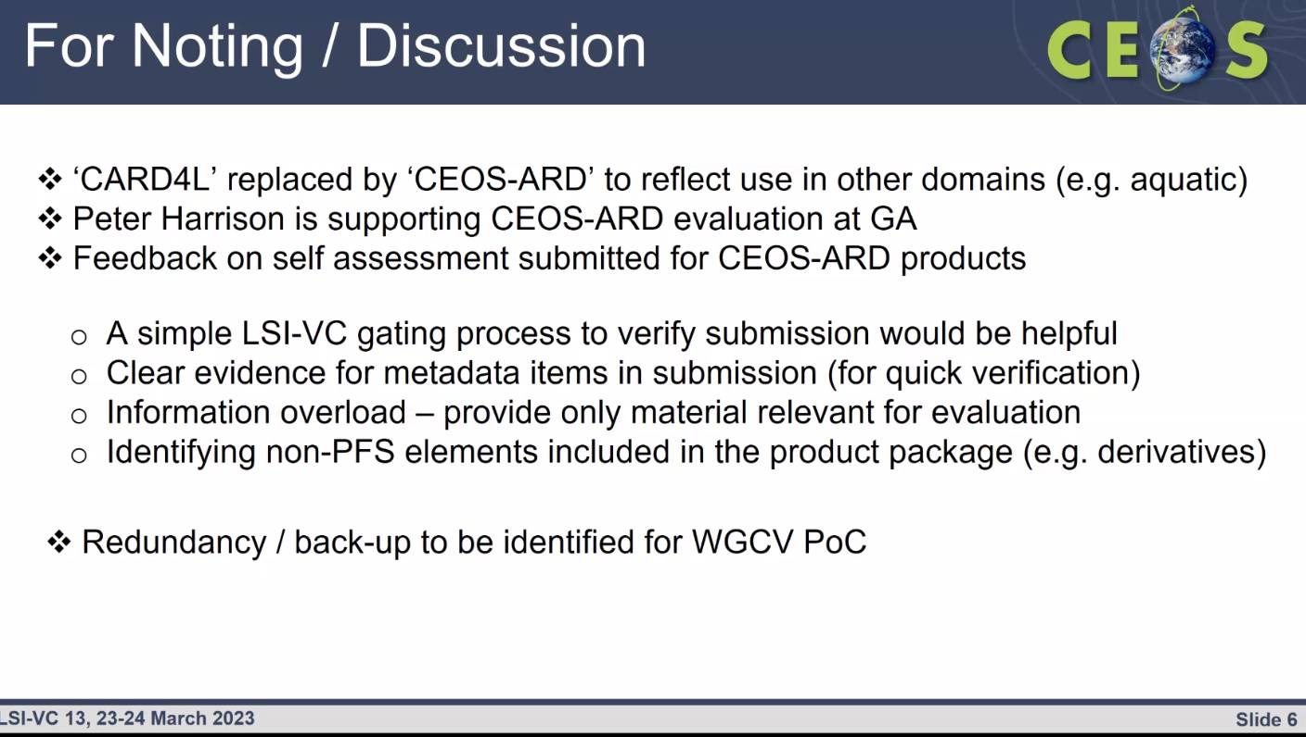
Discussion
- Peter Harrison (GA) noted the AIR submission is very light on detail when it comes to certain parts of the metadata. Some items cannot be traced to a source, and it is not clear what kind of algorithms were used and where they have sourced the data.
- Medhavy suggested a gating process, where there is an initial check of self-assessments. Matt Steventon (LSI-VC Sec) will review self-assessments in more detail in future, making sure specific references exist.
LSI-VC-13-02 | Peter Harrison and Medhavy Thankappan to work with Matt to add self-assessment guidance to the CEOS-ARD website. | May 2023
- We should provide better instructions for data providers. The PFS could have columns where data providers are supposed to say exactly where information is to be found. Where the information can be found should be clear for the reviewers as well as users.
- Ake Rosenqvist (JAXA) in chat: We should develop precise instructions to what data providers should provide for the reviewer: A copy of the PFS with the following filled out, (1) the relevant columns for each item (put an X in either of the Threshold or Target field; add a explanation/justification note for the reviewer where you think it would be helpful; any other comment/recommendation for LSI-VC (in effect to ourselves in the SAR team) you want to convey), and (2) the self-assessment summary table; At least one sample product as it will be provided to the users, comprising all parts required (measurement data, per-pixel metadata, general metadata XML). Zip the package and make it available for download; Brief cover letter to the LSI-VC/WGCV POC (pdf or email).
ALOS-3/4 Update [Slides]
Takeo Tadono (JAXA) reported:
- Thanked Medhavy and Peter for the recent approval of the ALOS-2 CEOS-ARD datasets.
- Noted the need for more specific data access links on the CEOS-ARD website, as there are various locations for the data.
- The latest global mosaic updates are coming soon.
- Noted the failure of ALOS-3 on launch. JAXA is now considering an ALOS-3 follow on. The reason for the failure is under investigation.
- The planned launch of ALOS-4 in JFY 2023 is continuing as scheduled. It may be impacted by the investigation of H3 launch vehicle failure.
- PALSAR-2 remains in good condition and is performing well.
LSI-VC-13-03 | Matt to update links to specific data access locations for the JAXA products. | COMPLETE
PFS Geometric Uncertainty and Absolute/Relative Accuracy [Slides]
Medhavy Thankappan (GA) reported:
- This follows from the action LSI-VC-12-08.
- Noted that the PFS items 1.7 and 1.8 say ‘not required’ - so the question remains as to how pixels are aligned.
- If aligning pixels across sensors is not required, how do we facilitate time series? To make sensors interoperable, the data needs references, to allow for alignment across sensors, missions, providers.
- The wording of PFS item 4.1 is a bit ambiguous and may need to be reviewed. This is the only parameter that focuses on the specific level of data quality - all other parameters only require documentation. It is a bit of an outlier.
- Taking this further to ensure cross-mission interoperability is at the focus of the Interoperability Framework. Having a common reference is something that CEOS needs to discuss and consider separately.
- Radiometric accuracy also needs to be kept in mind. Radiometric and geometric accuracy are equally important.
- The reason for the specific requirement within 4.1 came from initial discussions. The Threshold is very user specific. Perhaps we should scale back 4.1 to just make sure it is documented, and then leave it up to the user to consider whether it is useful for their own application.
- In summary: This action can be closed. No need to revisit specifics of 4.1. Items 1.7 and 1.8 will be covered at the level of the CEOS Interoperability Framework.
Open Geospatial Consortium (OGC) ARD Standards Working Group (SWG) Update [Slides]
Peter Strobl (EC-JRC, LSI-VC Co-Lead) reported:
- The SWG Charter is complete, and has passed through the commenting phase. Received relatively few comments.
- Peter presented on behalf of CEOS at ESRIN in February at the OGC TC. Noted many familiar names on the Charter member list.
- There are many related standards that the OGC ARD SWG will need to take into consideration. It will not be easy to keep the whole ecosystem happy.
- The GeoDataCube Working Group started in parallel with OGC ARD SWG. Also should be aware of the Data Exploitation Platform Working Group as well, which has a significant relationship with ARD.
- STAC is not a standard, but will show up in the discussions.
- Charter vote ends in mid April.
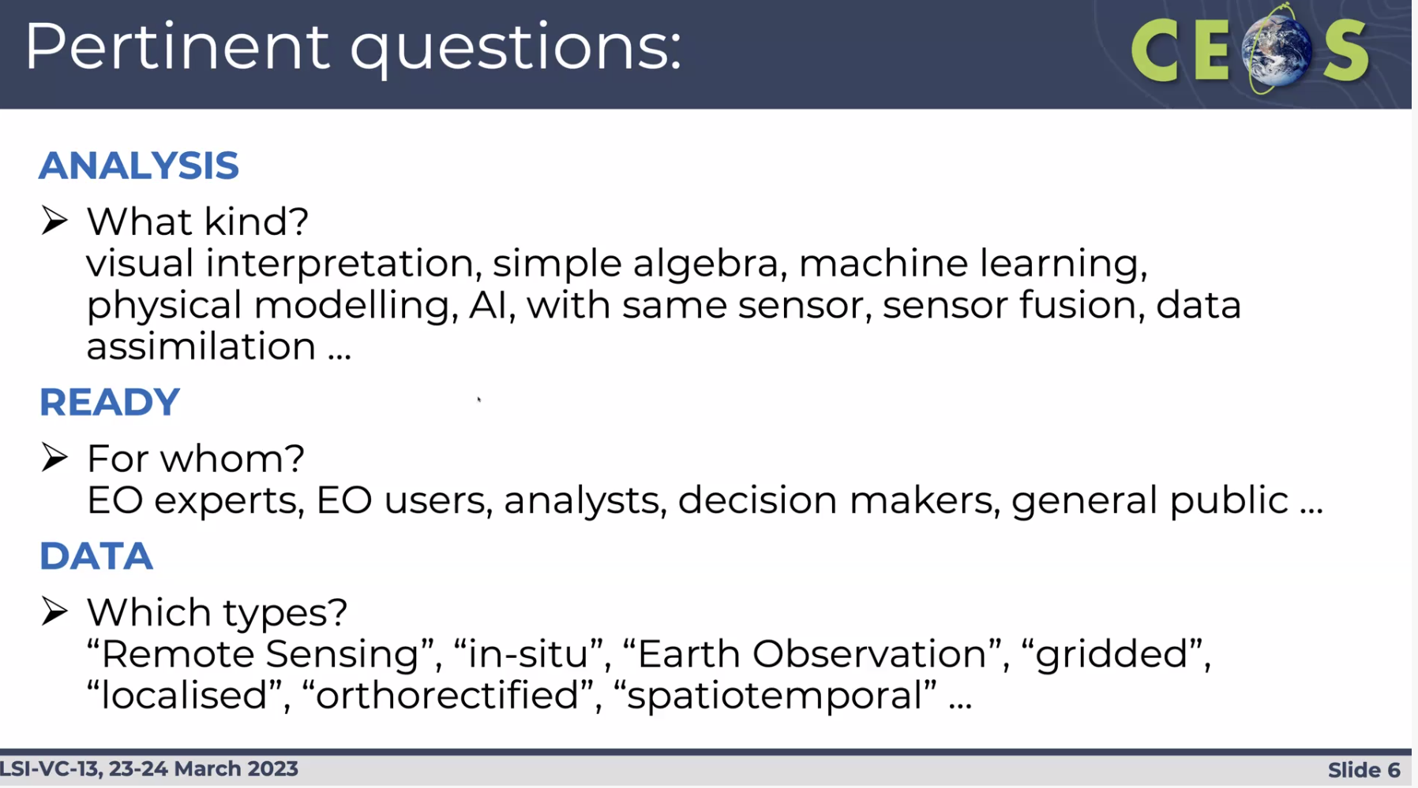
Discussion
- GeoData Cube Working Group shares a lot of synergies in terms of cloud interoperability, data access. Noted this for the WGISS and interoperability framework discussions. Need to be watching closely and be aware of any overlaps, etc.
Session 3: CEOS-ARD Assessment Progress Reports and Workshop Session
CSIRO [Slides]
Zheng-Shu Zhou (CSIRO) reported
- CSIRO aims to process NovaSAR-1 to be compliant with NRB v5.5.
- Previewed the file structure of NovaSAR-1 CEOS-ARD.
- The team is using COGs for the data.
- Reviewed various correction and conversion steps.
- The metadata follows the SAR CEOS-ARD specification.
- Using Copernicus DSM 30m for processing.
- Showed some applications of ARD use for burn area mapping (with Sentinel-2) and flood mapping.
- Currently the ARD processing takes place on CSIRO’s high performance computing system. The plan is to transfer to AWS in line with NovaSAR-1 IFP. Both the source and ARD products will be available on the cloud via the NovaSAR-1 data hub.
Discussion
- Steve Labhan asked about the current status of the assessment. 2.3 and 2.7 are met at the Target level, but not required at the threshold. The initial self-assessment has been completed, and will be submitted to CEOS shortly, following an internal review.
- The multi-modal burn area application is a good example and use case to showcase CEOS-ARD for both optical and radar products.
LSI-VC-13-04 | Matt to follow up with Zheng-Shu Zhou (CSIRO) on the burn area multi modal application as a case study for the use of CEOS-ARD products. | May 2023
- With only one of the two data types, optical or radar, how would the product change? Is it possible to quantify the value-add of the multimodal product? Would be good to show the improvement achieved from using a multimodal product - i.e. is it worth the effort. USGS is looking for examples to make the case to agencies about multi-modal and why using multiple ARD datasets provides improvements.
LSI-VC-13-05 | Matt to consider a focus on multi-modal case studies for the next CEOS-ARD Newsletter, as this is a priority for USGS. | July 2023
- Manju Sarma (ISRO) asked about sharing the CSIRO-developed processing scripts for NovaSAR. Zheng-Shu will have to ask for approval to share.
- Processing time depends on the scene size. It can take 5-6 hours to process a very large scene, but a smaller scene would only take a couple of minutes.
- Does the specification get into the specifics of noise filtering - or is that left to the data provider? In general the PFS do not dictate ‘how’ something is done - just ask that it be documented.
- Ake Rosenqvist (JAXA) noted that in the PFS, 1.7.4 is where a data provider would indicate if they have applied a filter. For NRB, Ake would recommend that users are not using speckle filtered data, as a lot of users would want to do their own speckle filtering and optimise. Discourage including this in the NRB product. An NRB on demand product could include a checkbox to include this.
- Patrick Quinn (NASA) in chat: Is it common to distribute ARD products as zip like this? Does the ARD spec say anything about the use of zip? I have concerns that zipping the files at the end negates the benefit of providing COGs.
- Ake Rosenqvist (JAXA) in chat: @Patrick. Good point on the zip. It has been an issue raised when importing zipped ALOS-2 ScanSAR products to the AWS. The PFSs don't have any requirements regarding the use of zip.
ISRO [Slides]
Radhika (ISRO) reported:
- Developing ARD products for Resourcesat-2 and -2A, processed to meet the Surface Reflectance PFS.
- Have validated their product against the Landsat-8 OLI product, and found they are in good agreement.
- The process was established in March 2022.
- Data is available from the Bhoonidhi data platform.
- They are validating with the NASA HLS dataset (Harmonised L8 and S2) and have found there is good correlation.
- There are just a few threshold requirements left to meet.
- Sample Level 3 data is available for 2017-2022.
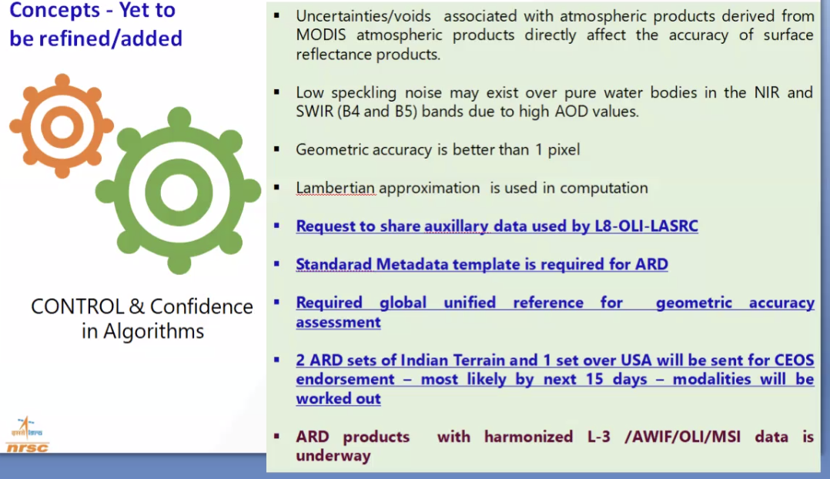
Discussion
- Steve Labhan (USGS, LSI-VC Co-lead) noted that the auxiliary data for Landsat is available on the USGS website and on Earth Explorer. He will follow up with ISRO.
LSI-VC-13-06 | Steve to follow up with Radhika about the source of the auxiliary data used by L8-OLI-LASRC. Specifically looking for the AOD data generated as part of LASRC. Earth Explorer does not contain this information. | In progress
- ISRO will submit their Resourcesat-2/2A self-assessment in the next couple of weeks.
- For the general metadata, they are yet to reach the threshold requirement for 1.14 and the DOI. For per-pixel, they are still working on 2.8, 2.9, and 2.10. Cloud and cloud shadow have been met for Threshold.
- Matt asked about the data access mechanisms. Bhoonidhi is an open source platform. They are hoping to add an API to the platform, but at the moment it is download only.
- Manju Sarma (ISRO) noted that all the projects can be downloaded via an order. An API is available, but not to the public. Access can be granted if needed, and they will be opening it up more broadly soon.
- Noted VEDAS is only a visualisation portal and Data Cube based. Bhoonidhi is focused on data download.
- ISRO is holding discussions with commercial cloud platforms to rehost their data on the cloud. There hasn’t been a decision yet, but the possibility is there.
- USGS and ISRO have a partnership where USGS receives the Resourcesat-2 data over the US and they process it at EROS. They will soon be adding Resourcesat-2A data reception as well. EROS will update their processing to meet the CEOS-ARD standard, and would like to host this US data on the cloud as well. The resolution is 24m for LISS-III, with coverage mostly over India and the US.
- There was also a partnership agreement with INPE, but this has probably been paused for now. ISRO is also investigating a new potential partnership with Germany.
ESA [Slides]
Ferran Gascon (ESA) reported:
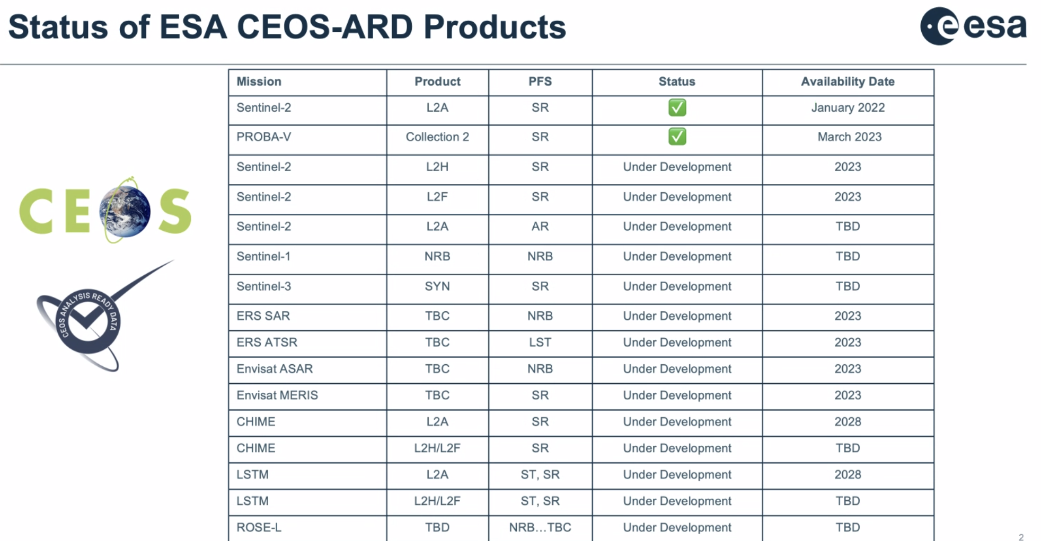
- The Sentinel-2 Collection 1 contains the CEOS-ARD SR product. This will soon be available through the new Copernicus Data Space Ecosystem.
- PROBA-V assessment was done together with VITO, and was approved on Tuesday this week. Very close to full compliance on the target level as well. The product was assessed as the Surface Reflectance PFS as part of the Top of Canopy PROBA-V product.
- Sentinel-2 and Landsat Harmonised and Fused products are under development. Will start the self-assessment later this year. Product is generated, but is not yet distributed operationally. Still an on-demand pilot product.
- The Sentinel-2 Aquatic Reflectance product will be distributed as an additional layer within the existing S-2 CEOS-ARD product. Expected in 2024. They will only process forward, no back processing, until Collection 2 is reached.
- The Aquatic Reflectance product will be at 60m resolution, due to SNR requirements. ESA also wants to leave some room for the private sector working at higher resolution. Landsat’s provisional AR product is 30m, but they are starting with a higher SNR. Enrico Cadau (ESA) is the POC for the AR product.
- The HLS product is 30m, and hosted on Microsoft Planetary Computer. The product presented by ESA is aimed at an on demand product, not systematically produced globally. More for mid-latitudes, harder for higher latitudes. Can get to 10m resolution.
- For Envisat ARD, ESA is starting with MERIS to assess applicability of CEOS-ARD SR PFS. A few issues to iron out before submitting. Aiming to submit by the end of the year.
- ERS and Envisat (A)ATSR will be assessed against the ST PFS.
- Also aiming to develop NRB for ERS and Envisat (A)SAR - for the entire collection.
- ESA is pushing to have all their data as CEOS-ARD compliant. Philippe Goryl (ESA, WGCV Chair) has been pushing for the historical datasets.
Silvia Scifoni (ESA) reported on the Sentinel-3 Synergy SR product:
- The Synergy product combines OLCI and SLSTR to provide improved data for land surface analysis.
- The product is currently about 76% compliant with the CEOS-ARD SR PFS for the threshold, and 59% for the target requirements.
- For general metadata, the product is currently not compliant with the coordinate reference system, and the map projection. The requirement is not completely clear regarding the map projection, and the SBG JPL and Sentinel-3 ESA teams had differing opinions. This is something LSI-VC needs to discuss.
- Need clarity on whether map projection is the requirement or whether georeferencing to lat/lon is sufficient.
- Peter Strobl (EC-JRC, LSI-VC Co-lead) noted that item 4.1 specifies it has to be a regular grid, as a threshold, and is currently a requirement. Ferran understood it this way, however there have been other teams who didn’t seem to understand it this way.
LSI-VC-13-07 | Schedule a further discussion on whether georeferenced products might be considered CEOS-ARD, or is a map projection strictly required. | June 2023
- Peter noted the CEOS Levels matrix, and the conflicts this discussion raises. Levels should be reconsidered in the frame of the CEOS Interoperability Framework.
- For the hyperspectral community, a georeferenced product is known as analysis ready. Need to be careful of uncertainty tolerance.
- For per-pixel metadata, the Sentinel-3 Synergy SR product is mostly compliant, except incomplete testing and cloud shadow. Under development and will probably be included in the next version.
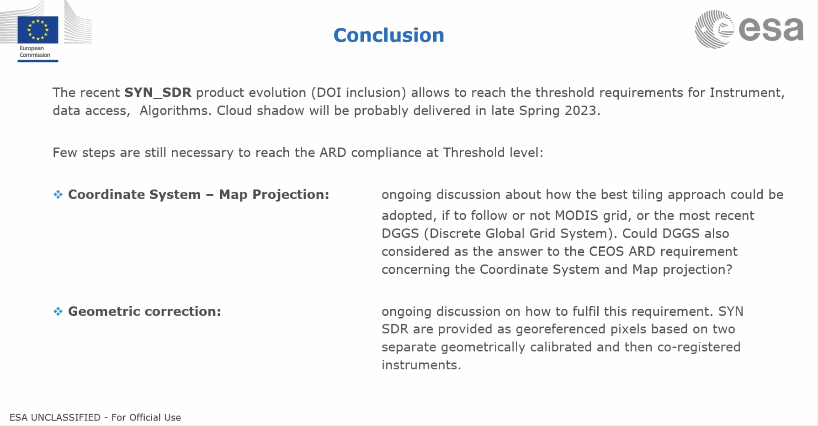
Discussion
- The team is currently deciding which grid to use for the SYN product. Open question as to which they will use, and DGGS is a possibility. No deadline for a decision, but it is an ongoing discussion.
- ESA has an activity on DGGS with USGS. Need to decide whether it is good for ESA missions, then assess beyond. The use of DGGS changes the whole model of product distribution, however it has advantages with database usage and is good for Data Cubes.
- Steve Covington (USGS) suggested for future missions, we might get to the point of distributing analytics. Then DGGS makes sense.
GISTDA [Slides]
Prayot Puangjaktha (GISTDA) reported on:
- The Thailand Earth Observations System (THEOS) consists of THEOS-1 (currently in orbit, launched in 2008) and THEOS-2 & -2A which are set to launch this year.
- GISTDA is actively seeking partners to increase its contributions to the global EO community.
- Developing a cloud utilisation plan, with the objective to improve satellite data storage, management, and analysis, as well as increase efficiency, productivity, and collaboration.
- New cloud data platform: sphere.gistda.or.th
- GISTDA is planning to develop THEOS ARD compliant with SR v5.0. They have passed some of the requirements, but they still have some improvements to make.
- Working to have ARD product of THEOS-1 available worldwide, in 2024.
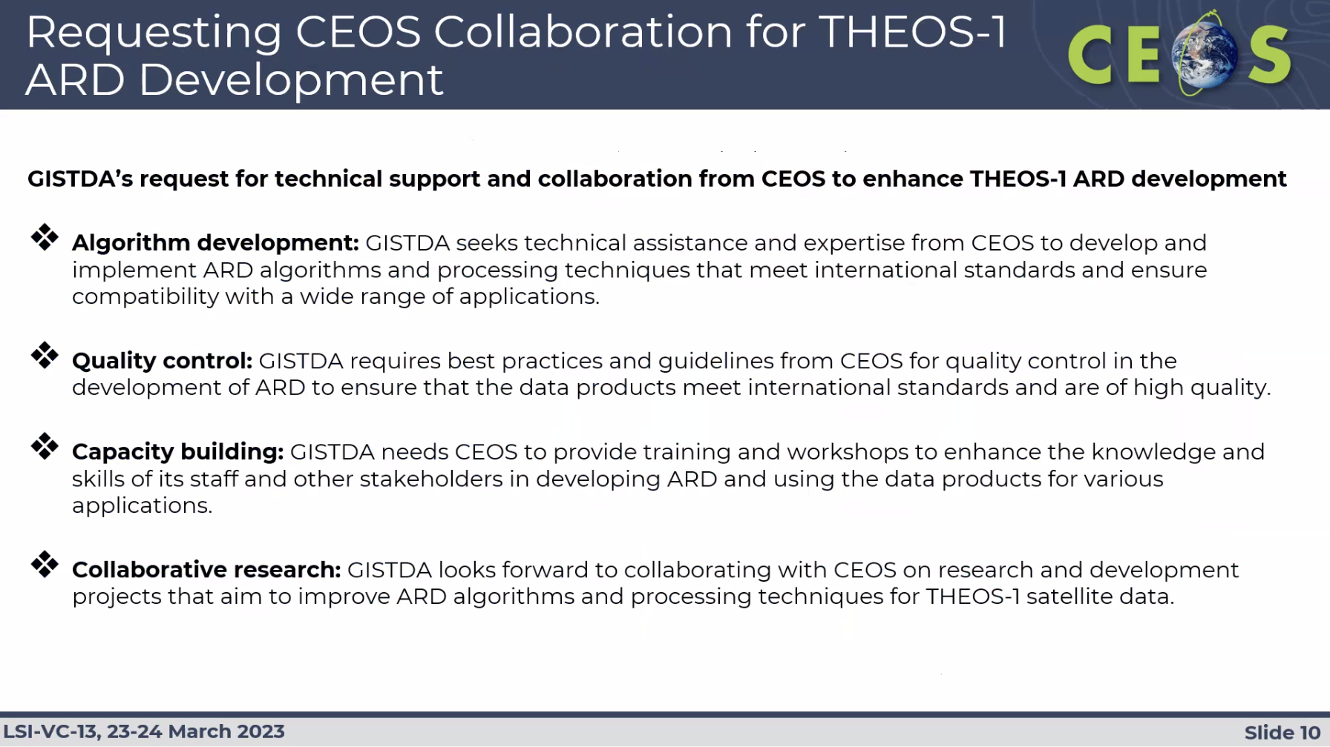
Discussion
- The Sphere platform is developed and operated by GISTDA.
- Steve Covington (USGS) asked about plans for a machine-to-machine API for Sphere. GISTDA noted they are planning to provide an API.
- Steve Labhan (USGS, LSI-VC Co-lead) asked if the team is aware of the Atmospheric Correction Inter-comparison eXercise (ACIX), which could be a good resource for their atmospheric correction algorithm. GISTDA would like to perform atmospheric correction in Thailand, but don’t have an appropriate test site. They need support from other agencies.
CONAE [Slides]
Laura Frulla (CONAE) reported:
- SAOCOM is operational, and they are processing the data to Level 2, for various applications.
- Access to data can be found through the CONAE website. The steps to access can be found in the slides.
- Hoping to publish the ARD converter under the Product Access page.
- Recently, there was an Announcement of Opportunity for SAOCOM, through ESA’s Third Party Missions Programme, for science and application developments with EO. The programme is called the Promotion of Utilisation and Mission Applications and Science (PUMAS).
Danilo Dadmia (CONAE) reported on CONAE’s progress with ARD:
- CONAE is working to create a CEOS-ARD processing tool for SAOCOM.
- They will use ESA’s SNAP tools and Python to process SAOCOM Level 1A single-look complex products, to output sigma nought and gamma nought images, along with projected local incidence maps, DEM, and layover shadow mask.
Discussion
- Ake Rosenqvist (JAXA) noted it is nice to see SAOCOM data becoming more openly available. The plan to make a linux version of the tool would be very much appreciated. If the user downloads the required data, the program can be run locally. The DEM would need to be saved locally as well.
- With the different products, sigma nought and gamma nought, the user can decide which one or both, and which per pixel metadata. Not all users would be interested in all the alternatives available for the per-pixel metadata, so it is good to have the options.
- There are a few different pathways to data access - but all are very complicated. Is there any discussion about loosening these restrictions? Will it be easier in the future? Laura noted the agreement with ASI made it more constrained. CONAE is opening as much as possible in the way they can, and improving data access is something they are discussing mainly for new missions.
- To fully embrace the potential of CEOS-ARD products, the data needs to be open and freely accessible. There is a nice archive of SAOCOM data being collected, with good quality data. Anything CONAE can do to further open the archive up would be great. Laura would hope it is open and free, but not sure it is possible.
LSI-VC-13-08 | LSI-VC to consider how best to support CONAE’s discussions on open data. Perhaps it would be useful to coordinate a letter from the CEOS Chair regarding the importance of open and free data policies. | June 2023
DLR [Slides]
Jonas Eberle (DLR) reported on DESIS Level-2A and SR:
- Currently assessing EnMAP for Aquatic Reflectance.
- Regarding DESIS, Martin can give more updates on the availability. Currently processing the data to L2A for eventual CEOS-ARD SR compliance.
- Sentinel-1 NRB products are being generated on DLR’s terrabyte platform. Will do a test case for Germany, with DLR users comparing different products.
- ESA has a plan to have the Sentinel-1 NRB product as an official Copernicus product, but that needs to be decided by the European Commision, which takes some time. DLR users need the product now. DLR is planning to migrate users away from Google Earth Engine to their terrabyte platform, and they need to be able to match product availability across the platforms.
- Working with ESA and NASA to collaborate on product specifications, processing steps, auxiliary layers, software and data formats.
- There is a plan to extend the Sentinel-1 NRB product to ORB as well.
- Jonas shared some feedback on ARD that was gathered from their interactions with their users:
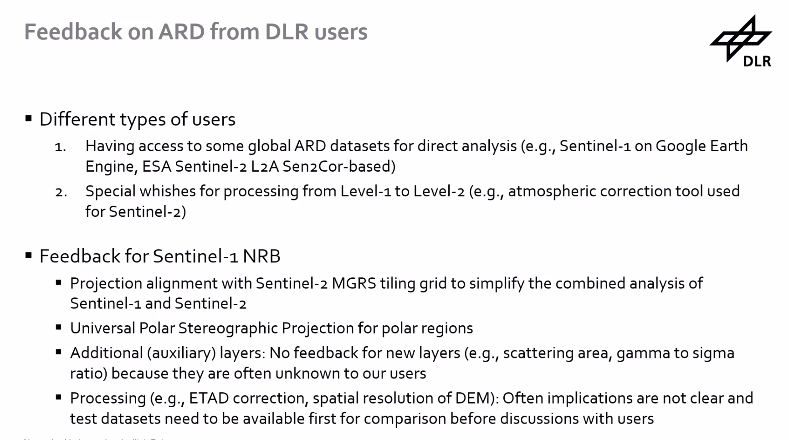
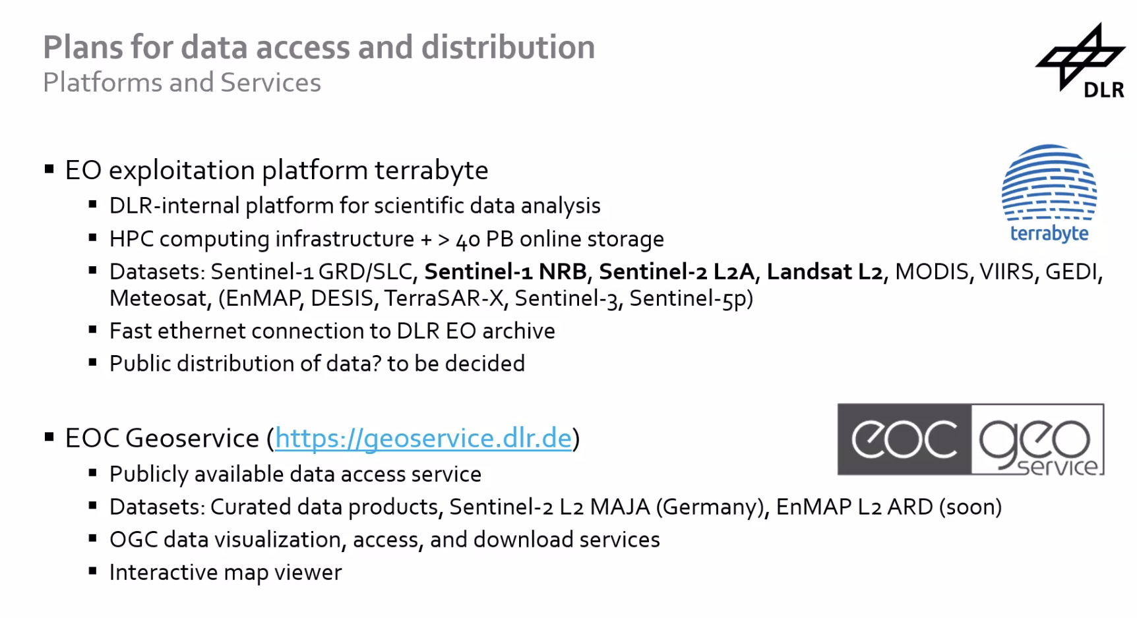
- DLR heavily relies on STAC - every dataset on their platform uses STAC, and are available through STAC API. The platform can be found here: https://geoservice.dlr.de
- The original data format is used for existing datasets, however this is not optimal for all users. The algorithms for the existing datasets makes it too costly to reformat.
Discussion
- Ferran Gascon (ESA) asked about projections on the poles, whether the universal polar stereographic (UPS) will be used, noting the current grid stops at +/- 84 deg. John Truckenbrodt (DLR) recognised there are no tiles at the poles yet, which needs to be done for Sentinel-1. There is a plan to cover this under the Sentinel-1 ORB activity. The Sentinel-2 grid diverges from MGRS slightly - needs an assessment of whether this can be extended to the poles or whether a different approach is needed.
- Yves Crevier (CSA) noted that in Canada, there is a strict regulatory framework for the distribution of RADARSAT and RCM data - which is currently managed by foreign affairs and defence. CSA sees the creation of ARD as a way around this framework, given ARD is considered a value added product. Is that something that DLR has considered for e.g., TerraSAR-X data, in order to facilitate open distribution?
- DLR has not yet started anything on this, but would like to find ways on transferring the secured data into terrabyte. They have already had the discussion whether it makes sense to define an ARD product for TerraSAR-X, however there might be limitations in terms of resolution. Hoping to look into it in the second half of this year.
- CSA and DLR agreed to have bilateral discussion on DLR’s feedback from users.
- Steve Covington (USGS) asked whether for the DESIS and EnMAP products, they will keep them in their raw geometry, as NASA is doing for SBG. Jonas suggested LSI-VC seek an update on DESIS from Martin at a future call, as he knows more on this topic.
Session 4: Industry Engagement & New Space CEOS Priority
CEOS New Space Task Team [Slides]
Ivan Petiteville (ESA, SIT Chair Team) reported:
- Reviewed the current and evolving geometries within the space-based Earth observation sector.
- National governments want to support their local industries. This can also create competition between countries.
- CEOS discussion on New Space is a priority of the ESA SIT Chair Team, through 2022-2023.
- Two documents available via the SIT-38 website:
  - Think piece on the Role of CEOS in New Space and on the Role of New Space in CEOS
  - NSTT Activities - Working Document
- Highlighted the two sections within the Working Document of relevance to LSI-VC: first is the ARD topic, and the second is measures to optimise the availability and usability of public EO programme data.
Discussion
- Steve Covington (USGS) noted that marketing surveys set a market value, more than the value of investment. There is a mismatch between the level of investment and market for new space - meaning either a large contraction of New Space companies is necessary, or there is an expectation that innovation will create a demand to bridge that gap. Has CEOS / ESA undertaken any studies in this direction?
- Brian Killough (SEO) noted the size of the market on the end user size is growing, with 90% of revenue coming from the downstream market.
- The complementary nature of traditional CEOS missions and New Space missions is very important. New Space requires the traditional missions for e.g., intercalibration. Noted the GHGSat example, targeting high resolution acquisitions using global datasets of methane to guide.
- ESA wants to develop the European industry. Working with New Space companies, as well as companies working for ESA. ESA develops less stringent requirements for the mission developments, as lower costs means less capabilities (no cal/val etc.).
- Tim Stryker (USGS) noted that a New Space company shouldn’t have one single anchor agency, as this can create dependency. There have been similar issues with the security and defence agencies in the US. Public agencies shouldn’t be in the business of picking the winners and losers. Need to consider whether these companies provide something that doesn't otherwise exist - methane complementarity is a good example of such a case.
- Brian suggested spinning this a different way - asking what can these companies do for us?
- Accessibility is the driving factor for companies - Landsat and Sentinel are clear winners in this regard.
- They also want to get their data working alongside space agency data. Interoperability together with New Space data needs to be a high priority.
- Ivan Petiteville (ESA, SIT Chair Team) noted these are the types of questions we have discussed within the New Space Task Team. Win-win partnerships are key.
- Will CEOS just seek to engage with New Space strictly? What about older more traditional space companies, e.g., Airbus? CEOS should make sure this is clear.
- In developing Landsat Next, USGS needs to have a good answer to respond to the question: “Why aren't you just buying commercial data?”. They need to show the complementarity between the types of missions.
- Engagement with New Space is hard to work out on a multilateral level, as each country has its own situation, priorities and experience.
- For the OGC ARD SWG, Dave Borges (NASA, SEO) noted he has had a discussion with ICEYE and invited them to join that group, as they are OGC members.
- Behind each activity in the working document is the goal to initiate a series of activities which benefit both CEOS and New Space. Mutual benefits are the priority.
- LSI-VC has been proactively making its own engagements with the New Space sector (e.g., Capella, Satellogic) and this is a good example for CEOS.
- Steve Labhan (USGS, LSI-VC Co-lead) will share a presentation during the New Space Task Team side meeting next week to initiate a discussion on an IEEE paper which attempts to define ‘New Space’.
Industry Engagement Strategy Update [Slides]
Andreia Siqueira (GA, LSI-VC Co-Lead) reported:
- Past paper: CEOS Analysis Ready Data – Involving the Private Sector (for information).
- Developed as part of the Australian SIT Chair term, and presented at the CEOS SIT Technical Workshop in 2020.
- The paper presented a number of recommendations, which we have progressed.
- Yves Crevier (CSA) noted that there are three different classes of industry groups related to ARD: enablers who help generate ARD, users who will use ARD, and data providers.
- Propose updating the paper, to align with the New Space Task Team white paper.
- Start with a light engagement approach, with teleconferences and workshops. Presenting this at Plenary would likely be of interest to CEOS Principals.
- Steve Covington (USGS) suggested that before we engage further with industry or update the strategy, we should first understand and articulate CEOS agencies’ own ambitions with CEOS-ARD first. It was suggested to start with a survey of LSI-VC representatives, and then expand to broader CEOS.
- It was agreed a CEOS-Industry ARD workshop might be a bit premature, until we get more information on agency priorities. Similarly, an update of the engagement strategy should be held off.
- The series of webinars and/or telecons could be rebooted in the meantime. ARD23 will also provide a means for industry engagement in the short-term.
LSI-VC-13-09 | Starting with LSI-VC representatives, undertake a survey (through consultation calls) with agencies to understand their ambitions with respect to CEOS-ARD, to inform priorities for further engagement with New Space and commercial providers. | June 2023

Decision 01 | We will articulate CEOS Agency ambitions wrt ARD before proceeding with any further update of CEOS-ARD industry engagement strategy, workshop, industry day, etc. Use ARD23 in the short term as our means of industry engagement.
ARD23 Planning Discussion [Slides]
- The ARD23 Satellite Data Interoperability Workshop will be held May 16-18 , 2023, in San Francisco, USA. There will be a CEOS-ARD session within the workshop.
- This provides a good means of short term engagement with industry.
- There is a need for a broader open discussion between industry and CEOS leadership.

Friday, March 24
Session 5: CEOS-ARD in the Cloud & Interoperability
CEOS Interoperability Framework Update and Plan for SIT-38 [Slides]
Steve Labahn (USGS) presented:
- LSI-VC started working towards a CEOS Interoperability Framework last year.
- At last year’s CEOS Plenary, the following action was recorded:
  - CEOS-36-10: WGISS is invited to propose an interoperability roadmap at SIT-38. Any CEOS member / entity wishing to contribute is invited to contact WGISS.
- The framework development team is led by WGISS Chair Makoto Natsuisaka, with members from WGISS, WGCV, LSI-VC, the CEOS-ARD Oversight Group and the SEO.
- The team has met 3-4 times this year, and are working on defining the scope and outline of what a CEOS Interoperability Framework would look like.
- The proposed framework consists of the syntactic, semantic, data architecture, data accessibility and common references, based on the work of Peter Strobl last year.
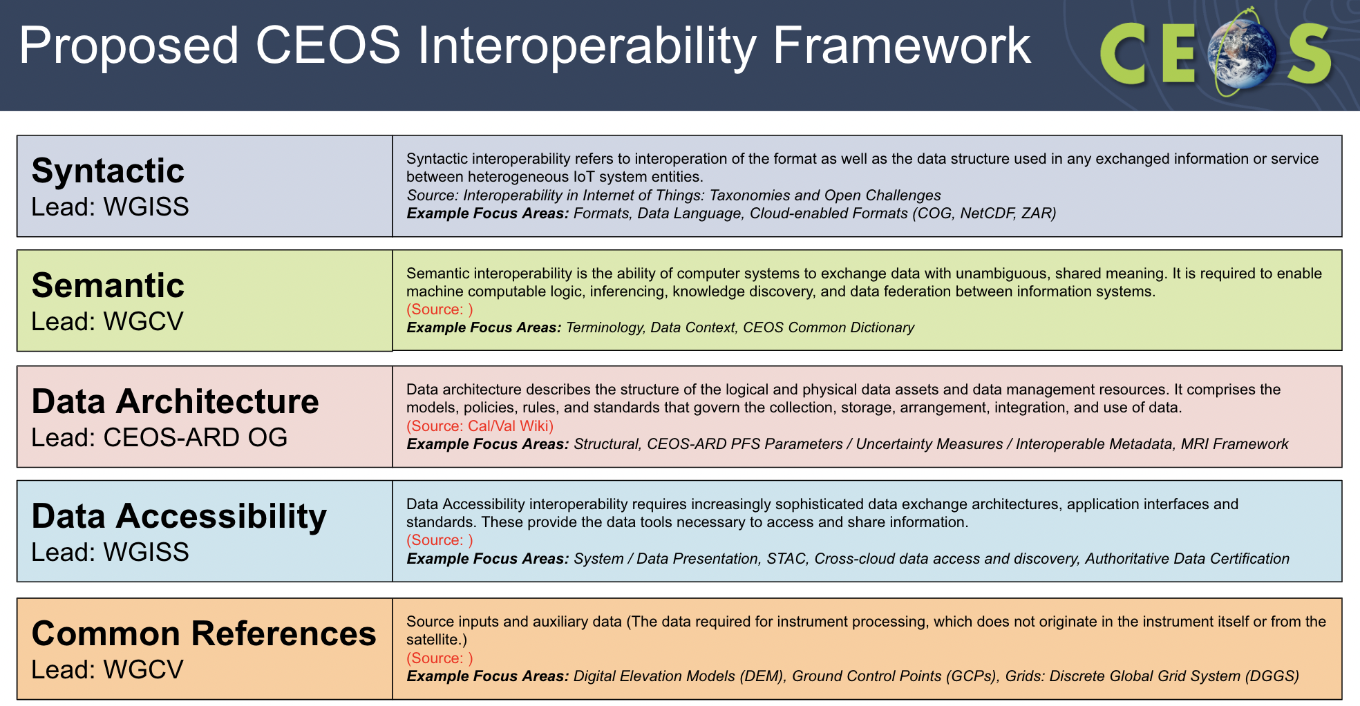
- The building blocks have been agreed on, but the definitions are still being refined. Sources for each definition are being included to allow traceability.
- The proposed roadmap identifies activities for each topic, including overall maintenance and promotion of the framework. The items identified would make good work plan items for each group
Discussion
- The overall activity will be led by WGISS, with specific groups leading each topic. WGISS will serve as the overall framework coordinator, while the lead for each of the topics would coordinate activity within those blocks, noting there will be more contributors for each than currently listed. The blocks will be fleshed out with more details, leads, etc.
- Tom Sohre (USGS) noted there may be a couple groups participating in each activity, with the lead coordinating the work.
- There could be dependencies across the work items.
- Terminology is a cross cutting block, and would impact all other components. It was suggested that this be one of the foundational activities that should start sooner rather than later.
- The group is hoping that, starting at the side meeting next week, the leads will start fleshing out each of the blocks.
- Peter Strobl (EC-JRC, LSI-VC Co-lead) commented on the conflict between choice and interoperability. Noted the ARD discussion yesterday, which showed nicely what is needed as the main components. With the current five blocks, things like data format could fit across different blocks, but it should be very clear where things fit. Each block should be independent as much as possible, and we should minimise and remove any overlaps.
- The current definitions and examples aren’t necessarily exclusive, and work needs to be done to sort this out. The definitions of the blocks need refining.
- It is important to keep in mind that individual activities might touch several of these boxes. That is ok, but we need to make sure they are coordinated, and we need to make it clear where the task is being led.
- CEOS-ARD is a good example, where there is a strong need for clear terminology. Common references and formats are important for interoperability of CEOS-ARD datasets.
- The Interoperability Framework aims to coordinate the relevant parts of all the overlapping pieces, including grid definitions, which are varied and not coordinated. The activities should be priorities under the framework, to promote integration and avoid stovepiping across the organisation.
- The OGC ARD Standards Working Group (SWG) should be referenced in the Framework under data architecture.
LSI-VC-13-10 | Tom Sohre to add a reference to the OGC ARD Standards Working Group in the CEOS Interoperability Framework. | May 2023
- Yves Crevier (CSA) commended the team on the good decomposition of the theoretical tasks needed to advance interoperability.
- ESA and CSA are currently working on an interoperability project for forests using RADARSAT-2 and Sentinel-1 datasets, helping them understand the issues for forest data interoperability. This is very helpful for identifying some of the issues that will be faced in this activity. It would be good for LSI-VC to hear their practical feedback as well, on their experiences with this activity. Perhaps this could inform the CEOS framework.
LSI-VC-13-11 | Follow up at LSI-VC-14 on the CSA-ESA interoperability activity, with the RADARSAT-2 and Sentinel-1 pilot on forests. Consider any inputs which could help shape the CEOS Interoperability Framework. | LSI-VC-14
- When CEOS-ARD was developed, the idea was to improve interoperability through guidance documents / technical notes. The interoperability tasks here are somewhat similar to the guidance documents for formats, etc., that were discussed previously.
- The Copernicus Data Space Ecosystem (CDSE) has at least three cloud enabled formats, with the potential to create options as well. Don’t have to settle on one format.
- Perhaps recommendations of popular and previously exploited formats. This helps keep up with the pace of the commercial sector.
- WGISS is hoping the group will continue to meet on the sides of the major CEOS meetings, with some virtual meetings in between.
- Terminology is a transversal task, across WGISS and WGCV. WGISS has in the past put together terminology documents. WGCV has an action at the moment to develop the terminology wiki on the cal/val portal.
- There are currently only three people working within the WGCV terminology group - Peter and two others. There are not enough resources to do much.
- WIthin the Interoperability Framework, terminology will be led out of WGISS, with other groups involved, including WGCV. WGISS should ensure other groups are included.
- The common dictionary has struggled with resources. The work should be elevated within CEOS, and perhaps we could migrate the definitions more prominently on the CEOS website.
- Suggested to just start with definitions, and then wait for comments, rather than trying to get it perfect from the start. Iterate. The issues often boil down to a governance approach – CEOS needs to pick a definition and go with it at some point. Not everyone will agree. It can be hard to pick a ‘good’ definition, and the lack of agreement can be buried in definition. If the definition is ambiguous, it leaves room for choices.
LSI-VC-13-12 | Follow up with the SEO about elevating the existing WGISS and WGCV terminology to make it more visible on the CEOS website. | LSI-VC-14
Copernicus Data Space Ecosystem (CDSE) [Slides]
Ferran Gascon (ESA) presented on the Copernicus Data Space Ecosystem (CDSE):
- Recent development on the Copernicus side. Called an Ecosystem, because it has different entities acting together, and offering products and tools together for users.
- The CDSE guiding principles are:
  - Contribute to building an attractive European solution to access and process Copernicus Sentinel data.
  - Provide users a long-term perspective, building trust and unlocking the potential of Sentinel data.
  - Support European industry in developing high-quality competitive operational services.
- The CDSE can be found at: https://dataspace.copernicus.eu/
- Data distribution service is the core element, with an open and free service.
- The public data portfolio will include all Copernicus Sentinel user level data, with Copernicus Sentinel auxiliary data, core datasets and “Expert” data. There may be some access restrictions on the core and “expert” datasets.
- All data available via ESA distribution will be available immediately, with deferred access on very limited data.
- Also on-demand reprocessing available for latest baseline processing on archived data.
- The Copernicus Data Access Service (DataHub) full service is guaranteed until the end of June 2023, with the capacity to ramp down until September 2023, when the service will be discontinued.
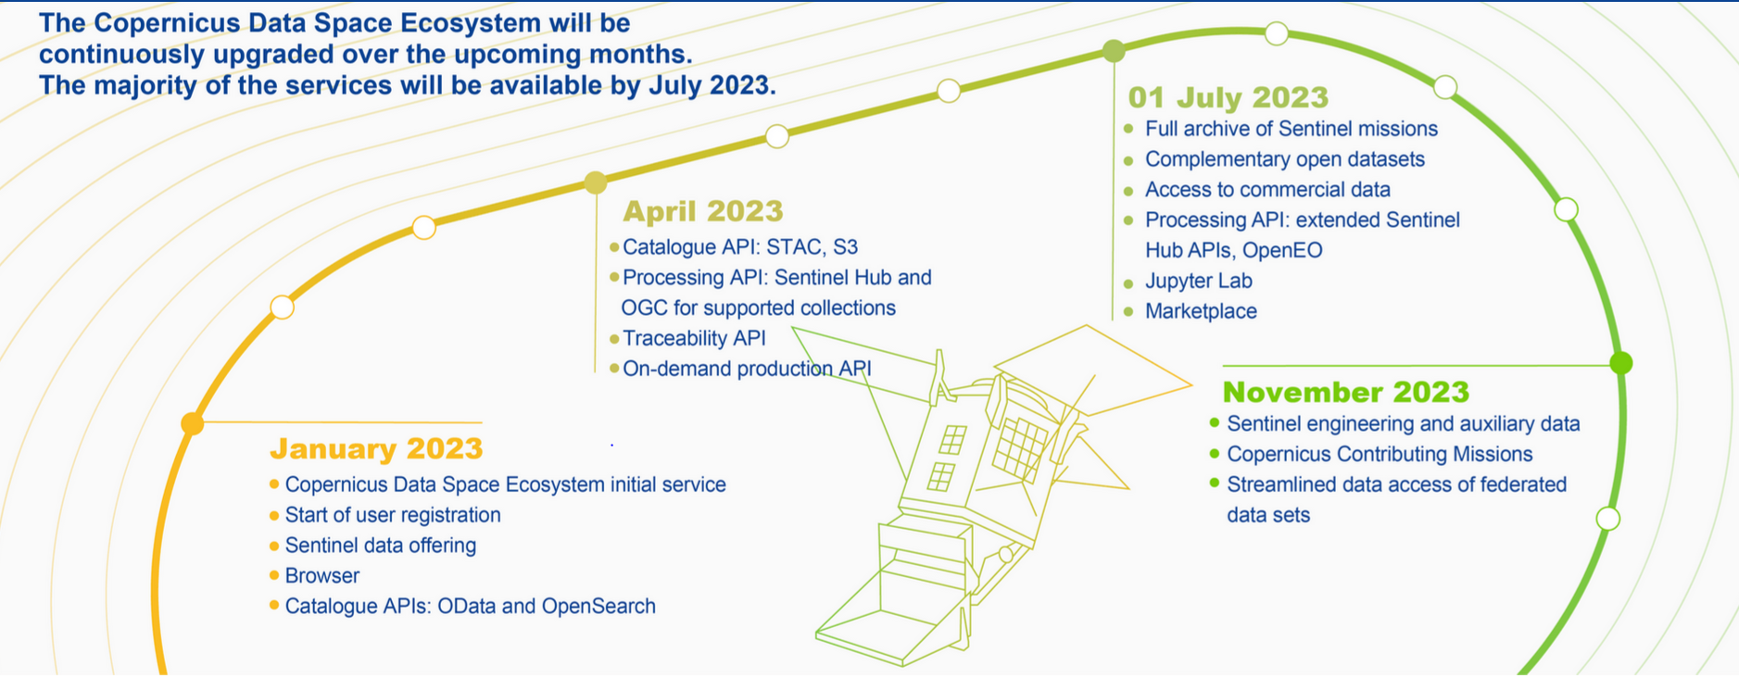
Discussion
- Sentinel-2 Collection 1 will be available for immediate access, and over time there will be incremental updates, for e.g. a Collection 2. The up-to-date scripts for processing will be made available to users in advance of significant reprocessings, in case users want to use the latest and greatest.
- Processing baseline changes will be included in on-demand processing scripts. Only changes that do not significantly impact e.g. radiometry - want to continue the ability for users to create consistent time series. Significant changes that would impact e.g. radiometry (e.g. atmospheric correction) would necessitate the point of a new collection.
- There is an issue with the versioning of collections. ESA hasn’t yet reflected that. If the upgrade is included, this would disrupt Collection 1, which would then have to be renamed..
- It could be worthwhile for CEOS to identify what really is the concept behind ‘collections’, what are the main characteristics, to be established by space agencies, so users know what to expect when we talk about ‘collections’. Steve Labhan (USGS) noted he will make a presentation on Collection management principles and guidelines later today.
- Continually moving the baseline is disruptive. Changing metadata is okay, but altering the radiometry and geometry is a significant issue.
- There are questions about how we should capture these collection changes, and their related radiometry changes. Making it clear to users, perhaps through an API, that the time series is impacted (discontinuities caused by collection changes). An on-demand service is one attempt at solving this issue.
- USGS has a system called ESPA (EROS Science Processing Architecture). It will be open for users with quotas of bandwidth and downloads. It is a third-party on demand processing service, not geographically limited in any way.
- It is a USGS priority for the next 7 years, to ensure Landsat data isn’t stovepiped. The goal is to provide external access capabilities, fully enabling Landsat to be a part of users’ analyses. Make it as open and accessible as possible, and build an ecosystem to enable this.
- For CDSE, Third Party means any party outside Copernicus which wants to do processing etc. using the ecosystem.
- One user account with different types of privileges, with the goal to move away from the different access hubs, to a single unified system.
- Regarding data egress, there will be some free bandwidth, and if a user requires more, there is a commercial option.
EU-US Collaboration on CDSE [Slides]
Steve Covington (USGS) presented:
- Will reach 20 PB of Landsat data by 2030. One year into Landsat Next, the archive will reach 35 PB.
- There is a large growth in data volume that needs to be managed.
- Their goal is to build an ecosystem, centred around a data exploitation portal. Want data archives to have a common API front end allowing search and discovery with consistent tools.
- Would like to see throughout CEOS an approach for a common API ‘standard’ that can be used across any data provider. With a single search, a user can look across a plethora of archives. Common API front end to enable search and discovery.
- With such high volumes of data, USGS don’t want users to download all the data. Prefer to process the data online.
- LSI-VC needs to discuss how to approach reprocessed CEOS-ARD compliant data. LSI-VC should also work on a CEOS-endorsed methodology for certifying copies of CEOS-ARD.
- USGS efforts on search and discovery should be done in collaboration with CEOS for greater benefit and a common approach. Goal to enable multi-source and multi-modal, and encourage cloud processing across CEOS.
Discussion
- Alyssa Whitcraft (GEOGLAM) noted the push on their side to move away from mission based science teams. There is the practical challenge about doing it in the cloud, as different agencies use different cloud providers. How are agencies addressing the selection of a cloud provider?
- Ran into this issue with commercial data, it is inexpensive to host, but NASA wouldn’t allow it. If everything is in the cloud on the same provider, it addresses a lot of the issues.
- Steve Covington (USGS) recognised this not our job as CEOS Agencies. We know we can’t be everything to everyone.
- If there is only one provider, there is no competition to drive down costs.
- This should be a discussion within WGISS, and as incoming WGISS Chair, USGS will consider this in their priorities, ensuring to communicate with LSI-VC.
LSI-VC-13-13 | Tom Sohre to raise with the WGISS team the discussion about a consistent front-end API across CEOS for data search and discovery as an important enabling technology for cross-cloud data access. Suggest that it becomes a focus area for WGISS, and perhaps a component of the CEOS Interoperability Framework, keeping in mind the connection to ongoing OGC activities as well. | WGISS-56
Cross-cloud data access and discovery (SEO) [Slides]
Brian Killough (NASA, SEO) presented:
- SEO took on a task over the last six months or so to look at different cloud data providers. Are there things we can be doing proactively to improve accessibility, etc.
- There was a workshop at Pecora last year, on implementing CEOS-ARD. Found that NASA should capture lessons learned from its recent trials with the three big cloud service providers (Google, Amazon, and Microsoft) – what are the advantages and disadvantages for using each one – and share them with other public EO agencies.
- There was also a request from GEO to CEOS SEO to inform the evolution of the GEOSS Common Infrastructure (GCI). Exact needs are unclear.
- The GEO Portal has been removed. At the annual GEO-CEOS meeting, CEOS was asked to join the GIDTT (GEO Information and Data Task Team) to provide guidance and input going forward. This will come out of ExCom this week.
- Open Earth Alliance (OEA) is a community framework, which aims to connect to the regional Data Cubes and the work around them. Currently not very active. There is a separate core group of people working on ODC core development, whereas OEA is more the connection to end users, and thinking about how these ODC systems around the world connect and what are the benefits. ODC v2.0 is expected soon.
- Algorithms which are used on one Data Cube can be easily transported to another. Microsoft Planetary Computer has adopted ODC.
- SEO team compared the performance of AWS (EC2), Google (Compute Engine) and Azure (Virtual Machine). Simple benchmarking - not a definitive analysis. Need more statistical analysis over time to determine accuracy of benchmarks. Some results are presented below.
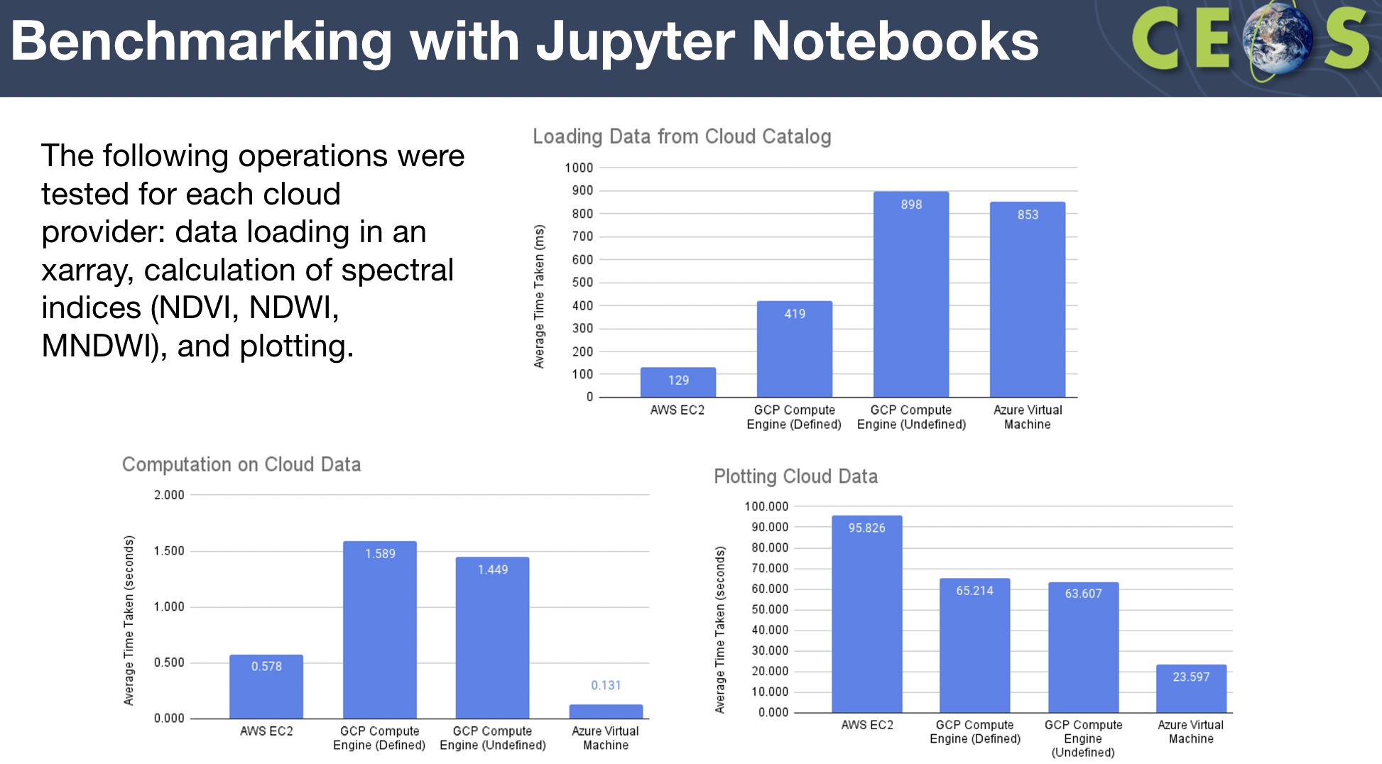
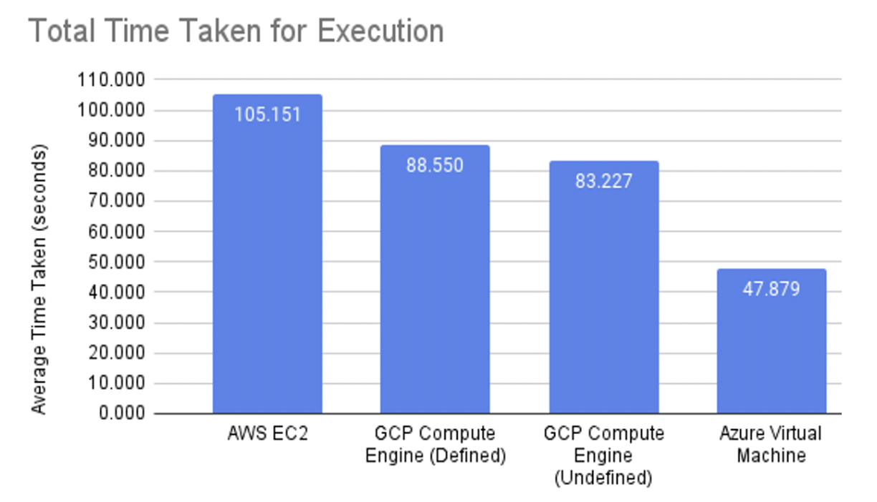
- There are very few cases where all three providers have the same products. A summary of some common products is shown below.
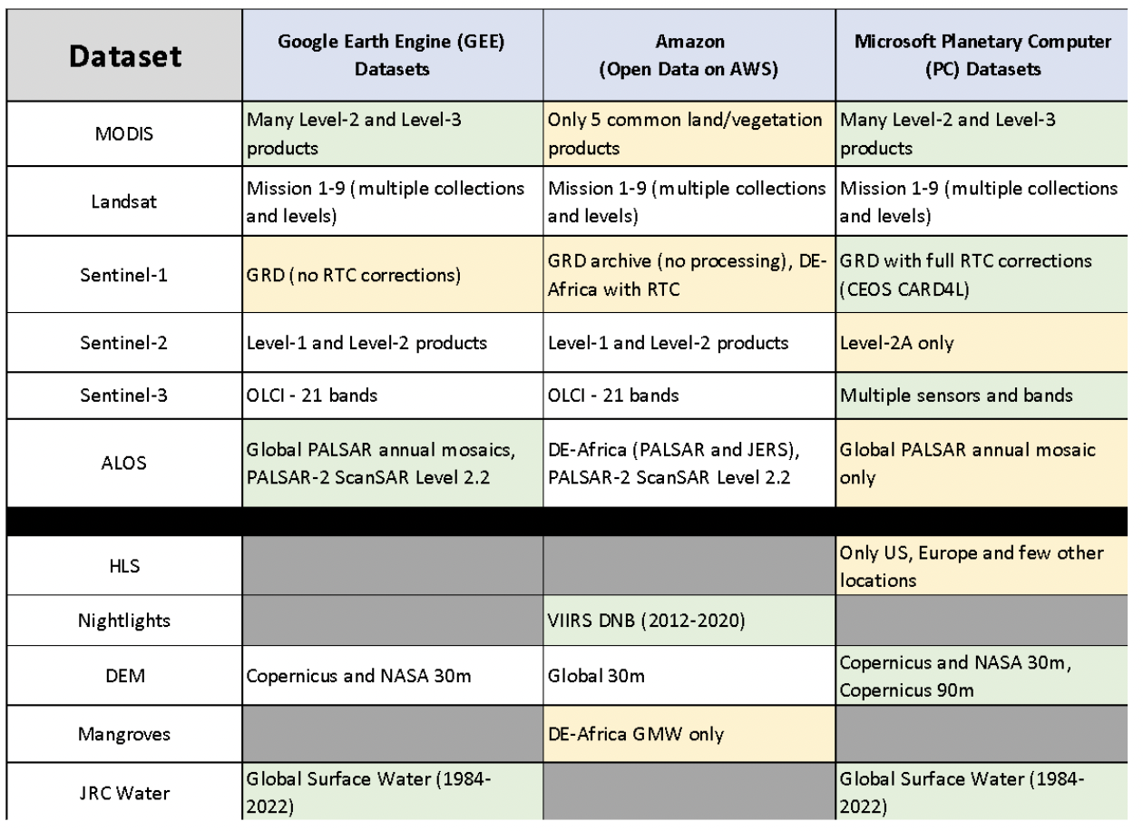
- User driven demand likely is what is influencing the dataset decisions.
- This fragmentation of datasets and different types of data across these different platforms makes it difficult for users. Users may be drawing pixels from multiple locations. Providing a means to make this easier for users would be a positive development.
- Ease of setup was best with Microsoft. Most common use for Amazon. Most diverse set of cloud services was also Amazon. Fastest execution was Microsoft. Most satellite datasets were hosted on Microsoft. Best ML/AI resources found on Microsoft.
- The SEO’s headline suggestion to users is to go where the required data is located.
- The SEO needs to formulate a more detailed plan for how to support the future GCI (GEOSS Common Infrastructure). The Open Earth Alliance (OEA) is a GEO Community Activity that can help connect the many regional and national Data Cubes and promote sharing of data and applications. The connection to cloud providers is managed by CEOS through the LSI-VC (ARD topics) and the SEO (implementation testing). How we move forward to improve these connections and add value to the global user community is uncertain but worth further discussion.
- Can we develop a list of CEOS “desires” that will improve access and use of our datasets from these regional Data Cubes and cloud providers? For example, we desire a unified metadata API (e.g., STAC) that has flexibility for different data types and sources. We desire notifications of latest dataset releases or reprocessed dataset releases. Are there other desires?
- Tested the integration of the Sentinel Hub with ODC. Used CreoDIAS, a cloud-based platform funded by the European Commission that provides access to EO data from the Copernicus program.
- Advantages:
  - CreoDIAS users have access to pre-configured environments for processing Sentinel data, such as this new environment that has been created for ODC.
  - SH-ODC offers excellent documentation and resources for users to easily get started with the platform and troubleshoot any issues that may arise.
  - During testing, the compute instance was set to eo1.large with 4 vCPUs. The user experience of running the analysis on JupyterLab was very smooth.
- Issues:
  - Data Type: The dc.load function returns a dataARRAY with bands as a dimension, as opposed to a dataSET. This will cause issues with existing ODC applications but fixes are possible to make them compatible.
  - Security Risk: It would be easy for anyone with JupyterLab notebook access to get the secret key SH_CLIENT_ID and SH_CLIENT_SECRET.
  - Cloud Administrators may have limited control over the underlying infrastructure in CreoDIAS as compared to AWS/Azure.
- The SEO plans to test (via Jupyter notebooks) specific ARD datasets to demonstrate ease of access and use of CEOS datasets in the cloud.
- NISAR will launch in early 2024, and it would be great to connect that data with the ALOS ScanSAR data, to create a full time series of L-band data. It would be a good interoperability test case and helpful pilot of some of the STAC discussions.
LSI-VC-13-14 | LSI-VC Secretariat to facilitate a discussion between JAXA, ISRO and NASA to explore the possibility of constructing an ALOS and NISAR long-term L-band time series. This would be a good interoperability test case and helpful pilot of STAC discussions. | LSI-VC-14
- Initiated in April 2020 as a CEOS WGISS initiative, the Earth Analytics Interoperability Lab (EAIL) is a data and analytics platform that uses AWS Cloud and Open Data Cube. Its advantages are Jupyter Hub, Dask scaling, customised ARD pipelines and GPU processing. The SEO is working with CSIRO in 2023 to further training on EAIL operations to support users and ensure sustainability.
Discussion
- End users appear to not mind that there is no such thing as a certified copy of data. The perception is that data is close enough, although they could be assuming it is the authoritative data.
- Noted the lossy compression of Google Earth Engine Sentinel-1 data.
- Should CEOS be concerned about this replication and sub-standard handling of data? Authoritative data should be a topic of concern for CEOS.
- People making legal and regulatory decisions need to be sure they are starting from the authoritative data source.
- Most users don't appear to care, but from the standpoint of good governance, CEOS should have a means of certifying a replica copy. Not necessarily a service, but perhaps some tools.
- Manipulation of this imagery is much more feasible with AI. There are cases where it would be an issue, including when data is used in legal cases.
- Documentation shows where the cloud services got the data. But they could’ve done re-processing, or it might not be the most recent product.
- Damiano Guerrucci (ESA) suggested CEOS establish some protocol for data owner notification of reprocessing, new datasets, etc.. If someone reprocesses, the same service could also notify the data owner. There is currently no service like this. This and authoritative data is being looked at by the WGISS System Level Team. A simple hash of that data or referencing metadata is not sufficient, even a change in format will complicate this. Need to be aware of potential for malicious use of data.
- CEOS WGISS System Level Team is considering best practices for STAC to address some deficiencies that have been identified with STAC, and are engaged in an active discussion with the STAC community. The flexibility of STAC can be detrimental to interoperability. Whether the recommendations from the best practices just become integrated into STAC itself is to be seen.
- Brian Killough (SEO) is unsure whether NISAR data will have a STAC extension. There will be a lot of generated Level 3 data products from NISAR.
- Where are the shortcomings that CEOS needs to address regarding search, discovery, access, use and exploitation? These SEO pilot activities seek to help identify these topics.
LSI-VC-13-15 | SEO to work with the LSI-VC team to produce a statement of recommendations / desires for CEOS to address regarding the search, discovery, access, use and exploitation of cloud-based EO data.  Examples: a unified metadata API (e.g., STAC) that has flexibility for different data types and sources; a process by which notifications of updated/new dataset releases or reprocessed collections can be pushed to data hosts; a solution for authoritative data source identification, etc. | LSI-VC-14
- WGISS perhaps addresses some of the points regarding service discovery best practices as well. Damiano Guerrucci (ESA) noted that perhaps there needs to be increased communication across CEOS, it may not be enough to just present the best practices as we can lose connection with the real applications. WGISS is working more in this direction but needs more contact with other groups.
CEOS-ARD in the Cloud & Interoperability Discussions [Slides].
Steve Labhan (USGS, LSI-VC Co-Lead) presented an introduction to SpatioTemporal Asset Catalog (STAC):
- STAC is not currently required in the CEOS-ARD PFS, but is strongly encouraged as a Cloud-enabling format. USGS Landsat Collection 2 and ESA’s CDSE both incorporate STAC.
- The STAC Specification consists of four semi-independent specifications. Each can be used alone, but they work best in concert with one another:
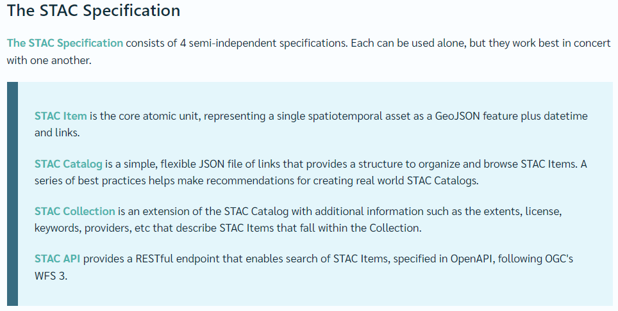
- Need to be very clear exactly which of these elements we are talking about, as each of these can be implemented alone.
- STAC is built off underlying standards, OpenAPI, following OGC’s WFS 3, noting the discussion on CEOS effort for a search and discovery API needing to be built on standards. STAC may be the answer.
- There are CEOS-ARD STAC Extensions for both optical and SAR datasets. Conducted March 2021 STAC Workshop to mature/finalise a “CARD4L” STAC Extension. Several issues remained unresolved and no significant progress has taken place since then.
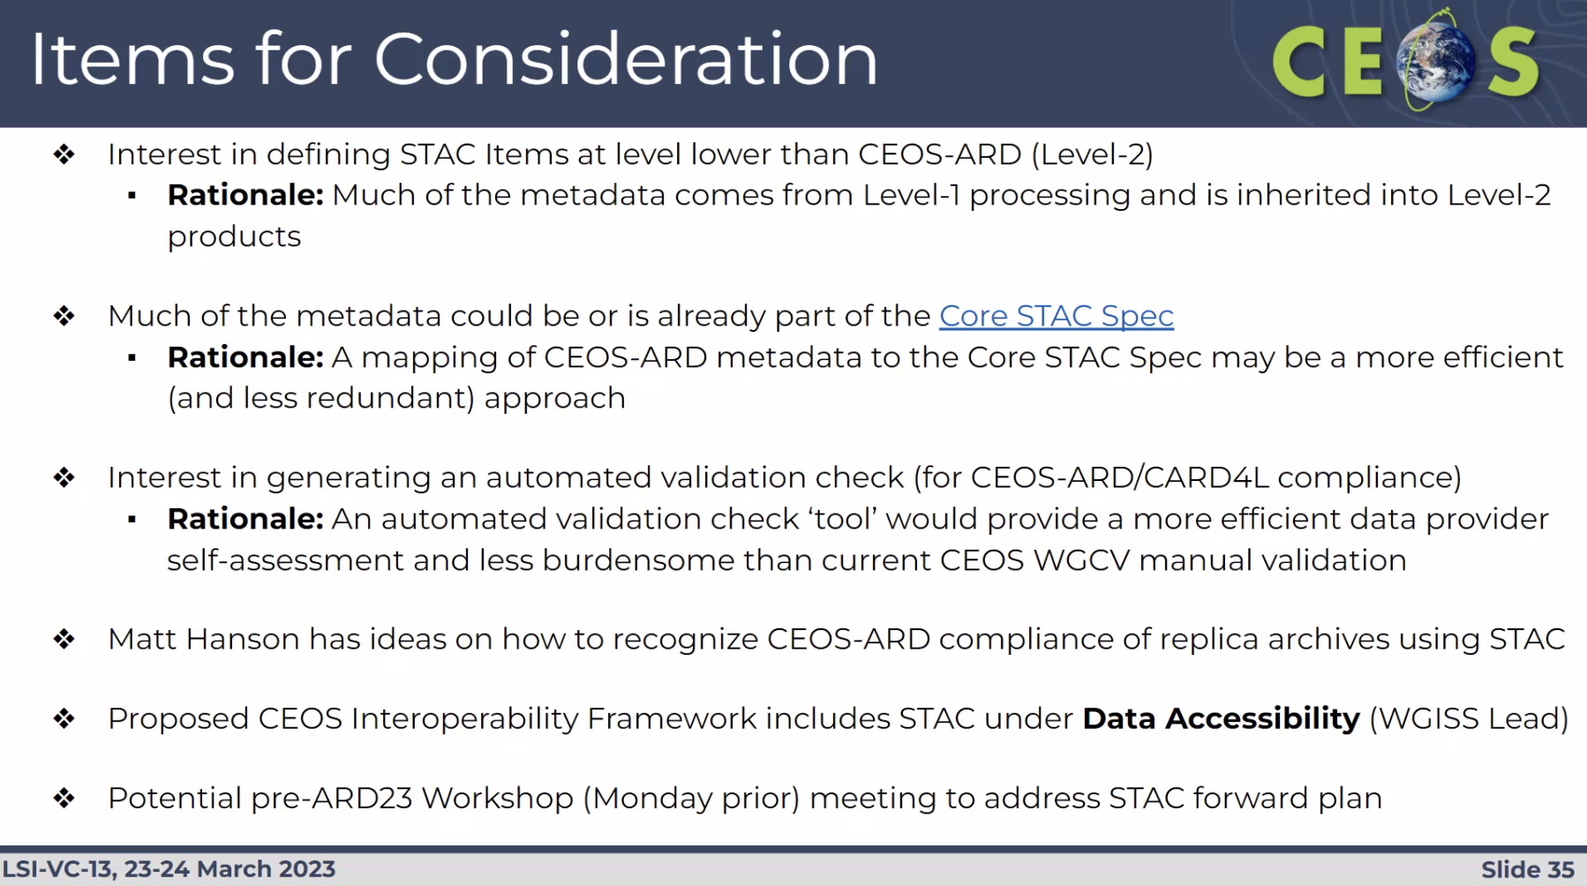
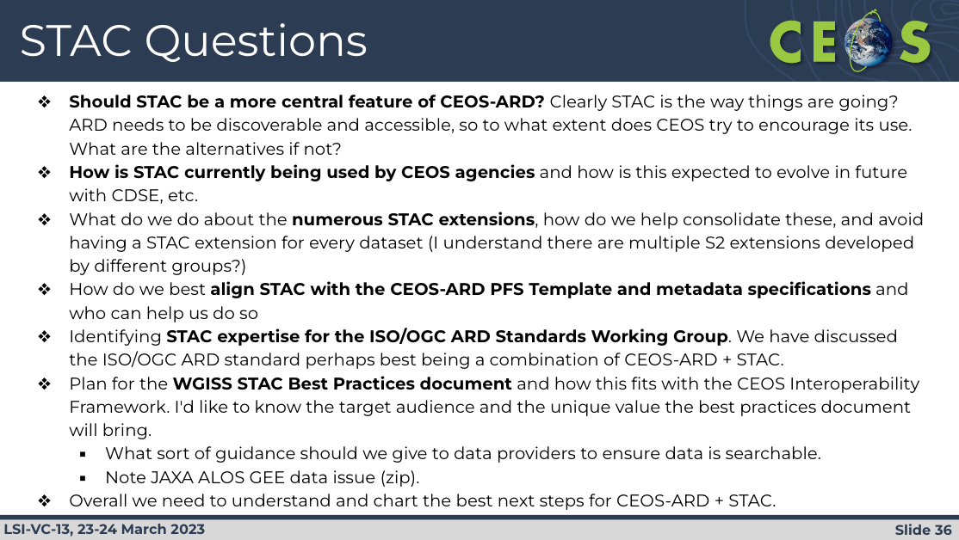
Discussion
- Steve Covington (USGS) asked about using the STAC API, for common search and discovery. Does STAC API do that? Or is it somehow modified per instance? Are the API’s different for different datasets?
- The STAC Catalog is basically an index of the data. But the syntax of the catalog might not be all the same. Need to make sure to use the metadata.
- Ideally there would be a single client for accessing data.
- For Landsat data, all of the above STAC items are implemented. The data is in a private bucket, so users would need to be in their own AWS account to make the connections.
LSI-VC-13-16 | Tom Sohre to clarify the limitations on the USGS STAC API implementation on AWS. Perhaps related to egress limiter / AWS account related issues? | June 2023
- Regarding the STAC Items, there is a subject of how it is defined for each mission. How CEOS should harmonise this. Is this a topic underway within WGISS?
LSI-VC-13-17 | Steve Labahn to ask Matt Hanson about:  - Updating the CARD4L STAC extension name to ‘CEOS-ARD’.  - Follow up the issues highlighted in the CARD4L extension disclaimer.  - Explore the idea of incorporating STAC into the PFS at Target level.  - How STAC might provide a solution for the authoritative data issue.  - A solution to the proliferation of STAC extensions. | Report at next LSI-VC telecon on the way forward for STAC + CEOS-ARD + Interoperability Framework, etc.
Session 6: Agriculture, Forestry, and Other Land Use (AFOLU)
Global Forest Observations Initiative (GFOI) Update [Slides]
Osamu Ochiai (JAXA) reported:
- CEOS hasn’t engaged much with GFOI lately, although Osamu has been continuing to represent CEOS at their meetings.
- There is increased demand for forest information to support best forest monitoring.
- CEOS attends the annual GFOI Plenary to coordinate international support to tropical countries on forest monitoring and GHG monitoring.
- GFOI founded under GEO in 2011, with key partners being Australia, CEOS, ESA, Germany, Norway, UK, USA and the World Bank.
- Four GFOI components include methods and guidance documentation, capacity building, research and development, and data coordination. CEOS is a key partner for data coordination.
- GFOI has over 450 activities with 70 partners and across 80 countries.
- GFOI 2023 Plenary will take place 9-11 May at FAO headquarters in Rome.
- It would be a good time to get feedback from end-users if CEOS contributions (mainly datasets) are useful or if there are any gaps or opportunities to improve. Discussions are underway with the GFOI Office to organise such a feedback process.
Discussion
- Noted that Chris Barnes of USGS will be the new data component manager for GFOI.
- It would be helpful to know if GFOI has any best practices or methods for collecting user feedback. This is still under discussion. Tom Harvey from GFOI is planning to hire someone dedicated to undertake this. Osamu was a bit hesitant to take on the action himself. Joana Melo’s paper is perhaps the best example of user feedback at the moment.
- Countries are not able to tailor the global datasets to match their definition of forest. Meanwhile, countries are also moving away from wall to wall monitoring toward point sampling high resolution data (like 5m). This is the approach advocated to countries by FAO, which leads to this shift we are seeing. Data from the paper showing the extent of satellite EO uptake is below:
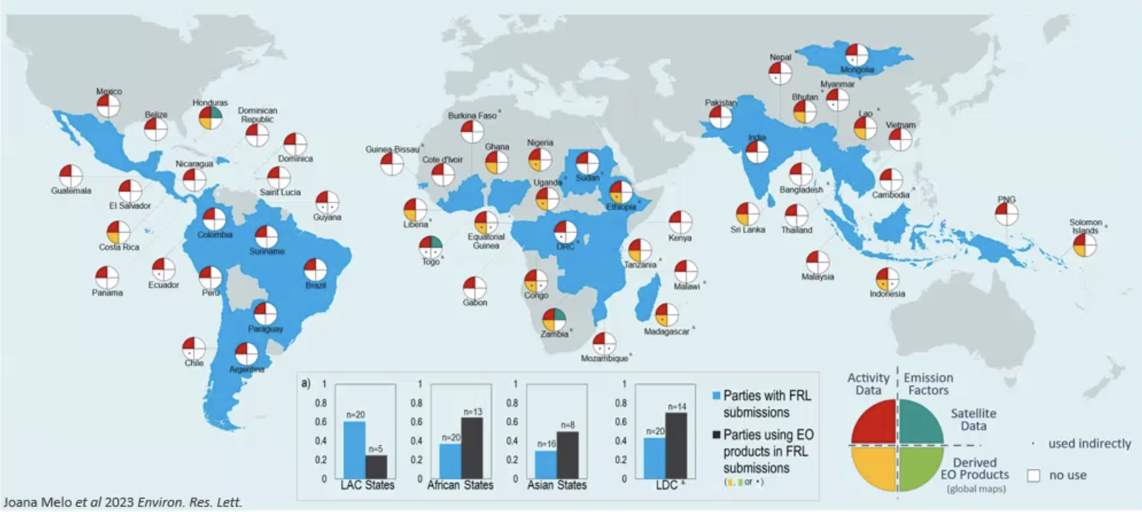
- There has been a big effort invested in satellite datasets for forest monitoring, and it is not being used.
- The headline learning from Joana’s paper is that we need some way for global products to be flexible to countries’ specific requirements.
- Sylvia will present some reflections on this. There is a lot of potential for the work they have been doing with countries.
LSI-VC-13-18 | Stephen to share the paper by Joana Melo. | COMPLETE  Paper here.
Silvacarbon Country Engagement [Slides]
Sylvia Wilson (USGS) reported:
- Has been working very closely with GFOI through the SilvaCarbon programme.
- 30 countries on the SilvaCarbon list, which is growing.
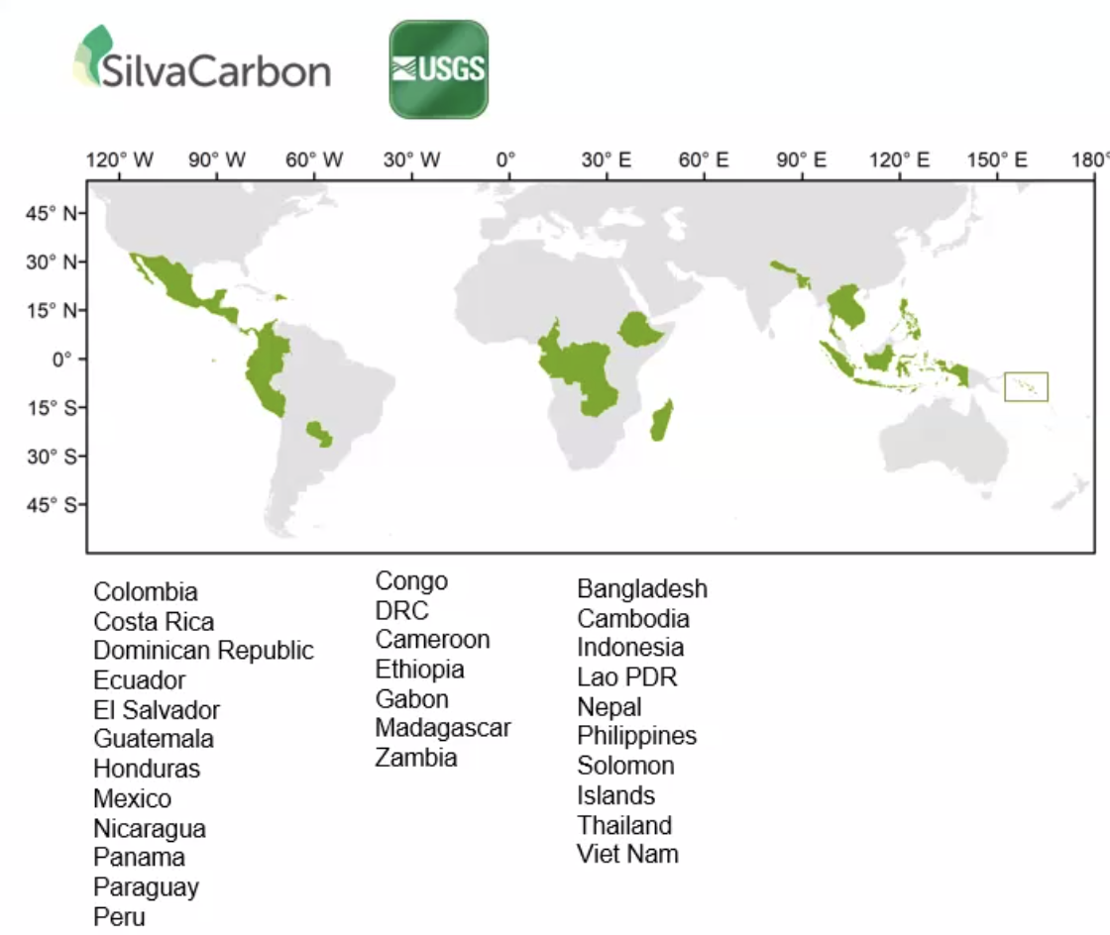

- Hosted the first regional SilvaCarbon/CEOS workshop in Paraguay in June 2022, with a focus on Biomass measurements. There will soon be a paper as a result of the workshop.
- Produced a model using GEDI data, validated against field work during the workshop. The results showed that the model underestimated biomass. However, the level of uncertainty was low enough that this methodology could benefit Paraguay if used in inaccessible areas or to augment the NFI.
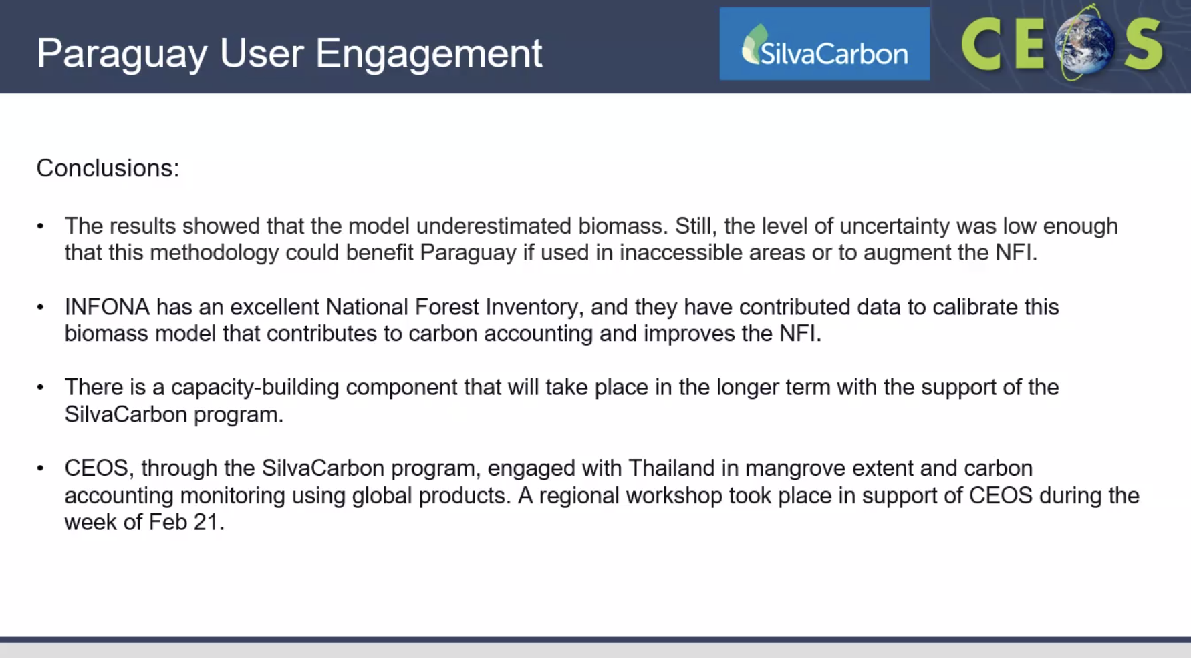
- A second workshop took place in February 2023 in Thailand, with a focus on mangrove extent and carbon accounting.
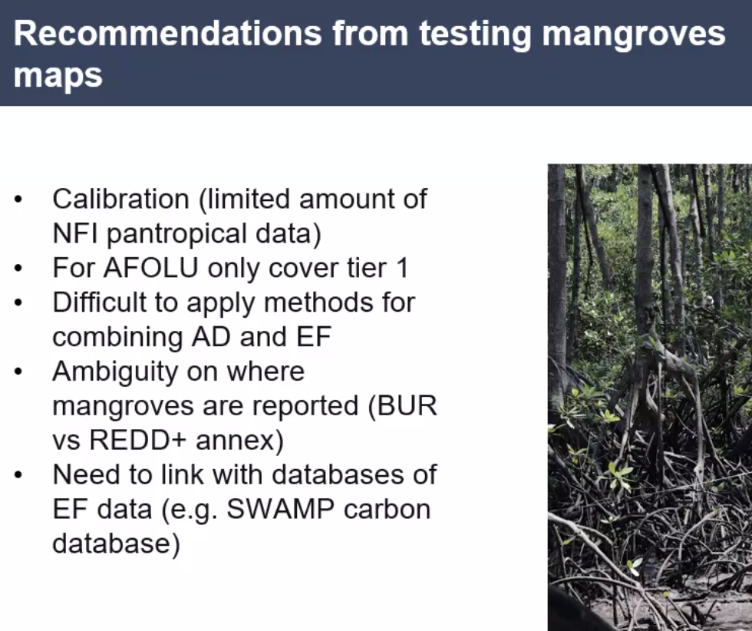
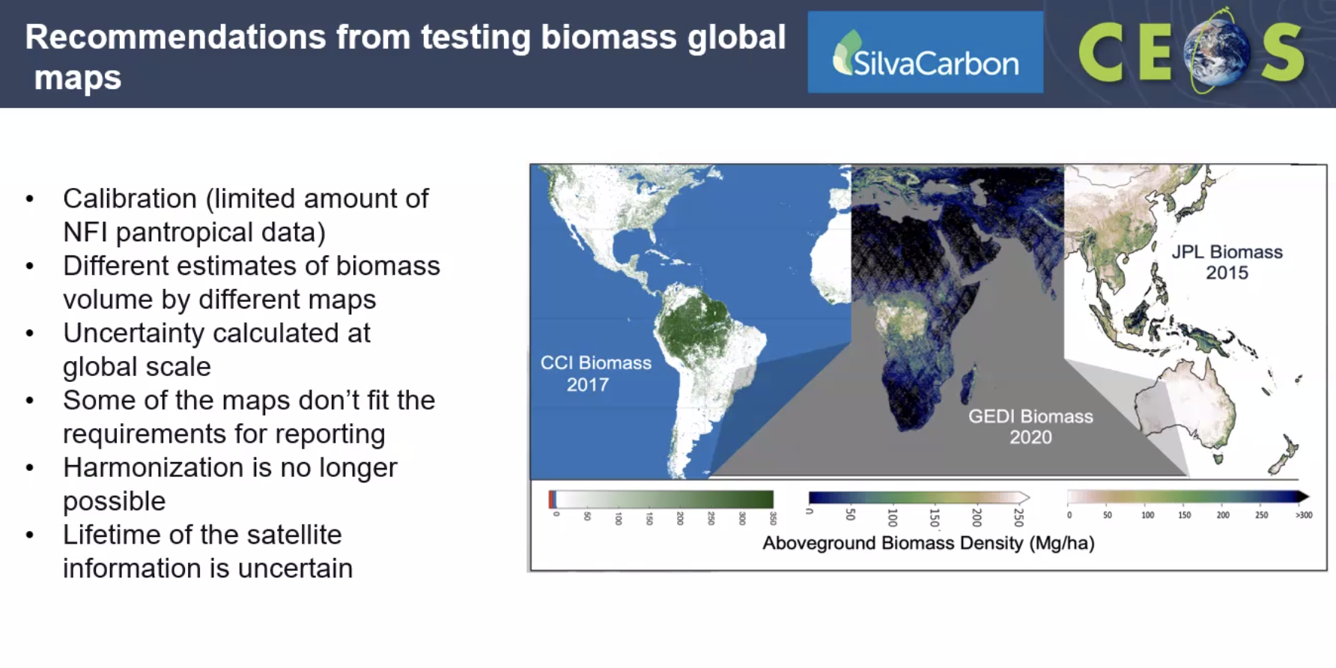
- There are two additional workshops in 2023 with a mangrove focus, in Gabon and Peru.
- SilvaCarbon is also planning bilateral country engagement on biomass estimates and mangrove mapping.
Discussion
- Ake Rosenqvist (JAXA) noted that for the Global Mangrove Watch (GMW), JAXA is planning to do an exercise in Thailand. The current GMW map is having some issues with the time series. JAXA has reprocessed the data, and will release v4 soon. Expect that this next version will be able to separate losses and gains (whereas current only looks at net change). Ake suggested that before Silvacarbon does any work with GMW data they should wait for v4. JAXA can organise to provide data in advance for specific countries.
LSI-VC-13-19 | Sylvia and Ake to coordinate early access to v4 Global Mangrove Watch data for specific countries, if needed for workshops. | As Needed
- Regarding the abandoning of the harmonised biomass map effort, the main reason is that all the uncertainties for these maps are calculated differently, which can be very hard to match up. The biomass harmonisation team has decided it wasn’t going to work.
- IPCC has to comply with the transparency framework, and can only give recommendations in the technical assessment. REDD+ is different, where the reviews will look at all the methods, and there can be issues if a dataset has lost uncertainty.
LSI-VC-13-20 | Stephen to share the recommendations presented by Sylvia with Ben Poulter for the AFOLU Roadmap. | COMPLETE
- A fourth version of the ESA CCI Biomass maps will be released in May, and will introduce better consistency between the maps. Using the reprocessed JAXA mosaics and ESA-JAXA collaboration resulted in individual ALOS/ALOS-2 scenes to further improve estimates of biomass. Not only mosaics, but individual scenes.
- Chris Barnes (USGS) is picking up the role of Data Component Manager at GFOI. Trying to leverage work he is doing on other projects, focusing on user needs.
- Osamu Ochiai (JAXA) & Stephen Ward (SIT Chair Team) have been discussing how we can revitalise the CEOS-GFOI relationship. Chris Barnes’ involvement will go a long way to increasing productivity. Noted the GFOI connection will be useful for the implementation of the AFOLU and GHG Roadmaps. Will take steps to increase uptake of datasets that CEOS Agencies are producing.
Group on Earth Observations Global Agricultural Monitoring Initiative (GEOGLAM) Update [Slides]
Alyssa Whitcraft (GEOGLAM) reported:
- Sven Gilliams (GEOGLAM) and Alyssa came from the GEOGLAM ExCom in Geneva earlier this week.
- Ian Jarvis, director of GEOGLAM, is retiring in April 2023, and the applications for a new Director have just closed.
- The GEOGLAM-CEOS relationship is coordinated through the Earth Observation Data Coordination group.
- NASA Harvest recently announced a Rapid Response Facility, and are seeking broader GEOGLAM engagement.
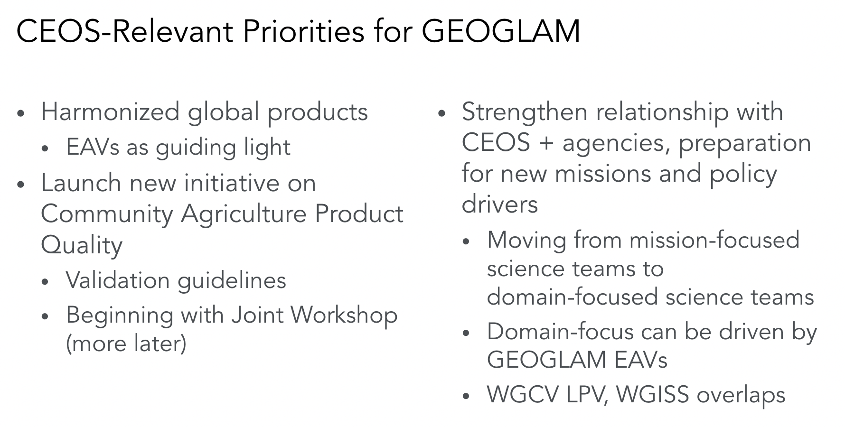
- Essential Agriculture Variables (EAVs) have been defined: https://agvariables.org/. CEOS is key to the first step in the data chain, for data collection and initial processing. Processing to Level 2 and the ARD specifications are key for the second step.
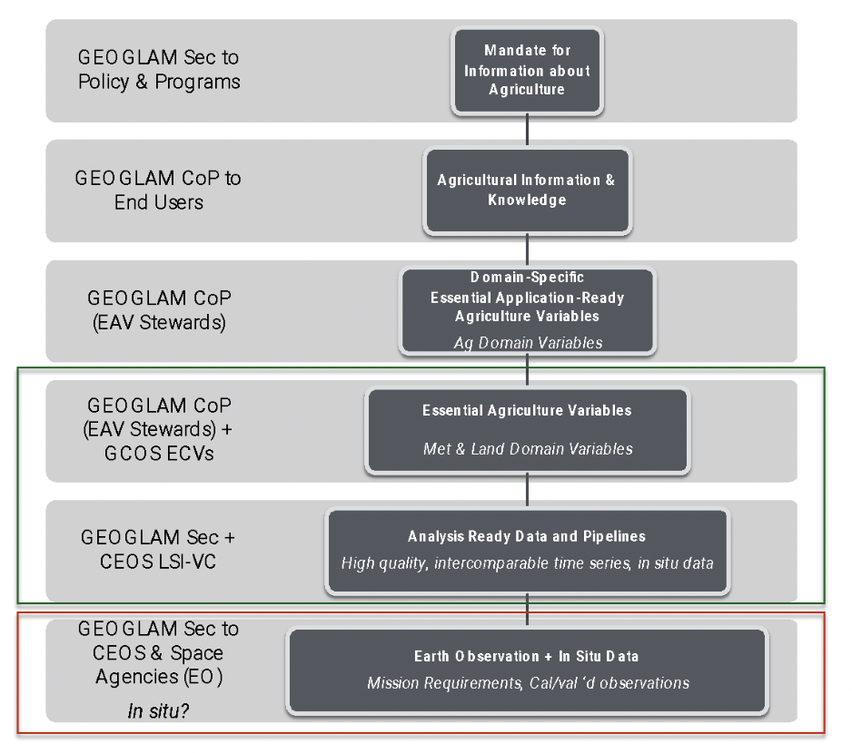
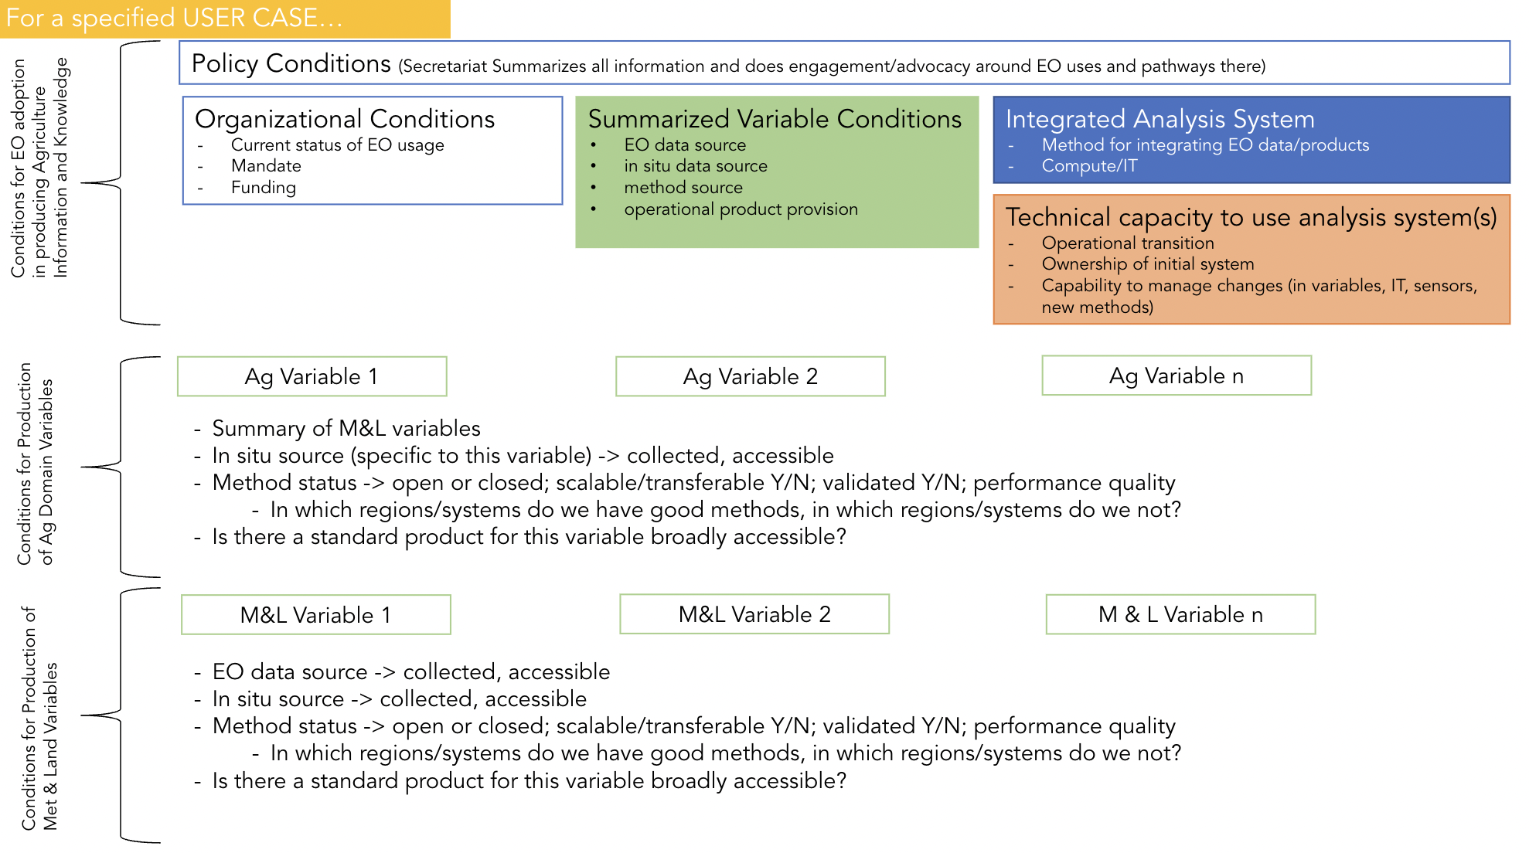
- GEOGLAM are using the CEOS GST AFOLU need for land cover as the for global, harmonised, trans-scalar crop type. Sven will be the POC for the CEOS GST AFOLU Roadmap.
- Community led good practices workshop for cropland and crop type validation will be held 12-14 September 2023, in Maryland, USA.
- In situ data scarcity is impacting the development of systematic operational monitoring capacities required to address policy priorities. GEOGLAM initiated a working group on in situ data in 2021.
- The gap analysis will include in situ data needs for EAVs.
- Plan to implement a demonstration distributed architecture with hosting capability using the open source CKAN solution under the neutral GEO/GEOGLAM umbrella, with an implementation of STAC and a common API to query the data
- Brad Doorn (NASA) has been LSI-VC GEOGLAM subgroup lead for years, and it is time for him to have a co-lead or pass leadership to another agency.
- Alyssa has been awarded NASA’s US-focused agriculture program (“NASA Acres”) and will step back from many GEOGLAM activities, however will remain EO Data Coordination WG (co-lead) and EAV WG (co-lead), with NASA Harvest support.
- Sven Gilliams will step up to co-lead the EO Data Coordination working group.
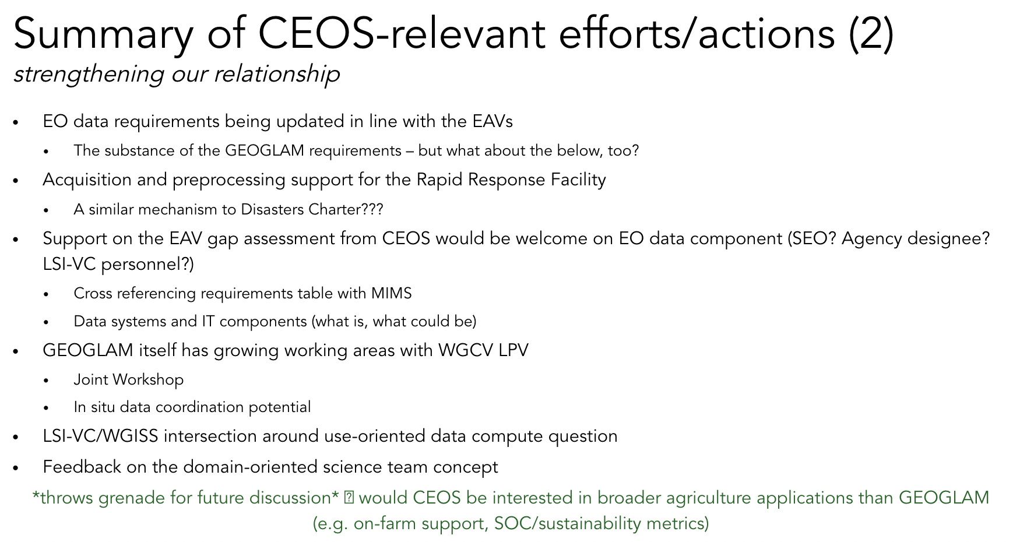
Discussion
- Regarding the EAVs, are there variables which publicly available satellite data do not address? Each is nested, and sometimes the type of data isn’t available.
- For example, crop nutrient status needs hyperspectral imaging. For evapotranspiration, sufficient thermal observations are necessary.
- Some can be achieved with open data, but often need higher resolution or better quality like from Planet data.
- Many of the meteorological and land EAVs overlap with ECVs. Then there are the agriculture domain EAVs which are very specific, and have no overlap with ECVs.
- GEOGLAM had a side meeting on EAVs this week, where a framework was agreed for undertaking the gap analysis. Looking at specific use cases and identifying the blockers to uptake of EO for the particular use case. Discussed proposed use cases and set objectives for various timeframes.
- There are the spatial, temporal and spectral components of the data. The RCA-EORES system matches well with what GEOGLAM has presented.
- Back when they did the initial definition of the EAV requirements, GEOGLAM looked at some select missions and mapped them to requirements.
- Geophysical variables matched up, however this doesn't necessarily mean that the mission is generating that geophysical variable, there could be a gap. USGS harvested data from the CEOS Database (MIM) and also added in commercial data.
- There is a clear collaboration here between CEOS and GEOGLAM, with the MIM Database and USGS RCA-EORES supporting.
LSI-VC-13-21 | USGS team, George Dyke and Libby Rose to connect with the GEOGLAM team on leveraging MIM and RCA-EORES to analyse a few of the GEOGLAM EAV requirements and identify contributing missions. Consider this a pilot activity for a broader CEOS response to GEOGLAM EAV requirements and gap analysis. | Update at LSI-VC-14
- For most of the agriculture applications, 24-48 hrs data latency is sufficient.
- Morning observations generally produce more useful data.
- Moving on to 10-30m focus in GEOGLAM generally.
- Commercial companies are addressing the finer resolution needs of GEOGLAM.
- The ESA World Cereal contract is ending, and the data should end up in the cloud for the long term. All the data that goes into the classifications as well. CDSE could be a good long term home. Also possibly AWS. Both the products and methods are open and should be stored.
CEOS AFOLU Roadmap Update [Slides]
Stephen Ward (SIT Chair Team) reported:
- The CEOS AFOLU Roadmap process started at the end of 2020, and has had a slow start. Supports the CEOS Global Stocktake Strategy.
- The GST Portal can be found at ceos.org/gst.
- Joint CEOS-TOPC AFOLU Workshop was held in September 2022. The workshop identified a workflow for integrating the GHG and AFOLU roadmaps and activities of CEOS, IPCC and WMO for an operational GHG monitoring, reporting and verification (MRV) system.
- Driver of the CEOS AFOLU Roadmap is to define the observational requirements in 2035 and chart the steps needed to meet them by CEOS Agencies.
- The recommendations are currently being developed by the team, and comments are welcome. First recommendation is a direct response to the Joana Melo paper, essentially.
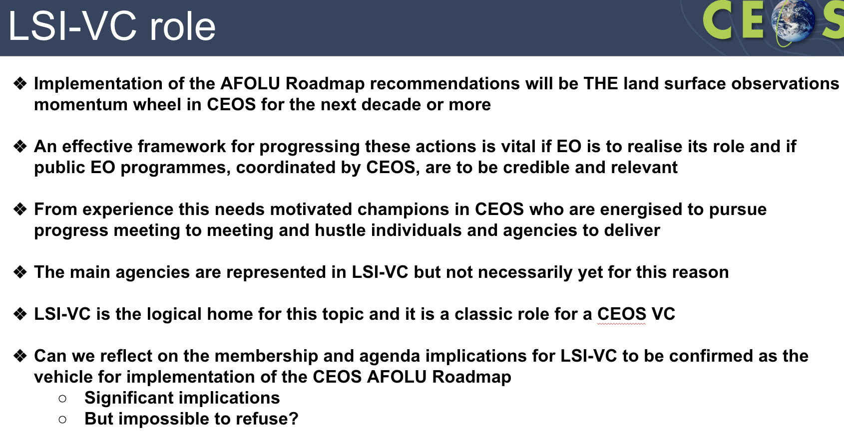
- The role of LSI-VC in responding to the AFOLU Roadmap (detailed above) is a classic CEOS VC role. LSI-VC needs to ensure that it has the representation required to respond to the recommendations.
- Need to discuss today: Is LSI-VC the home for this and what representation do we need to make it happen?
Discussion
- Steve Covington (USGS) noted that these inputs are useful for mission planning, but a very long lead time is needed for programs like Landsat.
- Need champions like USGS in LSI-VC to help drive this effort.
- Yves Crevier (CSA) noted the focus of LSI-VC and its subgroups has moved over the years. With the data supply situation stabilised, it was a natural evolution to focus on the access, ARD, etc. This focus will prompt a return to some of the supply-focus activities of the past.
- Science stakeholders are extremely important in this context. Having access to the ECVs, EAVs, EBVs, would help in focusing the definition of the products and investment strategy that we can put forward to meet the needs of the scientific community.
- Alyssa has found the EAVs to be a very useful communication tool.
- Need to understand user needs and observation requirements much better. Hope this team will step up. Will need the bigger LSI agencies to step up as well.
- USGS processes data to the SR/ST level and then anything higher level is left to users or other organisations.
- How do we enable and present data in the most effective way possible to allow these science activities to take place effectively?
- Understand the requirements and make sure the data matches the user needs.

Session 7: Other Agency/Mission Updates, AOB, Closing Business
CSA Update [Slides]
Yves Crevier (CSA) reported:
- Shared the new CSA logo.
- Noted evolution of the RADARSAT business model.
- Yves noted a challenge that is in development to assess and better understand the usefulness of the RADARSAT archive for specific challenges related to forests, ecosystem and biodiversity applications:
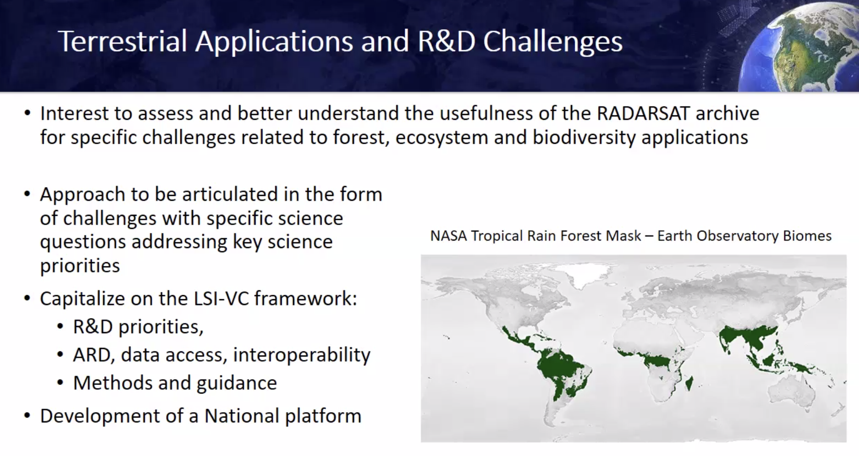
- Aiming to understand interoperability with other C-band missions.
- The tropical rainforest archive is rich. Started the collection from the first SDCG in Montreal. This meeting prompted action to develop a key long term archive for forestry. CSA wants to understand the contribution this can have.
- Developing Digital Earth Canada, but the platform will take a few years to develop. The RADARSAT-2 dataset will be used as a pilot on the platform to test the ARD and dataset availability.
- Collected over 80,000 scenes of 5m resolution SAR data over tropical forests.
- Seeking to answer the following key R&D questions through the challenge:
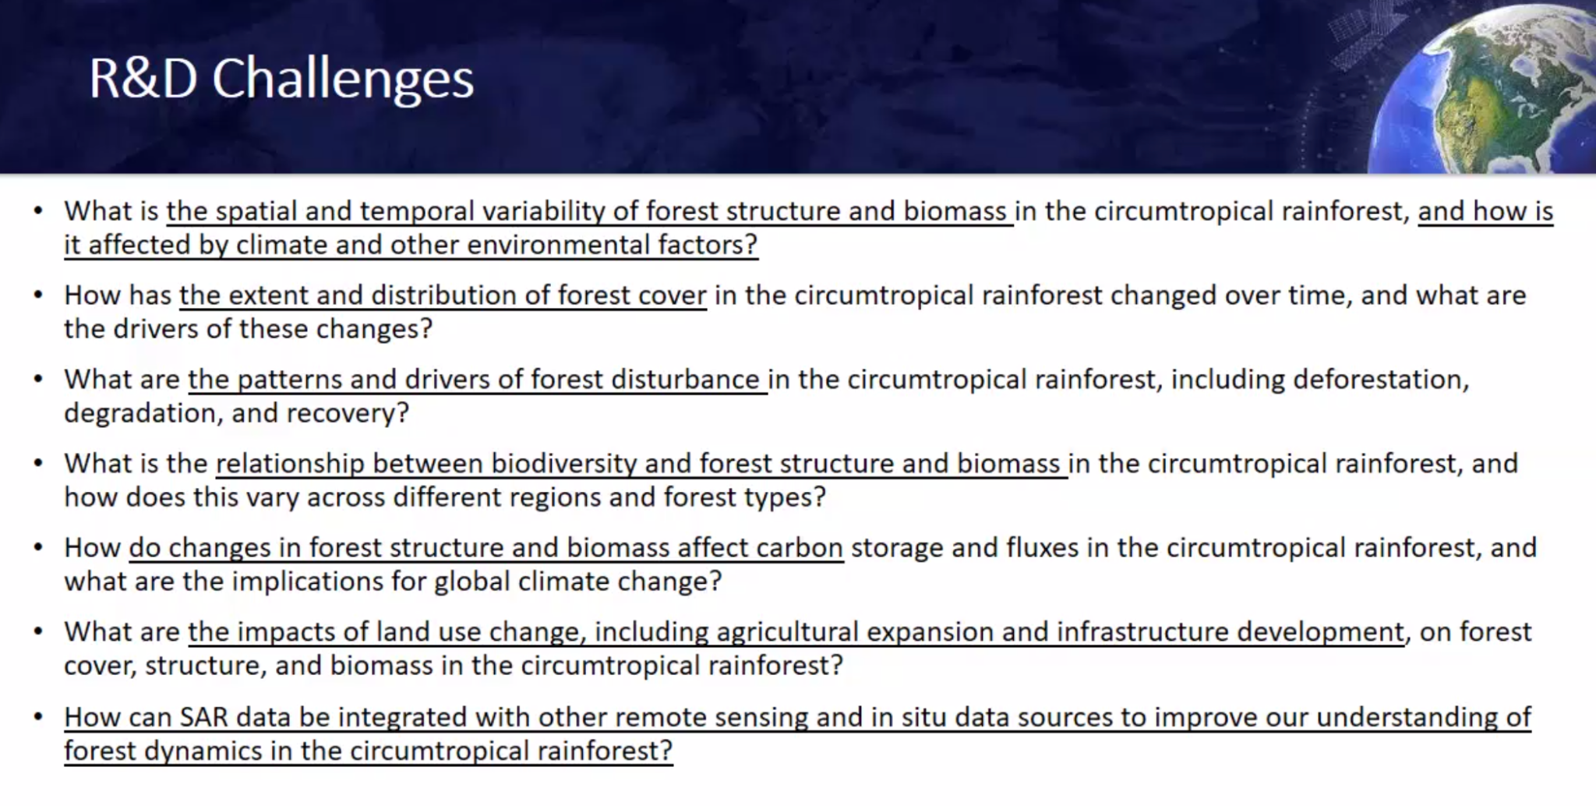
- Also looking at multi-source analysis. Could aim to use the CEOS Interoperability Framework to guide. Noted again the offer to test concepts from the CEOS Interoperability Framework if feasible / ready.
Discussion
- The concept of a target location, where there is a truth, and then providing various stacks of data - to challenge the multi-source, multi-modal approach to characterising LULC. Noted past example of a data challenge competition, which yielded improved results.
- Making sure we are pooling resources to make it happen. CSA is willing to coordinate and pull together resources, including CEOS partners to answer some of the above questions.
- RADARSAT data is semi-open, with approved access, users have to apply for approval.
- CSA has strict data distribution restrictions with the department of foreign affairs.
- CSA would like to collaborate and learn from the experiences of other agencies. Spending a lot of money on processing the data, and are hoping to leverage the CSA CEOS Chair term in 2024.
- CSA only plans to process the RADARSAT data to NRB ARD at the moment. Noted there is a CSA representative on the CEOS-ARD SAR team. Processing this data to CEOS-ARD facilitates access.
- Ake is working closely with Francois, and can advise how to process the data. Perhaps CSA could use CEOS-ARD product level definitions to bypass some of the data distribution restrictions as well, as the data is not raw anymore.
- Yves thanked MDA for supporting access to RADARSAT-2 images for the challenge.
LSI-VC-13-22 | Yves Crevier to provide additional details regarding the Radarsat archive R&D Challenge, when possible. LSI-VC will then consider ways that it might be able to support. | Update at LSI-VC-14
Landsat Next Briefing [Slides]
Tim Stryker (USGS) reported:
- USGS’s fundamental goal is to ensure public availability of a primary data record about the historical condition and current state of the Earth’s land surface and to predict its future condition.
- Landsat 7 lowered its orbit last year, the benefit is the LST is drifting. The radiometry of the mission is still in good shape. This will provide an interesting trove of unique data. There is a refuelling mission planned for 2027. Currently collecting data over the US only, and processing to Level 2 ARD.
- Landsat Next will have improved revisit frequency (constellation), higher spatial resolution (10m), and additional spectral bands, while maintaining the radiometric quality established by Landsat 8 and 9. The Landsat Next mission comprises 3 individual missions.
- The Sustainable Land Imaging (SLI) program’s vision is for long-term operational availability of a wide range of government, commercial, and international land imaging data and services to meet the needs for environmental monitoring and forecasting.
- USGS would like to ensure complementarity of future Copernicus, Landsat and related satellite systems through LSI-VC and bilateral coordination mechanisms.
WGClimate-18 CEOS-ARD Report [Slides]
Matt Steventon (LSI-VC / CEOS-ARD Oversight Group Secretariat) reported:
- CEOS-ARD Secretariat joined the WGClimate-18 meeting on 1 March 2023.
- WGClimate was considering a representative to the CEOS-ARD Oversight Group to explore opportunities. Have since heard that they are struggling for resources and it will not be possible at this time.
- Open question whether the CEOS-ARD concept applies to the climate domain. Needs to be end user driven.
- WGClimate will consider a preliminary assessment of some datasets/CDRs in the ECV Inventory against the existing CEOS-ARD Product Family Specifications. Will also consider whether there is a need for new PFS for other climate related products.
- Recommendations / suggestions related to LST CDR and requirement/gap analyses from the joint LSI-VC and WGClimate session held in 2019 are still relevant and will be followed up over the coming months.
- WGClimate also identified some areas where LSI-VC could support the space agency response to the latest version of the GCOS Implementation Plan:
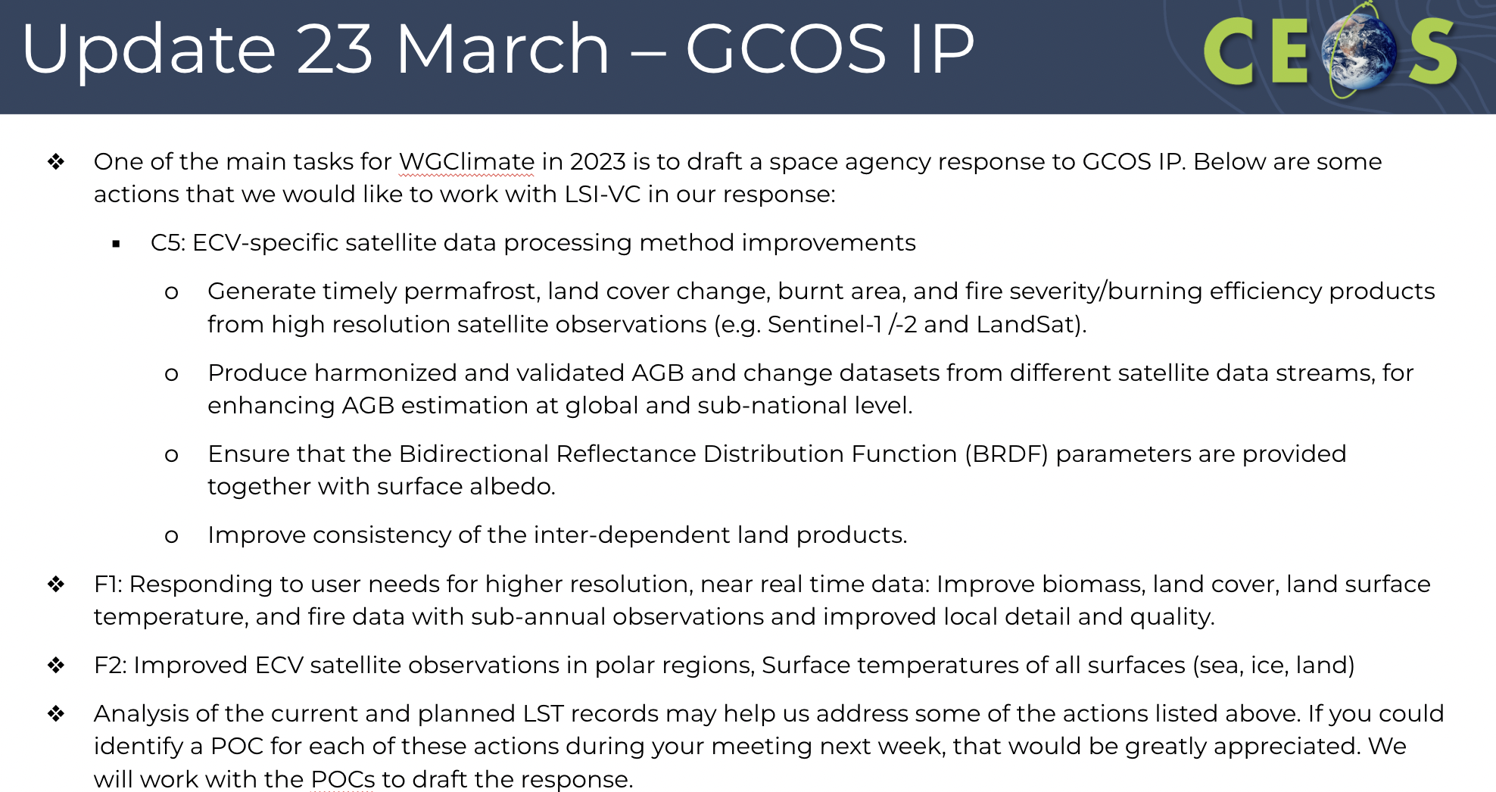
LSI-VC–13-23 | Matt to continue working with WGClimate to advance the following topics:  - The need / feasibility of CEOS-ARD products for the climate domain.  - WGClimate engagement in the CEOS-ARD Oversight Group.  - The requests from 2019 regarding LST Climate Data Records and gap/requirements analyses.  - LSI-VC support for the WGClimate response to the latest GCOS IP. | Update at LSI-VC-14
CEOS-ARD Comms Activities [Slides]
Libby Rose (SEO Comms Team) reported:
- @CEOSARD twitter account opened in June 2022, and currently has 55 followers.
- CEOS-ARD is one of the most popular topics of ceos.org/news articles. A number of articles were published over the last year on CEOS-ARD and related topics.
- Two editions of the CEOS-ARD Newsletter were published in 2022, with the second focused on CEOS-ARD @ LPS22.
- Two future editions are planned, each following major meetings where CEOS-ARD is featured.
- The SEO is hosting a CEOS Booth at IGARSS 2023 and GEO Week 2023, and is planning to produce a flyer, which will feature CEOS-ARD on one of the six panels.
- Planning to add a section to the CEOS-ARD website for communications materials, where the CEOS-ARD logo will be hosted in different formats and colours. Guidelines will also be provided for the use of the logo.
Discussion
- Steve Covington (USGS) suggested a news story on STAC.
- Noted the usefulness of retweeting from other space agency channels, as they have far more followers and can help grow our audience.
- At SIT-38 there will be a CEOS Communications side meeting, where these topics will be discussed more broadly.
LSI-VC-13-24 | Libby and Matt to coordinate a CEOS-ARD Branding Guidelines and logo package for distribution to CEOS-ARD data providers and hosting on the CEOS websites. | June 2023
Meeting Adjournment
The decisions and actions were reviewed and revised offline. The LSI-VC Co-Leads and LSI-VC Secretariat thanked everyone for their participation and valuable inputs to the discussions.

