Minutes v1.0
14th Meeting of the CEOS Virtual Constellation for Land Surface Imaging (LSI-VC)
10-12 October 2023
ESA ESRIN, Frascati, Italy

Participants
CONAE: Laura Frulla*, Danilo Dadamia*
CSIRO: Zheng-Shu Zhou*
DLR: Anna Wendleder, Stephanie Holzwarth
EC-JRC: Peter Strobl
ESA: Ferran Gascon, Ivan Petiteville, Clement Albinet, Silvia Scifoni, Magdalena Fitrzyk, Francesco, Bjorn Rommen*, Jolanda Patruno, Kevin Alonso, Georgia Doxani, Sabrina Pinori*
GA: Andreia Siqueira, Medhavy Thankappan, Peter Harrison*
GEOGLAM: Alyssa Whitcraft, Sven Gilliams*
IEEE: Siri Jodha Khalsa (Univ. of Colorado, Boulder)
ISRO: Hari Priya Sakethapuram, Radhika*, Keerthi V*, V Mamavalan Ramanujam*, Raghav Mehra*, Manju Sarma*, Usha Sundari
JAXA: Takeo Tadono*, Ake Rosenqvist, Makoto Natsuisaka*
KARI: Chiho Kang
LSI-VC Sec: Matt Steventon, Stephen Ward, Libby Rose
NASA: Patrick Quinn*, Eric Vermote*
SEO: Dave Borges, Brian Killough
UKSA: Sarah Cheesbrough
USGS: Steve Labahn*, Tim Stryker, Steve Covington, Tom Sohre*, Chris Barnes
University of Leicester Darren Ghent*

* indicates online

Thursday, March 23
Session 1: Welcome and Introductions
Welcome
Andreia Siqueira (GA, LSI-VC Co-Lead) welcomed participants to the meeting, expressing gratitude to Matt Steventon (LSI-VC Sec) and LSI-VC Co-Leads for their contributions. She noted Steve Labahn will be joining the meeting online, and Peter Strobl will be joining in person soon. Andreia reviewed the objectives and agenda for the next two and a half days, underscoring the packed agenda schedule.
Steve Labahn (USGS, LSI-VC Co-Lead) welcomed and thanked the participants for joining. He also extended thanks to Andreia for providing an overview of the meeting. A tour de table was performed.
Action Review
Matt Steventon (LSI-VC Sec) reviewed the selection actions from LSI-VC-13 and the team teleconferences since.
- LSI-VC-13-01: Steve and Tim to propose a USGS airborne LiDAR specialist for the LiDAR PFS development team.
  - This action was agreed to be closed formally, although there is a likelihood of continued work from the USGS perspective. Ake will provide an update on the Lidar side tomorrow.
- LSI-VC-13-04: Matt to follow up with Zheng-Shu Zhou (CSIRO) on the burn area multi modal application as a case study for the use of CEOS-ARD products.
- LSI-VC-13-05: Matt to consider a focus on multi-modal case studies for the next CEOS-ARD Newsletter, as this is a priority for USGS.
  - On the multi-modal topic for CEOS-ARD newsletter, USGS is working with CSIRO on NovaSAR data. It was agreed to close both the action and create a new action for case study.
LSI-VC-14-01 | Libby and Matt to prepare an edition of the CEOS-ARD Newsletter on multi-modal applications of CEOS-ARD, starting with the USGS RCMAP and CSIRO NovaSAR examples. | Q1 2024
- LSI-VC-13-07: Schedule a further discussion on whether georeferenced products might be considered CEOS-ARD, or is a map projection strictly required.
  - This action remains open. This will be pursued through the OCG ARD SWG. A new action was recorded to carry this forward.
LSI-VC-14-02 | Ensure that the discussion on whether georeferenced products might be considered ARD, or is a map projection strictly required, features in the context of the OGC ARD SWG. | ASAP
- LSI-VC-13-08: LSI-VC to consider how best to support CONAE’s discussions on open data. Perhaps it would be useful to coordinate a letter from the CEOS Chair regarding the importance of open and free data policies.
  - Various materials have been supplied to CONAE. Closed action. Materials also useful for JAXA to present to their government.
- LSI-VC-13-09: Andreia, starting with LSI-VC representatives, will undertake a survey (through consultation calls) with agencies to understand their ambitions with respect to CEOS-ARD, to inform priorities for further engagement with New Space and commercial providers.
  - This will be discussed by Andreia Siqueira (GA, LSI-VC Co-Lead) under agenda item 7.2. Closed.
- LSI-VC-13-12: Follow up with the SEO about elevating the existing WGISS and WGCV terminology to make it more visible on the CEOS website.
  - This action is closed. However, a pragmatic step is needed. Dave Borges (SEO) is happy to support whatever decision is reached.
LSI-VC-14-03 | Matt, Dave and Peter to discuss the best approach for elevating the existing WGISS and WGCV terminology to make it more visible on the CEOS website. | LSI-VC-15
- LSI-VC-13-13: Tom Sohre to raise with the WGISS team the discussion about a consistent front-end API across CEOS for data search and discovery as an important enabling technology for cross-cloud data access. Suggest that it becomes a focus area for WGISS, and perhaps a component of the CEOS Interoperability Framework, keeping in mind the connection to ongoing OGC activities as well.
  - This will be discussed at the upcoming WGISS meeting in a couple of weeks. Action can be marked complete. Follow up action recorded:
LSI-VC-14-04 | USGS team to follow up with Tom Sohre following the WGISS-56 meeting regarding the discussions there about consistent front-end APIs across CEOS for data search and discovery as an important enabling technology for cross-cloud data access. Also reflect on the SEO’s inputs to WGISS-56 on this topic.  Context: A statement of recommendations / desires for CEOS to address regarding the search, discovery, access, use and exploitation of cloud-based EO data could be helpful. E.g., a unified metadata API (e.g., STAC) that has flexibility for different data types and sources; a process by which notifications of updated/new dataset releases or reprocessed collections can be pushed to data hosts; a solution for authoritative data source identification, etc. | After WGISS-56
- LSI-VC-13-14: LSI-VC Secretariat to facilitate a discussion between JAXA, ISRO and NASA to explore the possibility of constructing an ALOS and NISAR long-term L-band time series. This would be a good interoperability test case and helpful pilot of STAC discussions.
  - The best forum to continue this is probably within the ICGS-SAR group. Mark this action as completed and pass it to that group. Approach from a scientific aspect needs consistent data. Aim to leave the policy out of the discussion.
- LSI-VC-13-15: SEO to work with the LSI-VC team to produce a statement of recommendations / desires for CEOS to address regarding the search, discovery, access, use and exploitation of cloud-based EO data.
  - Dave Borges (SEO) has discussed this topic with WGISS. This will be further discussed at WGISS-56 during Dave’s SEO report session. Closed.
- LSI-VC-13-16: Tom Sohre to clarify the limitations on the USGS STAC API implementation on AWS. Perhaps related to egress limiter / AWS account related issues?
  - This action will be closed. USGS will discuss this internally.
- LSI-VC-13-17: Steve Labahn to ask Matt Hanson about:
    - Updating the CARD4L STAC extension name to ‘CEOS-ARD’.
    - Follow up the issues highlighted in the CARD4L extension disclaimer.
    - Explore the idea of incorporating STAC into the PFS at Target level.
    - How STAC might provide a solution for the authoritative data issue.
    - A solution to the proliferation of STAC extensions.
  - Matthias Mohr is working on the STAC issues. WGISS STAC best practices group might be able to help coordinate these efforts. SEO is funding Radiant Earth, who have brought on Matthias, to support the community engagement side of the OGC ARD work. It was proposed to have a meeting soon to coordinate efforts.
  - Steve Covington (USGS) noted that incorporating STAC into the PFS seems to be against the idea of the PFS being non-prescriptive. Ake Rosenqvist (JAXA) noted that in the case of SAR, there is a mapping. The ongoing efforts provide a good opportunity to refine this aspect, with the combined PFS. The timing is right for the SAR PFS.
  - Steve Labahn (USGS) suggested that STAC should be covered from the interoperability framework context, without burdening the PFS with additional requirements.
LSI-VC-14-05 | LSI-VC Secretariat to organise a coordination meeting between the LSI-VC Leads, CEOS-ARD Oversight Group Lead, CEOS SEO, Radiant Earth, and Matt Hanson to discuss the approach to OGC ARD SWG community engagement and STAC, now that Matthias Mohr is contracted to support. | IN PROGRESS  Initial coordination call held on 24 October 2023
- LSI-VC-13-21: USGS team, George Dyke and Libby Rose to connect with the GEOGLAM team on leveraging MIM and RCA-EORES to analyse a few of the GEOGLAM EAV requirements and identify contributing missions. Consider this a pilot activity for a broader CEOS response to GEOGLAM EAV requirements and gap analysis.
  - There was a telecon last week with Alyssa Whitcraft. This will be covered under agenda item 8.3.
Session 2: Agency LSI Updates and CEOS-ARD Assessments
ISRO [Slides]
Hari Priya (ISRO) reported:
- Integrated Multi-Mission Ground Segment for EO Satellites (IMGEOS) is the platform where the data from the sensors is distributed to users. Different centres coordinate the data processing and dissemination to the users.
- Automated workflow chains are included in the process.
- Bhoonidihi is ISRO’s EO data hub which translates to ‘resources of the Earth’.
- EOS-04 (RISAT-1A), a follow-on mission from RISAT-1, was launched on 14 February 2022. It features a C-band SAR, with imaging modes Stripmap, ScanSAR and Sliding-Spotlight, and polarisations single, dual, compact and full. Swath is 10 - 223 km, with a resolution of 1 - 50 m.
- Level-2B is the Terrain Normalised product and will be submitted for CEOS-ARD assessment.
- ISRO is also developing an India Mosaic for systematic coverage. The data is available free and open for registered users. Sub-metre resolution data is only available to specific users. If needed, users can contact ISRO and they can help arrange the data.
- The EOS-04 NRB data is designed to be compliant with the CEOS-ARD NRB v5.5 PFS. The NRB data pixels indicate the true backscatter of the land cover without any overestimation, which allows for immediate analysis with minimum additional user effort.
- Level-2B data products are geo-coded incorporating the Copernicus 30 m Digital Elevation Model DEM (2019 version) and comprise the Terrain-flattened Gamma-Naught backscatter coefficient for each polarisation (e.g., HH, HV, VV, VH, RH, and RV).
- ISRO performed geometric analysis of the Level-2B data and found that the absolute geometric accuracy and Relative accuracy across cycles for Level-2B product is observed to be within 1 pixel (<18 m).
- The summary of the self-assessment of this data against the CEOS-ARD NRB PFS is below:
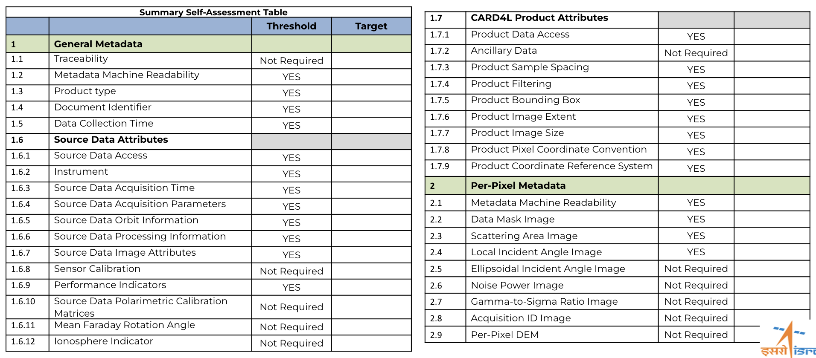
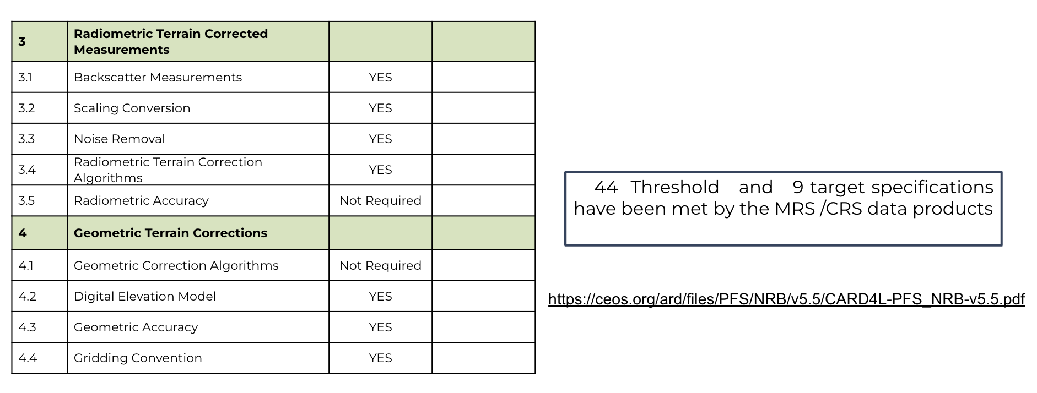
- The Indian sub-continent is systematically covered by EOS-04, with data at a resolution of 33 m and a swath width of 160 km. 33 cycles have been completed to date, with a repeat cycle of 17 days.
- ISRO is also hoping to have their India Mosaic Data Product certified as CEOS-ARD, compliant with the NRB v5.5. The product will be available as 18 metre sampling, in geometric projection.
- The self-assessment will be submitted after this meeting. Medhavy Thankappan (GA) suggested that based on the summary, it looks ready for submission.
LSI-VC-14-06 | Following the potential endorsement of the Combined “CEOS-ARD for SAR” PFS on October 11, Hari Priya and the ISRO team to fit their existing self-assessment for EOS-04 / RISAT-1A products (Level-2B Terrain Normalised Product, India Mosaic Data Product) into this new PFS format, before submission for peer review. Hari Priya will also confirm the exact number of products that are being submitted. | IN PROGRESS  Updated self-assessment tracking for end November submission
- ISRO is using the Australian reflectors. Medhavy Thankappan (GA) noted the Australian Corner reflectors are certified as FRM for SAR.
- Comparison with other C-band datasets. Connecting with Sentinel-1.
- Ake Rosenqvist (JAXA) noted the new CEOS-ARD for SAR PFS, with no changes to the threshold requirements for NRB. Suggested ISRO to submit against the new PFS, assuming it is endorsed.
- Global coverage is not done systematically, only done based on request. Systematic is only done over India. There are some plans for other regions as well. Once RISAT-1B is launched, it will have more capability to cover different global regions.
- ISRO has a number of products in their Roadmap for CEOS-ARD SAR products:
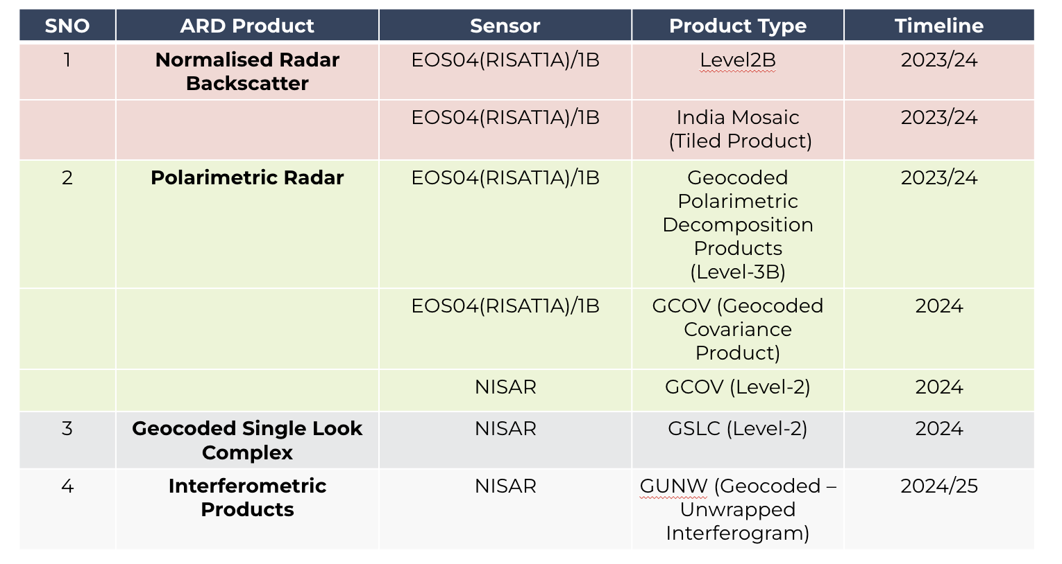
- ISRO is processing NovaSAR S-band data to Level-1 and Level-2 products. They plan to submit a self-assessment for NovaSAR in the near future.
Discussion
- Medhavy Thankappan (GA) asked about the coverage for NovaSAR products. Manju Sharma (ISRO), POC for NovaSAR, noted that ISRO’s coverage is limited to India, while Australia is covered by CSIRO, and other areas are covered by other partners. The ARD product for NovaSAR will only cover India.
- Different ground stations have different processing methods, hence ISRO and CSIRO NovaSAR ARD products are different. CSIRO’s product has recently been assessed to be CEOS-ARD compliant.
- Ake Rosenqvist (JAXA) noted it is great to see this focus to produce such a good range of CEOS-ARD products.
- Ivan Petiteville (ESA) asked about the shared agreements between the NovaSAR partners. The share is done by a certain number of minutes per orbit for each respective organisation, over their footprint. Each agency has their own policies. Airbus operates the satellite out of the UK.
- NISAR ARD products are also in development, ahead of the launch next year.
- Hari Priya (ISRO) will also present this update to the CEOS WGCV SAR meeting next week.
Resourcesat-2/2a Surface reflectance validation over RADCALNET sites [Slides]
Radhika (ISRO) reported:
- Radhika summarised the presentation from LSI-VC-13, on the status of the Resourcesat-2/2a surface reflectance CEOS-ARD products.
- ISRO is using RADCALNET sites for absolute validation. All bands have been compared except SWIR, with good results. See slides for all details.
- Also undertaking relative validation with respect to Landsat 8 and 9 OLI over RADCALNET sites and other CEOS sites.
- Surface reflectance product accuracy is around 95%, with ground measurements and Landsat-8 OLI sensor.
- The ARD products are ready for endorsement and will be submitted for peer review soon.
Discussion
- Medhavy Thankappan (GA) noted that the comparison mentions the LISS-III and L8/9 comparisons were near synchronous and asked how far apart they were temporally.
- It was noted that for Resourcesat-2, the comparisons occurred with a maximum of 8 days between acquisitions for the same location. For Resourcesat 2A, the same location was acquired 12 days apart.
- The self-assessment status was presented at LSI-VC-13. The only pending action is attaching a quality assessment layer. The model is well trained for certain regions but needs tuning elsewhere to meet the requirements of the PFS. Submission will take place once these final conditions are met.
KARI [Slides]
Chiho Kang (KARI) reported:
- KARI first attended LSI-VC four years ago. The ARD work is slowly progressing at KARI.
- KARI has four operational satellites, and there are four satellites under development.
- KOMPSAT-3 and -3A are twin satellites.
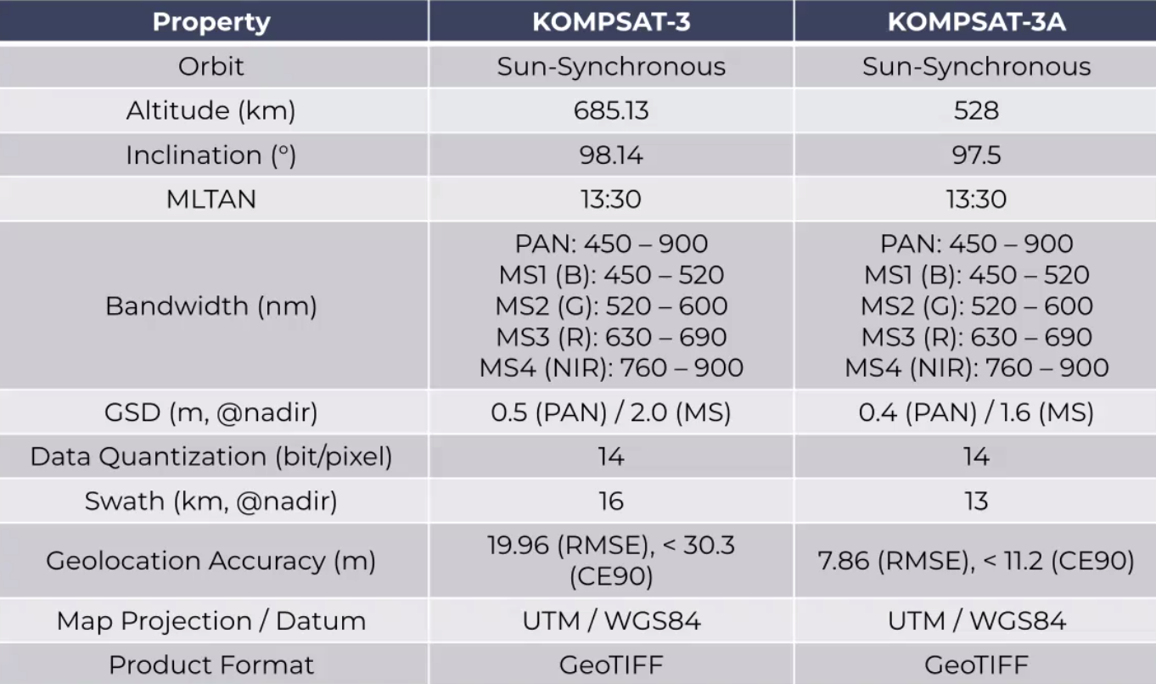
- KOMPSAT-3 and -3A are processed into three levels: 1R - radiometrically corrected, 1O - ortho-ready, and 1G - corrected for geometric distortions and projected to UTM.
- KARI had challenges in accessing physical properties using every pixel using high resolution products even with coarse accuracy to achieve the sub-pixel accuracy required by the PFS. KARI has instead focused on checking if the ARD product based on high resolution EO imagery, especially using KOMPSAT-3/3A imagery, can meet the threshold requirement for the CARD4L-SR.
- An assessment of atmospheric correction indicated that the reflectance closely aligns with the reference value of RADCalNet.
- Regarding the assessment of registration accuracy, it was found that 8-Down-scaled datasets meet the threshold of “4.1 Geometric Correction” in CEOS-ARD SR requirements (~16m spatial resolution). KARI suspects that if they had a better DEM they could meet the requirements at a higher resolution, but this requires testing. Also, global high resolution DEMs are not readily available.
- Cloud detection for “Per-Pixel Metadata” generation, the detection accuracy was for clouds, ~80%, and cloud shadow ~70%.
- KARI is also working to develop ARD products for KOMPSAT-5, which meets the NRB PFS requirements.
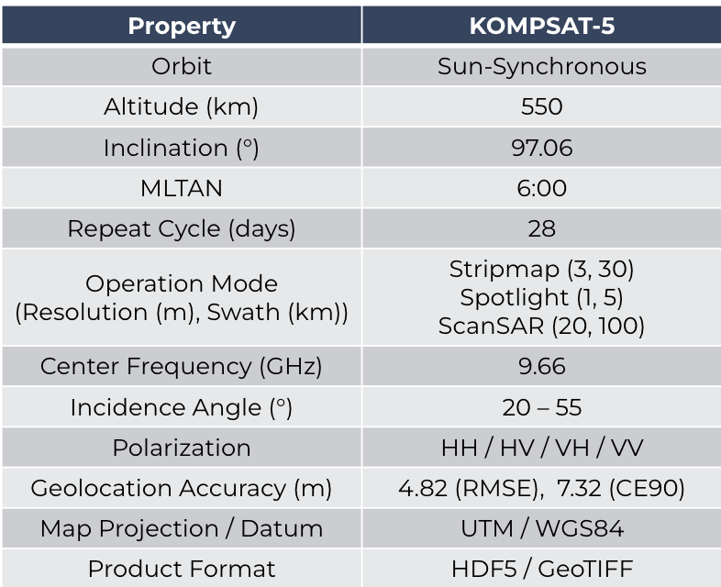
- KOMPSAT-5 products are processed into three levels: 1A - single look complex, 1C - geocoded ellipsoid corrected and 1D - Geocoded Terrain Corrected.
- KARI has focused on implementing and applying the RTC function to SAR imagery, especially using KOMPSAT-5 imagery, to meet the threshold requirement for NRB ARD products.
- Their radiometric terrain correct test referenced David Small’s paper regarding SAR backscatter normalisation conventions.
- KARI’s preliminary system design for the ARD processing system is below. See slides for more details.
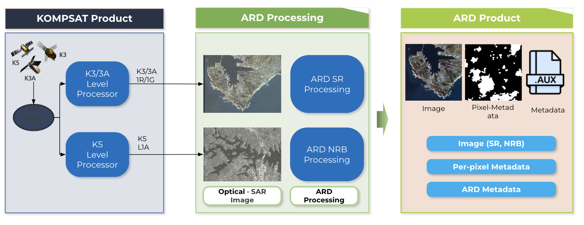
- KARI has termed it ‘K-ARD’, which will be compliant with the CEOS-ARD specifications.
- The software preliminary design will be completed by the end of 2023, and the detailed design will be completed by the end of 2024.
Discussion
- Medhavy Thankappan (GA) noted this issue will continue to come up, as resolutions improve and we look to engage the commercial sector more in CEOS-ARD. We specify a 10-100 m target product in the PFS. PFS works for the downsampled product, but is it appropriate to suggest this is the approach to use in these cases?
- Steve Covington (USGS) noted that this is a problem and a solution needs to be found. In the near term, if KARI or anyone else wants a product that is compliant, they need to downsample, which is not desirable. This is not a long term solution, because we want high resolution compatibility and compatibility for time series.
- Ake Rosenqvist (JAXA) noted that the discussion on high resolution issues has taken place several times. On the SAR side, it was decided to not have a per pixel requirement. Geometric accuracy requirement is for the data provider to be specific. It is up to the user to decide whether the accuracy is good enough for their application.
  - There are several reasons: for example NovaSAR didn't have the absolute accuracy to meet the requirement. There was a long discussion on scientific rigour versus inclusivity. It was thought that inclusivity was more important. All information is provided in the metadata and then it is left to the user to decide applicability for application.
  - Steve Covington (USGS) suggested this defeats the fundamental purpose of being CEOS-ARD.
- Peter Strobl (LSI-VC Co-Lead) noted that there needs to be a distinction between the quality of metadata and data. ARD primarily was about the quality of metadata. There are some elements like absolute accuracy. Need to more clearly distinguish between relative and absolute.
- Global references are not reliable for sub 10 m datasets. Have to be careful with absolute quality, especially for <10m data as there are no good global references.
- Downsampling isn’t great from a user perspective.
- Time series and interoperability are the core drivers of CEOS-ARD. If a product needs to be downsampled to meet this requirement then it may be the correct approach.
- There are many other hurdles to stacking data, such as projection. Slippery slope to be defining CEOS-ARD purely around this strict temporal stacking requirement. Ake expressed his reluctance regarding the idea of needing a product to be downsampled.
- Ake Rosenqvist (JAXA) suggested that KARI transition their in progress KOMPSAT-5 self-assessment to the new combined SAR PFS.
LSI-VC-14-07 | Matt to ensure the ISRO, ESA and KARI CEOS-ARD roadmaps are accurately captured on the ceos.org/ard tables (RISAT-1A products, NovaSAR, NISAR, Resourcesat-2/2A, KOMPSAT-3, KOMPSAT-5). | December 2023
LSI-VC-14-08 | LSI-VC Leads to summarise options for addressing the issue related to high resolution datasets and the 0.5 pixel rRMSE sub-pixel accuracy requirement of the SR PFS, for debate and decision at LSI-VC-15.  Discussions should consider the:  - Impact of this requirement on the applicability of CEOS-ARD to ‘New Space’ and industry generally;  - Core motivations for CEOS-ARD (stackable, time series analyses)  - Stopgap downsampling approach used by KARI and whether this is something that would be officially recommended to other VHR satellite operators  - Scientific rigour vs. inclusivity discussions and approach used by the SAR CEOS-ARD team (i.e., requiring documentation and leaving it up to users to decide dataset applicability for their applications). | Decision on way forward at LSI-VC-15
Status Report on the Black Marble Nightlight Occlusion Analysis and Thoughts on Additional ARD Testing [Slides]
Brian Killough (SEO) reported:
- Night light dataset underwent the PFS process and found a potential occlusion issue that the Black Marble team hadn’t previously considered how to address.
- The objective was to identify in the Area of Interest (AOI) pixels (full or partial) where light sources are blocked or obscured by topographic features such as hills, mountains, or buildings, etc.
- An area in Colorado was examined.
- Black Marble team does not look at the occlusion mask, and they probably should as there is missing data.
- The analysis used NASA's "Black Marble" Night Lights data with Copernicus Digital Elevation Model (DEM) data and orbital position data. Both datasets need to be in the same spatial resolution, coordinate system, and extent which involves resampling, reprojecting, or clipping the datasets.
- The issue has not been flagged in the current dataset. Although the team was aware of the issue in some parts of the world, the extent of the issue had not been thoroughly examined.
- Suomi NPP satellite, takes data only at night and uses Nadir looking perspective. The occlusion issue occurs in the fringes of the data. Suomi NPP has a very wide swath and it does not see the occlusion for the entire orbit cycle.
- There is an existing program which can predict potential occlusion events, involving target point selection, altitude analysis, and temporal patterns. This information was used to define a density heatmap, indicating concentrations of potential occlusion events during descending passes.
- The analysis was completed recently, and it suggested that potential occlusion events could be calculated at any location globally using terrain (DEM) data and orbit position data.
- Future studies should scale these pixel-level findings to an entire region and then compare potential occlusion results with actual Black Marble night light data.
- It would be good to coordinate these findings with the Black Marble team as they may desire to include these potential terrain occlusion locations in their ARD product as a metadata parameter.

Discussion
- Steve Covington (USGS) noted cloud filtering is already necessary so why not request the brightest pixel for each location? He mentioned that the Black Marble team's product is designed to fill the data on a daily basis.
- Siri Jodha (IEEE) shared via chat: https://www.earthdata.nasa.gov/learn/backgrounders/nighttime-lights. There are several night time lights products available.
- Brian Killough (SEO) noted that the SEO team is doing a pilot analysis to understand the impact of occlusion. This will be reported to the Black Marble team to consider a broader analysis.
- CEOS-ARD pushed SEO to consider the idea of adding an occlusion mask. The question now is how much further does the SEO take it. Currently thinking this effort will end with a conversation with the Black Marble team and a strong recommendation that they consider including an occlusion mask in future collections.
- A one time global mask could be done. A pixel-based global mask that identifies the missing data and/or where it was gap filled from?
- It is a fixed orbit, with a 3000 km swath width. At the equator, not getting much overlap between scenes.
- The occlusion mask discussion is also very important in the context of New Space missions, since they are often pointing platforms.
LSI-VC-14-09 | Brian to close the loop with the NASA Black Marble team, sharing the results of the SEO’s nighttime lights occlusion study and recommend to them that an occlusion mask layer be included in their standard products. Also discuss with the team whether this needs to be included as a Threshold or Target requirement in the Nighttime Lights PFS. This occlusion mask might also be needed in other PFS, in relation to satellites that are pointing – particularly relevant in the ‘New Space’ context. | COMPLETE  Report of meeting with NASA Black Marble team here
UK EO Data Hub [Slides]
Sarah Cheesbrough (UK Catapult) reported:
- Kick off of UK EO Data Hub took place in May this year.
- The Data Hub will serve as a single point EO data infrastructure, bringing together the breadth of UK EO assets and data offerings.
- Address key challenges in EO data access and discovery, interoperability, transparency, and trustworthiness​. Build on existing infrastructure.
- The UK is back in Copernicus as of 2023.
- Have organised some user pilots, engagement interviews and consultations with commercial data streams. The user stakeholder forum is ongoing.
- Steve Covington (USGS) noted that ESA and USGS can come up together with processes for assessing user needs. It would be something of interest to USGS to learn what process and methodology was used for assessing user needs.
LSI-VC-14-10 | Sarah Cheesbrough (UK Satellite Applications Catapult) to share with USGS and the LSI-VC team: details of the methodology used to assess user needs in the context of the UK EO Data Hub. | ASAP
- Data Hub ITT has been issued, with responses under review. Applications and data stream ITTs are expected to follow soon.
- Commercial data providers, did they accept the fact there will be a catalogue, a unique entry point.
- Ivan Petiteville (ESA) noted that in ESA’s development of the ground segment, they approached data providers, asked if they would like to see their products in a unique entry point. They were only interested when being paid, critical commercial information - see what their users are looking for. Dimension of commercial secrecy. Companies don't want to share due to having commercial value.
- Sarah Cheesbrough (UK Catapult) this has not been resolved. There is a 100 page report on licensing and these issues. Request for information sent to the data providers. None of them raised this issue, but came out of issues raised during consultations.
- Data streams, when hub ITT is going, start with the existing CEDA archive and start adding to that.
- Noted S-1 and S-2 ARD produced by DEFRA, initially wanted to go through the CEOS-ARD process but this didn't go ahead. Not sure why. Would be a good opportunity to re-open this discussion. Sarah spoke with the CEDA team about doing the CEOS-ARD self-assessment.
- Other information coming in from the Earth Observation Climate Information Service. UKSA has also recently signed an agreement with GHGSat, and hopes to host this on the EO data hub. 2000 scenes which have already been selected. Opportunity for tasking as well.
- Hoping to host GHGSat. Keen to hear anyone’s experience with that data.
- RFIs for VHR data are to be decided.
- Would also like to include NovaSAR to the hub but it ran into some data quality issues.
Discussion
- GHGSat is supplying emission TIFFs, but access is a bit difficult and manual intervention is needed. Discussion around a possible methane detection ARD version of their product. Would be a value add, but need some formal arguments / justification to push any development.
- Perhaps we can suggest combining GHGSat data with CEOS Agency data. Creating a pilot project.
- Sentinel-5P is a coarse methane detector, which is used by GHGSat. Complementarity between the public and private datasets is key. The goal of ARD would be to make it easier to pull these datasets together.
- ARD would help data providers make sure their products are internally consistent.
- Initial UK EO Data Hub datasets include the CEDA archive, for which a STAC catalogue is under development. There is the intention to link into other catalogues where possible.
- The Defra/JNCC ARD Sentinel products are ‘UK-ARD’ - different to the level 1C that Copernicus uses.
CSA [Slides]
Yves Crevier intended to join but had a change of plans at the last minute. He has provided his slides, which are available for the team to review.
LSI-VC-14-11 | LSI-VC Leads to reflect on the slides provided by Yves Crevier (CSA) and organise a follow up call to discuss next steps on actions. | Q4 2023
Session 3: Closing
Day 1 Wrap-up
- Andreia Siqueira (GA, LSI-VC Co-Lead) thanked all presenters and closed the first day of LSI-VC-14.

Wednesday, October 11
Session 4: Welcome
Welcome
Matt Steventon (LSI-VC Sec) welcomed participants to the second day of LSI-VC-14.
Session 2 (Cont.): Agency LSI Updates and CEOS-ARD Assessments
CSIRO [Slides]
Zheng-Shu Zhou (CSIRO) reported:
- CSIRO’s NovaSAR-1 CEOS-ARD Normalised Radar Backscatter product was recently certified as compliant with v5.5 of the NRB PFS. Zheng-Shu shared details on the structure of the data and the processing steps.
- The data is provided in Cloud Optimised GeoTIF (COG) format.
- Zheng-Shu provided details of the data product, which can be found in the slides.
- 14 products were assessed to be compliant with CEOS-ARD NRB v5.5:
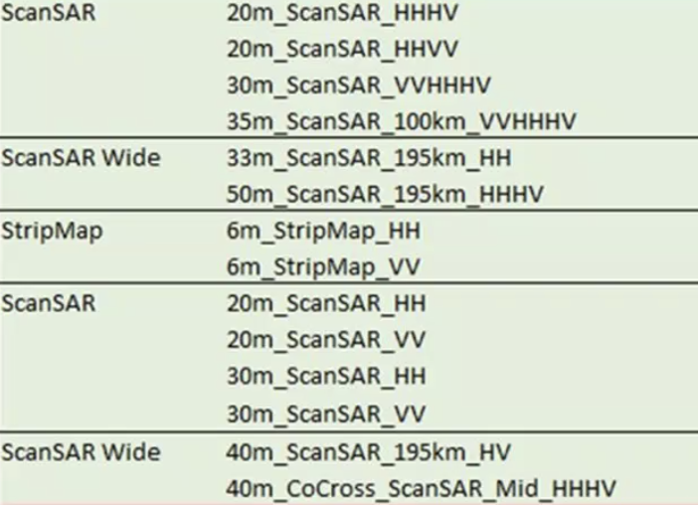
- NovaSAR-1 ARD has been applied to map burn areas on Fraser Island, Queensland, over October - December 2020. It has also been used for flood maps and ship detection.
Discussion
- Matt Steventon (LSI-VC Sec) congratulated the CSIRO team and asked if the NovaSAR-1 ARD has increased the user base for its data, both inside CSIRO and outside.
- Zheng Shu (CSIRO) shared insights regarding the state of data accessibility before ARD. He noted that before ARD, it was challenging for anyone to utilise the data effectively. However, with the implementation of ARD, it has become easier. ANU and Monash University are now using the data for PhD programmes. It is also being used for applications related to flooding. The Victorian government is also using the data. There is significant interest from other potential users who are keen to utilise the data for bushfire mapping, especially with the upcoming bushfire season.
- All agencies were encouraged to share these types of user stories to show the benefits and impact of the CEOS-ARD process. Making these benefits clear would be very advantageous. CSIRO will share their experiences on NovaSAR ARD with ISRO and other partners.
LSI-VC-14-12 | CEOS-ARD Comms team to follow up with Zheng-Shu Zhou (CSIRO) regarding the impact and increased user base that their NovaSAR CEOS-ARD has facilitated, as input to a future CEOS-ARD Newsletter article. | Q1 2024
LSI-VC-14-13 | Hari Priya and Zheng-Shu Zhou to connect regarding the NovaSAR CEOS-ARD, seeing if the work done by CSIRO might be transferable to the planned ISRO CEOS-ARD product, for efficiency (give the ISRO team a head start) and to potentially maximise interoperability of resulting products. | December 2023
- Ake Rosenqvist (JAXA) congratulated the team and asked if everything is being processed on demand, or is being processed in bulk and stored to download. Zheng-Shu noted all acquisitions from across Australia in the archive have been processed to CEOS-ARD. The data is free and available to all users, even outside Australia. CSIRO acquisitions are mostly over Australia.
- HariPriya (ISRO) noted that ISRO is downloading data for one particular region of interest. If we could share the L1 data, then we could compare the results of the processing. Process flow would be documented, and interoperability between these datasets would be better.
- Zheng-Shu (CSIRO) noted the potential benefits of collaborative efforts among all NovaSAR partners to exchange data and methods. From a CSIRO perspective, there is no problem with sharing workflows.
- Peter Strobl (EC-JRC, LSI-VC Co-Lead) noted from the framing of the intercomparison exercises, e.g. atmospheric corrections, this would be a good occasion to do this for SAR. The focus should be on arriving at a common understanding of what interoperability means and how to achieve compatible data across the partners.
- Sarah Chessbrough (UK Catapult) noted that UKSA and CSIRO have collaborated in the past on ARD. Airbus manages UK data. Sarah will get in contact to discuss this.
LSI-VC-14-14 | Zheng-Shu, Sarah Cheesbrough, Hari Priya to connect with other NovaSAR partners to explore opportunities for sharing of CEOS-ARD processes, data intercomparison exercises, interoperability studies and definition, etc.  Context: It would be beneficial if all NovaSAR partners were developing CEOS-ARD datastreams that are consistent and interoperable to the maximum extent possible. This international collaboration is a unique opportunity to explore questions around interoperability, differing processes, etc. | December 2023

Session 5: CEOS-ARD Framework – Peer Reviews and New Specifications
CEOS-ARD Peer Reviews [Slides]
Medhavy Thankappan (GA) reported:
- Acknowledged Peter Harrison (GA) for his work on the peer-evaluation work, and Matt Steventon for his work in the initial screening of the documents.
- Some feedback has been received recently about the assessment process. Guide about the process is now available online.
- The original process was modelled on the WGCV assessment of RADCALNET sites. Initially, the process was the same for threshold and target level submissions. Some changes were made to streamline the process for threshold level submissions, shown below in red. The red boxes are now only completed for target level evaluations.
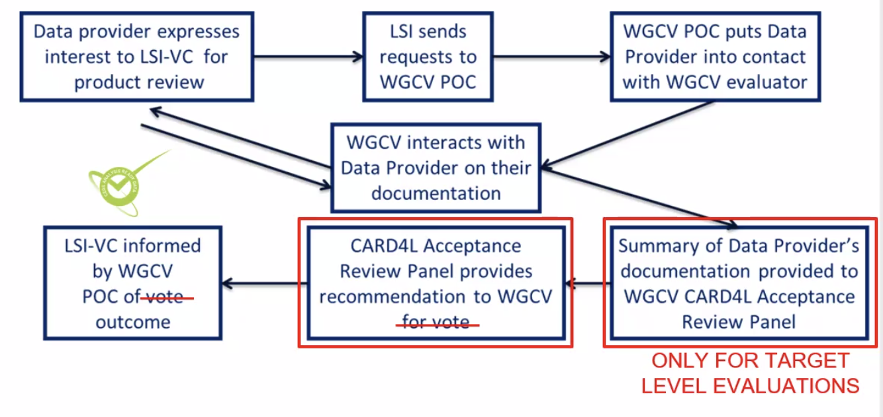
- Target evaluations are much more complex, and hence the panel is required.
- Since this change, the turnaround time has improved, with 4-6 weeks as the target time following the receipt of all materials.
- At the last WGCV meeting, Clement Albinet (ESA) was nominated as the alternate point of contact, to eliminate any issues with travel or leave.
- The process is the same for both CEOS Agencies and commercial entities.
- The process is to ensure the evidence for each requirement is there. If the WGCV evaluator finds any issues, they may go back to the data provider with some feedback.
- Any issues may go back into the review of the PFS when the data providers are having any issues with particular items.
- The currently in progress submissions come from AIR-CAS, on their Landsat-8 SR and ST products. Feedback was provided and followed up, but haven’t received a response from them.
- The next two self-assessments expected are from RISAT-1A NRB and EnMAP Aquatic Reflectance.
- The email for contacting the assessment team is ard-contact@lists.ceos.org. This is where self-assessments can be submitted, as well as feedback on the PFS.
LSI-VC-14-15 | LSI-VC Secretariat to update the contact email address on the PFS documents to ard-contact@lists.ceos.org. | IN PROGRESS
Discussion
- Discussion around the aspirational / development driver nature of the Target/Goal requirements. And whether data providers will work towards these given that an assessment will not rise above Threshold unless all Target/Goal requirements are met.
- The more the target requirements are met, the better and more acceptable the product will be.
- Peter Strobl (EC-JRC, LSI-VC Co-Lead) noted the ongoing standardisation process with OGC ARD SWG. Hope that the assessment process will become part of the ISO certification. Preference is to converge on a single level of standard if there is no sense of ‘levels’ of compliance in the emerging standard. Considering that we might eventually aim to converge on a single set of requirements in the frame of a future OGC/ISO standard (which would not typically have a Threshold and Goal level, for example) it would be helpful for us to understand where we stand on a combined set of requirements from across the existing Threshold and Goal spectrum.
- Siri Jodha Khalsa responded in chat: “there's nothing preventing there being two levels of compliance in an ISO standard, to my understanding. I know this is the case with IEEE at least. For example, the Resilient Positioning, Navigation, and Timing (PNT) User Equipment (UE) IEEE P1952 Standard defines various levels of resilience.”
- Landsat Next will take into account the target level specifications, with the goal of meeting as many as possible. The goal is to have Collection 3 compliant with the target level. This is an example of the aspirational / development driver impact in action.
- The biggest hurdle with the Target level requirements is around uncertainty measures.
- Clement Albinet (ESA) noted a similar debate in the SAR Subgroup about the geolocation accuracy Target - i.e., the team is not sure if any missions will ever meet the Target. Perhaps possible with Sentinel-1, but this would likely be at a high cost.
- There was a discussion about where to place the line between Threshold and Goal - should Goal be optimistic and never realistically achievable or should it be more achievable, e.g., for a certain % of providers?
- Good in CEOS to have a proposal, common agreement, on what should be a minimum common denominator regarding CEOS-ARD uncertainty. There should be an agreed CEOS input on uncertainty as input to the ARD SWG.
Combined SAR PFS [Slides]
Ake Rosenqvist (JAXA) reported:
- The CEOS-ARD SAR group has great contributions from many different agencies.
- Have developed the combined “CEOS-ARD for SAR” (CARD4SAR), which includes the GSLC PFS.
- The lidar terrain and canopy height product is progressing slowly in the group. The prime focus has been spaceborne lidar, but hopes to also apply it for airborne systems. GEDI, MOLI and ICESAT-2 teams as well as data providers have been working. A first draft is expected around the first quarter of 2024. Has been hard to get engagement and availability from the mission teams to develop the specifications.
- Some inputs on airborne lidar ARD have been received from Canada.
- There are two drivers, the first is to make spaceborne lidar more accessible, and ensure interoperability with imaging sensors and the second is to overlay lidar CEOS ARD product with SAR and optical images.
- Up for endorsement today is the Geocoded SLC (GSLC). The next in line is the interferometric radar (INSAR), which will be integrated into the CARD4SAR.
- Community uptake of the CEOS-ARD specifications has been successful.
- Interferometric CEOS-ARD products are under consideration by ESA for S-1.
- There are a number of volunteers to lead the INSAR PFS development.
- The Geocoded SLC Measurement data includes a Geometric Terrain Correction (map projection) relative to a common reference orbit, Radiometric Slope Correction (RTC), and Backscatter expressed as gamma-nought.
- Measurement data is provided in complex (float64) format from which backscatter amplitude/power and phase can be derived. If co-registered GSLC images in a stack have the same geometry, this allows for interferometric applications to be feasible with some simple image maths.
- Five additional GSLC per-pixel metadata requirements are included at the target level, in addition to eight requirements common with other SAR products.
- CARD4SAR, in response to the fact there is 70% commonality of parameters. Common parameters must match. This and the large number of PFS currently cause confusion for users and data providers. Changes to one PFS often mean that changes are needed in the other PFS. It's a challenge to keep them all aligned. This has driven the decision to have a single combined PFS:
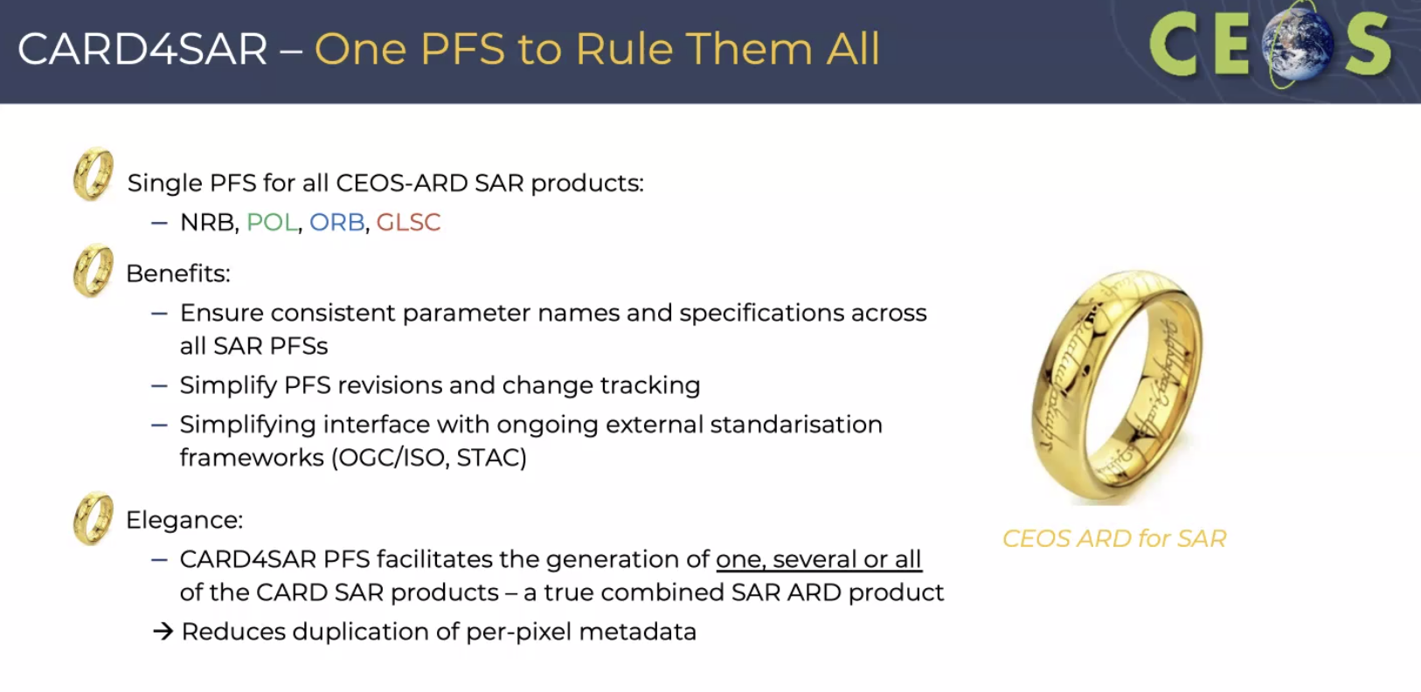
- The INSAR PFS will be built upon the CARD4SAR PFS and will be completely integrated with it.
- The NRB, POL, ORB and GSLC have many cross-links and dependencies across them and combining them allows a data provider to bundle as many of these together as desired.
- Level above this, what kind of architecture can we have, separate some things, but bring things together which are in common.
- Above this level, it prompts consideration of the overall architecture, suggesting a need for a broader CEOS-ARD architecture solution.
- Ake Rosenqvist (JAXA) reported that the new common template was used and the CARD4SAR PFS is consistent.
- A potential low hanging fruit would be an implementation of a common metadata specification for all PFSs, which would be a good next step for CEOS-ARD. This is where STAC also comes in.
- An accompanying single metadata specification, which ensures consistent mapping of parameter names between PFS and metadata has also been developed. The metadata specifications are a target requirement, not threshold.
- Could also consider whether it should be required to include GeoJson specification to support STAC.
- The PFS document history tracks the revisions to each original SAR PFS. No changes to the threshold requirements were made to endorsed PFSs (NRB v5.5, POL v3.5, ORB v1.0). Strict restrictions on this PFS could be implemented, for example, no requirement made for the geometric accuracy - must only be specified.
- If there were a change to the PFS that had an impact on existing products, they would still remain compatible with a previous version of the NRB PFS for example. But to date this is not the case.
- Documents are available at CEOS-ARD for SAR PFS (GSLC embedded) and Metadata specification.
Discussion
- Steve Labahn (USGS, LSI-VC Co-Lead) noted the shift from a geophysical parameter focus for PFS to now an instrument type (SAR).
- Discussion recently, have to decide how we package. Again an architectural question, if we have a PFS for SAR, it would be logical to have a PFS for Optical. Will also need a decision in the OGC ARD SWG context.
- Really needs a think about CEOS-ARD architecture at different levels - e.g. are we focusing on geophysical variables, or instrumentation. Needs a broader discussion about ARD architecture, levels of PFS, etc.
- SiriJodha Khalsa noted in chat: “NSIDC is the repository for ICESat-2”, and asked: “have you engaged with NUVIEW (https://nuview.space/), Capella Space, ICEYE, Synspective, Umbra Space?”.
- Combined SAR PFS was a result of both overlaps in requirements as well as a desire for consistency across the SAR PFS. There are similar consistency challenges with SR, ST and AR. Hence the suggestion for a CEOS-ARD for Optical PFS.
- Regarding the CARD4SAR abbreviation it was decided to only use CEOS-ARD and not ‘CARD’. Ferran suggested it would be better to change this to CEOS-ARD for SAR. This was agreed and Ake will update the draft PFS.
Decision 01 | The Combined CEOS-ARD for Synthetic Aperture Radar PFS was endorsed.

LSI-VC-14-16 | LSI-VC Secretariat and Ake to update ceos.org/ard to reflect the endorsement of the Combined CEOS-ARD for Synthetic Aperture Radar PFS. Labels distinguishing the different types of SAR CEOS-ARD will be retained in the CEOS-ARD products table. | COMPLETE

Session 2 (Cont.): Agency LSI Updates and CEOS-ARD Assessments
ESA [Slides]
Ferran Gascon (ESA) reported:
- Status of the various CEOS-ARD developments within ESA:
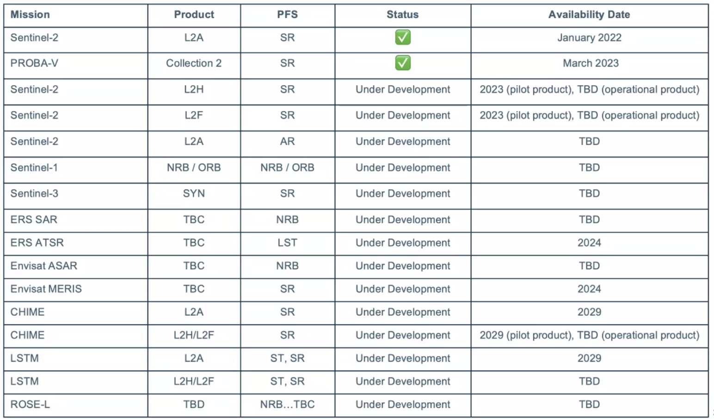
- Target more providing a separate tool to calculate the uncertainties. Will have to assess whether this is compliant with the specifications regarding uncertainties.
- ESA and the European Commission have commenced the Copernicus Data Space Ecosystem, which is gradually being upgraded with additional services and data.
- Sentinel-2 Collection 1 is under generation, with plans to complete the production by the end of 2023.
- ESA is working on a Discrete Global Grid System (DGGS) research and development activity, to identify a multi-mission DGGS framework, and developing a DGGS pilot platform for demonstration purposes.
- DGGS R&D activity won’t delay any operational activities and remains R&D for now. Peter is in discussion with the commission. Will share the findings with CEOS. There is no timeline for operational development.
- There are several DGGS available, the goal is to find one which accommodates all EO data.
- Four DGGS options were considered (below). Only consider what is practically used by the community and applicable in terms of software.
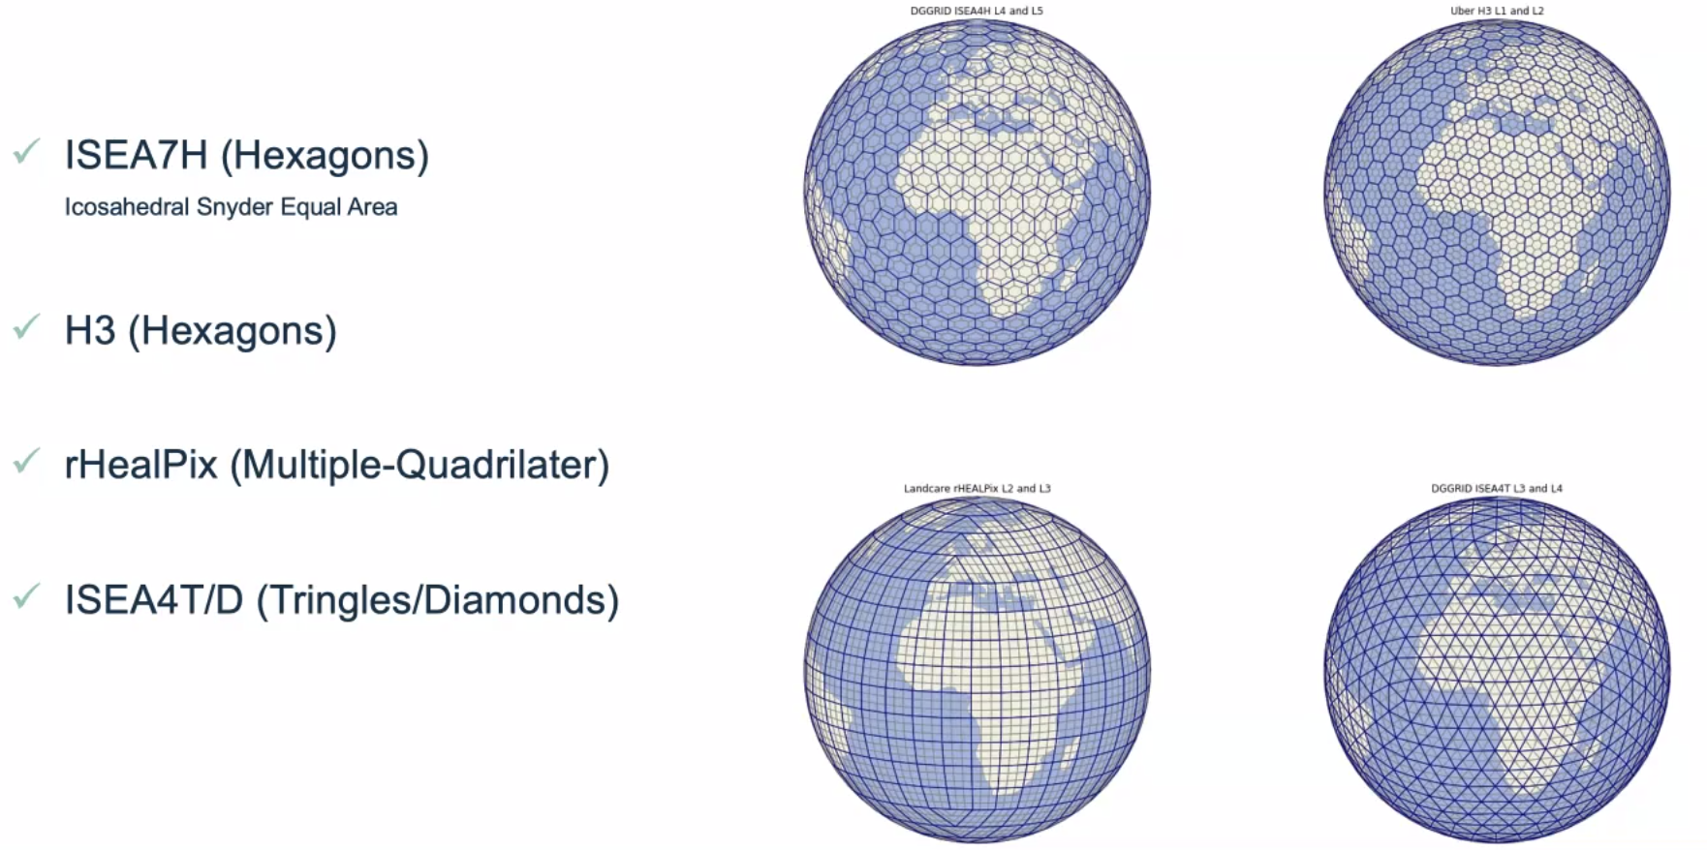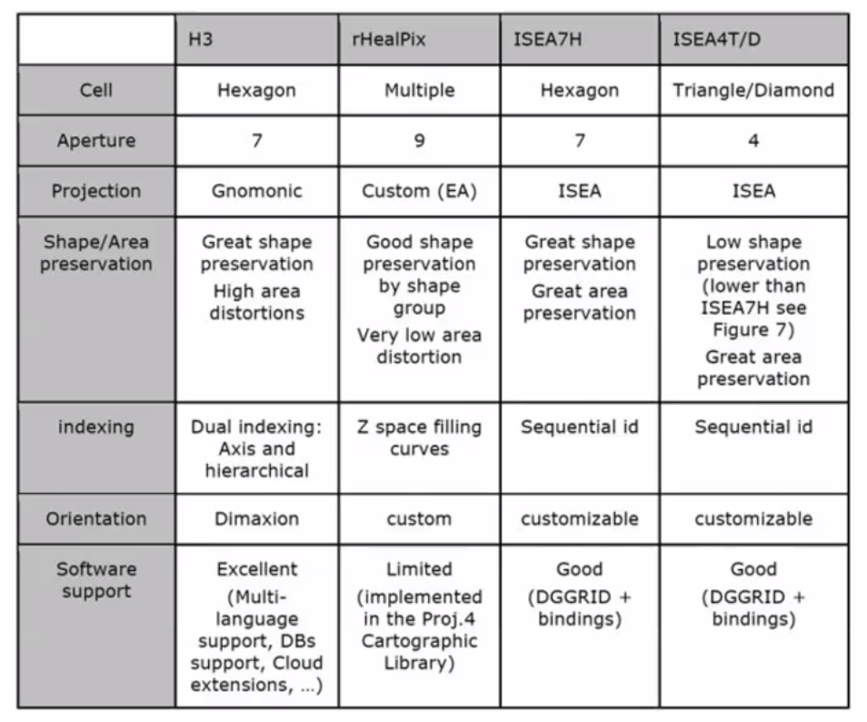
- H3 is the go-to grid for practical applications due to the good support and user experience, however it is subject to high area distortion.
- Often, users have to down-sample data to meet the alignment of projection cells.
- If ESA finds a DGGS that is most suitable, then they would be willing to invest to develop the required software.
- Coming up with criteria for the selection of a global grid. Getting this all down on paper. This is the priority.
- The challenge is the data compression aspect, as the product volume is increasing.
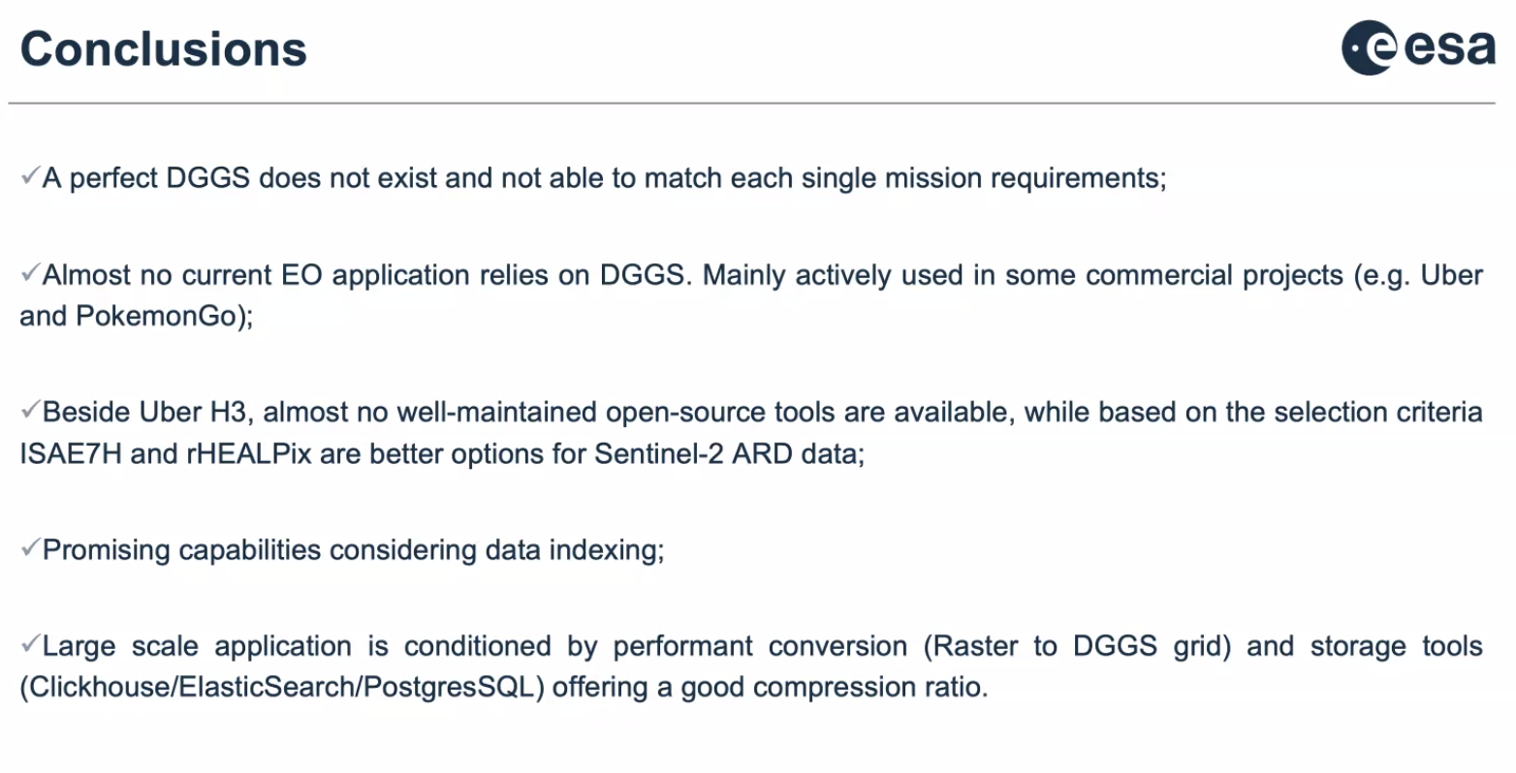
Silvia Scifoni (ESA) reported:
- Provided an update on the Sentinel-3 CEOS-ARD SR product.
- Synergy is one of the S3 products.
- Self-assessment is 76% threshold compliant, and 59% target compliant.
- Reviewed specifics of threshold assessment. Issues with the coordinate reference system and map projection (Ref: LSI-VC-13-07) – need to be revisited.
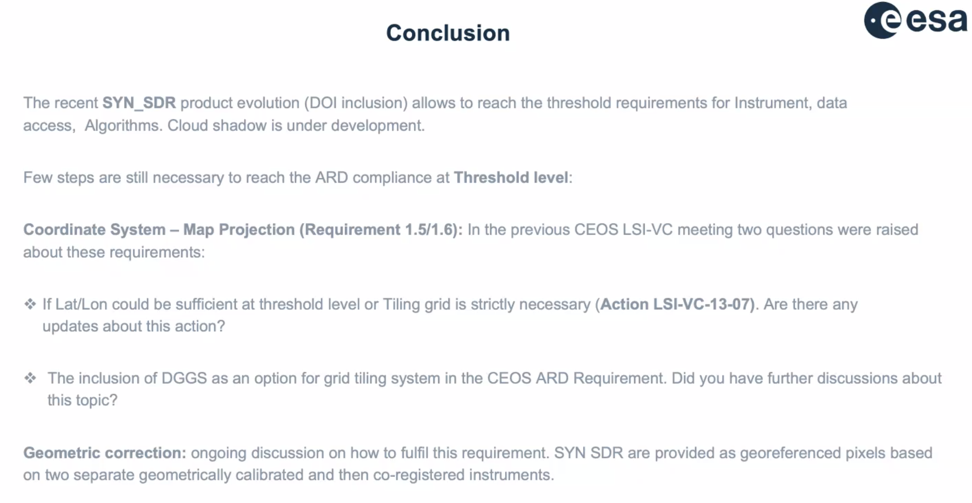
Discussion
- There has been no progress on LSI-VC-13-07: Schedule a further discussion on whether georeferenced products might be considered CEOS-ARD, or is a map projection strictly required, which needs to be addressed before the Sentinel-3 Synergy self-assessment can proceed to peer review. LSI-VC Secretariat pushed for a resolution during LSI-VC-14. A discussion and action plan will be confirmed during Session 12 (see below, Decision 02).
- Steve Covington (USGS) suggested that users should not need to be a geodesy expert to use the data. However, lat/lon, as long as it's referenced in a way that a user's software can figure out, is sufficient. Projected or unprojected, doesn't matter in practice.
- For the hyperspectral community, there are many users who don’t want the data to be resampled at all. At least for Surface Reflectance.
- Peter Strobl (EC-JRC, LSI-VC Co-Lead) has some additional thoughts on CEOS-ARD architecture, the ‘levels’ of ARD, etc. and a discussion on LSI-VC-13-07 would make sense in that context (see Session 12).
ESA Sentinel-1 ARD Implementation [Slides]
Clément Albinet (ESA) reported:
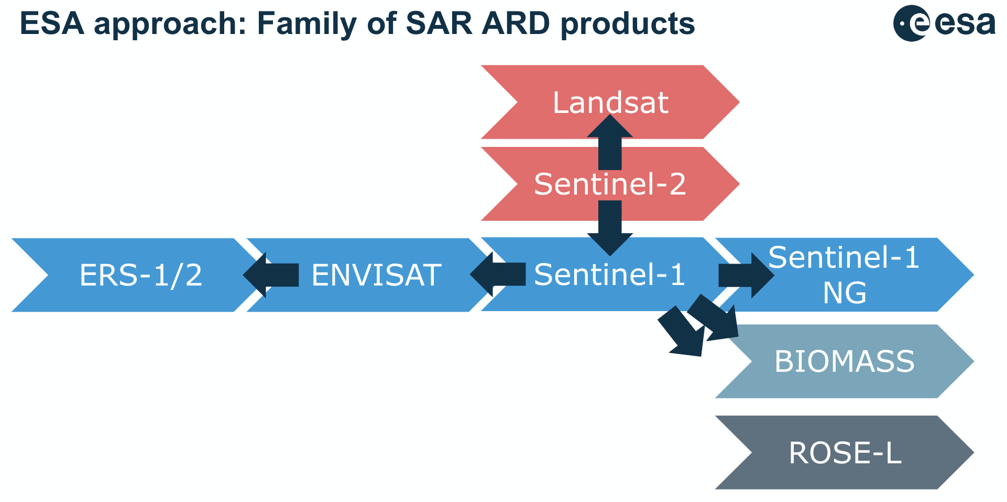
- The Sentinel-1 NRB product:
  - is calibrated with RTC, denoised, projected over Copernicus DEM, geolocated - allowing for immediate analysis;
  - uses the same griding / tiling system, and DEM as Sentinel-2 (based on MGRS);
  - is cloud-optimised GeoTIFF, VRT, XML and STAC;
  - uses an open-source processor (based on PyroSAR, GDAL, SNAP).
- Metadata provided in XML and STAC, JSON formats.
- Are also assessing Sentinel-1 against the ORB PFS.
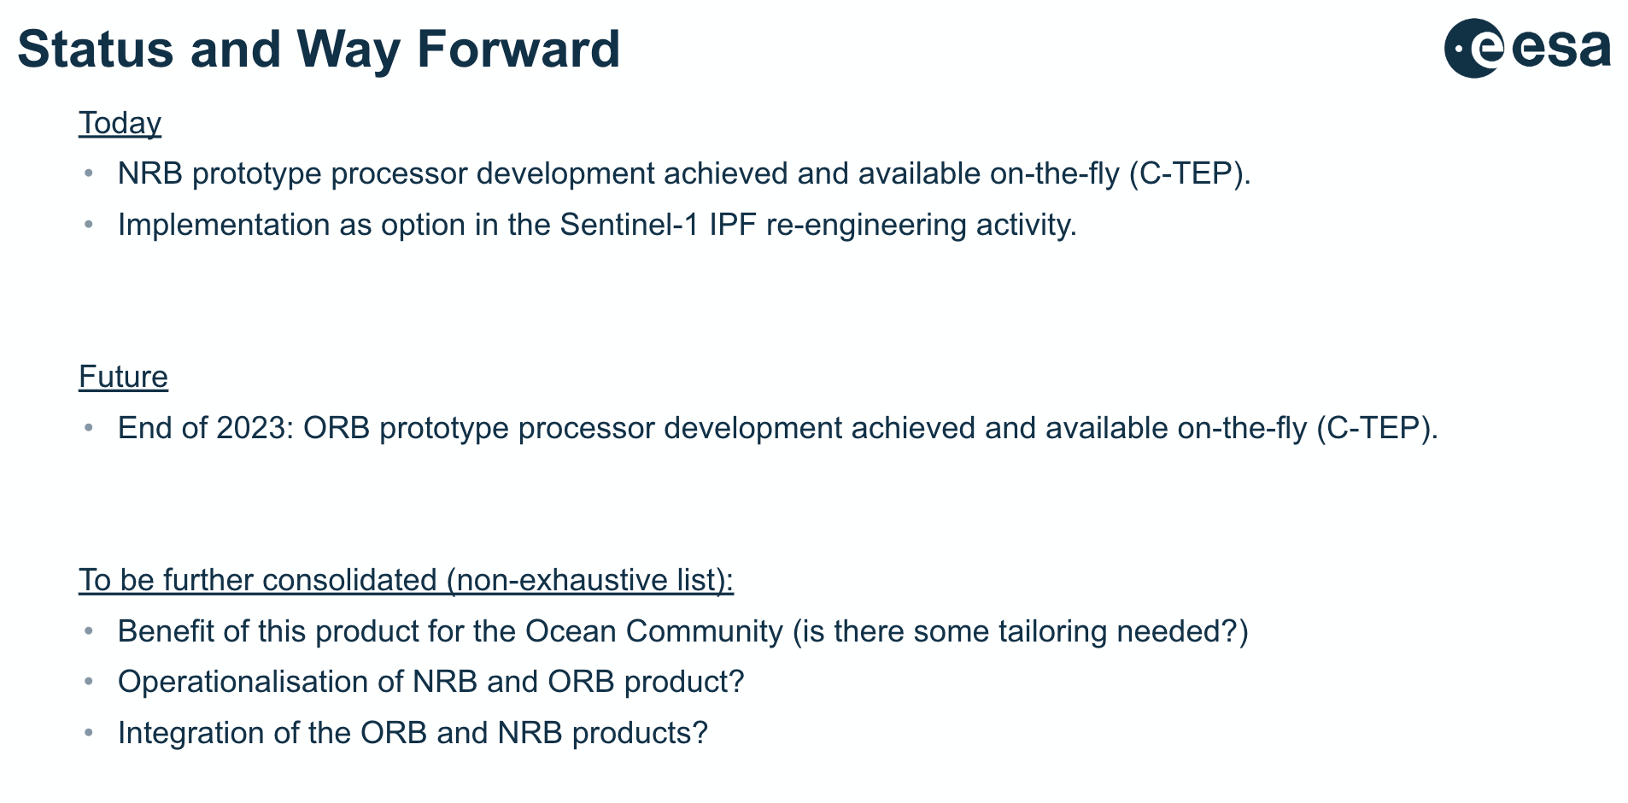
Discussion
- The NRB processor is available on Github, users can use it now with SNAP to generate their own data.
- For the prototyping, only Clement’s team needed to be involved, but for operational it will be a bit harder. It also depends on the scope of reprocessing, area choices, etc. On the order of 5 years for any operational production due to ground segment changes needed.
- For coastal areas the plan is to produce both NRB and ORB. Inland waters are produced with NRB. Technically the data should be similar, but the processing is different so there will be some differences. This will be investigated more in the long term.
JAXA [Slides]
Takeo Tadono (JAXA) reported:
- ALOS-3 was lost earlier this year due to a launch failure. JAXA is now accelerating the consideration of a follow-on mission. The ALOS-4 launch schedule is still to be announced.
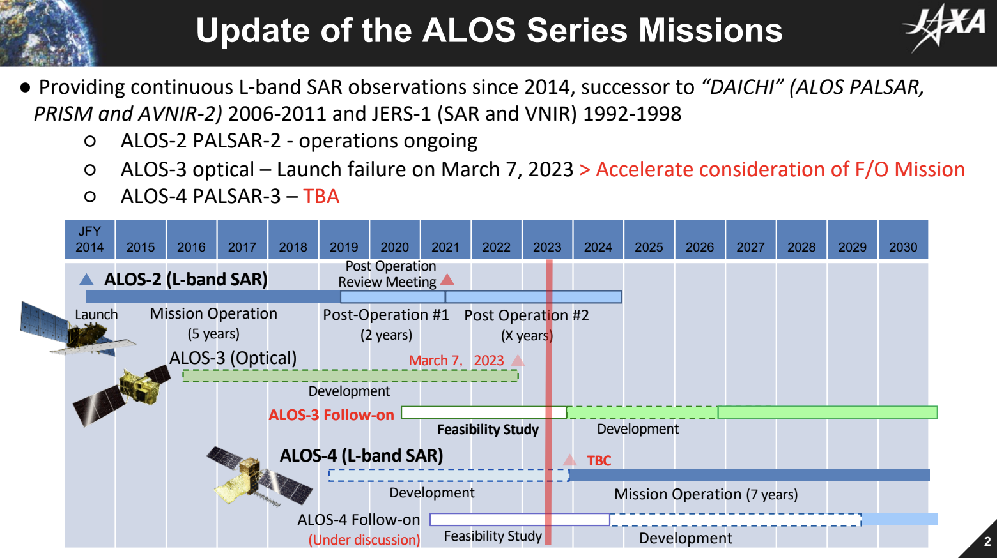
- ALOS-2 PALSAR-2 remains in good condition and with high performance. Over 100 kg of fuel remains, and the solar array paddle is declining in performance less rapidly than predicted.
- Since last November, JAXA has begun distributing open and free data for ScanSAR L1.1 and ScanSAR L2.2 which are CEOS-ARD NRB compliant.
- Global 25 m mosaics are also available for free.
- ALOS-4 specifications are as follows:
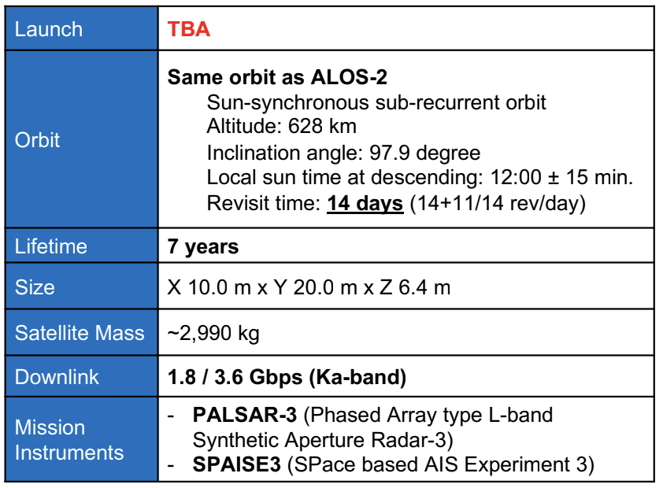
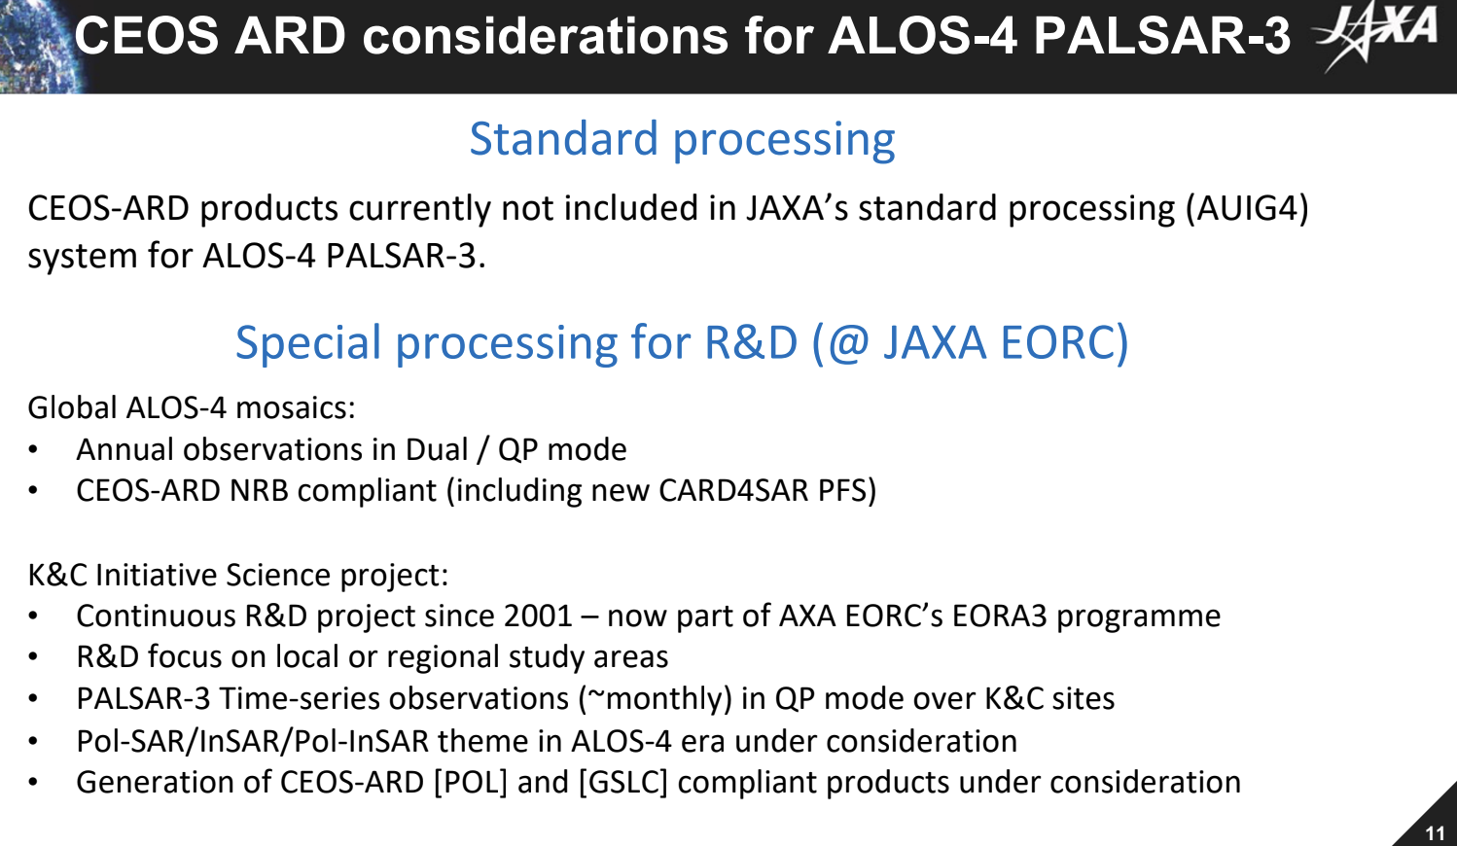
- CEOS-ARD products are currently not included in JAXA’s standard processing (AUIG4) system for ALOS-4 PALSAR-3, however, the generation of POL and GSLC compliant products are under consideration.
Discussion
- ALOS-4 Mean Local Time (MLT) is noon (which doesn’t matter for SAR). The selection of noon is related to covering different times of day compared to other missions. Noon time is chosen for complementarity with other observations like disaster monitoring. It was suggested to ensure coverage from noon to midnight, 6 am and 6 pm.
Session 6: LSI Interoperability, Validation, and Data Access Topics
CEOS Interoperability Framework Discussion Session [Slides]
Tom Sohre (USGS, WGISS Vice Chair) reported:
- This activity is in response to an action recorded at the 2022 CEOS Plenary. LSI-VC initiated the discussions.
- Interoperability is a long standing challenge of CEOS, activity in 2008 was to develop an Interoperability Handbook.
- Tom thanked LSI-VC for being an active participant in this initiative.
- The framework is made up of five factors:
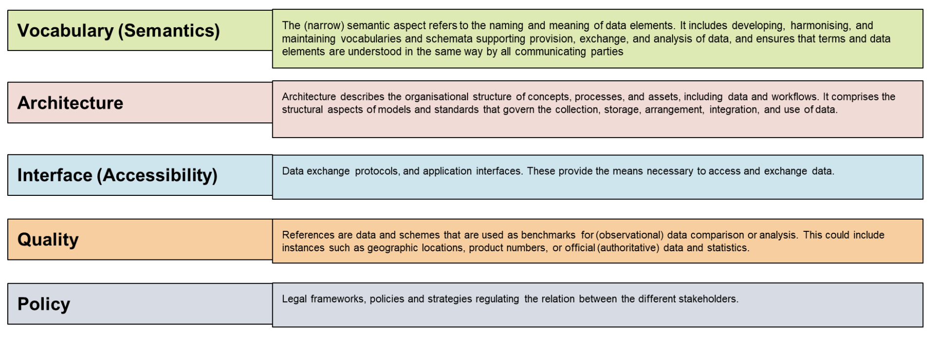
- An initial roadmap was developed, mapping CEOS activities in the current work plan (2023-25) to the five factors:
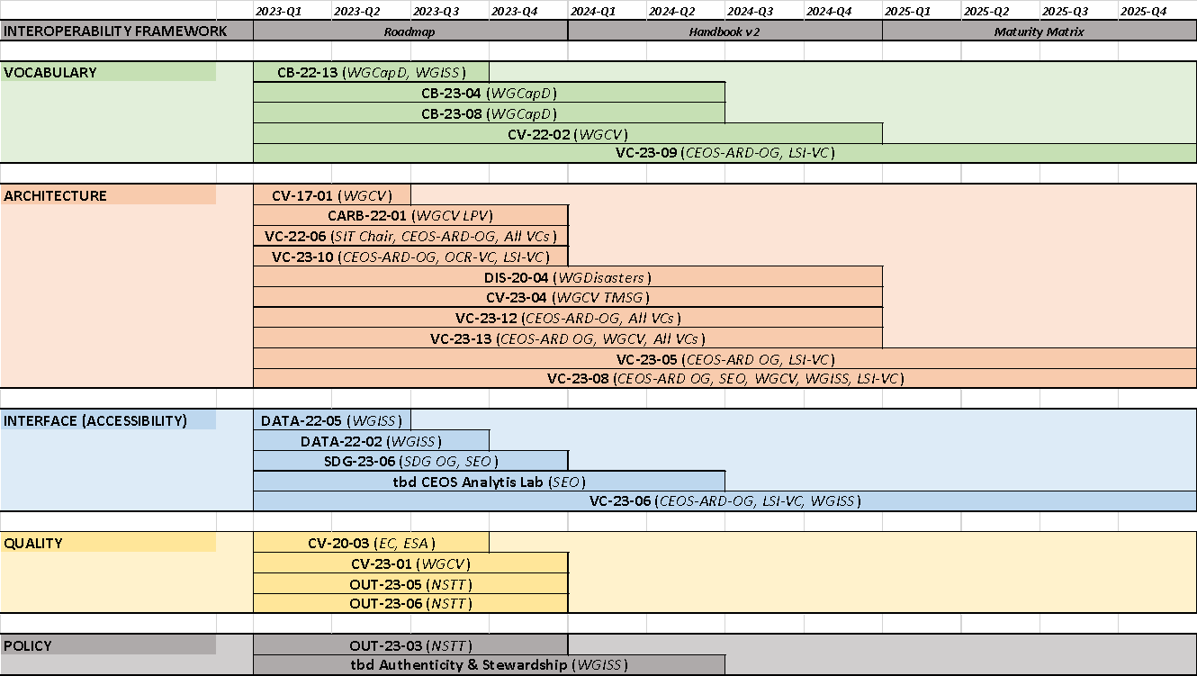
- Baseline of current activities. Noting that many of the activities could fit within other areas, but the goal is to identify the area they most support.
- There will be a matrix developed to map the activities.
- There are also a number of activities which benefit from the factors, as well as contribute to improving the overall framework maturity.
- This is an initial roadmap, where we have currently identified what is already happening across CEOS. The challenge now is to identify gaps to propose new activities to support the framework.
- WGISS would like to update the 2008 handbook next year, as a follow-on from the roadmap. The maturity matrix would be something to do following that.
- LSI-VC has provided input. Reflected the current CEOS Work Plan activities related to interoperability from LSI-VC:
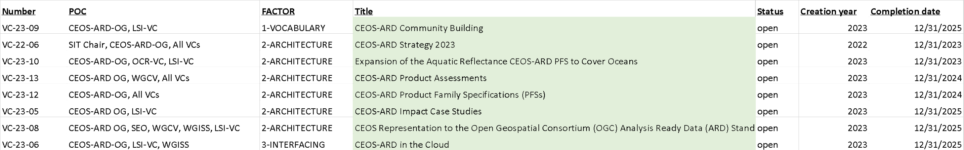
Discussion
- Steve Labahn (USGS, LSI-VC Co-Lead) thanked Tom and the WGISS team. LSI-VC Co-Leads met recently and sent the above input. Working Groups will contribute to identifying gaps and new supporting efforts.
- Bottom up approach will be followed to provide inputs to the roadmap. WGISS has oversight and visibility across CEOS. Also as a top down approach, WGISS should be providing guidance to CEOS on where they see gaps and opportunities, etc.
- WGISS Interoperability Interest Group had faded out before this year, but has since been reinstated since the Interoperability Framework came along. The intention for this group is to carry on this activity post-plenary, looking across all of CEOS. Want to continue monthly calls, etc. See it as an ongoing effort, and WGISS Interest Group serves as the lead.
- Peter Strobl (EC-JRC, LSI-VC Co-Lead) noted that the framework finds its natural home in the WGISS interoperability group, and having across CEOS scope is good. We had discussed champions and POCs to provide a focal point for any questions or contributions.
- Finding volunteers to be focal points has been challenging, and the interoperability team didn’t want that to hinder this year’s work. We do need a champion(s) for people to be able to reach out to. It will be very important as WGISS updates their interoperability handbook - volunteers would be relied on to flesh out the handbook text and identify use cases, and what we can do to improve the interoperability for that factor.
- Steve Labahn (USGS) noted that this seems foundational to the purpose of CEOS, doing things like this cooperatively across the agencies. Tools like this framework will improve the products that we deliver to users. It will be a natural evolution of CEOS-ARD.
- Demonstrators list have been popping up around CEOS. Showcase work - including CEOS-ARD, cloud interoperability. Some of these demonstrators with the SEO would really help this mature. Dave Borges (SEO) and Tom Sohre (USGS) have discussed this topic, and will present on this at the upcoming WGISS to demonstrate the capabilities. DE Africa, DE Australia, CDSE examples already exist.
- Dave Borges (SEO) noted that GEO has just reconstituted their GEOSS Infrastructure Development Task Team. Dave Borges, Mirko Albani and Alex Held are representing CEOS on that. They will be working over the next two years. Dave will work with Tom and WGISS.
- Tim Stryker (USGS) added the framework is a core piece of CEOS. There are several pieces and parts that fit together. Technologically we are now able to move forward on this topic. If WGISS is able to help serve as a clearing house. We all need to be looking at the different pieces, and seeing how they all really fit together to serve the CEOS mandate is a critical role for WGISS.
- Peter Strobl (EC-JRC) added that LSI-VC pushed for a comprehensive framework because interoperability will need to be built into everything we are doing in CEOS.
Session 7: ARD Community Engagement
CEOS-ARD Industry Engagement Strategy Update [Slides]
Andreia Siqueira (GA, LSI-VC Co-Lead) reported:
- Aiming to update this strategy, partly in response to the CEOS New Space Task Team effort, as well as our overall goal to increase engagement with commercial providers on CEOS-ARD.
- We discussed last at LSI-VC-13, during which it was agreed that we should start with a survey of CEOS Agencies and their ambitions with regard to CEOS-ARD, to help inform engagement with
- First strategy was put together as part of the CSIRO/GA SIT Chair Term in 2021 which includes a number of recommendations.
- The CEOS New Space Task Team has put together a white paper to be presented to the CEOS Plenary later this year. The paper includes 12 recommendations, including a specific recommendation for the ARD Oversight Group to update the Strategy.
- The proposed questions for the CEOS Agency survey are:
Specific Questions
    - To what extent is your agency involved or engaged with the CEOS-ARD initiative?
    - What are the primary goals or ambitions of your agency in relation to CEOS-ARD?
    - Do you see CEOS-ARD framework as a standard product in the future?
    - Is the CEOS-ARD framework serving its purpose?
    - Are you expecting the emergence of any additional PFS beyond the existing seven and the three currently in development?
    - According to you, who are the target stakeholders of CEOS-ARD?
    - To what extent do you think the CEOS ARD Datasets benefit the stakeholders?
    - What challenges do you foresee in the adoption of CEOS-ARD products?
Collaboration with Commercial Industry
    - In what ways do you believe collaboration with commercial providers could add value to CEOS ARD products?
    - Are there any specific areas or domains where you see potential collaboration with the commercial industry?
Feedback and Suggestions
    - Are there any additional comments, feedback, or suggestions you would like to share regarding the CEOS ARD framework, its products, or its future direction?
- The proposed way forward and timeline are as follows:
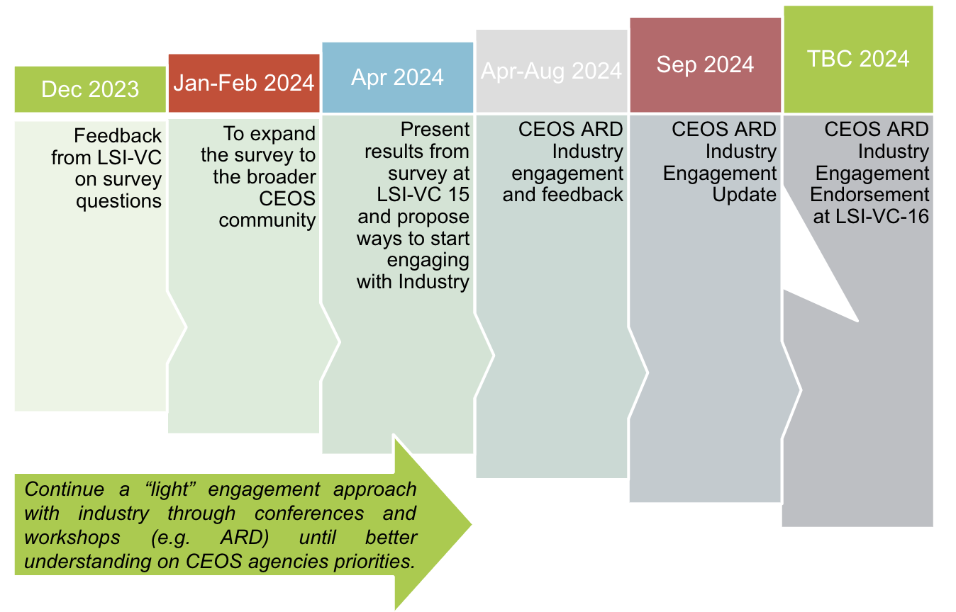
Discussion
- By late 2023/early 2024 we would be looking for responses from LSI-VC agencies. Feedback on the questions will be needed by the end of October 2023.
- This survey is to target CEOS Agencies, to understand their priorities regarding CEOS-ARD, and to guide our engagement with industry.
- Tim Stryker (USGS) asked about the ways to engage the industry in a thorough and structured manner and stressed the need to ensure an ongoing dialogue.
- Andreia Siqueira (GA, LSI-VC Co-Lead) noted we need to agree first within the CEOS on what engagement looks like.
- Dave Borges (SEO) added that it would be good to see a timeline integrated with the OGC ARD SWG activities. The set-up of the ISO/OGC group was such that anyone interested should be able to participate in the discussion. Siri Jodha (IEEE) noted that this engagement strategy should explicitly incorporate this aspect and asked how do we get this message out. It was noted that Mattias Mohr will be working explicitly on the community engagement topic in the context of the OGC ARD SWG.
LSI-VC-14-17 | Andreia to work with her LSI-VC Co-Leads to refine the questions for the survey of CEOS Agencies regarding ARD, before distribution to the rest of the team. Target a teleconference in Q1 2024 to finalise the set of questions to send out to agencies. | Q1 2024
LSI-VC-14-18 | Andreia and Dave to ensure the timeline for the update of the CEOS-ARD Industry Engagement Strategy reflects similar engagement activities that will take place in the context of the OGC ARD SWG. | ASAP

ISO/OGC Analysis Ready Data Standards Working Group
Patrick Quinn (NASA) reported:
- The ISO/OCG ARD SWG kicked off about six months ago, to make the CEOS-ARD specifications and framework a formal ISO/OGC standard.
- There have been a few challenges along the way with the organisation of the group, as it is a collaboration between ISO and OGC.
- The aim is to build on the CEOS-ARD standards and be compatible as much as possible.
Discussion
- Ferran Gascon (ESA) asked about the expected scope of the ISO/OGC standard, referring to the following slide. Will the standard explicitly cover the quality and format of metadata? Is that it’s unique value add?
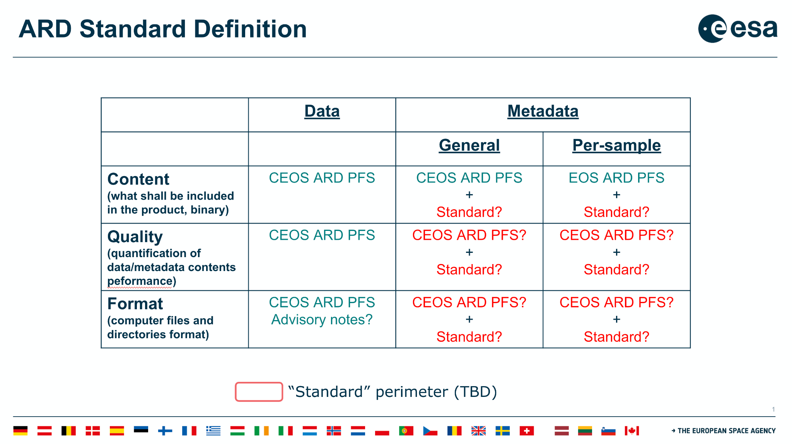
- OGC ARD SWG objective is to ensure compatibility with CEOS-ARD specs and avoid disrupting them. See the OGC standard as being a superset of the CEOS-ARD standard. It may be necessary to establish a clear definition of what "compatibility" entails in this context.
- Questions on anticipating a big overlap between the two, how much overlap can we have, whether we can make use of the PFS as they are, and whether elaborations or extensions are needed were asked.
- If ISO standard remains high level, and not orthogonal to what we are doing in CEOS that would be good.
- Some had expectations that ISO standard would be going into more details, defining metadata formats, quality conditions, etc. Patrick thinks this is still possible, since the standard is still actively being drafted. This viewpoint can be input.
- Siri Jodha (IEEE) added he talked this morning about sensor agnostic PFSs at a high level. It is a good target for ISO work. Currently, the focus is on Part 1, defining how the process will function, but the exact scope is not yet fully determined, and there are ongoing discussions regarding this.
- Ake Rosenqvist (JAXA) expressed the need for more clarification on the level of information that is needed for the standard. He does not want to make a start entering information into the draft doc without some more fundamental conceptual discussions in the OGC ARD SWG and guidance from leadership. There is a lot of content that is ready to go from the PFS, but whether it aligns with the objective needs clarification.
- Steve Labahn noted in chat: “I think it's important to keep in mind what some of the original objectives/strategies have been... one of them being to get industry involved and engaged in what we've already done with CEOS-ARD as the foundation.”
- Patrick Quinn noted in chat: “Also, yes, Steve, that I think has been one of the major hangups of the group, keeping that on the rails. It's been much more a question of how to get the engagement we need than the particulars of the spec, because it's important we have that alignment.”
- SiriJodha Khalsa noted in chat: “+1 for taking a forward-thinking approach to development of the ISO/OGC ARD spec, not just codification of existing PFSs”.
Session 8: Land Surface Observation Continuity, Gap Analyses, Applications
ECV Inventory Gap Analysis and LSI-VC Input on Land Surface Temperature CDRs & GCOS Implementation Plan (IP) Response Inputs from LSI-VC
Andreia Siqueira (GA, LSI-VC Co-Lead) provided some background [Slides]:
- There was an action taken at LSI-VC-8, with WGClimate, around LST Climate Data Records and Continuity.
- The proposed action is to identify a POC within LSI-VC for each action to help draft a response to the GCOS Implementation Plan. Three areas have been identified:
  - C5: ECV-specific satellite data processing method improvements;
  - F1: Responding to user needs for higher resolution, near real time data: Improve biomass, land cover, land surface temperature, and fire data with sub-annual observations and improved local detail and quality;
  - F2: Improved ECV satellite observations in polar regions, Surface temperatures of all surfaces (sea, ice and land).
Darren Ghent (NCEO University of Leicester) reported [Slides]:
- Climate Data Records (CDRs) are robust, sustainable, and scientifically sound climate records that provide trustworthy information on how, where, and to what extent the land, oceans, atmosphere and ice sheets are changing. These datasets are thoroughly vetted time series measurements with longevity, consistency, and continuity to assess and measure climate variability and change (NOAA, 2004).
- The ECV Inventory contains around 40 LST CDRS including both existing and planned.
- A CDR is not the same as a consistently reprocessed dataset.
- The requirements are listed as goal (G), baseline (B) and threshold (T):
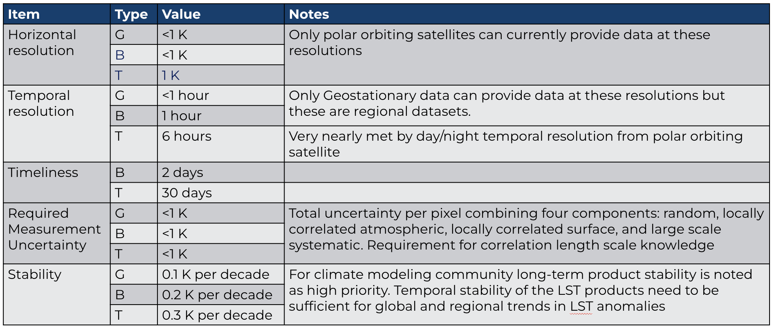
- A CDR now cannot just be a past archive of a dataset and needs to be kept up to date (within the last month).
- For a CDR, LST data records from multiple sensors need to be consistently processed and harmonised. Level-1 input data should itself constitute a Fundamental Climate Data Record (FCDR), with consistent calibration (brightness temperatures), corrections for orbital drift, stray light, etc, traceable uncertainty budget from the measurement equation, and harmonisation across missions.
- Interim CDRs to address the GCOS timeliness requirements are needed, which are NRT data underpinned by a consistent historical data record. There are currently no interim CDRs for LST.
- Currently, there is no independent assessment of the quality of these CDRs. Furthermore, most satellite level-1 data from agencies used for LST are not processed as FCDRs. LST data products are usually validated but not assessed for long-term stability.
Discussion
- FCDRs are homogenised datasets at level 1, inter calibrated against a reference sensor. From FCDRs, develop the TCDRs (Thematic CDRs). Most of that includes the level 2 LST data. But to generate the thematic CDR, we need the level 1 data appropriately harmonised over time.
- Instrument that has been in space for say 10 years, which could’ve drifted in its calibration. To get rid of any drift, the common approach is to take a reference sensor and intercalibrate it against the sensor. GSICS committee generally use IASI as a reference.
- Steve Covington (USGS) was not sure whether Landsat could meet the requirements of the CDRs. Temporal resolutions can only be met by the geostationary satellites. Within GCOS there is a recognition that a single satellite won’t meet all the requirements.
- Landsat thermal data records go back 40 years - is there anything that can be changed in the processing such that datasets are available for CDRs?
- Should look at the high resolution missions (e.g. Landsat) and assess their LST datasets to see whether they meet the GCOS requirements for data records, and if not see what steps can be taken such that they do meet the requirements in the future.
- Steve Labahn noted in chat: “I think we're still missing the mark... an action to USGS is fine, but there are perhaps other current and future observations, broader than just Landsat.”
LSI-VC-14-19 | USGS team to connect Cody Anderson with Darren Ghent regarding the calibration of the Landsat LST datasets and their applicability to the LST CDR actions communicated by WGClimate. This is just a first step – further discussion is needed and there are perhaps other current and future observations, broader than just Landsat. | Q4 2023
Surface Reflectance Quality, Equivalency and Consistency Project Working Session [Slides] [Proposal]
Simon Oliver (GA) reported:
- The concept was briefed a couple of times, including at ARD23, WGCV-52 in June and an online LSI-VC telecon.
- The idea is to produce direct-source consistent, equivalent, high quality surface reflectance from space agencies, commercial space companies and value-adders and avoid reprocessing currently required to achieve measurand (physical quantity being measured) interoperability.
- See this as the evolution or next step and build upon CEOS-ARD.
- Several organisations currently maintain pipelines for the production of surface reflectance from Landsat and Sentinel-2 data.
- Some benefits include:
  - Reduced duplication of effort, cost savings, increased global applicability of algorithms -> rather than having them tuned to particular flavours of surface reflectance, consistent time-series across sensors and providers, steps towards harmonisation/homogenisation, focuses efforts on supporting space agencies to optimise their products, focuses efforts on value-adding with a common baseline measurand.
- Goal is to improve the results from multi-sensor analyses.
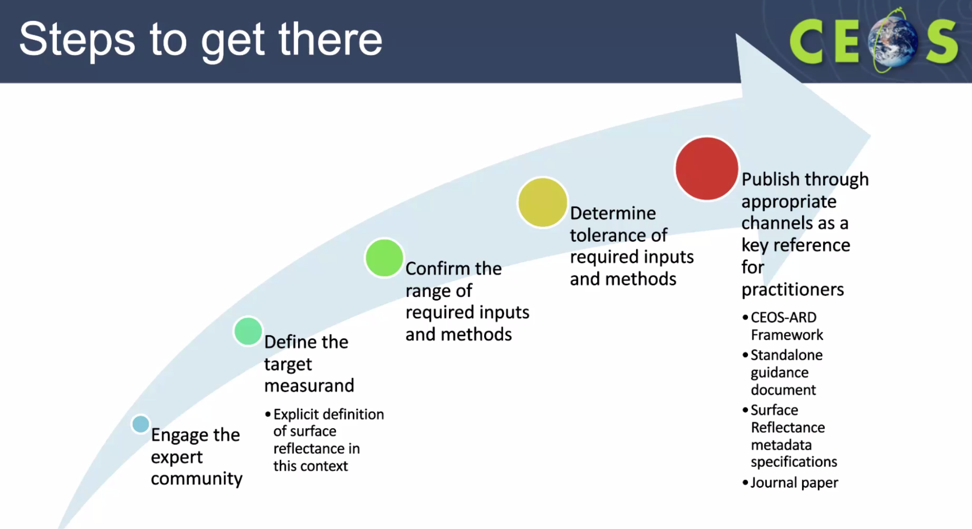
- Currently working on the first step - ‘engage the expert community’.
- Some options have arisen with how to progress this, including as a pilot activity with LSI-VC.
- Goal is to focus on the requirements and be non-specific in terms of tools or inputs.
- A couple of expressions of interest have been received to participate in this work:
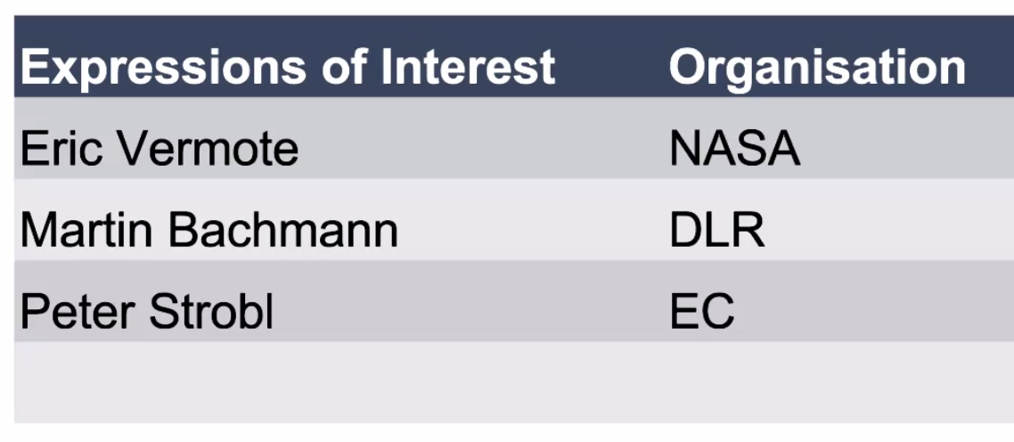
Discussion
- Bob Ryan (USGS Contractor) may also be a good person for this work. Medhavy will get him involved, and work with USGS on funding.
- Steve Covington (USGS) noted that the projection would matter as a fundamental question. Landsat and Sentinel-2 are great starting points but want them to be consistent for any mission and provider.
- Chris Barnes (USGS) asked if there is any crossover with what ACIX is trying to achieve. Trying to avoid a comparison exercise. The goal is to work out what the requirements are to achieve what is needed to have equivalent surface reflectance datasets.
- Peter Strobl (EC-JRC, LSI-VC Co-Lead) asked if we are trying to put together a sensor agnostic definition of the measurement.
- Simon Oliver (GA) noted this is something we are trying to avoid. Maintain the heritage of the sensor where the measurement was made but ensure consistency across the end products.
- Certain processes that are done within products cannot be reversed. Eg. adjacency correction.
- Always has to be a resampling step, to get a measurement of the same spot.
- This would be working at a measurement level. Interoperability at the measurement level is the focus here.
- Ferran Gascon (ESA) asked how to end up with a set of measurements which is comparable.
- For ACIX the same input data is used, retrieving surface reflectances, and then comparing different algorithms. Even if using the same inputs, feel results would be different due to different radiative transfer models, etc. Is constraining the inputs really sufficient to see a convergence in the end product?
- Stopping short of actually harmonising. Note on slide 4. Not wanting to produce a new product, but saying we want to produce something that is harmonisable. Take harmonizable products from wherever and put them into the processes below the line:
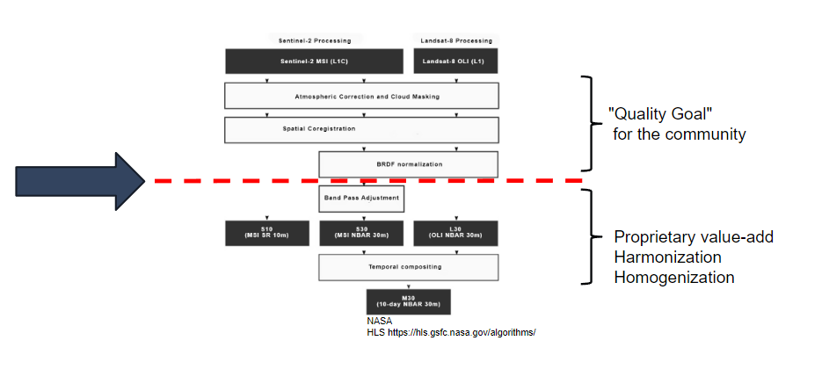
- The discussion here goes beyond the set of inputs with tolerance, it delves into the algorithms and the approach that produces the ARD. The goal is to discuss the variety of approaches used that would produce a consistent measurement.
- It is an ambitious objective, as it is challenging to make different algorithms converge. In the ACIX intercomparison, it was found that you have different values, but no idea which one is more accurate. It depends on how much you aim to make the algorithms converge.
- This activity should be linked with ACIX - good to already have Eric Vermote (NASA) involved in the work.
LSI-VC-14-20 | Steve Covington and Medhavy Thankappan to engage with Bob Ryan (USGS Contractor) regarding participation in the Surface Reflectance Quality, Equivalency and Consistency Project. | Q4 2023
LSI-VC-14-21 | Expressions of interest for participation in the Surface Reflectance Quality, Equivalency and Consistency Project to be sent to Simon Oliver <Simon.Oliver@ga.gov.au> (CC: Matt, Medhavy). | Q4 2023

Thursday, October 12
Session 10: Welcome
Welcome
Matt Steventon (LSI-VC Sec) welcomed participants to the meeting.
Session 6 (Contd.): LSI Interoperability, Validation and Data Access Topic
CEOS SEO Plans for an ARD Interoperability Test Using the CEOS Analytics Lab (CAL) as a ‘New Space’ Demonstration [Slides]
Brian Killough (CEOS SEO) reported:
- Goal: Conduct an ARD interoperability test using the CEOS Analytics Lab (CAL) as a contribution to the CEOS “New Space” initiative.
- ARD Interoperability: Evaluate how ARD datasets from CEOS can be used interoperably with datasets from the commercial space providers.
  - What are the issues using these datasets together?
  - Can CEOS provide any tools or utilities that would improve the interoperability?
  - Can CEOS make any recommendations to the commercial space providers that would improve the use of their data and its marketability?
- CEOS Analytics Lab (CAL): Use the cloud-based CAL tool to conduct the test. This will enable participation across SEO-funded partners and take advantage of the CSIRO Jupyter Python environment and Open Data Cube (ODC) utilities.
- CEOS New Space initiative: The CEOS organisation is searching for tangible tasks that can demonstrate improved connections between CEOS data and commercial data.
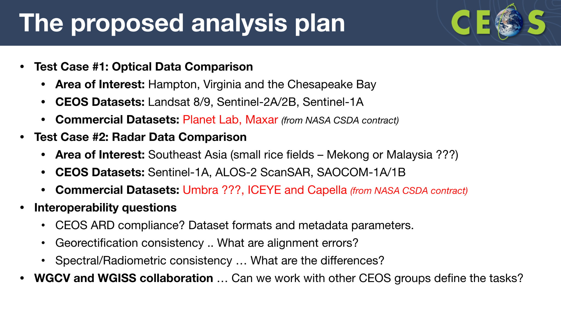
- SEO is discussing the idea of CSDA program dataset availability beyond NASA to CEOS. May explore ideas on NASA side.
- Looking for LSI-VC feedback on the interoperability questions above.
- SEO could run through self-assessments for commercial data which might serve as a means for establishing a dialogue with these companies.
- Perhaps SEO can help to identify alignment errors, etc.
- For Copernicus land service, Peter offered to share links to crowdsourcing examples.
Discussion
- Steve Covington (USGS) suggested including methodology for search and discovery. He asked about the number of searches carried out to build the overlapping imagery. It was noted that it is currently a painful barrier to EO data uptake. Search and discovery need to be included to access pieces in this pilot activity.
- Sarah noted companies like Skywatch are making it their business to aid this search, discovery and access. If an area could be identified with consistent ROI for acquisitions then it could be communicated to agencies for future acquisitions.
- Comparison might not be the right term as it implies they are being ranked. Interoperability assessment would be preferred.
- Communicating the added value of combining datasets, that will be important to capture for managers of space agencies and the commercial sector. In the New Space discussion, it was suggested to ensure we are showing the complementarity and benefits of combining products. Ensure this is clear in messaging.
- Landsat, Sentinel and Planet data, already working in synergy, led by Planet, fused product, have already proof that the outcome is better when these are combined. It gives a clear message that Planet needs Landsat and Sentinel to improve radiometry.
- Ivan Petiteville (ESA) suggested ensuring that we are also passing the message to the commercial sector about how important the public missions are to them.
- Steve Covington (USGS) suggested using the interoperability framework to guide the assessment. Each of the factors should be identified and addressed. Data policy and data access need to be part of the analysis. Steve and Tom Sohre (USGS) suggested using the framework factors to guide the questions and focus for this activity.
- Loop in both WGCV and WGISS - and others as identified in the interoperability framework.
- For CDSE, the idea is to have APIs that allow access to data from Sentinels, also recently added contributing missions, the idea is the interface is common for all data in the cloud. Then the data doesn't even need to be hosted directly by the platform itself (point to different locations).
- CEOS could usefully help to characterise the utility of bringing these datasets together. SEO will work with WGISS directly and frame in the context of the interoperability framework. Work with WGCV and WGISS.
- Under data quality requirements, helping define what could go into the PFS, for example. CAL activity would potentially provide good input.
LSI-VC-14-22 | The SEO will work with WGCV and WGISS to define plans for a “New Space” ARD interoperability project using the CEOS Analytics Lab, based on Interoperability Framework Factors. | ASAP
Drone Mapping for Detailed ARD Validation Testing [Slides]
Brian Killough (CEOS SEO) reported:
- Noted SRIX4Veg activity. Developing guidelines for UAV-based observation.
- Showed some comparisons of drone data vs various commercial and public satellite data sources.
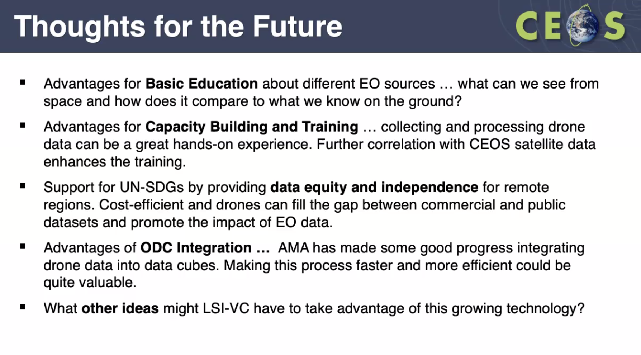
Discussion
- Just like UAVs and platforms that are taking photos simultaneously for calibration and validation. It is user friendly and now it becomes an avenue for someone with little satellite data experience. They can take their own picture and compare it with satellite images.
- USGS NLI and Ames, spend a lot of time working on drone data, very dense data, most people can't work with apart from small scale areas. One of the areas, if you’re going to do it right from a radiometric angle, need to use targets, etc. Big undertaking.
- USGS ECCOE, looking at drone use for validating surface reflectance products.
- Commercial group is using drone data to show what the capabilities are for satellite data. Replacing their current airborne data streams with satellite data, they need to be able to intercompare.
- Tim Stryker (USGS) noted there is a constant education challenge. A lot of people incorrectly think higher resolution means high quality. Radiometry is a completely different challenge - and impacts these UAV products too.
- The second follow on workshop for SRIX4Veg is on 24-25 November 2023, ahead of VH-RODA. Next SRIX4Veg exercise will be in Australia on 7-11 March 2024.
- Peter Strobl noted in chat: “Aerial (manned and drone) has become part of the Copernicus Emergency Service and complement satellite observations seamlessly see here.”
- Ivan Petiteville noted in chat: “SRIX4VEG is run as an international activity in cooperation with USGS, ASI, DLR, Geoscience Australia, and CSIRO. It would be interesting to also involve WGCV in this drone-related discussion. Intitial results from SRIX4VEG have been presented durign the at the 1st SRIX4Veg Workshop in March 2022.”
Aquatic Reflectance/Ocean Colour PFS Progress Report [Slides]
Chris Barnes (USGS) reported:
- In March 2020, Chris and Andreia started developing the AR PFS. It was endorsed by LSI in February 2022. SR PFS was used as a baseline, and brought in subject matter experts to help define the needs.
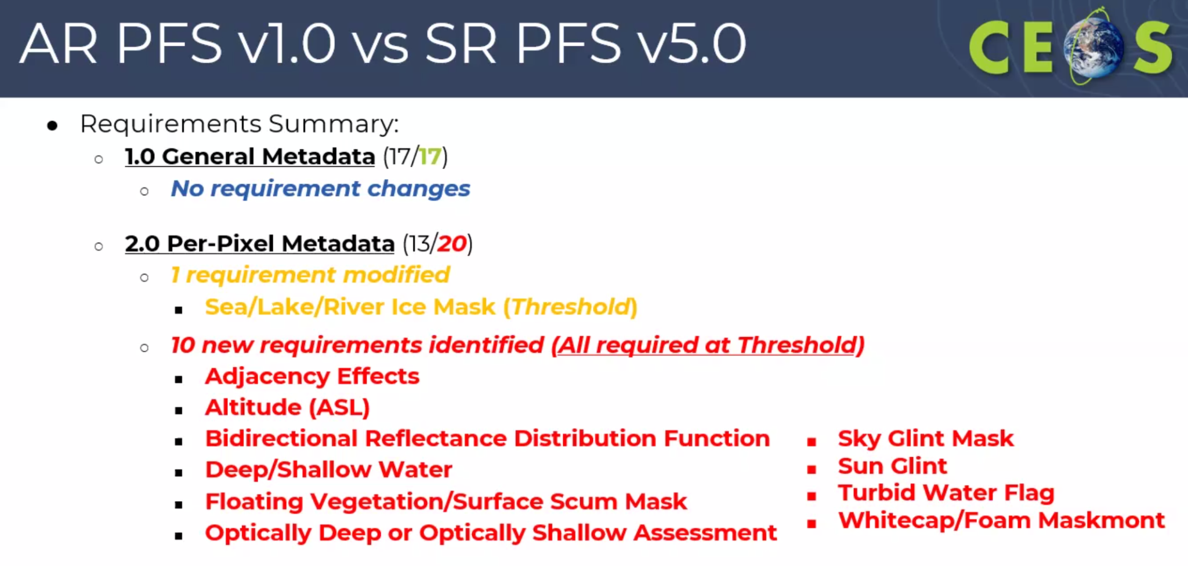
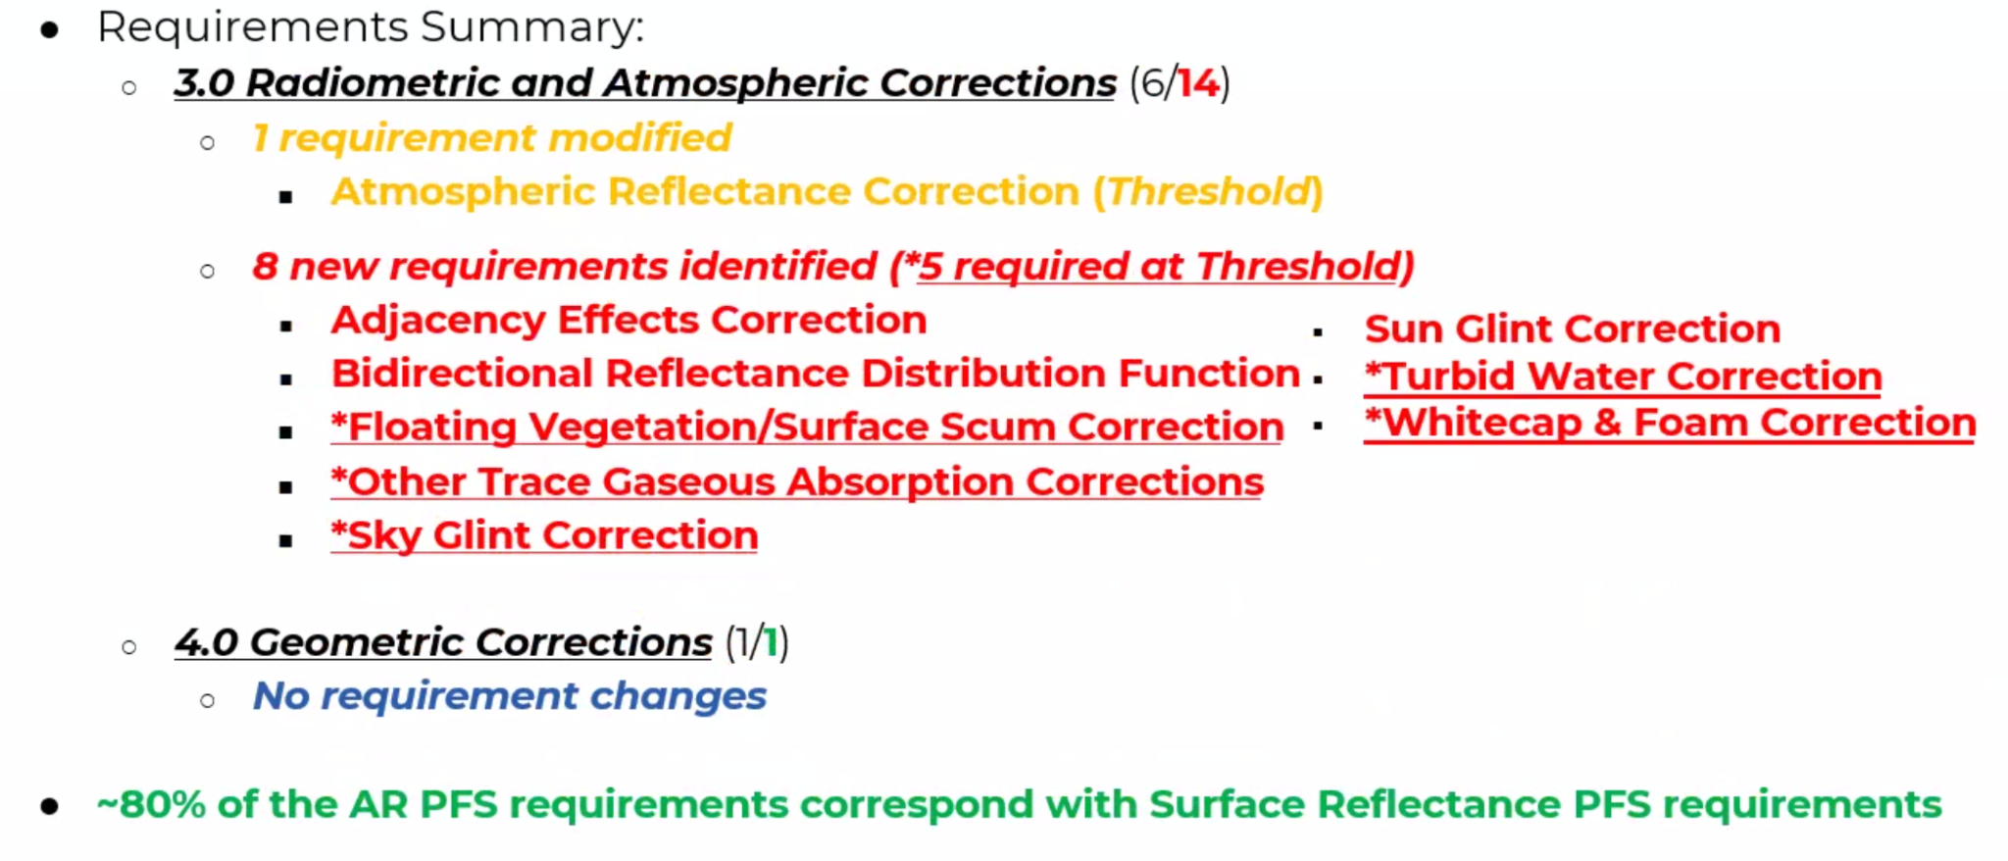
- About 80% of the AR PFS requirements correspond with the SR PFS requirements.
- Current PFS applies to multi/hyperspectral sensors over coastal and inland water bodies.
- Idea to expand the scope of the AR PFS to include oceans as well. OCR-VC has led this work, with GEO Aqua Watch and IOCCG.
- March 2023, IOCCG led an effort to review the AR PFS, and general observations and questions.
- DLR shared their experiences with roadblocks in implementing an EnMAP AR product. Awaiting recommendations for inclusion in future AR PFS updates via USGS/DLR bilateral engagement.
- In November 2023, the International Ocean Colour meeting will be used to finalise recommendations to CEOS ARD Oversight Group. Will be trying to get a formal buy-in.
- Early 2024, expect that IOCCG will present a recommendation to the ARD-Oversight Group to update the AR PFS v1.0 to include oceanic waters.
Discussion
- Ake Rosenqvist (JAXA) noted 80% of the parameters were similar to what was discussed with SAR PFS.
Session 11: Forests and Biomass Subgroup
CEOS Agriculture, Forestry and Other Land Use (AFOLU) Roadmap [Slides]
Stephen Ward (SIT Chair Team) reported:
- The AFOLU Roadmap lives within the LSI-VC Forests and Biomass subgroup. Need LSI and the agencies that operate these missions to keep hold of this activity.
- This group has been very focused on data format and ARD - need to meet the mandate of LSI-VC.
- Need LSI to look after things like this. It is a bit of a different scope for this group recently. May need to bring in other people. This is within the scope of the LSI-VCs mandate regarding LSI requirements and gap analyses.
- There are a lot of contributors to the Roadmap who are experts but not necessarily core LSI-VC people.
- Second leg of carbon roadmaps, supporting CEOS Strategy for GST.
- 2023 is the first Global Stocktake. The role of EO has to be demonstrated at COP-28. Need to make sure for Global Stocktake 2 that more countries are using space data for the reporting.
- Not as good as we think we are in terms of getting our data into the system.
- CEOS agencies tend to compete rather than collaborate which makes it confusing. Noted example of biomass maps, with different CEOS agencies distributing different maps, which can conflict and contradict, makes it messy and tricky for users to understand which is the best / authoritative source of data. There will be a presentation next week by Joana Melo at SIT TW. Noted Joana’s paper as the key source of this uptake data.
- AFOLU Roadmap contents:
  - Overview of IPCC methodologies: Stock change, Gain loss
  - EO for Activity Data: Land cover change working group
  - EO for Emissions Factors: Biomass harmonisation working group
  - Capacity Building and Stakeholder Engagement
  - Integrated Monitoring and Verification System
  - Recommendations
- It is research driven and includes six recommendations (see slides for details). The plan is to develop an appendix of actions for space agencies for specific next steps.
- There will be a full day side meeting next Tuesday. Hoping for the roadmap to be endorsed at CEOS Plenary. Actions will come at SIT-39.
- CEOS GST Portal: ceos.org/gst has been recently updated with Sentinel-3 fire maps, as well as updates to the agriculture page.
- LSI-VC will be a working team for tracking the actions.
Discussion
- Steve Covington (USGS) noted that the CEOS AFOLU Roadmap is very timely for USGS discussions on funding for Landsat Next, for example. Such a strategy and roadmap are very helpful with the justification of budgets. Roadmap will help explain the need and what the reporting is needed.
- Endorsements of actions are targeted by April 2024 - hoping to have drafts by February 2024.
- Peter Strobl (EC-JRC) noted a good reason to keep the actions in LSI-VC. Need to clarify the role of LPV in WGCV.
Session 2 (cont.): Agency LSI Updates and CEOS-ARD Assessments
USGS [Slides]
Tim Stryker (USGS) reported:
- Four USGS Landsat datasets have been certified as CEOS-ARD compliant. Their self-assessment table is available online with more details.
- See slides for improvements made during the upgrade from Collection 1 to Collection 2. Collection 3 aims to tick off the items which are not yet met at the target level.
- The AR product is still provisional and looks to be for some time. Hoping for one day to be CEOS-ARD compliant.
- Landsat-7 is still operational, but the orbit is drifting and not maintained. Awaiting refuelling the mission.
- On track for nearly 20 billion user accesses this year.
- Maxar’s Worldview 3 caught a picture of Landsat 8 in space with a series of eight shots at different angles. Able to see the status of the solar panels, and all look to be in good order. Very valuable images for mission managers.
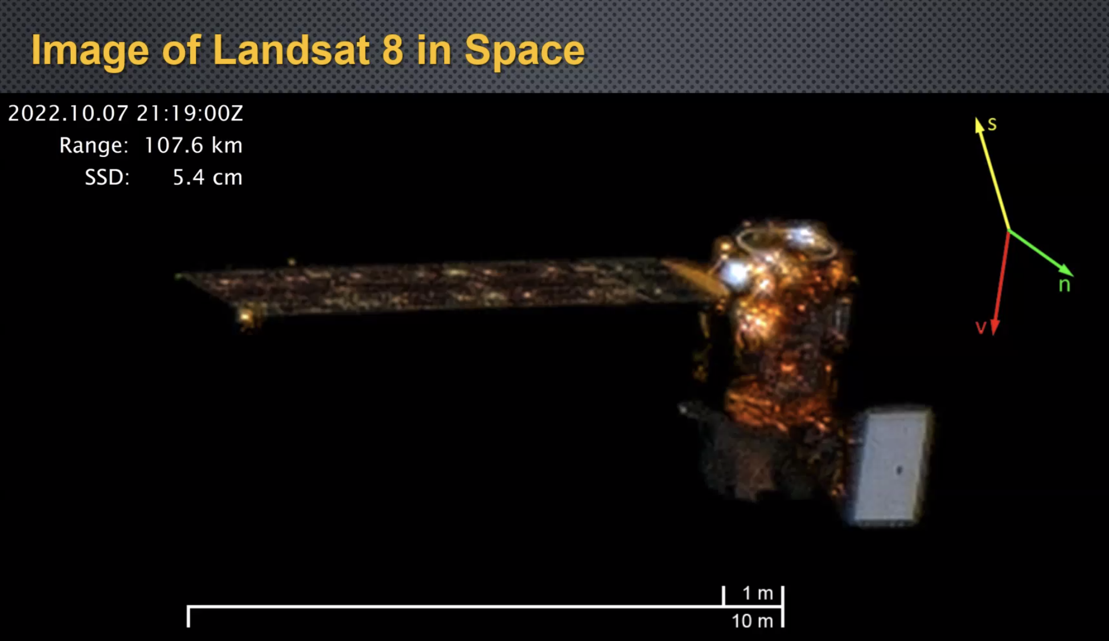
- Released new land cover database for 2021 on 31 July 2023.
- Also the land change monitoring, assessment and projection (1985 - 2021)
- Landcover Next will be a landsat-based land cover and change.
- The 2024 budget will allow the development of Landsat Next to go ahead. Proposals have gone out from NASA for the development of the instruments.
- If everything goes well, will have a contract by late spring for the instrument suite. By this time next year, will have spacecraft on contract. Depends on Congress budget approval.
- Canadians have their RCM with a similar configuration to Landsat Next. USGS will be discussing with them about lessons learned and international partnership.
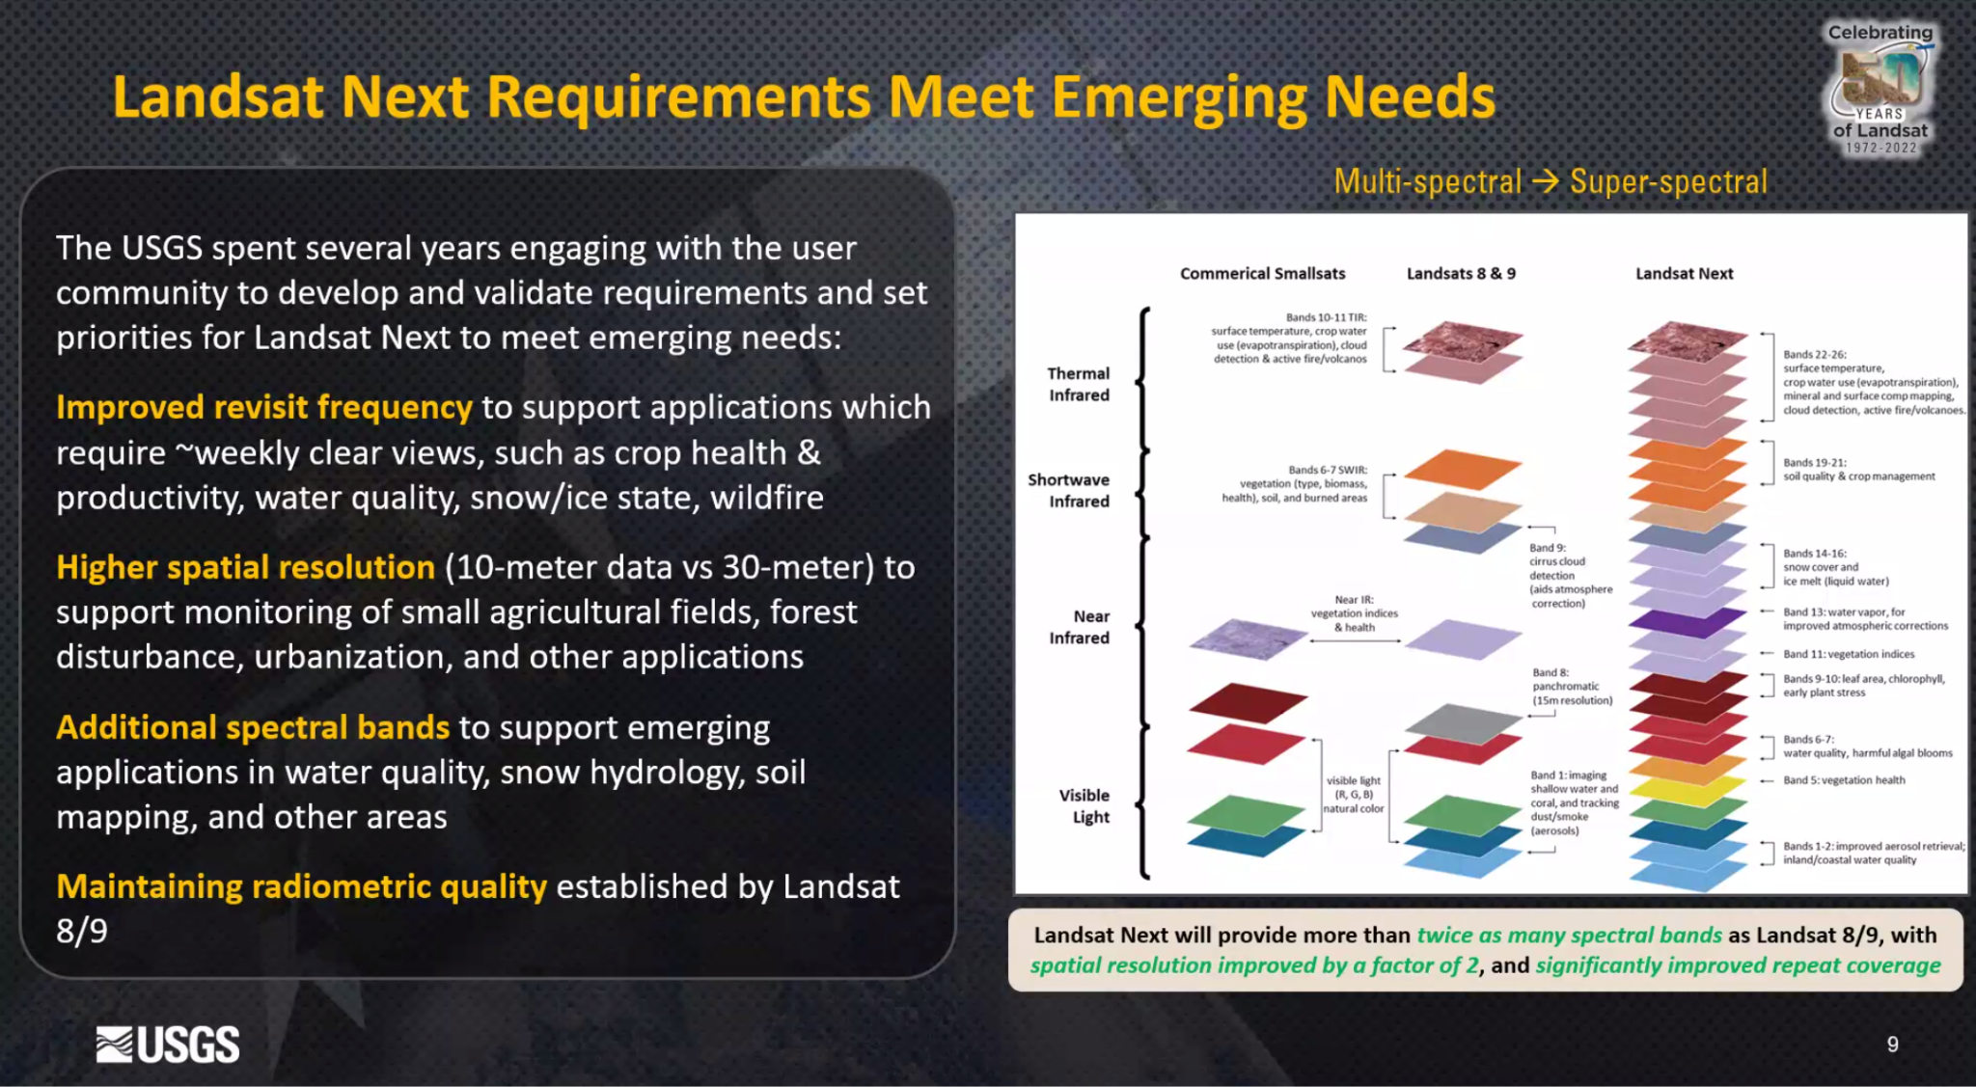
- Landsat Next bands are aligned with Copernicus Sentinel-2, talking to ESA next week to work on this. Align with the Copernicus programme, make data more easily accessible and more compatible.
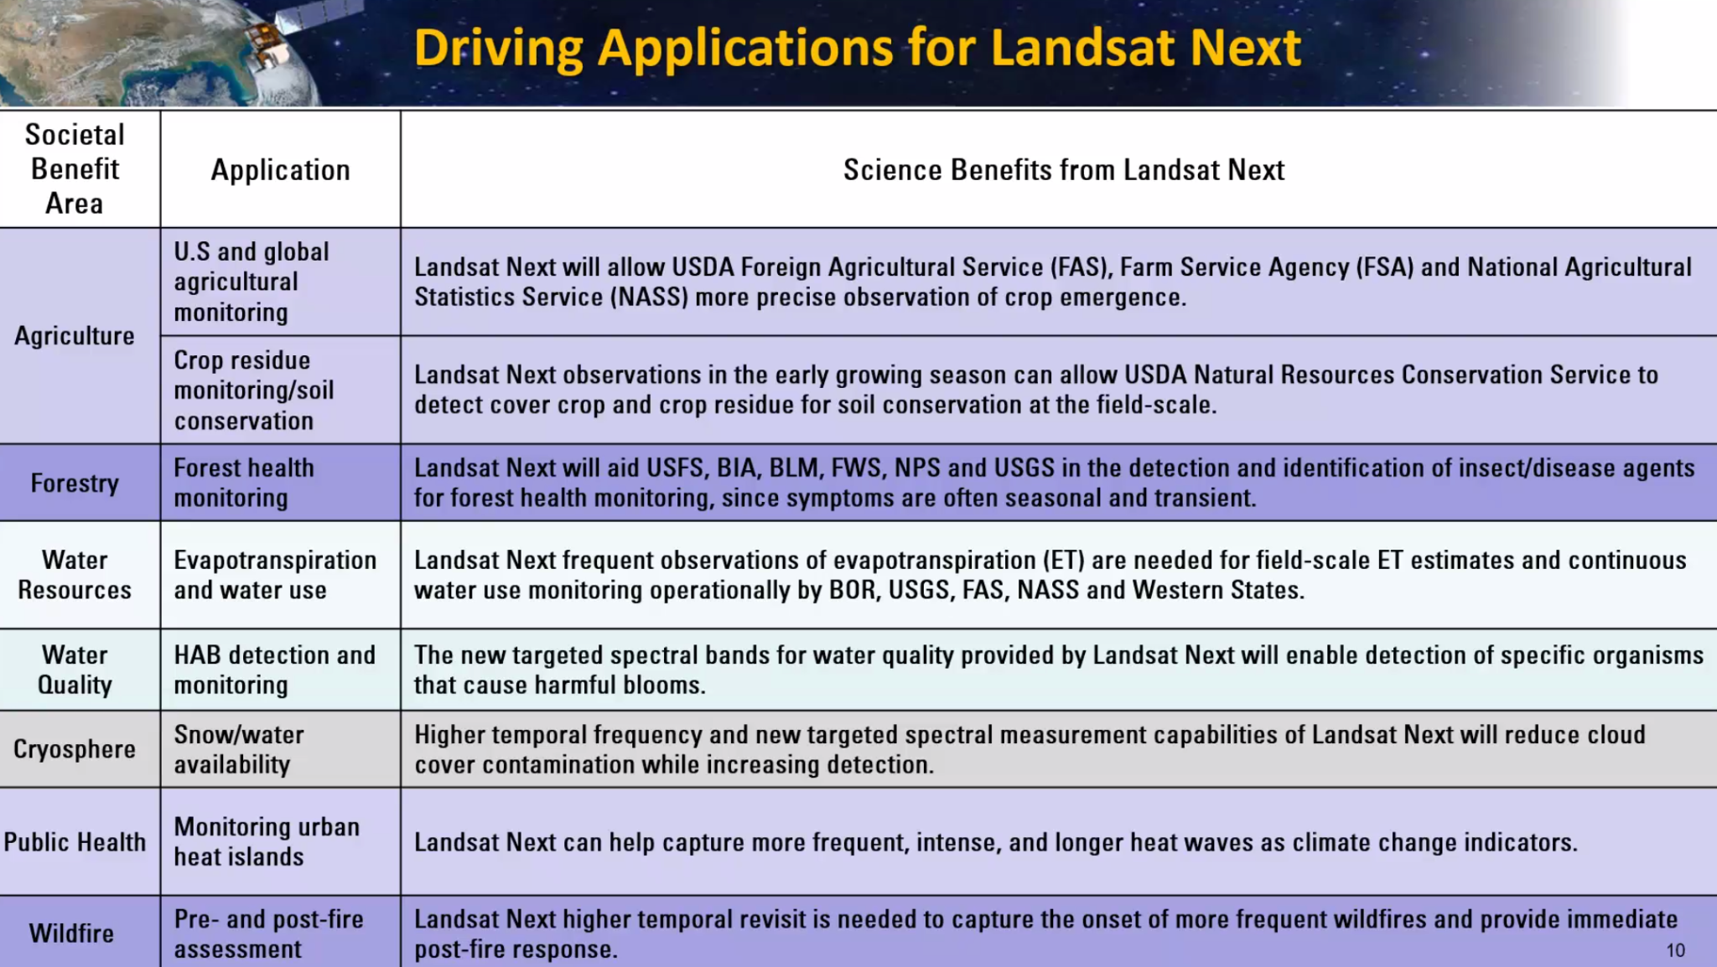
- USGS collaborates with many government agencies to track and support applications of satellite data.
- USGS partners with NASA on Landsat Next. The Landsat Next ground segment includes the mission operation system, Ground network element, data processing and archive systems.
- Will be a 14 fold increase in data volume - ground system will need to be a more complex endeavour. An increase in volume is not just a problem for the ground segment, but also for end users. Will need more processing power.
- USGS processes Surface Reflectance products and the end users are responsible for processing further.
- USGS also acquires a large amount of commercial data, airborne data for use for research and operations.
- The current USGS Landsat archive is 20PB, by 2030 will have grown to 35PB. In 2031, after Landsat Next begins, it will be close to 50PB.
- There may not be the infrastructure of services to cost-effectively utilise global EO holdings in the 2030s. It is an important conversation for CEOS as this needs to be worked out collectively.
- The Copernicus Space Data Ecosystem is a good example.
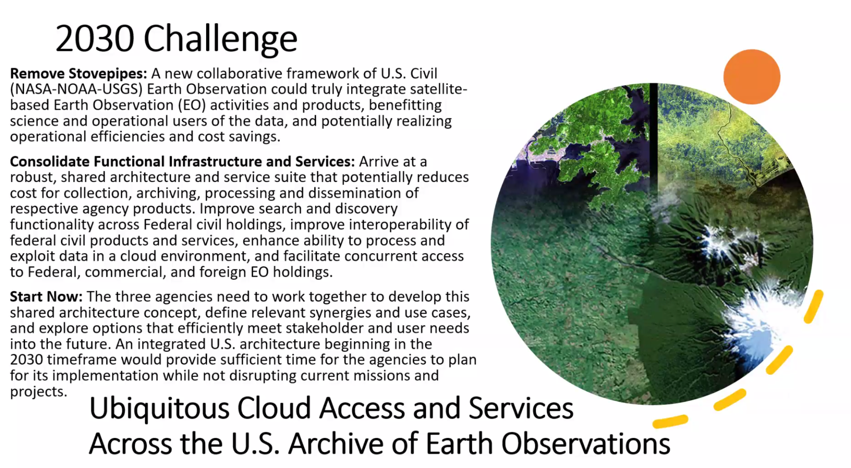
- The top request from users is for higher temporal resolutions. Combining with other agency data could bring the revisit time down to within a day. Working together to have access to each other’s near real time data.
- Disaster applications are especially important for frequent revisits. At the moment, Landsat is used mostly for disaster recovery, not response.
- Much value in better compatibility between datasets.
- A lot of important conversations are happening in LSI-VC, which CEOS needs to do. But we need to make sure we have champions for each activity. Eg interoperability.
Discussion
- International engagement is critically important to USGS, particularly through CEOS LSI-VC, WGCV and WGISS. It is driven by the NASA-USGS-NOAA ‘2030 Challenge’ and to be prepared for Landsat Next. Collection 3 will support Landsat Next. There will be several discussions taking place before then. E.g., around DGGS, ARD, etc. if these discussions don't happen this year or next it will be too late for Collection 3. There is a real sense of urgency across all of these areas.
- NOAA’s GEOXO will also increase the data volume exponentially. NASA also has the same issue but of another magnitude. All US agencies need to find a solution (‘2030 Challenge’), and hence aim to engage with CEOS to perhaps address this in an international collaborative approach.
- Ferran Gascon (ESA) there could be interoperability of archives. Trends at the moment are on the private sector side, the ecosystem on its own. In the public sector in Europe, it is focused around CDSE. With the running infrastructure, ESA is struggling to find out how to manage the exponential growth of data. Funding of cloud infrastructure and international agreements is a challenge.
- Steve Covington (USGS) noted a cultural shift that has to occur from local to cloud processing.
- The overall data ecosystem is the important part of all this - processing and data hosted in one place. Intended to be hosted on commercial partners who can add value to the data to the ecosystem as well. Interfaces and Information Technology are there but need to organise architecture standards.

Session 12: AOB
CEOS-ARD Communications Activities [Slides]
Libby Rose (LSI-VC Sec) reported:
- The following of the CEOS-ARD X (formerly Twitter) account (@CEOSARD) is steadily growing - currently at 102 followers.
- The analytics are showing great improvement since the previous report in March:
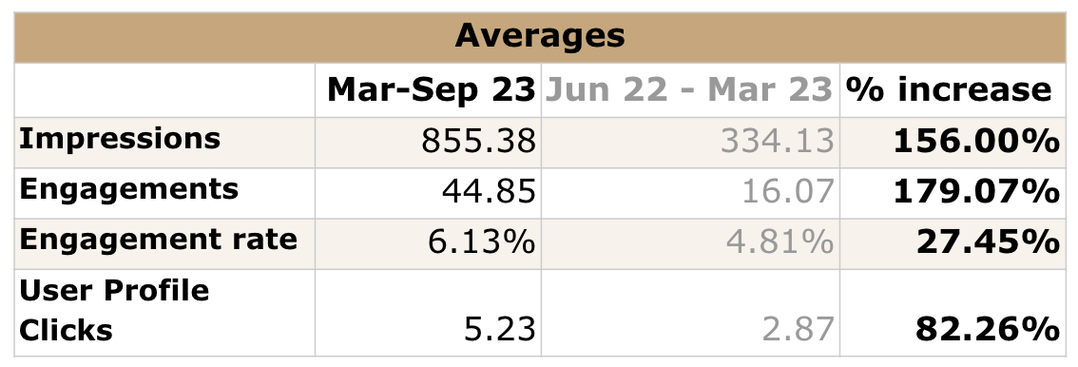
- Any topics to share on the account are welcomed, and members are invited to email Libby and/or Matt with any news. Thanks to those who contributed some topics a couple of weeks ago, following an email request.
- The SEO hosted a CEOS Booth at IGARSS 2023, and CEOS-ARD featured in three places: the poster presented by Andreia, as a row on the pull up banner, and as a page in the CEOS Flyer.
- GEO Week 2023 is taking place in November, and a CEOS Booth will be present. The designs for the walls have been completed, and features a CEOS-ARD bubble.
- The branding package is now available online. The package includes four colours (blue, green, black, and white) and two file sizes, as well as the design file and vector graphic. Where possible, the blue version should be used, but alternates are provided for compatibility with other designs.
Discussion
- Coastlines, food security and wetlands suggested as good focus areas for future CEOS-ARD communications activities.
- It was suggested to announce the endorsement of CEOS-ARD for SAR on social media.
- On semantics, in various places, CEOS-ARD, need to check consistency across website, documentation and socials. This was a decision of the CEOS-ARD Oversight Group, for search engine optimisation.
- Dave Borges (SEO) suggested co-branding and cooperation on stories with Radiant Earth, cloud native geospatial, OGC, etc. By co-branding, means allowing the use of logos. It was agreed that we should allow the use of logos, etc. provided we have a chance to review, etc. These groups have much bigger social followings.
- Peter Strobl (EC-JRC, LSI-VC Co-Lead) suggested Mastodon as an alternative to X as it may have a different and younger audience.
- IGARSS engagement on CEOS-ARD was mostly from the user perspective.
LSI-VC-14-23 | Libby to announce the endorsement of Combined CEOS-ARD for Synthetic Aperture Radar PFS once the document is in place and ceos.org/ard website updated. | ASAP
LSI-VC-14-24 | Ake to update the references to ‘CARD’ in the SAR metadata specification, replacing ‘CEOS-ARD’. This will be done before the Combined CEOS-ARD for Synthetic Aperture Radar PFS is posted online and announced. | COMPLETE

ARD Levels, CEOS-ARD Architecture
Peter Strobl (EC-JRC, LSI-VC Co-lead) led a discussion.
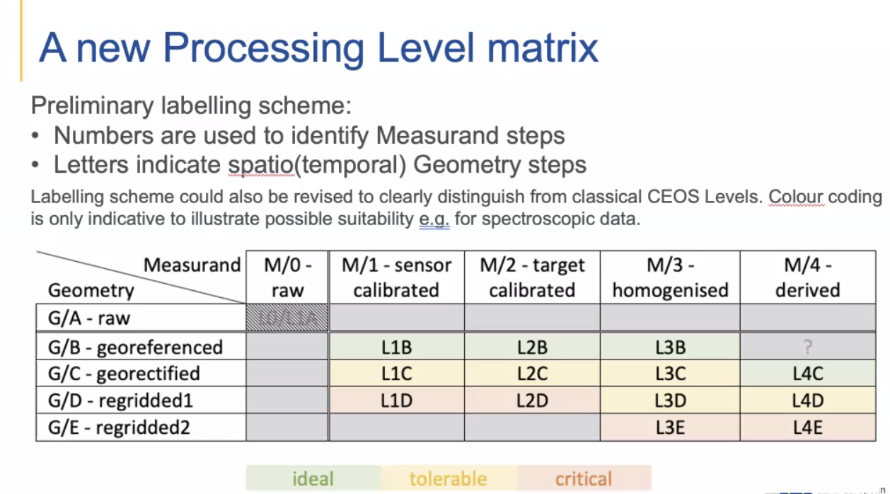
- On the vocabulary side the difference between georectified and orthorectified requires to be clarified.
Discussion
- Steve Covington (USGS) noted there are a lot of intermediate steps between Landsat raw data and Level 1C. They are internal to USGS and not public facing.
- A consistent set of terminology is needed as there are big ambiguities when using words like georectified, etc.
- Taking georeferenced to just mean that a single pixel can be located in space.
- Ake noted there are GRD products in SAR that are not georectified.
- Ferran Gascon (ESA) expressed his preference for the level concept emphasising the need to find the names for intermediate levels between raw and L1B products. On the homogenised and derived products, the old definition for L3 was multi-temporal and L4 is when the products were assimilated into modelling, etc.
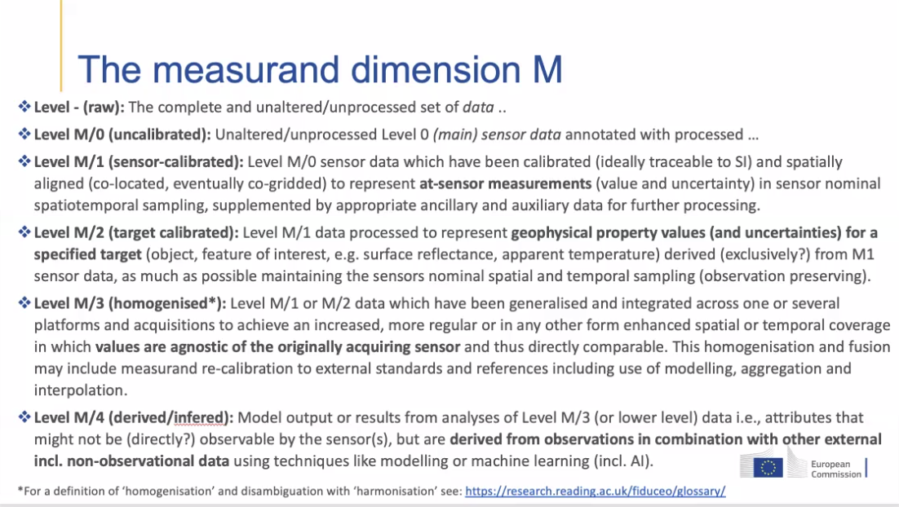
- The agency level definitions are different for each agency and do not match with the CEOS definitions.
- Need to look into the data architecture problem to get the 2030 Challenge raised by USGS under control. Questions were asked about injecting this level paper and slides into the 2030 Challenge US community discussions.
- Peter Strobl (EC-JRC, LSI-VC Co-Lead) briefed about the product level at ARD23 and it was well received by ‘new space’ representatives.
- This also ties into the discussions around the Sentinel-3 ARD issue.
- On action LSI-VC-13-07: if the data contains everything necessary to regularly grid them, as long as we allow regridding after ARD then we should not distinguish sensor grids from ground grids.
- Ferran Gascon (ESA) noted that the hyperspectral community has clearly requested not to interfere with the spectral data; keep sensor geometry.
- Steve Covington (USGS) added that the concern is not knowing how software packages reference a georeferenced product.
- There should be some responsibility of the data provider to provide the tool to regrid the product.
- Map projection (1.6) is a threshold requirement for the SR PFS.
- Questions about a product being self-standing or if a product and a tool for additional processing are acceptable were raised.
- Steve Covington (USGS) noted that the product tool would be acceptable in this case, as it would be only needed for advanced users.
- Steve Labahn (USGS) added that Cody Anderson from USGS has been looking at the uncertainty challenge and has some ideas on the packaging etc. Perhaps he should be involved in this discussion.
- There is no current update timeline for SR PFS update. This could just be a minor update and it doesn't affect anything that comes before. However, there are some other comments to reflect on for the next ‘major’ update (e.g., the sub-pixel accuracy issue which should be addressed soon).
- SAR PFS 1.7.11 - has the exact terminology needed to resolve the issue with 1.6 in the SR PFS. Propose to adopt the same wording as that in the SAR PFS. See Decision 02 below.
- Steve Labahn (USGS) noted if we change the name of the parameter then that would be a major update.
LSI-VC-14-25 | Peter to share paper “A Revised Processing Level Scheme For Earth Observation Data” and related slides with the USGS team so that they might be input into the US side discussions regarding the “2030 Challenge” as well as with Tom Sohre / WGISS, noting Tom’s upcoming WGISS Chair term and the existing CEOS Levels terminology published by WGISS.  Additional context: Potential uptake of any new schema will need a sustained effort to communicate the concept. Peter is communicating in the European context, and the US “2030 Challenge” discussions between USGS, NASA and NOAA would be another good forum to share this idea. WGISS is another forum that needs to be covered, and the USGS Chair of WGISS for the next two years provides a good opportunity. WGISS has a published CEOS Levels terminology, which could be the target of an update if agreed. The concept was also presented to ARD23 with good reception from commercial participants. Attempts to align the OGC ARD SWG work should also be undertaken. | COMPLETE
LSI-VC-14-26 | Steve Labahn to review the list of outstanding issues to address with the Surface Reflectance PFS to see if any other items can be addressed in minor update v5.0.1.  One additional potential update could be related to the 0.5 pixel rRMSE sub-pixel accuracy requirement (TBD). | COMPLETE
LSI-VC-14-27 | LSI-VC Leads and Secretariat to prepare minor update v5.0.1 of the Surface Reflectance PFS and share with the team for review. An LSI-VC teleconference will be planned for end November to cover the endorsement. | COMPLETE

Decision 02 | Agreed in principle to resolve the issue with parameter 1.6 (Map Projection) of the Surface Reflectance PFS (Ref: LSI-VC-13-07) by adopting the same wording used in section 1.7.11 of the recently endorsed Combined CEOS-ARD for Synthetic Aperture Radar PFS, that is, adding “(or geographical coordinates, if applicable)” after the requirement that “The metadata lists the map projection that has been used…“.  LSI-VC-13-07: Schedule a further discussion on whether georeferenced products might be considered CEOS-ARD, or is a map projection strictly required.  It was agreed that the Surface Reflectance PFS will undergo a minor update to v5.0.1 with this new, relaxed version of parameter 1.6.

Session 2 (cont.): Agency LSI Updates and CEOS-ARD Assessments
CONAE [Slides]
Danilo Dadamia and Laura Frulla (CONAE) reported:
- CONAE is using SNAP to process their SAOCOM images. Python is used to create the software and process masks, and build XML ARD format.
- SAOCOM Data Access is possible via two avenues:
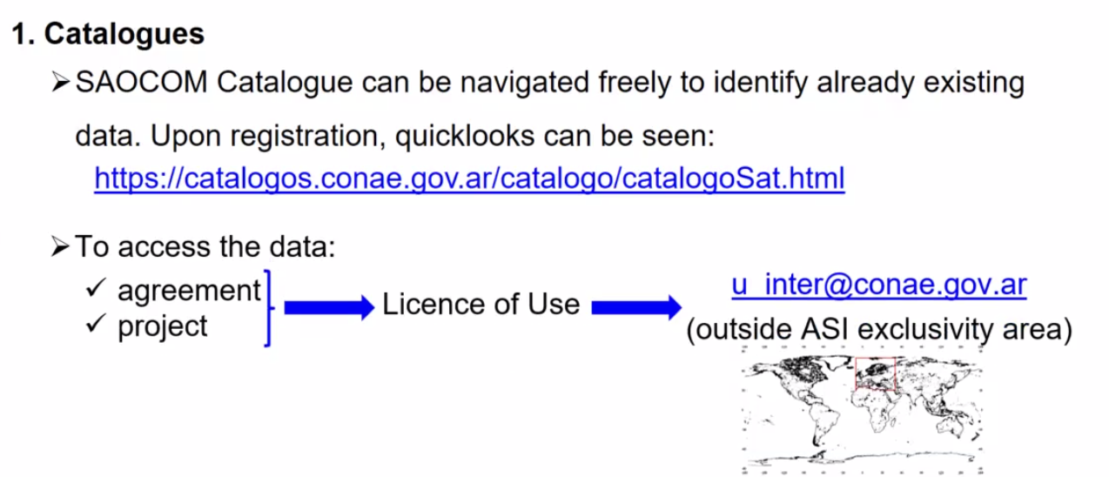
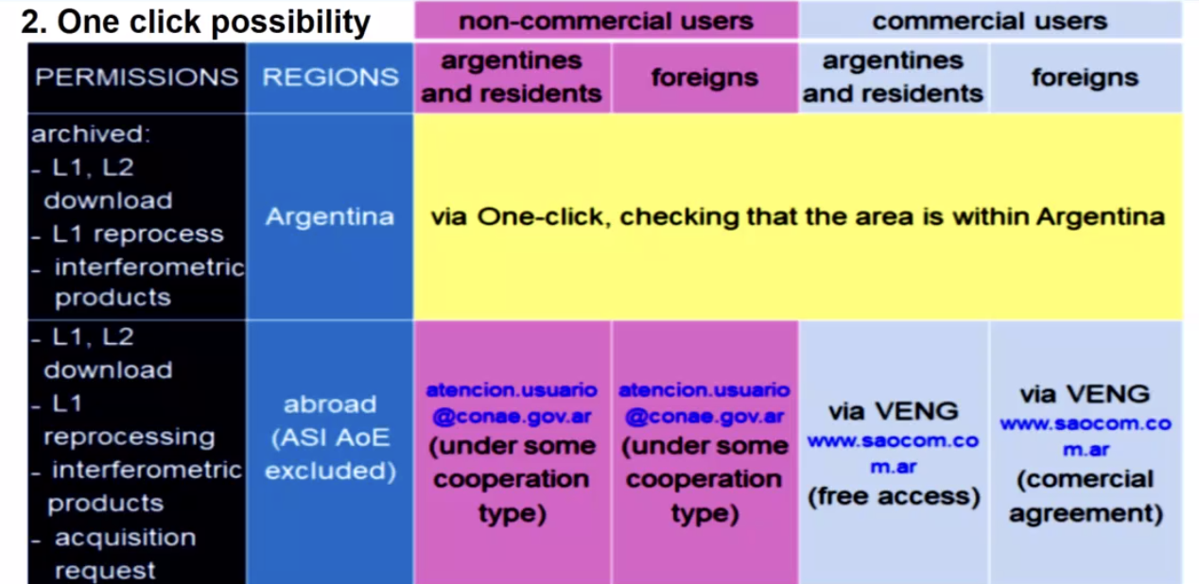
- The national space plans involve SAOCOM 2 launching in 2029, and SAOCOM 3 in 2034. There are also a number of smallsats planned, called SARE, with different instruments and focuses.
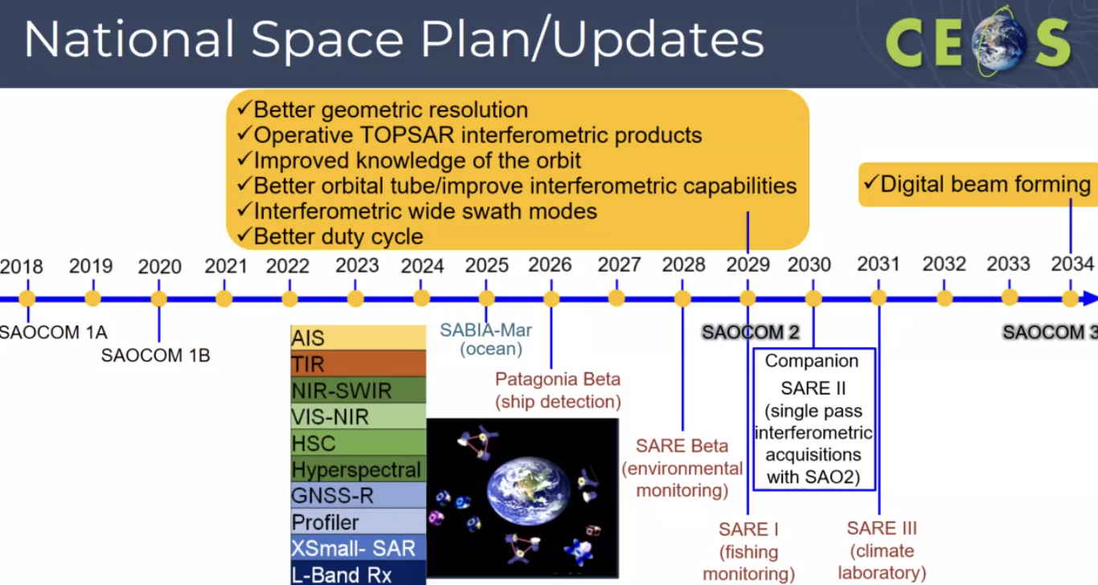
- There are also plans for a Geostationary satellite, together with other Latin American countries, to support the whole region.
Discussion
- Ake Rosenqvist (JAXA) noted a few small changes might need to be made to the processing, but within reach to be compliant with the new Combined SAR PFS. Danilo has been part of the SAR CEOS-ARD group and aims to have CONAE’s products be compliant with the new spec.
Session 13: Synthetic Aperture Radar LSI Acquisition Planning, Optimisation of Assets – Quad-pol and Multi-frequency Acquisitions; L-band Time Series
Ake Rosenqvist (JAXA) provided a brief session introduction. The session stemmed from some recommendations that came from the ESA POLINSAR workshop.
Quad-pol and Multi-frequency Requests from the POLINSAR Workshop [Slides]
Francesco Sarti (ESA) reported:
- Working with radar polarimetry groups from around the world.
- Need cooperation from agencies to respond to the recommendations.
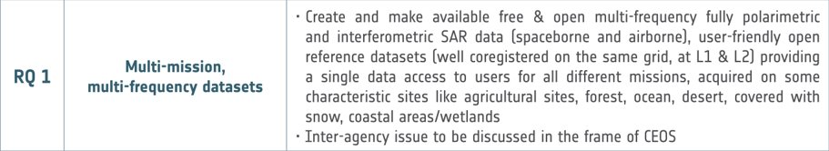
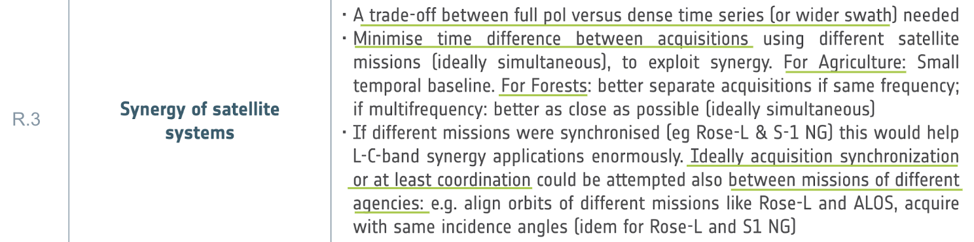
- Some initial research is ongoing between JAXA-ESA and ESA-CONAE. Hope to involve the International Coordination Group for Spaceborne SAR (ICGS-SAR)
- The scientific SAR polarimetry (POLINSAR) community has been advocating for many years, the creation of so-called supersites for polarimetry (and interferometry): a set of predefined sites, including various types of natural targets (forests, ice, snow, deserts, coastal areas, wetlands, agriculture etc.). Associated requirements:
  - In-situ data are regularly collected (plus lidar when relevant for the specific application).
  - Data from several different SAR missions (and airborne campaigns), at different frequencies, are acquired, including full-pol data, over appropriate time periods (multitemporal aspect).
  - Acquired datasets shall be harmonised and made available free and open for the scientific community.
  - Airborne campaign data shall come in a standardised format.
  - User-friendly open reference datasets (ideally coregistered on the same grid, at L1 & L2).
  - Providing a single data access to users for all data.
  - Include characteristic sites like agricultural sites, forests, oceans, deserts, sites covered with snow, and coastal areas/wetlands.
- There are additional requirements defined for forests, agriculture and snow.
- 25 sites have been selected by ESA and JAXA, to explore the synergies between C- and L-band data.
- Data will be made available online for research community use.
Discussion
- Existing sites are not yet ‘supersites’. The types of sites are common across the different projects, but the geographic locations are different.
- Same recommendations were made at the previous workshops, but it has never been accomplished. There are many reasons, but it mostly has to do with the capacity of the sensors. E.g. ALOS-2 swath width is small.
- Unsure which forum would be best to discuss this with all the relevant agencies. WGCV SAR subgroup is also a potential home for these discussions.
- Bjorn Rommen (ESA) noted the need to rely on a lot of airborne campaigns. CEOS could play a role: the results of the activity (datasets and software) are currently only open to the ESA community (i.e. entities within ESA members and cooperating states). Further dissemination of results may be possible but not automatically.
- Once we have done the activity and have the software - promoting open science. Want to be able to effectively share the data and results. CEOS promotes open science.
- In order to optimise the use of the data, we need to coordinate the acquisition of the data between mission managers. This would require some kind of CEOS project.
- Ivan Petiteville (ESA) added that WGCV has done cross-calibration campaigns in the past. But this is beyond cal/val. It could be a joint activity between LSI and WGCV.
- Want to demonstrate what you can do with multi-frequency polarimetric data - applications development. Can’t get funding to develop without the demonstration.
- CEOS Analytics Lab could be a platform to undertake analysis.
Current or Near-future CEOS Agency plans for Quad-pol SAR Observations
ESA: BIOMASS, ROSE-L, S1-NG [Slides]
Bjorn Rommen reported:
- Biomass will be ready for launch by Q4-2024. This mission will be the first P-band SAR in space. It is a fully polarimetric SAR mission with a high orbital activity duty cycle.
- The mission will be able to cover the globe every 9 months with interferometry.
- The first 17 months will be dedicated to a tomographic phase (TOM).
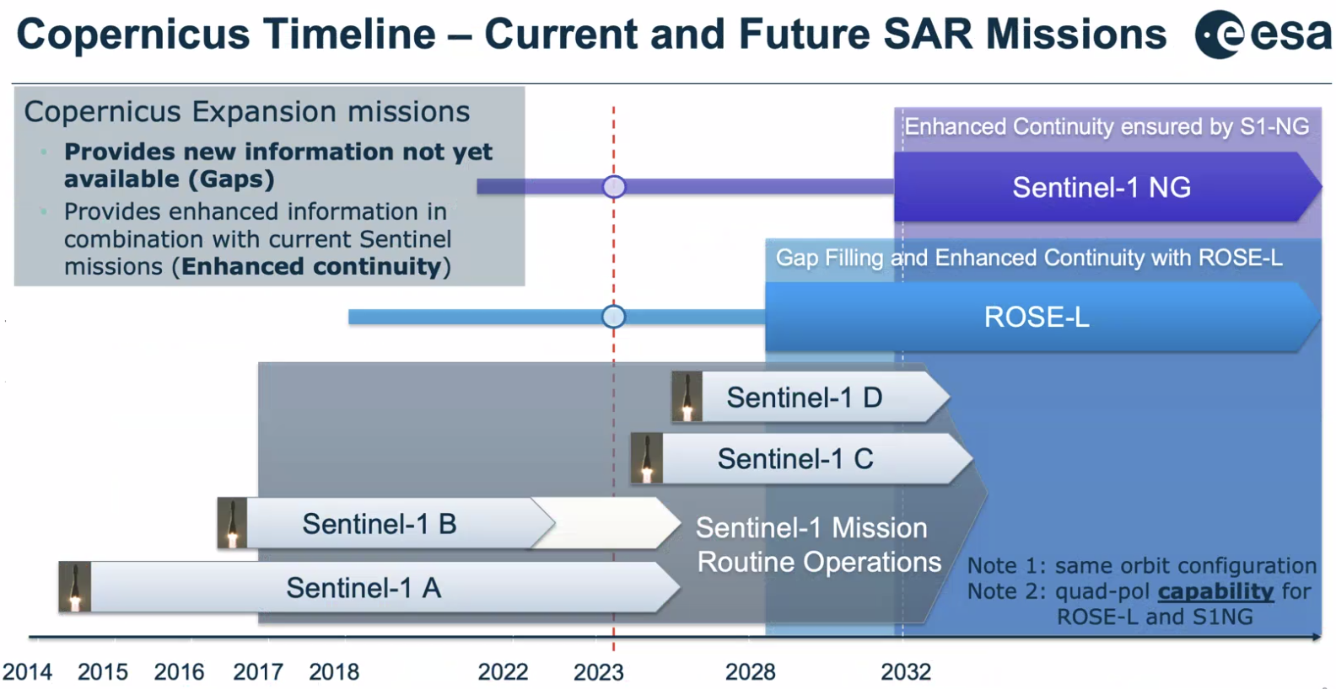
- All Copernicus missions will fly in the same orbit configuration. ROSE-L will be a couple of minutes behind Sentinel-1.
- Quad-pol observations would reduce the duty cycle from about 35 min to 20 min.
Discussion
- The prospects of Sentinel-1 NG and Rose-L together are exciting, but it is quite far away. Biomass will be very interesting, with all observations in quad pol.
- SAR tomography is when you acquire data over the same area from slightly different orbits and observation angles.
CONAE: SAOCOM-1A/B [Slides]
Laura Frulla reported:
- SAOCOM has three acquisition modes: baseline mission (fixed - cal/val), foreground mission (dedicated to users), and background mission (useful database).
- SAOCOM has acquired over 168000 quad-pol scenes.
- Details on the SAOCOM quad-pol acquisitions can be found in the slides.
- Point targets, rainforests and doldrums are used for the calibration and validation.
- The spatial resolution of stripmap is 10 m, topSAR narrow is 30 m and topSAR wide 50 m.
JAXA: ALOS-2/ALOS-4 [Slides]
Ake Rosenqvist reported:
- ALOS-4 will be in the same orbital plane as ALOS-2. The launch has been delayed due to the issues with the H3 launch vehicle.
- ALOS-4 is the advanced version of ALOS-2 allowing for interferometry between the two satellites.
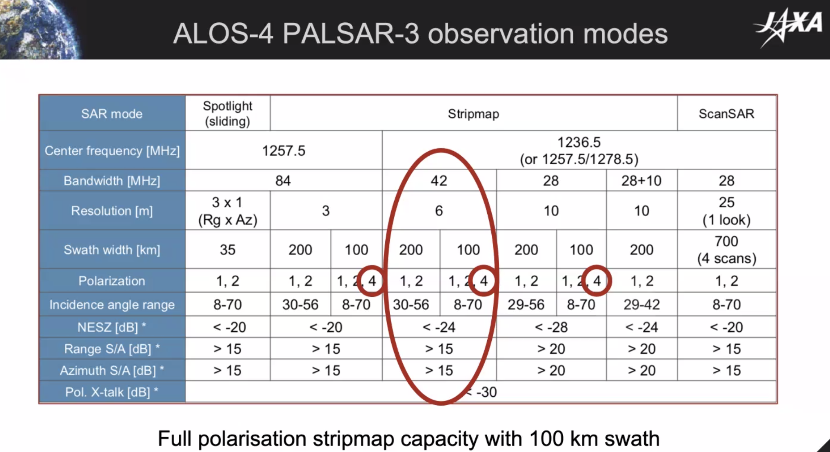
- 6 m resolution stripmap mode will be the most used. 100 km swath width, meaning only two cycles are needed for gap free regional coverage (5 currently needed for ALOS-2).
- Will be a nice complementarity with SAOCOM.
- A number of local study sites subject to data acquisitions.
- The ​​tentative plans for ALOS-4 PALSAR-3 QP observations include:
  - Annual global coverage in 6 m Polarimetric (QP) mode (descending)
  - ~ Bi-monthly QP national coverage over SE-Asia ( Thailand, Vietnam, Nepal, Laos, Cambodia)
  - ~ Monthly QP time-series observations over R&D sites
- Data access will be made available through JAXA research announcements. Next planned for ALOS-2/4 is expected in 2024.
- Some are tentative sites, others are more fixed. There is a potential to add more sites.
LSI-VC-14-28 | Ake to share KMLs for the ALOS-4 PALSAR-3 QP Bi-monthly QP national coverages over SE-Asia (Thailand, Vietnam, Nepal, Laos, Cambodia) and the monthly QP time-series observations over R&D sites with the ESA POLINSAR team. | ASAP
NASA: NISAR-L [Slides]
Ake Rosenqvist reported on behalf of Dave Borges:
- NISAR has both L-band and S-band instruments. The L-band instrument is operated by NASA. NISAR has polarimetric mode included.
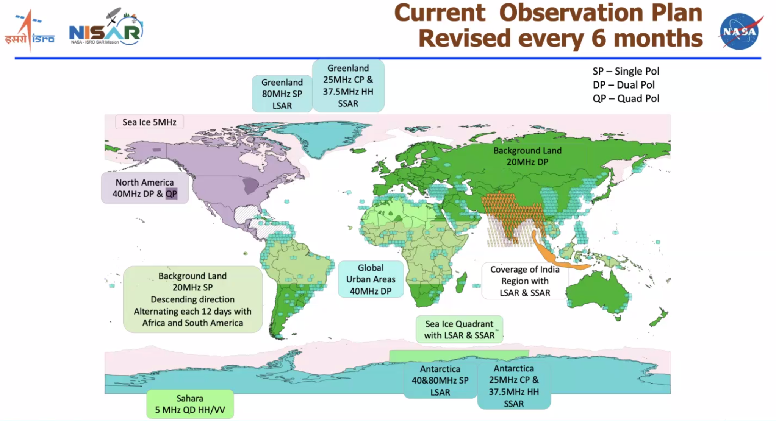
- The workhorse mode will be the dual pol at 30 m resolutions. The quad-pol observations are more experimental.
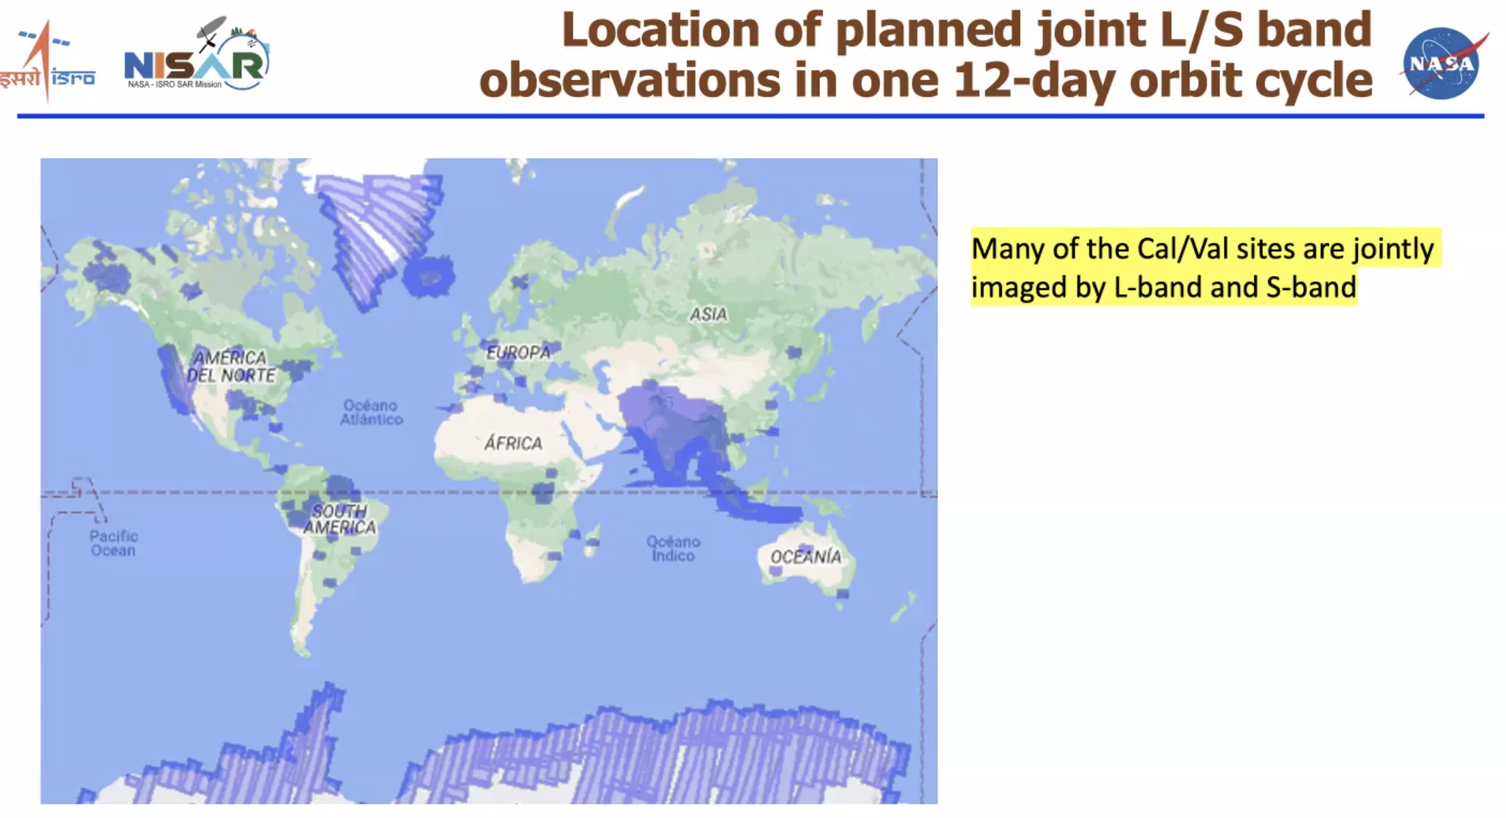
- NISAR allows for truly simultaneous observations of two frequencies.
- Data policy is free and open.
ISRO: NISAR-S [Slides]
Raghav Mehra reported:
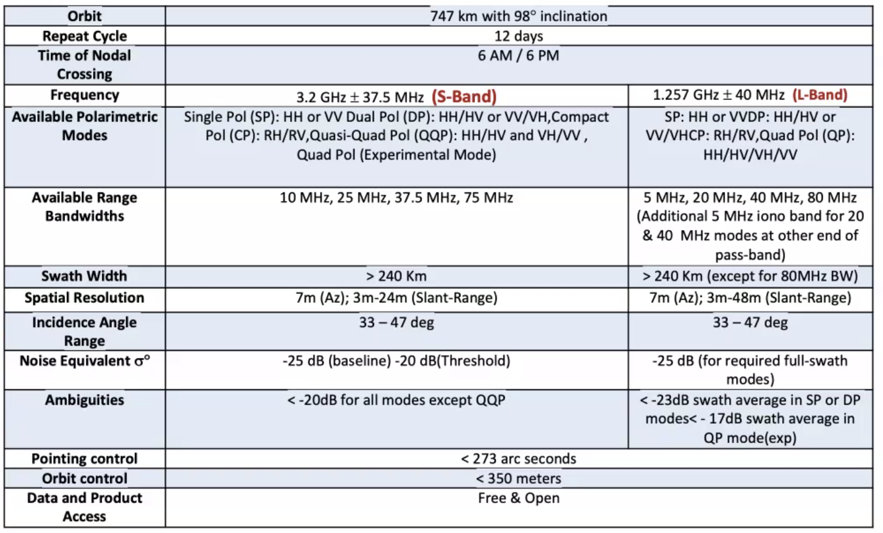
- Observation plan over India:
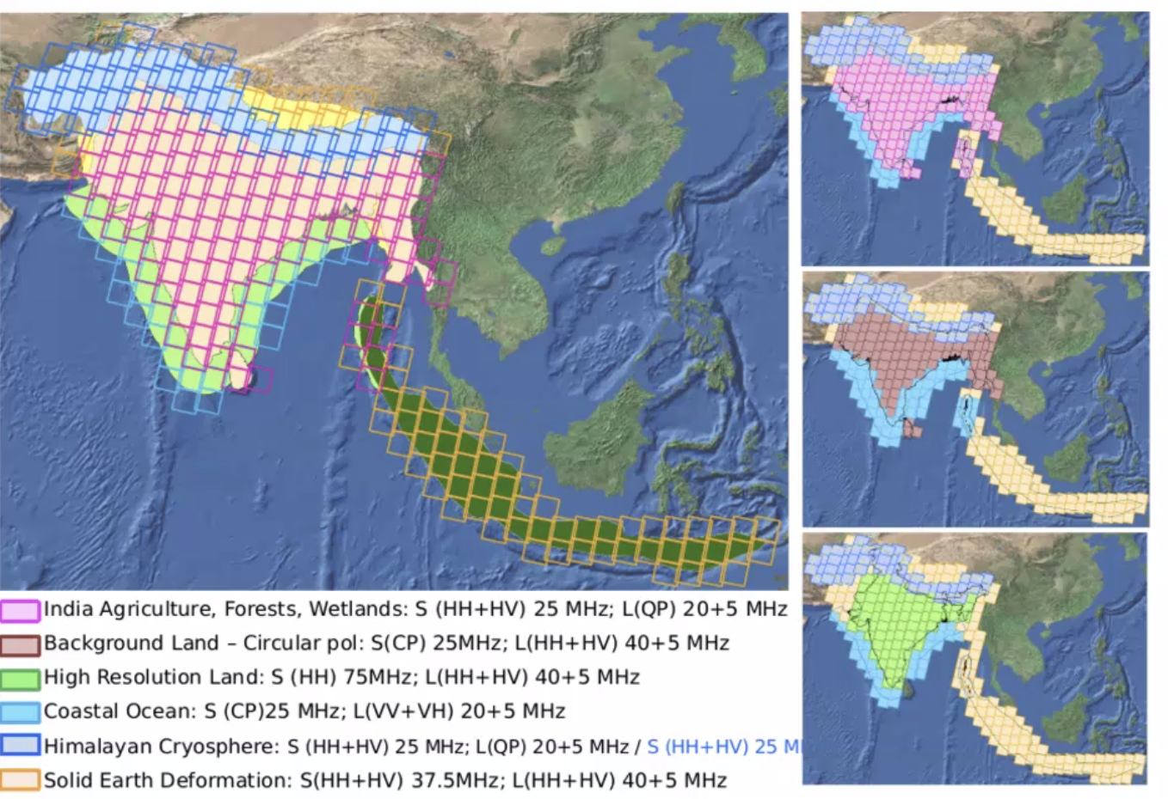
- Users can order quad-pol observations from RISAT-1A, with the below specifications:
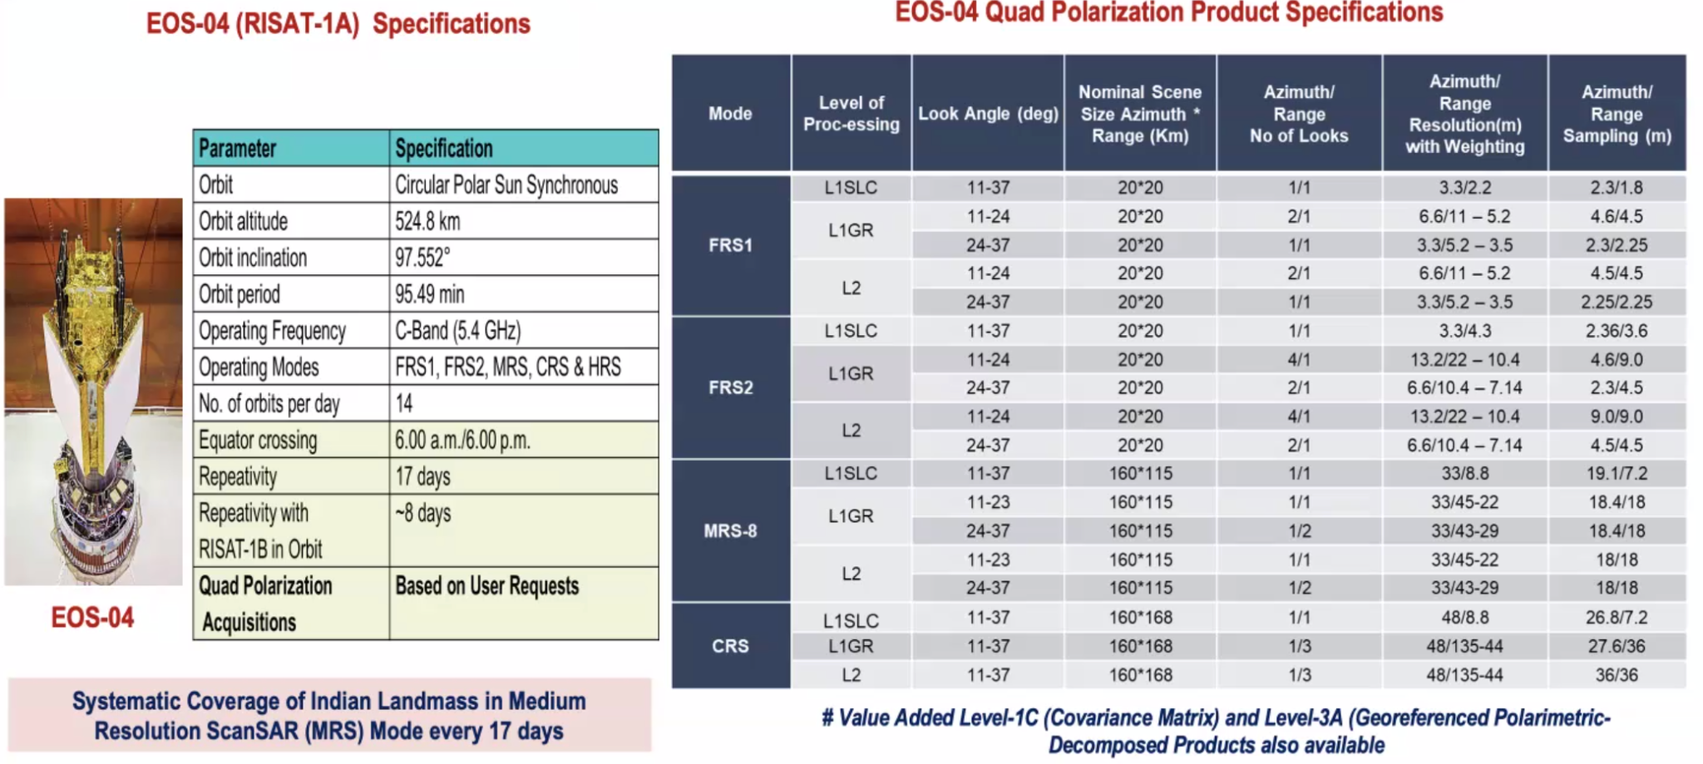
- Data policy for RISAT and NISAR-S are open access from Bhoonhidi policy. Users can also request future acquisition globally, by contacting ISRO.
CSA: RCM [Slides]
Ake reported on behalf of Yves Crevier:
- RADARSAT Constellation Mission (RCM) supports Quad Pol mode, for ad hoc specific acquisitions currently made over JECAM R&D sites.
- Compact Polarisation options are available on every beam mode – systematic acquisitions over the Canadian landmass.
- There is the possibility to request data.
ASI: SAOCOM/Europe & CSK [Slides]
Ake Rosenqvist reported:
- COSMO-SkyMed is an X-Band mission.
- ASI believes it would be possible to acquire quad-pol data for certain sites.
- ASI also operates SAOCOM-1A/1B over the European region. There is room for discussion on this topic, perhaps with ESA through their TPM programme.
- SAOCOM data over Europe would be particularly useful if it was complementary to the other observations. Quad pol would be particularly useful.
Discussion
- A lot of different wavelengths, at different resolutions. Technically, there shouldn’t be any problem in getting different acquisitions over different study sites.
- It could be organised through LSI-VC and WGCV collaboration.
- ICGS-SAR is also another home, but it would be nice to have it have a home in CEOS. A suitable route to feed into a lot of the applications work. There is an enormous potential for pol data, but no demonstrations.
- Looking at the phase differences to get more information.
- Not only about quad pol, but also multi-frequency applications. Need to have observations that are reasonably close in time.
LSI-VC-14-29 | Ake to collate information about sites where QP or compact pol data are being acquired, for communication with the ESA POLINSAR team. | ASAP
LSI-VC-14-30 | Hari Priya to provide input to Ake for LSI-VC-14-29. | ASAP
- Bjorn Rommen (ESA) is attending the WGCV SAR subgroup workshop next week. More to do with level 2 product validation for upcoming missions, but there is overlap in validation sites.
- Next POLINSAR workshop will be in June 2025. It will be an open meeting. USGS would like to learn more about SAR applications. Multi-modal exploitation is an area of interest for USGS.
LSI-VC-14-31 | Dave Borges (CEOS SEO) to share information on the CEOS Analytics Lab (CAL) with the ESA POLINSAR team.  Context: CAL is a potential location to collate CEOS agencies' quad pol acquisitions over to be determined sites and provide an access/analysis capability for science activities. | ASAP
LSI-VC-14-32 | LSI-VC Leads to seek opportunities to raise the ESA POLINSAR Workshop recommendations at the CEOS SIT-39 meeting in April 2024.  The recommendations cover requirements for multi-mission, multi-frequency datasets over supersites, overall increased synergy of satellite systems, and the need for new research sites.  There may be some connection to make with the CEOS biodiversity theme. This should perhaps also be raised alongside ICGS-SAR & LSI-VC discussions. | SIT-39
Session 8 (contd.): Land Surface Observation Continuity, Gap Analyses, Applications
Observation Requirements Analysis, USGS RCA-EO & EORES, GEOGLAM Requirements [Slides]
Steve Labhan (USGS, LSI-VC Co-lead) reported on this response to action LSI-VC-13-21.
- Recalled the set of requirements from GEOGLAM:
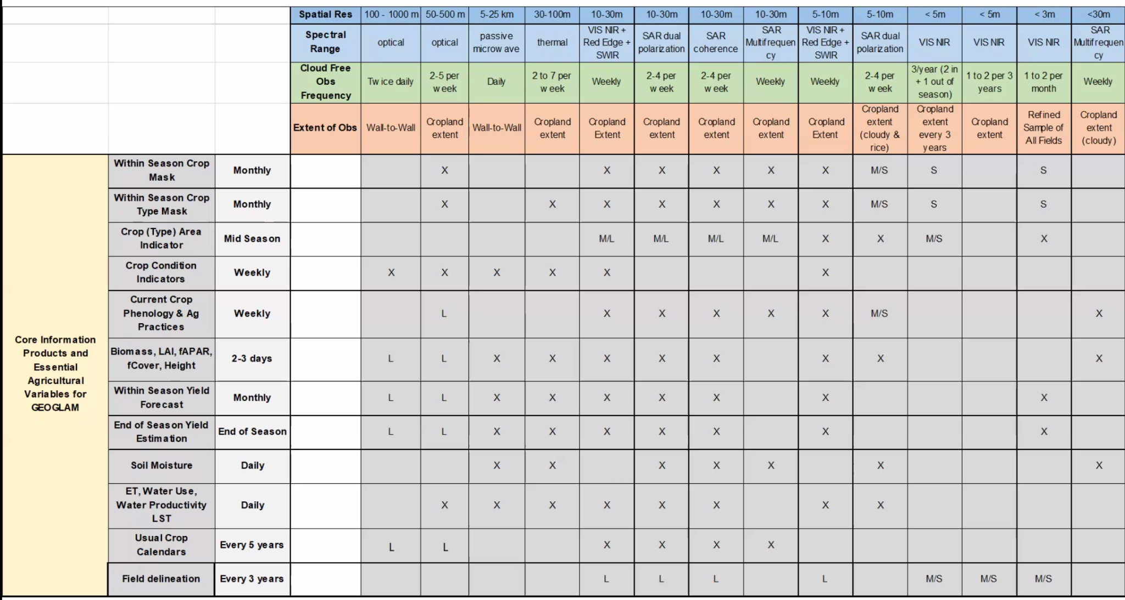
- USGS mapped the RCA user needs to GEOGLAM requirements data:
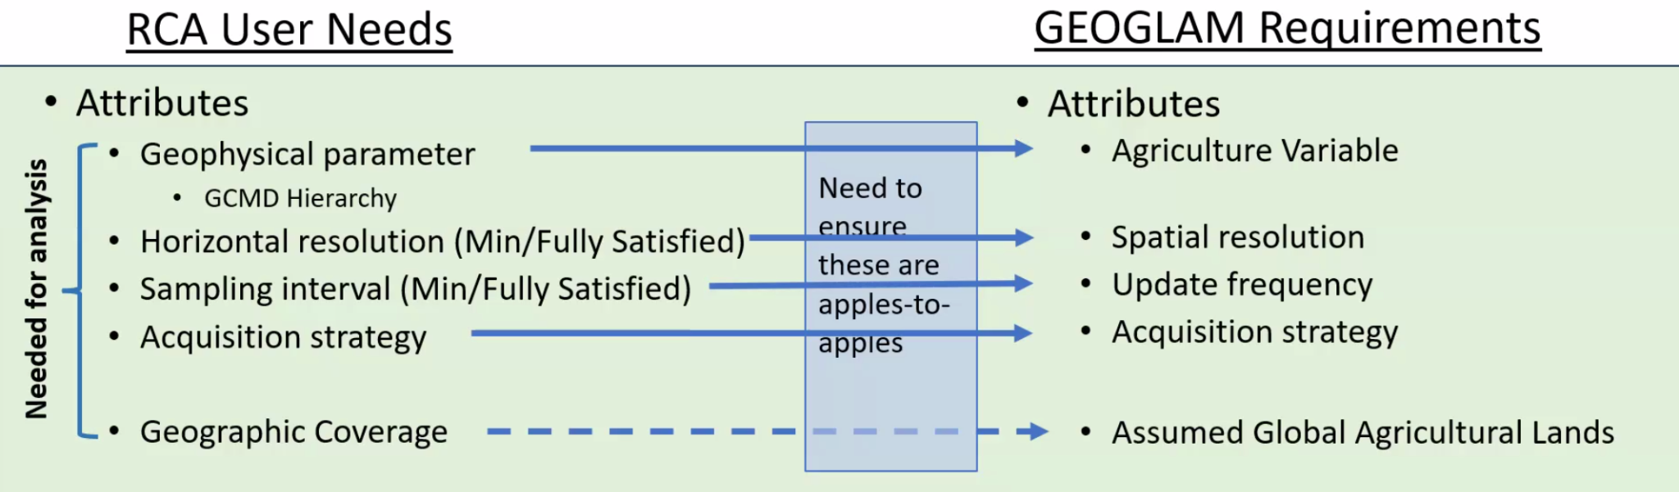
- Don’t make assumptions on the technologies - sensor agnostic. EAV requirements are pointed at radar or optical etc.
- Picked a couple of variables and mapped how the variables aligned.
- Tried to assess the matching of capabilities to user needs.
- Identified core architecture missions, to be used as an example.
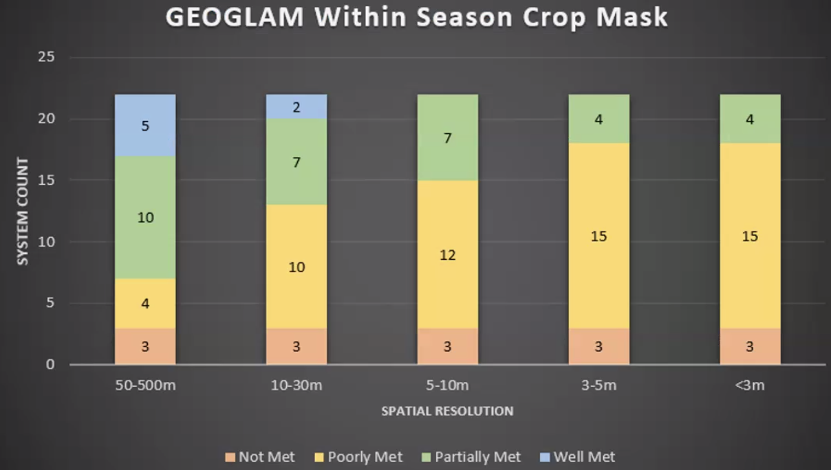
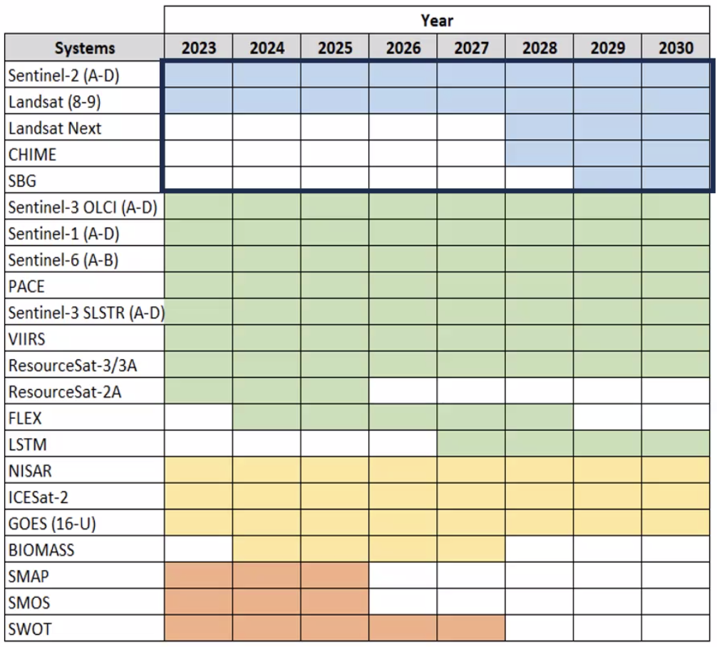
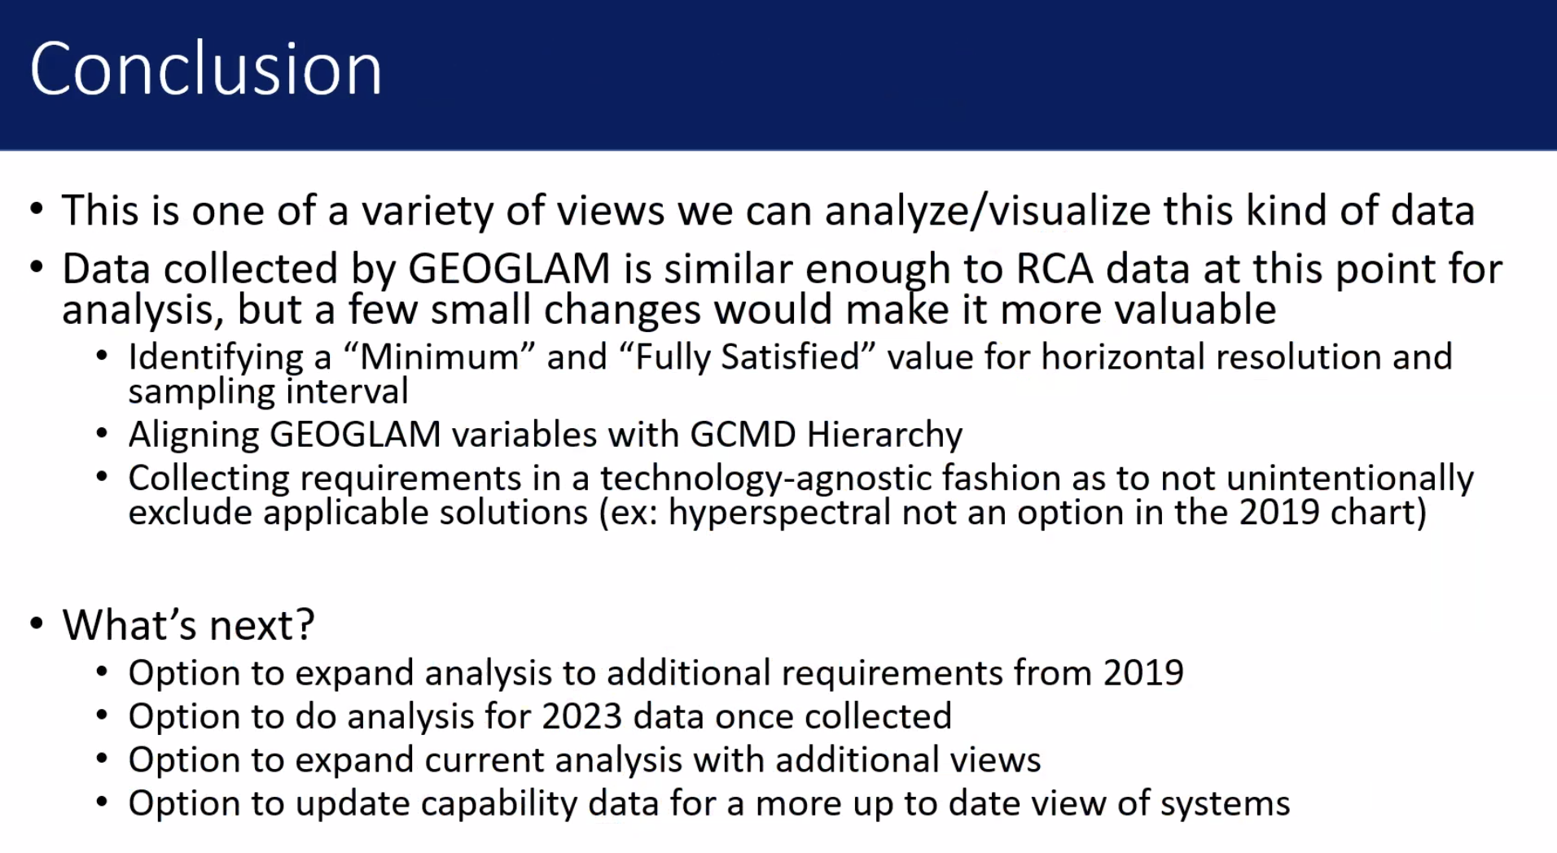
- This presentation was shared with the GEOGLAM team last week.
Alyssa Whitcraft (NASA):
- Land Crop Type Validation meeting, GEOGLAM-WGCV joint meeting was held recently.
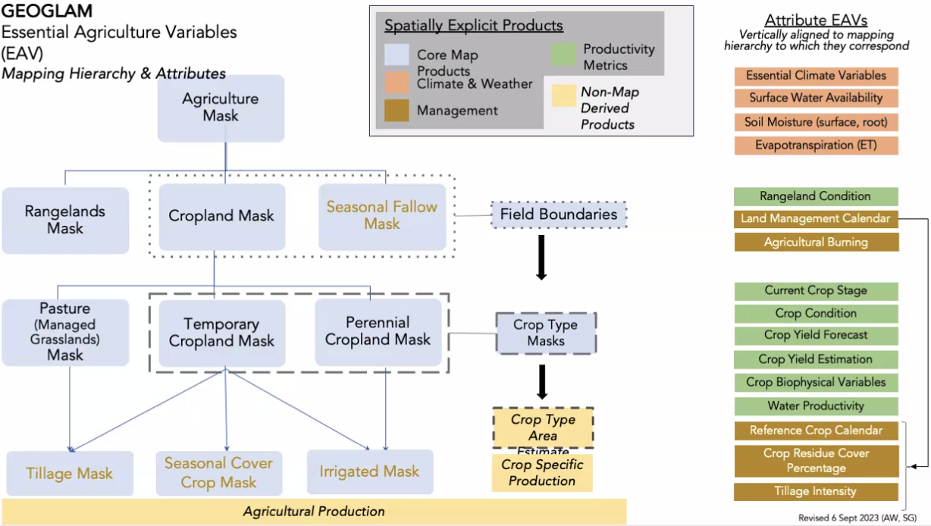
- Use the RCA as the baseline for what CEOS agencies are able to contribute to.
- Need to make use of most observations, and coordinate with agencies to think more broadly in the production of datasets.
- It is important to find the observation requirements and the suitability of the missions to meet these requirements.
- Analyse product quality with cal/val, and then for the actual product development.
- GEOGLAM is often on three year funding and there is no mandate for production. Hoping to change this in future.
Discussion
- In the USGS analysis, there is no guarantee that the products are actually being generated. GEOGLAM will be doing the gap analysis on their side.
- Brian’s team ran a combined observations analysis in COVE.
- Some products are produced by third party companies. Look at products that we have and those that we don’t yet produce. There are things we can add to the current data.
- There are multimodal application challenges - work done on GEOGLAM could help identify where synergies could be defined elsewhere.
- Collecting requirements from user communities in a common way would be useful.
- There are options or opportunities to enhance or improve the products.
- From an LSI perspective, not sure if the tooling is correct. Leveraging the infrastructure to respond to user needs.
- Currently there is no comprehensive database with products and services. It does not necessarily come from the data providers.
- Commercial components to the data, they are keen to build business cases.
- Soil moisture is one of the ECVs - but the requirement is a little different for GEOGLAM.
- Gaps will pop out of the USGS tooling where requirements are not met.
- Can prioritise where there existing methodologies, and operating missions, to meet missing requirements.
- Use the CEOS forum to help articulate the gaps identified.
- EORES is a database which contains all the user needs captured by USGS. Contains all the capabilities from the observation platform. Thought about enhancing this with the products and services also.
- Challenges around search and discovery, pulling together products from multiple agencies is a challenge and is costly.
- LSI-VC is the body to help identify the observation gaps.
- LSI-VC charter to capture user needs. Need a better way to collect these. Should start with an EORES and GEOGLAM example case.
LSI-VC-14-33 | Alyssa Whitcraft (GEOGLAM) will write a short paper on the GEOGLAM observation requirements, the potential use of the RCA EORES system and MIM Database, and clarify possible next steps and specific requests for CEOS agencies.  Additional context: The GEOGLAM use case will inform how LSI-VC might gather, organise and align requirements from other thematic areas and users. Aligning requirements to GCMD Hierarchy / USGS RCA EORES input needs could be efficient. | ASAP
Session 14: Closing Business
Wrap-up
- LSI-VC-15 will be around SIT-39 in Tokyo, Japan. Any preferences can be emailed to Matt Steventon. Matt will share options for the dates.
- The deadline for IGARSS 2024 abstract submission is Sunday, 15 October 2023.
LSI-VC-14-34 | LSI-VC Secretariat to share options for LSI-VC-15 dates around SIT-39 in Tokyo, Japan. | COMPLETE  3-5 April 2024 in Tokyo, Japan. Meeting page.

