Minutes v1.0
Committee on Earth Observation Satellites (CEOS)
Land Surface Imaging Virtual Constellation (LSI-VC)
Satellite Earth Observation Commercial Engagement Workshop
5 April 2024
Hosted by RESTEC / JAXA
Minato-ku, Tokyo

Participants
ESA: Ferran Gascon
GEOGLAM: Alyssa Whitcraft, Sven Gilliams
JAXA: Takeo Tadono, Ake Rosenqvist, Osamu Ochiai*
JAXA/RESTEC: Toshi Kamei, Satoshi Uenuma, Teppei Sato
LSI-VC Sec: Matt Steventon, Stephen Ward, Libby Rose, George Dyke*
NASA: Eric Vermote
SEO: Dave Borges
USGS: Steve Labahn, Tim Stryker, Steve Covington, Chris Barnes, Kelly Bruno
New Space Intelligence: Yumiko Nagai, Dorj Ichikawa, Senzoku Hiroshi, Gaku Saito, Yumiko Nagai
Yamaguchi University: Vaibhav Katiyar, Rosalie Reyes
Tellus: Hideto Yamazaki
Synspective: Gerald Baier, Mauro Mariotti
AxelGlobe: Lukasz Krawczyk, Shimpei Nakano
MRI: Masanori Muto
SkyServe: Harmit Janak Vyas
Oppofields LLC: Akira Mukaida

* indicates online

Meeting Notes
Session 1: Introduction to CEOS, LSI-VC and CEOS Analysis Ready Data (CEOS-ARD)
Welcome from JAXA and the CEOS Land Surface Imaging Virtual Constellation (LSI-VC) Leads [Slides]
Steve Labhan (USGS, LSI-VC Co-Lead) welcomed everyone to this special session of the LSI-VC-15 meeting. CEOS has long wished to engage more with industry on the CEOS-ARD concept and this is an important opportunity for us. Steve looks forward to hearing about the work of the companies present today and seeking opportunities for collaboration.
Takeo Tadono (JAXA) thanked everyone for their preparation and participation and looks forward to fruitful discussions.
Matt Steventon (LSI-VC Secretariat) provided an overview of CEOS and outlined the objectives for today’s session.
LSI-VC Overview and Key Activities [Slides]
Steve Labahn (USGS, LSI-VC Co-Lead) reported:
- CEOS, established in 1984, comprises over 60 Member Agencies and Associate members. It serves as the 'space-arm' of the Group on Earth Observations (GEO) and collaborates closely with GEO to ensure access to space-based Earth observation data.
- LSI-VC has two other co-leads alongside Steve Labahn, Andreia Siqueira (Geoscience Australia) and Peter Strobl (European Commission).
- CEOS-ARD was first developed to reduce the barriers to use of EO data and open up this source of information to new users and applications. Data supply for Data Cubes was a key consideration.
- LSI-VC’s goal is to facilitate coordinated and optimised land surface imaging contributions from CEOS Agencies to enable access to fundamental measurement products in support of confirmed, validated requirements linked to adopted CEOS priorities.
- Alongside the focus on CEOS-ARD, LSI-VC considers approaches to deal with higher-level product needs of thematic communities as well as underlying observation continuity.
- The CEOS-ARD specifications are being moved to GitHub to enable increased coordination with the community and provide a mechanism for direct input.
- CEOS, primarily through LSI-VC, are contributing to the OGC/ISO ARD Standards Working Group, to try and develop a formal standard, building on the foundation of CEOS-ARD.
- Commercial entities are welcome to participate in LSI-VC meetings and telecons.
CEOS Analysis Ready Data (CEOS-ARD) Overview [Slides]
Matt Steventon (CEOS-ARD Secretariat) reported:
- The CEOS-ARD effort started in 2015, aiming to provide clarity and a concrete definition for ‘analysis-ready’ satellite data. The work was also driven by the needs of the Open Data Cube and Digital Earth efforts.
- The goal was to address the needs of ‘non-expert’ users, through provision of sensor agnostic geophysical variables. LSI-VC sought to define key parameters and corrections for different types of geophysical products and ensure documentation, rather than prescribing specific methods.
- Other motivations included reducing pre-processing burden, facilitating cloud-based analysis, minimising data egress and processing costs, establishing a first step for interoperability, and maintaining openness and transparency.
- Current CEOS-ARD specifications include:
  - Combined SAR PFS, which includes Normalised Radar Backscatter (NRB), Polarimetric Radar, Ocean Radar Backscatter (ORB) and Geocoded Single Look Complex (GSLC) specifications.
  - Surface Reflectance
  - Surface Temperature
  - Nighttime Lights Surface Radiance
  - Aquatic Reflectance
- Work is ongoing to produce specifications for Precipitation and Ocean Colour.
- Please visit ceos.org/ard for the current and in-progress CEOS-ARD datasets. The ISRO EOS-4 (RISAT-1A) dataset was successfully assessed as compliant earlier this week.
- A product is assessed as CEOS-ARD via a self-assessment and peer-review process. The CEOS Working Group on Cal/Val (WGCV) reviews the requirements against the self-assessment and sample products.
- All are encouraged to join and contribute to the CEOS-ARD Github. This is a new development, and we are in the process of moving more of the core documents (e.g., specifications) over to Github in a native format to allow for direct contributions to the specifications.
CEOS-ARD for Synthetic Aperture Radar [Slides]
Ake Rosenqvist (JAXA) reported:
- The CEOS-ARD for SAR specification covers Normalised Radar Backscatter (NRB), Polarimetric Radar, Ocean Radar Backscatter (ORB) and Geocoded Single Look Complex (GSLC) products. The team is also currently working on adding Interferometric SAR specifications.
- A suggested metadata specification accompanies the SAR PFS, which if used provides a one-to-one mapping of parameter names between the PFS and metadata. The specifications suggest XML format but other formats are acceptable.
- CEOS-ARD SAR products are provided as gamma0. Some users still prefer sigma0, and would need to include a layer to provide the mapping from sigma0 to gamma0.
- CEOS-ARD for SAR has significantly lowered the bar to entry in the SAR domain.
Session 2: Reports from Japanese Commercial Sector Guests
AxelGlobe (AxelSpace) [Slides]
Lukasz Krawczyk and Shimpei Nakano (AxelGlobe Business Division) reported:
- AxelSpace started in 2008 out of the University of Tokyo and has developed and launched ten satellites.
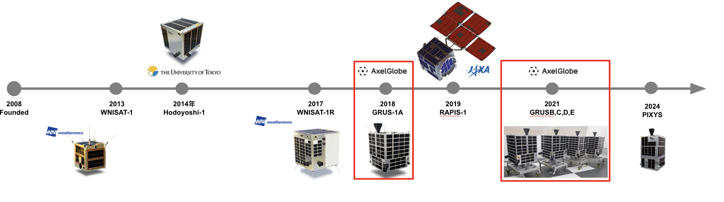
- AxelGlobe is an Earth Observation data and analysis platform produced by AxelSpace.
- The GRUS-1 sensor provides data across five bands in panchromatic and multispectral.
- Standard products include multispectral (radiometric and geometrically corrected), surface reflectance (atmospheric corrected) and true colour Images (pan-sharpened, colour corrected).
- Lessons learned include the importance of machine-to-machine interfaces. Standardised processing levels and metadata are crucial for interoperability. Transparency about the actual product is crucial for customers. Three priority areas are accessibility, interoperability and data quality. Aligning with standards is a good approach to improving all three aspects.
- Data products are delivered as COGs via STAC, which has helped different products be easily integrated, reducing the time and resources needed for data preprocessing and lowering the barrier to entry.
- AxelSpace standards already overlap with CEOS-ARD standards and they would like to move forward with an assessment. Perceived benefits of aligning with CEOS-ARD include interoperability across various missions and easier data comparison, combination, and analysis of data from different sources.
- AxelSpace data has undertaken third party evaluations with EDAP and FLARE.
- The goal is to close the gap between government and commercial missions when it comes to data quality and maximise interoperability between next generation GRUS and Sentinel-2 / Landsat Next, including data characteristics, spectral range and accuracy.
- The calibration and validation methods include both on-ground instrument calibration and regular on-orbit calibration.
Discussion
- Steve Labahn (USGS, LSI-VC Co-Lead) appreciated AxelSpace’s prioritisation of data accessibility.
- Ferran Gascon (ESA) asked about the algorithm used for atmospheric correction. It was noted that the algorithm is not public yet but is based on the MODIS algorithm. It is an in-house algorithm that compares results with Landsat and Sentinel.
- Ake Rosenqvist (JAXA) asked whether the results are published in peer reviewed journals. It was noted that AxelSpace has not published these yet but appreciated the suggestion.
- Steve Covington (USGS) talked about the transparency of quality metrics and noted that USGS is seeking commercial datasets that are complementary to government missions. Consistency with atmospheric correction is important. Steve asked if coincident acquisitions or other intercomparison activities are conducted with other AxelSpace missions or government missions.
- Transparency is maintained by providing descriptions of some of the algorithms in the EDAP report available online, along with details about radiometric, spectral and spatial aspects of the data.
- In terms of cross-calibration, after the launch of GRUS-B, C, D, E efforts were made to speed up the provision of data to customers. It can take up to two weeks to fly over all the RadCalNet sites. To enhance data quality, observations were conducted alongside Sentinel and Landsat, enabling the publication of data in just a few days. Regular calibration activities focus mainly on using the RadCalNet sites for absolute calibration, despite significant differences in the spectral ranges of the satellites.
- Ensuring consistency throughout an orbit and over time is a significant aspect of data quality. Right after launch, some degradation in quality was observed. To address this, on-orbit calibration is performed every couple of weeks, sometimes more frequently. The aim is to maintain the error within a few per cent during the mission lifetime.
- Steve Covington mentioned the implementation of CEOS-ARD and asked if AxelSpace had run into any issues with the specifications.
- It was noted that AxelSpace is in the process of familiarising itself with the process and reviewing the document and other assessments from data providers. AxelSpace is adjusting the development plan for the next generation of GRUS to be compliant. There is no feedback received as of yet. However, the documentation is easy to understand and follow.
New Space Intelligence [Slides]
Yumiko Nagai and Dorj Ichikawa reported:
- New Space Intelligence (NSI) was established in November 2021 and is based in Yamaguchi prefecture.
- The company currently employs a total of 18 individuals.
- NSI has established partnerships with AxelSpace to expand the use of satellite images and with Labsphere to develop Analysis Ready Data products.
- NSI has signed an MOU with the Asian Institute of Technology to develop scientific research and educational cooperation and promote friendly relations between the two parties.
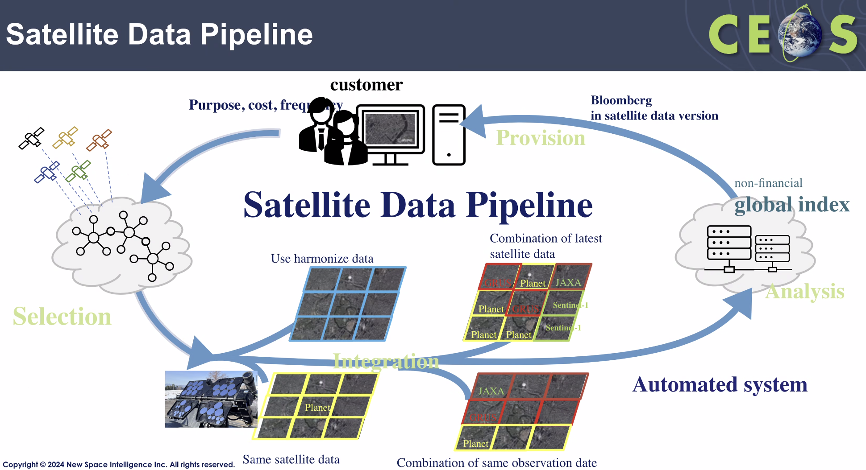
- NSI is developing various applications using satellite data, including for agriculture, sediment transfer, disaster monitoring, illegal dumping, forest monitoring, infrastructure, and remote island surveillance.
- NSI is performing analysis following the earthquake in Noto on 1 January 2024.
- The satellite data in the NSI pipeline are processed with radiometric, atmospheric, geo-registration and gridding to generate a single time-series of multi-satellite data (GRUS, Landsat, Sentinel-2 and other satellite data products).
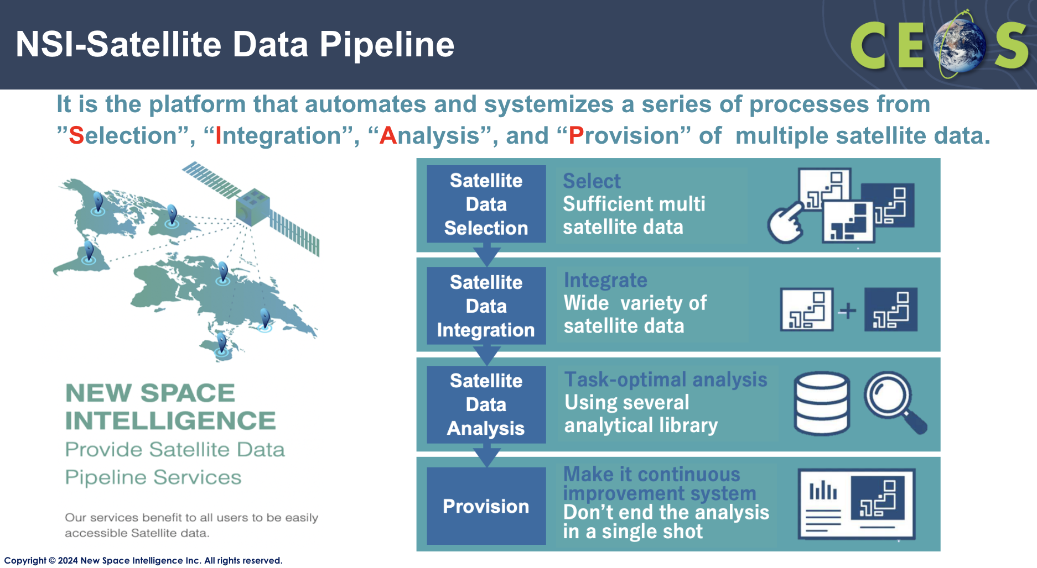
- CEOS RadCalNet sites are used for calibration and validation of multi-satellite data.
- NSI has a series of mirror reflectors used for satellite data integration, located at Ube, Yamaguchi, Japan.
- The sensor-specific radiometric, spatial, spectral and geometric resolutions are adjusted and removed, which allows for the production of interoperable data which can be combined from multiple sensors into a single seamless time series.
Discussion
- Matt Steventon (LSI-VC Secretariat) noted the potential of CEOS-ARD specifications to a data / analytics company like NSI. If NSI were to adopt CEOS-ARD as a requirement of its data providers, it would provide a clear, consistent baseline target and simplify the data ingestion process for NSI. Matt suggested matching the NSI ARD requirements to CEOS-ARD for mutual benefit.
Synspective [Slides]
Gerald Baier reported:
- Synspective is a Tokyo-based startup that develops and operates small SAR satellites.
- StriX is the satellite series developed by Synspective. It is a 125 kg small satellite, measuring 0.7 m³ at launch (packed).
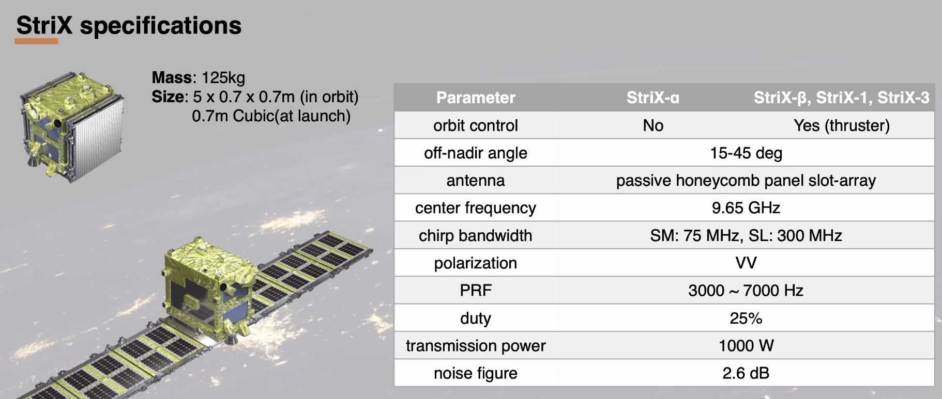
- Synspective has launched four StriX satellites, with the first (StriX-alpha) no longer operational.
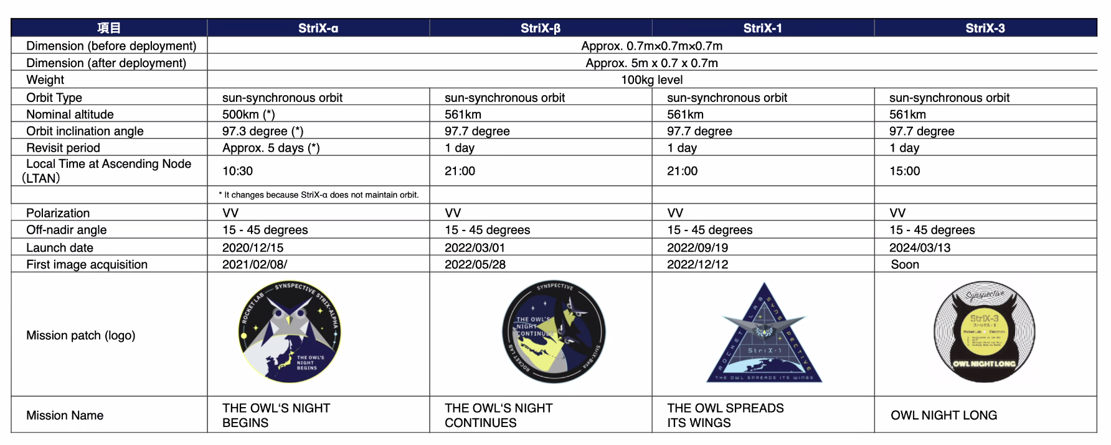
- The satellites operate in StripMap (20x50km, 3m resolution) and Sliding Spotlight (10x10km, 1m resolution) modes.
- Presented initial work with InSAR at Fringe 2023.
- Efforts are underway to work towards ARD. Undertaking calibration efforts, assessing file formats and metadata standards (CEOS, SICD and IEEE). Compatibility with 3rd party software is also important. There is ongoing testing with GAMMA, SARscape and SNAP.
- Synspective is mostly relying on two calibration sites: the Amazon rainforest for radiometric accuracy and pointing error elevation, and the Rosamond corner reflectors for resolution and geometric accuracy.
- The short-term goal is to provide regular and frequent calibration reports.
- Appreciated the documentation for the CEOS-ARD SAR specifications.
- Synspective will need some time to become compliant with the CEOS-ARD and would need to evaluate the impact of the StriX baseline accuracy.
- Synspective is excited about Geocoded SLC and is interested in CEOS suggestions for file formats, as there are many to choose from.
Discussion
- Ake Rosenqvist (JAXA) was impressed to see how far Synspective has come in just a few years. Ake mentioned that the CEOS-ARD specifications were primarily developed with CEOS missions in mind, and as such Synspective feedback would be particularly valuable. Ake expressed interest in collaborating to improve the specifications to better cater to Synspective's requirements, particularly regarding radiometric terrain correction at resolutions around 1 m.
- Regarding data volumes, it was suggested that processing on the fly could allow users to select specific per-pixel data layers as needed.
- In terms of file formats, for L2, which corresponds to the CEOS-ARD level, there are currently no specific requirements. It was suggested that COG could be recommended, as it is the most common format for higher-level products.
- USGS uses HDF 4 and 5 for Level 0, while ESA archives data in Zarr format and also uses COG for higher levels.
- LSI-VC is exploring how to best provide file format guidance, since it appears this would be a useful contribution to the community. This will also be addressed within the CEOS Interoperability Framework.
Tellus [Slides]
Hideto Yamazaki reported:
- Tellus is a satellite data platform initiated by the Japanese government. The mission is to “create new value through Space and Information Technology”.
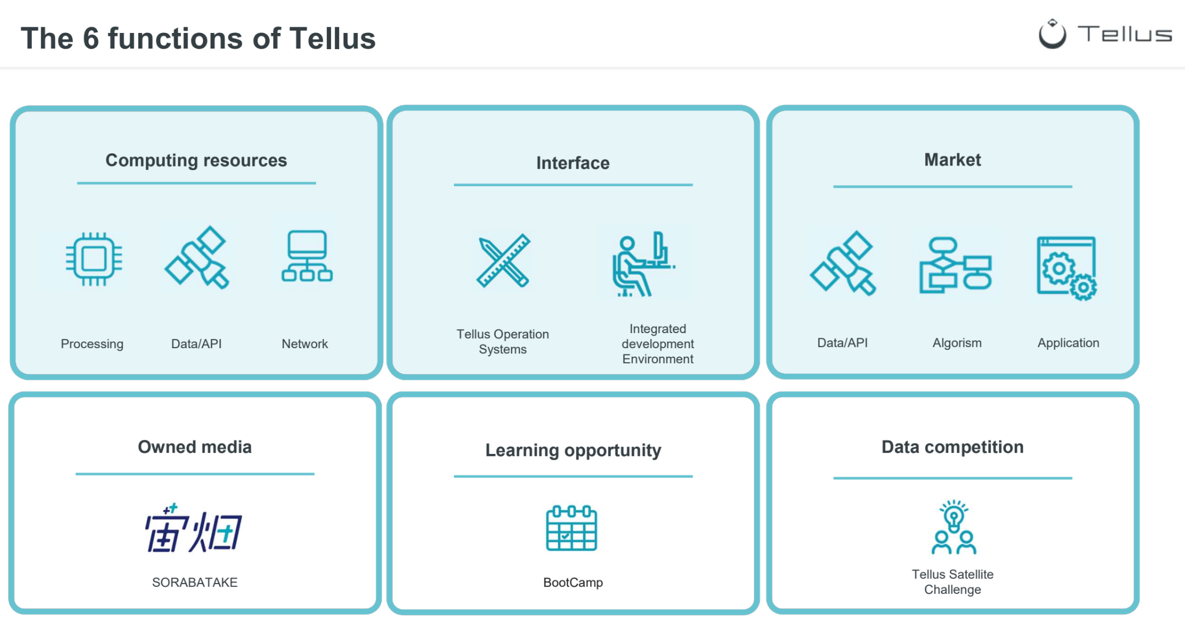
- As of today, there are over 37,000 registered customers, which has increased from 5,800 in February 2018.
- A variety of satellite data is available from Japanese satellites. The primary data provided by Tellus are the Japanese satellite data from JAXA and MEXT.
- Tellus provides services for software, platform, data and infrastructure.
- Platform as a service (PaaS) allows users to discover, store and analyse satellite data.
- Over 200 satellite datasets are available through the Tellus API.
- There are three Software as a Service (SaaS) offerings: TelluSAR for SAR data, Tellus VPL for identifying parking lots, and Tellus Satellite Data Master + QGIS, which can provide satellite data, analysis tools and computing resources.
- Signed an agreement with the EU regarding the exchange data between Tellus and the European Commission-operated Copernicus. Aims to encourage cooperation on data processing for common use and development of services in fields such as monitoring of marine and coastal areas, climate, water resource management, and disaster risk reduction.
Discussion
- Steve Covington (USGS) asked about the distribution of GOSAT data and how it functions. Tellus is currently in discussion with the Ministry of Environment regarding the best way to display the data. Tellus will store and provide the data. Tellus will not be the sole distributor, as the Ministry of Environment and the National Research Institute would also provide the data.
- Ake Rosenqvist (JAXA) asked about the link to QGIS and how it integrates with the data. It was noted that users can access QGIS through a remote desktop and browse the data hosted next to the processing capacity.
Session 3: Discussion on Collaboration Opportunities
CEOS Analytics Lab Interoperability Demonstrator [Slides]
David Borges (CEOS SEO, NASA) reported:
- NASA, as a contribution to CEOS, provides the Systems Engineering Office as a fundamental support service.
- In response to a need for CEOS project collaboration at a technical level, the CEOS Earth Analytics Interoperability Lab was developed. This platform is now known as the CEOS Analytics Lab (CAL). The CEOS Analytics Lab is an implementation of CSIRO’s Earth Analytics Science and Innovation platform (EASI). It is a combination of several open-source projects, including JupyterHub and Open Data Cube. It runs on AWS and implements Dask scaling.
- In 2023, CEOS established a temporary New Space Task Team, to gather experiences from across the CEOS Agencies. A white paper was delivered, which included some recommendations. One of the deliverables was for the SEO to demonstrate the integration of New Space data into CEOS Analytics Lab and evaluate its interoperability with common CEOS datasets.
- On the optical side, the satellites being considered as a starting point are Landsat 8, 9, Sentinel-2, Maxar, Planet Planetscope and DESIS. For SAR, Sentinel-1, ALOS, Umbra, ICEYE and Capella are being considered.
- The goal of this work is to improve understanding of commercial image quality as compared to public imagery datasets and evaluate cross-platform interoperability and accessibility of commercial datasets.
Discussion
- Ake Rosenqvist (JAXA) highlighted interest in ingesting commercial data into the system and testing data from the companies present at the meeting today.
- The concept of establishing a background mission using the commercial data being presented today was discussed. While noting that the main driver for commercial data is for paying customers, there will inevitably be a lot of orbits where there are no paid requests. Collecting data when there are no other requests would provide an opportunity to gather time series of data and help in building a useful archive. This could be a good collaboration between the companies present today and CEOS. The mission does not have to be a global mission. Example of TerraSAR-X was provided noting that even with only 3 minutes of duty cycle, it was used to collect a DEM over time.
- AxelSpace mentioned using additional capacity to build archive and regular calibration site captures.
- Synspective is also interested in building archives, in particular for disaster response, although they are stretched for capacity.
- There was a brief discussion on approaches for de-orbiting and sustainable operation. AxelSpace noted that satellites have propulsion to deorbit at End of Life (EOL). Tech demo was launched a couple of weeks ago which carried wings to create drag and deorbit. Synspective noted that the alpha-beta missions did not have deorbit specific propulsion, but alpha has already deorbited safely. The antenna was rotated to create drag.
Summary of Findings and Opportunities
Matt Steventon (LSI-VC Secretariat) reported:
- The summary of today’s discussion will be reported to CEOS leadership at next week’s SIT-39 meeting.
- Tim Stryker (USGS) emphasised that these engagements are very important for all of us. It is important for products to be complementary for everyone’s benefits. Tim thanked everyone for participating.
- Ferran Gascon (ESA) thanked everyone for participating and sharing their work. Ferran looks forward to collaborating further, on CEOS-ARD as well as in a broader sense.
- Steve Labhan (USGS, LSI-VC Co-Lead) noted the important role space agencies play in ensuring data quality, particularly in the context of new space. He highlighted ongoing forums for commercial engagement, such as JACIE and VH-RODA, as well as the ARD2x workshops organised by the commercial sector.
- AxelSpace welcomed the GitHub initiative as an opportunity for direct contribution and expressed interest in participating in the virtual LSI-VC meetings to get status updates and discuss updates on the specifications.
- Ake Rosenqvist (JAXA) mentioned that CEOS also has a Working group on Cal/Val (WGCV) with different subgroups for optical and SAR sensors. WGCV Subgroups are open for participation from the whole community. Matt and the LSI-VC leads can help point people in the right direction.
- The WGCV SAR subgroup will meet in India in 2024. There will be some informal meetings, presenting outcomes from cal/val activities, and joint use of calibration sites.
- There is the possibility of a follow-up session to today in Tokyo in March/April 2025, since JAXA is serving a two-year term as CEOS SIT Chair at the moment.

