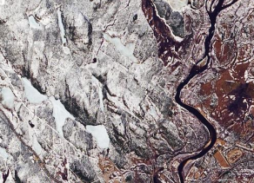
CEOS Analytics Lab & Commerical
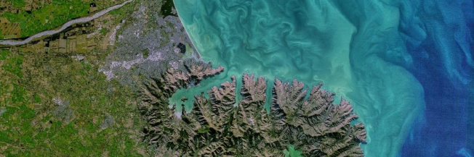
Interoperability
Study
David Borges
Systems Engineering Office
Committee on Earth Observation Satellites
NASA Earth Science Division
LSI-VC-15 Agenda 3.1
05 April 2024
CEOS Earth Analytics Interoperability Lab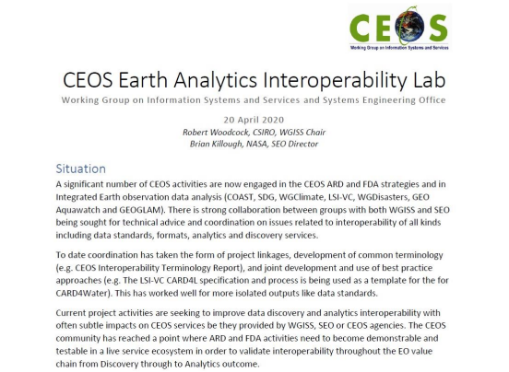
Slide 2
CEOS Analytics Lab c e o s . o r g / c a l
Slide 3
Analytics Lab Architecture
❖Analytics Lab is an implementation of CSIRO’s Earth Analytics Science and Innovation platform (EASI)
❖Combination on several open-source projects:
▪ JupyterHub
▪ Open Data Cube
▪ AWS
▪ Dask scaling
❖Scales individual user environments on demand.
❖Analysis can scale beyond the user environment using Dask workers that are used only when the analysis is run.
Slide 4
Commercial Interoperability Project • CEOS New Space Task Team (NSTT) Deliverable
D5) SEO should demonstrate the integration of New Space data into CEOS Analytics Lab and evaluate its interoperability with common CEOS datasets.
• Optical
• Landsat 8, 9
• Sentinel-2
• Maxar
• Planet Planetscope • DESIS
• SAR
• Sentinel-1 • ALOS
• Umbra
• ICEYE
• Capella
Slide 5
Commercial Interoperability Study Value ❖ Importance:
▪ Improve understanding of commercial image quality as compared to public imagery datasets
▪ Evaluate cross-platform interoperability and
accessibility of commercial datasets
▪ Explore challenges of working with data from both commercial and public platforms
▪ Understand workflows necessary to incorporate multiple data sources
▪ Provide a foundation of knowledge to promote increased use of commercial data
▪ Formulate future recommendations for guiding CEOS policy regarding commercial data
▪ Test usage on the CEOS Analytics Lab (CAL) and the Open Data Cube
▪ Delineate Interoperability of Systems vs Data
Slide 6
CEOS-SEO Preliminary Interoperability Analysis Sources
❖ Level 2A Data (Monthly Comparisons, 2018-Present):

Commercial Platforms Public Platforms
Planet Dove/SuperDove | Landsat 8/9
Maxar WorldView-02/03 | Sentinel 2
Teledyne DESIS | HLS

❖ Cal/Val Sites
Cal/Val Sites Northern Hemisphere _{Radiometric} Railroad Valley Playa (Nevada, USA) | Southern Hemisphere  Gobabeb  (Namibia, Africa)
Lake Ponchartrain  Spatial  Causeway  (Louisiana, USA) | Suramadu Bridge  (Indonesia, Asia)

Railroad Valley Lake Pontchartrain
Bridge Gobabeb
Suramadu Bridge
Slide 7
Commercial Interoperability Project • Technical Approach
• Data Access
• Evaluate use of commercial providers APIs (not all include API access) • Implement APIs to access data
• Data Loading
• Generate ODC indexing scripts for each commercial provider • Create demo indexer notebooks
• Analysis / Visualization
• Build notebooks evaluating:
• Pixel-by-pixel scatter plots comparing individual bands
• Inherent harmonization evaluation
• Resampling analysis
• Band to band spectral comparison
• OUT-23-05/06: NASA/ESA Mission Quality Assessment Framework Guidelines (optical & SAR)
Slide 8
Commercial Interoperability Project• Key Considerations and Challenges (Optical)
• Sensor Variation
• Impacts spectral band alignment, spatial detail, signal strength • Processing Biases
• Differences in atmospheric correction and vendor-specific sharpening will influence direct comparisons
• Situational Factors
• Slight time offsets and viewing geometry differences create irreducible limitations
• Commercial data compliance with CEOS-ARD PFS
Slide 9
Commercial SAR – SEO Assessment
Increase in small commercial “New Space” SAR companies
❖ X-band SAR systems
❖ Light-weight, low cost
❖ Large satellite constellations (10~50 satellites) ❖ Very high spatial resolution (0.2~2 m)
❖ Very high temporal revisit capacity (daily/sub-daily) ❖ Main market segment: defence, security
❖ Targeted observations per user requests
❖ Strategic background observation plans - probably not
Current (SAR) actors:
❖ Capella Space (USA) [9] ❖ ICEYE (Finland) [32] ❖ iQPS (Japan) [3]
❖ Synspective (Japan) [2] ❖ Umbra (USA) [7]
❖ Others?...
Image credit: Synspective Image credit: iQPS Image credit: ICEYE Image credit: Capella Image credit: Umbra
Slide 10
Commercial SAR – SEO Assessment SEO assessment (sample data)
❖ Data quality
▪ Geometry, Radiometry ❖ User friendliness
▪ Product levels
▪ Documentation
❖ Data accessibility
▪ Sample data
▪ Data for purchase
❖ CEOS-ARD
▪ Interest & relevance in providing CEOS-ARD product levels
▪ Mock (self-)assessment of sample products ❖ CEOS Analytics Lab (CAL)
▪ Feasibility for inclusion of sample data ▪ Additional processing?
Image credit: Synspective Image credit: iQPS Image credit: ICEYE Image credit: Capella Image credit: Umbra
Slide 11
CEOS Community Cal/Val Preliminary Findings & Opportunities
Preliminary Findings:
❖ Most commercial data doesn’t meet threshold CEOS ARD requirements
❖ CEOS Cal/Val Portal
▪ Some information is deprecated
▪ Could use improved navigation clarity and page overviews
❖ RadCalNet only has manual data access
❖ Clarity on commonly accepted CEOS standards and practices for Calibration and Validation
❖ Only one high resolution spatial test target on ECCOE - Baotou test site
Cal/Val Opportunities:
❖ Addition of API access to RadCalNet ❖ Development of automated Cal/Val systems based on CEOS approved methods
Commercial Data Opportunities: ❖ Work with commercial providers to conform with CEOS ARD Standards ❖ Work with providers to better document their calibration and validation processes
❖ Continue developing tools to index commercial data on the ODC
Slide 12
CEOS Outreach Efforts
• SatSummit 2024
• Washington, D.C.
• 16-17 May
• IGARSS 2024: CEOS Booth • Athens Greece
• 7-12 July
Slide 13

