CEOS LSI-VC Subgroup on GEOGLAM

**1. Brief History 1**

a. GEOGLAM’s Organization 1

b. Relationship with CEOS (2012-2019) 2

c. The LSI-VC Subgroup on GEOGLAM (2019-Present) 2

**2. Goals of GEOGLAM vis-à-vis CEOS (2023 - Present) 3**

**3. The Role of the LSI-VC and its Subgroup on GEOGLAM 3**

a. Constitution of the LSI-VC Subgroup on GEOGLAM 4

**4. Priorities: 2024-2025 5**

**5. Appendix 7**

**6. Version History 10**

# Brief History

## GEOGLAM’s Organization

GEOGLAM, established in 2011 by the G20 Agriculture Ministers as a part of their action plan on food price volatility, has as its overarching goal to improve the international capacity to use satellite data to generate timely, accurate, transparent, and relevant information on crop condition and early forecasts of crop production. The G20 Agriculture Ministers have reaffirmed their support for GEOGLAM every year since 2016, and GEOGLAM has expanded both its national and regional policy relevance as it supports food security early warning and response, national agricultural statistics, agricultural commodity monitoring for markets and trade analyses, and agricultural sustainability and climate adaptation and mitigation.

GEOGLAM’s Secretariat has received support over time from ISRO (India), INPE (Brazil), the French Ministry of Agriculture, Agriculture and Agri-food Canada, NASA (USA), UK Department for Environment and Rural Affairs (DEFRA), and and the German Ministry of Food and Agriculture. GEOGLAM has an Executive Committee which steers the work of the program and which is led by a set of Co-Chairs, of which there are currently four: Wu Bingfang (China), Bettina Baruth (European Commission - Joint Research Centre), Chris Justice (University of Maryland, USA), and Jana Plogmann (The German Ministry of Food and Agriculture). The activities which comprise GEOGLAM are principally supported by in-kind contributions from space agencies, ministries of agriculture, research centers, universities, and others. Central to this effort is **Earth Observation Data Coordination**, which it executes in partnership with CEOS.

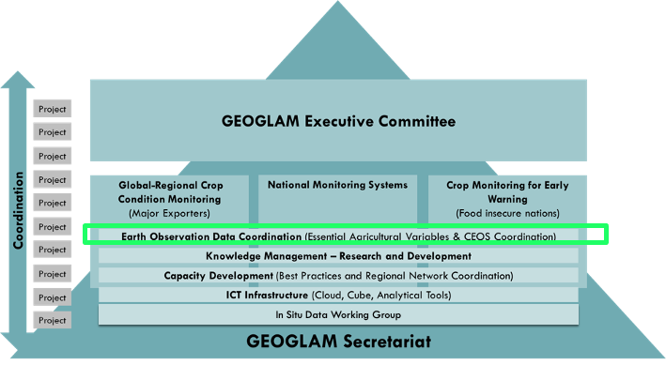

Figure 1: GEOGLAM Programme Schematic, with the cross-cutting EO Data Coordination area of effort highlighted in a green box

## Relationship with CEOS (2012-2019)

The relationship between CEOS and GEOGLAM began in 2012 in the form of the CEOS Ad Hoc Working Group for GEOGLAM, which was established to respond to the space-based Earth observation (EO) data needs set forth by GEOGLAM. From 2013-2015, the Ad Hoc Working Group (AHWG) annually prepared a CEOS Strategic Response to GEOGLAM Requirements document, for CEOS Plenary’s endorsement, which focused on the requirements for satellite data acquisition only. Beginning in 2015, the activities of the group broadened to cover more activities, including fostering strategic relationships and promoting and facilitating data access, data availability, and data utilization. These issues include legal barriers (i.e. restricted datasets), financial barriers (i.e. costs associated with data purchase or re-processing), connectivity and computational barriers, and utilization barriers (i.e. lack of human capacity, low data quality due to calibration/validation or geolocation errors, or lack of interoperability).A detailed accounting of the activities of the Ad Hoc Working Group can be found in the Appendix.

## The LSI-VC Subgroup on GEOGLAM (2019-Present)

In 2019, the AHWG was officially retired and **GEOGLAM’s permanent CEOS home was established as a Subgroup within the CEOS Land Surface Imaging Virtual Constellation (LSI-VC).** That same year, GEOGLAM launched a substantial initiative on the Essential Agriculture Variables (EAVs; See Appendix for Figures), which fell within the “EO Data Coordination” cross-cut of GEOGLAM (Figure 1). GEOGLAM’s internal focus on characterizing the EAVs, coupled with the global delays of the COVID-19 pandemic, meant that GEOGLAM did not make explicit requests of CEOS until 2024 when the EAVs reached a level of maturity for larger CEOS engagement.

# Goals of GEOGLAM vis-à-vis CEOS (2023 - Present)

While GEOGLAM’s core information products for the G20 are operationally met in the form of the monthly publication of the GEOGLAM Crop Monitor for the Agricultural Market Information System (AMIS), the GEOGLAM Crop Monitor for Early Warning, and the emerging GEOGLAM Global Crop Monitor, there remain opportunities to strengthen the use of satellite data in agricultural applications from the local to national to global scale and as they relate to national statistics, sustainability, climate adaptation and mitigation, and disaster risk reduction. With CEOS as “the space arm of GEO” since 2005, it remains a vital partner uniquely situated to resolve issues related to space data access, adoption, and sustained use that are experienced by GEOGLAM in fulfilling its national and global policy mandates.

**The goals of GEOGLAM vis-à-vis CEOS include:**

* Document satellite data and ground observation requirements relevant to GEOGLAM’s EAVs and community requirements;
  + Identify each agency’s current and planned contribution to EAVs - spanning research and development to tool development to operational product provision;
  + Identify current and planned capabilities and gaps in satellite observations relevant to generating the EAVs;
    - Develop methods and coordinate individual agency research and development efforts;
* Identify opportunities and address challenges for easing access to and utilization of (multi-mission) satellite data in the production of EAVs, particularly in the era of distributed or cloud computing;
* Collaborate on “good practices” for validating EAVs;
* Develop guidelines for the collection of calibration and validation data for EAVs;
* Coordinate with biodiversity, water, climate, and other adjacent communities on Essential Variables to maximize synergies and efficiencies, and to avoid duplication of effort;
* Maximize opportunistic joint efforts around capacity development for using satellite data for agriculture assessment and monitoring;
* Frame and facilitate relationships with the commercial space sector.

# The Role of the LSI-VC and its Subgroup on GEOGLAM

LSI-VC’s Terms of Reference lay out the purpose of sub-groups to be focusing on “data acquisition and user requirements… [and] associated strategies for their thematic areas (last accessed 9 Sep 2024),” with the sub-groups approved by the CEOS Strategic Implementation Team (SIT) Chair through recommendation of the LSI-VC co-leads and the prospective sub-group leadership. Many of the above goals fall within the realm of LSI-VC, although several activities implicate other CEOS bodies. As LSI-VC is the organizational home of GEOGLAM within CEOS, GEOGLAM looks to LSI-VC to support these relationships and for advice on how to reach the most success with other groups and the CEOS agencies.

The GEOGLAM Sub-Group between 2019-2023 did not have formal membership or a formal meeting schedule, instead becoming a discussion and action area specifically within the main LSI-VC. In April 2024, GEOGLAM presented to the CEOS SIT a case for renewing and deepening CEOS engagement in GEOGLAM, with the EAVs providing an organizing framework for the work to be undertaken together (Figure 2). Simply put, GEOGLAM - and therefore CEOS and its agencies - cannot be as impactful in agriculture and food security without the active contribution of space agency capabilities in the forms of missions, knowledge, expertise, resources, etc. Accordingly, CEOS SIT-39 adopted two actions related to GEOGLAM, one which pertains to agencies identifying points of contact to the LSI-VC Subgroup on GEOGLAM (SIT-39-05) and one which pertains to the broader visibility of GEOGLAM and Agriculture in CEOS (SIT-39-06). These are summarized in Table 1.

**Table 1:** Actions from SIT-39 (Tokyo, Japan) related to GEOGLAM

| **Action ID** | **Deadline** | **Action & Rationale** |
| --- | --- | --- |
| SIT-39-05 | June 2024 | **Action**: CEOS Agencies to identify points of contact to contribute to the LSI-VC Subgroup on GEOGLAM.  *Rationale: At SIT-39, GEOGLAM asked CEOS for greater CEOS agency-wide support for the EAVs and to reinforce CEOS agency representation and contributions in the GEOGLAM Subgroup of the LSI-VC to facilitate both of these objectives.* |
| SIT-39-06 | June 2024 | **Action**: SIT Chair to confer with LSI-VC and its GEOGLAM Subgroup leads regarding the visibility of CEOS Agriculture activities.  *Rationale: There is a need to ensure that agriculture continues to be suitably represented in the CEOS organization, meeting agendas, and three-year work plans.* |

## Constitution of the LSI-VC Subgroup on GEOGLAM

Maximum impact will be realized in the Subgroup when there is participation from agencies with both observation expertise (e.g. mission, sensor, cal/val, status) as well as agriculture expertise (e.g. program director for agriculture area), acknowledging that not all agencies will have both points of contact available and can still meaningfully contribute to the group. Additionally, the EO Data Coordination leads from GEOGLAM will also contribute to the Subgroup and provide guidance and priorities from the GEOGLAM perspective.

The LSI-VC Subgroup on GEOGLAM has only had one space agency lead since it was started in 2019: NASA. An objective once the Subgroup is constituted will be to identify the roles and responsibilities of Subgroup leadership, should it be necessary.

Current Points of Contact for LSI-VC and its Subgroup on GEOGLAM are in Table 2.

**Table 2: Current Points of Contact for the LSI-VC Subgroup on GEOGLAM**

| **Agency** | **LSI-VC Agency Lead** | **Agency Lead for GEOGLAM Subgroup - Observations Expertise** | **Agency Lead for GEOGLAM Subgroup - Agriculture Expertise** |
| --- | --- | --- | --- |
| *GEOGLAM* | *-* | *-* | *Alyssa Whitcraft (GEOGLAM Secretariat - Programme Scientist)* |
| *GEOGLAM* | *-* | *-* | *Sven Gilliams (GEOGLAM Secretariat Director)* |
| USGS | Chris Barnes |  |  |
| Geoscience Australia | Andreia Siqueira |  |  |
| EC/JRC | Peter Strobl |  |  |
| JAXA | Takeo Tadono |  |  |
| Canadian Space Agency |  |  |  |
| DLR |  |  |  |
| ESA | Ferran Gascon |  | Zoltan Szantoi |
| ISRO |  |  |  |
| Korea Aerospace Research Institute |  |  |  |
| NOAA | Jerry Xiwu Zhan |  |  |
| UKSA |  |  |  |
| VAST/VNSC |  |  |  |
| NASA |  |  |  |
| CSIRO | *are they on LSI-VC??* |  |  |

# Priorities: 2024-2025

In line with the actions from SIT-39 (Table 1) and the Goals stated herein, top priorities for the LSI-VC Subgroup on GEOGLAM include:

* Identifying engaged/active points of contact for each agency within GEOGLAM (SIT-39-05);
* Confirming the broader relationships between GEOGLAM and CEOS (SIT-39-06; Figure 2);
  + Confirming Terms of Reference for the LSI-VC Subgroup and the relationships, adding missing information related to membership, leadership, meetings, and milestones, as needed.
* Convening a workshop - with substantial CEOS agency leadership and involvement - that aims to collect the current status of the EAVs from the different agencies and identify 2-3 of the highest priority gaps, their source (e.g. observation, method, production, etc.), and opportunities to address them.
* Progressing the work already initiated with CEOS WG Cal/Val Land Product Validation
  + Completing the “Good Practices for Cropland and Crop Type Mapping Validation” document stemming from the September 2023 joint CEOS LPV - GEOGLAM EAV workshop
  + Agreeing upon specific outcomes, working group constitution, and resources to accomplish the emerging focus area on Evapotranspiration

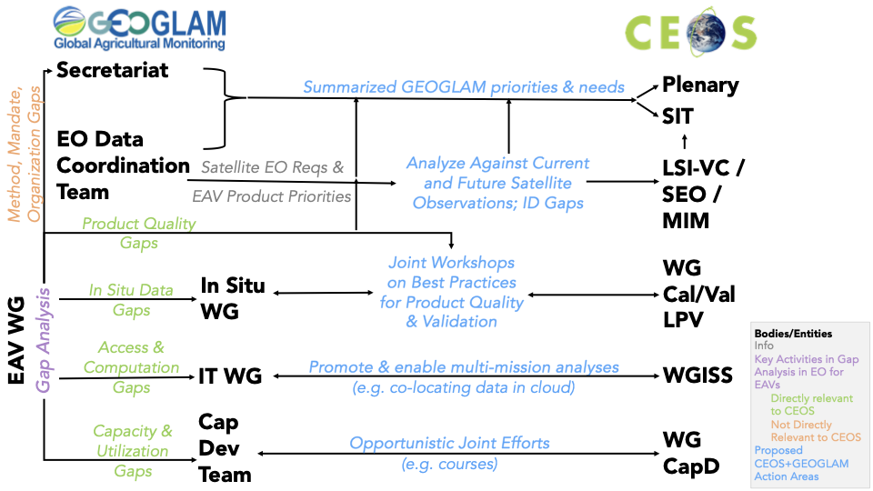

Figure 2: Possible realms of engagement between GEOGLAM and CEOS. There is additional support toward EAV production supported by multiple space agencies individually, already. CEOS involvement in these “realms” would support GEOGLAM success directly and indirectly by ensuring GEOGLAM and individual CEOS agencies are aligned.

# Appendix

**The CEOS Ad Hoc Working Group’s Activities (2012-2019):**

* 2012-2014: Supporting GEOGLAM in the organization of its 2012-2014 EO data requirements, and identifying and evaluating candidate missions to address these requirements. The requirements were drawn from best-practices for agricultural monitoring and information provision from GEOGLAM. Detailed assessments included coverage analyses and gap analyses, accounting for cloud cover impacts on optical acquisitions.
* 2012-2015: Developing the CEOS Strategic Response to GEOGLAM Requirements document, with a long-term vision toward ramping up to sustained imaging for national to regional to global scale operational monitoring programs;
* Supporting data acquisitions for research and development toward operations, largely coordinated through JECAM in cooperation with SIGMA and Sentinel-2 for Agriculture, as well as for Asia-RiCE via wall-to-wall observation coordination of Radarsat-2, ALOS-2m and Sentinel-1 over Vietnam and Indonesia;
* Linking to CEOS mission acquisition metadata, so as to facilitate the analysis of data records for backward-looking analyses, including analyses promoting the interoperable use of multiple sensors (SAR, optical, microwave, and the integration of multiple data types);
* Assisting in the development of flexible user agreements, to facilitate access to restricted datasets. This was initially focused on access to Radarsat-2 data, through the use of a Multiple User Request Form (MURF) and ALOS-2 Kyoto and Carbon (K&C) research project framework, with potential to adapt to other datasets;
* Engaging non-traditional and commercial EO suppliers, which have valuable satellite assets for GEO activities;
* Developing agricultural overlays and tools for the CEOS Systems Engineering Office’s COVE (CEOS Visualization Environment) tool. This includes land cover classification models, revisit analyses, and a coverage analyzer tool to support long-term country-level coverage assessments;
* Developing and prototyping data management services, to confront and mitigate challenges related to data storage, internet connectivity, and computational power for data analysis and visualization. These prototype Space Data Management Systems (SDMS), developed by the CEOS Systems Engineering Office (SEO), have been utilized and tested by FAO and the Asia-RiCE projects. This activity has evolved in the CEOS Data Cube;
* Partnering with the CEOS SEO to develop tools in the CEOS Visualization Environment (COVE) related to connecting to archival acquisition information;
* Coordinating with LSI-VC on ARD, MRI, and FDA activities, as well as sharing the GEOGLAM EO Requirements gathering process for other land surface imaging themes and areas in cooperation with CEOS Data Cube activity;
* Coordinating with WGCapD on training activities and longer-term visions for developing institutional capacity for EO data adoption;
* Supporting the provision of CEOS agencies’ EO datasets such as moderate resolution optical, passive microwave, precipitation radar, and others for usage by the GEOGLAM Crop Monitor team in their generation and delivery of monthly crop outlook information as input to the G20 Agricultural Market Information System.
* Various collaborations with e the CEOS
* Responding to the Updated GEOGLAM EO Requirements (2019), an evaluation of CEOS capacity to meet mission, as well as an investigation into solutions for data access and utilization challenges.

**Actors and Activities in Operationalizing the Use of EO for Agriculture Monitoring:**

CEOS is an implicated actor particularly at the foundational forms of data evolution (bottom). This figure also illustrates the key role of the EAVs in both advancing the data value chain toward use, as well as in communicating the data needs (aka requirements) back to CEOS and the agencies.

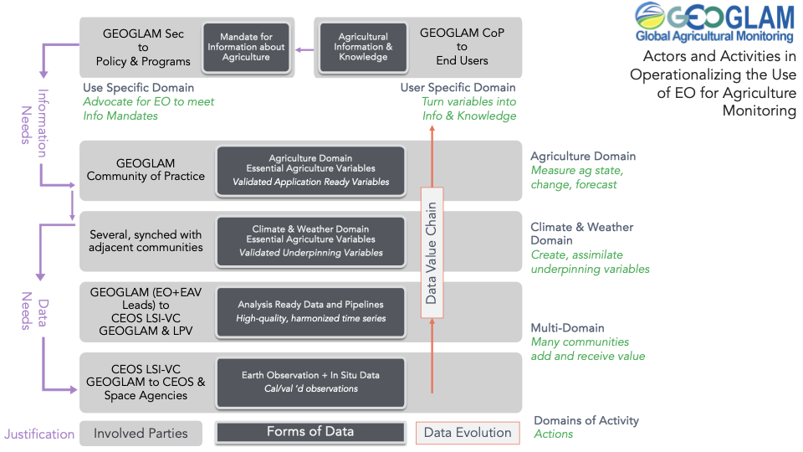

July 2024 Version of the **GEOGLAM Essential Agriculture Variables**, which have been identified and characterized by the GEOGLAM Community of Practice with stewards from ot (which nest multiple Essential Climate Variables and Biophysical Variables into single line-items, for visual simplicity):

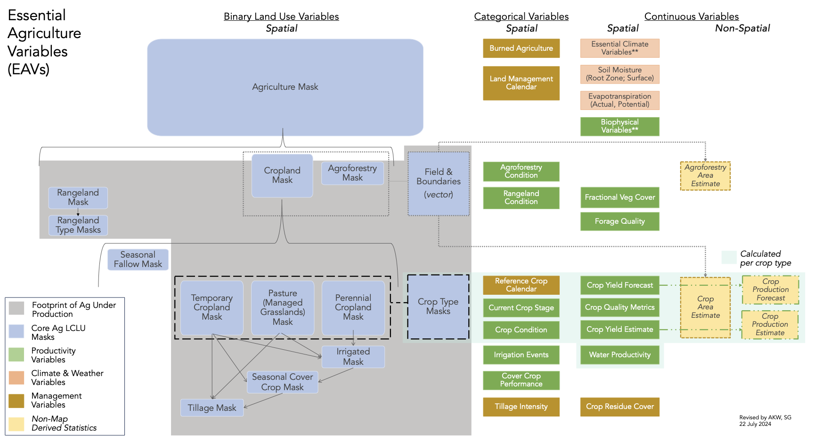

# Version History

* 1. Started by AKW - 9 Sept 2024