**16th Meeting of the CEOS Virtual Constellation for Land Surface Imaging (LSI-VC)**

**23-25 September 2024**

**Hosted by Geoscience Australia**

**101 Jerrabomberra Ave, Symonston ACT 2609, Canberra, Australia**

## Meeting Objectives

Community Engagement

1. Hold a session **with representatives from the Australian EO sector**, including ‘New Space’ companies. Act on the recommendations from the CEOS New Space Task Team white paper, promote CEOS-ARD, establish relationships and encourage CEOS-ARD self-assessments and other collaborations with LSI-VC. Explore opportunities to improve the discovery, access and utilization of land surface data, particularly CEOS-ARD, by Australian users and platforms.
2. Geoscience Australia has been a significant supporter of CEOS-ARD, including through initiatives like **Digital Earth Africa**. While on location at Geoscience Australia, we plan to meet with the staff who helped to develop and use this platform. Our goal is to gather feedback on CEOS-ARD to guide future development.
3. **CSIRO’s Earth Analytics Science and Innovation platform (EASI)** is another high performance data analytics platform that leverages cloud computing and analysis-ready Earth observation data. We will use the opportunity of being in Australia to engage with EASI leads and users, seeking feedback and guidance on CEOS-ARD. The platform boasts AI/ML support as a headline, so this might be an ideal opportunity to gather feedback on how CEOS-ARD can be tuned to better serve these approaches.

CEOS-ARD and Product Family Specification (PFS) Development

1. It has been generally agreed in LSI-VC that the best way forward for further **development of the CEOS-ARD Product Family Specification (PFS) is via GitHub**, for transparency, version control, and most importantly as a means to facilitate consistency across the different PFS and alignment with STAC. This is a major inflection point for CEOS-ARD and substantial discussion is needed to ensure we are clear on the what, how, and when of this major change in the framework. The specific objective will be to **define a clear roadmap and timeline for this development, as well as an initial set of implementation practices/guidelines.**
2. To enhance clarity and facilitate expansion of the CEOS-ARD Framework, we will focus on **refining the CEOS-ARD functional taxonomy/ontology/hierarchy.** This includes; a) clarifying our top-level categorisation of PFS (by sensor/wavelength/geophysical product/etc.); b) standardising terminology (agree an approach to ensuring common terminology across the PFS); and c) ensuring processing level consistency (consider how we can be more consistent with regard to processing levels of CEOS-ARD). Overall, seek to add a logical structure into the way EO data is classified and described, starting with CEOS-ARD. This discussion will be critical to appropriately structure the modular approach described in objective #4 above. *(Reference:* [*issue thread*](https://github.com/ceos-org/ceos-ard/issues/39)*,* [*slides*](https://ceos.org/document_management/Virtual_Constellations/LSI/Meetings/LSI-VC-16/4.4%20OGC-TC128_ARD-SWG_Structure_c20240605.pdf)*)*
3. **Discuss the feedback received during the development of the Ocean Reflectance PFS and reflect upon its applicability to other PFSs.** There are many logical questions raised and substantial changes that have been made, and it should be considered whether the same changes are needed on the land-oriented optical PFS, particularly as we look towards further consolidation of the parameters and requirements across all PFSs.
4. **Discuss the initial assessment of the commonality between the parameters and requirements of the optical PFSs** (i.e., the combined optical PFS work undertaken by USGS). Seek to resolve major discrepancies as a means of easing future work on defining consistent, modular parameter/requirement building blocks as described above.
5. **Various** [**feedback has been gathered regarding PFS parameters and requirements**](https://github.com/libbyrose/ceos-ard/issues)**.** We will use the meeting to review these and discuss PFS adjustments that might be needed in response.

CEOS-ARD Implementation

1. **Review ongoing CEOS-ARD self-assessments.** Obtain progress reports, work through any issues, and aim to accelerate any pending CEOS-ARD self-assessments towards peer review.
2. Review the findings of the **trial commercial SAR CEOS-ARD assessments** being undertaken by the CEOS Systems Engineering Office.

Land Surface Imaging Observation Requirements

1. Review the **CEOS AFOLU Roadmap Actions** ([here](https://ceos.org/document_management/Meetings/SIT/SIT-39/Presentations/2.3_AFOLU%20Actions%20V0-1.pptx)). Establish an understanding of what is needed to make progress on the actions assigned to LSI-VC. Discuss LSI-VC’s role in tracking the overall implementation of the CEOS AFOLU Roadmap.
2. **Wetlands and Mangroves** are a headline thematic area in the CEOS AFOLU Roadmap. At LSI-VC-15 it was agreed to include a standing session on Wetlands on future LSI-VC meeting agendas. An immediate objective is to agree a plan for LSI-VC / CEOS to contribute to the definition of the forthcoming [Ramsar Convention on Wetlands](https://www.ramsar.org/) geospatial information needs, starting with a discussion on the ​​short report on how EO and CEOS can support the Ramsar Convention *(Reference: LSI-VC-15-28)*. Information on wetland spatial extent and changes over time would be something CEOS could very helpfully provide for the Convention. LSI-VC might be able to influence the next Ramsar Science and Technology Review Panel (STRP) work plan that would address the lack of comprehensive EO data for certain regions and wetland types.

1. The **United Nations Convention to Combat Desertification (UNCCD)** has sent CEOS a letter requesting enhanced cooperation, highlighting several specific topics and requests, a few of which were directed to LSI-VC. We will discuss these requests and potential follow up actions. One key connection is to the OGC standards for geospatial LDN reporting indicators (an OGC standard working group (SWG) for the harmonization of geospatial reporting indicators (GRI) was endorsed by OGC members in July 2024.

Interoperability

1. Review progress and provide input for the **Surface Reflectance Quality, Equivalency and Consistency Project**.
2. Briefing on the current status of CEOS Interoperability Handbook 2.0 and discussions on possible contribution of LSI-VC for Interoperability Handbook 2.0

Other Topics

1. Exchange CEOS Agency **updates related to land surface imaging**. All agencies will be given an opportunity to present the latest activities in their agencies and raise any issues that would benefit from discussion and coordination. Provide an opportunity to report on **CEOS-ARD uptake and metrics** *(Reference: LSI-VC-15-26)*.
2. Reflect on feedback received from the presentation of the draft **CEOS-ARD Strategy 2024** to the SIT Technical Workshop on September 19 and make edits to finalise the document for presentation to CEOS Plenary 2024 for endorsement.

## Meeting Location

LSI-VC-16 will be held at Geoscience Australia: [101 Jerrabomberra Ave, Symonston ACT 2609](https://maps.app.goo.gl/ds5LJWvkD9vYQN4i7)

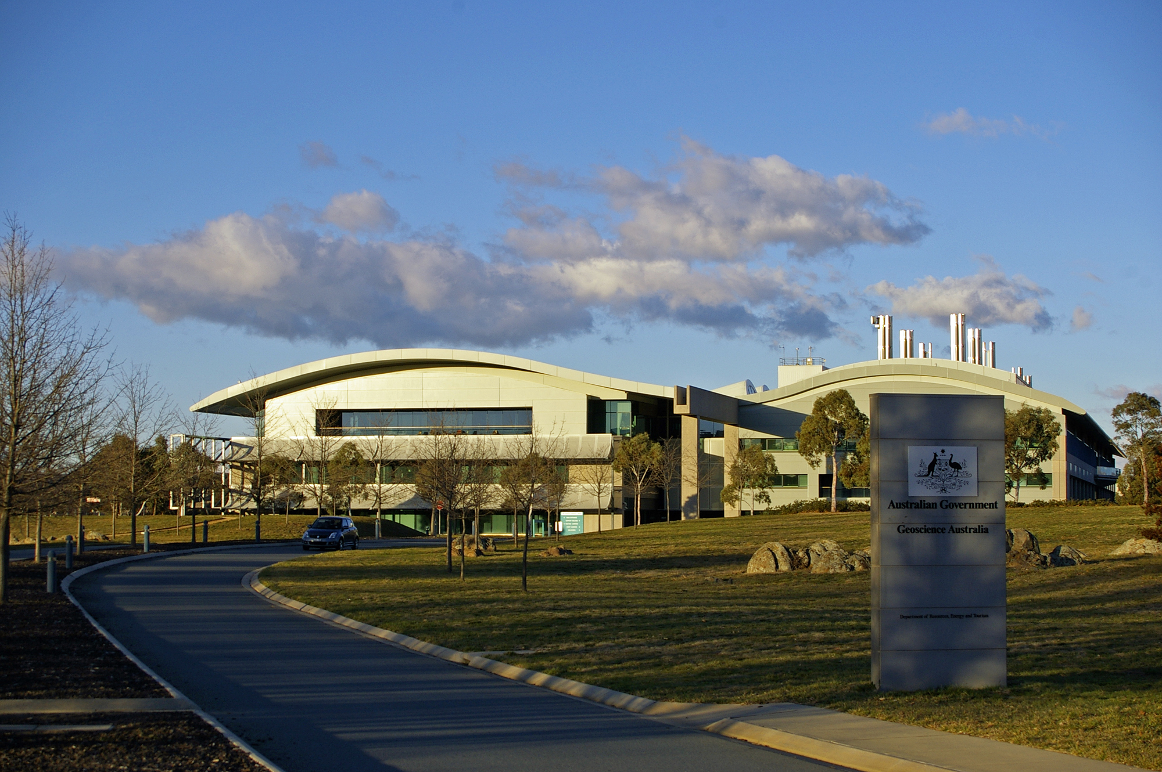

## Some Accommodation Options

[**Mantra on Northbourne Canberra**](https://maps.app.goo.gl/5sz1TwebVcni1u8i8)

84 Northbourne Ave, Canberra ACT 2612

[**Avenue Hotel Canberra**](https://maps.app.goo.gl/uyJpdt1Jf9m7S1G79)

80 Northbourne Ave, Braddon ACT 2602

[**Adina Serviced Apartments Canberra James Court**](https://maps.app.goo.gl/rPKf8KWP7iVL7iJw9)

74 Northbourne Ave, Braddon ACT 2601

## Transportation

Geoscience Australia is an approximately 20-minute drive from downtown Canberra and the suggested hotels noted above. This has the potential to be longer during peak hours and Parliament sitting weeks. Taxi/rideshares or private hire car are the recommended modes of transport. The following hire car companies have desks at Canberra Airport: Avis, Budget, Enterprise, Europcar, Hertz, Sixt. More information can be found [here](https://www.canberraairport.com.au/transport/rental-cars).

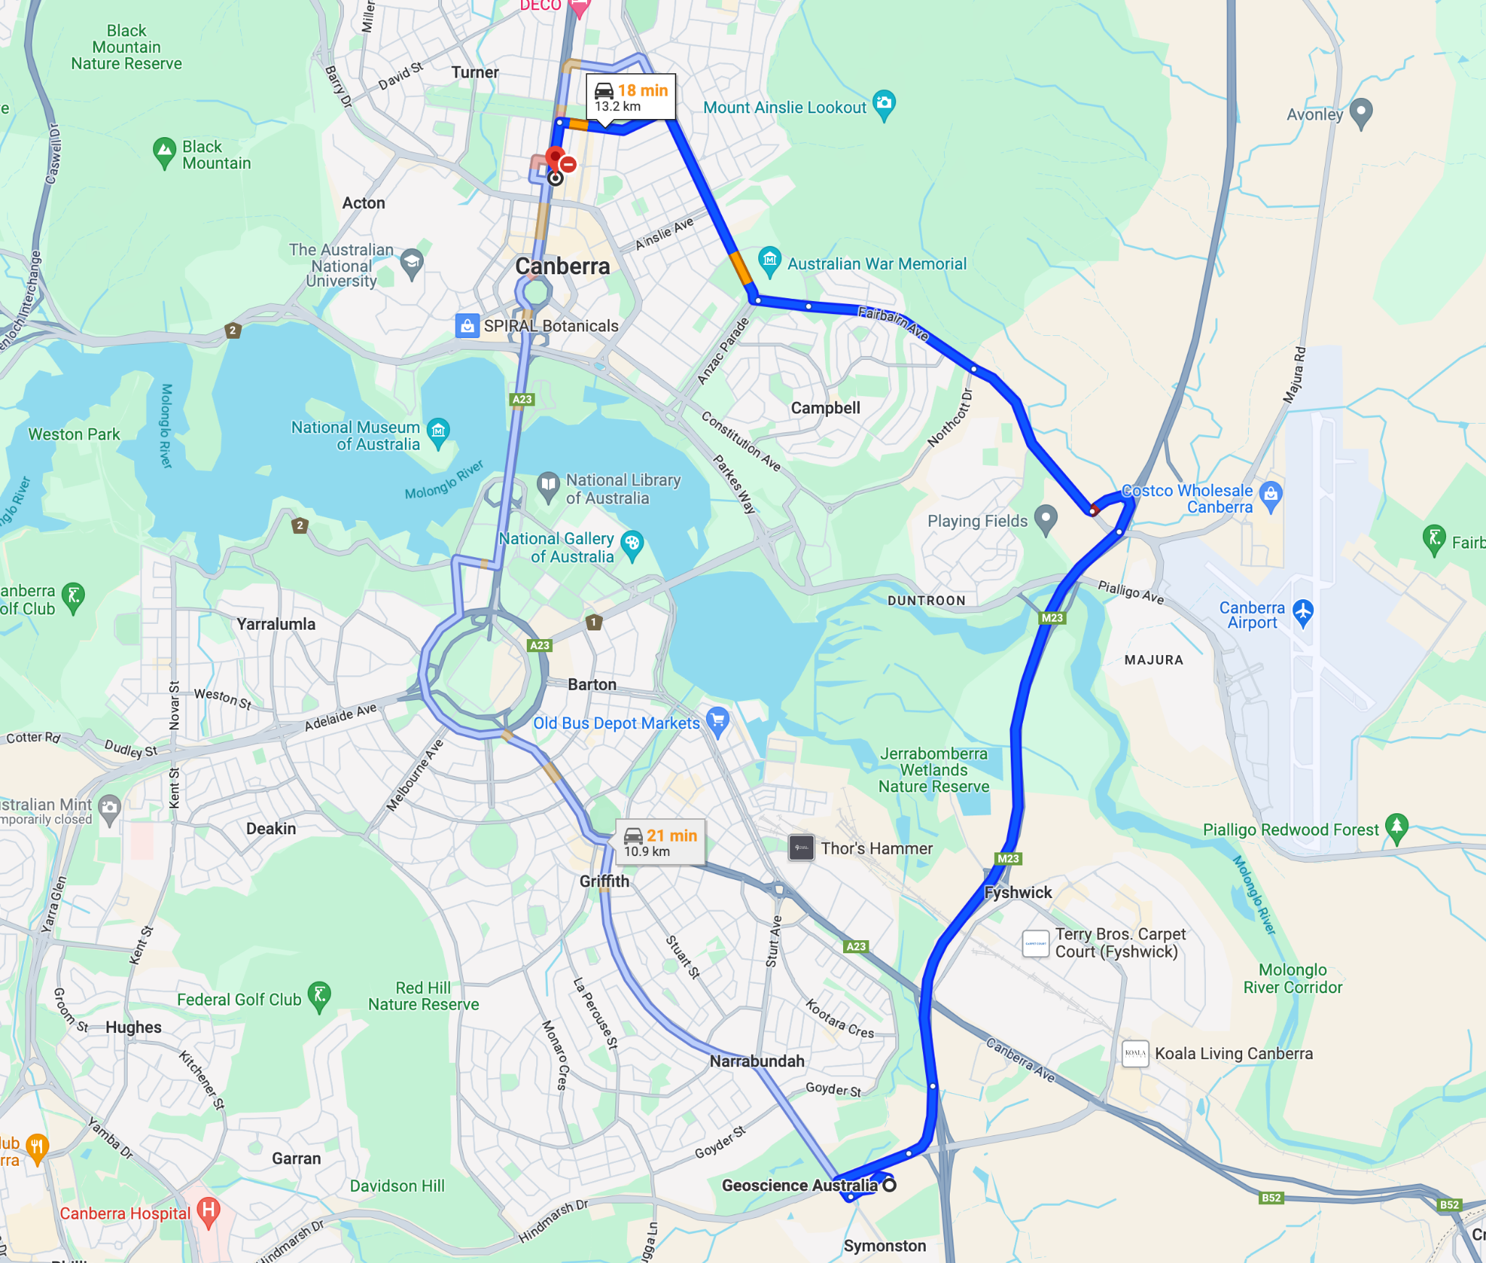

# Agenda

## Monday September 23

**Location**: Scriviner Room

| **Arrival / Teleconference Open**  *Meeting teleconference connection will be open for testing.* | | **08:30** | **30 min** |
| --- | --- | --- | --- |
| **Session 1: Welcome and Introductions (09:00 – 09:40)** | | | |
| **1.1** | Welcome [[slides](https://ceos.org/document_management/Virtual_Constellations/LSI/Meetings/LSI-VC-16/1.1%20Introduction%20LSI-VC%20Leads.pptx)]  *LSI-VC Co-Leads*   * Opening remarks * Roundtable of introductions * Introduction to CEOS and the LSI-VC * Meeting overview | 09:00 | 20 min |
| **1.2** | CEOS Analysis Ready Data (CEOS-ARD) Overview [[slides](https://ceos.org/document_management/Virtual_Constellations/LSI/Meetings/LSI-VC-16/1.2%20Steventon%20CEOS-ARD%20Intro%20(LSI-VC-16%20September%202024).pptx)]  *Matt Steventon (LSI-VC Secretariat)*   * Overview * Status of datasets * Ongoing self-assessments and peer reviews | 09:20 | 20 min |
| **Session 2: Partner Presentations and Perspectives (09:40 – 12:30)** | | | |
| **2.1** | Digital Earth Africa and the GA perspectives on CEOS-ARD [[slides 1](https://ceos.org/document_management/Virtual_Constellations/LSI/Meetings/LSI-VC-16/2.1_Wellington_DEAfrica_v1.pptx)] [[slides 2](https://ceos.org/document_management/Virtual_Constellations/LSI/Meetings/LSI-VC-16/2.1_MThankappan_GA%20ARD%20Perspective.pptx)]  *Michael Wellington/Medhavy Thankappan*   * Status of the platform and applications * Perspectives on CEOS-ARD | 09:40 | 20 min |
| **2.2** | CSIRO Earth Analytics Science and Innovation platform (EASI) [[slides](https://ceos.org/document_management/Virtual_Constellations/LSI/Meetings/LSI-VC-16/2.2_CEOS-LSIVC16-CSIROEASI-20240923.pdf)]  *Matt Paget*   * Status of the platform and applications * Perspectives on CEOS-ARD | 10:00 | 20 min |
| **2.3** | Esper Satellite Imagery [[slides](https://ceos.org/document_management/Virtual_Constellations/LSI/Meetings/LSI-VC-16/2.3%20Esper%20Satellite%20Imagery.pdf)]  *Ullas V. Bhanu*   * Introduction to Esper * Current Capability and Ongoing Work * CEOS-ARD compatibility and PFS status. | 10:20 | 20 min |
| **Break** | | 10:40 | 20 min |
| **2.4** | Geospatial Intelligence [[slides](https://ceos.org/document_management/Virtual_Constellations/LSI/Meetings/LSI-VC-16/2.4%20Geospatial%20Intelligence.pdf)]  *Jeremy Repetto* | 11:00 | 20 min |
| **2.5** | Arlula [[slides](https://ceos.org/document_management/Virtual_Constellations/LSI/Meetings/LSI-VC-16/2.5_Chaoui_Arlula%20Geostack_Final%20Version.pdf)]  *Sebastian Chaoui* | 11:20 | 20 min |
| **2.6** | Descartes Labs/EarthDaily [[slides](https://ceos.org/document_management/Virtual_Constellations/LSI/Meetings/LSI-VC-16/2.6%20EarthDaily%20Constellation%20-%20CEOS%20ARD%20-%20Canberra%20%20-%20Adelaide%20-%2023rd%20Sept%20-%20Final%20V2.pdf)]  *Paddy Brennan* | 11:40 | 20 min |
| **2.7** | Discussion / Buffer Time | 12:20 | 10 min |
| **Lunch** | | 12:30 | 60 min |
| **Session 3: New Approach to the CEOS-ARD Framework (13:30 – 17:00)** | | | |
| **3.1** | Introduction and Motivation [[slides](https://ceos.org/document_management/Virtual_Constellations/LSI/Meetings/LSI-VC-16/3.1%20Steventon%20CEOS-ARD%20Framework%20Rethink%20Introduction%20and%20Motivations%20(LSI-VC-16%20September%202024).pptx)]  *Matt Steventon (LSI-VC Secretariat)*   * Overview of the issues we are facing; Goals for LSI-VC-16 * ARD standardization efforts * CEOS-ARD Product Family Specification consistency – parameters, requirements, terminology * Metadata standards and alignment with SpatioTemporal Asset Catalogs (STAC) * CEOS-ARD taxonomy | 13:30 | 20 min |
| **3.2** | CEOS-ARD GitHub [[slides](https://ceos.org/document_management/Virtual_Constellations/LSI/Meetings/LSI-VC-16/3.2%20CEOS-ARD%20GitHub.pptx)]  *Matthias Mohr (Cloud-Native Geospatial Foundation)*   * Overview * Tutorial on core functions * Markdown documents and Word doc generation * Detailed description on how the Github is conceived to be used in practice for PFS development * Considerations: Ensuring that certain features in the current document based approach - such as document overview and visibility of comments - are not negatively affected. * Discussion | 13:50 | 70 min |
| **Break** | | 15:00 | 20 min |
| **3.3** | Introduction to SpatioTemporal Asset Catalogs (STAC) and the CEOS-ARD Extensions [[slides](https://ceos.org/document_management/Virtual_Constellations/LSI/Meetings/LSI-VC-16/4.5%20STAC%20Introduction%202024%20-%20CEOS.pptx)]  *Matthias Mohr (Cloud-Native Geospatial Foundation)*   * *STAC Introduction* | 15:20 | 60 min |
| **3.4** | Discussion   * Discussions and decisions: define a clear roadmap and timeline for GitHub migration, define next steps and actions, and agree an initial set of implementation practices/guidelines * Become clear on the what, how, and when of this major change in the framework | 16:20 | 40 min |
| **Adjourn** | | 17:00 |  |

## Tuesday September 24

**Location**: Scriviner Room

| **Arrival / Teleconference Open**  *Meeting teleconference connection will be open for testing.* | | **08:30** | **30 min** |
| --- | --- | --- | --- |
| **Session 4: Optical CEOS-ARD PFS Developments and Consolidation (09:00 – 13:00)** | | | |
| **4.1** | Session overview [[slides](https://ceos.org/document_management/Virtual_Constellations/LSI/Meetings/LSI-VC-16/4.1%20Steventon%20Optical%20CEOS-ARD%20PFS%20Developments%20and%20Consolidation.pptx)]  *Matt Steventon (LSI-VC Secretariat)*   * Optical PFS developments * Open issues from GitHub * Consolidation of optical PFS * GitHub ‘building block’ approach * Objectives | 09:00 | 10 min |
| **4.2** | Expansion of the Aquatic Reflectance PFS to cover the oceans [[slides](https://ceos.org/document_management/Virtual_Constellations/LSI/Meetings/LSI-VC-16/4.2_CEOS_SIT-TW-LSI%20VC%2024%20Sep2024_aquatic_ARD%20AD.pptx)]  *Arnold Dekker (CSIRO)*   * Overview of progress and timeline for completion * Feedback on the PFS coming from the AR to OR PFS discussion * Discussion | 09:10 | 60 min |
| **4.3** | Combined Optical PFS [[slides](https://ceos.org/document_management/Virtual_Constellations/LSI/Meetings/LSI-VC-16/4.3%20Combined%20Optical%20PFS.pptx)]  *Chris Barnes (USGS)*   * Outcome of initial assessment by USGS of the commonality between the optical PFS * Discussion: Proposals for consolidation   + Accommodating multi-source / mosaic input data   + Survey for AI/ML ready data | 10:10 | 30 min |
| **Break** | | 10:40 | 20 min |
| **4.4** | CEOS-ARD Functional Taxonomy/Ontology/Hierarchy [[slides](https://ceos.org/document_management/Virtual_Constellations/LSI/Meetings/LSI-VC-16/4.4%20OGC-TC128_ARD-SWG_Structure_c20240605.pdf)]  *Peter Strobl (EC)*   * How to tidy up the CEOS-ARD functional taxonomy/ontology/hierarchy * Clarifying our top-level categorisation of PFS (by sensor/wavelength/geophysical product/etc.) * Agree an approach to ensuring common terminology across the PFS * Consider how we can be more consistent with regard to processing levels of CEOS-ARD. * Decision: Logical structure into the way EO data is classified and described, starting with CEOS-ARD. | 11:00 | 60 min |
| **4.5** | Discussion and Decisions   * Timeline and approach for PFS consolidation * Sketching out a roadmap and actions for implementation of the GitHub / Building Blocks / STAC development * Governance Framework | 12:00 | 60 min |
| **Lunch** | | 13:00 | 60 min |
| **Session 5: UNCCD & Standards for Geospatial LDN Reporting Indicators (14:30 – 15:00)** | | | |
| **5.1** | United Nations Convention to Combat Desertification (UNCCD) [[slides](https://ceos.org/document_management/Virtual_Constellations/LSI/Meetings/LSI-VC-16/5.1%20OGC%20GRI%20SWG.pdf)]  *Nils Hempelmann (OGC) and Dave Borges (SEO, NASA)*   * UNCCD letter to CEOS requesting enhanced cooperation * assessing the availability and suitability of land surface datasets for SIDS and hyper arid areas. * CEOS and its LSI-VC could play a critical role in the development of OGC standards for geospatial LDN reporting indicators, building on the CEOS-ARD concepts and prior work by GEO-LDN on minimum data quality standards for SDG indicator 15.3.1. An OGC standard working group (SWG) for the harmonization of geospatial reporting indicators (GRI) has been endorsed by OGC members in July 2024 * Follow up actions | 14:00 | 30 min |
| **Session 6: Interoperability (15:00 – 15:30)** | | | |
| **6.1** | WGISS Interoperability Handbook v2.0 [[slides](https://ceos.org/document_management/Virtual_Constellations/LSI/Meetings/LSI-VC-16/6.1_Dube_Interoperability-Handbook_v1.pdf)]  *Nitant Dube (WGISS Vice Chair, ISRO)*   * Survey for AI/ML ready data | 14:30 | 30 min |
| **Session 7: CEOS Agriculture, Forestry and Other Land Use (AFOLU) Roadmap (14:00 – 14:30)** | | | |
| **7****.1** | CEOS AFOLU Roadmap Actions  *Stephen Ward (CEOS SIT Chair Team)*   * Review the CEOS AFOLU Roadmap Actions (here). * Establish an understanding of what is needed to make progress on the actions assigned to LSI-VC. * Discussion: Consistent, long-term, bias-corrected time series as a basis for higher-level AFOLU products. * Discussion: LSI-VC’s role in tracking the overall implementation of the CEOS AFOLU Roadmap. | 15:00 | 30 min |
| **Break** | | 15:30 | 20 min |
| **Session 8: Synthetic Aperture Radar ARD (15:50 – 17:45)**  **Moderator: Ake Rosenqvist (JAXA)** | | | |
| **8.1** | SAR CEOS-ARD Update [[slides](https://ceos.org/document_management/Virtual_Constellations/LSI/Meetings/LSI-VC-16/8.1_Rosenqvist_SAR-ARD_update_LSI-VC-16.pptx)]  *Ake Rosenqvist (JAXA)*   * Recent and ongoing assessments * Latest developments with the SAR PFS * Interferometric Radar (INSAR) progress | 15:50 | 20 min |
| **8.2** | CEOS SEO commercial SAR CEOS-ARD assessments [[slides](https://ceos.org/document_management/Virtual_Constellations/LSI/Meetings/LSI-VC-16/8.2_Rosenqvist-Borges_NewSpaceAssessment_LSI-VC-16.pptx)]  *Ake Rosenqvist (JAXA) / Dave Borges (SEO)* | 16:10 | 20 min |
| **8.3** | CSIRO NovaSAR CEOS-ARD Report [[slides](https://ceos.org/document_management/Virtual_Constellations/LSI/Meetings/LSI-VC-16/8.3_Zhou_CSIRO_NovaSAR_CEOS-ARD_LSI-VC-16.pdf)]  *Zheng-Shu Zhou (CSIRO)* | 16:30 | 20 min |
| **8.4** | ISRO SAR CEOS-ARD Report [[slides](https://ceos.org/document_management/Virtual_Constellations/LSI/Meetings/LSI-VC-16/8.4_Jayasri_ISRO-SAR-ARD_LSI-VC-16.pptx)]  *P.V. Jayasri (ISRO)* | 16:50 | 20 min |
| **8.5** | DLR Progress on Sentinel-1 ARD Production [[slides](https://ceos.org/document_management/Virtual_Constellations/LSI/Meetings/LSI-VC-16/8.5_Truckenbrodt_DLR_Sentinel-1_ARD_LSI-VC-16.pptx)]  *John Truckenbrodt (DLR)* | 17:10 | 20 min |
| **8.6** | Status update: Quad-pol and Multi-frequency data requests from the ESA POLINSAR Workshop 2023 [[slides](https://ceos.org/document_management/Virtual_Constellations/LSI/Meetings/LSI-VC-16/8.6_Fitrzyk_POLINSAR_LSI-VC-16.pptx)]  *Magdalena Fitrzyk (ESA)* | 17:30 | 15 min |
| **Adjourn** | | 17:45 |  |

**Wednesday September 25**

**Location:** Scriviner Room

| **Arrival / Teleconference Open**  *Meeting teleconference connection will be open for testing.* | | **08:30** | **30 min** |
| --- | --- | --- | --- |
| **Session 9: Other Business (09:00 – 10:40)** | | | |
| **9.1** | CEOS-ARD Surface Reflectance Products: Quality, Consistency and Equivalence [[slides](https://ceos.org/document_management/Virtual_Constellations/LSI/Meetings/LSI-VC-16/9.1%20Oliver%20Thankappan%20Surface%20Reflectance%20Quality%20Consistency%20and%20Equivalence.pptx)]  *Medhavy Thankappan (GA) & Simon Oliver (GA)*   * Review progress and provide input * Discussion | 09:00 | 45 min |
| **9.2** | Proposed ‘Building Block’ Approach to constructing PFS  *Matthias Mohr (Cloud-Native Geospatial Foundation)*   * Proposal for constructing modular ‘blocks’ using GitHub * Overview of how this addresses issues of consistency and supports consolidation of the PFS * Alignment of blocks with STAC | 09:45 | 30 min |
| **Break** | | 10:15 | 20 min |
| **Session 10: GEOGLAM & Consolidated Optical PFS** | | | |
| **10.1** | Draft LSI GEOGLAM Terms of Reference [[doc](https://ceos.org/document_management/Virtual_Constellations/LSI/Meetings/LSI-VC-16/10.1%20Terms%20of%20Reference%20for%20CEOS%20LSI-VC%20Subgroup%20on%20GEOGLAM.docx)] |  |  |
| **10.2** | Working Session: First Cut of a Consolidated Optical PFS and basis for ‘building blocks’ in GitHub [[doc](https://ceos.org/document_management/Virtual_Constellations/LSI/Meetings/LSI-VC-16/10.2%20CEOS-ARD_Combined_Optical_PFS_v0.1_draft%20(2)%20LSI-VC-16%20edits%20(3)%20(1).docx)] |  |  |
| **Lunch** | | 13:00 | 60 min |
| **10.2** | Continued: Working Session: First Cut of a Consolidated Optical PFS and basis for ‘building blocks’ in GitHub [[doc](https://ceos.org/document_management/Virtual_Constellations/LSI/Meetings/LSI-VC-16/10.2%20CEOS-ARD_Combined_Optical_PFS_v0.1_draft%20(2)%20LSI-VC-16%20edits%20(3)%20(1).docx)] |  |  |
| **Session 11: Wetlands (14:00 – 14:20)**  **Moderator: Ake Rosenqvist (JAXA)** | | | |
| **11.1** | Wetlands and EO [[slides](https://ceos.org/document_management/Virtual_Constellations/LSI/Meetings/LSI-VC-16/11.1_Rosenqvist_Wetlands_and_EO_LSI-VC-16.pptx)]  *Ake Rosenqvist (JAXA)*   * Plan for LSI-VC / CEOS to contribute to the definition of the forthcoming Ramsar Convention geospatial information needs, starting with a discussion on the short report on how EO and CEOS can support the Ramsar Convention (Reference: LSI-VC-15-28). * Information on wetland spatial extent and changes over time would be something CEOS could very helpfully provide for the Convention. * LSI-VC might be able to influence the next (2026-2028) Ramsar STRP work plan that would address the lack of EO data for certain regions and wetland categories. |  |  |
| **Session 12: CEOS Agency LSI/ARD Reports (11:35 – 13:00)** | | | |
| **12.1** | JAXA Report [[slides](https://ceos.org/document_management/Virtual_Constellations/LSI/Meetings/LSI-VC-16/12.1_Tadono_JAXA.pdf)]  *Takeo Tadono (JAXA)* | 11:35 | 20 min |
| **Session 13: Closing**  **Moderator: Matt Steventon (LSI-VC Secretariat)** | | | |
| **13.1** | Wrap up   * GitHub timeline proposal (Mohr) * LSI-VC-17/18 plans * Closing remarks |  |  |
| **Adjourn** | |  |  |