Minutes v1.0
16th Meeting of the CEOS Virtual Constellation for Land Surface Imaging (LSI-VC)
23-25 September 2024
Hosted by GA
Canberra, Australia
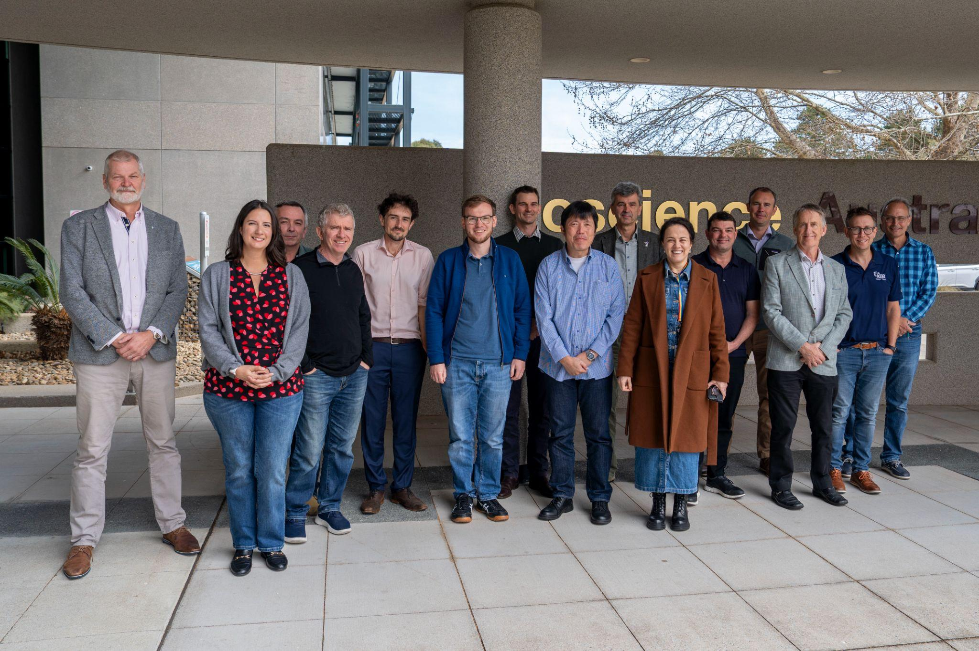
Participants
Arlula Sebastian Chaoui
Auspatious Alex Leith
CEOS SEO David Borges
Cloud-Native Geospatial Foundation Matthias Mohr
CSIRO Arnold Dekker, Matt Paget, Zheng-Shu Zhou*
Digital Earth Africa Michael Wellington (GA), Jahla Gato (GA), Adam Lewis
DLR John Truckenbrodt
EarthDaily Paddy Brennan
ESA Magdalena Fitrzyk
Esper Satellite Imagery Ullas Bhanu
European Commission Peter Strobl
FrontierSI Fang Yuan
Geoscience Australia Andreia Siqueira, David Hudson, Peter Harrison, Medhavy
Thankappan, Maggie Arnold, Sally Jensen, Jonathon Ross*,
Simon Oliver*, Alla Metlenko*
Geospatial Intelligence Jeremy Repetto
ISRO P.V. Jayasri, Nitant Dube, Raghav Mehra
JAXA Takeo Tadono, Ake Rosenqvist
LSI-VC Secretariat Matt Steventon, Stephen Ward, George Dyke*
OGC Nils Hempelmann
USGS Chris Barnes, Kelly Bruno, Tim Stryker, Tom Sohre*

* indicates online

Monday, September 23
Session 1: Welcome and Introductions
1.1: Welcome [Slides]
Andreia Siqueira (GA, LSI-VC Co-Lead) welcomed participants to Geoscience Australia and Canberra, and acknowledged the Ngunnawal people as Traditional Custodians of the ACT. Co-Leads Chris Barnes (USGS), Peter Strobl (EC), and Takeo Tadono (JAXA) added their welcome to LSI-VC-16.
LSI-VC-16 is an important milestone in terms of the technical direction for CEOS-ARD development, with a couple of workshop sessions planned around the new CEOS-ARD GitHub, pushing development of specifications to this platform, and seeking to consolidate the requirements, while also building in alignment with STAC.
LSI-VC-16 will also see us hold our second commercial engagement session, this time with representatives of the Australian EO community.
Andreia provided an overview of CEOS and the LSI-VC and led a tour de table.
1.2: CEOS Analysis Ready Data (CEOS-ARD) Overview [Slides]
Presenter: Matt Steventon (LSI-VC Secretariat)
Matt Steventon (LSI-VC Secretariat) provided an overview of CEOS-ARD, the background, motivations, specifications, and the current status of datasets that have been assessed as such.
He also noted the new CEOS-ARD Strategy 2024, which was presented at last week’s SIT Technical Workshop, and which will be presented to the CEOS Plenary in October. It summarises a collection of tasks/areas of activity that are needed to move us towards the end goal of having a broad portfolio of CEOS-ARD that is easily discovered, accessed and utilised.
Session 2: Partner Presentations and Perspectives
2.1: Digital Earth Africa and Geoscience Australia Perspectives on CEOS-ARD
Digital Earth Africa [Slides]
Presenter: Michael Wellington (GA)
Presented on Digital Earth Africa, which is a key program in terms of CEOS-ARD use. The platform, built on Open Data Cube, provides a routine, reliable and operational service, using Earth observations to deliver decision-ready products enabling policy makers, scientists, the private sector and civil society to address social, environmental and economic changes on the African continent. GA is a major partner, leading the initial establishment and now serving as a funding host. LSI-VC welcomed DE Africa feedback on the CEOS-ARD specifications and products.
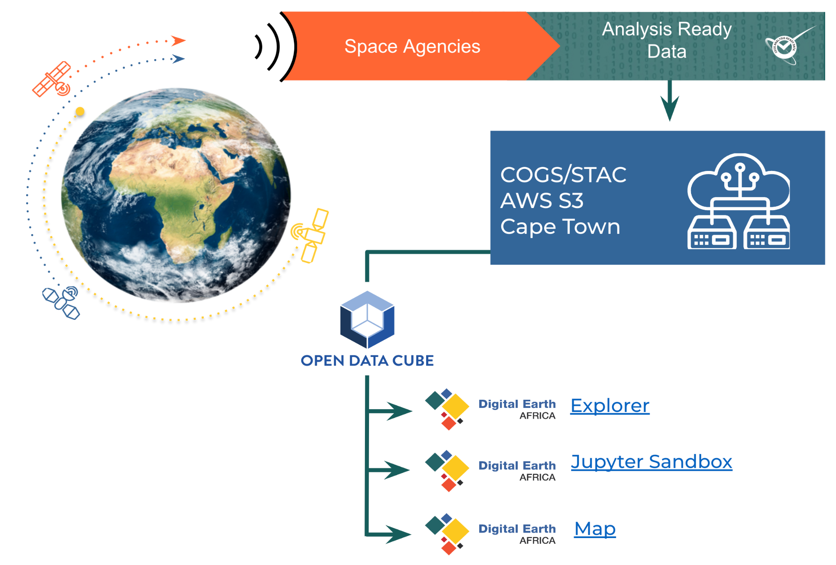
CEOS-ARD Surface Reflectance and Temperature from Landsat and Sentinel-2 underpins numerous DE Africa products and services, such as Fractional Cover; Water Observations from Space; Annual Geomedians; and NDVI Mean, Anomaly and Climatology. DE Africa also worked with Sinergise to develop CEOS-ARD for Sentinel-1 RTC.
DE Africa is looking for additional guidance on aquatic reflectance CEOS-ARD, noting that it is a clear and stated demand from industry and government in several African countries, for SDG reporting and aquaculture monitoring. They are testing the USGS provisional aquatic reflectance product, however there are known issues with negative reflectance values and differences in water masking, which highlight the need for aquatic reflectance CEOS-ARD.
Working towards incorporating Sentinel-1 monthly mosaics and Sentinel-3 and Sentinel-5P over the coming 12 months. CEOS-ARD compliance for Sentinel-3 SYN product is still progressing, but would be a welcome development. Specifically, DE Africa would welcome guidance for Sentinel-3 OLCI and SLSTR with a focus on surface reflectance (water) temperature (land and water).
It was noted that where a relevant CEOS-ARD specification is defined, it is built into agreements with service providers as a requirement.
DE Africa also has an interest in pre-harmonised datasets such as NASA HLS and is maintaining a watch.
On the importance of CEOS-ARD:
- Need EO data of sufficient quality to allow harmonised EO products, data assimilation in workflows, and sensor-agnostic approaches.
- Statements of uncertainty are needed in the CEOS interoperability framework/handbook to communicate uncertainties in EO measurements across time and space.
  - Statements and quantification of variation in uncertainty across geographies.
- Statements of known issues enable more informed use, enhancing overall reputation
- Quantification and qualification of data quality support a collaborative approach to improvement and drive confidence in EO approaches.
Geoscience Australia [Slides]
Presenter: Medhavy Thankappan (GA)
GA has been associated with the CEOS-ARD initiative from its conception and remains a strong supporter of the CEOS-ARD Strategy. CEOS-ARD has been very successful, in terms of its adoption by CEOS member agencies, and continues to attract interest from the industry sector, but more industry engagement is needed. Through LSI-VC and WGCV in CEOS, GA continues to support CEOS-ARD self-assessments for compliance against Product Family Specification (PFS) which remains a strong basis for achieving interoperability.
Achieving interoperability of multi-source data streams remains a high priority for the success of our Digital Earth programs (Australia, Africa, Antarctica), combined use of multi-source data provides better insights, and return on investment. Value creation results from analysis and application of EO data. Interoperability of multi-source data streams can amplify value creation.
A major milestone is the Australia-US Landsat Next Partnership – a new investment by the Australian Government in a full value chain partnership to ensure that benefits of Landsat Next are realised by Australians, Americans and in the Indo-Pacific ($AUD448.7M to 2034-45, then ~43.2M per year ongoing). This partnership will facilitate the following:
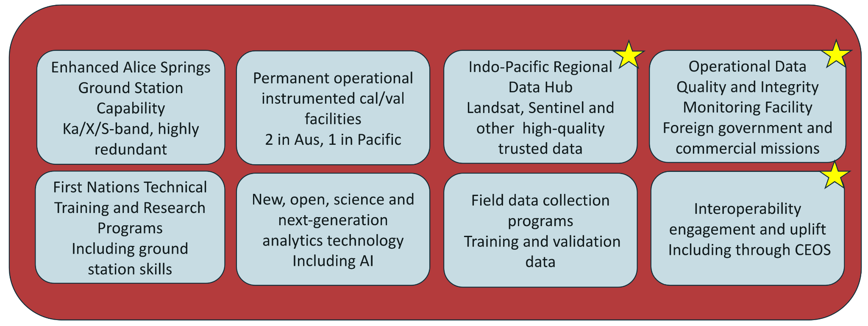
GA is also looking to the next steps for CEOS-ARD and increasing interoperability, with the Surface Reflectance Equivalence and Consistency project, which is investigating how certain tolerances might be defined for processing steps such that the end products derived from the surface reflectance may be more interoperable. These findings could potentially influence future CEOS-ARD Goal level requirements. This will be covered later in the LSI-VC-16 agenda.
Discussion
Chris Barnes (USGS) noted that USGS is about to release a new provisional aquatic reflectance product. It is an improvement over the current SeaDAS based implementation. Chris will make sure Michael is included in that distribution. Arnold is already included on the early adopters list.
LSI-VC-16-01 | Chris Barnes to inform Michael Wellington (GA/DE Africa) on the new USGS provisional aquatic reflectance product. | December 2024
2.2: CSIRO Earth Analytics Science and Innovation platform (EASI) [Slides]
Presenter: Matt Paget (CSIRO)
CSIRO’s EASI platform is an Open Data Cube (ODC) implementation in AWS. It provides similar infrastructure to DE Australia and Africa, and also allows some level of interoperability. There is a very similar technical stack but a different business model to the DEA platforms. STAC is an integral part of EASI. EASI also underpins the CEOS Analytics Lab (CAL).
The main purposes are to enable EO science in CSIRO and also as a tool for developing partnerships and commercial activities. It provides an end-to-end solution from data sourcing, indexing, processing and through to analytics and ARD.
EASI is entirely cloud-based, which is highly scalable and deployable, with new instances able to be established in around one day.
EASI implementations run by CSIRO currently use the following satellite data sources:
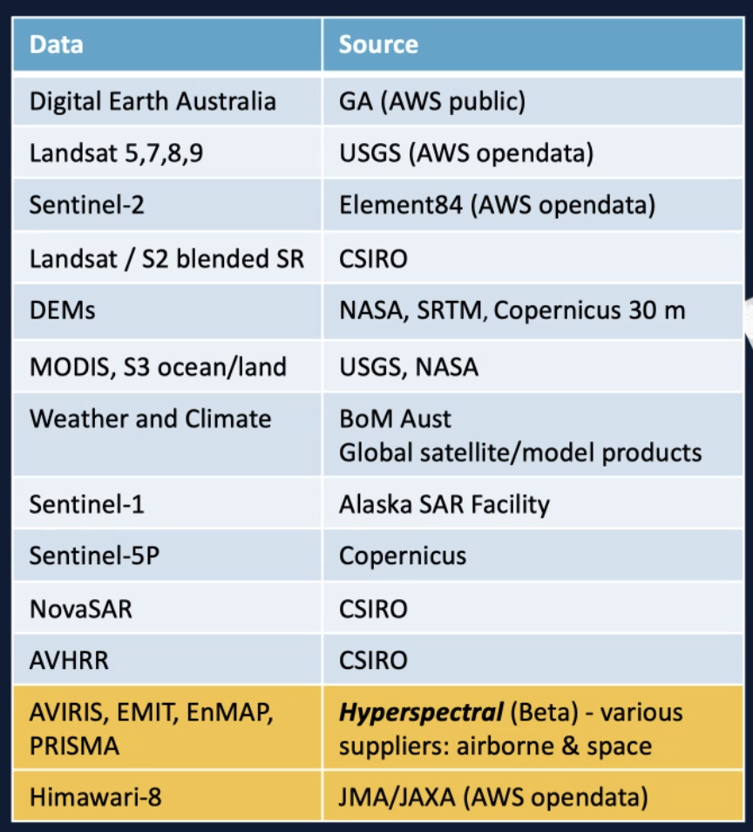
Users of EASI are broad, covering applications in minerals, water quality, bushfires, wetlands, vegetation cover, etc.
The CSIRO team have their own implementations of Sentinel-1 gamma0 ARD, providing customisation and flexibility for users. It was noted that the Sentinel-1 SNAP10 gamma0 process does not produce a CEOS-ARD level of product, but close.
EASI is currently set up to work with multispectral data, but a hyperspectral extension is in beta testing. This new functionality adds wavelength as a searchable dimension in the Data cube API. Hyperspectral workflows are being established.
Matt noted a project in support of CEOS WGISS data preservation and global AVHRR repatriation, and as a contribution to ESA. Providing Australian AVHRR top of atmosphere data and atmospheric correction approaches, facilitated by EASI.
In closing, Matt noted that Cloud Optimised Geotiff (COG) is the preferred format for data, and presented the following additional data preparation considerations:
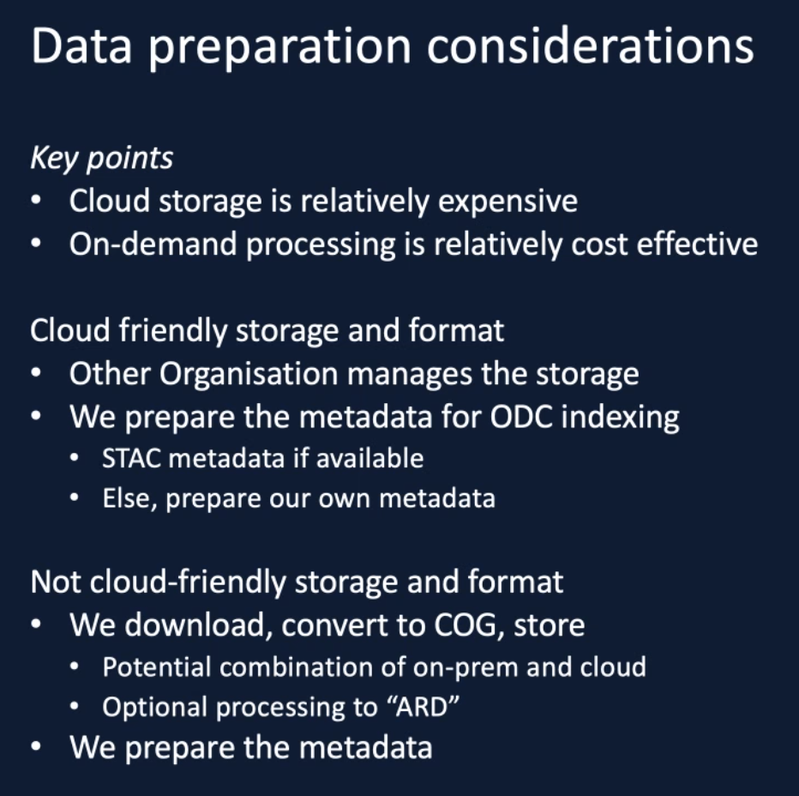
Discussion
Ake Rosenqvist (JAXA) noted the references to CSIRO’s polarimetric decomposition and pointed out that we do have a CEOS-ARD PFS for this type of dataset. It would be interesting to see how this CSIRO product stacks up against the specification. Matt noted this is just a preliminary product, but they do plan to go through the self-assessment process and set up appropriate metadata. Matt noted the intention wasn't to produce yet another product, but rather to prove a workflow for the cloud. They plan to work with partners to bring datasets into alignment.
It was recognised that similar ‘ARD’ products are being produced by a variety of data providers. This is an issue due to duplication of work and overall lack of interoperability (including in terms of metadata, gridding, etc.). Ideally we would want to see these aligned and to have the ARD dataset only produced once.
Peter Strobl (EC) asked about the note above regarding cloud storage being expensive, while cloud processing is cheap. Is it perhaps a vision for the future that agencies don’t store higher level products but rather generate them as they are needed. It could be a decision that agencies make in future. Is the right way forward perhaps to have CEOS-ARD certified workflows rather than certifying and storing separate products?
Oftentimes this comes down to the intended use/users as well as broader organisational decisions. Matt noted that having Landsat Collection 2 in the cloud and CEOS-ARD compliant has unlocked a lot of potential. For CSIRO, their science focus is a little different, meaning generating large datasets and storing them is not necessary, unlike a platform like DE Australia and Africa.
Fang Yuan (FrontierSI) suggested that for on-demand processing to be really valuable, it should be automated and seamless for the end user. If workflows remain the same, then that wouldn't be a huge barrier, besides a slight wait time for the additional processing. It also comes down to the number of users that need to access a specific piece of data and how often. It’s a trade off between storage and processing multiple times as needed.
David Hudson noted that whether the approach is to store or process on demand, the important thing for Geoscience Australia is to get datasets to the furthest point along the processing chain where the different users fork off to more specific datasets/processing. PRoviding the best common denominator and ideal starting point for the most possible downstream users. For GA this is not a question of shifting cost, GA pays regardless. There are situations in Copernicus for example where you have ‘user pays’ tools, but this is not the case here. Want to get the data as close as possible to the needs of multiple downstream users.
The SNAP toolbox was discussed. It is felt that it provides too many options to be considered ‘ARD’ in the same way as CEOS-ARD. It is not producing a CEOS-ARD product. If there was a similar tool with fewer options, that could be a good example of an on-demand ARD processor. SNAP presents a significant barrier to entry. A hypothetical Sentinel-1 CEOS-ARD tool, where a user would simply choose a date and area, that could be a good solution.
Tim Stryker (USGS) agreed that it really comes down to user needs. Need to identify a sweet spot in terms of standard product delivery versus a CEOS-ARD generation tool.
Tim also suggested that it could be useful for CSIRO to compare the different harmonised datasets on offer, such as Sen2Like, and NASA HLS and compare it to the CSIRO harmonised product. Could be a useful exercise.
2.3: Esper Satellite Imagery [Slides]
Presenter: Ullas Bhanu
Esper Satellite Imagery is a Melbourne based startup focusing on collecting hyperspectral imagery from micro satellite constellations, with a focus on providing industry with environmental data. Energy, agriculture and climate are their priorities. They are developing a machine-learning based platform for methane detection.
Ullas presented the Esperesso satellites, which have 100 bands, and provide 10-30m resolution across VIS-NIR. OTR-1 was launched in March 2024, but suffered a launch failure. OTR-2 is scheduled for launch in January 2025.
Bridging the gap between OTR-1 and OTR-2 with data from third parties. 150 bands, 10m, VIS-NIR, 470-900, suitable for agriculture, etc.
The second generation of Esper satellites, Esperoko, have 144 bands across VIS-SWIR, and provide 13.5 m resolution. These will launch in 2026. Their target industries are mining, energy, and defence.
Esper operates the Earthtones analytics platform, which offers both Esper and partners’ datasets. These are aligned with STAC. Esper conducted a trial self-assessment for their dataset, with the following result. There are a few per-pixel metadata issues to address to fully reach the threshold level of CEOS-ARD, but they are working towards that goal.
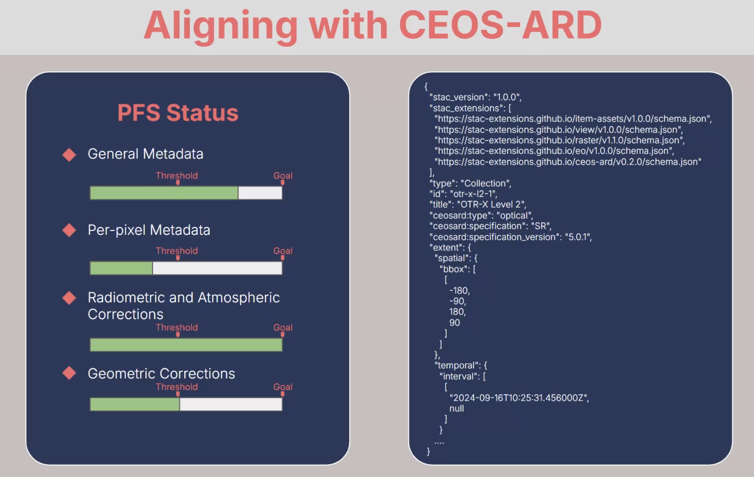
Discussion
The long-term cal/val strategy of Esper was questioned. Ullas mentioned a three-step process of in-lab calibration in Melbourne, the use of 14 different sites, as well as cross-calibration with a GEE cal/val layer.
For OTR-2 the swatch width is about 28km, and the duty cycle is about 50% of the orbit. Aiming to share the usage of the data to maximise value. Using band selection optimisation. Revisit cycle is two weeks. Ake suggested a systematic baseline data acquisition strategy, which would be helpful for scientific studies of the environment, etc. Data that could become free for academic use once past a point of economic value.
Bandwidths are 13nm for Esperesso, and 7-10nm with Esperoko. The SNR is 50-60 and 100, respectively.
The per-pixel issue preventing CEOS-ARD Threshold compliance is related to cloud masking. Esper is working towards an on-board processing approach. If they used ground processing, they would already be at the threshold level. Still trying to work out the specifics of their approach.
No default reference for GRI / GCP.
2.4: Geospatial Intelligence [Slides]
Presenter: Jeremy Repetto
Geospatial Intelligence is a provider of high-resolution optical and radar satellite imagery. They offer capabilities in satellite imaging, environmental monitoring, defence, intelligence, and natural disaster response.
Geospatial Intelligence is both a user and reseller of VHR data. Commercial data is the focus, typically in the 1.5-0.3m GSD range, but they also use lower resolution data sources for wider area analyses. Regular data for comparisons from epoch to epoch really depend on these open, non tasked, background sources like Landsat and Sentinel.
Geospatial Intelligence uses their Osprey platform to process Sentinel-1 and Sentinel-2 data, and they are building a library for AI/ML data that can be used for change detection and environmental monitoring. They also use a tip and cue approach to tasting high resolution data acquisitions.
In closing, Jeremy provided the following perspectives on CEOS-ARD:
- Our clients predominantly rely upon larger satellite missions with high resolutions and a high degree of relative and absolute accuracy.
  - Open-source ARD is important for large-scale projects and ongoing monitoring, but work best in combination with high resolution data.
- There is a role for existing satellite infrastructure to be used for satellite calibration and validation
  - In a recent project, Geospatial Intelligence found existing SAR reflector infrastructure in northeast Australia to be suitable for high resolution optical satellite calibration and validation.
  - Existing very-high resolution sensors with high accuracy could play a role in calibrating and validating other satellite datasets.
- Uptake and usage of open source satellite data by industry is limited by:
  - Frequency of collection
  - Resolution constraints
Discussion
Medhavy noted the use of the Queensland Corner Reflector Array referenced above. It would be excellent to know how the infrastructure was used also for optical calibration. Jeremy noted that they were provided with geodetic data and used high resolution imagery to see if the corner reflectors were visible, which they were, indicating they can be used for reference images.
The Osprey platform uses GA’s NBART products. At the time they acquired the data, it could only be accessed through the Australian National Computational Infrastructure (NCI), which proved difficult. They have since noticed a few issues with the terrain correction.
Matt noted that feedback on CEOS-ARD PFS from an Osprey and AI/ML perspective would be very helpful.
For data in the commercial space, often there is a lean towards the larger data providers since they have advanced GCP and DEM support. The lower accuracy thresholds from smaller / new space providers can be a turn off for users.
2.5: Arlula [Slides]
Presenter: Sebastian Chaoui
Arlula is a Sydney-based technology company that simplifies the procurement, secure management and distribution of satellite imagery at scale. They help organisations leverage geospatial data pipelines to create value without complexity. They have developed a new infrastructure to make accessing large EO datasets easier.
Sebastian presented some thoughts on the problems in the commercial EO industry:
- Poor product delivery and data management infrastructure.
- Inconsistent commercial data standardisation.
- Difficult to navigate licensing limits commercial adoption of technology.
Arlula’s Geostack platform is a cloud-based infrastructure that can be deployed for satellite operators or large buyers. It helps manage the data that is being produced and can connect to ground stations to task directly. Breaking down data silos is a core principle. It has been built to be scalable, with STAC-based APIs to integrate data feeds into new applications and workflows. The aim is to facilitate the integration of EO data into new applications.
It was noted that Arlula was awarded a grant to develop ARD technology for commercial EO, through the Australian Space Agency’s Moon to Mars grant program. They aim to leverage CEOS-ARD in this work, aiming to bring all the commercial data providers up to CEOS-ARD standard:
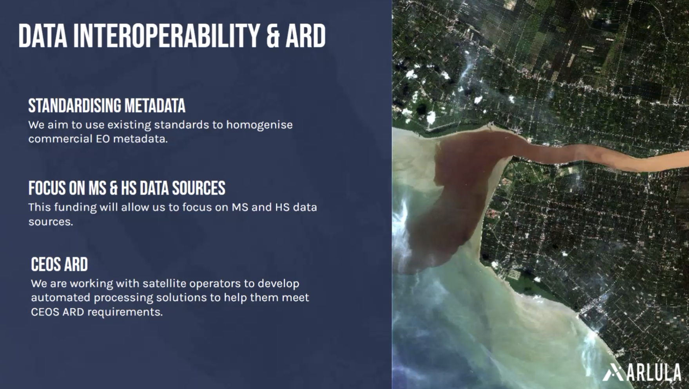
Sebastian referenced the NASA Commercial Smallsat Data Acquisition (CSDA) Program and suggested that having CEOS-ARD included as a requirement for procurement would go a long way to driving uptake of CEOS-ARD amongst commercial data providers. David Borges (SEO, NASA) has previously looked at this, but ran into barriers due to CEOS-ARD not being a formal standard. Matt Steventon (LSI-VC Secretariat) noted that we also have contacts on the similar ESA Earthnet Data Assessment Project (EDAP). It could be worth a follow up to see how CEOS-ARD might fit into and support these processes.
LSI-VC-16-02 | LSI-VC Leads to consider a follow up with the NASA CSDA and ESA EDAP teams regarding the potential for CEOS-ARD with their assessments / procurement processes. | LSI-VC-17
Sebastian noted that metadata schema standardisation would be a big help and would likely drive uptake. He suggested that there should be a metadata specification for optical CEOS-ARD, like there is with the SAR side currently.
Discussion
Sebastian presented the following points as discussion seeds:
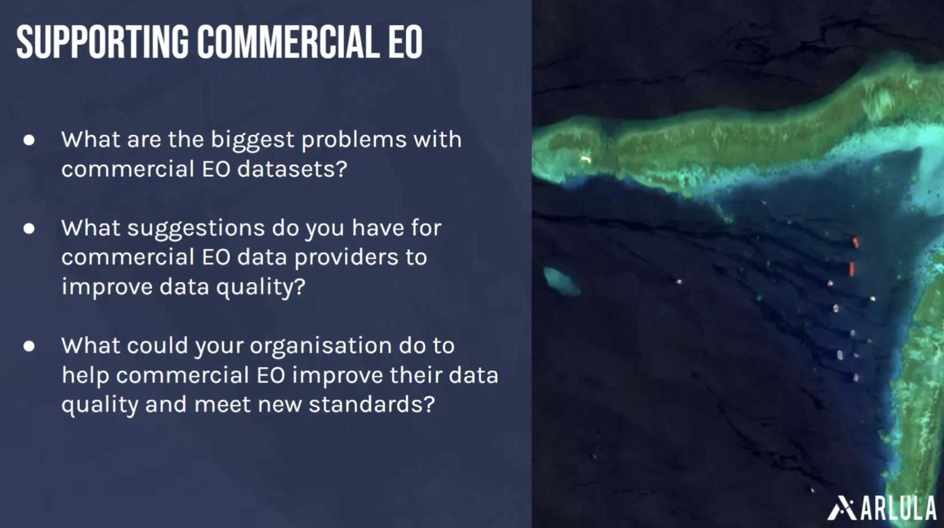
Medhavy Thankappan (GA) welcomed Arlula’s involvement in CEOS-ARD.
Ake Rosenqvist (JAXA) has been in contact with a number of SAR providers, including Capella, Umbra, Synspective. His findings are that none of them are providing anything close to CEOS-ARD in their public offerings. The closest is perhaps Capella, who are providing geo-corrected products. He has contacted these companies to try and start a dialogue on what can be done, work out if they are interested in CEOS-ARD, etc. He has been given the impression that they are content with their existing customers and processing systems. Noting that these companies are all offering high resolution X-band SAR, their customers are mostly defence, and they have their own workflows and requirements. There doesn't seem to be a strong desire for these companies to reach out to new users of the type we focus on with CEOS-ARD.
Defence is responsible for a huge amount of EO data procurement, and as such, everyone marches to that drum. This could be an example of the need for CEOS-ARD, to provide standards for the rest of the user community, and provide a clear target for these companies outside of the defence space. Perhaps bringing a bit more equity to the data demand side of the equation.
Kelly Bruno (USGS) noted the U.S. Joint Agency Commercial Imagery Evaluation (JACIE) program and the annual workshops that bring together federal agencies and commercial vendors to explore cal/val of imagery. And on the European side there is the VH-RODA meeting too. The next JACIE meeting will be held 7-11 April 2025. VH-RODA will take place at ESA ESRIN from 2-6 December 2024.
Matt Paget (CSIRO) noted the long standing topic around buying pixels vs scenes from commercial providers, and asked if Arlula, as a data broker, is seeing any changes in that regard. Sebastian noted that the heritage of minimum order quantities is basically a result of the labour-intensive, manual nature of past practices with ordering and acquiring data (phone calls, sales representatives, etc.). He noted that this is changing, with Big Data, automation, etc. and that their Geostack platform doesn’t have such a limitation. He added that he thinks we are moving towards EO being a commodity. Arlula is suggesting to satellite operators that they might make more money if data can be streamed to more people at a pixel level. Arlula is pushing those types of discussions now.
David Borges (SEO, NASA) noted long standing debates about opening up historical archives for societal benefit. He asked if Arlula is seeing any advancement on that line of thinking with commercial providers. It was noted that Umbra and Satellogic are opening up some select subsets of data, but there is still a lot of old style thinking. Free archive access is still not common. Ake suggested that these limited offerings / subsets of data are of limited use, because they are not comprehensive enough or of users’ areas of interest. Those types of archives are of limited use and we really need broad background observations to be of use for e.g. environmental applications. Given that the majority of commercial value of data lies in its recency, we would hope to see more access to archive data for scientific applications. As key anchor customers, CEOS agencies should advocate for the opening of data archives, making sure this is built into contracts.
It remains difficult to find and source commercial data. No consistency and too many APIs. There needs to be some sort of consolidation. Matthias noted the Sensor Tasking API (STAPI) that is somewhat aligned with STAC. A relatively new development.
Tim noted U.S. interagency discussions, with NGA/NRO buying data with provisions for public access to the same data as well.
It was suggested that there could be a useful role for LSI-VC to establish some sort of framework and interface for CEOS agencies that are interested in buying out old commercial archives and then releasing the data under creative commons licensing. It would be up to individual agencies to decide on any potential investment, but LSI-VC might be able to establish some sort of standardised proposal for historical data value. We would also need to track which agencies have purchased what data, to avoid duplicate purchases. This was brought up with reference to an instance where GA purchased medium resolution satellite imagery of Australia from DMCii and subsequently made it available with open licensing. GA made the case that the commercial value of the data drops to near zero, and so they offered to buy the archive out at a fraction of its regular value. This topic would be a good fit for the ‘Policy’ block of the CEOS Interoperability Framework and may need people with experience of contracts / lawyers to address properly.
LSI-VC-16-03 | LSI-VC Leads to consider whether there is a role for LSI-VC in establishing some sort of framework and interface for CEOS agencies that are interested in buying out old commercial archives and then releasing the data under creative commons licensing.  Notes: This would involve standardising some language around the value of historical data, understanding open licensing and setting a common licensing approach, and likely discussing the idea with some commercial providers. It would ultimately be up to CEOS agencies to decide whether to make such an investment, but LSI-VC might be able to bring awareness to this model and smooth the process. We would also need to track which agencies have purchased what data, to avoid duplicate purchases – cataloguing those. | 2025
LSI-VC-16-04 | LSI-VC Secretariat to raise an issue in GitHub for future CEOS-ARD specification development regarding the inclusion of licensing as a PFS parameter. Should provide a few classes of licensing across the spectrum that can be selected. | December 2024
2.6: Descartes Labs/EarthDaily [Slides]
Presenter: Paddy Brennan
The EarthDaily Constellation (EDC) will consist of 10 satellites launching in Q1 2025. They will provide daily global coverage, with 22 spectral bands (from visible to thermal infrared) and aim to provide consistent, scientific-quality data to enable change detection and predictive AI. The EarthDaily Constellation is a systematic collection mission, always nadir looking, always-on (over land).
Actively working towards CEOS-ARD and STAC to enable rapid integration, change detection and ML/AI applications at scale.
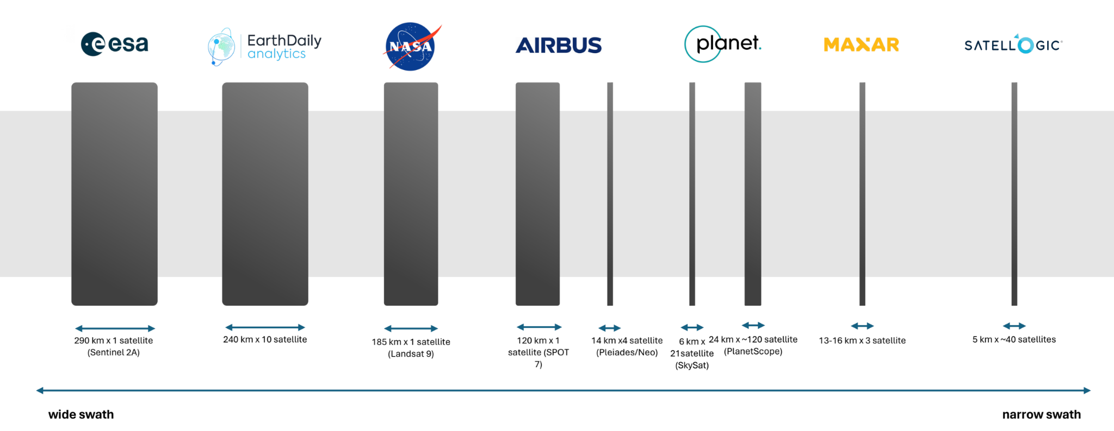
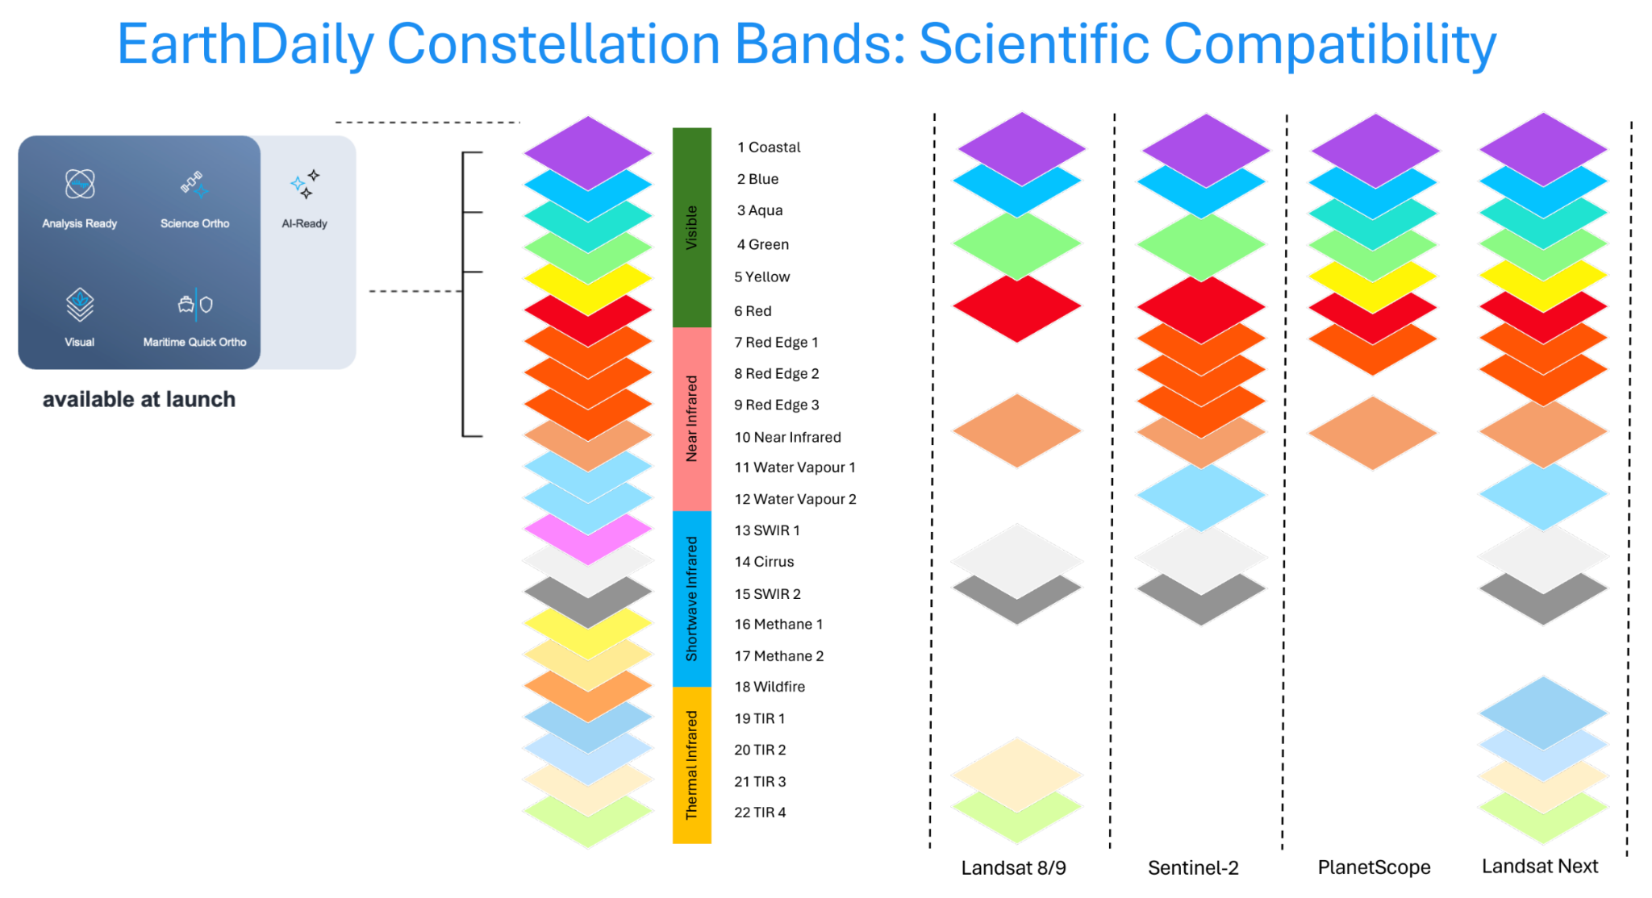
EarthPipeline is a turn-key scientific grade ground-segment. It is a new ground solution for New Space, designed to transform downlinked satellite data into high scientific quality “Analysis Ready Data” at scale. EarthMosiacs are EarthDaily’s offering of ARD products.
Paddy presented some thoughts on the need and case for standards like CEOS-ARD. By creating a standardised, consistent format for EO data, we reduce complexity and remove uncertainty. This is particularly important in an increasingly crowded EO landscape, with a rapid proliferation of EO companies and overwhelming level of choice for buyers. Time spent navigating complexity slows down innovation.

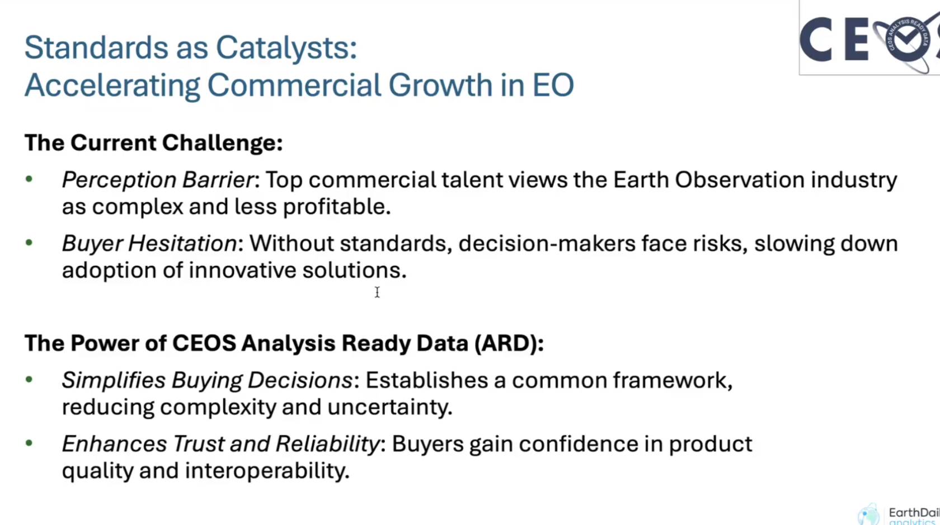
Discussion
The importance of sharing spectral band sensitivity coefficients was noted. This will be crucial to users’ assessment of the EarthDaily Constellation data and its applicability for their applications.
Session 3: New Approach to the CEOS-ARD Framework
3.1: Introduction and Motivation [Slides]
The CEOS-ARD Framework and specifications have to date been built on simple documents. This has served us well, but we are increasingly running into issues with this format. It is becoming difficult to ensure consistency across the PFS and to take advantage of commonalities between them. Updating the PFS is now a daunting exercise, as seen with the recent aquatic reflectance PFS update. Version control and history tracking is complicated, and it is difficult to reach a consensus among the various teams.
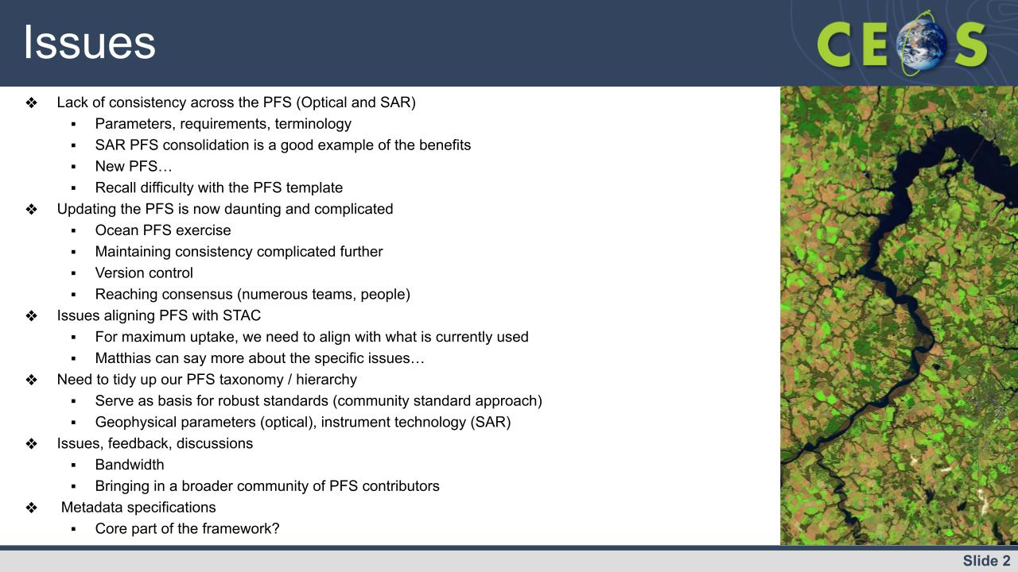
We think that a GitHub based approach and a modularisation of parameters (into ‘building blocks’) could be a way forward. This would ease alignment with STAC and also make it easier for a broader community to contribute to the specifications. But there are a lot of open questions:
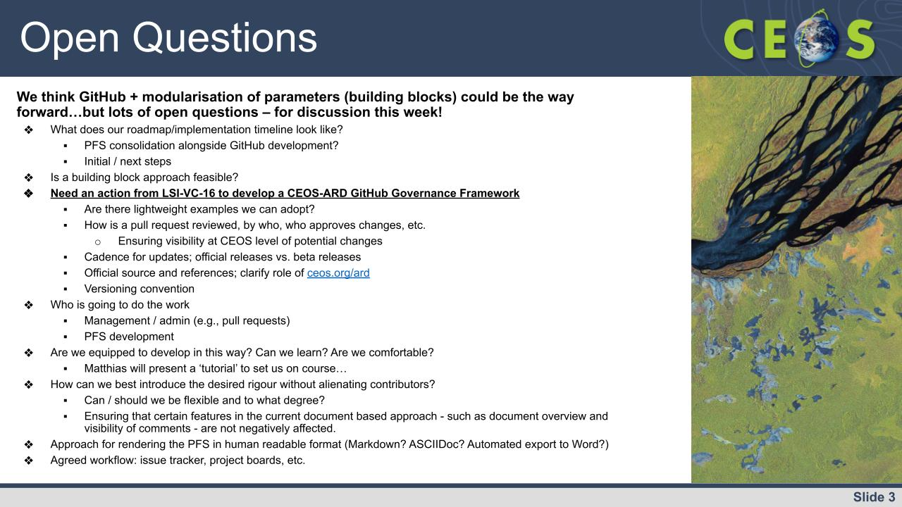
We want to come out of LSI-VC-16 with ideas of what goes into a CEOS-ARD GitHub governance framework, agree on some implementation practices, and define a timeline/roadmap for this development. Some implementation practices / guidelines that need to be considered include: versioning; cadence of official releases, approaches to beta versions; pull request review process; maintaining consistency; ensuring visibility; roles and responsibilities; description of workflow and Github tools (issue tracker, project board, etc.); and issue tracker conventions.
3.2: CEOS-ARD GitHub [Slides]
Matthias provided an overview of the motivations and benefits of a move to GitHub. He reiterated that with the status quo:
- PFS are not fully compatible and diverge more and more
- Combining documents is difficult
- And the development of PFS is not very open and difficult for external stakeholders to contribute towards.
Github development will be public, provide versioning, and a means for submitting issues (already active on the CEOS-ARD GitHub). Anyone can make pull requests and propose changes to the specifications (for review by a yet to be determined moderator/team). Issues and feedback on the PFS is becoming increasingly difficult to track and the GitHub issue tracker is already making this simpler and ensuring feedback does not get left behind.
Further changes are needed to unlock the full potential of a GitHub approach, such as implementing a ‘building block’ approach to parameters and requirements (see agenda item 4.5) and using a set of these common blocks across all PFS and generating PFS documents on the fly from a collection of these blocks. The purpose is to ensure consistent documents and re-usable requirements.
Matthias provided an overview of the existing CEOS-ARD GitHub repository and its features as well as an introductory tutorial on GitHub more generally.
Discussion
We need to define some roles for the management of the GitHub: overall administrators as well as a team of reviewers for different types of pull requests. We also need to agree how a consensus is reached on any proposed changes. How are these proposals fed back to CEOS experts for review, who is that collection of experts, and what is the timeframe for review.
We also need training materials and guidelines for the CEOS-ARD GitHub. We need to summarise all of the different functions, how they will operate, what is the process for reaching agreement, etc. This needs to be compiled in a governance framework with agreed procedures.
The GitHub has a learning curve and it is a fact that some people, including those that have been central to the CEOS-ARD and PFS development to date, will just not engage with the GitHub on a day-to-day basis. We need to ensure everyone remains in the loop. Ensuring there are no negative impacts due to the move to a GitHub approach will really fall back to maintaining the calls, meetings and dialogue that have got us this far. There will be an effort needed to make sure there is continued visibility of discussions across CEOS.
Another aspect to capture in a governance framework is the process for versioning (e.g., what counts as a 5.x release and what counts as a 5.0.x release?). How do we accumulate changes (in a development branch?) and what is the timeframe for merging these branches into the main branch. Who reviews the changes and how are these communicated. What is the cadence of official releases? Are there other branches for different streams of development? Need to capture the workflow. Releases of different PFS should be synchronised to keep an overall consistency?
Need to decide if official releases would be done as needed or on a regular schedule. Peter noted the need to consider reprocessing of archives. How often can we have release dates depends on the timelines of agency releases. It is important that releases take into account agency reprocessing opportunities and release schedules of collections. We don't want to be out of sync and constantly moving the goal posts for agencies.
A major benefit of the GitHub and building block approach will be the ability to more closely align with STAC. We need to align CEOS-ARD with such already adopted conventions to leverage the software and tooling that is already established and used by the community. We currently have a separate metadata specification for SAR, but we should consider instead adopting STAC directly to align with software that is currently in use (and allowing machine readability). It was noted that one of the benefits of the existing CEOS-ARD SAR metadata spec is its human readability.
George Dyke noted that this shift is not just about doing things in a different way, rather if done right this will unlock new possibilities. If CEOS-ARD and the specifications/metadata are codified in a more rigorous way, we can build upon existing tools and structures and ease use of the data.
Tailored engagement and training is critical to getting CEOS teams on board. This could be a role for the CEOS SEO.
In the proposed ‘building block’ approach, the PFS would be collections of the individual building blocks, which capture individual parameters and their requirements. The different PFS would draw upon the same set of blocks, but may have unique blocks. The idea is to have the PFS use the same blocks to the greatest extent possible, ensuring consistency between them. We have for a long time been talking about ‘consolidating’ the PFS, but in fact with this approach we are now talking about splitting the PFS into parameter blocks and then reconstructing the PFS from a collection of blocks. The picking and choosing of blocks is what then makes up a PFS.
We will also need to decide what happens when a necessary building block is slightly different to an existing one. The last option should be to create an entirely new block. We should try to have consistency wherever possible and avoid a proliferation of slightly different blocks.
It was noted that specific issues can be tracked with subscriptions and the discussions tab in GitHub. It was agreed that we should restrict our workflow to make it easier to engage. If we have comments spread across various GitHub functions it will be difficult to track. Need to agree on a workflow / process for discussions and reaching a decision. It was suggested that there could be links embedded in the PFS to raise a new issue in GitHub.
LSI-VC-16 Decision 01 | The LSI-VC agrees in principle that shifting the CEOS-ARD specifications and their development to GitHub would be beneficial.

LSI-VC-16-05 | LSI-VC Secretariat and SEO team to summarise the proposal to shift CEOS-ARD specification development to GitHub such that it can be shared with other stakeholders within CEOS (e.g., CEOS-ARD Oversight Group, OCR-VC, P-VC, Aquatic Reflectance PFS team, etc.) for their agreement.  Context: The LSI-VC agrees in principle that shifting the CEOS-ARD specifications and their development to GitHub would be beneficial. We need to summarise this in plain language and seek agreement from the other stakeholders in CEOS, including the CEOS-ARD Oversight Group. We need to capture all of the foreseen benefits and how the GitHub approach addresses the issues we are seeing with the status quo of CEOS-ARD specification development. | January 2025
LSI-VC-16-06 | LSI-VC Leads and Secretariat to set up a basic structure/TOC for a CEOS-ARD GitHub Governance Framework. It might be a good idea to start this in markdown format on the CEOS-ARD GitHub as a familiarisation exercise. | February 2025
LSI-VC-16-07 | SEO to consider the possibility and approach for a series of tailored training sessions for the CEOS-ARD GitHub. | February 2025

Tuesday, September 24
Session 4: Optical CEOS-ARD PFS Developments and Consolidation
4.1: Session overview [Slides]
Matt Steventon (LSI-VC Secretariat) presented an overview of this session. The purpose of this session is to continue the discussion on the issues with status quo PFS development. The session will cover:
- Lack of consistency across the PFS – in parameters, requirements, and terminology
- Updating the PFS is now daunting and complicated – consistency, versioning, reaching consensus
- Benefits of consolidated PFS with SAR – what can we learn and do on the optical side?
- Is the ‘building block’ / modular approach the way to ease this consolidation?
- Ocean Reflectance PFS development
- Difficulty discussing and getting consensus on PFS changes
- PFS taxonomy / hierarchy – product Levels, standards, geophysical parameter vs instrument
- Metadata specifications
Presentations in this session:
- Expansion of the Aquatic Reflectance PFS to cover the oceans (Dekker)
- USGS initial assessment of a PFS consolidation (Barnes)
- CEOS-ARD Functional Taxonomy/Ontology/Hierarchy (Strobl)
- Proposed ‘Building Block’ Approach to constructing PFS (Mohr)
4.2: Expansion of the Aquatic Reflectance PFS to cover the oceans [Slides]
This activity is primarily looking at how to expand the existing Aquatic Reflectance PFS such that it can cover from coastal and inland waters to oceans. The boundary between inland, coastal, estuarine, and ocean water is not a clear boundary.
In addition to ocean-specific changes, the review has also been raising many fundamental questions about the nature of the optical PFS. The team is struggling with how all of this feedback can be addressed by the broader optical PFS community. It is a timely example of where we need better processes for suggesting changes, ensuring consistency, consulting across multiple teams, development branches, etc.
Arnold presented the issues identified to date. Please see the slides for all of the details.
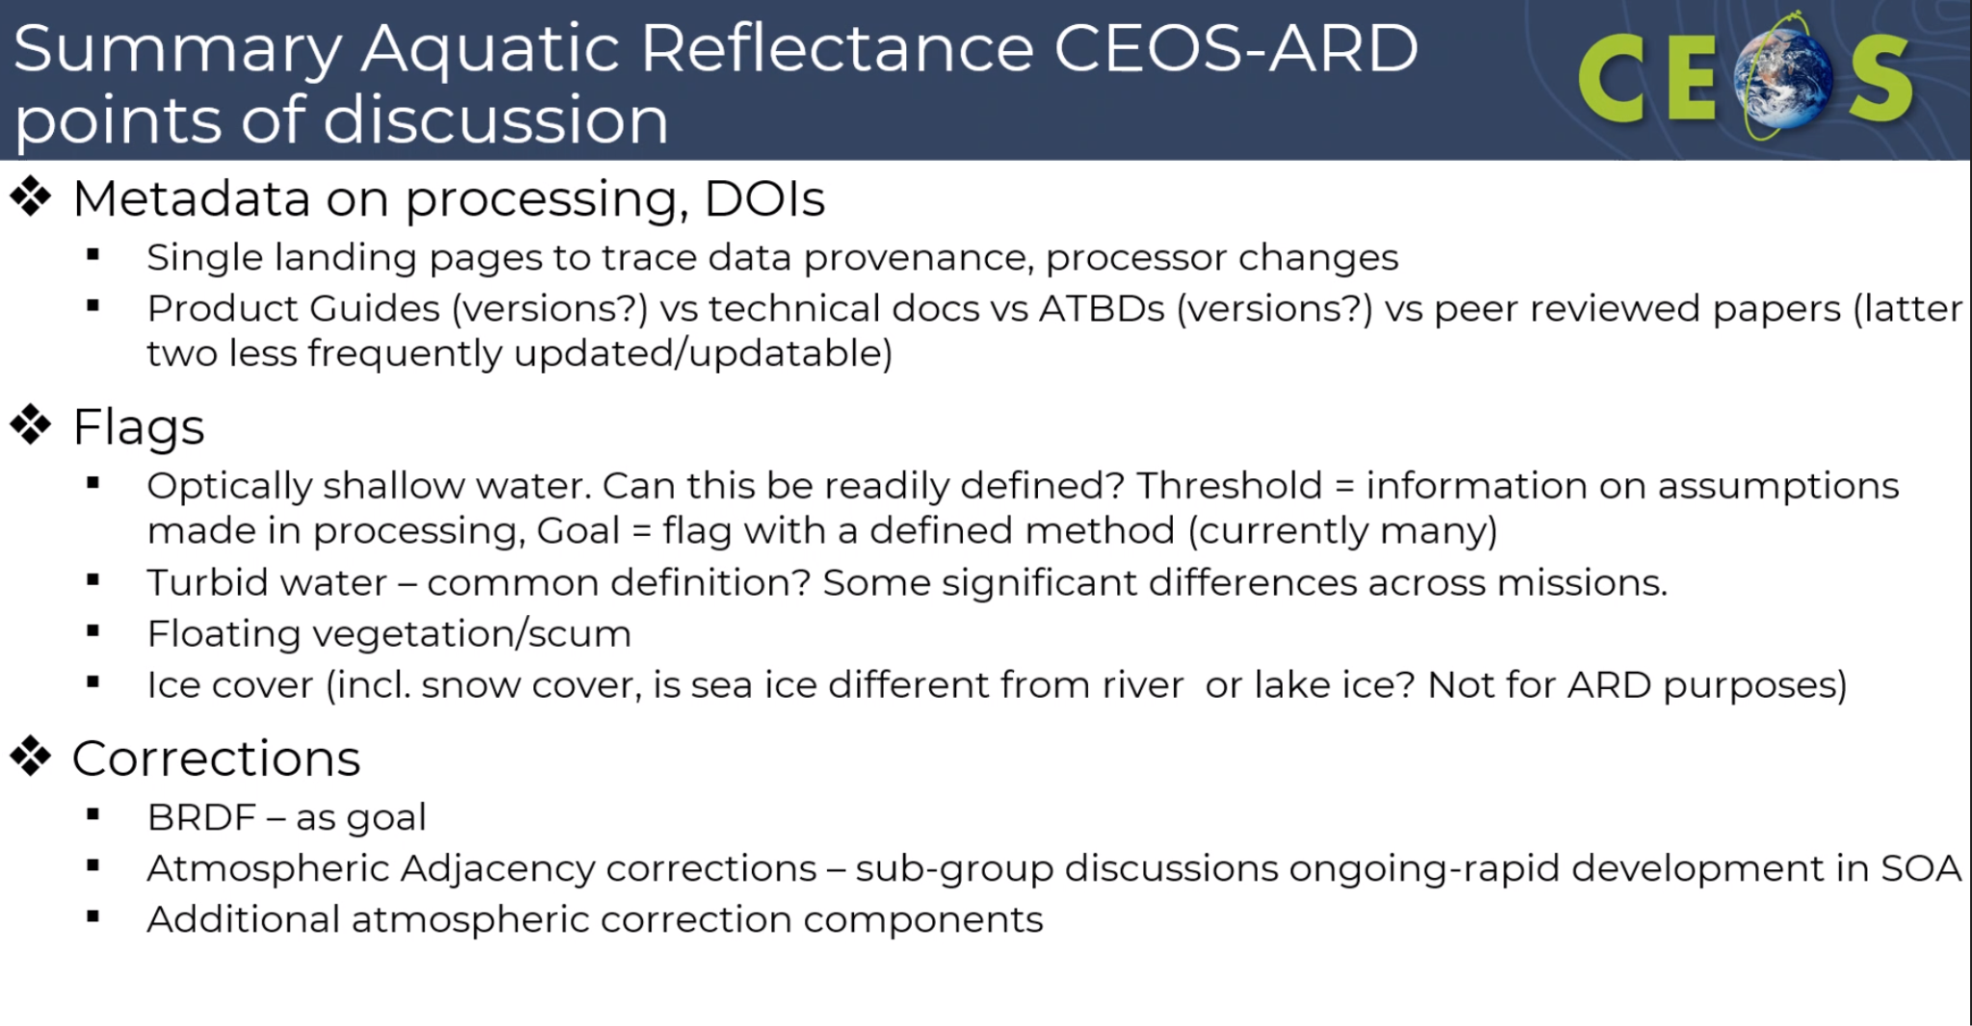
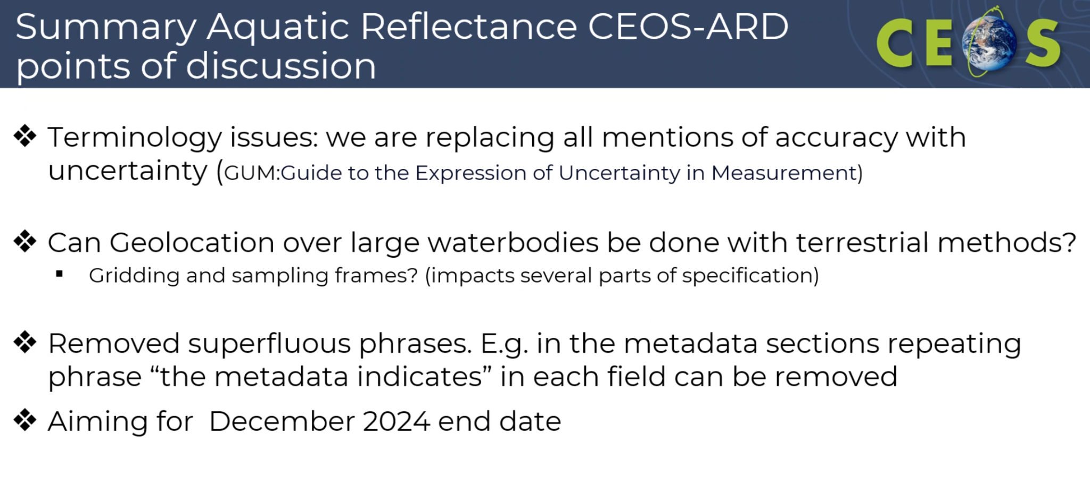
Discussion
This activity has provided a substantial amount of feedback on the SR PFS as well as the existing AR PFS. Things are complicated by the fact that we haven’t done a major update of the baseline SR PFS in quite some time (v5.0 in 2020). The general metadata fields in particular could do with an update, but this will require broad consultation that probably needs to wait until we have a more organised version of the existing specs (i.e., on GitHub).
We need to keep in mind the initial thinking behind the Threshold level requirement, which is accessibility and not making the initial bar too high for data providers. The Goal level is useful to provide a goal post for future development, and that’s where more tricky things should be covered.
We have avoided updating the surface reflectance specification out of an abundance of caution in not breaking existing product compliance. Maybe we have to accept the fact that we will be making substantial changes that are going to break some existing assessments. They can remain compliant with previous versions of the PFS. Need to decide whether breaking existing assessments is something we are happy to proceed with. It was noted that there are not a huge number of existing assessments, and these are mostly from CEOS agencies.
The building blocks / GitHub implementation really should be in place before we start trying to make changes to the SR PFS. Setting up the building blocks will take a few months (if this is handled solely by Matthias Mohr). Setting up the building blocks is not just a simple task of copy-pasting the rows – we need the fundamental structure of each block laid out first. And we also need to make sure the blocks are extensible.
We need to consider the ability to have mosaic/multi-source products on the optical side (already done in the combined SAR specification). This needs to be a consideration from the start of the building block approach.
It was agreed that we should aim to have an initial implementation of the building blocks on GitHub by the time of LSI-VC-17. Starting with the existing AR PFS could be a good idea, providing a target for the feedback being generated from the AR PFS review team.
We need unique tag names for each parameter, and to consolidate these wherever it makes sense. We would only want limited instances where a parameter is similar (perhaps with a suffix to denote which type of product it applies to) to another. We need to be clear on parameter/requirement names and their meaning/function. This is important for machine readability, etc.
We don’t think CEOS should be defining its own metadata standards, since there is no software that uses it. We should align with STAC and by doing so we ensure inherent alignment with various software and tools that are out there. There is already an ecosystem / community around STAC and we should capitalise on that. We don’t have an existing CEOS-ARD metadata specification outside of the SAR side.
Matthias would suggest that we don't define a new optical metadata spec, but instead align with STAC. We could keep the SAR metadata specification for now and just assign an alignment in the blocks, but would suggest aligning with STAC from the start with the optical side.
Ake suggested that human readability is an important factor behind the SAR metadata specification.
Building the SAR PFS blocks could be a nice way to influence the STAC SAR specification, which is currently underdeveloped. Aligning the SAR CEOS-ARD metadata specification with STAC would be a nice step forward.
Dave suggested that we engage as much as possible with the SAR commercial sector from the start. The SEO will present some results on their assessment of commercial datasets later in the meeting. Defence is a big driver of requirements in this space (particularly X-band) and we should engage to learn how the CEOS-ARD specs might be better aligned with these needs.
We need to harmonise our metadata fields across the PFS, decide whether we want all of them to be in one file (preferred), and how we want to structure those files.
4.3: Combined Optical PFS [Slides]
Chris Barnes (USGS) presented his analysis of the commonality between the optical PFS. They are already quite aligned, given their common starting point being the SR PFS. It was agreed that this combined PFS prepared by USGS would be an ideal place to start the building blocks. Further discussion is needed to resolve some of the open questions. We will hold a discussion tomorrow and aim to have a consolidated PFS as a starting point for the building blocks. This will not be an official release – the currently endorsed PFS will remain the official versions, but this gives us a starting point for the building blocks. This will hopefully streamline further consolidation at the building block stage.
4.4: CEOS-ARD Functional Taxonomy/Ontology/Hierarchy [Slides]
Peter presented his slides from the 128th OGC Member Meeting in which he presented various open questions and some proposals around semantics, categorisation of types of ARD, processing levels, ARD definitions, etc. Refer to the slides for full details.
Building blocks is the leading idea for how we introduce more consistency across the PFS, but Peter suggests that the first question that needs to be answered is what these building blocks are actually for.
At a macro level, we need a decision on which point do you want the different data streams to come together. That is, at which point do you aim to become sensor agnostic. It is important to include uncertainties otherwise you cannot merge datasets with any confidence. Uncertainty is fundamental.
How can we align the list of parameters / blocks / fragments with ISO 19156. How we solve that is unclear. That would be a subsequent step following the building block step.
Tim Stryker noted that we want to get to more widely understood and adopted approaches to ARD as well as related understanding and adoption of interoperability principles. But we can;t get there without the appropriate building blocks. Need to take some kind of action to start. Tim added that he doesn’t think CEOS agencies have a common understanding of what their processing levels are. Peter agreed.
Matt Paget (CSIRO) suggested that we don't want to create new and confusing sets of definitions. Instead we want to identify where we have overlap with existing structures, standards and definitions that are adopted at a geospatial standards level.
Tom Sohre noted that multiple definitions across different standards. It is not realistic to be able to change all those definitions to reach truly common definitions. So how do we find a way to make a link / translation between the differing definitions. Ensuring people can understand the differences, without forcing everything to come into line. Allowing some kind of mapping without making them all the same.
Peter noted that from a metrology point of view we need a common reference. Something that we can map against. So everyone can use what they want, but be able to reference a common schema. We need to decide whether we want to adopt an existing schema or go with our own and then build the common reference.
Dave Borges asked if it would make sense to have a proposal that all CEOS agencies consider adopting a common processing level definition like the one presented by Peter. Is that realistic?
Ake suggests that rather than trying to architect this top down, we need to address these issues as they come up, through the building blocks.
The evolutionary intention of the CEOS-ARD specifications was noted. We saw this as an evolution towards interoperability. Need to look at practical ways forward, while acknowledging there are some things like this that need to be addressed. We can’t get stuck by trying to architect a perfect solution.
Arnold also suggested working through this as we go. Language itself is nuanced and impossible to align. The Aquatic Reflectance PFS team is a good example of where different communities interpret things in different ways. Forcing alignment in all terminology and conventions is not realistic.
4.5: SpatioTemporal Asset Catalogs (STAC) Overview and Tutorial [Slides]
The STAC specification is a common language to describe geospatial information, so it can more easily be worked with, indexed, and discovered. It was created to address the issue of the existence of different satellite data access portals, APIs, etc. and provide consistency in using geospatial information. It was created as a bottom up initiative and started with identifying pieces of the metadata that are important for search and discovery so that they can be queried and pulled out. It is not a full-fledged metadata standard, a single source of truth, nor does it aim to cover all kinds of datasets, or be a replacement for ISO 19115, OGC CSW, etc.
Matthias provided an introduction / overview / training on the STAC framework and components. See the slides for details.
Matthias noted the existing/old STAC CARD4L extension. The optical mapping was quite good, however there were many SAR fields that were not covered in existing core/extensions. The recently updated new CEOS-ARD extension is quite limited, just covering the type of data and the PFS and its version. This is seen as the ideal case, where the CEOS-ARD extension would only cover aspects that are unique to CEOS-ARD, and the other parameters/requirements in the PFS would be covered by the STAC core or perhaps some other higher level extensions. Ideally we would have a specific section in the building blocks defining the mapping of the parameter to existing STAC field names. That would avoid the mapping, which currently needs to be updated by Matthias.
Ake asked what is required from the CEOS-ARD side to make our specification STAC compliant. And should data providers supply a separate additional JSON file that maps with STAC?
Matthias suggested there are a few approaches. Some datasets already come with STAC metadata, but these might not contain everything necessary for CEOS-ARD. Those data providers might need to extend the JSON files. The requirements in CEOS-ARD are quite extensive. Most providers wont have everything in place that is required. If there is no such STAC metadata file, you could just produce a new JSON file and put it alongside the existing.
Per-pixel metadata is stored as another asset, such as a COG or some type of file. Per-pixel metadata become assets with their own metadata.
LSI-VC-16-08 | Ake to work with Matthias to investigate the feasibility of replacing the SAR XML metadata specification with a modified STAC JSON. For the SAR PFS specifically we need to work out what is missing from the metadata on the STAC side. Those missing fields might necessitate a new STAC extension / evolution of the CEOS-ARD extension. | LSI-VC-17
Session 5: UNCCD & Standards for Geospatial LDN Reporting Indicators
5.1: United Nations Convention to Combat Desertification (UNCCD) [Slides]
Nils Hempelmann (Open Geospatial Consortium) presented on the newly formed Geospatial Reporting Indicators Standards Working Group under OGC (OGC GRI SWG).
The purpose of the GRI SWG is to:
- Develop a portfolio of open Standards that enable the robust, transparent, and consistent use of geospatial data and indicators in international reporting schemes; and,
- Accelerate the development and adoption of open Standards-based geospatial technologies that can form components of systems used to implement international reporting schemes, including systems supporting planning, data collection, monitoring, and reporting activities.
The UNCCD and SDGs are examples of reporting frameworks and these are an initial focus for the GRI SWG. These are aligned with CEOS priorities also, and Dave Borges (CEOS SEO) has been engaging in that context.
SDG Indicators are assigned to different UN custodian agencies. One of those that CEOS works with is UNCCD on Land Degradation Neutrality (LDN). The SDG Coordination Group under CEOS has worked on topics related to UNCCD for a long time.
Dave referenced the letter that CEOS received from the UNCCD Secretariat which requested further CEOS support: “In terms of standardization, CEOS and LSI-VC could play a critical role in the development of OGC standards for geospatial LDN reporting indicators, building on the ARD concepts and prior work by GEO-LDN on minimum data quality standards for SDG indicator 15.3.1. An OGC Standards WG Charter for the establishment of the geospatial reporting indicators WG is currently in the phase of electronic voting by OGC members.”
Nils noted that under UNCCD. countries have to provide a variety of information on how they are addressing LDN. All of the UNCCD strategic objectives can be underpinned with trends in e.g., land cover. SDG 15.3 is LDN – the proportion of land degraded over total land area. LSI-VC agencies provide the data that supports such indicators.
GEO is working on a toolbox for LDN. UNCCD reporting infrastructure aims to be enabled by standards based on interoperable tools and APIs.
The next reporting cycle is in 2026. The community is now in a situation where the data pipeline, from raw data to information, needs to be enhanced and optimised. Have identified a necessity of standardisation so that the tools and APIs are producing consistent and comparable indicator data. Such standards also open the opportunity to add more tools into the mix. Various OGC standards are already referenced.
Why do we need standards?
- Irregular country reported data creates inconsistencies which need to be cleaned consuming resources, time and effort.
- The lack of standards in default data could lead to inconsistencies, standards allow potential default datasets to be "vetted".
- Standards create buy-in and build community among the UNCCD's network, e.g., through the GEO Land Degradation Neutrality Flagship.
- Ultimately, we want to move towards a wider ecosystem of software tools which are interoperable with the UNCCD reporting platform "PRAIS".
- Taxonomies, e.g. restoration actions, are not standardised.
Noted they are using methodological guidance as a minimum standard such as existing good practice guidance. Agreed a JSON format for these reporting and data exchange. This was the practice for the last reporting round:
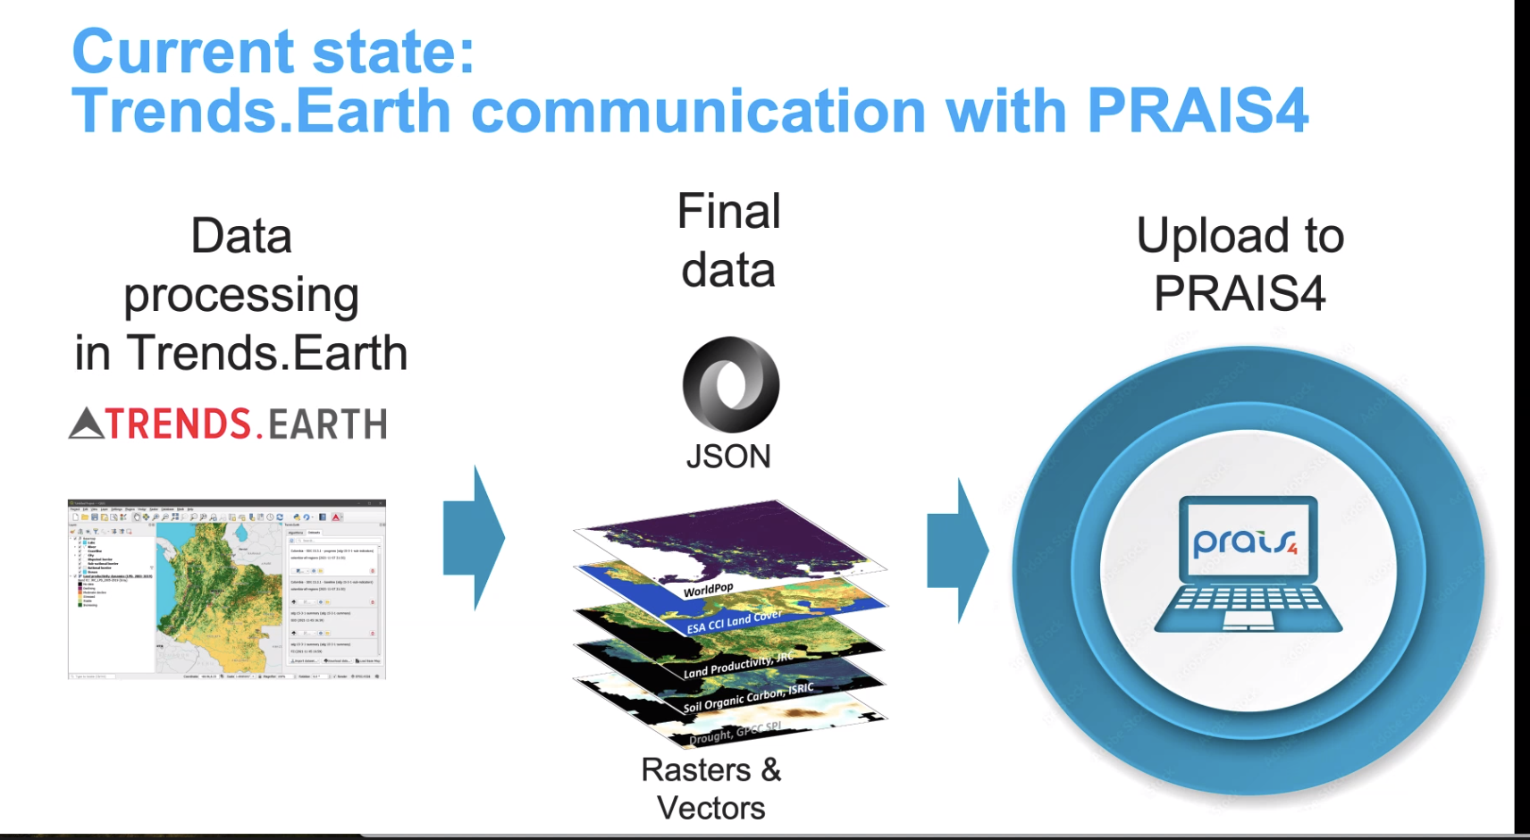
The OGC GRI SWG has been established with the goal of moving the current process into a formal OGC standard. Currently looking for co-chairs.
Discussion
The next reporting cycle is supposed to be finished by 2026. Deadline for contributions would therefore be by the end of next year. It was asked when UNCCCD needs some sort of deliverable from this SWG. Nils is not sure there is a deadline, but the planning was that the data production should start in summer 2025.
It is the intention to expand the GRI SWG to cover other thematic areas and reporting frameworks. The Charter for the SWG is quite broad.
LSI-VC support for the GRI SWG again comes back to the interest in / ability of LSI-VC to support products beyond Level 2, which is essentially a question that the agencies have to ask themselves. Principal level direction would be needed and it would be an agency level decision (i.e., not for CEOS).
Space asset continuity is the realm of LSI-VC, and so an activity at LSI-VC level would be, for example, assessing whether the current collection of space assets provides what is needed for the UNCCD reporting.
While moderate resolution data is relatively well covered by baseline observations from e.g., Landsat and Sentinel-2, the letter from UNCCD to CEOS points to another potential role for CEOS: “Countries in regional geographies of small island developing states (SIDS), mountainous states and hyper arid areas have expressed their need to go beyond moderate resolution satellite observations to track land degradation at higher spatial resolution. CEOS could directly contribute to assessing the availability and suitability of land surface datasets for these geographies, by prioritising SIDS and hyper arid areas.”
UNCCD is also asking for a CEOS perspective on the usefulness and trustworthiness of commercial data.

LSI-VC-16-09 | David Borges and LSI-VC Leads to consider how to raise the LSI-VC focused requests from UNCCD (letter) with CEOS leadership, noting that a commitment to address these will require confirmation of the scope of LSI-VC activities (i.e., should LSI-VC consider coordination higher level products and to what extent can this be done in a forum like CEOS, rather than at individual agency level). | SIT-40
Session 6: Interoperability
6.1: WGISS Interoperability Handbook v2.0 [Slides]
Nitant Dube (ISRO, WGISS Vice Chair) presented the latest on the WGISS Interoperability Handbook v2.0 activity. This is a follow on to the Interoperability Framework, which was endorsed by CEOS in 2023. The intent is to use the new framework to develop an updated handbook, which will provide an overview of existing capabilities within CEOS that could be used either by CEOS agencies or external users to develop approaches for interoperability or to improve/develop interoperability for Earth observation data and services The intent is not to tell providers how to do things, rather describe what to do, with links to guidance material. It will present a series of recommendations for agencies to consider to improve interoperability.
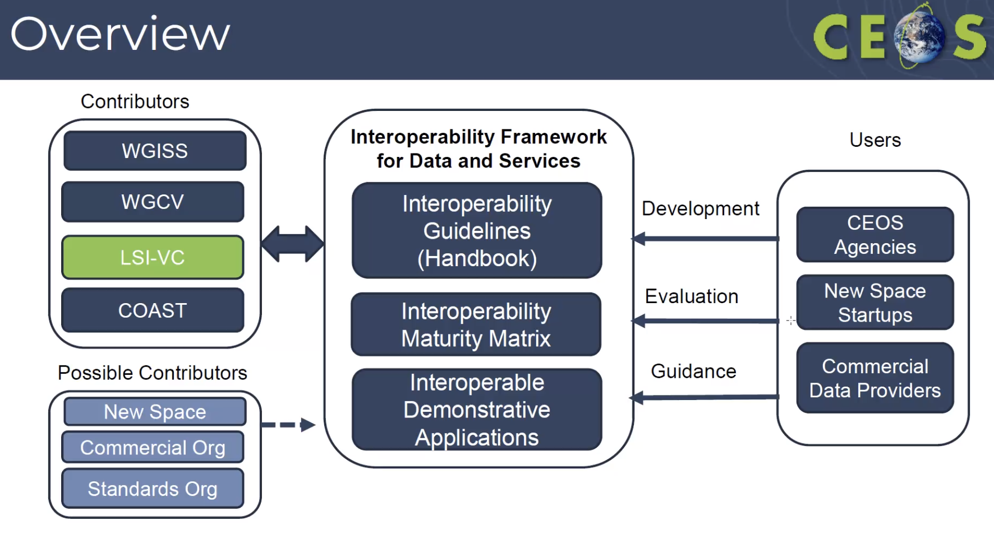
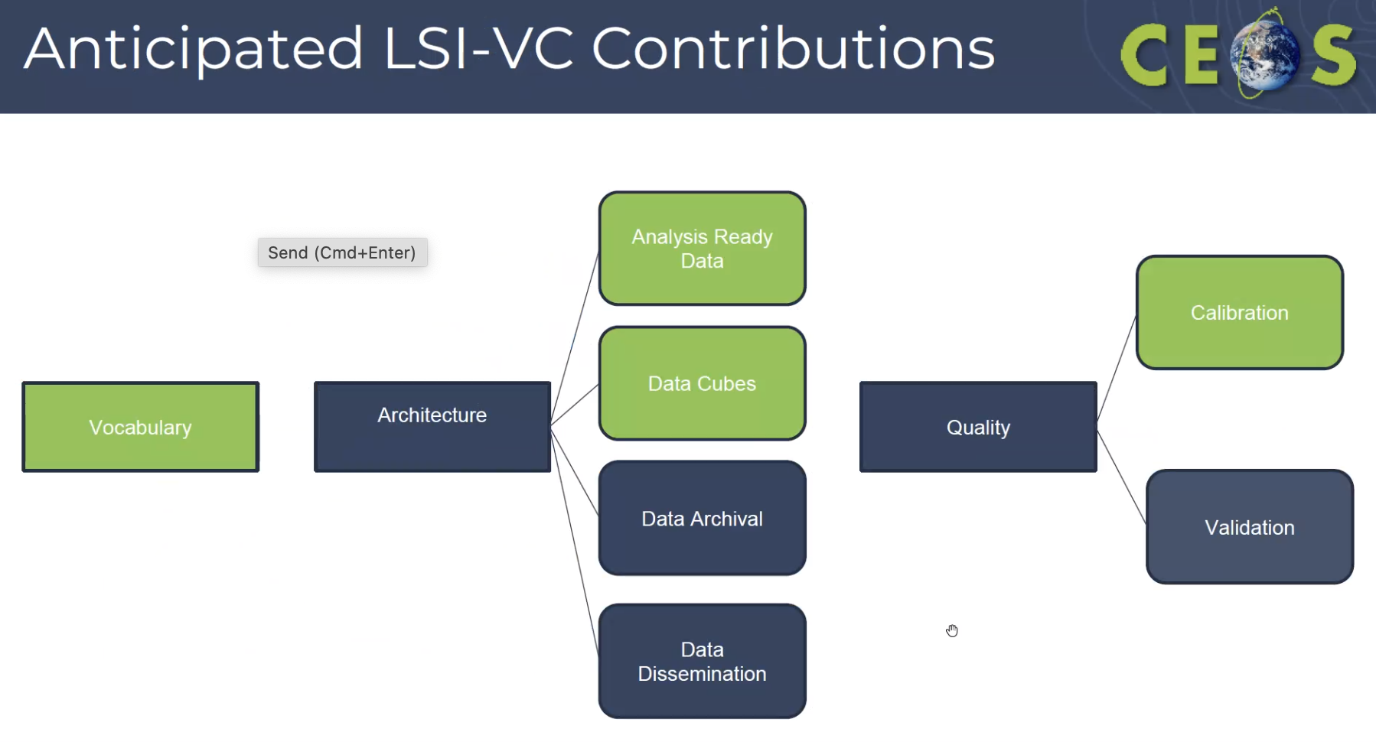
Currently CEOS-ARD is referenced as a starting point for interoperability and hence data providers are encouraged to develop CEOS-ARD:
- The CEOS ARD Framework should be used as a starting point for development of Analysis Ready Data
- CEOS Product Family Specifications (PFS) should be used for development of ARD products. In case if a new ARD is to be developed, use PFS template and submit to CEOS for approval
- CEOS ARD compliance of the product requires two level of assessments, first is self assessment (CEOS ARD Self Assessment Guide) and second is peer review by CEOS Experts
LSI-VC support is sought to flesh out these recommendations.
LSI-VC-16-10 | LSI-VC Leads and Secretariat to review the CEOS-ARD sections of the WGISS Interoperability Handbook v2.0 and provide feedback to the WGISS Vice Chair, Nitant Dube. | March 2025
WGISS plans two interoperability demonstrators, which have potential connections to / roles for LSI-VC:
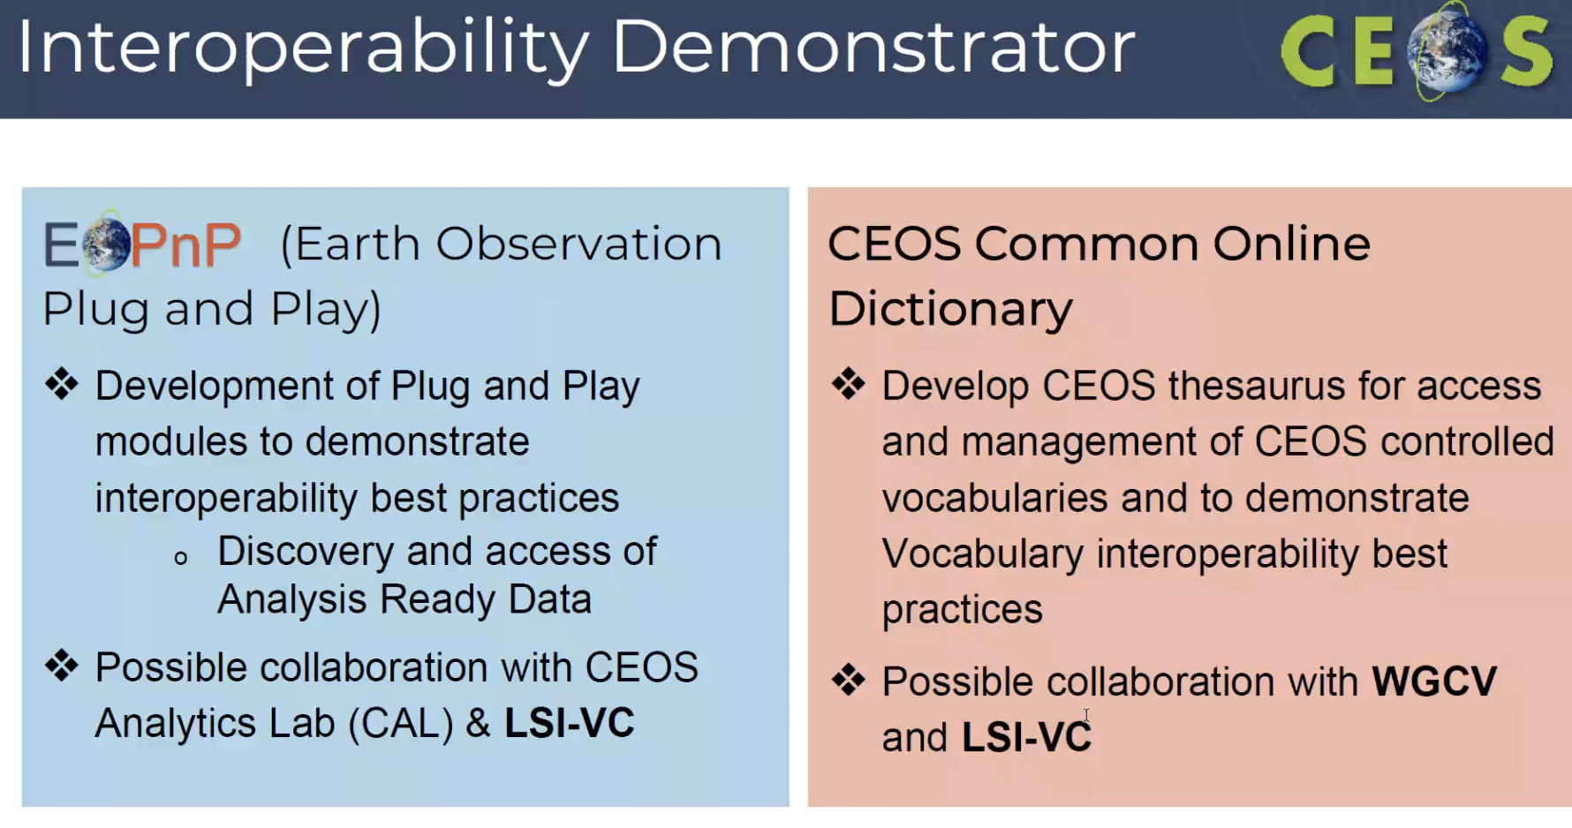
Discussion
It was suggested that Peter Strobl’s processing level matrix should be input to the Interoperability Handbook v2.0 as a recommendation.
We should make sure that the work on the consolidation of PFS or new PFS work are aligned with the definitions used in the common dictionary.
Dave suggested that the Interoperability Handbook and CEOS Comon Online Dictionary be put on GitHub. The dictionary should reference the Wooliams, Molch, Strobl paper.
LSI-VC-16-11 | LSI-VC Secretariat to issue a call for leads and contributors to the WGISS Interoperability Handbook v2.0 Architecture Component. | ASAP
LSI-VC-16-12 | Peter Strobl to submit his processing level matrix (see page 32 here) as a recommendation for the WGISS Interoperability Handbook v2.0 to Nitant Dube, WGISS Vice Chair. | ASAP
Session 7: CEOS Agriculture, Forestry and Other Land Use (AFOLU) Roadmap
7.1: CEOS AFOLU Roadmap Actions [Slides]
Stephen Ward (LSI-VC Forests and Biomass Subgroup) presented on this year’s activity to develop actions to implement and track the CEOS AFOLU Roadmap. There are seven categories of actions, from access to data to being able to use the data for reporting to UNFCCC. The expectation is that the LSI-VC Forests and Biomass Subgroup would be the ones to track these actions and report on them to CEOS leadership, given LSI-VC is the forum for discussing the relevant missions.
This should be the framework and provide justification for LSI-VC agencies to implement new missions that support the continuity of land observations for the decades to come. The Roadmap is an agreed set of requirements and actions that provides useful data points for agency planning. It is important that the agencies investing in LSI missions are aware and driving the actions.
The LSI-VC could consider rebooting the data supply / continuity charts like we saw in GFOI in support of the CEOS AFOLU Roadmap. This is a standard function of the CEOS VCs and the focus on AFOLU provides some scoping / bounds.
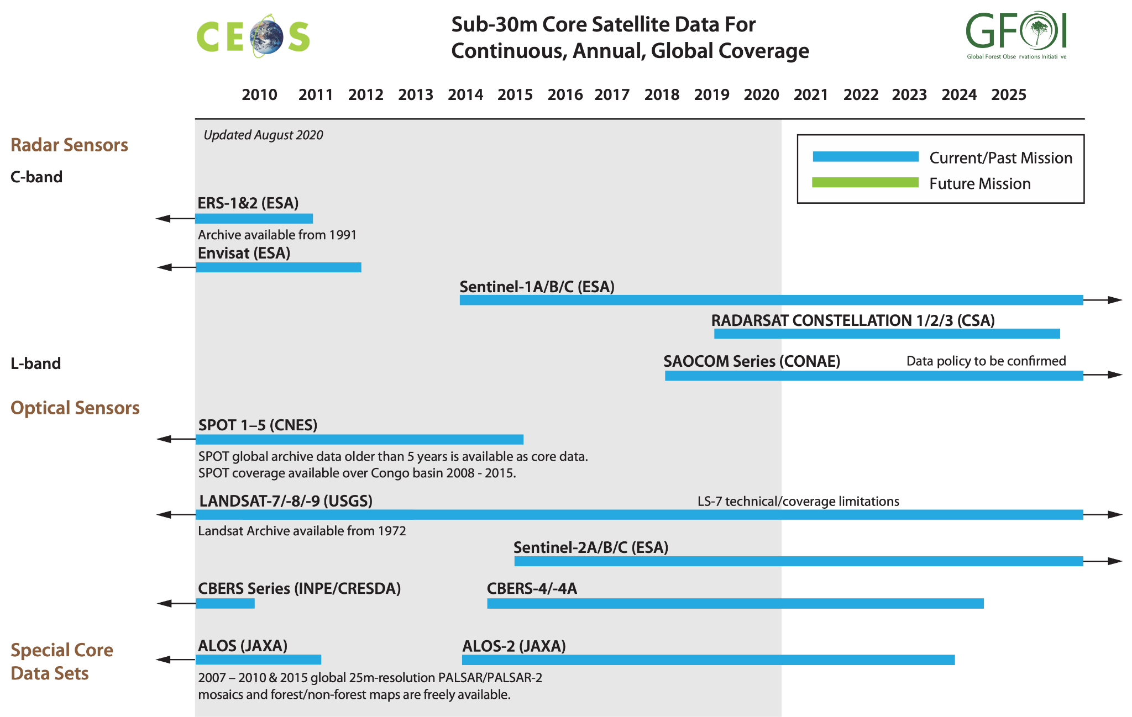
Discussion
It was noted that for many years the SIT Chair Team has acted as the focal point for AFOLU matters. This needs to change if we want LSI-VC to be seen as the lead for the CEOS AFOLU Roadmap. We need to make sure these AFOLU people are engaged as LSI-VC Forests and Biomass members and are brought up to speed and continuously engaged.
As with the UNCCD indicators discussion, addressing the CEOS AFOLU Roadmap also requires clarification of the scope of LSI-VC (beyond Level 2) and commensurate mandate and resourcing from CEOS Principals. LSI-VC needs to take the lead. Peter noted Copernicus Services, which is exactly aligned with the requirements in the AFOLU Roadmap.
A specific suggestion came from Mark Dowell at EC/JRC regarding the chance to have recognition of the potential of Landsat data and a multi-decadal, consistent, bias-corrected time series. This could be a useful data point / suggestion for agency planning.
Agriculture is not represented sufficiently in the AFOLU Roadmap.

LSI-VC-16-13 | LSI-GEOGLAM Subgroup Leads Alyssa Whitcraft and Sven Gilliams to ensure a strengthened representation of agriculture in the CEOS AFOLU Roadmap. | SIT-40

LSI-VC-16 Decision 02 | LSI-VC affirmed its support of the CEOS Agriculture, Forestry and Other Land Use (AFOLU) Roadmap and the role of the LSI-VC Subgroup to act as the body that tracks and reports on the implementation of the CEOS AFOLU Roadmap actions.
Session 8: Synthetic Aperture Radar (SAR)
8.1: SAR CEOS-ARD Update [Slides]
Ake Rosenqvist (JAXA, CEOS-ARD for SAR lead) reported the latest on the SAR family of CEOS-ARD specifications. The most recent version is v1.1, published on 23 July 2024 to address the fact that azimuth pixel spacing can be provided in units of metres or seconds, as well as a few other updates. The team is now working on the InSAR specs and this is targeted for completion by LSI-VC-17. Ongoing developments around multi-source NRB PFS as well as VHR SAR, which might require its own dedicated set of specifications. Work continues on the LiDAR PFS, with a potential first draft by Q1 2025.
Discussion
Alex Leith suggested that it would be nice to require STAC documents for all PFS (STAC with the Projection extension, at a minimum). Ake agreed that could possibly be included.
LSI-VC-16-14 | Chris Barnes to check if someone from USGS can be identified to contribute to the LiDAR PFS team. | ASAP
LSI-VC-16-15 | Peter Strobl to check if someone from the WGCV Terrain Mapping Subgroup can be identified to contribute to the LiDAR PFS team. | ASAP
8.2: CEOS SEO Commercial SAR CEOS-ARD Assessments [Slides]
Ake Rosenqvist (JAXA, CEOS-ARD for SAR lead) presented the work he has undertaken for the CEOS SEO as a follow up to the New Space Task Team recommendations to look at the interoperability of commercial datasets with CEOS agency data, using the CEOS Analytics Lab (CAL). As an extension of this work, the SEO team plans to perform some trial self assessments of commercial data against the CEOS-ARD specification. The datasets available were all X-band, reflecting their high resolution and smaller satellite nature.
Only 1 dataset included Geometric Terrain Correction (GTC), making it suitable for CAL ingestion (Capella free GEO product), and none offered Radiometric Terrain Correction (RTC), meaning none are suitable for CEOS-ARD at this stage. Some takeaways are shown below – see slides for full details of the assessment activity.
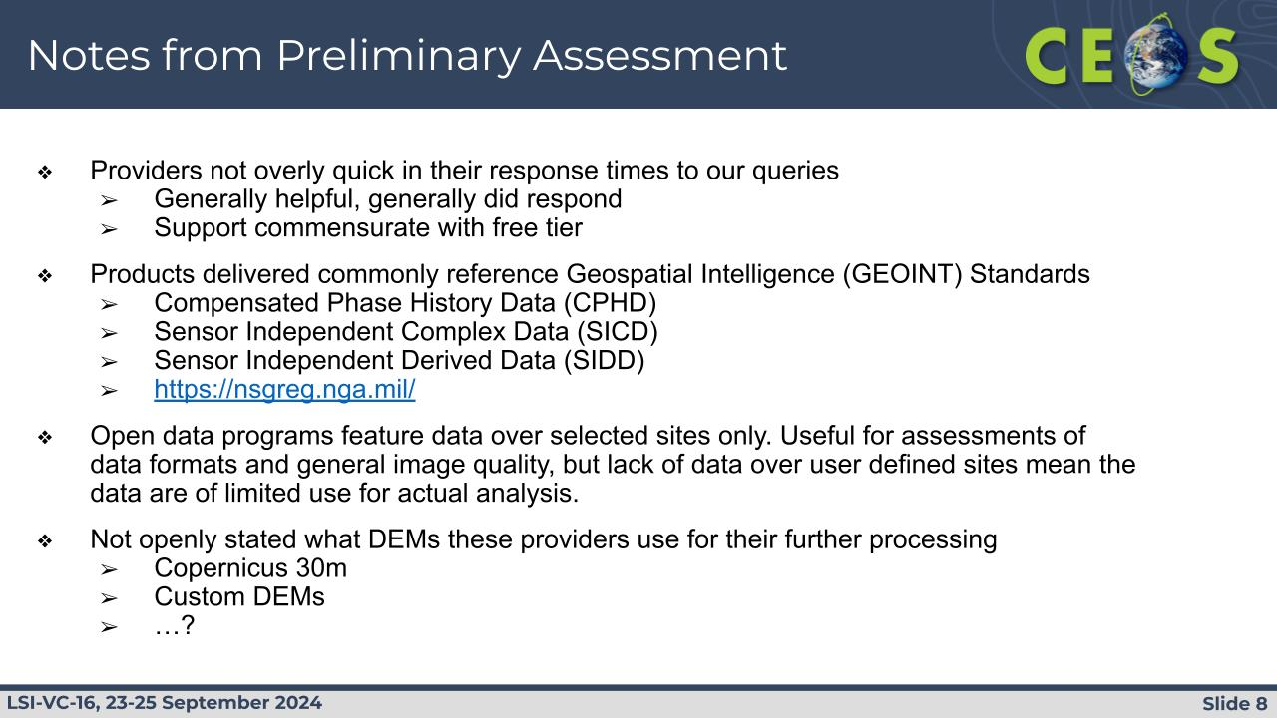
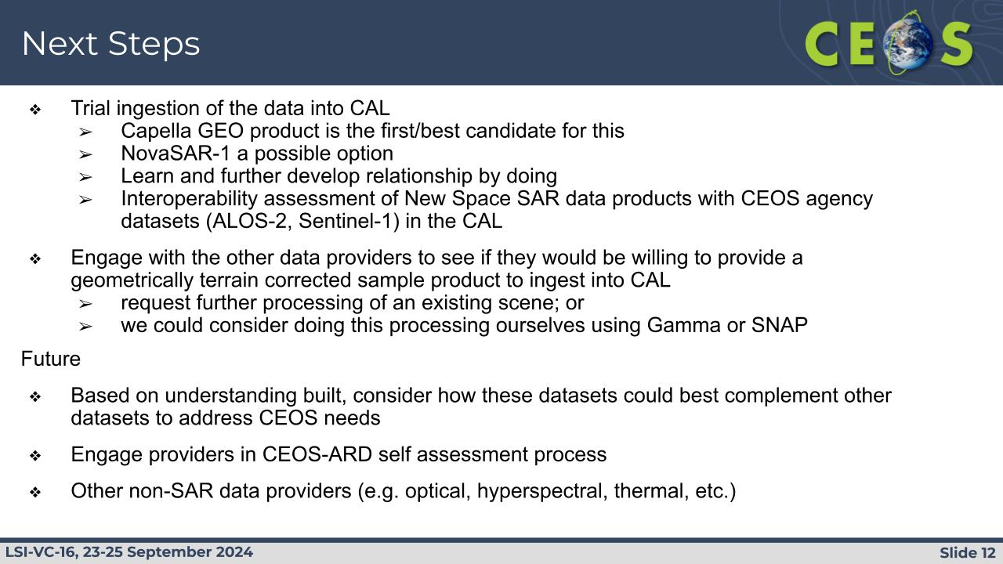
8.3: CSIRO NovaSAR-1 CEOS-ARD Report [Slides]
Zheng-Shu Zhou (CSIRO) presented an update on NovaSAR-1, a low cost S-band SAR mission for which Australia (CSIRO) is one of the capacity share partners. CSIRO NovaSAR products have been assessed to meet the requirements of CEOS-ARD NRB PFS v5.5. The mission was originally scheduled to conclude at the end of 2026 but a 3-year extension is looking likely. The following products are offered via CSIRO:
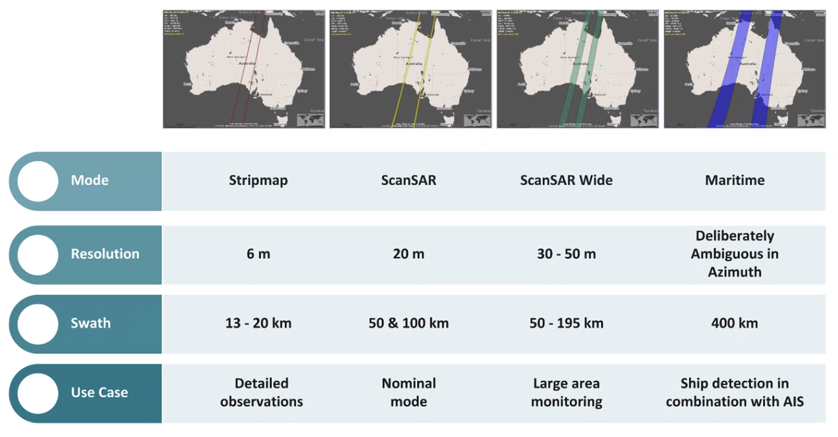
NovaSAR CEOS-ARD has been uploaded to AWS. 5300+ Level 1 products, including 2800+ CEOS-ARD products are now available on the data hub. There are global users of the data, but the majority of users are in Australia.
Zheng-Shu noted a collaboration with Australia's Terrestrial Ecosystem Research Network (TERN) in which NovaSAR data was acquired over TERN sites after launch to demonstrate data utility. TERN sites continue to be observed regularly, creating a useful collection of data.
NovaSAR is being used in the Great Western Woodlands Demonstrator of the CEOS Ecosystem Extent Task Team and for the EO for Climate Smart Innovation project in CSIRO.
NovaSAR has also been used for various studies in Antarctica - see slides for details..
Discussion
Ake commended the release of NovaSAR products for free online via AWS. He will look into these for applications in the CEOS Analytics Lab, specifically for some areas of interest in Southeast Asia.
Zheng-Shu confirmed that CEOS-ARD compliance has been a development welcomed by users, who report that the barrier to entry is greatly lowered when compared to the Level 1 data.
8.4: ISRO SAR CEOS-ARD Report [Slides]
P.V. Jayasri (ISRO) reported on ISRO’s SAR CEOS-ARD activities.
RISAT-1 (EOS-04) NRB products were approved as CEOS-ARD on 2 April 2024. The self-assessment covered 8 different EOS-04 NRB products / imaging modes. EOS-04 NRB products are available on ISRO's Bhoonidhi data hub for free: https://bhoonidhi.nrsc.gov.in/
EOS-04 India mosaic NRB products were also submitted for CEOS-ARD assessment against SAR PFS v1.1 last week. The peer review is ongoing.
EOS-04 Geocoded Polarimetric Decomposition Products (Level-3B) [PRD] and GCOV (Geocoded Covariance Product) [COMAT] are at design level and under validation by ISRO.
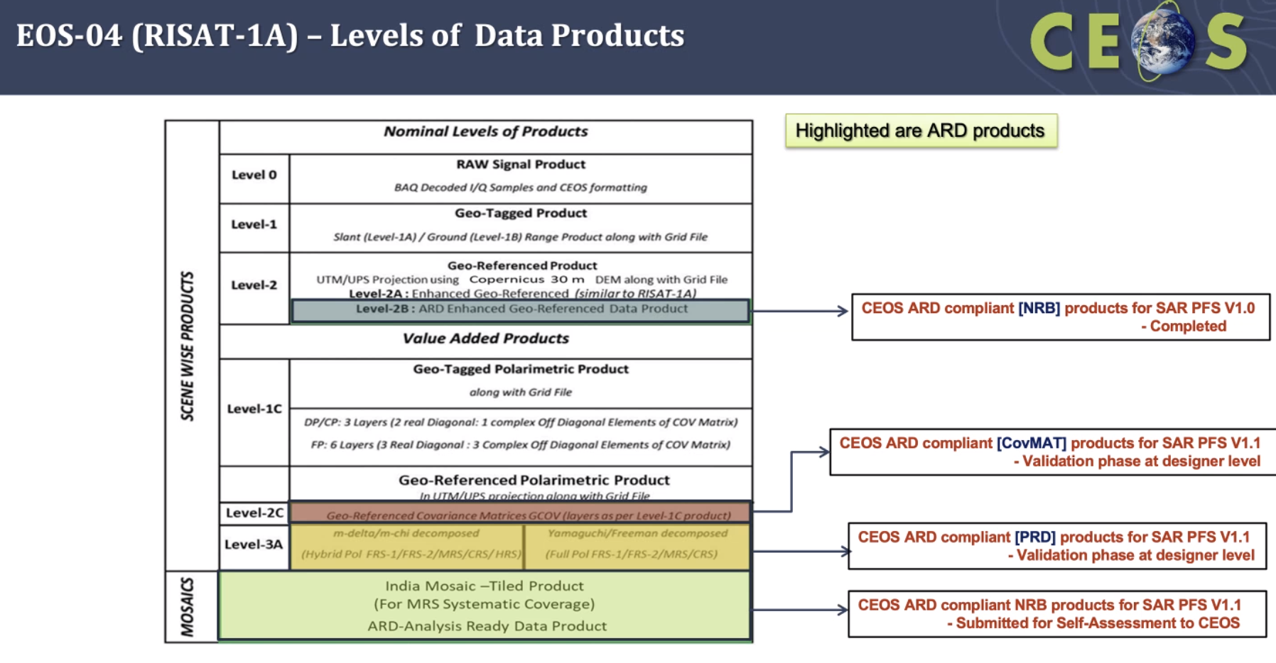
ISRO’s own NovaSAR NRB products are being designed and packaged and will be submitted for endorsement in time. Cross-validation with CSIRO NovaSAR NRB CEOS-ARD products has been performed and they are consistent.
Discussion
Matt noted the eight different EOS-04 products and asked if it is necessary to detail them all individually on ceos.org/ard. Ake says not at the resolution level but it is worth detailing the different modes, since they could be a bit different.
Zheng-Shu noted the comparison of CSIRO and ISRO NovaSAR data. CSIRO shared their NovaSAR CEOS-ARD products a while back and he asked if ISRO could do the same with their products over India so that CSIRO can do their own intercomparison.
LSI-VC-16-16 | LSI-VC Secretariat to work out an efficient way to capture the different modes of the EOS-04/RISAT-1A CEOS-ARD products on ceos.org/ard | LSI-VC-17
LSI-VC-16-17 | P.V. Jayasri (ISRO) to follow up with Zheng-Shu Zhou (CSIRO) regarding sharing of NovaSAR products over India so that CSIRO can do their own intercomparisons. | ASAP
8.5: DLR Progress on Sentinel-1 ARD Production [Slides]
John Truckenbrodt (DLR) presented on DLR’s work on Sentinel-1 ARD.
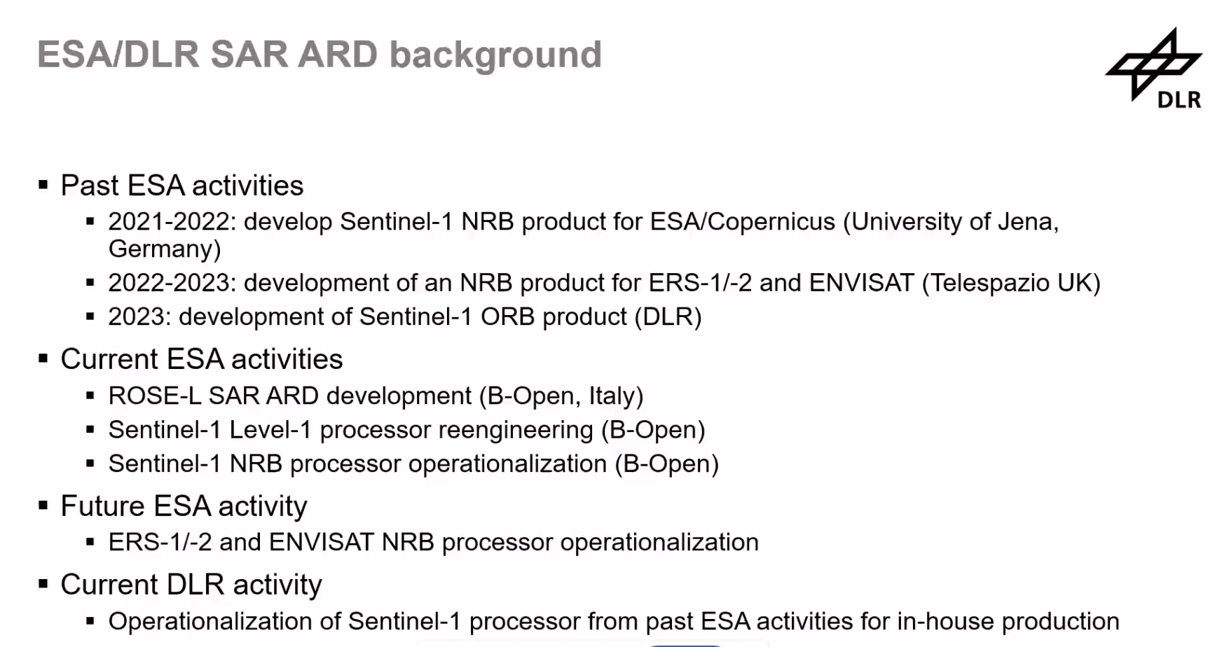
Noted the Terrabyte system and on-demand ARD processing capabilities. Terrabyte uses STAC extensively. The Sentinel-1 NRB product is radiometrically terrain corrected gamma nought backscatter per polarisation.
Noted the ocean radar backscatter product specification from last year. Follow up activity extended the ESA-DLR S1 NRB product to oceans. There are a number of differences to NRB.
In summary:
- The Sentinel-1 NRB and ORB products have been prototyped.
- The ESA NRB product is currently being consolidated with the objective to be generated systematically.
- The timeline of availability and characteristics of an ESA/Copernicus ARD product are not finally decided.
- In the meantime, DLR will produce its own NRB product to satisfy internal user demands (first individual user requests, then global).
- DLR continues to develop the ARD processor s1ard and investigates SAR processing options.
- DLR continues to participate in standardisation activities (CEOS-ARD, STAC) to further shape the SAR ARD landscape and give users the best experience.
Discussion
Noted the variety of Sentinel-1 products we are now seeing, coming from various providers for various different geographic regions and scopes. Currently this is very confusing for users. Noted DEAfrica, DLR, ESA, Google Earth Engine, NASA/JPL OPERA, etc.
John noted DLR aims to align as much as possible with ESA in anticipation of the systematic Copernicus product being available eventually.
Hoping that Copernicus will generate their NRB product soon and that it is comprehensive with all the necessary metadata to be CEOS-ARD, and that this then becomes the standard product, replacing these piecemeal datasets.
8.6: Status update: Quad-pol and Multi-frequency data requests from the ESA POLINSAR Workshop 2023 [Slides]
Magdalena Fitrzyk (ESA) presented an update on the ESA POLINSAR Workshop 2023 and the follow up via CEOS.
LSI-VC PolInSAR Team recommendations to SIT-39 were:
- Establishment of an agreed set of CEOS POLINSAR reference sites.
- Regular acquisition of fully polarimetric and multi-frequency SAR data over these sites (with a view towards increasing scope and integration of polarimetry in ongoing strategic background mission observation plans).
- Simplified access to data and tools for R&D purposes (shared repository of R&D data, CEOS-ARD, CEOS Analytics Lab, etc.).
Since SIT-39 Ake Rosenqvist has been working with the JAXA SIT Chair Team to identify POCs at CEOS agencies to join the LSI-VC Polarimetric Interferometric Synthetic Aperture Radar (PolInSAR) Team and assist with the above actions.
The next POLINSAR workshop will be held in late 2025/early 2026.
Discussion
Regarding nominations of agency POCs to the LSI-VC PolInSAR Team, Ake noted he has heard back from NASA (Christine Bognar is following up internally at NASA) but no others. Need more names otherwise the activity will not proceed.
LSI-VC-16-18 | LSI-VC Secretariat to work with the SIT Chair Team to send a reminder for nominations to the LSI-VC PolInSAR Team from CEOS Agencies. This is a follow up to action SIT-39-09. | COMPLETE
It was clarified that there is interest in both new tasking and archive data. New tasking would be specifically over the defined sites, but there is also interest in whatever data is already available.
The ICGS-SAR team (International Coordination Group for Spaceborne Synthetic Aperture Radar (SAR) Missions) is also following this topic.
P.V. Jayasri and ISRO are in contact with Magdalena. Ake welcomed their involvement in the LSI-VC PolInSAR Team.

Wednesday, September 25
Session 9: Other Business
9.1: CEOS-ARD Surface Reflectance Products: Quality, Consistency and Equivalence [Slides]
Simon Oliver and Medhavy Thankappan of Geoscience Australia presented on this project which aims to move CEOS-ARD further along the interoperability spectrum.
The CEOS-ARD Surface Reflectance (SR) PFS provides a good starting point for interoperability of multi-sensor SR products but there are differences among CEOS-ARD SR products given the non prescriptive nature of the PFS, and the variety of corrections that can be made while still falling under the general definition of ‘Surface Reflectance’. It perhaps highlights a need to be more specific of the definition of measurand for CEOS-ARD.
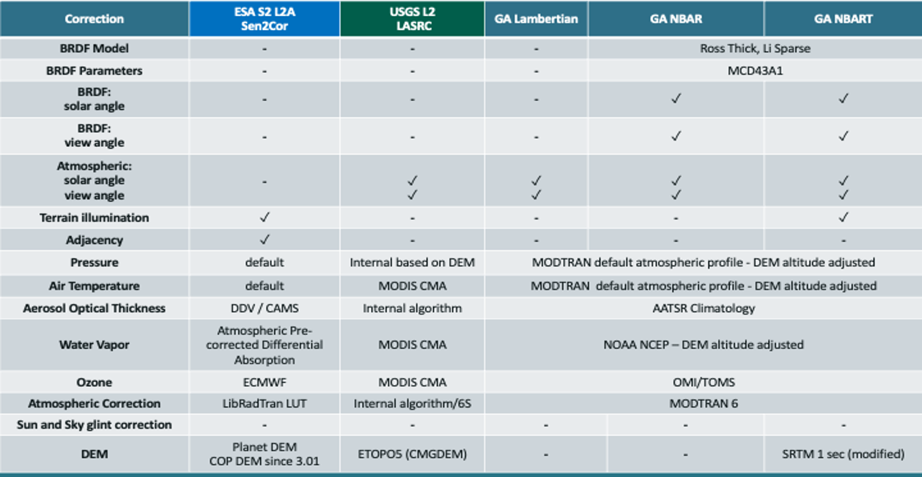
Inconsistency in surface reflectance products from different providers limits combined use of multi-sensor data, performing impactful analyses, and gaining deeper insights. For example, see variability in Normalised Difference Vegetation Index time-series profiles for the same area derived from Landsat, Sentinel-2 and PlanetScope data:
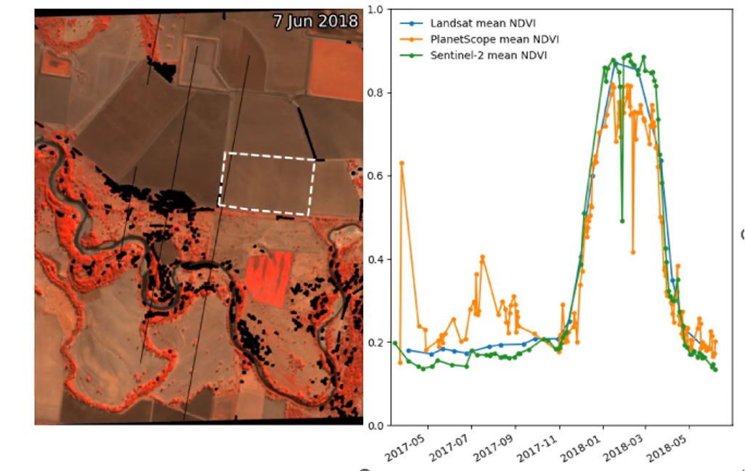
This project aims to build on CEOS-ARD achievements so far and take the next steps to achieve multi-sensor interoperability. To do so we need to provide an unambiguous characterisation of the SR quantity in the context of CEOS-ARD products. The project seeks to identify a set of inputs, corrections, associated parameters and tolerances for achieving SR equivalence in support of harmonising CEOS-ARD SR products.
Benefits:
- Consistent time-series across sensors, steps towards enhanced harmonisation amongst CEOS-ARD SR products.
- Focused effort on value-adding with a common foundational measurand and improve the results from multi-sensor analyses, gain better insights.
- Reduced duplication of effort, cost savings, increased global applicability of algorithms, higher return on investment.
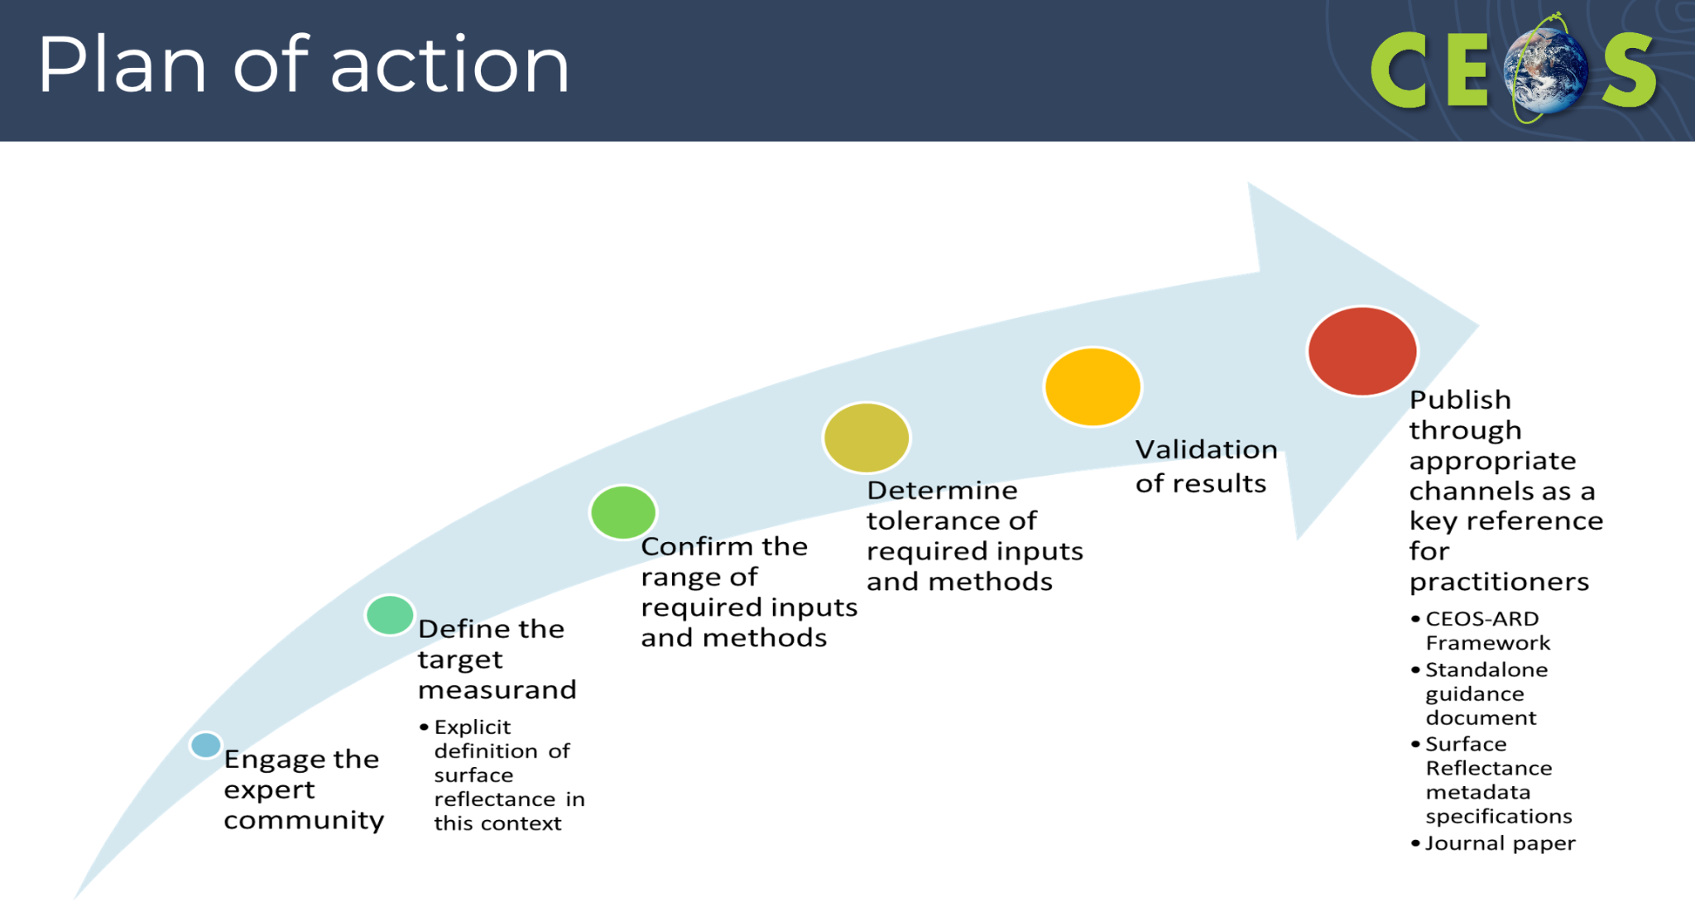
USGS’s Collection 3 is a key milestone and time driver for this work. There is not a lot of time left to contribute to its definition.
Discussion
The connection to ACIX was queried. It was noted that ACIX is a separate exercise that looks at atmospheric correction. Here we are instead acknowledging there are differences between the SR products (we know some of the reasons why) but if we can agree on a common set of what is needed for SR we can bring them a bit closer together. We're deliberately avoiding a comparison of methodologies here and focusing instead on the target quantity and its definition.
Medhavy noted an example of the methodology used in the northern hemisphere not working in the south. We need to acknowledge that there will always be differences but need to give some guidance in terms of tolerances, etc.
The measurand is the key, and agreeing what is needed so that we are all measuring the same thing.
Medhavy confirmed that we could see the outputs of this work feeding into the Goal requirements of the CEOS-ARD PFS in addition to the planned scientific paper. This would be a tangible outcome in the context of CEOS-ARD. The team is also engaging with WGCV and WGISS to work through some of the details and are ensuring a connection to the WGISS Interoperability Handbook.
GA and USGS are working very closely in terms of making sure we are not duplicating efforts on SR. Want to be able to take collection 3 straight out of the box and use them without major changes.
USGS would need this to be a formal publication to impact their operations. A peer reviewed journal publication to ensure scientific rigour and giving them something to cite.
Medhavy thinks there could be a less formal and faster turnaround ‘guidance document’ published in parallel.
Chris noted that we need to make sure we input any outputs from this project into the PFS at the opportunity of the next update cycle so that we are not doing yet another update of the PFS (although changes to Goal requirements specifically is easier).
Noted VH-RODA as another opportunity to share this project with the broader community and welcome additional participation.
9.2: Proposed ‘Building Block’ Approach to Constructing CEOS-ARD PFS
Matthias Mohr presented his proposal for a modular / ‘building block’ approach to the CEOS-ARD PFS parameters and requirements. Essentially the idea is to construct a collection of e.g. yaml files for each parameter present in the PFS. These files would include a description of the parameter, the Threshold and Goal requirements, mapping to STAC and other metadata, and whatever other fields are decided to be useful (and naturally extensible). These would be natively editable in GitHub providing tracking, version history, pull requests, etc. PFS would then be defined as some ‘set’ of these components, and the components would be used consistently across the PFS. The PFS will be able to be ‘rendered’ into a Word/PDF form as they currently are as well.
LSI-VC-16-19 | Matthias to set up an initial proposal for a building block so that we can start talking about the necessary components.  LSI-VC team to provide inputs on the fundamental structure and fields of a PFS building block.  Note: While the blocks will be extensible and able to include additional fields in future, it would be good to ensure we have given this sufficient thought up front to avoid changes down the line. | Discuss the structure at LSI-VC-17
It was noted that the PFS documents include a terminology section. It would be good if in future this could come from another CEOS GitHub repository, noting the plan to put the WGCV/WGISS CEOS terminology work into the CEOS GitHub.
We also need to resolve the issue with requirement numbers, which are not consistent among the PFS. We need to replace the existing numbers with a global ID for each parameter. Non-numerical would be best so that it is human-readable without a reference.
Need to ensure any update of the CEOS-ARD Governance Framework states that ceos.org/ard will be maintained as the shopfront, while technical development of the PFS, etc. shifts to GitHub.
To make the generation of the PFS from the building blocks easier, it was confirmed that there is no need to stick with the table format of the current PFS. Each parameter could be a chapter / section of a document. The table format doesn’t really add much.
It was suggested that we should make sure that the blocks are aligned with what is defined in the WGISS STAC best practices.
Multiple metadata tags could be added to each block, as shown below:
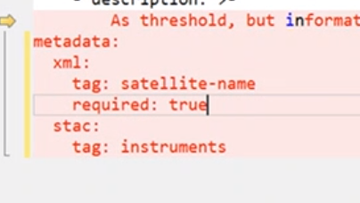

LSI-VC-16 Decision 03 | LSI-VC agreed to proceed with development of the CEOS-ARD GitHub and the modular ‘building block’ approach to parameters and requirements.

LSI-VC-16-20 | CEOS SEO and Matthias Mohr to produce a simple how to guide for the CEOS-ARD GitHub and building blocks approach. | LSI-VC-17
LSI-VC-16-21 | Peter Strobl to follow up with the CEOS SEO and WGISS team to agree an approach to get the CEOS terminology / common dictionary into the CEOS GitHub repository so that it might be referenced in future by the PFS. | LSI-VC-17
Matt Paget (CSIRO) offered to provide support to the establishment of the CEOS-ARD GitHub and building blocks.
Ake suggested that the SAR PFS could be a good starting point for the building blocks given this PFS has already been through a consolidation.
Need to have a timeline for the next 6 months. LSI-VC-17 will be a good time for a check-in and this is reflected in the due dates of the above actions.
Session 10: GEOGLAM & Consolidated Optical PFS
10.1: Draft LSI-GEOGLAM Subgroup Renewed Terms of Reference [Document]
Michael Wellington noted that Digital Earth Africa has a strong focus on agriculture and connections to FEWS NET, the Famine Early Warning Systems Network.
LSI-VC-16-22 | LSI-VC Secretariat to ensure Michael Wellington and the Digital Earth Africa team is connected to the LSI-GEOGLAM leads as potential contributors to the renewed subgroup. | December 2024
Noting the long standing discussions around higher level products, we should try to get some CEOS Principal clarification on which cases and to what extent should the LSI-VC and its subgroups should be involved in coordination of these products. Our role is unclear, and we also lack the representation to address this comprehensively. We need agencies to nominate people from the higher part of the value chain to LSI-VC if we are to work on these types of problems.
There was a discussion on how to bridge the gap between Level 2 and thematic products. CEOS agencies could perhaps cooperate on finding common best practices and documenting uncertainties.
Ahead of LSI-VC-16, Alyssa Whitcraft shared the draft terms of reference for the LSI-GEOGLAM Subgroup and outlined the following next steps for the Subgroup:
- Present the terms of reference at the GEOGLAM ExCom in China.
- Plan for CEOS Plenary:
    - The current thinking is that we'll have a side meeting there and "confirm" these ToR... and hopefully, Plenary will get behind the below actions/work-plan for 2024-2025:
      - Identifying points of contact for each agency within GEOGLAM (SIT-39-05);
      - Confirming the broader relationships between GEOGLAM and CEOS (SIT-39-06; Figure 2);
    - Confirming Terms of Reference for the LSI-VC Subgroup and the relationships, adding missing information related to membership, leadership, meetings, and milestones, as needed.
      - Convening a workshop - with substantial CEOS agency leadership and involvement - that aims to collect the current status of the EAVs from the different agencies and identify 2-3 of the highest priority gaps, their source (e.g. observation, method, production, etc.), and opportunities to address them.
In reviewing the above steps, the LSI-VC Leads came to the conclusion that they would propose that the order is backwards. They suggest starting with the workshop as a means for refining the terms of reference and membership of the subgroup.
LSI-VC-16-23 | LSI-VC Secretariat to report the outcomes of the LSI-VC-16 discussion to the LSI-GEOGLAM leads. Headline is that the LSI-VC Leads welcome the update of the LSI-GEOGLAM terms of reference, propose that the workshop take place before finalising the new terms of reference or membership of the subgroup, and that we should include people outside of CEOS agencies in the LSI-GEOGLAM membership, since organisations other than space agencies are often the ones doing higher level agriculture product development and provision. | COMPLETE
Matt Paget (CSIRO) noted the MODIS-based fractional cover product maintained by CSIRO. Matt is keeping that alive for now, however additional pull from the global community is needed to sustain it long term. He would welcome input from the LSI-GEOGLAM team regarding the science opportunities that could be used to direct CSIRO scientists and provide the cover and pull for this product. He is interested to hear what analysis products would be most useful for the community. Having a message from LSI-GEOGLAM about what would be most useful for GEOGLAM and the global community would provide useful leverage and messaging to put to scientists and management. Noted potential alignment with DE Africa.
LSI-VC-16-24 | LSI-GEOGLAM Leads to provide feedback to Matt Paget (CSIRO) regarding the utility of CSIRO’s fractional cover product to the GEOGLAM/global community and to provide direction on what analysis products would be most useful. | December 2024
LSI-VC-16-25 | LSI-GEOGLAM Leads to provide some boilerplate text that people can use when reaching out to try and identify new members for the subgroup. We are looking for people with missions and people with agriculture/applications expertise. | January 2025
LSI-VC should be the forum for doing the mapping of overlaps between EAV/EBVs, etc. and assessment of the commonality, tools, approaches, etc. It is a natural fit for the Copernicus Land Service too, and this could be a good topic for the LSI-VC-18 meeting (tentatively being planned at EC/JRC in Ispra).
10.2: Working Session: First Cut of a Consolidated Optical PFS and Basis for the ‘Building Blocks’ in GitHub
Chris Barnes and the USGS team have created an initial consolidated optical PFS, in the same format as the combined SAR PFS. There are still some parameters that have conflicting requirements, so the objective of this working session was to propose resolutions for each of these. In most cases it was agreed to retain distinct requirements for specific PFS, pending further discussion with the team’s responsible to see if a more comprehensive merging might be possible (e.g., one PFS adopts the convention of the other). In some cases the differences were very minor, grammatical or inconsequential, so proposals were made to consolidate the requirements. A track change version of the combined optical PFS (following LSI-VC-16 edits) can be found here.

LSI-VC-16 Decision 04 | It was agreed that the first draft of a combined optical PFS refined at LSI-VC-16 will not be released publicly (to avoid confusion). It will instead serve as an internal reference and starting point for development of the initial set of ‘building blocks’, since this process will be greatly simplified by the consolidation work already done.

LSI-VC-16-26 | Chris Barnes to make sure that the text in the consolidated optical PFS matches that from the latest SR PFS v5.0.1. Some minor discrepancies were noted. | December 2024
LSI-VC-16-27 | Chris Barnes to clean up the consolidated optical PFS (in consultation with PFS leads) before sending it to Matthias Mohr as an authoritative version for initial implementation of the ‘building blocks’ on GitHub. | December 2024
Session 11: Wetlands
11.1: Wetlands and EO [Slides]
Ake Rosenqvist presented on the Ramsar Convention on Wetlands. It is the oldest of all environmental Treaties (1971). 172 countries are signatory Parties, and its COPs are held every 3 years.
There are four bodies of the convention, including the STRP (Scientific and Technical Review Panel) – the Ramsar equivalent of SBSTA in UNFCCC. STRP develops technical and scientific guidance for the convention. ESA and JAXA are official observers to the STRP.
At the STRP25 meeting it was reported that only a fraction of Parties fulfil their reporting requirements, partly because there is a lack of data on wetlands. There is a big data gap for up-to-date information on wetlands, both for dedicated Ramsar sites and for wetlands globally. This is an impediment to the implementation of the Ramsar Convention. There is recognition of the need for a more synoptic view of wetlands.
CEOS and GEO people have been lobbying the STRP for a long time to increase uptake of remote sensing. The STRP recently made a proposal to the Standing Committee to set up an ad hoc task to initiate consultation with the EO community. The Standing Committee then requested the STRP, working with the Secretariat, organise a consultation with the Earth observation community on the development of an initiative to foster dialogue, knowledge exchange and guidance for earth observation in support of wetland inventory, assessment, monitoring and conservation efforts.
The ad hoc task has started now. A small number of space agency folks have been contacted by the Ramsar Secretariat to start crafting how we can do this. Importantly, there is an opportunity to provide wording for the next Ramsar Work Plan.
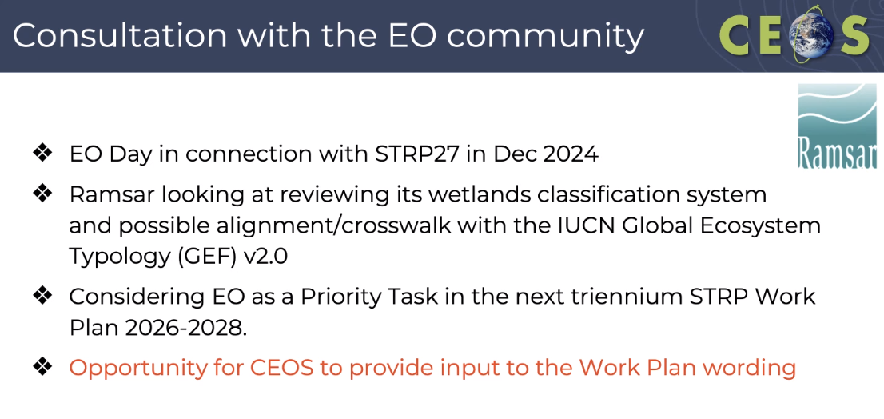
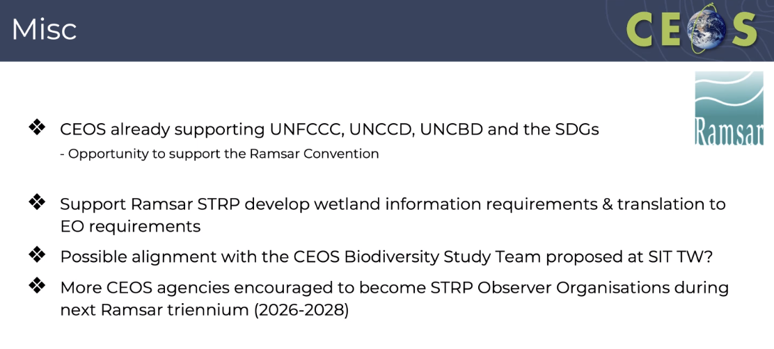
JAXA has had two past MOUs with Ramsar (expired). The Global Mangrove Watch (GMW) was developed as an effort to support the Ramsar Convention.
JAXA and ESA are Observer Organisations to the Convention. They would like to encourage other CEOS agencies to also become observers over the next triennium. Observers are typically involved at the technical level. A list of current observers to the STRP is available on ramsar.org
Discussion
Tim Stryker (USGS) suggested that Ake has identified a great opportunity for CEOS contribution. This seems like a natural task for LSI-VC. We should raise it in CEOS, highlight the opportunity, and note the connection to biodiversity/ecosystems. Tim thinks it would be great for the LSI-VC to flag this to CEOS leadership.
Regard the Work Plan wording, we wouldn't want to mention CEOS explicitly, but rather include appropriate hooks for CEOS engagement.
Alla Metlenko (Digital Earth Australia/GA) noted a Google-funded initiative to map all the wetlands over pilot areas. This was highlighted during a presentation by the UNEP Global Wetland Watch earlier this week. She has shared some of the concepts with the government entity in Australia that is responsible for wetland reporting. She offered to share what Digital Earth Australia has learned.
Ake knows about the initiative and has seen the UNEP / Global Wetlands Watch input at the most recent STRP meeting. The CEOS and GEO folks involved are Intending to work with UNEP too. The GMW dataset is used as the official layer for mangroves by UNEP.
LSI-VC-16-28 | Ake Rosenqvist and LSI-VC Secretariat to ensure the Ramsar Convention on Wetlands opportunities are presented to both CEOS SEC-326 and CEOS Plenary. LSI-VC Secretariat will work with the SIT Chair Team to arrange a report to SEC-326. | COMPLETE
The biggest opportunity is the EO Day (6 December in Gland, outside Geneva, IUCN location), which is back-to-back with the STRP28 meeting in December. There is a good chance of showcasing what can be done with remote sensing data at this opportunity. CEOS could have a short presentation showing the different ways we can provide information on wetlands, covering where they are, how they are doing, and variation in time. It was suggested that the Hudson Bay Lowlands Ecosystem Extent Task Team Demonstrator be included in any demonstration.
Session 12: CEOS Agency Reports
12.1: JAXA Report [Slides]
Takeo Tadono (JAXA) presented the JAXA agency update.
EarthCARE was launched on 29 May 2024, carrying the Cloud Profiling Radar (CPR) of JAXA, providing the world’s first measurement of vertical cloud motion from space.
ALOS-4 was successfully launched on 1 July 2024 and it is currently undergoing initial functional verification. ALOS-4 is the successor to the L-band SAR missions of ALOS and ALOS-2. While maintaining the high resolution (3 m), the width and frequency of observations will be significantly improved compared to ALOS-2. The goal is to ensure continuity with ALOS-2 and to develop new use cases.
Session 13: Closing
13.1: Wrap up
CEOS-ARD GitHub Work Items and Timeline
Matthias Mohr presented his personal plan for the GitHub implementation of CEOS-ARD:

CEOS-ARD Roadmap
Related issues: https://github.com/ceos-org/ceos-ard/labels/New%20Tech%20Framework

Preparation (Dec 2024):
- Chris Barnes: Create/updated combined Optical PFS -> send latest draft to MM
- MM: Check technology options for generation CEOS documents
  - Markup: Markdown/AsciiDoc/restructuredText/…
  - Doc generation: Self-made/Metanorma/Pandoc/…
  - References: Plain text (as is)/Bibtex/…
  - Programming language: JS/Python?
  - Definition language for building blocks: YAML/…?
- Dave Borges: GitHub Intro?

Proof of concept (Feb 2025):
- MM: Identify how to split, describe and structure building blocks, etc
- MM/Matt Paget: Convert Optical and SAR PFSes to fragments / BB and clean-up GitHub repository
  - ID
  - Requirements (goal/threshold can differ between PFS)
  - Justification
  - Metadata mapping (XML, STAC)
  - …?
- MM: Implement builder that generates documents (Word/PDF)
  - Peter Strobl: Switch from tables to chapters/normal text flow for requirements
  - Switch changes table to full changelog in appendix?
- MM: Set up CI to automatically generate documents (on release/on commit to main)

Short-term (Apr 2025, LSI-VC 17):
- MM: Document GitHub structure, workflow and builder / Basic intros to LSI VC
- CEOS/MM: Switch from numerical identifiers to stable identifiers
- CEOS/MM: Provide feedback on GitHub and improve GitHub issue tracker and project board

Mid-term (Sept 2025, LSI-VC 18):
- CEOS: Start to align building blocks / taxonomy / etc. (potentially align with STAC?)
- MM: Introduce metadata mappings to STAC metadata
- MM: Generate/create STAC extensions for PFS
- MM/Peter Strobl/WGISS/Tom: Integrate external repository for glossary/vocabulary?
- MM: Further Workshops/tutorials on working with the new tech
- MM: Set up CI to move documents to CEOS ARD website?
- MM: Set up CI to automatically generate documents (for each PR)
- MM: Implement builder to generate references (words in vocabulary are linked)
- MM: Different documents with (Word) and without (PDF) fields for assessment?

Long-term (2026/27):
- Online portal for PFS submission?
- Validation for PFS submission and/or metadata
- Metadata for Optical?
- Extend STAC to better cater for missing metadata in PFS (e.g. SAR)

Plans for the LSI-VC-17 and LSI-VC-18 Meetings

LSI-VC-16 Decision 05 | It was agreed that LSI-VC-17 will be held at JAXA Tsukuba Space Center (TKSC) from 14-16 April 2025.  Note: This is the week following SIT-40 which will be held April 8-10, 2025 in Fukuoka, Japan.

LSI-VC-16-29 | Peter Strobl to investigate whether LSI-VC-18 might be able to be hosted by EC/JRC in Ispra, Italy, from 3-5 September 2025.  Note: This is the week before the 2025 SIT Technical Workshop, which will be held September 9-11, 2025 in Darmstadt, Germany. | LSI-VC-17
Closing Remarks
This was a very important milestone meeting for LSI-VC and CEOS-ARD, as we contemplate a substantial shift in our processes with the aim of making CEOS-ARD more fit for purpose, aligned with community expectations, and accessible to those outside of CEOS. This meeting was heavy on face-to-face workshop time which was critical to working through the proposals and all of the details.
Andreia Siqueira (Geoscience Australia) thanked everyone for participating and closed the meeting.

