Minutes v1.0
17th Meeting of the CEOS Virtual Constellation for Land Surface Imaging (LSI-VC)
14-16 April 2025
Hosted by JAXA
Tsukuba, Japan
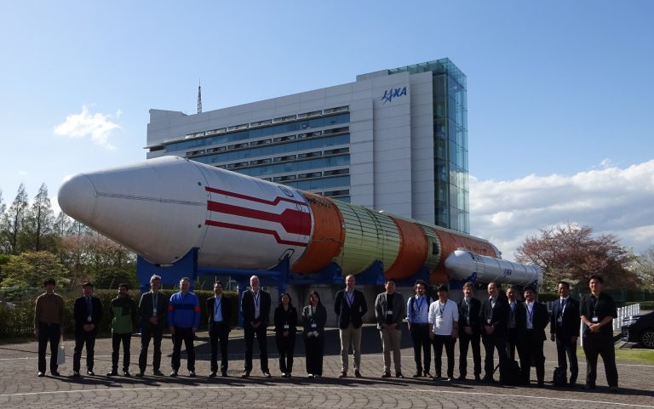
Participants
AEM Adrian Guzman*
AIST Hirokazu Yamamoto
Catalyst Griffin Williams*
Catapult/UKSA Sarah Cheesbrough*
CCRS Francois Charbonneau*
CEOS SEO David Borges
Cloud-Native Geospatial Foundation Matthias Mohr*
CONAE Ignacio Pascual*
CSIRO Arnold Dekker*, Matt Paget*
ESA Ferran Gascon, Leonardo De Laurentiis*, Philippe Goryl*, Patrick Griffiths*
European Commission Peter Strobl
Geoscience Australia Maggie Arnold, Jonathon Ross, Peter Harrison*, Medhavy Thankappan*
IEEE Siri Jodha Khalsa (Univ. of Colorado, Boulder)*
ISRO P.V. Jayasri*, Raghav Mehra*, V.Manavala Ramanujam*, Usha
Sundari*
JAXA Takeo Tadono, Ake Rosenqvist, Kei Oyoshi, Yousuke Ikehata, Mizukami Yosei, Kenshiro Arie*, Hironori Maejima*, Yutaro Shigemitsu*, Watanabe Tomohiro*, Shin-ichi Sobue*
LSI-VC Secretariat Matt Steventon, Harvey Jones, Stephen Ward*
NASA Melissa Martin*, Dana Ostrenga*, Patrick Quinn* New Space Intelligence Inc. Masahiko Nagai, Muhammad Daniel Iman, Saito Gaku*
NPL Nigel Fox*
RESTEC Haruya Hirano, Kazafumi Kobayashi, Osamu Isoguchi
Synspective Mauro Mariotti, Simonas Garsva, Krzysztof Orzel, Ryo Terunuma*
USGS Chris Barnes*, Pete Doucette*

* virtual participants
Monday, April 14
Session 1: Welcome and Introductions
1.1: Welcome from Hironori Maejima (JAXA, CEOS SIT Chair)
Hironori Maejima (JAXA SIT Chair) welcomed participants to the LSI-VC-17 meeting at the Tsukuba Space Centre in Japan. Takeo Tadono (JAXA, LSI-VC Co-lead) was introduced as the new JAXA lead for the LSI-VC AFOLU Subgroup.
1.2: Welcome [slides]
Presenters: LSI-VC Co-leads
Takeo Tadono (JAXA, LSI-VC Co-lead) welcomed participants to LSI-VC-17 and shared logistics information.
Chris Barnes (USGS, LSI-VC Co-lead) thanked JAXA for hosting the meeting, with anticipation to advance the CEOS-ARD Framework, endorse new CEOS-ARD Product Family Specifications (PFS), as well as to hear and learn from the CEOS Working Groups and community in support of CEOS-ARD and data quality. Chris noted that many CEOS-ARD product endorsements are currently being processed, including some from commercial providers. LSI-VC needs to explore ways to further improve CEOS-ARD in terms of interoperability and utility.
Matt Steventon (LSI-VC Secretariat) provided an overview of the meeting and led a tour de table.
Session 2: CEOS Analysis Ready Data (CEOS-ARD)
2.2: Addition of Interferometric Radar (InSAR) Products to the Combined CEOS-ARD PFS for Synthetic Aperture Radar (For Endorsement) [slides]
Presenter: Ake Rosenqvist (JAXA)
Ake Rosenqvist presented for endorsement Version 1.2 of the combined CEOS-ARD Synthetic Aperture Radar (SAR) PFS, which includes the addition of interferometric SAR (InSAR).
The CEOS-ARD Lidar PFS development effort has been limited since 2019 due to the absence of a lidar agency champion and a limited incentive for broad uptake. Ake proposed discontinuing the CEOS-ARD lidar activity.
Takeo Tadono (JAXA, LSI-VC Co-lead) suggested that as new lidar missions are developed in the near-future, the possibility of continuing the Lidar PFS could be reconsidered.
Peter Strobl (EC, LSI-VC Co-lead) observed within the terrain mapping community that lidar data is highly sought after, and there is a lot of preprocessing effort from the user side. He suggested reporting to CEOS Agencies the gap between user needs and the current readiness of lidar products. These data cannot be exploited to the extent that they are wanted.
Ake agreed, noting that expert engagement is essential particularly from those willing to invest the time to develop the document. Participation in meetings has been limited and a key challenge is the absence of a dedicated template designed for lidar, as many parameters are not shared by the SAR PFS.
LSI-VC-17-01 | Ake Rosenqvist and Peter Strobl to collaborate on a communication to CEOS Agencies regarding the development pause of the LiDAR CEOS-ARD PFS and noting the current disconnect between user needs and the current state of products from this class of observations, referencing user needs gathered through the Copernicus Services. | May 2025

LSI-VC-17 Decision 01 | LSI-VC agreed to pause the development of the LiDAR CEOS-ARD PFS due to a lack of contributing experts.
The SAR PFS currently has 25-30 contributing members. The combined SAR PFS comprises Normalised Radar Backscatter (NRB), Polarimetric Radar (POL), Ocean Radar Backscatter (ORB), and Geocoded SLC (GSLC). Version 1.2 of the combined SAR PFS proposes to include Interferometric SAR (InSAR). There was one recent product compliance for POL, and 12 more are under development.
The InSAR PFS supports two levels of InSAR product categories. The first category includes products generated from an InSAR pair or stack, such as wrapped and unwrapped interferograms and interferometric coherence. The second category are InSAR displacement products.
The “building blocks” from the combined SAR PFS have been used with new parameters added specifically for InSAR. Among the seven currently compliant SAR data providers, six use XML metadata specifications, which facilitate easier user access to parameters. JPL has developed a displacement product that will be submitted for endorsement shortly.
Discussion
Matthias Mohr (Cloud-Native Geospatial Foundation) noted that for InSAR and Aquatic Reflectance, the specific naming in the requirement for metadata fields like XML is optional. However in the long run, these requirements should be described more generally rather than referring to specific fields. For example, InSAR ID cannot be referred to in STAC.
Francois Charbonneau (CCRS) noted that it isn’t clear how STAC handles multi-source complex products like InSAR and other composite products. Therefore, a CEOS-ARD product should contain a STAC file AND a CEOS-ARD metadata file. STAC allows efficient search and cloud processing while complete CEOS-ARD metadata ensures traceability and quality information.
Ake Rosenqvist (JAXA) noted that the language in the SAR PFS - specifically Threshold references to parameters defined in Goal - can be cleaned up to avoid specific references at the threshold level.
Peter Strobl (EC, LSI-VC Co-lead) noted the important distinction of whether the issue related to naming, content, or format. From both a user perspective, with dozens of products, and a reviewers perspective, with as many submissions, it would make sense to harmonise metadata field names. A unique and expressive name and an unambiguous textual description of the metadata content establish a clear link between the two. A provider might still name their parameters as they wish; but for CEOS-ARD a mapping between the required metadata fields and a product's metadata must be provided. Finally, encoding of metadata fields in files or databases is independent and should not alter neither metadata labels nor their meaning.
Francois added that being more flexible on common naming conventions for providers has been a mistake. We need to be more stable and restricted about how we name parameters for each variable.
Peter Harrison (GA) noted that the PFS do not state any particular format, but XML is the accepted standard. JSON formatted STAC submissions are starting to be received, and different producers are using slightly different terminology. A standard should focus on unifying a particular metadata file format.
Ake previously received agency pushback on making format a threshold requirement. CEOS would like to ensure that data providers are compliant, but it may come at a cost of interoperability.
Ferran Gascon (ESA) suggested exploring the example STAC standard. It could be made mandatory, defining the metadata standard across all PFS as a core requirement.
LSI-VC-17 Decision 02 | LSI-VC endorsed the update of the Combined CEOS-ARD for Synthetic Aperture Radar PFS to include new requirements for Interferometric Radar (InSAR) products, subject to minor finalisation of parameter naming (e.g., acqID).
2.1: Version 2.0 of the Aquatic Reflectance CEOS-ARD PFS (For Endorsement) [slides]
Presenter: Arnold Dekker (CSIRO)
The CEOS-ARD Aquatic Reflectance (AR) PFS Version 1, which focused on near-inland and coastal waters, skipped analysing the general metadata which was inherited from the existing PFS documents. For Version 2, which was updated to include oceans, many aspects of the general metadata required improvement. These improvements were collected and presented to the ARD Oversight Group (OG) for discussion.
Version 1 focused on finer spatial resolution data, as the inland and coastal community thought the ocean community had their own methods and did not need to be included. Introducing oceans to Version 2 brought about challenges such as the shift from km-scale open ocean pixels to sub-100 m pixels and the lack of a Ground Control Point (GCP) based referencing system causing higher relative location uncertainty.
There has been great interaction between agencies and the expert community to update the PFS over the last year. Version 2 of the AR PFS was presented for endorsement.
The wording of many metadata requirements throughout the PFS was improved, with small but important changes. The document has become less prescriptive but more stringent about definitions. The ocean colour community regularly updates its algorithms, so the stance has been taken that any algorithm can be used, as long as it is compliant with the PFS requirements.
New PFS requirements were added for ‘Version of CEOS-ARD PFS Compliance,’ ‘Radiometric Encoding,’ and ‘Co-Registration and Orthorectification.’ There were updates to Threshold and Goal requirements and naming throughout the PFS. The document’s references were also updated and organised by requirements.
Four AR products are currently under assessment. The question was raised as to whether these providers should be asked to switch to an assessment against Version 2.
Discussion
Matt Steventon (LSI-VC Secretariat) thanked Arnold for his leadership and coordination of the update, as well as Daniela Gurlin (Independent Consultant) and the rest of the team. The AR PFS tries to stay as consistent with Surface Reflectance (SR) PFS as possible, but the parameters vary quite significantly. The updated shared requirements should be migrated to the Optical PFS.
Chris Barnes (USGS, LSI-VC Co-lead) noted that Landsat provisional AR products are currently under assessment. He asked if they could shift to Version 2, explaining that since USGS will not go operational with the current product, the version change will not be a concern. This change would help with the development of Collection 3 over the next 12-18 months.
Chris added that USGS has received feedback on the provisional product and is considering a different algorithmic approach for Aquatic Reflectance. The current approach has not been reliably consistent across inland and coastal waters, so they are exploring a new approach for Collection 2. DLR is evaluating their approach for AR but hit a roadblock with Version 1.
Matt noted that there is a need for sustained engagement with the ocean community members and suggested that Arnold could help coach the group in self-assessment. While there are a few products in the pipeline, none are compliant yet.
Arnold Dekker (CSIRO) invited engagement during his presentation at ESA Living Planet Symposium in June 2025.
LSI-VC-17 Decision 03 | LSI-VC endorsed Version 2.0 of the Aquatic Reflectance CEOS-ARD PFS, subject to resolution of minor outstanding editorial changes and endorsement by IOCCG / OCR-VC.
2.3: CEOS-ARD Datasets and Continuity (For Discussion)
Presenter: Matt Steventon (LSI-VC-Secretariat)
With the PFS now in place, it is important to consider whether sufficient effort is being made to encourage CEOS Agencies to produce and make available CEOS-ARD compliant products. A call was put out in 2024 for high-priority candidate products, and an analysis of the CEOS MIM Database was conducted to identify missions and instruments that perform LSI. A table of over 300 datasets was developed, featuring information on resolution, coverage, and utility.
Ake Rosenqvist (JAXA) suggested making recommendations for agencies to consider producing CEOS-ARD-compliant products. JAXA’s CEOS-ARD compliant datasets could be highlighted as an example. This is not about discontinuing other data formats, but about encouraging CEOS-ARD as a selectable format for users.
Peter Strobl (EC, LSI-VC Co-lead) proposed adding information such as active/passive sensor type and wavelength range to the table. He recommended distilling which PFS each product would best align with, categorising by resolution, and establishing an agreed-upon resolution scale.
Dave Borges (CEOS SEO) noted that CEOS already conducts annual outreach to update the MIM database and asked whether an LSI-VC recommendation could be included in the agency survey email, specifically asking when products will become CEOS-ARD compliant.
Peter noted that this is a crucial topic for LSI’s future identity. We need to identify application areas that clearly benefit from interoperable ARD. CEOS should consider how to partner with agencies to demonstrate added value and measurable improvements in quality. He suggested using use case pilots and practical examples going forward in terms of LSI’s identity.
LSI-VC-17-02 | CEOS Agency representatives are asked to review the MIM Database export of missions/instruments that have ‘land surface imagery’ as an instrument measurement category and provide a response regarding their respective agency's plans/intent for CEOS-ARD from these missions. LSI-VC members are also asked to consider additional criteria for the table such that an effective sorting/prioritisation can be undertaken. The table will inform efforts to engage additional CEOS Agencies and POCs in LSI-VC and CEOS-ARD. | July 2025
Session 3: CEOS-ARD Framework Considerations
3.1: Proposal for a CEOS-ARD Framework update to clarify processing levels, accommodation of higher level products, categorisation of PFS, etc. [slides]
Presenters: Matt Steventon (LSI-VC Secretariat) and Peter Strobl (EC, LSI-VC Co-lead)
While the current ARD Framework addresses CEOS governance, it lacks detailed guidance, particularly regarding the role of the ARD Oversight Group (OG), the assessment of PFS, and their classification and promotion. There is a recognised need to resolve ongoing circular discussions by establishing a practical, workable framework tailored to the CEOS-ARD context. It was suggested that leadership should be taken to make concrete decisions in this regard.
A key objective is to clarify definitions around processing levels while maintaining a focus on space-based Earth observation. The updated framework should provide structure and facilitate the development and integration of higher-level products.
It was proposed that these elements could be captured in a new Table of Contents (ToC) for the CEOS-ARD Framework.
Discussion
Ake Rosenqvist (JAXA) noted the need to revisit the self-assessment and peer review process, specifically regarding the definition and use of threshold and goal requirements. The original intention was for some parameters to reach the goal level, however, it has become apparent that this aim has largely been lost, with current self-assessments only targeting threshold compliance. As a result, very few providers strive for goal level adherence. Ake suggested that, in addition to indicating threshold compliance, assessments could also report a level of goal compliance.
Dave Borges (CEOS SEO) noted that the future vision is for CEOS-ARD to be the de facto standard.
Peter Strobl (EC, LSI-VC Co-lead) remarked that, in standards development, compliance is typically binary. Introducing multiple levels of agreement may unnecessarily complicate the standards.
Ake added that the SAR PFS contains certain parameters that are defined as goal-only, such as the scattering area image.
Peter Harrison (GA) noted that most products fall between threshold and goal. No one will be able to fully reach the goal with the traceability issue in most of the PFS. However in many cases, products exceed the threshold with a number of parameters already meeting goal levels. If people can provide more information than the threshold, then they should be encouraged to do so.
Medhavy Thankappan (GA) noted that the peer review process currently focuses on one-on-one evaluation of threshold compliance. Achieving goal compliance requires a more involved process, typically involving a review panel assessment.
This complexity has contributed to the system evolving into a binary framework in practice. Since full goal compliance is unlikely, there should be a way to formally acknowledge when some of the parameters are goal level compliant.
Peter Strobl asked a broader question: Do we want to document quality or guarantee fitness for purpose? While quality can be documented through clear metrics and benchmarking, determining whether data is suitable for specific applications requires evaluation against use cases—a more complex, but arguably more useful, approach for end users.
Jonathon Ross (GA, LSI-VC Co-lead) noted that this issue has been deliberately avoided, but needs to be considered if CEOS-ARD is to serve users beyond the current base, many of whom are comfortable working with Level 0 data.
Peter Strobl (EC, LSI-VC Co-lead) reported:
The current definition of processing levels is a legacy construct, dating back over 30 years. These classifications were formulated by communities that cannot reasonably be expected to align across different domains and application areas. Given their historical nature and the evolving needs of users, it is worth questioning whether processing levels as defined then are still necessary, and if so, what exactly we aim to categorise by them.
In particular, users working with spectral data often take issue with the rigid processing paradigm that necessitates orthorectification before analysis. The original concept behind ARD was to bridge the gap between sensor-specific and target-oriented analysis products. Notably, some PFS have already moved towards being sensor-agnostic. The optical domain would be the primary point to clarify for future PFS.
A key question is whether ARD should encompass both Level-2 target-calibrated and Level-3 sensor-agnostic data products. It is important to clearly delineate the criteria and purposes of each category.
Level 0 and 1 are mostly out of the scope of ARD. Level 2 is the first instance where 'ARD' comes into play from the perspective of application oriented users: there is a declared target (feature of interest); calibrated at target, removing non-target influence on the data; dependent to sensor set-up (observation geometry, sensor specs); target oriented analysis of same sensor configuration data is feasible. Interoperability is only reached if the measurands match and are sensor independent.
For the application-oriented user, the most helpful interoperability is Level 3. Level 2 might require considerable processing to align data between missions.
Level 3 is where 'ARD' reaches its full potential, described by: a target feature of interest is declared; calibrated at target; harmonised to be sensor-agnostic; analysis widely independent of the specific sensor and observation conditions; readiness largely depending on proper documentation metadata, and common standards and references.
Discussion
Ferran Gascon (ESA) supported the CEOS-ARD focus on Level 2 and Level 3 products. Level 1 should not be the main goal if the objective is to facilitate the uptake of data. Across all PFS, it is not necessary to evaluate fitness-for-purpose, but rather to focus on ensuring consistency and standardisation.
Patrick Griffiths (ESA) cautioned against undoing long-standing level definitions without a clear understanding of their implications. He noted the importance of distinguishing between ‘analysis readiness’ and ‘interoperability,’ emphasising that the two concepts are often conflated. Interoperability enables joint use of different datasets but does not necessarily imply readiness for analysis in a standardised workflow.
Medhavy Thankappan (GA) supported a focus on Level 2 and Level 3. Interoperability does not always require one sensor to mimic another; rather, preserving sensor-specific characteristics while enabling combined use is often more appropriate. He referenced the Surface Reflectance Quality and Consistency project, which aims to define measurands consistently across sensors to improve cross-sensor usability without enforcing homogeneity.
Pete Doucette (USGS) raised the challenge of evaluating the added value of integrated, harmonised products such as HLS. While interoperability is often the goal, in practice, it involves substantial data wrangling and the omission of certain spectral bands that do not align between sensors. Has integrated data demonstrably improved decision-making outcomes compared to single-source products?
Peter emphasised the importance of explicitly including uncertainty alongside data values. He argued that at every step of the processing chain from Level 2 to Level 3 uncertainty propagates and increases, particularly as modelling assumptions are introduced during sensor harmonisation. While resampling might help reduce uncertainty in some cases, this needs to be substantiated and transparently conveyed to users.
The Sentinel-3 team have expressed a preference to work in sensor geometry and have requested greater flexibility in CEOS-ARD requirements concerning orthorectification. This aligns with current surface reflectance practices and underscores the importance of feedback loops in CEOS-ARD development. Demonstrating the tangible benefits of the CEOS-ARD approach through coordinated pilot studies and use case experiments is therefore essential.
Dave Borges (CEOS SEO) noted that at the last WGISS meeting, it was decided that WGISS will lead future interoperability demonstrator activities, which should be closely coordinated with CEOS-ARD initiatives.
LSI-VC-17-03 | LSI-VC Secretariat to follow up with the WGISS Chair regarding integration of CEOS-ARD into the WGISS Interoperability Demonstrators currently in planning. | May 2025

Pete Doucette highlighted the challenge of distinguishing clearly between interoperable and harmonised data. Although there are small-scale examples in the literature demonstrating the utility of these approaches, it would benefit the CEOS-ARD initiative to expand upon these demonstrations.
Ake noted that the current InSAR PFS accommodates the displacement product, which is a derived output showing ground displacement instead of backscatter. There are ongoing discussions around how to deal with composite mosaic products that are created from multiple source datasets. While current PFS support these to some extent, provided each pixel originates from a single data source, they become problematic when products are averaged over time (e.g., annual composites).
The multi-source NRB PFS will be developed after InSAR is completed, which represents a slightly higher level than a Layman’s Level 3. More products like these will become more common and CEOS-ARD needs to be prepared to deal with them.
Peter noted a potential requirement for ARD would be to know how often a product was resampled. The SAR PFS would most likely qualify for Level 3C.
It was shared that if you apply the same reference to make products look the same, they are homogenised. If they retain differences but can be used in a time series, i.e. are described according to the same references, they are harmonised. By this definition, aligning spatial resampling so pixels match spatially constitutes as homogenisation, as is the case for HLS.
The ongoing work on the CEOS-ARD Framework, particularly the categorisation of PFS and ensuring that associated metadata and specifications are tailored accordingly, will significantly improve clarity and usability for data providers and users alike.
LSI-VC-17 Decision 04 | LSI-VC agreed that an update to the CEOS-ARD Framework to formally adopt a new PFS product level categorisation as drafted here would be beneficial and create a more robust CEOS-ARD Framework. The exact definitions remain open for review.

LSI-VC-17-04 | Peter Strobl to draft a 1-2 page addition for the CEOS-ARD Framework relating to the adoption of the product level categorisation outlined here. | LSI-VC-18

Siri Jodha Khalsa (Univ. of Colorado, Boulder) provided an example from Google satellite imagery, noting that although the imagery is geolocated, buildings appear slanted because it is not orthorectified. He emphasised that the first step in developing a standard must be to agree on the terminology being used.
Peter agreed and added that it is high time for consensus on a common vocabulary, at least within individual domains. He referenced the semantics chapter from the Interoperability Handbook, which resulted in a useful analysis and a published paper. This work led to recommendations that are now included in the CEOS Interoperability Handbook.
3.2: WGISS Analysis of AI/ML Readiness of CEOS-ARD and Suggestions for the CEOS-ARD PFS and Framework [slides]
Presenter: Yousuke Ikehata (JAXA)
WGISS is considering publishing a white paper on AI/ML for Earth observation. The definition of the jargon term ‘AI/ML ready data’ is not clear. This has been discussed in ESIP (Earth Science Information Partners), and they have developed a checklist for AI-readiness. They developed a checklist with four categories: Data Preparation, Data Quality, Data Documentation and Data Access.
The comparison between CEOS-ARD and ESIP’s checklists can be described in a compliance matrix, which highlights compatibility with CEOS-ARD requirements. Incompatible requirements include those that are AI-oriented and data access, and documentation. CEOS-ARD features many aspects related to data access and documentation, but ESIP asks whether parameters are crosswalked in an ontology/common vocabulary, and if there are example tools available.
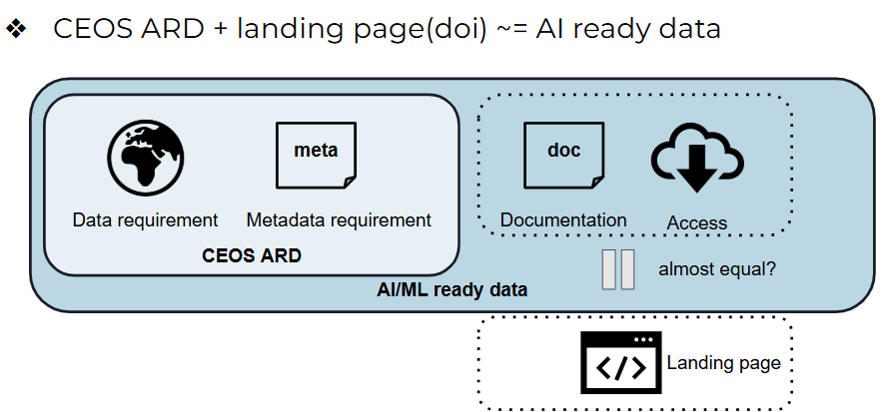
Providers compatible with CEOS-ARD may not be for AI-ready data. To support transparency and improve alignment with emerging user needs, a proposal was put forward to add an AI-readiness column to the existing CEOS-ARD Datasets table hosted online. This would help users assess the suitability of different datasets for AI/ML workflows. Participants were also invited to complete a survey intended to assess community awareness of the ESIP checklist and to gather feedback on CEOS-ARD’s potential role in supporting AI-readiness. The survey is available here.
CEOS-ARD currently does not include explicit requirements on the user-facing aspects of data access. While data may be available via FTP or similar protocols, specifications regarding modern access mechanisms such as APIs are not included. This is in contrast with the ESIP checklist, which specifically asks whether datasets are accessible through machine-actionable interfaces, a critical factor for many AI/ML applications.
Discussion
Jonathon Ross (GA, LSI-VC Co-lead) asked what from this list is specific to AI?
Yousuke Ikehata (JAXA) noted that the definition of AI/ML readiness remains vague. If alternative definitions or checklists are available from other sources, they can be evaluated. However, at present, there is no clear, universally accepted definition of what constitutes ‘AI/ML-ready’ data. In the future, if a robust checklist is identified or created, its requirements could be incorporated into the CEOS-ARD framework. WGISS is reaching out to LLM developers to better understand what might make geospatial data easier to use in machine learning workflows.
Peter Strobl (EC, LSI-VC Co-lead) asked what is actually meant by ‘data’ in this context. He asked what scale or type of imagery is being referred to when discussing AI-readiness, and whether the discussion applies to all data considered under AI use.
Pete Doucette (USGS) noted that the term ARD itself is a very relative expression. Its meaning depends on the nature of the analysis intended. LSI-VC does not necessarily need to change its approach to AI-ready data. The implication that AI requires fundamentally different data may not be accurate. Moreover, as AI technologies continue to evolve rapidly, including new paradigms for data integration and harmonisation, these advancements are likely to reshape how we understand AI readiness.
Peter noted that observational data needs to be predictable and clean. Without these characteristics, data begins to resemble model-based outputs, which undermines the observational value. Achieving AI readiness often requires moving towards higher levels of abstraction and processing. As a result, most raw observations are not AI-ready and many never will be.
Pete noted that at the other end of the spectrum, recent advances in transformers require less processing and produce less noise. Many AIs can handle Level 1 and Level 2.
An invitation was sent to LSI-VC members working on developing geospatial models to engage with NASA-IBM Geospatial Foundation Model Prithvi, Clay, and Google DeepMind.
Dave Borges (CEOS SEO) proposed to gather inputs from the Cloud Native Geospatial Conference on what model builders would benefit from in CEOS-ARD.

LSI-VC-17-05 | David Borges to use the opportunity of the Cloud Native Geospatial Conference to gather feedback from the AI/ML model builder community on the current state of CEOS-ARD as well as what they would like to see in terms of future development to make CEOS-ARD more tailored to AI/ML applications. | May 2025
LSI-VC-17-06 | Alexander Brooks to review the WGISS TEIG assessment of CEOS-ARD against the ESIP Data Readiness Cluster Checklist for AI/ML Readiness of Data and provide a report back to a future LSI-VC meeting on adjustments that could be made to the CEOS-ARD PFS to increase compliance. | LSI-VC-18
LSI-VC-17-07 | LSI-VC team members are asked to respond to the CEOS WGISS TEIG questionnaire for the AI/ML whitepaper. | May 2025

Session 4: CEOS-ARD and Data Quality
4.1: Data quality findings and issues from the CEOS-ARD assessment process [slides]
Presenter: Peter Harrison (Geoscience Australia)
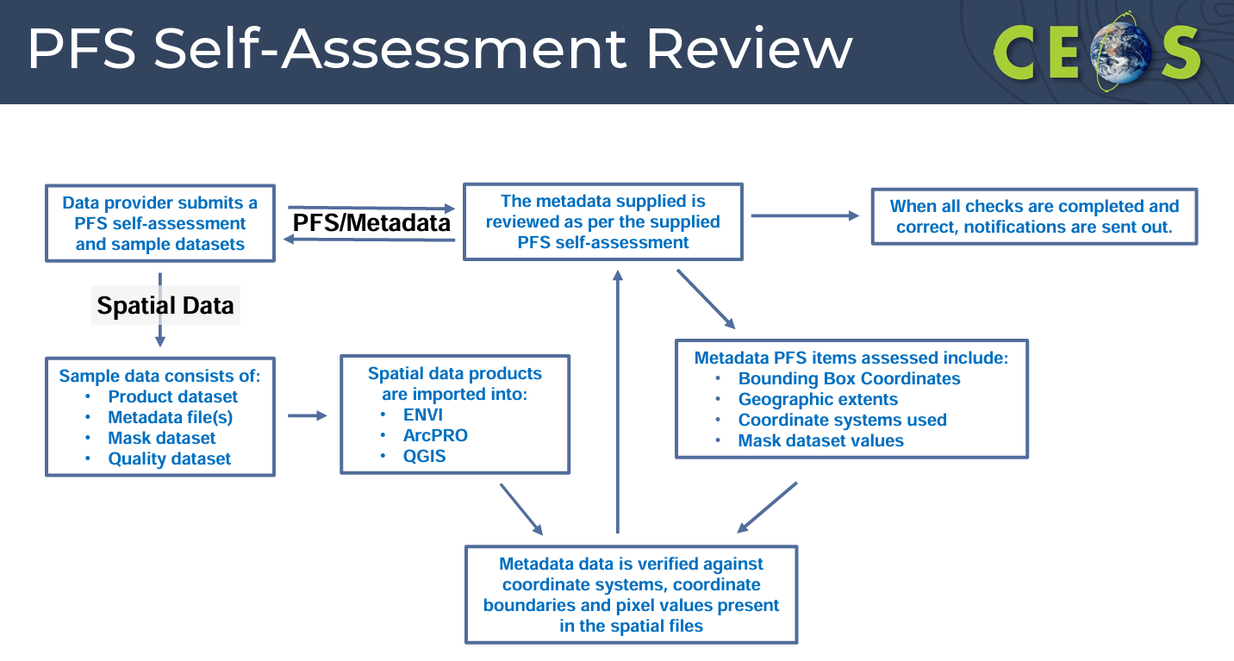

The PFS Self-Assessment review involves a detailed evaluation of products against every required parameter specified in the PFS for both spatial data and metadata. These are iterative processes that can be complex, particularly when data is distributed across multiple files and formats. The metadata does not always follow the chronology of the PFS’ metadata parameters. In some cases, especially the SR PFS, items can be difficult to locate. Sometimes the PFS version used for self-assessment has been superseded or incorrectly identified.
In one observed case, several mask pixel values are not referenced in the metadata. The missing mask values were ‘Not required’ as they were Goal requirements in the PFS. This allowed the product to achieve Threshold status despite missing essential metadata for users.
More examples of self-assessment data quality issues are shown in the slides.
The CEOS-ARD self-assessment review process is both iterative and parallel. These issues raise the following questions for the CEOS-ARD assessment process: do we continue as we are, solely assessing the metadata to the PFS requirements, or extend the process to ensure the quality of products associated or expected with the CEOS-ARD brand?
Discussion
Matt Steventon (LSI-VC Secretariat) noted that for products to be ARD, it needs to not to have such quality issues.
Ake Rosenqvist (JAXA) added that the first example shown highlights a shortcoming in how the PFS is phrased. It is unclear to the provider how they should address certain requirements. It should be a threshold requirement that other categories are specified and acknowledged when certain parameters are goal level.
LSI-VC-17-08 | Ake Rosenqvist to suggest an update to the CEOS-ARD PFS that would address Case 1 of the data quality issues highlighted under agenda item 4.1 of LSI-VC-17. The parameter description for Data Mask Image (item 2.2) in the SAR PFS will be clarified to remove ambiguity. | LSI-VC-18

While there are traditionally accommodated products as long as the metadata is provided and described, these examples demonstrate that such flexibility is no longer acceptable. Allowing products with significant quality issues undermines the credibility of the standard and it damages the CEOS-ARD brand and negatively impacts all stakeholders.
4.2: European perspectives (ESA EDAP, TPM, CCM) [slides]
Presenter: Leonardo De Laurentiis (ESA)
The two main roles of ESA are the traditional ESA procurement role, which involves providing datasets to end users, and ESA commercialisation roles, which involve providing Earth observation datasets to end users to support research, development, and science needs. The second is its growing role in the commercialisation of Earth observation data, which includes collaboration with the European Commission (EC) through various programmes involving national missions such as IRIDE and the Atlantic Constellation, as well as emerging very high-resolution missions.
ESA manages a number of Third Party Missions (TPMs) and Copernicus Contributing Missions (CCMs). These represent ESA’s position as both a data buyer and a data assessor. Earth observation data sourced through these missions is used to meet scientific and operational needs. The Earthnet Data Assessment Project plays a key role in this process. TPMs cover domains including SAR, multispectral, and atmospheric data, and missions are assessed based on their scientific applicability. In the optical domain, assessments are conducted according to three resolution categories to better support diverse user needs.
CCMs include data from both established and emerging missions. Currently, there are nine emerging missions from European companies across various domains. One focus of CCM is to boost the European community and commercial landscape. To date, ESA has signed 20 contracts across different procurement categories.
CCM covers on-demand and systematic coverage data. On-demand data acquisition meets the needs of Copernicus Emergency or Security Services, and Systematic coverage concerns fixed datasets that are provided to serve a specific purpose, such as the Triennial Very High Resolution (VHR) optical coverage of Europe, which is conducted every three years.
The Earthnet Data Assessment Pilot (EDAP) framework underpins assessments for both TPMs and CCMs. The EDAP team in TPM works before submission to member states. The Sentinel mission performance clusters support specific domains mainly for emerging data suppliers. EDAP organises the yearly VH-RODA forum, which addresses the quality of commercial missions.
EDAP was launched in 2022 to perform early data assessment on various existing, new, and future EO missions. There remains a focus on the New Space sector, and it is divided into separate instrument domains led by leading European data Quality Control (QC) experts. The main product of the EDAP assessment is a technical note that develops a Cal/Val maturity matrix.
In 2024, ESA signed a collaborative agreement with NASA for a joint EO mission Quality Assessment (QA) framework. At the Joint Agency Commercial Imagery Evaluation (JACIE) conference, USGS expressed interest in joining the development of mission guidelines and data quality assessments.
The EDAP Maturity matrices are used to evaluate data quality. For each item in the Maturity Matrix, recommendations are given on how to improve. ARD is the criteria for ‘Ideal.’
CCM Maturity Matrices leverage RadCalNet, HyperNETS, and PICS sites like La Crau and Ankara. There is also a focused effort to expand methodologies and in-situ resources for new domains, especially for very high-resolution (VHR) and thermal infrared (TIR) observations.
For Category 2 and 3 CCMs, data quality assessment consists of an evaluation of imagery acquired over a number of predefined reference sites. Radiometric assessments include analysis of spectral profiles, intercomparisons with reference sensors, and intercomparisons with in-situ RadCalNet data. Geometric accuracy assessments involve comparisons against high-precision reference layers.
The EDAP EO mission quality assessment framework features the CEOS-ARD format as the ideal case for product format. EDAP’s Cal/Val Maturity Matrix is a ‘green light’ for Category 1 CCM.
Given the economic interest, the need to assess and demonstrate data quality is particularly important. This is one of the good aspects of this assessment as it presents an opportunity for the companies to internally advocate for and improve data quality. For both CCMs and TPMs, the EDAP assessments are conducted relative to the mission-stated requirements. In addition to verifying data quality, these assessments also explore interoperability, particularly how well the commercial data complements the Sentinel missions at the application level.
EDAP has proposed a potential extension of the Maturity Matrix with an ARD Maturity Matrix, including four proposed classes, assessed against threshold and goal requirements. An open question remains as to whether this would involve a separate, parallel assessment for vendors.
VH-RODA will take place from 17 November to 21 November, 2025 at ESA-ESRIN in Frascati, Italy.

4.3: WGCV Capabilities for Data Quality and Connection to CEOS-ARD Framework [slides]
Presenter: Nigel Fox (NPL)
A mission's success is dependent on quality assurance. It is not just about how good the data is for a particular application, but more importantly, about how consistent the data is with the provider's claim.
There is an increasing need for ARD and quality assurance is a fundamental driver. The CEOS Fiducial Reference Measurements (FRM) Framework is the validation arm of satellite data products, and provides increasingly robust uncertainty evaluations of agency missions. The future will hopefully see the introduction of SI-Traceable Satellites (SITSats).
The goal of the framework is to create a combined QA standard that assesses the quality of data provided by a customer. In this process, the data provider justifies their claims by providing evidence across all boxes in a matrix. Independent validators then assess the agreement and consistency of the data. The process covers product information, metrology, generation, and validation. One of the main goals is to establish a common framework between ESA, NASA, and USGS.
The CEOS Product Validation Platform (PVP) aims to assist with the calibration and validation (Cal/Val) of radiometric and spatial characteristics of data. The framework is designed to be more specific about the targets that data providers must supply evidence for.
Within the WGISS data management and stewardship model, the Cal/Val Maturity Matrix (MM) represents the data quality block. Unlike ARD, the MM does not require adherence to specific standards but focuses on the specification of data elements. Nigel emphasised the increasing utility and use of this reporting method.
A similar approach is MM for Greenhouse Gases, which are being used in the development of the CEOS Greenhouse Gas Task Team’s (GHG-TT) Common Practices Plume-detected Methane Emissions.
The QA MM is a comprehensive standard for mission quality, currently being applied in the QA evaluation of both ESA and NASA commercial missions. The assessment results are summarised within the Cal/Val MM framework. One of the major benefits of this assessment process is the creation of a formal communication channel between agencies and commercial data providers. However, the validation process itself remains labour-intensive. The Cal/Val MM has been integrated into the CEOS WGISS Maturity Matrix, where it represents the data quality component.
The MM reporting style is proving particularly valuable, as it enables graded assessments rather than simple binary outcomes. This approach helps identify progress, encourages improvements, and makes the most critical aspects visible to users. There is potential for developing a similar MM to report compliance with CEOS-ARD PFS, moving toward a more nuanced and progressive assessment framework, rather than the current binary threshold/target approach.
Looking ahead, the focus will be on evidencing fitness for purpose and usability. While full uncertainty is not achievable, the EDAP programme is exploring a limited number of broad application types and applying assessment criteria to generate quantitative metrics.
The CEOS Product Validation Platform effort, formerly the Radiometric and Spatial Match-up database, is an initiative within WGCV that aims to facilitate interoperable global satellite imagery for both public and commercial agencies. The platform is built around a selection of Pseudo-Invariant Calibration Sites (PICS) that serve as radiometric and spatial references.
WGCV recommends that CEOS Agencies regularly collect and freely provide access to Level 1 satellite imagery and metadata against these common CEOS reference sites. These calibration sites will be integrated into a virtual reference. Commercial providers are encouraged to adopt the same practices.
Imagery is to be made accessible via APIs or platforms like the UK Earth Observation Data Hub (EODH). CEOS will also deliver QA feedback to operators and users via a web application developed by NPL.
The identified radiometric sites include instrumented sites in Railroad Valley (USA), Gobabeb (Namibia), and Lake Tahoe (USA), as well as natural PICS in Libya and Algeria. Spatial sites with high-resolution sensors include the King Fahd Causeway (Saudi Arabia-Bahrain) and the Lake Pontchartrain Causeway (USA). Sites with medium-resolution sensors include the Baotou Target (China) and the ISRO NRSC target (India).
A database of radiometric and spatial data will be developed within NPL’s Cal/Val infrastructure, with initial implementation using sensors such as Sentinel-2, Landsat, and Planet.
The next steps include interaction with commercial missions to deliver imagery over reference sites. The virtual reference concept will be refined over the coming months, and the CEOS Product Validation Platform (PVP) will be populated with commercial and agency satellite imagery as a fully functional service for agencies and commercial operators alike. In time, other types of products are envisioned for the service beyond Level 1 optical data, such as SAR and surface reflectance.

4.4: Proposal and Discussion: Future of CEOS-ARD and Data Quality Consideration [slides]
Presenter: Jonathon Ross (GA, LSI-VC Co-lead)
At CEOS Plenary 2024, the newly developed CEOS-ARD Strategy was presented and was received positively, gaining recognition from CEOS Principals.
The CEOS-ARD framework offers several benefits for CEOS Agencies and Members. It lowers barriers to Earth observation data uptake by targeting new user communities and not just existing users, thereby expanding reach. It enhances interoperability between datasets, institutions, and governments, and improves supply chain resilience by mitigating against ‘single points of failure’ and increasing user confidence to invest in operational uptake. It showcases institutional leadership by convening and enabling sector growth and impact.
When aiming for operational uptake among business and international conventions, there is a demand for long term data continuity assurance. From a CEOS Agency perspective, this provides a strong position to demonstrate leadership.
Geoscience Australia can take advantage of its CEOS Chair year in 2026 to support LSI-VC and the ARD OG. There is significant support from CEOS Principals and a growing involvement from the commercial sector. With that momentum, GA proposes to bring a discussion to CEOS Plenary 2025 outlining the opportunities and challenges, with the goal of developing a new, more ambitious CEOS-ARD Strategy for endorsement at CEOS Plenary 2026.
GA would like to explore how to strengthen the CEOS-ARD brand and visibility to users, how to better align with the needs of data procurement, and identify potential partnerships and risks. Questions for discussion include:
- Do we need to introduce requirements for data quality to go to the next step and identify the minimal floor?
- How can we support users to find products fit for purpose?
- Do we need a framework for ongoing monitoring of these L2/L3 qualities?
- Do we need to be stricter in certain areas to drive practical interoperability?
- Are there other ways CEOS-ARD can evolve?
- How could we more systematically drive impact?
- Should we ask CEOS Principals to pledge implementation?
Discussion
Ferran Gascon (ESA) noted that CEOS-ARD has so far focused on content, with a little attention to format. If the scope is to extend to be more ambitious and cover other aspects, we should consider how and why it should be done. There are various dimensions to consider when speaking with different communities.
Ake Rosenqvist (JAXA) noted that since there are representatives from commercial companies already involved, we should understand from them how we can make CEOS-ARD attractive to the commercial sector and if there are any barriers. Ake suspected that one advantage would be to reach out to user groups by having data provided in a way that is easier to ingest by non-experts.
Krzysztof Orzel (Synspective) noted that commercial companies seek profit. CEOS-ARD could provide an opportunity to access ESA’s TPM and CCMs, which is a significant advantage. He agreed that data quality requirements should be established but with differences between constellations kept in mind. Some can provide rapid response data, e.g. minutes and hours, not always at the same viewing angle. If commercial companies can sell data as CEOS-ARD branded, it would increase confidence in data quality. Image quality discussions ongoing within the commercial sector recognised high application dependency and that allowances might need to be made for low-latency data.
Peter Strobl (EC, LSI-VC Co-lead) noted that in the future, a product will likely represent the whole entity of a measurement acquired by a certain mission over a certain period. There will always be some data in an archive that is not meeting the quality barrier. He emphasised the need to construct methods that do not compromise the overall description. There should be a balance between presenting the product as a whole while ensuring it remains useful for detailed analysis.
The reliability of metadata is a key area where very high standards are needed, especially for those that are verifiable. There are other things, like measurements for which no reference exists and uncertainties which inherently have uncertainties at a greater level than other parts of the data. Data quality requirements need to be adapted to the possibility of verification, which is not an easy task. CEOS-ARD should stand for the reliability of the overall assessment, ensuring that the work is done thoroughly.
Peter stressed the need to address interoperability in greater depth, as it is a term with varying interpretations. There should be more precision and clarity regarding interoperability, particularly in the time domain, noting that there are areas to improve the inherent interoperability in terms of temporal discretisation (i.e. common intervals).
Jonathon Ross (GA, LSI-VC Co-lead) asked what can be done to support users in assessing their needs and evaluating which products are interoperable with each other. He suggested a focus on changing the data to be more interoperable and supporting users in understanding which datasets they can use together for their specific applications, similar to Nigel Fox’s assessment of fitness for purpose.
Assessing user needs in the context of fitness for purpose was discussed. A common language between users' expression of needs and the ability to turn that into specifications for data needs to be identified. A user survey on interoperability and usability could be conducted through platforms like Copernicus services, shared with a subset of user groups e.g. UNFCCC, UNCCD, Ramsar. A good indication of user needs are the essential variable indicators, most of which do not contain specific measurements like SR or backscatter, which cannot be directly provided but rather contributed to. The focus should be on commonalities and essentials at a sensor-agnostic level, with redundancy in the system to ensure reliability.
Ake noted that the beginning of CEOS-ARD was limited to only image data. On the SAR side, the team had started thinking about how to provide image products in the best possible format. After that exists a ground plate to derive higher-level thematic products. Without a product level or category, further advancement is not possible.
Today, CEOS-ARD is articulated to geophysical variables. There are agreed standards and parameters for these variables, but the ontology is difficult to digest. There also needs to be an agreement on the distinction between variables and parameters.
Patrick Quinn (NASA) noted that within NASA, the Global Change Master Directory (GCMD) is under Earth Science Data Systems. Its definitions are not tied to the IPCC.
Dave Borges (CEOS SEO) noted that demonstrating the value impact of CEOS-ARD is crucial, highlighting that tangible evidence of value is convincing. He suggested discussing how to capture value with a subset of content that can showcase this impact.
Ferran added that from an ESA perspective, before CEOS-ARD, they were only providing Top-of-Atmosphere (TOA) data. One of CEOS-ARD's main contributions is supporting the production and provision of Bottom-of-Atmosphere (BOA) products.
Jonathon noted that if companies and agencies are complying with CEOS-ARD, a robust framework is essential, as more users are taking advantage of its interoperability.
Dave mentioned a recent GEO LDN activity and how they presented the GEO value. GEO is close to releasing a final version of its GEO Value Impact Assessment Tool. It might be an interesting exercise for CEOS-ARD to go through this tool and questionnaire with the GEO LDN team.
LSI-VC-17-09 | As an initial step in a broader effort to capture the value and uptake of CEOS-ARD, David Borges will connect the LSI-VC Leads and Secretariat with the GEO Value team to arrange an exploratory teleconference. | June 2025
The opportunity to establish a CEOS-ARD help desk was discussed. This would support data providers and users and offer advice on processing systems.
LSI-VC-17-10 | LSI-VC members and contributors, including those from the private sector, to provide feedback to the incoming CEOS Chair Team <Jonathon.Ross@ga.gov.au>; <Maggie.Arnold@ga.gov.au>; <matthew@symbioscomms.com> and CEOS-ARD Oversight Group <ard-oversight-group@lists.ceos.org> on matters that could be considered by an ambitious next-generation Future ARD Strategy. Feedback is sought on the issues that should be considered by such a strategy, including potential opportunities to accelerate the uptake and impact of CEOS-ARD, risks to the success of CEOS-ARD, and additional linkages and partnerships that could support the agenda. In identifying matters for consideration, contributors may wish to reflect on evolving user needs, developments in space/ground/digital technology, and the changing sector landscape. | 30 June 2025

Tuesday, April 15
Session 5: CEOS-ARD for Procurement (continued)
5.1: NASA Commercial Satellite Data Acquisition (CSDA) Programme perspective [slides]
Presenters: Melissa Martin and Dana Ostrenga (NASA CSDA)
Melissa Martin (NASA CSDA) reported:
Melissa Martin serves as the Programme Manager for NASA’s Commercial Satellite Data Acquisition (CSDA) programme, with Dana Ostrenga as the Project Manager.
The US government fleet serves as a backbone for global EO coverage. Commercial satellite data is an important complement to this fleet that increases NASA’s pace of discovery.
For some vendors, NASA’s purchases represent their critical revenue stream. CSDA’s mission is to identify, evaluate, and acquire commercial satellite data that support NASA’s Earth science research and application goals. Vendors highlight the value of standards for cross-calibration, sources for intercomparison, geolocation and validation accuracy, algorithm development, and support for RadCalNet sites.
The programme aims to establish a continuous and repeatable process to on-ramp new commercial data vendors, enable sustained use of purchased data and dissemination by the NASA science community, and ensure long-term data preservation and access.
The NASA CSDA programme currently holds contracts with 15 vendors across a range of domains, including hyperspectral, multispectral, SAR, methane, GNSS-R and GNSS-RO, precipitation, DEMs. There are three tiers of end-user license agreements: US Government, US Government Plus, and Public Release.
NASA data available through CSDA was initially usable for scientific research, and has been expanded to permit operational use. The NASA research community remains the primary user of CSDA data.
CSDA works closely with US federal agencies to align and share data acquisitions, evaluation processes, data requirements and needs. JACIE has been leveraged as a key forum for continuing collaboration with international partners and increasing interoperability.
CSDA also coordinates with commercial data procurement within the US government, including the Civil Applications Committee (CAC), National Reconnaissance Office (NRO), National Geospatial-Intelligence Agency (NGIA), National Oceanic and Atmospheric Administration (NOAA), and US Environmental Protection Agency (EPA).
Data evaluation criteria include:
- Accessibility of vendor supplied imagery and data;
- Accuracy and completeness of metadata;
- Quality of User Support Services;
- Usefulness of data for advancing Earth system science research and applications activities;
- Quality of vendor supplied imagery and/or data
The NASA ROSES initiative solicits commercial data that can supplement the existing NASA Earth Observing fleet and other free and open data sources.
CSDA is working to expand stakeholder engagement and support, notably through monthly webinars whereby vendors can present updates on their constellation, instrumentation, data products, and science uses and applications. Tools like AI are being explored in the commercial sector to expand the utility of data. The community is engaged through conferences, workshops, and science meetings to identify opportunities and challenges.
Dana Ostrenga (NASA CSDA) reported:
Data is provided by vendors through NASA-approved user requests. CSDA provides sustained data use through data repositories, search and access to data, and availability to approved researchers. Long term data preservation is ensured through the NASA catalogue, the ability for users to interact directly with vendors, and storage in the Earthdata Cloud.
CSDA would like to leverage standards and best practices partnerships through CEOS and other forums. Commercial agencies are not bound by government agency data requirements, which can make it challenging for them to conform to standards. A standard recognition should be provided to commercial partners in forums like JACIE.
ESCO maintains a list of standards approved for use in the NASA Earth Science Data Systems. The ESCO process includes an initial screening, community review, post review, and areas of focus.
Commercial entities can better leverage commercial data products that meet the rigorous standards of CEOS-ARD, facilitating easier integration with NASA’s Earth Science data ecosystem. In support of CEOS-ARD, the programme can focus its evaluations on data processing levels, metadata standardisation, quality indicators, formatting and accessibility, and validation procedures.
Commercial partners could also be encouraged to leverage established validation protocols and best practices from CEOS WGCV, allowing them to apply FRM approaches to their datasets, incorporate uncertainty characterisation methods, adopt standardised validation site protocols, develop evaluation rubrics, include WGCV representatives in evaluation processes, establish technical benchmarks, and create feedback mechanisms.
Complementing the CEOS WG efforts could strengthen the CSDA programme by providing commercial data with a stamp of approval from an established and trusted organisation like CEOS.
Discussion
Ake Rosenqvist (JAXA) noted that regarding the usefulness of commercial data and how to optimise it, CSDA have tasking rights included in the programme. LSI recently conducted an assessment of commercial SAR data, where several companies made their data available online and free of charge. However, these were random observations with no spatial or temporal consistency, offering little utility. Tasking rights, therefore, are crucial.
Most commercial data providers offer data at much higher resolutions than CEOS data, which can be complementary. However, the users CEOS typically cater to generally look for large-scale, national-level data. It is important to stimulate commercial data providers to take background observations, ensuring that the data they collect is useful for the majority of users.
Dana Ostrenga (NASA CSDA) noted that CSDA has been trying to encourage commercial data providers to regularly observe certain cal/val sites. This would help in assessing the quality of the data while also capturing areas of interest for scientific studies.
Peter Strobl (EC, LSI-VC Co-lead) appreciated the effort for long-term data preservation, and asked what would happen to data ownership and rights if a provider disappears.
Melissa Martin (NASA CSDA) noted that CSDA has never adjusted the data if a partner is to provide preservation. CSDA ensures that all required information is captured. If a vendor were to disappear, the data would still be retained by CSDA.
Peter added that in such a case, CSDA would not be able to provide licensing if the provider no longer existed.
Melissa noted that the previous contracts were based on different End User License Agreements (EULAs). Typically, CSDA would uplift the license and compensate commercial partners with the change in data value. These matters are currently being planned with CSDA’s policy and legal teams.
Peter suggested considering a timeframe (e.g. 20–25 years) after which data might become publicly available, recognising that the commercial value would decrease over time. Given CSDA's investment in storing and maintaining the data, it would be reasonable for CSDA to retain it for long-term use. Historical data holds significant value and should be further explored. Vendors may not intend to keep their own data indefinitely.
Jonathon Ross (GA, LSI-VC Co-lead) noted complementarity to ESA and WGCV and how they highlight the essential role government agencies play in supporting both the private sector and users. He welcomed reflections on enhancements and better integration through CEOS, and suggested onboarding providers from additional countries.
Considerable effort has been invested in defining these protocols and processes – they could be adopted as CEOS best practices, enabling any agency to build on them. Jonathon suggested this be developed as a CEOS-LSI-VC Best Practice and proposed an action to assess how CEOS-ARD evaluations are conducted and how this work could be leveraged to make assessment processes more efficient.
LSI-VC-17-11 | CEOS-ARD Oversight Group (contact: Medhavy Thankappan of GA), NASA, ESA and USGS to explore opportunities for the adoption of the Joint Earth Observation Mission Quality Assessment Framework as a ‘CEOS Best Practice for Third Party Mission Assessment’, and to identify opportunities to ensure assessments undertaken, and information gathered, consistent with such a Best Practice can lead to streamlined CEOS-ARD compliance assessments. | Report back by LSI-VC-18

While the processes are slightly different, it would be valuable to identify common elements and ensure the framework is adaptable for other agencies. Having a common framework is helpful, and existing peer review processes could be leveraged alongside other review activities.
Dave Borges (CEOS SEO) added that the SAR quality assessment framework is already available, with the optical framework to follow soon, as well as an atmospheric framework.
Melissa expressed strong motivation to bring CEOS into CSDA’s work, as this would help strengthen their efforts.
Dave noted that CEOS-ARD branding could be particularly impactful. Since CSDA holds monthly webinars focused on vendors, CEOS might consider participating to introduce CEOS-ARD to that community.
Dana welcomed CEOS participation in upcoming webinars and offered to coordinate specialised CEOS-focused sessions.
Instead of a one-off introduction to CEOS-ARD, ongoing engagement with vendors and utility assessments could become key leverages. ROSES could also provide value to capture CEOS-ARD. The virtual CEOS-ARD help desk idea could be used to explain the assessment process and help participants tap into a broader CEOS expert community.
Melissa shared that CSDA is planning to host an in-person workshop with the commercial sector in September 2025 at NASA Goddard. This will be an open forum with panel discussions to hear directly from vendors about their needs. CEOS-ARD will be an excellent topic to showcase.
Dave noted that this workshop will coincide with the CEOS SIT Technical Workshop in September 2025.
LSI-VC-17-12 | LSI-VC Secretariat to follow up with Melissa Yang Martin and Dana Ostrenga of the NASA CSDA program regarding opportunities for CEOS-ARD representation in:  - The monthly CSDA vendor webinars (to introduce CEOS-ARD and as an opportunity to gather feedback on CEOS-ARD and its value);  - Opportunities around the ROSES program for capturing the value of CEOS-ARD;  - The opportunity of the CSDA virtual office hours and support from the CEOS-ARD side (perhaps providing capacity building support for involvement in CEOS-ARD);  - The planned CSDA forum with the commercial sector (in-person workshop, September, at NASA Goddard). | June 2025
Chris Barnes (USGS, LSI-VC Co-lead) echoed Jonathon and Dave’s comments regarding deeper engagement with the commercial sector. He noted ongoing efforts to determine a cadence for updating CEOS-ARD PFS and expressed a desire to establish an open dialogue with industry. Planet has been enthusiastic about developing a CEOS-ARD compliant product, opening the door to the commercial sector and providing mutual benefit. Chris asked if the AI/ML mentioned is connected to search and discovery/access or science applications?
Melissa responded that CSDA is doing all of it. Through the ROSES call, a big component was the development of tools with AI/ML. The disaster response team at NASA is developing a foundation model that ingests commercial optical and SAR data. Exploring different models to explore the use of commercial data.
Dana added that NASA has another group ingesting Maxar data into foundation models. AI/ML methods used for quicker search and discovery, and some exploratory work towards what path it can take through the data system.
Chris noted that this topic was raised for the first time in LSI-VC and that there is still uncertainty around the definition of AI/ML. He encouraged an ongoing dialogue on the topic.
Session 6: CEOS-ARD PFS Requirements
6.1: Consistency of Optical CEOS-ARD PFS Requirements [slides]
Presenter: Chris Barnes (USGS, LSI-VC Co-lead; remote from USA)
Chris has been leading the CEOS-ARD optical combined PFS activity. At LSI-VC-16, it was decided to combine only the SR, ST, and NLSR PFS into a single combined version. This aims to maintain requirement consistency for the building block and GitHub migration efforts.
The combined optical PFS aims to identify and resolve inconsistencies across the existing optical PFS documents, ensure alignment and streamlining of requirements, and assess potential impacts on other PFS.
A key question is whether IOCCG and LSI-VC wish to pursue a physically combined optical and SAR PFS. If so, a phased approach and defined timeline would be necessary to achieve this.
The Building Block and GitHub migration effort has demonstrated some complexity, particularly for requirement numbering.
Chris proposed temporarily removing the AR PFS from the combined optical PFS due to errors introduced by conflicting requirements across PFS. The immediate focus should be on aligning the SR, ST, and NLSR PFS, which could be completed in approximately two weeks. Chris also suggested establishing an optical PFS Tiger Team to review and address all content and recommendations from AR PFS v2.0. A fully combined optical PFS incorporating SR, ST, NLSR, and AR could then be presented at LSI-VC-18.
If endorsed, LSI-VC should proceed with the building block strategy and GitHub migration, including defining GitHub governance processes and offering training.
Discussion
Jonathon Ross (GA, LSI-VC Co-lead) asked about the motivation behind merging optical and SAR PFS.
Chris Barnes (USGS, LSI-VC Co-lead) explained that the idea came up recently as a follow up from LSI-VC-16. The question is whether we should merge similar requirements from SAR and optical PFS. Is there one requirement for data access, for example, that would be similarly required across PFS?
Ferran Gascon (ESA) noted that the challenge is about finding common requirements across all PFS. This was initiated in the past with the PFS template. A core set of requirements would be valuable.
Peter Strobl (EC, LSI-VC Co-lead) noted the need for a completely different approach. First, talk about the framework, then merge them. Optical and SAR cannot be merged but there are common geospatial elements that can be organised better. This will come from the building blocks approach. There should be consistency across common parameters.
Matthias Mohr (Cloud-Native Geospatial Foundation) asked about the way to line up better requirements that are similar across multiple PFS, such as things not specific to measurements and sensors. This will require point-by-point reviewing.
Chris noted that the aim is to get a baseline combined optical PFS document by initially removing the AR PFS V1.0 and starting a fresh document. AR PFS V2.0 should then be brought in, and a team would need to look at the impacts of bringing it in.
Matthias noted that if building blocks are the future approach, the combined optical PFS will serve as an intermediate version. It’s necessary to understand the differences between existing PFS to ease the migration to building blocks.
Chris responded that it is still needed to maintain the integrity of the PFS that have been endorsed by CEOS. The transition is worthwhile but traceability should be maintained. The SAR PFS are in good shape, but the optical needs reconciliation.
Patrick Quinn (NASA) suggested a more hierarchical approach, branching new PFS from existing ones. While the current system has grown organically, it’s now close to a building blocks model, though more structure and consistency are needed. A prior working group also explored combining all PFS.
Ake Rosenqvist (JAXA) noted that he had previously discussed with Chris on mapping the SAR and combined optical PFS to identify similar requirements. There were challenges in accommodating multi-source products like PlanetScope mosaics, which are not currently supported by optical PFS. A decision is needed on whether to proceed now or postpone.
Matthias has examined both the SAR and optical XML specifications, and questioned whether a separate optical XML spec makes sense. SAR metadata lacks tooling support, and metadata specs only succeed with strong ecosystem support, like STAC.
Jonathon suggested revisiting after the building block implementation to avoid confusing data providers.
Chris emphasised the need to clean up the combined optical PFS before proceeding with the building blocks transition. The document will be released after the building block implementation.
Matt Steventon (LSI-VC Secretariat) noted that Version 2 of the AR PFS differs significantly from other optical PFS and aligning it with the SR PFS will be a longer effort.
Peter noted that the AR PFS contains a lot of clarifications that concern a lot of optical PFS, which can be moved over as consolidated requirements.
Matthias noted that it is easy to go through the AR PFS with the accompanying decisions document, which summarises the changes made and their justification. He recommended forming a review group to go through this and the other optical PFS together, ensuring the discussion remains focused on specific changes.
Peter suggested reviewing the optical requirements together as a first step and postponing discussion on any non-optical points.
It was suggested that it would be a good idea to assemble a team of representatives from agencies that have made PFS submissions. The purpose would be to review proposed changes to the PFS and ensure that existing assessments are not compromised.
Matthias noted that if the goal is to eventually combine PFS, there is a risk of breaking existing structures. He recommended defining the changes we can release as minor versions and what would classify breaking it up.
LSI-VC-17-13 | Chris Barnes to remove AR PFS v1.0 from the "combined" optical PFS reviewed at LSI-VC-16; update the document to address additional errors identified since LSI-VC-16; generate a new combined optical PFS for only SR, ST, and NLSR; and convene an Optical PFS Tiger Team to review and address all AR v2.0 and LSI-VC-16/17 recommendations and prepare a Combined Optical PFS (SR, ST, NLSR and AR) for endorsement at LSI-VC-18. The Tiger Team should include representatives from all agencies that have a currently endorsed CEOS-ARD dataset so that there is full awareness of any potential backwards incompatibility. | LSI-VC-18

Session 7: Commercial Sector Uptake of CEOS-ARD
7.1: New Space Intelligence [slides]
Presenters: Masahiko Nagai and Muhammad Daniel (New Space Intelligence Inc.)
NSI is the first commercial start-up company to conduct ‘calibration-as-a-service,’ and is focused on user-centric Cal/Val processes rather than provider-driven approaches. The main challenges identified in Earth observation data utilisation are variations in spatial, spectral, and radiometric properties in inter- or intra-constellation satellites. The frequency of observations between these satellites is also problematic for observations that require high revisit times.
Satellite constellations present their own challenges for data consistency, particularly in achieving interoperability across multiple sources.
NSI has developed a dedicated cal/val site to work through these challenges. The first site developed is a large fixed mirror in Tokiwa, Japan. The site includes both a custom-built mirror array and a Labsphere mirror array, supporting data collection from satellites such as Axelspace and Planet.
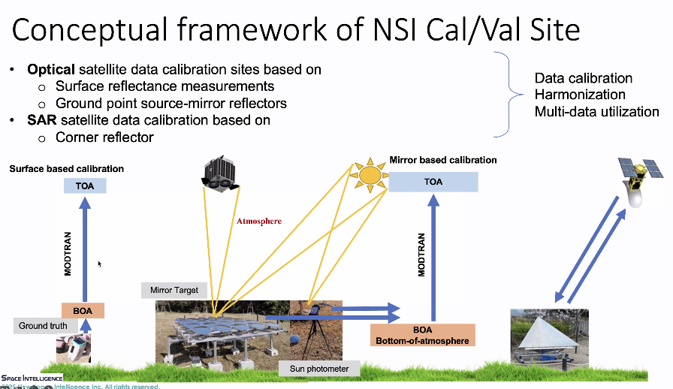
Field campaigns are also being developed with mirror arrays, handheld spectrometers, and UAV observations. The UAV observations are used in parallel to the satellite observations to develop training data.
NSI’s international partners include Labsphere, USGS SDSU Image Processing Lab, ISRO, and PhilSA.
Ground mirror reflectors facilitate improvement in band registration and geolocation accuracy. An original method is being developed for measuring the spread of reflected energy from the ground mirrors, the ‘In-flight Point Spread Function (IPFS),’ to further enhance image quality.
For SAR data, trihedral corner reflectors are used for calibration, with one of the key application areas being coastal erosion monitoring. Accurate georectification is essential for this type of analysis. Data standardisation is an important consideration and NSI will follow the CEOS-ARD PFS for SR.
Discussion
Ake Rosenqvist (JAXA) asked whether the optical mirror reflector uses sunlight for reflection.
Masahiko Nagai (NSI) noted that they collect satellite orbit and sun angle to tilt the mirrors. The pointing angle is very important. By keeping a mirror in a specified offset, the mirror can also stimulate Lambertian reflectance. They use Sentinel-2 quality documentation provided by ESA.
Ferran Gascon (ESA) asked if atmospheric effects influence the measurements.
Masahiko Nagai (NSI) noted that it depends on the processing applied on the data.
Peter Strobl (EC, LSI-VC Co-lead) asked if the mirror has been used to realise different brightness levels for checking system brightness.
It was noted that this has not been done as standard calibration sites are often too bright.
Ferran asked how accurate the radiance provided is in terms of radiometric uncertainty.
It was noted that the uncertainty is somewhat vague. While calibration is conducted in the field, they prefer to calibrate against field measurements. The setup is currently being used for radiometric calibration.
Hirokazu Yamamoto (AIST) commented on the various calibration methods. Human, vicarious, and onboard calibration methods are compared, and are very useful.
Ferran asked how the device’s geometry is calibrated.
NSI uses GNSS information and calibration is done with the guidance of Labsphere who worked to install the device in 2024.
Ake asked how NSI’s corner reflectors differ from standard models.
NSI noted that their corner reflectors include a hole to allow for drainage of dust and water, requiring less maintenance. Two reflectors are currently installed along the coast, and they are seeking involvement from local governments.
P.V. Jayasri (ISRO) asked which frequency bands are supported.
NSI noted that they are making reflectors for ALOS and Sentinel missions, supporting L-band and C-band.
Takeo Tadono (JAXA, LSI-VC Co-lead) noted that the required reflector size depends on the purpose and that a larger reflector may be needed in some cases.
7.2: Discussion session regarding commercial sector uptake of CEOS-ARD [slides]
Moderator: Matt Steventon (LSI-VC Secretariat)
Increased commercial data uptake enhances value for both users and CEOS Agencies. It is an opportunity to gapfill CEOS Agency datasets, provide redundancy of critical observations, and resilience. Engagement with the broader community is needed for any work on standards to be accepted.
Commercial engagement so far has been ad hoc, and there is a need to identify the highest priority candidates for engagement, assess current levels of engagement, barriers and opportunities for the CEOS-ARD PFS, high resolution data, optical mosaic products, financial aspects, and standards. Profits remain the bottom line, building the business case and appealing CEOS-ARD should be a priority.
There are numerous commercial organisations providing services for data, platforms, analytics, insights, and software. Data producers span the optical/multispectral, hyperspectral, infrared, radar, lidar, and radio signal domains.
Commercial engagement should not be done on a purely bilateral basis; there is a need to participate in multilateral forums while identifying and prioritising key actors. Existing engagements have primarily been with primary data producers. Walking these actors through the CEOS-ARD self-assessment process will require sustained and structured support. There should be a decision to plan to resolve known issues hindering commercial sector uptake.
The current suites of PFS are unsuitable for Very High Resolution (VHR) SAR data, so even commercial data providers keen to adopt CEOS-ARD cannot do so until ‘VHR-adapted’ PFS are produced. This is the next target for the SAR team for 2025.
User consultation workshops are planned at various events in 2025. Commercial engagement in CEOS should leverage global networks and showcase a coordinated message.
Discussion
What else is missing from the current PFS?
Ake Rosenqvist (JAXA) noted that multi-source input is missing. Currently, it is only applicable for products that come from a single source. Averaged mosaics need to be accommodated. The structure used to distinguish between product and data source will probably not change. This applies to a combination of ascending, descending SAR data built on different observation geometries. It would be valuable to hear the commercial sector’s perspective on CEOS-ARD, including any challenges or roadblocks they face.
Mauro Mariotti (Synspective) noted that standardisation means ‘easy to use’. Synspective is both a data provider and an analytics company. Many users attempt to analyse data but still require support. He emphasised the preference for using existing, well-developed standards rather than creating proprietary ones. Synspective has been in contact with CEOS for some time, which helps streamline their processes. If standards are unclear, users also lack clarity about the data. Clear, demonstrated rules benefit both providers and users.
Synspective are unsure how to set priorities for users. They are working on use cases like wind speed assessment, which has its own requirements for calibration. It would be useful to be able to identify which product will be the most important for the user.
Ake noted that it would be interesting if Synspective went through the SAR PFS to assess which parameters are relevant, irrelevant, or currently unachievable, such as radiometric terrain correction for VHR data. Input from commercial actors would be helpful when refining CEOS-ARD products tailored for VHR SAR data. NRB is currently the most interesting product, but ocean backscatter may be more important. He welcomed Synspective’s input to help develop the VHR PFS.
Griffin Williams (Catalyst) noted that Catalyst had recently gone through the self-assessment process. PCI Geomatics (Catalyst) has started working with commercial and SmallSat companies on radiometric and geometric corrections. The next step will be aligning workflows with the CEOS-ARD PFS for broader application across commercial partners.
Catalyst assessed both optical and SAR PFS, finding the process relatively straightforward. Some minor ambiguities were noted, for example, certain metadata tags were not explicitly defined. An issue arose where data masking was interpreted as simply indicating ‘clear,’ whereas the PFS specifies cloud masks based on threshold values. High spatial resolution imagery from SmallSat providers presents challenges, particularly when sub-metre data is compared against coarser reference datasets. Many partners currently use Sentinel-2 10 m DEMs as a reference, and there is uncertainty as to whether this is sufficient for CEOS-ARD compliance.
The second challenge relates to the commercial business case. While programmes such as NASA’s CSDA and EDAP offer a clear value proposition regarding purchasing data, there is a need to blend and align these programmes more effectively. Doing so would help encourage SmallSat companies to pursue CEOS-ARD compliance. Catalyst also suggested streamlining the engagement process through CSDA.
Matt Steventon (LSI-VC Secretariat) asked whether Catalyst had experienced any promising use cases for CEOS-ARD datasets.
Griffin noted that Catalyst had done processing with the Microsoft RTC dataset, which was CEOS compliant except for the metadata structure. This dataset has been gaining significant traffic through the Palantir platform.
Jonathon Ross (GA, LSI-VC Co-lead) highlighted ongoing questions regarding timing and adoption. Until a critical mass of CEOS-ARD-compliant products becomes widely available, limited user uptake is expected. He emphasised the need to support users in leveraging CEOS-ARD, especially through partnerships with the GEO community. He noted that GEO users often build workflows around their preferred datasets, and integrating CEOS-ARD adds an extra layer of effort. He flagged a key opportunity for capacity development and encouraged GEO’s new strategy to account for the operational risks of relying on single data sources.
Dave Borges (CEOS SEO) noted that there needs to be a strong business case on the CEOS-ARD impact card and CEOS-ARD is the only thing we have. He proposed the development of a Google Form to gather project overviews, usage examples, impacts, and future plans for one-on-one commercial outreach. Testimonials are relatively easy to get. The CEOS Comms team has been developing StoryMaps and could develop one CEOS-ARD with more external validation and case studies than currently exist.
SEO has built a cloud native geospatial introductory training leveraging NASA’s HLS data towards specific analysis around Sustainable Development Goals (SDGs). It has been well-received and could be adapted for presentation to the GEO community.
Does Synspective bring in data outside of CEOS-ARD?
Mauro noted that higher level processing requires different kinds of data, so a lot of other sources are used at Synspective. CEOS-ARD would simplify work internally and is welcomed.
It was noted that many prospective users require formal standards before they invest in it.
Griffin noted that Catalyst had engaged with CEOS-ARD in the past under CARD4L, and transitioning to CEOS-ARD was a natural step as it matured. Recognition as a formal standard would encourage broader uptake.
NASA’s ROSES solicitation is a key funding mechanism, and Dave would like to see CEOS-ARD included in its future requirements, something that is already under consideration. Inclusion of the PFS would be particularly valuable.
Matt proposed running user-focused webinars on CEOS-ARD. These could include hands-on training leveraging priority access to JAXA data, and engagement with Synspective and iQPS.
Pete Doucette (USGS) reflected on the broader identity of LSI-VC, suggesting that one strategic path is the curation of standards. He questioned when CEOS will demonstrate capacity for a true virtual constellation, and stressed the importance of pragmatism in choosing commercial vendors to demonstrate end-to-end metadata curation and virtual constellation interoperability.
Are there groups in CEOS who would be candidates for running interoperability pilots?
Jonathon suggested conducting pilots to find flaws in practically supporting interoperability. GEO is trying to move from piloting new ideas to moving towards operational products. These need to support multiple data sources.
Pete suggested leveraging JACIE’s evaluations of data quality. CEOS could seek vendor recommendations as part of a pilot initiative. Maxar and Planet Labs were given as contrasting examples—Maxar offering refined GSDs, and Planet experimenting with harmonisation between commercial and public datasets, including daily revisit capabilities.
Chris Barnes (USGS, LSI-VC Co-lead) noted that many US-based commercial providers are already producing CEOS-ARD relevant products. Trying to engage with NASA CSDA and vendors like Planet would be worthwhile. Developing a compelling use case scenario to demonstrate interoperability would be helpful in outreach efforts.
Matt referenced the Cloud Native Geospatial Forum and noted that OGC has produced a paper on pilot activities, which may have involved CEOS-ARD datasets in the disaster pilot.
Dave noted that the SEO is heavily focused on the cloud native geospatial forum. Matthias will attend and give a presentation on CEOS-ARD. There should be a balance as real progress will require focused in in-depth engagement with a shorter list of companies. As a next step, a hackathon or number of sprints could be scheduled. Planet may be interested in joining a three-hour sprint technical meeting.
The ARD2x forum is no longer active, though there remains a broader ecosystem of EO and geospatial workshops. Referencing Melissa’s comment, Dave noted that CEOS is mentioned frequently in JACIE. He asked what was discussed in relation to CEOS-ARD, and likewise for the VH RODA activity.
Medhavy Thankappan (GA) noted that interoperability was a key theme, with SR highlighted as a use case for harmonisation. He also shared updates from the SR Quality and Consistency team and noted other data quality initiatives underway across CEOS, particularly in WGCV. Medhavy also spoke with Jessica from Planet, who expressed interest in a pre-exercise before submitting for CEOS-ARD compliance.
Pete added that on the first day of JACIE, six agencies came together to align on future directions, feeding into NASA’s ROSES call and the broader exploration of virtual constellation pathways.

LSI-VC-17-14 | LSI-VC Secretariat to work with the CEOS Comms Team and SEO to prepare a plan for a series of activities aimed at increasing the commercial sector’s engagement with CEOS-ARD. Ideas discussed include a standardised survey form and communication campaign for the collection of use cases that demonstrate the value of CEOS-ARD; repurposing existing SEO webinar content and adding a CEOS-ARD angle; leveraging partners’ ongoing webinar series (e.g., Tellus workshops); a CEOS-ARD Storymap; hands-on webinars/CEOS-ARD hackathons/development sprints, etc. | LSI-VC-18
LSI-VC-17-15 | Ake Rosenqvist to engage the Synspective team in the development of the VHR SAR PFS update, follow up regarding a trial CEOS-ARD self-assessment of Synspective datasets, and seek CEOS-ARD use case demonstrations / testimonials. | LSI-VC-18
LSI-VC-17-16 | LSI-VC Leads and SEO to discuss with Pete Doucette (USGS) the specifics of a demonstration of capacity for a public-private virtual constellation that demonstrates interoperability and drives CEOS-ARD self-assessment. Leveraging existing connections through JACIE was suggested when it comes to choosing specific vendors through which to demonstrate some end-to-end metadata curation and virtual constellation interoperability. | LSI-VC-18

Session 8: JAXA Tsukuba Space Centre Site Tour and Exhibition
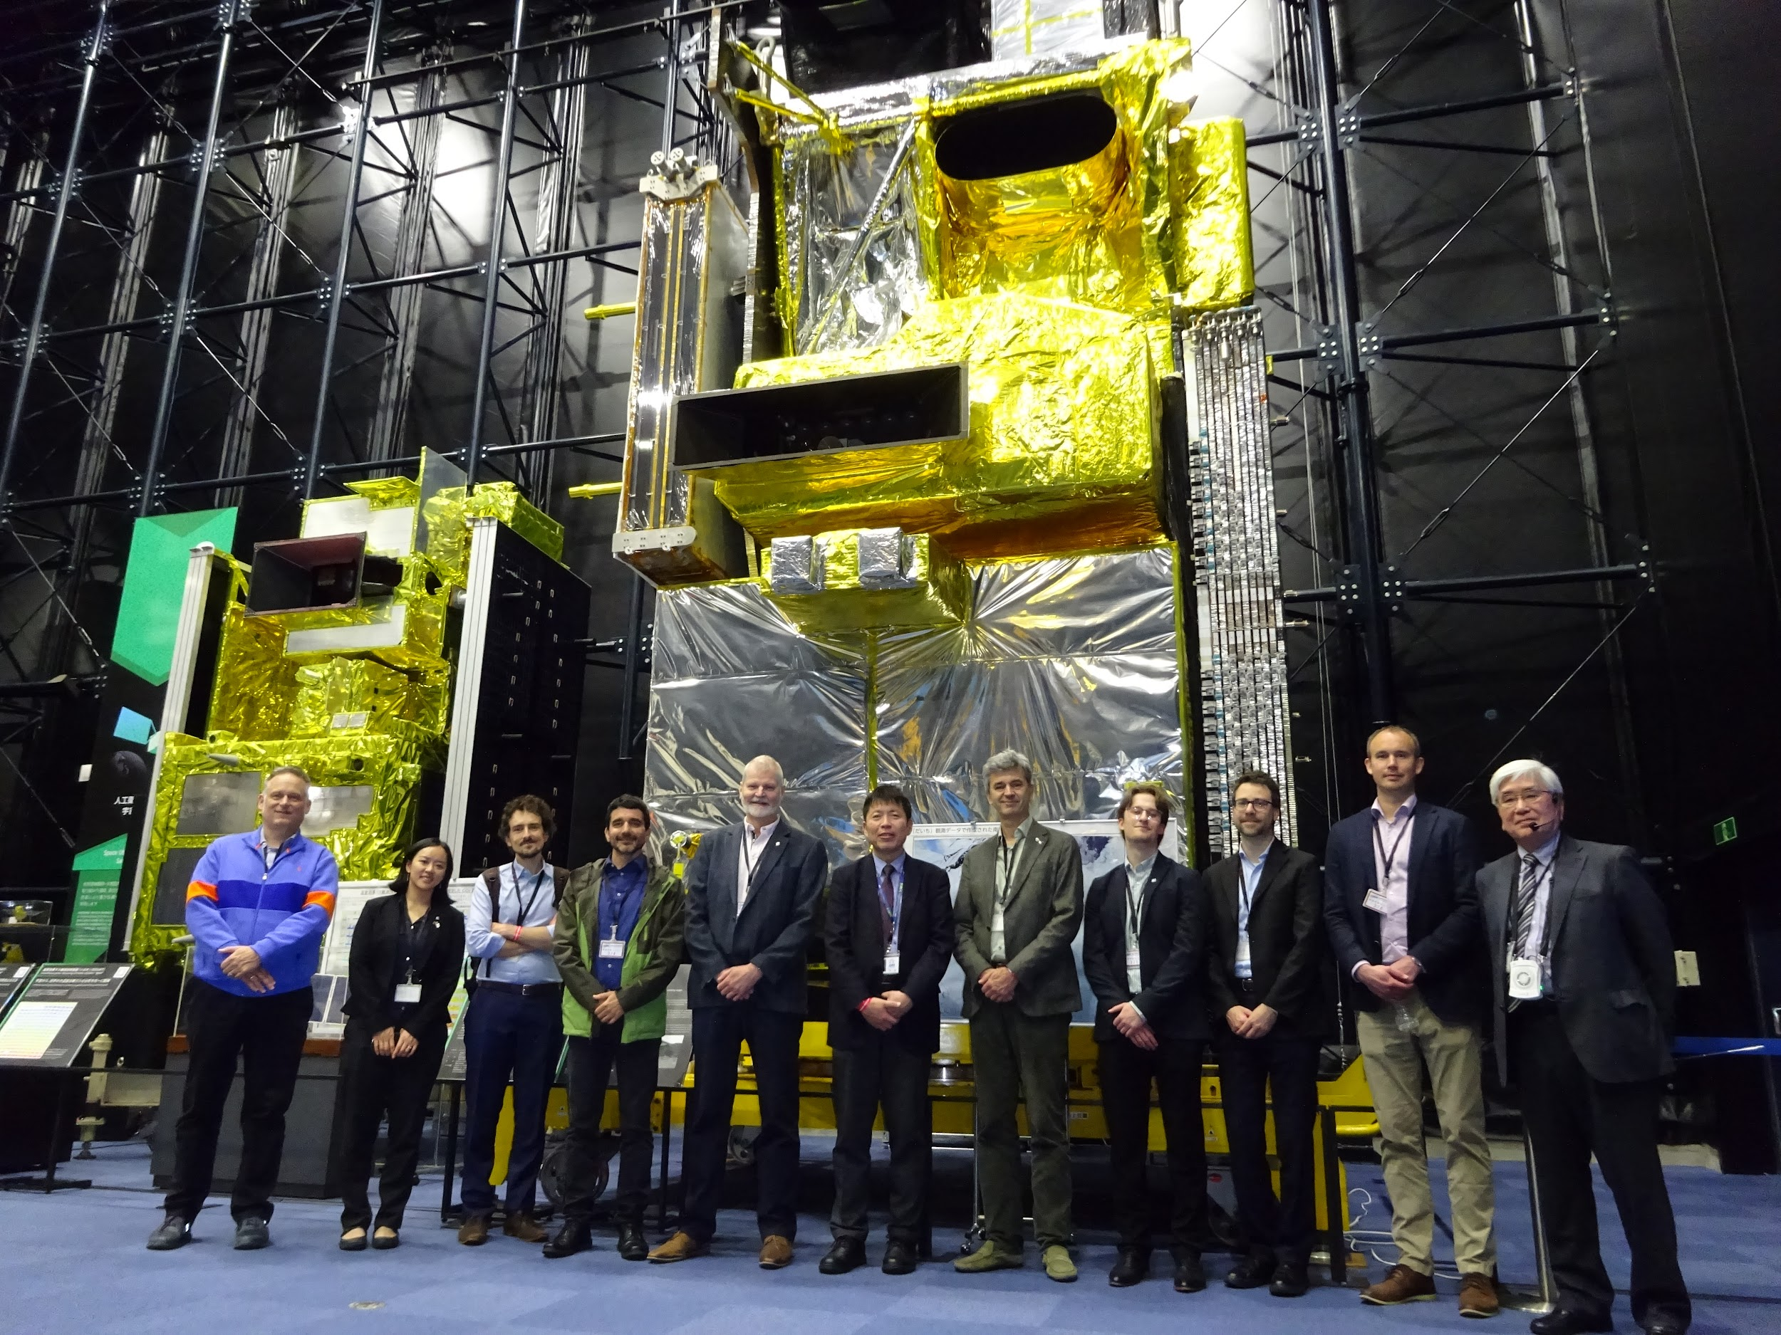

Wednesday, April 16
Session 9: CEOS-ARD PFS Building Blocks and GitHub Implementation
9.1: CEOS-ARD Building Blocks Progress [slides]
Presenter: Matthias Mohr (SEO; remote)
The framework being built for the CEOS-ARD PFS Building Block approach is independent of GitHub. The technical options have been explored for a Building Block framework, which include how to combine the PFS into a document that can be maintained in the long term.
The framework will be based on Python with YAML and Markdown formats. An application has been developed to validate and generate PFS documents available at github.com/ceos-org/ceos-ard-cli, which produces the PFS in PDF and HTML formats for reading, and in Word format for self-assessment.
The SAR PFS will be the first PFS to be converted into building blocks. New functionality includes a consistent and reusable structure, glossary items and citations (BibTeX-based), partial validation, and new identifiers. New short HTML and PDF versions have been added, as well as clickable in-text references. The building blocks are categorised by assets, glossary, PFS, references, requirements, and sections.
Further details of PFS requirements, references, and metadata in the Building Blocks approach can be found in the slides. The PFS are displayed in the GitHub on the CEOS-ARD homepage in PDF, HTML, and Word formats.
Discussion
Feedback was sought on the updated PFS format, noting that it represents a substantial formatting change. The Word documents remain the same as before, except each requirement now has fields that can be filled out when self-assessing.
LSI-VC-17 Decision 05 | LSI-VC supported the change in visual layout/format of the PFS documents necessitated by the building block implementation, provided that there is a plan to create an ‘assessor’ and ‘submitter’ version / tool that will streamline the job of filling out / assessing the responses to the requirements.  Rationale: Having one single document with both the requirements and then sections to fill out / assess is not good for readability. Having a standalone form (format TBD) that streamlines this interaction is desirable.
Ake Rosenqvist (JAXA) noted that the ease of developing new PFS and working documents is key. One of the concerns is how users can navigate quickly around the document. The item numbers in the current PFS are not random numbers but part of the structure. When we develop the PFS we decide what represents product and source metadata. There are some fields that are missing, as this was built on the combined PFS and then decoupled. Ake proposed maintaining a master SAR PFS that mirrors the structure and content of the existing combined SAR PFS. When developing new requirements, it would be helpful to identify which other PFS would be affected by a proposed change. The ORB PFS, for example, currently has no indication of which requirements are shared with other PFS. A master PFS should include cross-references indicating links between requirements and the other PFS to which they apply.
Chris Barnes (USGS, LSI-VC Co-lead) suggested maintaining requirements as artefacts in a master PFS. Maintaining the PFS is not sustainable in Google Docs, but a high-level view should be kept.
Matthias Mohr (SEO) noted the idea to create a tool to search by requirement ID that outputs the PFS that feature it. Dependencies between PFS can quickly become out of sync, especially when new PFS refer to older ones that are not updated accordingly. In the long run, a web tool could be implemented to streamline editing the PFS. Ideally, when changes are made an updated PFS would be generated alongside immediately.
The numbering and ordering of the PFS metadata requirements was discussed, with recognition of an immense improvement to the modularity of the PFS documents. Text identifiers can work as well as numbers for something that is meant to be flexible and modular, although expanding the concept may expose issues with each metadata section. Each PFS is a collection of different requirements that belong together in a certain order. There was an agreement to stay consistent with the current approach, especially in aligning CEOS-ARD with geophysical variables. The SAR PFS building blocks should be reusable across other PFS to support commonality. The goal is not to enable bespoke PFS but rather to promote consistency and reuse.
Peter Harrison (GA) noted the need to include terms such as “Not relevant” in the SAR PFS to account for NRB parameters related to Pol and InSAR that do not apply in some contexts. The usability of the current Word document format for self-assessment lacks clear visual differentiation between the standard text and areas intended for completion by the self-assessor. This increases the risk of missing required fields.
The GitHub-based tools could generate more user-friendly, structured forms such as dynamic tables or web forms, which could be exported to various formats (e.g. PDF, HTML, Word) to better support both self-assessment and peer review processes.
Peter Harrison (GA) reiterated that while the Word document format is acceptable, it becomes problematic for reviewing self-assessments. In the mask, for example, there are both threshold and goal levels filled. The role of the peer reviewer in any format decision should be considered.
Peter Strobl (EC, LSI-VC Co-lead) noted that it would be feasible to have a reviewer’s page which displays requirement-by-requirement text, responses, and flags for threshold and goal.
Matthias continued, presenting the roadmap for LSI-VC-18:
- Document history and justifications for changes (see AR)
- Convert InSAR PFS and Optical PFS
- Update SAR XML specification (identifiers only)
- Better granularity of requirements (freely usable in threshold and goal)
- Create web tool to look up requirement dependencies
- Extend documentation
- Training
The long-term vision is for PFS to share building blocks where feasible, ensuring consistency and the same metadata language. The focus is to build a framework that can be standardised with OGC and/or ISO. Other standards organisations may create ARD specifications not yet in scope of CEOS, but it would be valuable to have them in the same agreed format.
The optical and SAR metadata requirements diverge significantly, creating issues when considering common metadata specifications. Matthias shared as an alternative to ‘Target’ and ‘Goal,’ where RFC 2119 uses Requirement (required) and Recommendation (optional).
Discussion (continued)
Chris Barnes (USGS, LSI-VC Co-lead) noted the importance of recognising the diverse stakeholders interacting with the PFS, including data providers, reviewers, and PFS authors, each with different roles and needs. He proposed summarising these roles and their associated requirements in a phased use case study involving each stakeholder group.
Dave Borges (CEOS SEO) referenced the previous day's discussions around hackathons and sprints. He acknowledged Pete’s comments on maintaining an open and unbiased process but suggested that early engagement with selected companies could help assess the usability of the GitHub-based workflow. Once the system reaches a steady state, we could arrange a longer sprint session, potentially with a company like Planet, involving both technical staff and other key participants to work through the process end-to-end and identify pain points across the whole workflow, including users, developers and assessors. The process could also be conducted in parallel with a CEOS Agency.
Ake Rosenqvist (JAXA) noted that the optical PFS may not yet be ready for Planet. Aligning the three current optical PFS documents into a final version would still require a couple of weeks of effort, and a fully complete version may be ambitious before LSI-VC-18.
Peter Strobl (EC, LSI-VC Co-lead) added that the AR content relevant to optical products is not far from completion. Most general feedback applies to the optical PFS as a whole, and AR-specific elements could be addressed separately. Geometry remains one of the most significant areas needing refinement.
Chris noted that significant work has been done on the SAR PFS and that the discussions should focus on evaluating the building block approach itself, rather than on specific product types. He questioned whether the building blocks are being formulated in a way that allows each stakeholder to interact with them effectively. We should avoid generating a framework that makes new products no longer compliant. A sanity check should be performed on Landsat and Sentinel-2.
Matthias noted that, in theory, no products should become de-compliant, since the new approach only changes the document generation method; the content remains the same.
Griffin Williams (Catalyst) noted that Catalyst would be willing to test drive the process, and resubmit their assessment against the building blocks. Gaining an assessor’s perspective in parallel with the data provider would be valuable.
Chris suggested holding a dedicated three-hour meeting in the near term to review the requirements of assessors and applicants.
Three sets of requirements should be developed. Peter Harrison, in charge of the assessor requirements, could provide bullet points on what he would like to see as an assessor, Griffin from the data provider side, and Ake and Chris from the PFS author side. The three-hour sprint can be held once a draft statement is ready. These discussions have reached a tipping point of wanting more PFS and engagement, so some groundwork is needed to produce this scale.
LSI-VC-17-17 | Matthias Mohr to add a task to the building block development roadmap regarding a web form / mechanism for data providers to assess against the PFS requirements. | May 2025
LSI-VC-17-18 | To inform development of the building block workflow tools, the following leads for each of the different groups of stakeholders/users will compile a set of requirements:  - PFS author: Ake Rosenqvist and Chris Barnes  - Data provider: Griffin Williams  - Peer reviewer: Alexander Brooks  Requirements will be discussed on a joint teleconference with Matthias Mohr before final submission to him as the developer. | May 2025

9.2: CEOS-ARD Governance and GitHub Implementation [slides] [slides] [slides]
Presenters: Matthias Mohr (SEO; remote) and Chris Barnes
The CEOS-ARD GitHub currently offers versioned file management, a web interface for editing, an issues forum, pull requests, and project boards. Since LSI-VC-16, the building blocks have been made available on GitHub, as well as an automatic document generation tool.
The roadmap for LSI-VC-18 includes GitHub training (NASA), feedback on the GitHub approach, and potentially a simplified web interface.
Overleaf is an online LaTeX web interface for producing documents, which would suit PFS development well, with live previews of published documents.
Discussion
Dave Borges (CEOS SEO) noted that the AMA team can help produce some CEOS GitHub training. SEO had tried doing so for the CEOS Analytics Lab (CAL), using different time blocks across time zones. It was not typically reusable and had limited attendance in the past. A better approach may be to record training content that can be uploaded online.
Peter Strobl (EC, LSI-VC Co-lead) noted that there was a discussion around enabling easier input to the glossary. Short, targeted videos on specific topics, with direct links to GitHub, would be more effective and sustainable than hosting full online training events.
Jonathon Ross (GA, LSI-VC Co-lead) suggested ensuring that someone remains available for questions and proposed a video walkthrough of the self-assessment process.
Dave noted that the CEOS-ARD repository contains contributor guidelines. However, there are no guidelines for the entire CEOS organisational GitHub. The ARD repository exists and could perhaps be scaled up.
Matthias noted that the existing CEOS-ARD contributor guidelines are more technical and specific to ARD documentation. GitHub also provides general and freely available contribution guidelines that could be referenced or adapted.
LSI-VC-17-19 | David Borges to initiate development of CEOS Organisational GitHub Contributor Guidelines and Governance, covering overarching rules for the CEOS GitHub and the policies for data security and backups as well as ownership roles and responsibilities.  Chris Barnes to lead a specific instantiation of these broader guidelines specifically for the CEOS-ARD repository covering, for example, the process for a PFS development branch being adopted as a release version, etc. David Borges, Matt Steventon, Matthias Mohr, Brian Terry, GA, Peter Strobl, and Dominik Weckmueller (dominik.weckmueller@ext.ec.europa.eu) of JRC (KCEO glossary) are interested in contributing to the CEOS-ARD guidelines. | Endorsement of CEOS-ARD specific governance at LSI-VC-18
The CEOS Organisational GitHub currently has seven owners, which were appointed on a logical basis. GitHub has the option to choose who has access and permissions to different repositories. The CEOS SEO should be the overall owner, and each repository should have official contacts running it.
Peter noted that even though it is a minor formality, a backup should be agreed. A proposal should be developed to ensure the safety of the GitHub.
9.2: CEOS-ARD Governance and GitHub Implementation (Cont.)
Presenter: Matthias Mohr (SEO; remote) and Chris Barnes
Matthias continued his presentation and highlighted that CEOS-ARD documents are unlicensed, meaning there are no implications for the data. In particular for commercial entities, unlicensed can mean unusable. A potential issue in licensing the CEOS-ARD documents is that any relicensing would need approval from all previous contributors.
Matthias proposed to apply Creative Commons 4.0 licensing to documents in the CEOS-ARD GitHub repository. This license is commonly used for similar purposes, such as Wikipedia, the CEOS Interoperability Handbook and SAR guide, and the European Commission.
An alternative is Apache License 2.0, which is commonly used in open source software, documents, and databases by NASA Worldwind and Earth Science Data and Information System (ESDIS), Geoscience Australia, OpenDataCube, and OGC software.
Discussion (Cont.)
Dave Borges (CEOS SEO) noted that this was reported at SIT-40 for information, and proposed that it be brought forward at the SIT Technical Workshop in September 2025 for a decision. This decision would apply to the entire CEOS Organisational GitHub and therefore also to the CEOS-ARD repository.
Jonathon Ross (GA, LSI-VC Co-lead) proposed four considerations:
- Contributions to CEOS-ARD are received through GitHub.
- Contributor guidelines will be established.
- A decision on licensing is made (Apache 2.0 or Creative Comms Attribution 4.0 International)
- An acknowledgement of the relicensing issue, with a communication sent to the CEOS lists.
It was noted that software documentation can be under Apache 2.0 and database documentation repositories would be under CC-BY 4.0. It was agreed to present this at 2025 SIT Technical Workshop and decided at the 2025 CEOS Plenary. The openness of CEOS is one of its greatest strengths; it should not be compromised.
LSI-VC-17 Decision 06 | Once the CEOS Organisational GitHub licensing is finalised with a CEOS Plenary 2025 endorsement, the CEOS-ARD Oversight Group should send an announcement to the CEOS Members and Associates mailing lists announcing the intention to adopt the same for CEOS-ARD and to call for any objections related to past contributions being included under this license moving forward.
Chris Barnes shared on CEOS-ARD Governance:
The framework being established seeks to promote a collaborative environment by migrating documents and interactions to GitHub and gathering feedback from the community. Clear guidance needs to be established for interacting in this environment and developing PFS.
The roles and responsibilities will be grouped into three categories: maintainers/owners, contributors, and users. Pull request management will consist of submission guidelines, a review and approval process, and handling conflicts and revisions. For the management of community feedback and issues, guidelines and a workflow for issue submissions and resolution need to be developed, while ensuring transparency and incremental PFS improvement.
Chris asked for what should and should not be included in the CEOS-ARD GitHub Governance. The aim is to have it endorsed at LSI-VC-18.
Discussion
Dave Borges (CEOS SEO) noted that contributor guidelines and governance could be the same thing. He suggested that Brian, Chris, Matthias, Matt, and Dave develop them together. Currently, the GitHub landing page also needs to be cleaned up and it might be worth considering the creation of a governance repository.
The document should be developed with the ARD Oversight Group (OG) and endorsed at CEOS Plenary. Having governance over the GitHub would ensure security and demonstrate maturity. Formalising the governance document would also help structure the PFS update process, allowing for incoming comments to be sorted and prioritised.
Peter suggested that while the governance document may not need to address every detail, the Knowledge Centre for Earth Observation (KCEO) at JRC would be willing to hear how CEOS approach and is willing to help.
Session 10: Agency Reports
10.1: ESA Efforts to Improve Mission Interoperability [slides]
Presenter: Ferran Gascon (ESA)
With the increasing number of missions across science, Copernicus, and metrology, ensuring interoperability between them has become an increasing challenge.
By 2030, ESA’s Copernicus operations will include six new Sentinel missions and more than double the number of operating satellites. Data volumes generated will become incompatible with systematic data replication, so the use of data holdings will require innovative data storage management and access interfaces.
Evolutions foreseen in Copernicus are needed in the collaborative setting to adapt to future challenges. These changes will need to occur in a collaborative setting to adapt to the rapidly changing landscape of data management. It is time to prepare for what has been termed the ‘jungle of platforms,’ to embrace European interoperability by design and to develop strategies for managing the expanding data volumes.
Existing challenges consist of building a distributed environment in which services, data, and users can be managed without duplication. Another challenge lies in transitioning from unified data access to an ecosystem of interoperable and decentralised services, all while maintaining their own identity and control. Offering innovation, stability, and security to all these stakeholders remains a key issue.
ESA currently manages operations for Coperncius, DestinE, and Earth Explorers, which are establishing similar principles and architecture guidelines. These principles are being consolidated into a comprehensive ‘ESA Observation Framework’ (EOF). EOF aligns with the best practices established by the European Commission to accelerate the formation of sovereign European Data Spaces.
The first solution is OpenEO, a platform that enables simple data access for processing multiple Earth observation datasets, providing: data access and processing for multiple datasets, scalable and efficient processing, a standardised system across platforms, independence from underlying technologies, and support to FAIR (Findable, Accessible, Interoperable, and Reusable) data.
Since 2024, OpenEO has been implemented in the Copernicus Data Space Ecosystem. The second solution is STAC, which has been adopted across many projects beyond Copernicus, and the third is data format evolution. It is a fundamental priority to optimise access to the Copernicus data volume, facilitate harmonised combination of multi-Sentinel data, foster the evolution from individual products to streamlined data access, and support AI-readiness.
This new format includes the definition of a metadata model for all Sentinel products, the definition of STAC metadata, data representation, and the development of Sentinel processors in Python.
The EOPF product is categorised by measurements, quality, conditions, and attributes. The product global attribute incorporates three primary metadata categories: Discovery, Other, and Processing history metadata. An additional file for CEOS-ARD could also be included.
Zarr is an open-source format for compressed n-dimensional arrays. It is a relatively new format, so it needs to be advocated to the community.
A solution for formatting and gridding data is DGGS. It has been proposed for the Sentinel and DestinE platforms, to make available vast amounts of climate and Earth observation data. Different data representation structures and formats complement the synergistic use and analysis of large volumes of diverse data. There is a need for interoperable data representation that streamlines the combination of these large volumes. The adoption of both DGGS and Zarr is proposed.
DGGS partitions the Earth’s surface into a hierarchy of discrete cells, which facilitates multiple resolutions, spatial indexing, uniform coverage, and interoperability. Any product can be resampled to DGGS, and used alongside other datasets. DGGS HEALPix provides an equal-area, iso-latitude tiling of the sphere, ensuring uniform coverage.
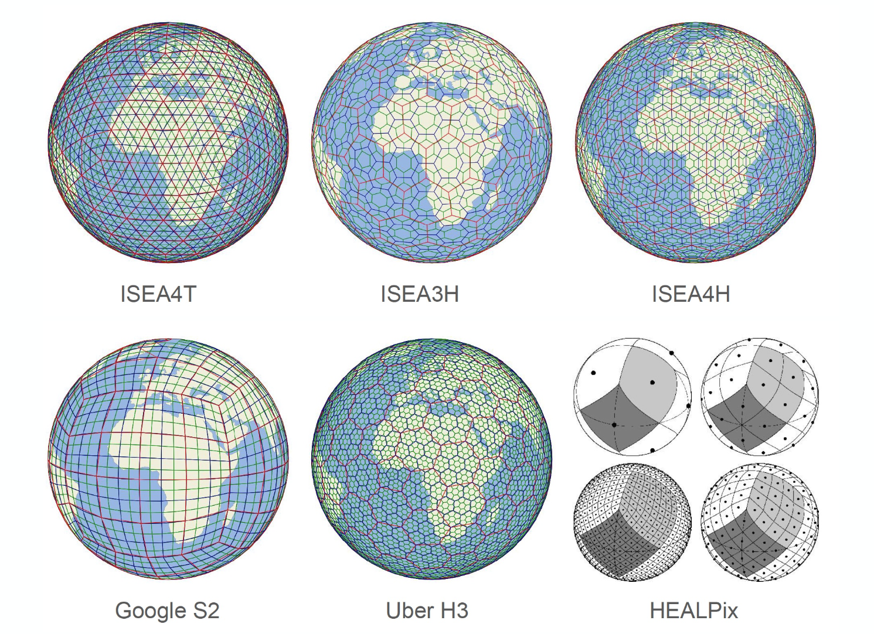
Discussion
Peter Strobl (EC, LSI-VC Co-lead) noted that DGGS formats are better than projections. They come with standardised APIs, and interoperability will always be possible between all types of DGGS.
Ferran added that formats like HLS or Sen2like would work in native projections and would not require resampling. There is no perfect DGGS, which is why there are different types, each with their own pros and cons.
Jonathon Ross (GA, LSI-VC Co-lead) suggested establishing a CEOS Best Practices on this.
Ferran noted that ESA's R&D activity and DestinE have made concrete choices regarding DGGS, but there is still some ongoing debate about the best approach. HEALPix, initially developed for CMBR mapping, was chosen as the spatial backbone for the DGGS-based format. It is capable of supporting an efficient Earth Data Cube.
Peter expressed a desire to hear a science-level justification for the choice of HEALPix. He recalled a global gridding workshop held in 2017 which faced resistance to changing existing legacy systems. He cautioned against adopting a solution well-justified for a single domain without considering whether it is appropriate for the entire global model.
Ferran noted that the design for a generic DGGS representation combines both HEALPix and Zarr. The proposed solution aims to instantiate this format for Sentinel and DestinE products, develop and demonstrate processing workflows, implement operational converters, introduce native DGGS data representation in data processors, and demonstrate operations-ready data.
Peter added that there is a USGS commitment here with Tom Merispringer as TMSG Co-chair. He noted ongoing discussions in Europe with OGC’s Domain and Standards Working Group, a very active community. Peter stressed the importance of ensuring that the work in DestinE feeds into these meetings. The Pangeo pilot project ‘X-DGGS’ is bringing SAR and DGGS together. There are particular reasons to bring a method or grid together.
Chris Barnes (USGS, LSI-VC Co-lead) added that LSI should leverage the US-EU bilateral relationship to get in front of the Collection 3 implementation team.This should be the most important topic, and the projection needs to be decided. Chris asked whether the focus will be only on Copernicus missions.
Ferran Gascon (ESA) noted that another pilot study will use Landsat as a reference with resampled Landsat, Sentinel-2, and Sentinel-3 data.
LSI-VC-17-20 | LSI-VC Secretariat to include on the LSI-VC-18 agenda an item related to DGGS (Discrete Global Grid System), with a view to further discussion and adoption of a CEOS/LSI-VC Best Practice related to the ESA DGGS selection. | LSI-VC-18
There is still uncertainty about whether DGGS will be a success, so it may be prudent to consider a more classic projection as a backup. UTM is a sub-optimal baseline, but there is no immediate time pressure to make a change. Peter noted that a decision will need to be made when the first expansion missions come online.
10.2: USGS Landsat Collection 3 Status [slides]
Chris Barnes (USGS/KBR; remote from USA)
Landsat Collection 3 will reprocess the 53+ year record to implement improvements and enhancements, such as Level-1 radiometric calibration/geometric correction, Level-2 atmospheric correction, Level-2 global aquatic reflectance, and metadata structures to accommodate Landsat Next. The target public release is 2028/2029, aimed to be ‘Landsat Next-ready.’
The executive vision seeks to resolve Collection 2 known issues on surface reflectance products, provide a modernised USGS Landsat Data Processing and Archive System while advancing Landsat 1-9 archive data quality, and prepare for the integration of Landsat Next into Collection 3.
Collection 2 uses a number of projections, whereas Collection 3 proposes a single Lambert Azimuthal Equal Area projection. USGS wants to remain interoperable with other missions.
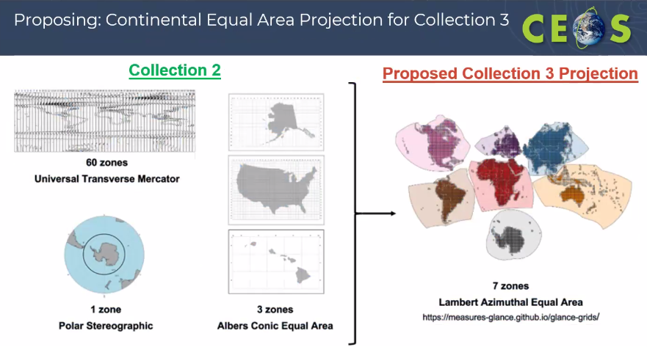
Proposed next steps include sample product generation, continued user engagement, further characterisation at CEOS WGCV GRGIX, and the Landsat programme decision prior to final specification ‘lock-in.’
As of April 2025, there is a push for a formal coordination plan with European colleagues on the definition of Collection 3, primarily regarding its projection. The project should be CEOS-ARD compliant, with the aim for Goal level compliance.
The period from March 2025 through the following year will be critical for defining Collection 3 algorithms and surface reflectance. Messaging from USGS on this topic should remain consistent.
Discussion
Jonathon Ross (GA, LSI-VC Co-lead) asked what geometries could be used in collaboration with other users, beyond what CEOS can contribute alone, in order to demonstrate that users are benefiting from coordinated missions and harmonised data production.
Peter Strobl (EC, LSI-VC Co-lead) noted that the glance projection ensemble is not the same as the equi-seven projection. When using these projections on a continental basis, it is important to check with the respective continents to see if there are anything similar in place. Even slight shifts in projection grids could lead to problems. If the group proceeds with a continental LAA approach, selecting appropriate projections for each region will be essential.
Pete Doucette (USGS) specified that we should focus on a strategy to demonstrate (not just enable) the VC concept.
Session 11: Land Surface Imaging Data Continuity and Availability
11.1: CEOS-GEO Interface and LSI-VC Role [slides]
LSI-VC Secretariat and Co-Leads
Jonathon Ross (GA, LSI-VC Co-lead) shared that GEO adopted a new strategy for the next decade with a focus on Earth Intelligence. While CEOS talks about ARD, GEO talks about decision-ready data. There is a strong emphasis from GEO on engaging further down the value chain, to work with different user communities rather than engaging with thematic domains.
GEO as a System of Systems had a concept of assessing observational needs and feeding them to different networks. The UKSA CEOS Chair and the GEO Secretariat Director are keen to hold a meeting. What messages would LSI-VC like to share with GEO?
Matt Steventon (LSI-VC Secretariat) asked whether GEO’s new strategic focus has been formally documented in a statement.
It was noted that data gaps persist in many areas, with some domains lacking continuity. Much relevant data is neither free nor open, and GEO can assist in facilitating access to affordable or open commercial data.
Jonathon asked whether CEOS should support individual GEO projects, and suggested exploring Level 3 and Level 4 products in GEO that CEOS could align with. This might be an entry point for EAVs or EBVs. Alternatively, as in the land domain, CEOS might continue to reach out directly to stakeholders.
Maggie Arnold (GA) noted that this would depend on the role of LSI-VC, and whether it encompasses making data readily available. Is it within the responsibility of CEOS to engage with higher level products?
Defining what constitutes a ‘higher-level product’ would be a useful first step. If such products are considered, they would go beyond immediate sensor corrections. Many downstream products share overlapping components, and some data classes may add useful semantic value, simplifying radiometric complexity while still retaining up to 80% of the content.
Dave Borges (CEOS SEO) noted that CEOS has an external request process in place to address engagement with outside entities. CEOS Agencies supported GEO at first to serve as a buffer for such requests.
Matt Steventon (LSI-VC Secretariat) asked whether there is a similar question or engagement opportunity with GEOGLAM, which is persisting well and is effectively self-managing. It has also been included in the new GEO Work Programme.
Jonathon asked if GEO is measuring value at the end of the chain, and to what extent can CEOS-ARD help? The CEOS Chair could explore this issue of the Level 3 and Level 4 products with the GEO Secretariat director. The emphasis should be placed that GEO should convene groups to identify requirements.
11.2: Develop a Proposal Regarding LSI-VC Providing a Framework and Interface for CEOS Agencies That Are Interested in ‘Buying Out’ Old Commercial Archives and Then Releasing the Data Under Creative Commons Licensing (LSI-VC-16-03) [slides]
Presenter: Maggie Arnold (GA)
At LSI-VC-16, David Hudson (GA) raised this as a potential topic of interest. A note has since been developed outlining potential requirements for a catalogue of archived Earth observation data.
The aim is to foster an open discussion around creating an interface for CEOS Agencies to unlock archived commercial data for public use. LSI-VC would need:
- A catalogue of both opportunities and past acquisitions to avoid double paying (this information could potentially be maintained in the CEOS Database);
- Agreed and consistent wording that could be used in negotiation to clarify the intended purposes (e.g. global frameworks, public good) and necessary licensing terms of the acquired data, etc. (e.g. resulting data should be free and open);
- An understanding of where and how this data could be stored, and any necessary partnerships.
- An understanding of whether we would insist on data being CEOS-ARD compliant?
- A proposed name e.g. “CEOS Open Data Program”
- A register for shapefiles/KML areas are released on an openmap/GUI for agencies to explore what data or products are available, which would allow users to explore available products. The coverage map would allow for the current extent of Earth observation data held or known by CEOS agencies.
- Agreement to use a quality assessment framework like the NASA CSDA or ESA EDAP process?
Discussion
Ake Rosenqvist (JAXA) noted that CEOS could link into the US and European data buy-in programme. Japan also has similar initiatives.
Jonathon Ross (GA, LSI-VC Co-lead) noted that the NASA case is particularly interesting. Their licensing category, which ensures data is full, free, and open, would be required to be used in the context of CEOS.
Ferran Gascon (ESA) noted that when ESA purchases data, it is through a restricted license for specific projects.
Peter Strobl (EC, LSI-VC Co-lead) noted that many historic archives are likely to exist in different shapes. A categorisation system would be needed to manage this, essentially a pre-classification framework distinguishing between levels such as RAW, orthorectified, and others. One approach could be to ‘buy out’ the data in stages, beginning with Landsat-resolution archives. This would be particularly valuable for users working with Landsat time series, who could benefit from access to intermediate data that fills historical gaps. An image archive with reasonable representation per resolution category could be built, with specific schemes developed based on resolution and orthorectification accuracy, allowing providers to decide whether or not to make their archives openly available.
Dave noted that ‘free and open’ has been the goal for NASA CSDA from the beginning. Although this goal is being approached progressively through a tiered structure, the long-term intention is that all commercial data acquired by NASA will ultimately be made openly available.
Jonathon suggested reaching out to agencies and inviting them to share an expression of interest. Agencies such as the European Commission, Geoscience Australia, and ISRO could be among the first to express interest.
LSI-VC-17-21 | Noting that NASA’s CSDA program already has an advanced legal framework in place as well as a vision towards making all purchased data free and open, David Borges will investigate the feasibility and legal realities of CSDA serving as the lead purchaser on behalf of a CEOS consortium – in relation to the idea of LSI-VC providing a framework and interface for CEOS agencies that are interested in ‘buying out’ old commercial archives and then releasing the data under creative commons licensing (LSI-VC-16-03). | LSI-VC-18
Dave noted that he recently attended WGISS-59, where he learned about the Data Purge Alert initiative, which could be leveraged here. If an agency is going out of business, WGISS will engage with them to ask for their data for free. More information is available on the CEOS WGISS webpage.
Ferran noted that data would need to be checked in terms of licensing, especially the TPM archives.
Peter suggested that after ten years, the license for the data is handed over to the buyer.
LSI-VC-17-22 | Ferran Gascon to investigate the specifics of the licensing implemented by the ESA Third Party Missions program, i.e., whether it is perpetual, etc. | LSI-VC-18
Jonathon asked about potential integration between MIM and COVE, suggesting that MIM could serve as a useful platform for cataloguing data acquisition opportunities.
Ake reported that he, in collaboration with SEO, did an assessment of commercial SAR data. Many SAR startups offer parts of their archives for public use, but this data is often too limited or general to support specific applications. By contrast, legacy datasets from established providers like Airbus, such as those used to generate the Copernicus DEMs, could be highly valuable if made accessible.
Jonathon proposed including a request to providers for ‘systematic coverage,’ which could be a key criterion in evaluating data offerings. This activity might stimulate more background observation scenarios.
Ake noted that there are certain applications that a background programme would feed into CEOS activity. This provides another engagement asset for CEOS with the commercial sector.
Matt asked whether there are instances where ESA has bought the same data as NASA, as this could be a good example case.
Peter suggested phrasing it as a marketplace by establishing some rules.
Ferran added that entering the commercial domain jointly would involve licensing and legal matters.
It was agreed to draft a concept note for circulation and feedback ahead of LSI-VC-18.
LSI-VC-17-23 | Maggie Arnold to share an updated version of the ‘Unlocking Commercial EO Archives for Public Use’ concept note with LSI-VC members, for written feedback ahead of a revisit at LSI-VC-18. | June 2025
Session 12: Other Thematic Topics and Agency Reports (continued)
12.1: Latest Activities related to SAR CEOS-ARD products from ISRO [slides]
Presenter: P.V. Jayasri (ISRO)
ISRO has designed and developed SAR missions that are compliant with CEOS-ARD. RISAT-1A was launched in February 2022, and is planned to be followed by RISAT-1B in May 2025 and NISAR in June 2025. Data from ISRO missions are stored in ISRO’s Data Dissemination Portal, Bhoonidhi.
A number of ISRO EOS-04 products have been submitted for CEOS-ARD endorsement:
- EOS-04 Level-2B NRB which was endorsed in April 2024.
- EOS-04 tile-based India Mosaic NRB product in January 2025.
EOS-4 NRB products can be searched and filtered in Bhoonidhi. Examples of EOS-04 products and modes are detailed in the slides.
Discussion
Ake Rosenqvist (JAXA) appreciated ISRO’s alignment with CEOS-ARD specification, including polarimetric (Pol) products. Offering these pre-processed products will significantly improve user access and usability. Ake also commented on the schedule of two upcoming satellite launches, EOS-09 and NISAR in the next two months.
Jonathon Ross (GA, LSI-VC Co-lead) thanked ISRO for the presentation, and asked whether Bhoonidhi is different from Bhuvan, or if the two platforms are connected.
It was clarified that Bhuvan hosts more derived and thematic products, while Bhoonidhi provides access to lower-level datasets.
12.2: Synthetic Aperture Radar (SAR) Topics [slides]
Presenter: Ake Rosenqvist (JAXA)
LSI-VC PolSAR
Previously known as POLINSAR, the activity has been renamed as PolSAR to reflect its broader scope.
PolSAR offers significantly more information than standard SAR due to the inclusion of phase information. It offers substantial potential for new insights, but remains an underutilised resource. The research community working in this area has remained relatively small, largely due to limited access to polarimetric datasets for analysis. There is a substantial capacity within CEOS with many missions offering the capability for PolSAR, including Biomass, NISAR, ALOS, RISAT, COSMO-SkyMed, RCM, NovaSAR, TanDEM, and SAOCOM.
This activity stems from a recommendation made during the ESA POLINSAR workshop series, which have consistently issued recommendations encouraging CEOS Agencies to acquire more PolSAR data. LSI-VC has taken up this initiative and aims to advance it, especially with the growing number of PolSAR missions being launched.
Recommendations were submitted at SIT-39, proposing the identification of POLINSAR sites that span a range of biomes and application areas. Where possible, the activity seeks to build on existing efforts. Preferably, these sites would include in situ measurements, airborne data, lidar, and other complementary observations. Synergies are being sought with initiatives such as GEO-TREES.
CEOS Agencies were asked to acquire polarimetric SAR data over these selected sites and to make the data available in some form. The long-term vision is to demonstrate the value of polarimetric observations to CEOS Agencies and encourage their inclusion in routine background observation plans.
For this programme, simplified data access mechanisms are being put in place for research and development purposes. LSI-VC is collaborating with the CEOS SEO to provide storage and access via an analysis platform, such as the CEOS Analysis Lab (CAL).
LSI-VC is keen for ISRO to join this initiative, and would appreciate a designated PoC.
Current status updates of the PolSAR team include:
- Defining PolSAR science team and reference sites.
- Compiling PolSAR observation requests for each contributing SAR mission.
- Coordinating observation tasking with nominated Agency PoCs.
- Starting PolSAR observations in time for the Northern Hemisphere’s summer.
- Setting up a data repository and toolboxes on CAL.
- Establishing interim reporting at SIT Technical Workshop 2025 and LSI-VC-18.
- Contributing to and attending the ESA POLINSAR workshop scheduled for February 2026.
LSI-VC-17-24 | Maggie Arnold to contact Amy Parker (CSIRO) to seek NovaSAR participation in the LSI-VC PolSAR team. | May 2025
ICGS-SAR and Potential Virtual Constellation (VC)
There has been an interest from the CEOS community in incorporating ICGS-SAR activities into CEOS structures. Several options have been explored, and the team is currently exploring being established as a CEOS Virtual Constellation. LSI-VC would like to reach a common understanding regarding coordination between ICGS-SAR and LSI-VC.
There is a clear overlap between the LSI-VC PolSAR activity and ICGS-SAR’s Thematic Area 1. This could serve as a natural basis for a CEOS SAR activity. The CEOS-ARD SAR development is a core LSI-VC activity, with no present equivalent in ICGS-SAR. Ake’s preference is to keep this in LSI-VC, especially with the planned alignment of SAR and optical PFS.
Land Surface Imaging covers PolSAR and optical activities. ICGS discussions cover all land imaging applications. While some lower thematic groups also address ocean-related applications, such as sea winds and ice, the bulk of the activity is land-focused.
Jonathon acknowledged that clean divisions are often not feasible and emphasised the importance of maintaining appropriate links, such as with OSVW-VC.
Ake added that there used to be a SAR Cal/Val group led by Laura Frulla, but all Cal/Val content has since been aligned under WGCV’s SAR Subgroup. This subgroup however has limited engagement with CEOS, aside from the formal affiliation.
Peter Strobl (EC, LSI-VC Co-lead) proposed to warmly invite ICGS-SAR to join CEOS on whatever terms they want to discuss. CEOS can draw on the Interoperability Frameworks to facilitate this. It may be useful to review how current Working Groups and VCs handle interoperability to inform this approach.
Jonathon noted that CEOS recently created the COAST-VC, which operates in the opposite direction of a typical VC. The correct action is to evaluate what this group is doing and what CEOS can do to make it more resourceful and impactful.
All current ICGS-SAR members are CEOS members. ICGS-SAR is a dynamic group with an established coordination between agencies. ICGS-SAR began as a coordination mechanism for SAR missions and evolved into a thematically organised initiative, holding plenary meetings every two years, with additional virtual meetings.
Matt proposed that the CEOS SAR ARD work that is already happening independently should remain the same. The issue is that it does not fit directly into the CEOS organisational structure.
12.3: EO for Wetlands [slides]
Presenter: Ake Rosenqvist (JAXA)
The Ramsar Convention, a key international agreement for wetland conservation, has historically had limited engagement with Earth observation data. However, the Secretariat is now increasingly recognising its value. The Ramsar Standing Committee recently mandated an investigation into the usefulness of EO to support the Ramsar objectives.
As part of this effort, interviews were conducted with several EO experts, including Ake himself and colleagues from ESA. In December 2024, during a four-day meeting of the Scientific and Technical Review Panel (STRP), Ramsar's equivalent of SBSTA, an EO Day was organised in collaboration with JAXA, ESA, the European Commission, the Ramsar Secretariat, and the CEOS Executive Officer. This session generated several formal recommendations which were endorsed by the Ramsar Standing Committee.
- Recommendation 1: Develop an initiative to support the use of EO
- Recommendation 2: Establish or strengthen bilateral cooperation with space agencies and Earth observation initiatives
- Recommendation 3: Identify technological development needs.
- Recommendation 4: Disseminate the findings of the EO consultation, identify and recommend actions.
The Ramsar Convention operates through a small, relatively informal structure, which enables direct engagement with senior leadership. An EO-focused side event is planned for the upcoming Ramsar COP, to be held in Zimbabwe in July 2025, and will be introduced by the Secretary General of the Convention. The Ramsar Secretariat, with support from ESA and JAXA, proposed a revised proposal for the Post-2025 GEO Work Programme with direct involvement of the Ramsar Convention. This proposal, led by the Secretariat and STRP, aims to explore and advance the use of Earth observation data for wetland monitoring, with a focus on defining essential wetland variables (e.g. wetland extent and temporal change). The proposal was downgraded to a pilot product.
Discussion
Jonathon Ross (GA, LSI-VC Co-lead) noted that many CEOS Agencies are not on the Ramsar committee. He suggested that Ake prepare a communication for CEOS Agencies about the Ramsar COP scheduled for July 2025.
Peter Strobl (EC, LSI-VC Co-lead) highlighted that the wetlands topic is particularly interesting in the context of integrating optical and radar observations.
LSI-VC-17-25 | Ake Rosenqvist to prepare a 1-pager on the opportunity of the Ramsar COP (July 2025) for communication to CEOS Agencies, so that they might connect with their national delegations regarding the opportunities for EO to support the Ramsar Convention. | May 2025
12.4 CEOS AFOLU Roadmap Actions and Implementation and Stewardship under LSI-VC [slides]
Presenter: Matt Steventon (LSI-VC Secretariat)
For many years, AFOLU topics have largely been driven by the priorities of the CEOS SIT Chair. With the completion of the CEOS AFOLU Roadmap and actions, LSI-VC has a clear stewardship of AFOLU in CEOS. It is essential that appropriate structures are established within LSI-VC to manage and progress AFOLU activities effectively. Five people were identified as PoCs for AFOLU, with a formal decision taken at SIT-40:
- LSI-VC AFOLU
  - Takeo Tadono (NASA), Clement Albergel (ESA)
- LSI-VC GFOI
  - Inge Jonckheere (ESA), Stephen Ward (JAXA)
- LSI-VC GEOGLAM
  - Sven Gilliams (GEOGLAM), Alyssa Whitcraft (GEOGLAM)
The AFOLU actions will be reviewed in the next LSI-VC Leads call.
The terms of reference of the subgroup and reporting cadence need to be refined.
Ake Rosenqvist (JAXA) noted that there are five AFOLU actions related to wetlands.

12.5: JAXA ALOS-4 update [slides]
Presenter: Takeo Tadono (JAXA)
Takeo shared an overview of past, present, and future JAXA satellite missions.
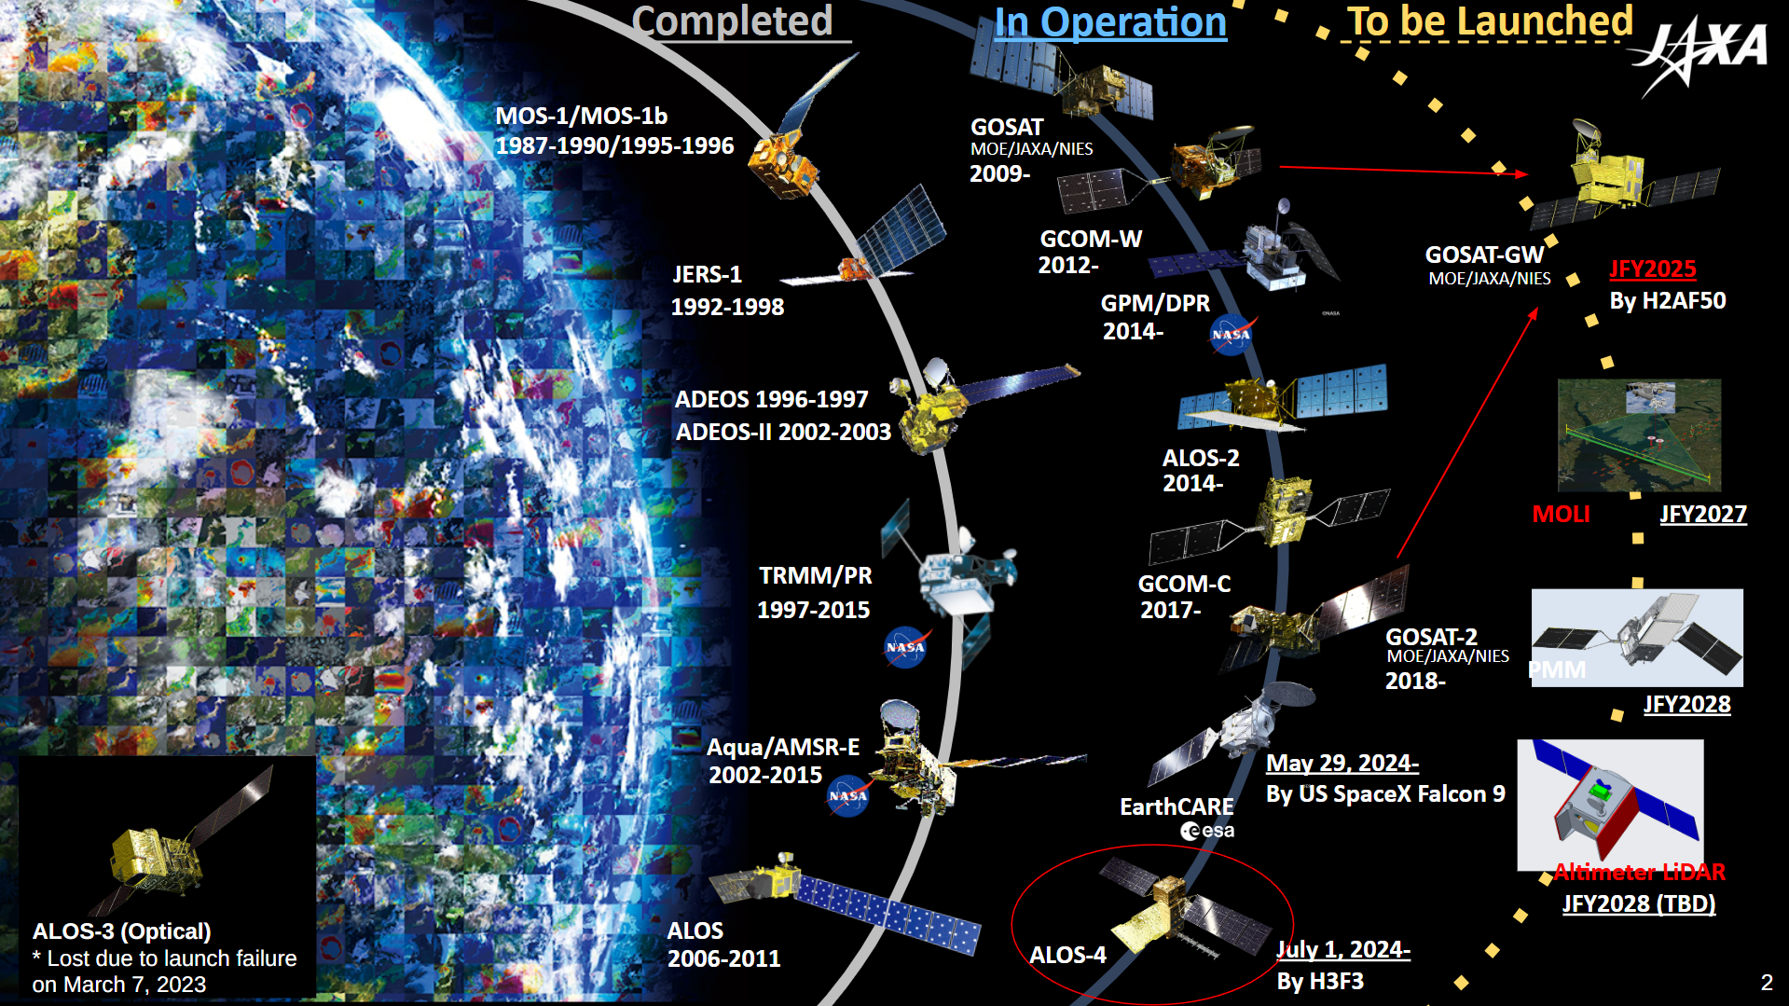
JAXA’s next satellite launch will be GOSAT-GW, scheduled to fly on the final launch of the JAXA H-IIA rocket.
ALOS-4, launched on 1 July 2024 aboard an H3 rocket, carries the L-band SAR instrument PALSAR-3, which offers a significant improvement over ALOS-2 with an observational swath of 200 km, four times wider than its predecessor’s 50 km. The mission’s Initial Calibration and Validation (ICV) phase concluded on 31 March 2025, and the mission has since entered nominal observation operations. In order to make these observations, there are three major modes: Spotlight, Stripmap, and ScanSAR, each of which utilises several beams.
Takeo provided details of the initial PALSAR-3 Cal/Val operation results and future observation operation plan. Details are available in the slides.
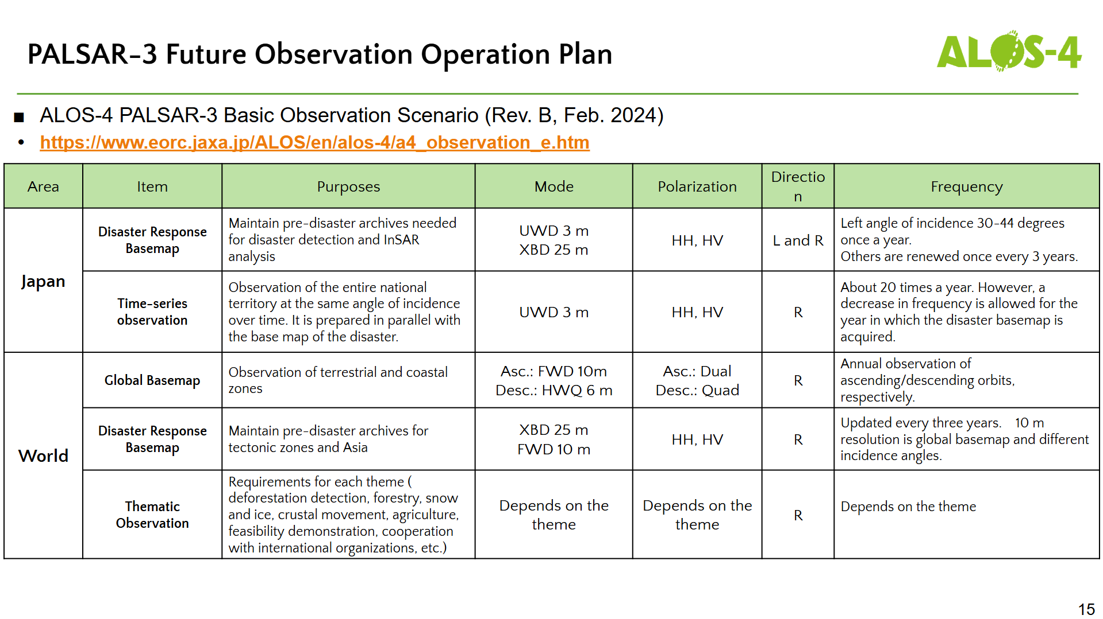
JAXA has officially begun data provision as of May 2025, offering four standard products from Level 1.1 to Level 2.1. A CEOS-ARD-compliant global mosaic is also in development. Trials of wide-area mosaics over New Zealand have shown promising results, demonstrating the feasibility of producing global-scale mosaics in future.
Discussion
Peter Strobl (EC, LSI-VC Co-lead) asked what aspects of vegetation are represented in L-band observations and how forests can be distinguished from non-forest areas.
Ake Rosenqvist (JAXA) noted that there is a relationship between backscatter and AGB. There is volume scattering which occurs from vegetation. Ake also noted that polarimetric data allows different scattering types to be identified.
Takeo Tadono (JAXA) added that random forest classification is currently being introduced for data training.
Session 13: Closing
13.1: Wrap up
Presenters: LSI-VC Co-leads
LSI-VC-18 will be held in Ispra, Italy, from 3 to 5 September 2025, scheduled for the week prior to SIT Technical Workshop (SIT TW) 2025. The meeting will have a European version of a commercial engagement session.
Takeo Tadono (JAXA) thanked all participants, both in person and online, and noted that the meeting featured very productive and engaging discussions.
LSI-VC-17 Decision 07 | LSI-VC-18 will be held in Ispra, Italy at the European Commission’s Joint Research Centre from 3-5 September, 2025, the week before SIT Technical Workshop 2025.

