LSI-VC-18 logistics information guide

Hosted by the European Commission Joint Research Centre (EC-JRC)

**2-5 September 2025**

**Location**

Via E. Fermi, 2749, 21027 Ispra VA, Italy

Room 305 (3rd Floor), Building 102

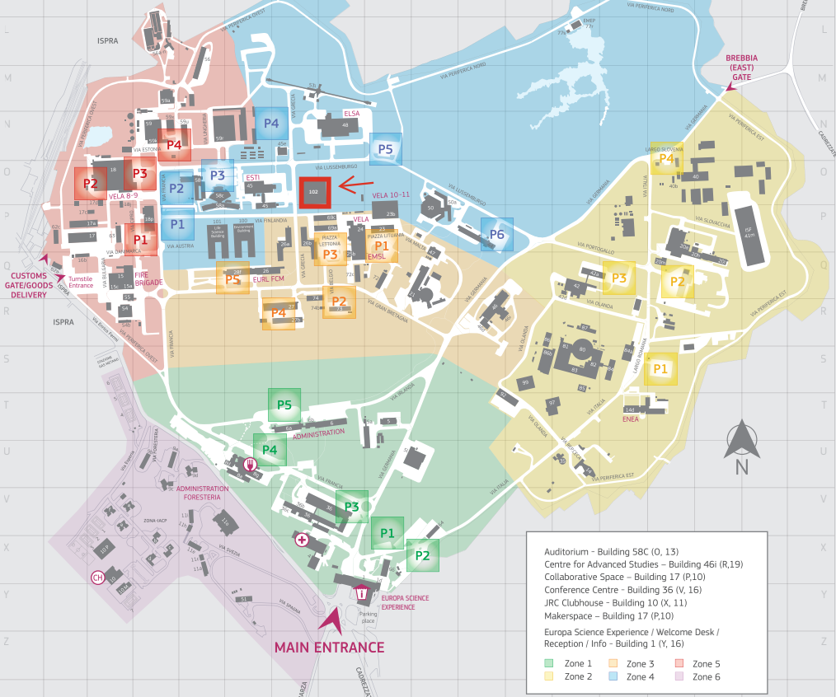

14

15

18

16

17

13

The meeting room (no. 305, 3rd floor) is in building 102 (O,15) highlighted in red on this site map.

## **Access & Transportation**

* The JRC shuttle bus will depart from the Hotel Dei Tigli (link [here](https://www.hoteldeitigli.com/home-page)) at **08:15** and arrive at JRC at 08:30.
* Secure your JRC shuttle service by filling out the [attached form](https://docs.google.com/document/d/1xXmSI6J3-QQwnjnwhr1HaipI9vqYG7cI/edit?usp=drive_link&ouid=107560518937524911059&rtpof=true&sd=true) and submitting to [JRC-D6-SECRETARIAT-AND-FINANCIAL-SERVICES@ec.europa.eu](mailto:JRC-D6-SECRETARIAT-AND-FINANCIAL-SERVICES@ec.europa.eu).
* Those arriving by their own means are asked to arrive at the main gate (Y,16) no later than 08:30. Those arriving by car should park outside JRC (Y,17) and enter by foot to register at the reception desk (Y,16) before moving their vehicle into the JRC. We suggest you park at the P3 (O,13-14) car park.
* Please ensure to bring your passport every time you enter the site. The full list of security details for visitors can be read [here](https://drive.google.com/file/d/11Pv2F3NEBIlbh_8VgfBGQHbzv9se7zrb/view?usp=drive_link).

**Catering details**

For lunch breaks during the meeting we will go to the on-site mensa (U,14), located about a 5–8 minute walk from the meeting room.

A non-hosted joint dinner is proposed for Thursday 4 September, and for those interested, group reservations can be made in Angera for the remaining meeting days.

**JRC Shuttle pick-up at Malpensa**

For those who booked a JRC shuttle with pick up at Malpensa airport, below you find a plan where to meet the driver. For domestic arrivals it will be just after having left the baggage claim area, international arrivals will have to turn left and cross the terminal until arriving at entry 3.

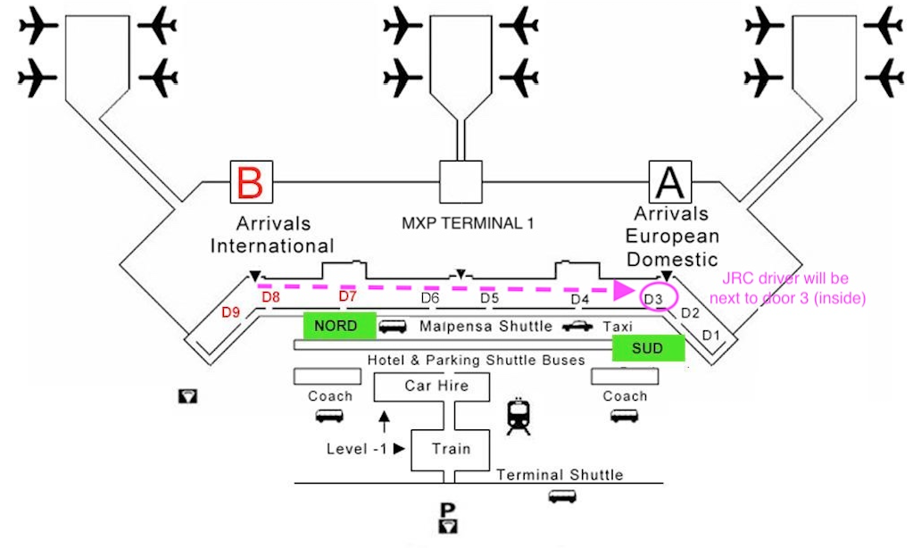

At Terminal 2 the driver will be just outside the baggage area (all same door) inside the terminal (which is much smaller).

**JRC Shuttle pick-up at Malpensa**

For those who booked a JRC shuttle with pick up at Milano Centrale train station, below you find a plan where to meet the driver.

