MINUTES OF THE JOINT LSI-VC / SDCG / GEOGLAM MEETING
6-8 September 2017
ESA ESRIN, Frascati, Italy

Wednesday, September 6
Overview and Recap
Stephen Ward (SDCG Secretariat) recalled the history behind the establishment of the joint meetings, noting the expected travel efficiencies and better flow of information between the groups. Overall, the rationale is efficiency, synergies, and promotion of cross-fertilization and information sharing.
Stephen presented an assessment of the travel efficiencies (which appear to be modest) gained by holding the joint meetings. He noted that the greater size of a joint meeting requires increased logistical support and arrangements, reducing the pool of potential hosts.
GFOI Plenary is typically the first quarter of the year and because of the CEOS commitment to lead the GFOI data component, SDCG is obligated to participate there.
LSI-VC is necessarily internally focused, whereas the GFOI and GEOGLAM communities are user focused as their core business.
Stephen reviewed the main agenda topics for the joint meeting: Analysis-Ready Data, Moderate Resolution Interoperability, Future Data Architectures (including Pilots, Global Data Flows, and common planning and analysis tools).
Adam Lewis (GA, LSI-VC Co-Lead) noted that LSI-VC doesn’t plan to ‘take over’ the tasks of the SDCG and the CEOS-GEOGLAM ad hoc Working Group. He agreed that the synergies afforded by the joint meetings are a significant potential gain.
Jonathon Ross (GA, CEO) noted that the GEO Programme Board is placing much more focus on user-driven approaches, due to the success of initiatives such as GFOI and GEOGLAM. The need for a scalable model around user engagement on thematic requirements development has been identified, and this has the potential to increase the quality of requirements CEOS and space agencies receive from users.
Brad Doorn (NASA, CEOS-GEOGLAM Co-Lead) noted that GEOGLAM does need the kind of support that LSI-VC can offer – in particular help with the broader interaction with the space community, allowing the GEOGLAM group to focus on the agricultural aspects.
Core Mission Status
Landsat-7, -8, -9+
Jenn Lacey (USGS, LSI-VC Co-Lead) provided an update on the Landsat missions, noting that an observation status is available in her backup slides. She will also review the plans for Landsat global ARD production in a later presentation.
She reported that the Landsat-7 mission has completed its final mission burn and is in free drift to its EOL. There may be one additional burn as a part of a NASA research mission into on-orbit refueling called Restore-L, though Landsat-7 isn’t yet confirmed as the candidate mission. This would take place in the 2020 timeframe.
Jenn noted that they have expanded ground and international collaborator networks for Landsat-8. She reported that the Landsat Global Archive Consolidation (LGAC) data repatriation effort is continuing with good cooperation from partners. As of August 2017, 4.2 million scenes have been retrieved, with 71% ingested.
Landsat-9 will be a rebuild of Landsat-8, with OLI-2 being a remake of OLI in order to optimise data continuity. A consolidated Mission Operations Center (MOC) for Landsat-8 and Landsat-9 is planned. This should represent a cost saving over time, but presents a challenge. The same ground stations will be used for Landsat-9.
The Data Processing and Archive System (DPAS) is planned to incorporate ARD developments, with the plan being for DPAS to produce to L1T, and then a multi mission global ARD product.
David Jarrett (NASA) noted that Landsat-9 is on track for a December 2020 launch, and arrangements are being made with the same contractors who built Landsat-8, which helps ease the process. Jeff Masek (NASA) noted that TIRS-2 on Landsat-9 is largely the same, but a change will address a stray light issue with one of the light filters.
Sentinel-2A, -2B+
Bianca Hoersch (ESA, LSI-VC Co-Lead) reported that Sentinel-2A and 2B operations are routine and nominal. They plan to release a pre-operational L2A product over Europe using Sen2Cor via the Open Access Hub in May 2018. The team is working to make data more reliable, and they have addressed issues around weekend outages.
There has been some discussion on a Copernicus-wide DEM, and there is a need to reassess whether the DEM used for Sentinel-2 needs to be changed, as some accuracy problems have been reported with the current DEM. This is being studied by ESA and JRC.
Sentinel-2B data is being disseminated via the data hub. Over the northern winter, Antarctica coverage was completed to the full extent of Sentinel-2’s capability, and every other cycle the Antarctic coastal ring is imaged.
At present, the team is looking at producing ARD-compliant data using the Sen2Cor tool. A study comparing several L2A ARD algorithms showed that no one algorithm is the best, though a couple were near the top including Sen2Cor and MAJA. ESA has proposed a roadmap toward global systematic production.
Bianca reviewed the four Copernicus data hubs: Copernicus Data Hub, Collaborative Data Hub, International Access Hub, and Copernicus Services Data Hub. There is strong demand for L2A products, and this is a clear sign that ARD is desired by users.
Bianca shared some application examples covering agriculture (rice crop monitoring), the coastal and ocean domain, and the Copernicus Marine Environment Monitoring Service (CMEMS). She noted that the number of downstream services is increasing rapidly. S2maps.eu was highlighted as an example.
Some next steps include European Data Relay System (EDRS) user commissioning, reprocessing of commissioning phase data in September 2017, and updating the naming convention for the entire Sentinel-2 archive.
Bianca also reviewed the status of PROBA-V – which has been extended to October 2019 – including its products and data access.
Stephen Ward asked about Sentinel-2 ARD for the Vietnam Data Cube, and Bianca noted that early next year is the target for global systematic processing to L2A. This will be done initially using Sen2Cor, but that doesn't mean that it will be the final selection, with other methods currently being assessed.
Sentinel-1A, -1B+
Pierre Potin (ESA) provided an overview of the Sentinel-1 mission. The mission is now generating 11 TB a day (3TB was the original plan), and they are using the EDRS to increase coverage, enhance timeliness, and provide quasi-real-time data.
The Sentinel-1 observational scenario includes Interferometric Wide Swath mode (IW) dual-pol coverage over land globally every 12 days, and all acquisition information for each cycle is published online. The Sentinel-1 systematic data production scenario includes data being produced within 24 hours.
Sentinel-1 related documentation and technical notes are available on the portal, as well as news and regular web stories: http://sentinels.copernicus.eu
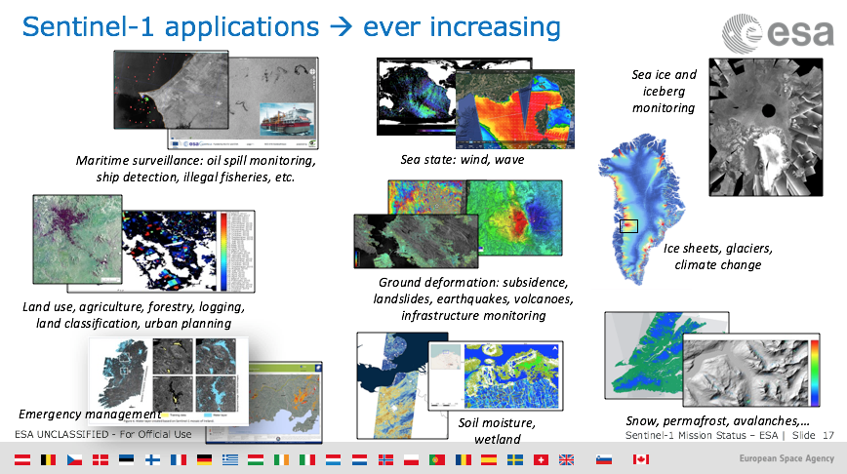
Overall the mission is in good shape, with high quality data being provided routinely for services with systematic global coverage, and free-and-open data access.
Frank Martin Seifert (ESA, SDCG Co-Chair) noted that the increased capacity is very useful for improving the density of time series for forestry and agriculture.
Sentinel-3A, -3B+
Susanne Mecklenburg (ESA) presented a Sentinel-3 mission status and overview. Full performance will be achieved once 2 satellites are in orbit.
The Sentinel-3A ramp-up phase is close to completion, with a final review to take place in September 2017. All L1 and L2 products have been released, and an L2 synergy product will be available to the public in Q3 2017. New additional products (AOD and FRP) are expected to be available by the end of 2017. The full reprocessing of OLCI and SLSTR data from the commissioning phase is expected to be released by the end of next year. Preparations are currently underway for Sentinel-3B, with launch planned for April 2018.
Due to a request from the Copernicus Marine Environment Monitoring Service (CMEMS), optimized orbit phasing for Sentinel-3A/-3B and -3C/-3D is planned to improve SRAL meso-scale sampling at 4-7 days.
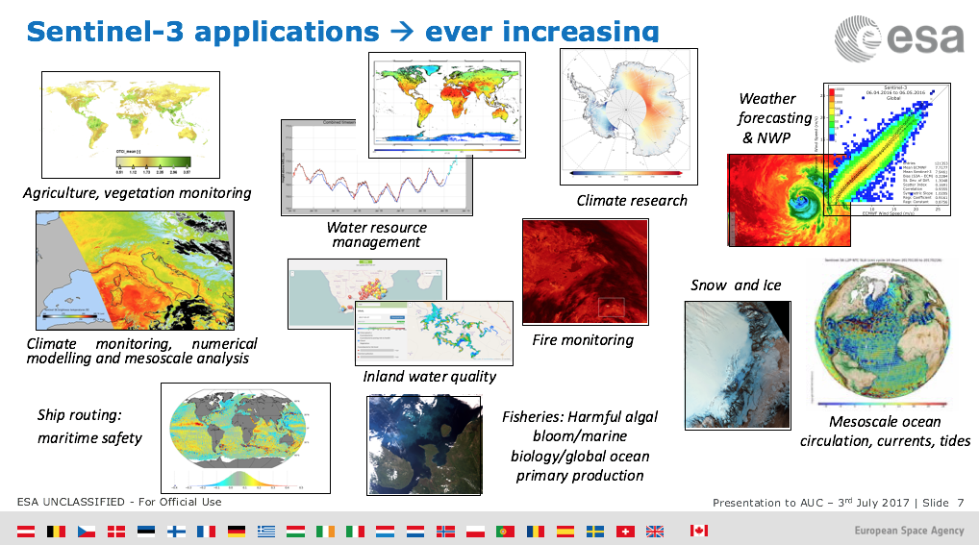
Susanne reported that Sentinel-3 is well equipped to support applications over land, with OLCI performing well radiometrically, spectrally, and spatially, and L2 products are reportedly good. Improvements and validation of SLSTR L1 and L2 products are ongoing.
Sentinel-3B is on track for an April 2018 launch.
Adam Lewis asked if the Sentinel-3 AOD product could be used to calibrate Sentinel-2 products. Susanne confirmed that there are no concrete plans at the moment; the AOD product is very much still in the development stage.
Jonathon Ross asked about the timeframe for reprocessing of the OLCI and SLSTR data from the commissioning phase. Susanne confirmed that ESA will be waiting until the end of this year so that further upgrades can be made to the process. In testing they have found that reprocessing is very fast (order of 2 weeks for the whole archive in question). Jonathon noted that it can be a challenge for other data hubs (e.g., the Australian Copernicus Hub) to download these bulk updates.
CARD4L Overview and Status
Status Report on the CARD4L Efforts and Outlook
Adam Lewis reported an update on the ARD concept. Adam noted strong interest and increasing acceptance of the ARD concept by data providers. The CEOS FDA-AHT have also indicated that ARD is a key component of future data architectures. Interoperability studies also highlight the need for ARD, and there was a strong focus on ARD at the recent World Cover conference. Catapult (UK) have initiated a series of workshops on ARD. Overall, the outlook is good, and these examples highlight the importance of the LSI-VC’s ARD work.
LSI-VC has developed the overall CEOS Analysis-Ready Data for Land (CARD4L) framework, had the high-level definition of CARD4L endorsed by CEOS, and nearly finalised the first release of the Product Family Specifications (PFS). A process for assessing products as CARD4L will be developed next.
Recently, the idea of expanding CARD to other domains has come out of discussions in the FDA-AHT. The rationale needs to be considered carefully, however the core idea/definition of CARD will not change – it will just require new PFS to be written, primarily by the appropriate CEOS Virtual Constellations, overseen by the SIT Chair.
LSI-VC is considering how to encourage data providers to engage with the ARD concept. Data providers need to be convinced of the benefits, supported with the adoption of the framework, and also acknowledged.
Discussion on CEOS ARD Strategy
Stephen Ward reviewed the current draft of the FDA paper for CEOS Plenary. He stressed the need for LSI-VC’s vision for ARD to be consistent with what is in the FDA Plenary paper. We need to ensure that the ARD objectives and trajectory are clearly articulated in the FDA paper.
Ivan Petiteville asked when the user community will be called upon to validate the CARD4L PFS. Adam noted that this is a discussion topic for this afternoon’s LSI-VC-4 meeting.
Brad Doorn noted the importance of achieving clarity on the data needs of thematic users.
CARD4L-Compliant Product Generation – Status, Plans, Roadmap
USGS (Landsat)
Jenn Lacey reported that USGS is planning to be producing ARD for the United States by the time of the PECORA-20 meeting, in November 2017. ARD is also central to LCMAP. Global ARD will follow.
Jenn shared the product definition characteristics, which are consistent with the CARD4L product definition statement. Globally there will be a focus on tiling, and some global pilots are planned (USGS is seeking input on pilot locations).
Action 1 | LSI-VC to develop a roadmap for CARD4L production for the thematic groups’ reference. | December 2017

ESA (Sentinel-2)
Bianca confirmed that Sentinel-2 L2A products are very close to meeting the CARD4L specifications, however there are a couple of points that will need to be addressed around geometric accuracy and uncertainty.
Susanne reported that in order for Sentinel-3 products (SR and LST) to meet the definition of CARD4L, some decisions would need to be made around data format, and these changes could have significant cost implications and would take time to implement.
ARD Needs and Plans for Thematic Pilots
Brian Killough (NASA, SEO) noted that, to date, the most common request from users has been for Landsat data, simply due to higher familiarity. Sentinel-1 is the next most popular request; Sentinel-2 interest is growing fast as awareness grows. ‘Power users’ typically want to create their own ARD. This is not the case for developing countries, and for many new users globally.
The CEOS SEO has put together packaged python algorithms to generate Sentinel-1 ARD; a single Python script can now be used to create gamma-0 products. The SEO is planning to further investigate the possibility of Sentinel-1 SLC ARD – a potential example of ‘enhanced’ ARD.
To date, there has been only one explicit request for Sentinel-2 ARD (TaiwanCube). The SEO hopes to take a similar approach to tool provision as was done for Sentinel-1 GRD data.
Ivan Petiteville questioned whether the CARD4L PFS should be released if they are still under development/evolving. Adam noted that the process of improving the specifications relies on feedback from users. Ivan suggested that the evolving nature of the PFS needs to be made clear to the community.
It was reported that most countries work directly with FAO on forestry, and many depend on FAO for the creation of ARD. The GEOGLAM team reported that most agricultural users are creating their own ARD products.
GOES-16 Surface Reflectance Products – Discussion on Their CARD4L Potential and Value for Land Applications
Matt Steventon reported on behalf of Kevin Gallo (NOAA). Kevin has made the LSI-VC aware that GOES-16 surface reflectance products are considered future products. He suggested that if LSI-VC or other CEOS groups have an interest in seeing surface reflectance products sooner rather than later, some specific requirements and potential uses should be defined.
Kevin has put together a document to demonstrate the utility of these products, which will be shared with NOAA management when ready. LSI-VC has provided input, and Kevin is now looking for feedback from the thematic groups (GFOI and GEOGLAM) to help strengthen the argument.
Attendees were asked to be aware of this process, and to review and provide feedback on the document once received from Kevin.

Moderate Resolution Sensor Interoperability Overview
Gene Fosnight (USGS) introduced the MRI initiative, noting that MRI is focused on the considerations required when attempting to combine datasets for particular applications. The aim is to identify good practices to ensure that data are not misused, and there is also a need to understand the uncertainties involved, to ensure that products are optimal for a given application. Combining datasets serves two purposes: increasing the density of time series and extending data streams into the past via archives. Both SAR and optical data are in scope.
The MRI Framework complements CARD4L and describes issues and solutions for multi-sensor datasets. Like the CARD4L Framework, it covers general metadata, per-pixel metadata, measurements and corrections, and geolocation and corrections for image-to-image registration. Lessons learned from case studies (e.g., Harmonized Landsat Sentinel-2, EC vegetation dynamics work) feed into the framework. Extra input has been gathered via the MRI survey, contributing lessons learned and best practices.
Gene presented the following early recommendations:
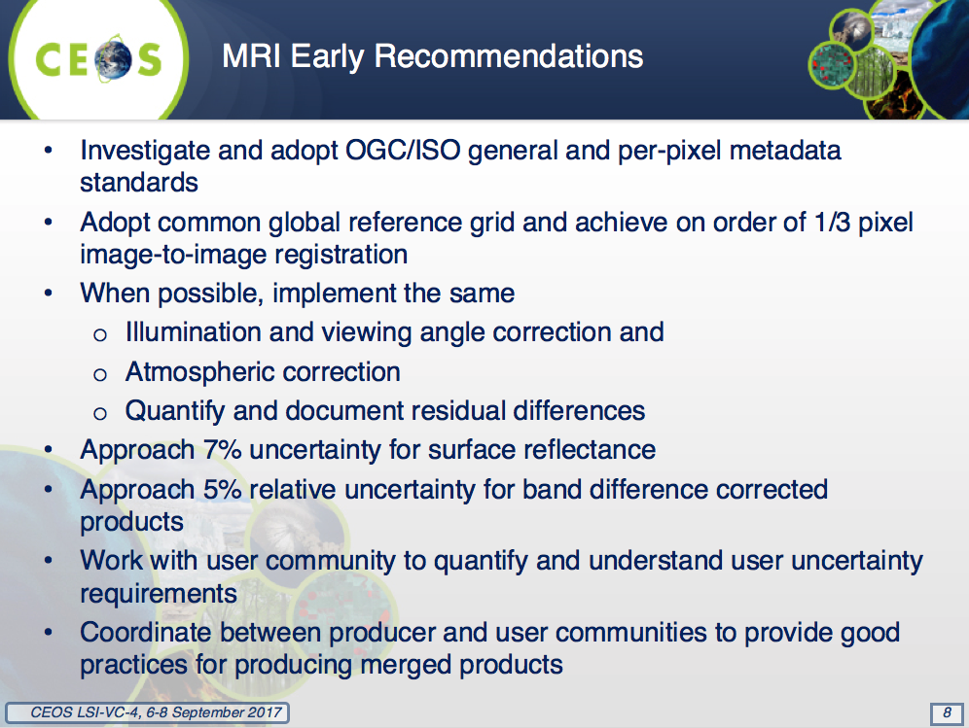
Harmonized Landsat Sentinel-2 (HLS)
Jeff Masek (NASA) presented an overview of the HLS project, which aims to harmonize Landsat-8 and Sentinel-2 data into a single seamless record at the radiometric level, improving temporal density (global coverage every 2-3 days). 65 test sites are being employed in HLS, with 7% of global land surface covered (test data available).
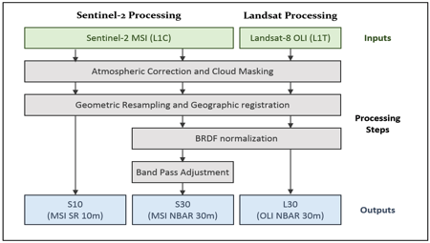
Jeff presented some example outputs that show the utility of high temporal density data.
Results are cross-checked with daily MODIS products. The lack of an accurate Sentinel-2 cloud mask causes errors. The HLS process has also been cross-checked with the MRI Framework.
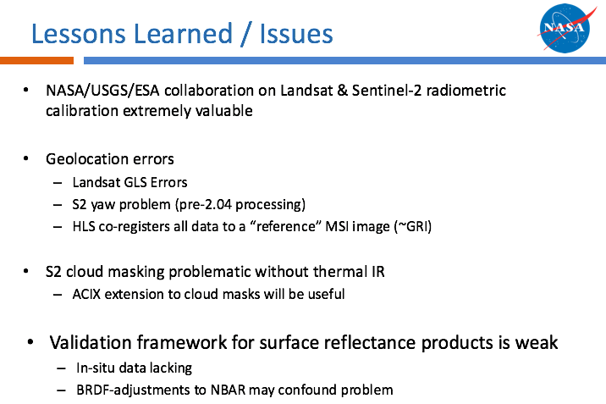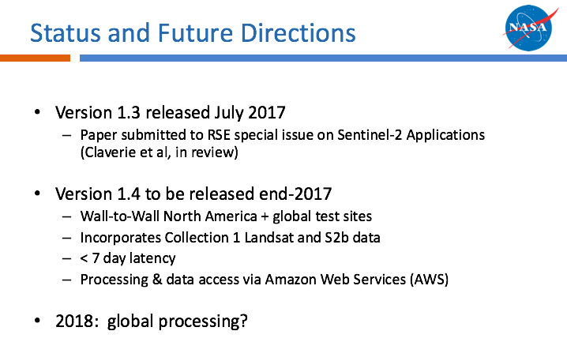
HLS website (public access, sample data available via FTP, algorithm & product descriptions, request new sites): https://hls.gsfc.nasa.gov
NEX project page (registered user access, all HLS data available, documents (slides, user guides)): https://nex.nasa.gov/nex/projects/1371
Jonathon Ross asked whether the HLS team has considered using GOES-16 data to help with the Sentinel-2 cloud mask issues. Jeff confirmed this has not been considered at this stage. Sentinel-3 is another possibly useful data source in this regard.
Brian Killough noted that he is looking forward to trying this data in the Vietnam Data Cube.
MRI Discussion
Jenn Lacey noted that the MRI initiative started as a 2017 USGS CEOS Chair initiative. There have been discussions with COM about continuing the work as a 2018 CEOS Chair initiative, however at this stage it is not clear how it will be taken forward (taken up wholly by LSI-VC, 2018 CEOS Chair initiative, conclude, etc.). A discussion is needed around how to expand this work in CEOS, and the next steps going forward (e.g., should the survey be continued?). This will be discussed in detail during the LSI-VC sessions.
Gene reported that the user perspective has been under-represented to date. Stephen Ward hopes that GFOI can step up and provide a strong user perspective/feedback on interoperability requirements.
Adam Lewis suggested that, going forward, the MRI document should capture the different approaches for making data interoperable (radiometric matching, final product merging, etc.). Gene agreed that this would be helpful.

Thursday, September 7
Review of Global Data Flows Study
As background, George reviewed the ‘Global Data Flows Study’ (GDF) that was initiated by the SDCG in 2016. The basic premise was that, with data supply strong, data flow is arguably now the top priority role for SDCG, and the CSIRO-initiated FDA study agreed with many of the conclusions of the GDF study.
The conclusions of the study noted the broader trend of data volumes outstripping user capacity, that the business as usual approach is not considered sustainable, the increasing number of data sources, reinforced the need for ARD products and tools, and that data providers are the key actor in quality assurance of data products. The study recommendations were grouped by Space Data Providers, Capacity Building Partners, and Users and Countries, and focused around ARD, interoperability, pilots, and the emerging role of cloud data storage and compute.
Future Data Architectures (FDA) Update and Implications
The 2016 CEOS FDA report looked at the ‘what’ of FDA, and the 2017 continuation tackles the ‘how’ – specifically around tasks that CEOS is going to do together.
The FDA initiative activities fall into five categories: CEOS ARD; interoperable open source tools; data, processing, and architecture interface standards; analytical processing capabilities; and user metrics. The purpose of the user metrics activities is to provide feedback to system backers to justify development, future work, and resources. For this group, the most relevant tasks being proposed by the FDA report are: comprehensive CEOS ARD strategy and interoperable open source tools (including CEOS Data Cube).
The way forward for FDA in the CEOS structure is a key point to be debated at the upcoming CEOS meetings (be it via a continuation of the FDA Ad Hoc Team, dispersion of tasks to existing CEOS groups, etc.). Maintaining visibility of the FDA issues is a top priority.
For the SIT Technical Workshop presentations, Ivan Petiteville suggested that a diagram be constructed that shows the relationship between the various activities (i.e., CARD4L, FDA, MRI, etc.).
Adam Lewis noted the discussion within LSI-VC around CARD4Ocean and CARD4Atmosphere. The business case for these components of a broader CEOS ARD strategy are not yet clear, but will be investigated, and the concepts will be floated at/before the upcoming CEOS meetings with the various stakeholders.
Report on Copernicus Data and Information Access Services (DIAS)
The motivation for the Copernicus Data and Information Access Services (DIAS) is to avoid moving vast quantities of Copernicus data around, instead bringing users and their workflows to the data archives.
Functional requirements for the DIAS were finalised in December 2016, and the procurement phase is currently underway.
Despite the benefits offered by the ‘users to the data’ concept, DIAS is not planned to replace the existing distribution systems at this stage. This could change in the future however, and the decision will be reviewed in the 2019 timeframe.
CEOS Data Cube Pilots
Brian Killough provided a summary and update on the CEOS Data Cube pilots, which are built using the Open Data Cube core. The CEOS SEO aims to have 20 Data Cubes in operation in the next five years. A high-level summary of the pilots is available on the Open Data Cube website: https://www.opendatacube.org/ceos. Other implementations of the Open Data Cube are Geoscience Australia’s Digital Earth Australia (DEA) and the USGS LCMAP system.
Brian noted that he has been reaching out to The World Bank on Data Cube implementations, and there has been some significant interest there.
Land Imaging Requirements Assessment
Alyssa Whitcraft presented a summary of the framework used by GEOGLAM to characterize and evaluate observation requirements:
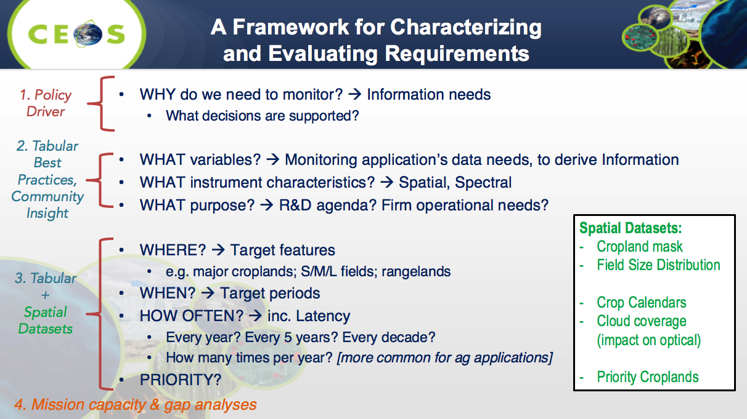
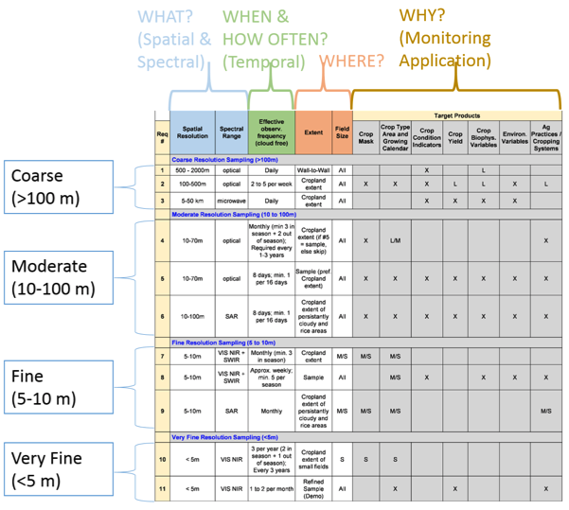
It is vital to take cloud cover into account; observation frequency will have to be higher than the required frequency. Alyssa presented some charts that show how different combinations of missions will achieve the Revisit Frequency Required (RFR) for a cloud-free view. The results (Whitcraft et al, 2015) show that SAR is a necessity for some areas, as no combination of existing optical missions will reliably meet the RFR.
GEOGLAM is currently undertaking a requirements refresh due to the evolution of science, the state of operational monitoring systems, and the desire to move to a holistic approach (consideration of data input, access capacity, analytic requirements/capacity, and information delivery).
Alyssa presented some suggestions for LSI-VC’s carbon requirements work. She suggested that a carbon subgroup be established to: identify some key priority variables; fill out the requirements table as above by answering the ‘what’, ‘where’, ‘when’, and ‘how often’; and then assess gaps and overlaps for measurements (see slides 14-17 for details).
It was noted that a specialized team (perhaps involving GFOI and GEO) is needed to assess the carbon requirements; evaluating mission gaps is the domain of the space agencies/LSI-VC.
Systems Engineering Tools for Integrated Land Surface Imaging
Brian Killough presented a summary and status of CEOS tools that may be useful in the requirements analysis process (COVE, Data Policy Portal). The COVE tool provides projected coverages of ground swaths, and more recently, an acquisition reporting function has been added which allows users to visualize and access actual coverage achieved. Currently Landsat-8 and Sentinel-1 and -2 coverage reports are available. He presented a demonstration of the coverage analyzer.
Brian reviewed some of the approaches the SEO have used for requirements analysis in the past. They consider spatial coverage, resolution, revisit performance, mission continuity, spectral resolution, and data access and availability.
In general, the feasibility of doing a very broad analysis of observation gaps and requirements was questioned. Brian is not confident that it will be possible to achieve the goal set out in the LSI-VC plans. It is perhaps more realistic to undertake these gap analyses in an ad hoc manner, in response to approaches by interested parties.
It was also noted that, despite analysis results, it will be difficult for agencies to move to fill gaps or change data policies. Gene Fosnight noted the Landsat-10 requirements gathering process, suggesting that these types of opportunities could benefit greatly from comprehensive gap analyses.
George Dyke stressed the importance of not becoming complacent in the current ‘data rich’ world. While current coverage from core missions like Landsat-8 and Sentinel-2 is good, this can change rapidly (for many reasons), resulting in observation gaps for which analysis would be handy to have.
George noted that the MIM Database team is looking into incorporating spectral response curves in the MIM DB, which could be useful for gap analyses.

Friday, September 8
GEOGLAM Meeting Main Outcomes
Brad Doorn presented the GEOGLAM meeting outcomes report:
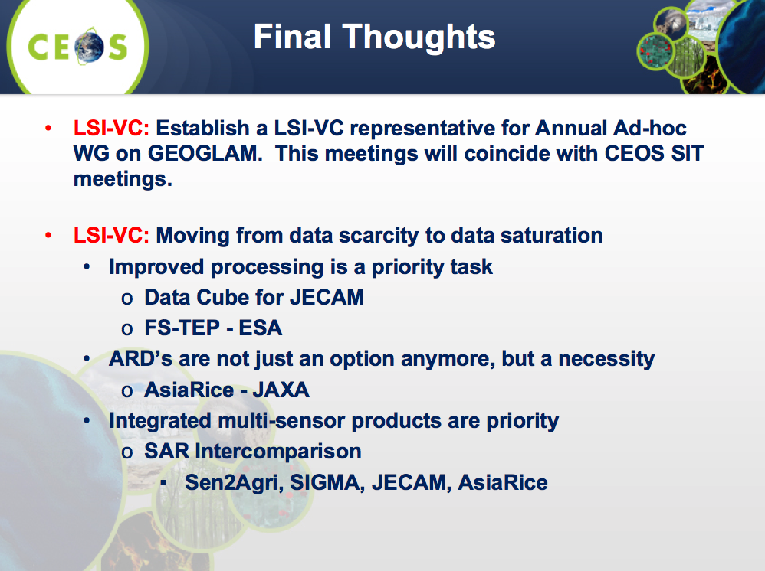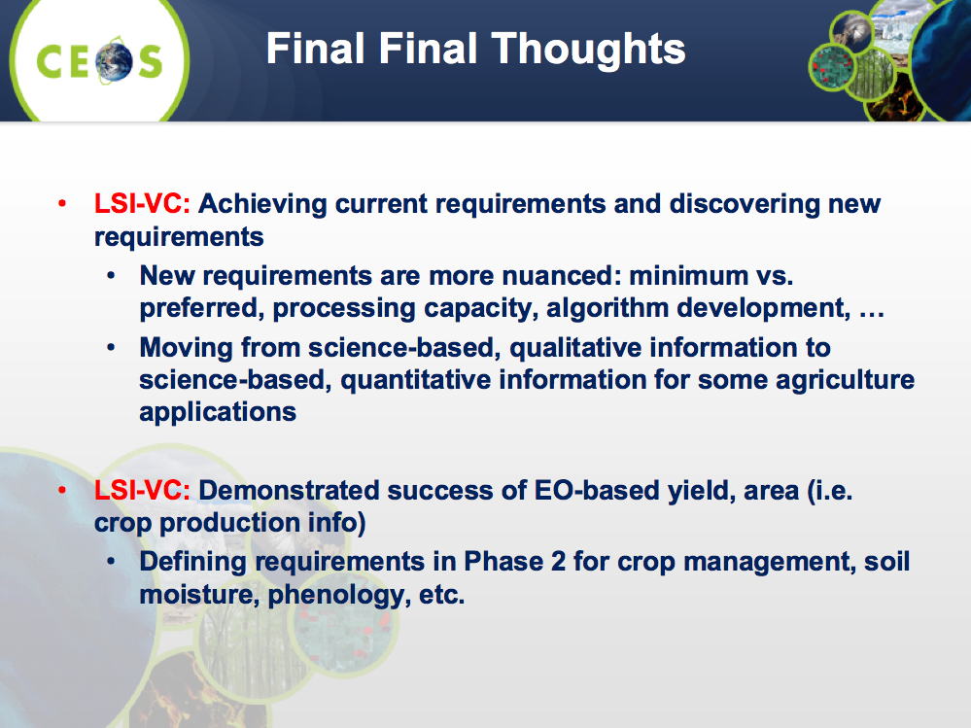
Adam Lewis welcomed future GEOGLAM inputs on the CARD4L Product Family Specifications. Stephen Ward noted that the SDCG will suggest a formal consultation process (with SDCG, GEOGLAM) around the CARD4L specifications.
Action 2 | SDCG-GFOI and CEOS-GEOGLAM to provide feedback on the CARD4L PFS by engaging in the reviews that will be coordinated by LSI-VC. | December 2017

SDCG-12 Main Outcomes
Frank Martin Seifert reported:
- Earlier in the week, SDCG held a deforestation early warning meeting with WRI and GOFC-GOLD around a ‘GFOI ALERT’ activity. GFOI ALERT is a proposed deforestation early warning system. Next steps include: a user needs assessment, followed by a WRI forum event in Washington, D.C. (February 2018), adding countries to the WRI pilot list (Vietnam, Colombia), technical studies and demonstrations (e.g., JJ-FAST/GLAD comparison). There is strong SDCG agency support for the GFOI ALERT proposal.
- Strong GFOI R&D support continues, including related to GFOI ALERT. Agencies agreed there is a need for a forum event upon confirmation of a new funding phase from ESA (at ESRIN and/or CSA). CSA have indicated a willingness to help populate the Vietnam Data Cube.
- The COVE Coverage Analyzer tool represents a significant step forward for the SDCG Space Data Services, allowing actual acquisitions to be plotted and accessed. The addition of SPOT World Heritage data is being investigated.
- GFOI Phase 2 presents a major shift, and the Data User Advisory Group will require significant capacity. CEOS is also represented on the MGD Advisory Group (Ake). Another SDCG Co-Chair is required, following the departure of Gene/USGS. SDCG Secretariat departure is a great loss and SDCG will appeal to CEOS Plenary for resources.
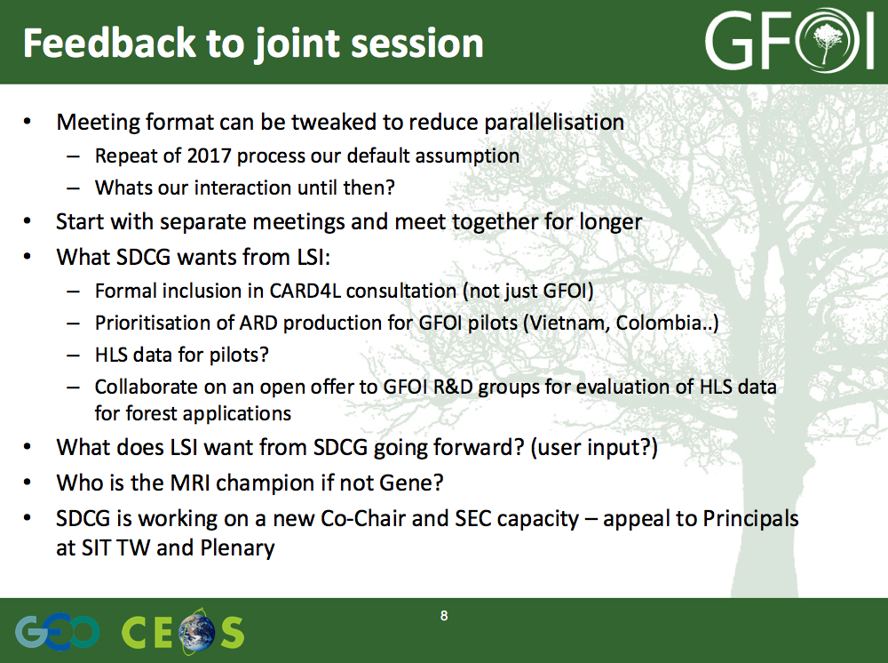
Adam Lewis noted that SDCG/GFOI input on the CARD4L PFS is critical. Feedback from users is also key, and the connection to these communities offered by SDCG and GEOGLAM is ideal.
LSI-VC-4 Main Outcomes
Adam Lewis presented the following:
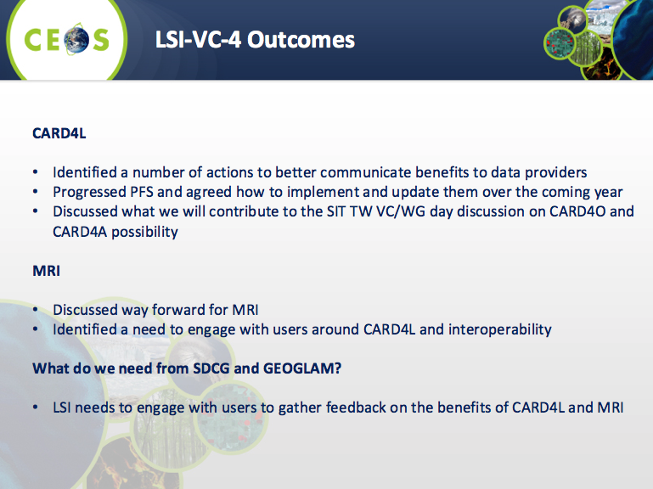
Ivan Petiteville suggested that LSI-VC needs to be engaging the user community in the PFS directly, making sure that their engagement is noted/promoted. Showing that ARD has strong user pull and involvement is critical.
Action 3 | SDCG to connect with Jeff Masek regarding the testing of HLS data for GFOI Pilots. | December 2017

Options for Joint Way Forward
Stephen Ward presented options for the joint way forward:
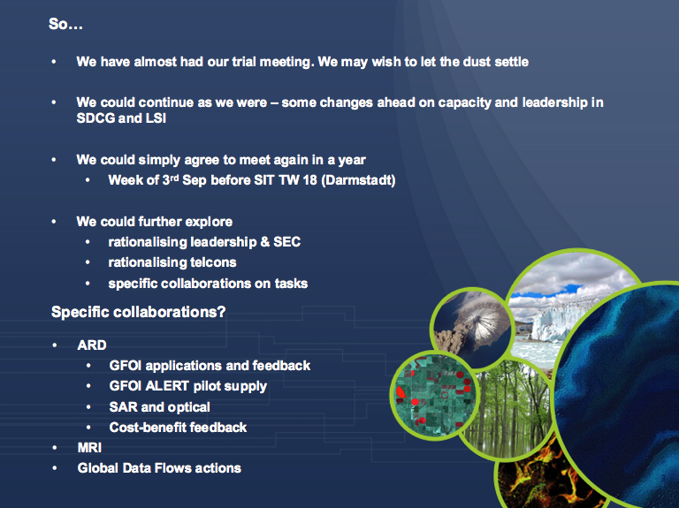
It was agreed to hold another joint meeting in a year’s time. It was also agreed that the time allocated to the meetings was appropriate, however we should reduce session overlap in the future – perhaps by holding SDCG early in the week, the joint/LSI sessions in the middle, and GEOGLAM at the end of the week.
Stephen Ward noted that SDCG will also continue to meet around GFOI Plenary, maintaining the important linkage to the user community.
Jonathon Ross noted that there appears to be no appetite for the LSI-VC to absorb the AHTs. He asked if we suggest to CEOS that the AHTs continue as usual, or do we propose that they become permanent groups? Stephen Ward noted that SDCG is not in a good position capacity wise to be suggesting a new structure. It is important that any solution does not lose the identity of the thematic groups and they do not lose their visibility within CEOS. Jeff Masek suggested that any solution should be expandable in the future to accommodate other themes as necessary.
It was agreed that any restructuring of the thematic groups/AHTs/LSI-VC should be tackled in the future.
Meeting Close
The Leads of the LSI-VC, SDCG for GFOI, and CEOS ad hoc Working Group on GEOGLAM thanked everyone for attending and adjourned the meeting. The Leads thanked Gene Fosnight for his service to SDCG/GFOI and CEOS, and wished him all the best for his retirement.
APPENDIX A
Attendees

Organisation | Name
AAFC | Ian Jarvis
CNES/ESA | Jean Jean Hervé
COM/ESA | Michael Berger
CSA | Paul Briand
CSA | Yves Crevier
DLR | Helmut Staudenrausch
ESA | Bianca Hoersch
ESA | Espen Volden
ESA | Ferran Gascon
ESA | Frank Martin Seifert
ESA | Ivan Petiteville
ESA | Pierre Potin
ESA/CNES | Steven Hosford
GA | Andreia Siqueira
GA | Adam Lewis
GA | Jonathon Ross
JAXA | Ake Rosenqvist
JAXA | Takeo Tadono
LSI-VC Secretariat | Matt Steventon
NASA | Brad Doorn
NASA | Dave Jarrett
NASA | Jeff Masek
NASA | Kurt Thome (remote)
NASA/SEO | Brian Killough
SDCG Secretariat | George Dyke
SDCG Secretariat | Stephen Ward
SEO/AMA | Otto Wagner
SEO/AMA | Sanjay Gowda
SEO/AMA | Shaun Deacon
UK Catapult | Dan Wicks
UMD/GEOGLAM Sec | Alyssa Whitcraft (remote)
USGS | Gene Fosnight
USGS | Jenn Lacey

APPENDIX B
Actions Record

 | Action | Due Date
Action 1 | LSI-VC to develop a roadmap for CARD4L production for the thematic groups’ reference. | December 2017
Action 2 | SDCG-GFOI and CEOS-GEOGLAM to provide feedback on the CARD4L PFS by engaging in the reviews that will be coordinated by LSI-VC. | December 2017
Action 3 | SDCG to connect with Jeff Masek regarding the testing of HLS data for GFOI Pilots. | December 2017

