MINUTES OF THE 4th MEETING OF THE CEOS
LAND SURFACE IMAGING VIRTUAL CONSTELLATION (LSI-VC)

6-7 September 2017
ESA ESRIN, Frascati, Italy

Outcome Summary

- The links that the thematic groups (SDCG for GFOI, CEOS-GEOGLAM ad hoc Working Group) have to the user communities were identified as being of the utmost importance.
- Analysis-Ready Data (ARD) is a common thread between all of the groups, and progressing ARD would be of great benefit to all communities.
- It was agreed that the joint meetings are a step in the right direction and should continue annually around SIT Technical Workshop.
- LSI-VC needs to give further consideration to what is needed from the SDCG for GFOI and CEOS-GEOGLAM ad hoc Working Group. To start, feedback on the utility of CARD4L and MRI, a clear statement of the thematic communities’ needs, as well as guidance on how agencies can better service user communities would be very useful.
- LSI-VC identified five actions that will be progressed to better engage data providers in CARD4L (see table on page 5).
- LSI-VC progressed the CARD4L Product Family Specifications (PFS) and agreed how to implement and update them over the coming year.
- Confirmed LSI-VC’s strategy for the SIT Technical Workshop VC/WG day discussion regarding the concepts of CARD4Oceans and CARD4Atmosphere. It was agreed that LSI-VC should not be prescriptive, present questions for CEOS debate, and engage the meteorological agencies ahead of the discussion.

Wednesday September 6th
Welcome
The Co-Leads of the LSI-VC (Adam Lewis, GA; Bianca Hoersch, ESA; Jenn Lacey, USGS) welcomed participants to the meeting and made a call for additions to the agenda.
Morning Joint Session Reflection
The group reflected on the morning’s joint session with the SDCG for GFOI and CEOS-GEOGLAM ad hoc Working Group. It was noted that while there are plenty of topics worth discussing as a group, the way forward is still unclear and requires more discussion. The links that the thematic groups have to the user communities were identified as being of the utmost importance. A lack of resources in the thematic groups is clear, and consolidation of groups/representation, travel optimisation etc. may help to address that. Overall, it was agreed that the joint meetings are a step in the right direction and should continue.
Brian Killough (NASA, SEO) suggested that the joint meetings be held annually around SIT Technical Workshop. He added that it is clear that the SDCG and GEOGLAM groups are not going away, and maintaining their links to the user communities is key and completely necessary.
Analysis-Ready Data (ARD) is a common thread between all of the groups, and progressing ARD would be of great benefit to all communities. Adam noted that the development of a general requirements gathering/mapping process, if feasible, would be another great contribution, and would lay the groundwork for any new initiatives/themes that come forward in the future.
Above all, LSI-VC needs a clear statement of the thematic communities’ needs.
Action Review
Matt Steventon reviewed the outstanding actions from LSI-VC-3. A summary is presented below.
No. | Description | Due Date
LSI-VC-3-01 | Jenn Lacey to coordinate LSI-VC mission timelines with the CEOS MIM Database team. | ON HOLD  Scope will be restricted to CARD4L datasets; action to be revisited once first datasets are assessed.
LSI-VC-3-04 | Jonathon Ross and Adam Lewis to revise the CARD4L definition wording around ‘atmospheric correction directional scattering’. | CLOSED  Will be resolved during the LSI-VC-4 discussion on CARD4L PFS.
LSI-VC-3-07 | Bimal Bhattacharya to share coverage maps that summarise the quantity and location of available AWiFS data.  Jenn Lacey to share any related information obtained by USGS. | CLOSED  AWiFS archive is linked in the CEOS COVE Coverage Analyzer (http://www.ceos-cove.org/) – providing a full record of actual acquisitions.
LSI-VC-3-13 | Adam Lewis to work with the FDA-AHT at the 2017 SIT Technical Workshop (September) to ensure that lessons learned from the FDA Pilots are fed back into the work of the LSI-VC (i.e., in the areas of CARD4L and MRI). | CLOSED  This linkage is effectively in-place, and feedback from the AHT is happening.
LSI-VC-3-16 | Paul Briand to explore the possibility of sharing a new Canadian SAR flood mapping algorithm with Brian Killough, in support of the Vietnam Data Cube pilot. | CLOSED  Algorithm does not work as expected; will not be pursued any further.
LSI-VC-3-19 | Paul Briand to share some Canadian examples of work done with the private sector to release down-sampled/higher-level products derived from commercial datasets. | CLOSED  Unable to be shared.
LSI-VC-3-22 | CEOS SEO to look at the terrestrial chapter of the CEOS Strategy for Carbon Observations from Space, constrain the rows currently in the requirements matrix, and assess what high-level requirements exist. | IN PROGRESS  Alyssa Whitcraft will present an update tomorrow.
LSI-VC-3-23 | Mark Dowell to reach out to GEO regarding having GEO Carbon and GHG Initiative experts fill out any carbon requirements template supplied by LSI-VC/CEOS. | ON HOLD  Pending outcome of LSI-VC-3-22
Approach/Strategy to Engaging Data Providers in the Provision of CARD4L
Adam initiated the discussion by noting that we are seeking to identify the key elements of a strategy to engage data providers in the provision of CARD4L.
The approach for the session was to: agree an approach and responsibilities for preparation of a strategy to engage data providers in the provision of CARD4L; and develop an approach to monitoring the uptake of, and benefits from, CARD4L.
The discussion proposed that, to motivate data providers to produce ARD, they would need to be:
- Convinced of the value / benefit of providing CARD4L;
  - For example, through capturing stories of the benefits of ARD (CEOS and LSI-VC are unlikely to be resourcing detailed economic studies of the benefits of ARD).
- Supported to adopt the CARD4L framework;
  - Including through access to relevant materials and having a sense of ownership of the framework, and having access to technical knowledge and experience in the production of ARD.
- Recognized / Acknowledged for their achievements.
  - Which might be achieved through the publication of a list of CARD4L datasets.
Dan Wicks (UK Catapult) noted that he has been approached by numerous commercial providers interested in becoming aligned with Catapult’s ARD work, so there is clearly an interest and willingness to engage.
It was agreed that the academic sector must be included in any efforts around capturing the benefits of CARD4L.
Brian Killough (NASA, SEO) noted that there has been no mention of Sentinel-1 ever having routine ARD production. He is curious whether a gamma-naught product is something ESA would consider releasing in addition to the data processing toolbox already available.
Dan suggested that the comparatively low demand for Sentinel-1 ARD could be due to the fact that free-and-open SAR data is a very new concept.
Ivan Petiteville (ESA) asked whether we are doing a good enough job of advertising CEOS efforts around ARD. He suggested a dedicated website to improve communication. He added that CARD4L would ideally be in an advanced state before expanding the CARD concept to the ocean and/or atmosphere domains (i.e., CARD4O, CARD4A).
Jeff Masek (NASA) noted the importance of engaging data providers as early as possible, as long lead times are required when it comes to adapting missions under development.
The LSI-VC agreed to a suite of realistic actions that could be carried out by LSI-VC that would help to motivate and empower data providers. Specifically:
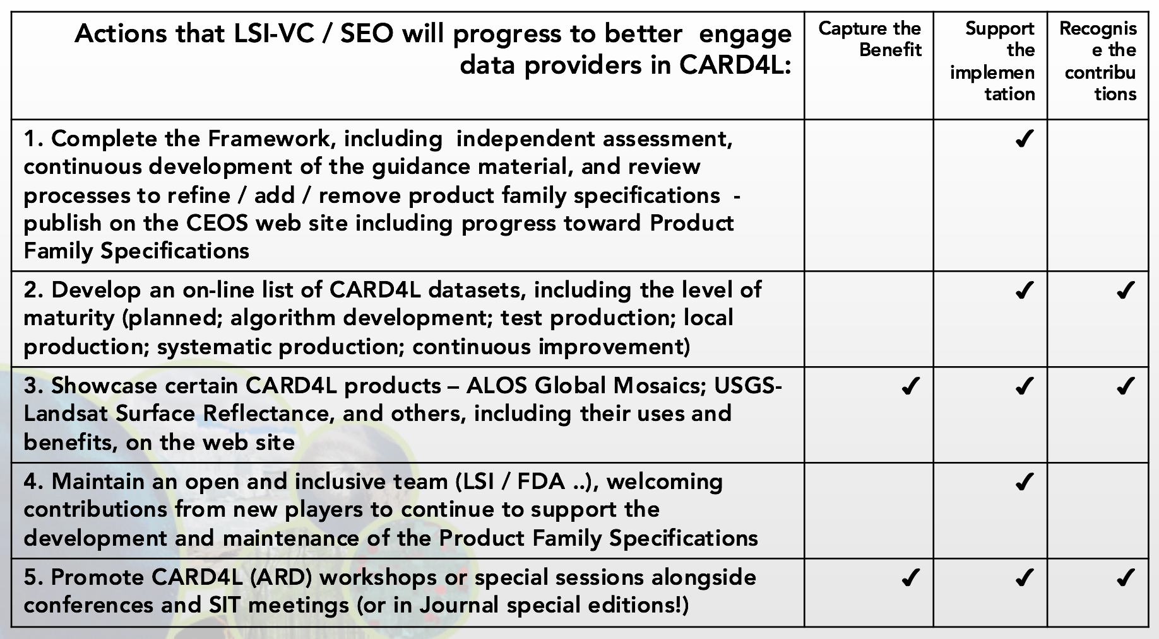
LSI-VC-4-01 | Matt Steventon to prepare a first draft of a CARD4L informational website. Content should include a background of CARD4L, a development roadmap, the current specifications, and a listing of CARD4L-compliant datasets. | December 2017
CARD4L Assessment Framework
There was a discussion around the difference between CARD4L Assessments and user feedback (on the utility of CARD4L datasets). The idea proposed is that data providers would perform the Assessments, and users would have an outlet (e.g., CEOS/CARD4L websites) for providing feedback on the datasets. It was agreed that providing a means (yet to be decided) for users to provide feedback on CARD4L datasets is a good idea.
Ferran Gascon (ESA) noted the very active Sentinel-2 user forum, stating that it is extremely helpful for the development teams; they gather user feedback regularly.
The responsibility for doing the assessments was also discussed – does this fall exclusively to the data providers, or could third parties or even LSI-VC perform the assessments? Matt Steventon noted that the assessments are objective, so it shouldn’t really matter who does them. Brian supported the proposal that LSI-VC perform the assessments, and suggested that LSI-VC could work with the data providers on this step. A counter opinion was that by assessing datasets as ‘CARD4L-compliant’, LSI-VC is in endorsing the dataset to users.
A formal decision on responsibilities for the assessments will be made when we finalise the Assessment Framework.
CARD4L Product Family Specifications (PFS)
Adam reviewed the latest CARD4L PFS and made live updates. Brian Killough (NASA, SEO) suggested the possibility of an ‘enhanced’ SAR backscatter CARD4L (perhaps as an extra column in the PFS table, or a standalone PFS, if needed) which includes some phase information. Paul Briand (CSA) supported the idea, citing feedback received from a recent survey of Canadian users.
LSI-VC Implementation Plan
Jenn Lacey (USGS) reviewed the current version of the LSI-VC Implementation Plan.
Regarding the tasks related to requirements assessment and gap analyses, she asked for feedback on the benefits and steps required to move forward. In general, the feasibility of doing a very broad analysis of observation gaps and requirements was questioned, especially with global optical land surface imaging being well covered. Jeff Masek (NASA) noted that the same is not true for SAR, and so there could be some scope for activity there.
Brian Killough (NASA, SEO) agreed that the idea of a broad, general gap/requirements analysis is not feasible, and we could instead consider presenting a good set of tools and working through specific requests in an ad hoc manner. He suggested that we could put together a guidance document – which outlines the information we need to be able to assist, as well as the tools available (COVE, etc.) – to be provided to groups that approach LSI-VC for assistance.
Jenn asked whether we should consider reducing the scope from what was proposed in the original terms of reference (from which the Implementation Plan was derived).
It was agreed that the current tasks look on-target, and that the top row of the table from the terms of reference (which references ‘time horizons’) should be deleted, as the time horizons are inaccurate.
LSI-VC-4-02 | Jenn to revise the LSI-VC Implementation Plan based on the discussion, and to circulate the update for feedback and approval. Target having the update done by CEOS Plenary. | COMPLETE

Thursday September 7th
CSA Update
Paul Briand (CSA) provided an update on the activities of CSA/Canada in relation to FDA and ARD:
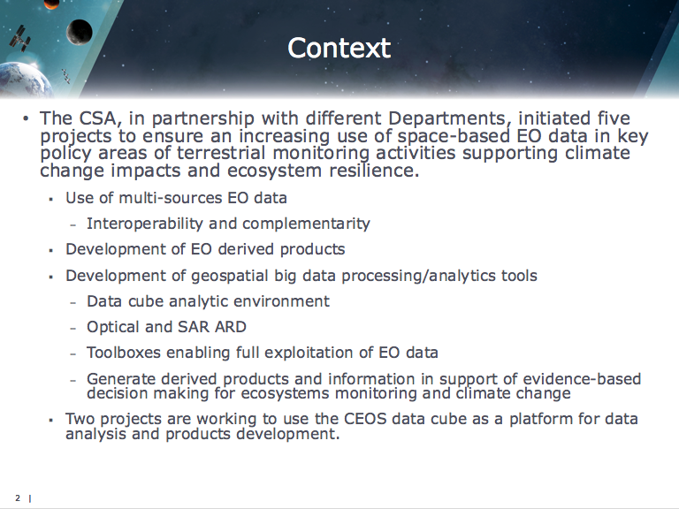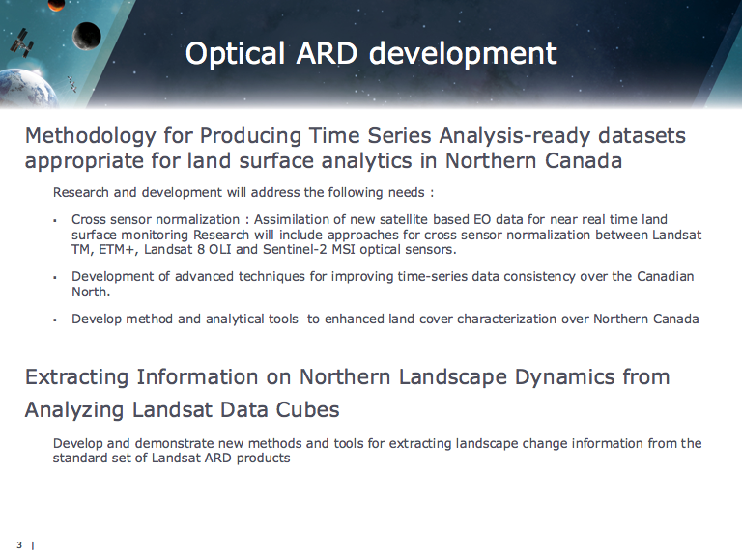
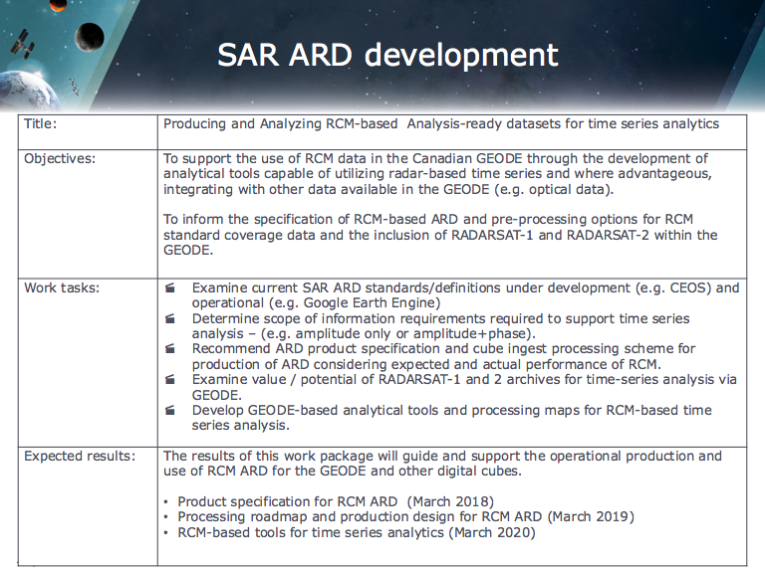
Paul noted that the Canada Centre for Mapping and Earth Observation (CCMEO) have always preferred to develop their own tools/methods to meet their specific requirements, and this will be the case for ARD as well. This will provide another ARD dataset for comparison.
The SAR ARD project has just started, and is motivated by the Radarsat Constellation Mission (RCM), which will provide systematic SAR coverage. CCMEO will assess the standard RCM coverage and define an ARD standard to cover the needs of users. The CARD4L SAR backscatter PFS is being taken into consideration, and CCMEO are also assessing what has been done in other groups. Enabling Data Cube ingestion of the data and interoperability with other SAR datasets for time series analysis are under consideration. A proposed product specification for RCM ARD and a roadmap for its production, as well as a collection of analytical tools, are expected by March 2018.
Noting CCMEO’s plans to create an optical ARD dataset, Jenn suggested performing a comparison with Landsat ARD over northern Canada.

LSI-VC-4-03 | Paul Briand to share CCMEO optical ARD pilot coordinates with Jenn for a comparison with Landsat ARD. | November 2017
LSI-VC-4-04 | Paul Briand to share the details of the atmospheric correction algorithm being used by CCMEO. | November 2017
Ferran Gascon (ESA) noted the Atmospheric Correction Intercomparison eXercise (ACIX), suggesting that their results could be useful for CCMEO’s ARD work. He also suggested that CSA could get involved in ACIX, noting that a very high latitude pilot site in Canada could be very useful.
LSI-VC-4-05 | Ferran Gascon to pass on ACIX details to Paul Briand. | ASAP  ACIX results could be useful for CCMEO’s ARD work. A very high latitude ACIX pilot site in Canada could also be very useful.
UK Catapult
Dan Wicks (UK Catapult) provided some context for the UK’s involvement in LSI-VC: in 2009, the UK introduced an innovation growth strategy to identify opportunities for growth, specifically aiming to grow the UK’s share of the global space market from 6 to 10 per cent, with a focus on downstream activities. This led to the establishment of the Satellite Applications Catapult in 2013, which has the goal of encouraging growth in the sector, and works across industry, academia, and government.
Dan noted the increasing recognition of EO across the UK government; there are efforts underway to assess how the UK government can start exploiting EO more coherently.
The UK’s Department for Environment, Food & Rural Affairs (DEFRA) have an EO strategy, and are conducting an EO data integration pilot, which is looking at how the department might consolidate its use of EO data.
DEFRA, aided by Catapult, are producing regular ARD from Sentinel-1 and Sentinel-2 for government use. Catapult have their own method for producing Sentinel-2 ARD, and are also creating an open toolset for Sentinel-2 ARD production (currently undergoing testing and evaluation; further work to be done around BRDF and cloud masking). A full report on Catapult’s Sentinel-2 ARD work will be available at the end of this month.
LSI-VC-4-06 | Dan Wicks to share the Catapult Sentinel-2 ARD report when ready. | COMPLETE
Dan reported that Sentinel-1 is a very important dataset for the UK, noting the past joint project with Australia on SAR ARD and the strong demand for Sentinel-1 data in the UK from both expert and non-expert users. Catapult is also considering the opportunities for polarimetric and interferometric products.
Catapult is also working closely with the Open Data Cube initiative, and have recently become a Partner. Their involvement is due to the Wales Cube pilot. Catapult are also collaborating directly with Brian Killough and the CEOS SEO on Data Cube matters. The Wales Cube instance is working, and they hope to make it publicly available by the end of the month.
Adam Lewis (GA) asked whether there is any work ongoing around in situ measurements, as part of the BRDF correction work. Dan reported that there is nothing ongoing, but they are exploring the possibility with Nigel Fox (CEOS WGCV; running a number of cal-val sites in the UK).
Jonathon Ross (GA, CEO) noted the Crop Map of England (CROME), and asked whether Dan had any further information on its development. Dan reported that it was established under DEFRA, and he offered to share more information.
LSI-VC-4-07 | Dan Wicks to share further technical details of the Crop Map of England (CROME). | COMPLETE
Moderate Resolution Interoperability (MRI)
Gene Fosnight (USGS, MRI Lead) stepped through the latest version of the MRI Framework document, ahead of its release for next week’s SIT Technical Workshop. CARD4L dictates that products must come with the information required for interoperability, and the MRI Framework complements this by outlining what is necessary for application-specific interoperability. Gene noted that it has been constructed from a user perspective, i.e., how to approach the interoperability of products for specific applications. A key question to be resolved is whether the MRI Framework should be taken forward, and if so, how?
Ivan Petiteville (ESA) stressed the need to make sure that CARD4L and MRI are completely aligned, to avoid duplication of effort and confusion.
Adam Lewis (GA) noted that the MRI Framework and the case studies should identify any omissions from the CARD4L documents. Gene agreed, noting that the idea is that the Framework will feed back into CARD4L, improving it.
Jeff Masek (NASA) noted that the focus of the MRI survey seems to have shifted. Initially, it was presented as an effort to collect the details of major projects that were producing products from combined datasets, but has now become an anonymous survey of anyone combining products in some way.
A number of changes to the MRI SIT Technical Workshop slides were suggested. Gene will revise the PowerPoint accordingly (see action below).
LSI-VC-4-08 | Gene to revise the MRI SIT Technical Workshop slides:  - Include an overview box diagram of the relationship between CARD4L, the MRI Framework, LSI-VC, etc.  - Revise the wording on slide 3 as follows: “Product recommendations for CARD4L to maximise interoperability.”  - Ensure the slides present the information as: “here is what we set out to do, here’s what was achieved, and here are the potential future tasks.”  - Ensure that we show CEOS Principals what they will get for committing resources to an extension of the MRI work.  - Move dot point on engaging user communities up to the ‘Framework’ section.  - Retain the “move beyond focus…” point, perhaps changing it to “ARD optical products” rather than “SR products”. | CLOSED

It was noted that the European Commission (CEOS Chair for 2018) have a strong user focus; showing how MRI will increase the uptake of Sentinel data and improve the competitiveness of SMEs is key.
SIT Technical Workshop Preparation
Adam led an interactive review and update of his CEOS Analysis Ready Data slides for SIT Technical Workshop.
CARD Extension to Ocean and Atmosphere
Adam led an interactive review and update of his Extension of CARD Concept to Atmosphere and Ocean slides for SIT Technical Workshop.
It was noted that the focus of LSI-VC is very different to that of the other CEOS VCs (which are interested in more specific geophysical parameters).
It was agreed that the slides should not be prescriptive, and simply present questions for CEOS debate (avoid forcing any outcomes).
It was agreed that it would be a good idea to engage with the meteorological agencies, in particular EUMETSAT, on the concept of CARD4Ocean and CARD4Atmosphere ahead of the VC/WG Day discussion at SIT Technical Workshop. Adam will ensure they are informed and invite them to join him during the presentation.
LSI-VC-4-09 | Adam to ensure that the meteorological agencies (in particular EUMETSAT) are aware of the CARD4O and CARD4A concept ahead of the VC/WG Day discussion at SIT TW, and invite them to join him during the presentation. | CLOSED
LSI-VC-5
A short discussion was held around the location of LSI-VC-5, which will be hosted by JAXA, February 21-23, 2018. It was suggested that central Tokyo would be a more convenient location than Tsukuba Space Center. Takeo Tadono (JAXA) agreed, and will investigate the possibility of a central Tokyo location for the meeting.
LSI-VC-4-10 | Takeo Tadono to investigate the possibility of a central Tokyo location for LSI-VC-5. | COMPLETE  LSI-VC-5 will be held at the RESTEC office.
CARD4L PFS Updates
Adam reviewed the technical details of the CARD4L PFS, in particular the change requests received in the last round of review, and made changes live on the screen.
Andreia Siqueira (GA) will be coordinating PFS-specific teleconferences to further review the technical details.
LSI-VC-4-11 | Andreia Siqueira to coordinate PFS-specific teleconferences to further review the PFS technical details. | COMPLETE
LSI-VC-4 Main Outcomes, Thoughts on the Joint Way Forward
The LSI-VC Leads presented the following summary of high-level outcomes from LSI-VC-4:
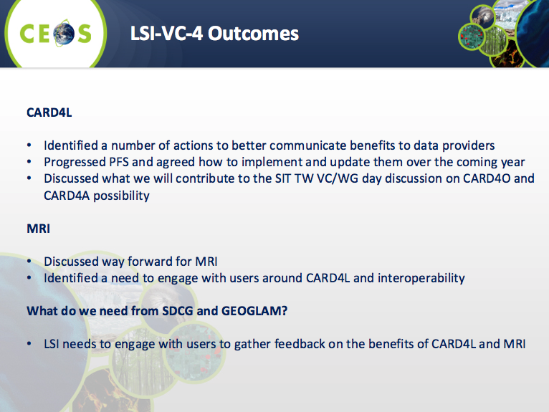
It was noted that:
- We have spoken about CARD4L production, and demonstrating the benefits to data providers via an informational website. An action was recorded to progress this.
- Regarding the joint way forward with SDCG and GEOGLAM: we need a better understanding of the benefits of routine CARD4L production for each of the user communities.
- We need to give further consideration to what we need from SDCG and GEOGLAM, as the critical connections to the user community. Feedback on the utility of CARD4L, as well as how agencies can better service the user communities would be very useful.
Thursday Closing Remarks
Adam, Bianca, and Jenn thanked everyone for attending the dedicated LSI-VC-4 sessions. Adam and Jenn noted that Bianca will be taking on a new role within ESA, and will therefore be stepping down as an LSI-VC Co-Lead. They thanked Bianca for her service to CEOS and LSI-VC. A new Co-Lead from ESA is expected to be confirmed in the coming month.
APPENDIX A
Attendees

Organisation | Name
CSA | Paul Briand
ESA | Bianca Hoersch
ESA | Ferran Gascon
ESA | Ivan Petiteville
ESA/CNES | Steven Hosford
GA | Andreia Siqueira
GA | Adam Lewis
JAXA | Takeo Tadono
NASA | Dave Jarrett
NASA | Jeff Masek
NASA | Kurt Thome (remote)
NASA/SEO | Brian Killough
UK Catapult | Dan Wicks
USGS | Gene Fosnight
USGS | Jenn Lacey
LSI-VC Secretariat | Matt Steventon

APPENDIX B
Actions Record

No. | Action | Due Date
LSI-VC-4-01 | Matt Steventon to prepare a first draft of a CARD4L informational website. Content should include a background of CARD4L, a development roadmap, the current specifications, and a listing of CARD4L-compliant datasets. | December 2017
LSI-VC-4-02 | Jenn to revise the LSI-VC Implementation Plan based on the discussion, and to circulate the update for feedback and approval. Target having the update done by CEOS Plenary. | COMPLETE
LSI-VC-4-03 | Paul Briand to share CCMEO optical ARD pilot coordinates with Jenn for a comparison with Landsat ARD. | November 2017
LSI-VC-4-04 | Paul Briand to share the details of the atmospheric correction algorithm being used by CCMEO. | November 2017
LSI-VC-4-05 | Ferran Gascon to pass on ACIX details to Paul Briand. | ASAP  ACIX results could be useful for CCMEO’s ARD work. A very high latitude ACIX pilot site in Canada could also be very useful.
LSI-VC-4-06 | Dan Wicks to share the Catapult Sentinel-2 ARD report when ready. | COMPLETE
LSI-VC-4-07 | Dan Wicks to share further technical details of the Crop Map of England (CROME). | COMPLETE
LSI-VC-4-08 | Gene to revise the MRI SIT Technical Workshop slides:  - Include an overview box diagram of the relationship between CARD4L, the MRI Framework, LSI-VC, etc.  - Revise the wording on slide 3 as follows: “Product recommendations for CARD4L to maximise interoperability.”  - Ensure the slides present the information as: “here is what we set out to do, here’s what was achieved, and here are the potential future tasks.”  - Ensure that we show CEOS Principals what they will get for committing resources to an extension of the MRI work.  - Move dot point on engaging user communities up to the ‘Framework’ section.  - Retain the “move beyond focus…” point, perhaps changing it to “ARD optical products” rather than “SR products”. | CLOSED
LSI-VC-4-09 | Adam to ensure that the meteorological agencies (in particular EUMETSAT) are aware of the CARD4O and CARD4A concept ahead of the VC/WG Day discussion at SIT TW, and invite them to join him during the presentation. | CLOSED
LSI-VC-4-10 | Takeo Tadono to investigate the possibility of a central Tokyo location for LSI-VC-5. | COMPLETE  LSI-VC-5 will be held at the RESTEC office.
LSI-VC-4-11 | Andreia Siqueira to coordinate PFS-specific teleconferences to further review the PFS technical details. | COMPLETE

