MINUTES OF THE 7th MEETING OF THE CEOS
LAND SURFACE IMAGING VIRTUAL CONSTELLATION (LSI-VC)

14-15 February 2019
Hanoi, Vietnam

Key Outcomes
- Product Family Specifications were agreed for the first three CEOS Analysis Ready Data for Land (CARD4L) data products (Surface Reflectance, Surface Temperature, Normalised Radar Backscatter). The specifications provide guidance to CEOS Agencies and the wider Earth observation community for future data provision.
- Procedures relating to the production of CARD4L, including self-assessment mechanisms and approaches to communication and wider CEOS ARD strategy proposals were discussed. This discussion increased LSI-VC’s shared understanding of these processes, and awareness of the next set of challenges, such as promotion, file formats, and engagement outside of the CEOS community.
- It was agreed that Digital Earth Africa is a good focal point for demonstrations of CARD4L supply, accessibility, and usability. This trial will give LSI-VC the opportunity to gather information regarding the barriers to data supply, accessibility, and use.
- The sub-team of ESA and USGS that has been developing concepts and definitions around the ‘interoperability spectrum’ reported to LSI-VC, and the next steps for this critical work were identified. CARD4L is a necessary step to achieve interoperability, but is not of itself sufficient.
- Procedural matters, such as the relationship between LSI-VC and the SDCG-GFOI and CEOS-GEOGLAM ad hoc teams were considered. In response to questions raised by the SIT Chair team, actions were agreed to progress a review of the terms of reference of the LSI-VC.

Thursday February 14th

Session 1:​ Welcome and Introductions

Welcome and Introductions
Adam Lewis (GA) initiated the meeting and welcomed everyone on behalf of the LSI-VC Co-Chairs. He thanked VNSC for hosting the meeting and welcomed VNSC representative, Dr Pham Thi Thanh Nga to say a few words. Dr Nga welcomed visitors to Vietnam and to VNSC. A tour de table followed, after which Steve Labahn (USGS) reviewed the meeting objectives and status of the various work areas of LSI-VC.

Action Review
Matt Steventon (LSI-VC Secretariat) reviewed the outstanding actions from LSI-VC-6 and the 2018 Joint Meeting. He reported that of the 21 actions recorded, 20 have been/will be completed as of LSI-VC-7. Of the outstanding actions, all are now closed except for LSI-VC-6-11, and this will be carried forward. Adam reported that RADI (China) has been contacted in regard to LSI-VC-6-02 and their parallel “Ready To Use” (RTU) data initiative is the driver for this outreach. Demonstrating that there are mutual benefits to ensuring consistency between ARD and RTU will be key.

Session 2: CARD4L Product Family Specifications (PFS)

Overall PFS Status & Updates to Existing PFS
Andreia reviewed the current status of the PFS. In late 2018 a number of agencies conducted ‘self assessments’ of their data products to provide final feedback on the PFS for Surface Reflectance (SR), Land Surface Temperature (LST) and Normalised Radar Backscatter (NRB). Feedback was captured during teleconferences and incorporated into the draft PFS.
Several further PFS are being developed by the Radar community and their status will be reported under a later item. Zoltan offered to put Andreia in contact with one of his JRC colleagues so they can participate in the SAR PFS Definition Team and to establish a dialogue around the possibility of a Sentinel-1 Global Backscatter Mosaic consistent with the NRB PFS.
LSI-VC-7-01 | Zolti to connect Nadine Gobron (EC/JRC) with Andreia regarding participation in the SAR PFS Definition Team and the S-1 Global Backscatter Mosaic. | COMPLETE  JRC will consider the radar related PFS once the S-1 global mosaic tender takes place.
The three PFS (NRB, SR, LST) were then reviewed and presented for endorsement.
Synthetic Aperture Radar (SAR) Normalised Radar Backscatter (NRB)
Andreia and Ake noted the strong participation of the SAR PFS Definition Team with the development, review and finalisation of the NRB PFS. Adam commended the team on their work. The PFS has gone through a broad review, generating substantial feedback and revisions throughout the year.
The Synthetic Aperture Radar (SAR) Normalised Radar Backscatter (NRB) Product Family Specification (PFS) was tabled for endorsement.
Decision 01 | The LSI-VC endorsed the Normalised Radar Backscatter Product Family Specification.
The meeting agreed that the PFS will be reviewed by a technical editor to address remaining matters of expression and consistency. USGS agreed to provide a technical editor to undertake this work.
Surface Reflectance (SR)
LSI-VC reviewed the development of the Surface Reflectance PFS, which was similarly updated on the basis of feedback through the self-assessment processes and circulated as a final draft in early 2019. It was noted that the technical community was very supportive of the development of the PFS and that there were no parts of the community that had expressed objections to the draft.
The meeting discussed several comments from USGS which, due to the US government shutdown, were not received previously. Those comments included questions about consistency (in particular between the surface reflectance and the surface temperature PFS), and clarity (in regard to the wording of requirements for DOI references).
In considering these comments the meeting adopted a ‘no-regrets principle’, i.e., that moving a requirement from ‘threshold’ to ‘target’ levels in the specification was a relaxation of the requirements, and likely to be ‘no regrets’; in contrast, a movement from ‘target’ to ‘threshold’ would impose stricter requirements and could cause inconvenience to data providers in unforeseen ways. It was also noted that the PFS are reviewed on an annual cycle.
The following specific decisions were made in response to the USGS comments:
For consistency:
1.1: move the requirements for a DOI to the ‘target’ level of requirements.
Matters of style and clarity to be addressed by a technical writer:
1.1: traceability: ensure that the link is included; add an examples annex at the end of the PFS.
1.9, 1.13, 1.14: use a single DOI link.
2.12: move AOD requirement to threshold level.
2.3: incompleteness of ancillary data: include guidance for the ‘N/A’ case (e.g., USGS).
3.1: as for 1.1.
3.4 & 3.5: the material covers both requirement and metadata: (re)move the latter to the ‘general metadata’ area (if not already covered there).
4.1: delete the note / comment which is not required as part of the specification.
The PFS will be reviewed by a technical editor to address remaining matters of expression and consistency and to implement the final changes, minuted above, that were agreed in the meeting.
The Surface Reflectance (SR) Product Family Specification (PFS) was tabled for endorsement.
Decision 02 | The LSI-VC endorsed the Surface Reflectance Product Family Specification.
Land Surface Temperature (LST)
As with the Surface Reflectance PFS, LSI-VC reviewed the development of the LST PFS and responded to a series of points raised by USGS that were not able to be addressed prior to the meeting.
Consistency and content:
1.10: sensor calibration file: a higher standard than for Surface Reflectance. Agreed to set this as target, rather than threshold for consistency and to minimise impact.
1.14, 1.16, 2.7: agreed to not make changes to LST just for the sake of consistency with the SR PFS.
2.7: apply this requirement at the target level rather than threshold.
3.3: apply this requirement at the target level rather than threshold.
Matters of style and clarity to be addressed by a technical writer:
3.2: remove text that describes a specific methodology, rather than the actual requirement.
The PFS will be reviewed by a technical editor to address remaining matters of expression and consistency and to implement the final changes, minuted above, that were agreed in the meeting.
The Land Surface Temperature (LST) Product Family Specification (PFS) was tabled for endorsement.
Decision 03 | The LSI-VC endorsed the Land Surface Temperature Product Family Specification.
Andreia closed by presenting the following plan for the review of the PFS through 2019:
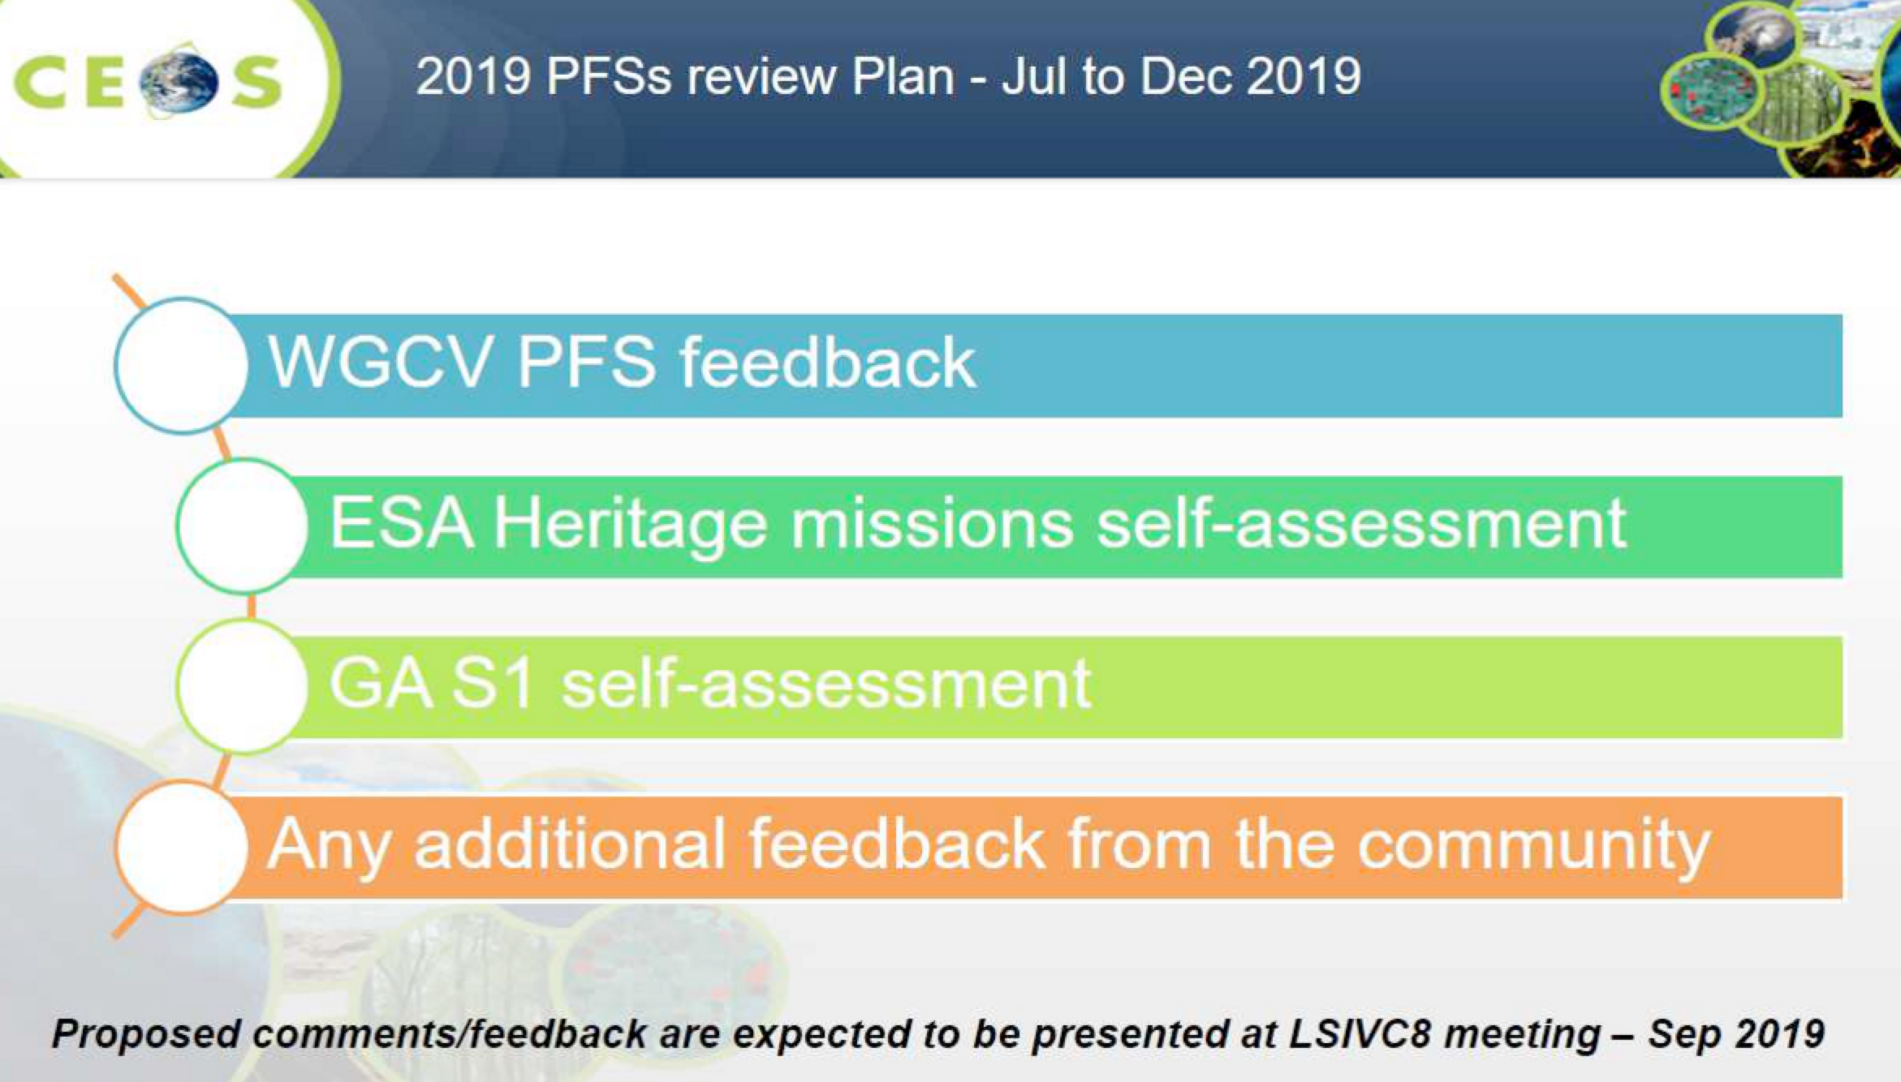
New Synthetic Aperture Radar PFS
Ake presented a summary of the status of these under development PFS:
- Geocoded Single-Look Complex (GSLC)
- Polarimetric Radar Decomposition (PRD)
- Polarimetric Radar Covariance Matrix (CoVar)
- Differential Interferometry Products (DInSAR)
  - Geocoded interferograms (wrapped / unwrapped)
  - Interferometric coherence
The new PFS were also presented at the recent WGCV SAR subgroup meeting in Buenos Aires. Overall reception to the CARD4L concept was positive, and the subgroup offered to review the documents. The reception from WGCV has changed from ‘why’ to ‘how can we make the specifications better’. There was a general caution to avoid over simplifying the products.
The expected number of users for these products decreases as you move down the above list, but it is hoped that NRB CARD4L will be a gateway that will introduce more users to the more advanced/specialised products. NRB is an important step in democratising the use of SAR.
Ake presented the following next steps:
- At least one sample dataset will be produced for each PFS by different members of the SAR Definition Team and these will be referenced in the PFS/linked on the CEOS ARD website.
- Standardisation of metadata requirements across the PFS and harmonising the metadata naming convention.
- The SAR PFS are still on a theoretical level, and it is expected that the sample products and self-assessments will reveal detailed feedback to be incorporated in future revisions.
- NRB v1.0 has been endorsed. Targeting other SAR PFS for endorsement at LSI-VC-8.
Broader CEOS ARD Strategy
Stephen Ward presented on the SIT Vice-Chair’s initiative on a broader CEOS ARD strategy. The objectives are specifically:
- Ensure continued relevance of public EO programme data and information, leveraging the availability of all relevant CEOS agency missions to meet user needs for information;
- Meet the changing expectations of the user base, which is increasingly non-technical and more accustomed to simplicity in geospatial data sourcing, integration and application;
- Establish a broad understanding of, and participation in, CEOS efforts to define, produce, and apply ARD in support of societal needs;
- Ensure effective engagement of the three key stakeholder groups: EO data providers (both public and private); Big Data hosts and aggregators who stage increasing amounts of CEOS agency free and open data; and data users;
- Manage expectations of all stakeholders as to the status and outlook for ARD availability – so that all might plan and invest with confidence in capabilities to best exploit the CEOS agency ARD;
- Establish priorities for which products and applications might follow on from the current land-specific PFS;
- Ensure appropriate organisational responsibilities across the CEOS structure for the definition and execution of the way forward on ARD.
There was a discussion around the paradigm shift that has taken place recently, with a huge increase in commercial and small satellites, often with radiometry and geometry that is not up to standard, and the use of smart processing and machine learning to harness the increased volume and velocity of data. CARD4 Machine Learning (CARD4ML) is perhaps a topic that needs further discussion within CEOS. Overall, there is hope that there is still a future for large, high quality, reference missions such as Landsat and Sentinel. Steve Labahn believes so, noting that Planet, for example, requires Landsat and Sentinel data as reference standards, and their stance has since shifted from competitiveness to complementarity.
Stephen stressed that the PFS alone are not enough to encourage change – data providers need to re-tool their data flows, Big Data distributors need to be engaged, and data users need to adapt their workflows to make the most of the benefits offered.
The SIT Vice-Chair (CSIRO/GA) has a draft action from CEOS Plenary regarding a broader CEOS ARD strategy to tackle these aspects and more (e.g., partnerships for CEOS, priorities for CEOS in promoting uptake, CARD4ML, roles within CEOS). Inputs will definitely be needed from LSI-VC and the SIT Vice-Chair Team will be in touch over the coming months.
Adam noted the strong sense of CARD4L ownership in LSI-VC, and we would want to see that continue, not be lost to another CEOS group through the emergence of a broader CEOS ARD strategy. LSI needs to discuss whether we want to take on CEOS ARD in general so we don't lose oversight of the work done to date on CARD4L.
It was suggested that the focus for CARD4ML should be on promoting the growth of industries using space data, allowing the industry to take off by covering the basics regarding access, usability, etc. CARD4ML will feature in the draft paper for SIT-34, and Stephen suggested that LSI-VC respond with comments/edits to the paper expected in the next few weeks.
LSI-VC-7-02 | Stephen to share the draft SIT-34 CEOS ARD Strategy paper with the LSI-VC team. | CLOSED
Session 3: CARD4L Product Assessments
ALOS/JERS Mosaics NRB Self-Assessment Review
Ake reviewed JAXA’s initial self-assessment of the ALOS/JERS annual mosaics against the NRB PFS and presented their findings. He noted that the general metadata requirements demonstrate the need for a defined standard format for the metadata. The NRB PFS team will address this in the next revision by suggesting a general format for the presentation of metadata to meet the requirements of the PFS.
A more comprehensive self-assessment will take place next Japanese financial year (April onwards) and Ake expects this assessment to be complete by the end of 2019.
Geoscience Australia SR Self-Assessment Outcomes
Medhavy presented outcomes from GA’s self-assessment undertaking. He reported that GA’s Landsat and Sentinel-2 SR products are not compliant with the threshold data access metadata requirements (currently discussing internally how this could be achieved) and also the spectral band information requirements. He noted that the CEOS MIM could be used as a reference for the latter. Steve Labahn noted that USGS will address this by adding a link to the DOI.
Medhavy reported that there are a number of things to resolve to make these products compliant with the Target requirements, and these are detailed in the presentation.
GA is planning to do intercomparisons between their Sentinel-2 ARD and the recently released Level-2A data from ESA (as already done for USGS Landsat ARD products). Their findings will influence their decision whether to use the ESA Level-2A products rather than generating their own (and therefore avoiding duplication of effort).
CARD4L Product Assessment Process
Andreia reviewed the product assessment process agreed at LSI-VC-6:
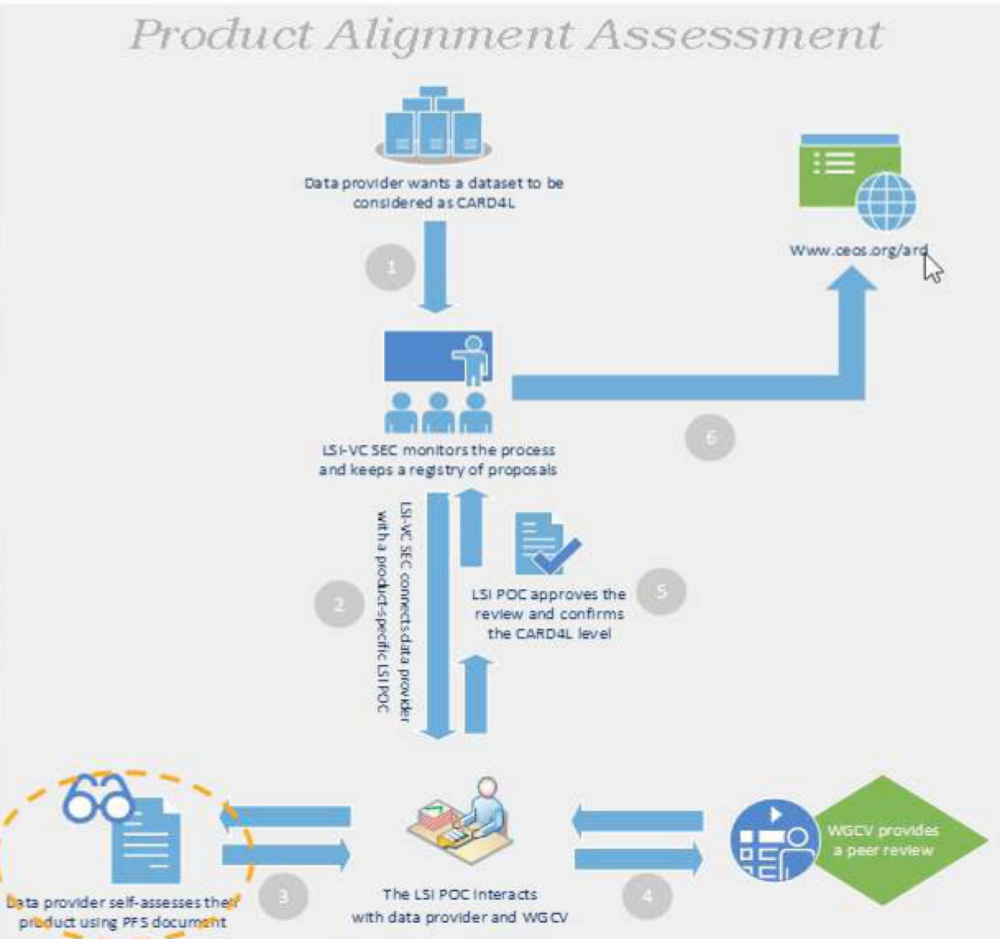
Andreia noted that ESA (Mirko Albani) will be undertaking self-assessments of select ESA heritage missions (ERS initially, with results planned for presentation at LSI-VC-8). She also recalled the JAXA, ESA, and USGS self-assessment pilots already undertaken. Feedback was used to improve the PFS and the current status of the CARD4L compliance of these products is summarised in the following chart:
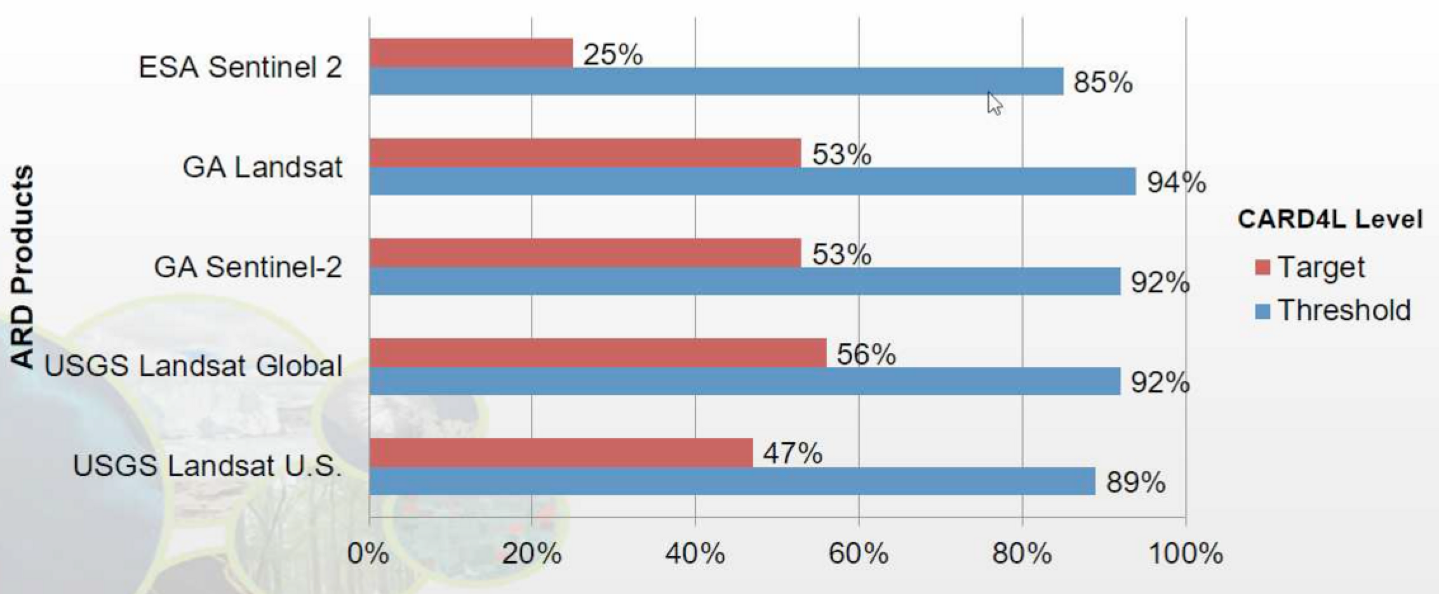
The next steps needed in regard to the product assessment process are:
- Agree the package of information to be provided by LSI-VC to data producers interested in undertaking a self-assessment of their ARD.
- Propose and endorse a standardised self-assessment process/guidelines/instructions for data producers.
- Agree the package of information that needs to be provided by data producers to WGCV for the peer review.
- Confirm POCs on the LSI-VC side for each of the PFS for the peer review process with WGCV.
- Initiate trial runs of the peer review process with WGCV.
LSI-VC-7-03 | Andreia to develop guidelines (i.e., instructions) to aid data providers with the self-assessment process. | ASAP
Andreia outlined the proposed contents of the two packages of materials to be provided to/by data producers for the assessment and peer review.
Decision 04 | The LSI-VC agreed the package of information to be provided by LSI-VC to data producers interested in undertaking a self-assessment of their ARD, as follows:  - CARD4L introduction: Description & Framework details.  - Self-assessment guidelines (i.e., instructions) (to be developed, see LSI-VC-7-03).  - Detailed self-assessment template (standardised).  - Summary self-assessment template (standardised).  - Directory location to upload required information.
Decision 05 | The LSI-VC agreed the package of information that needs to be provided by data producers to WGCV for the peer review, as follows:  - Completed detailed self-assessment template.  - Completed summary self-assessment template.  - Sample imagery data.  - Sample metadata.  - Contact details for the data producer’s point of contact.
Andreia confirmed that there will be multiple people (coordinated by a single POC) undertaking the peer reviews within WGCV, and they will be overseen by the WGCV POC (Medhavy Thankappan).
The timeline proposed for the WGCV pilot peer reviews was agreed to be too tight/ambitious. A follow up action was recorded in response:
LSI-VC-7-04 | Takeo and Ake to discuss the proposed schedule for WGCV peer review of the JAXA JERS/ALOS mosaic self-assessment and confer with Andreia. | ASAP
There was a discussion around the need to engage other CEOS Agencies and have them adopt the CARD4L concept and self-assess their products. Steve noted the recent efforts to connect with Chinese agencies as well as GISTDA.
Adam cautioned about advertising datasets as CARD4L when they are not yet fully assessed as at least meeting the threshold level of the PFS. The CARD4L dataset register in particular needs to be very clear regarding assessment status. Conversely, it was noted that some users might not be interested in datasets being 100% compliant, so there is perhaps still some value in advertising datasets that are partially compliant/on their way to being fully compliant.
Session 4: CEOS ARD Pilots & Promotion
2019 VAST-VNSC CEOS Chair Initiative
Dr Pham Thi Thanh Nga (VNSC) presented on the 2019 CEOS Chair Initiative. The initiative is built around the Vietnam Data Cube, which will benefit greatly from the availability of ARD. The initiative is focused on the development of Data Cube methodologies and products for forest and rice monitoring in the Mekong Delta region (covering Vietnam, Cambodia, Laos, and Thailand).
Open Data Cube
Brian Killough (NASA, SEO) presented an Open Data Cube (ODC) status update, noting again that ARD is critical to the success of the ODC initiative. The primary issue facing ODC users is the cost and complexity of producing ARD on their own.
Brian reported on the activities of the annual ODC Conference taking place this week in Canberra, Australia. Data interoperability is one of the foci for the development teams.
Brian recalled the engagement he has had with the Amazon Web Services Sentinel-1 ARD Working Group. One of the members (Sinergise) has offered to process all of the GRD data into a COG format gamma nought backscatter product, however the group needs guidance on the form of the backscatter product. Brian has supplied them with the NRB PFS in the hope it will be adopted as the specification for this data. Another member (e-geos) is also investigating the possibility of hosting SLC data in a 1-2 month global rolling archive on AWS. Both of these cases are a golden opportunity for uptake of CARD4L and the PFS by the broader community. Adam and Steve thanked Brian for his efforts with the AWS working group.
Zolti asked about Digital Earth Africa. Adam reported that GA have committed 10.4 Million USD over 3 years just this week, and a formal announcement and kick-off is expected in the next month. Zolti noted the European Commission’s interest in the project and suggested following up in due course.
Ake noted the Sentinel-1 backscatter and ALOS/JERS mosaics currently being offered by Google Earth Engine. The two datasets are hosted alongside one another, but in different units, which is not evident to users. The S-1 data is in dB, whereas the JAXA mosaics are in linear amplitude. This case highlights the importance of having the CARD4L specifications out and used as soon as possible.
ODC Conference and Partners’ Forum Outcomes
Stephen Ward reported briefly on the outcomes from the recent ODC Conference and Partners’ Forum. The 2019 ODC Conference included parallel strategy (Partners) and technical (developer coding sprint) threads. The Conference marked the availability of a Docker-based deployment (Cube in a Box), the Data Cube Applications Library (DCAL), and represents a maturity milestone for the ODC project overall. The Partners track agreed on a number of strategic priorities for ODC for the coming year including: availability and flows of Analysis Ready Data; industry engagement; and, the necessary resources to move ODC forward. ODC is also planning a significant User Conference in the March 2020 timeframe.
ARD availability will be a major factor moving forward, and the ODC implementations offer good opportunities for CARD4L supply and user access trials.
CARD4L Dataset Register and Infographic
Matt Steventon (LSI-VC Secretariat) presented two pieces of work that have been progressed over the last six months in the interest of better communicating the planned availability of CARD4L datasets:
The CARD4L Dataset Register, which is a catalogue of available CARD4L and where to access it, and which is expected to be updated as new datasets undergo assessment:
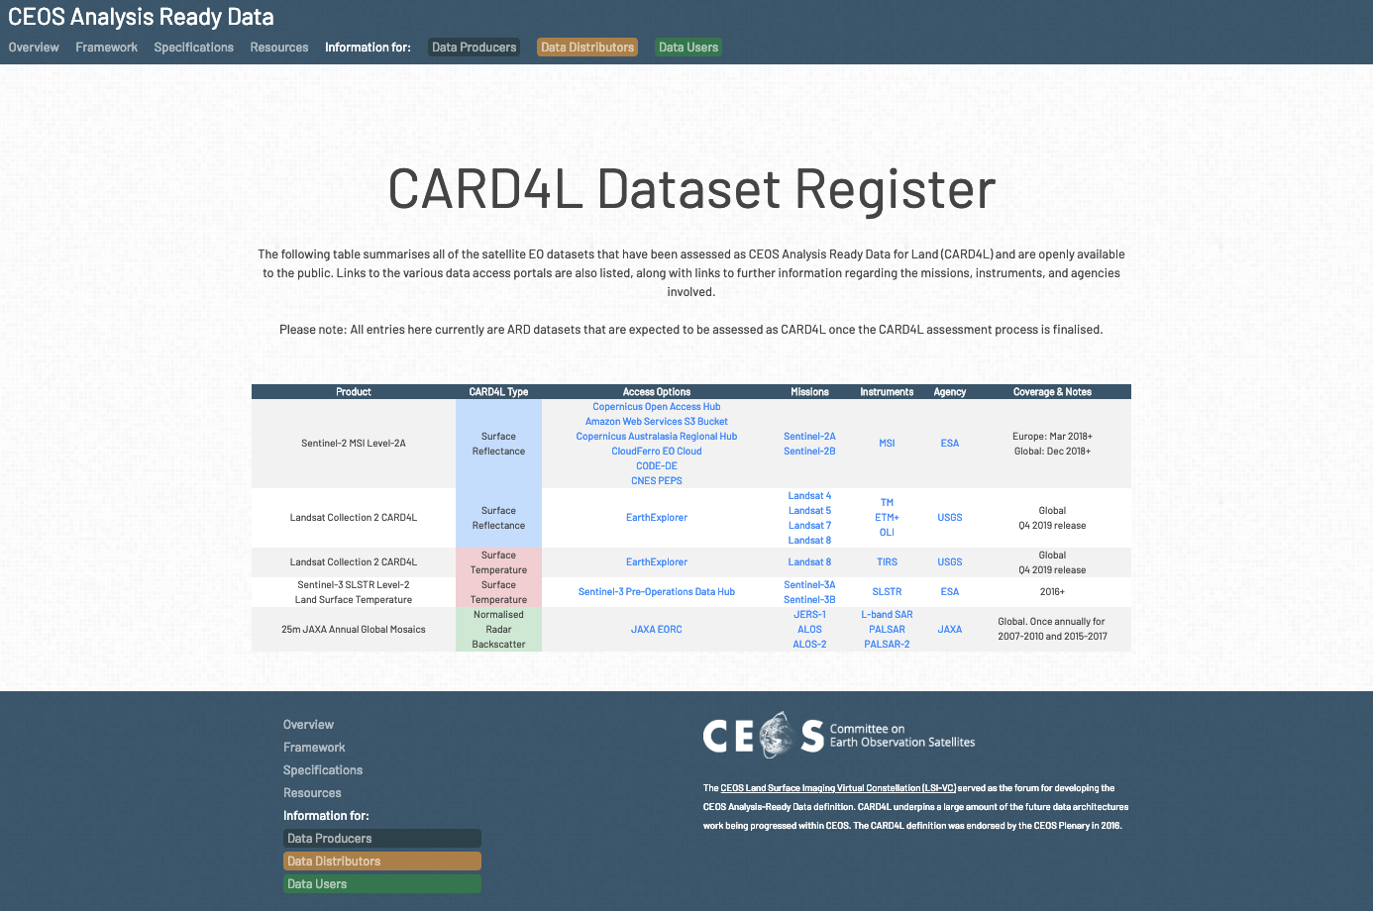
And, the CARD4L Infographic, which has been prepared as a promotional/outreach piece, presenting the information from the CARD4L Dataset Register along with an indication of the growth of CARD4L archives:
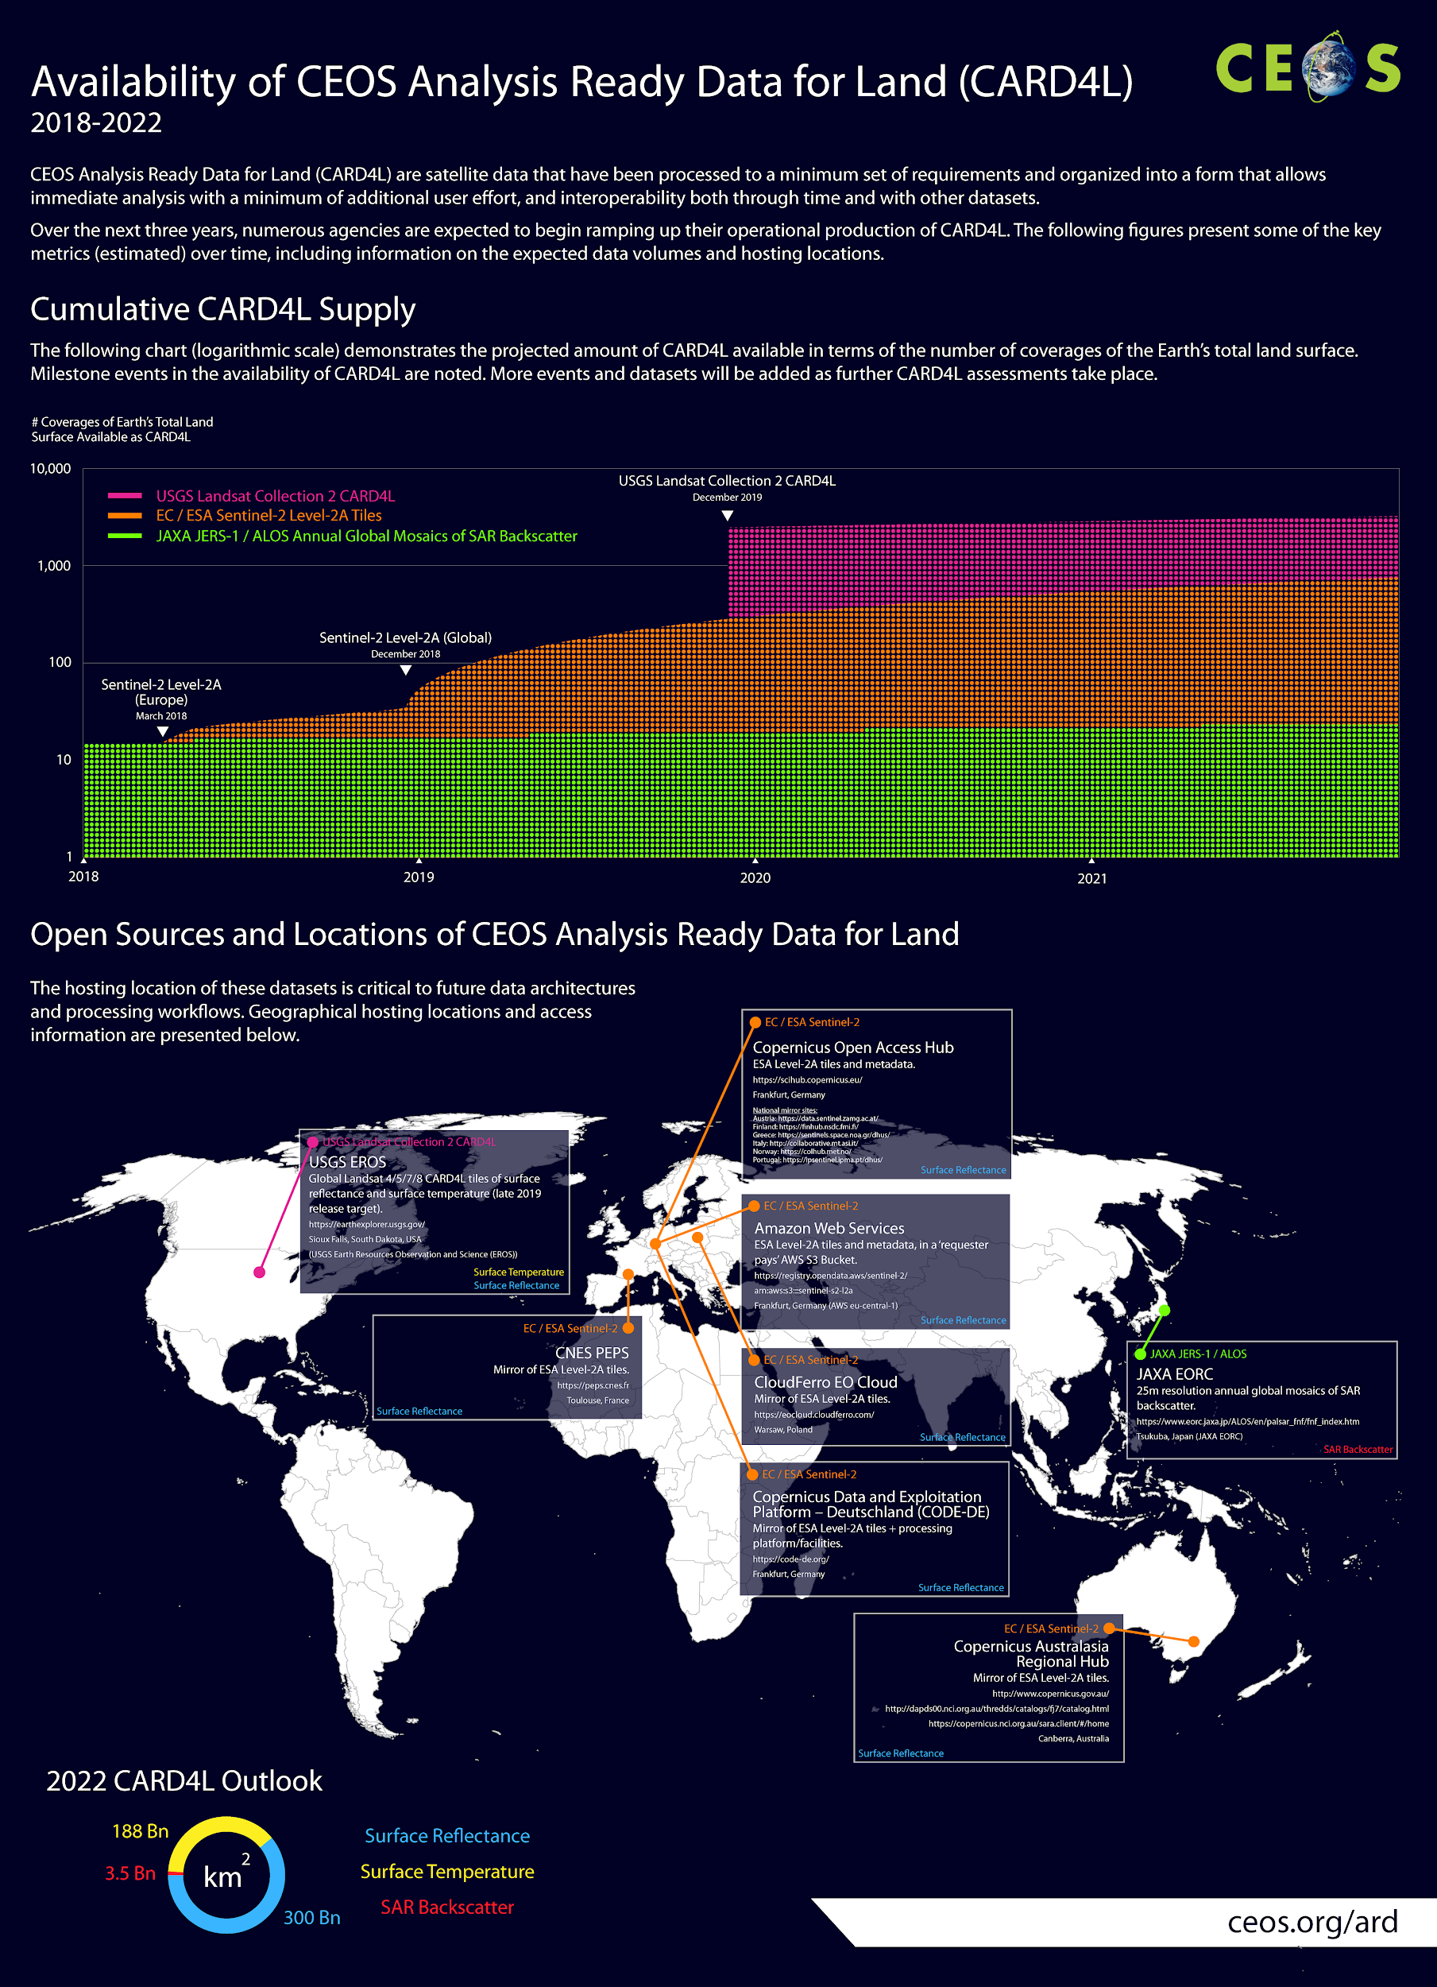
Matt also presented some thoughts arising from his work on these materials, regarding accessibility and usability, CARD4L on the horizon, and further initial candidates for CARD4L self-assessment.
A brief discussion followed, and the following decisions and actions resulted:
Decision 06 | The CARD4L Register was agreed as a useful catalogue of CARD4L datasets. It will remain unlinked from the main ceos.org/ard page until it is updated to show the four-step process of self-assessment and peer review, as well as the progress of each dataset along this process. There will be a clear delineation between datasets that are fully approved as CARD4L and those still in the assessment pipeline.
Decision 07 | Work on the CARD4L Infographic will be frozen for now, so as to not get too far ahead of the assessment process.
LSI-VC-7-05 | Matt to update the CARD4L Register (to remain unlinked for now) to show the four step process of self-assessment and peer review, as well as the progress of each dataset along this process. There should be a clear delineation between datasets that are fully approved as CARD4L and those still in the assessment pipeline. | ASAP
LSI-VC-7-06 | Matt to include a discussion item on the next call agenda regarding how to deal with partial CARD4L compliance of datasets. | March 21
Discussion on CEOS ARD Pilots & Promotion
A discussion was held on two key topics: CEOS ARD promotion and accessibility and usability.
It was noted that accessibility and usability will be features of the SIT Vice Chair’s Broader CEOS ARD Strategy, and it was suggested that LSI-VC should take the lead on the accessibility aspects, given that this is something we will need to tackle in the near future. The purpose of the PFS is to make data easier to use and in turn show more societal benefits. Unless we take the next step and ensure data is produced and supplied to users in an easy to access manner, these benefits will not be realised.
Adam presented the following areas of focus for LSI-VC regarding CARD4L going forward, covering the fundamentals of PFS development and product assessment through to promotion, communication, and uptake:
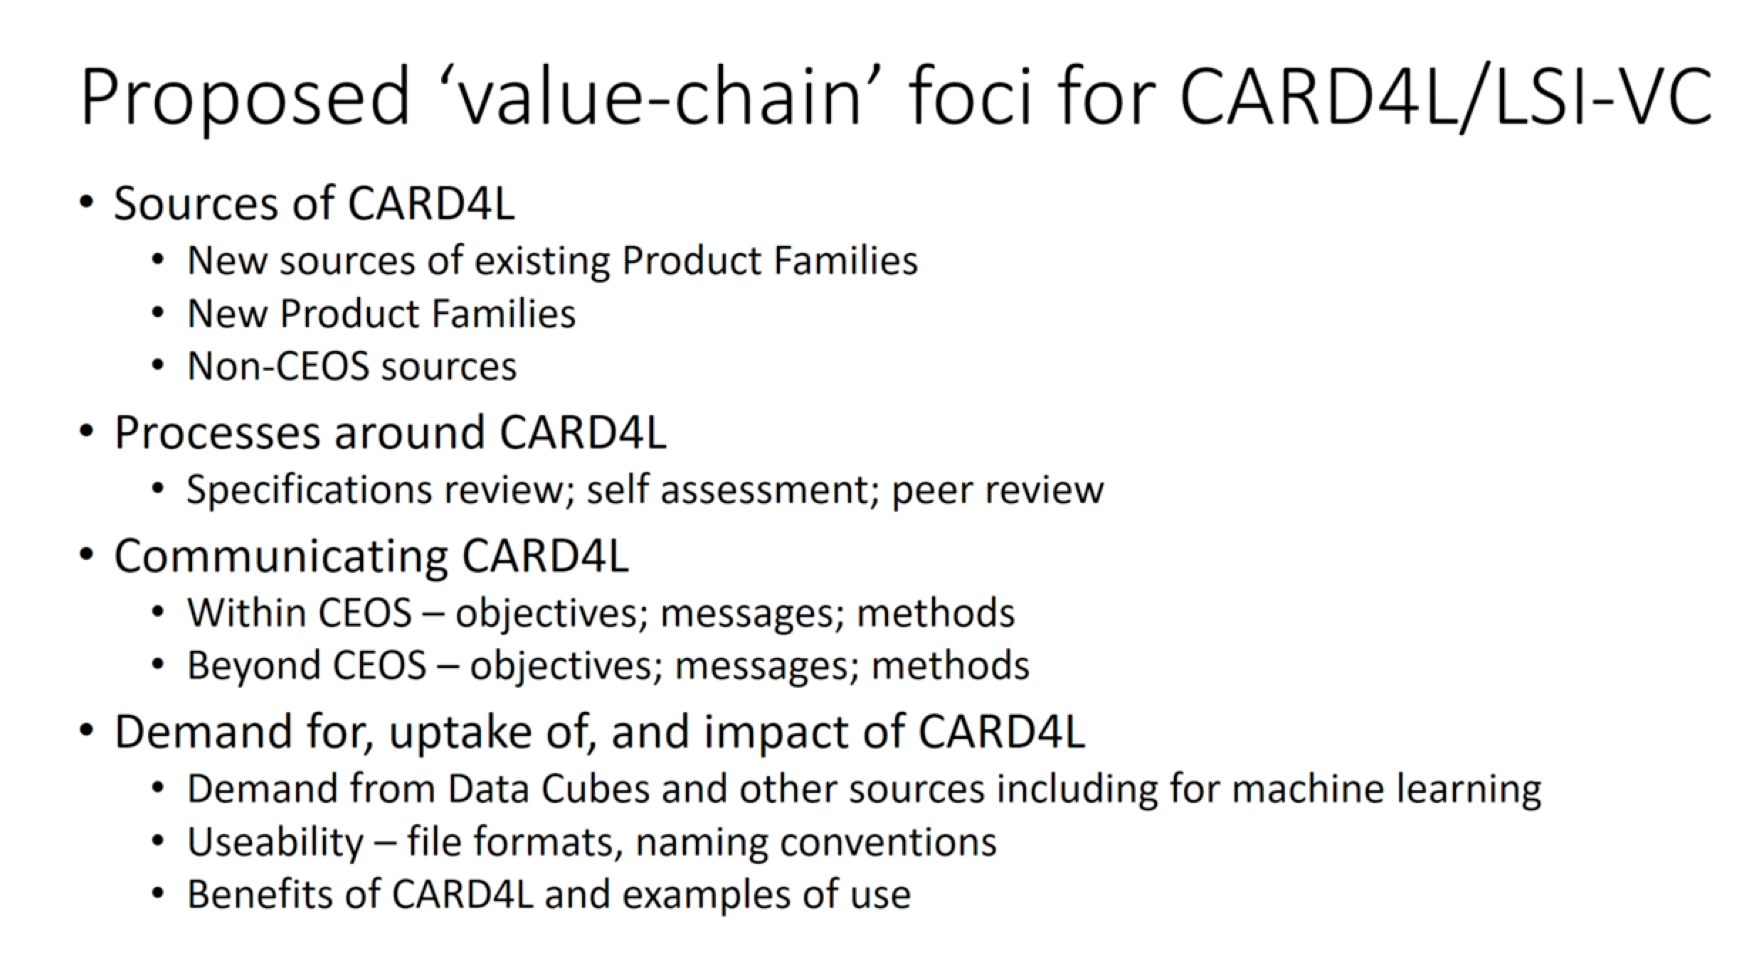
It was suggested that once ARD becomes ubiquitous, Big Data players and data aggregators will start pulling and serving ARD by default. For this to happen, space agencies will need to confirm demand from users for ARD, and to do this we should start by pushing data to these various global Big Data platforms on an agency by agency basis, as well as agency data portals. We should also focus on strong specific test cases, and populating Digital Earth Africa was agreed as a great focal point for such an effort, given its strong governance, coordination, and funding prospects.
NB: later in the meeting, an action was recorded to rewrite CEOS Work Plan Task VC-31 to refocus it on the use of Digital Earth Africa for CARD4L supply and user access trials.
LSI-VC-7-07 | All to provide Andreia additional ideas for the calendar (e.g., conferences, engagement opportunities). | ASAP
Session 5: Requirements and Gap Analyses
Adam opened the session by noting the recent proposal from the CEOS-GEOGLAM AHWG regarding a new CEOS Work Plan Task for LSI-VC:
AGRI-12: Characterize requirements and describe work plan for developing long-term interoperable moderate resolution surface reflectance (or NDVI) | Q1 2020 | A work plan will be established by LSI-VC and CEOS AHWG on GEOGLAM. This is not a task to develop the dataset itself! A requirement across multiple vegetation monitoring communities is long-term NDVI time series. With the data deluge resulting from Sentinel-2 and Landsat-8, there are ample opportunities to move this method into the moderate resolution domain. To maximize value, it should be made interoperable with historical observations in the 250-1000m resolution time series. | LSI-VC and CEOS AHWG on GEOGLAM
Adam suggested that this might be a good cross-cutting item that can bring together various threads:
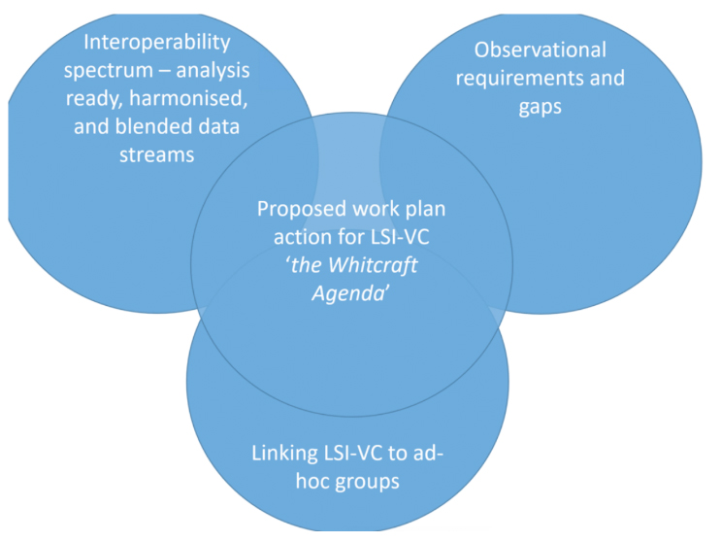
A very brief discussion followed. It was decided that we need more time to consider this proposal before it is included in the CEOS Work Plan as an LSI-VC responsibility. We need a clearer sense of responsibilities and resources before committing, and LSI-VC has put this item on hold until we are able to discuss it further. LSI-VC will suggest to the CEOS Executive Officer that LSI-VC be removed from this Task for now.
MIM Database API Demonstration
Matt presented the capabilities of the MIM Database API and made some suggestions regarding how this capability could be leveraged in service of LSI-VC gap analysis and observation requirement priorities. He presented the following mockup of a web-based front end for the API, which would let users create custom timelines, waveband plots, coverage maps, and access a Python Notebook environment for customised/advanced analysis.
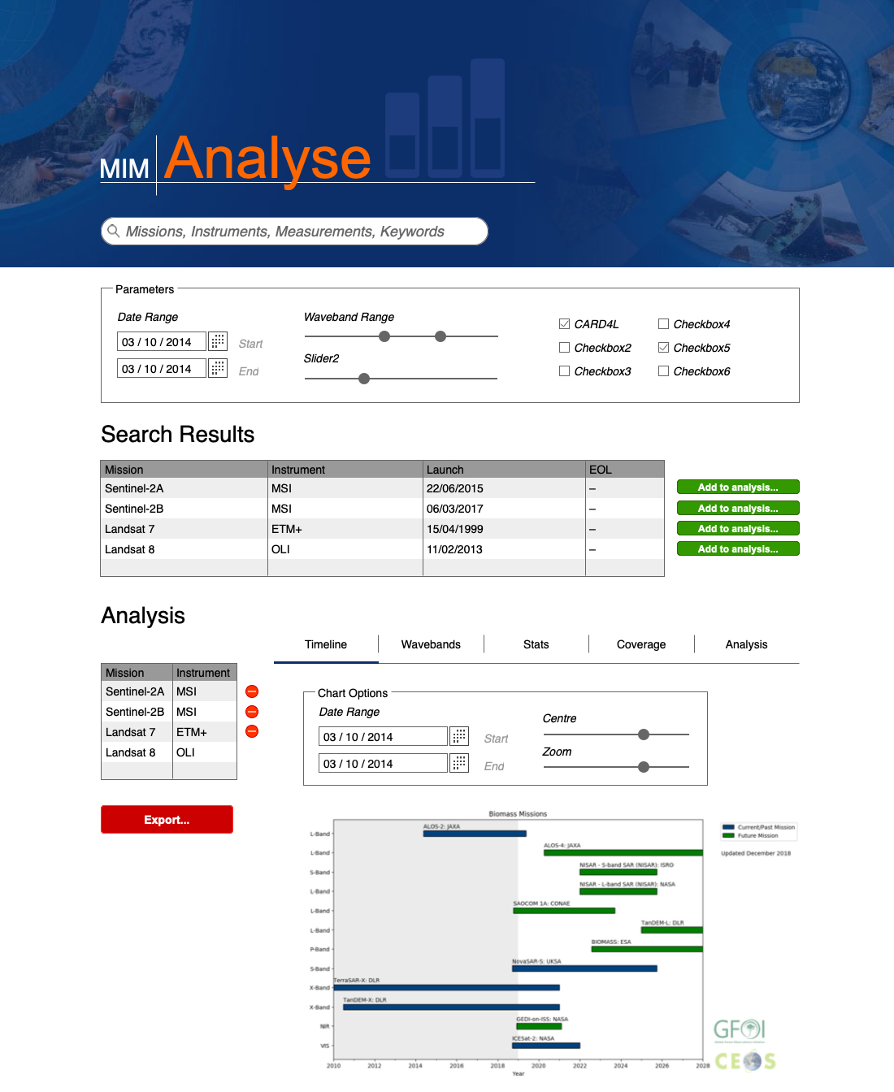
He closed by noting that the CEOS MIM team remains ready to support, but needs guidance from LSI-VC on the information CEOS needs regarding gaps and what would be useful in a companion web application for the API (e.g., gaps.eohandbook.com).
The meeting participants agreed to give further consideration to the requirements. It was noted that it would be helpful to add CARD4L flags to MIM Database mission/instrument entries where these datasets exist, as well as spectral response information for CARD4L missions/instruments.
Other CEOS Information System Tools for Gap Analysis
Brian Killough spoke about COVE and other CEOS information system tools for gap analysis. He noted the need to restrict the scope of these tools, as there are countless possible variables, which makes broad gap analyses (and providing tools to do them) very difficult.
Brian presented some example questions that users have approached the SEO with for support. Coverage questions are common, as well as questions around wavebands, measurements, future capabilities, and gaps (e.g., SLI study).
The MIM Database API will give CEOS a lot of functionality, and an easy to use, LSI-tailored UI/web interface could be a good output for LSI-VC to target. Bridging the gap between user requirements and the information in the MIM Database could be a good role for LSI-VC.
MIM and COVE could be used together to answer, for example, the question posed by the CEOS-GEOGLAM AHWG (i.e., AGRI-12).

Friday February 15th

Session 6: LSI-VC and CEOS Organisational Matters

Proposed Merger of SDCG-GFOI and CEOS-GEOGLAM into LSI-VC
Jenn reviewed the history of this topic and the current status. She noted the scrutiny of ad hoc team life cycles by the SIT Chair Team and the push to find permanent homes for the activities of the SDCG for GFOI and CEOS AHWG on GEOGLAM. Given our existing collaboration with these groups, the proposal accepted by the Leads of the groups (and presented at CEOS Plenary 2018) has been to merge these groups into LSI-VC organisationally, while also maintaining their independence and links to the end-user community. The other options (e.g., new WG) are not acceptable as they impose additional requirements regarding CEOS meeting representation, funding, etc., which would hinder the activity of SDCG-GFOI (for example).
Jenn noted that there was a lack of clarity coming out of CEOS Plenary regarding support for the merger proposal. A CEOS Plenary action was recorded for LSI-VC, SDCG, and CEOS-GEOGLAM to present a draft plan for the way forward at SIT-34. Jenn suggested coming to the meeting with a revised terms of reference also to demonstrate how the merge will be carried out in practice – this would give some clarity and context. Adam supported the idea. It was suggested that the terms of reference could also outline the approach for future inclusion of new thematic subgroups (e.g., biodiversity). Jenn added that there is another action for all VCs to consider their leadership terms, so the timing of the terms of reference revision is convenient.
A few options for the leadership rotation were discussed – the leading idea being that one of the Co-Lead positions be up for nomination each year, and should someone be interested in serving as a Lead they will take over the role at the following face-to-face meeting. This rotation would be staggered, resulting in, at a minimum, Lead terms of three years (though this would not be forced).
Chuck Wooldridge (NOAA, SIT Chair Team) noted that LSI-VC is seen as successful and engaged, and the pushback on the plan is not a reflection on LSI-VC but instead part of a broader re-think about the CEOS organisational structure, and also a desire to not see LSI-VC become overloaded by taking on too many responsibilities.
Jenn has reviewed the terms of reference and identified where changes would be necessary. She presented these findings to the group. It was suggested that the scope be expanded to cover SDCG-GFOI and CEOS-GEOGLAM in generic terms, allowing further subgroups to be added in future if needed. It was agreed that the Implementation Horizon section be removed, while making sure the key points from the Implementation Horizon are reflected in the objectives.
It was agreed that a small writing team take over for the next few weeks to update the terms of reference by the end of the month. A teleconference of this team will be held next week, and all are welcome to attend. The following initial responsibilities were noted:
- Adam will take on the incorporation of the key Implementation Horizon table points into the objectives.
- Dave will do a first draft of the leadership paragraph.
- Stephen Ward and Jenn (with Tom Maiersperger) will input from the SDCG-GFOI perspective.
- The CEOS-GEOGLAM Leads will be invited to input from their perspective.
LSI-VC-7-08 | Matt to arrange a call for next week (target Wednesday) to kick-off the terms of reference revision. | COMPLETE
LSI-VC-7-09 | Matt to set up a Google Doc for the terms of reference revision. | COMPLETE
LSI-VC-7-10 | Matt to request a SIT-34 side meeting on the LSI-VC terms of reference update. | COMPLETE

Session 7: Moderate Resolution Interoperability (MRI)

Landsat – Sentinel-2 Interoperability Progress

NASA Harmonized Landsat/Sentinel-2 (HLS)
Jeff Masek presented on the Harmonized Landsat/Sentinel-2 (HLS) project and presented some results and validation work. NASA’s Earth Science Data Systems is planning to support global HLS implementation beginning in 2020. HLS product need was documented by the U.S. Interagency Satellite Needs Working Group. Processing will migrate to a US Government data system in the near future.
Jeff also noted that NASA is keen to work more closely with ESA on the cloud masking aspects. Ferran encouraged all to get involved in CMIX. Medhavy noted that GA is now in a position to join.
LSI-VC-7-11 | Jeff to share his slides from a past Pecora meeting regarding lessons learned on Sentinel-2 and Landsat interoperability. | ASAP
Ferran asked which BRDF method will be selected for the global product. Jeff reported that the plan is to offer both, giving users the choice. He is unsure whether they will offer on-demand processing or systematically produce two different products.

Landsat-S2 ARD Interoperability Working Group
Ferran presented the outcomes of this ESA-USGS bilateral work, which is being carried out as an MRI Framework case study. The joint work covers: MRI terminology, geometry, and radiometry (TOA & BOA). The terminology work is being carried out in response to LSI-VC’s CEOS Work Plan task. Ferran showed the draft definitions for the following terms as well as an ‘interoperability spectrum’ diagram.
- Analysis Ready Data (ARD)
- Interoperable Products
- Harmonised Products
- Fused Products
- CEOS ARD for Land (CARD4L) Products
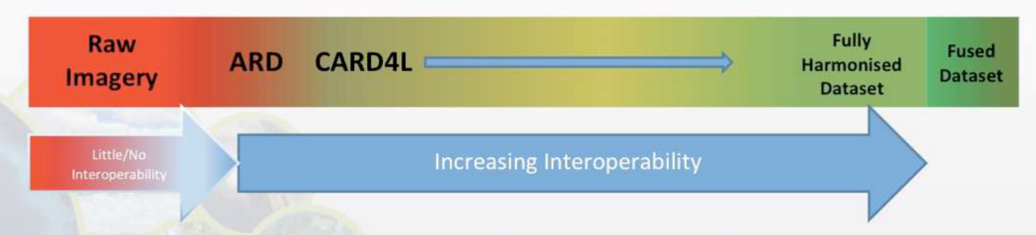
A discussion followed on the spectrum and whether the inclusion of both ARD and CARD4L is appropriate. It was suggested that it is perhaps confusing to have both ARD and CARD4L on this spectrum, and that maybe the spectrum should be exclusively from the CEOS perspective.
It was noted that the definitions in the presentation have only been defined bilaterally by ESA and USGS at this stage, and when they go out to LSI-VC for review, everyone needs to contribute their agencies’ perspectives also.
LSI-VC-7-12 | Ferran/Steve to share the draft MRI terminology definitions and spectrum diagram with the team for review, feedback, and eventual LSI-VC endorsement. The definitions will be posted on the LSI-VC website once complete. | COMPLETE
Copernicus DEM
Ferran presented on the procurement of the Copernicus DEM, which is expected to be available by mid-2019. A DEM Intercomparison eXercise (DEMIX) will be organised. USGS is participating in discussions with ESA regarding exercising options for a high-quality, redistributable, global DEM.
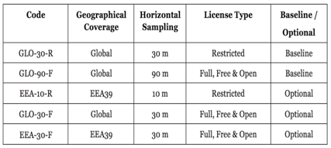
Adam suggested that a contribution from GA to exercise the GLO-30-F option could be a possibility, and he will follow up with Steve and Ferran. Ferran noted that this will be an option at any point during the contract, and ESA are open to further discussions regarding co-funding opportunities.
Steve added that if the 90m full, free, and open option is better than SRTM, the plan is to use it for Landsat Collection 2 (if the timing works). There is also interest in the 30m product if it will result in a significant improvement to the Landsat offering. Ake noted that the 90m full, free, and open Copernicus DEM would be a better option than SRTM, which is now 15 years old.

Future MRI Activities
Ferran presented the following proposals for new MRI activities:
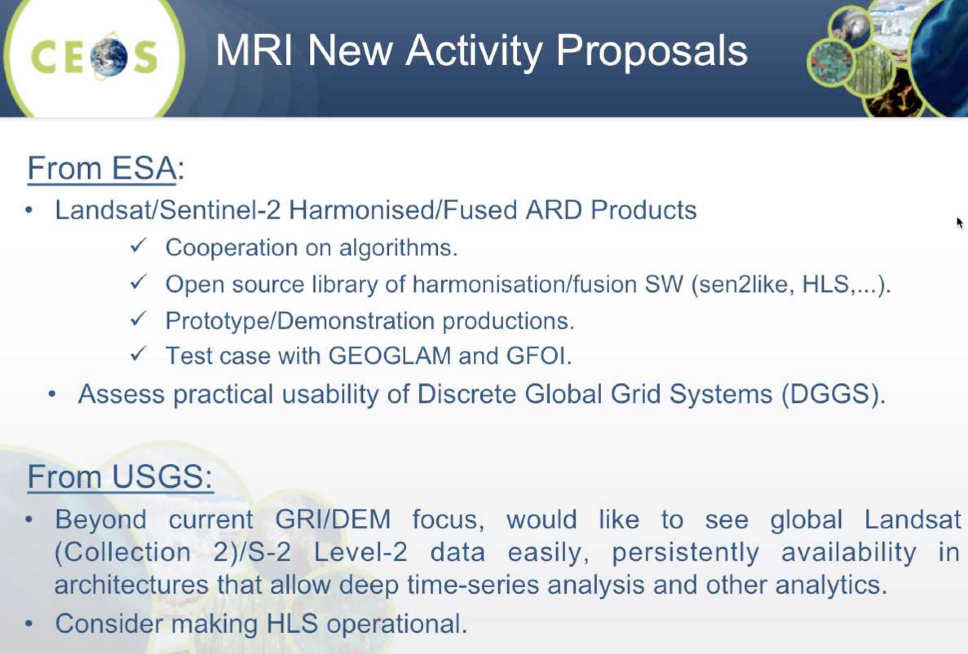

In addition to the proposals presented above, Steve noted that accessibility is a key area USGS wish to work with ESA on through their bilateral arrangement. Stephen asked Steve what LSI-VC might do on CARD4L accessibility aspects. It was agreed that Digital Earth Africa is a good focal point for demonstrations of CARD4L supply, accessibility, and usability. Zolti noted that EC would likely also be supportive of such an effort.
LSI-VC-7-13 | LSI-VC Leads to confer on the rewording of CEOS Work Plan Task VC-31 (including specific desired outcomes) to refocus it on the use of Digital Earth Africa for data supply and user access trials – in relation to coordination on CARD4L accessibility. | COMPLETE
Steve closed the session noting that the ESA-USGS bilateral effort is the extent of USGS’s ability to engage on MRI at the moment. Expanding LSI-VC’s MRI efforts beyond this bilateral will require more resources and participation from other agencies.
Session 8: Agency Reports
The following agency reports were presented:
- ESA (Ferran Gascon)  - EC (Zoltan Szantoi)  - JAXA (Takeo Tadono)  - GA (Medhavy Thankappan)  - CSA (Yves Crevier) | - UKSA (Asimina Syriou)  - USGS (Steve Labahn)  - NOAA (Chuck Wooldridge)  - GISTDA (Sararak Tanarat)

The following points were some of those raised during the brief discussions following each of the presentations:
- JAXA should consider CARD4L as a standard output product from the planned re-processing of the ALOS archive.
- The 1996-2013 Radarsat worldwide archive will be opened soon, possibly in 2019. This will be done in stages/batches.
- CSA is targeting the production of CARD4L-compliant radar data.
- Environment and Climate Change Canada have a proprietary Data Cube that was developed in-house. CARD4L is needed to feed this system.
- UKSA has SPOT 1-5 ARD in the pipeline. The University of Geneva will be responsible for producing the data. Sentinel-1, Sentinel-2, Landsat, and SPOT data will be used for the UK’s Data Cube projects.
- Sararak indicated that GISTDA are keen to do CARD4L self-assessments for some of their products.
LSI-VC-7-14 | Zolti to follow up the framework contract manager at JRC (Nadine Gobron) on the possible assessment of the Sentinel-2 Global Mosaic product as CARD4L. | COMPLETE  JRC will ask the Lot2 contractor to evaluate the GM products against the SR PFS.
LSI-VC-7-15 | Steve to share the USGS report comparing file formats (e.g., COG, JPEG2000). | COMPLETE
Session 9: Global Data Flows Discussion
Stephen Ward opened the discussion session with a presentation. He noted that standardisation (i.e., ARD) is a solid first step towards the ease of use and interoperability for government EO data, but we need to look forward to ensure that the full benefits of ARD are realised and that CEOS agencies are competitive in terms of ease of access, application, and mixing of data. Industry thought leaders (e.g., Planet) are making good progress towards a ‘post-scene’ world (e.g., Cloud Optimized GeoTIFFs on object stores like Amazon Web Services S3; SpatioTemporal Asset Catalog specifications) to harness the rapid increase in data volumes.
Some questions were presented for CEOS consideration:
- Where are our large data holdings?
- In what format?
- How are they accessible?
- What obstacles do users face in mixing our various CARD4L datasets?
Noting that ESA has suggested an open-source library for the generation of CARD4L surface reflectance fused/harmonised products, Stephen asked whether we could have target outputs of Cloud Optimized GeoTIFFs (COGs) and SpatioTemporal Asset Catalogs (STACs) to support user access and usability in a post-scene future.
Stephen noted that LSI-VC agency data are being re-hosted and distributed by big data aggregators, and suggested that CEOS should be proactive in encouraging the hosting of CARD4L datasets and work with these aggregators on formats and access. The SIT Vice-Chair’s Broader CEOS ARD Strategy will cover these aspects.
Stephen asked everyone to consider what should be done by LSI-VC in regard to improving the supply, accessibility, and usability of CARD4L going forward, noting the previously agreed Digital Earth Africa trial is an ideal first step. This trial will give us the opportunity to gather information regarding the barriers to data supply, accessibility, and use.
It was agreed that we also need to keep the commercial thought leaders (e.g., Planet) on board with CARD4L. A second ARD/STAC workshop to follow up the August 2018 workshop was reported to be in planning. CEOS/LSI-VC attendance should be prioritised.
LSI-VC-7-16 | Ferran to contact Ignacio regarding a follow up to the August 2018 Planet ARD + STAC workshop. A data accessibility angle for a second workshop would be good. | Planned for August 5-7: https://www.linkedin.com/feed/update/urn:li:activity:6507674107105148928/
Session 10: Closing
CEOS Work Plan Review
Steven Hosford (ESA/CNES, CEO) presented a summary of the 2019-2021 CEOS Work Plan and the outstanding inputs needed from the LSI-VC. A review of each LSI-VC CEOS Work Plan Task/Deliverable was conducted, and the following required changes/notes were recorded:
- VC-30: This activity is related to, but broader than, the interoperability case study being conducted by LSI-VC (USGS and ESA). At this point it is not clear what resources will be available for this work, hence there is no party identified as responsible. It was agreed that this action be halted for now.
- VC-31: Adam Lewis/GA was nominated as the lead, and Q4 2019 was confirmed as the due date. The action will be rewritten to focus on the use of Digital Earth Africa for data supply and user access trials, as per LSI-VC-7-13.
- VC-33: Completed for this year, but we will retain it for visibility of the ongoing work.
- VC-XX: Pilot approaches to conducting integrated assessments of gaps/opportunities in mission measurements:
  - This is a new action and hence unnumbered for now.
  - There is no lead name/agency associated with this action.
  - This action will be frozen as there is no lead identified and it is awaiting the outcome of VC-37 before commencing.
- Steve Labahn was added as the lead of the (currently unnumbered) 'MRI definition' task. The title was revised to make it shorter (target terms were moved to the description).

LSI-VC-8 and the Next Joint Meeting
It was reported that the SIT Chair is considering moving the 2019 SIT Technical Workshop (second week of September) to Fairbanks, Alaska. If this change occurs, Jenn suggested that LSI-VC-8 and the LSI/SDCG/GEOGLAM Joint Meeting take place the week before (September 3-6) in Anchorage. Jenn reported that she should be able to arrange meeting space in Anchorage through USGS, and will follow up in due course.
Review of Actions
Matt Steventon reviewed the meeting actions and made changes as necessary. The following action was also added to the record:
LSI-VC-7-17 | Ake to prepare a discussion around a standardised metadata file format (might be applicable only to the SAR PFS). Matt to include an item on the agenda for the next team teleconference. | March 21
Wrap-up & Closing
Adam Lewis closed the meeting, and thanked VAST-VNSC again for hosting. He added that both VNSC and GISTDA should feel welcome to join our meetings again in the future. He commended everyone for their excellent work on the PFS and recalled that the next step is for us to consider CARD4L supply, accessibility, and usability, so that all of the potential benefits are realised. Steve Labahn thanked everyone for joining, especially Ferran for standing in for Susanne Mecklenburg as the ESA Lead.

APPENDIX A
Attendees

Organisation | Name
CSA | Yves Crevier
EC/JRC | Zoltan Szantoi
ESA | Ferran Gascon
ESA/CNES | Steven Hosford*
ESA (LSI SEC) | Stephen Ward
ESA (LSI SEC) | Matt Steventon
GA | Adam Lewis
GA | Andreia Siqueira
GA | Medhavy Thankappan
GISTDA | Sararak Tanarat
JAXA | Takeo Tadono
JAXA | Ake Rosenqvist
NASA | Dave Jarrett
NASA | Jeff Masek*
NASA/SEO | Brian Killough*
UK Catapult | Asimina Syriou
USGS | Jenn Lacey
USGS | Steve Labahn
VNSC | Pham Thi Thanh Nga
VNSC | Nguyen Tien Cong
VNSC | Linh Phan
* indicates remote attendance

APPENDIX B
Actions & Decisions Record

LSI-VC-7-01 | Zolti to connect Nadine Gobron (EC/JRC) with Andreia regarding participation in the SAR PFS Definition Team and the S-1 Global Backscatter Mosaic. | COMPLETE  JRC will consider the radar related PFS once the S-1 global mosaic tender takes place.
LSI-VC-7-02 | Stephen to share the draft SIT-34 CEOS ARD Strategy paper with the LSI-VC team. | CLOSED
LSI-VC-7-03 | Andreia to develop guidelines (i.e., instructions) to aid data providers with the self-assessment process. | ASAP
LSI-VC-7-04 | Takeo and Ake to discuss the proposed schedule for WGCV peer review of the JAXA JERS/ALOS mosaic self-assessment and confer with Andreia. | ASAP
LSI-VC-7-05 | Matt to update the CARD4L Register (to remain unlinked for now) to show the four step process of self-assessment and peer review, as well as the progress of each dataset along this process. There should be a clear delineation between datasets that are fully approved as CARD4L and those still in the assessment pipeline. | ASAP
LSI-VC-7-06 | Matt to include a discussion item on the next call agenda regarding how to deal with partial CARD4L compliance of datasets. | March 21
LSI-VC-7-07 | All to provide Andreia additional ideas for the calendar (e.g., conferences, engagement opportunities). | ASAP
LSI-VC-7-08 | Matt to arrange a call for next week (target Wednesday) to kick-off the terms of reference revision. | COMPLETE
LSI-VC-7-09 | Matt to set up a Google Doc for the terms of reference revision. | COMPLETE
LSI-VC-7-10 | Matt to request a SIT-34 side meeting on the LSI-VC terms of reference update. | COMPLETE
LSI-VC-7-11 | Jeff to share his slides from a past Pecora meeting regarding lessons learned on Sentinel-2 and Landsat interoperability. | ASAP
LSI-VC-7-12 | Ferran/Steve to share the draft MRI terminology definitions and spectrum diagram with the team for review, feedback, and eventual LSI-VC endorsement. The definitions will be posted on the LSI-VC website once complete. | COMPLETE
LSI-VC-7-13 | LSI-VC Leads to confer on the rewording of CEOS Work Plan Task VC-31 (including specific desired outcomes) to refocus it on the use of Digital Earth Africa for data supply and user access trials – in relation to coordination on CARD4L accessibility. | COMPLETE
LSI-VC-7-14 | Zolti to follow up the framework contract manager at JRC (Nadine Gobron) on the possible assessment of the Sentinel-2 Global Mosaic product as CARD4L. | COMPLETE  JRC will ask the Lot2 contractor to evaluate the GM products against the SR PFS.
LSI-VC-7-15 | Steve to share the USGS report comparing file formats (e.g., COG, JPEG2000). | COMPLETE
LSI-VC-7-16 | Ferran to contact Ignacio regarding a follow up to the August 2018 Planet ARD + STAC workshop. A data accessibility angle for a second workshop would be good. | Planned for August 5-7: https://www.linkedin.com/feed/update/urn:li:activity:6507674107105148928/
LSI-VC-7-17 | Ake to prepare a discussion around a standardised metadata file format (might be applicable only to the SAR PFS). Matt to include an item on the agenda for the next team teleconference. | March 21

Decision 01 | The LSI-VC endorsed the Normalised Radar Backscatter Product Family Specification.
Decision 02 | The LSI-VC endorsed the Surface Reflectance Product Family Specification.
Decision 03 | The LSI-VC endorsed the Land Surface Temperature Product Family Specification.
Decision 04 | The LSI-VC agreed the package of information to be provided by LSI-VC to data producers interested in undertaking a self-assessment of their ARD, as follows:  - CARD4L introduction: Description & Framework details.  - Self-assessment guidelines (i.e., instructions) (to be developed, see LSI-VC-7-03).  - Detailed self-assessment template (standardised).  - Summary self-assessment template (standardised).  - Directory location to upload required information.
Decision 05 | The LSI-VC agreed the package of information that needs to be provided by data producers to WGCV for the peer review, as follows:  - Completed detailed self-assessment template.  - Completed summary self-assessment template.  - Sample imagery data.  - Sample metadata.  - Contact details for the data producer’s point of contact.
Decision 06 | The CARD4L Register was agreed as a useful catalogue of CARD4L datasets. It will remain unlinked from the main ceos.org/ard page until it is updated to show the four-step process of self-assessment and peer review, as well as the progress of each dataset along this process. There will be a clear delineation between datasets that are fully approved as CARD4L and those still in the assessment pipeline.
Decision 07 | Work on the CARD4L Infographic will be frozen for now, so as to not get too far ahead of the assessment process.

