MINUTES OF THE 8th MEETING OF THE CEOS
LAND SURFACE IMAGING VIRTUAL CONSTELLATION (LSI-VC)

4–6 September 2019
Anchorage, AK, USA

Key Outcomes
- It was agreed that partial compliance of CARD4L datasets will be accommodated. The self-assessment summary tables will be available alongside references to the datasets on CEOS materials and the ARD website so users can assess the applicability of the dataset to their application despite the lack of full CARD4L compliance. Sample products (those submitted for the CARD4L assessment process) will be posted on the CEOS ARD website and elsewhere alongside references to CARD4L datasets.
- KARI (Korea) joined the meeting for the first time. They are assessing their products against CARD4L and producing some initial ARD based on CARD4L with sub-10m data from KOMPSAT.
- The CEOS ARD Strategy was discussed. LSI-VC contributions and supporting actions were agreed. In particular, the CEOS–Industry ARD Workshop is being scoped and LSI-VC will connect with WGCV and WGISS on the CEOS Interoperability Terminology Report and standardisation topics.
- The meeting dynamic with SDCG-GFOI and the CEOS-GEOGLAM AHWG is working well. LSI-VC took on actions to contribute to the work of the SDCG-GFOI and CEOS-GEOGLAM AHWG, and vice-versa. It was agreed that the SDCG-GFOI and CEOS-GEOGLAM AHWG will propose to become the LSI-VC Forests and Biomass and GEOGLAM subgroups (respectively) at the 2019 SIT Technical Workshop.
- Dr. Zoltan Szantoi (European Commission) was nominated to succeed Dr. Susanne Mecklenburg (ESA) as an LSI-VC Co-Lead.
- The joint session with WGClimate resulted in the LSI-VC agreeing to undertake two actions from the WGClimate Coordinated Action Plan (around LST Climate Data Records and continuity). This is a positive step forward on the LSI-VC requirements and gap analysis thread, and a new CEOS Work Plan Task will be suggested in response.

Wednesday September 4th

Session 1:​ Welcome and Introductions

Welcome and Introductions
Steve Labahn (USGS, LSI-VC Co-Lead) welcomed the group to Alaska and to LSI-VC-8. He noted this is the first time running a single-threaded joint meeting.
There was a tour de table of introductions. The complete attendance list is attached in Appendix A.
Alyssa Whitcraft (GEOGLAM) sees LSI-VC as the logical home for the two thematic groups. She welcomes the opportunity to have these very productive joint meetings.
Steve Labahn noted that recent discussions of the Working Group Study Team seem to indicate that there will be no change to the CEOS structure as a result. The LSI-VC, SDCG-GFOI and CEOS-GEOGLAM AHWG merger remains the preferred approach.
Stephen Ward (SDCG Secretariat) noted the strong emphasis of the 2020-2021 SIT Chair on CEOS ARD and LSI-VC support. The CSIRO/GA strategy was written to help support LSI-VC and take the concept of CEOS ARD to the next level.
Steven Hosford (ESA/CNES, CEO) reported that Philippe Maisongrande (CNES, CEOS-GEOGLAM AHWG Co-Lead) is looking to become more engaged in GEOGLAM going forward, having now cleared some existing commitments.
Stephen Ward reported that the SDCG Exec met yesterday to discuss the new SDCG Work Plan, the way forward, and to brief Chris Barber (USGS, SDCG Co-Lead) before his first meeting. Chris will provide a good bridge between CEOS and the GFOI Capacity Building Component (run by SilvaCarbon, which is also led by USGS). This linkage should be quite useful, in particular in support of CEOS ARD pilots.

Action Review
Matt Steventon (LSI-VC Secretariat) reviewed the action status from LSI-VC-7 and the 2018 Joint Meeting.
LSI-VC-8-01 | Zolti to follow up the possibility of assessing the EC Sentinel-1 and Sentinel-2 global mosaic products as CARD4L. | ASAP
There is a need to differentiate between the validation of ARD datasets versus processing chains; these two things are not the same. CARD4L does provide for an uncertainty assessment which is intended to address the quality of datasets. This topic will be addressed later in the meeting.
The Harmonized Landsat/Sentinel-2 (HLS) dataset is a good candidate for a CARD4L self-assessment. The timing is good as a global dataset is being developed.

Session 2: CARD4L Product Family Specifications (PFS)

Status and Outlook for the PFS
Andreia Siqueira (GA) reviewed the history of CARD4L development, CARD4L status, SAR PFS team activities and involvement, and the annual review cycle for the PFS. Updates will be presented for endorsement next at LSI-VC-9 (March 2020). Feedback on the PFS was received from WGCV earlier this year, and we are also expecting feedback from the ESA Heritage Missions Department (they are currently assessing historical ERS backscatter products).
There was a discussion around an appropriate cadence for updates to the PFS. It was agreed that overall stability is desirable, and that any self-assessment should reference the version of the PFS used.
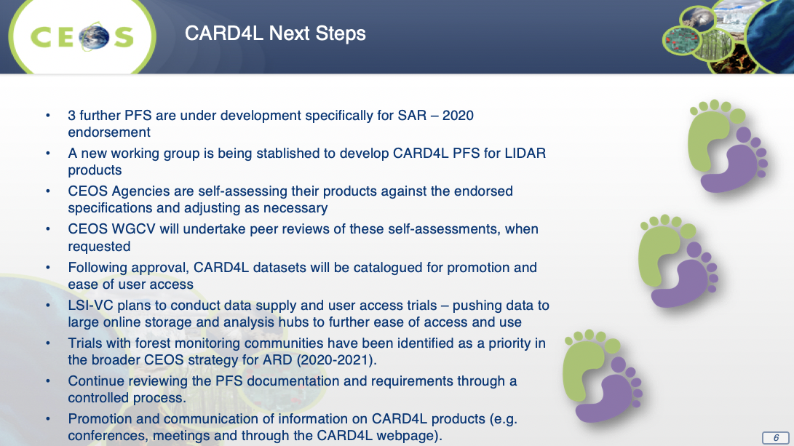
Andreia reviewed upcoming events of relevance to CARD4L, noting in particular the GEO Week 2019 ARD side session, which will consist of two keynote speeches as well as a panel discussion of 4-5 people.
There was a discussion about ARD versus CARD4L and the need to be consistent with terminology and messaging.
The out-of-cycle update of the Surface Temperature PFS was also noted. Darren Ghent has sent Andreia new language to address the editorial error regarding the split window algorithm. Andreia will send the new wording to the LSI-VC team for review and approval.
CARD4L LIDAR
Ake Rosenqvist (JAXA) noted the recent emergence of numerous lidar missions, which has led to the idea of a CARD4L LIDAR specification to accelerate uptake of these datasets, in particular for biomass estimation. The proposal has received interest from various people in the lidar and biomass communities, and the idea aligns well with other CEOS work and priorities (e.g., the WGCV LPV Biomass Validation Protocol, SDCG-GFOI). A team has been established to explore the idea further, including people from the GEDI, ICESat-2 and MOLI mission teams, as well as various advanced science users. This PFS would be completely different to the existing imaging-focused CARD4L PFS, instead covering point measurements/altimetry (not application specific).
Synthetic Aperture Radar PFS Update
Ake reviewed the status of the SAR PFS team members (JAXA, ESA, NASA JPL, GA, CSIRO, CONAE, ASF, Agriculture Canada, NRCan) and noted that he would also like to have the involvement of ASI, CSA, and DLR in particular.
The group is focused on developing the PFS, producing sample products, and defining metadata file specifications (currently prototyping this for LSI-VC, with the potential of adoption for the other PFS in the future). Version 5.0 of the NRB PFS is planned for endorsement at LSI-VC-9. The Polarimetric Radar (PR) PFS is (tentatively) a merger of the past Polarimetric Decomposition (PD) and Polarimetric Covariance Matrix (COV) PFS and is targeted for endorsement at LSI-VC-9 also.
Ake noted that a discussion is needed at the LSI-VC level about the best approach for the PR PFS and whether to instead have two separate documents for PD and COV specifically. Steve Labahn and Brian Killough (NASA, SEO) suggested using a single document, with separate sections for the PD and COV specific parts.
LSI-VC-8-02 | LSI-VC to review the draft PR PFS and provide feedback to Ake on:  - the best way to structure the document with regard to the overlaps and specifics of the PD and COV products;  - the metadata specifications.  Consideration also needs to be given to overlaps in the SR and ST PFS and how these might also be streamlined. | CLOSED
Medhavy Thankappan (GA) reviewed progress on the InSAR PFS, which is a combined document for three products: wrapped interferogram, unwrapped interferogram and interferometric coherence. He is currently seeking feedback on the PFS and some comments have been received from WGCV. A decision on the next steps toward endorsement is expected to be made in September.
Ake reviewed some sample products for various SAR PFS. He suggested these be added to the CEOS ARD website along with the PFS. The following topics and questions were presented for discussion:
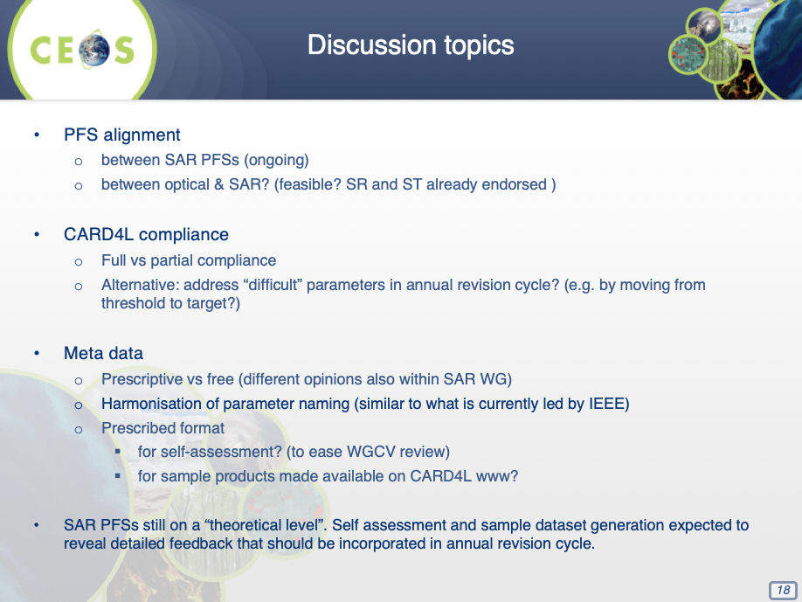
Ake presented a proposed metadata file structure developed by the SAR team. It was agreed that this cannot be a prescribed requirement for CARD4L compliance, but it could be presented as a recommendation. Steve Labahn suggested this could be a target requirement but not threshold.
Ake showed the PR PFS and the extra level of detail added regarding metadata fields. He asked for LSI-VC feedback on this approach, e.g., on whether it is too prescriptive. Steve stressed the importance of referencing existing or external standards wherever possible, even if it means developing the standard separately and externally from the PFS.
Decision 01 | It was agreed to not put detailed metadata specifications (as currently drafted) into any of the SAR PFS, but rather point to a separate document for the detailed metadata specifications (similar to how the SR and ST PFS point to the ISO 19115-2 metadata standard).
Full versus partial CARD4L compliance of datasets was also discussed. It was suggested that LSI-VC review and revise troublesome requirements in the annual update cycle (e.g., the DOI issue) by moving requirements from threshold to target if they appear to be too stringent.
Decision 02 | It was agreed that partial compliance of CARD4L datasets will be accommodated. The self-assessment summary tables will be available alongside references to the datasets on CEOS materials and the ARD website so users can assess the applicability of the dataset to their application despite the lack of full CARD4L compliance.
Decision 03 | Sample products will be posted on the CEOS ARD website and elsewhere alongside references to CARD4L datasets.

Session 3:​ CARD4L Products & Assessments

Agency Updates on CARD4L Datasets
USGS (Landsat Collection 2)
Steve Labahn reviewed Landsat Collection 1 and Collection 2, covering the specific processing steps for Collection 2 including the incorporation of the Sentinel-2 GRI. He noted that Collection 2 is being developed with COG and STAC in mind and the USGS team is actively engaged in the teams leading those discussions. These are two improvements being made in relation to cloud data access/use, the others being a new visualization tool (LandsatLook) and connections to third party tools (Esri, ODC, Pangeo, etc.).
Steve reviewed the Collection 1 U.S. ARD CARD4L self-assessment summary tables. USGS expects their Collection 2 self-assessment to be ready for WGCV peer review in the next few weeks.
Brian Killough asked about the possibility of pre-indexing data for the ODC connection on AWS, noting it would allow users to simply point their Data Cube instance at the data’s AWS location. Steve suggested that this could be functionality related to STAC, and this will be discussed further in the ODC group and could be raised during next week’s ODC Partners Forum meeting.
ESA (Sentinel-2 Surface Reflectance)
Matt Steventon reported on behalf of Ferran Gascon (ESA). He presented an overview of the Sentinel-2 mission, its products and their levels, access locations, and the Sen2Cor processor. The slides included a summary of the preliminary self-assessment undertaken for the Sentinel-2 Level-2A products.
Matt closed by noting the ARD On-Demand Demonstrator service, which is a prototype implementation provided by the ESA Research and Service Support (RSS) that allows users to configure ARD as desired. Features of the ARD On-Demand Demonstrator include:
- Works with Sentinel-2 and Landsat-8 data;
- Supported atmospheric correction algorithms: Sen2Cor, LaSRC, iCOR, MAJA;
- Custom output projection (UTM, Lat/Lon WGS84);
- Custom output format (SAFE, GeoTiff, HDF, NetCDF);
- Operable by a web interface;
- Uses the IPT Poland IaaS (CREODIAS precursor).
JAXA (ALOS NRB)
Ake reported that JAXA are now planning three NRB self-assessments:
- 25m ALOS PALSAR/ALOS-2 PALSAR-2 mosaics
  - Global coverage (2007-2010; 2015-2018+)
  - Derived from 10m/20m Fine Beam data
  - Self-assessment ongoing
- 50m PALSAR-2 ScanSAR
  - Regional coverage (pan-tropical + selected global regions)
  - 1x1 deg tiles (non-mosaicked)
- ALOS PALSAR (FBS, FBD, POL, ScanSAR)
  - Scene-based, full resolution
  - Full global archive (2006-2011)
  - JAXA to develop and release CARD4L format conversion software
Ake presented the findings/outcomes of the global mosaic self-assessment. In summary, JAXA’s global SAR mosaic products are currently not fully compliant with the CARD4L NRB specifications (v4.1). Processing of the 2018 global mosaic with revised SAR processing software is underway to address errors affecting the geometric accuracy. The global mosaic metadata will also be complemented and/or modified to conform with the (new) CARD4L metadata file formats being developed by the CARD4L SAR group. The aim is to have at least the 2018 global mosaic products fully compliant with CARD4L NRB (v5.0) by LSI-VC-9.

WGCV Report
Medhavy presented some background on WGCV and also the key outcomes from the recent WGCV-45 meeting. Of particular note is that the WGCV CARD4L peer review process presented at WGCV-45 was agreed. An initial pool of reviewers was also identified. WGCV is now in a position to peer review the CARD4L self-assessments when requested. The peer review process was reviewed in detail (see slides) and a couple of changes were requested. Medhavy will work with the WGCV to update the peer review process to clarify the role of the LSI-VC Secretariat as the initial POC for the peer review process and to remove the current need to wait until the next face-to-face meeting of the WGCV for final approval of datasets.
LSI-VC-8-03 | Medhavy to work with the WGCV team to adjust the CARD4L peer review process with regard to the need to wait until the next face-to-face meeting of the WGCV for final approval, as well as to clarify the role of the LSI-VC Secretariat as the initial POC for the peer review process. | ASAP

A couple of comments were noted during the discussion following the presentation:

The need for WGCV panel members to manage any conflicts of interest was noted.

The Sentinel-2 self-assessment is essentially ready for the peer review. This was waiting on revisions related to the DOI requirements, however with the agreement that partial compliance will be accommodated, the peer review could begin straight away.

Session 4:​ CEOS ARD Strategy

CSIRO/GA 2020-2021 SIT Chair Priorities & CEOS ARD Strategy
Matt presented a summary of the CSIRO/GA 2020-2021 SIT Chair priorities, in particular the CEOS ARD Strategy. The intention for the CSIRO/GA term is to escalate, elevate and encourage accomplishment of ongoing pieces of CEOS work.
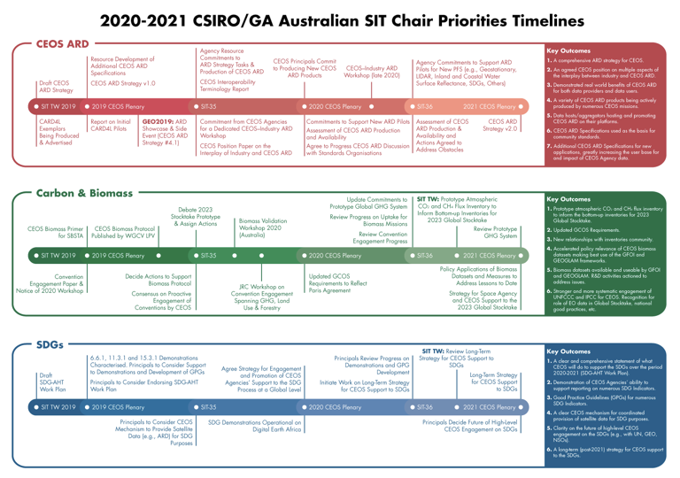
The draft CEOS ARD Strategy presented at CEOS SIT Technical Workshop is online here. The main objectives of the strategy are:
- ensure effective engagement of the three key stakeholder groups (producers, hosts, users);
- manage expectations of all stakeholders as to the status and outlook for ARD availability – so that all might plan and invest with confidence;
- establish priorities for which products and applications might follow on from the current CARD4L PFS;
- ensure appropriate organisational responsibilities across the CEOS structure for the definition and execution of the way forward on ARD.
The strategy is foreseen as an informal collection of ARD-related activities across the CEOS structure, with light oversight and coordinated reporting supported by SIT.
A discussion followed the presentation:
- Future interaction with OGC on standards was discussed. At the outset, the CEOS ARD discussion avoided the topic of standardisation, however in time this may become appropriate.
- Steve Labahn asked about the implications of the incoming SIT Chair ARD priority for LSI-VC. In particular, he asked whether LSI-VC is going to have to take up further responsibilities (and therefore require more resources). It was clarified that the intention of the proposed incoming SIT Chair priorities is to try and streamline and coordinate existing CEOS activities.

Discussion: CEOS ARD Strategy Task 1.4: CEOS Interoperability Terminology Report
Matt introduced the discussion. The CEOS Interoperability Terminology Report was suggested by LSI-VC as a means for broader CEOS review, input and endorsement of the MRI Terminology definitions already agreed by LSI-VC. It was noted that there are other efforts ongoing in WGISS and WGCV IVOS regarding terminology definition that need to be connected also to ensure consistency across CEOS.
Steve noted that the intention is to develop CEOS-endorsed language to describe the continuum of product interoperability. The action needed now is to identify an LSI-VC person/team to take this forward to completion. Steve volunteered to take the next steps.
LSI-VC-8-04 | Steve Labahn to connect with Nigel Fox and Mirko Albani (CC: Cindy Ong) regarding the CEOS Interoperability Terminology Report and the similar terminology definition work ongoing in WGCV and WGISS. | ASAP

Discussion: CEOS ARD Strategy Task 2.3: CEOS Paper on the Interplay of Industry and CEOS ARD
Matt introduced the discussion. This task calls on CEOS to prepare a paper describing the different roles industry may play (e.g., as data users, data providers, data hosts, and as providers of processing chains to produce data that meet CEOS ARD specifications) and also proposes to cover topics related to machine-to-machine communication (including the role of COG and STAC technologies), machine learning, automation, and analysis platforms – all of which feature heavily in many commercial ‘New Space’ strategies.
The LSI-VC discussed:
- It’s not clear that this is a ‘position paper’ – the objective is more to describe a functional working model. The strategy was revised to remove the word ‘position’ from this task ahead of SIT Technical Workshop.
- There is also a perceived desire for industry to be involved in the process of defining ARD standards. Part of this could be encouraging self-assessment of their data as CEOS ARD.
- It is thought that if Landsat and Sentinel lead the way by standardising their approaches, then industry will follow through and request self-assessment if they perceive benefits.
- The past two ARD Workshops with Planet have been successful, but we’ve had trouble bringing this success across to CEOS. One suggestion could be to have a session during LSI-VC-10 to consult with industry (e.g., Sinergise) on how best to interact with them.
- Steven Hosford suggested engaging Ferran in the dialogue with Sinergise.
LSI-VC-8-05 | LSI-VC Secretariat to follow up Ferran regarding the discussion with Sinergise around a potential CEOS-Industry ARD workshop in Ljubljana, Slovenia. | ASAP

Discussion: Accessibility & Location of ARD
George Dyke introduced the discussion, which aimed to revisit the paradigm of “bringing the users to the data”, assess progress in this direction, and look at how ARD is currently produced and made available. Some questions posed by George were:
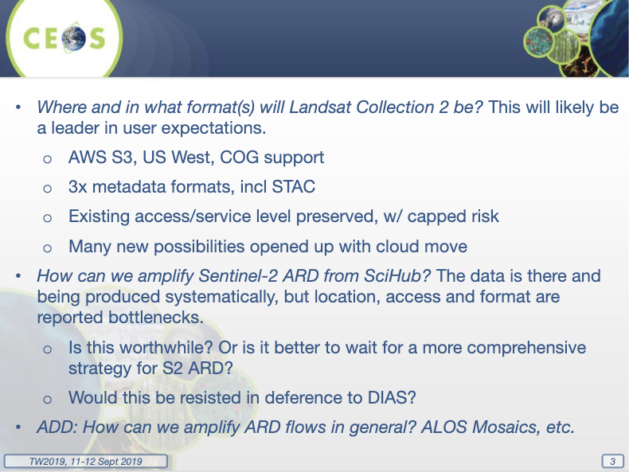
Some further notes from the discussion:
- There has been limited progress related to the accessibility of data, which is often fragmented across the world with many different datasets, locations and access options. Sentinel access in particular is a challenge, though it is available on GEE, and there are some solutions on AWS which could help there in 2020.
- Need to consider the proposed CEOS-Industry ARD Workshop included in the SIT Vice Chair prospectus. Clearer objectives need to be defined, which will help determine who should be invited, e.g., would cloud or EO providers be invited, commercial EO providers, etc.
- The role of DIAS remains unclear. Brian is exploring with Albrecht Schmidt of ESA (who is now formally supporting the CEOS SEO). If DIAS can help with implementation, this would be useful.
- The overall takeaway is that ARD accessibility is likely to proceed as increment steps (towards the ultimate vision of having the user ‘brought to the data’). This should be kept as the shared endpoint.

Session 5:​ CEOS ARD Promotion

Discussion: CEOS ARD Strategy Task 4.2: CEOS–Industry ARD Workshop
George introduced the discussion. This CEOS ARD Strategy task calls on CEOS Agencies to commit to organise a dedicated CEOS ARD workshop, inviting agencies, researchers and the private sector to continue engagement between EO data providers (public and commercial), big data hosts/aggregators, and data users.
The proposal being followed up by George is to co-locate the ARD3 workshop (i.e., the next Planet ARD workshop) with LSI-VC-10 / 2020 SIT Technical Workshop and this CEOS–Industry ARD Workshop. The objective of co-locating these meetings would be for CEOS to participate and be seen to be a co-leader in the ARD space that the first two ARD workshops have established. George has reached out to Sinergise (Sentinel Hub) who are willing to co-host a meeting in Ljubljana (Slovenia), and he will continue following up – looping in ESA as well, given their connection to Sinergise and European industry in general.
Some potential objectives for the meeting are:
- Promotion of PFS uptake, sharing plans, encouragement of self-assessment;
- Hearing from industry on ARD definition and practice;
- Location, discoverability, distribution, and amplification of ARD flows;
- Encouraging interoperability between solutions;
- Addressing emerging topics such as Machine Learning;
- Considering if/where joint ways forward may make sense.

Discussion: CEOS ARD Strategy Task 4.4: Promotion of CEOS ARD to Standards Organisations
Matt reported that this task seeks to explore with standards organisations (e.g., OGC) whether CEOS ARD specifications might be used as the basis for broader, official community standards, and, to ensure that CEOS work is recognised by others including the data research community.
A discussion followed:
- It is not clear it is the role of CEOS to undertake any actions related to standardisation. It was clarified that this task is not necessarily suggesting that CEOS undertake the standards work itself, but rather to explore whether the CARD4L PFS provide a basis that could be carried forward as formal standards.
- The high workload involved in any kind of standardisation effort was recognised. WGISS has past experience with standardisation that would be good to hear about.
- It was noted that industry pull is key for standards development, and perhaps this is something that will evolve naturally with further industry engagement. Steve Labahn noted that Planet have been vocal about the need for ARD standards of some sort, and others reported that they are starting to hear the desire from various other places also.
LSI-VC-8-06 | Dave Jarrett and Jenn Lacey to ask Andy Mitchell, Rob Woodcock, and Richard Moreno to have a discussion about their past experiences with standardisation in WGISS. | ASAP

Session 6:​ CEOS ARD Pilots

Open Data Cube Update
Brian reviewed his draft slides for SIT Technical Workshop and made various updates. He showed some examples of ODC implementations including prototypes in Ghana and Taiwan as well as Digital Earth Africa and some pilot applications in support of the UN SDGs.
Brian highlighted the crucial role the provision of Analysis Ready Data plays in the Open Data Cube community and for users in general. ARD is no longer a desire of global users, but is now becoming a requirement and an expectation. ARD will help increase the use and impact of satellite data and remove the data workflow burden on less experienced data users. ARD stored on cloud-based systems allows easy connection to the Open Data Cube infrastructure. The combination of CEOS ARD (data) and the ODC (tool) is seen as an end-to-end contribution from CEOS to the user community.
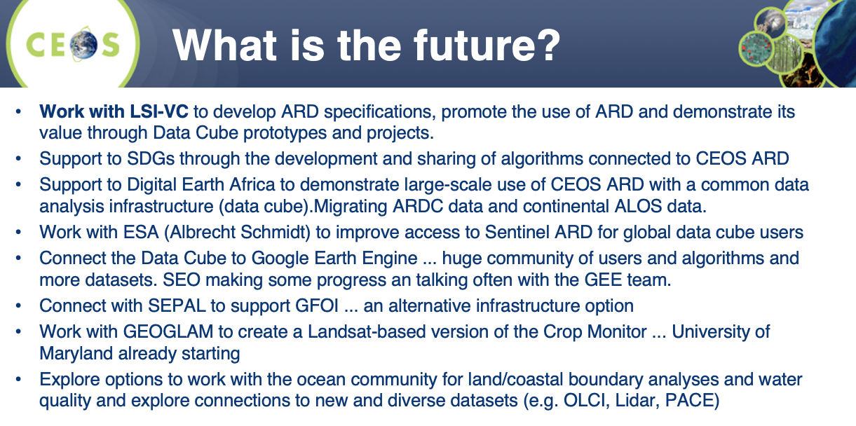

Digital Earth Africa Update
Medhavy presented an update on Digital Earth Africa. Digital Earth Africa, built around Open Data Cube, will provide a routine, reliable and operational service, using Earth observations to deliver decision-ready products enabling policy makers, scientists, the private sector and civil society to address social, environmental and economic changes on the continent and develop an ecosystem for innovation across sectors. Digital Earth Australia will provide technical and operational guidance. Medhavy presented some background, the governance structure, a year-by-year plan for the development of Digital Earth Africa, and two web portals with further information regarding the datasets and products of the platform: maps.digitalearth.africa and explorer.digitalearth.africa.

Working Session: Progress Specifics of ARD Promotion and Pilots with Thematic Subgroups
Brian moderated this working session. He presented some slides and topics to initiate the discussion:
- How can we improve promotion of CEOS ARD?
- How can we better promote the radar datasets (Sentinel-1 and ALOS)?
- How can we improve the Sentinel ARD data flow situation to improve global use of that data?
- How can we start evaluating compliance of ARD datasets against the CEOS ARD specifications?
- How can we progress ARD use to support GEOGLAM (agriculture), GFOI (forests) and UN-SDGs?
- What meetings and conferences can we use to promote CEOS ARD in the future?
- How can we engage the oceans and atmosphere communities?
- How should we engage with the commercial sector?
Steve Labahn suggested the development of a standard CARD4L promotional slide deck that can be used at the various meetings and conferences attended by LSI-VC members, to ensure consistent messaging.
LSI-VC-8-07 | LSI-VC Secretariat to prepare a standard CARD4L promotional slide deck. | ASAP
Regarding the prioritisation of future CARD4L datasets, both commercial and CEOS Agency datasets are in scope and desired. Resourcesat (ISRO/India) is a priority for USGS (near-daily acquisitions over the U.S.). The NASA HLS dataset would be another key target for CARD4L compliance. JAXA have already reported that they plan to expand their efforts beyond the global mosaic products to ALOS PALSAR scenes and certain ALOS-2 PALSAR-2 tile-based data. Brad Doorn noted that even ‘redundant’ datasets add a lot of value for users through increased robustness. Other suggestions included THAICOTE and THEOS-2 (GISTDA/Thailand), CBERS (CRESDA/INPE), and KOMPSAT (KARI/Korea).
There is significant value in planning ARD as a standard product from the outset of a mission, such as is being done for NISAR and NovaSAR-1. It would be of great value for LSI-VC to begin discussions regarding CARD4L adoption with agencies that are currently in mission planning phases.
LSI-VC-8-08 | Steven Hosford to chase up the submission of ESA’s S-2 self-assessment for WGCV peer review. | CLOSED
Brian asked:
- Can someone (or Google) evaluate the Google Earth Engine (GEE) Sentinel-1 dataset? Sentinel-1 on GEE is the only global ARD product but some questions have been raised regarding its quality.
- Can someone (or Amazon) evaluate the ARD datasets available on AWS through the public datasets registry.
Overall the feeling was that this is not the responsibility of CEOS/LSI-VC. Brian noted that the NRB Sentinel-1 ARD dataset is currently only being produced by Google. Steven Hosford reported that there have been some limited internal discussions around ESA’s plans for Sentinel-1 ARD products, but ESA doesn’t make the decisions regarding the processing chains alone (European Commission). To date, no one has made a commitment for a Sentinel-1 CARD4L product, but there is growing awareness. Brian asked if there are any steps LSI-VC/CEOS can take to escalate and accelerate Sentinel-1 and Sentinel-2 ARD efforts within the European Commission.
LSI-VC-8-09 | Brian, Jenn, and Steve to set up a meeting with ESA and EC representatives at SIT Technical Workshop to explore the possibility of accelerating S-1 and S-2 ARD efforts – following up a past meeting and the ideas around back-processing the S-2 archive and hosting it on AWS. | CLOSED
LSI-VC-8-10 | Andreia & Brian to follow up an IGARSS 2020 session on ARD. | COMPLETE

Thursday September 5th

Session 7:​ Forests and Biomass Subgroup

GFOI Framework Update
Stephen Ward presented an update on SDCG, noting that there have been some changes in the co-chairs with Joanne Nightingale and UKSA stepping down, and Chris Barber from USGS stepping in as a co-chair. GFOI remains a GEO Flagship despite some discussion during the change over of the GEO Secretariat Director. The GFOI R&D programme is expected to be carried forward by Wageningen University.
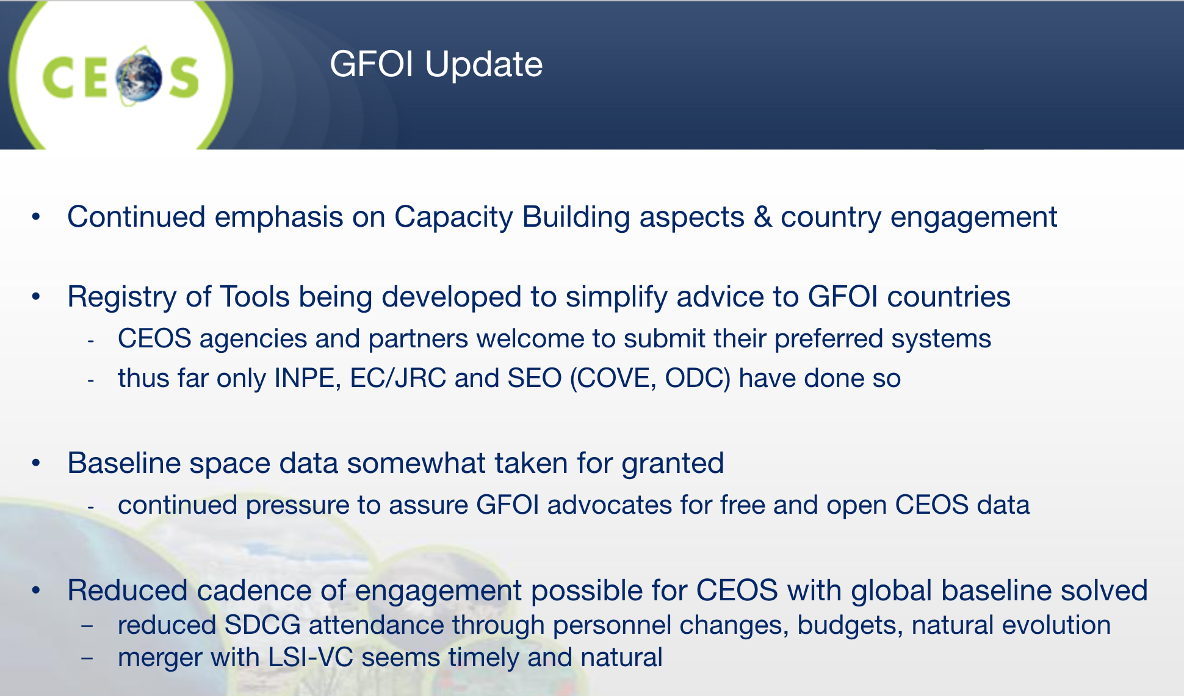
LSI-VC-8-11 | LSI-VC members to connect relevant government and agency contacts with the SDCG Secretariat regarding any tools and systems that might be suitable for the GFOI tool registry and CALM assessment. | ASAP

SDCG for GFOI
The SDCG Work Plan has been updated to reflect the slimmer profile of the group. It has a continued focus on the core business of assurance of data suitable for annual National Forest Monitoring System (NFMS) reporting. A healthy supply of core data from Landsat and the Sentinels allows time for SDCG to focus on tasks of additional value, such as:
- Data access, formats, ARD;
- Support to LSI-VC on ARD pilots with thematic communities;
- Working with FAO to link their SEPAL tool with Open Data Cube;
- Working through the new USGS co-chair (Chris Barber) with SilvaCarbon (e.g., for ARD feedback).
Chris Barber reported that SEPAL is currently running on AWS and points to GEE as a data store. Erik Lindquist (FAO) has confirmed that pointing the tool to an AWS S3 bucket (e.g., Collection 2) is a possibility (avoiding a long-term dependence on GEE has been a SEPAL design decision).
Steve Labahn noted that USGS needs more specificity when it comes to ARD pilots, but they are willing to explore support to any proposals. A collection of locations that meet multiple requirements would be desirable.

GFOI Methods and Guidance Documentation (MGD)
Ake presented the background of the MGD and its counterpart web application, REDDCompass. He noted the 2019-2020 update of the MGD to incorporate evolutions in the space since 2016. The next version will be fully online, meaning it will be dynamic and easier to update. Key changes since 2016 include numerous global observation missions now being online, the biomass protocol, etc. Ake also showed the GFOI repository of tools for NFMS, which currently includes, amongst others, COVE, SEPAL, ODC, and the ESA Forestry TEP.
LSI-VC-8-12 | LSI-VC members to encourage their agencies to contribute to the update of the GFOI MGD (working via Ake). Ake to share the latest TOC. | ASAP
LSI-VC-8-13 | Takeo/Ake/JAXA to consider submitting JJ-FAST to the GFOI repository of tools. | ASAP

New SDCG Work Plan
Ake reviewed the overall structure of the new light-weight SDCG Work Plan and the individual tasks making up each of the main sections. See the slides for full details.
Global Baseline Observations: with capacity now good, no annual reports are expected going forward. The mission timelines will be maintained, including via the MIM Database (automated).
Biomass: this is a new focus, with lots of new investment from agencies in lidar and SAR. SDCG will aim to accelerate the policy relevance of these datasets through communication, support, and ‘market’ development by working with the GFOI Capacity Building Component and SilvaCarbon. CARD4Lidar is another idea floated with LSI-VC and others. The CEOS Biomass Protocol is under development and will be released soon, however there is no ‘home’ for biomass in CEOS at this point, and this needs further discussion by CEOS. For now, biomass has been incorporated as a 2020-2021 SIT Chair priority.
Capacity Building: SDCG’s engagement with the GFOI Capacity Building Component will be rebooted with Chris Barber (USGS) with Sylvia Wilson (USGS, SilvaCarbon). SDCG is seeking closer engagement to, among other reasons, support biomass measurement uptake, space data tool promotion, and ARD pilots for LSI-VC.
Convention Engagement: SDCG aims to support the Agriculture, Forestry and Other Land Use (AFOLU) aspects of the CEOS effort on international convention engagement, including through support to the proposed 2020 Convention Engagement Workshop.
MGD: Ake is the SDCG representative to the MGD team. Chris Barber was nominated as a second space agency representative for the MGD support task.
R&D and Early Warning: specifics of SDCG involvement are pending clarity and funding.
LSI-VC-8-14 | SDCG Work Plan task leads to suggest milestones and timelines through to end-2020. | ASAP
Data Support: Brian presented SEO updates related to SDCG including SDCG-15 action updates and a COVE status report.
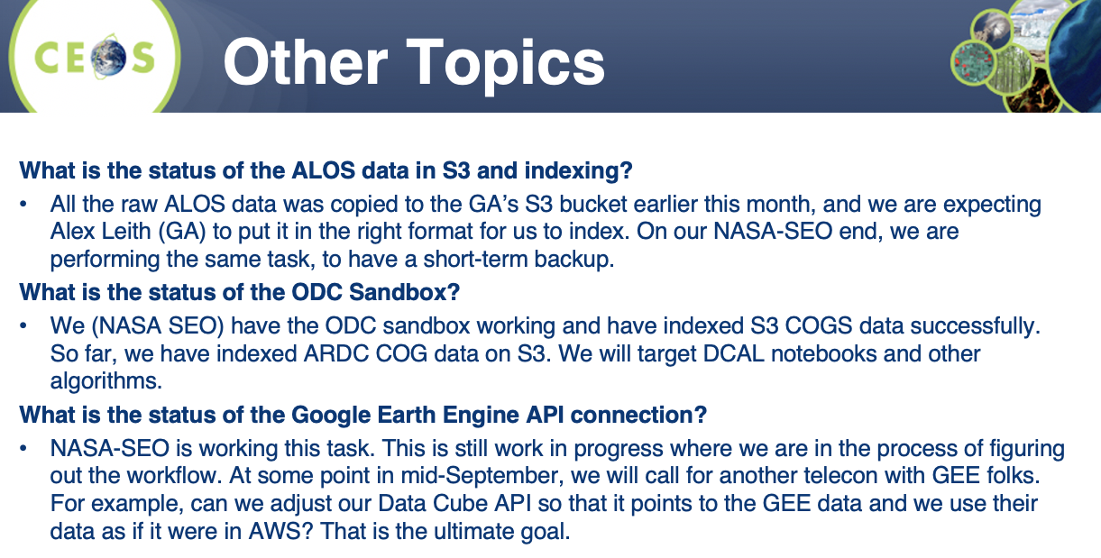
LSI-VC-8-15 | Brian to follow-up with Alyssa on missing mission (one of Sentinel-1B or Sentinel-2B) in the COVE Coverage Analyzer tool. | COMPLETE  Sentinel-1B and 2B are represented in COVE

Support to the SIT Chair Prospectus 2020-2021, including for Biomass
Stephen Ward reviewed the carbon and biomass thread of the 2020-2021 SIT Chair priorities. George Dyke summarised the thinking behind the meetings and processes changes proposed by CSIRO/GA – namely being to streamline consultation calls and making SIT meetings more strategic, in line with the original vision.
Jenn Lacey and Steve Labahn (USGS) would like to see back-to-back week meetings compressed into one week wherever possible, e.g., holding these joint LSI/SDCG/GEOGLAM meetings and SIT Technical Workshop in the same week. This minimises time away from home and further increases travel efficiency. JAXA supported this as well.
Jenn suggested that CEOS could also better communicate the specific purpose of each of the various CEOS meetings in the annual cycle.
Steve asked about the meeting frequency needed by a joint LSI-VC with SDCG-GFOI and the CEOS-GEOGLAM AHWG as thematic subgroups. Stephen noted that SDCG requires two meetings per year, however SDCG participation is now limited and therefore quite flexible (all participants are also engaged in LSI-VC) – it seems feasible that all meetings could be joint going forward. GEOGLAM needs only one meeting with CEOS per year.

Session 8:​ Agriculture Subgroup

Revised GEOGLAM Observation Requirements
Alyssa provided an overview of GEOGLAM and its recent activities, in particular around satellite data requirements, which were revised last year. The CEOS response to these requirements has now been written. Alyssa reviewed the draft response document, which includes full observation requirements in the appendices.
A discussion followed the presentation:
- There was concern about the wording ‘CEOS Response’ – rather saying ‘CEOS AHWG on GEOGLAM Response’. The level of review and approval by CEOS Agencies was questioned.
- Jeff Masek (NASA) noted that requirements for Landsat 10 are being defined in the next year and these observational requirements from GEOGLAM would be a good input and should be communicated directly if possible. Jeff confirmed he would be an appropriate point of contact for follow up.
- Steve Labahn suggested that the concept of ARD+ might be something that could be revisited in the future terminology work (i.e., CEOS Interoperability Terminology Report).
- Regarding hyperspectral measurement requirements, the lack of current examples makes assessment a challenge. Steve Covington (USGS) asked if there is research within GEOGLAM/JECAM to look at what would be required. For example, it would be useful to understand if there are a specific set of bands which could be useful, i.e., superspectral versus hyperspectral.
- On capacity development, space agencies are best to invest directly with people/groups that have existing connections to thematic communities. It is difficult to coordinate this at CEOS-level.

Essential Agricultural Variables
Alyssa showed preliminary EAV definitions, and stressed that they are EAVs for GEOGLAM, with a focus on its agricultural monitoring activities. Jenn suggested mission timelines for each of the EAVs would be helpful. This could be output from the MIM Database.

GEOGLAM Capacity Development Activities
Alyssa summarised GEOGLAM’s capacity development activities. Of note was that Nancy Searby (NASA) is a funder of GEOGLAM activities in South America, and is also interested as incoming WGCapD Chair.

GEOGLAM Community Views on ARD
Brad Doorn (NASA) reflected on the future of the CEOS-GEOGLAM AHWG, noting the decision point around whether the group continues, evolves, or is wound up. While the AHWG has done a lot of work over the past several years, there is an ongoing role to be fulfilled around the interface between GEOGLAM and CEOS Agencies.
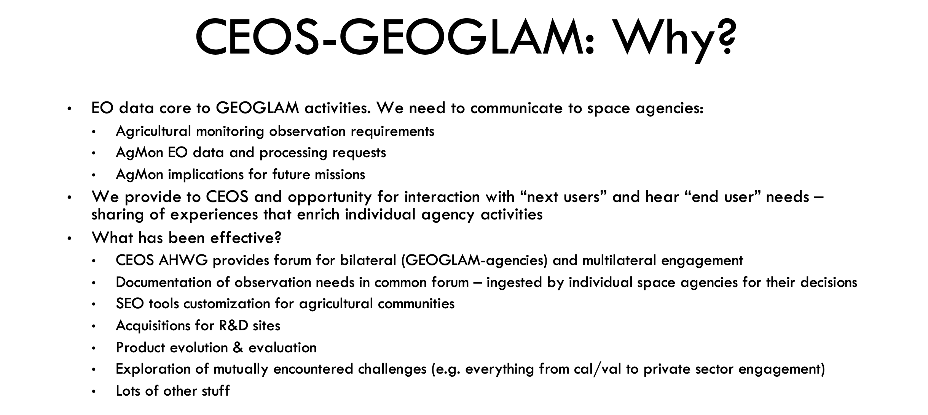
Work remains for the CEOS-GEOGLAM AHWG, given the constant evolution of missions, instruments, user needs, etc. GEOGLAM provides a critical connection between users and space agencies. The main challenge facing CEOS-GEOGLAM and GEOGLAM is space agency participation and what form/scope this takes. The presentation slot for GEOGLAM at the annual CEOS Plenary meetings is critical as it provides a direct connection with CEOS Principals.
Brad stressed the view that they would like the LSI-VC subgroup named for GEOGLAM, rather than agriculture more broadly, to keep the identity and focus. Jenn noted that the broader reference to agriculture was to stress the linkage to land (and LSI-VC), but agrees that the reference to GEOGLAM makes sense.
There wasn’t any opposition to using the GEOGLAM subgroup naming. It was noted that the same approach wasn’t appropriate for GFOI as the current scope of SDCG is starting to broaden beyond support to GFOI (e.g., new woody biomass datasets are being addressed by SDCG, but not by GFOI).
Many of the questions around what GEOGLAM and SDCG look like as LSI-VC subgroups was addressed in the LSI-VC presentation to CEOS Plenary 2018. The overall intention is to have the work continue to function as it has under the AHT/AHWG arrangements.
LSI-VC-8-16 | LSI-VC Secretariat to summarise the proposed future meeting solutions/scenarios (e.g., Sunday/Monday before SIT-35, condensing to one week total; combining with SDCG and biomass workshop). | CLOSED
LSI-VC-8-17 | LSI-VC to review the CEOS Response to the GEOGLAM Observational Requirements document. | COMPLETE

Asia-RiCE Report
Matt presented some background on Asia-RiCE on behalf of Shin-ichi Sobue (JAXA). Asia-RiCE is the work of an ad hoc team of stakeholders with an interest in the development of an asian rice crop estimation and monitoring component for the GEOGLAM initiative.
Of particular note, Matt reported that there is interest from JAXA in assessing JJ-FAST data (JICA-JAXA Forest Early Warning System in the Tropics; ALOS-2 orthorectified/slope-corrected gamma-nought; processed using SIGMA-SAR) as CARD4L. An internal investigation is underway to determine the changes necessary for CARD4L compliance. JAXA asked whether the LSI-VC team can provide support with the self-assessment. There is the potential for CARD4L pilots using this data and the Asia-RiCE network of contacts.
LSI-VC-8-18 | Takeo & Ake to connect with JAXA colleagues (Shin-ichi Sobue and RESTEC) regarding undertaking a CARD4L self-assessment for the JJ-FAST ALOS products. | ASAP

Session 9:​ LSI-VC and Thematic Groups Collaboration

Agency Updates on Missions/Programmes Related to LSI, GFOI, and GEOGLAM
USGS
Jenn Lacey presented on the Landsat program, Landsat 7 and Restore-L, Collection 2, the Landsat Advisory Group Report: Cost Sharing Models for Landsat Data, the Sustainable Land Imaging (SLI) Draft Requirements, and the EROS Calibration/Validation Center of Excellence (ECCOE).
KARI’s Satellites and ARD
Chiho Kang and Daehoon Yoo presented, noting that KARI is considering how to generate surface reflectance ARD from KOMPSAT. They are only at the very beginning of the process of developing their ARD workflows. Sub-10m ARD products are not addressed by the current CARD4L framework, in part because civil space agencies don’t generally generate free and open data below this spatial resolution. They have produced some initial ARD based on CARD4L with sub-10m data from KOMPSAT. There will be challenges in verification of fine resolution products to within CARD4L PFS parameters, but there may also be an opportunity to learn from KARI’s experience. Planet is also producing ARD on 1m data.
KARI does release free and open data as a national institute, but also has arrangements with commercial providers to distribute data products. In general, data policy in South Korea is quite strict.
Ake asked about the source of the 0.5 and 0.2 pixel rRMSE accuracies in the optical and SAR PFS, and Andreia noted she will look back at the original provenance.
LSI-VC-8-19 | Andreia to investigate the provenance of the 0.5 and 0.2 pixel rRMSE accuracies in the optical and SAR PFS. | ASAP
Geoscience Australia
Medhavy presented some GA activities including the Digital Earth Australia Landsat Collection upgrade (GA’s Landsat Collection 3 will use USGS Collection 1 Level 1 as a baseline), the Digital Earth Australia Labs initiative (funding for three private sector projects), the continental surface reflectance validation campaign, independent Landsat surface brightness temperature validation using GA’s products and field data, operational ARD processing for Sentinel-1 (over Australia), and Digital Earth Africa.
LSI-VC-8-20 | Medhavy to connect with Jeff Masek regarding sharing SR field validation data for use with HLS as well as the comparisons done with USGS SR products. | ASAP
JAXA
Takeo Tadono (JAXA) presented an overview of JAXA’s ALOS missions, including the upcoming ALOS-3 (optical) and ALOS-4 (with PALSAR-3 SAR). PALSAR-3 will expand upon the swath width of PALSAR-2 without decreasing the resolution and image quality through the use of digital beam forming (DBF) techniques. The ALOS-4 reference orbit is the same as ALOS-2. Takeo also presented some background on the 25m L-band SAR mosaics and forest/non-forest maps, as well as JAXA’s overall plans with regard to free and open data (see slides below). He closed by summarising JAXA’s efforts to date on CARD4L (NRB) and noted that CARD4L compliance for their optical datasets (AVNIR-2, ALOS-3) will be considered.
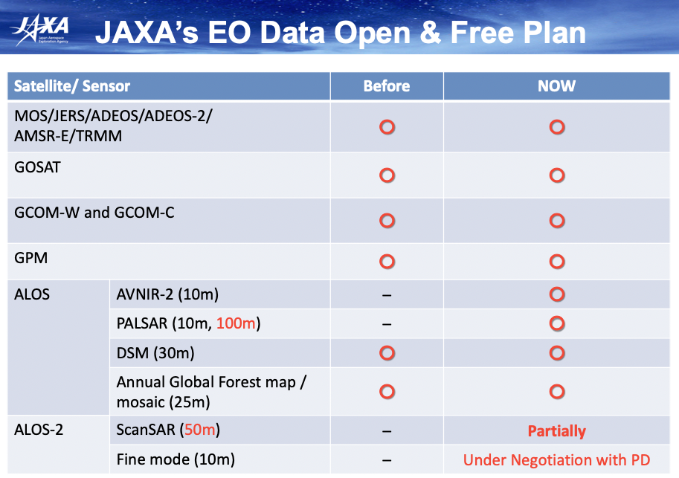
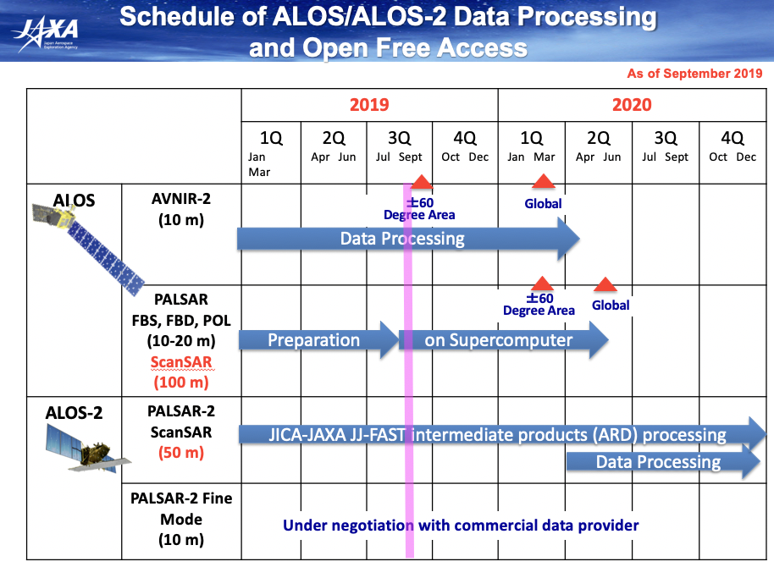
Harmonized Landsat / Sentinel-2
Jeff Masek (NASA) presented. Merging Sentinel-2 and Landsat data streams can provide 2-3 day global coverage. The goal with HLS is a “seamless” near-daily 30m surface reflectance record including atmospheric corrections, spectral and BRDF adjustments, and regridding.
HLS is running quasi-operationally over all of North America and a number of large test sites (as well as Italy and France). Products are generated with a 4-5 day lag. In general, the lag is driven by Sentinel-2 availability on Google Cloud, but sometimes it is caused by atmospheric data delays.
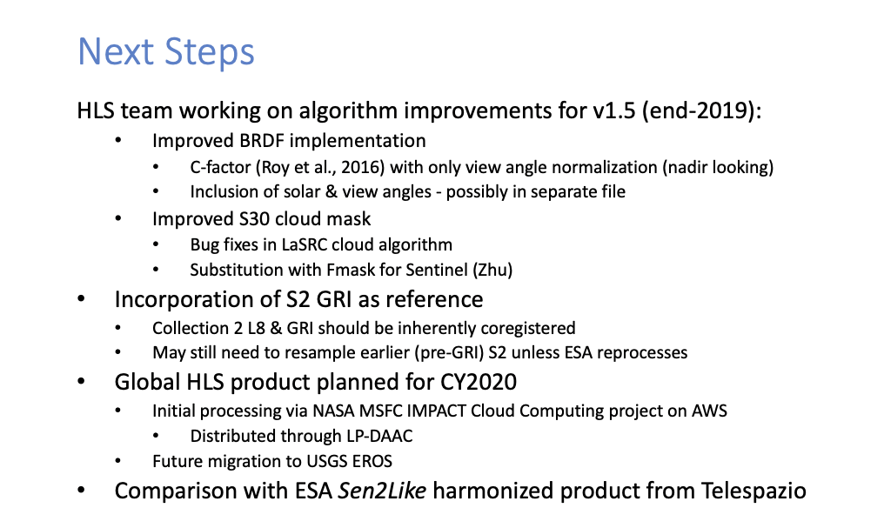
Jeff reported that the COG format might be used for the HLS global product. AWS US-West was encouraged as the hosting location for HLS data.

Friday September 6th

Session 10:​ CEOS Organisation and Processes

Decision: New LSI-VC Co-Lead Nomination
David Jarrett (NASA) read the nomination for Dr. Zoltan Szantoi (European Commission) to succeed Dr. Susanne Mecklenburg (ESA) as an LSI-VC co-lead. This nomination is consistent with LSI-VC’s goal to promote leadership diversity by sharing the three co-lead responsibilities across major geographic regions. The nomination is contingent on final approval by the European Commission.
Steve Labahn supported the nomination, noting that having continuity of a European representative is good, and having the European Commission as a co-lead is particularly helpful as we explore the possibility of accelerating the development of Sentinel CARD4L.
Decision 04 | Dr. Zoltan Szantoi (European Commission) was nominated to succeed Dr. Susanne Mecklenburg (ESA) as an LSI-VC Co-Lead.

Working Group Study Team (WGST) Status and Impacts
Brian Killough reported the latest on the Working Group Study Team. Now that the study has concluded, the decision is to not spin up a new CEOS Working Group, as this option lacks the agency support necessary (e.g., a lead, resources). It was agreed to instead use existing CEOS leadership processes (e.g., the CEOS Secretariat, SEO) to manage new requests and priorities (possibly water, polar/arctic-related themes). These conclusions will be presented at SIT Technical Workshop next week.

Session 11:​ Requirements and Gap Analyses

Context and CEOS Work Plan Tasks/Deliverables
Matt presented the background and history of the LSI-VC’s thread of work related to requirements and gap analyses. The CEOS Carbon Strategy was selected as an early focus for this work, as broad, generalised gap analyses were agreed to not look feasible. The LSI-VC reached out to the CEOS carbon community multiple times, with little result and infrequent interactions. It was agreed that there is not much we can do in a one-way fashion – LSI-VC needs inputs and feedback from the thematic side. The requirements tasks were discontinued in favour of focusing on progressing CEOS tools and information systems in support of gap analyses. Matt summarised what he sees as necessary for LSI-VC to restart the requirements and gap analyses work thread:
- A thematic area with a reasonably small scope to trial an LSI-VC requirements/gap analysis process;
- An active counterpart on the thematic side that can translate science requirements into observational requirements;
- A specific set of unique requirements (e.g., global moderate resolution optical is not a good focus for a gap analysis).
Werner Balogh (WMO) asked about links to the WMO rolling requirements review, noting that they were working to link GEOGLAM into this work. Matt noted there’s no existing link. Werner suggested this could be useful.

CEOS-CGMS WGClimate Report
Jörg Schulz (EUMETSAT, WGClimate Chair) reported background on WGClimate, including the Architecture for Climate Monitoring from Space, the ECV Inventory, the GHG Monitoring Roadmap, the WGISS Carbon Community Portal, and WGClimate’s convention engagement work. He presented three actions from the WGClimate Coordinated Action Plan that have been delegated to LSI-VC and would be a useful output from the LSI-VC’s requirements and gap analyses work thread:
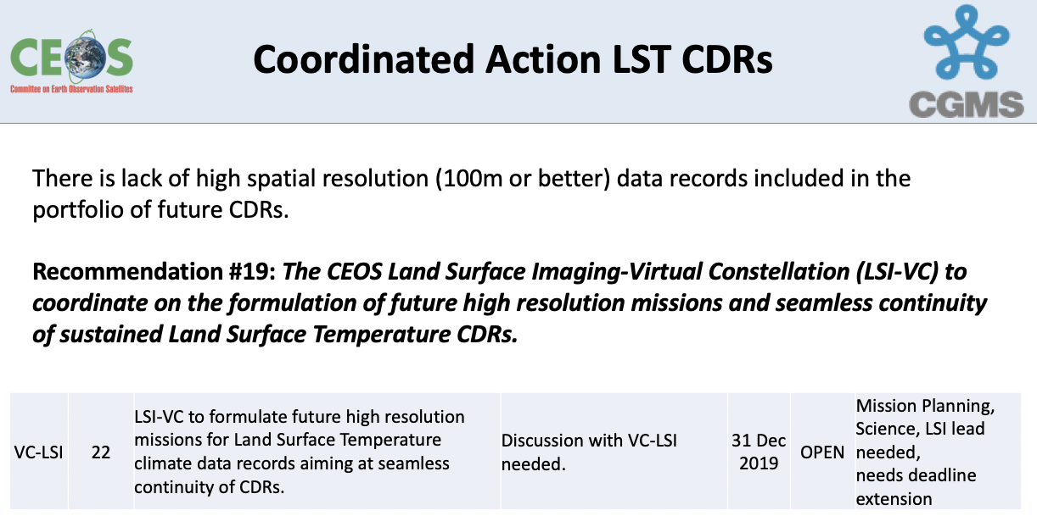
The goal here is to do a deeper analysis looking at the availability of LST datasets. Datasets may also exist, but they may not necessarily be processed into a CDR. Data collection versus CDR generation is a key distinction. It was noted that Landsat is likely the only continuous historical dataset (with future continuity planned and in development, e.g., Landsat 9 TIRS-2 has been upgraded to a Class B instrument). There are a few future plans being discussed by ESA/EC (Sentinel) and ISRO/CNES.
Landsat is calibrated at Level 1, consistently processed, and should therefore meet the 2004 CDR definition from NOAA. Derived geophysical records would also comply.
For this action, LSI-VC will begin by summarising the plans and projections of the way forward for USGS on Landsat TIRS, expanding to cover other missions and agencies in time.
Studying and understanding the future continuity of LST measurements is a valuable action for LSI-VC, as well as space agencies, outside of the WGClimate need. The question of whether these measurements are supporting a CDR would also need to be addressed in a study, including whether there is a processing plan in place. This would necessarily involve both LSI-VC and WGClimate expertise on scientific assessment.
Steve asked if there is any sense of specific requirements with regard to bands, temporal resolution, or other desired characteristics for the CDR. Any further information that can help direct the discussions regarding future potential additions to the CDR/contributing missions would be helpful.
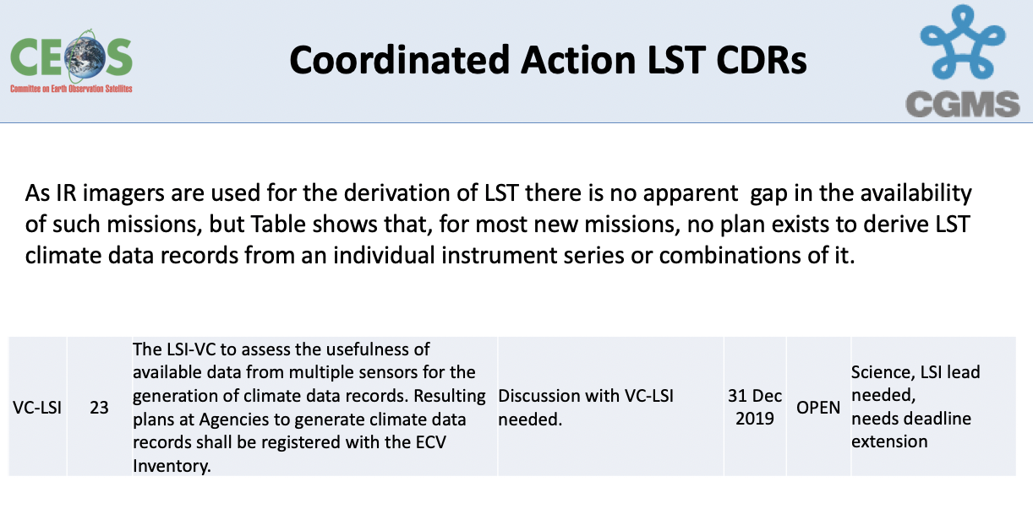
It was clarified that there are no resolution requirements for these datasets, and so that opens up many options, e.g., MODIS. Steve Labahn suggested the ARD stocktake could be a good starting point for this action.
Jörg suggested that activity and discussion on the following LAI action be postponed until there is an outcome from an ongoing assessment within WGClimate.
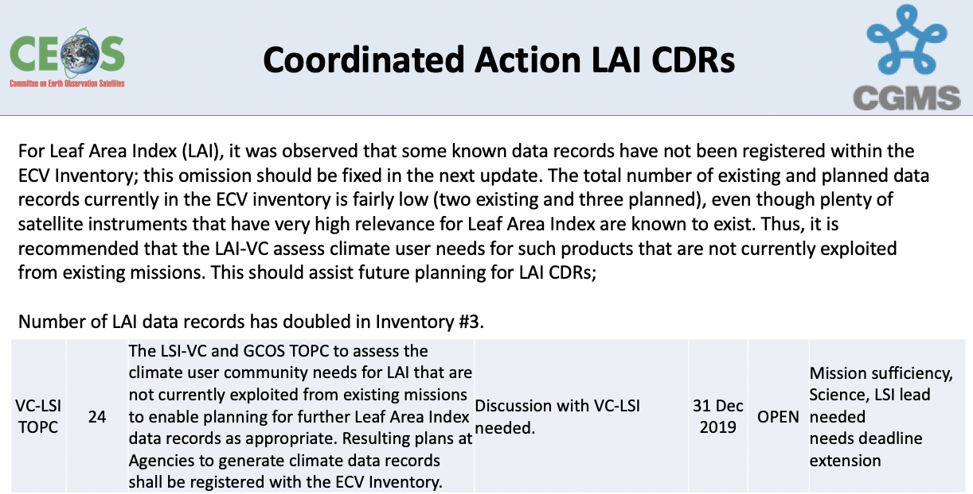
Jörg reported that the dialogue with the SBSTA community is gaining some traction, and awareness of space-based capabilities (including for biomass) and initiatives like GFOI is growing. Jörg noted a CEOS Plenary action on SDCG to prepare biomass materials as supplements to the SBSTA 51 submissions.
LSI-VC-8-21 | Stephen Ward and Jörg Schulz to follow up CEOS-32-04 (SDCG to explore a supplementary information paper for the SBSTA 51 CEOS submission – on forest biomass measurements from space) and the potential for the existing biomass materials to serve as inputs to the COP-25 Earth Information Day. | SIT TW 2019

Biomass Mission Coordination
Stephen Ward presented on CEOS biomass mission coordination and data uptake, as well as the ESA Biomass CCI. Overall, there is a need to accelerate the policy relevance of these new biomass missions, which have had substantial investment from space agencies.
Biomass mission coordination is currently implemented through an informal multi-mission group, with close ties to WGCV/LPV but not formally recognised in the CEOS structure. CEOS Agencies need to consider whether there are benefits to be realised from formalisation within the CEOS Virtual Constellation framework – and should that be LSI-VC or a standalone VC? Stephen asked how might we take advantage of the incoming SIT Chair term to initiate cooperation and establish CEOS Principal attention and support. A two-hour side meeting dedicated to this topic is planned for SIT Technical Workshop next week.
David Crisp (NASA/JPL) noted that biomass measurements are the key missing link in models for UNFCCC/IPCC reporting. Atmospheric GHG and land cover are directly measurable, but biomass measurements are desperately needed to close the loop on these models. CEOS coordination on this topic would be helpful.

MIM Database and API Update
George presented an update on the MIM Database (addition of: launch activity based on COSPAR, datasets based on OpenSearch, featured datasets, and links to exploitation platforms) and development of the API.
George suggested that CARD4L could be added as featured datasets and linked to mission and instrument pages. Steve Labahn suggested reusing some of the DOI information that is already a prerequisite for CARD4L compliance.
There was a discussion around the inclusion of band information in the MIM Database. Steve Labahn strongly supports its inclusion in the Database as a standard feature, as it would be very helpful for interoperability and gap studies. This information should come from the agencies directly to maintain the provenance and source of the data in the Database. Jörg noted that sensor performance will drift with time, so including very specific response curve information could be difficult.
Steve Labahn suggested that the USGS Joint Agency Commercial Imagery Evaluation (JACIE) might be a useful source of information for band data and in general.

Session 12:​ Closing

Review of Actions
Matt Steventon reviewed the actions and decisions. Several updates were made to the record and the following additional actions and decision were recorded:
LSI-VC-8-22 | SDCG and GEOGLAM AHWG leads to update their 2019 SIT Technical Workshop slides to propose LSI-VC subgroup decision and naming agreements. | COMPLETE
LSI-VC-8-23 | Matt to ask Syed (AMA) about solutions for hosting CARD4L sample data (AWS or otherwise) for ceos.org/ard. Matt will work with Ake to get initial sample data up on a test page. | ASAP
LSI-VC-8-24 | Brian to work with Steve to connect Landsat Collection 2 to the Africa ODC Sandbox demonstration. | ASAP

Decision 05 | It was agreed that the SDCG-GFOI and CEOS-GEOGLAM AHWG will propose to become the LSI-VC Forests and Biomass and GEOGLAM subgroups (respectively) at the 2019 SIT Technical Workshop.

Wrap-up & Future Meetings
Steve Labahn thanked everyone for attending and closed the meeting. The next meeting will be held in the late March timeframe in Australia, adjacent SIT-35. In accordance with LSI-VC-8-16, the LSI-VC Secretariat will summarise the proposed future meeting scenarios at the next LSI-VC teleconference.

APPENDIX A
Attendees
Organisation | Name
Agriculture and Agri-Food Canada | Andrew Davidson*
DLR | Albrecht von Bargen#
ESA | Simon Pinnock#
ESA/CNES | Steven Hosford
ESA (LSI SEC) | Stephen Ward
ESA (LSI SEC) | George Dyke
ESA (LSI SEC) | Matt Steventon
EUMETSAT | Alexandra Nunes#
EUMETSAT | Jörg Schulz#
EUMETSAT | Robert Husband#
GA | Andreia Siqueira
GA | Medhavy Thankappan
GEOGLAM | Alyssa Whitcraft
JAXA | Takeo Tadono
JAXA | Ake Rosenqvist
JAXA | Misako Kachi#
KARI | Chiho Kang
KARI | Daehoon Yoo
NASA | Brad Doorn
NASA | Dave Jarrett
NASA | Jeff Masek
NASA | Marissa Herron
NASA | Wenying Su#
NASA/JPL | David Crisp#
NASA/SEO | Brian Killough
NASA/SEO | Sanjay Gowda
USGS | Chris Barber
USGS | Chris Crawford*#
USGS | Jenn Lacey
USGS | Steve Covington
USGS | Steve Labahn
WMO | Werner Balogh#
* indicates remote attendance
# joint session with WGClimate only

APPENDIX B
Actions & Decisions Record

LSI-VC-8-01 | Zolti to follow up the possibility of assessing the EC Sentinel-1 and Sentinel-2 global mosaic products as CARD4L. | ASAP
LSI-VC-8-02 | LSI-VC to review the draft PR PFS and provide feedback to Ake on:  - the best way to structure the document with regard to the overlaps and specifics of the PD and COV products;  - the metadata specifications.  Consideration also needs to be given to overlaps in the SR and ST PFS and how these might also be streamlined. | CLOSED
LSI-VC-8-03 | Medhavy to work with the WGCV team to adjust the CARD4L peer review process with regard to the need to wait until the next face-to-face meeting of the WGCV for final approval, as well as to clarify the role of the LSI-VC Secretariat as the initial POC for the peer review process. | ASAP
LSI-VC-8-04 | Steve Labahn to connect with Nigel Fox and Mirko Albani (CC: Cindy Ong) regarding the CEOS Interoperability Terminology Report and the similar terminology definition work ongoing in WGCV and WGISS. | ASAP
LSI-VC-8-05 | LSI-VC Secretariat to follow up Ferran regarding the discussion with Sinergise around a potential CEOS-Industry ARD workshop in Ljubljana, Slovenia. | ASAP
LSI-VC-8-06 | Dave Jarrett and Jenn Lacey to ask Andy Mitchell, Rob Woodcock, and Richard Moreno to have a discussion about their past experiences with standardisation in WGISS. | ASAP
LSI-VC-8-07 | LSI-VC Secretariat to prepare a standard CARD4L promotional slide deck. | ASAP
LSI-VC-8-08 | Steven Hosford to chase up the submission of ESA’s S-2 self-assessment for WGCV peer review. | CLOSED
LSI-VC-8-09 | Brian, Jenn, and Steve to set up a meeting with ESA and EC representatives at SIT Technical Workshop to explore the possibility of accelerating S-1 and S-2 ARD efforts – following up a past meeting and the ideas around back-processing the S-2 archive and hosting it on AWS. | CLOSED
LSI-VC-8-10 | Andreia & Brian to follow up an IGARSS 2020 session on ARD. | COMPLETE
LSI-VC-8-11 | LSI-VC members to connect relevant government and agency contacts with the SDCG Secretariat regarding any tools and systems that might be suitable for the GFOI tool registry and CALM assessment. | ASAP
LSI-VC-8-12 | LSI-VC members to encourage their agencies to contribute to the update of the GFOI MGD (working via Ake). Ake to share the latest TOC. | ASAP
LSI-VC-8-13 | Takeo/Ake/JAXA to consider submitting JJ-FAST to the GFOI repository of tools. | ASAP
LSI-VC-8-14 | SDCG Work Plan task leads to suggest milestones and timelines through to end-2020. | ASAP
LSI-VC-8-15 | Brian to follow-up with Alyssa on missing mission (one of Sentinel-1B or Sentinel-2B) in the COVE Coverage Analyzer tool. | COMPLETE  Sentinel-1B and 2B are represented in COVE
LSI-VC-8-16 | LSI-VC Secretariat to summarise the proposed future meeting solutions/scenarios (e.g., Sunday/Monday before SIT-35, condensing to one week total; combining with SDCG and biomass workshop). | CLOSED
LSI-VC-8-17 | LSI-VC to review the CEOS Response to the GEOGLAM Observational Requirements document. | COMPLETE
LSI-VC-8-18 | Takeo & Ake to connect with JAXA colleagues (Shin-ichi Sobue and RESTEC) regarding undertaking a CARD4L self-assessment for the JJ-FAST ALOS products. | ASAP
LSI-VC-8-19 | Andreia to investigate the provenance of the 0.5 and 0.2 pixel rRMSE accuracies in the optical and SAR PFS. | ASAP
LSI-VC-8-20 | Medhavy to connect with Jeff Masek regarding sharing SR field validation data for use with HLS as well as the comparisons done with USGS SR products. | ASAP
LSI-VC-8-21 | Stephen Ward and Jörg Schulz to follow up CEOS-32-04 (SDCG to explore a supplementary information paper for the SBSTA 51 CEOS submission – on forest biomass measurements from space) and the potential for the existing biomass materials to serve as inputs to the COP-25 Earth Information Day. | 2019 SIT Technical Workshop
LSI-VC-8-22 | SDCG and GEOGLAM AHWG leads to update their 2019 SIT Technical Workshop slides to propose LSI-VC subgroup decision and naming agreements. | COMPLETE
LSI-VC-8-23 | Matt to ask Syed (AMA) about solutions for hosting CARD4L sample data (AWS or otherwise) for ceos.org/ard. Matt will work with Ake to get initial sample data up on a test page. | ASAP
LSI-VC-8-24 | Brian to work with Steve to connect Landsat Collection 2 to the Africa ODC Sandbox demonstration. | ASAP

Decision 01 | It was agreed to not put detailed metadata specifications (as currently drafted) into any of the SAR PFS, but rather point to a separate document for the detailed metadata specifications (similar to how the SR and ST PFS point to the ISO 19115-2 metadata standard).
Decision 02 | It was agreed that partial compliance of CARD4L datasets will be accommodated. The self-assessment summary tables will be available alongside references to the datasets on CEOS materials and the ARD website so users can assess the applicability of the dataset to their application despite the lack of full CARD4L compliance.
Decision 03 | Sample products (those submitted for the CARD4L assessment process) will be posted on the CEOS ARD website and elsewhere alongside references to CARD4L datasets.
Decision 04 | Dr. Zoltan Szantoi (European Commission) was nominated to succeed Dr. Susanne Mecklenburg (ESA) as an LSI-VC Co-Lead.
Decision 05 | It was agreed that the SDCG-GFOI and CEOS-GEOGLAM AHWG will propose to become the LSI-VC Forests and Biomass and GEOGLAM subgroups (respectively) at the 2019 SIT Technical Workshop.

