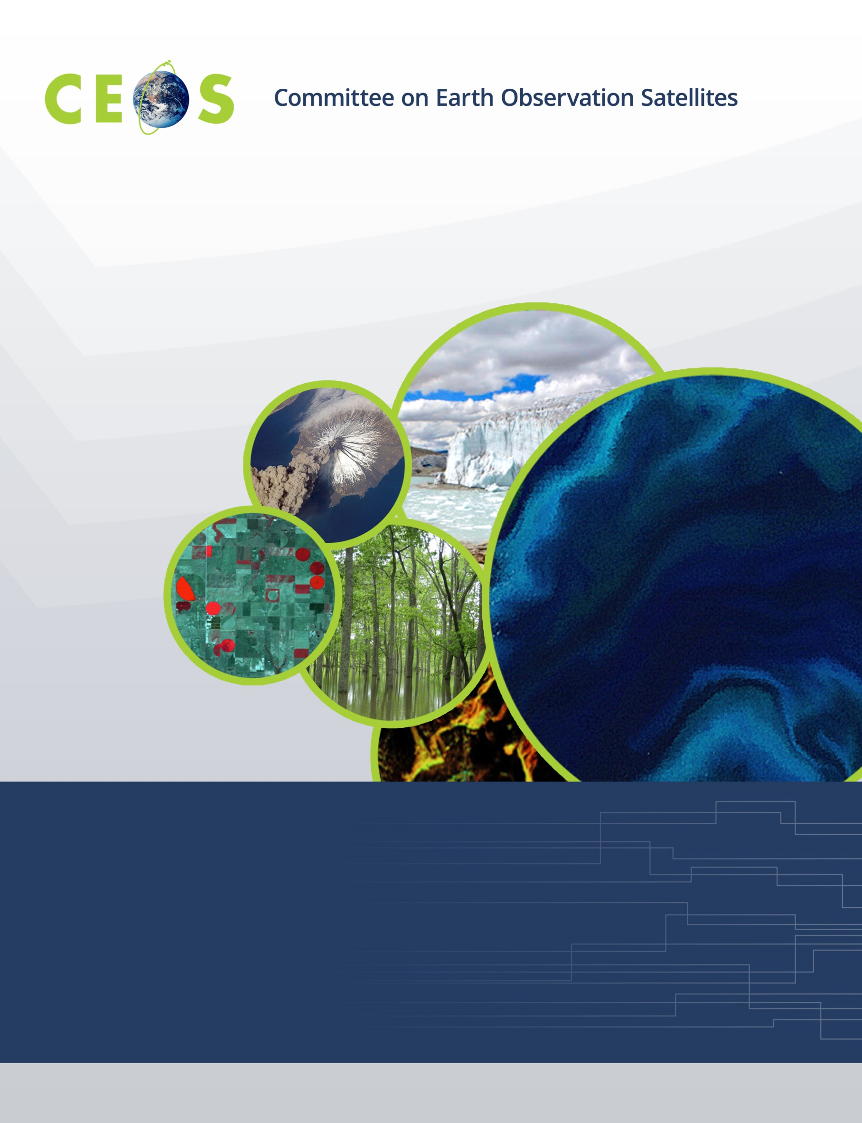

Working Group on Calibration and Validation
CEOS WGCV #43, São José dos Campos, SP, Brazil
Hosted by INPE
April 10-13, 2018
Agenda
Version 1 April 3, 2018

Monday, April 9, 2017

WGCV Attendees Arrivals/WGISS Day 1

WGCV Business
Available for splinters and pre-meetings

WGCV Business
9:00 – 17:30
WGISS Discussions (should register for WGISS meeting if planning to attend)

Tuesday, April 10, 2017

08:15 Meet in Hotel Lobby for Transportation to Meeting

09:00 Convene
Joint Session with WGCV
09:00 Welcome and Introductions, adoption of Joint Plenary agenda M. Albani,
K. Thome
09:10 Host Welcome Opening Address Dr. Ricardo Galvão,
INPE General Director
OR
Dr. Maria Virginia Alves,
INPE Head of Staff
09:40 CEOS Executive Officer Report S. Hosford
10:10 CEOS 2018-2020 Work Plan S. Hosford

10:30 Break
Joint Session with WGCV, continued
10:50 GEO Secretariat Report P. de Salvo*
11:10 CEOS Systems Engineering Office Report B. Killough*
11:30 WGISS Overview M. Albani
11:45 WGCV Overview K. Thome
12:00 Overview of WGISS/WGCV Joint Effort; Past Achievements & Discussion M. Albani,
K. Thome

12:00 Lunch
Joint Session with WGCV, continued
13:30 Data Formats and Interoperability in the framework of FDA R. Woodcock,
M. Thankappan
14:00 Quality Indicators in Discovery Metadata M. Morahan,
N. Fox
14:30 CEOS Data Cubes and CEOS Test Sites Data Access R. Woodcock,
in support to WGCV Activities G. Stensaas

15:00 Group Photo

15:10 Break
15:30 Standardization and Best Practices (e.g. ISO 19159-3) R. Moreno,
C. Ong
16:00 Summary on Joint Interaction and Additional Opportunities; M. Albani,
Joint Recommendations to CEOS and GEO K. Thome
16:30 Minutes and Action Items review M. Piepgrass,
Jamie Nickeson

17:00 Adjourn

19:00 No-host Dinner

Wednesday, April 11, 2017

08:15 Meet in Hotel Lobby for Transportation to Meeting

09:00 Convene
Workshop on Future Data Architectures (FDA) and Introduction of Copernicus Data and Information Access System (DIAS)
FDA Platforms and Elements Landscape
09:00 Introduction
09:10 Exploitation Platforms and Common Reference Architecture C. Lopes*
09:30 ESA Data Cubes R. Leone*, A. Della Vecchia
09:50 Sentinel-2 ARD: Making the Process Operational F. Moscato*
10:10 Open Data Cube in Uganda S. Reid*

10:30 Break
FDA Platforms and Elements Landscape, continued
10:50 Horizontal Scalability for the Colombian Data Cube P. Lozano-Rivera, H. Castro*
11:10 Copernicus DIAS M. Ditter
11:30 GeoHazards Exploitation Platform (GEP) and BIOMASS
Missions Application Platform (MAP) J. Patruno*, A. Della Vecchia
11:50 Pipelines, Ingestion, on-Demand–EO Data Supply Chains in FDA R. Woodcock
12:10 USGS Experiences With Cloud K. Kline*

12:30 Lunch

WGCV Business and Meeting Introduction
13:30 Chair/Vice Chair welcome and opening K. Thome/C. Ong
13:45 Tour de table All
14:00 Meeting overview, goals, and agenda approval K. Thome
14:15 WGCV Chair’s Report K. Thome
14:45 WGISS/WGCV Session summary and WGCV Action Item Status K. Thome

15:10 Break

Agency and Subgroup Reports
15:30 INPE J. Vianei
15:45 JAXA A. Kuze
16:00 CSIRO C. Ong
16:15 GA M. Thenkapan
16:30 SAR Sub-Group Report B. Chapman
16:50 Day 2 Summary K. Thome

17:00 Adjourn

Thursday, April 12, 2017

08:15 Meet in Hotel Lobby for Transportation to Meeting

09:00 Convene

Agency and Subgroup reporting
09:00 ISRO A. Misra
09:15 BelSpo J-C. Lambert
09:30 ACSG Sub-Group Report J-C Lambert
09:50 IVOS Sub-Group Report N. Fox
10:10 LPV Sub-Group Report F. Camacho

10:30 Break
Subgroup and Task Group reporting
10:50 MW Sub-Group Report X. Dong
11:10 ACIX Report K. Thome
11:20 On-going evaluation for the Evolution of DEM used in Copernicus
Space Component Data Processing P. Goryl
11:30 Cloud Mask update P. Goryl/K. Thome
Agency Reports
11:45 NSSC X. Dong
12:00 USGS G. Stensaas
12:15 ESA P. Goryl

12:30 Lunch
Agency Reports
13:45 NASA K. Thome
WGCV CEOS Work Plan Status
14:00 WGCV Work Plan Actions K. Thome
14:20 Pre-launch calibration workshop N. Fox, A. von Bargen
14:40 Surface reflectance validation M. Thenkapan

15:00 Break
15:20 Surface reflectance training course outcome C. Barrientos Gajardo
15:35 Uncertainties for Analysis Ready Data All
16:15 Cal/al for Greenhouse gases observation spectrometers A. Kuze
16:30 Carbon actions update K. Thome

17:00 Adjourn

Friday, April 13, 2017

09:00 Convene

WGCV Business
09:00 Day 3 Summary K. Thome
09:15 Lessons from FDA and DIAS Workshop and
applicability to WGCV C. Ong
09:45 RadCalNet Approval K. Thome/M. Thankappan
10:00 GSICS solar irradiance approval N. Fox
10:15 Web site update status J. Nickeson

10:30 Break
10:50 WGCV Newsletter, telecons and other outreach K. Thome
11:00 Future Meetings; Vice Chair K. Thome
11:10 Action Item review and meeting wrap up K. Thome

12:00 Adjourn

