Welcome to the EUMETSAT Headquarters, welcome to Darmstadt and welcome to Germany!

MEETING VENUE

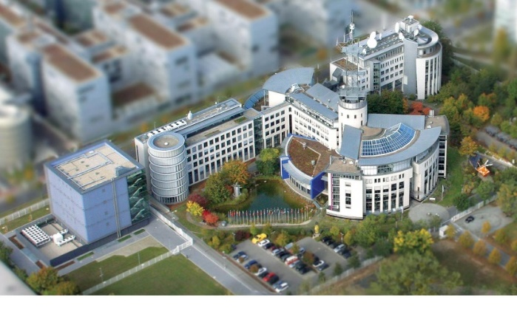
The meeting will be held in Darmstadt at the premises of European Organisation for the Exploitation of Meteorological Satellites
(EUMETSAT) at Eumetsat Allee 1, 64295 Darmstadt, Germany.

EUMETSAT operates a system of meteorological satellites that observe the atmosphere and ocean and land surfaces – 24 hours a day, 365 days a year. This data is supplied to the National Meteorological Services of the organisation's Member in Europe, as well as other users worldwide.

CITY DARMSTADT
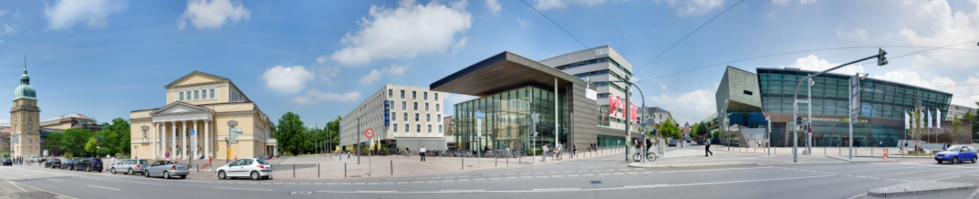
Darmstadt is located just 30 km south of Frankfurt am Main in Hesse. The city enjoys a reputation as a ‘City of Science’ thanks to the many public and private scientific research establishments located there, not to mention the Headquarters of EUMETSAT and the European Space Agency Operations Centre (ESA/ESOC).

Darmstadt is not only a “city of science”, but also a city of art and culture. Home to top researchers, musicians, engineers, and artists for centuries, today’s Darmstadt is the product of a unique fusion between artistic traditions and technological advancement. The pedestrianised area in the city centre offers numerous restaurants, shopping, and relaxation possibilities. Just a short trip out of town is the beautiful Odenwald mountain range a haven for nature lovers and outdoor enthusiasts and also home to the famous Bergstrasse, one of the best wine regions in Germany.
For more information visit http://www.darmstadt-tourismus.de/en.html

HOW TO REACH DARMSTADT
Darmstadt is located 30km away from the Frankfurt International Airport. You can reach Darmstadt from Frankfurt airport using:
- AIR-Liner Bus linking Darmstadt Railway station and Frankfurt Airport (single fare 8.70 €). Services leave regularly and take approximately 30 minutes. The bus schedule can be downloaded HERE.
At Frankfurt Airport, AIR-Liner stops at:
Terminal 1 – bus stop: Nr 14 – arrival level
Terminal 2 – bus stop: Exit E8

Taxis - Taxi TAM offers for EUMETSAT guests a preferential rate of 38 € from airport to Darmstadt city center.
Taxi TAM: +49 6151 44 7 22 or +49 170 380 47 22

LOCAL TRANSPORT

- Local Taxi
Taxi Planet +49 6151353152
Kala Taxi +49 615121923

- Bus and tram - for all important information you need for travelling by bus and tram - from timetables to ticket purchases – please visit http://www.rmv.de/en/.
The nearest tram stop to EUMETSAT is MOZARTTURM (out of EUMETSAT main gate turn left onto Am Kavalleriesand and then cross over Rheinstrasse and turn left).

- Bike - in addition to public transport and taxis, you can also use bicycles – or even e-bikes – to get around Darmstadt. For details please check: https://www.callabike-interaktiv.de/de/staedte/darmstadt. There is a “Call a Bike” station for bicycles close to the Central Train Station, 10 min walk from EUMETSAT.

ACCOMMODATION

Below you will find the list of some hotels in Darmstadt. We have negotiated block bookings with special rates at few of them, but availability is limited so please book early to avoid disappointment.

Recommended Hotels (names are web links)
Best Western Plaza – 5min walk to EUMETSAT HQ
(Am Kavalleriesand 6, 64295 Darmstadt, Tel.: +49 6151 7377500)
- Reservations can be made online, or send your request at the following email reservierung@darmstadt.plazahotels.de
- Cancellation policy: Free of charge cancellation until two days before arrival. For later cancellations, no-shows or early departures will be charged with 90% of the booked arrangements.
Intercity Hotel Darmstadt - 15min walk to EUMETSAT HQ
(Poststraße 12, 64293 Darmstadt; Tel.: +49 6151 906910)
- Reservation: In order to make the booking use the web site, or send your request at the following email reservations.darmstadt@intercityhotel.com
- Cancellation policy: Free of charge cancellation until one week before arrival. 90% of the total price for cancellation outside the free of charge period or in case of non-arrival.
Prinz Heinrich Darmstadt - 20 min walk to EUMETSAT HQ
(Bleichstraße 48, 64293 Darmstadt, Tel.: +49 6151 8137 - 0)
- Reservation: In order to make the booking please go to web site (http://www.hotel-prinz-heinrich.de/home) or send an email at info@hotel-prinz-heinrich.de
- Cancellation policy: Free of charge cancellation until 12pm on the arrival day. 100% of the total price for cancellation after 12pm or no shows.

Other Hotels
Maritim Hotel (Rheinstraße 105, 64295 Darmstadt; Tel.: +49 6151 8780) Email: reservierung.dar@maritim.de
B&B Hotel (Zweifalltorweg 4, 64293 Darmstadt; Tel.: +49 6151 9672-0; Email: darmstadt@hotelbb.com)
Ibis Hotel (Kasinostraße 4, 64293 Darmstadt; Tel.: +49 6151 3973-720)

MEALS AND SOCIAL EVENTS

Icebreaker will take place on Tuesday 28 August at EUMETSAT HQ.

Dinner/ Social Event will take place on Thursday 30 August. More details will follow.

In case you are staying on in Darmstadt here are a few recommendations of places to eat:

- Ratskeller (German kitchen, very good beer, typical German dishes, good place to take in the ambiance of the market square)
Marktplatz 8, 64283 Darmstadt
+49 61 51 264 44
- Braustübl (Traditional German restaurant near to the station, 10-minute walk from EUMETSAT)
Goebelstrasse 7, 64293 Darmstadt
+49 6151 876587
- Vapiano (Modern mixture of an Italian and fast food type of restaurant, near to the train station, 10-minute walk from EUMETSAT)
Rheinstraße 103, 64295 Darmstadt, Germany
+49 6151 6675666

- Restaurant Lemongrass (Thai cuisine, just a few minute walk from EUMETSAT)
Mina-Rees-Str. 5a, D-64295 Darmstadt
06151 5003872
- Yang Ji Sushi and More (Sushi and fresh Korean cuisine in the city centre)
Adelungstraße 11, 64283 Darmstadt
06151 3528554
- das krü (The restaurant serves up its own and sometimes very different interpretations of a range of dishes from Germany, Austria and the Mediterranean countries. It listed amongst „the best 500 restaurants in Germany for everyday”.)
Ludwigstraße 8, 64283 Darmstadt
06151 272441
- Zoo-Bar-Restaurant (The restaurant combines international inspiration with seasonal domestic ingredients to create unmatchable dining experiences.)
An der Stadtkirche 17-19, 64283 Darmstadt
06151-4923535

VISA
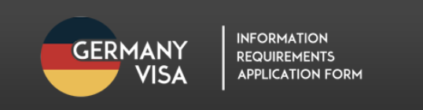
To find out if you will need to obtain a visa and to learn the visa application requirements, please check the website:
http://www.germany-visa.org/germany-visa-requirements/.
The participants who need a letter of invitation for the visa application contact Bojan Bojkov (Bojan.Bojkov@eumetsat.int) with a cc to Jaime Nickeson (Jaime.Nickeson@nasa.gov).

EMERGENCY CONTACT INFORMATION

We hope that you do not need to use them, but just in case the worst happens:

Emergency services: dial 112
Police emergencies: dial 110
Medical Emergency: Darmstadt Clinic (Grafenstr 9, 64283 Darmstadt, Phone: +49 6151 107 8161)
http://www.klinikum-darmstadt.de/presentation/contact.php

