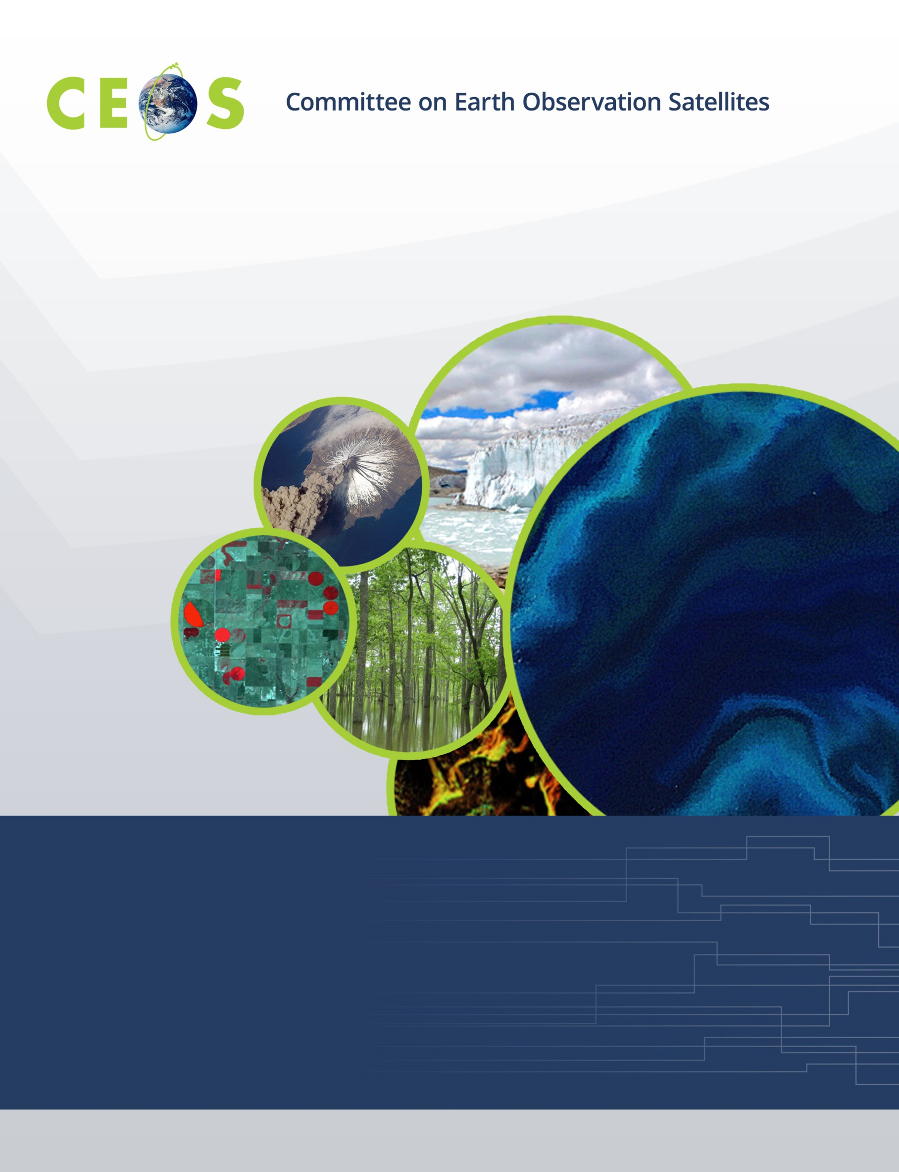
Working Group on Calibration and Validation
CEOS WGCV #44, Darmstadt, Germany
Hosted by EUMETSAT
August 28-31, 2018
Agenda
Version 0 May 29, 2018

Monday, August 27, 2018
WGCV Attendees
Arrivals
WGCV Business
Chair available for splinters and pre-meetings in afternoon and evening

Tuesday, August 28, 2018

08:30 Registration
9:00 Convene
 | WGCV Business and Meeting Introduction
09:00 | Chair/Vice Chair welcome and opening |  | K. Thome/C. Ong
09:15 | Tour de table |  | All
09:30 | Logistics
09:45 | Welcome to EUMETSAT |  | TBD
10:15 | Meeting overview, goals, and agenda approval |  | K. Thome
10:30 Break
10:45 | WGCV Chair’s Report | K. Thome
11:30 | RadCalNet status | TBD
11:45 | Update on Pre-launch calibration workshop | N. Fox/A. von Bargen
12:00 | ACIX final report | P. Goryl/A. von Bargen
12:15 | Cloud Mask Task Group | TBD
12:30 Lunch
12:15 | DEM Update and Discussion | TBD
 | Subgroup reporting
13:50 | ACSG Subgroup Report |  | B. Bojkov
14:10 | IVOS Subgroup Report |  | N. Fox
14:30 | LPV Subgroup Report |  | M. Roman
14:50 | MW Subgroup Report |  | X. Dong
15:10 Break
15:30 | SAR Subgroup Report |  | B. Chapman
15:50 | GEO Secretariat Report |  | P. de Salvo
16:10 | CEOS Systems Engineering Office (SEO) Report |  | B. Killough
16:30 | CEOS Executive Officer Report |  | S. Hosford
17:00 | CEOS 2019-2021 Work Plan |  | S. Hosford
17:15 Adjourn
Icebreaker

Wednesday, August 29, 2018
 | 9:00 Convene
 |  |  |  |  | WGCV Business
 | 09:00 |  |  |  | Day 1 Summary |  | K. Thome
 |  |  |  |  | WGCV Interactions with external entities
 | 09:15 |  |  |  | Proposed topics could include:
 |  |  |  |  | GSICS Interactions
 |  |  |  |  | GSICS Executive Panel; GRWG, Subgroup updates
 | 10:30 Break
 |  |  |  |  | WGCV Interactions with other CEOS entities
 | 10:45 |  |  |  | Proposed topics include:
 |  |  |  |  | EUMETSAT activities within CEOS
 |  |  |  |  | Ocean Colour Radiometry Virtual Constellation
 |  |  |  |  | Ocean Surface Vector Wind Virtual Constellation
 |  |  |  |  | Sea Surface Temperature Virtual Constellation
 | 12:30 Lunch
 |  |  |  |  | WGCV Interactions with other CEOS entities, cont’d
 | 13:30 |  |  |  | Proposed topics include:
 |  |  |  |  | Working Group Climate/CGMS
 |  |  |  |  | L1 top-of-atmosphere interoperability
 |  |  |  |  | Uncertainties for Analysis Ready Data
 |  |  |  |  | Greenhouse gas reference standards for interoperability
 |  |  |  |  | Cal/Val for Greenhouse gases observation spectrometers
 |  |  |  |  | Carbon actions update
 |  |  |  |  | Biomass Validation Protocols
 | 15:15 Break
 |  |  |  |  |  | Agency Reports
 |  | 15:30 |  |  |  | EUMETSAT
 |  | 15:45 |  |  |  | BelSpo
 |  | 16:00 |  |  |  | CNES
 |  | 16:15 |  |  |  | DLR
 |  | 16:30 |  |  |  | ESA
 |  | 16:45 |  |  |  | ROSCOSMOS
 |  | 17:00 |  |  |  | UKSA
17:15 Adjourn
Dinner

Thursday, August 30, 2018
 | 9:00 Convene
 |  |  |  |  | WGCV Business
 | 09:00 |  |  |  | Day 2 Summary |  |  | K. Thome
 |  |  |  |  | Agency Reports
 | 09:15 |  |  | CMA
 | 09:30 |  |  |  | CSIRO
 | 09:45 |  |  |  | GA
 | 10:00 |  |  |  | ISRO
 | 10:15 |  |  |  | JAXA
 | 10:30 |  |  |  | NSSC
 | 10:20 Break
 |  |  |  |  | WGCV/WGISS WGCV-43 Actions Updates
 | 11:00 |  |  |  | Summary of WGCV/WGISS interactions from WGCV-43 |  | K. Thome
 | 11:10 |  |  |  | Data Formats and Interoperability in the framework of FDA |  | M. Thankappan
 | 11:30 |  |  |  | Quality Indicators in Discovery Metadata |  | N. Fox
 | 11:50 |  |  |  | CEOS Data Cubes and CEOS Test Sites Data Access
 |  |  |  |  | in support to WGCV Activities |  | G. Stensaas
 | 12:10 |  |  |  | Standardization and Best Practices (e.g. ISO 19159-3) |  | C.Ong
 | 12:30 Lunch
 |  |  |  |  | WGCV Work Plan Status
 | 13:30 |  |  |  | WGCV Work Plan Actions |  | K. Thome
 | 13:45 |  |  |  | Continental scale surface reflectance validation |  | M.Thankappan
 | 14:15 |  |  |  | CARD4L-branded specification documents
 | 14:30 |  |  |  | Data product formats to facilitate interoperability
 | 14:45 |  |  |  | Long-term plans for Moderate-Resolution Interoperability
 | 15:00 Break
 |  |  |  |  | WGCV Work Plan Status, cont’d
 | 15:15 |  |  | Closure of WGCV website reorganization (CV-01); RadCalNet (CV-09)
 |  |  |  | ACIX (CV-13); GSICS/CEOS reference Solar Spectrum evaluation (CV-16)
 | 15:30 |  |  | 2019-2021 Work Plan inputs
 |  |  |  |  |  | Agency Reports
 | 16:00 |  |  | INPE
 | 16:15 |  |  |  | NASA
 | 16:30 |  |  |  | NOAA
 | 16:45 |  |  | USGS
 | 17:00 Adjourn

Friday, August 31, 2018
 | 9:00 Convene
 |  |  |  |  |  | WGCV Business
 | 09:00 |  |  | Day 3 Summary |  |  | K. Thome
 | 09:15 |  |  | Action item summaries update |  |  | K. Thome
 | 09:45 |  |  | WGCV Newsletter, telecons and other outreach |  |  | K. Thome
 | 10:00 |  |  | Web site and Cal/Val Portal update status |  |  | J. Nickeson/P.Goryl
 | 10:15 Break
 | 10:30 |  |  |  | Vice-chair nomination; Candidate presentation and voting
 | 11:30 |  |  |  | Meeting summary |  |  | K. Thome
 | 11:45 |  |  |  | Future directions |  |  | C. Ong
 | 12:00 |  |  |  | Future Meetings |  |  | C. Ong
 | 12:15 |  |  |  | Chair hand-over |  |  | K. Thome
 | 12:30 Adjourn

