Minutes v1.0
WGCV-49 Day #1
Tuesday, 29 June 2021

Welcome and Chair Report [Slides]
Presenter: A. Kuze
Main points:
- Akihiko Kuze (WGCV Chair, JAXA) welcomed everyone to the meeting and reviewed the agenda.
- Reviewed WGCV-48 actions, which have all been completed. Cindy progressed the discussion with ISO and we will hear an update this week. The action regarding the DEM has also been completed.
- Minor updates were provided for the CEOS Work Plan 2021-2023, given the Work Plan was only an incremental update due to the drawn out cycle in 2020.
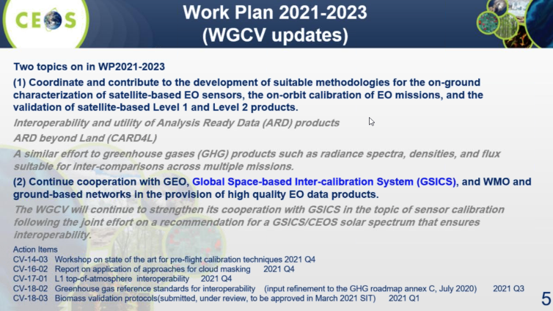
- The Soil Moisture Product Validation Good Practice Protocol was endorsed by WGCV on Nov. 30.
- The CEOS Aboveground Woody Biomass Product Validation Good Practices Protocol was endorsed by the SIT-36 meeting in March 2021.
- Team updates since WGCV-48:
  - Kuze-san presented to SIT-36 on biomass and the GHG/Global Stocktake work;
  - Met on March 12 to review the WGCV presentation for the SIT-36 meeting (March 22-25);
  - Contributed to the CEOS study team on the UNFCCC GST through various calls;
  - Joined the CEOS ARD Framework review (ARD Beyond Land meetings); and,
  - Attended the GSICS annual meeting, which included the presentation of a CEOS-WGCV overview and recommendation regarding the TSIS HSRS solar spectra, which the GSICS community endorsed.
Land Product Validation (LPV) Subgroup Report [Slides]
Presenter: F. Camacho
Main points:
- LPV Plenary held 26-27 May 2021. Agenda in slides.
- LPV Strategy covers: development of good practices, promoting validation and intercomparison exercises, improving access to ground reference datasets and communication.
- Four GPG now produced, with biomass the most recent. Good Practices Protocols for Land Cover, VIs, Phenology and FAPAR are in progress. Global Surface Reflectance Validation Good Practices need to be addressed.
- BRIX-2 is underway and will be presented later.
- Biomass product harmonisation activity for the UNFCCC GST is ongoing.
- Open science activity proposed to use the ESA-NASA Multi-mission Algorithm and Analysis Platform (MAAP). Idea is to build more confidence for policy, and to make harmonised products from GEDI, etc. Goal is to have a pilot harmonisation framework (and product) by COP26 (November 2021).
- SRIX4Veg: joint effort to ensure consensus on surface reflectance validation protocols using drones. Registration is now open. Focuses on UAV-mounted hyperspectral imagers capable of 400 - 1000nm contiguously at <= 10nm spectral resolution. More details and registration: http://frm4veg.org/srix4veg/
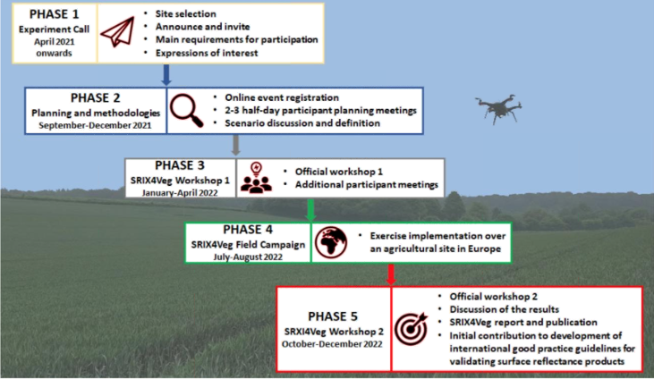
- Sentinel-3 albedo C3S validation and intercomparison exercise is ongoing. Underestimation of S3 snow albedo identified as a problem with IDPIX (OLCI processing) misidentifying snow pixels as clouds. LPV supersites were a key input for understanding this.
- Land cover: ESA CCI Land cover moving from Stage 3 to Stage 4. Ground data points are updated annually.
- LST: ECOSTRESS, stage 1 validation of level-2 LST&E products has been completed. Landsat 9 preparatory validation activities are ongoing. A round robin is being coordinated by JPL, field campaigns, and will define protocol for Landsat 9 validation.
- GEO-TREES (CARB-21-03): GEO Community Activity for a forest biomass reference system for tree-by-tree inventory data - supporting coordination and collection of new high-quality reference measurements for biomass products. CEOS Agencies are encouraged to coordinate on data collection for biomass following the endorsed WGCV LPV biomass protocol.
- Copernicus LAW: Network for validation of LST, AOD, WV. Validation for Land S3 products. LPV supersites are represented in this activity.
- GAOFEN Validation Network: 42 sites, all land surface ECVs, national standards (protocols) enacted, measurement initiated. Fills an important gap for this part of the world. Xingfa Gu <guxingfa@radi.ac.cn> is the POC.
- 13 actions closed during the last LPV Plenary:
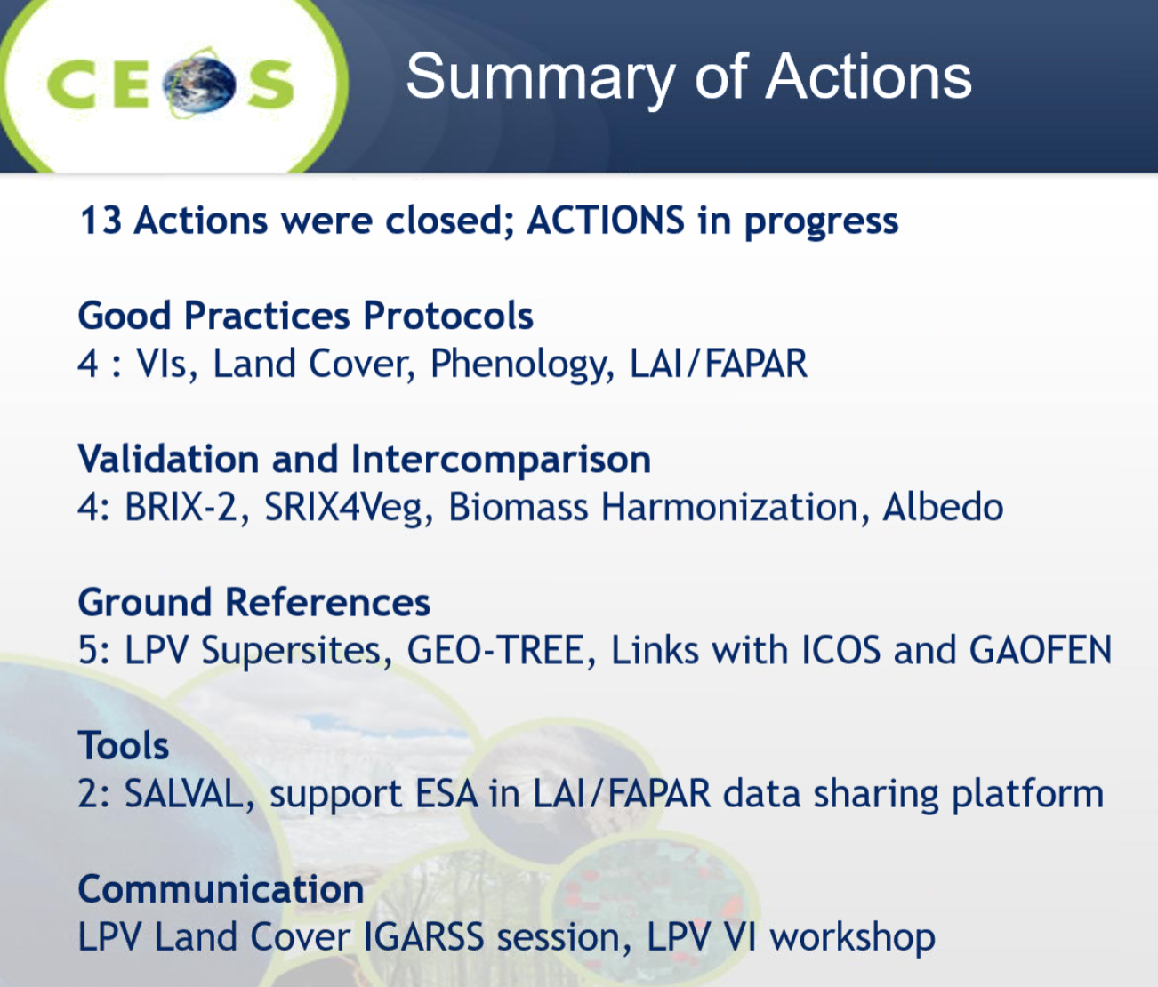
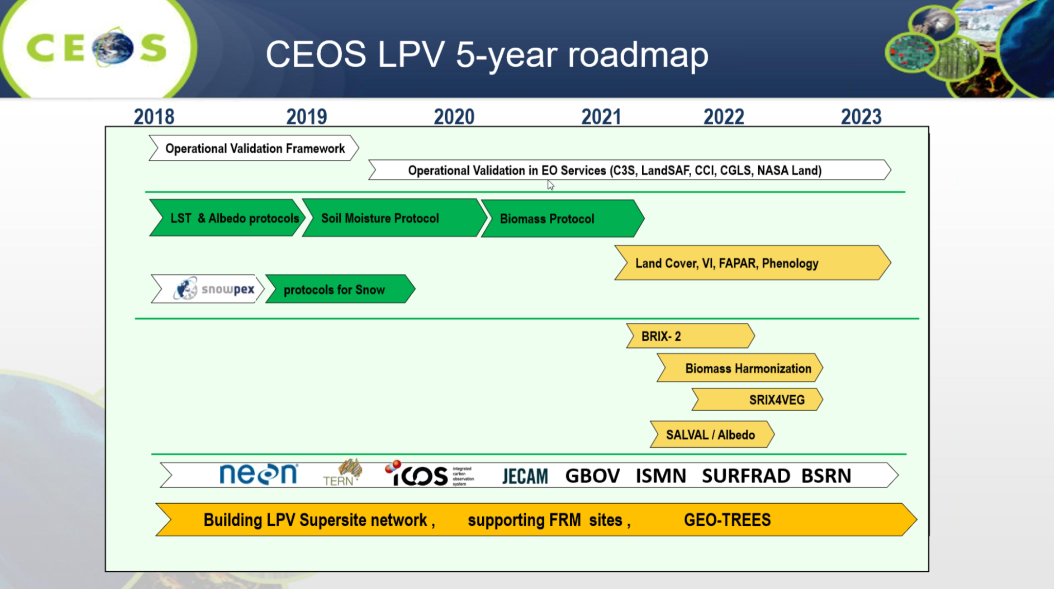
Discussion
- Medhavy Thankappan (GA) commented on the UAV-based SR validation exercise being planned, noting that Geoscience Australia has established a modest capability for UAV-based SR validation and are planning a campaign in August, if travel restrictions due to COVID allow. GA is interested in contributing to SRIX4VEG.
BRIX-2
Presenter: P. Goryl
Main points:
- BRIX-2 is being undertaken to intercompare biomass retrieval models. It is the follow-on to BRIX-1.
- BRIX-1 was based on the precursor of the NASA-ESA MAAP. Retrievals were evaluated over 3 sites. The exercise was very helpful and showed similar behaviour for 4 models despite being very different methods. A key lesson learned was the use of the same ROIs for training and validation will introduce strong bias in results.
- BRIX-2 will be similar to BRIX-1, again organised by ESA and NASA , with the following methodology: 2 workshops, one at start to discuss the protocol, second to share results. Will be based on NASA-ESA MAAP again. The timeline is as follows:
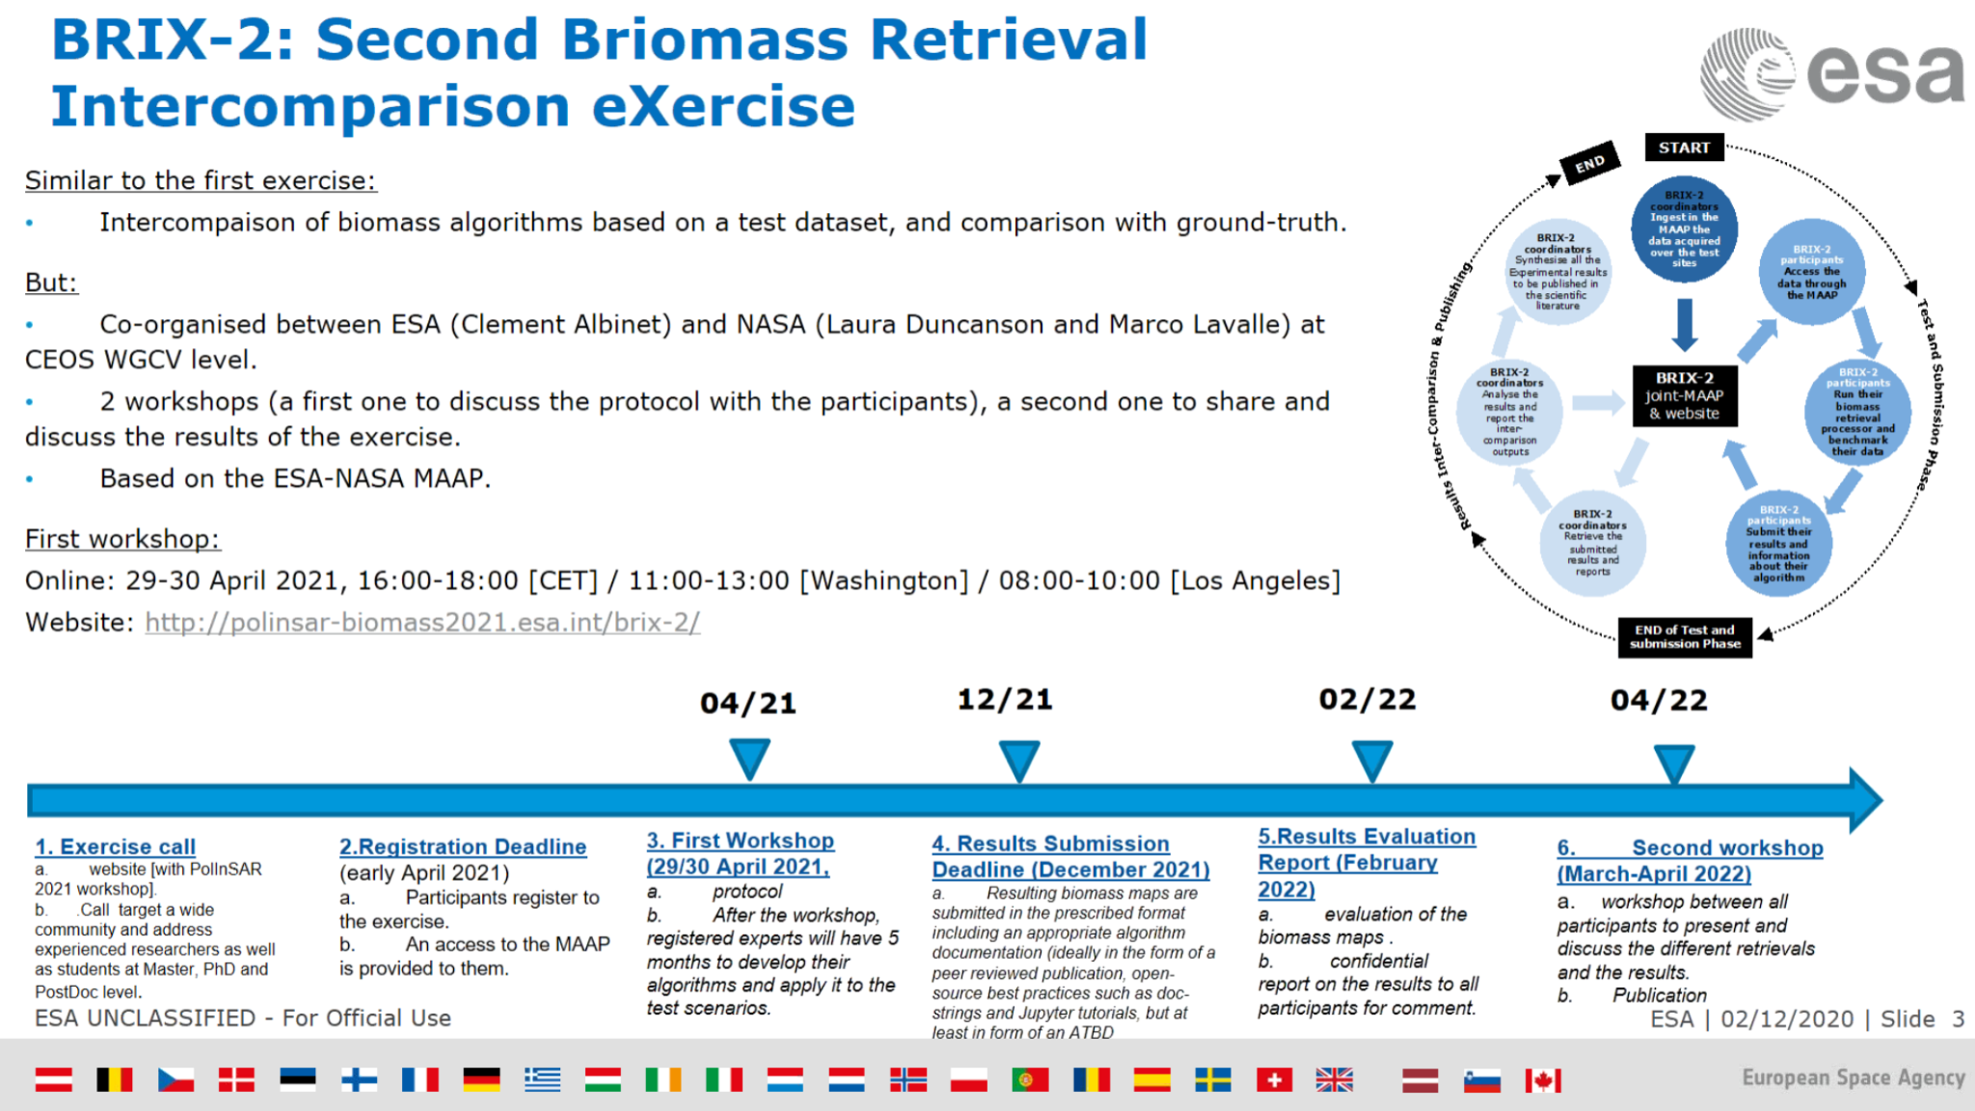
- BRIX-2 will use the WGCV LPV biomass protocol for the validation of products. 18 teams have confirmed their participation.
Infrared and Visible Optical Sensors (IVOS) Subgroup Report
Presenter: N. Fox
Main points:
- Presented IVOS Terms of Reference:
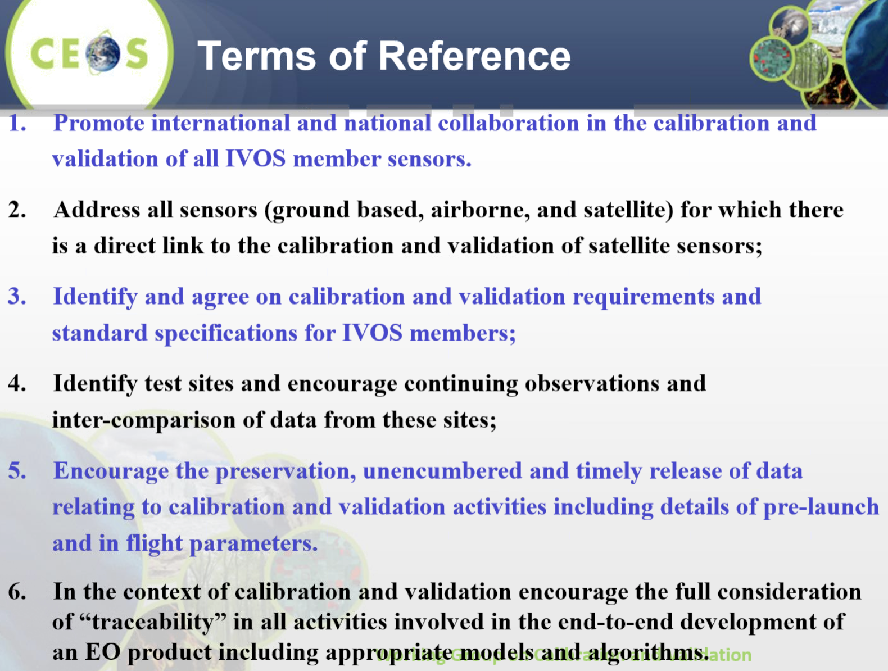
- Workshop on state-of-the-art for pre-flight calibration techniques (CV-14-03) has been delayed with the aim of eventually having a face-to-face meeting, hopefully in 2022.
- Various project workshops were held over the last year (see slides).
- PICSCAR: Project focused on improving the common understanding of the characterisation of PICS and their usage monitoring the performance of satellites and performing intercomparisons. The PICSCAR portal was shown, which includes analysis tools. Going forward the intention is to extend the database and portal to include other sites, focusing initially on priority sites from a community questionnaire.
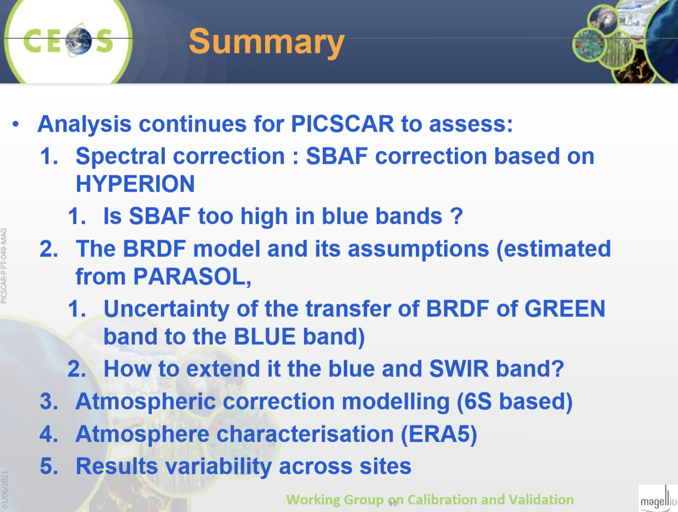
- RadCalNet: Test sites are nominally owned or operated by members who are responsible for the QA and characterisation of their test site on the ground. All data from sites is transmitted to a common portal, which NASA then processes through a common chain and delivers TOA reflectance data every 30 minutes to users (hyperspectral, with uncertainties). This is a CEOS WGCV calibration service. There are currently 5 sites, with 2 more in preparation. Sentinel-2 is being used for cross-comparisons. There are 674 recorded users, with around half active, resulting in significant download volumes. There were 102 attendees at the first RadCalNet users workshop. Substantial helpful feedback was collected:
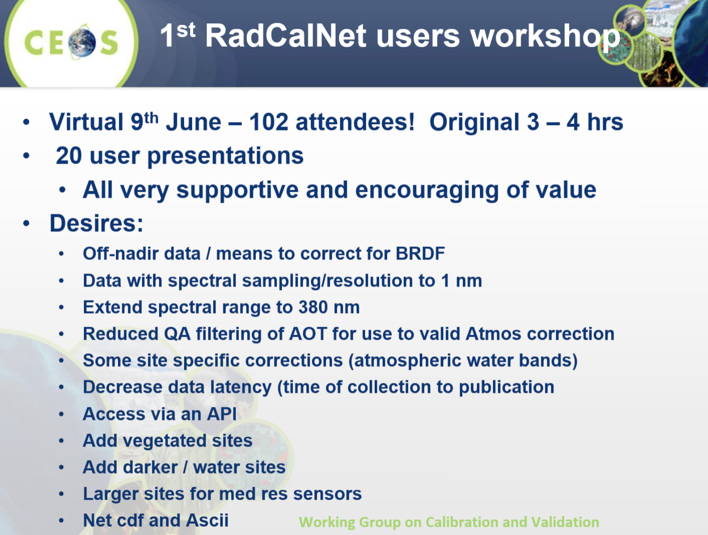
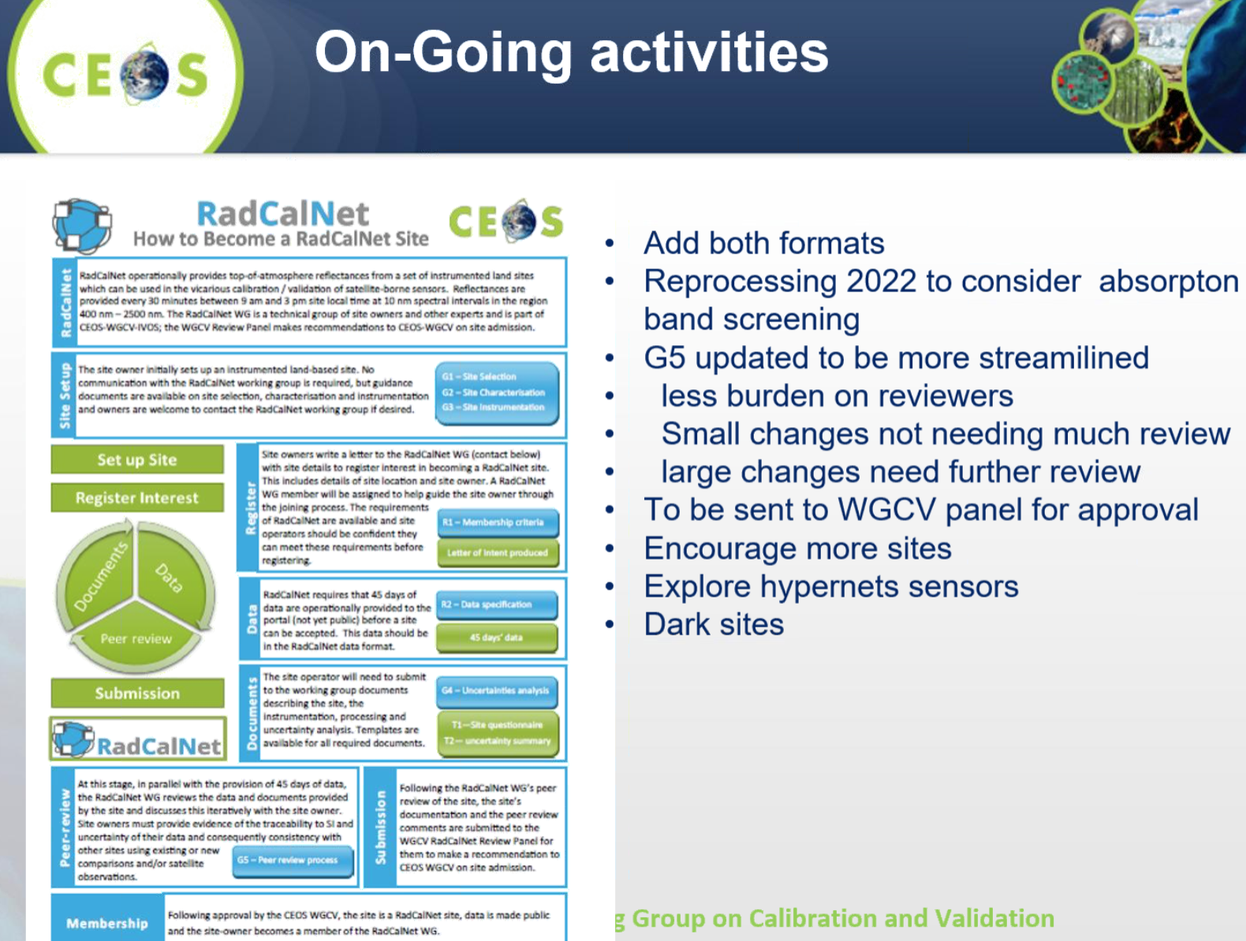
- Solar irradiance spectrum: Was the focus of a recent workshop. Considering updating WGCV’s official spectrum recommendation because of significant differences in the SWIR bands, which are particularly relevant to GHG measurements (see below, red is the old spectrum). Will likely propose that WGCV adopt the TSIS high resolution spectrum as the new CEOS solar irradiance reference spectrum for the spectral range 350 - 2700nm. We will hear more on Day 3 of WGCV-49.
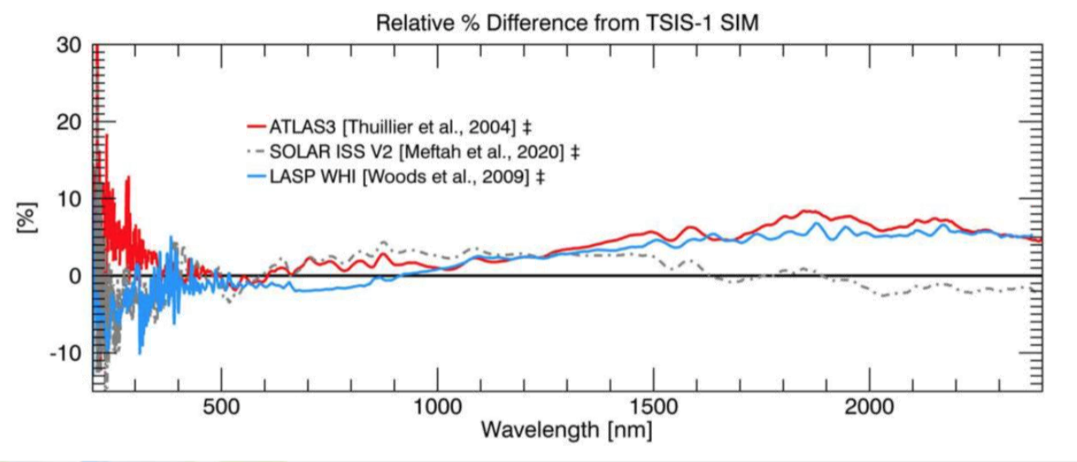
- FLARE: Labsphere presented to IVOS on the FLARE vicarious calibration network. Seeking how to make FLARE aligned with the CEOS mission. While noting that they are a commercial company, IVOS has proposed documenting their capabilities on the cal/val portal.
- SI-traceable Space-based Climate Observing System (SITSCOS): The workshop report will be published very soon on the cal/val portal. There are various recommendations in the document, one being that world space agencies should plan to strategically sustain (on an operational basis) an SI-traceable climate observing system.
- Still planning CEOS Surface Temperature comparisons (5 yearly) and similar OCR exercises.
- Upcoming meetings:
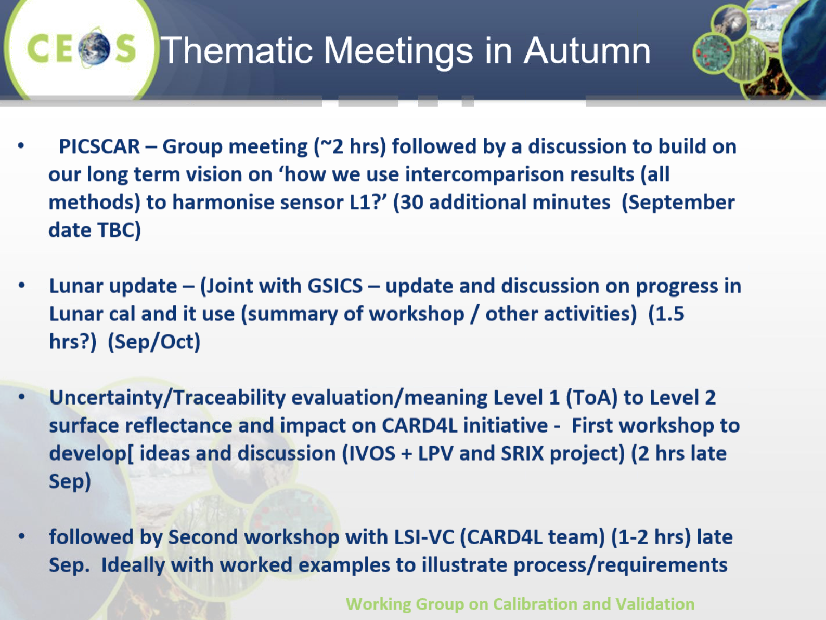
- Further short notes: IVOS is keen to revitalise and use the cal/val portal as a community interface; working to support commercial ARD sector and LSI-VC in terms of traceability and uncertainty; working towards integration of cal/val methods to develop optional strategies for interoperability and prospect of space-based reference sensors; need to increase engagement with some agencies that have withdrawn from IVOS.
Discussion
- Peter Strobl asked about the solar reference spectrum and noted the recent major collection reprocessing of the Landsat archive. A similar activity is planned for the Sentinel-2 archive towards the end of 2021. How much of an influence does this spectrum discussion have on this. Nigel responded there will be an impact if people choose to use it, certainly for certain Sentinel-2 bands. In the visible domain, there is an absolute level of difference between the new and old spectrums. It will make a difference. It is important that people check what the change will mean for them. It should be kept in mind that this is only a recommendation, but one made because of the 9-10% differences in the SWIR bands, which have a significant impact on GHG measurements. Individual agencies need to assess whether they wish to change the spectrum – CEOS cannot make that decision, just communicate and identify the new spectrum, reasons, and the differences.
- Manik noted in chat: “One of the contributions of WGCV-CEOS is the QA4EO framework which we routinely use for accepting products and deliverables and assigning maturity to them. Do you have labels such as QA4EO certified that we can use on our website?” Nigel responded: “Not QA4EO certified as this implies a standardisation but a phrase like 'consistent with QA4EO principles' is a good phrase. We will be migrating the QA4EO legacy site to the Cal/Val portal shortly as well.“
Terrain Mapping (TMSG) Subgroup Report [Slides]
Presenter: P. Strobl
Main points:
- As of June 28: 58 participants in TMSG, from 14 countries, 50% CEOS background. Plenary postponed (waiting for DEMIX progress) envisaged for Q3 2021 (virtual, maybe in conjunction with Geomorphometry 2021, 13-17 Sep, Perugia, IT).
- Digital Elevation Inter-Comparison (DEMIX) kick-off meeting held with 26 participants on 26 and 30 June 2020. 25 participants active (CAS, DLR, EC, ESA, ISRO, JAXA, NASA, USGS) + domain experts and industry. Progress of subgroups is as follows:
  - Terminology and analytical basis: Revised terminology and comprehensive definitions (glossary) finished; Peer reviewed paper in preparation.
  - Algorithms and software – open source tool box: Extensive test of algorithms and tools; Initial test protocol developed; Tests ongoing; Implementation of ‘wine contest’ concept.
  - Platforms and processing: Major support by ESA (through VtWeb); Discussions on cooperation with CEOS Earth Analytics Interoperability Lab (EAIL); Ensuring easy and consistent access to test data; Preparations for roll out of tests to continental/global scale.
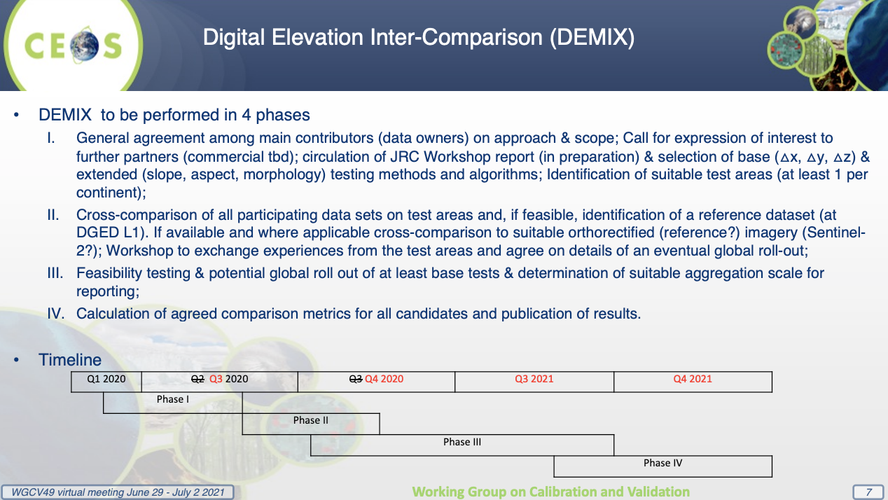
- DEMIX video link.
Discussion
- Tim Hewison (EUMETSAT) asked via chat: “Have assessments at lower spatial resolutions been considered within DEMIX?” Peter responded that the focus on 1 arcsecond is just due to the selection of the five DEMs noted in the video. Others could be considered.
Terminology and Common Online Dictionary [Slides]
Presenter: P. Strobl
Main points:
- With the advent of ‘Big Data’, Earth Observation, Geospatial Sciences and many of their fields of application become increasingly intertwined, i.e., they become a single ‘domain of knowledge’. Traditions and legacy usage make their vocabularies increasingly complex and confusing as soon as previous ‘communities’ are crossed. Multidisciplinary working groups need to agree on terminology when starting their work, often struggling with diverging practices and then starting their own tailored versions (often as “least common denominator”).
- Key vocabularies in EO/Geosciences include:
  - ISO/TC 211 terminology management group: https://isotc211.geolexica.org/
  - OGC: https://www.ogc.org/ogc/glossary/, http://www.opengis.net/def/glossary/
  - INSPIRE glossary: https://inspire.ec.europa.eu/glossary
  - CEOS: http://ceos.org/document_management/Working_Groups/WGISS/Interest_Groups/Data_Stewardship/White_Papers/EODataStewardshipGlossary_v1.2.pdf
  - NASA: https://earthobservatory.nasa.gov/glossary
- Of these only the ‘Geolexica’ is interlinked and addressable (per term). None show structure or ontology and all have gaps and inconsistencies.
- Some examples were presented (see slides) along with some proposed good practices:
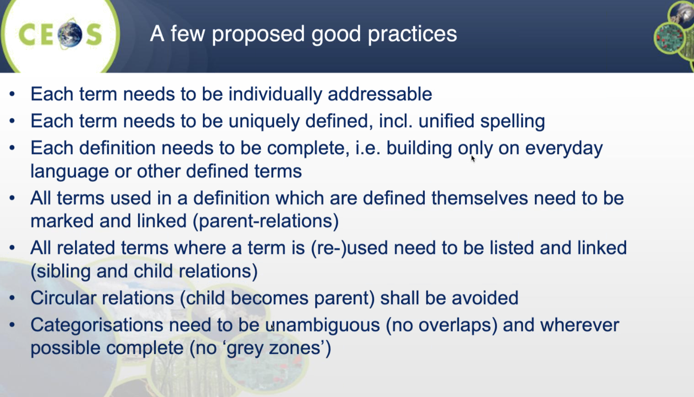
- And governance suggestions for a consolidated glossary:
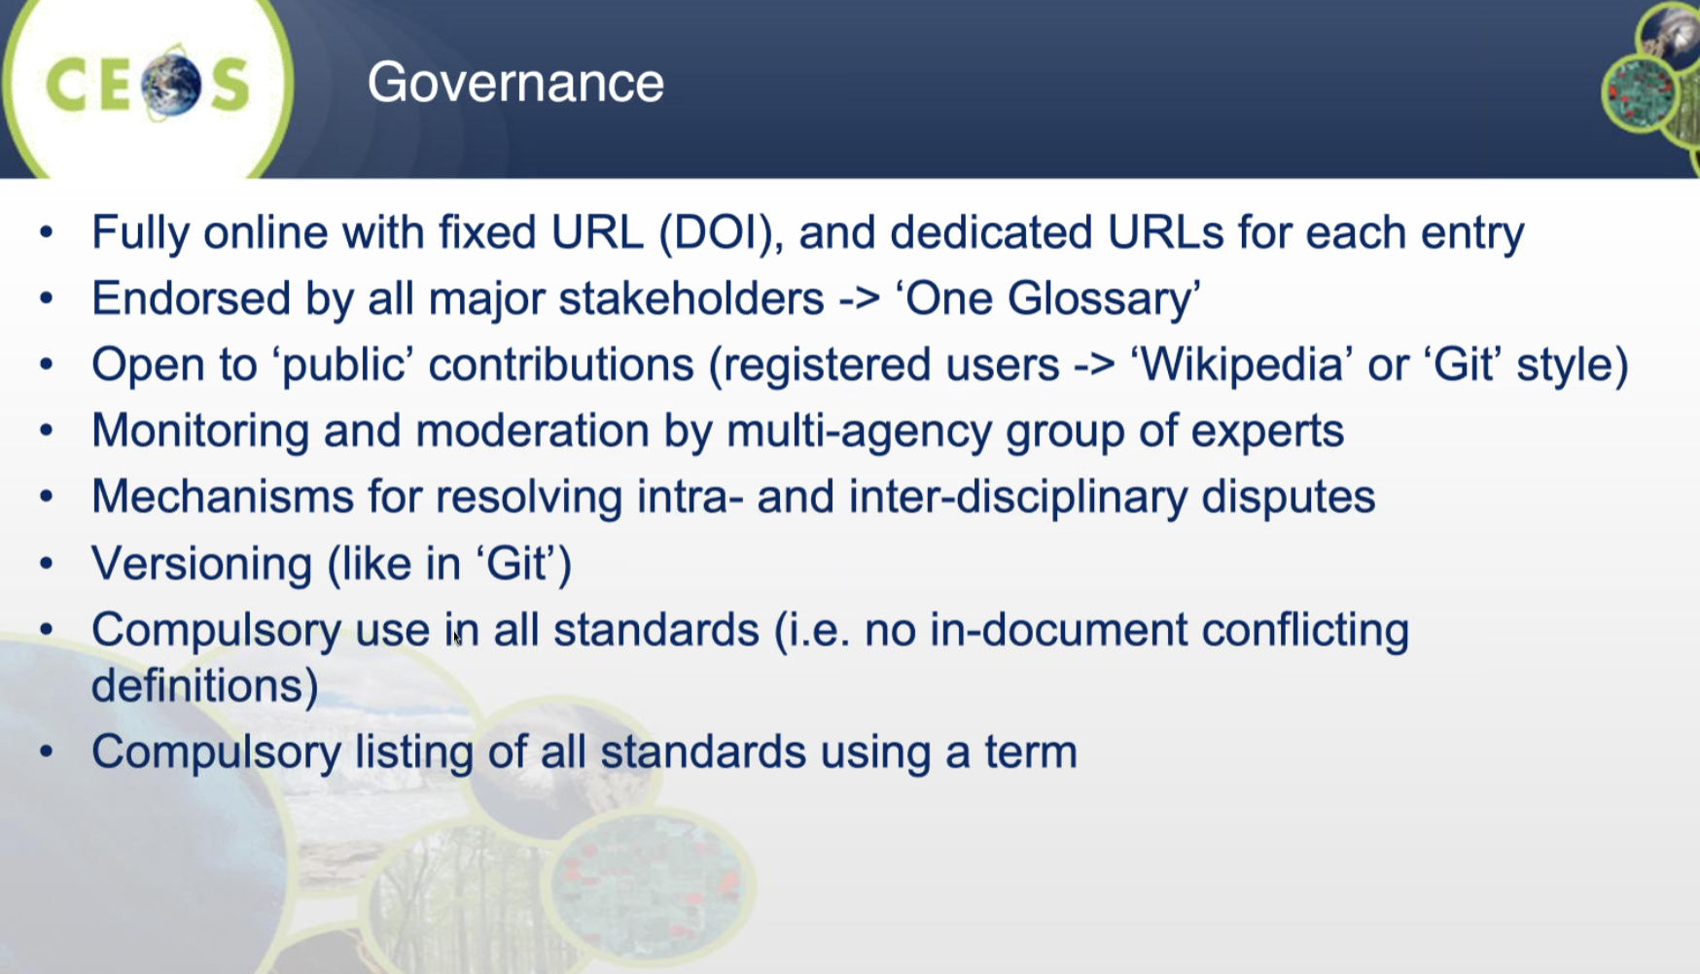
- Peter has discussed with the OGC Technical Committee in December 2020, ISO TC211 in May 2021, and the FAIR dataset quality information (FAIR-DQI) working group in June 2021. Conclusions: a consolidation of geospatial/EO terminology seems largely welcome; rules procedures and tools/platform needed. Decision required on how to proceed, if desired. Peter has also discussed this with WGISS.
Discussion
- Nigel supported WGCV action on this topic. He noted IVOS’ existing work on cal/val terminology specifically. We need a clear understanding of the dynamic of the teams proposed to be involved. ISO was noted in particular as a critical participant, but there was some concern about their complex processes being a potential hindrance. Peter noted that definitions are not standards, and so hopefully wouldn’t be impacted by strict ISO standards processes. We need to decide if this is a CEOS-led activity or not.
- Philippe noted the wiki-style pages on the cal/val portal provide a good basis. This was started by Emma Wooliams / IVOS.
- Greg Stensaas suggested that we need not be completely consistent until there is an ISO endorsed definition. But if there is an international standard that provides definition and terminology, we should incorporate those into CEOS definitions. He agrees we are making something useful for CEOS users and we should continue.
- Kuze-san noted the proposed joint WGISS-WGCV meeting in March 2022, which would be an ideal opportunity to discuss this further.
An action related to this topic was recorded later in the meeting. Refer to the minutes from Day 4.
Next Meeting, Adjourn
Main points:
- Kuze-san thanked everyone for joining and closed Day 1 of the WGCV-49 meeting.

